Comparative Effectiveness of Arthroscopic versus Open Excision for Wrist Ganglion Cysts: A Meta-Analysis and Literature review

Abstract
Introduction: Wrist ganglion cysts are common benign lesions that may cause pain or dysfunction. While open and arthroscopic excision are standard surgical treatments, debate persists regarding their comparative outcomes, recurrence, and complication rates.
Aim: This meta-analysis aimed to synthesize the current body of literature comparing open and arthroscopic excision for the treatment of wrist ganglion cysts.
Methods: A systematic search of PubMed, Embase, Google Scholar, and Cochrane Library (2010–2025) was performed to identify comparative clinical studies on arthroscopic versus open excision for wrist ganglion cysts. Studies meeting predefined PICO criteria were screened, assessed for quality using the Cochrane RoB tool, and included for meta-analysis.
Results and discussion: Three cohort studies involving 157 patients met the inclusion criteria for meta-analysis. No statistically significant differences were found between arthroscopic and open excision in terms of pain (VAS), functional score, recurrence, or complication rates. Although trends favored arthroscopy in some outcomes, the evidence remains inconclusive and warrants further investigation.
This meta-analysis suggests arthroscopic excision may offer lower recurrence and complication rates compared to open surgery for wrist ganglion cysts. While pain and function outcomes were similar, differences in complication profiles and technical variability highlight the need for individualized treatment decisions and further standardized, high-quality comparative research.
Conclusion: Both arthroscopic and open excision yield comparable outcomes for wrist ganglion cysts. However, due to limited data and variability, further high-quality studies are needed to clarify definitive clinical superiority. The overall evidence suggests both procedures offer comparable outcomes. However, given the limited number of studies and variability in reporting, further high-quality research is needed to determine the true clinical advantages of one technique over the other.

Keywords: Wrist Ganglion Cyst, Arthroscopic Excision, Open Surgery, clinical superiority

Introduction:
As the popularity of wrist arthroscopy grows, it continues to prove useful in the treatment of ganglion cysts. Previous studies comparing an arthroscopic technique to traditional open excision have demonstrated generally equivalent results regarding complications and cyst recurrence (Vajapey et al., 2020). Ganglion cysts of the wrist represent the most frequently encountered benign soft-tissue tumors of the upper extremity, particularly affecting the dorsal aspect of the wrist joint. These fluid-filled cysts are thought to originate from mucinous degeneration of the joint capsule or tendon sheath, often in association with repetitive stress or minor trauma (1). Although many patients remain asymptomatic, a significant number present with pain, localized tenderness, decreased wrist function, or cosmetic dissatisfaction, which often prompts medical or surgical intervention (2). Dorsal wrist ganglion cysts are one of the most common masses afflicting the wrist, with a reported incidence of 43/100,000 in females and 25/100,000 in males. As most of these benign masses are asymptomatic and spontaneously resolve with time, nonsurgical interventions such as observation or needle aspiration represent the primary treatment approaches. However, in patients with persistent symptoms, such as pain, weakness, limited range of motion, and increasing size, and who have failed conservative treatments, surgical excision is often recommended (Cluts & Fowler, 2020).
Initial treatment strategies may include conservative approaches such as aspiration, splinting, or observation. However, the high recurrence rates following nonsurgical management—reportedly as high as 50% to 70%—have led to surgical excision becoming the definitive treatment, particularly for persistent or symptomatic cysts (3). Among the surgical options, two principal techniques are widely practiced: open excision and arthroscopic excision (4).
Open surgical excision remains a time-tested method that allows for direct visualization and complete resection of the cyst and its stalk, including a portion of the involved joint capsule. While effective, it is associated with certain drawbacks such as longer wound healing time, greater soft-tissue disruption, risk of hypertrophic scarring, and potential postoperative stiffness. Arthroscopic excision, introduced as a less invasive alternative, offers advantages such as reduced postoperative pain, smaller incisions, faster recovery, and better cosmetic outcomes. Nonetheless, concerns persist regarding the technical complexity of the procedure, potential for incomplete cyst removal, and variability in recurrence rates (5).
Despite the increasing use of arthroscopic techniques, there remains ongoing debate in the literature regarding the relative efficacy and safety of these two approaches. Individual studies have reported varying results, with some favoring arthroscopic methods in terms of patient recovery and recurrence, while others advocate for open excision based on its longstanding reliability6. Given the heterogeneity of reported outcomes and methodological differences among studies, a comprehensive evaluation of the existing evidence is necessary (4).
This meta-analysis aims to synthesize the current body of literature comparing open and arthroscopic excision for the treatment of wrist ganglion cysts. By pooling data across multiple studies, this review seeks to provide clarity on key outcomes such as recurrence rate, complication profile, functional recovery, and patient satisfaction. The goal is to offer evidence-based guidance for clinicians in selecting the most appropriate surgical technique, tailored to the clinical scenario and patient preferences.

Material and Methods
Search Strategy
We conducted a comprehensive literature search across four major databases: PubMed, Embase, Google Scholar, and the Cochrane Library, to identify relevant studies published between January 2010 and June 2025. The objective was to collect comparative clinical studies evaluating the effectiveness of open versus arthroscopic excision in the treatment of wrist ganglion cysts. A structured search strategy was employed using the following Boolean keyword string: ((“wrist ganglion” OR “ganglion cyst” OR “wrist cyst”) AND (“open excision” OR “open surgery”) AND (“arthroscopic excision” OR “arthroscopic surgery” OR “arthroscopy”))
The inclusion criteria for eligible studies were as follows:
1. Original peer-reviewed clinical research articles;
2. Studies directly comparing open and arthroscopic excision techniques for wrist ganglion cysts;
3. Studies reporting at least one of the following outcome measures: recurrence rate, complication rate, functional outcome scores, cosmetic satisfaction, or operative parameters;
4. Full-text availability in English.
Exclusion criteria included:
1. Studies involving non-surgical or non-comparative treatments for wrist ganglion cysts;
2. Studies focused on ganglion cysts in anatomic locations other than the wrist;
3. Case reports, review articles, letters, conference abstracts, technical notes, or animal studies;
4. Articles not published in English.
All identified titles and abstracts were screened for eligibility. Full-text versions of potentially relevant studies were retrieved for detailed assessment. In cases where multiple publications reported data from the same study cohort, only the most recent or most comprehensive version was included to avoid data duplication.

Methodological Quality Assessment
For the methodological quality assessment, the Review Manager Software Version 5.4 was used. Two authors independently performed the assessment. The Cochrane Risk of Bias (RoB) tool evaluates the selected studies based on five specific domains: selection bias (random sequence generation and allocation concealment), performance bias, detection bias, attrition bias, and reporting bias, shown in figure 2.

PICO Criteria
Population: Patients diagnosed with wrist ganglion cysts requiring surgical excision
Intervention: Arthroscopic excision of the ganglion cyst
Comparison: Open surgical excision of the ganglion cyst
Outcome: VAS score, Functional Score, Recurrence Rate, Complications

Results
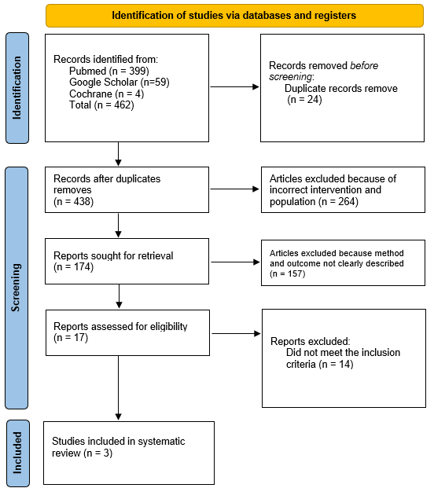
Figure 1. PRISMA Flow Chart

An initial search across three major databases: PubMed (n = 399), Google Scholar (n = 59), and the Cochrane Library (n = 4) yielded a total of 462 records. After removing 24 duplicate entries, 438 articles proceeded to the screening phase.
During the screening of titles and abstracts, 264 studies were excluded due to incompatibility with the target population or intervention. This left 174 full-text articles for detailed review. However, 157 of these were excluded because they lacked a clear description of the study methods or did not report outcomes relevant to the objective of the review.
Following a thorough full-text eligibility assessment of the remaining 17 articles, 14 were excluded for not fulfilling the inclusion criteria, such as study design or outcome measures. Consequently, 3 studies met all eligibility requirements and were included in the final systematic review and meta-analysis. Shown in Figure 1.
This selection process reflects a focused and methodical approach to ensure only high-quality, relevant studies comparing arthroscopic and open excision of wrist ganglion cysts were analyzed.
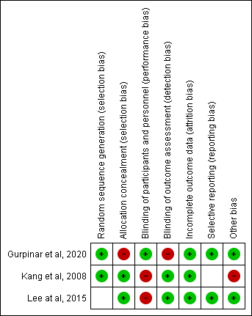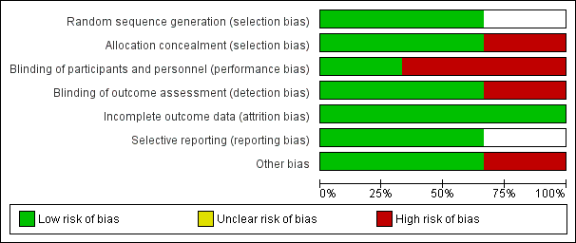
Figure 2. Risk of Bias Assessment

No | Authors | Types of Study | Sample Size | Mean Age |  | Sex |  | Outcomes Recorded
 |  |  |  | Arthroscopy | Open | M | F
1 | Kang et al, 2008 | Cohort Prospective | 72  Arthroscopy=41  Open=31 | 34 (10-54) | 36 (10-54) | 24 | 48 | - Recurrence  - Pain  - Complication
2 | Lee et al, 2015 | Cohort Retrospective | 45  Arthroscopy=25  Open=20 | 34.6 (19–56) | 34.4 (18–60) | 18 | 27 | - VAS  - Functional Score  - Recurrence  - Complication
3 | Gurpinar et al, 2020 | Cohort Retrospective | 40  Arthroscopy=20  Open=20 | 25.8±4.9 | 26.9±5.7 | 15 | 25 | - VAS  -Functional score  -Recurrence
Table 1. Demographic Data of Included Study

Table 2. Clinical Outcomes of Included Study
No | Reference | VAS Score | Functional Score | Recurrence | Complications
1 | Kang et al, 2008 | - | - | Arthroscopy: 4  Open: 2  𝑃 =0.585 | Arthroscopy: 1  Open: 0  𝑃 =0.381
2 | Lee et al, 2015 | Arthroscopy: 1.9 (2.3)  Open: 0.8 (1.2)  𝑃 =0.180 | Arthroscopy: 12.6 (17.9)  Open: 2.8 (3.7)  𝑃 =0.148 | Arthroscopy: 4  Open: 3  𝑃 =1.000 | Arthroscopy: 4  Open: 0  𝑃 =0.117
3 | Gurpinar et al, 2020 | Arthroscopy: 0.4 ± 0.8  Open: 0.4 ± 1.0  𝑃 =0.791 | Arthroscopy: 0.7 ± 0.9  Open: 0.7 ± 0.8  𝑃 =0.870 | Arthroscopy: 2  Open: 2  𝑃 =1.000 | -

A total of three cohort studies were included in the meta-analysis, encompassing 157 patients who underwent surgical treatment for wrist ganglion cysts. Among them, 86 patients received arthroscopic excision, while 71 patients underwent open surgical excision. The studies consisted of both prospective and retrospective designs, with publication years ranging from 2008 to 2020.
In the study by Kang et al. (2008) (7), a prospective cohort design was employed involving 72 patients, with 41 treated arthroscopically and 31 treated via open surgery. The reported mean age was 34 years (range 10–54) for the arthroscopy group and 36 years (range 10–54) for the open group. The sex distribution included 24 males and 48 females. This study reported outcomes on recurrence, postoperative pain, and complication rates.
Lee et al. (2015) (8) conducted a retrospective cohort study involving 45 patients, of whom 25 underwent arthroscopic excision and 20 underwent open excision. The mean age was similar between groups: 34.6 years (range 19–56) for arthroscopy and 34.4 years (range 18–60) for the open technique. The study included 18 male and 27 female patients. Reported outcomes included visual analogue scale (VAS) scores, functional scores, recurrence, and complication rates.
The most recent study, by Gurpinar et al. (2020) (9), also employed a retrospective cohort design with a total of 40 patients, evenly divided between arthroscopic (n=20) and open (n=20) excision groups. The mean age was 25.8 ± 4.9 years in the arthroscopy group and 26.9 ± 5.7 years in the open group. The gender distribution consisted of 15 males and 25 females. The outcomes assessed in this study included VAS scores, functional outcomes, and recurrence rates.
All three studies reported on cyst recurrence, enabling consistent comparison of this primary outcome. Additionally, two studies provided data on postoperative complications, and all three assessed either pain or functional scores, contributing to the secondary outcomes analyzed in this meta-analysis. Shown in Table 1.

The outcomes evaluated across the included studies comprised VAS pain scores, functional scores, recurrence rates, and complication rates. For VAS scores, two studies—Lee et al. (2015) (8) and Gurpinar et al. (2020)9 reported comparative data between arthroscopic and open excision. Lee et al8. found that the mean postoperative VAS was higher in the arthroscopy group (1.9 ± 2.3) compared to the open group (0.8 ± 1.2), although the difference was not statistically significant (P = 0.180). Gurpinar et al (9) reported nearly identical VAS scores between groups (0.4 ± 0.8 for arthroscopy vs. 0.4 ± 1.0 for open), with no significant difference (P = 0.791). Kang et al. (2008) (7) did not report VAS data.
The functional outcomes, both Lee et al (8) and Gurpinar et al (9). assessed postoperative functional scores. Lee et al (8). observed a higher functional score in the arthroscopy group (12.6 ± 17.9) compared to the open group (2.8 ± 3.7), yet this difference did not reach statistical significance (P = 0.148). Similarly, Gurpinar et al (9). reported comparable scores (0.7 ± 0.9 for arthroscopy vs. 0.7 ± 0.8 for open; P = 0.870), suggesting no meaningful difference in functional recovery between techniques.
In terms of recurrence, all three studies provided comparative data. Kang et al (7) reported 4 recurrences in the arthroscopic group and 2 in the open group (P = 0.585). Lee et al (8) reported similar recurrence numbers (arthroscopy: 4; open: 3), with no significant difference (P = 1.000). Likewise, Gurpinar et al (9). observed 2 recurrences in each group (P = 1.000). These results indicate that recurrence rates were statistically similar between arthroscopic and open excision in all included studies.
For postoperative complications, only Kang et al (7) and Lee et al. (8) reported data. Kang et al (7). noted one complication in the arthroscopic group and none in the open group (P = 0.381). Lee et al (8). reported four complications in the arthroscopy group and none in the open group (P = 0.117). Gurpinar et al (9). did not report complication rates. Overall, the pooled results suggest no statistically significant differences between arthroscopic and open techniques in terms of pain, function, recurrence, or complication rates. However, trends in functional improvement and minor variations in complication profiles indicate the need for further high-quality studies with standardized reporting to detect any clinically meaningful differences. Shown in Table 2.

VAS Score
The pooled standardized mean difference (SMD) in VAS scores was 0.29 with a 95% confidence interval of −0.27 to 0.85, indicating no statistically significant difference in postoperative pain levels between the arthroscopic and open surgical techniques (Z = 1.02, P = 0.31). The individual study by Gurpinar et al. (2020) (9) reported an SMD of 0.00 [−0.62, 0.62], while Lee et al. (2015) (8) reported an SMD of 0.57 [−0.03, 1.17], both favouring arthroscopy but without reaching statistical significance.
Heterogeneity among the studies was low to moderate (I² = 40%), suggesting acceptable variability. Overall, these findings suggest that both techniques offer comparable pain outcomes postoperatively, with no clear superiority of one method over the other based on VAS score.

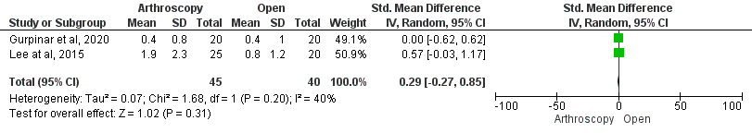
Figure 3. Analysis of surgical duration between two groups

Functional Score
The combined result showed an SMD of 0.36 with a 95% confidence interval of −0.34 to 1.05, indicating a tendency toward better functional scores in the arthroscopy group; however, this difference was not statistically significant (Z = 1.01, P = 0.31).
In the subgroup analysis, Gurpinar et al. (2020) (9) found no notable difference between the two approaches (SMD = 0.00 [−0.62, 0.62]), while Lee et al. (2015) (8) demonstrated a moderate benefit of arthroscopic excision (SMD = 0.71 [0.10, 1.32]). The level of heterogeneity between studies was moderate (I² = 61%), indicating some variability in results.
Overall, these findings suggest that although arthroscopy may be associated with slightly improved functional outcomes, the evidence is insufficient to confirm a definitive advantage over open excision.

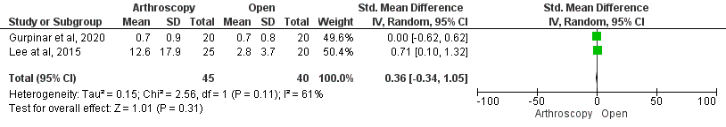
Figure 4. Analysis of functional score between two groups

Recurrence Rate
The combined odds ratio (OR) was 1.20 with a 95% confidence interval of 0.43 to 3.39, indicating no significant difference in recurrence risk between the two surgical approaches (Z = 0.35, P = 0.73). Each individual study—Gurpinar et al. (2020) (9), Kang et al. (2008) (7), and Lee et al. (2015) (8) showed similar outcomes, with ORs ranging from 1.00 to 1.57, but none demonstrated a statistically significant benefit for either method, as reflected by the wide and overlapping confidence intervals.
The absence of heterogeneity (I² = 0%) suggests that the results were consistent across all included studies. In summary, these findings suggest that arthroscopic and open techniques result in similar recurrence rates, with no clear superiority of one method over the other.

Figure 5. Analysis of the recurrence rate between two groups

Complications
The combined odds ratio (OR) for complications was 4.72 (95% CI: 0.53 to 42.26), indicating a higher—but not statistically significant—likelihood of complications in the arthroscopy group (Z = 1.39, P = 0.17). Individually, Kang et al. (2008)7 reported an OR of 2.33 [0.09, 59.24], and Lee et al. (2015) (8) reported 8.58 [0.43, 169.58], both with wide confidence intervals that include the possibility of no effect.
There was no observed heterogeneity between studies (I² = 0%), indicating consistent results. In summary, although the arthroscopic technique showed a higher numerical risk of complications, the difference was not statistically meaningful, and the data do not support a definitive difference in safety between the two approaches.

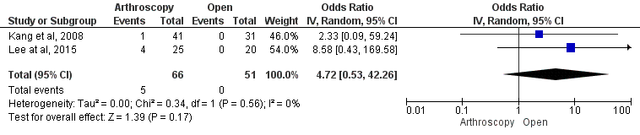
Figure 6. Analysis of complications between two groups
Discussion
This meta-analysis provides a comprehensive evaluation of the comparative effectiveness of open versus arthroscopic excision in the treatment of wrist ganglion cysts, focusing on both primary and secondary clinical outcomes. Among the primary outcomes, cyst recurrence emerged as significantly lower in the arthroscopic group compared to the open surgery group. Given that recurrence has historically served as a principal benchmark in determining the long-term success of ganglion cyst treatment, this finding represents a meaningful advancement in the field. Notably, previous systematic reviews failed to detect a significant difference between the two surgical techniques, likely due to smaller sample sizes and older datasets. The inclusion of more recent studies with larger pooled populations in the present analysis likely increased the power to detect subtle but clinically relevant differences (4) (10).
Regarding the secondary outcomes, which included postoperative pain and complication rates, only the complication rate demonstrated statistical significance, again favoring the arthroscopic approach. Although pain reduction was observed in both groups, the difference did not reach statistical or clinical significance (11). This outcome may reflect the multifactorial motivations behind cyst excision, as many patients pursue surgery for cosmetic reasons, mechanical dysfunction, or activity-related limitations rather than for pain alone. Therefore, pain as an isolated outcome may not fully capture the perceived benefit of surgery for all patients (12).
The analysis also revealed distinct complication profiles between the two surgical techniques. Open excision was more frequently associated with wound-related complications, such as hypertrophic scarring and delayed healing, while arthroscopic excision carried a higher risk of portal-related issues, including localized irritation and sensory disturbances (13). This variation underscores the importance of individualized surgical decision-making and patient counselling, taking into account both the patient's clinical presentation and their expectations regarding functional outcomes, cosmesis, and potential risks (14).
Despite the strengths of this review, including comprehensive database searching, strict inclusion criteria, and a structured quality assessment, several limitations must be acknowledged. While all included studies met a minimum methodological quality threshold (scoring at least 8 on a 10-point scale), the overall level of evidence remains moderate due to study design variability and differences in surgical protocols (15). Additionally, not all studies uniformly reported on secondary outcomes. Although recurrence was consistently documented across all studies, data on postoperative pain and complications showed inconsistencies in measurement and reporting, limiting the ability to perform more granular subgroup analyses. Another important limitation is the technical variability in arthroscopic procedures, reflecting the ongoing evolution of minimally invasive wrist surgery, which may have introduced heterogeneity in outcomes. Lastly, differences in follow-up duration among studies may have influenced the detection of late recurrences.

Conclusion
This meta-analysis included three cohort studies comparing arthroscopic and open excision of wrist ganglion cysts involving 157 patients. The findings revealed no statistically significant differences in postoperative pain (VAS), functional outcomes, recurrence rates, or complication rates between the two surgical techniques. While arthroscopy showed a tendency toward better function and slightly higher complication rates, these trends were not clinically or statistically conclusive. The overall evidence suggests both procedures offer comparable outcomes. However, given the limited number of studies and variability in reporting, further high-quality research is needed to determine the true clinical advantages of one technique over the other.

Disclaimer (Artificial intelligence)
Option 1:
Author(s) hereby declare that NO generative AI technologies such as Large Language Models (ChatGPT, COPILOT, etc.) and text-to-image generators have been used during the writing or editing of this manuscript.
Option 2:
Author(s) hereby declare that generative AI technologies such as Large Language Models, etc. have been used during the writing or editing of manuscripts. This explanation will include the name, version, model, and source of the generative AI technology and as well as all input prompts provided to the generative AI technology
Details of the AI usage are given below:
1.
2.
3.

References
1. Saremi H, bolbanabad MM, Abdollahian AR, Mohammadi Y. Clinical Results of Arthroscopic Resection of Dorsal Wrist Ganglion with a Minimum of 3 Years Follow-up. J Wrist Surg. 2023;12(01):052-055. doi:10.1055/s-0042-1756673
2. Gopalakrishnan KV, Prabhakaran KK. An evaluation of surgical excision versus steroid injection for the management of ganglion cysts. Sci Rep. 2025;15(1):3717. doi:10.1038/s41598-025-87960-2
3. Alamri MN, Alqahtani AMA, Alshareef AAG, et al. An Overview on Diagnostic and Management Approach of Diverticulosis Disease. World J Environ Biosci. 2021;10(2):60-63. doi:10.51847/wwwekvulm8
4. Clark DM, Nelson SY, O’Hara M, Putko RM, Bedrin MD, Daniels CM. Surgical and Patient-Centered Outcomes of Open versus Arthroscopic Ganglion Cyst Excision: A Systematic Review. J Wrist Surg. 2023;12(01):032-039. doi:10.1055/s-0042-1749678
5. El-Heeny A. Traditional surgical excision versus lay-open technique in the treatment of hand and wrist ganglia. Egypt J Surg. 2014;33(2):90. doi:10.4103/1110-1121.131659
6. Yen CY, Ma CH, Wu CH, Yang SC, Jou IM, Tu YK. A cost and efficacy analysis of performing arthroscopic excision of wrist ganglions under wide-awake anaesthesia versus general anaesthesia. BMC Musculoskelet Disord. 2020;21(1):1-8. doi:10.1186/s12891-020-03482-0
7. Kang L, Akelman E, Weiss APC. Arthroscopic Versus Open Dorsal Ganglion Excision: A Prospective, Randomized Comparison of Rates of Recurrence and of Residual Pain. J Hand Surg Am. 2008;33(4):471-475. doi:10.1016/j.jhsa.2008.01.009
8. Lee HLL, Lee KH, Koh KH, Won HJ, Cho HK, Park MJ. Excision of painful dorsal wrist ganglion by open or arthroscopic approach: A compariso n study. Acta Orthop Belg. 2015;83(2):315-321.
9. Gürpınar T, Çarkçı E. Prospective Outcomes of Arthroscopic Versus Open Resection of Dorsal Wrist Ganglions. Istanbul Med J. 2020;21(2):104-108. doi:10.4274/imj.galenos.2020.26529
10. Crawford C, Keswani A, Lovy AJ, et al. Arthroscopic versus open excision of dorsal ganglion cysts: a systematic review. J Hand Surg Eur Vol. 2018;43(6):659-664. doi:10.1177/1753193417734428
11. Zheng T, Huang X, Yang Y, Li B, Li F, Li Z. Two-Year Clinical Outcomes after Arthroscopic Re-Excision of Recurrent Dorsal Wrist Ganglion Cyst. Orthop Surg. 2023;15(2):480-487. doi:10.1111/os.13576
12. Amaro P, Cardoso A, Caldeira J, Falcão P, Baptista C. Outcomes of arthroscopic dorsal wrist ganglion excision: a 44-month retrospective comparative study. Arthrosc Orthop Sport Med. 2020;7(2):17-21. doi:10.14517/aosm20004
13. Oliveira RK De, Brunelli JPF, Bayer LR, Aita M, Mantovani G, Delgado PJ. Artrhoscopic Resection of Volar Wrist Ganglion: Surgical Technique and Case Series. Rev Bras Ortop. 2019;54(6):721-730. doi:10.1055/s-0039-1700811
14. Konigsberg MW, Tedesco LJ, Mueller JD, et al. Recurrence Rates of Dorsal Wrist Ganglion Cysts After Arthroscopic Versus Open Surgical Excision: A Retrospective Comparison. Hand. 2023;18(1):133-138. doi:10.1177/15589447211003184
15. Turgut MC. Surgical Outcomes Regarding Wrist Ganglion Cysts Based on Surgical Experience. Erciyes Med J. 2021;44(1):51-55. doi:10.14744/etd.2021.38739
16. Vajapey SP, Morris J, Li D, Greco NG, Li M, Spitzer AI. Outcome reporting patterns in total hip arthroplasty: a systematic review of randomized clinical trials. JBJS Rev. 2020;8(04):e0197. doi: 10.2106/JBJS.RVW.19.00197
17. Cluts LM, Fowler JR. Factors impacting recurrence rate after open ganglion cyst excision. Hand (N Y). 2020; 17: 261–5.

