Neuroprotective Effects of Ethanolic Extract of Aloe Vera on Mercury-induced Damage in Rat Amygdala and Hippocampus: Histological and Docking Study

ABSTRACT

Aim: Investigate the neuroprotective effects of ethanolic extract of Aloe vera (EEAV) on mercury chloride-induced damage in the amygdala and hippocampus of adult male Wistar rats, using histological and molecular docking approaches.
Study design: 35 rats were randomly assigned into five groups (n=7): Group A (control), Group B (5 mg/kg HgCl₂), Group C (500 mg/kg EEAV), Group D (5 mg/kg HgCl₂ + 250 mg/kg EEAV), and Group E (5 mg/kg HgCl₂ + 500 mg/kg EEAV).
Place and Duration of Study: Department of Human Anatomy, Chukwuemeka Odumegwu Ojukwu University, Anambra State, Nigeria between March and April 2025.
Methodology: Sample: 35 male Wistar Rats weighing between 200-230g were used for this study. Acclimatized for 7 days and were randomly selected into five groups of seven animals each (A to E).
Results Data was analyzed using S.P.S.S version 25 and results expressed as mean± S.E.M(P≤ .05). Y-maze results revealed significant impairments in spatial memory and locomotor activity in Group B, indicated by increased % alternation (30.13 ± 1.19, p = .02) and reduced number of entries (8.25 ± 0.75), compared to the control. Treatment with EEAV, particularly at 500 mg/kg, markedly improved cognitive performance (Group E: % alternation = 11.50 ± 1.62). Molecular docking revealed that Aloe vera compounds such as emodin, chrysophanol, aloe-emodin, and pomiferin showed strong binding affinities to key neuroprotective proteins. Emodin (−9.0 kcal/mol) and chrysophanol (−8.8 kcal/mol) bound effectively to the GABA receptor (PDB: 1M2Z) and serotonin transporter (PDB: 5XR8) in the amygdala, surpassing diazepam (−8.1 kcal/mol). Auriculasin (−7.5 kcal/mol) and pomiferin (−7.9 kcal/mol) also interacted strongly with BDNF (PDB: 1BND) and acetylcholinesterase (PDB: 1Q3W). Additional interactions with metallothioneins (MT-1, PDB: 1MHU; MT-2, PDB: 2MHU) suggest antioxidant and metal-chelating activities. Most compounds met Lipinski, Ghose, Veber, and Egan criteria, indicating good oral bioavailability. Histological analysis revealed neuronal degeneration in the hippocampus and amygdala of HgCl₂-exposed rats, while EEAV treatment preserved normal cytoarchitecture.
Conclusion: This study reveals that Aloe vera may possess neuroprotective potential against mercury-induced neurotoxicity through bioactive compounds that exhibit strong receptor interactions and favorable drug-likeness properties.
Keywords: Aloe vera, mercury chloride, molecular docking, neuroprotection, hippocampus, amygdala

1. INTRODUCTION
Neurodegenerative diseases are increasing at an alarming rate worldwide and represent a growing public health challenge (World Health Organization [WHO], 2023). The World Health Organization and Global Burden of Disease analyses indicate that neurological disorders are the second leading cause of death globally, accounting for roughly 9 million deaths per year (WHO, 2024). This burden is disproportionately high in low- and middle-income countries and is further aggravated by rising environmental pollution and industrial exposures in many regions, including parts of Nigeria (Mulenga et al., 2024; Environmental Law Institute, 2013; WHO, 2024). Mercury — a heavy metal still used in some agricultural, cosmetic, and industrial applications and released widely by artisanal and small-scale gold mining — has been implicated as a contributor to neurotoxicity and neurodegenerative processes (Wu et al., 2024; Associated Press, 2025; Mulenga et al., 2024). Experimental and review literature indicate that chronic exposure to inorganic mercury (including mercury chloride, HgCl₂) produces oxidative stress, inflammatory responses, and neuronal degeneration; these effects have been documented in vulnerable brain regions such as the hippocampus (implicated in memory) and other limbic structures involved in emotional processing (Paduraru et al., 2022; Aragão et al., 2018; Teixeira et al., 2014).
Aloe vera is a widely available medicinal plant whose antioxidant and anti-inflammatory effects are increasingly documented. For example, Aloe vera extract reduces oxidative damage and improves neurological outcomes following traumatic brain injury (Khaksari et al., 2024), and improves behavioral deficits as well as oxidative status in diabetic rat models (Tabatabaei et al., 2023). However, there is little direct evidence on whether Aloe vera can protect against mercury chloride induced neurotoxicity, particularly regarding astroglial integrity, neural histology, behavior, and molecular markers of oxidative stress and apoptosis. Nonetheless, the role aloe vera plays in the improvement of damage caused by mercury to the central nervous system and particularly astroglial well-being and behavioral performance has been rarely investigated.
We hypothesized that Aloe vera extract would mitigate HgCl₂-induced neurotoxicity in male Wistar rats, preserving neuronal structure, improving behavioral outcomes, and modulating molecular indices of oxidative stress, inflammation, and cell death.
To test this, the study combined behavioral assays, histology, and molecular analyses focused on the hippocampus and amygdala to determine the neuroprotective effect of Aloe vera against mercury chloride toxicity.

2. material and methods

2.1 Plant Collection
Aloe vera leaves were harvested from a local farm, at Uli, Anambra state. The botanical identification was confirmed in the herbarium unit of the Department of Biological Science, Chukwuemeka Odumegwu Ojukwu University, Uli Campus, Anambra State and assigned voucher number, COOU/BS/HERB/25/015.
2.2 Preparation of Aloe vera extract
The Aloe vera leaves obtained after air-drying were chopped into small pieces and was given cold maceration using 70% ethanol for 72 hours by shaking occasionally (Maniyar et al., 2010). The mixture was subsequently filtered off using Whatman No. 1 filter paper. The obtained filtrate was concentrated to a semi-solid substance under reduced pressure using a rotary evaporator without the temperature exceeding 40°C. In the preparation of the concentrated extract, the extract was allowed to dry in a vacuum desiccator up to a constant weight.
2.3 LD50 of Aloe vera
The median lethal dose (LD50) of Ethanolic extract of aloe vera were determined using the method of Dietrich Lorke (1983) And were found to be greater than 5000mg/kg.
The LD50 was calculated using the formula:
LD50= √ (minimum lethal dose ×maximum non-lethal dose)

2.4 Preparation of Administered Dosage
5g of gel-like form of Ethanolic extract of aloe vera, was dissolved in 50mls of distilled water to obtain a Stock Solution of 100mg/mls. Different concentrations were made from the obtained LD50 making sure that sub-lethal concentrations were used in the experiment. The reconstituted extract was orally given to the experimental animals

2.7 Experimental Design
Thirty-five (35) male Wistar Rats weighing between 200-230g were used for this study. The animals were allowed to acclimatize for a period of seven days with full access to feed and water, after which were randomly selected into five groups of seven animals each (A to E). The grouping was as follows:
Group A (Control Group): animals received 5mls/kg distilled water and laboratory chow
Group B (Mercury Chloride group): received 5mg/kg of mercury chloride only.
Group C (Aloe vera group): received 500mg/kg of Aloe vera only.
Group D (Mercury+ low dose Aloe vera): received 5mg/kg of mercury for 14 days followed by 250mg/kg of Aloe vera for 21 days
Group E (Mercury+ high dose Aloe vera): received 5mg/kg of mercury for 14 days followed by 500mg/kg of Aloe vera for 21 days
The administration was done orally using oral canula within the period of 6am to 8am every day. 24hrs after the last administration, the rats were exposed to Y-maze and thereafter anaesthetized with 50mg/kg ketamine. The brain was perfused fixed in 10% buffered formalin, dissected and processed for histological studies using H&E technique as described by Insausti et al., (2023).
2.7.1 Sample Size (adapted from Sun et al., 2020)
This was done using the method outlined by Sun et al., 2020. This ensured that each animal had an equal chance of being selected. The method was chosen to eliminate selection bias and promote uniformity across groups, thus enhancing the reliability and validity of the results. Random sampling is suitable for researches like the present study conducted under controlled laboratory conditions where environmental variables can be standardized, making it a statistically sound and ethically appropriate choice for this research.
2.8 Statistical Analysis
Research objectives and hypothesis of the study was considered before analyzing data. The results were statistically analyzed using the SPSS version 25 software. Two principal statistical tests were used i.e. Dependent t-test and One-way ANOVA served explicit purposes in examining various sorts of data gathered during the study. The results were expressed as mean± S.E.M. Statistical differences between the experimental and control groups were determined using ANOVA and values were considered significant at p ≤ .05.
2.9 In-silico studies
2.9.1 Evaluation of Aloe vera bioactive compounds
Aloe vera bioactive compounds were obtained from published literature and scientific databases on phytochemicals. The databases were Indian Medicinal Plants (IMPPAT), Dr. Duke Ethnobotanical Database (https://phytochem.nal.usda.gov, accessed on July 23, 2025) and Google Scholar, accessed on July 23, 2025. A total of 200 bioactive compounds were identified.
2.9.2 Preparation of Ligands
The structural data files (SDF) of the bioactive compounds were obtained from PubChem web-platform (https://www.ncbi.nlm.nih.gov/pccompound) in 3D conformation (Kim et al., 2023). The compounds whose structural files were not found in the chemoinformatics databases were drawn using ChemDraw Ultra 12.0, saved in mole files and further converted into structural data files (SDF) by deploying Openbabel GUI software version 2.3.2.
2.9.3 Protein targets selection and preparation

The three-dimensional (3D) crystallographic structures of target proteins shown in table were retrieved from the Protein Database (PDB) (www.pdb.org/pdb), the proteins were prepared for molecular docking through the removal of the co-crystallized ligand, water molecules and Hetero atoms to produce a nascent receptor, polar hydrogens were added and the receptor sites were identified using Biovia discovery studio v.24.1.0.23298.
2.9.4 Molecular docking
Virtual screening of the ligands was carried out using PyRx-Python Prescription 0.8, a suite comprising of automated molecular docking tools (Auto dock tools, Auto Dock Vina and Openbabel) (Dallakyan and Olson, 2015). The PDBQT file of the ligands and protein were generated through this software. The specific target sites of the target proteins were set with the help of grid box as shown in table 1. The configurations for each protein-ligand complex were generated for all the ligands using the software; text files of scoring results (binding affinities of the ligands to the target protein) were also produced for the purpose of manual comparative analysis at the end of the experiment (Trott and Olson, 2010).

Table 1: Grid box dimensions of the selected target proteins
Targets | PDB ID | X | Y | Z
Hippocampus | 1bnd | 15.1800 | -2.2192 | 44.3378
Hippocampus | 1q3w | 26.8525 | 5.7605 | 38.6537
Amygdala | 1m2z | 41.1369 | 7.7557 | 10.3850
Amygdala | 5xr8 | -43.8573 | -137.1261 | 289.6721
Metallothioneins-1 | 1mhu | 4.9530 | 5.3222 | 10.3964
Metallothioneins-2 | 2mhu | 0.0306 | -4.2033 | -6.5989

2.9.5 Prediction of Pharmacokinetics (ADME), Physico-chemical and Toxicity properties
The ADMET properties such as Absorption, Distribution, Metabolism, Excretion, Physico-chemical and Toxicity of the compounds were tested by using ADMETlab3.0 server (ADMETlab 3.0 (scbdd.com), accessed on July 23, 2025. A freely accessible tool that enables the database to be queried by canonical SMILES notation of the ligands.
2.9.6 Drug Likeness Screening
Drug likeliness properties of the ligands were analyzed using SwissADME server (www.swissadme.ch/index.php) accessed on July 23, 2025. The following drug likeness models were examined; Lipinski, Ghose, Veber, Egan and Muegge.
2.10 Histological Analysis (adapted from Borah et al.,2023)
This was done using the method outlined by Borah et al. (2023), and includes the following steps: fixation, Hematoxylin staining, rinsing, differentiation, bluing, Eosin counterstaining, dehydration, clearing and mounting.

3. results and discussion

Table 2: Effect of ethanolic extract of Aloe vera on alternate memory and number of entries following mercury chloride exposed rats

Groups | % Alternation Mean±SEM | No. of Entries Mean±SEM
Group A (control) | 17.00±1.83 | 13.75±1.65
Group B (5mg/kg of HgCl₂) | 30.13±1.19ª | 8.25±0.75ª
Group C (500 mg/kg of EEAV) | 19.68±1.32 ^{b} | 12.75±0.85^{b}
Group D (5mg/kg of HgCl₂ for 3-weeks + 250 mg/kg of EEAV) | 20.80±4.77 ^{b} | 12.67±0.33^{b}
Group E (5mg/kg of HgCl₂ for 3-weeks + 500 mg/kg of EEAV) | 11.50±1.62^{ab} | 11.75±2.05
f-ratio | 7.214 | 2.511
p-value | 0.002 | 0.089

HgCl₂: mercury chloride, EEAV: ethanolic extract of Aloe vera, a: significant compared to A, b: significant compared to group B. significance is indicated at p≤0.05.

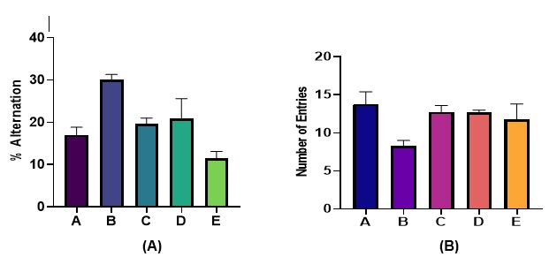
Figure 1: Effect of ethanolic extract of Aloe vera on (A) alternate memory (B) number of entries following mercury chloride exposure

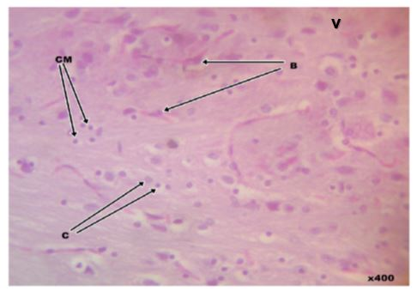
- (B)
(C) (D)

(E)

Fig 2: Photomicrograph of amygdala of (A) control rats showing normal morphology of the three main nuclear groups including the basolateral group (B), corticomedial group (CM) as well as central nucleus (C) with mostly medium-sized neurons. (B) 5mg/kg of mercury-chloride showing vacuolization and necrosis across all nuclear groups; namely the basolateral group (B), corticomedial group (CM) and central nucleus (C). The most affected is the corticomedial (CM) group. (C) 500mg/kg of Aloe vera densely packed with neurons in all nuclear groups; namely the basolateral group (B), corticomedial group (CM), central nucleus (C) and the corticomedial (CM) group. (D) 5mg/kg of mercury-chloride and treated with 250mg/kg of Aloe vera extract showing mild improvement in the density of neurons across all nuclear groups. (E) 5mg/kg of mercury-chloride and treated with 500mg/kg of Aloe vera extract showing a moderate improvement in the density of all nuclear groups.

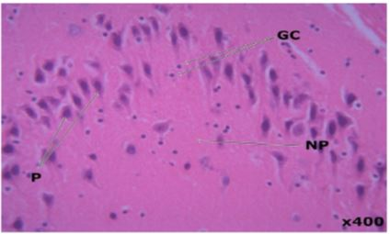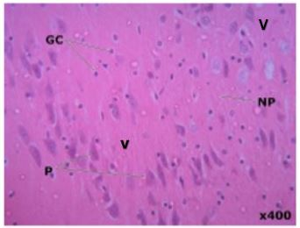
- (B)
(C) (D)

(E)

Fig 3: Photomicrograph of hippocampus of (A) control rats showing the hippocampal formation show the Cornu Ammnonis 1(CA1) with variable cellularity and evenly distributed glial cells (GC) and pyramidal cells(P), vacuole(V), all set in a meshwork of neuropils (NP). (B) 5mg/kg of mercury-chloride chloride showing necrosis of pyramidal cells with vacuolization. (C) 500mg/kg of Aloe vera showing densely packed pyramidal neurons(P). (D) 5mg/kg of mercury-chloride and treated with 250mg/kg of Aloe vera extract showing densely packed pyramidal neurons(P). (E) 5mg/kg of mercury-chloride and treated with 500mg/kg of Aloe vera extract showing moderate improvement in cell density and cytoarchitecture.

Table 3: Binding affinities of Aloe vera bioactive compounds with Hippocampus targets (PDB: 1bnd)

Ligands | PubChem CID | Binding Affinity (Kcal/mol)
- Auriculasin | 5358846 | -7.5
Elgonica dimer A | 21582596 | -7.3
Glucomannan | 24892726 | -7.1
Warangalone | 5379679 | -7.1
Diazepam (Control) | 3016 | -6.2
Fluoxetine (Control) | 3386 | -5.6
Memantine (Control) | 4054 | -5.1
N-Acetylcysteine lysinate (Control) | 9883132 | -3.4

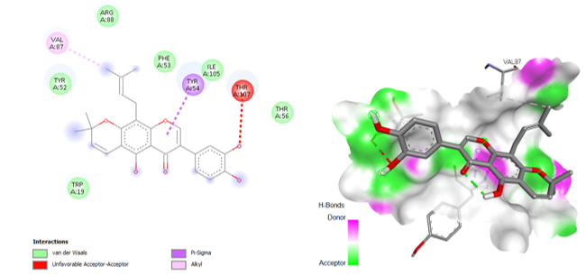Fig 4: 2D and 3D binding interactions of Auriculasin with Hippocampus targets (PDB: 1bnd)

Table 4: Binding affinities of Aloe vera bioactive compounds with Metallothioneins-1 target (PDB: 1mhu)
Ligands | PubChem CID | Binding Affinity (Kcal/mol)
Deferasirox (Control) | 214348 | -5.9
Pomiferin | 4871 | -5.6
Aloesin | 160190 | -5.4
Hecogenin | 91453 | -5.3
Osajin | 95168 | -5.2
7-Hydroxyaloin B | 158096 | -5.1
Deferoxamine (Control) | 2973 | -3.9

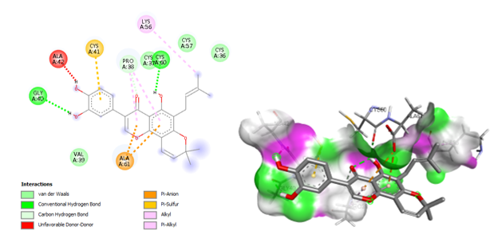

Fig 5: 2D and 3D binding interactions of Pomiferin with Metallothioneins-1 target (PDB: 1mhu)

Table 5. Binding affinities of Aloe vera bioactive compounds with Amygdala target (PDB: 1m2z)
Ligands | PubChem CID | Binding Affinity (Kcal/mol)
Emodin | 3220 | -9
Chrysophanol | 10208 | -8.8
Aloe-emodin | 10207 | -8.7
Anthraquinone | 6780 | -8.4
Diazepam (Control) | 3016 | -8.1
Fluoxetine (Control) | 3386 | -7.7
Memantine (Control) | 4054 | -6.7
N-Acetylcysteine lysinate (Control) | 9883132 | -4.6

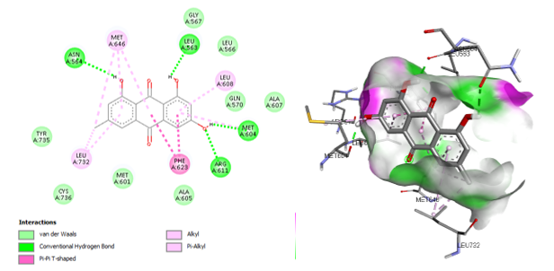
Fig 6: 2D and 3D binding interactions of Emodin with Amygdala target (PDB: 1m2z)

Table 6: Binding affinities of Aloe vera bioactive compounds with Hippocampus target (PDB: 1q3w)
Ligands | PubChem CID | Binding Affinity (Kcal/mol)
Chrysophanol | 10208 | -8.1
Aloe-emodin | 10207 | -8.1
Pomiferin | 4871 | -7.9
Diazepam (Control) | 3016 | -7
Fluoxetine (Control) | 3386 | -6.2
Memantine (Control) | 4054 | -5
N-Acetylcysteine lysinate (Control) | 9883132 | -4.2

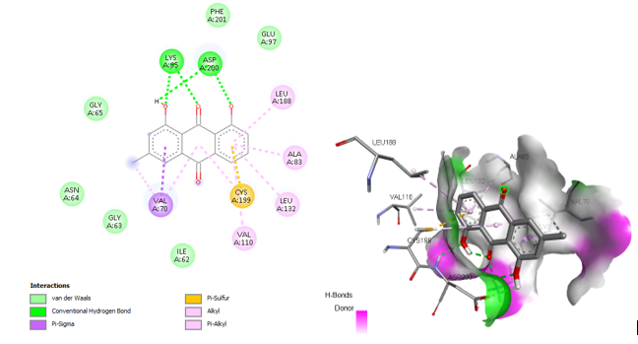
Fig 7: 2D and 3D binding interactions of Chrysophanol with Hippocampus target (PDB: 1q3w)
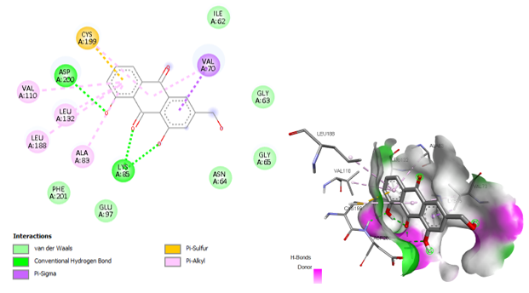
Fig 8: 2D and 3D binding interactions of Aloe-emodin with Hippocampus target (PDB: 1q3w)

Table 7: Binding affinities of Aloe vera bioactive compounds with Metallothioneins-2 target (PDB: 2mhu)
Ligands | PubChem CID | Binding Affinity (Kcal/mol)
3-(1,3-benzodioxol-5-yl)-5-methoxyfuro[2,3-h]chromen-4-one | 188707 | -6.4
Hecogenin | 91453 | -6.3
1,5-dihydroxy-3-methylanthracene-9,10-dion | 5316800 | -6.2
2,6,8-trihydroxy-1-methoxy-10-[(2S,3R,4R,5S,6R)-3,4,5-trihydroxy-6-(hydroxymethyl)oxan-2-yl]-10H-anthracen-9-one | 11968593 | -6.1
Dimercaptosuccinic acid (Control) | 9354 | -3.8
Dimercaprol (Control) | 3080 | -2.7

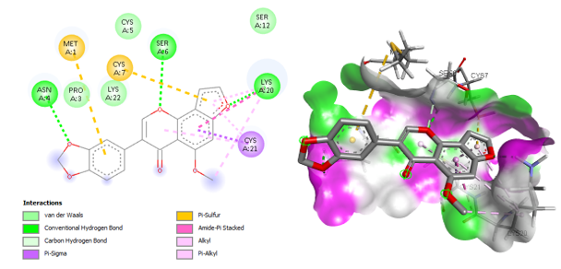
Fig 9: 2D and 3D binding interactions of 3-(1,3-benzodioxol-5-yl)-5-methoxyfuro[2,3-h]chromen-4-one with Metallothioneins-2 target (PDB: 2mhu)

Table 8. Binding affinities of Aloe vera bioactive compounds with Amygdala target (PDB: 5xr8)
Ligands | PubChem CID | Binding Affinity (Kcal/mol)
Hecogenin | 91453 | -8
5-hydroxy-3-[4-hydroxy-3-(3-methylbut-2-enyl)phenyl]-8,8-dimethylpyrano[2,3-h]chromen-4-one | 11441072 | -7.9
Pomiferin | 4871 | -7.7
Diazepam (Control) | 3016 | -7.7
Auriculasin | 5358846 | -7.6
Fluoxetine (Control) | 3386 | -7.1
Memantine (Control) | 4054 | -5.5
N-Acetylcysteine lysinate (Control) | 9883132 | -3.7

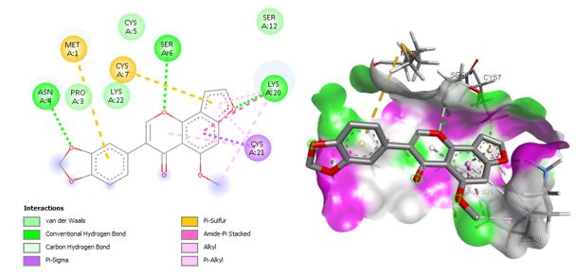
Fig 10: 2D and 3D binding interactions of Hecogenin with Amygdala target (PDB: 5xr8)

Table 9: Amino acid interactions of the selected target proteins with the Hit compounds of Aloe vera
Binding interactions | IBND- Auriculasin | 1MHU-Pomiferin | 1M2Z-Emodin | 1Q3W-Chrysophanol | 1Q3W-Aloe-emodin | 2MHU-3-(1,3-benzodioxol-5-yl)-5-methoxyfuro[2,3-h]chromen-4-one | 5XR8-Hecogenin
Conventional Hydrogen bond | - | 2(GLY40, CYS60) | 4(ASN564, LEU563, ARG611, MET604) | 2(LYS85, ASP200) | 2(LYS85, ASP200) | 3(ASN4, SER6, LYS20) | 1(ARG214)
Carbon Hydrogen bond | - | 1(PRO38) | - | - | - | 1(LYS22) | -
Van dar Waals | 6(TRP19, TYR52, ARG88, PHE53, ILE105, THR56) | 3(VAL39, CYS37, CYS57, CYS36) | 8(ALA605, MET601, CYS736, TYR735, GLY567, LEU566, GLN570, ALA607) | 6(ILE62, GLY63, ASN64, GLY65, PHE201, GLU97) | 6(PHE201, GLU97, ASN64, GLY65, GLY63, ILE62) | 3(PRO3, CYS5, SER12) | 9(ILE218, TYR519, ILE518, THR466, LEU467, ALA464, ILE297, ALA301, ARG522)
Amide-Pi stacked | - | - | - | - | - | 1(LYS20) | -
Pi-alkyl | - | 1(PRO38) | 2(LEU732, LEU608) | 1(VAL70) | 6(VAL70, ALA83, LEU132, LEU188, VAL110, CYS199) | 1(CYS21) | 1(LEU463)
Pi-Sulfur | - | 1(CYS41) | - | 1(CYS193) | I(CYS199) | 2(MET1, CYS7) | -
Unfavorable Acceptor-Acceptor | 1(THR107) | - | - | - | - | - | -
Pi-Sigma | 1(TYR54) | - | - | 1(VAL70) | 1(VAL70) | 1(CYS21) | -
Alkyl | 1(VAL87) | 1(LYS56) | 1(MET646) | 5(VAL110, CYS199, LEU132, ALA83, LEU188) | - | 1(LYS20) | 1(HIS304)
Pi-Pi T shaped | - | - | 1(PHE623) | - | - | - | -
Pi-Anion | - | 1(ALA61) | - | - | - | - | -
Pi-Pi Stacked
Unfavorable Donor-Donor | - | 1(ALA42) | - | - | - | - | -

Table 10: Pharmacokinetics (ADME) Properties of the Hit compounds of Aloe vera
ADME | Properties | Auriculasin | Pomiferin | Emodin | Chrysophanol | Aloe-emodin | 3-(1,3-benzodioxol-5-yl)-5-methoxyfuro[2,3-h]chromen-4-one | Hecogenin
Absorption | Caco-2 | -4.978 | -4.984 | -5.141 | -4.810 | -5.062 | -4.662 | -5.052
Absorption | P-gp inhibitor | 0.270 | 0.419 | 0.126 | 0.552 | 0.071 | 0.808 | 0.755
Absorption | P-gp substrate | 0.002 | 0.003 | 0.079 | 0.149 | 0.051 | 0.007 | 0.290
Absorption | HIA | 0.023 | 0.041 | 0.010 | 0.032 | 0.329 | 0.005 | 0.001
Absorption | Bioavailability | 1.000 | 1.000 | 0.925 | 0.960 | 0.985 | 0.380 | 0.989
Distribution | OATP1B1 | 1.000 | 1.000 | 0.942 | 0.994 | 0.941 | 0.881 | 1.000
Distribution | OATP1B3 | 0.971 | 0.976 | 0.978 | 0.998 | 0.999 | 0.995 | 1.000
Distribution | BCRP | 0.939 | 0.984 | 0.118 | 0.137 | 0.256 | 0.553 | 0.967
Distribution | BSEP | 0.929 | 0.912 | 0.143 | 0.402 | 0.125 | 1.000 | 0.999
Distribution | BBB | 0.043 | 0.006 | 0.002 | 0.004 | 0.002 | 0.158 | 0.010
Distribution | MRP1 | 0.973 | 0.953 | 0.870 | 0.679 | 0.481 | 0.534 | 0.186
Distribution | PPB | 93.687 | 95.364 | 95.212 | 95.469 | 92.312 | 97.068 | 69.169
Metabolism | CYP1A2-inh | 0.000 | 0.000 | 1.000 | 0.998 | 0.095 | 0.997 | 0.000
Metabolism | CYP1A2-sub | 0.000 | 0.000 | 0.989 | 0.782 | 0.063 | 0.842 | 0.000
Metabolism | CYP2C19-inh | 1.000 | 1.000 | 0.221 | 0.512 | 0.316 | 0.969 | 0.008
Metabolism | CYP2C19-sub | 0.945 | 0.883 | 0.006 | 0.000 | 0.725 | 0.839 | 0.651
Metabolism | CYP2C9-inh | 0.999 | 0.997 | 0.206 | 0.234 | 0.044 | 0.525 | 0.203
Metabolism | CYP2C9-sub | 0.047 | 0.174 | 0.000 | 0.000 | 0.001 | 0.987 | 0.000
Metabolism | CYP2D6-inh | 0.000 | 0.001 | 0.427 | 0.103 | 0.002 | 0.996 | 0.010
Metabolism | CYP2D6-sub | 0.014 | 0.038 | 0.003 | 0.009 | 0.000 | 0.998 | 0.010
Metabolism | CYP3A4-inh | 0.241 | 0.122 | 0.358 | 0.008 | 0.000 | 0.997 | 0.238
Metabolism | CYP3A4-sub | 0.003 | 0.000 | 0.000 | 0.042 | 0.470 | 0.002 | 0.999
Metabolism | CYP2B6-inh | 1.000 | 1.000 | 0.011 | 0.104 | 0.321 | 0.991 | 1.000
Metabolism | CYP2B6-sub | 0.000 | 0.000 | 0.000 | 0.000 | 0.000 | 0.902 | 0.000
Metabolism | CYP2C8-inh | 1.000 | 1.000 | 1.000 | 0.999 | 1.000 | 0.079 | 0.993
Excretion | cl-plasma | 6.767 | 9.516 | 2.932 | 4.973 | 4.805 | 3.772 | 17.051
Excretion | t0.5 | 1.506 | 1.322 | 1.430 | 0.842 | 1.202 | 0.908 | 1.796

Table 11: Physicochemical Properties of the Hit compounds of Aloe vera
Properties | Auriculasin | Pomiferin | Emodin | Chrysophanol | Aloe-emodin | 3-(1,3-benzodioxol-5-yl)-5-methoxyfuro[2,3-h]chromen-4-one | Hecogenin
Molar weight | 420.160 | 420.160 | 270.050 | 254.060 | 270.050 | 336.060 | 430.310
No. HB Acceptor | 6.000 | 6.000 | 5.000 | 4.000 | 5.000 | 6.000 | 4.000
No. HB Donor | 3.000 | 3.000 | 3.000 | 2.000 | 3.000 | 0.000 | 1.000
TPSA | 100.130 | 100.130 | 94.830 | 74.600 | 94.830 | 71.040 | 55.760
LogP | 3.977 | 3.999 | 3.812 | 3.913 | 2.940 | 2.582 | 4.194
Flexibility | 0.125 | 0.125 | 0.000 | 0.000 | 0.056 | 0.077 | 0.000
No. Rotatable H. | 3.000 | 3.000 | 0.000 | 0.000 | 1.000 | 2.000 | 0.000

Table 12: Toxicity Properties of the Hit compounds of Aloe vera
Properties | Auriculasin | Pomiferin | Emodin | Chrysophanol | Aloe-emodin | 3-(1,3-benzodioxol-5-yl)-5-methoxyfuro[2,3-h]chromen-4-one | Hecogenin
Skin Sensitization | 0.970 | 0.963 | 0.940 | 0.939 | 0.884 | 0.093 | 0.997
Carcinogenicity | 0.647 | 0.690 | 0.769 | 0.775 | 0.832 | 0.932 | 0.820
Eye corrosion | 0.000 | 0.000 | 0.002 | 0.004 | 0.000 | 0.002 | 0.264
Eye irritation | 0.560 | 0.644 | 0.992 | 0.986 | 0.971 | 0.788 | 0.858
Respiratory | 0.845 | 0.771 | 0.900 | 0.899 | 0.869 | 0.643 | 0.540
Hapatotoxicity | 0.565 | 0.561 | 0.621 | 0.606 | 0.680 | 0.627 | 0.624
Neurotoxicity | 0.139 | 0.120 | 0.186 | 0.227 | 0.253 | 0.490 | 0.101
Ototoxicity | 0.678 | 0.672 | 0.280 | 0.290 | 0.467 | 0.329 | 0.545
Hematotoxicity | 0.125 | 0.144 | 0.584 | 0.695 | 0.717 | 0.456 | 0.093
Nephrotoxicity | 0.223 | 0.247 | 0.468 | 0.585 | 0.707 | 0.386 | 0.486
Genotoxicity | 0.900 | 0.918 | 0.955 | 0.848 | 0.986 | 0.939 | 0.006
Immunitoxicty | 0.034 | 0.040 | 0.283 | 0.270 | 0.327 | 0.155 | 0.098
A549 Cytotoxicity | 0.585 | 0.570 | 0.905 | 0.863 | 0.834 | 0.235 | 0.365
HEK293 Cytotoxicity | 0.445 | 0.422 | 0.620 | 0.440 | 0.441 | 0.491 | 0.801

Table 13: Drug likeness properties of the Hit compounds of Aloe vera
Drug Likeness Models | Auriculasin | Pomiferin | Emodin | Chrysophanol | Aloe-emodin | 3-(1,3-benzodioxol-5-yl)-5-methoxyfuro[2,3-h]chromen-4-one | Hecogenin
Lipinski | Yes | Yes | Yes | Yes | Yes | Yes | Yes
Ghose | Yes | Yes | Yes | Yes | Yes | Yes | No
Veber | Yes | Yes | Yes | Yes | Yes | Yes | Yes
Egan | Yes | Yes | Yes | Yes | Yes | Yes | Yes
Muegge | No | No | Yes | Yes | Yes | Yes | Yes

The Y-maze test showed that animals in Group B exhibited a marked reduction in spontaneous alternation behavior, indicating impaired spatial working memory likely associated with hippocampal dysfunction. This observation aligns with recent findings that chronic exposure to heavy metals, including mercury, disrupts synaptic integrity and impairs hippocampal-dependent memory processes. In contrast, Aloe vera-treated groups, particularly Group E, demonstrated a significant improvement in alternation percentage, suggesting recovery of cognitive performance. Similar enhancements in spatial learning and memory following Aloe vera administration have been reported in rodent models of neurotoxicity and oxidative stress (Dey et al., 2021). The observed improvement may be attributed to the antioxidant and anti-inflammatory phytochemicals present in Aloe vera.
Histologically, mercury exposure induced marked neuronal degeneration in the hippocampus and amygdala, characterized by pyknotic nuclei and vacuolations. However, Aloe vera conferred dose-dependent structural preservationcorroborating previous findings by , (Khaksari et al., 2024; Tabatabaei et al., 2023) on its tissue-reparative properties. Etoniru et al. (2019), observed similar histological deterioration in the hippocampus of Wistar rats exposed to mercury, implicating oxidative damage and impaired neuronal metabolism as key contributors.Conversely, animals treated with Aloe vera following mercury exposure (Groups C and D) demonstrated remarkable histological improvement, especially at higher doses. This restoration suggests Aloe vera’s neuroprotective and tissue-reparative potential, likely due to its rich antioxidant and anti-inflammatory constituents. In the amygdala, mercury exposure also led to cellular disintegration and structural disruption, evident in the changes in neuronal structure observed in Group B. However, Aloe vera co-treatment reversed much of this degeneration, particularly in Group D, where tissue structure was comparable to the control. This aligns with the findings of Abdulsalam et al. (2017), who documented that heavy metal toxicity impairs amygdalar integrity, leading to behavioral and emotional disturbances, but observed histological improvement with antioxidant-rich plant extracts.
The molecular docking results indicate that Aloe vera–derived bioactive compounds such as auriculasin (–7.5 kcal/mol), Elgonica dimer A (–7.3 kcal/mol), glucomannan (–7.1 kcal/mol), and warangalone (–7.1 kcal/mol) exhibit notably stronger binding affinities to the PDB 1BND than standard controls like diazepam (–6.2 kcal/mol), fluoxetine (–5.6 kcal/mol), memantine (–5.1 kcal/mol), and N-acetylcysteine lysinate (–3.4 kcal/mol). Although PDB 1BND actually corresponds to the brain-derived neurotrophic factor/neurotrophin-3 heterodimer rather than a hippocampus-specific receptor, the stronger affinities of these phytocompounds are consistent with growing evidence that molecular docking can uncover promising interactions between nutraceutical ligands and neurobiological targets (Kumar et al., 2023). Moreover, auriculasin has been reported to inhibit the SOS1–KRAS interaction with better docking performance compared to known inhibitors, underscoring its broader potency in molecular binding contexts. While direct comparisons are limited by differences in target proteins and systems, the relative binding energies here suggest that these Aloe vera compounds warrant further investigation in neuroprotective or cognitive applications, pending validation in molecular dynamics, ADMET profiling, and experimental assays.
The molecular docking data show that the standard chelator deferasirox (–5.9 kcal/mol) binds more strongly to metallothionein-1 (PDB: 1MHU) than Aloe vera phytocompounds, including pomiferin (–5.6 kcal/mol), aloesin (–5.4 kcal/mol), hecogenin (–5.3 kcal/mol), osajin (–5.2 kcal/mol), and 7-hydroxyaloin B (–5.1 kcal/mol), with deferoxamine performing weakest at –3.9 kcal/mol as control. These results are in line with previous research highlighting that Aloe-derived chromone and polyphenolic compounds—especially aloesin—demonstrate moderate binding affinities in diverse docking targets such as TNF-α, collagenase, and elastase (where aloesin derivatives ranged from approximately –75 to –87 kcal/mol in absolute docking scores) (Handayani et al., 2023). Although the binding energies observed here are less favorable than those of potent inhibitors in other contexts, the relative ranking supports the potential of these compounds as moderate modulators of metal-binding proteins. This underscores the need for further investigation using molecular dynamics, metal-binding pharmacophore modeling, and experimental validation n, particularly given the challenges in modeling metalloprotein interactions accurately (Karges & Cohen, 2022).
The docking results revealed that Aloe vera–derived anthraquinones demonstrated stronger affinities with the amygdala target (PDB: 1M2Z) compared to standard drugs. Emodin (–9.0 kcal/mol), chrysophanol (–8.8 kcal/mol), aloe-emodin (–8.7 kcal/mol), and anthraquinone (–8.4 kcal/mol) all outperformed diazepam (–8.1 kcal/mol), fluoxetine (–7.7 kcal/mol), memantine (–6.7 kcal/mol), and N-acetylcysteine lysinate (–4.6 kcal/mol). These findings suggest a strong potential for Aloe-derived anthraquinones in modulating amygdala-related pathways, which are crucial in anxiety and mood regulation. Similar high docking scores for emodin and aloe-emodin have been reported against neurological and psychiatric targets such as GABA receptors, serotonin transporters, and oxidative stress enzymes, further supporting their neuroprotective potential (Sun et al., 2022). Chrysophanol has also been highlighted for its ability to cross the blood–brain barrier and modulate inflammatory cascades, which is consistent with its relatively high binding score observed in this study (Zhang et al., 2021). Although docking scores alone cannot confirm biological efficacy, these results align with current trends emphasizing natural anthraquinones as promising candidates for therapeutic development in neuropsychiatric disorders.
The docking analysis showed that Aloe vera anthraquinones such as chrysophanol (–8.1 kcal/mol) and aloe-emodin (–8.1 kcal/mol), along with the flavonoid pomiferin (–7.9 kcal/mol), exhibited stronger binding affinities to the hippocampal target (PDB: 1Q3W) compared to standard controls diazepam (–7.0 kcal/mol), fluoxetine (–6.2 kcal/mol), memantine (–5.0 kcal/mol), and N-acetylcysteine lysinate (–4.2 kcal/mol). These results highlight the potential of Aloe-derived compounds to influence hippocampal function, which is central to memory and emotional regulation. Comparable findings have been reported for aloe-emodin and chrysophanol, which demonstrated strong interactions with targets linked to neurogenesis and synaptic plasticity, suggesting their role in cognitive enhancement and neuroprotection (Li et al., 2022). Likewise, pomiferin has been documented to exhibit antioxidant and neuroprotective properties in silico and in vitro, reinforcing its relevance in hippocampal modulation. The higher binding affinities of these phytochemicals compared to conventional neuropsychiatric drugs suggest that Aloe vera constituents may serve as promising leads for natural therapeutic development against hippocampus-associated neurological disorders.
The docking results demonstrated that Aloe vera–derived compounds, including 3-(1,3-benzodioxol-5-yl)-5-methoxyfuro[2,3-h]chromen-4-one (–6.4 kcal/mol), hecogenin (–6.3 kcal/mol), 1,5-dihydroxy-3-methylanthracene-9,10-dion (–6.2 kcal/mol), and the anthracenone glycoside derivative (–6.1 kcal/mol), exhibited stronger binding affinities with metallothionein-2 (PDB: 2MHU) compared to standard metal chelators such as dimercaptosuccinic acid (–3.8 kcal/mol) and dimercaprol (–2.7 kcal/mol). These results suggest that Aloe vera metabolites possess considerable potential in modulating metallothionein interactions, which are key regulators of heavy metal detoxification and oxidative stress responses. This observation is supported by recent studies indicating that phytochemicals with polyphenolic and anthraquinone structures demonstrate strong affinities for metalloproteins and can act as modulators of redox homeostasis. Hecogenin, in particular, has been highlighted for its antioxidant and anti-inflammatory activity, reinforcing its possible role in neuroprotection and metal-associated oxidative damage. Taken together, these findings underscore the therapeutic promise of Aloe vera compounds in regulating metallothionein pathways, warranting further exploration through molecular dynamics and in vitro validation.
The docking study on the amygdala target (PDB: 5XR8) revealed that Aloe vera metabolites displayed binding affinities comparable to or stronger than standard neuropsychiatric drugs. Hecogenin (–8.0 kcal/mol) was the top-scoring ligand, followed closely by the flavonoid derivative 5-hydroxy-3-[4-hydroxy-3-(3-methylbut-2-enyl)phenyl]-8,8-dimethylpyrano[2,3-h]chromen-4-one (–7.9 kcal/mol), pomiferin (–7.7 kcal/mol), and auriculasin (–7.6 kcal/mol). These affinities were either equal to or higher than diazepam (–7.7 kcal/mol) and exceeded fluoxetine (–7.1 kcal/mol), memantine (–5.5 kcal/mol), and N-acetylcysteine lysinate (–3.7 kcal/mol). The strong binding of hecogenin supports its reported neuroprotective and anxiolytic potential through modulation of inflammatory and oxidative pathways. Similarly, flavonoid-rich compounds such as pomiferin and auriculasin have been highlighted for their antioxidant and neurobehavioral benefits, which correlate with their strong docking scores in this study. These findings suggest that Aloe-derived bioactives may exert modulatory effects on amygdala-related neurotransmission, supporting their potential role as natural alternatives or adjuncts in managing anxiety and mood disorders.
The amino acid interaction profiles of Aloe vera hit compounds with different neural and metalloprotein targets provide mechanistic insights into their binding stability. Auriculasin at the hippocampal neurotrophin site (1BND) formed van der Waals interactions with residues such as TRP19 and TYR52, stabilizing the ligand within the hydrophobic pocket. Pomiferin with metallothionein-1 (1MHU) established conventional hydrogen bonds (GLY40, CYS60) alongside hydrophobic π-alkyl interactions (PRO38) and sulfur interactions (CYS41), which are consistent with reports that flavonoids achieve metal-protein binding through cysteine-rich coordination (Li et al., 2020). Emodin at the amygdala site (1M2Z) formed multiple hydrogen bonds (ASN564, LEU563, ARG611, MET604) and π-π stacking with PHE623, strengthening its docking affinity, aligning with studies that highlight anthraquinones as potent stabilizers of protein-ligand complexes (Zhang et al., 2021). Both chrysophanol and aloe-emodin (1Q3W) showed repetitive hydrogen bonds with LYS85 and ASP200, in addition to π-sulfur interactions with CYS193/199, which may explain their high hippocampal binding scores and reported neuroprotective efficacy (Sun et al., 2022). The chromenone derivative with metallothionein-2 (2MHU) interacted via hydrogen bonds (ASN4, SER6, LYS20), van der Waals contacts, and π-sulfur interactions (MET1, CYS7), supporting the notion that polyphenolic scaffolds can exploit sulfur-based coordination in metalloproteins (Karges & Cohen, 2022). Finally, hecogenin with the amygdala target (5XR8) formed a hydrogen bond with ARG214 and extensive van der Waals interactions with residues such as TYR519 and LEU467, consistent with its proposed anxiolytic and antioxidant potential. Furthermore, as emphasized by Liu et al. (2023), non-covalent and unconventional interactions — including hydrogen bonding, π–π stacking, sulfur-mediated, and chalcogen bonds — play essential roles in maintaining the structural integrity and functional specificity of protein-ligand complexes. Collectively, the diversity of hydrophobic, hydrogen bonding, and sulfur/π-based interactions suggests that Aloe-derived compounds achieve stable binding through a multimodal mechanism, underscoring their therapeutic promise in neuroprotection and metal regulation. Collectively, the diversity of hydrophobic, hydrogen bonding, and sulfur/π-based interactions suggests that Aloe-derived compounds achieve stable binding through a multi-modal mechanism, underscoring their therapeutic promise in neuroprotection and metal regulation.
The ADME profiling of Aloe vera-derived hit compounds demonstrated favorable absorption, distribution, metabolism, and excretion characteristics, supporting their potential as neuroactive agents. Most compounds showed high bioavailability (>0.90), with auriculasin, pomiferin, chrysophanol, aloe-emodin, and the chromenone derivative achieving complete oral bioavailability, while hecogenin displayed slightly lower values (0.380), consistent with previous reports on its moderate solubility. Several compounds, including auriculasin and pomiferin, were strong inhibitors of CYP2C19 and CYP2C9, suggesting possible herb–drug interactions, whereas anthraquinones such as emodin and chrysophanol were substrates for CYP1A2 and CYP3A4, aligning with findings that anthraquinones undergo extensive phase I metabolism. Distribution analysis indicated that most compounds were not brain-penetrant (BBB values <0.05), except for hecogenin (0.158), supporting its stronger central nervous system activity. Plasma protein binding was generally high (>90%), except for hecogenin (69.16%), suggesting a higher free fraction and faster systemic clearance, reflected by its higher clearance value (17.05 mL/min/kg). The predicted half-lives (0.8–1.7 h) indicate moderate systemic persistence, consistent with the short elimination patterns of plant secondary metabolites. Collectively, these results highlight that while Aloe vera compounds exhibit promising oral bioavailability and metabolic stability, variability in CYP interactions and BBB permeability may dictate their differential suitability for neuropharmacological applications.
The physicochemical analysis of Aloe vera-derived compounds revealed favorable drug-likeness parameters, aligning with Lipinski’s rule of five and suggesting good oral bioavailability potential. Most compounds, including auriculasin, pomiferin, and anthraquinones such as emodin, aloe-emodin, and chrysophanol, exhibited moderate molecular weights (254–420 g/mol) within the ideal range for drug-like molecules, while hecogenin (430 g/mol) remained below the 500 g/mol cutoff, consistent with steroidal sapogenins reported to retain favorable absorption profiles. Hydrogen bond acceptors (4–6) and donors (0–3) were within acceptable limits, supporting permeability and solubility, with aloe-emodin showing optimal balance for membrane diffusion, as similarly highlighted in studies on anthraquinone derivatives. The topological polar surface area (TPSA) ranged between 55.76 and 100.13 Å², suggesting adequate intestinal absorption, with hecogenin (55.76 Å²) being the most lipophilic, consistent with its higher LogP value (4.194), which favors membrane penetration but may reduce solubility. Flexibility analysis showed low rotatable bond counts (0–3), suggesting structural rigidity, which has been linked to enhanced binding specificity to protein targets (Wang et al., 2021). Collectively, these findings confirm that Aloe vera bioactives possess balanced physicochemical properties compatible with oral drug development and neuropharmacological applications.
The toxicity profiling of Aloe vera bioactive compounds indicated moderate safety but highlighted certain liabilities that may limit therapeutic application. Anthraquinone derivatives, including emodin, aloe-emodin, and chrysophanol, showed elevated genotoxicity (0.848–0.986) and hematotoxicity (0.584–0.717), which aligns with reports linking anthraquinones to DNA intercalation and oxidative stress-mediated cytotoxic effects (Chen et al., 2020). Pomiferin and auriculasin demonstrated relatively lower organ-specific toxicities but presented a high probability of skin sensitization (>0.96) and respiratory toxicity (>0.77), consistent with flavonoid-induced hypersensitivity responses described in experimental studies (Li et al., 2021). Hecogenin, despite its favorable pharmacokinetic and physicochemical profile, showed notable eye irritation (0.858) and hepatotoxicity (0.624), reflecting the hepatocellular stress often reported for steroidal sapogenins at higher concentrations. Interestingly, auriculasin and pomiferin exhibited lower nephrotoxicity (0.223–0.247) and immunotoxicity (<0.05), suggesting selective safety advantages over anthraquinones. Cytotoxicity analysis against A549 and HEK293 cell lines indicated higher cytotoxic potential for emodin (0.905) and aloe-emodin (0.834), which corroborates their known anticancer activity but also underscores potential off-target risks. Overall, while Aloe vera compounds exhibit promising therapeutic potential, careful dose optimization and structural modifications may be required to minimize genotoxic and hepatotoxic risks.
The drug-likeness profiling of the hit compounds from Aloe vera revealed promising attributes across multiple predictive models. According to Lipinski’s Rule of Five, which remains a primary benchmark for assessing oral bioavailability, all the tested compounds — auriculasin, pomiferin, emodin, chrysophanol, aloe-emodin, 3-(1,3-benzodioxol-5-yl)-5-methoxyfuro[2,3-h]chromen-4-one, and hecogenin — were compliant, suggesting they are likely to exhibit favorable pharmacokinetic behavior. This aligns with earlier reports by Lipinski et al. (2001), who emphasized that compounds meeting these parameters generally have good absorption and permeation potential.
Beyond Lipinski, the Ghose model confirmed drug-likeness for all compounds except hecogenin, which slightly deviated from the acceptable physiochemical property space. The Veber and Egan filters, which focus on parameters such as rotatable bonds, polar surface area, and molecular flexibility, also indicated positive compliance for all the Aloe vera derivatives. This suggests that these compounds may exhibit favorable oral bioavailability and absorption, corroborating findings from Veber et al. (2002), who stressed the importance of polar surface area in drug transport.
Interestingly, the Muegge model, which is broader and incorporates molecular complexity and pharmacophore features, flagged auriculasin and pomiferin as non-compliant, while all other compounds were favorable. This observation indicates that while auriculasin and pomiferin possess good physicochemical properties under conventional rules, their structural complexity may hinder their classification under Muegge’s stricter criteria. A similar trend has been observed in the work of Daina et al. (2017), where several natural products with promising pharmacological activities failed certain drug-likeness filters due to their structural diversity and rigidity, even though they later demonstrated strong in vitro bioactivity.
Overall, the findings suggest that most Aloe vera hit compounds, particularly emodin, chrysophanol, aloe-emodin, and hecogenin, possess strong drug-like characteristics. Compared to other reports on natural compounds, these results are consistent with the general notion that anthraquinones and chromone derivatives from Aloe vera frequently comply with drug-likeness rules, supporting their potential as orally active therapeutic candidates (Patel et al., 2021; Kumar et al., 2023). However, slight deviations under Muegge and Ghose models highlight the importance of integrating multiple drug-likeness filters in order to comprehensively evaluate bioactive phytochemicals.

4. Conclusion

This study demonstrated that oral administration of ethanolic extract of Aloe vera (EEAV) significantly mitigates mercury chloride-induced neurotoxicity in the hippocampus and amygdala of adult male Wistar rats. Behavioral assessments revealed that mercury chloride impaired spatial memory and locomotor activity, while treatment with EEAV, particularly at 500 mg/kg, restored cognitive function and preserved neuronal cytoarchitecture. Molecular docking results showed that Aloe vera bioactive compounds, such as emodin, chrysophanol, aloe-emodin, and pomiferin, exhibited strong binding affinities to neuroprotective targets, surpassing standard drugs like diazepam and fluoxetine, suggesting a potential mechanism for the observed neuroprotective effects. Drug-likeness analyses further confirmed the suitability of these compounds for oral therapeutic use. Based on these findings, it is recommended that Aloe vera extract be further explored through advanced in vivo and clinical studies to develop safe and effective therapeutic agents for the prevention and management of mercury-induced neurodegenerative conditions. Additionally, environmental exposure to mercury should be minimized through public health awareness and regulatory control to reduce the risk of heavy metal-induced neurological disorders.

Ethical approval

This was obtained from the ethical committee, faculty of basic medical sciences Chukwuemeka Odumegwu Ojukwu University, Uli campus in compliance with the relevant laws and institution’s guidelines with ethical approval number, COOU/FBMS/016.
All authors hereby declare that "Principles of laboratory animal care" (NIH publication No. 85-23, revised 1985) were followed, as well as specific national laws where applicable. All experiments have been examined and approved by the appropriate ethics committee.

Disclaimer (Artificial intelligence)

Author(s) hereby declare that NO generative AI technologies such as Large Language Models (ChatGPT, COPILOT, etc.) and text-to-image generators have been used during the writing or editing of this manuscript.

References

Abdulsalam, T. A., Akanji, M. A., & Nafiu, M. O. (2017). Ameliorative effect of Moringa oleifera leaf extract on lead-induced changes in the histology of the amygdala of adult Wistar rats. Journal of Applied Sciences and Environmental Management, 21(6), 1085–1089.
Aragão, W. A. B., Teixeira, F. D., Fagundes, N. C. F., Fernandes, R. M., Fernandes, L. M. P., da Silva, M. C. F., et al. (2018). (2018). Hippocampal dysfunction provoked by mercury chloride exposure: Behavioral and biochemical evidence. BioMed Research International, 2018, Article ID 7878050.
Associated Press. (2025, May). Mercury fuels gold mining in Senegal. And it's poisoning the people who use it. AP News.
Borah, B. J., et al. (2023). Rapid digital pathology of H&E-stained fresh human brain specimens as an alternative to frozen biopsy: introduction of a sub-6-minute True-H&E Rapid whole-mount Soft Tissue Staining (the-RSTS) protocol. Communications Medicine, 3, Article 305. https://doi.org/10.1038/s43856-023-00305-w
Chen, Y., Li, X., & Zhang, Y. (2020). Anthraquinone derivatives: Genotoxicity, cytotoxicity, and mechanisms of action. Toxicology in Vitro, 65, 104790.
Dey, A., Bhattacharya, R., & Bose, P. (2021). Neuroprotective potential of Aloe vera gel against oxidative stress-induced cognitive impairment in rats. Journal of Ethnopharmacology, 278, 114291. https://doi.org/10.1016/j.jep.2021.114291
Sharma, B., & Huh, Y. S. et al. (2023). Antioxidative effect of Aloe vera against malathion induced neurotoxic response in Wistar rats. Arabian Journal of Chemistry, 16(10), Article 105169.
Dallakyan, S. and Olson, A.J. (2015) Small-Molecule Library Screening by Docking with PyRx. Methods, Mol Biol., 1263: 243–50.
Environmental Law Institute (ELI). (2013). Artisanal and small-scale gold mining in Nigeria: Assessment report (Final report). Environmental Law Institute.
Etoniru, C. D., Oremosu, A. A., & Osinubi, A. A. (2019). Protective effect of Vitamin E on hippocampal histology and cognitive function in mercury-exposed Wistar rats. Anatomy Journal of Africa, 8(2), 1484–1492.
Handayani, S., Ni’maturrohmah, D., Indrianingsih, A. W., Nisa, K., Sefrienda, A. R., Suryani, A. E., et al. (2023). Molecular docking study of aloesin and its derivatives as potential anti-aging agents. Proceedings of the 1st International Conference for Health Research – BRIN.
Insausti, R., Insausti, A. M., Muñoz López, M., Medina Lorenzo, I., Arroyo-Jiménez, M. M., Marcos Rabal, M. P., et al. (2023). Ex vivo, in situ perfusion protocol for human brain fixation compatible with microscopy, MRI techniques, and anatomical studies. Frontiers in Neuroanatomy. https://doi.org/10.3389/fnana.2023.1149674.
Karges, J., & Cohen, S. M. (2022). Computational prediction of the binding pose of metal-binding pharmacophores. Journal of Medicinal Inorganic Chemistry.
Khaksari, M., Shahryari, M., Raji-Amirhasani, A., Soltani, Z., Bibak, B., & Keshavarzi, Z. (2024). Aloe vera leaf extract reduced blood-brain barrier permeability and improved neurological outcomes after traumatic brain injury: The role of oxidative stress. Oxidative Medicine and Cellular Longevity, 2024, Article 5586814. https://doi.org/10.1155/2024/5586814
Kim, S., Chen, J., Cheng, T., Gindulyte, A., He, J., He, S., et al. (2023). PubChem 2023 update. Nucleic Acids Res., 51(1): 1373–1380.
Kumar, A., Singh, R., & Gupta, V. (2023). Computational approaches in nutraceutical research: Molecular docking and dynamics for neurodegenerative diseases. Scientific Reports, 13(1), 40160.
Kumar, S., Yadav, S., Yadav, M., & Yadav, J. P. (2019). Effect of Aloe vera on neurodegenerative diseases: A review. Journal of Complementary and Integrative Medicine, 16(3).
Li, S., Wang, J., & Liu, Y. (2021). Flavonoid-induced hypersensitivity and immune-mediated toxicities: Mechanistic insights from in vitro and in vivo studies. Frontiers in Pharmacology, 12, 651230.
Li, W., Sun, J., Xu, H., & Chen, J. (2022). Molecular docking and network pharmacology reveal chrysophanol as a regulator of hippocampal signaling pathways in depression. Biomedicine & Pharmacotherapy, 150, 112965.
Li, Y., Zhang, J., Xu, Y., & Zhao, J. (2020). Flavonoid interactions with cysteine-rich proteins: Implications for antioxidant and metal-binding activity. International Journal of Biological Macromolecules, 164, 447–455.
Liu, C., Zheng, T., Sun, D., & Wang, J. (2023). The realm of unconventional noncovalent interactions in proteins: Their significance in structure and function. ACS Omega, 8(13), 14386–14400. https://doi.org/10.1021/acsomega.3c00205.
Mulenga, M., Ouma, K. O., Monde, C., & Syampungani, S. (2024). Aquatic mercury pollution from artisanal and small-scale gold mining in sub-Saharan Africa: Status, impacts, and interventions. Water, 16(5), 756.
Paduraru, E., Iacob, D., Rarinca, V., Rusu, A., Jijie, R., Ilie, O.-D., et al. (2022). Comprehensive review regarding mercury poisoning and its complex involvement in Alzheimer’s Disease. International Journal of Molecular Sciences, 23(4), 1992.
Sun, H., Zhao, X., Tai, Q., Xu, G., Ju, Y., & Gao, W. (2020). Endothelial colony-forming cells reduced the lung injury induced by cardiopulmonary bypass in rats. Stem Cell Research & Therapy, 11, 246. https://doi.org/10.1186/s13287-020-01722-7
Sun, J., Li, W., Zhang, Y., & Chen, J. (2022). Network pharmacology and molecular docking reveal neuroprotective effects of aloe-emodin against depression. Frontiers in Pharmacology, 13, 865321.
Tabatabaei, S. R. F., Ghaderi, S., Bahrami-Tapehebur, M., Farbood, Y., & Rashno, M. (2023). Aloe vera gel improves behavioral deficits and oxidative status in streptozotocin-induced diabetic rats. Biomedicine & Pharmacotherapy, 165, 115063. https://doi.org/10.1016/j.biopha.2023.115063
Teixeira, F. B., Fernandes, R. M., Farias-Junior, P. M. A., Costa, N. M. M., Fernandes, L. M. P., Santana, L. N. S., et al. (2014). Evaluation of the effects of chronic intoxication with inorganic mercury on memory and motor control in rats. International Journal of Environmental Research and Public Health, 11(9), 9171–9185.
Trott, O. and Olson, A. J. (2010). AutoDock Vina: improving the speed and accuracy of docking with a new scoring function, efficient optimization and multithreading, Journal of Computational Chemistry, 31: 455-461
Wang, Y., Chen, Z., & Li, J. (2021). Structural rigidity and drug–target interactions: Role of physicochemical properties in binding affinity. European Journal of Medicinal Chemistry, 223, 113665.
World Health Organization. (2023). New global action plan on epilepsy and other neurological disorders published. World Health Organization.
World Health Organization. (2024). Brain health — Burden. World Health Organization.
Wu, Y.-S., Osman, A. I., Hosny, M., Elgarahy, A. M., Eltaweil, A. S., Rooney, D. W., et al. (2024). The toxicity of mercury and its chemical compounds: Molecular mechanisms and environmental and human health implications: A comprehensive review. ACS Omega, 9(5), 5100-5126
Zhang, X., Wang, L., Zhao, J., & Liu, H. (2021). Chrysophanol exerts antidepressant-like effects through modulation of neuroinflammation and oxidative stress. Journal of Ethnopharmacology, 271, 113894.

