Clinicians' perspectives on pregabalin and nortriptyline combination therapy for neuropathic pain in Indian settings

.
ABSTRACT
Objective: To gather clinicians' perspectives on the clinical use and prescription patterns of the combination therapy of pregabalin and nortriptyline for neuropathic pain in Indian settings.
Methodology: This cross-sectional study utilized a multiple-response questionnaire comprising 23 questions designed to gather information on clinical use, prescription patterns, clinical observations, and experiences from specialists regarding the management of neuropathic pain with a combination of pregabalin and nortriptyline in routine settings. Data analysis was performed using descriptive statistics.
Results: The study included 287 experts. Antidepressants, particularly nortriptyline, were identified as the preferred first-line pharmacotherapy by 41% of respondents. Additionally, 61% of clinicians reported frequently prescribing pregabalin for neuropathic pain. Among combination therapies, nortriptyline was the most commonly prescribed alongside pregabalin, as reported by 81% of participants. A significant proportion (65.16%) agreed that the combination of pregabalin and nortriptyline is highly effective for neuropathic pain. Approximately 52% of respondents considered the combination much more effective than monotherapy. The majority of clinicians (42.51%) identified patients with severe neuropathic pain unresponsive to monotherapy as the most likely to benefit from this combination therapy.
Conclusion: The study highlights that clinicians widely prescribe and consider the combination of pregabalin and nortriptyline as highly effective for neuropathic pain, especially in patients unresponsive to monotherapy and those with coexisting anxiety and depression. Clinicians strongly agree on its efficacy and consider it significantly more effective than monotherapy.
Keywords: Neuropathic pain, Antidepressants, Pregabalin, Nortriptyline

1. INTRODUCTION

The International Association for the Study of Pain (IASP) defines neuropathic pain as “pain caused by a lesion or disease of the somatosensory system,” emphasizing its complex and often refractory nature. “Neuropathic pain affects 6–10% of the general population and significantly impairs quality of life and productivity, while also contributing to a considerable socioeconomic burden” [1,2]. In the UK, an estimated 7% of the population experiences neuropathic pain [1]. In India, the prevalence is reported to be around 10%, with even higher rates among individuals with diabetes, HIV/AIDS, and leprosy [3]. A study from South India found prevalence as high as 19% in specific populations, underscoring the disproportionate burden of neuropathic pain in high-risk groups [4].
The pathophysiology of neuropathic pain is multifactorial, involving both peripheral and central mechanisms. Key processes include ectopic discharges from injured nerves, central sensitization within the dorsal horn, and loss of inhibitory interneurons that normally regulate nociceptive transmission [5,6]. These changes promote neuronal hyperexcitability, amplify pain signaling, and contribute to the persistence of pain even after the initial injury has healed.
Given these distinct mechanisms, neuropathic pain requires a specialized treatment approach. Etiological treatment is possible only in select conditions, so management primarily focuses on symptom control. The Special Interest Group on Neuropathic Pain (NeuPSIG) recommends gabapentinoids (such as pregabalin), tricyclic antidepressants (TCAs) like nortriptyline, and serotonin-norepinephrine reuptake inhibitors (SNRIs) as first-line therapies [7].
Pregabalin, a gabapentinoid, binds to the α2-δ subunit of voltage-gated calcium channels, reducing calcium influx and thereby limiting excitatory neurotransmitter release. It has been shown to effectively reduce pain and improve quality of life with a favorable safety profile [3,8]. Nortriptyline, a TCA, inhibits serotonin and norepinephrine reuptake, thereby enhancing descending inhibitory pathways. It also stabilizes neuronal membranes through sodium channel blockade, contributing to its analgesic effect [9,10].
For patients who do not achieve adequate relief with monotherapy, combination therapy has emerged as a promising option. The concurrent use of pregabalin and nortriptyline is of particular clinical interest due to their complementary mechanisms. Pregabalin reduces neuronal hyperexcitability through calcium channel modulation, while nortriptyline enhances central inhibitory control via serotonergic and noradrenergic pathways. Together, they provide a synergistic effect by addressing both excitatory and inhibitory imbalances in neuropathic pain [11–13]. Importantly, such combinations may allow the use of lower doses of each drug, reducing the risk of dose-related side effects while maintaining efficacy [14]. This approach is increasingly recognized as a practical strategy in patients who are intolerant to high-dose monotherapy [11].
Despite its growing use in clinical practice, evidence on clinicians’ perspectives regarding this combination remains limited. This study seeks to address this gap by exploring clinicians’ insights into the clinical use of pregabalin and nortriptyline for neuropathic pain in Indian settings.
2. materialS and methods

A cross-sectional study was conducted among experts in managing neuropathic pain in routine clinical practice across India from June 2024 to December 2024. The study was performed after obtaining approval from Bangalore Ethics, an Independent Ethics Committee, which was recognized by the Indian Regulatory Authority, the Drug Controller General of India.
An invitation was sent to clinical professionals across India based on their expertise and experience in treating neuropathic pain in the month of March 2024 for participation in this Indian survey. About 287 clinicians from major cities of all Indian states, representing the geographical distribution, shared their willingness to participate and provide necessary data. Clinicians had the discretion to skip questions they did not wish to answer. Written informed consent was obtained from all participants, who were required to independently complete the questionnaire without consulting peers. Unanswered questions were treated as non-attempts.
The questionnaire booklet titled PENN (Evaluation of Pregabalin and Nortriptyline Combination Therapy for Neuropathic Pain) was sent to the doctors who were interested in participating in this study. The PENN study questionnaire comprised 23 questions covering current feedback, treatment preferences, clinical observations, and specialists’ experiences in managing neuropathic pain with combination therapy.
The data were analyzed using descriptive statistics. Categorical variables were presented as percentages, and the frequency of occurrence and the corresponding percentages were used to represent the distribution of each variable. To visualize the distribution of the categorical variables, graphs and pie charts were created using Microsoft Excel 2019 (version 16.0.17928.20114).
3. results

The study included 287 clinicians. The distribution was as follows: 18% neurologists, 11% neurosurgeons, 32% consultant physicians, 34% psychiatrists, and 4% orthopedicians. Approximately 52% reported that 21% to 30% of their patients present with neuropathic pain in routine settings each month. According to 41% of participants, the majority of patients with neuropathic pain are between 41 and 50 years of age. Around 47% of experts indicated that approximately 10% to 20% of young patients (<40 years) present with neuropathic pain in routine settings. More than half (58.54%) of respondents identified diabetes mellitus (DM) as the most common cause of neuropathic pain, followed by post-herpetic neuralgia (18.12%), alcohol-induced neuropathy (22.3%), and all of them (1.05%).
According to 43% of clinicians, the most common symptom of neuropathic pain is a burning sensation. Half of the participants (50.17%) reported that the biggest challenge in managing neuropathic pain is poor patient adherence to medication. Additionally, 41% of respondents indicated that antidepressants (e.g., nortriptyline) are the preferred first-line pharmacotherapy for managing neuropathic pain (Fig. 1).

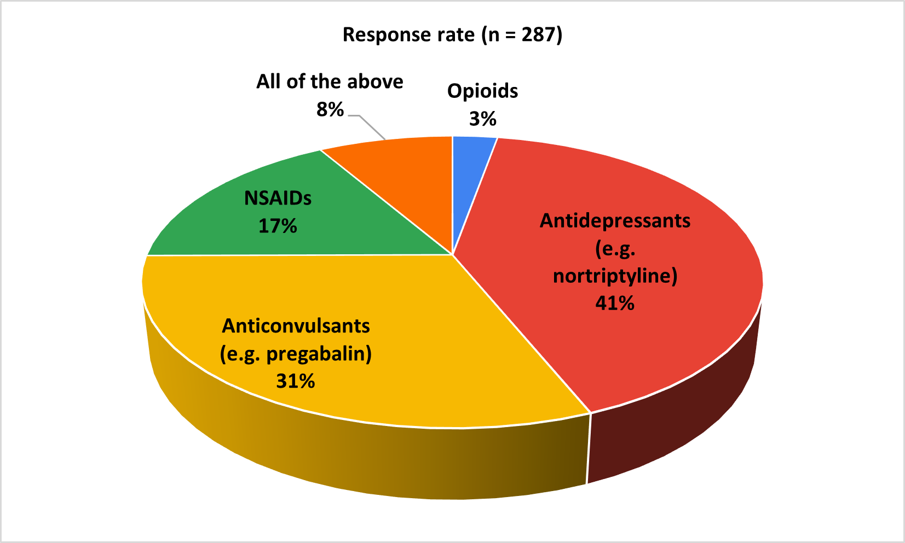
Fig. 1: Distribution of responses to the preferred first-line pharmacotherapy for managing neuropathic pain

About 61% of the participants reported that they prescribe pregabalin frequently for neuropathic pain compared to other medications (Fig. 2). Approximately 40% of clinicians reported observing improvements within the first two weeks of pregabalin use, while an equal proportion (40.42%) noted benefits within two to four weeks.

As reported by 50% of respondents, dizziness is the most commonly observed side effect in patients receiving pregabalin for neuropathic pain. In cases of an inadequate response to pregabalin monotherapy, 38% of respondents preferred combining pregabalin with a TCA, while 32% opted for titration of the pregabalin dose. According to 81% of experts, nortriptyline is the most commonly prescribed medication in combination with pregabalin for neuropathic pain (Fig. 3).

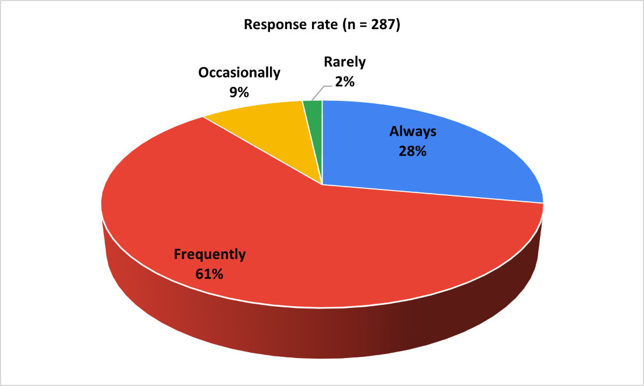
Fig. 2: Distribution of responses to the frequency of pregabalin prescription for neuropathic pain among clinicians

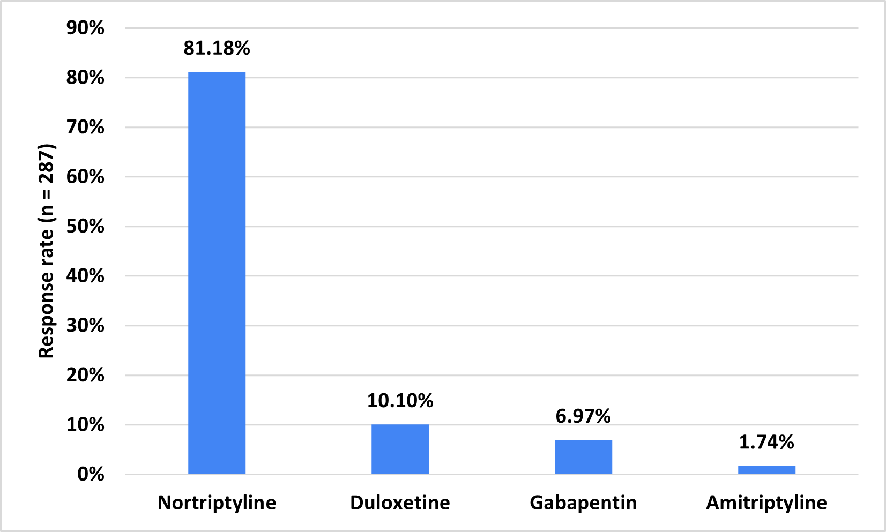
Fig. 3: Distribution of responses to the most commonly prescribed drug in combination with pregabalin for neuropathic pain

The majority of clinicians (65.16%) agreed that the combination of pregabalin with nortriptyline is significantly effective in treating neuropathic pain (Fig. 4). Approximately 57% stated that this combination is frequently prescribed in routine settings for treating neuropathic pain. The majority of experts (53.66%) expected improvement in neuropathic pain symptoms within 2 to 3 weeks of starting pregabalin with nortriptyline.

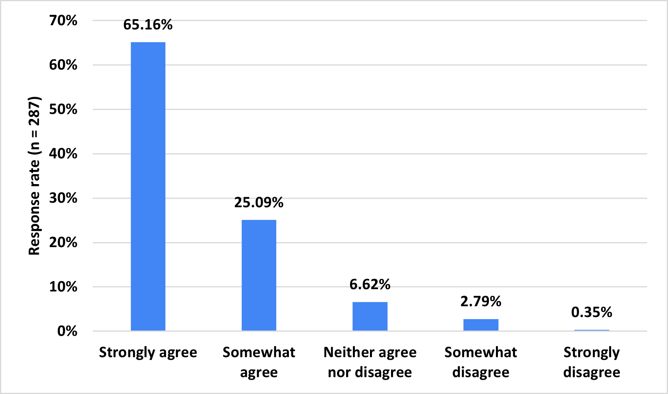
Fig. 4: Distribution of responses to the clinician’s agreement on the efficacy of pregabalin-nortriptyline combination for neuropathic pain

As indicated by 43% of respondents, enhanced pain relief is the primary reason for prescribing a combination of pregabalin and nortriptyline for neuropathic pain. About 52% of clinicians reported that this combination is much more effective than monotherapy (Table 1). According to 52% of participants, approximately 51% to 75% of patients on combination therapy with pregabalin and nortriptyline reported significant improvement in pain management.

Table 1. Distribution of responses to the clinicians' perception on the effectiveness of pregabalin and nortriptyline combination therapy compared to monotherapy for neuropathic pain
Effectiveness | Response rate (n = 287)
Much more effective | 51.92%
Moderately more effective | 36.93%
Slightly more effective | 9.76%
Not more effective | 1.05%
Not attempted | 0.35%

The majority of participants (42.51%) identified patients with severe neuropathic pain unresponsive to monotherapy as the group most likely to benefit from a combination of pregabalin and nortriptyline, while 37% of clinicians indicated that this combination is particularly beneficial for patients with coexisting anxiety and depression (Table 2). Approximately 57% stated that they frequently follow established guidelines (e.g., NICE, IASP) for managing neuropathic pain. About 38% of clinicians reported that they sometimes recommend the addition of non-pharmacological treatments in managing neuropathic pain.

As stated by 64% of participants, patients' reluctance to take medications is the most frequently encountered barrier when treating neuropathic pain. Approximately 33% of respondents reported that the most common approach to evaluating the impact of neuropathic pain on a patient’s quality of life is assessing functional outcomes such as the ability to work and sleep, while 31% of clinicians relied on patient self-reports during consultations.

Table 2: Distribution of responses to the clinicians’ perspectives on patient groups most likely to benefit from pregabalin and nortriptyline combination therapy
Patients group | Response rate (n = 287)
Patients with severe neuropathic pain unresponsive to monotherapy | 42.51%
Patients with coexisting anxiety and depression | 36.59%
Elderly patients with multiple comorbidities | 11.85%
Patients with a history of poor tolerance to other medications | 8.71%
Not attempted | 0.35%

4. discussion

The study findings provide valuable insights into the combination therapy of pregabalin and nortriptyline for the management of neuropathic pain in routine Indian settings. The results indicate that antidepressants, such as nortriptyline, are commonly preferred as first-line pharmacotherapy for managing neuropathic pain. In line with this finding, Dworkin et al. recommended tricyclic antidepressants (TCAs), including nortriptyline, as a first-line treatment for neuropathic pain [15]. Additionally, Fornasari emphasized that antidepressants have historically been among the earliest medications used in this context [16].
A significant proportion of clinicians in our survey reported prescribing pregabalin frequently, reflecting its established role in neuropathic pain. Pregabalin has consistently demonstrated efficacy and tolerability in randomized clinical trials and real-world studies [17–19]. In the present study, dizziness was identified as the most common side effect, consistent with previously reported safety profiles [19].
Importantly, our findings highlight that nortriptyline was the most common agent prescribed in combination with pregabalin. The preference for this combination can be understood through its complementary pharmacological actions. Neuropathic pain involves both peripheral and central sensitization, as well as deficient descending inhibition. Pregabalin, by binding to the α2-δ subunit of voltage-gated calcium channels, reduces excitatory neurotransmitter release (e.g., glutamate, substance P), thereby dampening neuronal hyperexcitability at the spinal and peripheral levels [3,7]. Nortriptyline, by inhibiting serotonin and norepinephrine reuptake, enhances descending inhibitory pathways, while also exhibiting sodium-channel blocking activity, which further contributes to stabilizing neuronal membranes [9,10,25].
When used together, pregabalin and nortriptyline act synergistically by targeting different aspects of the pain pathway: pregabalin reduces abnormal excitatory input, whereas nortriptyline strengthens inhibitory control. This dual action results in more comprehensive pain modulation, explaining the enhanced efficacy observed in our survey and previous clinical trials [11,12,20,21]. From a practical perspective, the combination allows for the use of lower individual doses, thereby minimizing dose-related adverse effects such as pregabalin-induced dizziness or nortriptyline-related anticholinergic effects [11,22].
The preference for pregabalin over nortriptyline as monotherapy, as reported by many clinicians, may be explained by its FDA approval for neuropathic pain, faster onset of analgesic effect (often within 2–4 weeks), and generally favorable tolerability profile compared to TCAs [17–19]. However, in cases of inadequate response, the addition of nortriptyline provides a rational strategy, particularly in patients with severe pain or comorbid anxiety and depression, where nortriptyline’s antidepressant effect offers added benefit [20,23].
Our findings align with earlier studies supporting this combination. Giri et al. reported improved pain relief and tolerability with pregabalin–nortriptyline in diabetic peripheral neuropathy [12]. Das et al. found superior outcomes with the combination compared to pregabalin monotherapy [20]. Holbech et al. and Bansod et al. further demonstrated the clinical preference and effectiveness of this dual regimen [11,21]. These results are supported by meta-analyses indicating that gabapentinoid–antidepressant combinations provide enhanced pain control compared to single agents [22–24].
The present study identified patients with severe neuropathic pain unresponsive to monotherapy as the group most likely to benefit, consistent with recommendations by Boccella et al. and Holbech et al., who noted that combination therapy is particularly effective for refractory cases or where tolerability limits higher doses of single drugs [11,25].
The key strengths of the study include its large sample size and the use of a well-structured, validated questionnaire to gather data from clinicians. However, certain limitations must be acknowledged. The reliance on expert opinion introduces potential bias, as varying perspectives and preferences may influence the results. Additionally, the survey may not fully capture emerging evidence or evolving trends in neuropathic pain management. A notable limitation is the limited availability of extensive literature specifically addressing the combination of pregabalin and nortriptyline for neuropathic pain treatment. These limitations should be considered when interpreting the findings. To address them, future prospective trials or real-world observational studies are recommended to validate the survey results and provide a more comprehensive understanding of optimal treatment strategies.
5. Conclusion

The study highlights the significant burden of neuropathic pain, with diabetes mellitus as a leading cause. Pregabalin, commonly used as a first-line agent, showed early treatment benefits. The combination of pregabalin with nortriptyline is preferred for severe or refractory cases and patients with anxiety or depression. Despite guideline adherence, poor patient compliance and underuse of non-pharmacological strategies remain key challenges.

Ethical Approval:

This study was performed after obtaining approval from Bangalore Ethics, an Independent Ethics Committee, which was recognized by the Indian Regulatory Authority, the Drug Controller General of India.

COMPETING INTERESTS DISCLAIMER:
Authors have declared that they have no known competing financial interests OR non-financial interests OR personal relationships that could have appeared to influence the work reported in this paper.

Disclaimer (Artificial intelligence)
Author(s) hereby declare that NO generative AI technologies such as Large Language Models (ChatGPT, COPILOT, etc.) and text-to-image generators have been used during the writing or editing of this manuscript.

References

- Chong S. NICE neuropathic pain guidelines: clarity for initial treatment. Prescriber. 2014;25(6):8–10.
- Sharma H, Rani T, Khan S. An insight into neuropathic pain: A systemic and up-to-date review. Int J Pharm Sci Res. 2023;14(2):607-21.
- Raju N, Villavan S, Ravi S, Murugesan R, Theivendren P, Jaganathan V, et al. Clinical effectiveness and treatment satisfaction between two triple-therapy regimens in treating neuropathic pain: A real-world data. Ibrain. 2023;1‐14.
- Reynolds EL, Callaghan BC, Banerjee M, Feldman EL, Viswanathan V. The metabolic drivers of neuropathy in India. J Diabetes Complications. 2020 Oct;34(10):107653.
- Treede RD, Jensen TS, Campbell JN, Cruccu G, Dostrovsky JO, Griffin JW, et al. Neuropathic pain: redefinition and a grading system for clinical and research purposes. Neurology. 2008 Apr 29;70(18):1630–5.
- Finnerup NB, Attal N, Haroutounian S, McNicol E, Baron R, Dworkin RH, et al. Pharmacotherapy for neuropathic pain in adults: a systematic review and meta-analysis. Lancet Neurol. 2015 Feb;14(2):162–73.
- Cavalli E, Mammana S, Nicoletti F, Bramanti P, Mazzon E. The neuropathic pain: An overview of the current treatment and future therapeutic approaches. Int J Immunopathol Pharmacol. 2019 Mar 22;33:2058738419838383.
- Bates D, Schultheis BC, Hanes MC, Jolly SM, Chakravarthy KV, Deer TR, et al. A Comprehensive Algorithm for Management of Neuropathic Pain. Pain Med. 2019 Jun;20(Suppl 1):S2–12.
- Derry S, Wiffen PJ, Aldington D, Moore RA. Nortriptyline for neuropathic pain in adults. Cochrane Database Syst Rev. 2015 Jan 8;2015(1):CD011209.
- Maladkar MN, Tekchandani CM, Bajaj RK. A step closer in the management of uncontrolled neuropathic pain: gabapentin-nortriptyline combination. International Journal of Research in Orthopaedics. 2020 Oct 22;6(6):1365–70.
- Holbech JV, Jung A, Jonsson T, Wanning M, Bredahl C, Bach FW. Combination treatment of neuropathic pain: Danish expert recommendations based on a Delphi process. J Pain Res. 2017 Jun 26;10:1467–75.
- Efficacy and Tolerability of a Fixed Dose Combination of Pregabalin and Nortriptyline in the Management of Diabetic Peripheral Neuropathy among Indian Population. Indian Journal of Neurology. 2023 Dec 24;4(1):1–5.
- Verma V, Singh N, Singh Jaggi A. Pregabalin in Neuropathic Pain: Evidences and Possible Mechanisms. Curr Neuropharmacol. 2014 Jan;12(1):44–56.
- Merwar G, Gibbons JR, Hosseini SA, Saadabadi A. Nortriptyline. In: StatPearls [Internet]. Treasure Island (FL): StatPearls Publishing; 2025 [cited 2025 Mar 27]. Available from: http://www.ncbi.nlm.nih.gov/books/NBK482214/
- Dworkin RH, Backonja M, Rowbotham MC, Allen RR, Argoff CR, Bennett GJ, et al. Advances in neuropathic pain: diagnosis, mechanisms, and treatment recommendations. Arch Neurol. 2003;60(11):1524–34.
- Fornasari D. Pharmacotherapy for neuropathic pain: a review. Pain Ther. 2017;6(Suppl 1):25–33.
- Freynhagen R, Serpell M, Emir B, Whalen E, Parsons B. Time to onset of neuropathic pain reduction: a retrospective analysis of data from nine randomized, placebo-controlled clinical trials of pregabalin. Pain Med. 2013;14(3):350–9.
- Roy S, Dureja GP, Das P, Jain PN, Shetty N, Thomas J. Patterns of prescription of neuropathic pain drugs in tertiary care centers of India: a cross-sectional study. Indian J Pain. 2019;33(1):42–6.
- Derry S, Bell RF, Straube S, Wiffen PJ, Aldington D, Moore RA. Pregabalin for neuropathic pain in adults. Cochrane Database Syst Rev. 2019;1:CD007076.
- Das S, Chakraborty S, Bhattacharyya S, Mitra K, Ghosh S. Efficacy of combination of pregabalin and nortriptyline in comparison to pregabalin monotherapy in painful diabetic neuropathy: a randomized controlled trial. Indian J Pharmacol. 2014;46(3):236–40.
- Bansod S, Rai P, Phatak A, Joshi S, Akarte N. Evaluation of efficacy and safety of fixed dose combination of pregabalin and nortriptyline in patients with neuropathic pain: an observational study. J Clin Diagn Res. 2017;11(4):FC05–FC08.
- Khajuria V, Gupta S, Madan M, Razdan R. Comparative evaluation of pregabalin and amitriptyline in neuropathic pain. J Clin Diagn Res. 2014;8(9):HC01–HC03.
- Navarro A, Bär KJ, Finnerup NB. Combining antidepressants and anticonvulsants for neuropathic pain: a review of clinical evidence. Eur J Pain. 2019;23(7):1183–95.
- Marielle E, Wiffen PJ, Moore RA. Combination pharmacotherapy for neuropathic pain in adults. Cochrane Database Syst Rev. 2012;(11):CD008943.
- Boccella S, Guida F, Palazzo E, Marabese I, de Novellis V, Maione S. Neuropathic pain models and their role in the study of pregabalin–nortriptyline combination therapy: translational insights. Pharmacol Res. 2019;142:142–50.

