Stratigraphic Interpretation Using Seismic Reflection and Well Log Data of ‘OGEY’ Field, Niger Delta, Nigeria
ABSTRACT
The stratigraphic interpretation of ‘OGEY’ Field, deep offshore Niger Delta, Nigeria was carried out with a view of correlating the subsurface facies and deducing the environments of deposition of the field. This was done by using the concept of sequence and seismic stratigraphy. The data available and used for this study include digital 3-D seismic, well logs, biostratigraphic information and check shot data. Lithological identification was done with the aim of differentiating the shale and sandstone lithological units. This process was carried out using the gamma ray and resistivity logs.
The reservoir sands were correlated across the wells after defining the reservoir's depositional environment to monitor their lateral continuity and probable structures within the well coverage area. The well log data was also tied with seismic sections for accurate geologic interpretation. Seismic facies analysis was done by combining the geometric information with the seismic attributes. The lithologies identified are sand, sandy shale and shale, respectively. The sequence boundaries identified were dated 20.4Ma, 17.7Ma, 15.50Ma, 12.10Ma and 10.35Ma while the Maximum Flooding surfaces were dated 19.4Ma, 15.9Ma, 12.80Ma, 10.4Ma, and 9.6Ma respectively. The result revealed three system tracts, which are LST, TST and HST, which indicated five depositional sequences. Four seismic sequences were observed in this field and they are SF1, SF2, SF3, and SF4. The environment of deposition for the field is deep offshore with depositional units ranging from turbidite sand to sheet sands, channel levee and overbank complex, canyon fills and mass transport deposits. The study concluded that the stratigraphic features of the field could be used to reevaluate the prospects and improve the production.
Keywords: seismic attributes, facies analysis, depositional environment, sequence stratigraphy, depositional unit, seismic facies

- INTRODUCTION
Stratigraphy is well known as the science of the layers characteristics of rocks (Davies, 2007). “Seismic stratigraphy uses seismic reflection patterns to identify depositional sequences to predict the lithology of seismic facies by interpreting depositional processes and environmental settings, and to analyse relative changes in sea level as recorded in the stratigraphic records” (Mitchum, 1977). “The use of seismic stratigraphy for identifying exploration targets has been the focus of several studies” (Galloway, 1975; Brown and Fisher 1977; Mitchum 1977; Payton 1977, Armentrout and Perkins, 1991; Miall, 1991; Posamentier and George, 1994; Galloway 1998; Davies 2004; Catuneanu 2006). “These studies have shown that seismic stratigraphic principles can help to improve seismic interpretations. Stratigraphic interpretations, such as geologic time correlations, the definition of genetic depositional units, and thickness and depositional environment of genetic units can be achieved using seismic stratigraphy” (Mitchum et al., 1977; Catuneanu, 2006; Adeleye et al., 2020). “Generally, application of seismic stratigraphic techniques has become an important component of standard seismic interpretation workflows. The method has continued to enhance the identification of well drilling opportunities with reduced risks and uncertainties in business decisions, especially in areas under well control. Also, as exploration continues to move into frontier regions and into deeper parts of sedimentary basins where well control is limited or lacking, fundamental to delineating drilling targets is interpreting stratigraphy, sedimentary facies and geologic history from seismic reflection data” (Galloway, 1976; Cross and Lessenger, 1988; Paumard, 2019; Cawthra, 2020; Adeleye et al., 2020). Seismic reflection profiles form an important source of data for the interpretation of subsurface stratigraphy and depositional systems (Jurado and Comas, 1992; Sarhan et al., 2017). (Veeken, 2007) reported that “four major groups of systematic reflections are distinguished on seismic sections: sedimentary reflections representing bedding planes; unconformities or discontinuities in the geological record; artefacts like diffractions and multiples; and non-sedimentary reflections like fault planes and fluid contacts. One of the standard operations in seismic interpretation for hydrocarbon exploration is the ability to identify and distinguish the various subsurface features that fall under these aforementioned categories from the seismic data. These features are subsequently evaluated for their possible implications for hydrocarbon accumulations, if any, in the area of interest. Generally, to delineate geological features and potential areas of commercial oil and gas accumulations, the seismic reflection data must be interpreted in a geologically meaningful manner using various interpretation techniques, one of which is seismic stratigraphy”.
- GEOLOGY OF THE STUDY AREA
“The Niger Delta is located at the southern part of a major series of rifts extending from what is now the Atlantic Ocean to the modern Mediterranean and hosts the largest petroleum providence of Africa (Fig. 1). These rifts are of cretaceous age and at one time allowed a continuous seaway to extend across the continent” (Selley and Van der Spuy, 2016). “The Niger Delta Basin is located within the perioceanic section of the Abakaliki–Benue suture zone of the much larger southern Nigerian basin. On the west, it is separated from the Dahomey (or Benin) basin by the Okitipupa basement high, and on the east it is bounded by the Cameroun volcanic line. Its northern margin transects several older tectonic elements the Anambra basin, Abakaliki uplift, Afikpo syncline and Calabar Flank” (Nwaezeapu et al, 2018). “The Niger Delta is the youngest sedimentary basin within the Benue Trough system” (Emujakporue et al., 2009). The Niger and Benue Rivers are the main suppliers of sediments.
The Cenozoic section of the Niger Delta is divided into three formations, which include Akata, Agbada and Benin Formation, representing prograding depositional environments (Short and Stauble, 1967). The delta is 75000 km² in size and reaches a maximum of 12km in the centre of the basin (Whiteman, 1982). The basal Akata Formation, which is predominantly marine prodelta shale is overlain by the paralic sand/shale sequence of the Agbada Formation. The topmost section is the continental upper deltaic plain sands known as the Benin Formation. All the hydrocarbon accumulations in the Niger Delta occur in the sands and sandstones of Agbada Formation where they are trapped by rollover anticlines (Ekweozor and Dankoru, 1994; Michele et al., 1999; Uko, 1996). Akata Formation is about 6400 m thick at the center of the clastic wedge; the lithologies include dark gray shale and silts, having streaks of sand whose origin could be from turbidite flow. This Akata Formation grades vertically into the Agbada Formation with abundant plant remains and micas in the transition zone (Doust and Omatsola 1990; Fig. 2). The age of this formation ranges from Miocene to recent.

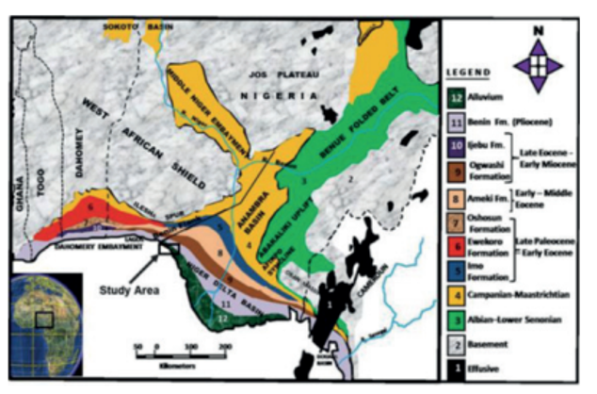
Fig. 1. Geological Map of Nigeria showing the Location of the Study Area (Niger Delta) (modified after Murat, 1972)
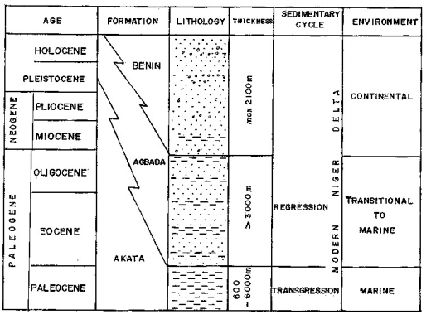
Fig. 2. Generalized Lithostratigraphy of Niger Delta (Nwangwu, 1990)

While Agbada Formation extends throughout Niger Delta clastic wedge and has a maximum thickness of about 3962 m. The lithology of this formation includes alternating sands, silts and shales. Strata in the Agbada Formation are believed to have been produced in fluvial–deltaic environment. Agbada Formation ranges from Eocene to recent (Sanuade et al, 2017). Benin Formation is the top of the clastic wedge of Niger Delta. The top of this Formation consists of the recent subaerially exposed delta top surface. The shallow part of Benin Formation is made up of non-marine sands that were deposited in either the upper coastal plain or alluvial depositional environments (Doust and Omatsola, 1990). Benin Formation ranges from Paleocene to recent (Short and Stauble, 1967).
The Niger Delta Depobelts represent successive phases of delta growth. They are composed of bands of sediments about 30–60 km wide with lengths of up to 300 km, (Stacher, 1995). They form when paths of sediment supply are restricted by structural deformation, focusing sediment accumulation into restricted areas on the delta. Depobelts can eventually change location when local accommodation gets filled and the locus of deposition will shift basinward (Doust and Omatsola, 1990).
- MATERIALS AND METHODS
The data available and used for this study include digital 3-D seismic data, well logs data and well header, biostratigraphic data and check shot data. The base map of OGEY field (Fig. 3) reveals certain information about the field, including the location of shot points, the location of wells within the field and the coordinates of field boarders with the locations of the four wells(OGEY 1, OGEY 2, OGEY 3 and OGEY 4) used for this study.
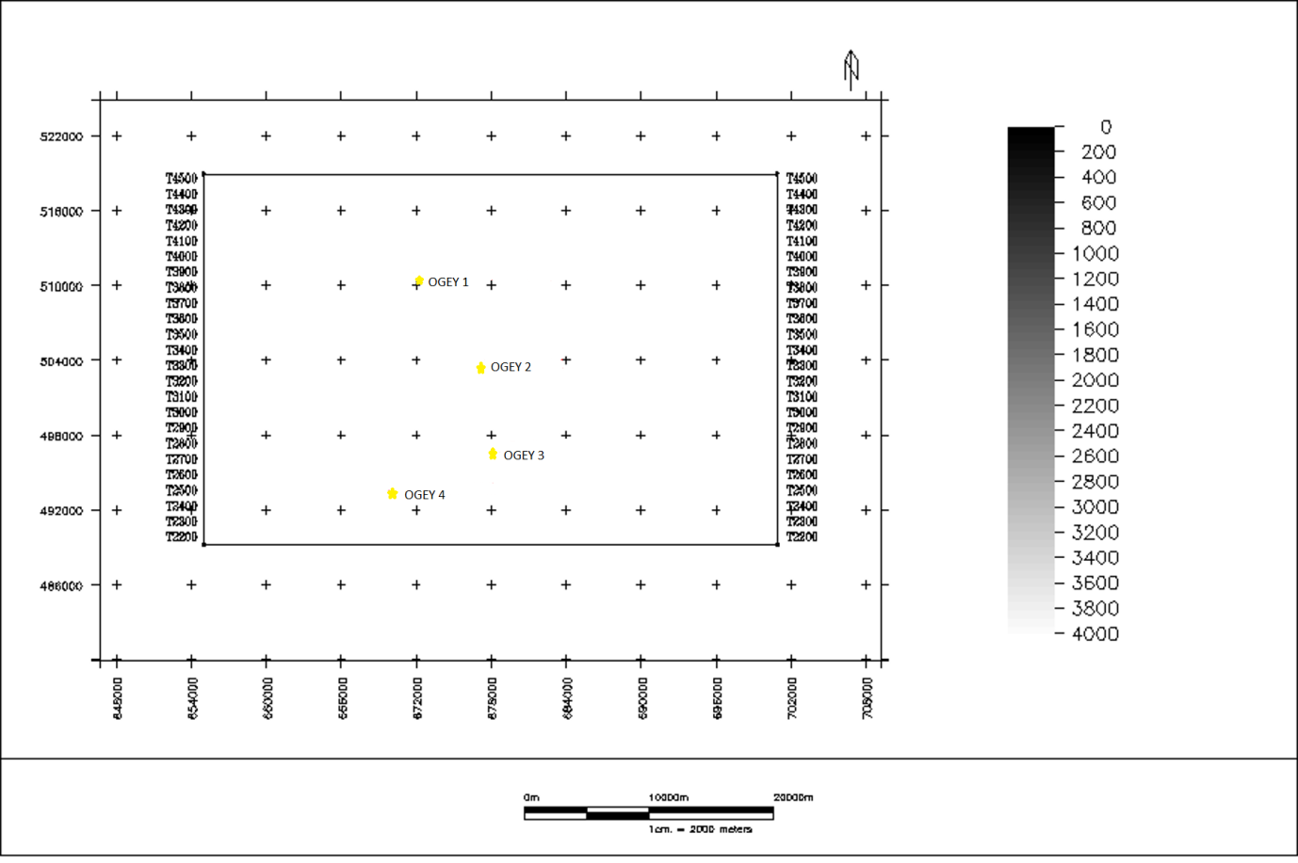
Fig. 3. Base map of OGEY Field.

The Post-stacked 3D seismic data (SEG-Y format). Each seismic section is displayed with a linear scale of two-way travel times in milli-seconds which increases downward. The horizontal axis is distance (km). Table 1 shows the summary of the well log data sets from four wells. It was used for the identification of geologic formations, fluids, correlation between wells, facies relationships and depositional environment of sediment. The well log data was also correlated with seismic sections for accurate geologic interpretation. The Biostratigraphic data was available for OGEY 1 well (Table 1). It was used to validate sequence stratigraphic interpretation from both seismic sections and wireline logs. Also, the Checkshot survey information was available for the four wells (Table 1). It was used to generate time-depth plots for the various checkshots. The time-depth plots were used for the seismic to well ties to enhance structural and stratigraphic interpretation.
Table 1. Summary of Logs and Biofacies data present in the wells.
LOG/WELLS | OGEY 1 | OGEY 2 | OGEY 3 | OGEY 4
Caliper | X | X | x | X
Gamma Ray | • | • | • | •
Deep Resisitivity | • | • | • | •
Density | • | • | • | •
Neutron | • | • | • | •
Sonic | • | • | • | •
Checkshot | • | • | • | •
Biostratigraphic data | • | X | x | X
• | Available
x | Not available
Key

The methodology workflow that was adopted for this research work starts from the data analysis and interpretation, which includes data loading and quality control, chronostratigraphic correlation, well log interpretation, seismic to well tie, seismic data interpretation and environment of sediment deposition definition then finally stratigraphic interpretation. Lithological identification was done with the aim of differentiating the shale and sandstone lithological units. This process was carried out using a gamma ray log. The guiding principle used is by considering the response of the gamma ray log to radioactive elements. Shales generally have a higher proportion of radioactive elements when compared to sandstone. In well logging, properties of the formation drilled are measured, such as lithology, porosity and resistivity of the formation, amongst others. They are normally arranged according to triple Combo logs such that they into three different tracks representing lithology, resistivity and porosity. Gamma ray and deep resistivity logs were principally used for the delineation of hydrocarbon and water-bearing zones. The resistivity log is set at a logarithm scale of 0.2 – 2000 ohm-meters. At reservoir zones, gamma ray response is expected to be low, and the resistivity is expected to be high since hydrocarbons are highly resistive. This was employed for the qualitative delineation of hydrocarbon-bearing sand intervals. The reservoir sands were later correlated across the wells after defining the reservoirs depositional environment to monitor their lateral continuity and probable structures within the well coverage area. Sequence stratigraphic interpretation was established by integrating lithofacies and well log data. Sequence stratigraphy interpretation was carried out using the data sets available (i.e. biofacies, well logs and seismic data). The Epoch and the ages of the key surfaces from biofacies data was then determined by corresponding the bio-zones information with the SPDC Niger Delta chronostratigraphic chart (Fig. 4) defined by Armentrout, (1987), Armentrout and Clement (1991), Stacher. (1995). The stratigraphic markers identified through interpretation of biofacies is imported into petrel and then integrated into the well section as well top markers, based on the information obtained from the biofacies data. The system tracts (HST, LST, and TST) were identified on the biofacies data based on their depositional setting with their respective depth values. Then it’s correlated with well log signature building sequence based on the distinctive characteristics of parasequences stacking pattern. They include: the maximum flooding surfaces (MFS) and the sequence boundary (SB). The maximum flooding surfaces correspond to where there is an abundance of fauna deposition, while the sequence boundary corresponds to where there is low deposition. One the well logs regions with MFS should also have high radioactive readings on the gamma ray log, coupled with high density readings. SB should show evidence of erosion or truncations on well logs. For a more detailed stratigraphic work, a seismic sequence analysis was done. The result of the seismic sequence analysis is compared to that obtained from well logs and biofacies data, both information were integrated to get more detailed stratigraphic information. A well tie is used in generating a synthetic, which is compared with the original seismic to properly tie well top markers to a particular event on the seismic profile. This involves using the sonic log (when inverted, yields velocity) and density log to generate an acoustic impedance log, a reflection coefficient series is then generated from each of the acoustic impedance boundary using the zero offset reflectivity formula. The synthetic seismogram (fig. 5) was generated by the convolution of the reflection coefficient of each lithological unit with a Ricker wavelet containing a frequency of 30Hz which is within the frequency range of the base seismic data. It was observed that at this frequency, the 3-D base seismic data was at zero- phase. At the zero-phase wavelet, the maximum amplitude coincides with the spike of the reflector and the pattern of the wavelet becomes symmetrical. From the seismic-well tie, it was also observed that there was a perfect match between the seismic and the synthetic seismogram.
KEY
AVAILABLE
NOT AVAILABLE
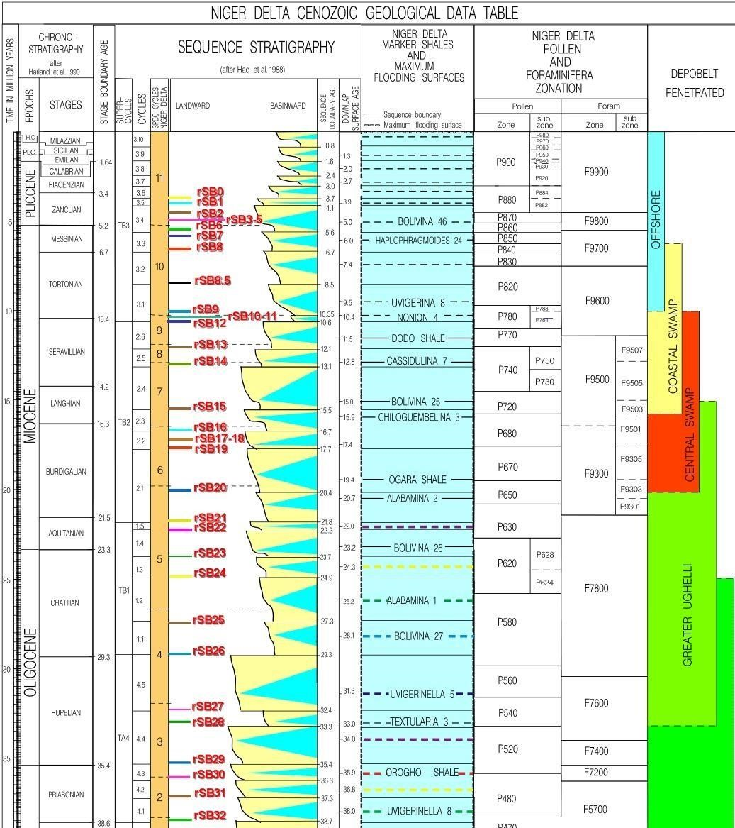

Fig. 4. SPDC Chronostratigraphic Chart of Niger-Delta (Emery and Myers1996).

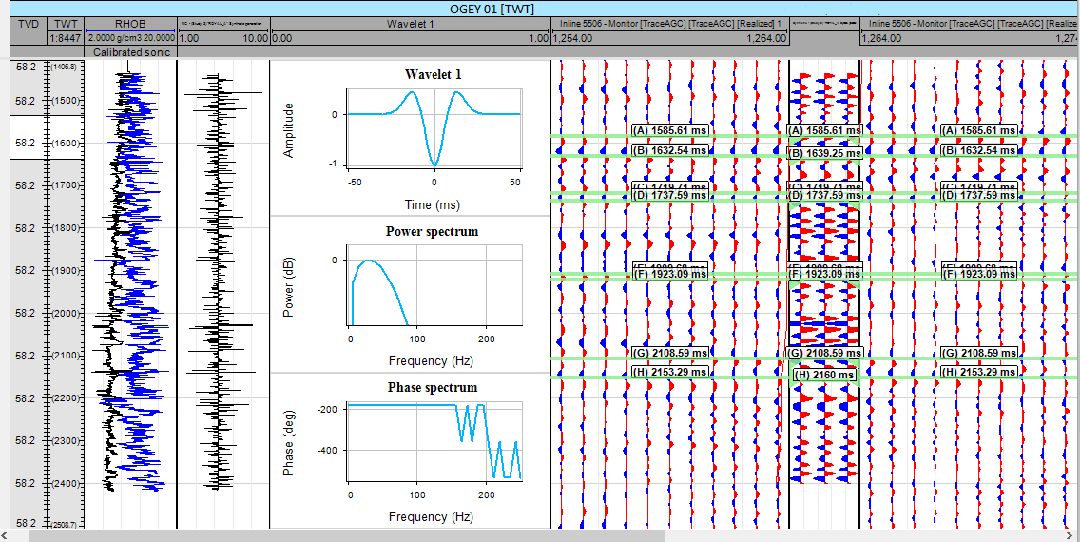
Fig. 5. Synthetic Seismogram generated from the convolution of the reflectivity series and a wavelet.

The log motive approach was used in establishing the sedimentary facies, their successions and environmnets of deposition in this field. This was based on the fact that mechanism of sediment depostion varies from one depostion setting to the other (Asqith and Gibson 1982, Wagoner et al., 1990). This results to difference on vertical facies succession. Log signature may be associated with wide range of depositional environments.
The facies is the sum of characteristics of a rock, including its chemical, physical and biological features that distinguishes it from adjacent rock. Seismic facies are therefore defined as seimically defined bodies that exhibit similar patterns, attributes and reflection. A seismic facies unit is a mapped, three-dimensional seismic unit. There are four major types of features used to define separate facies unit which are; Seismic amplitude, Reflection geometry. Reflection continuity and Wavelet frequency.

- RESULTS AND DISCUSSION
The lithology identified within the field is sand, sandy shale and shale respectively. The sequence boundaries identified were dated 20.4Ma, 17.7Ma, 15.50Ma, 12.10Ma and 10.35Ma while the Maximum Flooding surfaces were dated 19.4Ma, 15.9Ma, 12.80Ma, 10.4Ma, and 9.6Ma respectively. The result revealed three system tracts which are LST, TST and HST, which indicated five depositional sequences (Fig. 6). Four seismic sequences were observed in this field and they are SF1, SF2, SF3, and SF4. The first Maximum Flooding Surface recognized in the OGEY 01 well was dated 19.4Ma at a depth of 10800ft characterised by the Ogara shale marker on the chronostratigraphic chart. The 20.4Ma SB, 19.4 Ma MFS and 17.7Ma SB occurred within the SPDC foram F9300 zone. The second Maximum Flooding Surface was dated 15.9Ma characterised by the Chiloguembelina 3 shale at a depth of 10050ft, the third Maximum Flooding Surface was dated 12.80Ma characterised by the Casidulina 7 at a depth of 9450ft. The 15.9Ma MFS, 15.5Ma SB, 12.80Ma MFS and 12.1Ma SB are within the F9500 zone. The F9300 zone to F9500 zone indicates that sediments are within the middle Miocene Epoch (Table 2). The fourth Maximum Flooding Surface was dated 10.4Ma characterised by Nonion 4 shale marker at a depth of 8370ft and the fifth Maximum Flooding Surface was dated 9.6Ma characterised by the Uvigerina 8 shale marker at a depth of 7370ft. The 10.4Ma MFS, 10.35Ma SB, and 9.6Ma MFS are defined in the F9600 Zone, indicating Late Miocene Epoch. For the paleoenvironment interpretation, it is observed that there is a high proportion of shale (90%) over the well section is indicative of dominance of low-energy depositional conditions. The lower part of the well section (11330 – 7890ft) is dominated by rich and diverse deep-water calcareous benthics. Since the abundance of calcareous foraminifera is indicative of lower bathyal environments and the abundance of arenaceous foraminifera is indicative of upper bathyal environments, the analysis of the data shows that the above foraminiferal association is indicative of sediment deposition in a lower to upper Bathyal environment.
Table 2. Summary of Biostratigraphic studies, showing determined key surfaces, depth of occurrence, foram zones and their Epoch
KEY SURFACES  AGE | MD  (FT) | F-Z0NE | EPOCH
9.6Ma MFS | 7370 | F-9600 | LATE MIOCENE
10.35Ma SB | 8156 | F-9600 | LATE MIOCENE
10.4Ma MFS | 8370 | F-9600 | LATE MIOCENE
12.10Ma SB | 9300 | F-9500 | MIDDLE MIOCENE
12.80Ma MFS | 9450 | F-9500 | MIDDLE MIOCENE
15.50Ma SB | 9970 | F-9500 | MIDDLE MIOCENE
15.9Ma MFS | 10050 | F-9500 | MIDDLE MIOCENE
17.7Ma SB | 10330 | F-9300 | MIDDLE MIOCENE
19.4 Ma MFS | 10800 | F-9300 | MIDDLE MIOCENE
20.4Ma SB | 11310 | F-9300 | MIDDLE MIOCENE
.

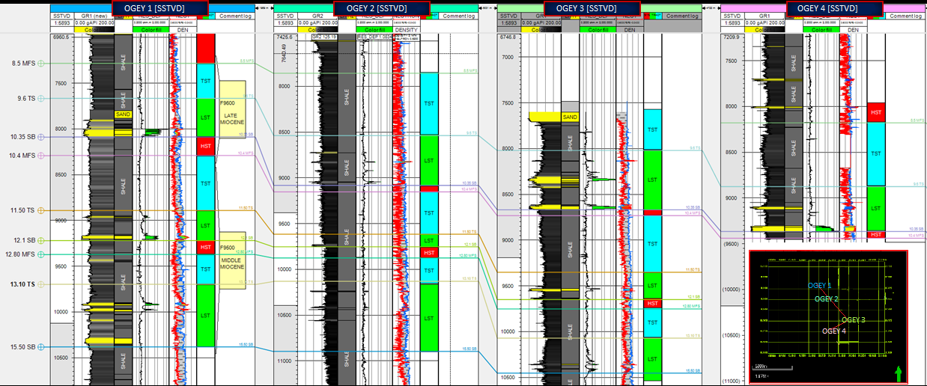
Fig. 6. Depositional Sequences of ‘OGEY’ Field Interpreted on Wireline Log and Correlation Supported with Biostratigraphic Information

4.1 Seismic Interpretation
The 3-D Seismic Interpretation approach, when integrated with the well logs by comparing marker beds or other correlation points picked on well logs with major reflections on the seismic section, can improve the interpretations of the data laterally and vertically. This section describes results from seismic-to-well tie, fault mapping, horizon mapping and time-depth conversion as shown in Figs. 7-9.
4.2 Seismic Sequence Analysis and Facies Unit
Four major sequences (Fig. 10a and 10b) were observed in this field by analyses the reflection terminations (amplitude, continuity, toplap, and truncation) and observation of seismic parameters (amplitude, continuity, configuration and frequency) and external geometries (tabular, lenticular, mounded and wedge.), each of these seismic sequences is then further sub-divided into two seismic facies after analyzing the characteristics. Brief description of each of them are provided below: Seismic Sequence 1: This interval is the bottom part of the seismic data (Fig. 10a) to a range of about -3252 milliseconds (i.e., from the bottom part to the blue line on Fig. 10a, it is also represented on Fig. 10b from the bottom to the brown line), this is controlled by post deformations as a result of mobile shale diapirism. Reflection in this sequence displays parallel internal configurations being concordant to the sequence boundaries. This sort of configuration indicates unique form sedimentation conditions for an infill or a sequence on top of subsidising substraction (Veeken et al., 2006).

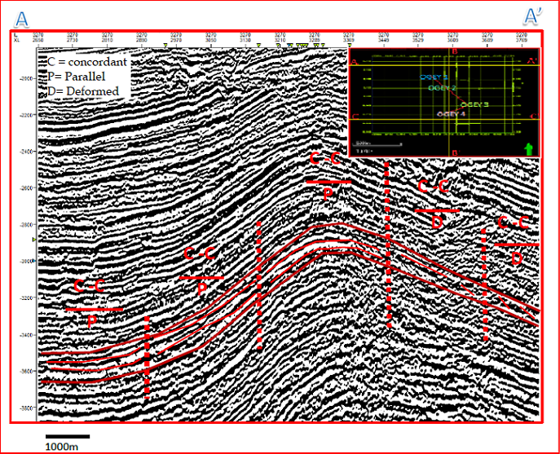Fig. 7. Geometric Capturing Approximately along West to East (A to A’) of ‘OGEY’ Field on inline 3270
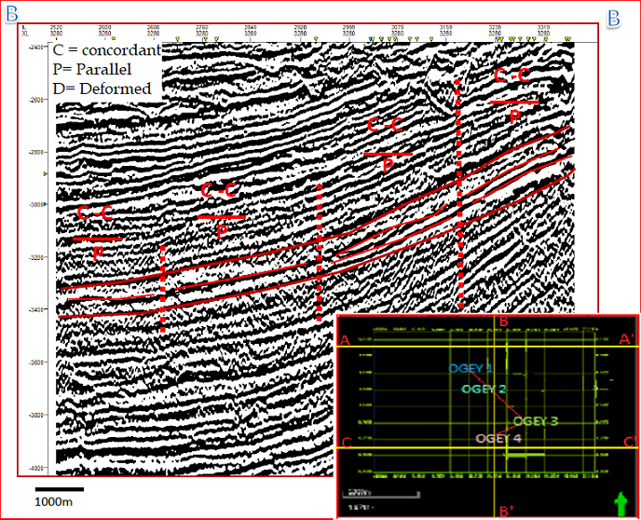
Fig. 8. Geometric Capturing Approximately along North to South (B to B’) OF ‘OGEY’ Field on Crossline 3280
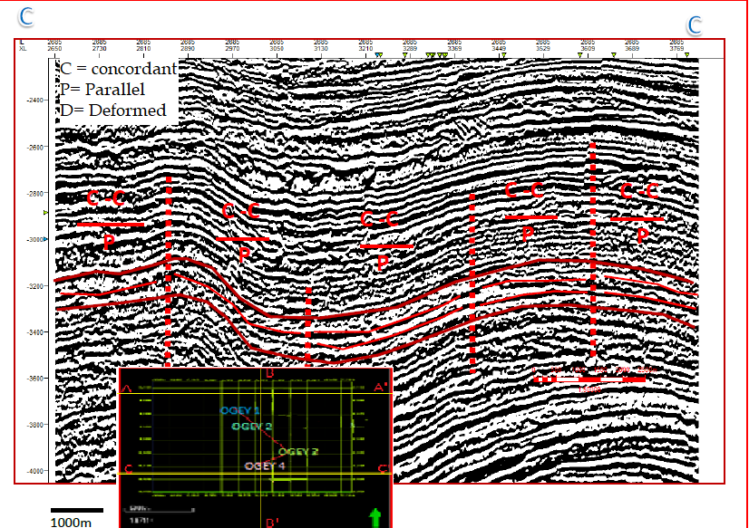
Fig. 9. Geometric Capturing Approximately along West to East (C to C’) of ‘OGEY’ Field on inline 2665

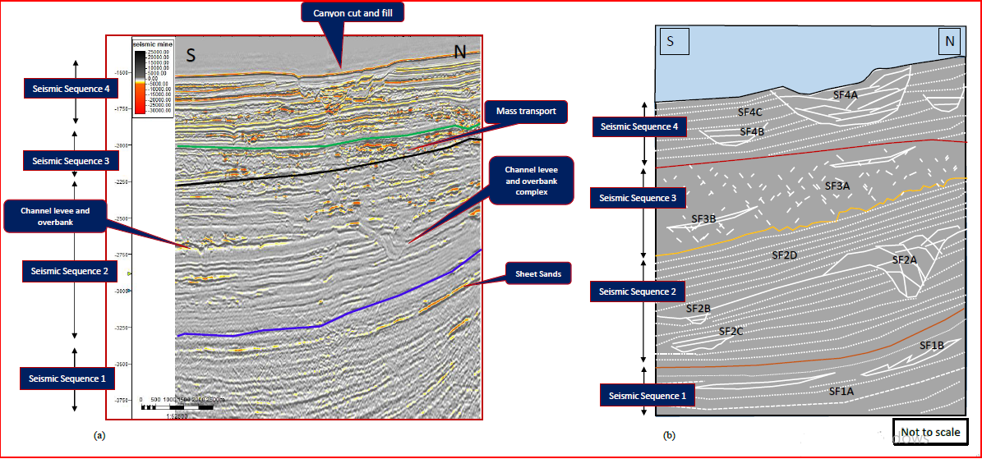
Fig. 10. Seismic facies interpretation on inline 3480 (a) Interpreted Section for Seismic Sequence Analysis of ‘OGEY’ Field. (b) Schematic Image Illustration Facies Unit Identified Within Each Sequence.
4.3 Environment of Deposition Definition
The results defined from the Integration of well logs, biofacies, and seismic data confirms that the environment of deposition for the field is deep offshore with depositional units ranging from Turbidite sand to Sheet sands, Channel Levee and Overbank Complex, Canyon Fills and Mass transport Deposits (Figure 10).
- CONCLUSION
The stratigraphy of ‘OGEY’ field, deep offshore Niger Delta has been interpreted using the concept of sequence and seismic stratigraphy. This was done by integrating wireline log, biofacies and 3D postack seismic data. Five Maximum Flooding surfaces and Five Sequence Boundaries were identified and utilized to subdivide the stratigraphic succession into five depositional sequence and their corresponding system tracts. Three system tracts are present in each depositional sequence. These are the Lowstand System Tracts, Trangressive Stage System Tracts and the Highstand System tracts. Seismically, ‘OGEY’ field comprises four seismic sequences with their Facies unit identified. The seismic sequence one contains two Facies units: SF1A (reflections with low to medium values of amplitude, medium values of frequency and continuity) and SF1B (high amplitudes, discontinuous (i.e., low continuity) with medium frequency). The lithologies identified are sand, sandy shale and shale, respectively. The sequence boundaries identified were dated 20.4Ma, 17.7Ma, 15.50Ma, 12.10Ma and 10.35Ma while the Maximum Flooding surfaces were dated 19.4Ma, 15.9Ma, 12.80Ma, 10.4Ma, and 9.6Ma respectively. The result revealed three system tracts, which are LST, TST and HST, indicating five depositional sequences. Four seismic sequences were observed in this field and they are SF1, SF2, SF3, and SF4. The environment of deposition for the field is deep offshore with depositional units ranging from turbidite sand to sheet sands, channel levee and overbank complex, canyon fills and mass transport deposits. The external geometry observed within the seismic sequence one was sheet forms and interpreted to be possibly either distributary channel sands or weakly confined channels, the other depositional sequences have their peculiar characters relative to sequence one.
- RECOMMENDATIONS
Further study should be done on Spectral Decomposition of the study area to properly image the boundaries of channel axes, margins and splays. This would greatly contribute to accuracy of assigning wells to be drilled in the study area. Also, wells assigned closer the channel axis. This is because the axis contains more potential holding capacity for hydrocarbon storage. More wells drilled can also help to understand the nature of connectivity and quality of the reservoirs.
Disclaimer (Artificial intelligence)
Option 1:
Author(s) hereby declare that NO generative AI technologies such as Large Language Models (ChatGPT, COPILOT, etc.) and text-to-image generators have been used during the writing or editing of this manuscript.
Option 2:
Author(s) hereby declare that generative AI technologies such as Large Language Models, etc. have been used during the writing or editing of manuscripts. This explanation will include the name, version, model, and source of the generative AI technology and as well as all input prompts provided to the generative AI technology
Details of the AI usage are given below:
1.
2.
3.
REFERENCES
Abbey, C. P. and Orenuga, I. A. (2017): Identification of Lithofacies and Depositional Environment: Case study of Teger Oil Field Niger Delta. Petroleum Technology Development Journal (ISSN 1595-9104): An International Journal v7 (1): 33-51
Abiola O. and Olowokere, M. T. (2016): Seismic facies analysis and depositional process: interpretation of “George” Field, offshore Niger Delta, Nigeria. Journal of Basic Applied Research International, v13(4): 243-252.
Abiola, O., Olowokere, M. T. and Ojo, J. S. (2018): Sequence Stratigraphy and depositional interpretation: A Case Study of “George” Field, offshore Niger Delta, Nigeria”, Petroleum Research, v3(1): 25-32.
Adekunle, S. and Elileojor, E. O. (2017). Use Of Seismic Attributes and Well Logs Data in Quantitative Reservoir Characterization of K-Field, Onshore Niger Delta Area, Nigeria. IOSR Journal of Applied Geology and Geophysics (IOSR-JAGG). Volume 5, Issue 5 Ver. II, p63-72.
Adiela, U. P. (2016). Reservoir Characterization of X-Field, Onshore, Niger Delta. International Research Journal of Interdisciplinary & Multidisciplinary Studies (IRJIMS). Volume-II, Issue-II, March 2016, p83-89.
Ager, D. V. (1981): The Nature of the Stratigraphical Record. 2d ed. New York: Halsted Press.
Ajisafe, Y. C., Ako, B. D (2013). 3-D Seismic Attributes for Reservoir Characterization of “Y” Field Niger Delta, Nigeria. IOSR Journal of Applied Geology and Geophysics, 1(2): 23-31.
Ajisafe, Y. C. (2015): Petrophysical evaluation of reservoirs in ‘y’ prospect Niger delta. RMZ – M&G v62: 55–63.
Alao, P. A., Olabode, S. O. and Opeloye S. A. (2013). Integration of Seismic and Petrophysics to Characterize Reservoirs in ‘ALA’ Oil Field, Niger Delta. The Scientific World Journal. Volume 2013, p421-435.
Alistair R. Brown (2004). Interpretation of Three-Dimensional Seismic Data (6th Ed.). The American Association of Petroleum Geologists and the Society of Exploration Geophysicists Tulsa, Oklahoma, U.S.A.
Armentrout, J. M. (1987). Integration of biostratigraphy and seismic stratigraphy: Pliocene-Pleistocene, Gulf of Mexico. Innovative Biostratigraphic Approaches to Sequence Analysis: New Exploration Opportunities, pp. 6-14.
Ameloko, A. A., and Omali, A. O. (2013). Reservoir Characterization and Structural Interpretation of Seismic Profile : A case study of Z-field, Niger Delta, Nigeria. Petroleum & Coal. v55(1) 37 – 43.
Armentrout and Clement (1991). Biostratigraphic calibration of depositional cycles: a case study in High Island-Galveston-East Breaks areas, offshore Texas: In Gulf Coast Section SEPM 11th Annual Research Conference, pp. 21-51.
Asquith and Gibson (1982). Basic Well Log Analysis: AAPG Methods in Exploration Series. 16; pg. 12-135.
Asquith, G.B. and Gibson, C. R. 1982. Basic Well Log Analysis for Geologists. American Association of Petroleum Geologist Bulletin. Vol. 51(2), pp. 761‐799.
Asquith G. and Krygowski D. 2004. Basic well Log Analysis. 2 Edition, American Association Emery, D. and Myers, KJ (eds) 1996. Sequence Stratigraphy. v+ 297 pp. Oxford: Blackwell Science. Price£ 29.50 (paperback). ISBN 0 632 03706 7.
Ayolabi, E. A. and Adigun, A. O. (2013): The Use of Seismic Attributes to Enhance Structural Interpretation of Z-Field, Onshore Niger Delta. Earth Science Research. 2(2): 223-238.
Bacon, M., Simm, R. and Redshaw, T. (2003). 3D seismic interpretation. Cambridge University Press, 222.
Brown L.F. Jr, Fisher, W.L.(1977). Seismic stratigraphic interpretation of depositional systems: examples from the Brazilian rift and pull-apart basins. Am. Assoc. Petrol. Geol. Mem.26, pp. 213- 248
Catuneanu O, Willis, A. J. and Miall, A. D. (1998): Temporal significance of sequence boundaries. Sedimentary Geology, v121: 157-178
Catuneanu O. (2006). Principles of Sequence Startigraphy, 3rd ed. Elsevier Radarweg Publishing. p42-54
Catuneanu O, Galloway W. E., Christopher G., Kendall, S. C., Miall, A. D., Posamentier, H. W., Strasser, A. and Tucker, M. E. (2011): Sequence Startigraphy: Methodology and Nomenclature, Newsletter on Startigraphy, Stuttgart, v44(3): 173-245
Coe, A., Bosence, D. Church, K. Flint, S. Howell, J. and Wilson, C. (2002): The Sedimentary Record of Sea Level Change, Cambridge University Press, 288 pp.
Coffen, J. A. (1984): Interpreting Seismic Data. Penwell Publishing Company, Tulsa Oklahoma. pp. 39-118.
Coleman, J. M. and Prior, D. B. (1980): Deltaic Sand Bodies. American Association of Petroleum Geologists Note series 5: 195p.
Chopra, P., Papp, E. and Gibson, D. (2005): Geophysical Well Logging. PennWell Books, Tulsa, Oklahoma, 254 pp.

Darrel S. Cowan; Trenton T. Cladouhos; Julia K. Morgan Structural geology and kinematic history of rocks formed along low-angle normal faults, Death Valley, California. GSA Bulletin (2003) 115 (10): 1230–1248.https://doi.org/10.1130/B25245.1.
Ejeh, I. O. (2010): Sedimentary Fill Modeling: Relationships to Sequence Stratigraphy and Its Implications for Hydrocarbon Exploration in the Niger Delta, Nigeria. The Pacific Journal of Science and Technology, v11(1): 502-509.
Ejedawe, J. E., Coker, S. J. L, Lambert-Aikhionbare, D. O., Alofe, K. B., and Adoh, F. O., (1984). Evolution of oil-generative window and oil and gas occurrence in Tertiary Niger Delta Basin: AAPG, vol. 68, pp. 1744-1751.
Ejedawe, J.E. (1981) Patterns of incidence of oil reserves in Niger Delta Basin, American Association of Petroleum Geologists. 65: 1574-1585.
Ekweozor, C. M. and Dankoru, E. M. (1994). Northern delta depobelt portion of the AkataAgbada. (1) Petroleum system, Niger Delta, Nigeria, In, Magom, L.B., and Dow, W.G., eds. The petroleum system- from source to Trap, A.A.P.G. Memoir 60: Tulsa, 599 – 614.
Emery, D. and Myers, K. J. (1996): Sequence Stratigraphy. 2nd ed. Blackwell Science Ltd. p47-98
Emery, D., Myers, K. J., Bertram, G. T., Griffiths, C. M. Milton, N. J. Reynolds, A. D. Richards, M. T. and Sturrock, S. J. (2003): Sequence Stratigraphy, Blackwell Science Ltd. Pp. 11-177.
Evamy, B.D., Haremboure, J., Karmerlimg, P., et al. (1978) Hydrocarbon Habitat of Tertiary Niger Delta. American Association of Petroleum Geologists Bulletin, 62, 1-39.
Galloway, W.E. (1975). Process framework for describing the morphologic and stratigraphic evolution of deltaic depositional systems, in: Broussard, M.L. (Ed.) Deltas: models for exploration. pp. 87-98
Galloway, W.E. (1998). "Genetic stratigraphic sequences in basin analysis". I. Architecture and genesis of flooding-surface bounded depositional units. American Association of Petroleum Geologists Bulletin, v. 22, p. 241 - 542.
Galloway, W.E. (1976). "Genetic stratigraphic sequences in basin analysis". I. Architecture and genesis of flooding-surface bounded depositional units. American Association of Petroleum Geologists Bulletin, v. 22, p. 241 - 542.
Jurado, M. J., & Comas, M. C. (1992). Well log interpretation and seismic character of the Cenozoic sequence in the northern Alboran Sea. Geo-Marine Letters, 12(2), 129-136.
Nyantakyi, E. K., Hu, W. S., Borkloe, J. K.Qin, G.and Han, M. C (2013). Structural and Stratigraphic Mapping of Delta Field, Agbada Formation, Offshore Niger Delta, Nigeria. American Journal of Engineering Research. Volume 02, Issue-11, pp-204-215.
Payton, C. E. (1977): Seismic Stratigraphy— Applications to Hydrocarbon Exploration. Am. Assoc. Petrol. Geol. Mem. v26. 510pp
Sarhan, M. A., Basal, A. M. K., & Ibrahim, I. M. (2017). Integration of seismic interpretation and well logging analysis of Abu Roash D Member, Gindi Basin, Egypt: implication for detecting and evaluating fractured carbonate reservoirs. Journal of African Earth Sciences, 135, 1-13.
Stacher, P. (1995). Resent understanding of the Niger Delta hydrocarbon habitat, in, Oti, M.N., and Postma, G., eds., Geology of Deltas: Rotterdam, A.A. Balkema, p. 257-267.
Ramesh, A. (2016): Well logging principles, Interpretation and Applications. Msv. Thesis, Dr Be Ambedkar University Srikakulam.
Rider M, (1986). The Geological Interpretation of Well Logs. Blackie, Glasgow, pg. 151-165. Principles of Sequence Stratigraphy (SEPMSTRATA, 2017). Retrived from http://www.sepmstrata.org/page.aspx?pageid=229
Wagoner et al., (1990). Siliciclastic Sequence Stratigraphy in Well Logs, Cores, and Outcrops: Concepts for High-Resolution Correlation of Time and Facies_Pt. 2. AAPG Methods in Exploration Series 7, (7), 16–20. https://doi.org/0-89181-657-7.
Mutti, E., and W. R. Normark, 1991, An integrated approach to the study of turbidite systems, in P. Weimer, and M. H. Link, eds., Seismic facies and sedimentary processes of submarine fans and turbidite systems: New York, Springer-Verlag, p. 75–106.
Mitchum Jr, R. M. et al., (1977). Seismic stratigraphy and global changes of sea level: Part 6. Stratigraphic interpretation of seismic reflection patterns in depositional sequences: Section 2. Application of seismic reflection configuration to stratigraphic interpretation.
Van Wagoner, J. C., Mitchum, R. M., Champion, K. M. and Rahmanian, V. D. (1990): Siliciclastic sequence Startigraphy in well logs, cores and outcrops. AAPG Methods in Exploration series, v7: 1-55.
Vail, P. R. et al., (1977). Seismic stratigraphy and global changes of sea level: Part 3. Relative changes of sea level from Coastal Onlap: section 2. Application of seismic reflection Configuration to Stratigrapic Interpretation.
Veeken, P. C. (2006). Seismic stratigraphy, basin analysis and reservoir characterization, Elsevier, Volume 37.
Weber, K. (1971). Sedimentological aspects of oil field in the Niger Delta. Georgie en Mijnbowuw, volume 50, 559-576.
Adeleye, M. A., Yekeen, K. O., & Amidu, S. A. (2020). Seismic stratigraphic analysis for hydrocarbon exploration in the Beta Field, Coastal Swamp Depobelt, Niger Delta. Geology, Geophysics and Environment, 46(4).

