Palynological Authentication of Six Medicinal Legume Species Collected from Al-Madinah Al-Munawwarah

Abstract
Accurate identification of medicinal plants is highly necessary to ensure their safety and efficacy. This study aims to authenticate six medicinal plants belong to legume family (Fabaceae Family). Pollen morphology marker was used to authenticate the six studied species. Initial identification was carried out in the field. Later it was confirmed using regional flora and botanical guides, including flora of Saudi Arabia and online database. Pollen grains were isolated and transferred to slides. A light microscope (LM) at magnifications ranging from 10x to 40x is used to analyze the detailed morphology.Quantitative fndings revealed that the studied species; Cullen plicatum, Leucaenaleucocephala, Senna italic and Tephrosia apollinea possess monad pollen grains, typically suboblate to triangular convex. In contrast, Pithecellobium dulce and Vachellia flava exhibited polyad grains that are oblate and circular. The polar axis ranges from 19–22 µm in C. plicatum to 53.0–56.97 µm in L. leucocephala, while the equatorial diameter reaches up to 100 µm in P. dulce. These fndings contribute to the standardization of pollen identification methods, ensuring improved quality control and authentication of medicinal plants for pharmaceutical and industrial applications. Also, this study contributes in linking traditional medicinal knowledge with palynological evidence, which is valuable for biodiversity documentation and herbal standardization in Saudi Arabia.
Keywords: Authentication; pollen grain morphology; medicinal plants; palynology; Saudi Arabia.
1. Introduction
Plants are widely used in many indigenous systems of medicine for therapeutic purposes. Herbal medicine, also called botanical medicine or phytomedicine are generally cheaper, accessible or readily available and more culturally acceptable to many because of the belief that they cause less side effects than some synthetic drugs (Roopashree et al., 2022; Mensah et al., 2019; Abdel-Aziz et al.,2016;Chanda, 2014; Lynch and Berry, 2007; Pal and Shukla, 2003). According to WHO (2002) around 80% of the global population still relies on botanical drugs. Moreover, the increased demand for botanical products is met by an expanding industry (Seukep et al., 2025; Dzoyem et al., 2013; Mafimisebi et al., 2013; Sucher and Carles, 2008).
The use of medicinal plants for treatments of various ailments in Saudi Arabia is ancient and still available among the tribal and medicinal healers (Al-Robai et al., 2022; Qari et al., 2021;Ullah et al., 2020; Tounekti et al., 2019; Syed, 2017; Rahmanet al., 2004 ).According to Dailah, (2022), In the Middle East, Saudi Arabia is regarded as the origin of herbal medicine. Its flora is considered the richest biodiversity areas in the Arabian Peninsula and comprises very important genetic resources of crop and medicinal plants. The safe use of herbal medicines is critical issue and requires prior authentication of the raw herbal materials used to make them. Thus, the rapid and accurate identification of herbal medical plants is highly necessary to ensure their safety and efficacy (Ghadage et al., 2025; Indrayanto, 2022). Moreover, adulteration and use of spurious materials as substitutes have become a major concern for users and industry for reasons of safety and efficacy (Kshirsagar et al.,2017 Ganie et al., 2015;Techen et al., 2004).
The authentication methods for herbal products include macro- microscopy, spectroscopy, chromatography, chemometry, immunoassays, DNA fingerprinting etc. Pollen morphology is considered as a significant tool for modern taxonomist for identification plant species (Qayyum et al., 2025; Tripathi et al., 2025; Alotaibi et al., 2020; Ramzan et al., 2019; Fazal et al., 2013). Moreover,Pollen characters are useful in solving complicated problems of interrelationships between various taxa and assessment of their status in the classification, particularly with reference to the families, subfamilies, tribes, genera, species, and subspecies. Mature pollen grain size, exine sculpturing, and number of pores are the most distinctive features for plant species identification (Faegri and Iversen, 1975; Klimko et al., 2000).
This study aims to authenticate six medicinal plants belong to legume family (fabaceae family). The study well offer valuable insights for identification of the selected medicinal plants and contribute to bridging traditional medicinal knowledge with microscopic plant analysis.
2. Materials and Methods
2.1. Plant Collection
Six medicinal plants; Cullen plicatum (C.plicatum), Leucaena leucocephala (L.leucocephala), Pithecellobium dulce (P.dulce), Senna italic (S.italica ),Tephrosia apollinea (T.apollinea), and Vachellia flava (V. flava) belonging to legume family were collected from various regions in Al-Madinah Al-Munawwarah. This including Wadi Qanat, Wadi Al-Aqiq, Wadi Malal, and Mountain Uhud between February and March 2025. The collected species were selected for their good reputation in traditional medicine in the study area.
Initial identification was carried out in the field and later confirmed using regional flora and botanical guides, including Flora of Saudi Arabia (Migahid, 1996 ) and the online database Plants of the World Online (https://powo.science.kew.org).

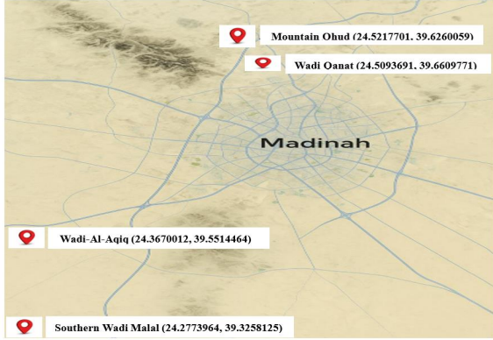
Figure 1: Geographical coordinates of the site of the selected medicinal Plants.
2.2. Herbarium Preparation
Plant specimens were preserved using a flower press kit, the Aboofx Wooden Flower Press, which features seven layers and measures 15.7 × 11.8 inches. This press ensures even pressure and efficient drying using multiple ventilated wooden boards. Once fully dried, the specimens were mounted on standard herbarium sheets and labeled with the following information: • Scientific name • Collection location • Date of collection • Habitat details Herbarium specimens of the six plant species were preserved in the Herbarium of the Department of Biology, College of Science, Taibah University, and labeled with the accession codes TUH001 to TUH006.
2.3. Pollen Sample Preparation
Pollen grains were isolated by removing anthers from mature floral buds and gently crushing them to release the pollen. The grains were then transferred to a slide, stained with diluted safranin (1:5 ratio of 1% safranin to distilled water), and covered with a cover slip for observation. The sample size consisted of five pollen slides prepared for each species.
2.4. Microscopic Examination
Prepared slides were observed under a light microscope (LM) at magnifications ranging from 10x to 40x to analyze the detailed morphology of the pollen grains. Observations focused on:
1. Pollen shape
2. Aperture type and number
3. Surface ornamentation Photomicrographs for documentation and interspecies comparison were captured using a compound light microscope (Novex, The Netherlands).
2.5. Measurement of Pollen Grains
Pollen grain dimensions were measured from calibrated photomicrographs using image analysis software Image J. Lines were drawn across specific polar and equatorial views to obtain measurements in micrometers using the Analyze > Measure tool. Multiple grains per species were measured to calculate average sizes. The results were saved for statistical analysis, and scale bars were optionally added to the images for publication purposes.
3. Results
3.1. The pollen grains morphology of the selected medicinal plants
Among the plants studied, C. plicatum, L. leucocephala, S. italic and T. apollinea possess monad pollen grains, typically suboblate to triangular convex. In contrast, P. dulce and V. flava exhibited polyad grains that is oblate and circular. These traits aid in identifying and classifying the selected medicinal plants (see Table 2 and Figures 2-7).

Table 1: Scientific Names and Local Names with Growth Habitats, Chorotype, and Collection Sites of the selected medicinal plants.
Collection Site  and Date | Chorotype | Growth  Habit | Local Name | Medicinal Plant
Southern WadiMalal, March 7, 2025 | Saharo-Arabian | Perennial, shrub or subshrub | Hama | C. plicatum
Wadi-Al-Aqiq, March 1, 2025. | Mesoamerican | Perennial, shrub or tree | Leucaena | L. leucocephala
Mountain Ohud, February 12, 2025. | Neotropical | Perennial shrub or tree | Luz hendi | P. dulce
Wadi-Al-Aqiq, March 1, 2025 | Afro-Asian | Perennial, subshrub | Eshrek | S.italica
Mountain Ohud, February 12, 2025. | Afro-Tropical to South Asian | Perennial,subshrub | Teqtaq | T. apollinea
Southern WadiMalal, March 7, 2025. | Saharo-Sindian | Perennial shrubs or tree | Salam | V. flava

Table 2: Pollen Morphology of the selected medicinal plants.

Surface Ornamentation | Aperture Type and Number | Pollen Shape | Medicinal Plant
Coarsely reticulate | Tricolpate | Suboblate to triangular convex | C. plicatum
psilate to scabrate | Tricolpate | Subprolate | L. leucocephala
Psilate | Colpate (no pores observed) | Oblate, circular | P. dulce
Scabrate | Tricolpate | Subprolate to triangular convex | S. italica
Reticulate | Tricolpate | Subprolate to triangular convex | T. apollinea
Microreticulate to finely rugulate | Inaperturate | Polyad grain, oblate, circular | V. flava

3.2. The dimension of pollen grains of the selected medicinal plants

The dimensions of pollen grains show significant variation among the studied species. The polar axis ranges from 19–22 µm in C. plicatum to 53.0–56.97 µm in L. leucocephala, while the equatorial diameter reaches up to 100 µm in P. dulce, indicating notable differences in pollen size and shape. The P/E ratio also varies, with the lowest value being 0.35 in P. dulce and the highest 1.54 in T. apollinea, reflecting differences in the elongation or flattening of the grains (see Table 3 and Figures 2-7).

Table 3: Pollen Grain Dimensions of the selected medicinal plants.
P/E Ratio (μm) | Equatorial diameter (µm) | Polar Axis (µm) | Medicinal Plant
0.872μm | 22–25 μm | 19–22 μm | C. plicatum
1.132μm | 50–50.53μm | 53–56.97 μm | L. leucocephala
0.35μm | 85–100 μm | 30–35 μm | P. dulce
0.716 μm | 32–35 μ m | 23–25 μ m | S. italica
1.54μm | 16.59–19.83μm | 26.29–30.14 μm | T. apollinea
0.652 μm | 32–37 μ m | 20–25 μ m | V. flava

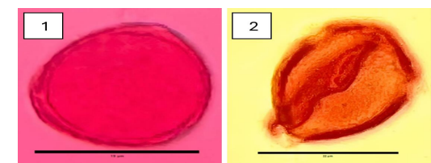

Figure 2: Light microscopic image of Pollen grain of C. plicatum: (1) polar view (2) equatorial view.
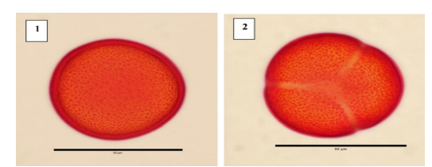
Figure 3: Light microscopic image of Pollen grain of L. leucocephala: (1) polar view (2) equatorial view.

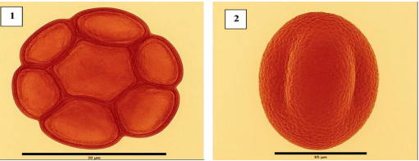

Figure 4: Light microscopic image of Pollen grain of P. dulce: (1) polar view (2) equatorial view.

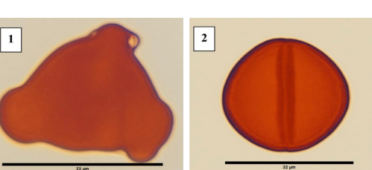

Figure 5: Light microscopic image of Pollen grain of S. italic: (1) polar view (2) equatorial view.

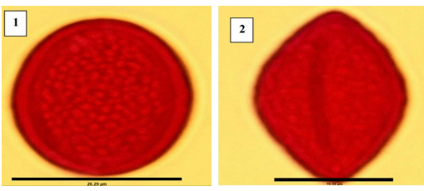
Figure 6: Light microscopic image of Pollen grain shape of T. apollinea: (1) Polar view (2) equatorial view.

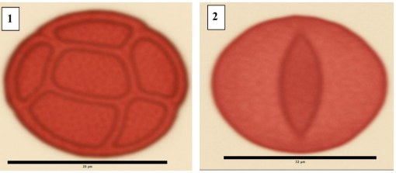
Figure 7: Light microscopic image of Pollen grain shape of V. flava: (1) polar view (2) equatorial view.

4. Discussion
Study of the pollen grain morphology of legume family has received great attention from authors. This is due to its high nutritional and therapeutic importance. (Bapir and Galalae, 2023; Abo Elnaga et al., 2022; Aye and Lin, 2020; Bank and Rudall, 2016; AL-Timen and Musawi, 2013; LUZ et al., 2013;) focused in investigation of pollen grains marker for the identification of the family taxa. The palyno-morphological characters, such as polar axis, equatorial diameter, P/E ratio, pollen shape, aperture type are considered highly reliable for the identification and taxonomic classification of medicinal plants (Javed et al., 2024; Mazari et al., 2017; García et al., 2012; Shaheen et al., 2009). Light microscopy (LM) and scanning electron microscopy (SEM) are usually used for this purpose. In this study light microscopy observations consistently revealed colpate apertures without clearly visible pores (pori). For example, the pollen grains of C. plicatum, L. leucocephala, S. italica, and T. apollinea all exhibited three distinct colpi, yet no definitive pori were observed under the light microscope, suggesting a tricolpate condition rather than tricolporate. This discrepancy may be due to limitations in staining techniques and the magnification power used. In this study, observations were made under 40x magnification, which may not be sufficient to resolve minute pore structures, particularly if they are small or partially obscured by stain deposits. The visibility of apertures can also be influenced by the type and intensity of the stain, which may enhance the colpi while masking the finer details of the pori. Previous palynological studies have confirmed the presence of pori using scanning electron microscopy (SEM), Baxtiyorovna et al., (2025) supported the tricolporate classification when he studied the some selected medicinal plants. Similarly, Elkordy et al., (2022) described T. apollinea as tricolporate based on SEM evidence, while Khan et al., (2020) characterized L. leucocephala as tricolporate with psilate to scabrate ornamentation. However, under light microscopy, especially with the standard 40x objective, these features may appear absent or indistinct, leading to a different morphological interpretation. These findings emphasize the importance of integrating multiple microscopy techniques for accurate pollen identification and the cautious interpretation of aperture types based solely on light microscopy.
The pollen grain dimensions reveal clear differences in pollen grain size and shape among the six studied Fabaceae species, which reflect both taxonomic and ecological adaptations. C. plicatum showed relatively small, nearly round pollen grains (P/E = 0.872 um), which is typical for insect-pollinated plants. Its coarse surface ornamentation helps pollen stick to pollinators (Unkelbachand Reinhardt, 2024). L. leucocephala had the largest pollen grains, with a slightly elongated shape (P/E = 1.132 um), which may support efficient pollen transfer in trees and shrubs that depend on large pollinators or wind.
The current study findings answers the original research question regarding the taxonomic and ecological value of pollen morphology in medicinal legumes of Al-Madinah AlMunawwarah. In interpreting the results, multiple explanations should be considered. Differences in pollen features may stem from evolutionary lineage, environmental stressors, and pollination syndromes. For example, the structural robustness of certain grains may reflect adaptation to arid environments or selective pressures from specific pollinators (Singh, 2010; Smýkalet al., 2015). Rather than attributing pollen variations solely to phylogenetic divergence, this study acknowledges the multifactorial nature of palynological diversity, including ecological, evolutionary, and functional influences, avoiding overreliance on currently dominant evolutionary theories unless directly supported by data.
5. Conclusion
This study has demonstrated that the pollen morphology of medicinal plants within the Fabaceae family offers valuable taxonomic insights that can aid in the identification, classification, and conservation of these species in Al-Madinah AlMunawwarah. By comparing six species C. plicatum, L. leucocephala, P. dulce, S.italica, T. apollinea, and V. flava we observed differences in pollen shape, aperture type, and surface ornamentation. These findings reinforce the critical role of palynological analysis in distinguishing between morphologically similar taxa, particularly in arid environments where floral traits may converge due to climatic pressures.
Importantly, this work contributes to filling a documented research gap by linking traditional medicinal knowledge with micro-morphological evidence. The integration of ethnobotanical data with pollen traits broadens our understanding of the region’s medicinal flora and underscores the importance of preserving native plant diversity. On a larger scale, these results highlight how palynology can support environmental monitoring and historical vegetation analysis in regions sensitive to climate change.

COMPETING INTERESTS DISCLAIMER:
Authors have declared that they have no known competing financial interests OR non-financial interests OR personal relationships that could have appeared to influence the work reported in this paper.

Disclaimer (Artificial intelligence)

Option 1:

Author(s) hereby declare that NO generative AI technologies such as Large Language Models (ChatGPT, COPILOT, etc.) and text-to-image generators have been used during the writing or editing of this manuscript.

Option 2:

Author(s) hereby declare that generative AI technologies such as Large Language Models, etc. have been used during the writing or editing of manuscripts. This explanation will include the name, version, model, and source of the generative AI technology and as well as all input prompts provided to the generative AI technology

Details of the AI usage are given below:
1.
2.
3.

6. References
Abdel-Aziz, Shadia M., Abhinav Aeron, and Tarek A. Kahil. "Health benefits and possible risks of herbal medicine." Microbes in food and health. Cham: Springer International Publishing, 2016. 97-116.
Abo Elnaga A, Alnagger AA, Rabei S. Pollen Grain Variation among Some Trees of Fabaceae in New Damietta, Egypt. Scientific Journal for Damietta Faculty of Science. 2022 Dec 1;12(1):174-82.
Alotaibi SS, Sayed SM, Alosaimi M, Alharthi R, Banjar A, Abdulqader N, Alhamed R. Pollen molecular biology: Applications in the forensic palynology and future prospects: A review. Saudi journal of biological sciences. 2020 May 1;27(5):1185-90
Al-Robai SA, Ahmed AA, Mohamed HA, Ahmed AA, Zabin SA, Alghamdi AA. Qualitative and quantitative ethnobotanical survey in Al Baha province, southwestern Saudi Arabia. Diversity. 2022 Oct 13;14(10):867.
AL-Timen RA, Musawi AA. Morphological study pollen grain belong to cultivated spp. of the family Fabaceae grown in Baghdad University campus/Jadiriya. Iraqi Journal of Science. 2013;54(3):569-76.
Aye TT, Lin SS. Taxonomy and pollen morphology of nine species in Fabaceae. J Myanmar Acad Arts Sci. 2020;18(4):301-13.
Banks H, Rudall PJ. Pollen structure and function in caesalpinioid legumes. American Journal of Botany. 2016 Mar;103(3):423-36.
Bapir NN, Galalaey AM. Taxonomic study of pollen grains for five species of Fabaceae Family. Kirkuk Univ J Agric Sci. 2023 Jul 1;14(3):413-27.
Baxtiyorovna NA, Qudratovich XK, Zamira D, Ramadan MF, Ma’rufovich NM, Qizi DF, Abdukhamidovich OU, Maqsudjanova MG, Sayfullayevna NN, Zafar M, Majeed S. Pollen as an insect interaction marker: palynological, chemical, and microscopic perspectives of selected medicinal plants. Genetic Resources and Crop Evolution. 2025 May 5:1-5.
Chanda S. Importance of pharmacognostic study of medicinal plants: An overview. Journal of pharmacognosy and phytochemistry. 2014 Jan 1;2(5).
Dailah HG. The ethnomedicinal evidences pertaining to traditional medicinal herbs used in the treatment of respiratory illnesses and disorders in Saudi Arabia: A review. Saudi Journal of Biological Sciences. 2022 Sep 1;29(9):103386.
Dzoyem JP, Tshikalange E, Kuete V. Medicinal plants market and industry in Africa. InMedicinal plant research in Africa 2013 Jan 1 (pp. 859-890). Elsevier.
Elkordy A, Osman AK, Badry MO. Seed and pollen morphology and numerical analysis of Tephrosia Pers.(Fabaceae) and their taxonomic significance. Acta Botanica Croatica. 2022 Oct 1;81(2):149-58.
Faegri, K. and Iversen, J., 1975. Textbook of pollen analysis.
Fazal H, Ahmad N, Haider Abbasi B. Identification, characterization, and palynology of high‐valued medicinal plants. The Scientific World Journal. 2013;2013(1):283484.
Ganie SH, Upadhyay P, Das S, Sharma MP. Authentication of medicinal plants by DNA markers. Plant gene. 2015 Dec 1;4:83-99.
García NM, Chaves VA, Briceño JC, Travieso CM. Pollen grains contour analysis on verification approach. InInternational Conference on Hybrid Artificial Intelligence Systems 2012 Mar 28 (pp. 521-532). Berlin, Heidelberg: Springer Berlin Heidelberg.
Ghadage D, Chavan Y, Jadhav P, Kengar M, Aiwale P, Patil A. Advanced Herbal Technology: A Review of Plant Identification, Authentication, and Advanced Extraction Techniques. Journal of Advancement in Pharmacognosy. 2025;5(1):1-0.
Indrayanto G. The importance of method validation in herbal drug research. Journal of Pharmaceutical and Biomedical Analysis. 2022 May 30;214:114735.
Javed M, Prasad N, Farooqui A, Quamar MF, Singh M. Taxonomic insights into medicinal plants pollen, using advanced microscopy techniques, from the Western Ghats, India. Grana. 2024 Jul 3;63(4):275-88.
Khan SU, Zafar M, Ullah R, Shahat AA, Ahmad M, Sultana S, Malik K. Pollen diversity and its implications to the systematics of mimosaceous species by LM and SEM. Microscopy Research and Technique. 2021 Jan;84(1):42-55.
Klimko M, Kluza M, Kreft A. Morphology of pollen grains in three varieties of Helianthus annuus L. Roczniki Akademii Rolniczej w Poznaniu. Botanika. 2000(03).
Kshirsagar P, Umdale S, Chavan J, Gaikwad N. Molecular authentication of medicinal plant, Swertia chirayita and its adulterant species. Proceedings of the National Academy of Sciences, India Section B: Biological Sciences. 2017 Mar;87(1):101-7.
LUZ CF, Maki ES, Horak-Terra I, Vidal-Torrado P, Mendonca Filho CV. Pollen grain morphology of Fabaceae in the special protection area (SPA) Pau-de-Fruta, Diamantina, Minas Gerais, Brazil. Anais da Academia Brasileira de Ciências. 2013;85:1329-44.
Lynch N, Berry D. Differences in perceived risks and benefits of herbal, over-the-counter conventional, and prescribed conventional, medicines, and the implications of this for the safe and effective use of herbal products. Complementary therapies in medicine. 2007 Jun 1;15(2):84-91.
Mafimisebi TE, Oguntade AE, Ajibefun IA, Mafimisebi OE, Ikuemonisan ES. The expanding market for herbal, medicinal and aromatic plants in Nigeria and the international scene. Med Aromat Plants. 2013;2(144):2167-0412.
Mazari P, Liu Q, Khan MA, Sadia S, Ahmad L. Pollen morphology and pollen fertility estimation of three medicinal plant species of Hypericum L. from Kaghan Valley, Northern Pakistan. American Journal of Plant Sciences. 2017 Nov 8;8(12):3073-83.
Mensah ML, Komlaga G, Forkuo AD, Firempong C, Anning AK, Dickson RA. Toxicity and Safety Implications of Herbal Medicines. Herb. Med. 2019 Jan 30:63.
Migahid, A. M. Flora of Saudi Arabia (4th ed., Vols. 1–3). Riyadh, Saudi Arabia: King Saud University.1996.
Pal SK, Shukla Y. Herbal medicine: current status and the future. Asian pacific journal of cancer prevention. 2003 Aug 20;4(4):281-8.
Plants of the World Online. (n.d.). Royal Botanic Gardens, Kew. Retrieved April 20, 2025, from https://powo.science.kew.org
Qari SH, Alrefaei AF, Filfilan W, Qumsani A. Exploration of the medicinal flora of the Aljumum region in Saudi Arabia. Applied Sciences. 2021 Aug 19;11(16):7620.
Qayyum I, Ahmad M, Shinwari ZK, MAKSUDA N, USMANKULOVNA MH, Khawaja S, Habib A, Idrees M. Palynological investigation for taxonomic authentication of medicinal flora from the Hindukush range of northern Pakistan. Pak. J. Bot. 2025 Apr 1;57(2):685-700.
Rahman MA, Mossa JS, Al-Said MS, Al-Yahya MA. Medicinal plant diversity in the flora of Saudi Arabia 1: a report on seven plant families. Fitoterapia. 2004 Mar 1;75(2):149-61..
Ramzan S, Shaheen S, Hussain K, Sharifi‐Rad J, Khan MA, Harun N, Jaffer M, Khan F. Implication of palynological techniques for the authentication of adulterated drugs traded with the same name in different herbal markets of district Lahore, Pakistan. Microscopy research and technique. 2019 Jun;82(6):931-40.
Roopashree S, Anitha J, Mahesh TR, Kumar VV, Viriyasitavat W, Kaur A. An IoT based authentication system for therapeutic herbs measured by local descriptors using machine learning approach. Measurement. 2022 Aug 15;200:111484.
Seukep AJ, Mbuntcha HG, Kuete V. Progress in the medicinal plants market and industry in Africa from 2013. InMedicinal Plant Research in Africa 2025 Jan 1 (pp. 805-821). Elsevier.
Shaheen N, Khan MA, Hayat MQ, Yasmin G. Pollen morphology of 14 species of Abutilon and Hibiscus of the family Malvaceae (sensu stricto). Journal of Medicinal Plants Research. 2009 Nov;3(11):921-9.
Singh, G. Plant systematics: An integrated approach (3rd ed.). Science Publishers; 2010.
Smýkal P, Coyne CJ, Ambrose MJ, Maxted N, Schaefer H, Blair MW, Berger J, Greene SL, Nelson MN, Besharat N, Vymyslický T. Legume crops phylogeny and genetic diversity for science and breeding. Critical Reviews in Plant Sciences. 2015 Jun 1;34(1-3):43-104.
Sucher NJ, Carles MC. Genome-based approaches to the authentication of medicinal plants. Planta medica. 2008 May;74(06):603-23.
Syed AH. SHPIS: A database of medicinal plants from Saudi Arabia. International Journal of Advanced Computer Science and Applications. 2017;8(5).
Techen N, Crockett SL, Khan IA, Scheffler BE. Authentication of medicinal plants using molecular biology techniques to compliment conventional methods. Current medicinal chemistry. 2004 Jun 1;11(11):1391-401.
Tounekti T, Mahdhi M, Khemira H. Ethnobotanical study of indigenous medicinal plants of Jazan region, Saudi Arabia. Evidence‐Based Complementary and Alternative Medicine. 2019;2019(1):3190670.
Tripathi S, Anis N, Vaish S, Kumar A, Singh K, ARYA AK. Potential in Palaeoecological Reconstruction from Modern Pollen Calibrations along the Kukrail Reserve Forest, Central Ganga Plain, India. Journal of the Palaeontological Society of India. 2025 Mar 25:05529360251320221..
Ullah R, Alqahtani AS, Noman OM, Alqahtani AM, Ibenmoussa S, Bourhia M. A review on ethno-medicinal plants used in traditional medicine in the Kingdom of Saudi Arabia. Saudi journal of biological sciences. 2020 Oct 1;27(10):2706-18.
Unkelbach J, Reinhardt AL. Atlas of the Oman pollen flora–Pollen morphology of the arid Arabian Peninsula vegetation. Review of Palaeobotany and Palynology. 2024 Dec 1;331:105204.

