Parity-Related Alterations in Zinc, Copper, and Cobalt Levels Among Cervical Cancer Patients in Basrah - Iraq

Abstract
Trace elements play vital roles in various cellular metabolic processes, maintaining the balance between oxidants and antioxidants, and in carcinogenesis. This is a case-control study involving 90 married women in which estimates the levels of zinc, cobalt, and copper according to the number of children they had as a risk factor in the blood of cervical cancer patients compared to healthy controls. The data analysis was carried out using SPSS17 and expressed as mean ± standard deviation (x ± s). The cobalt concentrations were markedly higher in patients (1.62 ± 0.15 µg/dL) than in controls (0.35 ± 0.04 µg/dL, p < 0.0001), with consistent significance across all subgroups. Similarly the results demonstrated a significant raise of zinc levels in patients (2.55 ± 0.27 µg/dL) compared with controls (1.51 ± 0.25 µg/dL, p = 0.0009). Copper levels also showed an overall increasing trend in patients (0.39 ± 0.12 µg/dL) compared with controls (0.26 ± 0.16 µg/dL), though not all differences reached statistical significance. According to the outcomes, there is an imbalance in the levels of some trace elements, especially zinc and cobalt, in cervical cancer patients, which can serve as a biomarker for identifying the disease due to their role in accelerating the disease process.
Keywords: Copper, Zinc, Cobalt, Cervical cancer, Biomarkers.
Introduction
One of the most prevalent gynecological cancers in the world, cervical cancer poses a serious threat to public health, especially in low- and middle-income nations. The World Health Organization reports that it is the fourth most common cause of cancer-related deaths worldwide and the fourth most common in women in terms of diagnosis and frequency. Chronic infection with high-risk human papillomavirus (HPV) types, particularly types 16 and 18, is the main cause of its incidence; these kinds are thought to be responsible for over 70% of cases (1). Precancerous lesions called cervical epithelial neoplasms are the first step in the sequential progression of cervical cancer, which can thereafter lead to invasive carcinoma. Numerous factors, such as host genetic predispositions, environmental conditions, and oncogenic viral genes, influence its process (2). Multiple partners, smoking, long-term oral contraceptive usage, early sexual beginning, and coinfection with specific STDs are risk factors for cervical cancer (3). Due to differences in screening and immunization protocols, the disease nevertheless poses a serious health burden even though it is avoidable. The widespread use of HPV vaccination programs and Pap testing has dramatically decreased morbidity and mortality rates in high-income nations (4). However, a lack of preventative programs and delayed diagnosis result in higher death rates in places with inadequate health infrastructure. Accordingly, cervical cancer continues to be a significant health concern and evidence of the disparities in global health equity that still persist (5).
Numerous physiological activities, including immunological function, oxidative stress management, DNA synthesis and repair, depend on trace elements like selenium (Se), iron (Fe), copper (Cu), cobalt (Co), and zinc (Zn), ( 6, 7). Of these, zinc and copper have been studied in gynecological cancers the most. Copper can catalyze the production of reactive oxygen species (ROS) and aid in angiogenesis, while zinc is necessary for antioxidant enzymes and immune defense (6,8).
According to earlier studies, compared to healthy controls, copper levels and the Cu/Zn ratio are higher in cervical cancer patients, while blood and tissue zinc levels are frequently lower (8,9). These changes are believed to worsen inflammation, oxidative stress, and DNA damage—processes known to contribute to carcinogenesis. (6). The behavior of other elements, such cobalt, in cervical cancer and the way trace element levels change with reproductive history (such as the number of children), which may affect exposure or physiological demand, have received less attention.
The current study aimed to compare the levels of cobalt, copper, zinc and in patients with cervical cancer to healthy controls, stratified by the number of children. We predicted that, in comparison to controls, cervical cancer patients would exhibit lower or dysregulated zinc levels and greater levels of copper and cobalt, with variations potentially impacted by parity. Clarifying the significance of trace element imbalances in the pathogenesis of cervical cancer and discovering possible biomarkers may be made easier with an understanding of these connections.
Materials and Methods
Study setting
This was a case-control study that was carried out at the Ibn Ghaswan hospital and cancer center in Basrah city during July to November, 2024.
Study population
Study comprised 90 married women (age between 16-62 years) in two groups: women having histologic-proven cervical cancer presenting in the department of gynecological oncology of Ibn Ghaswan hospital and tumor center (case group = 50) and age-matched cancer-free women (comparison group=40). The cervical cancer patients were diagnosed of any clinical stage by biopsy from abnormal area and the positive Human Papillomavirus (HPV) test, that detects the high-risk HPV strains that cause cervical cancer. The two groups were divided into subgroups based on parity (5 groups). All the participants were informed before they were recruited and the following steps were also followed to ensure confidentiality of the participant information by the researchers. Smokers, alcoholic, hysterectomy patients, patients with other co-morbidities such as renal disease, hypertension, pulmonary disease, liver disease, diabetes mellitus were excluded from the study.
Sample collection and preparation:
5 milliliters of venous blood were taken from each patient subject and the healthy control subject. Blood samples were collected in tubes containing heparin as an anticoagulant and prepared for digestion to determine zinc, cobalt and copper.
Digestion Procedure:
To digest the samples, 0.5 ml of whole blood was moved into a Pyrex test tube, and 4 ml of (1:1) [conc. HClO₄ and conc. HNO₃] was added. The tubes were then placed in an oil bath at 160 ⁰C for 1hr. The tubes were then taken out of the bath and allowed to cool to room temperature before being filled with 0.5 M HCl to reach a volume of 10 ml. The elements detection in the blood done by the flame atomic absorption spectrometry (AAS) [10].
Statistical analysis of the clinical data was carried out using SPSS17. Quantitative data were expressed as mean ± standard deviation (x ± s). p < 0.05 was used as the criterion for statistical significance.

Results and discussion
This study analyzed the influence of parity on concentrations of trace elements—zinc, copper, and cobalt—in women with cervical cancer in comparison to healthy controls, as presented in Table 1 and Figures 1,2,3. The findings demonstrate significant disruptions in trace element homeostasis among patients, with increasing number of children associated with elevated zinc and cobalt levels, and a modest rise in copper concentrations.
Zinc levels were markedly higher in patients across all parity groups, with statistical significance observed in every category (p-values ranging from 0.00001 to 0.0045), and in the total comparison (patients: 2.55 ± 0.27 μg/dL vs. controls: 1.51 ± 0.25 μg/dL; p = 0.0009). The elevation was most notable in women with two children (G2), where levels reached (2.98 ± 0.22 μg/dL). Zinc plays a vital role in immune regulation, DNA synthesis, and antioxidant defense, and its increase may reflect compensatory responses to tumor-induced stress or active involvement in neoplastic proliferation (11). Several studies have reported decreased zinc levels in the serum and tissues of patients with cervical cancer compared with healthy controls (12,13 Akter et al. , chen et al.). Increased zinc concentrations may reflect the cancer cells’ heightened demand for zinc-dependent enzymes involved in DNA replication, cell proliferation, and antioxidant defense ( 14 Ho & Song, 2009).
Copper concentrations demonstrated variable increases in cancer patients, with statistically significant differences in G3 (p = 0.001), and G5 (p = 0.019), although the overall comparison remained marginally insignificant (p = 0.076). Copper's involvement in oxidative reactions and angiogenesis may contribute to tumor progression; however, results suggest a less consistent pattern, likely influenced by external variables such as dietary intake, inflammation, or ceruloplasmin levels(15). Similar findings were reported by (Cunzhi et al. 2003) (16), who observed that both serum copper levels and the Cu/Zn ratio were significantly higher in patients with cervical cancer. Likewise, (Okunade et al. 2018) (17) found that the mean serum copper level was higher in cervical cancer patients compared to the control group, although this difference did not reach statistical significance.
Cobalt levels were significantly elevated among cancer patients across all parity groups, with p-values of 0.0000 in each category. Total patient cobalt concentration was (1.62 ± 0.15 μg/dL) compared to (0.35 ± 0.04 μg/dL) in controls. Cobalt, a trace component of vitamin B12, may influence cellular respiration, erythropoiesis, and hypoxic signaling—processes often altered in the tumor microenvironment. The sharp contrast suggests a parity-dependent accumulation or dysregulation potentially related to reproductive-induced metabolic shifts [18]. Alani et al. (2024) (19) reported a non-significant increase in plasma cobalt levels in cervical cancer patients and a non-significant decrease in breast cancer patients relative to healthy female controls.
These findings indicate that reproductive history—specifically number of children—may be a critical factor influencing trace element dynamics in the context of cervical cancer. Repeated pregnancies are known to induce metabolic strain, hormonal variation, and immune shifts, which may modulate trace element absorption, distribution, and utilization. Our findings of elevated cobalt concentrations in patients compared to controls are consistent with previous studies highlighting the role of trace element dysregulation in cancer development. Patients with cervical cancer have been found to have elevated zinc levels, which may be related to the mineral's simultaneous functions in DNA synthesis, antioxidant defense, and tumor cell proliferation (11). Previous studies showed significantly higher levels of cobalt in cervical cancer patients and the cobalt accumulation has been connected with vagaries in hypoxic signaling, erythropoiesis, and metabolic regulation within the tumor situation . In contrast, the study showed a mutable trends in copper levels, which is consistent with various studies reporting that copper is often raised up in malignant tumors due to its role in oxidative stress and angiogenesis, although it does not always reach statistical significance (20,21). Collectively, these results support the hypothesis that disruption of trace element homeostasis contributes to cervical carcinogenesis and may serve as a biomarker for disease progression.
Table 1: Trace Elements levels in control and patients’ groups

Element | Group | Number of Children | Trace Element Concentration µg/dL
Element | Group | Number of Children | Control (mean$±SD)$ | Patient (mean$±SD)$ | P-Value
Zinc | G1 | 1 | 2.04±0.33 | _
Zinc | G2 | 2 | 1.95±0.25 | 2.98±0.22 | 0.0045
Zinc | G3 | 3 | 1.34±0.28 | 2.75±0.27 | 0.00002
Zinc | G4 | 4 | 1.21±0.24 | 2.33±0.28 | 0.00001
Zinc | G5 | 5 | 1.01±0.19 | 2.17±0.31 | 0.00003
Zinc | Total | All Number of Children | 1.51±0.25 | 2.55±0.27 | 0.0009
Copper | G1 | 1 | 0.12±0.05 | _
Copper | G2 | 2 | 0.14±0.11 | 0.21±0.06 | 0.098
Copper | G3 | 3 | 0.13±0.06 | 0.30±0.12 | 0.001
Copper | G4 | 4 | 0.19±0.12 | 0.33±0.14 | 0.166
Copper | G5 | 5 | 0.21±0.15 | 0.34±0.16 | 0.019
Copper | Total | All Number of Children | 0.26±0.16 | 0.39±0.12 | 0.076
Cobalt | G1 | 1 | 1.12±0.04 | _
Cobalt | G2 | 2 | 0.19±0.06 | 1.68±0.12 | 0.0000
Cobalt | G3 | 3 | 0.18±0.02 | 1.64±0.14 | 0.0000
Cobalt | G4 | 4 | 0.16±0.05 | 1.61±0.16 | 0.0000
Cobalt | G5 | 5 | 0.13±0.07 | 1.58±0.19 | 0.0000
Cobalt | Total | All Number of Children | 0.35±0.04 | 1.62±0.15 | 0.0000

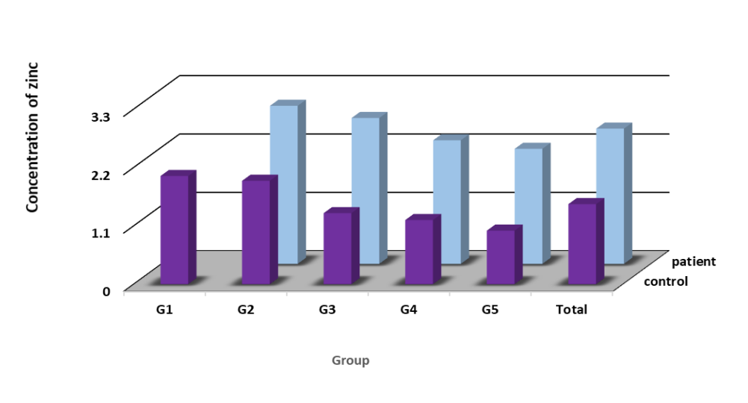
Figure 1: Number of Children Effect on zinc
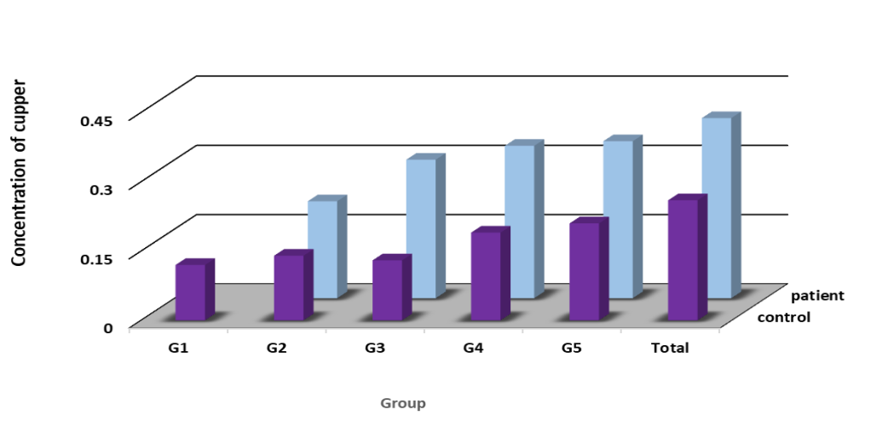
Figure 2: Number of Children Effect on copper
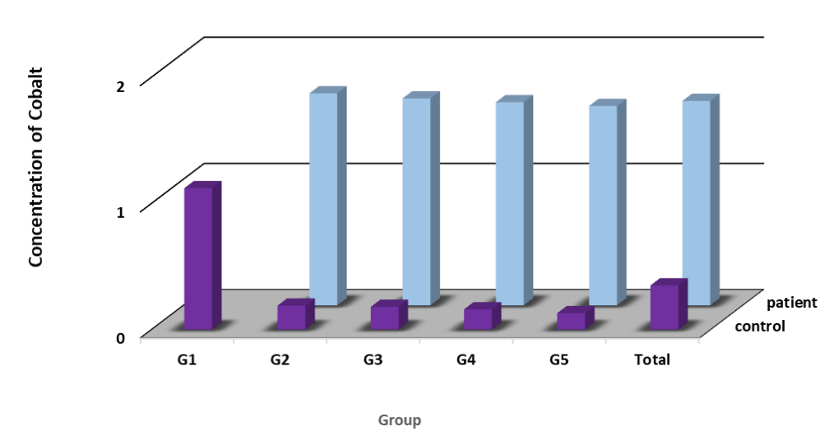
Figure 3: Number of Children Effect on cobalt
Conclusion
Significant disparities between the control and sick groups were found by comparing the amounts of trace elements across all child demographics. With a strong statistical significance (p < 0.01), zinc levels were significantly higher in patients than in healthy people, demonstrating a possible role for zinc imbalance in disease state. Some patient groups (e.g., G3 and G5) showed significant increases in copper levels, but in general, the element levels were fluctuating and the overall difference was not statistically significant (p = 0.076). The study showed that cobalt may be a biomarker closely linked to the disease, as the most significant difference was observed in its levels, which were consistently higher in patients than in healthy controls in each group (p = 0.000). Overall, the study suggests that zinc and cobalt may be important markers for diagnostic and prognostic purposes, and may also contribute to disease progression.

References
1- Sung, H., Ferlay, J., Siegel, R. L., Laversanne, M., Soerjomataram, I., Jemal, A., & Bray, F. (2021). Global cancer statistics 2020: GLOBOCAN estimates of incidence and mortality worldwide for 36 cancers in 185 countries. CA: A Cancer Journal for Clinicians, 71(3), 209–249. https://doi.org/10.3322/caac.21660
2- Arbyn, M., Weiderpass, E., Bruni, L., de Sanjosé, S., Saraiya, M., Ferlay, J., & Bray, F. (2020). Estimates of incidence and mortality of cervical cancer in 2018: A worldwide analysis. The Lancet Global Health, 8(2), e191–e203. https://doi.org/10.1016/S2214-109X(19)30482-6
3- Small, W., Bacon, M. A., Bajaj, A., Chuang, L. T., Fisher, B. J., Harkenrider, M. M., ... & Gaffney, D. K. (2017). Cervical cancer: A global health crisis. Cancer, 123(13), 2404–2412. https://doi.org/10.1002/cncr.30667
4- Crosbie, E. J., Einstein, M. H., Franceschi, S., & Kitchener, H. C. (2018). Human papillomavirus and cervical cancer. The Lancet, 382(9895), 889–899. https://doi.org/10.1016/S0140-6736(13)60022-7
5- Bray, F., Ferlay, J., Soerjomataram, I., Siegel, R. L., Torre, L. A., & Jemal, A. (2018). Global cancer statistics 2018: GLOBOCAN estimates of incidence and mortality worldwide for 36 cancers in 185 countries. CA: A Cancer Journal for Clinicians, 68(6), 394–424. https://doi.org/10.3322/caac.21492
6-Michalczyk, K., & Cymbaluk-Płoska, A. (2020). The role of zinc and copper in gynecological malignancies. Nutrients, 12(12), 3732. https://doi.org/10.3390/nu12123732
7-Tiffany-Castiglioni, E., & Qureshi, I. A. (1980). Role of trace elements in cancer. Biological Trace Element Research, 2(2), 129–144. https://doi.org/10.1007/BF02783862
8-Yuce, K., Erenus, M., Akhan, S. E., Batioglu, S., & Durukan, T. (2003). Serum and tissue levels of six trace elements in gynecologic cancers. European Journal of Gynaecological Oncology, 24(3–4), 298–302.
9-Akter, S., Roy, R., Akter, S., Afrose, S., & Rahman, M. (2024). Trace elements and cervical cancer: A case–control study in Bangladeshi women. Journal of Trace Elements in Medicine and Biology, 78, 127295. https://doi.org/10.1016/j.jtemb.2023.127295
10-Shakir SK, AL-Saeed AHM, Abdulwahid AA. (2021). Estimation of Some Hematological Parameters, Liver Enzymes and Iron Mineral in Adult of Celiac Disease Patients. Basrah Journal of Science , 39(3), 484-49
11-Skrajnowska, D., & Bobrowska-Korczak, B. (2019). Role of Zinc in Immune System and Anti-Cancer Defense Mechanisms. Nutrients, 11(10), 2273. https://doi.org/10.3390/nu11102273
12-Akter, N., Hossain, F., Naher, S., Khatoon, F., Meher, S., Sayed, S., Nihar, F., & Akther, M. (2024). Association of serum copper, zinc level in invasive cervical cancer in a tertiary hospital. International Journal of Reproduction, Contraception, Obstetrics and Gynecology, 13(6), 2618–2622. https://doi.org/10.18203/2320-1770.ijrcog20241860
13-Chen, C. A., Hwang, J. L., Kuo, T. L., Hsieh, C. Y., & Huang, S. C. (1990). Serum copper and zinc levels in patients with cervical cancer. Journal of the Formosan Medical Association, 89(8), 677–682. https://doi.org/10.1016/S0929-6646(05)80085-3
14-Ho, E., & Song, Y. (2009). Zinc and prostatic cancer. Current Opinion in Clinical Nutrition & Metabolic Care, 12(6), 640–645. https://doi.org/10.1097/MCO.0b013e328331b6c1
15-Wessels, I., & Rink, L. (2020). The role of zinc in antiviral immunity. Advances in Nutrition, 11(2), 348–358. https://doi.org/10.1093/advances/nmz082
16-Cunzhi H., Jiexian J., Xianwen Z., et al. (2003) “Serum and tissue levels of six trace elements and copper/zinc ratio in patients with cervical cancer and uterine myoma.” Biological Trace Element Research ;94(2):113-22. doi: 10.1385/BTER:94:2:113.
17-Okunade, K. S., Dawodu, O. O., Salako, O., Osanyin, G. E., Okunowo, A. A., & Anorlu, R. I.. (2018) “Comparative analysis of serum trace element levels in patients with invasive cancer of the cervix. Pan African Medical Journal. 20;31:194. doi: 10.11604/pamj.2018.31.194.14425
18-Jelkmann, W. (2012). The disparate roles of cobalt in erythropoiesis, and doping relevance. Open Journal of Hematology, 3(1), 3-6.
19-Alani, J. M., Victory, E. F., & Olatunbosun, A. G. (2024). Essential- (Cobalt, Chromium, Molybdenum and Nickel) and Non-Essential- (Aluminium, Beryllium and Boron) Heavy Metals in Patients with Breast- or Cervical- Cancer. Tropical Journal of Obstetrics and Gynaecology, 43(1). https://tjog.org/index.php/tjog/article/view/432

20-Finney, L., Vogt, S., Fukai, T., & Glesne, D. (2019). Copper and angiogenesis: Unraveling a relationship key to cancer progression. Clinical and Translational Medicine, 8(1), 32. https://doi.org/10.1186/s40169-019-0253-z
21-Babu, S., Jayaraman, S., & Mathan, G. (2020). Trace elements in cervical cancer: A case–control study. Biological Trace Element Research, 197(2), 421–428. https://doi.org/10.1007/s12011-019-02020-4

