Optimizing Computer-Aided Detection for Tuberculosis Thresholds for Community TB Screening in Nigeria: Recalibrating Threshold with Local Data

Abstract
Background: Computer-aided detection (CAD) is a promising tool for tuberculosis (TB) screening, but its performance, particularly the optimal abnormality score thresholds, is highly context-specific. This study aimed to optimise the use of computer-aided detection (CAD4TB) software in tuberculosis (TB) screening by customising its threshold settings based on individual patient characteristics and reported symptoms.
Method: The study was a retrospective observational study utilizing secondary data from community-based TB screening using portable digital X-ray (PDX) with CAD4TB AI. A total of 18,529 adults were screened across various settings, with 16,047 participants having complete results on both CAD4TB and molecular tests (GeneXpert). Most participants were from the general population (35.0%), slums (25.3%), and hard-to-reach areas (16.5%). The mean CAD4TB score was 43.13 (range: 0–99.3). CAD4TB AI findings were validated against molecular results to determine diagnostic accuracy. Sensitivity, specificity, PPV, and NPV were calculated, and ROC curves were generated to assess AI score thresholds and case detection yield by age and setting.
Findings: The mean age was 43.5 ± 18.4 years; 62.6% were males. The study found a high TB prevalence of 10.9%. The performance of CAD exhibited significant variation among individuals with a prior history of tuberculosis. The optimal threshold for this subgroup was a score of 48 (sensitivity 91.0%, specificity 41.9%, AUC 0.76), compared to a score of 36 for those without prior TB (sensitivity 90.6%, specificity 39.0%, AUC 0.81). This confirms that CAD accuracy is reduced among people previously treated for TB, likely due to post-TB radiological sequelae. While no single threshold met the WHO Target Product Profile (≥90% sensitivity and ≥70% specificity) for the entire population, the study demonstrated CAD's good overall accuracy (AUC >0.80) and its value as a high-sensitivity screening tool.

Conclusion: CAD is an effective tool for community-based TB screening in Nigeria. However, its implementation requires locally validated, context-specific thresholds rather than universal cut-offs. Programmes must adopt different thresholds for key subgroups, such as those with a history of TB, to balance case detection with cost-effectiveness. Continuous re-evaluation of thresholds with each software update is essential to maintain optimal performance and impact.

Keywords: Computer-Aided Detection (CAD), Tuberculosis Screening, TB Thresholds, Patient Profiles.

Introduction
“In 2019, 10 million people were infected with TB worldwide, with estimated three million people who did not receive clinical diagnosis” (Fukunaga et al., 2021). “This has created a persistent gap in TB case detection, even when the United Nations General Assembly (UNGA) in 2018 committed to diagnosing and treating 40 million people with TB in 2022” (Satyanarayana et al., 2023). “There has been a continuous effort to prevent and control TB, with progress chalked in the development of therapeutic regimes” (Tiberi et al., 2018). “However, despite the long historical and continuous effort, M. tuberculosis infections remain a dogged health concern globally” (Chakraborty & Jayawickrama, 2024; Farhat et al., 2024). “It is of great concern due to the emergence of antibiotic-resistant Multidrug-Resistant and Extensively drug-resistant strains and the co-prevalence of diabetes and the HIV epidemics, which increase TB risk” (Olaleye et al., 2023). “Chest radiography (CXR) plays a key role in the screening and triage of pulmonary tuberculosis (TB) and can guide the effective use of diagnostic testing to improve case detection and cost-efficiency” (Geric et al., 2023). “Computer-aided interpretation of chest radiography offers the opportunity for cost- and labour-efficient population-based TB-screening by preselecting individuals with abnormal lung fields for microbiological sputum examination” (Fehr et al., 2021). “In resource-limited settings with high TB burden, community-based screening programmes have been established to increase case-finding” (Creswell et al, 2014).However, “these programmes are challenged by high costs for medical staff and diagnostics, including molecular tests such as Xpert MTB/RIF® and microbiological culture. conventional microbiological cultures are not costly, but it is time-consuming, because M TB is a slow growing bacteria, include these informations” (Yadav et al., 2022). “To reduce the cost and staffing requirements associated with diagnostic testing, digital chest radiography (CXR) has become an important tool to identify individuals with lung field abnormalities who require sputum testing according to WHO guidelines for TB screening” (Soares et al., 2021; Macpherson et al., 2025).
“CAD4TB produce an abnormality score that can be used to signal probable TB and trigger further TB diagnostic evaluation relative to a selected threshold” (Frascella et al, 2021). “Previous retrospective studies have highlighted that CAD4TB can identify CXRs with abnormal lung fields and TB-related abnormalities” (Onozaki et al, 2015; Pande et al, 2015) and reduce the cost for diagnostics (Qin et al, 2019). “Effective integration of CAD4TB into routine programming requires the calibration of CAD products based on the local context and intended use, as well as decision-making around the goals for screening and acceptable costs” (World Health Organisation, 2021).
“Currently, no official guidelines exist for selecting a decision threshold. Also, most CAD software products do not come with a pre-set manufacturer-recommended threshold that defines a cut-off to be referred for diagnostic evaluation for TB. Even when some manufacturers recommend thresholds for defining images as abnormal, evaluations by the WHO guideline development group demonstrated substantial variation in the diagnostic accuracy (sensitivity and specificity) of CAD programmes across settings, even within the same technology set to the same threshold. This calls for calibration of CAD thresholds for a given software based on the settings and population in which it will be used” (WHO, 2021).
“Several studies also suggested the importance of obtaining a study-specific decision threshold adjusted to the underlying TB prevalence and demographic parameters” (Zaidi et al, 2018). This study, therefore, seeks to calibrate CAD4TB to local settings and population groups by comparing the diagnostic accuracy of CAD compared to a reference standard, as this has the potential to increase active TB case finding and advance the goal of eradicating TB by 2030.
Objectives of the Study
This study aimed to optimise the use of computer-aided detection (CAD4TB) software in tuberculosis (TB) screening by customising its threshold settings based on individual patient characteristics and reported symptoms.
The specific objectives of the study were:
1. To set the CAD4TB threshold for targeted community Tuberculosis Active Case Finding (TBACF) in Nigeria
2. To use varied patient characteristics, clinical symptoms and CAD4TB score to set a threshold score for presumptive TB identification.
Research Questions
The following research questions guided this study:
1. What is the CAD4TB threshold for targeted community Tuberculosis Active Case Finding (TBACF) in Nigeria?
2. How can varied patient characteristics, clinical symptoms and CAD4TB score be used to set a threshold score for presumptive TB identification in Nigeria?
Methods and Materials
Study Design and Setting
This study adopted a retrospective case–control design using routinely collected data from community-based active tuberculosis (TB) case-finding activities. A total of 18,529 adults were screened across multiple community settings, including general population areas, slums, hard-to-reach locations, camps, and other sites. Of these, 16,047 participants with complete results on both CAD4TB and molecular tests (GeneXpert and others) were included in the analysis. Data were obtained from portable digital X-ray (PDX) screening integrated with CAD4TB artificial intelligence (AI) software implemented under the KNCV intervention. The study was conducted across six Nigerian states; Benue, Cross River, Delta, Katsina, Kano, and Nasarawa—covering three geopolitical zones: North-Central, North-West, and South-South. Screening activities were carried out in diverse settings, including hard-to-reach remote villages, prisons, internally displaced persons (IDP) camps, urban slums, and general population areas. States and sites were purposively selected based on operational feasibility and accessibility.
Study Population
The study population comprised individuals aged 15 years and above who participated in the community-based active TB case-finding campaigns and were screened using portable digital X-ray. Participants were included regardless of the presence or absence of respiratory or constitutional symptoms for TB. Cases were defined as individuals with a chest X-ray and bacteriological confirmation of pulmonary TB through GeneXpert MTB/RIF Ultra or sputum culture. Controls were individuals with chest X-rays but negative bacteriological test results for TB. Pregnant women, individuals who were not screened with chest X-rays but provided sputum samples, and patients already on TB treatment prior to screening were excluded.
Data Sources and Collection Procedures
All study data were retrospectively extracted from the electronic presumptive registers generated by seven PDX machines deployed across the six states and from the web-based X-ray and clinical symptom evaluation platform (XMAP). A structured data extraction tool (Proforma) was designed to collect relevant variables from both sources. Trained data clerks, who were part of the KNCV Tuberculosis Local Organizations Network (TB LON) projects, extracted data under the supervision of the researcher. The researcher, with controlled access to the XMAP platform, segregated the data according to local government areas and states.
Demographic, clinical, and microbiological data, including CAD4TB scores and bacteriological test results were obtained for all participants. The GeneXpert MTB/RIF Ultra assay (Cepheid) was used for bacteriological confirmation. Chest X-ray images were anonymized and stored in DICOM format. CAD analysis was performed using CAD4TB version 7 (Delft Imaging, Hertogenbosch, Netherlands). Expert human readers also reviewed the X-rays to identify lung abnormalities such as cavitary lesions indicative of active or infectious disease.
Data Quality Assurance
Data entry into the e-presumptive registers was performed by experienced clerks, with oversight from State Programme Officers (SPOs) or State Programme Managers (SPMs). Data were further reviewed and validated by the Monitoring and Evaluation (M&E) team at the central office. Active Case Finding (ACF) coordinators, SPOs, and SPMs in each state provided clarifications and ensured data consistency and completeness before analysis.
Data Management and Statistical Analysis
Extracted data were compiled into a standardized CSV spreadsheet and uploaded to the WHO CAD for TB Detection Calibration Tool for analysis. Categorical variables were summarized using frequencies and percentages and compared using the Pearson chi-square (χ²) test or Fisher’s exact test, where appropriate. Continuous variables were presented as mean and standard deviation (SD) for normally distributed data or as median and interquartile range (IQR) for non-normally distributed data. Comparisons of continuous variables, such as mean CAD4TB scores, were conducted using the Student’s t-test for two groups or Analysis of Variance (ANOVA) for more than two groups. Statistical significance was set at p < 0.05.
Ethical approval
The ethical approval was sought from the National Health Research Committee (NHREC) and University of Port Harcourt (UPH/CEREMAD/REC/MM95/057) before the commencement of this study. There is no invasive procedure, as the study will be done with secondary data. All necessary steps were taken to ensure the confidentiality of patients’ personal information; all the results from CAD4TB and bacteriological tests in the E. presumptive register were de-identified and coded with unique identifiers and were securely protected in a password-protected file in a secure computer, which was accessible only to authorized individuals.
Results and Findings

Table 1: Distribution of AUC, sensitivity, specificity and CAD4 score of participants based on Gender
Variables | Sensitivity % | Specificity % | CAD4 Score | AUC (95% CI)
Female
Sen (approx. 90%) ‖ Spec | 90.00 | 35.40 | 32 | 0.799(0.686 – 0.842)
Sen ‖ Spec (approx. 70%) | 78.60 | 68.60 | 46 | 0.799(0.686 – 0.842)
Male
Sen (approx. 90%) ‖ Spec | 90.20 | 44.70 | 40 | 0.830 (0.788 – 0.857)
Sen ‖ Spec (approx. 70%) | 84.50 | 69.40 | 50
*Sen – Sensitivity *Spec - Specificity
Table 1 shows the distribution of AUC among participants based on their gender. The AUC for males was higher than for females (0.830 versus 0.799). Similarly, the CAD4 threshold cutofffor males 40 (Sen 90.20%, Spec 44.70%) is greater than for females 32 (Sen 90.00%, Spec 35.40%). For males the missed cases were 13, True Positive (TP) 116 for sensitivity of approximately 90%, and missed cases 22; TP 107 for specificity of approximately 70%. For females the missed cases were 13, True Positive (TP) 116 for sensitivity of approximately 90%, and missed cases 30; TP 99 for specificity of approximately 70%.
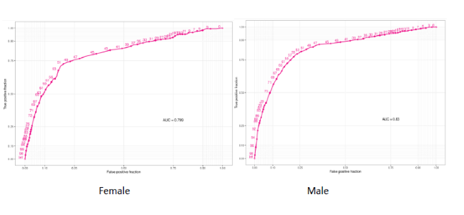

Figure 1a: Plot showing AUC for participants based on age categories

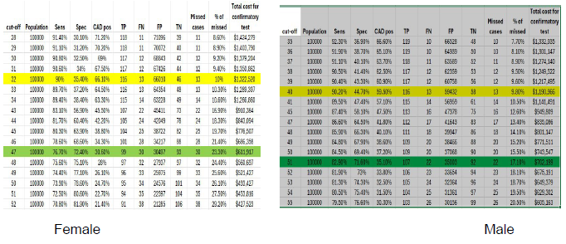

Figure 1b: Picture of CAD4 cut off for participants based on gender

The figure shows that at the suggested CAD4 threshold cutoffs of 32 for females (missed TB cases were 13, True Positive (TP) 116, and attracted about 1,322,528 dollars for confirmatory tests) and 40 for males (missed TB cases were 13, True Positive (TP) 116, and attracted about 1,190,966 dollars for confirmatory tests), they correspond, respectively, to a sensitivity of approximately 90%.

Table 2: Distribution of AUC, sensitivity, specificity and CAD4 score of participants based on Location/setting
Variables | Sensitivity % | Specificity % | CAD4 Score | AUC (95% CI)
Health Facility
Sen (approx. 90%) ‖ Spec | 90.50 | 53.10 | 47 | 0.813 (0.771 – 0.855)
Sen ‖ Spec (approx. 70%) | 81.00 | 70.30 | 57 | 0.813 (0.771 – 0.855)
Slum
Sen (approx. 90%) ‖ Spec | 90.90 | 40.40 | 43 | 0.781(0.763 – 0.799)
Sen ‖ Spec (approx. 70%) | 75.00 | 70.00 | 55 | 0.781(0.763 – 0.799)
General population
Sen (approx. 90%) ‖ Spec | 90.80 | 23.30 | 11 | 0.756(0.724 – 0.788)
Sen ‖ Spec (approx. 70%) | 67.80 | 69.70 | 45 | 0.756(0.724 – 0.788)
Camp
Sen (approx. 90%) ‖ Spec | 87.00 | 18.80 | 38 | 0.724(0.571 – 0.877)
Sen ‖ Spec (approx. 70%) | 73.90 | 50.20 | 41 | 0.724(0.571 – 0.877)
Hard to Reach
Sen (approx. 90%) ‖ Spec | 90.30 | 65.20 | 48 | 0.854(0.834 – 0.874)
Sen ‖ Spec (approx. 70%) | 87.40 | 70.80 | 51 | 0.854(0.834 – 0.874)
Correctional centre
Sen (approx. 90%) ‖ Spec | 90.20 | 37.50 | 37 | 0.795(0.762 – 0.827)
Sen ‖ Spec (approx. 70%) | 77.30 | 70.80 | 49 | 0.795(0.762 – 0.827)
*Sen – Sensitivity *Spec - Specificity

Table 2 displays the distribution of AUC values for participants categorized by their locations or settings. The AUC was high for all locations/settings. The AUC ranged from 0.724 for those in camp to 0.854 for those in hard-to-reach areas. 0.830 versus 0.799). The CAD4 threshold cutoffscores were Camp 38 (Sen 87.00%, Spec 18.80%), Correctional Centre 37 (Sen 92.20%, Spec 37.50%), Hard to Reach 48 (Sen 90.30%, Spec 65.20%), Slum 43 (Sen 90.90%, Spec 40.40%), and Health Facility 47 (Sen 90.50%, Spec 53.10%).
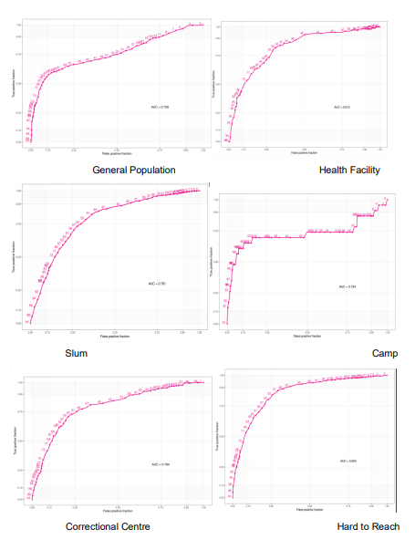

Figure 2a: Plot showing AUC for participants based on settings/location

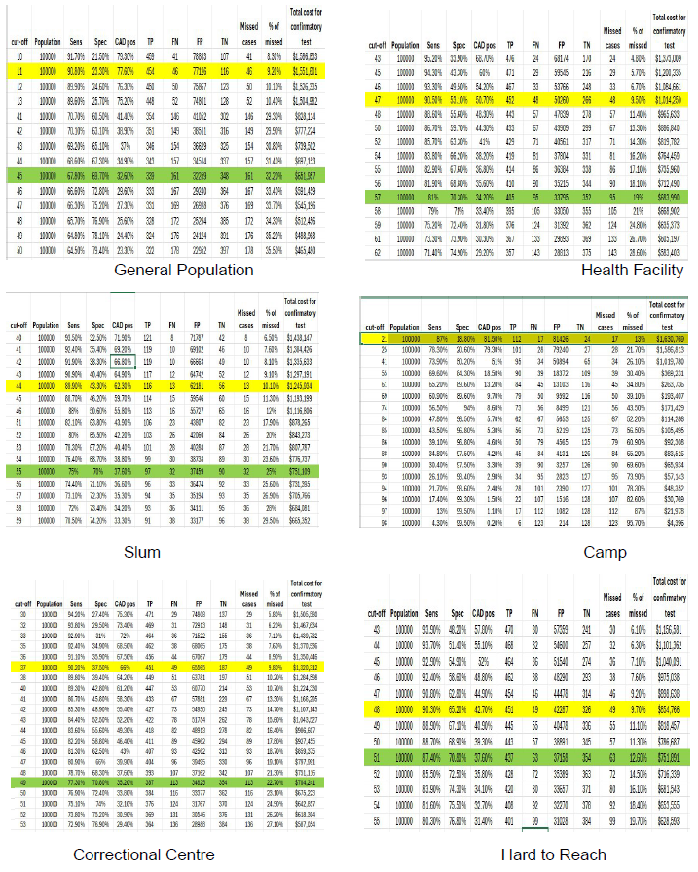

Figure 2b: Picture of CAD4 cut off for participants based on settings/location

The figure shows that at the suggested CAD4 Threshold cut Off scores of 38 for Camp (missed TB cases was 17, True Positive (TP) 112 and attracted about 1,630,769 dollars for confirmatory test), 37 for Correctional centre (missed TB cases was 49, True Positive (TP) 451 and attracted about 1,300,312 dollars for confirmatory test), 48 for Hard to Reach (missed TB cases was 49, True Positive (TP) 451 and attracted about 854,766 dollars for confirmatory test), 43 for Slum (missed TB cases was 13, True Positive (TP) 116 and attracted about 1,245,934 dollars for confirmatory test), and 47 for Health Facility (missed TB cases was 43, True Positive (TP) 452 and attracted about 18,380 dollars for confirmatory test), corresponding respectively to sensitivity of approximately 90%.

Table 3: Distribution of AUC, sensitivity, specificity and CAD4 score of participants based on previous treatment for TB
Variables | Sensitivity % | Specificity % | CAD4 Score | AUC (95% CI)
Yes
Sen (approx. 90%) ‖ Spec | 91.00 | 41.90 | 48 | 0.758(0.694- 0.812)
Sen ‖ Spec (approx. 70%) | 69.70 | 70.20 | 69 | 0.758(0.694- 0.812)
No
Sen (approx. 90%) ‖ Spec | 90.60 | 39.00 | 36 | 0.812(0.765 – 0.867)
Sen ‖ Spec (approx. 70%) | 80.10 | 71.00 | 49 | 0.812(0.765 – 0.867)
*Sen – Sensitivity *Spec - Specificity
Table 3 shows the distribution of AUC of participants based on previous treatment for TB. The AUC for those who previously had TB was lower than those who never had TB before (0.758 versus 0.812). However, the CAD4 Threshold cut off for those that previously had TB 48 (Sen 91.00%, Spec 41.90%) is greater than those that never had TB before 36 (Sen 90.60%, Spec 39.00%). For those that previously had TB the missed cases were 0, True Positive (TP) 1 for sensitivity of approximately 90% and missed cases also of 0; TP 1 for specificity of approximately 70%. For those that never had TB before the missed cases were 2, True Positive (TP) 18 for sensitivity of approximately 90% and missed cases 4; TP 16 for specificity of approximately 70%.
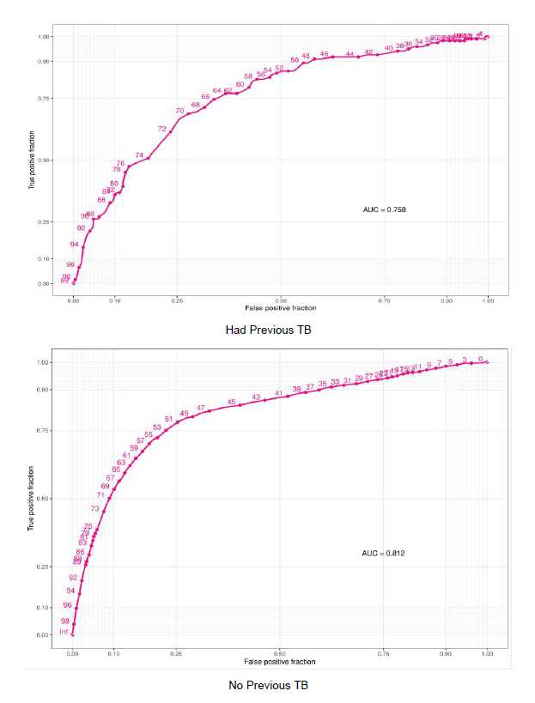

Figure 3a: Plot showing AUC for participants based on history of TB

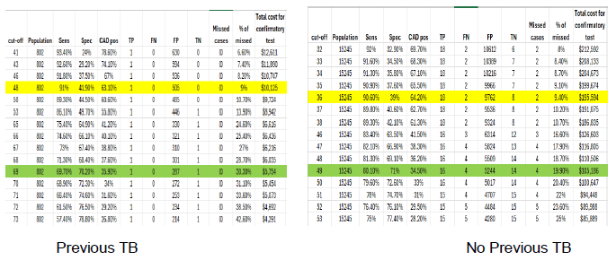

Figure 3b: Picture of CAD4 cut off for participants based on history of TB

The figure shows that at the suggested CAD4 Threshold cut Off scores of 48 for those that previously had TB (missed TB cases was <1 , True Positive (TP) 1 and attracted about 10,125 dollars for confirmatory test) and 36 for those that never had TB before (missed TB cases was 2, True Positive (TP) 18 and attracted about 195,594 dollars for confirmatory test), corresponding respectively to sensitivity of approximately 90%.
Discussion of Findings
The current study revealed that 10.9% of individuals have TB disease, and 5.0% have undergone previous TB treatment. A similar study in Zambia had a similar prevalence of microbiologically confirmed TB among those with and without a history of previous TB, at 12.4% and 16.9%, respectively (Kagujje et al., 2023). The mean CAD4 score was significantly higher in those previously treated for TB than in those not previously treated (48.38 versus 45.32). The CAD threshold cutoff score was 48 for previous treatment (sensitivity of 91.0%, specificity of 41.9%) with an AUC of 0.76 and 36 for no previous treatment for TB CAD4 (sensitivity of 90.60%, specificity of 39%) with an AUC of 0.81. The finding is in agreement with the WHO report, which documented that patients with previous TB due to scarring in the lungs are less accurate compared to new cases (World Health Organization, 2021a). In contrast to the current study, a retrospective analysis of data from a cross-sectional active TB in Zambia CAD4TB, sensitivity and specificity were 89.3% (95% CI: 78.1–96.0%) and 24.0% (19.9–28.5%) and 90.5% (86.1–93.3%) and 60.3% (57.4–63.0%) among those with and without a TB history, respectively. In line with the current study, the performance of CAD systems as TB triage tools is lower among people previously treated for TB (Kagujje et al., 2023). A study on the accuracy of computer-aided chest X-ray screening in Kenya found that Sensitivity and specificity were lower for smear-negative pulmonary tuberculosis (Khan et al., 2020). The same study documented that the positive predictive value was significantly lower among those with a previous history of tuberculosis. A study that investigated the parameters affecting the performance accuracy of versions 6 and 7 of CAD4TB in TB screening programs in South Africa and Lesotho stated that individuals with a previous history of TB showed lower performance. Both versions showed significantly worse performance in people with a prior history of TB. For version 6, the AUC is 0.68 for those with previous TB and 0.87 for the rest (p < 0.01). For version 7, the corresponding figures are 0.76 and 0.89 (p < 0.01) (Nzimande et al., 2025). “Among persons with a history of TB, the optimum thresholds for achieving at least 90% sensitivity differed substantially by sex. Substantial differences in specificity between men and women (irrespective of prior TB history) were observed with both CAD software systems when a fixed threshold approximating 90% sensitivity in the overall study population was applied. This likely reflects, in large part, the trade-off between sensitivity and specificity at a fixed abnormality threshold, as the AUROCs for these subgroups were similar. However, prior studies from Bangladesh and Kenya found lower CAD accuracy for TB among women than among men” (Gelaw et al., 2023; Kagujje et al., 2023). Reduced CAD accuracy among women could, in part, be due to breast attenuation in some women, which reduces visualization of pertinent anatomy in the lower lung zones, especially if post-TB scarring is also present (Kagujje et al., 2023). “Report has it that in some settings, over 80% of patients earlier treated for TB have post-pulmonary TB radiological changes, which very frequently include cavitation, volume loss, and fibrosis” (Lema et al., 2025; Urbanowski et al., 2020). As a result of their condition, when such individuals present for care, it may be difficult to differentiate whether radiological changes are due to previous TB sequelae or a new active TB episode, even for expert radiologists. Consequently, this can result in overtreatment of patients for TB, lead to avoidable exposure to anti-TB therapy, result in failure to treat the true cause of illness, and waste limited health resources. Furthermore, given that post-TB radiographic sequelae change the lung shape and texture, similar to active TB, the performance of CAD for TB screening/triaging may be altered. “Although CAD did not meet WHO sensitivity and specificity standards and performed more poorly in some subgroups, it might still be a useful screening tool that could detect not only people with microbiologically proven tuberculosis but also those who are perhaps infectious. Likewise, despite modest specificity and a high false positivity rate, a context-specific CAD-directed strategy could still be cost-saving, especially during large-scale screening. Findings from this study have informed those engaged in future community-based calibration studies, national tuberculosis programs, and global health bodies involved in tuberculosis care and prevention, to disrupt the tuberculosis transmission cycle and end tuberculosis” (Scott et al., 2025). Even though CAD4TB only reported a CAD score and a two-fold classification of whether tuberculosis was probably present, other CAD software programs could detect lung abnormalities, such as cavities, and identify potentially infectious individuals. This formed an important basis for future research. The study had several strengths. For instance, it focused on a community-based population that utilized the test and included participants with and without cough who met other screening criteria for TB testing. The findings had wide generalizability for the use of CAD4TB in population screening settings. This enabled the study to assess threshold identification across countries and subgroups. The thresholds identified in the study could serve as a starting point, though updated versions of CAD algorithms may require reassessment. Subgroup analyses were also conducted, including age, gender, setting or location, and previous TB status.
“A limitation of the study was that the analysis focused solely on one specific CAD software. It was unknown whether the observed variation between CAD4TB versions applied to other image interpretation algorithms used for TB screening” (Fehr & Wong, 2022). Another limitation was the use of a case–control design, which might have introduced biased estimates of CAD diagnostic accuracy. The study included participants aged 15 years and older. It therefore could not comment on the diagnostic accuracy of CAD in children and young adolescents—an important population contributing approximately 5–10% of the global tuberculosis burden (Scott et al., 2024). However, the WHO recommended CAD only as a screening or triage tool for individuals aged 15 years and above. Additionally, the model did not account for potential long-term benefits of early TB detection or the effects of missed TB cases on onward transmission and the development of new infections. These factors should be considered in future studies using empirical data or more detailed modeling, as they could influence the overall cost-effectiveness of these strategies.
Conclusion
Understanding threshold selection and contextually specific settings is paramount to enable wider adoption of this CAD product as an effective triaging and screening tool for tubercolosis. The rapid updates of CAD programmes and CAD software versions call for continued investigation and assessment of performance accuracy to ascertain variation and necessary threshold adjustments to ensure the optimal global impact of this AI technology. In addition to performance accuracy investigation, such evaluations enable users to gain an evidence-based understanding of the programmatic implications of these updates, allowing studies to be planned to optimise CAD performance capabilities.
Recommendations
Based on the discussion of findings and conclusions of this study, the following recommendations are put forward:
1. National Tuberculosis Programme should adopt a stratified screening algorithm that uses a higher CAD threshold for individuals with a history of previous TB and a lower threshold for those without.
2. Given the rapid evolution of CAD algorithms and the significant performance variations between versions and populations, it is recommended to institutionalise a routine re-evaluation process. This protocol should mandate local pilot testing and threshold calibration for every new version of CAD software before wide-scale deployment.

COMPETING INTERESTS DISCLAIMER:
Authors have declared that they have no known competing financial interests OR non-financial interests OR personal relationships that could have appeared to influence the work reported in this paper.
Disclaimer (Artificial intelligence)
Author(s) hereby declare that NO generative AI technologies such as Large Language Models (ChatGPT, COPILOT, etc.) and text-to-image generators have been used during the writing or editing of this manuscript.

References
Chakraborty, A., & Jayawickrama, J. (2024). History of tuberculosis and contemporary challenges. In A Brief Social History of Tuberculosis (pp. 10-24). Routledge.
Creswell, J., Sahu, S., Blok, L., Bakker, M. I., Stevens, R., &Ditiu, L. (2014). A multi-site evaluation of innovative approaches to increase tuberculosis case notification: Summary results. PLoS ONE, 9, e111344. https://doi.org/10.1371/journal.pone.0111344
Farhat, M., Cox, H., Ghanem, M., Denkinger, C. M., Rodrigues, C., Abd El Aziz, M. S., ... & Pai, M. (2024). Drug-resistant tuberculosis: a persistent global health concern. Nature Reviews Microbiology, 22(10), 617-635.
Fehr, J., & Wong, E. B. (2022). Similar performances but markedly different triaging thresholds in three CAD4TB versions risk systematic errors in TB screening programs. medRxiv, 2022-04.
Fehr, J., Konigorski, S., Olivier, S., Gunda, R., Surujdeen, A., Gareta, D., Smit, T., Baisley, K., Moodley, S., Moosa, Y., Hanekom, W., Koole, O., Ndung'u, T., Pillay, D., Grant, A. D., Siedner, M. J., Lippert, C., Wong, E. B., & Vukuzazi Team (2021). Computer-aided interpretation of chest radiography reveals the spectrum of tuberculosis in rural South Africa. NPJ digital medicine, 4(1), 106. https://doi.org/10.1038/s41746-021-00471-y
Frascella, B., Richards, A. S., Sossen, B., Emery, J. C., Odone, A., Law, I., Onozaki, I., Esmail, H., & Houben, R. M. G. J. (2021). Subclinical tuberculosis disease: A review and analysis of prevalence surveys to inform definitions, burden, associations, and screening methodology. Clinical Infectious Diseases, 73(3), e830–e841. https://doi.org/10.1093/cid/ciaa1402
Fukunaga, R., Glaziou, P., Harris, J. B., Date, A., Floyd, K., & Kasaeva, T. (2021). Epidemiology of Tuberculosis and Progress Toward Meeting Global Targets - Worldwide, 2019. MMWR. Morbidity and mortality weekly report, 70(12), 427–430. https://doi.org/10.15585/mmwr.mm7012a4.
Gelaw, S. M., Kik, S. V., Ruhwald, M., Ongarello, S., Egzertegegne, T. S., Gorbacheva, O., ... & Denkinger, C. M. (2023). Diagnostic accuracy of three computer-aided detection systems for detecting pulmonary tuberculosis on chest radiography when used for screening: Analysis of an international, multicenter migrants screening study. PLOS Global Public Health, 3(7), e0000402.
Geric, C., Qin, Z. Z., Denkinger, C. M., Kik, S. V., Marais, B., Anjos, A., David, P. M., Ahmad Khan, F., & Trajman, A. (2023). The rise of artificial intelligence reading of chest X-rays for enhanced TB diagnosis and elimination. The international journal of tuberculosis and lung disease : the official journal of the International Union against Tuberculosis and Lung Disease, 27(5), 367–372. https://doi.org/10.5588/ijtld.22.0687
Kagujje, M., Kerkhoff, A. D., Nteeni, M., Dunn, I., Mateyo, K., &Muyoyeta, M. (2023). The performance of computer-aided detection digital chest X-ray reading technologies for triage of active tuberculosis among persons with a history of previous tuberculosis. Clinical Infectious Diseases, 76(3), e894–e901. https://doi.org/10.1093/cid/ciac679
Khan, F. A., Majidulla, A., Tavaziva, G., Nazish, A., Abidi, S. K., Benedetti, A., Menzies, D., Johnston, J. C., Khan, A. J., & Saeed, S. (2020). Chest X-ray analysis with deep learning-based software as a triage test for pulmonary tuberculosis: A prospective study of diagnostic accuracy for culture-confirmed disease. The Lancet Digital Health, 2(11), e573–e581. https://doi.org/10.1016/S2589-7500(20)30221-1
Lema, R. E., Shayo, G. A., Nkrumbih, Z., & Nagu, T. J. (2025). Change in lung function abnormalities in patients treated for first ever pulmonary tuberculosis in Dar es Salaam, Tanzania. Journal of clinical tuberculosis and other mycobacterial diseases, 40, 100538. https://doi.org/10.1016/j.jctube.2025.100538.
Macpherson L, Miller C, Hamada Y, Rangaka L, Ruhwald M, Falzon D, et al. (2025). Policies, practices, opportunities and challenges for tuberculosis screening: a global survey of national tuberculosis programmes. BMJ Global Health;10:e016000. https://doi.org/10.1136/bmjgh-2024-016000
Nzimande, N., Murphy, K., Reither, K., Bosman, S., Ayakaka, I., Glass, T. R., ... & Ncayiyana, J. (2025). Performance of CAD4TB artificial intelligence technology in TB screening programmes among the adult population in South Africa and Lesotho. Journal of Clinical Tuberculosis and Other Mycobacterial Diseases, 100540.
Olaleye, S. A., Balogun, O. S., & Adusei-Mensah, F. (2023). Bibliometric structured review of tuberculosis in Nigeria. African Health Sciences, 23(2), 139–160.
Onozaki, I., Law, I., Sismanidis, C., Zignol, M., Glaziou, P., & Floyd, K. (2015). National tuberculosis prevalence surveys in Asia, 1990–2012: An overview of results and lessons learned. Tropical Medicine & International Health, 20(9), 1128–1145.
Pande, T., Vasquez, N. A., Cazabon, D., Creswell, J., Brouwer, M., Ramis, O., Stevens, R. H., Ananthakrishnan, R., Qayyum, S., Alphonsus, C., Oga-Omenka, C., Nafade, V., Sen, P., & Pai, M. (2020). Finding the missing millions: Lessons from 10 active case finding interventions in high tuberculosis burden countries. BMJ Global Health, 5(12), e003835. https://doi.org/10.1136/bmjgh-2020-003835
Qin, Z. Z., Sander, M. S., Rai, B., Titahong, C. N., Sudrungrot, S., Laah, S. N., Adhikari, L. M., Carter, E. J., Puri, L., Codlin, A. J., & Creswell, J. (2019). Using artificial intelligence to read chest radiographs for tuberculosis detection: A multi-site evaluation of the diagnostic accuracy of three deep learning systems. Scientific Reports, 9(1), 1–10. https://doi.org/10.1038/s41598-019-51503-3
Satyanarayana, S., Pretorius, C., Kanchar, A., Garcia Baena, I., Den Boon, S., Miller, C., Zignol, M., Kasaeva, T., & Falzon, D. (2023). Scaling Up TB Screening and TB Preventive Treatment Globally: Key Actions and Healthcare Service Costs. Tropical medicine and infectious disease, 8(4), 214. https://doi.org/10.3390/tropicalmed8040214.
Scott, A. J., Perumal, T., Hohlfeld, A., Oelofse, S., Kühn, L., Swanepoel, J., Geric, C., Ahmad Khan, F., Esmail, A., Ochodo, E., Engel, M., & Dheda, K. (2024). Diagnostic Accuracy of Computer-Aided Detection During Active Case Finding for Pulmonary Tuberculosis in Africa: A Systematic Review and Meta-analysis. Open forum infectious diseases, 11(2), ofae020. https://doi.org/10.1093/ofid/ofae020
Scott, A. J., Perumal, T., Pooran, A., Oelofse, S., Jaumdally, S., Swanepoel, J., Gina, P., & Mthiyane, T. (2025). Clinical evaluation of computer-aided digital X-ray detection of pulmonary tuberculosis during community-based screening or active case-finding: A case–control study. The Lancet Global Health, 13(3), e517–e527. https://doi.org/10.1016/S2214-109X(24)00516-3
Soares, T. R., de Oliveira, R. D., Liu, Y. E., Silva Santos, A. D., Santos, P. C. P. D., Monte, L. R. S., ... & Croda, J. (2021). Evaluation of chest X-Ray with automated interpretation algorithms for mass tuberculosis screening in prisons. medRxiv, 2021-12.
Tiberi, S., Du Plessis, N., Walzl, G., Vjecha, M. J., Rao, M., Ntoumi, F., ... & Zumla, A. (2018). Tuberculosis: progress and advances in development of new drugs, treatment regimens, and host-directed therapies. The Lancet Infectious Diseases, 18(7), e183-e198.
Urbanowski, M. E., Ordonez, A. A., Ruiz-Bedoya, C. A., Jain, S. K., & Bishai, W. R. (2020). Cavitary tuberculosis: the gateway of disease transmission. The Lancet. Infectious diseases, 20(6), e117–e128. https://doi.org/10.1016/S1473-3099(20)30148-1
World Health Organization. (2021). Determining the local calibration of computer-assisted detection (CAD) thresholds and other parameters: A toolkit to support the effective use of CAD for TB screening. https://apps.who.int/iris/handle/10665/345122
Yadav, R. N., Verma, A. K., & Kaushik, G. (2022). Laboratory Cost Analysis of Conventional and Newer Molecular Tests for Diagnosis of Presumptive Multidrug-Resistant Tuberculosis Patients. Journal of global infectious diseases, 14(3), 93–98. https://doi.org/10.4103/jgid.jgid_309_21
Zaidi, S. M. A., Habib, S. S., Van Ginneken, B., Ferrand, R. A., Creswell, J., Khowaja, S., & Khan, A. (2018). Evaluation of the diagnostic accuracy of computer-aided detection of tuberculosis on chest radiography among private sector patients in Pakistan. Scientific Reports, 8(1), 1–9. https://doi.org/10.1038/s41598-018-30810-1.

