AUTOIMMUNE HEMOLYTIC ANEMIA REVEALING SARCOIDOSIS: A CASE REPORT

Abstract

Hematological involvement in sarcoidosis is often characterized by lymphopenia and splenomegaly. However, auto-immune hemolytic anemia associated with sarcoidosis is scarcely reported. Herein, we report a novel case of this unusual clinical presentation.
A 40-year-old female was admitted for a normocytic and regenerative anemia. The Coombs test was positive for anti-IgG attesting of its auto-immune origin. The CT scan showed multiple mediastinal and abdominal lymphadenopathies and a bilateral interstitial pattern in the lung. Further investigations were negative for infectious diseases, malignancies and auto-immune diseases. Labial biopsy showed the presence of a non-caseating granulomatosis supporting the diagnosis of systemic sarcoidosis. The association between the two conditions was deemed fortuitus. Oral steroids were used to achieve remission for both sarcoidosis and auto-immune hemolytic anemia.
Keywords:
Sarcoidosis, Autoimmune hemolytic anemia, autoimmunity.
Introduction:
Systemic sarcoidosis is an ubiquitous disease involving multiples organs. Its pathogenesis is still not fully understood. [1] A hallmark of the disease is the presence of noncaseating granulomas in involved organs. Mediastinal and pulmonary involvement are the most common presentations. The extra-thoracic localizations are diverse and dominated by ocular, cutaneous, peripheral lymph nodes and hepatic damage. Hematological involvement is widely represented by lymphopenia and splenomegaly.
Autoimmune hemolytic anemia (AIHA) is an acquired hemolysis caused by the host’s immune system acting against its own red cell antigens. AIHA might be primary or secondary, depending on the presence of an underlying condition promoting immune dysregulation [2].
AIHA associated with sarcoidosis has been rarely reported. In this report we describe a novel case of AIHA leading to the diagnosis of systemic sarcoidosis.

Case presentation:
A 40-year-old woman with no significant medical history, presented with an asthenia and dyspnea. She had a Body Mass Index of 13.67 Kg/m2 (weight of 35 Kg and size of 1.6 m), paleness and vitiligo. The clinical examination was unremarkable otherwise. Complete blood count showed normocytic regenerative anemia (hemoglobin of 5.2 g/dL, mean corpuscular volume of 95 fl, reticulocyte count of 150000/mm3), thrombocytopenia (platelet count of 78,000/mm3) and lymphopenia (lymphocytes of 1200/mm3). Serum total bilirubin was above normal range at 5.2 mg/l and serum lactate hydrogenase was at 212 UI/l. Peripheral blood smear was normal. Diagnosis of AIHA was established given high reticulocytes count and positive direct Coombs test with the presence of IgG antibodies (+++).
Thyroid function test was normal. C-reactive Protein, renal function and aminotransferases were within normal range. Gamma-glutamyl-transferase and alkaline phosphatase were twice the normal rate. Calcium and phosphate levels were respectively 2.51mmol/l and 0.78 mmol/l. Serum protein electrophoresis showed polyclonal gammopathy of 20g/l. There was neither hypercalciuria nor proteinuria. Aseptic leucocyturia of 250000/ml was noted with no other detectable abnormality. Serum ferritin was of 94 ng/ml, vitamin B12 of 706 pmol/l and folate of 20 nmol/l. Viral serology for HBV, HCV and HIV were negative. ANA, anti-ENA, anti-DNA, anti-cardiolipins and anti-B2GP1 were negative as well as anti-smooth muscle, anti-mitochondrion and anti-LKM1 antibodies. C3, C4 and CH50 Complement levels were within the normal range.
The chest X-ray showed mediastinal enlargement associated with bilateral interstitial syndrome (Figure 1).
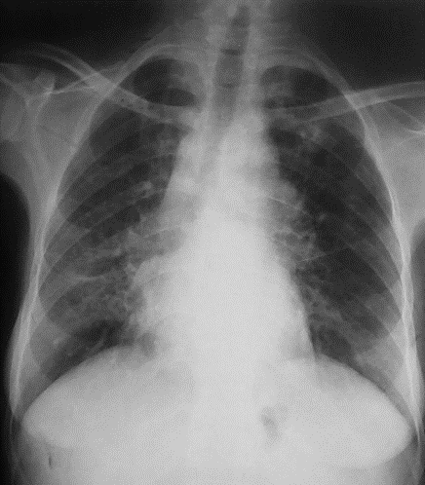

Figure 1. Chest X-ray showing mediastinal enlargement associated with bilateral interstitial syndrome.

Computed tomography of the chest, abdomen and pelvis highlighted the presence of multiple mediastinal lymphadenopathies and reticulonodular interstitial pattern of the lung (Figures 2 and 3).

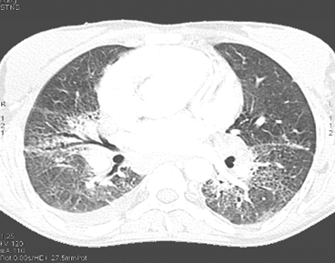
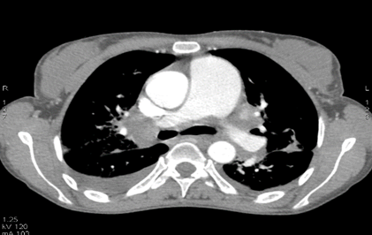

Figure 2. CT scan showing multiple mediastinal lymphadenopathies Figure 3. CT scan showing reticulonodular interstitial pattern of the lung.

Tuberculin skin test was negative as well as the sputum smears for acid-fast bacilli. The bone marrow biopsy was normal. Lymph node biopsy was not performed as the size of the mediastinal lymphadenopathies was 14 mm for the largest one. The angiotensin converting enzyme level was normal of 15 UECA. Spirometry showed a severe restrictive syndrome with reduced Forced Vital Capacity (FVC) at 38%, reduced Forced Expiratory Volume 1 (FEV 1) at 43% and a normal ratio FEV1/FVC of 97%. Bronchoscopic inspection was normal. The study of the bronchial fluid showed a lymphocytic alveolitis with 24.2% lymphocytes and CD4/CD8 ratio at 1,1. No malignant cells were seen in cytology. Cervical ultrasound revealed normal sized but heterogeneous parotids. The parotid MRI showed bilateral cystic formations (Figure 4).
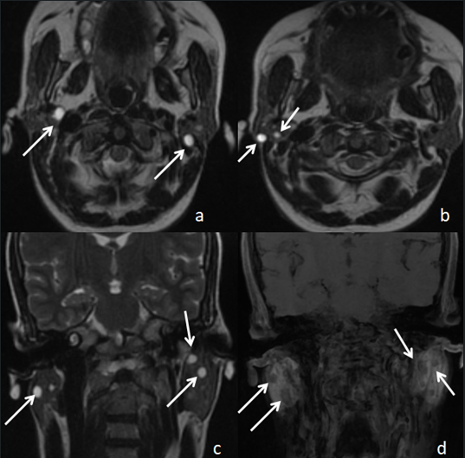
Figure 4. Parotid MRI showing bilateral cystic formations. T2-weighted sequences in the axial plane (a, b) and coronal plane (c), and T1-weighted sequence after Gadolinium injection in the coronal plane (d), showing bilateral intra-parotid cystic lesions, millimeter-sized, with low signal on T1, high signal on T2, not enhanced after Gadolinium injection (arrows).

The diagnosis of sarcoidosis was highly suspected. Histological examination of salivary glands revealed non-necrotizing granulomatous inflammation which was highly compatible with the diagnosis of sarcoidosis (Figure 5).

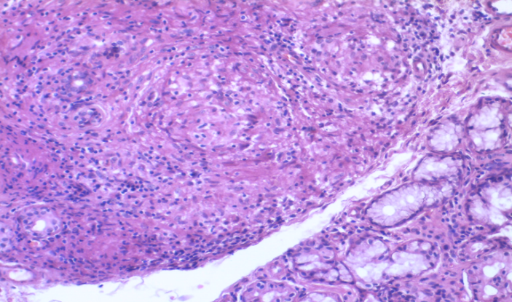

Figure 5. Histological examination of salivary glands revealing non-necrotizing granulomatous inflammation.

The diagnosis of sarcoidosis associated with autoimmune hemolytic anemia was retained. The lymphopenia in our patient is related to the sarcoidosis. However, the mechanism of the thrombopenia was initially uncertain: either secondary to hypersplenism or related to an auto-immune origin defining the Evans syndrome (seeing the association with an AIHA).
The patient was treated with oral prednisone at a dose of 1 mg/kg/day during four weeks with subsequent tapering. The outcome was favorable with clinical improvement and normalization of the hemoglobin level to 12.2 g/dl and rise in the platelet count to 137000/ mm³. The diagnosis of sarcoidosis associated with Evans syndrome was the most likely.
After 5-year-follow-up, no relapses were reported.

DISCUSSION:

It is well known that the diagnosis of sarcoidosis depends on clinical and radiological presentation, evidence of noncaseating granuloma, and exclusion of alternative disease. As sarcoidosis shares multiple clinical and biological features with several diseases, its diagnosis can be challenging [1,3].
The incidence of sarcoidosis in association with other autoimmune diseases is underestimated. In Taiwan, the study of Chi-Hung Wu including a total of 1237 patients with sarcoidosis revealed that they tended to be at higher risk of autoimmune comorbidities than the control group (17.6% vs 9.4%, P < 0.05). Autoimmune thyroid disease, Sjögren's syndrome and ankylosing spondylitis were significantly associated with sarcoidosis [4]. However, the association between sarcoidosis and AIHA is exceptional [5].
The etiopathogenesis of sarcoidosis is still unknown. The most widely accepted hypothesis assumes one or more environmental antigens, bacterial or other, as potential triggers [1]. Genetic susceptibility has also been suspected; HLA-DRB1*04/*15 has been associated with extrapulmonary sarcoidosis [6, 7]. The triggering antigen in sarcoidosis or other autoimmune diseases leads to preferential induction of Th-1 type CD4 cells and down regulation of Th-2 type cells which, in theory, gives rise to potential autoimmunity [8].
Recently, it has been shown that Th17+/CD4+T cells are increased in sarcoidosis granulomatous tissue and peripheral blood [9]. After stimulation of naive T cells by antigen presenting cells and differentiation into CD4+ cells, the macrophages are activated by secretion of mediators, such as tumor necrosis factor (TNF)-α, interleukin (IL) -2, IL-12, IL-17 and interferon (INF)-γ, which induces the formation of granulomas. Depending on the inflammatory environment, granulomas can persist, regress, or organize through migration of fibroblasts, which can cause progressive tissue fibrosis [9].
AIHA may precede or occur at any stage during the follow-up of sarcoidosis. However, it is unclear whether it is a coincidence or if there is a possible pathogenic link [5].
The first line treatment in AIHA consists of steroids. Second-line therapy includes immunosuppressives, cytotoxic agents, splenectomy, and intravenous globulin [11].
In sarcoidosis, treatment depends on clinical presentation. In our patient, oral steroids were sufficient to achieve remission.

Conclusion:
Further studies aiming at identifying the antigens involved in the genesis of sarcoidosis may be necessary for a better understanding of the possible link between sarcoidosis and AIHA as well as a better management of sarcoidosis.

Disclaimer (Artificial intelligence)
Option 1:
Author(s) hereby declare that NO generative AI technologies such as Large Language Models (ChatGPT, COPILOT, etc.) and text-to-image generators have been used during the writing or editing of this manuscript.
Option 2:
Author(s) hereby declare that generative AI technologies such as Large Language Models, etc. have been used during the writing or editing of manuscripts. This explanation will include the name, version, model, and source of the generative AI technology and as well as all input prompts provided to the generative AI technology
Details of the AI usage are given below:
1.
2.
3.

References:
1.Korstena P, Tampea B, Konigb MF, Nikiphorou E. Sarcoidosis and autoimmune diseases: differences, similarities and overlaps. Sarcoidosis and autoimmune diseases. CurrOpinPulm Med. 2018; 24:504–512.
2. Hill Q, Hill A, Berentsen S. Defining autoimmune hemolytic anemia: a systematic review of the terminology used for diagnosis and treatment. Blood advances. 2019; 3:1897-1906.
3. Jeny F, Bouvry D, Freynet O, Soussan M,Brauner M, Planes C et al. Management of sarcoidosis in clinical practice. Frontiers in clinical practice sarcoidosis. Eur Respir Rev. 2016; 25: 141–150.
4. Chi-Hung WU, Pei-I. CHUNG, Chen-Yi WU, Yen-Ta CHEN, Yun-Wen CHIU, Yun-Ting CHANG et al. Comorbid autoimmune diseases in patients with sarcoidosis: A nationwide case–control study in Taiwan. Journal of Dermatology. 2016: 1–8.
5. Damak C, Snoussi M, Frikha F, Chebbi D, Jallouli M, Ben Salah R et al. Sarcoidosis and autoimmune hemolytic anemia: is there a pathogenic link? Electronic Journal of General Medecine. 2020;17(1):e169.
6. David R. Moller, Ben A. Rybicki, Nabeel Y. Hamzeh, Courtney G. Montgomery, Edward S. Chen1, Wonder Drake, Andrew P. Fontenot. Genetic, Immunologic, and Environmental Basis of Sarcoidosis.Pathobiologic Basis of Sarcoidosis. AnnalsATS. 2017; 14(6):429-436.
7. Darlington P, Gabrielsen A, Sorensson P, Tallstedt L, Padyukov L, Eklund A et al. HLA-alleles associated with increased risk for extrapulmonary involvement in sarcoidosis. Tissue Antigens. 2014;83: 267–272.
8. Ghaddar RK, Muzaffar TH. Pulmunary Sarcoidosis and Autoimmune Hemolytic Anemia.Archives of Iranian Medicine. 2011; 14:146-148.
9. Facco M, Cabrelle A, Teramo A, Olivieri V,Gnoato M, Teolato S et al. Sarcoidosis is a Th1/Th17 multisystem disorder. Thorax 2011; 66:144-150.
10. Grafa L, Geiserb T. La sarcoidose. Forum Médical Suisse. 2018;18(35):695–701.
11. Chernow K,Donegan T, MilmanT and Henry D. Sarcoidosis, complete heart block, and warm autoimmune hemolytic anemia in ayoung woman. The journal of community and supportive oncology. 2015;13:159-161.

