Hypomagnesemia in Type 2 Diabetes Mellitus: Correlation with Glycemic Control and Microvascular Complications
Abstract
Background: Low magnesium levels contribute to defective tyrosine-kinase activity, post-receptor impairment of insulin action, and aggravated insulin resistance in patients with Type 2 Diabetes Mellitus (T2DM). Hypomagnesemia has also been linked to the development of microvascular and macrovascular complications such as neuropathy, retinopathy, and cardiovascular disease.
Methods: This study included patients with a history of T2DM who attended the clinic and fulfilled eligibility criteria. Patients were diagnosed according to ADA/WHO guidelines and had regular hospital follow-up for at least one year. A detailed clinical history was obtained, including duration of diabetes, treatment type, and symptoms such as blurring of vision, tingling, numbness, burning sensation, frothing of urine, and pedal oedema. Past history of coronary artery disease and cerebrovascular accidents was also recorded. Clinical examination included general assessment, body mass index (BMI), waist circumference, pulse rate, and blood pressure measurement.
Results: The study highlighted the association between hypomagnesemia and T2DM, with low magnesium levels linked to poor glycemic control and increased risk of complications. Hypomagnesemia is seen in 31.5 patients and was significantly associated with longer duration of diabetes (>10 Hypomagnesemia years: 45.2%). Poor long-term glycemic control (HbA1c >8%) was significantly associated with hypomagnesemia (37.9% vs 22.6%, p=0.02), whereas short-term control (FBS >130) showed only a trend (p=0.06).
Conclusion: Monitoring serum magnesium levels in T2DM patients is clinically important. Correction of hypomagnesemia through dietary supplementation or pharmacological replacement can improve insulin sensitivity, glycemic control, and endothelial function. Routine screening for magnesium deficiency, particularly in females and patients with long-standing diabetes, may help reduce complication risk and support timely interventions.
Keywords: insulin sensitivity, Diabetes Mellitus, glycemic control, tyrosine-kinase activity

Introduction
Diabetes is a long-term disease caused by the body's inability to process and regulate blood glucose due to excess production of insulin from the pancreas or the inability of the insulin to regulate the blood glucose levels¹. The number of DM patients was approximately 463 million adults in 2019, which have been projected to raise up to 578 million adults by 2030 and 700 million by 2045¹.
Magnesium is the fourth most abundant cation in the human body and the second most abundant cation inside the cells^{2,3}. Mg²⁺ regulates a number of physiological functions like muscle contraction, neuromuscular conduction, glycemic control, myocardial contraction, and blood pressure by acting as the cofactor for more 300 enzymatic reactions. It plays a major role in energy production, active transmembrane transport for other ions, synthesis of nuclear materials, and bone development ^{4,5}. It is a critical element in cellular proliferation and apoptosis, and an important factor in both cellular and humoral immune reactions ⁶.
Lower serum concentration of magnesium has been reported in diabetes mellitus patients compared to the nondiabetic controls^{7,8}. Many studies have reported a reverse relationship between serum magnesium levels and glycaemic control. Magnesium levels negatively correlates with serum glucose levels and glucosuria. Intracellular magnesium is involved in insulin mediated glucose uptake and vascular tone⁹. Low magnesium levels cause defective tyrosine-kinase activity, post-receptorial impairment of insulin action and aggravated insulin resistance in diabetic patients ⁹. Development of micro and macrovascular complications like neuropathy, retinopathy and cardiovascular disease in diabetes is also be linked to the prevalence of hypomagnesemia^{10,11}.
Materials and method

Study Design and Ethical Approval
This hospital-based, cross-sectional observational study was conducted in the Diabetic Clinic and Medicine Department of the hospital. Prior to initiation, approval was obtained from the Institutional Review Board and Institutional Ethics Committee. Written informed consent was obtained from all participants before enrollment.

Study Population
The study included patients with a history of Type 2 Diabetes Mellitus (T2DM) who attended the clinic and met the eligibility criteria. Patients diagnosed with T2DM according to ADA/WHO guidelines and on regular follow-up in the hospital for at least one year were included. Exclusion criteria comprised critically ill patients, those on medications known to affect serum magnesium levels, individuals with serum creatinine greater than 1.5 mg/dL, and those with acute or chronic diarrhea. Patients with thyroid or adrenal dysfunction, recent metabolic acidosis, pregnancy or lactation, or sepsis were excluded. Individuals unwilling to provide consent were also not considered for the study.

Data Collection
Data were collected using a structured proforma. A detailed clinical history was recorded, including duration of diabetes, type of treatment, blurring of vision, tingling, numbness, burning sensation, frothing of urine, pedal oedema, and past medical history of coronary artery disease and cerebrovascular accidents. Clinical examination consisted of general assessment with measurement of body mass index (BMI) and waist circumference, as well as pulse and blood pressure evaluation. Dilated fundus examination was carried out to detect diabetic retinopathy. Neurological evaluation was performed to assess peripheral neuropathy using vibration testing with a 128 Hz tuning fork, ankle jerk reflex, pinprick sensation, and the Semmes-Weinstein 5.07/10 g monofilament test.

Laboratory Investigations
Laboratory parameters included serum magnesium, fasting blood sugar (FBS), glycated hemoglobin (HbA1c), and urine albumin-creatinine ratio (ACR). Serum magnesium was estimated using the Siemens Dimension® Clinical Chemistry System with a modified methylthymol blue complexometric procedure. FBS was measured using the GLUC method, an adaptation of the hexokinase reference method. HbA1c was analyzed using the BIO-RAD D-10 HbA1c program® based on high-performance liquid chromatography (HPLC), certified by the National Glycohemoglobin Standardization Program (NGSP) as compliant with the Diabetes Control and Complications Trial (DCCT) reference method. Urine ACR was measured to assess the presence of diabetic nephropathy.

Definitions
For the purpose of this study, hypomagnesemia was defined as serum magnesium less than 1.6 mg/dL. Unsatisfactory glycemic control was defined as fasting blood sugar greater than 130 mg/dL for short-term control and HbA1c greater than 8% for long-term control. Diabetic nephropathy was diagnosed when urine ACR was 30 mg/g or higher. Normal cut-off values for obesity were taken as BMI ≤ 23 kg/m² and waist circumference < 85 cm in males and < 80 cm in females. Hypertension was defined as blood pressure greater than 140/90 mmHg or current use of antihypertensive medication.

Statistical Analysis
Data were entered into Microsoft Excel® and analyzed using the Statistical Package for Social Sciences (SPSS®). Descriptive statistics were presented as frequency distribution tables, bar charts, and pie diagrams. The Chi-square test was used to analyze categorical variables, while comparisons between continuous variables were made using the unpaired t-test. Pearson correlation coefficient analysis was used to assess associations between continuous variables. A p-value of less than 0.05 was considered statistically significant.
Results
A total of first consecutive 200 cases of Type 2 diabetic patients who attended medicine dept. and diabetic clinic, who met inclusion and exclusion criteria were enrolled in the study.

Baseline Characteristics
A total of 200 patients with T2DM were studied, of whom 113 (56.5%) were male and 87 (43.5%) were female. The mean age was 51.2 ± 11 years (range 25–78 years), with no significant gender difference. The mean duration of diabetes was 6.2 ± 4.9 years, with nearly half (44.5%) having diabetes <5 years. Overweight (BMI >23 kg/m²) was seen in 31% of patients, while central obesity (WC >85 cm in males, >80 cm in females) was present in 65.5%. Hypertension was noted in 36% of the population.
Table 1. Baseline characteristics of study population (N=200)
Variable | Male (n = 113) | Female (n = 87) | Total (%)
Age (years, mean ± SD) | 51.5 ± 11.0 | 50.9 ± 10.9 | 51.2 ± 11.0
Duration of diabetes (years, mean ± SD) | 6.1 ± 5.1 | 6.3 ± 4.7 | 6.2 ± 4.9
Overweight (BMI >23 kg/m²) | 32 (28.3) | 30 (34.5) | 62 (31.0)
Central obesity (WC high) | 69 (61.1) | 62 (71.3) | 131 (65.5)
Hypertension | 42 (37.2) | 30 (34.5) | 72 (36.0)

Prevalence of Diabetic Complications
Diabetic retinopathy was present in 97 patients (48.5%), peripheral neuropathy in 133 (66.5%), and nephropathy in 103 (51.5%). Poor short-term glycemic control (FBS >130 mg/dL) was observed in 70.5%, while poor long-term control (HbA1c >8%) was present in 58%.
Figure 1. Prevalence of diabetic complications and poor glycemic control in the study population
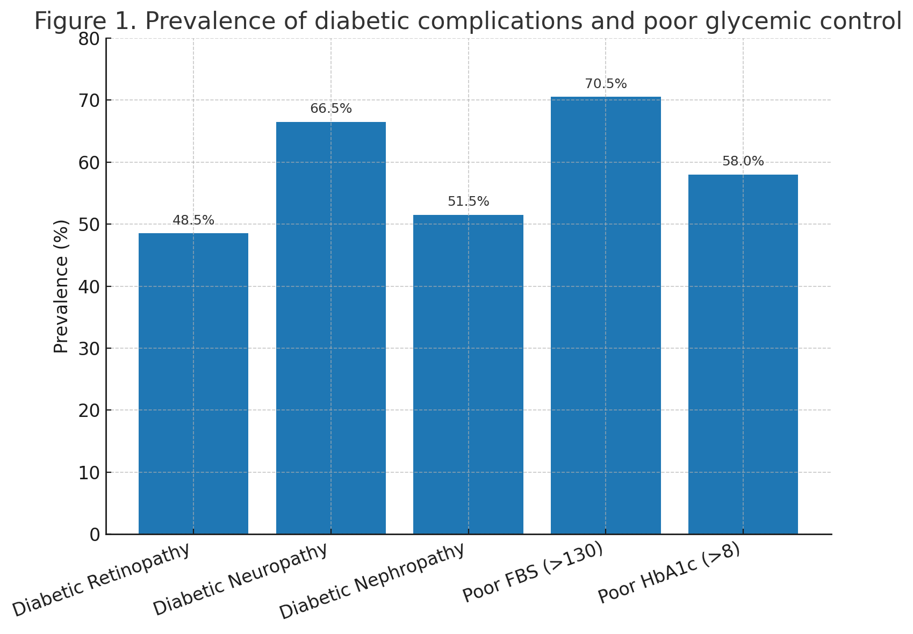

Prevalence of Hypomagnesemia
Hypomagnesemia (serum Mg <1.6 mg/dL) was seen in 63 patients (31.5%). Mean serum magnesium in the total sample was 1.7 ± 0.4 mg/dL, significantly lower in females (1.62 ± 0.35) compared to males (1.76 ± 0.37, p=0.01). Patients with hypomagnesemia had mean levels of 1.26 ± 0.18 compared to 1.89 ± 0.23 in those without (p<0.001).
Table 2. Serum magnesium levels in study population
Group | N | Mean Mg (mg/dL ± SD) | p-value
Total population | 200 | 1.70 ± 0.40 | –
Hypomagnesemia (<1.6) | 63 | 1.26 ± 0.18 | <0.001
Normal Mg (≥1.6) | 137 | 1.89 ± 0.23 | –
Males | 113 | 1.76 ± 0.37 | 0.01
Females | 87 | 1.62 ± 0.35 | –

Association of Hypomagnesemia with Clinical Variables
Hypomagnesemia was significantly associated with longer duration of diabetes (>10 years: 45.2%), female gender (41.4% vs 23.9% in males, p=0.008), diabetic retinopathy (39.2% vs 24.3%, p=0.02), diabetic neuropathy (39.1% vs 16.4%, p=0.001), and diabetic nephropathy (38.8% vs 23.7%, p=0.02). No significant association was found with BMI, waist circumference, or hypertension.
Table 3. Association of hypomagnesemia with diabetic complications
Variable | Present (%) | Absent (%) | p-value
Duration >10 years | 45.2 | 19.1 (<5 yrs) | 0.003
Female gender | 41.4 | 23.9 (males) | 0.008
Diabetic retinopathy | 39.2 | 24.3 | 0.02
Diabetic neuropathy | 39.1 | 16.4 | 0.001
Diabetic nephropathy | 38.8 | 23.7 | 0.02
High BMI | 32.3 | 31.2 (normal BMI) | 0.87
High WC | 28.2 | 37.7 (normal WC) | 0.17
Hypertension | 37.5 | 28.1 | 0.17

Correlation of Serum Magnesium with Glycemic Status and Duration
Serum magnesium showed a significant negative correlation with fasting blood sugar (r = -0.48, p<0.001), HbA1c (r = -0.44, p<0.001), and duration of diabetes (r = -0.15, p=0.036). Poor long-term glycemic control (HbA1c >8%) was significantly associated with hypomagnesemia (37.9% vs 22.6%, p=0.02), whereas short-term control (FBS >130) showed only a trend (p=0.06).
Figure 2. Correlation of serum magnesium with FBS and HbA1c
(Scatter plots showing inverse correlation trends)

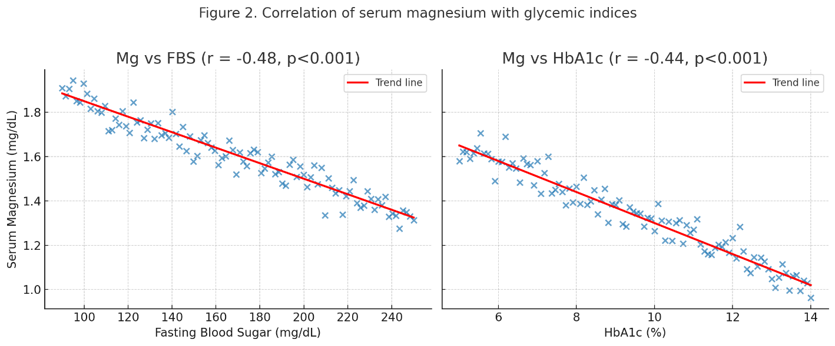
Discussion
In this study, hypomagnesemia was observed in nearly one-third of patients with Type 2 Diabetes Mellitus (T2DM), consistent with previous reports highlighting magnesium deficiency as a common metabolic disturbance in diabetes. Serum magnesium levels were significantly lower in females compared to males, and patients with hypomagnesemia demonstrated higher prevalence of chronic diabetic complications, including neuropathy, nephropathy, and retinopathy. Furthermore, magnesium levels were inversely correlated with both fasting blood sugar and HbA1c, indicating a potential link between hypomagnesemia and poor glycemic control.
Magnesium plays a critical role in glucose metabolism, acting as a cofactor for various enzymatic reactions involved in carbohydrate utilization, insulin signaling, and cellular glucose transport ¹⁰. Low serum magnesium has been associated with insulin resistance, impaired insulin secretion, and endothelial dysfunction, all of which contribute to the pathophysiology of T2DM ^{12,13}. Our finding of higher prevalence of poor glycemic control in patients with hypomagnesemia aligns with previous studies demonstrating that magnesium deficiency worsens glycemic indices and may predispose to the development of microvascular complications ^{7,14}.
The significant association between hypomagnesemia and diabetic neuropathy observed in this study is noteworthy. Magnesium deficiency has been linked to increased oxidative stress, neuronal excitability, and impaired nerve conduction, all of which contribute to peripheral neuropathy ¹⁵. Similarly, the association of hypomagnesemia with diabetic nephropathy and retinopathy in our population suggests that low magnesium may accelerate microvascular injury through its effects on vascular tone, endothelial integrity, and inflammation ¹⁶. A recent meta-analysis also confirmed that low magnesium status increases the risk of both diabetic nephropathy and retinopathy ¹⁷.
Female gender and longer duration of diabetes were significant predictors of hypomagnesemia in our cohort. These findings are in line with earlier reports suggesting that hormonal influences and chronic hyperglycaemia may increase urinary magnesium excretion, thereby predisposing females and long-standing diabetics to magnesium depletion¹⁸. Interestingly, obesity and hypertension did not show significant associations with hypomagnesemia in this study, although previous literature has suggested a potential link ¹⁹. This discrepancy may be due to differences in study population, cut-off definitions, and sample size.
Overall, our findings reinforce the clinical importance of monitoring serum magnesium in T2DM patients. Correction of hypomagnesemia through dietary supplementation or pharmacological replacement has been shown to improve insulin sensitivity, glycemic control, and endothelial function ^{20,21}. Routine screening for magnesium deficiency, especially in females and patients with long-standing diabetes, may help identify individuals at risk for complications and allow for timely interventions.
In addition to magnesium, other electrolytes such as sodium, potassium, calcium, and chloride are also affected in patients with Type 2 Diabetes Mellitus. Several studies have demonstrated that diabetes and its treatments influence electrolyte homeostasis, which in turn contributes to metabolic disturbances and vascular complications. Hyponatremia and hypernatremia have both been reported in diabetic patients due to osmotic diuresis and altered renal handling of sodium ²². Potassium disturbances are common in poorly controlled diabetes, particularly in patients on insulin therapy, leading to hypokalemia or hyperkalemia depending on the clinical context ²³. Altered calcium metabolism has also been implicated in the progression of vascular complications and impaired insulin secretion ²⁴. Likewise, disturbances in chloride levels have been associated with acid–base imbalance in diabetes ²⁵.
Taken together, these findings emphasize that while hypomagnesemia is a significant concern, comprehensive monitoring of electrolyte balance in diabetic patients may provide better insights into disease progression and prevention of complications.

Limitations
The study was hospital-based with a modest sample size, which may limit generalizability. Serum magnesium alone was measured, while ionized or intracellular magnesium levels may provide better assessment of magnesium status. Furthermore, the cross-sectional design precludes establishing a causal relationship between hypomagnesemia and diabetic complications.

Conclusion
Hypomagnesemia is common among T2DM patients and is associated with poor glycemic control and increased prevalence of microvascular complications. Routine evaluation of magnesium status should be considered in the management of diabetes to optimize long-term outcomes.

Disclaimer (Artificial intelligence)
The authors declare that generative AI technology (ChatGPT, GPT-5, OpenAI, https://chat.openai.com) was used solely for language editing purposes. All intellectual content, analysis, and conclusions are entirely the authors’ own.

References
1. Saeedi P, Petersohn I, Salpea P, et al. Global and regional diabetes prevalence estimates for 2019 and projections for 2030 and 2045: Results from the International Diabetes Federation Diabetes Atlas, 9th edition. Diabetes Research and Clinical Practice. 2019;157:107843. doi:10.1016/j.diabres.2019.107843
2. Al Alawi AM, Majoni SW, Falhammar H. Magnesium and Human Health: Perspectives and Research Directions. International Journal of Endocrinology. 2018;2018:e9041694. doi:10.1155/2018/9041694
3. Romani AMP. Cellular magnesium homeostasis. Archives of Biochemistry and Biophysics. 2011;512(1):1-23. doi:10.1016/j.abb.2011.05.010
4. Bertinato J, Xiao CW, Ratnayake WMN, et al. Lower serum magnesium concentration is associated with diabetes, insulin resistance, and obesity in South Asian and white Canadian women but not men. Food & Nutrition Research. 2015;59. doi:10.3402/fnr.v59.25974
5. Gröber U, Schmidt J, Kisters K. Magnesium in Prevention and Therapy. Nutrients. 2015;7(9):8199-8226. doi:10.3390/nu7095388
6. Feske S, Skolnik EY, Prakriya M. Ion channels and transporters in lymphocyte function and immunity. Nat Rev Immunol. 2012;12(7):532-547. doi:10.1038/nri3233
7. Pham PCT, Pham PMT, Pham SV, Miller JM, Pham PTT. Hypomagnesemia in Patients with Type 2 Diabetes. Clinical Journal of the American Society of Nephrology. 2007;2(2):366. doi:10.2215/CJN.02960906
8. Simmons D, Joshi S, Shaw J. Hypomagnesaemia is associated with diabetes: Not pre-diabetes, obesity or the metabolic syndrome. Diabetes Res Clin Pract. 2010;87(2):261-266. doi:10.1016/j.diabres.2009.11.003
9. Shaikh MK, Devrajani BR, Soomro AA, Shah SZA, Devrajani T, Das T. Hypomagnesemia in Patients with Diabetes mellitus. Published online 2011.
10. Barbagallo M, Dominguez LJ. Magnesium and type 2 diabetes. World J Diabetes. 2015;6(10):1152-1157. doi:10.4239/wjd.v6.i10.1152
11. Pitliya A, Vasudevan SS, Batra V, et al. Global prevalence of hypomagnesemia in type 2 diabetes mellitus - a comprehensive systematic review and meta-analysis of observational studies. Endocrine. 2024;84(3):842-851. doi:10.1007/s12020-023-03670-7
12. de Baaij JHF, Hoenderop JGJ, Bindels RJM. Magnesium in man: implications for health and disease. Physiol Rev. 2015;95(1):1-46. doi:10.1152/physrev.00012.2014
13. Gommers LMM, Hoenderop JGJ, Bindels RJM, de Baaij JHF. Hypomagnesemia in Type 2 Diabetes: A Vicious Circle? Diabetes. 2015;65(1):3-13. doi:10.2337/db15-1028
14. Sales CH, Pedrosa L de FC. Magnesium and diabetes mellitus: their relation. Clin Nutr. 2006;25(4):554-562. doi:10.1016/j.clnu.2006.03.003
15. Guerrero-Romero F, Rodríguez-Morán M. Hypomagnesemia is linked to low serum HDL-cholesterol irrespective of serum glucose values. J Diabetes Complications. 2000;14(5):272-276. doi:10.1016/s1056-8727(00)00127-6
16. Dong JY, Xun P, He K, Qin LQ. Magnesium intake and risk of type 2 diabetes: meta-analysis of prospective cohort studies. Diabetes Care. 2011;34(9):2116-2122. doi:10.2337/dc11-0518
17. Zhang Y, Li Q, Xin Y, Lv W, Ge C. Association between serum magnesium and common complications of diabetes mellitus. Technol Health Care. 26(Suppl 1):379-387. doi:10.3233/THC-174702
18. Rodríguez-Morán M, Guerrero-Romero F. Low serum magnesium levels and foot ulcers in subjects with type 2 diabetes. Arch Med Res. 2001;32(4):300-303. doi:10.1016/s0188-4409(01)00298-3
19. Song Y, Manson JE, Buring JE, Liu S. Dietary magnesium intake in relation to plasma insulin levels and risk of type 2 diabetes in women. Diabetes Care. 2004;27(1):59-65. doi:10.2337/diacare.27.1.59
20. Rodríguez-Morán M, Guerrero-Romero F. Oral magnesium supplementation improves insulin sensitivity and metabolic control in type 2 diabetic subjects: a randomized double-blind controlled trial. Diabetes Care. 2003;26(4):1147-1152. doi:10.2337/diacare.26.4.1147
21. Guerrero-Romero F, Simental-Mendía LE, Hernández-Ronquillo G, Rodriguez-Morán M. Oral magnesium supplementation improves glycaemic status in subjects with prediabetes and hypomagnesaemia: A double-blind placebo-controlled randomized trial. Diabetes Metab. 2015;41(3):202-207. doi:10.1016/j.diabet.2015.03.010
22. Liamis G, Liberopoulos E, Barkas F, Elisaf M. Diabetes mellitus and electrolyte disorders. World J Clin Cases. 2014;2(10):488-496. doi:10.12998/wjcc.v2.i10.488
23. Palmer BF, Clegg DJ. Electrolyte and Acid-Base Disturbances in Patients with Diabetes Mellitus. N Engl J Med. 2015;373(6):548-559. doi:10.1056/NEJMra1503102
24. Sun G, Vasdev S, Martin GR, Gadag V, Zhang H. Altered calcium homeostasis is correlated with abnormalities of fasting serum glucose, insulin resistance, and beta-cell function in the Newfoundland population. Diabetes. 2005;54(11):3336-3339. doi:10.2337/diabetes.54.11.3336
25. Kovesdy CP, Lott EH, Lu JL, et al. Hyponatremia, hypernatremia, and mortality in patients with chronic kidney disease with and without congestive heart failure. Circulation. 2012;125(5):677-684. doi:10.1161/CIRCULATIONAHA.111.065391

