Role of Tumour Necrosis Factor-Alpha and Adiponectin in Insulin Therapy Failure in Type 2 Diabetic Patients

ABSTRACT
Background: Tumour necrosis factor alpha (TNF-α) and Adiponectin are both Pro and anti-inflammatory cytokines that play major roles in the pathogenesis and therapeutic management of many metabolic diseases.
Aim: This study aimed at evaluating the role of TNF-α and Adiponectin amongst Insulin-Treatment Failure and insulin therapy success in type 2 Diabetic Mellitus subjects using enzyme-linked immunosorbent assay (ELISA).
Methodology: The study was conducted at the Diabetic unit of the Cité verte hospital, Yaounde, Cameroon, between February 2023 and March 2024. A case-control study was conducted with 80 enrolled participants (41 subjects in insulin treatment failure and 39 with therapy success). The TNF-α, adiponectin and glycated haemoglobin were measured on whole blood specimens using immunoassay techniques. The Graph Pad Prism 5.0 and EPI Info 7.1. software was used for the analysis of data.
Results: TNF-α and Glycated haemoglobin (HbAIc) mean levels were higher in patients with insulin-treatment failure subjects (TNF-α: 19.4 ± 8, HbAIc: 35.26 ± 11pg/ml) compared to patients with therapy success (TNF-α: 17.1 ± 6 pg/ml, HbAIc: 21.5 ± 5 pg/ml) with p < 0.001. The Adiponectin mean levels were lower in subjects with treatment failure (5.62 ± 4 pg/ml) compared to patients with treatment success (6.33 ± 6 pg/ml), was not statistically significant, p=0.0818. A negative correlation was observed between TNF-α and Adiponectin in subjects with treatment failure, with r=-0.03, which was not statistically significant, p=-0.08.
Conclusion: The variation of TNF-alpha and Adiponectin in the serum of treatment failure and non-failure Diabetic patients could justify their implications in the pathogenesis of type 2 diabetes. The increased levels of TNF-α, HbAIc, combined with the low levels of adiponectin, could be exploited as signalisation biomarkers for monitoring Insulin treatment failure and other metabolic dysregulation and inflammation.
Keywords: Type 2 diabetes, pro-inflammatory cytokines, insulin-treatment failure, insulin-treatment success, Adiponectin

- INTRODUCTION
"Diabetes mellitus (DM) is a disease characterised by the disturbance of glucose homeostasis owing to insulin malfunction in the target tissues, causing abnormalities in fat, protein, and carbohydrate metabolism. The principal hallmark of the disease is an elevated glucose level in the venous plasma, which is the gold standard for the diagnosis of DM. The elevation of plasma glucose level is caused by absolute insulin deficiency, as in type 1 diabetes (T1DM), or increased insulin resistance, as in T2DM or both" (Emad-Eldin et al., 2024). "The management of insulin-treatment failure (ITF) in type 2 diabetes mellitus (T2DM) represents a major public health challenge worldwide. Despite regular insulin injections, many patients experience persistent hyperglycemia, frequent hypo- or hyperglycemic episodes, and unexplained weight fluctuations. One of the key mechanisms underlying these complications is chronic low-grade inflammation, which interferes with glucose metabolism and pancreatic β-cell function" (1–3). "Cytokines play a central role in this process. Pro-inflammatory cytokines such as tumour necrosis factor-alpha (TNF-α), interleukin-1β (IL-1β), and interleukin-6 (IL-6) are consistently elevated in T2DM patients" (4–6). "TNF-α, in particular, induces insulin resistance by disrupting insulin signalling pathways in peripheral tissues and promoting β-cell apoptosis through oxidative stress and endoplasmic reticulum dysfunction" (7–9).
"Adiponectin, is referred to as AdipoQ, APM1, or ACRP30, is composed of 244 amino acids, with a molecular weight of around 26 kilodaltons (kDa) secreted by white adipose tissue" (Yu et al., 2022). "These proteins are encoded by the AdipoQ gene and are located on the chromosome locus 3q27. They are secreted by adipose tissue, exerts protective effects by enhancing insulin sensitivity, stimulating lipid oxidation, and providing cardiovascular protection" (10–12). "Adiponectin exists in various isoforms— low, medium, and high molecular weight—which exert their effects via receptors AdipoR1, AdipoR2, and T-cadherin, differentially expressed across tissues and immune cells. These distinct isoforms and receptor interactions underscore the complexity of adiponectin signalling and its broad spectrum of physiological effects" (Gianoli et al., 2025 ; Patel et al., 2021).
"However, reduced circulating levels of adiponectin are frequently observed in patients with obesity and T2DM, which contributes to the development of insulin resistance" (13, 14). "They cross-talk between adipocytes and immune cells, particularly macrophages, further aggravate this inflammatory state, creating a cycle of metabolic inflammation that fuels insulin resistance" (15–17). Glycated haemoglobin (HbA1c) is a measurement used for glycaemic control. The HbA1c was introduced into clinical use in the 1980s and subsequently has become a major guide for clinical practice.
Recent studies suggest that "the balance between pro-inflammatory cytokines (e.g., TNF-α) and anti-inflammatory adipokines (e.g., adiponectin) may serve as predictive markers for insulin therapy outcomes in T2DM" (18–20). The goal of this study was to evaluate the role of TNF-α and Adiponectin amongst Insulin-Treatment Failure (ITF) and success (ITS) T2DM subjects attending the Endocrinology unit of the clinical setting in a sub-Saharan African population Hospital, Cameroon.

2. MATERIALS AND METHODS

2.1 Study design
The study was a case-control study with 80 participants enrolled between February 2023 and March 2024. All participants were consecutively recruited from the diabetic unit of the Cité verte hospital during daily routine consultation.
2.2 Study population
The study population was made up of 80 diabetic patients divided into two groups: a group of patients with Insulin-Treatment Failure (ITF) consisting of 41 subjects as the case group and a group of 39 people with Insulin-Treatment Success (ITS) as the control group. The glycated haemoglobin (HbAIc) levels were considered for the selection of participants in the study. Specimens were aliquoted and stored at −80°C until ready to be used. Demographic data and clinical information were gathered for each participant through a standard questionnaire, which covered parameters like age, gender, insulin regimen, and duration of insulin treatment.

2.3 Sample collection and analysis site
Five millilitres (5ml) of whole blood were collected, transported and analysed at the Centre for the Study and Control of Communicable Diseases (CSCCD) of the Faculty of Medicine and Biomedical Sciences (FMBS), University of Yaoundé I, Cameroon. Serum specimens were obtained by centrifuging whole blood at 5000 rpm for 5 minutes and subsequently stored in cryo-vals at -20°C. All samples were analysed within two months of collection to prevent cytokine degradation over time.
2.4. Laboratory measurements
2.4.1 Measurement of TNF-α and Adiponectin: TNF-α and Adiponectin were measured using quantitative sandwich Enzyme-linked Immunosorbent Assay (ELISA) kits from Invitrogen (Thermo Fisher Scientific, USA). A solid-phase Immune Enzymatic technique was employed on a microtiter plate for the quantitative determination of TNF-α and Adiponectin in human plasma. Samples were analysed according to the manufacturer's specifications. The absorbance was read using a spectrophotometer (Biotech ELx800, USA) set at a dual wavelength of 450-550 nm, with each sample run in duplicate. The concentration of both cytokines was determined by extrapolating the results from a standard curve generated by plotting the average absorbance (450-550 nm) obtained.
2.4.2 Measurement of glycated haemoglobin (HbA1c) using immune turbidimetry: Glycated haemoglobin was measured by Immunoturbidimetry using antibodies specific to HbA1c.The immunoturbidimetric instrument measured the changes in the sample. All the procedures as recommended by the manufacturer were respected.
2.5 Statistical Analyses
Data were analysed using the Graph Pad PRISM 5.0 software package (Graph Pad Software Inc., La Jolla, California, USA) and Epi Info 7.0 software (Epi Info™). Comparisons between TNF-α and Adiponectin within the various groups were conducted using the non-parametric Student's T-test. The correlations between TNF-α and Adiponectin were determined using Pearson’s correlation coefficient. A significance level of p < 0.05 was considered statistically significant.

3. RESULTS AND DISCUSSION
3.1 Patient characteristics
We enrolled 80 diabetic patients, of whom 65 % (n= 52) were females and 35 % (n= 28) males. Their mean age (± SD) was 56.89 ± 11.08 years. Patients were classified into two groups: Insulin Treatment Failure 51 %, n= 41, and Insulin Treatment Success 49 %, (n= 39).
3.2 Levels of TNF-α
The TNF-alpha levels were higher in ITF subjects compared to ITS subjects, with a mean ± SD of -0.1418±5 pg/ml, and -3.135±4 pg/ml, with p ≤0.001. The levels of glycated haemoglobin were higher in ITF compared to ITS, with a mean of 9.4 ±8 % and 6.37±6 %. The TNF-alpha levels were higher in ITF subjects compared to ITS subjects, with a mean ± SD of -0.1418±5 pg/ml, and -3.135±4 pg/ml, with p ≤0.001. The levels of Adiponectin were lower in ITF subjects compared to ITS subjects, with a mean ±SD of 5.62±4 pg/ml and 6.332±6 pg/ml, with p=0.081.
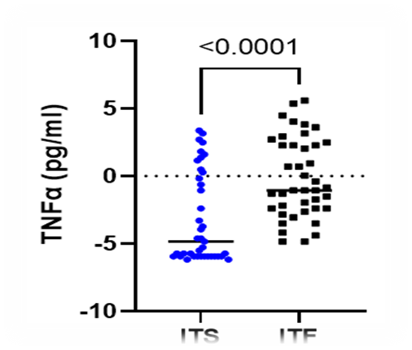

Figure 1: The dot plot illustrates the plasma levels of TNF-α in Insulin Treatment Failure and Success groups.
3.3 Levels of Adiponectin
Adiponectin concentrations varied between 1.60 and 8.97 pg/ml in ITF subjects, and from 2.252 to 10.51 pg/ml in ITS subjects (Fig. 2). This study revealed relatively lower levels of adiponectin in insulin-treated subjects than in our controls, but with a statistically non-significant difference (p=0.0818). The levels of glycated haemoglobin were higher in ITF compared to ITS, with a mean of 9.4 ± 8 % and 6.37±6 % respectively.
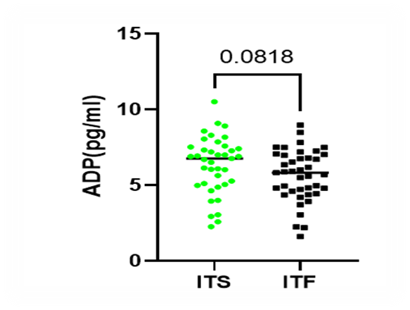
Figure 2: The dot plot illustrates the plasma levels of ADP in Insulin Treatment Failure and Success groups.

TABLE 1: THE PLASMA LEVELS of TNF-Α and ADP in INSULIN TREATMENT FAILURE and SUCCESS GROUPS

Variable | ADP |  |  | TNF
 | ITF (Median) n=41 | ITS (Median) n= 39 | P | ITF (Median) n=41 | ITS (Median) n=39 | P
Sexe
Female | 5.94 (2.1-7.01) | 6.50 (2.25-9.08) | 0.79 | -1.06 (-4.8 – (-5.31)) | -4.83 (-6.17 - 3.15) | 0.24
Male | 5.90 (1.60- 8.48) | 6.99 (2.5-10.5) | 0.46 | -0.73 (-4.17- 5.60) | -4.51 (-5.95 - 3.38) | 0.32
Age
[20-40] | 5.873 (3.5-7.49) | / | / | -0.8406 (-3.5-5.37) | / | /
[41-60] | 5.86 (1.60-8.48) | 6.36 (2.93-10.5) | 0.65 | -2.06 (-4.84 - 5.6) | -5.17 (-6.18 - 3.38) | 0.33
[61-80] | 5.69 (3.7-8.97) | 6.99 (2.25-9.08) | 0.57 | 0.71(-3.51 - 4.49) | -5.06 (-5.95 - 2.49) | 0.27

3.4 Correlation between TNF-alpha and Adiponectin
There was a negative correlation between TNF-alpha and Adiponectin in ITF subjects, with r=-0.03 but non statistically significant p=-0.08. It is understood that within the two populations, for concentrations of TNF-alpha that evolve in an increasing way, we have concentrations of Adiponectin, which evolve in a decreasing Our results corroborate those of Chenxiao Liu et al. (2016), who found after a meta-analysis that the overall risk of T2DM is strongly associated with high levels of inflammatory cytokines, including TNF-alpha, and low levels of Adiponectin Showing that an interaction between inflammation and the development of T2 diabetes in subjects.

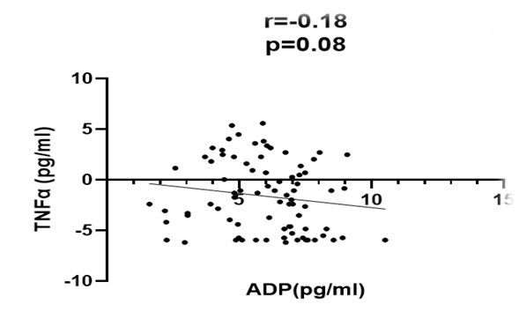
Figure 3: Association between TNF-α and ADP in the general population study.

3.5 DISCUSSION
The results obtained show that the levels of TNF-alpha are significantly higher in ITF subjects, compared to ITS. Among other things, our results showed a significant difference between the two populations (p≤0.001); with concentrations varying between -4.838 and 5.600 pg/ml in ITF subjects and -6.170 to 3.379 pg/ml of blood in ITS subjects.
This is in line with the results of several scientific articles, which have also reported elevated levels of TNF-alpha in insulin-treated diabetics. According to the study by Shamsi et al. (2018), "TNF-alpha is associated with insulin resistance in these subjects". In addition, in the study conducted by Muhammad Sajid et al. (2018) on "the role of TNF-alpha in the development of insulin resistance and the pathogenesis of T2DM, high levels of TNF-alpha have been shown to induce insulin resistance, which impairs insulin, contributing to the development of T2DM". Swaroop et al (2012) found "a positive but also significant correlation between TNF-alpha and HOMA IR (homeostasis assessment method to calculate insulin resistance) in T2DM subjects, suggesting an involvement of TNF-alpha in the development of insulin resistance. It is understood that within the two populations, for concentrations of TNF-alpha that evolve in an increasing way, we have concentrations of Adiponectin, which evolve in a decreasing way".
Our results corroborate those of Chenxiao Liu et al. (2016), who found after "a meta-analysis that the overall risk of T2DM is strongly associated with high levels of inflammatory cytokines, including TNF-alpha, and low levels of Adiponectin, showing that an interaction between inflammation and the development of T2DM". The results of this study also support the findings of Jeon et al. (2018), who evaluated "the level of Adiponectin in subjects with T2DM and healthy subjects, reporting a low concentration of adiponectin in subjects with type 2 diabetes".
The analyses also showed that there was an inverse (r = -0.03) and non-significant (p = 0.82) correlation between TNF-alpha and Adiponectin ITF subjects. Similarly, there is an inverse correlation between TNF-alpha and Adiponectin in non-insulin-treated subjects (r= -0.08), but this does not remain very significant (p= 0.59).

4. CONCLUSION
The increased levels of TNF-alpha, HbAIc, combined with the low levels of adiponectin, could be exploited as signalisation biomarkers for monitoring Insulin treatment failure and other metabolic dysregulation and inflammation. The variation of TNF-alpha and Adiponectin in the serum of Treatment Failure and non-failure Diabetic patients could justify their implications in the pathogenesis of type 2 diabetes and be a good predictive marker for its management.

CONSENT
All authors declare that written informed consent was obtained from the patients (or other approved parties) for publication of this study.

ETHICAL APPROVAL
All authors hereby declare that the study was conducted in accordance with ethical standards approved by the Cameroon National Ethics Committee, N° 2023/0220409/CEIRSH/ESS/MIM, and have therefore been performed in accordance with the ethical standards laid down in the 1964 Declaration of Helsinki.

COMPETING INTERESTS DISCLAIMER:
Authors have declared that they have no known competing financial interests OR non-financial interests OR personal relationships that could have appeared to influence the work reported in this paper.

Disclaimer (Artificial intelligence)

Option 1:

Author(s) hereby declare that NO generative AI technologies such as Large Language Models (ChatGPT, COPILOT, etc.) and text-to-image generators have been used during the writing or editing of this manuscript.

Option 2:

Author(s) hereby declare that generative AI technologies such as Large Language Models, etc. have been used during the writing or editing of manuscripts. This explanation will include the name, version, model, and source of the generative AI technology and as well as all input prompts provided to the generative AI technology

Details of the AI usage are given below:
1.
2.
3.

REFERENCES
Beutler B, Cerami A. 1989 The biology of cachectin/TNF-α: primary mediator of host response. Annu Rev Immunol. 1989;7:625–55.
Hotamisligil GS, Shargill NS, Spiegelman BM. 1993 Adipose expression of tumor necrosis factor-α: direct role in obesity-linked insulin resistance. Science.;259(5091):87–91.
Hotamisligil GS. 2000 Molecular mechanisms of insulin resistance and the role of the adipocyte. Int J Obes. 2000;24(Suppl 4):S23–7.
Chen L, Chen R, Wang H, Liang F. 2015 Mechanisms linking inflammation to insulin resistance. Int J Endocrinol. 2015;2015:508409.
Bastard JP, Maachi M, Van Nhieu JT, Jardel C, Bruckert E, Grimaldi A, et al. 2002 Adipose tissue IL-6 content correlates with resistance to insulin activation of glucose uptake both in vivo and in vitro. J Clin Endocrinol Metab. 2002;87(5):2084–9.
Choi KM. 2016 The impact of organokines on insulin resistance, inflammation, and atherosclerosis. Endocrinol Metab (Seoul). 2016;31(1):1–6.
Lee BC, Lee J. 2014 Cellular and molecular players in adipose tissue inflammation in the development of obesity-induced insulin resistance. Biochim Biophys Acta. 2014; 1842(3):446–62.
Wensveen FM, Valentić S, Šestan M, Turk Wensveen T, Polić B. 2015 The “Big Bang” in obese fat: events initiating obesity-induced adipose tissue inflammation. Eur J Immunol. 2015;45(9):2446–56.
Shamsi KS, et al. 2018 Association of TNF-α with insulin resistance in insulin-treated diabetic patients. J Diabetes Metab. 2018;9(2):1000781.
Sajid M, et al. 2018 Role of tumor necrosis factor-alpha in the development of insulin resistance and pathogenesis of type 2 diabetes mellitus. J Diabetes Metab Disord. 2018;17(2):1–6.
Swaroop JJ, Rajarajeswari D, Naidu JN. 2012 Association of TNF-α with insulin resistance in type 2 diabetes mellitus. Indian J Med Res. 2012;135:127–30.
Jeon JY, et al. 2018 Circulating adiponectin levels and their association with insulin resistance in type 2 diabetes patients. Diabetes Metab J. 2018;42(5):431–8.
Liu C, Feng X, Li Q, Wang Y, Li Q, Hua M. 2016 Adiponectin, TNF-α, and inflammatory cytokines and risk of type 2 diabetes: a systematic review and meta-analysis. Sci Rep. 2016;6:31982.
Matthews DR, Hosker JP, Rudenski AS, Naylor BA, Treacher DF, Turner RC. 1985 Homeostasis model assessment: insulin resistance and β-cell function from fasting plasma glucose and insulin concentrations in man. Diabetologia. 1985;28:412–9.
Van Dielen FMH, Buurman WA, Hadfoune M, Nijhuis J, Greve JW. 2004 Macrophage inhibitory factor and other inflammatory mediators normalize after weight loss in morbidly obese subjects. J Clin Endocrinol Metab. 2004;89(8):4062–8.
Yudkin JS, Panahloo A, Stehouwer C, Emeis JJ, Bulmer K, Mohamed-Ali V, et al. 2000 The influence of improved glycaemic control with insulin and sulphonylureas on acute phase and endothelial markers in type II diabetic subjects. Diabetologia. 2000;43:1099–106.
Sartipy P, Loskutoff DJ. 2003Monocyte chemoattractant protein 1 in obesity and insulin resistance. Proc Natl Acad Sci USA. 2003;100(12):7265–70.
Morris AM, et al. 2006 T cell-mediated hepatic inflammation modulates adiponectin levels in mice: role of tumor necrosis factor alpha. Metabolism. 2006;55(4):555–9.
Samad F, Yamamoto K, Pandey M, Loskutoff DJ. 1997 Elevated expression of transforming growth factor-β in adipose tissue from obese mice. Mol Med. 1997;3(1):37–48.
Swaroop JJ, Rajarajeswari D, Naidu JN. 2012 Association of TNF-α with insulin resistance in T2DM patients. Indian J Med Res. 2012;135:127–30.
Emad-Eldin, M., Balata, G. F., Elshorbagy, E. A., Hamed, M. S., & Attia, M. S. (2024). Insulin therapy in type 2 diabetes: Insights into clinical efficacy, patient-reported outcomes, and adherence challenges. World Journal of Diabetes, 15(5), 828.
Gianoli, S., Tang, J., Odegard, K. C., Yuki, K., & Koutsogiannaki, S. (2025). Harnessing adiponectin for sepsis: current knowledge, clinical insights and future therapies. Critical Care, 29(1), 300.
Patel, K. P., Sen, D. B., Sen, A. K., Vaghela, D., Balaraman, R., & Maheshwari, R. A. (2021). Review on adiponectin: A benevolent adipokine. Journal of Pharmaceutical Research International, 33(30A), 25–39.
Yu, K. T., Myint, T., & Latt, T. S. (2022). Single nucleotide polymorphisms at +45 T>G and at +276 G>T of the adiponectin gene and plasma adiponectin level in Myanmar type 2 diabetic patients. Asian Journal of Biochemistry, Genetics and Molecular Biology, 10(3), 23–32.

