Original Research Article
PRIORITIZATION OF SUB-WATERSHEDS FOR EROSION-PRONE IDENTIFICATION: A STUDY OF KIILE WATERSHED, ARUNACHAL PRADESH, INDIA

Abstract
Watershed prioritization is a strategic procedure used to delineate the most erosion-prone sub-watersheds. Identifying these critical areas is paramount for the effective allocation of resources and the successful implementation of soil and water conservation measures at the watershed level. However, studies concerning the mountainous watershed of Kiile are limited. In this study, the prioritization of 10 sub-watersheds of the Kiile River was done to identify erosion-prone areas using quantitative morphometric analysis. The watershed and its drainage networks were delineated using ALOS PALSAR 12.5 m resolution DEM in ArcGIS 10.4. For prioritisation, morphometric parameters such as linear, areal, and relief aspects were considered and calculated using standard formulae provided by various hydrologists and geomorphologists. Each morphometric parameter was preliminarily ranked based on its relation with soil erodibility. The final prioritization was done based on the compound value (Cp). The analysis result revealed that SW-8 and SW-5 are the most erosion-prone sub-watersheds with the lowest compound value, indicating greater susceptibility to erosion. Based on the results, the sub-watersheds of the Kiile River were categorised into four priority classes: very high, high, medium, and low. The SW-8 and SW-5 fall under the very high priority class, SW-3, SW-4, SW-6, and SW-9 fall under the high priority class, SW-1, SW-7, and SW-2 fall under the medium priority class, and SW-10 falls under the low priority class. This study significantly contributes to the management of mountainous watersheds and may be useful for decision-makers in sustainably managing and conserving the watershed resources.
Keywords: Conservation; Morphometry; Prioritization; Substantial; Watershed.
- INTRODUCTION
A watershed is a naturally occurring hydrological unit identified by natural boundaries and distinguished by similar physical, topographic, and climatic characteristics (Javed et al., 2011). Analysis of river morphometry involves quantitatively describing the basin’s geometry to understand the drainage pattern, its hydrological behaviour and the geomorphology of an area (Das, 2021). Morphometric analysis provides significant insights into the topography, erosion level, soil characteristics, and drainage features of the basin (Sarkar et al., 2020). Detailed analyses of river morphometry may reveal how drainage morphometry influences landforms and their characteristics (Latha, 2024). It also offers quantitative data that is useful for hydrologic modelling, watershed prioritization and conservation and management of natural resources (Choudhari et al., 2018). At the watershed level, managing natural resources like land and water has become the most critical due to the growing demand for these resources (Hema et al., 2021). Therefore, there is a need to implement well-planned watershed management practices to combat excessive runoff, inadequate infiltration, increased soil erosion, and low productivity (Choudhari et al., 2018). A pertinent approach to prioritize watersheds through morphometric analysis would aid in better planning. Morphometric parameters have been utilized in various research studies for the characterization of watersheds (Mangan et al., 2019; Mahala, 2020; Prianka et al., 2025) for the assessment of groundwater potential (Jasmin and Mallikarjuna, 2013) and for sub-watersheds prioritization (Javed et al., 2011; Rahaman et al., 2015; Chandniha et al., 2017; Sharma and Mahajan, 2020; Shekar et al., 2023).
Sub-watershed level prioritization has become scientifically significant as it aids in the effective management of natural resources by tackling key challenges such as soil degradation, erosion, floods and droughts (Aher et al., 2014; Golom et al., 2025). In mountainous watersheds, soil erosion is among the most critical issues (Jain and Das, 2010). Due to intricate lithology and uneven terrain, managing the entire river basin may be difficult (Singh et al., 2023) and implementing a conservation plan can be challenging due to limited manpower and resource restrictions (Chowdary et al., 2013). However, this can be achieved by identifying specific areas that require the implementation of management strategies the most. Therefore, watershed prioritization substantially identifies the stressed area by ranking different sub-watersheds in order of varying levels of conservation treatment to be given to such watersheds (Mishra, 2016). In recent times, morphometric analysis has emerged as one of the effective techniques, especially in the area of watershed prioritization (Singh et al., 2021). The Morh watershed in Gujarat was prioritized using morphometric analysis and GIS techniques (Thakkar and Dhiman, 2007). The morphometric characteristics of the Wah Umbah micro-watershed in the East Khasi Hills of Meghalaya were thoroughly examined by researchers (Sarmah et al., 2012). Their studies confirm at least two episodes of quaternary tectonic movements in the area, resulting in drainage anomalies. Similarly, the morphometry of the Bhilanganga catchment, Uttarakhand, was examined to identify priority sub-basins for conservation measures (Khare et al., 2014). Asim et al., (2025) prioritized the sub-watersheds of the upper Ravi Basin, Himachal Himalaya, to identify the most erosion-susceptible sub-watersheds using morphometric and hypsometric analyses. A sub-basin part of Lower Subansiri was characterized and prioritized using multicriteria analysis to comprehend its behaviour to neo-tectonic activity (Sangma et al., 2020). The morphotectonic and morphometric feature of the Chite Lui basin, Mizoram, was studied by geographers (Barman et al., 2021) to prioritized sub-watersheds based on soil erosion and groundwater potential zones. Numerous attempts have also been made to find vulnerable watershed areas for the application of a comprehensive watershed management strategy (Haregeweyn et al., 2012; Das, 2014; Devatha et al., 2015; Dhungel and Fiedler, 2016; Bouguerra and Jebari, 2017).
In recent times, Remote Sensing (RS) and Geographical Information Systems (GIS) have emerged as convenient tools for evaluating the morphometric parameters of the watersheds (Singh et al., 2020; Das et al., 2025). Koradia and Patel (2025) employed a GIS and remote sensing-based approach to assess erosion risk and prioritize soil and water conservation measures in a semi-arid watershed, demonstrating the effectiveness of integrated morphometric and land-use analyses in erosion management. With the integration of RS and GIS, river morphometry can be studied more effectively than the conventional method (Giri et al., 2020), as GIS provides a better spatial representation of topographic characteristics on the map (Mohammed et al., 2018). The drainage networks and catchment areas can be easily obtained from the Digital Elevation Model (DEM) using automated procedures within a GIS environment Bhatt and Ahmed, 2014).
  - Study Area
The Kiile watershed is located in the intermontane valley of Ziro in the Lower Subansiri district of Arunachal Pradesh. Geographically, it is located between 27º 30ꞌ N to 27º 38ꞌ N latitude and 93º 45ꞌ E to 93º 55ꞌ E longitude with a total area of about 147.44 km² (Figure 1). The study area has an altitudinal variation ranging between 1535m and 2672m. The Kiile watershed has been divided into ten sub-watersheds formed by the ten tributaries such as SW-1 (25.44 km²), SW-2 (11.96 km²), SW3- (25.97 km²), SW-4 (6.25 km²), SW-5 (14.08 km²), SW-6 (9.12 km²), SW-7 (4.71 km²), SW-8 (16.40 km²), SW-9 (9.98 km²) and SW-10 (6.36 km²) and is drained by the Kiile River which flows longitudinally in the north-south direction. Numerous streams and gullies flow from east to west, joining together to drain the area. For the delineation of sub-watersheds, streams with an order of 3rd and above have been considered, and accordingly, 10 sub-watersheds have been demarcated. The remaining area is designated as an inter-basin area that is drained by streams lower than the 3rd order. The inter-basin area occupies 17.17 km² in the Kiile watershed. The basin appears like an intermontane valley dotted with small isolated hills and presents a typical geomorphological configuration (Rupa, 2007). Geologically, its formation is considered to represent the lacustrine origin (Agarwal et al., 2009). The Geological Survey of India states that the study area is divided into five geological formations, viz. Bomdila Formation, Chilliepam Formation, Hapoli Formation, Khetabari Formation and Tenga Formation (GSI, 2000). The study area is located in a zone of heavy rainfall. The arrival of the monsoon takes place in March/April and lasts until September. The annual rainfall in the area varies between 2240-2910 mm, with peak precipitation occurring in June and July (Patnaik, 2017).
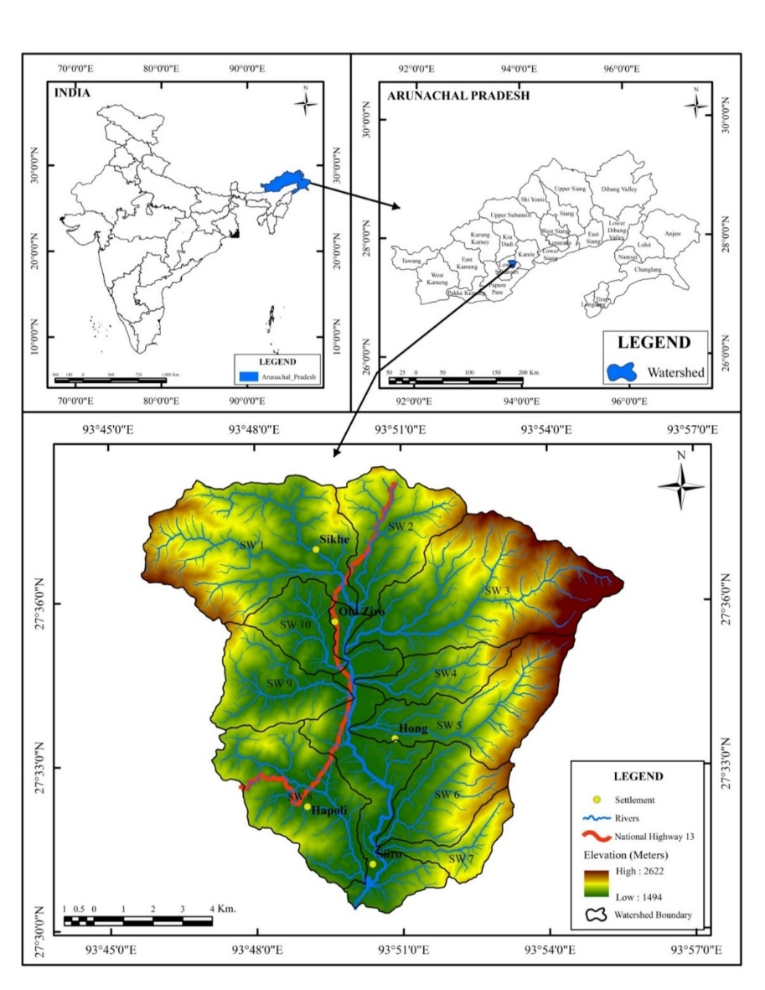

Fig. 1. Location Map of the Study Area
Source: Downloaded from https://bhuvan.nrsc.gov.in and generated using ArcGIS 10.4
- METHOD AND MATERIAL
The base map of the study area was prepared using Survey of India (SOI) Toposheet No. 83 E/14 on a 1:50000 scale and Digital Elevation Model (DEM) of Advanced Land Observing Satellite-Phase Array-Type L-Band Synthetic Aperture Radar (ALOS-PALSAR) with 12.5 m resolution downloaded from https://asf.alaska.edu/. to obtain the database for morphometric analysis. The filled DEM was used to compute flow direction as well as flow accumulation. The watershed was delineated using pour points with the help of a hydrology tool available in the ArcGIS environment (Barman et al., 2021; Mahato and Nimasow, 2023). Further, sub-watersheds and inter-basin regions of the Kiile River were determined. Streams with an order of 3 or higher were considered for defining sub-watersheds. Consequently, 10 sub-watersheds were defined. The rest of the study area is designated as an inter-basin area drained by streams with an order lower than 3 as described in Mangan et al., (2019).
For morphometric analysis, a detailed assessment of linear, areal, and relief aspects was carried out using Haokip et al., (2022) method. Morphometric parameters including stream order (u), stream number (Nu), total stream length (Lu), mean stream length (Lsm), stream length ratio (RL), bifurcation ratio (Rb), basin length (Lb), drainage density, (Dd), stream frequency (Fs), drainage texture (T), form factor (Rƒ), elongation ratio (Re), circulatory ratio (Rc), length of overland flow (Lg), constant of channel maintenance (C), Compactness coefficient (Cc), basin relief (Bh), relief ratio (Rh), ruggedness number (Rn) were calculated using standard formulae suggested by the researchers as presented in Table 1.
Prioritization of sub-watersheds was carried out by ranking each morphometric parameter based on its relation with soil erodibility. The highest number was determined by the total number of sub-watersheds according to Haokip et al., (2022). Thus, the ranking for the study area ranged from 1 to 10.
Table 1. Morphometric Parameters and their Formulae
Sl. No. | Morphometric parameters | Formula | Reference
1 | Stream order (u) | Hierarchical rank | Strahler (1964)
2 | Stream number (Nu) | Nu = Total no. of stream segment of order ‘u’ | Horton (1945)
3 | Stream length (Lu) | Length of the streams | Horton (1945)
4 | Mean stream length (Lsm) | Lsm= Lu/Nu  Where, Lu= total stream length of order ‘u’  Nu= total no. of stream segment of order ‘u’ | Strahler (1964)
5 | Stream length ratio (RL) | RL= Lu/Lu-1  Lu= total stream length of order ‘u’  Lu-1= total stream length of its next lower order | Strahler (1964)
6 | Bifurcation ratio (Rb) | Rb= Nu/Nu+1  Nu= No. of streams  Nu+1= No. of a segment of higher order | Schumm (1956)
7 | Drainage density (Dd) | D= Lu/A  Lu= Total stream length of all orders  A= Area of the basin | Horton (1945)
8 | Stream frequency (Fs) | Fs= Nu/A  Nu= Total no. of streams of all orders  A= Area of the basin | Horton (1945)
9 | Drainage texture (T) | T= Nu/P  Nu= Total no. of streams of all orders  P= Perimeter of the basin | Horton (1945)
10 | Form factor (Rf) | Rf= A/Lb²  A= Area of the basin  Lb²= Square of the basin length | Horton (1945)
11 | Elongation ratio (Re) | Re= 2√A/ℼ/Lb  A= Area of the basin  ℼ= 3.14  Lb= Length of the basin | Schumm (1956)
12 | Circulatory ratio (Rc) | Rc= 4ℼA/ P²  ℼ= 3.14  A= Area of the basin  P²= Square of the perimeter | Miller (1953)
13 | Length of overland flow (Lg) | Lg= 1/(2* Dd)  Dd= Drainage density | Horton (1945)
14 | Constant of channel maintenance (C) | C= 1/Dd  Dd= Drainage density | Schumm (1956)
15 | Compactness coefficient (Cc) | Cc= P/2√ℼA  P= Perimeter of the basin  ℼ= 3.14  A= Area of the basin | Horton (1945)
16 | Basin relief (Bh) | Bh= H-h  H= Maximum elevation in meter  h= Minimum elevation in meter | Schumm (1956)
17 | Relief ratio (Rh) | Rh= Bh/Lb  Bh= Basin relief  Lb= Basin length | Schumm (1956)
18 | Ruggedness number (Rn) | Rn= Bh*Dd  Bh= Basin relief  Dd= Drainage density | Schumm (1956)
A rank of 1 was allocated to the morphometric parameter having the greatest impact on accelerating the process of erosion, while 10 indicated the least effect on the erosion process. Following the ranking of each morphometric parameter for 10 sub-watersheds, the rank values were summed and averaged to derive a compound value (Cp) as expressed the listed authors (Prabhakar et al., 2019; Abdeta et al., 2020; Odiji et al., 2021; Tukura et al., 2021). Final prioritization was done by assigning ranks to the Cp value of each sub-watershed. The sub-watershed with the lowest Cp value was assigned the highest priority rank (1), indicating more susceptible and vulnerable to soil erosion. Likewise, the least priority number (10) was assigned to the sub-watershed having the highest compound value, indicating a lesser risk related to soil erosion (Chandniha and Khansal, 2017; Malik et al., 2019; Rakesh et al., 2019). The detailed methodology adopted for the morphometric analysis of the Kiile River is shown in Figure 2.
Morphometric Analysis
(Using GIS software and Formulae)
Linear parameters
Areal parameters
Relief parameters
Stream order
Stream number
Total stream length
Mean stream length
Stream length ratio
Bifurcation ratio
Basin length
Drainage density
Stream Frequency
Drainage texture
Form factor
Elongation ratio
Circulatory ratio
Length of overland flow
Constant channel maintenance
Compactness coefficient
Basin relief
Relief ratio
Ruggedness number
Data Collection
(ALOS PALSAR RTC DEM and Topographic Maps)
Processing over DEM
(Using GIS software)
Fill Sink
Flow direction
Flow accumulation
Stream defining
Stream to Feature
Watershed delineation
Defining Sub-watersheds
Ranking each morphometric parameter
Calculating compound value for each sub-watershed
Priority ranking of each sub-watershed based on compound value
Morphometry based prioritization

Fig. 2. Methodology Flow Chart
Source: Developed by the Authors
- RESULTS
The Kiile watershed covers a geographical area of 147.44 Km², which has been divided into ten Sub-watersheds, viz, SW-1, SW-2, SW-3, and so on. The area and perimeter of 10 sub-watersheds are shown in Table 2. In terms of area coverage, SW-3 is the largest sub-watershed with an area of 25.97 km², and SW-7 is the smallest sub-watershed covering an area of 4.17 km². The perimeter of the Kiile watershed is measured as 57.12 km. Whereas, for all the sub-watersheds, the perimeters range between 11.79 and 24.93 km. The SW-10 has the shortest perimeter, and the SW3 has the longest perimeter. The morphometric analysis revealed that the Kille River is a 6th-order river formed by 764, 171, 36, 11, 2, and 1 number of 1st, 2nd, 3rd, 4th, 5th, and 6th-order streams, respectively. The total length of the watershed’s stream is 425.62 km. Its drainage pattern at the higher elevation varies from dendritic to sub-dendritic, whereas at the lower elevation, it is parallel to sub-parallel. Analysis of various morphometric parameters of the Kiile watershed is presented below.
Sub-watersheds | Area (km²) | Perimeter (km)
SW-1 | 25.44 | 24.66
SW-2 | 11.96 | 16.89
SW-3 | 25.97 | 24.93
SW-4 | 6.25 | 14.31
SW-5 | 14.08 | 21.64
SW-6 | 9.12 | 14.24
SW-7 | 4.71 | 13.5
SW-8 | 16.4 | 20.3
SW-9 | 9.98 | 14.96
SW-10 | 6.36 | 11.79
Kiile watershed | 147.44 | 57.12
Table 2. General Information on the Kiile and its Sub-watersheds

Linear Parameters
Stream order (u):
The analysis of stream order is the most fundamental step in assessing any drainage basin (Mahala, 2020). Several hydrologists and geomorphologists have suggested different schemes of stream ordering, such as Gravelius (1914); Horton (1945); Strahler (1964). The streams of the Kiile watershed have been ranked according to Strahler's stream ordering system (Figure 3). The smallest fingertip tributaries are designated as order 1, and when two first-order channels join, a segment of order 2 is formed (Strahler, 1964). The stream order of each sub-watershed is mentioned in Table 3.
Stream Number (Nu):
It is the total count of stream segments found in each order (Horton, 1945). In the study area,
there is a total of 985 streams, of which 764 are 1st-order streams, along with 171, 36, 11, 2, and 1 as 2nd, 3rd, 4th, 5th, and 6th-order streams, respectively.
Stream Length (Lu):
Stream length refers to the total length of streams across all hierarchical orders (Barman et al., 2021). In a watershed, a longer stream length reveals a flatter river plain and a smaller length indicates the steepness of the gradient with fine texture (Strahler, 1964). The Kiile watershed has a total stream length of about 425.62 km. The 1st order stream has a total length of about 210.55 km, 2nd order stream has 103.25 km, 3rd order stream has 65.86 km, 4th order stream has 26.48 km, 5th order stream has 6.11 km, and 6th order stream has 13.37 km, respectively (Table 3).

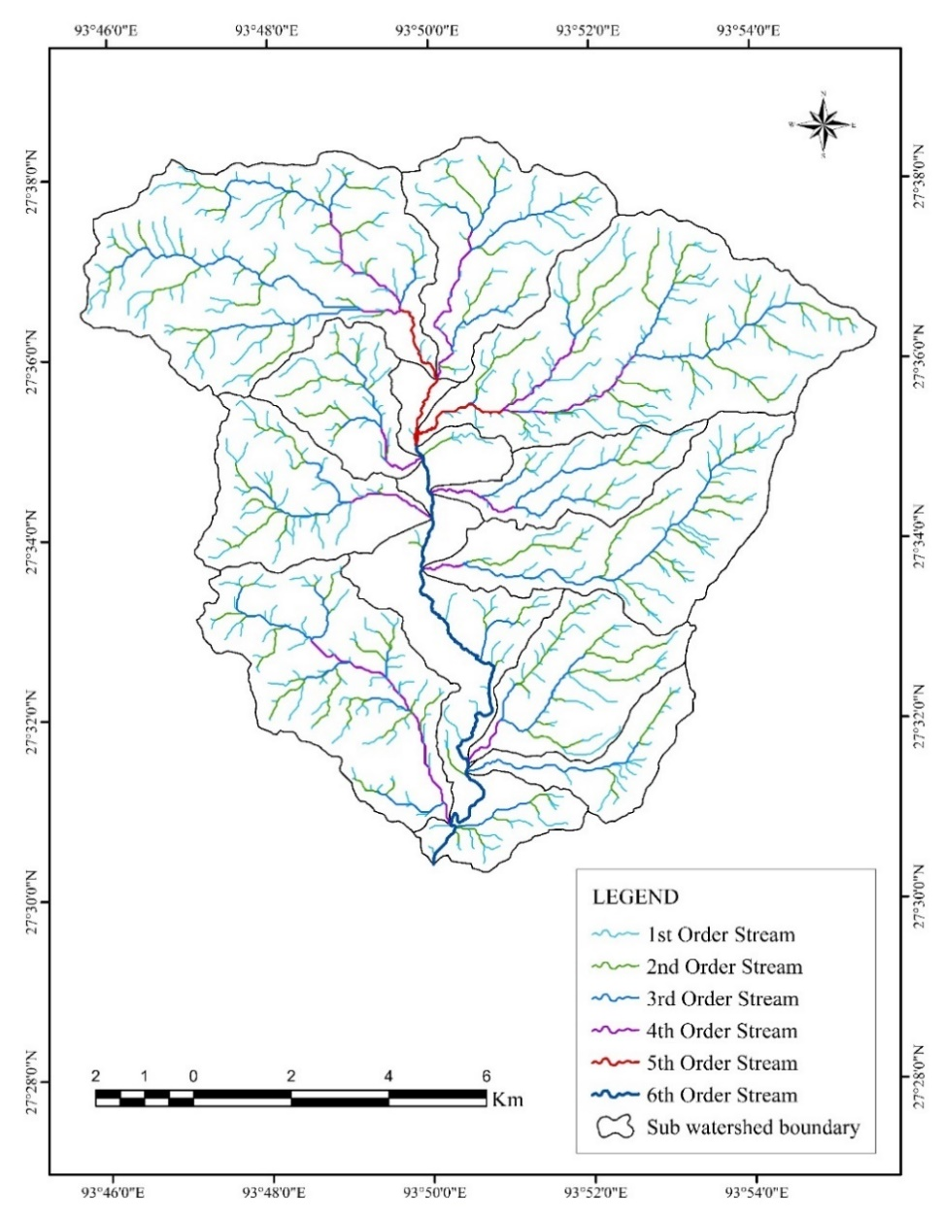

Fig. 3. Stream Order
Stream Length Ratio (RL):
The stream length ratio (RL) is the ratio of the average stream length of an order to the average stream length of its previous order (Horton, 1945). The (RL) value of the Kiile River ranges between 1.27 to 4.38, the highest (RL) value was observed in the 6th order stream, while the lowest was recorded in the 5th order stream. The RL value range in all sub-watersheds are 0.67-5.73 (SW-1), 1.67-3.97 (SW-2), 0.92-2.58 (SW-3), 1.12-3.81 (SW-4), 0.25-4.08 (SW-5), 0.7-4.08 (SW-6), 3.57-5.48 (SW-7), 2.6- 4.11 (SW-8), 1.01-3.44 (SW-9), and 1.71-2.13 (SW-10). In most of the sub-watersheds, the higher RL values were mostly observed in the 3rd order stream. The difference in the value of the stream length ratio is due to the slope and characteristics of the topography (Pande et al., 2017).
Bifurcation Ratio (Rb):
The bifurcation ratio is described as the ratio of the number of streams of a specific order (Nu) to the number of streams of the subsequent higher order (Nu+1) (Schumm, 1956). A higher Rb value signifies intense overland flow (increased soil erosion) and reduced recharge for the sub-watershed (Prabhakar et al., 2019). Normally, in flat plain areas Rb value is minimum found to be 2; however, in mountainous regions, it varies between 3 and 4 (Horton, 1945). The Kiile River showed an average bifurcation ratio of 3.99. In most sub-watersheds, the highest Rb value occurs in the 2nd and 3rd order stream, whereas for the entire Kiile watershed, the highest value of Rb is found in the 5th order and the lowest in the 6th order stream. Among the sub-watersheds, the highest mean Rb value is recorded from SW-7.

Basin Length (Lb):
Basin length signifies the length of a basin that is adjacent to a drainage channel (Schumm, 1956). It serves as the main channel of the watershed where the majority of the water flows. Among 10 sub-watersheds, the SW-3 has the longest basin length of 9.76 km, and SW-10 has the shortest basin length (3.76 km) (Table 3).
Table 3. Morphometric Analysis: Linear Parameters
Sub-watersheds | Stream order (u) | Number of streams (Nu) | Total stream length | Mean stream length | Stream length ratio (RL) | Bifurcation ratio (Rb) | Basin length (Lb) (km)
Sub-watersheds | Stream order (u) | Number of streams (Nu) | (Lu) (km) | (Lsm) (km) | Stream length ratio (RL) | Bifurcation ratio (Rb) | Basin length (Lb) (km)
SW-1 | 1st | 130 | 37.93 | 0.29 | - | - | 7.76
SW-1 | 2nd | 30 | 14.8 | 0.49 | 1.68 | 4.34 | 7.76
SW-1 | 3rd | 5 | 14.08 | 2.81 | 5.73 | 6 | 7.76
SW-1 | 4th | 2 | 3.82 | 1.91 | 0.67 | 2.5 | 7.76
SW-1 | 5th | 1 | 1.9 | 1.9 | 0.99 | 2 | 7.76
SW-1 | Average |  |  |  | 2.26 | 3.71 | 7.76
SW-1 | Total | 168 | 72.53 |  |  |  | 7.76
SW-2 | 1st | 60 | 15.04 | 0.25 | - | - | 5.24
SW-2 | 2nd | 15 | 6.21 | 0.41 | 1.64 | 4 | 5.24
SW-2 | 3rd | 4 | 6.52 | 1.63 | 3.97 | 3.75 | 5.24
SW-2 | 4th | 1 | 3.79 | 3.79 | 2.32 | 4 | 5.24
SW-2 | Average |  |  |  | 2.64 | 3.91 | 5.24
SW-2 | Total | 80 | 31.56 |  |  |  | 5.24
SW-3 | 1st | 133 | 38.9 | 0.29 | - | - | 9.72
SW-3 | 2nd | 27 | 20.27 | 0.75 | 2.58 | 4.92 | 9.72
SW-3 | 3rd | 5 | 6.98 | 1.39 | 1.85 | 5.4 | 9.72
SW-3 | 4th | 2 | 5.62 | 2.81 | 2.02 | 2.5 | 9.72
SW-3 | 5th | 1 | 2.61 | 2.61 | 0.92 | 2 | 9.72
SW-3 | Average |  |  |  | 1.84 | 3.7 | 9.72
SW-3 | Total | 168 | 74.38 |  |  |  | 9.72
SW-4 | 1st | 29 | 8.13 | 0.29 | - | - | 5.87
SW-4 | 2nd | 6 | 2.92 | 0.48 | 1.65 | 4.67 | 5.87
SW-4 | 3rd | 3 | 5.49 | 1.83 | 3.81 | 2 | 5.87
SW-4 | 4th | 1 | 2.05 | 2.05 | 1.12 | 3 | 5.87
SW-4 | Average |  |  |  | 2.19 | 3.22 | 5.87
SW-4 | Total | 39 | 18.59 |  |  |  | 5.87
SW-5 | 1st | 74 | 21.04 | 0.28 | - | - | 8.27
SW-5 | 2nd | 14 | 12.63 | 0.9 | 3.21 | 5.28 | 8.27
SW-5 | 3rd | 2 | 7.37 | 3.68 | 4.08 | 7 | 8.27
SW-5 | 4th | 1 | 0.95 | 0.95 | 0.25 | 2 | 8.27
SW-5 | Average |  |  |  | 2.51 | 4.76 | 8.27
SW-5 | Total | 91 | 41.99 |  |  |  | 8.27
SW-6 | 1st | 50 | 12.7 | 0.25 | - | - | 5.42
SW-6 | 2nd | 8 | 9.57 | 1.19 | 4.76 | 6.25 | 5.42
SW-6 | 3rd | 2 | 3.51 | 1.75 | 1.47 | 4 | 5.42
SW-6 | 4th | 1 | 1.23 | 1.23 | 0.7 | 2 | 5.42
SW-6 | Average |  |  |  | 2.31 | 4.08 | 5.42
SW-6 | Total | 61 | 27.01 |  |  |  | 5.42
SW-7 | 1st | 25 | 5.48 | 0.21 | - | - | 4.96
SW-7 | 2nd | 3 | 2.26 | 0.75 | 3.57 | 8.33 | 4.96
SW-7 | 3rd | 1 | 4.11 | 4.11 | 5.48 | 3 | 4.96
SW-7 | Average |  |  |  | 4.52 | 5.66 | 4.96
SW-7 | Total | 29 | 11.85 |  |  |  | 4.96
SW-8 | 1st | 102 | 23.37 | 0.23 | - | - | 7.05
SW-8 | 2nd | 26 | 13.46 | 0.5 | 2.17 | 3.92 | 7.05
SW-8 | 3rd | 6 | 8.26 | 1.3 | 2.6 | 4.34 | 7.05
SW-8 | 4th | 1 | 5.78 | 5.35 | 4.11 | 6 | 7.05
SW-8 | Average |  |  |  | 2.96 | 4.75 | 7.05
SW-8 | Total | 135 | 50.87 |  |  |  | 7.05
SW-9 | 1st | 56 | 16.2 | 0.28 | - | - | 5
SW-9 | 2nd | 12 | 6.81 | 0.56 | 2 | 4.67 | 5
SW-9 | 3rd | 2 | 3.86 | 1.93 | 3.44 | 6 | 5
SW-9 | 4th | 1 | 1.95 | 1.95 | 1.01 | 2 | 5
SW-9 | Average |  |  |  | 2.15 | 4.22 | 5
SW-9 | Total | 71 | 28.82 |  |  |  | 5
SW-10 | 1st | 37 | 9.24 | 0.23 | - | - | 3.76
SW-10 | 2nd | 11 | 5.05 | 0.49 | 2.13 | 3.72 | 3.76
SW-10 | 3rd | 3 | 2.49 | 0.97 | 1.97 | 3.67 | 3.76
SW-10 | 4th | 1 | 1.24 | 1.66 | 1.71 | 3 | 3.76
SW-10 | Average |  |  |  | 1.93 | 3.46 | 3.76
SW-10 | Total | 52 | 18.02 |  |  |  | 3.76
Kiile watershed | 1st | 764 | 210.55 | 0.27 | - | - | 15.21
Kiile watershed | 2nd | 171 | 103.25 | 0.6 | 2.23 | 4.46 | 15.21
Kiile watershed | 3rd | 36 | 65.86 | 1.82 | 3.03 | 4.75 | 15.21
Kiile watershed | 4th | 11 | 26.48 | 2.4 | 1.31 | 3.27 | 15.21
Kiile watershed | 5th | 2 | 6.11 | 3.05 | 1.27 | 5.5 | 15.21
Kiile watershed | 6th | 1 | 13.37 | 13.37 | 4.38 | 2 | 15.21
Kiile watershed | Average |  |  |  | 2.45 | 3.99 | 15.21
Kiile watershed | Total | 985 | 425.62 |  |  |  | 15.21

Areal Parameters
Drainage Density (Dd):
Drainage density influences the infiltration rate and vegetation cover of the watershed (Macka 2001). The drainage density of a watershed is determined by relief features, climate, infiltration capacity, rock types, length of streams and arrangement of stream segments (Smith 1956). The Dd determines the runoff rate in the watershed by measuring the correlation between precipitation and slope gradient (Kaliraj et al., 2015). The Dd for the entire watershed is 2.886 km/ km² (Table 4). High drainage density indicates low vegetation cover, impermeable sub-surface, and greater surface runoff (Pophare and Balpande, 2014). Whereas, low drainage density as recorded in SW-7 (2.515 km/ km²) indicates dense vegetation cover with permeable sub-surface or high infiltration capacity and low surface runoff (Figure 4a).
Stream Frequency (Fs):
Stream frequency refers to stream count per unit area (Horton, 1945). There is a strong association of stream frequency with drainage density across all sub-watersheds, as stream flow increases with an increase in drainage density (Gajbhiye et al., 2014). A high stream frequency indicates greater runoff, which leads to a higher risk of soil erosion (Prabhakar et al., 2014). In the study area, the SW-8, SW-9, and SW-10 show higher (Fs) values among other sub-watersheds and hence are liable to more surface runoff. The (Fs) of the Kiile watershed is 6.680 km². Thus, the watershed shows a high stream frequency, suggesting greater runoff due to its steep slope and high relief (Srinivasa et al., 2004).
Drainage Texture (T):
The drainage texture as defined by Horton (1945), is the ratio of the total streams in a watershed
to its basin parameter. Drainage texture also refers to the relative spacing of streams per unit length (Singh, 1980). Smith (1950) classified the drainage texture into five categories i.e. extremely coarse (< 2), coarse (2-4), moderate (4-6) fine (6-8), and extremely fine (> 8). The Kille watershed has a drainage texture of 17.244, whereas the sub-watersheds range from 2.148 to 6.812 (Table 4). SW-1, SW-3, and SW-8 have fine drainage textures, and SW-4 and SW-7 have coarse drainage textures. Generally, a higher value of drainage texture indicates lower infiltration capacity, which directs more erosion and vice versa (Altaf et al., 2014). The entire Kiile watershed exhibits a significantly high drainage texture, whereas its sub-watersheds have coarse to moderate drainage texture.
Form Factor (Rf):
The ratio of the basin area to the square of the basin length is known as the form factor (Horton, 1945). The form factor value would always be smaller than 0.78 for a perfectly circular basin (Gajbhiye et al., 2014). The basin will be more elongated the smaller the form factor value is (Sreedevi et al., 2013). The form factor for the entire watershed is 0.637. Thus, the (Rf) value indicates that the Kiile watershed is close to circular. However, the (Rf) values for sub-watersheds vary between 0.181 to 0.450 (Table 4). SW-4 has the lowest (Rf) value (0.181) and is more elongated than SW-10, which has the highest (Rf) value (0.450) among all sub-
watersheds.
Elongation Ratio (Re):
According to Schumm (1956), the elongation ratio is defined as the ratio of the diameter of a circle with the same area as the basin to the longest possible basin length. The elongation ratio for ten sub-watersheds is shown in (Table 4). The SW-10 has the highest Re value (0.755), and SW-4 has the lowest Re value (0.480). A high elongation ratio signifies sufficient percolation and low runoff (Sreedevi et al., 2013). The elongation ratio also determines the shape of the watershed, which can be divided into five categories based on these values: circular (0.9–1), oval (0.8–0.9), less elongated (0.7–0.8), elongated (0.5–0.7), and more elongated (< 0.5) (Pareta and Pareta, 2018). The elongation ratio for the Kiile watershed is 0.900, as shown in (Table 4). This value indicates that the Kiile watershed is oval-shaped and characterized by high peak flow for a short duration (Nag et al., 2020).
Circulatory Ratio (Rc):
Circulatory ratio (Rc) measures how much of a watershed’s surface area corresponds to the
surface area of a circle whose circumference matches that of the watershed (Miller, 1956). The Rc value of a watershed is affected by the stream’s length and frequency, land use/land cover attributes, geological aspects, climatic conditions, and slope characteristics (Patel et al., 2013). In a circular basin, water flows faster in comparison to an elongated basin. The Rc value less than 1 signifies a basin that is more elongated and irregular with a structurally controlled drainage system (Rudraiah et al., 2008). The SW-7 exhibits the lowest Rc value (0.324) indicating an elongated shape with medium to low relief while in SW-10 the highest Rc value of 0.574 was recorded. The Rc for the whole watershed is 0.567 indicating a nearly circular-shaped basin that experiences peak flood runoff during the monsoon.
Length of Overland Flow (Lg):
Overland flow differs from surface runoff as it denotes the volume of water that travels over the ground following the precipitation. Whereas, surface runoff refers to the volume of water that flows down the channel to a particular discharge point (Arefin et al., 2024). Horton (1945) asserts that the length of the water over the surface is referred to as overland flow before it is concentrated into a defined flow channel. The higher Lg values indicate low relief and a slower runoff process (Magesh et al., 2013). Conversely, a low Lg value shows high relief and a faster runoff process (Benzougagh et al., 2022). Table 4 presents the Lg value for each sub-watershed, which varies from 0.161 and 0.198. The SW-8 has the lowest Lg value among sub-watersheds, while the highest Lg value was recorded from SW-7 and SW-2 (Figure 4c). Thus, SW-8 is characterized by rapid surface runoff to the stream channel. The Lg value for the whole watershed is 0.173 km, signifying a low Rc value indicating rapid discharge of rainwater into stream channels and making it vulnerable to flash floods, especially during the peak monsoon season.
Constant of Channel Maintenance (C):
The proportion of the area of the basin to the length of all streams is known as the constant of channel maintenance, and its value is reciprocal to the drainage density (km/sq.km) (Schumm, 1956). Environmental factors like climatic regime, rock composition, vegetation cover, slope features, etc., affect the constant of channel maintenance (Chandrashekar et al., 2015). A low C value denotes less chance of percolation or infiltration and a higher possibility of surface runoff (Bhagwat et al., 2011). According to Schumm (1956), landforms are categorised according to the constant of channel maintenance into five groups: highly erodible (<0.2), moderately erodible (0.2-0.3), moderately low erodible (0.3-0.4), low erodible (0.4-0.5) and least erodible (>0.5). The (C) value of the Kille watershed is 0.346 km/sq.km. The C values for each of the sub-watersheds are shown in (Table 4) (Figure 4d).
Compactness Coefficient (Cc):
Horton (1945) defined the compactness coefficient as the ratio between the perimeter of a catchment area and that of a similar circular region. The value of the compactness coefficient in a circular basin is usually equal to 1, and precipitation concentration in the main channel is likely faster in a circular basin (Altaf et al., 2014). The more elongated a watershed is, the higher its compactness coefficient (Kadam et al., 2019). The value of Cc is affected by climate conditions, vegetation covers and lithology, serving as an indicator of the basin’s infiltration efficacy (Bhat et al., 2019). The Cc values for all sub-watersheds were calculated as SW-1 (1.380), SW-2 (1.379), SW-3 (1.381), SW-4 (1.618), SW-5 (1.629), SW-6 (1.330), SW-7 (1.757), SW-8 (1.401), SW-9 (1.336), and SW-10 (1.321) (Table 4). The SW-7 has the highest Cc value of (1.757), among all sub-watersheds, while SW-10 has the lowest Cc value of (1.321) (Figure 4e).

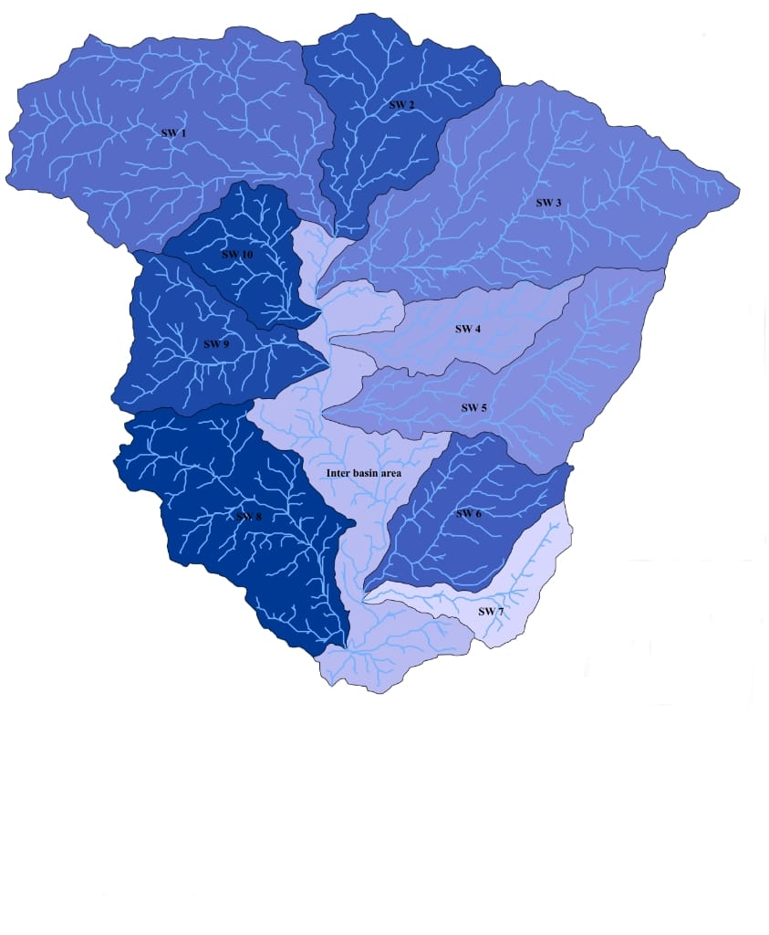
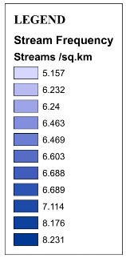
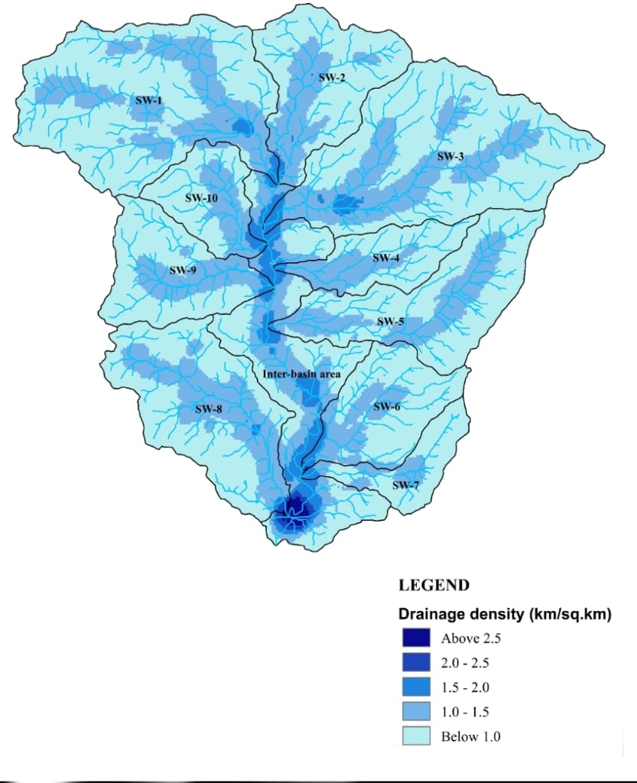
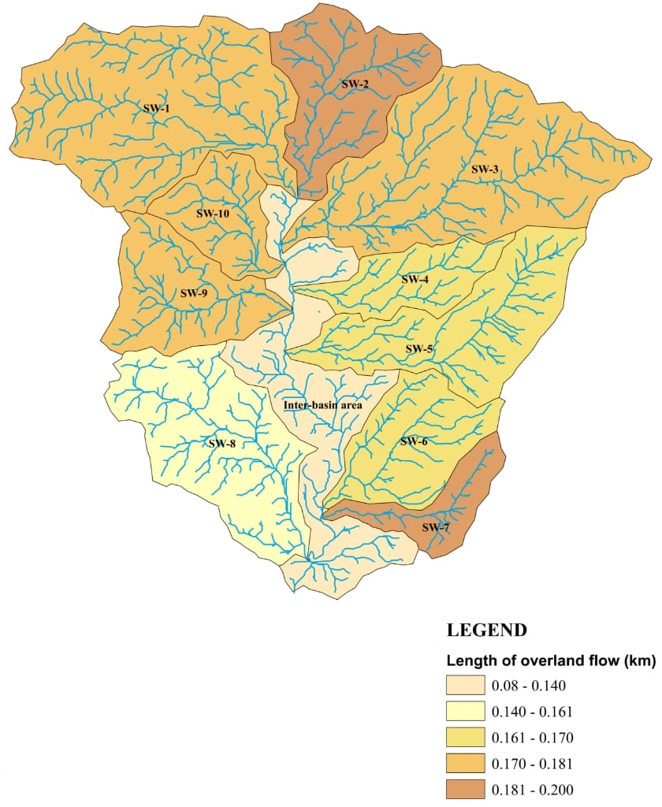
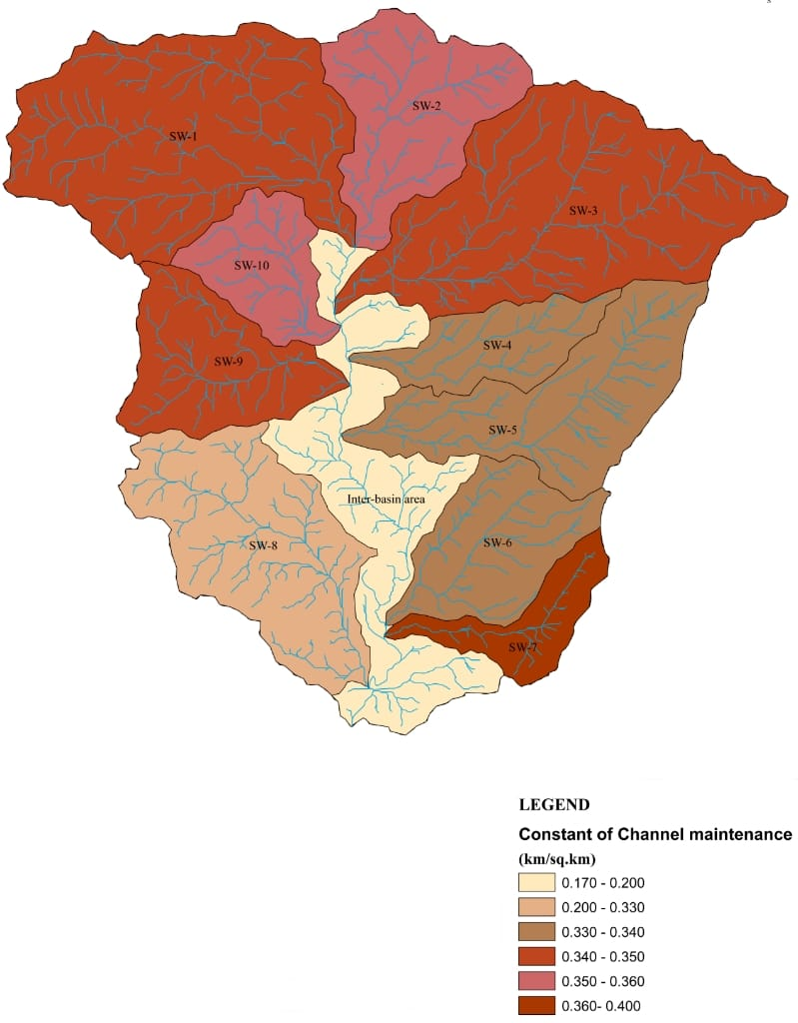
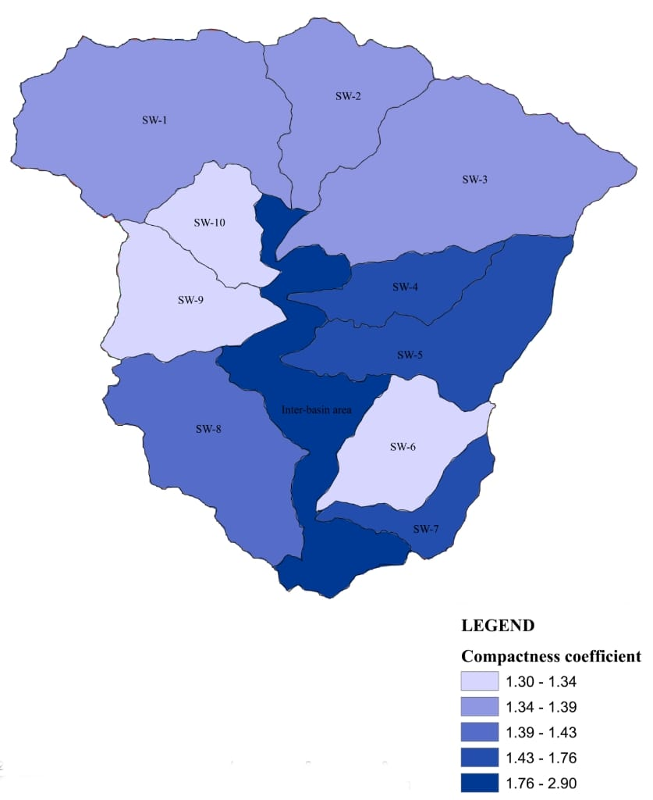
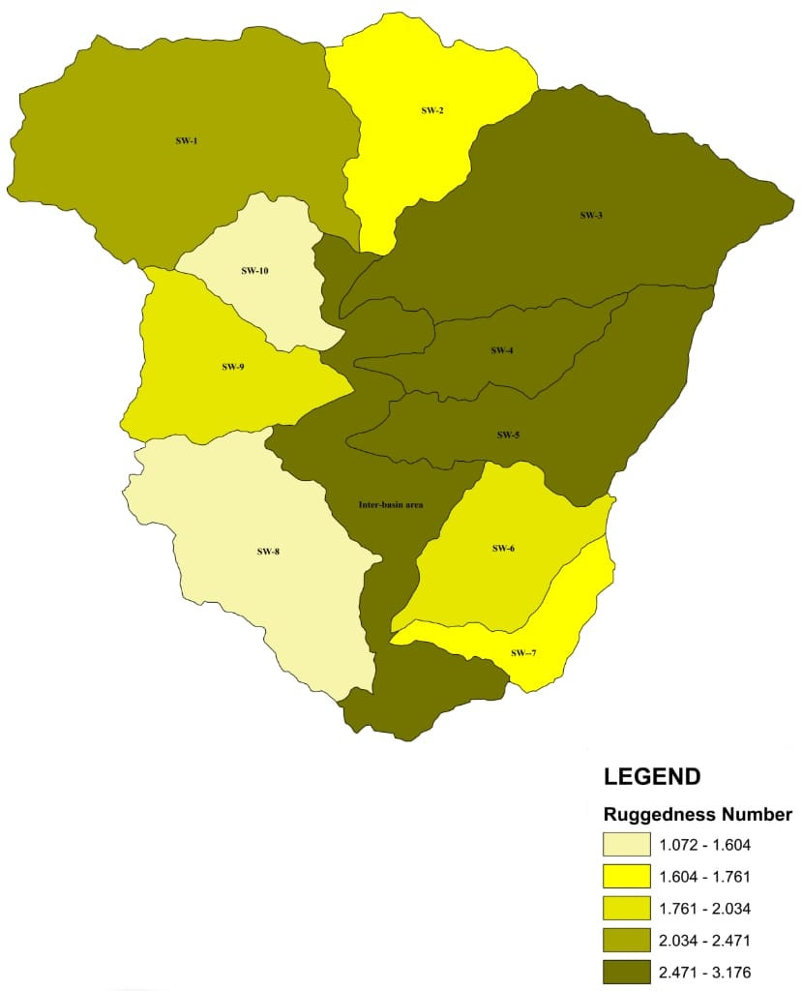
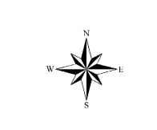
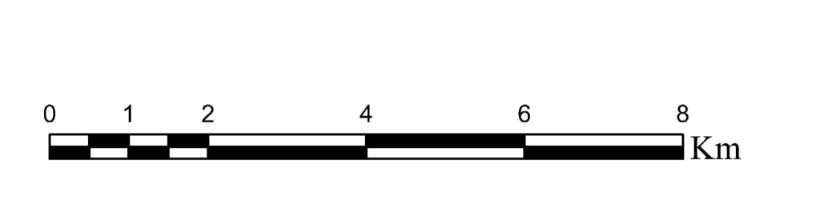
a.
b.
c.
d.
e.
f.

Fig. 4 a. Drainage density, b. Stream frequency, c. Length of overland flow,
d. Constant of channel maintenance, e. Compactness coefficient, f. Ruggedness number
Table 4. Morphometric Analysis: Areal parameters
Sub-watersheds | Dd | Fs | T | Rf | Re | Rc | Lg | C | Cc
SW-1 | 2.851 | 6.603 | 6.812 | 0.422 | 0.731 | 0.525 | 0.175 | 0.350 | 1.380
SW-2 | 2.638 | 6.689 | 4.736 | 0.435 | 0.740 | 0.526 | 0.189 | 0.379 | 1.379
SW-3 | 2.864 | 6.469 | 6.738 | 0.274 | 0.590 | 0.524 | 0.174 | 0.349 | 1.381
SW-4 | 2.974 | 6.240 | 2.655 | 0.181 | 0.480 | 0.383 | 0.168 | 0.336 | 1.618
SW-5 | 2.982 | 6.463 | 4.205 | 0.205 | 0.510 | 0.377 | 0.167 | 0.335 | 1.629
SW-6 | 2.961 | 6.688 | 4.283 | 0.310 | 0.627 | 0.564 | 0.169 | 0.337 | 1.330
SW-7 | 2.515 | 6.157 | 2.148 | 0.191 | 0.491 | 0.324 | 0.198 | 0.397 | 1.757
SW-8 | 3.101 | 8.231 | 6.650 | 0.329 | 0.652 | 0.499 | 0.161 | 0.322 | 1.401
SW-9 | 2.887 | 7.114 | 4.745 | 0.399 | 0.708 | 0.560 | 0.173 | 0.346 | 1.336
SW-10 | 2.833 | 8.176 | 4.411 | 0.450 | 0.755 | 0.574 | 0.176 | 0.352 | 1.321
Kiile watershed | 2.886 | 6.680 | 17.244 | 0.637 | 0.900 | 0.567 | 0.173 | 0.346 | 1.327
[Dd: Drainage density; Fs: Stream frequency; T: Drainage texture; Rf: Form factor; Re: Elongation ratio; Rc: Circulatory ratio; Lg: Length of overland flow; C: Constant channel maintenance; Cc: Compactness coefficient]
Relief parameters
Basin Relief (Bh):
Basin relief (Bh) refers to the elevation difference. It represents the maximum vertical distance from the highest and the lowest points of a sub-basin (Sridevi et al., 2013). The SW-3 and SW-5 show the highest basin relief of 1109m and 912m, respectively. Whereas the SW-8 and SW-10 have the lowest basin reliefs, 346m and 434m, respectively. The basin relief has a substantial influence on river carrying capacity, sediment transport, steepness of slope, and flood frequency (Schumm and Hadley, 1961).
Relief Ratio (Rh):
The relief ratio (Rh) measures the relationship between the maximum watershed relief and the
maximum watershed length that runs parallel to the primary drainage line (Lindsay and Seibert, 2013). Generally, the high Rh value describes the characteristics of an elevated region, whilst low values reflect the characteristics of valleys and pediplains (Asode et al., 2016). Elevated regions are characterized by increased runoff and potent erosion. In the study area, SW-7 has the highest Rh value (0.128) and SW-8 has the lowest Rh value (0.049), respectively.
The relief ratio of the Kiile watershed is recorded as 0.074 (Table 5).
Ruggedness Number (Rn):
Strahler (1964) described the ruggedness number (Rn) as the product of maximum basin relief and drainage density. The evaluated ruggedness number for the study area’s sub-watersheds ranges between 1.034 and 3.171 (Table 5) (Figure 9). The geology, geomorphology, slope, steepness, vegetation cover, and climate of an area significantly determine the ruggedness index of the area (Mahala, 2020). The high ruggedness numbers indicate structural complication and vulnerability to erosion and vice versa (Jothimani et al., 2020). The Rn value of the Kiile watershed is 3.293.

Table 5. Morphometric Analysis: Relief Parameters
Sub-watersheds | Maximum elevation (m) | Minimum elevation (m) | Basin relief (Bh) (m) | Relief ratio (Rh) (km) | Ruggedness number (Rn)(km)
SW-1 | 2262 | 1513 | 749 | 0.096 | 2.149
SW-2 | 2165 | 1513 | 652 | 0.124 | 1.714
SW-3 | 2622 | 1513 | 1109 | 0.114 | 3.171
SW-4 | 2197 | 1513 | 684 | 0.116 | 2.031
SW-5 | 2425 | 1513 | 912 | 0.110 | 2.717
SW-6 | 2182 | 1508 | 674 | 0.124 | 1.968
SW-7 | 2146 | 1508 | 638 | 0.128 | 1.601
SW-8 | 1854 | 1508 | 346 | 0.049 | 1.072
SW-9 | 2123 | 1513 | 610 | 0.122 | 1.372
SW-10 | 1947 | 1513 | 434 | 0.115 | 1.229
Kiile watershed | 2622 | 1494 | 1128 | 0.074 | 3.293

Ranking and Prioritization of Sub-watersheds
The ranking of different morphometric parameters, including linear, areal, and relief characteristics for each sub-watershed, was performed based on morphometric values and their relationship with soil erodibility. Morphometric parameters including drainage density (Dd), stream frequency (Fs), drainage texture (T), bifurcation ratio (Rb), and ruggedness number (Rn) exhibit a positive relationship with soil erosion hence, the highest value of these parameters was given a rank of 1, and the next highest value was given a rank of 2 and so on (Singh et al., 2021; Das, 2014; Jithimani et al., 2020; Puno and Puno, 2019). The morphometric parameters such as form factor (Rf), elongation ratio (Re), circulatory ratio (Rc), length of overland flow (Lg), constant of channel maintenance (C), and compactness coefficient (Cc) have a negative relationship with soil erosion hence, their lowest value depicts more vulnerability to soil erosion in a watershed. Accordingly, the lowest value of these parameters was given a rank of 1, the next lowest value was given a rank of 2, and so on (Singh et al., 2017; Singh et al., 2021; Das, 2014; Javed et al., 2009; Jothimani et al., 2020; Puno and Puno, 2019). After ranking each parameter for all ten sub-watersheds, a compound factor value was computed by adding the rank values of all parameters of each sub-watershed and dividing it by the total number of parameters to arrive at a compound value (Javed et al., 2009; Khandey and Javed, 2016; Nitheshnirmal et al., 2019; Ali et al., 2024). In the present study, it has been divided by eleven (number of parameters). The final prioritization was done by assigning the highest priority rank of 1 to the sub-watershed having the least compound value. This implies that the sub-watershed with the highest priority infers the greatest risk associated with surface runoff, peak flow, and soil erosion (Abdeta et al., 2020). Likewise, the last priority rank 10 is given to the sub-watershed having the highest compound value (Chandniha et al., 2017; Malik et al., 2019; Rakesh et al., 2023), signifying a lesser risk associated with soil erosion. In this study, SW-8 and SW-5 have the lowest compound value and fall in the very high priority; SW-3, SW-4, SW-6 and SW-9 fall in high priority, SW-1, SW-7, and SW-2 fall in medium priority, and SW-10 falls in the low priority class (Figure 5.). Detailed rankings of all morphometric parameters and final priority rankings of ten sub-watersheds are shown in Table 6 and Table 7, respectively.

Table 6. Priority Rankings of Morphometric Parameters of 10 Sub-watersheds
Morphometric parameters | Sub-watersheds
Morphometric parameters | SW-1 | SW-2 | SW-3 | SW-4 | SW-5 | SW-6 | SW-7 | SW-8 | SW-9 | SW-10
Bifurcation Ratio (Rb) | 3.710  (7) | 3.910  (6) | 3.700  (8) | 3.220  (10) | 4.760  (2) | 4.080  (5) | 5.660  (1) | 4.750  (3) | 4.220  (4) | 3.460  (9)
Drainage density (Dd) | 2.851  (7) | 2.638  (9) | 2.864  (6) | 2.974  (3) | 2.982  (2) | 2.961  (4) | 2.515  (10) | 3.101  (1) | 2.887  (5) | 2.833  (8)
Stream frequency (Fs) | 6.603  (6) | 6.689  (4) | 6.469  (7) | 6.240  (9) | 6.463  (8) | 6.688  (5) | 6.157  (10) | 8.231  (1) | 7.114  (3) | 8.176  (2)
Drainage texture (T) | 6.812  (1) | 4.736  (5) | 6.738  (2) | 2.655  (9) | 4.205  (8) | 4.283  (7) | 2.148  (10) | 6.65  (3) | 4.745  (4) | 4.411  (6)
Form factor  (Rf) | 0.422  (8) | 0.435  (9) | 0.274  (4) | 0.181  (1) | 0.205  (3) | 0.31  (5) | 0.191  (2) | 0.329  (6) | 0.399  (7) | 0.45  (10)
Elongation ratio (Re) | 0.731  (8) | 0.740  (9) | 0.590  (4) | 0.480  (1) | 0.51  (3) | 0.627  (5) | 0.491  (2) | 0.652  (6) | 0.708  (7) | 0.755  (10)
Circulatory ratio (Rc) | 0.525  (6) | 0.526  (7) | 0.524  (5) | 0.383  (3) | 0.377  (2) | 0.564  (9) | 0.324  (1) | 0.499  (4) | 0.56  (8) | 0.574  (10)
Length of overland flow (Lg) | 0.175  (7) | 0.189  (9) | 0.174  (6) | 0.168  (3) | 0.167  (2) | 0.169  (4) | 0.198  (10) | 0.161  (1) | 0.173  (5) | 0.176  (8)
Constant of Channel maintenance (C) | 0.35  (7) | 0.379  (9) | 0.349  (6) | 0.336  (3) | 0.335  (2) | 0.337  (4) | 0.397  (10) | 0.322  (1) | 0.346  (5) | 0.352  (8)
Compactness Coefficient (Cc) | 1.38  (5) | 1.379  (4) | 1.381  (6) | 1.618  (8) | 1.629  (9) | 1.33  (2) | 1.757  (10) | 1.401  (7) | 1.336  (3) | 1.321  (1)
Ruggedness number (Rn) | 2.135  (3) | 1.719  (7) | 3.176  (1) | 2.034  (4) | 2.719  (2) | 1.995  (5) | 1.604  (8) | 1.072  (10) | 1.761  (6) | 1.229  (9)
Sum of rankings (x) | 65 | 78 | 55 | 54 | 43 | 55 | 74 | 43 | 59 | 81
Total no. of parameters (y) | 11 | 11 | 11 | 11 | 11 | 11 | 11 | 11 | 11 | 11
Compound parameter value (Cp) (x/y) | 5.90 | 7.09 | 5.00 | 4.90 | 3.90 | 5.00 | 6.72 | 3.90 | 5.18 | 7.36
Note: values in parentheses indicate priority/rank

Table 7. Final priority ranking based on compound factor value
Sub-watersheds | Compound value | Priority rank | Priority Class
SW-1 | 5.9 | 5 | Medium
SW-2 | 7.09 | 7 | Medium
SW-3 | 5 | 3 | High
SW-4 | 4.9 | 2 | High
SW-5 | 3.9 | 1 | Very high
SW-6 | 5 | 3 | High
SW-7 | 6.72 | 6 | Medium
SW-8 | 3.9 | 1 | Very high
SW-9 | 5.18 | 4 | High
SW-10 | 7.36 | 8 | Low

Table 8. Details of priority classes of sub-watersheds
Priority class | Range of final priority | Sub-watersheds count | Sub-watersheds number | Total area (km²)
Very high | < 4.90 | 2 | SW-8 and SW-5 | 30.48
High | 4.90 - 5.18 | 4 | SW-3, SW-4, SW-6, and SW-9 | 51.32
Medium | 5.90 - 7.09 | 3 | SW-1, SW-7, and SW-2 | 42.11
Low | >7.09 | 1 | SW-10 | 6.36

The morphometric analysis revealed that the maximum sub-watersheds of the study area fall in the high-priority class, covering an area of 51.32 km² (Table 8). Whereas, 42.11 km² formed by three sub-watersheds (SW-1, SW-7, and SW-2) fall in the medium-priority class.

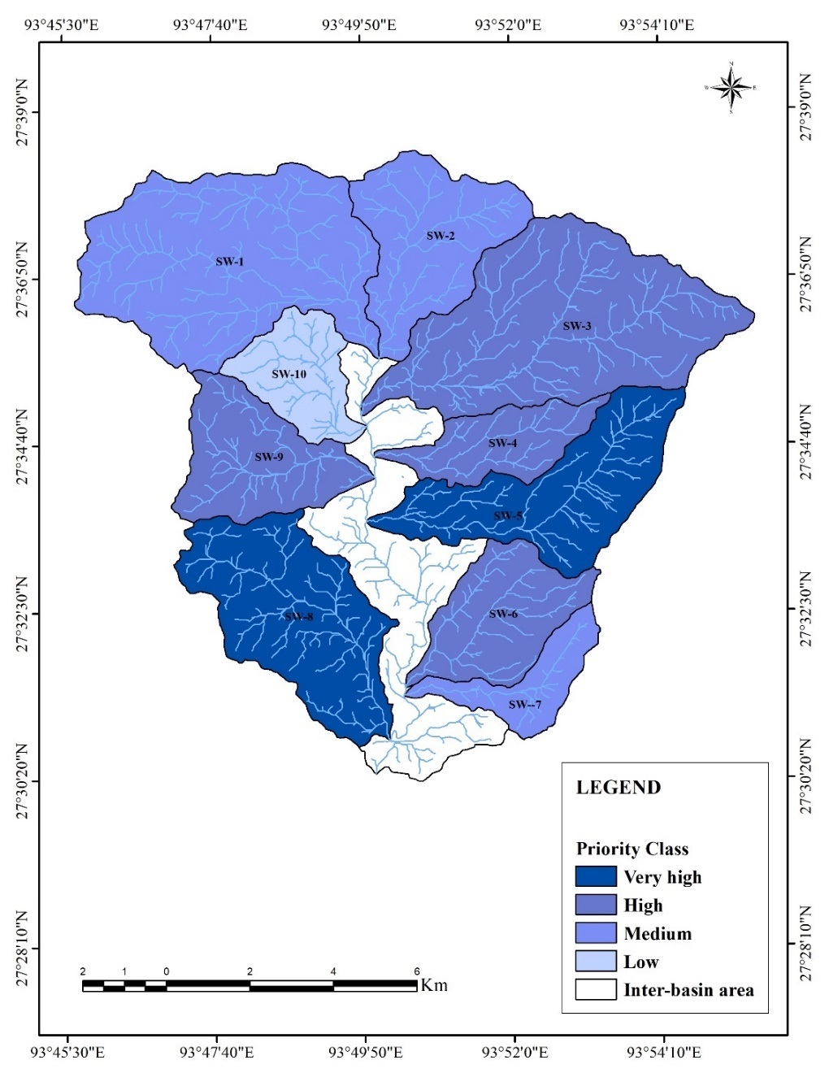

Fig.5 Prioritization of sub-watersheds
DISCUSSIONS
In this study, ten sub-watersheds of the Kiile River were prioritized using morphometric analysis to understand their hydrological behaviour and vulnerability to soil erosion. The analysis of morphometric characteristics of the Kiile River reveals that the main River of the study area is a 6th- order that exhibits dendritic to sub-dendritic at the higher elevation and parallel to sub-parallel at the lower elevation. The bifurcation ratio value indicates that structural disturbances moderately influence the study area, although the SW-7, which has the highest (Rb) value, is significantly controlled by lithology and geological structures in controlling drainage characteristics, a pattern also noted by Pasham et al., (2024) in structurally influenced basins and by Rao et al., (2023) in a similar study on northeastern watershed. The drainage density and stream frequency are highest in SW-8, indicating impervious rock, low vegetation cover, and greater surface runoff, which is comparable to the observations of Pophare and Balpande (2014), who reported similar relationships between these parameters and surface characteristics. The drainage density, stream frequency, and drainage texture of the entire watershed indicated a moderately permeable subsurface or infiltration capacity, with greater runoff on steep slopes and rapid discharge of rainwater. The form factor indicates the elongated nature of the basin. The form factor value for the entire watershed is (0.637), which indicates that the watershed is close to a circular shape. The highest value of elongation ratio among sub-watersheds is measured at SW-10 (0.755), indicating a less elongated basin characterized by a shorter flow path and faster runoff. The lowest Re value was recorded from SW-7 (0.491), signifying a strong dependence of landscape formation on hydrologic and geomorphic processes on landscape development, a relationship also observed by Kaliraj et al., (2015) in similarly dissected terrains. The lowest circulatory value observed in SW-7 (0.324) indicated a more elongated and irregular basin with a structurally controlled drainage system. While in SW-10, the highest Rc value of (0.54) was recorded, suggesting a more or less circular shape with maximum run-off during the monsoon. The length of overland flow is lowest in SW-8, signifying rapid discharge of rainwater into the stream channel, making the sub-watershed vulnerable to flash floods, especially during the peak monsoon season. Whereas SW-7, with the highest (Lg) value, signifies greater infiltration capacity compared to other sub-watersheds. The constant of channel maintenance, which provides the infiltration and runoff capacity of the basin, shows low to moderate permeability or infiltration capacity in all sub-watersheds with moderate to high runoff. This observation aligns with the findings of Mahala (2020), who showed that basins with lower infiltration capacities exhibit higher runoff potential under similar hydrological conditions. The Basin relief and relief ratio of the Kiile watershed reveal steep slopes with high runoff and moderate to active erosional processes. The high ruggedness number of the Kiile watershed suggests a higher susceptibility to soil erosion due to the structural complexity associated with the area’s relief characteristics.
- CONCLUSION
Prioritization of sub-watersheds is essential for effective watershed management, as it allows identification of the most vulnerable areas requiring conservation interventions. In this study, ten sub-watersheds were evaluated using eleven morphometric parameters of linear, areal, and relief aspects, with final ranking based on a compound factor value. The results indicate that SW-8 and SW-5 fall under the very high priority class, making them highly susceptible to soil erosion. Appropriate conservation measures, such as constructing drainage structures to channel runoff and afforesting steep slopes to stabilize soil and reduce runoff, are recommended for these sub-watersheds. The SW-3, SW-4, SW-6 and SW-9 are classified as high priority, SW-1, SW-2, and SW-7 as medium priority and SW-10 as low priority (Figure 5). The study demonstrates the effectiveness of integrating GIS and remote sensing in morphometric analysis for sub-watershed prioritization and erosion risk assessment. However, integration of these analyses with appropriate soil erosion models, such as the Revised Universal Soil Loss Erosion (RUSLE), could provide more precise soil loss estimates. Hence, the study can be extended further in future with the application of an appropriate soil loss model, which may provide crucial information for planners and decision-makers and may help in implementing targeted conservation measures in the area.

DISCLAIMER (ARTIFICIAL INTELLIGENCE)
Author(s) hereby declares that NO generative AI technologies such as Large Language Models (ChatGPT, COPILOT, etc) and text-to-image generators have been used during the writing or editing of this manuscript.
DECLARATION OF COMPETING INTEREST
The authors declare no competing interests.
REFERENCES
Abdeta, G. C., Tesemma, A. B., Tura, A. L., & Atlabachew, G. H. (2020). Morphometric Analysis for Prioritizing Sub-watersheds and Management Planning and Practices in Gidabo Basin, Southern Rift Valley of Ethiopia. Applied Water Science, 10(7), 1-15. https://doi.org/10.1007/s13201-020-01239-7.

Agarwal, K.K., Bali, R., Kumar, G.M., Srivastava, P., & Singh, P.V. (2009). Active Tectonics in and Around Kimin-Ziro Area, Lower Subansiri District, Arunachal Pradesh, NE India. Zeitschrift fur Geomorphologie 53(1):109–120. https://doi.org/10.1127/0372-8854/2009/0053-0109.
Aher, P. D., Adinarayana, J., & Gorantiwar, S. D. (2014). Quantification of Morphometric Characterization and Prioritization for Management Planning in Semi-arid Tropics of India: A Remote Sensing and GIS Approach. Journal of Hydrology, 511, 850–860. https://doi.org/10.1016/j.jhydrol.2014.02.028.
Ali, R., Sajjad, H., Masroor, M., Saha, T. K., Roshani, & Rahaman, M. H. (2024). Morphometric Parameters-Based Prioritization of Watersheds for Soil Erosion Risk in Upper Jhelum Sub-catchment, India. Environmental Monitoring and Assessment, 196(1), 82. https://doi.org/10.1007/s10661-023-12226-1.
Altaf, S., Meraj, G., & Romshoo, S. A. (2014). Morphometry and Land Cover Based Multi-Criteria Analysis for Assessing the Soil Erosion Susceptibility of the Western Himalayan Watershed. Environmental Monitoring and Assessment, 186, 8391-8412. https://doi.org/10.1007/s10661-014-4012-2.
Arefin, R., Seker, D. Z., Hore, R., & Meshram, S. G. (2024). GIS and Remotely Sensed Data-based Morphometric Elements Analysis for Determination of Bengal Basin Evolution. Environment, Development and Sustainability, 26(2), 3423-3456. https://doi.org/10.1007/s10668-022-02838-x.
Asim, M., Singh, J., Singh, S., & Tiwari, P. (2025). Watershed Prioritization of the Upper Ravi Basin, Himachal Himalaya Using Morphometric and Hypsometric Analysis. In Land and Water Nexus in South Asia: Exploring the Interplay of Resources (pp. 103-135). https://doi.org/10.1007/978-3-031-87429-1_4.
Asode, A. N., Sreenivasa, A., & Lakkundi, T. K. (2016). Quantitative Morphometric Analysis in the Hard Rock Hirehalla Sub-basin, Bellary and Davanagere Districts, Karnataka, India using RS and GIS. Arabian Journal of Geosciences, 9, 1-14. https://doi.org/10.1007/s12517-016-2414-x.
Avinash, K., Deepika, B., & Jayappa, K. S. (2014). Basin Geomorphology and Drainage Morphometry Parameters used as Indicators for Groundwater Prospect: Insight from Geographical Information System (GIS) Technique. Journal of Earth Science, 25, 1018-1032. https://doi.org/10.1007/s12583-014-0505-8.
Barman, B. K., Rao, C. U. B., Rao, K. S., Patel, A., Kushwaha, K., & Singh, S. K. (2021). Geomorphic Analysis, Morphometric-based Prioritization and Tectonic Implications in Chite Lui River, Northeast India. Journal of the Geological Society of India, 97, 385-395. https://doi.org/10.1007/s12594-021-1696-0.
Benzougagh, B., Meshram, S. G., Dridri, A., Boudad, L., Baamar, B., Sadkaoui, D., & Khedher, K. M. (2022). Identification of Critical Watershed at Risk of Soil Erosion using Morphometric and Geographic Information System Analysis. Applied Water Science, 12, 1-20. https://doi.org/10.1007/s13201-021-01532-z.
Bhagwat, T. N., Shetty, A., & Hegde, V. S. (2011). Spatial Variation in Drainage Characteristics and Geomorphic Instantaneous Unit Hydrograph (GIUH); Implications for Watershed Management—A Case Study of the Varada River basin, Northern Karnataka. Catena, 87(1), 52-59. https://doi.org/10.1016/j.catena.2011.05.007.
Bhat, M. S., Alam, A., Ahmad, S., Farooq, H., & Ahmad, B. (2019). Flood Hazard Assessment of Upper Jhelum Basin using Morphometric Parameters. Environmental Earth Sciences, 78, 1-17. https://doi.org/10.1007/s12665-019-8046-1.
Bhatt, S. & Ahmed, S.A. (2014). Morphometric Analysis to Determine Floods in the Upper Krishna Basin using Cartosat DEM. Geocarto International, 29(8):878–894. https://doi.org/10.1080/10106049.2013.868042.
Bouguerra, S., & Jebari, S. (2017). Identification and Prioritization of Sub-watersheds for Land and Water Management using InVEST SDR Model: Rmelriver Basin, Tunisia. Arabian Journal of Geoscience, 10(15):1-9. https://doi.org/10.1007/s12517-017-3104-z.
Chandniha, S. K. & Kansal, M. L. (2017). Prioritization of Sub-watersheds Based on Morphometric Analysis using Geospatial Technique in Piperiya Watershed, India. Applied Water Science, 7, 329-338. https://doi.org/10.1007/s13201-014-0248-9.
Chandrashekar, H., Lokesh, K. V., Sameena, M., & Ranganna, G. (2015). GIS–based Morphometric Analysis of Two Reservoir Catchments of Arkavati River, Ramanagaram District, Karnataka. Aquatic Procedia, 4, 1345-1353. https://doi.org/10.1016/j.aqpro.2015.02.175
Chopra, R., Dhiman, R. D., & Sharma, P. K. (2005). Morphometric Analysis of Sub-Watersheds in Gurdaspur District, Punjab using Remote Sensing and GIS Techniques. Journal of the Indian Society of Remote Sensing, 33, 531-539. https://doi.org/10.1007/BF02990738.
Choudhari, P. P., Nigam, G. K., Singh, S. K., & Thakur, S. (2018). Morphometric-based Prioritization of Watershed for Groundwater Potential of Mula River Basin, Maharashtra, India. Geology, Ecology, and Landscapes, 2(4), 256-267. https://doi.org/10.1080/24749508.2018.1452482.
Chowdary, V. M., Chakraborthy, D., Jeyaram, A., Murthy, Y. K., Sharma, J. R., & Dadhwal, V. K. (2013). Multi-criteria Decision-making Approach for Watershed Prioritization using Analytic Hierarchy Process Technique and GIS. Water Resources Management, 27(10), 3555–3571. https://doi.org/10.1007/s11269-013-0364-6.
Das, D. (2014). Identification of Erosion-prone Areas by Morphometric Analysis using GIS. Journal of the Institution of Engineers (India): Series A, 95(1): 61-74. https://doi.org/10.1007/s40030-014-0069-8.
Das, M., Sahariah, D., Deka, D., Dey, P., & Patnaik, S.K 2025. “RUSLE-Based Estimation of Annual Soil Loss and Its Environmental Geoscience Implications in the Mansiri River Basin, Assam, India”. Asian Journal of Geological Research 8 (3):442–461. https://doi.org/10.9734/ajoger/2025/v8i3208.
Das, S. (2021). Hydro-geomorphic Characteristics of the Indian (Peninsular) Catchments: Based on Morphometric Correlation with Hydro-sedimentary Data. Advances in Space Research, 67:2382-2397. https://doi.org/10.1016/j.asr.2021.01.043.
Devatha, C. P., Deshpande, V., & Renukaprasad, M. S. (2015). Estimation of Soil Loss using USLE Model for Kulhan Watershed, Chattisgarh-A Case Study. Aquatic Procedia, 4, 1429-1436. https://doi.org/10.1016/j.aqpro.2015.02.185.
Dhungel, R., & Fiedler, F. (2016). Water Balance to Recharge Calculation: Implications for Watershed Management using Systems Dynamics Approach. Hydrology, 3(1), 13. https://doi.org/10.3390/hydrology3010013.
Gajbhiye, S., Mishra, S. K., & Pandey, A. (2014). Prioritizing Erosion-prone Area Through Morphometric Analysis: A RS and GIS Perspective. Applied Water Science, 4, 51-61. https://doi.org/10.1007/s13201-013-0129-7
Giri, P., Diwate, P., and Mawale, Y. K. (2020). Morphometric Analysis of Tapi Drainage Basin using Remote Sensing and GIS Techniques. Sustainable Development Practices Using Geoinformatics, 57-72. https://doi.org/10.1002/9781119687160.ch4.
Golom, T., Nayak, D. R., Saikia, M., Bandyopadhyay, A., & Bhadra, A. (2025). Prioritization of Tlawng River Basin of Mizoram Based on Erodibility Through Morphometric Analysis using GIS Technique. Journal of Water Management Modeling.
Gravelius, H. (1914). Morphometry of Drainage Basins. Quaternary International, v. Goschen Ve.
Haokip, P., Khan, M. A., Choudhari, P., Kulimushi, L. C., & Qaraev, I. (2022). Identification of Erosion-prone Areas using Morphometric Parameters, Land use Land cover and Multi-criteria Decision-making Method: Geo-Informatics Approach. Environment, Development and Sustainability, 24(1), 527-557. https://doi.org/10.1007/s10668-021-01452-7.
Haregeweyn, N., Berhe, A., Tsunekawa, A., Tsubo, M., & Meshesha, D. T. (2012). Integrated Watershed Management as an Effective Approach to Curb Land Degradation: A Case Study of the Enabered Watershed in Northern Ethiopia. Environmental Management, 50(6): 1219-1233. https://doi.org/10.1007/s00267-012-9952-0.
Hema, H. C., Vittala, S. S., & Govindaiah, S. (2021). Quantitative Morphometric Infer in the Hard Rock Terrain Based on SRTM-DEM and GIS-Chintamani Watershed, Chikkaballapur District, Karnataka, India. Sustainable Water Resources Management, 7(4), 57. https://doi.org/10.1007/s40899-021-00534-8.
Horton, R. E. (1945). Erosional Development of Streams and Their Drainage Basins; Hydrophysical Approach to Quantitative Morphology. Geological Society of America Bulletin, 56(3), 275-370.
Jain, M.K. & Das D. (2010). Estimation of Sediment Yield and Areas of Soil Erosion and Deposition for Watershed Prioritization using GIS and Remote Sensing. Water Resources Management, 24: 2091–2112. https://doi.org/10.1007/s11269-009-9540-0.
Jasmin, I., & Mallikarjuna, P. (2013). Morphometric Analysis of Araniar River Basin using Remote Sensing and Geographical Information System in the Assessment of Groundwater Potential. Arabian Journal of Geosciences, 6, 3683-3692. https://doi.org/10.1007/s12517-012-0627-1.
Javed, A., Khanday, M. Y., & Ahmed, R. (2009). Prioritization of Sub-watersheds Based on Morphometric and Land Use Analysis using Remote Sensing and GIS Techniques. Journal of the Indian Society of Remote Sensing, 37, 261-274. https://doi.org/10.1007/s12524-009-0016-8.
Javed, A., Khanday, M. Y., & Rais, S. (2011). Watershed Prioritization using Morphometric and Land use/land Cover Parameters: A Remote Sensing and GIS based Approach. Journal of the Geological Society of India, 78, 63-75. https://doi.org/10.1007/s12594-011-0068-6.
Jothimani, M., Abebe, A., & Dawit, Z. (2020). Mapping of Soil Erosion-Prone Sub-Watersheds Through Drainage Morphometric Analysis and Weighted Sum Approach: A Case Study Of the Kulfo River basin, Rift valley, Arba Minch, Southern Ethiopia. Modelling Earth Systems and Environment, 6, 2377-2389.
Kadam, A. K., Jaweed, T. H., Kale, S. S., Umrikar, B. N., & Sankhua, R. N. (2019). Identification of Erosion-Prone Areas Using Modified Morphometric Prioritization Method And Sediment Production Rate: A Remote Sensing and GIS Approach. Geomatics, Natural Hazards and Risk, 10(1), 986-1006. https://doi.org/10.1080/19475705.2018.1555189.
Kaliraj, S., Chandrasekar, N., & Magesh, N. S. (2015). Morphometric Analysis of the River Thamirabarani Sub-basin in Kanyakumari District, South West Coast of Tamil Nadu, India, using Remote Sensing and GIS. Environmental Earth Sciences, 73, 7375-7401. https://doi.org/10.1007/s12665-014-3914-1.
Khanday, M. Y., & Javed, A. (2016). Prioritization of Sub-watersheds for Conservation Measures in a Semi-Arid Watershed using Remote Sensing and GIS. Journal of the Geological Society of India, 88, 185-196. https://doi.org/10.1007/s12594-016-0477-7.
Khare, D., Mondal, A., Mishra, P. K., Kundu, S., & Meena, P. K. (2014). Morphometric Analysis for Prioritization using Remote Sensing and GIS Techniques in a Hilly Catchment in the State of Uttarakhand, India. Indian Journal of Science and Technology, 7(10), 1650-1662. https://doi.org/10.17485/ijst/2014/v7i10.18.
Koradia, A., & Patel, J. N. (2025). Erosion risk assessment for prioritization of soil and water conservation measures in the semi-arid region: A remote sensing and GIS-based approach. Journal of the Indian Society of Remote Sensing, 53(3), 293–305. https://doi.org/10.1007/s12524-024-01996-x.
Latha, P. S. (2024). Prioritizing Sub-watersheds using Morphometric Analysis and Geospatial Tools in the Gosthani River Basin, Southern India. Goya Journal, 17(4), 261-275. https://doi.org/10.5281/zenodo.14523396.
Lindsay, J. B., & Seibert, J. (2013). Measuring the Significance of a Divide to Local Drainage Patterns. International Journal of Geographical Information Science, 27(7), 1453-1468. https://doi.org/10.1080/13658816.2012.705289.
Macka, Z. (2001). Determination of Texture of Topography from Large Scale Contour Maps. Geografski Vestnik 73(2):53–62.
Magesh, N. S., Jitheshlal, K. V., Chandrasekar, N., & Jini, K. V. (2013). Geographical Information System-Based Morphometric Analysis of Bharathapuzha River Basin, Kerala, India. Applied Water Science, 3, 467-477. https://doi.org/10.1007/s13201-013-0095-0.
Mahala, A. (2020). The Significance of Morphometric Analysis to Understand the Hydrological and Morphological Characteristics in two Different Morpho-climatic Settings. Applied Water Science, 10(1), 1-16. https://doi.org/10.1007/s13201-019-1118-2
Mahato, R. & Nimasow, G. (2023). Morphometric Analysis of Bichom .River Aasin, Arunachal Pradesh, India using ALOS PALSAR RTC DEM and Geospatial Technology. Applied Geomatics, 15(4), 853-870. https://doi.org/10.1007/s12518-023-00528-5.
Malik, A., Kumar, A., & Kandpal, H. (2019). Morphometric Analysis And Prioritization of Sub-Watersheds in a Hilly Watershed using a Weighted Sum Approach. Arabian Journal of Geosciences, 12, 1-12. https://doi.org/10.1007/s12517-019-4310-7.
Mangan, P., Haq, M. A., & Baral, P. (2019). Morphometric Analysis of Watershed using Remote Sensing and GIS—A Case Study of Nanganji River Basin in Tamil Nadu, India. Arabian Journal of Geosciences, 12, 1-14. https://doi.org/10.1007/s12517-019-4382-4.
Miller, V.C. (1953). A Quantitative Geomorphologic Study of Drainage Basin Characteristics in the Clinch Mountain area, Virginia and Tennessee, Project NR 389042, Technical Report 3. Columbia University Department of Geology, ONR Geography Branch New York.
Mishra, C. D. (2016). Prioritization of Watersheds for Efficient Planning and Management Through Advanced Techniques. Department of Farm Engineering, Banaras Hindu University. http://hdl.handle.net/10603/268354.
Mohammed, A., Adugna, T., & Takala, W. (2018). Morphometric Analysis and Prioritization of Watersheds for Soil Erosion Management in Upper Gibe Catchment. Journal of Degraded and Mining Lands Management, 6(1), 1419-1426. https://doi.org/10.15243/jdmlm.2018.061.1419.
Nag. S., Roy, M., & Roy, P. (2020). Optimum Prioritisation of Sub-Watersheds Based on Erosion-Susceptible Zones Through Modeling and GIS Techniques. Model Earth Systems Environment. https://doi.org/10.1007/s40808-020-00768-z.
Nitheshnirmal, S., Thilagaraj, P., Rahaman, S. A., & Jegankumar, R. (2019). Erosion Risk Assessment Through Morphometric Indices for Prioritisation of Arjuna Watershed using ALOS-PALSAR DEM. Modelling Earth Systems and Environment, 5, 907-924. https://doi.org/10.1007/s40808-019-00578-y.
Odiji, C. A., Aderoju, O. M., Eta, J. B., Shehu, I., Mai-Bukar, A., & Onuoha, H. (2021). Morphometric Analysis and Prioritization of Upper Benue River Watershed, Northern Nigeria. Applied Water Science, 11, 1-28. https://doi.org/10.1007/s13201-021-01364-x.
Pande, C.B. & Moharir, K. (2017). GIS-based Quantitative Morphometric Analysis and its Consequences: A Case Study from Shanur River Basin. Maharashtra India. Applied Water Science 7(2):861–871. https://doi.org/10.1007/s13201-015-0298-7.
Pareta, K. & Pareta, U. (2011). Quantitative Morphometric Analysis of a Watershed of Yamuna Basin, India using ASTER (DEM) data and GIS. International Journal of Geomatics and Geosciences, 2(1), 248-269.
Pasham, H., Gugulothu, S., Badapalli, P. K., Dhakate, R., & Kottala, R. B. (2024). Geospatial Approaches of TGSI and Morphometric Analysis in the Mahi RiverBasin using Landsat 8 OLI/TIRS and SRTM-DEM. Environmental Science and Pollution Research, 31(41), 54129-54146.
Patel, D. P., Gajjar, C. A., & Srivastava, P. K. (2013). Prioritization of Malesari Mini-watersheds Through Morphometric Analysis: A Remote Sensing and GIS perspective. Environmental Earth Sciences, 69(8), 2643-2656. https://doi.org/10.1007/s12665-012-2086-0.
Patnaik, S. K. (2017). Land holding, land ownership and customary law governing land fragmentation in Ziro valley, Arunachal Pradesh. Neo Geographia, 4(2), 1-12.
Pophare, A. M. & Balpande, U. S. (2014). Morphometric Analysis of Suketi River Basin, Himachal Himalaya, India. Journal of Earth System Science, 123, 1501-1515. https://doi.org/10.1007/s12040-014-0487-z.
Pophare, A. M., & Balpande, U. S. (2014). Morphometric Analysis of Suketi River Basin, Himachal Himalaya, India. Journal of Earth System Science, 123(7), 1501–1515. https://doi.org/10.1007/s12040-014-0487-z.
Prabhakar, A. K., Singh, K. K., Lohani, A. K., & Chandniha, S. K. (2019). Study of Champua Watershed for Management of Resources by using Morphometric Analysis and Satellite Imagery. Applied Water Science, 9(5), 127. https://doi.org/10.1007/s13201-019-1003-z.
Priyanka, T., Veeraiah, B., Jogu, L.S., Kishoor, K., & Gardas, N.K. 2025. Morphometric Characterization of Sudda Vagu Basin in a Hard Rock Aquifer System Using Geospatial and Geostatistical Tools in Part of Nirmal District, Telangana State, India”. Asian Journal of Geographical Research 8 (1):46–60. https://doi.org/10.9734/ajgr/2025/v8i1255.
Puno, G. R., & Puno, R. C. C. (2019). Watershed Conservation Prioritization using Geomorphometric and Land use-Land cover Parameters. Global Journal of Environmental Science and Management, 5(3), 279-294. https://doi.org/10.22034/gjesm.2019.03.02.
Rahaman, S. A., Ajeez, S. A., Aruchamy, S., &Jegankumar, R. (2015). Prioritization of Sub-watershed based on Morphometric Characteristics using Fuzzy Analytical Hierarchy Process and Geographical Information System–A study of Kallar Watershed, Tamil Nadu. Aquatic Procedia, 4, 1322-1330. https://doi.org/10.1016/j.aqpro.2015.02.172.
Rakesh, C. J., Govindaraju, Lokanath, S., & Kumar, A. K. (2023). Prioritization of soil Erosion Prone Sub-watersheds Through Morphometric Analysis using Geospatial and Weighted Sum Approach: A Case Study of Boranakanive Reservoir Catchment in Tumkur District, Karnataka, India. Environmental Earth Sciences, 82(12), 306. https://doi.org/10.1007/s12665-023-10996-y.
Rao, K. S., Barman, B. K., Neog, S., Barman, J., & Biswas, B. (2023). Morphometry-based prioritization of watersheds for soil and water conservation measures: a case study on Vanvate Lui basin, Mizoram, NorthEast India. Arabian Journal of Geosciences, 16(4), 279. https://doi.org/10.1007/s12517-023-11353-w.
Rudraiah, M., Govindaiah, S., & Vittala, S. S. (2008). Morphometry using Remote Sensing and GIS Techniques in the Sub-basins of Kagna River Basin, Gulburga District, Karnataka, India. Journal of the Indian Society of Remote Sensing, 36, 351-360.
Rupa, T. (2007). Geomorphological and Land Use Study of Kiile River Basin Eastern Himalaya Arunachal Pradesh. Department of Geography, Rajiv Gandhi University. http://hdl.handle.net/10603/302115.
Saha, S., Das, J., & Mandal, T. (2022). Investigation of the Watershed Hydro-morphologic Characteristics through the Morphometric Analysis: A study on Rayeng Basin in Darjeeling Himalaya. Environmental Challenges, 7, 100463. https://doi.org/10.1016/j.envc.2022.100463.
Sangma, F. & Guru, B. (2020). Watersheds Characteristics and Prioritization using Morphometric Parameters and Fuzzy Analytical Hierarchal Process (FAHP): A Part of Lower Subansiri Sub-basin. Journal of the Indian Society of Remote Sensing, 48, 473-496.
Sarkar, D., Mondal, P., Sutradhar, S., & Sarkar, P. (2020). Morphometric Analysis using SRTM-DEM and GIS of Nagar River Basin, Indo-Bangladesh Barind Tract. Journal of the Indian Society of Remote Sensing, 48(4), 597-614. https://doi.org/10.1007/s12524-020-01106-7.
Sarmah, K., Jha, L. K., & Tiwari, B. K. (2012). Morphometric Analysis of a Highland Microwatershed in East Khasi Hills District of Meghalaya, India: Using Remote Sensing and Geographic Information System (GIS) techniques. Journal of Geography and Regional Planning, 5(5), 142. https://doi.org/10.5897/JGRP11.120.
Schumm, S. A. (1956). Evolution of Drainage Systems and Slopes in Badlands at Perth Amboy, New Jersey. Geological Society of America Bulletin, 67(5), 597-646.
Schumm, S. A., & Hadley, R. F. (1961). Progress in the Application of Landform Analysis in Studies of Semiarid Erosion US Department of the Interior, Geological Survey.437, 437-453.
Sharma, S. & Mahajan, A. K. (2020). GIS-based Sub-watershed Prioritization through Morphometric Analysis in the Outer Himalayan Region of India. Applied Water Science, 10(7), 1-11. https://doi.org/10.1007/s13201-020-01243-x.
Shekar, P. R., Mathew, A., PS, A., & Gopi, V. P. (2023). Sub-watershed Prioritization using Morphometric Analysis, Principal Component Analysis, Hypsometric Analysis, Land use/Land Cover Analysis, and Machine Learning Approaches in the Peddavagu River Basin, India. Journal of Water and Climate Change, 14(7), 2055-2084. https://doi.org/10.2166/wcc.2023.221.
Sherin, S. & KS, A. (2022). Morphometric Characteristics of a Tropical River Basin, Central Kerala, India using Geospatial Techniques. Landscape & Environment, 16(1), 114. https://doi.org/10.21120/LE/16/1/1.
Singh, A. P., Arya, A. K., & Singh, D. S. (2020). Morphometric Analysis of Ghaghara River Basin, India, using SRTM data and GIS. Journal of the Geological Society of India, 95, 169-178.
Singh, K. N. (1980). Quantitative Analysis of Land from Sand Settlement Distribution in Southern Uplands of Eastern Uttar Pradesh (India). Publisher: Vimal Prakashan, Varanasi. edition: 1st ed View all formats and editions, Vimal Prakashan, Varanasi.
Singh, M. C., Satpute, S., & Prasad, V. (2023). Remote Sensing and GIS-based Watershed Prioritization for Land and Water Conservation Planning and Management. Water Science & Technology, 88(1), 233-265. https://doi.org/10.2166/wst.2023.207.
Singh, M. C., Yousuf, A., & Prasad, V. (2021). Morphometric and Principal Component Analysis–based Prioritization of Reservoir Catchments using Geospatial Techniques for Land and Water Conservation Aspects in North-West India. Arabian journal of geosciences, 14, 1-22. https://doi.org/10.1007/s12517-021-06822-z.
Smith, K. G. (1950). Standards for Grading Texture of Erosional Topography. American Journal of Science, 248(9), 655-668.
Sreedevi, P. D., Sreekanth, P. D., Khan, H. H., & Ahmed, S. (2013). Drainage Morphometry and its Influence on Hydrology in a Semi-arid Region: Using SRTM data and GIS. Environmental Earth Sciences, 70, 839-848. https://doi.org/10.1007/s12665-012-2172-3.
Srinivasa Vittala, S., Govindaiah, S., & Honne Gowda, H. (2004). Morphometric Analysis of Sub-Watersheds in the Pavagada area of Tumkur district, South India using Remote Sensing and GIS techniques. Journal of the Indian Society of Remote Sensing, 32, 351-362. https://doi.org/10.1007/BF03030860.
Strahler, A.N. (1964). Quantitative Geomorphology of Drainage Basins and Channel Networks. In: Chow VT (ed) Handbook of Applied Hydrology. McGraw Hill Book Company, New York.
Thakkar, A. K., & Dhiman, S. D. (2007). Morphometric Analysis and Prioritization of Mini Watersheds in Mohr Watershed, Gujarat using Remote Sensing and GIS Techniques. Journal of the Indian Society of Remote Sensing, 35, 313-321. https://doi.org/10.1007/BF02990787.
Tukura, N. G., Akalu, M. M., Hussein, M., & Befekadu, A. (2021). Morphometric Analysis and sub-Watershed Prioritization of Welmal watershed, Ganale-Dawa River Basin, Ethiopia: Implications for Sediment Erosion. Journal of Sedimentary Environments, 6, 121-130. https://doi.org/10.1007/s43217-020-00039-y.

