ASSESSMENT OF THE BENEFITS OF GEOGRAPHIC INFORMATION SYSTEM
IN COMMERCIAL PROPERTY DEVELOPMENT IN PORT HARCOURT, NIGERIA

Abstract

This study assesses the benefits of Geographic Information Systems (GIS) in commercial property development in Port Harcourt, Nigeria, focusing on its impact on decision-making, efficiency, and sustainability. Data were collected through surveys, interviews, and field observations, with spatial data obtained from high-resolution satellite imagery and processed using GIS software. The findings show strong agreement (84.2% to 93.6%) on GIS's role in improving decision-making, cost reduction, and risk management. However, challenges in integrating GIS with regulatory frameworks and other external factors, such as market conditions, were noted. Spatial analysis of three case studies (Creek Road Market, New Mile 1 Market, and RivTaf Shopping Center) revealed varying compliance with planning standards, with RivTaf demonstrating the highest compliance. The study recommends institutionalizing GIS in development control, enhancing training, updating planning policies, improving infrastructure, and expanding GIS use for post-development monitoring to promote sustainable property development in Port Harcourt.

Keywords: Geographic Information Systems (GIS), Commercial Property Development, Sustainable Development, Spatial Data, Sustainable Cities.

1.0 Introduction
Geographic Information Systems (GIS) have become essential tools in various sectors, especially in urban planning and property development. The use of GIS in commercial property development is crucial for addressing challenges such as land use planning, zoning, infrastructure management, and environmental sustainability(Maurya, & Kumar, 2024). By integrating spatial data with analytical tools, GIS provides accurate, real-time, and actionable insights, making it an invaluable resource for planning and developing commercial properties (Ahmada, & Fauzan, 2024).
Commercial property development is central to urban growth and economic prosperity in many cities, especially in fast-developing African contexts. In Port Harcourt, Rivers State, rapid urbanisation has stressed existing planning frameworks, resulting in frequent violations of development standards such as encroachments on road, river, and rail setbacks with often serious consequences for safety, infrastructure, and liveability. As noted recently, the Rivers State government has taken enforcement actions against firms violating building codes and development permits, underscoring the urgency of stricter development control (The Guardian, 2024).
The use of Geographic Information Systems (GIS) in property development offers solutions to various challenges by enabling more informed decision-making, enhancing site selection, streamlining the design and construction phases, and improving property management (Adewale et al., 2025). GIS is vital for monitoring and analyzing spatial data, allowing for the visualization of land use patterns, assessment of environmental risks, and prediction of future development trends (Attah et al., 2024). Additionally, GIS helps developers evaluate crucial factors like proximity to essential services, transportation networks, and environmental constraints, all of which are important in the realm of commercial property development.
While Geographic Information Systems (GIS) have proven in many jurisdictions to enhance precision in spatial planning, risk mitigation, and regulatory compliance, their application in commercial property development in Nigeria and particularly in Rivers State—remains limited. Studies on property valuation in Port Harcourt have begun exploring GIS for improving valuations and cadastral management (Ayedun, Akinjare, Omodo & Alimi, 2022), but comprehensive analyses that test compliance with standards (setbacks, plot coverage, building line, parking) using spatial methods are rare.
In this context, applying GIS to commercial property development in Rivers State is not just a technological enhancement but a necessary step toward achieving sustainable, efficient, and safer urban growth. The aim of this study is to assess the benefits of Geographic Information Systems (GIS) in enhancing commercial property development in Port Harcourt, Nigeria. Specifically, it seeks to evaluate how GIS can improve the efficiency, decision-making processes, and sustainability of commercial property projects in the region
2.0 Study Area
The study was carried out in Port Harcourt, the capital of Rivers State, Nigeria, located within latitudes 4°45′–5°00′ N and longitudes 6°55′–7°05′ E. Port Harcourt is a major commercial and industrial hub in the Niger Delta region, with rapid urbanisation driving increasing demand for retail, market, and shopping infrastructure. Three case studies were selected to represent different scales and typologies of commercial property development. These include: Creek Road Market, one of the city’s traditional open markets situated near the Bonny River waterfront; New Mile 1 Market, a large urban market located along Ikwerre Road and intersected by a rail corridor; and the RivTaf Shopping Center, a modern mall at Golf Estate off Peter Odili Road, Trans-Amadi. Together, these sites capture the contrast between unplanned traditional markets and formal private-sector shopping developments. The choice of Port Harcourt and these three markets is informed by their economic importance, exposure to planning challenges, and the need to evaluate compliance with commercial property development standards in a rapidly urbanising environment.
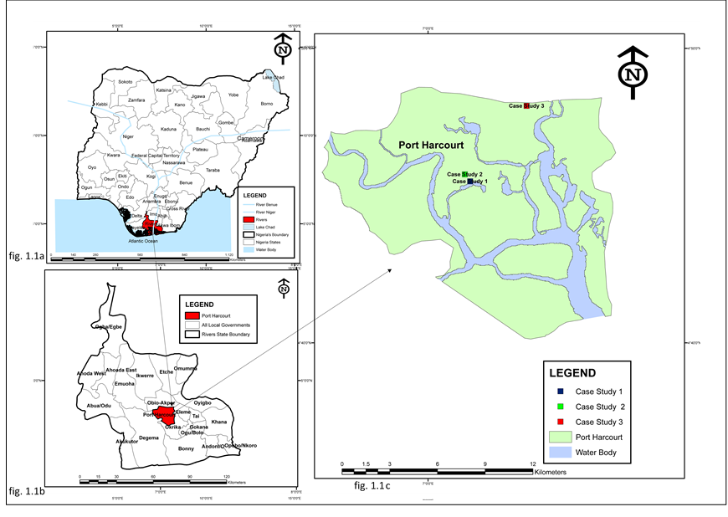
Map 1: Study Area map of Rivers State showing Location of Case Studies
Source: Office of the Surveyor General, (2024)

Literature Review
Concept of Geographic Information Systems (GIS)
Geographic Information Systems (GIS) are powerful tools that enable the collection, analysis, management, and visualization of spatial and geographic data. A GIS integrates hardware, software, and data to capture, store, manipulate, analyze, manage, and present spatial information, thereby allowing users to interpret patterns, relationships, and trends within geographical contexts (Kraak & Ormeling, 2020). By incorporating various layers of spatial data, GIS facilitates the creation of maps and models that represent real-world phenomena, supporting informed decision-making across multiple sectors, including urban planning, environmental management, transportation, and property development (Longley et al., 2015).
At its core, GIS operates on the principle of spatial data, which is organized into vector and raster formats. Vector data represents geographic features as points, lines, and polygons (e.g., roads, buildings, and land parcels), while raster data represents continuous data in grid form (e.g., elevation, temperature, or land cover) (Tomlinson, 2015). GIS combines these data types to produce comprehensive spatial analyses and models that can inform planning, development, and management decisions. Moreover, GIS can process and analyze large datasets, identify spatial patterns, and predict future trends, making it indispensable in fields such as commercial property development, where spatial accuracy and the integration of diverse data layers are critical (Verburg et al, 2015)

GIS in Property Development
Geographic Information Systems (GIS) have become essential tools in property development, significantly transforming how developers, planners, and investors assess, plan, and manage projects. By integrating both spatial and non-spatial data, GIS enhances decision-making, improves project efficiency, and aids in risk mitigation throughout the development cycle from site selection to post-development management. In the site selection phase, GIS enables developers to evaluate factors such as transport access, utility availability, land topography, zoning regulations, and environmental risks (Maurya & Kumar, 2024). This capability helps to minimize poor location choices and increases the likelihood of project success. Furthermore, GIS facilitates land-use planning and zoning compliance by mapping land-use patterns, ensuring compatibility and reducing conflicts (Abubakar et al 2015) Environmental assessments are another significant advantage of GIS. It helps identify sensitive areas, flood zones, and unstable soils, which allows developers to design sustainable projects that comply with environmental regulations (Xu, Zhao, & Liu, 2019). In infrastructure planning, GIS also plays a critical role by assisting in the design of efficient transportation, utilities, and public services while pinpointing gaps or aging systems that may require upgrades (Attah et al., 2024).
Moreover, GIS strengthens risk management by analyzing historical and environmental data to predict hazards such as flooding, soil erosion, or crime (Verburg et al, 2015). In property management, GIS offers benefits such as efficient tracking of ownership, maintenance, and facility performance (Tomlinson, 2015). Lastly, GIS enhances market analysis and investment planning by mapping demographic trends, land values, and growth patterns. This enables investors to identify profitable opportunities and forecast demand effectively (Zhang & Ching, 2023). Overall, GIS provides a comprehensive framework that supports sustainable, efficient, and profitable property development.

Benefits of GIS Utilisation in Promoting Commercial Property Development
Geographic Information Systems (GIS) have emerged as a transformative tool for property development. GIS enables the analysis of spatial data to optimise land use, enhance infrastructure planning, and assess environmental impacts. Several GIS tools, such as ArcGIS, QGIS, and AutoCAD, offer specialised functions for mapping, spatial analysis, and planning that can be directly applied to commercial property development projects.
- Site Suitability and Environmental Compatibility: GIS plays a crucial role in evaluating the suitability of land for commercial development by considering various factors such as soil quality, water availability, environmental sensitivity, and proximity to infrastructure. For example, GIS tools can overlay environmental data layers on top of land-use maps to assess areas prone to flooding or erosion, thereby helping developers select the most suitable sites for construction (Obafemi, Eludoyin & Opara, 2011). This capability is vital in Port Harcourt, where the risk of flooding and land degradation is high.
- Urban Growth Management: GIS can assist in managing urban growth patterns by predicting the future development of commercial areas based on demographic trends, land availability, and infrastructure development. It can also help to manage the complexities of zoning laws and land-use patterns to ensure that commercial properties are developed in harmony with residential, industrial, and environmental needs (Koko, 2025).
- Infrastructure Planning and Resource Allocation: GIS enables developers to visualise and analyse infrastructure systems like transportation networks, utilities, and drainage systems. By integrating GIS with other planning tools, stakeholders can design more efficient resource allocation strategies, reducing costs and maximizing the effectiveness of existing infrastructure (Zhang, & Ching, 2023).
- Stakeholder Collaboration and Engagement: GIS tools facilitate collaboration among different stakeholders involved in commercial property development. Real estate surveyors, urban planners, local authorities, and developers can all use GIS platforms to share data, discuss planning scenarios, and make informed decisions. This improves transparency and decision-making and ensures that development aligns with the community's needs (Izeogu, 2018).
- Environmental Impact Assessments (EIAs): The integration of GIS in EIAs allows for more comprehensive assessments of the potential environmental impacts of proposed commercial developments. By analysing spatial data, developers and environmental experts can identify potential risks such as flooding, soil erosion, and habitat destruction, and make adjustments to minimise these impacts (Akeh & Mshelia, 2016).
- Security: The security benefits of GIS in commercial property development are multifaceted, encompassing risk management, enhanced surveillance, and informed urban planning. The integration of GIS helps mitigate potential threats and enables proactive measures, ensuring safer environments for investment and occupation. Leveraging GIS for commercial development in regions like Nigeria, where urbanisation often outpaces planning efforts, could significantly bolster property security and support long-term sustainable development (Koko, 20250
- Potential for High Returns: Commercial properties typically generate significant rental income. The appreciation in value over time also offers capital gains for investors. In Port Harcourt, properties such as retail centers in high-traffic locations can achieve robust rental yields despite challenges like rising rents and limited parking spaces (Nwaogu, Egolum, & Ewurum, 2021).
- Tax Benefits: Investors can enjoy various tax benefits through commercial property development, including deductions for depreciation and interest payments. These tax incentives make commercial property a desirable investment vehicle for many institutional and individual investors.

Empirical Literature Review
This section reviews key studies on the use of Geographic Information Systems (GIS) in commercial property development, focusing on its role in enhancing sustainability, reducing costs, and improving decision-making processes. Alfaqih and Hassan (2016) examined how cloud-based GIS solutions reduce infrastructure costs for commercial property developers. Their study highlighted that these platforms enable remote collaboration, reduce the need for expensive hardware, and minimize the carbon footprint, making them a cost-effective and sustainable option, particularly in resource-limited areas.
Brundtland (1987) introduced the concept of sustainable development, emphasizing the need to meet present needs without compromising future generations. GIS, as highlighted in this framework, plays a critical role in supporting sustainable property development GIS plays a key role in this by integrating environmental, economic, and social factors into property development decisions. It helps developers assess environmental impacts, optimize land use, and ensure projects align with sustainability principles, fostering responsible land-use planning and green building practices.

Li, Wang, and Zhang (2022) examined GIS's role in promoting environmental sustainability in commercial property development, focusing on air quality and green space assessment. Their study showed how GIS integrates environmental data to help developers make informed decisions about site selection and design. GIS identifies areas with better environmental quality and mitigates negative impacts on the environment, underscoring its critical role in aligning property development with sustainability goals.
Longley, et al., (2015) provided a comprehensive guide on GIS and its applications in urban planning and property development. They emphasized the role of GIS in transforming raw geographic data into actionable insights, supporting developers in land-use planning, resource management, and infrastructure design. The authors highlighted the multidisciplinary applications of GIS, noting its critical role in promoting sustainability by integrating environmental monitoring, urban planning, and resource management in commercial property development.
Malczewski (2020) explored the integration of GIS with multi-criteria decision analysis (MCDA), allowing developers to assess factors like environmental impact, cost, accessibility, and market demand. He opined that combination helps resolve trade-offs and supports more balanced, sustainable decision-making in complex property development projects, highlighting GIS's role in informed, sustainability-driven decisions.
Miller and Shaw (2019) highlighted the importance of geospatial analysis in property development. Their work provided a detailed guide to geospatial analysis techniques, such as spatial data modeling and statistical analysis, which are essential for identifying optimal locations, assessing environmental constraints, and predicting future urban growth. GIS-based geospatial analysis allows developers to evaluate the long-term impacts of their projects on both the environment and the community, ensuring that property development is aligned with sustainability objectives.
Rogers (2003), in his influential work on the diffusion of innovations, provides valuable insights into the adoption of new technologies like GIS in property development. Rogers’ theory explains how new technologies spread from innovators and early adopters to the broader population. The study of GIS adoption through this lens highlights the importance of understanding the stages of adoption and the factors that influence the diffusion process. Rogers’ work emphasizes that effective strategies for overcoming resistance and promoting wider adoption are essential for integrating GIS into commercial property development.
Urban sprawl poses a significant challenge to commercial property development, affecting infrastructure, resource allocation, and environmental sustainability. Onwuzuligbo et al. (2022) used GIS and remote sensing techniques to model urban sprawl in Greater Port Harcourt, highlighting its impact on land use and property development. Their findings underscore the need for proactive GIS-based spatial planning to manage expansion, preserve ecological balance, and support sustainable urban growth. Understanding residential patterns is essential for strategic commercial property planning. Wizor (2014) utilised GIS to map single-family housing estates on Port Harcourt's urban fringes, revealing patterns that influence commercial property placement. Strategic integration of commercial zones into residential areas can foster economic synergy, reduce commuting times, and improve urban livability. Globally, GIS applications in property valuation and land management offer valuable lessons for Port Harcourt. Weber (2001) demonstrated the integration of GIS and Online Analytical Processing (OLAP) for accurate land valuation, a model that could enhance transparency and efficiency in Port Harcourt’s property market. Similarly, Greenhalgh et al. (2020) used GIS to analyse stock and value changes in York, showcasing its potential for land administration and property market analysis in Port Harcourt.
The relationship between real estate values, spatial centrality, and economic activity has been explored in international contexts. Battaglia et al. (2010) applied GIS to study these dynamics in Swindon, UK, reinforcing the importance of accessibility and centrality for commercial success. These principles are equally relevant for optimizing the placement and functionality of commercial properties in Port Harcourt’s hubs. The integration of GIS into the planning, management, and evaluation of commercial properties in Port Harcourt offers a robust framework for sustainable urban development. By leveraging GIS for flood risk assessment, spatial planning, property valuation, and sprawl management, stakeholders can enhance decision-making, support economic growth, and address urban challenges. This approach ensures that commercial properties contribute to Port Harcourt’s economic vitality while aligning with broader sustainability objectives.
Commercial property development involves the strategic process of purchasing, developing, and selling properties intended for business use. These properties include office buildings, retail centers, industrial parks, and mixed-use developments. As the backbone of urban economies, commercial properties play a crucial role in supporting economic activity, providing spaces for businesses to operate and grow. The reviewed studies emphasize that GIS is a critical tool in sustainable commercial property development. GIS helps developers assess environmental impacts, optimize land use, and engage in collaborative decision-making. From reducing infrastructure costs (Alfaqih & Hassan, 2016) to fostering sustainability (Brundtland, 1987), GIS plays an integral role in promoting responsible development practices. The integration of GIS with decision-making frameworks such as multi-criteria analysis (Malczewski, 2020) and its adoption process further underscores its value in commercial property development. These studies highlight the significant role of GIS in balancing economic, environmental, and social factors, ensuring that property development is sustainable and meets the needs of both current and future generations
3.0 Methodology
Data collection for this study utilized both quantitative and qualitative methods. Questionnaire surveys were conducted to gather quantitative data on land use and infrastructure conditions. The surveys targeted professionals involved in commercial property development in Port Harcourt, including land surveyors, real estate surveyors, valuers, town planners, and developers. Additionally, oral interviews with local stakeholders, along with the researcher’s field observations, provided qualitative insights into compliance with planning standards. Spatial data were collected using high-resolution satellite imagery, which was processed and digitized with GIS software to extract key features such as buildings, roads, and open spaces. This spatial data included satellite imagery, base maps, and field-collected coordinates from the three case study sites: Creek Road Market, New Mile 1 Market, and RivTaf Shopping Center. The data were processed and analyzed using ArcGIS 10.5 software. Non-spatial data, including road classifications, right-of-way standards, and planning regulations, were sourced from planning manuals and secondary literature. This non-spatial data comprised planning standards and regulatory documents, such as the Federal Highways (Building Lines) Regulations (1971), the National Building Code (2006), and the NIWA Act (1997). These documents provided important benchmarks for assessing compliance.
3.1 Data Acquisition
Spatial data were obtained for the three case study sites—Creek Road Market, New Mile 1 Market, and RivTaf Shopping Center. Satellite imagery were sourced and prepared for analysis. Field coordinates of the study sites were collected to support georeferencing and digitisation. In addition, relevant planning regulations such as the Federal Highways (Building Lines) Regulations (1971), the National Building Code (2006), and the NIWA Act (1997) were reviewed to provide benchmarks for commercial property development standards, including road, river, and rail setbacks, plot coverage, parking provision, and building line requirements
Below are satellite imageries of the three case studies acquired from google Earth
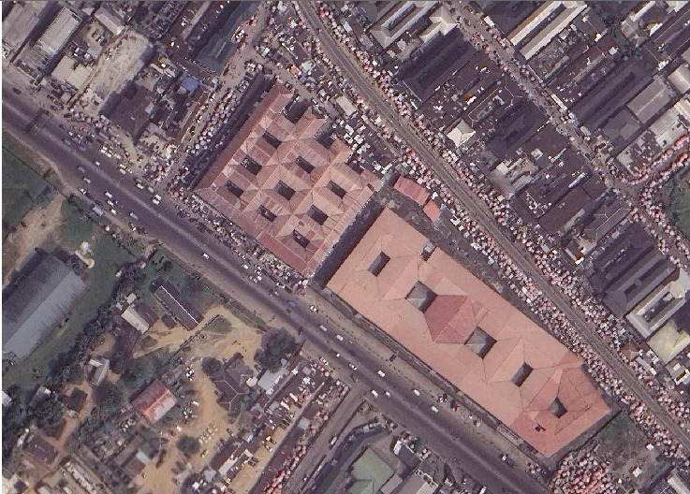
Figure 1a: Satellite Imagery of Mile market
(Source: Google Earth (2025)

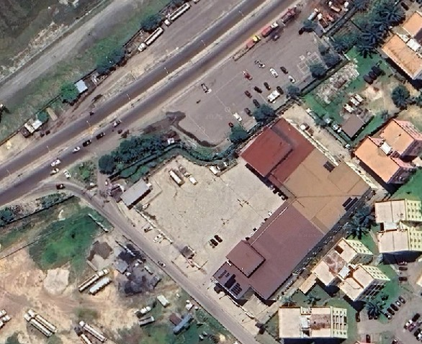Figure 1b: Satellite imagery of RivTaf Shopping mall
(Source: Google Earth (2025)

Figure.1c Satellite imagery of Creek Road market
(Source: Google Earth (2025)

4.0 Results
4.1 Results from Benefits of GIS Utilisation on Public Commercial Property Development

Table 1: Analysis of the Benefits of GIS Utilisation on Public Commercial Property Development
S/N | Research Question Item | N | Disagree  (%) | Undecided  (%) | Agree (%) | Range | Min | Max | Sum | Mean | Std. Dev.
1 | GIS helps in identifying and mitigating environmental risks, such as flooding, in public commercial property development. |  | 5 (2.5%) | 12 (5.9%) | 186 (91.6%) |  |  |  | 587 | 2.89 | 0.383
2 | GIS helps in reducing costs by improving resource allocation and project coordination. |  | 3 (1.5%) | 13 (6.4%) | 187 (92.1%) |  |  |  | 590 | 2.91 | 0.339
3 | GIS provides valuable insights for selecting prime locations for commercial property development. |  | 10 (4.9%) | 20 (9.9%) | 173 (85.2%) |  |  |  | 569 | 2.80 | 0.508
4 | GIS utilisation enhances spatial planning for public commercial property development. |  | 10 (4.9%) | 15 (7.4%) | 178 (87.7%) |  |  |  | 574 | 2.83 | 0.492
5 | GIS utilisation helps streamline administrative processes and regulatory compliance in public commercial property development. | 203 | 12 (5.9%) | 20 (9.9%) | 171 (84.2%) | 2 | 1 | 3 | 565 | 2.78 | 0.538
6 | GIS utilisation improves market analysis and helps developers identify profitable areas for investment. |  | 4 (2.0%) | 18 (8.9%) | 181 (89.2%) |  |  |  | 583 | 2.87 | 0.390
7 | The use of GIS enhances efficiency in project management and monitoring during the development phase. |  | 5 (2.5%) | 21 (10.3%) | 177 (87.2%) |  |  |  | 578 | 2.85 | 0.424
8 | The use of GIS improves decision-making processes during property development projects. |  | 3 (1.5%) | 10 (4.9%) | 190 (93.6%) |  |  |  | 593 | 2.92 | 0.320
9 | The use of GIS improves risk assessment and management in large-scale development projects. |  | 4 (2.0%) | 12 (5.9%) | 187 (92.1%) |  |  |  | 589 | 2.90 | 0.359
10 | Utilizing GIS reduces costs associated with land acquisition and property management. |  | 8 (3.9%) | 20 (9.9%) | 175 (86.2%) |  |  |  | 573 | 2.82 | 0.475
 | Grand Average | 203 | 5.2 | 20.1 | 178 | 2 | 1 | 3 |  | 2.86 | 0.42
Source: Researcher Data (2025), SPSS v.23 Output

The results in Table 1 reveal strong consensus among respondents on the benefits of Geographic Information Systems (GIS) utilisation in public commercial property development. Across all the ten research items, the majority of respondents indicated agreement, with percentages of agreement ranging between 84.2% and 93.6%, thereby underscoring the widespread recognition of GIS as a critical tool in property development.
Item 8, which assessed whether GIS improves decision-making processes during property development projects, recorded the highest level of agreement (93.6%), with a mean score of 2.92 and a relatively low standard deviation (0.320), suggesting strong consistency in respondents’ perceptions. Similarly, Items 2 and 9, which examined the role of GIS in reducing costs and improving risk assessment, attracted agreement levels of 92.1%, with mean values of 2.91 and 2.90, respectively, reflecting the significance of GIS in ensuring cost-effectiveness and effective risk management in development projects.
Conversely, Item 5, which investigated whether GIS helps streamline administrative processes and regulatory compliance, recorded the lowest agreement (84.2%) and the lowest mean (2.78), alongside the highest standard deviation (0.538). This indicates that, while most respondents acknowledge the administrative benefits of GIS, there is slightly more variability in opinion compared to other items. Similarly, Item 3 (GIS providing insights for selecting prime locations) showed a relatively lower mean score of 2.80 and higher variability (0.508), suggesting that location-related insights, though recognized, may be influenced by other contextual factors such as local market dynamics and political considerations.
Overall, the grand mean of 2.86 (on a 3-point scale) and a standard deviation of 0.42 demonstrate a strong positive perception and consistency among respondents regarding GIS benefits in public commercial property development. These findings highlight that GIS is perceived as a valuable tool for improving decision-making, risk management, project coordination, cost reduction, and investment analysis in the sector.
4.2 Result in applying GIS spatial analysis to evaluate compliance with these standards.
The spatial analysis applied in this study focused on three case studies, namely: RivTaf Shopping Center, Creek Road Market, and New Mile 1 Market. Buffer analysis was employed to evaluate proximity and restrictions around key features such as the major road corridors and river in any case, thereby helping to establish required setbacks and ensuring safety, accessibility, and compliance with planning regulations. Near analysis was carried out to assess the spacing between buildings within each commercial location, with a focus on how structures align with prescribed building line standards and acceptable planning practices. Furthermore, calculations were performed to determine building coverage and parking space availability, both of which are essential for assessing commercial development suitability. For instance, building coverage was derived by comparing the total built-up area of digitized structures against the overall land parcel area for each case study, while parking space analysis considered the extent of open areas available to accommodate vehicles in line with commercial facility requirements. The analysis was first to create a map of the three case studies and then the analysis follows. Below are the results:
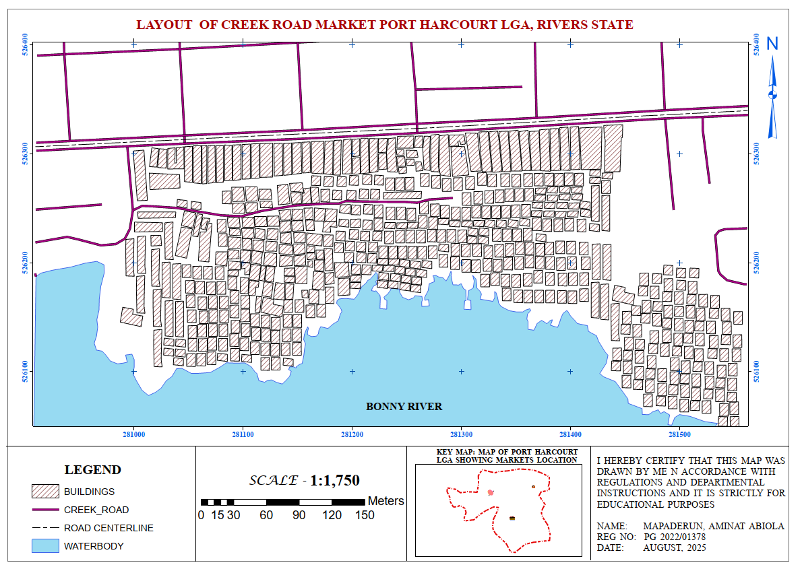
Figure 2: Layout of Creek Road Market
(Source: Researcher Data (2025), Mapping Output)
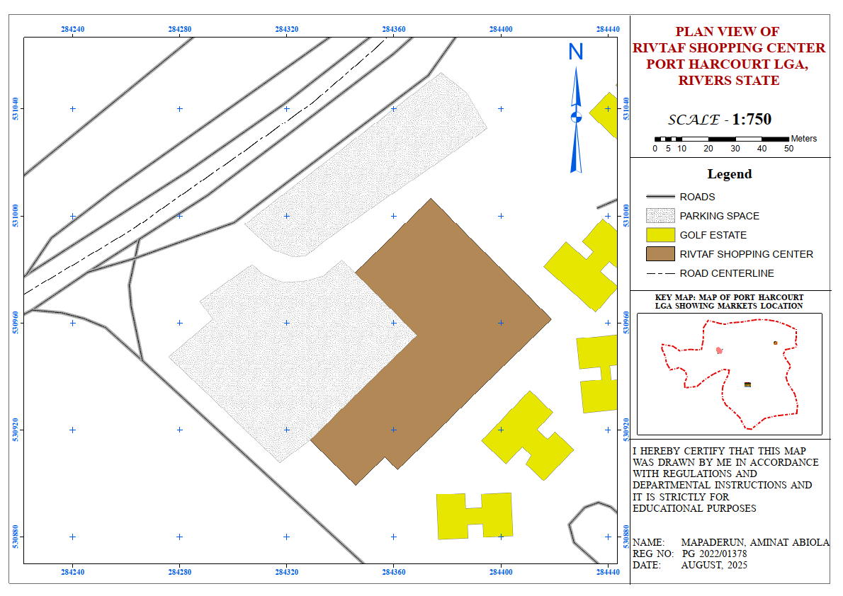
Figure 3: Layout of RivTaf Shopping Center
Source: Researcher Data (2025), Mapping Output)
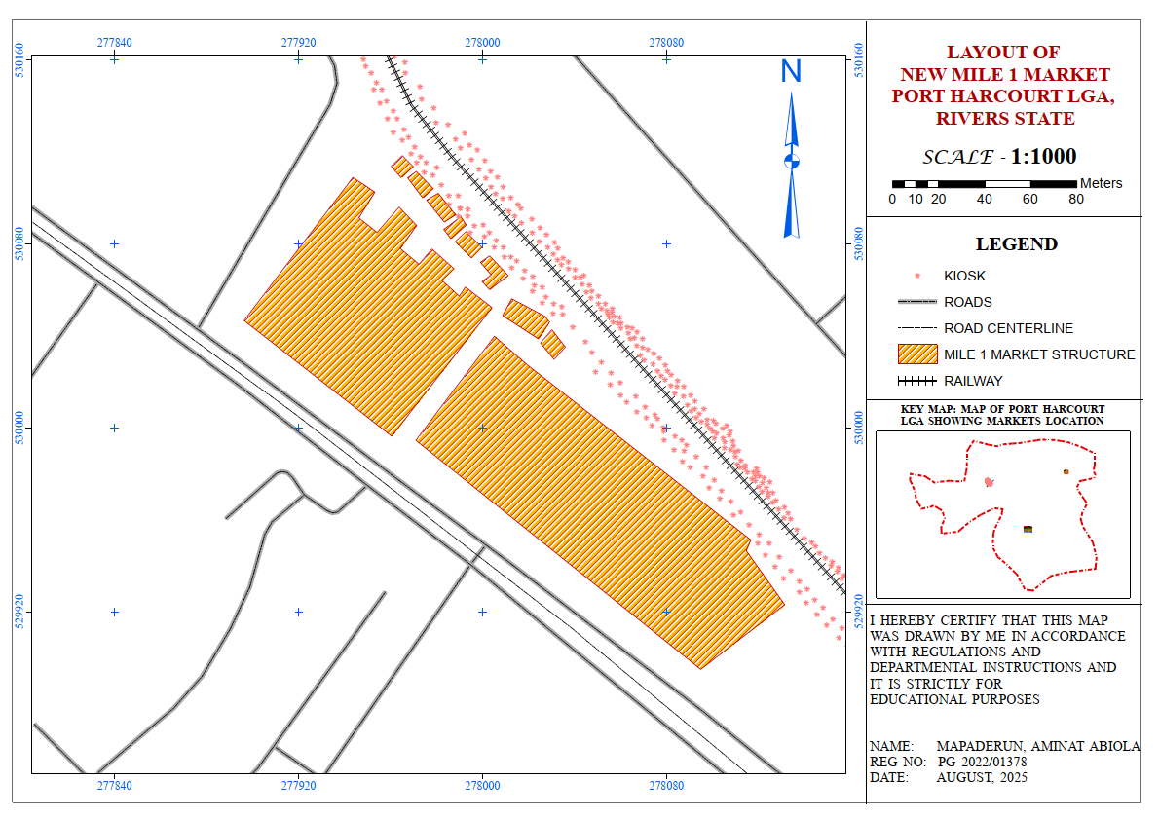
Figure 4.: Layout of New Mile One Market
(Source: Researcher Data (2025), Mapping Output)
The maps for RivTaf Shopping Center, Creek Road Market, and New Mile 1 Market depict the spatial layout of buildings, roads, and adjoining rivers. They highlight structure density, open spaces, and access routes, serving as base layers for spatial analyses such as buffer, proximity, building coverage, and parking evaluation. The analysis was carried out following the standards for commercial property development and the result is presented in a table below

Table 2: Result from analysis using GIS to check conformity to Commercial Property Development standard in study area
Indicator | Creek Road Market | RivTaf Shopping Center | New Mile 1 Market
Referenced Easting | 281062.66 | 284356.811 | 277989
Referenced Northing | 526314.77 | 530968.632 | 530027
Area (m²) | 107,264.57 | 9,862 | 28,733
Parking Space (m²) | Nil | 6,140.27 | 1,845
Met Parking Standard | No | Yes | No
Road Setback Encroachment | Yes (49 structures) | No | Yes (2 structures)
River Setback Encroachment | Yes (176 structures) | No | No
Rail Setback Encroachment | No | No | Yes (288 kiosks, incl. 9 structures)
Plot Coverage (%) | 68% | 39.5% | 55%
Average Building Line (m) | 0.9 | 14 | 3
Met Building Line Standard | No | Yes | Yes
(Source: Researcher Data (2025), Mapping Output)
4.1.3 Result of the Comparative Evaluation of the Case Studies
The comparative analysis of Creek Road Market, New Mile 1 Market, and RivTaf Shopping Center revealed marked differences in compliance with commercial property development standards. While RivTaf largely conformed to required benchmarks, Creek Road and Mile 1 showed significant lapses, particularly in setbacks, parking provision, and building line requirements.
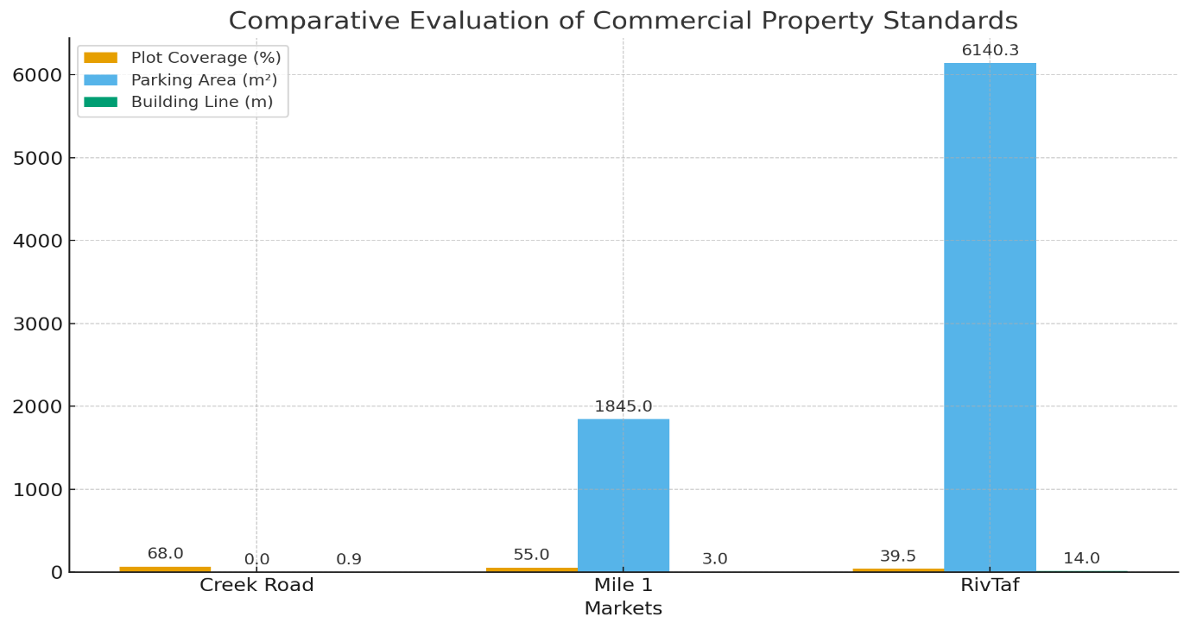
Figure 5: Comparative Compliance of the Three Case Studies with Key Commercial Property Development Standards
Source: Researcher Data (2025), Mapping Output

The figure above presents a bar chart comparing key indicators plot coverage, parking provision, and building line for the three markets. The chart highlights RivTaf’s relative compliance compared to the deficiencies observed in Creek Road and Mile 1.
4.3 Discussion
The findings reveal a strong consensus on the benefits of GIS in public commercial property development, with agreement levels ranging from 84.2% to 93.6% in commercial property development, with strong support for its benefits in decision-making, cost reduction, and risk management. The highest agreement (93.6%) was in GIS's role in improving decision-making, indicating it is seen as crucial for informed, efficient development decisions. Similarly, GIS's effectiveness in cost reduction and risk management was widely acknowledged (92.1%).
However, the lower agreement in Item 5 (84.2%) suggests that while GIS can streamline administrative processes, challenges in integrating it with regulatory frameworks remain. Item 3 showed that while GIS is useful for site selection, other factors like market conditions also influence decisions, as reflected in the higher variability in responses. Overall, GIS is viewed positively as a valuable tool for property development, though challenges in administrative integration and external factors in site selection still exist.
The findings from the spatial analysis highlight notable differences in the extent of compliance with commercial property development standards across the three case studies. GIS proved effective in operationalizing the standards into measurable indicators such as road, river, and rail setbacks, plot coverage, parking adequacy, and building line conformity.
For Creek Road Market, results indicated the highest level of non-compliance. With 49 structures encroaching on the road setback and 176 within the river setback, the market presents clear evidence of unregulated growth. The absence of designated parking facilities further compounds issues of congestion and accessibility. The average building line of 0.9 m, far below the required 9 m, underscores poor adherence to planning standards.
The New Mile 1 Market showed partial compliance. It provided 1,845 m² of parking space and maintained a 55% plot coverage, which aligns with the permissible maximum of 60%. However, the encroachment of 2 structures into the road setback and 9 structures into the railway setback, along with the presence of 288 kiosks and umbrella stalls within the rail corridor, highlights safety and regulatory lapses. Its average building line of 3 m represents some improvement over Creek Road but still falls short of the standard.
By contrast, the RivTaf Shopping Center demonstrated substantial compliance with most regulations. Despite occupying the smallest area (9,862 m²), it provided 6,140.27 m² of parking space, maintained a 14 m building line, and avoided encroachments on both road and river setbacks. Its 39.5% plot coverage was well within the required 60%, showing evidence of planned development consistent with both the National Building Code and Rivers State planning standards.
Overall, the findings reinforce the value of GIS in identifying areas of compliance and non-compliance. As shown in Figure 5., RivTaf clearly outperforms the traditional markets, which face challenges of overcrowding, inadequate parking, and widespread setback encroachments. These results demonstrate that integrating GIS into development control processes can support evidence-based planning, improve safety, and promote sustainable commercial property development in Port Harcourt.

5.0 Conclusion
The findings of this study highlight a strong consensus on the benefits of Geographic Information Systems (GIS) in public commercial property development, with respondents recognizing its significant role in decision-making, cost reduction, and risk management. The highest agreement was on GIS's ability to improve decision-making (93.6%), reflecting its importance in facilitating informed and efficient development decisions. Similarly, GIS’s effectiveness in reducing costs and improving risk management was widely acknowledged (92.1%). However, challenges remain, particularly in integrating GIS with regulatory frameworks, as seen in the lower agreement on administrative benefits (84.2%), and in site selection, where market conditions and other external factors influence decisions. The spatial analysis of the three case studies further emphasizes GIS's effectiveness in operationalizing development standards. GIS helped identify areas of non-compliance, particularly in Creek Road Market, which showed significant encroachments and poor adherence to setbacks and building lines. New Mile 1 Market demonstrated partial compliance, while the RivTaf Shopping Center exhibited substantial adherence to regulations, serving as an example of well-planned development. The study concludes that GIS offers a practical and evidence-based approach for monitoring, evaluating, and enforcing commercial property standards, thereby enhancing sustainable urban development.
5.1 Recommendations
Based on the findings, the following recommendations are made:
- Institutionalize GIS in Development Control: Planning authorities in Rivers State should adopt GIS as a standard tool for monitoring commercial property development, ensuring compliance with road, river, and rail setbacks.
- Capacity Building and Training: Estate surveyors, planners, and regulatory officials should be trained in GIS applications to strengthen technical expertise and enhance enforcement capacity.
- Policy Reforms: Existing planning laws, including the Rivers State Physical Planning and Development Law, should be updated to mandate GIS-based assessments before construction approvals.
- Provision of Adequate Infrastructure: Markets such as Creek Road and Mile 1 should be redesigned to provide standard parking facilities, circulation space, and regulated kiosks to reduce congestion and safety risks.
- Public Awareness and Engagement: Stakeholders, including traders and developers, should be sensitized on the importance of compliance with development standards and how GIS aids transparency in the process.
- Expand GIS Use for Post-Development Monitoring: GIS should be used beyond the planning phase to monitor infrastructure performance and community impacts, ensuring ongoing compliance and sustainability.

Disclaimer (Artificial intelligence)
Option 1:
Author(s) hereby declare that NO generative AI technologies such as Large Language Models (ChatGPT, COPILOT, etc.) and text-to-image generators have been used during the writing or editing of this manuscript.
Option 2:
Author(s) hereby declare that generative AI technologies such as Large Language Models, etc. have been used during the writing or editing of manuscripts. This explanation will include the name, version, model, and source of the generative AI technology and as well as all input prompts provided to the generative AI technology
Details of the AI usage are given below:
1.
2.
3.

References
Abubakar, A. T., Muritala, A. O., Mbamara, B. E., & Popoola, O. Y. (2025). The Use of GIS in Development Control Enforcement in Nigeria: Opportunities and Challenges. International Journal of Research and Innovation in Social Science, 9(4), 7061-7072
Adewale, B., Fatai, O. B., Ene, V., Adewale, B. A., Ohis Aigbavboa, C., Ogunbayo, B. F., & Ene, V. O. (2025). Exploring the Integration of Digital Technologies and Lean Principles for Transformative Construction Project Management: A Review. In The Fourteenth International Conference on Construction in the 21st Century (CITC-14) (pp. 2-5).
Ahmada, N. H., & Fauzan, T. R. (2024). Integration of Geographic Information Systems and Spatial Data Analysis in Location Decision Making for Manufacturing Industries. International Journal Software Engineering and Computer Science (IJSECS), 4(1), 196-209.
Akeh, G.I. and Mshelia, A.D. (2016). Climate change and urban flooding: Implications for Nigeria's built environment. https://www.preventionweb.net/publications/view/50865
Alfaqih, T. M., & Hassan, M. M. (2016). GIS Cloud: Integration between cloud things and geographic information systems (GIS) opportunities and challenges. International Journal on Computer Science and Engineering (IJCSE), 3(5), 360-365.
Ayedun, C. A., Akinjare, O. A., Omodo, E., & Alimi, R. K. (2022). Geographical Information System (GIS) Application to Property Valuation Practices in Port Harcourt Metropolis of River State, Nigeria.
Battaglia, F., Borruso, G., & Porceddu, A. (2010). Real estate values, urban centrality, economic activities. A GIS analysis on the city of Swindon (UK). In International Conference on Computational Science and Its Applications (pp. 1-16). Berlin, Heidelberg: Springer Berlin Heidelberg.
Brundtland, G. H. (1987). Our common future: Report of the World Commission on Environment and Development. Oxford University Press.
Attah, R. U., Gil-Ozoudeh, I., Garba, B. M. P., & Iwuanyanwu, O. (2024). Leveraging geographic information systems and data analytics for enhanced public sector decision-making and urban planning. Magna Sci Adv Res Rev, 12(2), 152-63.
Federal Republic of Nigeria. (1971). Federal Highways (Building Lines) Regulations. Lagos: Federal Ministry of Works.
Federal Republic of Nigeria. (1992). Nigerian Urban and Regional Planning Act, Cap 88 LFN 2004. Lagos: Government Printer.
Federal Republic of Nigeria. (2006, revised 2018). National Building Code of Nigeria. Lagos: Federal Ministry of Housing and Urban Development.
Greenhalgh, P., King, H., Muldoon-Smith, K., Adebayo, A., & Ellis, J. (2020). Using GIS to explore the potential of business rating data to analyse stock and value change for land administration: A case study of York. ISPRS International Journal of Geo-Information, 9(5), 321.
Izeogu, P. C. V. (2018). Problems and prospects of urban and regional planning in Nigeria: port Harcourt metropolis since 1914. Page Publishing Inc.
Koko A. F., (2025) A Study of Urban Growth Model in Nigeria Using Geospatial Approaches. International Journal Of Research And Innovation In Applied Science (IJRIAS) X(1) 269-278
Kraak, M. J., & Ormeling, F. (2021). Cartography: Visualization of spatial data (4th ed.). Pearson.
Liu, X., Huang, B., Li, R., Zhang, J., Gou, Q., Zhou, T., & Huang, Z. (2022). Wind environment assessment and planning of urban natural ventilation corridors using GIS: Shenzhen as a case study. Urban Climate, 42, 101091.
Longley, P. A., Goodchild, M. F., Maguire, D. J., & Rhind, D. W. (2015). Geographical information systems and science (4th ed.). John Wiley & Sons
Malczewski, J. (2020). GIS and multi-criteria decision analysis (2nd ed.). Wiley.
Maurya, A., & Kumar, A. (2024). The Role of GIS in the Study of Sustainable Development and Environmental Management. International Journal for Multidisciplinary Research.
Miller, H. J., & Shaw, S. L. (2001). Geographic information systems for transportation: principles and applications. Oxford University Press.
National Environmental Standards and Regulations Enforcement Agency (NESREA). (2007). Establishment Act. Abuja: Federal Government of Nigeria.
National Inland Waterways Authority (NIWA) Act, Cap. N47 LFN 2004. (1997). Laws of the Federation of Nigeria. Abuja: Federal Government Press.
Nwaogu, S., Egolum, C., & Ewurum, N. I. (2021). Real estate market performance in Nigeria: Longitudinal evidence from residential and commercial property sectors in Port Harcourt. Journal of Economics, Finance and Management Studies, 4(7), 1077-1095.
Obafemi, A. A., Eludoyin, O. S., & Opara, D. R. (2011). Road network assessment in trans-amadi, port harcourt in nigeria using gis. International Journal for Traffic and Transport Engineering, 1(4), 257-264.
Onwuzuligbo, C. U., Okeke, U. C., Udochukwu, E., Effiom, I. U., & Kikpoye, J. U. (2022). Modelling urban sprawl of the Greater Port Harcourt City using remote sensing and geographic information system techniques. Earth Science Malaysia.
Rogers, E. M. (2003). Diffusion of innovations (5th ed.). Free Press.
Tang, K. H. D., Foo, C. Y. H., & Tan, I. S. (2020, October). A review of the green building rating systems. In IOP Conference Series: Materials Science and Engineering (Vol. 943, No. 1, p. 012060). IOP Publishing
The Guardian. (2024, December 5). Rivers govt seals companies over non-compliance with building laws. The Guardian Nigeria. https://guardian.ng/news/rivers-govt-seals-companies-over non-compliance-with-building-laws/
Tomlinson, R. F. (2007). Thinking about GIS: geographic information system planning for managers (Vol. 1). ESRI, Inc..
United Nations. (2015). Transforming our world: The 2030 Agenda for Sustainable Development. United Nations. https://sdgs.un.org/goals
Verburg, P. H., Crossman, N., Ellis, E. C., Heinimann, A., Hostert, P., Mertz, O., ... & Zhen, L. (2015). Land system science and sustainable development of the earth system: A global land project perspective. Anthropocene, 12, 29-41
Verburg, P. H., Crossman, N., Ellis, E. C., Heinimann, A., Hostert, P., Mertz, O., ... & Zhen, L. (2015). Land system science and sustainable development of the earth system: A global land project perspective. Anthropocene, 12, 29-41
Weber, B. (2001). The use of GIS & OLAP for accurate valuation of developable land. Journal of Real Estate Portfolio Management, 7(3), 253-280.
Wizor, C. H., & Wali, E. (2019). Spatial Assessment of Urban Facilities and Services in Port Harcourt Metropolis, Nigeria. Asian Journal of Advanced Research and Reports, 6(1), 1-12.
Xu, C., Zhao, J., & Liu, P. (2019). A geographically weighted regression approach to investigate the effects of traffic conditions and road characteristics on air pollutant emissions. Journal of Cleaner Production, 239, 118084.
Zhang, Y., & Ching, L. C. (2023). Optimize Urban Infrastructure Planning Based on Big Data and Enhance Xi'an's Urban Image. International Journal of Communication Networks and Information Security, 15(4), 180-192.

