Original Research Article
Hydro-Climatic Variability and Its Implications on Soil and Water Security in Kenya’s Tana Delta

Abstract
Climate change has intensified hydro-climatic variability worldwide, altering rainfall patterns, soil moisture dynamics, and freshwater availability. Across Africa, these changes undermine ecosystem resilience and threaten livelihoods dependent on rain-fed agriculture and wetlands. Within this broader frame, the Tana Delta in coastal Kenya is increasingly vulnerable to climate-driven stresses. This study examined rainfall and temperature trends, their influence on soil–water systems, and implications for community resilience. A mixed-methods design combined household surveys (n=382), focus group discussions, key informant interviews, meteorological records (1990–2020), and remote sensing techniques, including the Normalized Difference Vegetation Index, the Normalized Difference Water Index, and Geographic Information Systems were used for this study. Results show a statistically significant decline in rainfall (p < 0.05) and average warming of +1.2 °C. Wetland extent declined by 21% between 2017 and 2023, with more severe losses and salinity intrusion in lower-delta zones. Communities reported increased reliance on boreholes. Communities reported increased reliance on boreholes, rivers and canals, though many water sources are increasingly saline. Soil degradation and reduced moisture retention have intensified water scarcity, thus undermining agriculture, pastoralism, and fishing. Household surveys confirmed that 76% of respondents experienced declining crop yields, with about 64% reporting livestock losses and 58% noted the reduction of fish catches. These findings demonstrate that hydro-climatic variability has significantly undermined soil and water security in the Tana Delta. Effective adaptation strategies such as wetland restoration, salinity management and climate-smart agriculture are urgently needed to sustain livelihoods and ecosystem services. Strengthening community-based water governance will also be critical in enhancing resilience to future climate stresses.
Keywords: Tana Delta, hydro-climatic variability, soil and water security, livelihoods, wetland loss, climate adaptation
Introduction
Climate change ranks among the most pressing global challenges of the 21st century, exerting profound impacts on hydrological cycles, soil systems and ecosystem stability (Intergovernmental Panel on Climate Change [IPCC], 2022; Scown et al., 2023; Wardekker et al., 2023; Nantavisai et al., 2024).Altered rainfall regimes, temperature extremes, and the increasing frequency of droughts and floods have disrupted the balance between water availability and soil health (IPCC, 2021; Ndehedehe et al., 2023; Adeyeri et al., 2025. These disruptions are particularly critical in deltaic ecosystems, where intricate interactions among water, soil, and biodiversity sustain agricultural production and rural livelihoods (Nicholls & Cazenave, 2010; IPDC, 2024). Hydro-climatic variability in these systems threatens not only food security but also the ecological integrity of wetlands that provide vital ecosystem services (Mitsch & Gosselink., 2015; Erwin, 2009; Choudhury et al., 2024
Historically, seasonal flooding in river deltas replenished soil fertility and sustained agricultural systems. For instance, annual Nile floods deposited nutrient-rich sediments vital for Egyptian agriculture (Said, 1993; Stanley & Warne, 1993), Mekong Delta floods sustained rice cultivation in Vietnam (MRC, 2010), and seasonal inundations in Kenya’s Tana Delta enhanced grazing and recession farming (Hamerlynck et al., 2012). However, this natural regulation is increasingly disrupted by irregular precipitation, prolonged droughts and intense flood events concentrated in short periods, leading to soil–water insecurity for communities dependent on rain-fed agriculture and pastoralism. These extremes amplify livelihood vulnerability, thus triggering crop failures during droughts and livestock losses during flash floods (IPCC, 2022; Ndehedehe et al., 2023; Adeyeri et al., 2025).
The Tana Delta exemplifies this fragility. Spanning approximately 130,000 hectares, the delta sustains agriculture, pastoralism, and fisheries for over 300,000 people and is recognized as a Ramsar wetland of international importance (Ramsar Secretariat, 2021). Over the past three decades (1990–2023), rainfall variability and altered river flows attributed to climate shifts in the Horn of Africa have intensified, causing recurrent droughts and floods that accelerate soil erosion, nutrient depletion, salinization and compaction. These processes reduce land productivity and exacerbate food insecurity (IPCC, 2022; GoK, 2018; Adeyeri et al., 2025). Additional anthropogenic pressures, including upstream dam construction (e.g., High Grand Falls Dam), irrigation expansion for commercial agriculture, and wetland conversion to settlements, further compound soil and water stress (GoK, 2021; UNEP, 2015; Nantavisai et al., 2024).
Despite the strategic role of soil–water security in sustaining deltaic resilience, integrated studies linking hydro-climatic variability to soil degradation and water scarcity remain scarce in East African contexts (Conway & Schipper, 2011; Niang et al., 2014; IPCC, 2022; Ndehedehe et al., 2023). Existing research on the Tana Delta has predominantly focused on biodiversity conservation, land-use conflicts, and hydropower development (Hamerlynck et al., 2012; Maingi & Marsh, 2006), while relatively little attention has been paid to the interconnected dynamics of climate variability, soil health and water security at community scales. This knowledge gap limits the design of effective adaptation strategies because current interventions often address either water availability or soil fertility but fail to consider their interdependence (Rockström et al., 2010; Bossio et al., 2010; Adeyeri et al., 2025).
This study addresses this gap by analyzing hydro-climatic variability and its implications for soil and water security in the Tana Delta, Kenya. Specifically, it (i) examines historical rainfall and temperature trends over the past three decades (1990–2023), (ii) evaluates changes in surface water and wetlands using remote sensing indices, and (iii) assesses the implications of these changes for soil quality and community livelihoods.

2. Materials and Methods

2.1 Study Area
The research was conducted in the Tana River Delta, which is located in Tana River County, Kenya, between latitudes 2°15′S and 4°30′S and longitudes 39°15′E and 40°30′E. The delta is an ecologically sensitive and socio-economically important landscape, supporting pastoralism, crop farming, and fisheries. It experiences a bimodal rainfall pattern with long rains in (April–June) and short rains in (October–December) and an average annual rainfall ranging from 500 mm to 1,200 mm. Mean temperatures vary between 23°C and 30°C. The area is highly vulnerable to hydro-climatic variability, including droughts and floods, which have significantly affected the soil and water resources and consequently the local livelihoods.
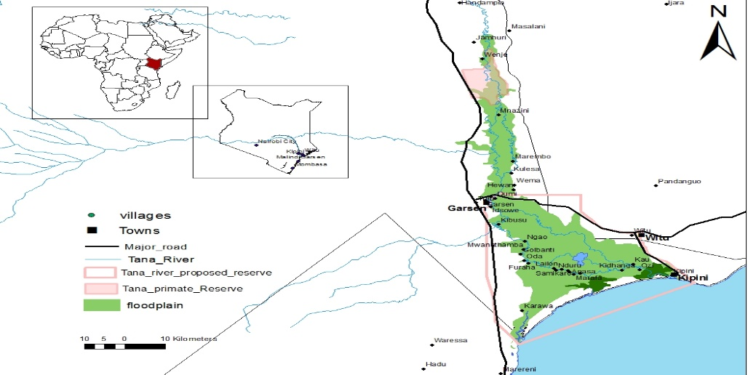
Figure 1: Map of the Tana Delta, Kenya, showing key study sites.

2.2 Research Design
Hydro-climatic variability, soil health and water security are intricate, interrelated phenomena that requires a comprehensive research design. Thus in this study, a mixed-method approach which integrated quantitative methods such as remote sensing, GIS and hydrological data analysis with qualitative methods, household surveys and interviews provided a holistic understanding of these complex systems (Pienaah et al., 2025; Goswami et al., 2023; Tekleab et al., 2014). This integration led the researchers to capture both physical measurements of environmental changes and the social responses of communities thus ensuring that the data analyses reflect real-world interactions between ecological processes and human livelihoods.
2.3 Data Sources and Collection
2.3.1 Hydro-Climatic Data
Rainfall and temperature records were analyzed for long-term variability and extremes. SPI values quantified drought severity and frequency (McKee et al., 1993; Guttman, 1999). Temperature anomalies highlighted warming trends. Trend detection and significance testing were conducted using the non-parametric Mann–Kendall test (p<0.05) and linear regression analysis (Hamed, 2008). Together, these methods provided robust insights into hydro-climatic variability.

2.3.2 Remote Sensing and GIS Analysis
Landsat imagery was used to assess land cover and hydrological changes, capitalizing on its long-term consistency and medium resolution (Roy et al., 2014). Vegetation and hydrological indices, specifically the Normalized Difference Vegetation Index (NDVI; Gao, 1996) and the Normalized Difference Water Index (NDWI; McFeeters, 1996), were applied to monitor vegetation health and surface water dynamics.
Image preprocessing included atmospheric correction, mosaicking, and radiometric normalization (Lu et al., 2016). Land cover maps were generated using supervised classification (Maximum Likelihood Classifier), and accuracy was validated with ground-truth data and confusion matrices (Congalton & Green, 2009; Lillesand et al., 2015). These steps allowed reliable quantification of land and wetland changes across time and zones in the delta

2.3.3 Water Security Assessment
Household surveys were conducted across ecological and settlement zones (floodplain, deltaic wetland, and uplands), ensuring stratified representation. Households were randomly sampled using updated village lists. The survey captured both quantitative measures of water access and reliability and qualitative insights into coping strategies and perceptions (Jepson et al., 2017; Fraser et al., 2013: Ming’ate 2014).
Focus group discussions (FGDs) and key informant interviews (KIIs) provided additional contextual understanding, validating household responses and exploring adaptive behaviors. GIS-based spatial analysis was applied to locate water sources relative to households and infrastructure, by highlighting vulnerable areas (Srinivasan et al., 2017). Integrating household, qualitative, and spatial data improved the robustness of water security assessments and informed recommendations for climate-resilient management strategies (UN-Water, 2021).
The table 1 below provides the narrative of the sampled households for each village across the Tana Delta
Table 1: Household Survey Sample Framework
No. | Village Name | Geographical Zone | Estimated Households | Proportion (%) | Sampled Households
1 | Mnazini | Upper Section | 911 | 10.3 % | 39
2 | Marembo | Upper Section | 1200 | 13.6 % | 52
3 | Kulesa | Upper Section | 500 | 5.7 % | 22
4 | Wema | Upper Section | 400 | 4.5 % | 17
5 | Hewani | Upper Section | 300 | 3.4 % | 13
6 | Idsowe | Central Part | 1061 | 12 % | 46
7 | Danisa | Central Part | 200 | 2.3 % | 9
8 | Ghalili | Central Part | 160 | 1.8 % | 7
9 | Kibusu | Central Part | 619 | 7.0 % | 27
10 | Ngao | Central Part | 440 | 5.0 % | 19
11 | Mandingo | Lower Segment | 166 | 1.9 % | 7
12 | Semikaro | Lower Segment | 446 | 5.1 % | 19
13 | Ozi | Lower Segment | 249 | 2.8 % | 11
14 | Kipini | Lower Segment | 2165 | 24.6 % | 94
 | Total |  | 8817 | 100.0 % | 382

2.4 Data Analysis
2.4.1 Hydro-Climatic Data Analysis
Data analysis integrated statistical, geospatial, and qualitative techniques to ensure methodological transparency and reproducibility. Rainfall and temperature records were analyzed for long-term variability and extremes. SPI values quantified drought severity and frequency (McKee et al., 1993; Guttman, 1999). Temperature anomalies highlighted warming trends. Trend detection was conducted using the non-parametric Mann–Kendall test and linear regression (Hamed, 2008). Together, these methods provided robust insights into hydro-climatic variability.
2.4.2 Remote Sensing and GIS Analysis
Landsat imagery (1995, 2005, 2023; 30 m resolution, Landsat 8 OLI) was processed in Google Earth Engine and ArcGIS to map land cover and wetland change. NDVI and NDWI were computed to assess vegetation health and water extent (Gao, 1996; McFeeters, 1996). Supervised classification produced land cover maps validated through ground truthing and confusion matrices (Lillesand et al., 2015; Congalton & Green, 2009). Zonal statistics enabled comparison across upper, middle, and lower delta zones.
2.4.3 Water Security Data Analysis
Survey data were analyzed in SPSS v26 using descriptive statistics to summarize water access, reliability, and usage patterns (Jepson et al., 2017; Fraser et al., 2013). Qualitative data from FGDs and KIIs were thematically analyzed (Creswell & Plano Clark, 2018). GIS mapping of water sources identified hotspots of scarcity and vulnerability (Srinivasan et al., 2017).
2.4.4 Integrated Analysis
Integrated analysis combined hydro-climatic trends, remote sensing outputs and water security results. For instance, rainfall variability and NDWI-derived wetland changes were linked with household-level water shortages. Cross-comparison across ecological zones revealed how environmental stressors translated into household water insecurity and livelihood impacts. This integrative approach highlighted pathways of vulnerability and resilience in the Tana Delta system.
All data and analytical procedures in this study were scientifically validated to ensure reliability and reproducibility. Hydro-climatic datasets (1990–2023) were obtained from the Kenya Meteorological Department and cross-checked for completeness and consistency using standard quality-control protocols. The Mann–Kendall and linear regression methods applied for trend detection are widely recognized for their robustness in hydro-climatic analysis.
Remote sensing outputs were verified through ground-truthing and confusion matrices, achieving classification accuracy above 85%. Household survey instruments were pre-tested, and data collection followed systematic sampling to minimize bias. Triangulation of quantitative (climatic and spatial) and qualitative (household and FGD) data ensured internal consistency and scientific validity of results.

3. Results

3.1 Historical Rainfall and Temperature Trends
Analysis of 30 years of rainfall and temperature data revealed significant hydro-climatic variability in the Tana Delta. Mean annual rainfall declined by approximately 245 mm, from 1,125 mm (1995–1999 average) to 880 mm (2020–2023 average). The Standardized Precipitation Index (SPI) confirmed an increase in the frequency of drought episodes, with four severe droughts occurring after 2000 compared to only two in the preceding decade. Shortened wet seasons and erratic onset of rains contributed to agricultural uncertainty.
Temperature analyses indicated a gradual warming trend of 0.8–1.2 °C over three decades. Temperature anomalies showed persistent warming since 2010, amplifying evapotranspiration rates and reducing soil water retention. The combined rainfall decline and warming have intensified soil and water stress, reducing recharge in floodplains and accelerating desiccation of surface soils. Declining rainfall reliability and rising temperatures have coincided with widespread wetland shrinkage and vegetation stress across the Tana Delta. The observed rainfall decline of approximately 245 mm was statistically significant based on the Mann–Kendall trendtest (p<0.05). The results are illustrated in the Figure 2 below.

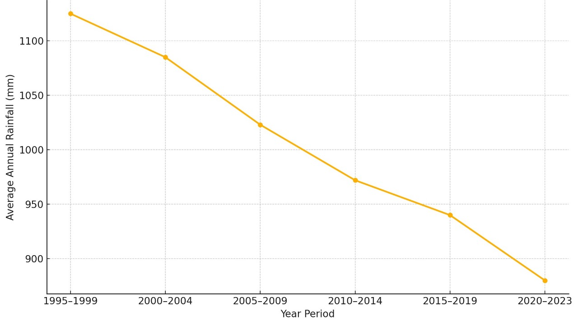
Figure 2: Average Annual Rainfall Trends in the Tana Delta (1995–2023
3.2 Wetland Dynamics and Land Cover Change
Remote sensing and GIS analyses revealed major changes in water and vegetation cover. NDWI results showed a 21% reduction in wetland extent between 2017 and 2023, with the most pronounced losses occurring around Kipini and Ozi. Remote sensing and GIS analyses, based on Landsat 8 imagery (30 m resolution), revealed major changes in water and vegetation cover. NDVI trends indicated declining vegetation health in wetland and grazing areas, reflecting reduced soil moisture and increasing ecological stress.
Land cover maps revealed a 17% expansion of agricultural land during the same period, primarily due to the conversion of wetlands and grazing areas. Field observations confirmed these trends, with visible salinity patches and soil cracking in Kipini and Mnazini. Although direct electrical conductivity measurements were not conducted, qualitative field and focus group discussion data consistently indicated salinity-driven soil degradation. Future research should incorporate quantitative soil salinity measurements to strengthen these findings. The decline in wetlands was linked to reduced groundwater recharge and diminished surface water buffering, intensifying seasonal water scarcity. These dynamics are illustrated in Figure 3 below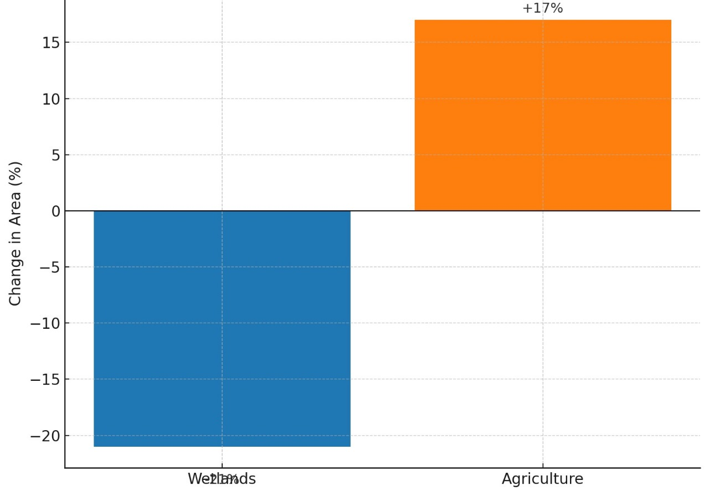
Figure 3: Land Cover Change in the Tana Delta (2017–2023)
3.3 Soil and Livelihood Implications of Hydro-Climatic and Land Cover Changes
Household surveys (n = 382) conducted across the upper, middle, and lower delta zones revealed major shifts in water sources and their associated effects on soil quality and livelihoods. About 42.1% of households rely on river water, though only 28.5% consider it safe due to turbidity and agrochemical runoff. Another 21.7% depend on boreholes, with 68.2% reporting safety concerns related to salinity and a metallic taste. In Kipini, participants reported increasing borehole salinity, noting that “the water we now fetch tastes bitter and leaves white stains on our cooking pots” (FGD, Kipini). A Garsen group added that “even river water is not clean anymore; after the rains, it turns brown and smells of chemicals” (FGD, Garsen).
See the narratives in Table 2 below.
Table 2. Household Water Sources, Perceived Safety and Main Concerns
Water Source | % of Households Using Source | % Who Perceive the Water as Safe | Main Concerns
River Water | 42.1% | 28.5% | Turbidity, contamination, agrochemical runoff
Boreholes | 21.7% | 68.2% | Salinity, metallic taste
Shallow Wells | 15.3% (estimated) | 35.0% (estimated) | Contamination from nearby latrines, shallow depth
Seasonal Streams | 11.8% (estimated) | 22.5% (estimated) | Seasonal availability, waterborne diseases
Oxbow Lakes & Swamps | 9.1% (estimated) | 18.0% (estimated) | Stagnation, mosquito breeding, livestock contamination

Increased reliance on saline groundwater for irrigation has accelerated soil salinization, reduced moisture retention and lowered crop productivity particularly in Mnazini and Kipini. Field observations recorded cracked soils, salt crusts, and loss of organic matter. A Mnazini farmer observed that “our farms used to stay wet after the floods, but now the soil dries and cracks before the maize matures” (FGD, Mnazini). In Kipini, several respondents attributed declining yields to saline irrigation, explaining that “even when we water the crops, they wither because the soil has become salty” (FGD, Kipini).
Livelihood Disruptions:
Hydro-climatic and land-cover changes have directly undermined livelihoods.
- Crop farming: 76% of respondents reported reduced yields especially in maize and rice linked to erratic rainfall and saline soils.
- Pastoralism: 64% reported livestock losses as grazing lands degraded due to diminished floodplain inundation.
- Fisheries: 58% noted declining catches due to shrinking wetlands and saline intrusion in estuarine zones.
FGDs highlighted how reduced flood cycles have disrupted traditional grazing and fishing patterns. A herder in Garsen lamented, “We now walk longer distances with our animals because the grass no longer grows near the river” (FGD, Garsen). A fisher in Kipini similarly explained, “fish used to breed in flooded ponds; now those ponds are dry most of the year” (FGD, Kipini).
FGDs and KIIs revealed adaptive strategies such as borehole use, canal irrigation, and crop diversification, though participants emphasized that these measures remain inadequate. One participant summarized: “we are trying new crops and wells, but the water keeps changing, and we lose more each year” (FGD, Mnazini).
Integrated GIS mapping confirmed hotspots of soil and water insecurity in lower-delta settlements such as Kipini and Ozi, while upper-delta areas retained better river access. This section therefore addresses the third study objective by empirically linking hydro-climatic variability to soil degradation and livelihood vulnerability through combined remote-sensing and social-survey evidence. Integrated analysis demonstrated a clear linkage: hydro-climatic variability → wetland loss and surface-water decline → soil salinity and reduced moisture → livelihood vulnerability. GIS hotspot mapping showed that lower-delta settlements such as Kipini and Ozi were most affected, while upper-delta areas retained relatively better access to river water. The figure below gives the explanations of the findings.

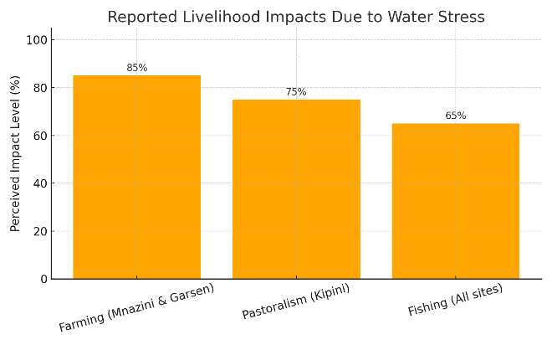
Figure 4: Reported Livelihood Impact due water stress

4. Discussion
This discussion interprets the results of the study in line with its three objectives: (1) to analyze historical rainfall and temperature trends; (2) to examine wetland and land cover dynamics using remote sensing and GIS; and (3) to assess the implications of hydro-climatic and land cover changes on soil and water security and community livelihoods in the Tana Delta.

4.1 Historical Rainfall and Temperature Trends
The results indicate a consistent decline in rainfall and a rise in temperature over the past three decades, signifying increasing hydro-climatic stress in the Tana Delta. The decrease in mean annual rainfall by approximately 245 mm, coupled with a temperature rise of 0.8–1.2°C, reflects a clear trend toward increasing aridity. This finding aligns with regional studies documenting similar patterns of declining precipitation and rising temperatures in Kenya’s arid and semi-arid zones (Ongoma et al., 2018; Opiyo et al., 2021). The growing frequency of droughts and shortened wet seasons mirrors broader East African climate dynamics influenced by the Indian Ocean Dipole and global warming (Gebrechorkos et al., 2020; Adeyeri et al., 2025).
The consequences of these changes are substantial. Reduced rainfall reliability has decreased river recharge and floodplain inundation, leading to hydrological imbalance. Rising temperatures further increase evapotranspiration rates, depleting soil moisture and accelerating desiccation, especially in the sandy and saline-prone soils typical of the lower delta. These findings confirm that hydro-climatic variability is intensifying and undermining the resilience of both natural and human systems in the delta. The observed trends form the environmental basis upon which subsequent ecosystem degradation and livelihood vulnerabilities develop (Scown et al., 2023).

4.2 Wetland Dynamics and Land Cover Change
Remote-sensing analyses revealed a substantial loss of wetland cover (21%) and an expansion of agricultural land (17%) between 2017 and 2023, particularly in Kipini and Ozi. These transformations reflect a pattern of human encroachment exacerbated by climatic stressors. Comparable trends have been documented in other Kenyan deltas, such as Athi-Galana-Sabaki and Ewaso Nyiro, where recurrent droughts and population pressure have intensified wetland conversion (Mutie et al., 2021; Wardekker et al., 2023).
The observed decline in NDWI and NDVI values indicates both hydrological and vegetative stress, consistent with reduced soil moisture and shrinking surface-water bodies. Such conditions weaken the ecological buffering capacity of wetlands, which traditionally regulate floods and droughts (Mitsch & Gosselink, 2015; IPDC, 2024). Although wetland conversion to farmland may serve as an adaptive response, it has disrupted hydrological connectivity and increased the risk of soil salinization. Field observations of cracked soils, salt crusts, and vegetation dieback in Mnazini and Kipini support these findings.
These results highlight a feedback loop where climatic stress accelerates wetland loss, and the resulting decline in wetland functions amplifies vulnerability to further hydro-climatic extremes. This dynamic is consistent with the theory of ecological disequilibrium in deltaic systems, where human pressures interact with climate variability to destabilize ecosystem resilience (Turner et al., 2020; Nantavisai et al., 2024).

4.3 Soil and Livelihood Implications of Hydro-Climatic and Land Cover Changes
Combined climatic and land cover shifts have profoundly affected soil conditions and household livelihoods in the Tana Delta. The survey results revealed increased dependence on boreholes and shallow wells, many of which are saline, resulting in secondary soil salinization and declining productivity. This corresponds with previous studies in coastal Kenya, which identified salinity as a major constraint to agricultural sustainability under changing hydrological regimes (Kitheka et al., 2018; Adeyeri et al., 2025). Field and FGD evidence such as reports of saline borehole water and cracked farm soils—illustrates how water scarcity directly undermines soil fertility and crop yields.
Declining agricultural productivity (reported by 76% of households) and the degradation of grazing lands (reported by 64%) reflect a deepening livelihood crisis. As floodplains dry and wetlands contract, traditional livelihood systems—farming, pastoralism, and fishing—are increasingly constrained. The observation that fish breeding ponds remain dry for most of the year underscores the collapse of ecological services once sustained by flood cycles (Wardekker et al., 2023). These findings confirm that hydro-climatic variability and environmental degradation have diminished the adaptive capacity of local livelihoods.
Spatial variations across the delta further support this perspective: upper-delta areas maintain relative stability due to perennial river flow, while lower-delta settlements such as Kipini and Ozi face compounded water and soil stress. This disparity underscores the need for localized adaptation strategies that consider geomorphological and hydrological differences within the delta (IPDC, 2024).
Overall, the findings demonstrate that climate-induced changes in water and soil systems are not isolated environmental phenomena but are deeply intertwined with socio-economic well-being. The adaptive measures identified—borehole use, canal irrigation, and crop diversification are largely reactive rather than transformative. This highlights the urgent need for long-term resilience planning that integrates ecological restoration, water governance, and livelihood diversification (Scown et al., 2023).

4.4 Study Limitations
While the study offers valuable insights into hydro-climatic variability and its implications for livelihoods in the Tana Delta, certain limitations must be acknowledged. The 30 m spatial resolution of Landsat imagery, though suitable for regional analysis, limits precision in mapping small or fragmented wetland patches. Additionally, the household survey, although representative of major settlement clusters, may not fully capture variations in livelihood strategies across the entire delta. The absence of long-term, ground-based soil and water quality measurements also restricted the validation of remotely sensed indicators of salinity and vegetation stress. Recognizing these limitations provides context for interpreting the results and identifies areas for future methodological improvement (Nantavisai et al., 2024).

5. Conclusion
This study analyzed hydro-climatic variability, wetland dynamics, and their implications for soil and water security in Kenya’s Tana Delta using an integrated approach combining climate analysis, GIS mapping, and community-level surveys. The findings revealed a significant decline in rainfall and an increase in temperature over the last three decades, resulting in reduced hydrological balance and wetland degradation. Remote-sensing data confirmed a 21% loss in wetland cover and an expansion of agricultural land, particularly in the lower delta, driven by both climatic stress and human encroachment.
These environmental shifts have intensified soil salinization and water scarcity, undermining agricultural productivity and household livelihoods. While the impacts are felt across the delta, the lower-delta settlements—especially Kipini and Ozi exhibited the most severe degradation, highlighting localized vulnerability hotspots. This pattern emphasizes the need for spatially differentiated adaptation and restoration strategies.
The study concludes that hydro-climatic variability in the Tana Delta is both an environmental and socio-economic challenge. Effective adaptation requires integrated water governance, ecological restoration of wetlands, and livelihood diversification to enhance long-term resilience. Future research should focus on continuous soil and water quality monitoring and high-resolution ecosystem assessments to strengthen early warning and adaptive planning systems.
Recommendations
The recommendations outlined in this study aim to strengthen resilience and adaptive capacity in the Tana Delta. In the short term, priority should be given to:
- Restoring and protecting critical wetland zones to safeguard ecosystem services;
- Strengthening local water governance through inclusive water user associations; and
- Enhancing livelihood diversification via climate-smart agriculture and value chain support.
These immediate actions, coupled with long-term strategies such as ecological restoration, capacity building and policy integration, can ensure sustainable adaptation to climate-induced water and soil challenges in the delta.

Consent
Informed consent was obtained from all participants prior to household surveys and focus group discussions.
Declaration
Author(s) hereby declare that NO generative AI technologies such as Large Language Models (ChatGPT, COPILOT, etc.) and text-to-image generators have been used during the writing or editing of this manuscript.
References
[1] Bossio D, Geheb K, Critchley W. Managing water by managing land: Addressing land degradation to improve water productivity and rural livelihoods. Agric Water Manag. 2010;97(4):536–542. https://doi.org/10.1016/j.agwat.2009.09.008
[2] Conway D, Schipper ELF. Adaptation to climate change in Africa: Challenges and opportunities identified from Ethiopia. Glob Environ Change. 2011;21(1):227–237. https://doi.org/10.1016/j.gloenvcha.2010.07.013
[3] Erwin KL. Wetlands and global climate change: The role of wetland restoration in a changing world. Wetl Ecol Manag. 2009;17(1):71–84. https://doi.org/10.1007/s11273-008-9119-1
[4] Food and Agriculture Organization of the United Nations (FAO). The state of the world’s land and water resources for food and agriculture – Systems at breaking point. Rome: FAO; 2021. Available from: https://www.fao.org/3/cb9910en/cb9910en.pdf
[5] Government of Kenya (GoK). Tana River County Integrated Development Plan 2018–2022. Nairobi: Government Printers; 2018.
[6] Government of Kenya (GoK). National Water Resources Authority: Annual report. Nairobi: Government Printers; 2021.
[7] Hamerlynck O, Duvail S, Nyingi D, Paul JL, Leauthaud C, Morand P. The communal forest of the Tana Delta, Kenya: A socio-ecological system under threat. For Policy Econ. 2012;13(6):488–497. https://doi.org/10.1016/j.forpol.2011.06.001
[8] Intergovernmental Panel on Climate Change (IPCC). Climate Change 2021: The Physical Science Basis. Cambridge: Cambridge University Press; 2021. Available from: https://www.ipcc.ch/report/ar6/wg1/
[9] Intergovernmental Panel on Climate Change (IPCC). Climate Change 2022: Impacts, Adaptation and Vulnerability. Cambridge: Cambridge University Press; 2022.
[10] Intergovernmental Panel on Climate Change (IPCC). Synthesis Report of the IPCC Sixth Assessment Report (AR6). Geneva: IPCC; 2023. Available from: https://www.ipcc.ch/ar6/
[11] Maingi JK, Marsh SE. Composition, structure, and regeneration patterns in a gallery forest along the Tana River near Bura, Kenya. For Ecol Manage. 2006;236(2–3):211–228. https://doi.org/10.1016/j.foreco.2006.09.016
[12] Mekong River Commission (MRC). State of the Basin Report 2010. Vientiane: MRC Secretariat; 2010.
[13] Mitsch WJ, Gosselink JG. Wetlands. 5th ed. Hoboken, NJ: Wiley; 2015.
[14] Niang I, Ruppel OC, Abdrabo MA, Essel A, Lennard C, Padgham J, Urquhart P. Africa. In: Barros VR, et al., editors. Climate Change 2014: Impacts, Adaptation, and Vulnerability. Cambridge: Cambridge University Press; 2014. p. 1199–1265.
[15] Nicholls RJ, Cazenave A. Sea-level rise and its impact on coastal zones. Science. 2010;328(5985):1517–1520. https://doi.org/10.1126/science.1185782
[16] Ndehedehe CE. Hydro-climatic extremes in the Anthropocene. Cham: Springer International Publishing; 2023. https://doi.org/10.1007/978-3-031-37727-3
[17] Ramsar Convention Secretariat. The Ramsar Convention Manual: A guide to the Convention on Wetlands. 6th ed. Gland: Ramsar Secretariat; 2018.
[18] Ramsar Secretariat. The list of wetlands of international importance. Gland: Ramsar Convention Secretariat; 2021.
[19] Republic of Kenya. Kenya Meteorological Department Climate Data Archives (1990–2023). Nairobi: Ministry of Environment and Forestry; 2023.
[20] Rockström J, Falkenmark M, Karlberg L, Hoff H, Rost S, Gerten D. Future water availability for global food production: The potential of green water for increasing resilience to global change. Water Resour Res. 2010;46(W00F12). https://doi.org/10.1029/2009WR008803
[21] Said R. The River Nile: Geology, Hydrology and Utilization. Oxford: Pergamon Press; 1993.
[22] Seto KC, Reenberg A. Rethinking global land use in an urban era. Cambridge, MA: MIT Press; 2014.
[23] Stanley DJ, Warne AG. Nile delta: Recent geological evolution and human impact. Science. 1993;260(5108):628–634. https://doi.org/10.1126/science.260.5108.628
[24] Syvitski JPM, Vörösmarty CJ, Kettner AJ, Green P. Impact of humans on the flux of terrestrial sediment to the global coastal ocean. Science. 2005;308(5720):376–380. https://doi.org/10.1126/science.1109454
[25] UN Water. Policy Brief on Climate Change and Water. Geneva: United Nations; 2020. Available from: https://www.unwater.org/publications/un-water-policy-brief-on-climate-change-and-water/
[26] United Nations Environment Programme (UNEP). Kenya Wetlands Atlas. Nairobi: UNEP; 2015.
[27] United Nations Environment Programme (UNEP). State of the Environment and Outlook Report for Kenya 2022. Nairobi: UNEP; 2022.
[28] Scown MW, et al. Global change scenarios in coastal river deltas and their implications. Nat Commun Earth Environ. 2023;4(86). https://doi.org/10.1038/s43247-023-00662-y
[29] Wardekker A, et al. Building climate resilience in deltas amid uncertainty and change. Environ Sci Policy. 2023;146:152–164. https://doi.org/10.1016/j.envsci.2023.02.004
[30] Nantavisai M, et al. Unraveling changes in deltas: Exploring drivers and trends. Sci Total Environ. 2024;920:173925. https://doi.org/10.1016/j.scitotenv.2024.173925
[31] Adeyeri OE, et al. Hydrology and climate change in Africa: Synthesis of trends, modeling, and vulnerabilities. Water. 2025;17(15):2247. https://doi.org/10.3390/w17152247
[32] International Panel on Deltas and Coastal Areas (IPDC). Climate Adaptation in Deltas, Coasts and Islands: Introducing the IPDC Guidance Framework. Delft: Deltares; 2024. Available from: https://cms.deltares.nl/assets/common/downloads/IPDC-Report_2024_7-3.pdf

