Mapping and Analysis of Hydro-Morphometric Parameters of Otammiri River Basin in Owerri, Imo State, Nigeria Using Geospatial Technique

Abstract
Notwithstanding that Otammiri river basin is one of the most important watersheds in Imo State, its hydrology is not well known. Good understanding of a basin drainage system and morphometry is fundamental for watershed management. Therefore, the aim of this study is to investigate the morpho-hydrological attributes of Otammiri watershed using geospatial technique. Landform, sub-catchment, drainage mapping, linear and areal morphometry analysis of the basin has been carried out by analyzing SRTM DEM-30 data using ArcGIS10.5 and supher11. Strahler (1964) stream order method was used for stream ordering. This study revealed that the basin is divided into 3 wings as a result of the confluence of Otammiri and Nworie river. The study area is rough and situated in surface of elevation range of 10m to 140m above mean sea level with total number of 82 streams of total length, 105 kilometers draining a landed area of approximately 113 square kilometers. The elevation of the basin decreases from north eastern part to the southern part with a large portion of the surface situated in a terrain of slope between 1 degree and 90 degrees. Results revealed that there are one (1) fourth order streams, three (3) third order streams, nineteen (19) second order streams and fifty-nine (59) first order streams.The river network revealed a dendritic pattern and a stream frequency of 0.7257, drainage density 0.9292 km⁻¹, circulatory ratio of 0.320 and elongation ratio of 0.770. These digital derivatives attest that geospatial technique is effective in characterization of hydro-morphometric attribute of a river basin.
KEY WORDS; Morphometry, Hydrology, DEM, River basin, GIS

- Introduction
“River basin morphometry serves as a fundamental tool for quantitative assessmentof various physical aspects of a river basin. It provides a quantitative evaluation of watersheds as a base for good understanding of their characters, conserve and manage the environment. Conservation of natural resources is of prime importance for sustainable development and to mitigate the demand and supply gap between resources” (Sangeetha et.al 2019). “Studies on river and stream ordering systems abound all over the world because of the importanceof water to the sustenance of life” (Abiodun et’al 2018). “Drainage parameters define the topographical, geological and hydrological condition of a basin” (Angillieri 2012; Kabite and Gessesse 2018.; Madaviand Anshumali 2019), Good understanding of morphometric attributes of a drainage basin is invaluable for its management. As per Oruonye et al (2016) “Quantitative analysis of drainage basin morphometric parameters is invaluable in river basin evaluation for soil, water and natural resources management at micro level. Monitoring, management and sustaining the environment require the use of most promising technologies. In this study geospatial technology can be construed to be the integration of remote sensing and geographic information system (GIS)”.
“Integration of geographical information system (GIS) and remote sensing has proved to be reliable in solving verities of problems in geographic space. In this study, attempt has been made to characterize hydrological attributes of Otammiri river basin using remote sensing and GIS.The use of remote sensing and GIS in analysis and management geographical referenced data is becoming more popular in contemporary times due to effectiveness and speedy information delivery”(Emmanuel et al 2020). “A geographic information system (GIS) enables geospatial and hydro analysts to investigate geospatial and hydrological trend and understand the relationships that exist between the physical environment and human activities” (Nkeki et al 2014). “Recently, with the advent of remote sensing and GIS techniques, more precise data generation for morphometric analysis can be done” (Mesa LM 2006; Sreedev et al 2009; Magesh et al 2013; Rai et al 2014; Chandrasekar et al 2014).
“Remote sensing technique is an authentic method for basin study as the satellite images provide the opportunities to get a synoptic view of a large area. Digital Elevation Model (DEM) in the field of GIS provides for three-dimension evaluation of the earth surface” (Sumantra 2016). Digital elevation model (DEM) data are elemental in deriving primary topographic attributes which serve as input variables to a variety of hydrologic and geomorphologic studies

1.1 Aim and Objectives
The aim of the study is to examined the morphometric character of Otammiri River Basin using geospatial technique.
1.1.1 Objectives
To map landform of the basin
To determine the linear morphometry
To investigate the areal morphometry
To investigate the number of sub-catchments within the basin

1.2 Study Area
The study area in this investigation is Otammiri river-basin, situated in Owerri, the capital of Imo State. The basin measures approximately 113 square kilometers and is geographically located within longitudes 06⁰ 57’E and 07⁰ 07’E and latitudes 05⁰25’N and 05⁰32’N. The river with length of 105 kilometers is the principal tributary of Imo River-a major river.
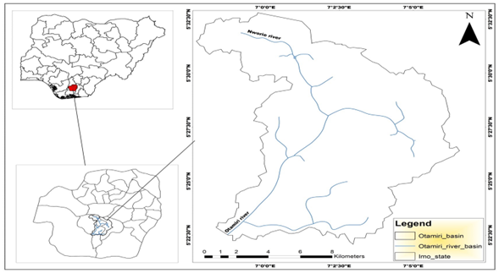
Figure1 Location map of the study area
- Material And Methods
Digital Elevation Dataset from Shuttle Radar Topographical Mission (SRTM) of one arc second (30m resolution) covering the study area has been downloaded from USGS explorer. DEM is a system of grids or pixel with each cell containing a value that approximatethe elevation of the real-worldspacecovered by the cell. Software used include ArcGIS10.5 and Surpher11. Arc-GIS and its extensions have the capacity to processing DEM into runoff route.
2.1 Drainage Extraction
The drainage network of the basin was extracted from series of geo-processing tools in hydrology extension of Arc GIS 10.5. The output of this method is a basis for extracting stream features. The depressions in the DEM were filled using the fill tool and was used to create the flow direction grid of the Basin. Flow direction grid holds values in its cells that indicate the direction of the steepest descent from each cell. This value determines the direction water will flow from each cell based on the underlying topography of the landscape. Flow direction grid is fundamental to the generation of flow accumulation grid. Flow accumulation grid is important because it identifies cells of high flow where streams and channels are to be expected. In other wards each cell in the flow accumulation grid contains a value that is determined by the number of upstream cells flowing into it. The Flow Accumulation Grid was processed to create the Stream Definition Grid. A threshold of the volume of flow (number of accumulating cells) that defines a stream in the project area was set. This helped in proper definition of the stream segments. The idea here is that the grid cells that accumulate runoff from a specified number of cells are considered to be the stream (flow route) cells. stream is linear connection of pixels that accumulate the most runoff within a basin. Strahler’s system of classification designates a segment with no tributaries as a first-order stream, where two first order meets the second order begins.To further investigate the attributes of the basin, it was further disaggregated into sub catchment areas. Proper management of the individual sub-basins is indispensable for effective management of the entire basin.
2.2 Surface Analysis
The topography of the basin was also investigated to assess the direction of water flow during extreme climatic condition. The DEM was symbolized using surface analysis tool of ArcGIS10.5. On this scheme each pixel is assigned a unique digital number which represent the elevations of the cell. This number is the average elevation of all points within the celland is located at the center of each cell in geographic space. GIS cartographically assign unique color symbol to each digital number for visual interpretation of the terrain. Progressively, The DEM was imported to Surfer11 environment and the surface was further investigated using the 3-D and profile extensions of the software
2.3 Linear Morphometry
Linear morphometric analysis performed in this study include; Stream order(u), Stream number (Nu), stream length (Lu) and bifurcation ratio (Rb). Stream order analysis determines the position of a stream within a river network. This study adopted a stream ordering system asper Strahler (1964) in which a finger stream without a tributary is designed as 1st order and second order begins where two or more first order streamsjoined and so on. Stream number is the number of streams in the various orders while stream length is the summation of lengths of each order within the river network system. In this study, these variableshave been calculated using GIS tools. As per Sayeed etal(2017),the ratio between the numbers of stream segments of any given order to the number of the next higher order is defines as the bifurcation ratio. This is an index topredict flood potential of a basin as low value of Rb signifies high flood potential while the reverse hold true for high value of bifurcation ratio. These parameters are summarized in table table1 below.

2.4Areal Morphometry
The areal morphometry applied in this study are drainage density (Dd), Stream frequency (Fs), circulatory ratio (Rc), and elongation ratio (Re). Drainage density this is the ratio of sum of stream length in a watershed to area of the same catchment. An impervious surface of high precipitation will record high value of (Dd) while a permeable basin will record low value.Stream frequency is defined as the ratio of a total number of channels cumulated for all orders within a watershed and the area of the same watershed. It is a factor that helps to assess the geology and permeability of a catchment. In this Study these values have been calculated using GIS tools. (See table1)
Ahuchaogu et al(2021)opined that circulatory ratiois quantity derived from evaluating the ratio of the area of the watershed to the area of circle having the same circumference as the perimeter of the same watershed. It provides a quantitative index of the shape of the basin i.e. circular basin has a maximum efficiency of the movement of runoff, whereas an elongated basin has the least frequency. It is a useful index for predicting drainage discharge, particularly in a time of extreme climatic condition. Elongation ratio is defined as the ratio of diameter of a circle of the same area as the basin to the maximum basin length. Sumantra et al (2016)opined that “it is a factor for classifying drainage basins into varying shapes. The value of elongation ratio varies from 0 to 1 i.e. circular (0.9- 1.0), oval (0.8-0.9), less elongated (0.7-0.8), elongated (0.5-0.7), and more elongated (<0.5) (Schumms1956)”. A circular basin is more efficient in runoff discharge than an elongated basin because flow from all corners of the basin charges the channel at the same time. In this study these parameters were calculated following the formular given in table1

- Result and Discussion
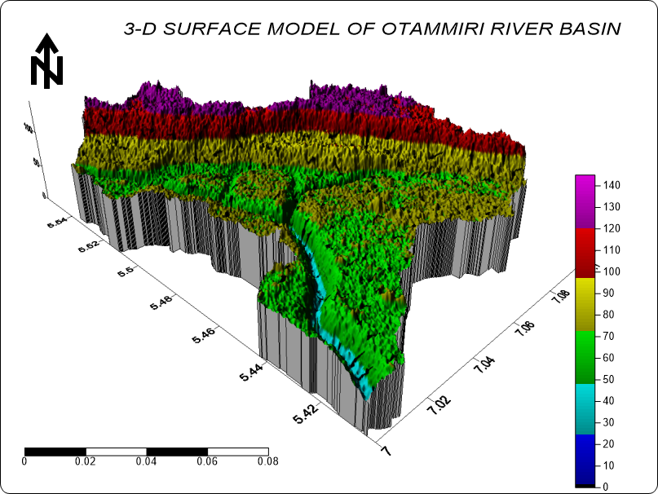
Figure2 3-D surface of the study area
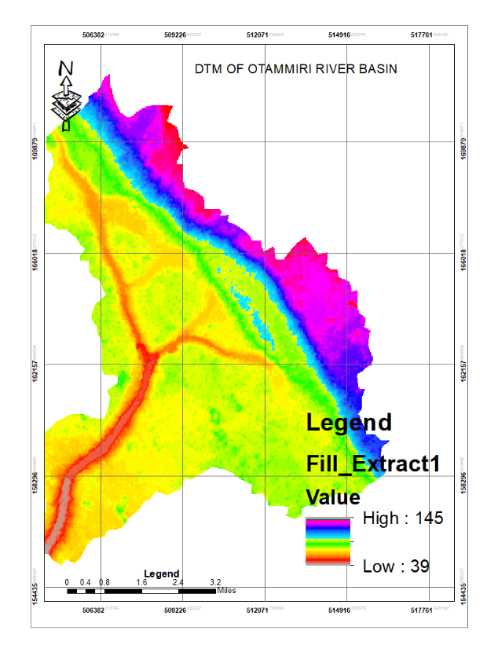
Figure3 Digital terrain model of the study area
Figure2 and 3 are the 3-D surface model and digital terrain model of the study area respectively. 3-D topographic surface of the study area was mapped and visualized using surfer11 application. This GIS method has the ability to produce, 3-D image of a landscape that gives same visual impression to all audience located in any viewing direction. It can be seen that the study area is divided into 3 wings as a result of the confluence of Otammiri and Nworie river. The study area is rough with elevation range of between 10m to 140m above mean sea level. The elevation decreases from north eastern part to the southern part.
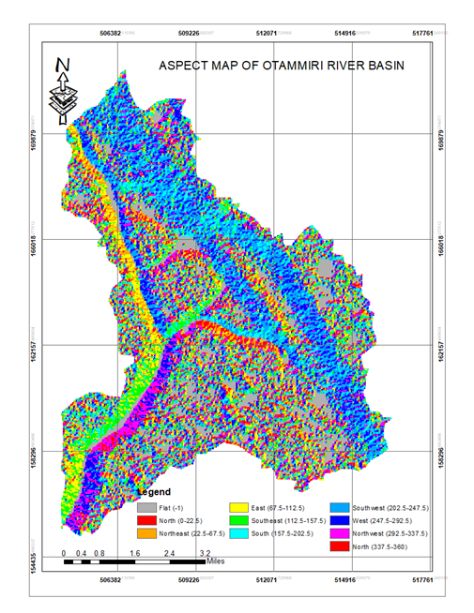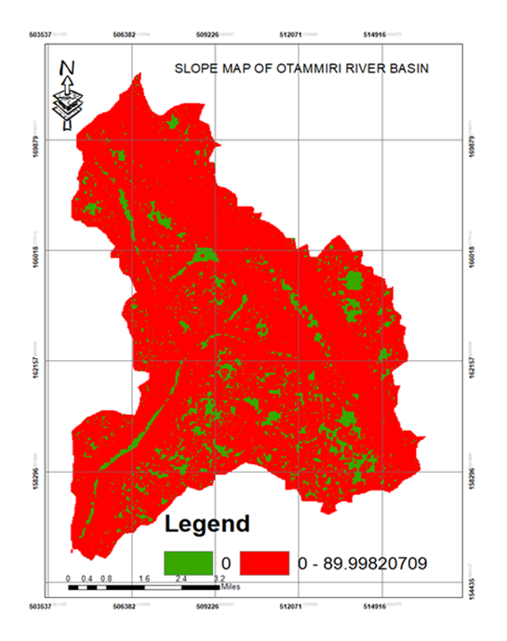
Figure4 aspect map of the study area Figure5 Slope map of the study area

Figure 4 and 5 are aspect map and slope map of the study area respectively. Locations of 0-degree slope is considered to be flat region. Aspect detects the downslope or downhill direction of the maximum rate of change in value from each cell to its neighbors. It is often referred to as the slope direction. At a particular location a value is generated for the cell and this value indicates the compass direction of such slope. The aspect of a terrain is measured clockwise (indegrees) from 0° which is the north through northeast and move to the north again through the northwest which complete 360°. In Figure5 the slope facing north, northeast, east and south east are presented in red, dark yellow, light yellow and green shades respectively while those facing south, south west, west and north west are presented on sky blue, dark sky blue, blue and purple shades respectively. Flat areas have no slope direction as a result they are assigned the value of -1 and represented with the Arsh shades. The slope direction grid can be used effectively for advance topographical modeling such as identifying and characterizing areas of high-water runoff and landslide, estimating the portion of land that will receive high and low solar illumination for agricultural research purposes.
The slope displays the magnitude of surface structure inclination (i.e., the level of steepness). areas of 0-degree slope are considered to be flat region and these areas are presented on green on the slope map. The slope map revealed that large portion of the study area lie in a terrain between 1 degree and 90 degrees. These areas are symbolized red on the slope map(Fig5)

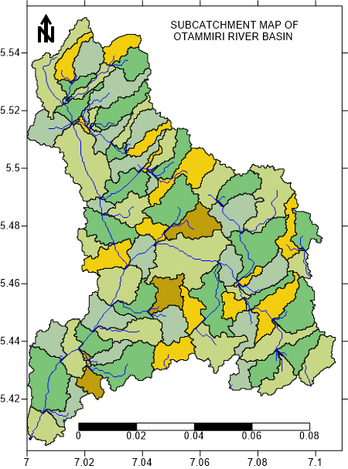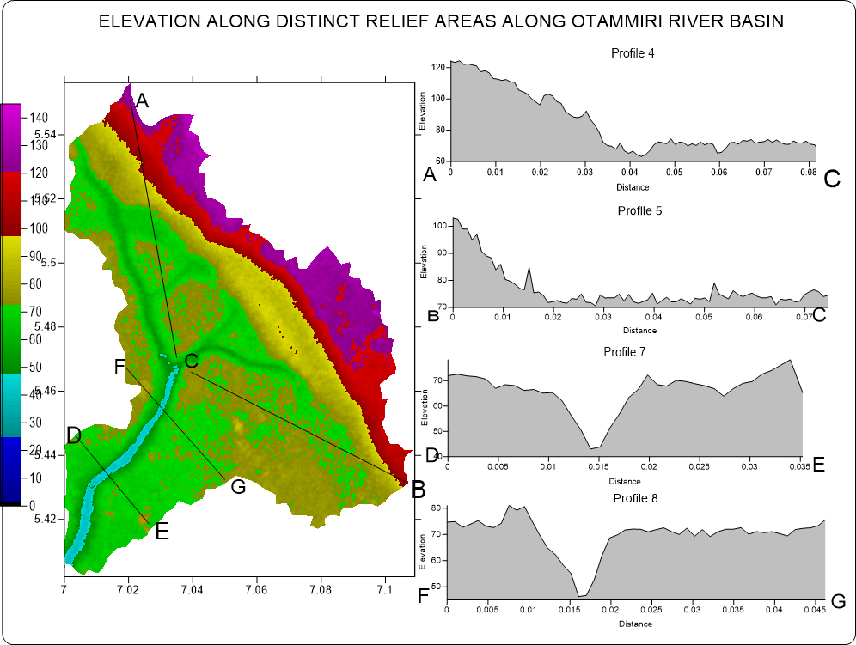
Figure6Sub-catchment map of the study areaFigure7 profile at some location along the basin

Figure6 is the Overlay of the drainages and the sub-catchment map. The overall stream network of the study area was mapped using the filled SRTM dataset. The extraction process identified all the cells of the DEM that ultimately drained to the specified outlet location and the stream network created determined the channels for the watershed. The basin is made up of 84 sub-catchments. Each sub catchment has a river segment or a tributary that drains it. Management of the individual sub-catchments make it easier for proper management of the entire basin. In most cases, it is utilized for planning agricultural activities and more importantly, it is an indispensable tool for monitoring and tracking down sources of stream pollution. Figure7 shows profile along some distinct locations and some river cross profiles along some points across the river channel.These can be used to determine flood potentials of the river because discharge and flow speed at any point along the course of a river is influenced by the slope of the cross section.
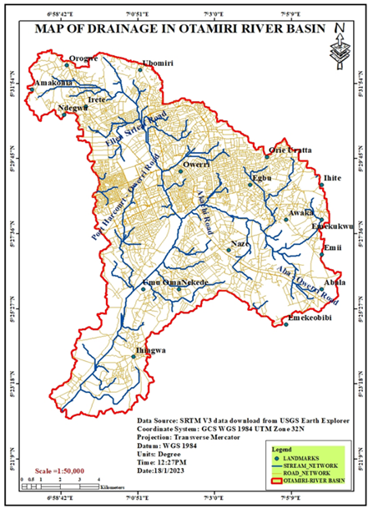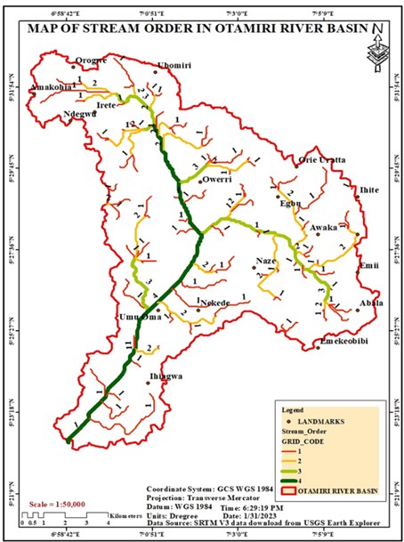
Figure8Drainage map of the study area Figure9Drainage order map of the study area

Figure8 is the drainage map of the study area. The overall stream network of the study area was mapped using the sink filled SRTM dataset. This was processed using the hydrological module of ArcGIS 10.5. The sink areas are pixels which have heights that are lower than neighboring pixel values. when these sink are filled the runoff from the DEM will reach its edges. The void filled raster was use to generate the flow direction map which was subsequently processed to drainage network.
The channel networks in the study area, are predominantly dendritic drainage pattern,which was well formed by interlinking of the streams with its tributaries branching and rebranching freely in all directions.There are 96 number of streams draining approximately113 square kilometers area of land. Therefore, the stream frequency measures 1.17. The morphology of the drainage channel network is important because it can be used to interpret the geology of the basin. Figure9 is the drainage order map of the basin. It revealed that the basin is a 4th order basin with first order river dominating.
Table1 morphometric attributes of Otammiri river basin
Parameter | formular |  | Value
Basin area | Software analysis |  | 113.00Sq.kilometers
Circulatory Ratio | Rc=4ΠA/P2 |  | 0.320
Elongation Ratio | Re=2{(A/π) ½}/Lb |  | 0.770
Stream frequency | Nu/A |  | 0.7256
Drainage density | ` Lu/A |  | 0.9292km-¹
Stram Order |  | Stream number |  | Bifurcation Ratio
1 |  | 59 |  | 3.105
2 |  | 19 |  | 6.333
3 |  | 3 |  | 3
4 |  | 1

3.1 Limitation of Study
The limitation of this study is based on the fact that accuracy of open-source DEM is affected by earthly canopies and also depend on terrain condition as weather the terrain is rugged or smooth. Therefore, open source DEMs need further refinement to improve their reliability for real world spatial analysis. Chukwuocha et al ( 2021) carried out a refinement of SRTM and used it to detect eroded sites on a mild terrain which could not be detected using the DEM in its raw form. However, due to time and financial constrain the number of ground reference point needed to refine the DEM in this study is numerous and could not be obtained. Notwithstanding, to make this project a reality, numerous trials was made during selection of threshold value that define the stream segments by making series of visits to the study area. This was to ensure that the selected threshold produces drainages that reflects reality. Many of these field visits were made during heavy downpour so as to see if there are evidences of other natural drainage routes since it is obvious that some has been altered by anthropogenic (constructions) activities and their traces may be revealed by flooding foot print. Besides, accuracy assessment was carried out on the data used based on well dispersed 30 ground referenced control points located at least between 300 to 400m meter apart from each other within the study area. These were collected using Digital level and the planimetric were collected using DGPS. These control points were made to be in the same datum with SRTM DEM which is vertically referencedto EGM 96 geoid

3.2 Accuracy Assessment
Accuracy is the nearness of the observed value to the most probable value. Accuracy assessment determines the fitness of a geographic data or information for a particular geospatial application. Root mean square is one of the most widely accepted evaluation metrics for accuracy assessment of open-sourced derived DEM. It aggregates the differences between a set of real-world values and their corresponding estimates into a single measure of predictive value. In view of this 30-ground control elevation of points obtained by flying level which has been harmonized to the same datum with their DEM equivalent has been utilized to derive the root mean square using equation I below. This analysis resulted to a root mean square error (RMSE) of 5.202
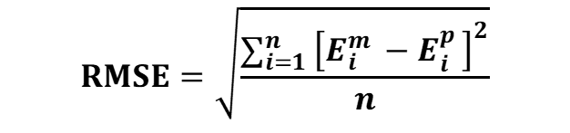
(1)
where E^{m}elevation of ground control points. E^{p}Elevation of equivalent points extracted from DEM. n is the number of evaluation points used.

Tabe 2 Accuracy evaluation
NO OF POINTS | ELEVATION OF GROUND  CONTROL | ELEVATION FROM DEM | E^{M} -E^{P}
1 | 67.55 | 64.72704082 | 2.822959184
2 | 66.3 | 62.09438776 | 4.205612245
3 | 50.22 | 57.57908163 | -7.359081633
4 | 67.65 | 64.31887755 | 3.331122449
5 | 68.32 | 66.06632653 | 2.253673469
6 | 6501 | 64.18622449 | 0.81377551
7 | 64.11 | 69.20001002 | -5.09001002
8 | 6400 | 70.22001121 | -6.22001121
9 | 62.10 | 62.34399729 | -0.243997293
10 | 59.38 | 68.44002122 | -9.06002122
11 | 62.22 | 62.16392909 | 0.056070908
12 | 66.21 | 64.88337542 | 1.326624584
13 | 70.22 | 69.68877551 | 0.53122449
14 | 72.56 | 70.0127551 | 2.547244898
15 | 63.12 | 63.79081633 | -0.670816327
16 | 62.09 | 62.00166023 | 0.08833977
17 | 53.67 | 54.33210121 | -0.662101208
18 | 65.32 | 65.02783996 | 0.292160037
19 | 61.22 | 61.99078509 | -0.77078509
20 | 65.70 | 70.44423111 | -4.74423111
21 | 58.22 | 57.77040816 | 0.449591837
22 | 57.92 | 59.98950958 | -2.069509579
23 | 58.99 | 60.88744273 | -1.897442732
24 | 59.23 | 59.62244898 | -0.39244898
25 | 60.23 | 65.44002324 | -5.21002324
26 | 57.21 | 57.8801541 | -0.670154102
27 | 55.21 | 57.22222001 | -2.01222001
28 | 59.99 | 57.58928571 | 2.400714286
29 | 54.72 | 55.60685652 | -0.886856518
30 | 53.66 | 55.31002121 | -1.65002121

RMSE = 5.202

4. Conclusion
Mapping of morphometric parameters prevailing within a catchment is fundarnental for morphometric analysis and watershed management. Therefore, in this study morphometric analysis ofOtammiri river basin in Owerri Imo state has been carried out using Geospatial technique. Several geoprocessing tools of ArcGIS10.5 and surfer 11 were utilized to process the SRTM-DEM to generate the stream segments, sub-catchments, morphometric attributes and multiple terrain models for in-depth investigation of hydrological character of the basin. This was followed by series of ground investigations and accuracy assessment. Result revealed a total number of 96 streams draining a landed area of 113 square kilometers approximately. The elevation of the basin decreases from north eastern part to the southern part with a large portion of the surface situated in a terrain of slope between 1 degree and 90 degrees. The basin is a 4th order river basin and river network analysis revealed a dendritic pattern and a stream frequency of 1.17 number of streams per square kilometers. These digital derivatives are indispensable for proper understanding and management of the basin. They also attest that geospatial approach is effective in mapping andhydro-analysis of a river-basin

Disclaimer (Artificial intelligence)
Option 1:
Author(s) hereby declare that NO generative AI technologies such as Large Language Models (ChatGPT, COPILOT, etc.) and text-to-image generators have been used during the writing or editing of this manuscript.
Option 2:
Author(s) hereby declare that generative AI technologies such as Large Language Models, etc. have been used during the writing or editing of manuscripts. This explanation will include the name, version, model, and source of the generative AI technology and as well as all input prompts provided to the generative AI technology
Details of the AI usage are given below:
1.
2.
3.
References
Abiodun, O.A.,Adebowale, A .A., Matthew, O. I(2018), Drainage Basin Morphology And Terrain Analysis Of The Lower Benue River Basin, Nigeria. Science.World Journal,2018, 13(1) pp18-22

Amulya (2018). Morphometric Analysis of Bettahalasuru Using GIS And Remote Sensing.
International Journal of Applied and Advanced Scientific Research, 3, (1),12-16.

Angillieri, M.Y, (2012), Morphometric characterization of the Carrizal basin applied to the evaluation of flash floods hazard, San Juan, Argentina. Quat Int, 253:74–79

Akajiaku C. C, Emmanuel U. A., Ogbenna U., Franklin O. and Cecilia B. (2021)Detection of Eroded Sites of Mild Terrains by Adjusting SRTM DEM Errors.Surveying and Land Information Science, Vol. 80, No. 1, 2021, pp. 17-31

Chandrasekar, N. M. (2014) GIS model-based morphometric evaluationof Tamiraparani sub basin Tirunelveli, India. Arab Journal Geo science 7: 131-141.

Clarke, J.I (1996)Morphometry from Maps. Essays in geomorphology. Elsevier publication. Co., New York,1996, pp 235–274

Emmanuel U.A (2020). Application of Geospatial Techniques in Modeling and Analysis of
Topographical Settings in Kogi State, Nigeria, Proceedings of FIG Working Week 2020 “Smart surveyors for land and water management” Amsterdam, the Netherlands,2020, 10–14

.Kabite,G., Gessesse B. (2018)Hydro-geomorphological characterization of Dhidhessa River Basin, Ethiopia. Int Soil Water Conserv , 2018, 6(2):175–183;

Grohmann H (2004) Morphometric analysis in geographic information systems: Computers&GeoSciences, 30: 1055-1067

Mesa L.M (2006) Morphometric analysis of a subtropical Andean basinTucumán Argentina Environmental Geology 50: 1235-1242.
Magesh N.S, Jitheshlal KV, Chandrasekar N, Jini KV (2013) Geographicalinformation system-based morphometric analysis of Bharathapuzha river basinKerala, India. Applied Water Science 3: 467-477

Nkeki, F.(2014). Mapping and Geovisualizing Topographical Data Using Geographic Information System (GIS.) Journal of Geography and Geology;2014, 6, (1), 1-13

Oruonye E. D., Ezekiel B. B., Atiku H. G., Baba E. and Musa N. I. (2016) Drainage Basin Morphometric Parameters Of River Lamurde: Implication For Hydrologic And Geomorphic Processes.; Journal of Agriculture and Ecology Research International 5(2): 1-11

Sangeetha, G.,Srinadh, A., Chethan, B., Visha, K. Nithin, l. Y (2019), Morphometric Analysis and Prioritization of Microwatershed of Bisalpur Reservoir using Geospatial Techniques. International Journal of Innovative Technology and Exploring Engineering, 8 (12), 2991-2997

Schumm S.A (1956) Evolution of drainage systems and slopes in badlands at Perth Amboy, New Jersey. Geol Soc Am Bull 67:597–646

Sreedevi, P.D, Owais S, Khan, H.H, Ahmed, S (2009) Morphometric analysis of awatershed of South India using SRTM data and GIS. Journal of the Geological Society of India 73: 543-552.
Sreedevi, P.D, Subrahmanyam K, Ahmed, S. (2005) The significance of morphometric analysis for obtaining groundwater potential zones in a structurally controlled terrain. Environmental Geology 47: 412-420.
Sumantra. S.B.,(2016) Analysis of GIS Based Morphometric Parameters and Hydrological Changes in Parbati River Basin, Himachal Pradesh, India Journal of Geography & Natural Disasters Volume 6 (2) 1-8

