IMPACT OF URBAN EXPANSION ON AGRICULTURAL LAND IN THE NIAMEY IV MUNICIPAL DISTRICT, NIGER
Abstract
Like many major cities in Sub-Saharan Africa, Niamey, the capital of Niger, continues to grow at a sustained pace, pushing the city’s boundaries as far as possible. This growth is accompanied by the consumption of space, leading to significant land transformation. The consequences of this land transformation are characterized by a decrease or even the disappearance of agricultural spaces. The aim of this article is to analyze the factors of urban pressure on agricultural spaces in the Niamey 4 municipal district. To achieve this, a mixed data collection approach is adopted to gather both qualitative and quantitative information. Data were collected through field visits, interviews with municipal officials, and a survey of 39 heads of household in Kongou Zarmagandey. The results showed that more than half of the households lost a significant part of their agricultural land due to declining yields, family and social issues, and manipulations by private entities. The investigation also reveals that the dynamics of urbanization of agricultural land in ACN4 are characterized by residential pressure on agricultural land.
Keywords: Impact, urban expansion, agricultural land, municipal district, Niamey 4.
Introduction
A planetary phenomenon, urbanization today affects most regions and has a strong impact on the lives of rural populations, particularly in peri-urban rural areas (Guibey, 2022). Thus, analyses of land use in African cities report issues of land use change that continue to grow due to accelerated urbanization (Motcho, 2020; Ursula, 2016; etc.).
Thus, Niamey, the capital of Niger, faces several challenges that it seeks to address in order to build its sustainable development. These challenges are demographic, economic, and environmental. The city of Niamey has indeed been marked in recent years by natural phenomena such as droughts, floods, heatwaves, etc. These factors make the natural resources of the city of Niamey vulnerable. Like other municipalities in the country, Niamey is experiencing strong growth due to a massive exodus of rural inhabitants fleeing the growing precariousness in the countryside and a high natural internal growth rate of about 5.3 children per woman (INS, 2013). The direct effect of Niamey's growth creates a huge demand for housing and especially for land. Hence, the phenomenon of land sales occurring all over the city of Niamey, particularly in its outskirts where expansion is possible, especially in the Niamey 4 communal district(ACN 4).
This phenomenon drives customary owners, communities, and private developers to engage in a dynamic of subdivisions without considering agricultural activities in peri-urban areas, the natural resources, particularly their importance for producers and peri-urban populations. The combination of these factors plunges the city into a situation of food insecurity as the sale of agricultural land, especially in the ACN 4, is increasingly widespread. The central question of this article is to understand how urban expansion impacts agricultural land in Niamey?
The demographic growth of Niamey in general and of ACN 4 in particular is indeed accompanied by the consumption of space, leading to significant land mutations. This is not without consequences for agricultural spaces, which are held 'hostage' in the urbanization process. The manuscript first presents the methodology, then the city of Niamey and ACN 4. Emphasis is placed on the analysis of results, concluding with the discussion.
- Materials and methods
This study was conducted using secondary data from surveys, reports, statistical data from the National Institute of Statistics (INS), the general census of agriculture and livestock conducted by the Ministry of Agriculture and Livestock in 2016, as well as from the General Directorate of Agricultural Statistics of the city of Niamey, etc. This documentary exploitation was supplemented by primary data collected from direct field observations, supported by semi-structured interviews and the use of satellite images.
These interviews allowed us to exploit information gathered from resource persons such as the heads of land and agriculture services, the chief of the village Kongou Zarmagandey, a village attached to ACN 4. To understand the consequences of urban sprawl on agricultural spaces, we conducted 39 interviews with households in this peri-urban village of ACN IV. These interviews involved both men and women household heads. A total of 29 men and 10 women were surveyed. The information collected not only helped identify agricultural spaces affected by this city expansion but also provided insight into agricultural yield before and after the land was urbanized. All the data collected underwent qualitative and quantitative processing. The results obtained are represented in the form of maps, the analysis of which allowed us to identify the impact of agricultural land sales on the food needs of the population.
- The city of Niamey and the Niamey 4 Communal Arrondissement
The city of Niamey is one of the eight regional entities of Niger. Located in the far west of Niger where the rainfall is significantly higher than the national average, it is spatially positioned between 2° 10' 43" and 2° 14' 05" East longitude and 13° 28' 45" and 13° 36' 16" North latitude, with an altitude that varies between 180 and 250 meters. Data from the 4th general population census of Niger in 2012 reported the population of Niamey as 1,026,848 inhabitants in 2012 (INS, 2013). This population is increasing at a rate of 2.9% per year.
Niamey is indeed experiencing rapid demographic and spatial growth over the past forty years. In just a decade, its population almost doubled, rising from 674,950 in 2001 to 1,026,848 in 2012, and is estimated by the INS to reach 1,492,414 inhabitants in 2024 (INS, 2013; 2024). As for the area of the city, it has increased dramatically from 2,347 ha in 1972 to 4,400 in 1977; 11,000 ha in the early 2000s to reach 30,000 ha today (INS, 2013). This ongoing expansion of Niamey poses a threat to agricultural land due to the rising demand for housing.
It should be noted that the situation in Niamey is far from the dynamism of the major coastal metropolises of the South (Abidjan, Accra, Cotonou, etc.), however, at the national level, its population is significant; as it constitutes one-third of the urban population of Niger (Issaka, 2010, p. 25). Niamey currently has five (5) municipal arrondissements, including Niamey 4, which is our area of study represented by map 1.
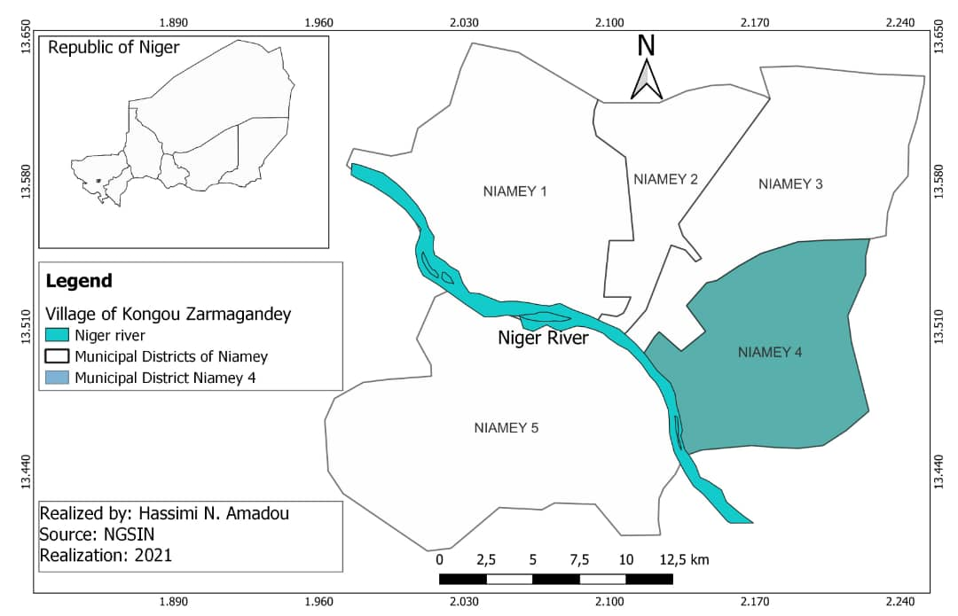
Map 1: Location of the study area
The choice of this area is not random. In terms of area, ACN 4 is one of the largest municipal districts in the city of Niamey, and moreover, the availability of land and the emergence of private actors in the land sector in Niger, specifically within the framework of subdivision operations, have played an important role in the urbanization process of Niamey 4. ACN 4 is located to the east of the city, between latitudes North 13°24' and 13°35' and longitudes East 2°00' and 2°15'.
It covers an area of about 106.09 km² and is entirely located on the plateau of the left bank of the Niger River. It is characterized by a discontinuity of the urban fabric with a significant area occupied by the racetrack, the Diori Hamani international airport, and a large part of the green belt (CV), although the latter is coveted by stakeholders operating in the property sector, the rightful owners, and state institutions supposed to protect the space. The ACN 4 has twenty-three (23) urban neighborhoods and seven (7) administrative villages. Its population is estimated at 321,775 inhabitants in 2017, distributed among 44,046 households, including 2,631 agricultural households.
Land resources in ACN 4 remain insufficient and are further declining due to urbanization. The pressure on land is therefore high, and land becomes a contentious issue for the rural population whose main activities are agriculture and livestock farming. Apart from rain-fed crops, irrigated crops, rice cultivation, and fruit tree cultivation are practiced along the Niger River, in the Koris of Ouallam, and around a few ponds. Despite the strong potential of this local (urban and peri-urban) agriculture, certain constraints such as land issues, the expansion of built-up areas, and the decline in soil fertility due to saturation and overexploitation of land caused by high demand hinder the expansion of these production systems and increase food insecurity among populations (Ludovic and Philippes, 2012, p. 2).
The growth of Niamey in general worries producers about the shrinking of agricultural plots, a phenomenon related to the division of family land and the spatial expansion of the city. ACN 4 is therefore exposed to the greed of all those interested in selling plots in this part of the city. What then are the factors in the sale of land in ACN 4?
3. Results and Discussions
3.1. Factors of Land Sales in ACN 4
The main factors for the sale of agricultural land in the ACN 4 are urbanization, lack of resources, inheritance, declining yields, and manipulation by private actors.
3.1.1. Urbanization as a Factor of Land Sales
Urbanization is one of the fundamental reasons for the disappearance of agricultural land in Niamey. Indeed, the capital of Niger has experienced rapid growth due to demographics and rural exodus. Its population grew from 1,026,848 in 2012 to nearly 1,500,000 today, with a natural growth rate of 2.9% (INS, 2013; Motcho, 2020, p. 227). This population growth has led to a rapid expansion of the city that does not exclude ACN 4 despite its recent creation. Indeed, its population increased from 271,432 in 2012 to reach 365,122 inhabitants in 2021 (Figure 1).
In a decade, namely from 2012 to 2021, its population experienced an increase of 26% (93,690), in other words, more than a quarter of the current demographic weight (Urbaplan, 2008; INS, 2013, 2022; SPAT/DC, 2021).

Figure 1: evolution of the ACN4 population from 2000 to 2022
Source: field survey, 2025
This urban dynamic exacerbates the phenomenon of land sales in the ACN 4. Thus, local communities and private developers create unplanned subdivisions without considering the peri-urban areas, natural resources, particularly their importance for producers, which are the populations. Agricultural lands, which should contribute to improving agricultural production at the local level and combating food insecurity, are burdened by the weight of land speculation.
Thus, we observe in the peri-urban area of ACN 4 the predominance of the phenomenon of land sales, either by owners who feel threatened by unchecked urbanization in Niamey, or by poor populations who sell their fields, often to wealthier individuals, in order to meet immediate needs. Additionally, out of fear of expropriation or usurpation of their lands by the State for public utility purposes, residents of surrounding villages engage in frenzied sales of their lands. Hence, the land dispossession of villagers is often highlighted by private land developers, while these agricultural spaces play a crucial role in the pursuit of food security. In addition, there is the search for individual housing by urban households. Graph 2 shows that 30% of the surveyed population justifies the sale of their land by urban sprawl.

Figure 2: factors for selling land in Kongou Zarmagandey
Source: field survey, 2025
These reasons result in a significant transformation of space and a very often changing vocation, especially when resource management frameworks (POS, SCOT, PUR, etc.) are absent, weak, less rigorous, or not enforced. This leads Pauliet et al. (2012, p. 18) to state that "the land pressure caused by urban growth makes it very difficult to preserve land for agriculture, while leaders and urban planners only marginally recognize the value of this activity, which is even more concerning." Thus, rural land capital in peri-urban areas, caught in the urban spiral, makes agricultural production increasingly precarious. Apart from urbanization, other factors can also be taken into account in the phenomenon of land sales in the ACN 4.
3.1.2. Lack of resources and inheritance, land at stake
The lack of resources results from the low income of the population, and the low resilience capacity of these individuals due to poverty. The populations of the peri-urban villages of Niamey like Kongou Zarmagandey face enormous difficulties in adapting during the lean periods and their only recourse is livestock or land. 18% of the surveyed households confirmed that they sold their land during this period. This constitutes a real problem that undermines land security, even though this sale will only further exacerbate their impoverishment.
Family problems related to the erosion of social values, with a constantly deteriorating social cohesion, push heirs or landowners to sell their land, as reported by 5% of our sample. 10% of landowners justify land sales due to ordinary social problems (marriage, baptism, children's weddings), which often only affect their honor at the expense of the future of an entire generation. As these problems are recurring, the solution relies on the sale of the land, which constitutes a true 'lost investment'.
3.1.3. Decrease in yield and manipulation by private entities as other factors
For 20% of respondents, soil unproductivity is another reason for the sale of land by peri-urban populations of the ACN 4. There is also the promotion that developers make to landowners. Indeed, if in the rule of private developers, the owner earns 50% of the parcel rate with "the guarantee of viability and regularization," other authorized people to make subdivisions promise landowners additional parcels as bait in order to retain them.
The most instructive example is that of Kongou Zarmagandey, a suburban village in ACN 4 where a landowner owning land in Kongou Zarmagandey may find themselves with plots in other suburban or rural villages of other municipal districts of Niamey such as Gayi Koira, North Fandora, or even in Kongou Gonga. In this urban village, 17% of the sample population have fallen victim to this manipulation. One thing is certain, the proposed land is not worth as much as what is deserved. Thus, it can be assumed that the developers themselves have an influence on the owners they manipulate to benefit their own interests.
3.2. The actors of land speculation in ACN 4
Since 2011, local authorities have been excluded from the arena of actors due to the quotas perceived as exorbitant by the population, even if, regardless of what is said, they still play a very important role in land speculation. In the Niamey 4 Municipal District, the actors of land speculation are numerous:
- Public actors including the Ministry of Urbanism, Housing, and Land, which are key players in land governance. This ministry is responsible for controlling land use in accordance with urban planning plans and general regulations; for ongoing monitoring, in conjunction with the relevant ministers, of the purpose of urban land reserves, and for supporting local authorities in developing urban and rural town planning and development plans. As for the Ministry of Finance, it is the Directorate of Land and Cadastre Taxation (DFFC) that is responsible for the development and implementation of national policy in terms of land, domain, and cadastral taxation, in conjunction with the Directorate of Legislation, Litigation, and International Relations, and finally, the Town Halls which manage urban and peri-urban spaces. - The ACN 4, which is under the authority of the city of Niamey, is one of the actors involved in land management. It has authority over these various local communities. However, it acts as an agent by delegation of power, as specified in law n° 2017-20 of April 12, 2017, establishing the fundamental principles of urban planning and development in its article 52, which states that: "the operations of concerted development are subject to agreements between the State, local authorities, and the public or private developer. These agreements specify, in addition to the boundaries of the area concerned, the methods of consultation that involve all stakeholders throughout the duration of the operation."
- Private actors are notaries, surveyors, study firms, and any other person holding the subdivision certification. However, starting in 1997 with the signing of decree No. 97-36 of August 8, 1997, concerning the procedures for the development of subdivision plans, these private actors were enriched with the introduction of private developers. For example, in the urban village of Kongou Zarmandey, from 2002 to 2014, there were four subdivisions as shown in map 2 and the price per square meter has increased significantly. The price, which eight years ago did not exceed 1250F, now varies between 1500F, 1750F, and 1900F. More clearly, for a piece of land of 400m2, one must spend 500,000F, 600,000F, 700,000F, or even 750,000 depending on the value or location of the land. For example, for a plot of land located between two major roads, the minimum price is 650,000F, and for a plot on a single major road, you need to spend at least 550,000F.
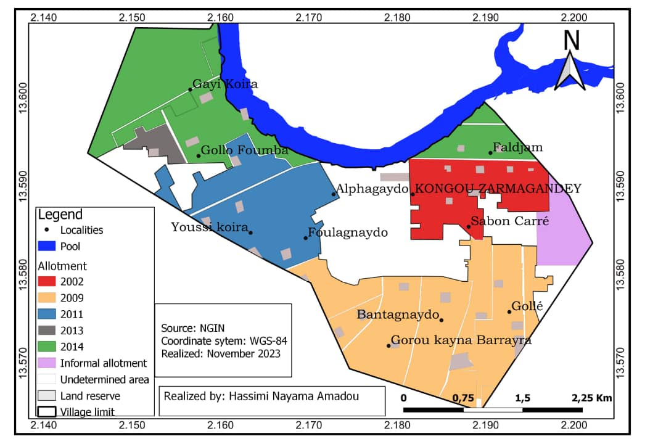
Map 2: subdivision of the urban village of Kongou Zarmagandey
- The sales agents who are intermediaries between owners and buyers often promote and sell parcels. It should be noted that these agents operate informally and have a vast network of regularization channels.
- The semi-private actors are state-owned companies and sub-regional organizations that participate in land production while creating housing estates for the officials of these structures. Among these last ones, we can cite the case of the agency for the safety of air navigation (ASECNA), which has a housing estate at the ACN IV level housing its administrative staff; the Nigerien company for urban planning and real estate construction (SONUCI) whose mission is to implement state policy on housing, etc. In addition to these, various companies are included: the Urban Land Development Company (SATU-SA), VALIMO, GOBIR, etc.
- The customary chiefs are responsible for managing their land under the oversight of local authorities. According to ordinance 93-015 regarding the guiding principles of the rural code dated March 2, 1993, the customary authorities have the prerogative to oversee the sale and purchase of land within their localities in close collaboration with territorial communities by providing customary landholding documents.
- Landowners are key players in the chain of actors involved in land sales. They are the real engines of informal land sales. This is what Motcho (2020, p. 247) describes as 'pseudo-subdivisions in the peripheral area.' How has the construction of ACN 4 developed over the past 30 years?
  - Development of built-up front on agricultural lands of the ACN 4 from 1990 to 2020
The maps below show a clear increase in built-up areas on agricultural land of ACN 4 during the period 1990-2020. Indeed, in this panel, we observe an expansion of built-up areas on agricultural spaces (fields and irrigated crops).
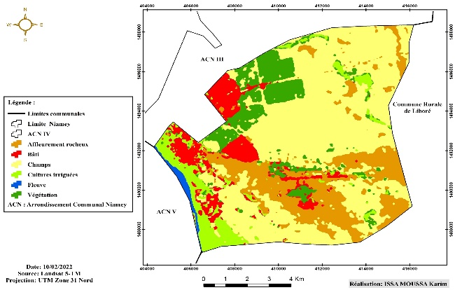 | 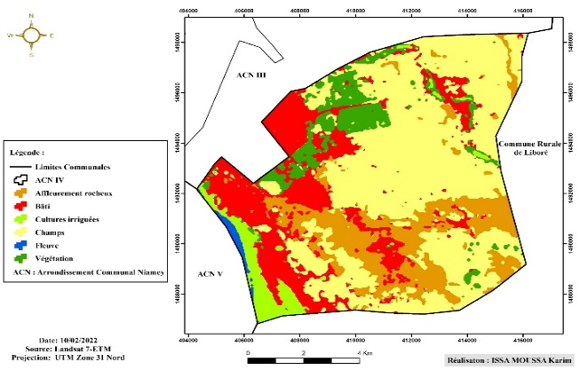
Carte 1 : occupation du sol en 1990 | Carte 2 : occupation du sol en 2000
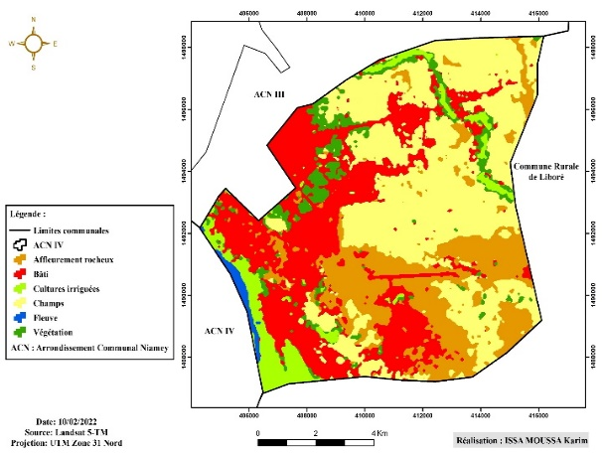 | 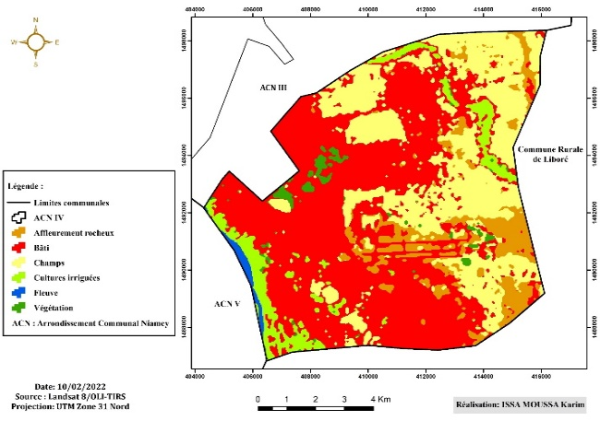
Carte 3 : occupation du sol en 2010 | Carte 4 : occupation du sol en 2020
Chart 1: evolution of the built front of ACN 4 from 1990 to 2020
By observing map 3, we note that in 1990, the land use was dominated by farmland and a green belt stretching from the west to the north. It indicates a strong chlorophyll activity through its reflectance. The built-up area is concentrated particularly in the west, but also represented by the old neighborhoods (Talladje, Airport). From the year 2000 (map 4), we observe that the urban fabric has gained prominence and has gradually expanded not only to the east of the green belt but also to the south with the Airport neighborhood. The year 2010 (map 5) highlights an evolution with an accelerated pace without altering the overall dynamics in which the various spatial units have evolved, meaning that the area losses of certain units automatically lead to the progression of others. Indeed, the built environment continues to evolve significantly both to the north and to the south. The year 2020 (map 6) is marked by a strong land occupation. The most notable fact is the rampant increase in built space.
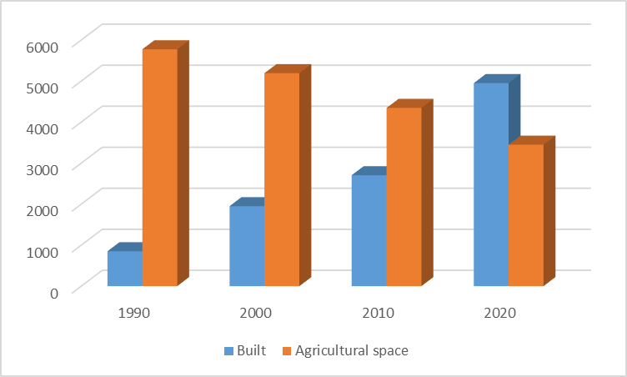
Figure 3: Land use of the ACN 4 from 1990 to 2020
Source: field survey, 2025
Figure 3 gives us an overview of the evolution of built-up space and the regression of agricultural land between 1990 and 2020. Indeed, in 1990, built-up space accounted for only 850 hectares, or 9% of the total area of the ACN 4, compared to 5773 hectares for agricultural spaces. This can be explained by the low demographic weight, as well as the absence of real estate developers, who have a considerable impact on subdivision operations. By 2000, the increase rose to 1949 hectares, or 20% of the occupied surface area. It is important to emphasize that this sprawl coincides with a new era in the city of Niamey. This phenomenon is described by Issaka (2013, p. 5) as a land waste from the early 2000s with the operation 'plot for salary arrears,' which subsequently gave a real impetus to informal real estate development. However, a regression of fields is observed in favor of built areas, decreasing from 5044 to 4775 hectares from 1990 to 2000, which represents 30% of the total area.
In 2010, the built-up area continued to evolve both north and south, as confirmed by its size of 2703 hectares, representing a rate of 28%. Such progression does not occur without impacting the fields that serve as a source of supply for landowners during the rainy season through subsistence agriculture. The area of built-up space nearly doubled between 2010 and 2020, increasing from 2703 to 4949 hectares, resulting in a ratio of 2246 hectares.
Noted by Motcho (2020, p. 232), "the analysis of land use does not take into account urban sprawl, which is more difficult to grasp without a detailed field survey that would have shown us the transfer of rural land from the hands of farmers to those of urban dwellers anticipating the expansion of the capital." Indeed, such a progression over a decade leaves a detrimental observation in this communal district because the fields, which are drastically decreasing, represented only 30% of the total space in 2000 compared to 53% in 1990. This observation supports Motcho's statement (2020, p. 233) about the city of Niamey, which says that "urban sprawl has mainly occurred at the expense of fields and fallow land." What are the consequences of the urbanization of agricultural lands in ACN 4?
  - Consequences of the sale of agricultural land on food security
Land speculation in peri-urban areas is not a practice without consequences because the sale of agricultural land by producers is certainly not to be encouraged and the stakes are numerous. Nowadays, the issue of food security remains an unresolved reality in Niger despite the emergence of several programs, foundations, and many other initiatives. This is why, in the context of population and spatial growth of cities, environmental crises, and land saturation, food availability remains a significant challenge to overcome. To address this challenge, an urging for securing land as well as property rights, particularly by limiting sales and modernizing agriculture through adequate and suitable means, is urgent. When the foundation supporting the activities that ensure the survival of an entire community disappears, it will inevitably lead to the collapse of the sources of income for the populations.
Thus, the decrease in the cultivated area, if not accompanied by an improvement in techniques or the use of chemical or organic fertilizers with proper treatments, implies a decrease in production. According to the village chief of Kongou, "urban sprawl has had an impact on agricultural production leading to the loss of arable land. The decline in agricultural yields has been observed for 20 years, and sometimes, we can only plant 4 to 5 seeds per year to be able to harvest something. The greatest deficit was observed in 2023." (Interview from October 17, 2024).
The unavailability of data regarding the food deficit of the municipal services in Niamey has not allowed us to conduct an analysis on the number of peri-urban villages that have cultivated land, as well as on the cereal balance over a period of 10 years, for example. Nevertheless, reports from the Ministry of Agriculture for the entire Niamey region for the years 2022 and 2023 estimated that 42 peri-urban villages in Niamey cultivated land in 2023 compared to 36 in 2022 for the Niamey region (Ministry of Agriculture, 2023; 2024).
As for the cereal balance for the year 2023, the net production of cereals for Niamey is estimated at 7,218 tons against a human consumption need of 253,840 tons; resulting in a deficit of 246,622 tons (Ministry of Agriculture 2024, p. 20). It was 11,905 tons in 2022 against a need of 270,125 tons. However, in 2008, cereal production was the highest, at 23,973 tons. Cereal production is mainly composed of millet (11,920 tons) and rice (3,442 tons). Corn is often grown in the off-season and strongly relies on other cereal crops. (Ludovic and Philippes, 2012, p. 15).
The reasons for this agricultural deficit have been justified by surveys conducted among households in Kongou Zarmagandeye. All respondents attribute this deficit to the decrease in soil fertility, land fragmentation, and the reduction in the area of fields. 'The loss of land has a significant impact because it deprives us of our agricultural activities and increases food insecurity. After losing the lands threatened by construction, some villagers are forced to go far beyond Hamdalaye to buy fields' (Interview on October 17, 2024). 75% of respondents have reported food shortages for two decades, as confirmed by the words of Mariama (interview in 2024), a resident of Zarmagandey, 'before the years. In 2000, I could have up to 25 bags of millet and 6 bags of cowpeas. But today, I can only have 2 bundles of millet and 3 containers of 25 liters of cowpeas. "I can harvest 200 bundles of millet and have 10 bags of cowpeas most of the time, and in 2023, I only harvested 2 bundles of millet and filled 2 containers of cowpeas" (Hamidou, 2024). Such statements are numerous in Kongou because for them, this drop in yield is largely caused by urbanization and environmental degradation. Market gardening has also seen a drastic decline. Major crops like cabbage, peppers, and moringa are also affected by the sale of land in Kongou Zamangandey. Among the 39 respondents, 29 engage in market gardening in this urban village. 18 respondents reported a low yield compared to 5 with an average yield and 6 with a good yield (figure 4). The unproductivity of the soils often drives farmers to sell their land. This leads to the impoverishment of peasants who are further exposed to food insecurity.

Figure 4: Market Gardening Yield
Source: Field Survey, 2025
A serious survival problem then arises, increasing their level of vulnerability and exposure to often degrading ways of life. From an economic perspective, the sale of land by an agricultural population is not a good sign. Land is the main basis for the subsistence of local populations, especially those living in peri-urban areas, whether it involves agriculture, livestock, or any other activity. The loss of this precious asset for producers constitutes a serious problem that should have been prevented rather than considered. Whatever the angle of perception, the loss of land in no way benefits peri-urban dwellers.
The land market has allowed Nigerians to accumulate wealth at the expense of customary owners, through the buying and selling of plots. With the private subdivision authorized since 2006, the economic stakes related to land have significantly increased. Many young people who have ventured into the field have become references in the region due to the large amounts of money they have been able to earn. The only problem is that neither the state nor the local authorities have made an effort to control this black market or to quantify the speculators and the financial resources derived from land. The brokers in the area also benefit as the market is lively without respite.
The change in land use from a natural landscape to an artificial landscape can cause many problems for a population that knows only agriculture as an activity. Indeed, vegetation cover will be threatened by human actions. Once anthropized, the soils will be burdened with non-degradable materials. Even in the event of the disappearance of agricultural activities, serious attention will need to be paid to hygiene and sanitation to address this, hence the need for rigorous planning and adequate development. Unbuilt fields will serve as reservoirs for waste. Such practices do not come without consequences because even if agricultural use is discarded, we will see soil impermeability leading to flooding or unmanageable neighborhoods, which can cause a serious environmental problem.
- Discussion
In the Niamey 4 Commune District, the sale of land is due to several factors. The results showed that urbanization is one of the causes of the disappearance of agricultural land in Niamey due to the advancement of the built-up area. The analysis shows that urban growth poses many problems due to land use, with its corollary being urban sprawl and the disappearance of agricultural land on the outskirts of the city. The balance between urban and agricultural spaces is therefore one of the major issues for land management and planning (Augusseau et al, 2016, p.9). Niamey 4 is characterized by a population growth that continues to increase over time. Thus, 30% of respondents stated that urbanization is one of the causes of land sales in ACN4, compared to 18% who attributed sales to poverty, 5% to inheritance, 10% to ordinary social problems, 20% to low soil productivity, and 17% to the manipulation of private actors.
This exponential growth of the population leads to a strong consumption of space for housing needs. This is not without consequences for peri-urban agricultural lands, which are heavily impacted by urbanization. We have shown that in the ACN 4, built-up space has experienced rapid growth over three decades, increasing from 850 ha to 4949 ha between 1990 and 2020, while agricultural areas have regressed from 5773 ha in 1990 to 3447 ha in 2020, representing a decrease of nearly half of the cultivated areas. Augusseau et al (2016, p. 9) demonstrated this in Reunion, where as early as the 1990s, urbanization consumed 500 to 600 ha of agricultural land per year, accounting for nearly 1% of agricultural land. The same observation was made by Chauvot and Beccaïni (2011, p. 1) in its study of three regions of France, namely Provence-Alpes-Côte d’Azur, where demographic dynamics are consuming space and urbanization is gaining ground: from 1970 to 2000, productive agricultural land decreased by 20% in the region. The competition between different land uses is particularly strong in Paca. The numerous reliefs, remarkable spaces, and risk areas that cannot be built on shift the pressure onto other natural or agricultural spaces. Today, 76% of the region's inhabitants are concentrated in only 10% of the territory. Motcho (2020, pp: 232-233) also demonstrated this in Niamey in his analysis of land use. He explains the drastic reduction in the areas occupied by fields and fallow land between 1987 and 2017, which decreased from 63.68% to 47.98% of the area allocated to the city of Niamey, representing a loss of 14,945.83 hectares over 30 years.
A finer analysis shows that the loss of fields and fallow land is three times greater between 2002 and 2017 than between 1987 and 2002, not due to an acceleration in the rate of population growth but rather to a voracity in the fragmentation of the city's hinterland. This is confirmed on one hand by the evolution of the area of the urban fabric, which increased from 5,362.93 ha in 1988 to 8,857.60 ha in 2002, reaching 20,685.0 ha in 2017, and on the other hand by the increase in the population, which is about 300,000 inhabitants every 12 years: between 1988 and 2001, the population of Niamey multiplied by 1.78 compared to 1.45 for the period 2001-2012. These ideas corroborate those of Pauleit et al. (2016, p. 22) in their study in Addis Ababa, where 24% of agricultural land was lost between 2006 and 2011. The reduction of agricultural space has also been evident in all the Abidjan sub-prefectures. It is 52.63% in Bingerville, 38% in Anyama, 33.34% in Songon, and 25.32% in Brofondoumé (Aman et K-B, 2021, p.19).This is what drives Adam et al. (2025) to state that "The process of land mutation, which initially takes place in the peripheral areas of commune 5 through the buying and selling of gardens and fields, has intensified in recent years with both formal and informal subdivision operations carried out by public and private actors."
The strong demographic and spatial pressure generates a land issue that pits housing against agriculture (Ludovic, 2012, p. 5). Pauleit et al. (2016, p. 22) show that this expansion has mainly taken the form of spontaneous growth, driven by landowners and real estate developers. In the absence of guidance from appropriate government policies and strategies, which should direct these new developments to vacant lots and ensure that urbanized land is well used, this unregulated expansion leads to the loss of highly fertile agricultural land and green spaces that provide ecosystem services. These ideas are also the same ones developed by AgriMedia (2025) that focus on the impact of urbanization on vegetable lands in Kinshasa. It showed that in the N’djili Brasseries area, to the east of the city, many plots once dedicated to vegetable production have disappeared under the foundations of new buildings. For vegetable growers, every square meter lost reduces the city's ability to feed itself locally (https://agrimedia.cd/kinhsasa). Saidou Guibeye (2022) made the same observation in Gorou Banda, a peri-urban village in the ACN 5 of Niamey. He noted a gradual decrease in the percentage of landowners in Gorou Banda, dropping from 68% to 32% of owners between 2007 and 2022. According to him, if this trend continues, there will be no more landowners by 2037.
The failure of local policies is another issue. Indeed, the urban sprawl of Niamey in general and that of ACN 4 in particular can be explained by the emergence of private actors in the field of land development. This leads Ibrahim (2018) to conclude that: "It was from 2006 that the State of Niger really began to authorize private developments [...]. While between 1990-2004 the State and its branches excessively produced plots, the emergence of private developers has been a tragedy." Such an observation clearly shows that public policies through decision-making have radically transformed the sector. This has, over time, created an unfavorable climate for the norms of rational planning in the city.
Also, local authorities and customary leaders have lost their prerogatives regarding land control due to liberalization and the advent of private plotters who often exploit the ignorance of farmers to sell agricultural lands. This prompts Meyer (2016, p. vi) to state that "the production of urban plots is interpreted in terms of territorialization at the city scale and control over the lands for the future expansion of the capital by economic actors sometimes more powerful than the State." Issaka (2013) also mentioned it in Niamey, where he believes that over the past 20 years, the weakness of the State has been greatly exploited by individuals who have been able to impose their logic on the rest of the community.
The commodification of agricultural land in the peri-urban areas of cities like Niamey has increased in recent decades. Peri-urban spaces are threatened by the city's expansion due to rapid population growth. This observation was also made by Adam et al (2025) in ACN 5. Indeed, its proximity to the city of Niamey motivates many buyers who mostly purchase land to resell it after development. A similar observation was made in ACN 4, where we showed that in the urban village of Kongou Zarmagandey, 66% of farmers reported having sold land. In contrast, only 34% of those surveyed have never sold land, and those individuals live in Niamey.
These land transactions often occur under irregular conditions due to landowners' lack of knowledge about securing procedures and the absence of a regulatory system for rural land markets. Without control, this land market risks gaining ground and accelerating the decapitalization of the most disadvantaged, with all possible effects. This could encourage them to resort to irrigated crops to address the problem of food insecurity. With the loss of land reserves useful for agricultural activities, the risk of food insecurity represents the main consequence of land transformations in peri-urban areas (Adam et al, 2025). Our findings confirm this, as 75% of respondents have observed a decline in agricultural yields over the past two decades, with yields being poor for 63% of respondents.
Conclusion
This study on the impact of urban expansion on agricultural land in the Niamey 4 municipal district highlighted the causes of land sales, which are related to urbanization, poverty, family and social issues, but also to low agricultural yields and manipulation by private actors. This sale of agricultural land is a consequence of the high demand for housing in Niamey. Indeed, in three decades, Niamey 4 has lost nearly half of its agricultural land in favor of construction, which has doubled in a decade. ACN 4, having exhausted its land reserves, has expanded into the villages that are linked to it. This spatial extension is not without consequences, as agricultural lands are severely affected by speculation among local authorities, customary leaders, and private developers who have dominated the land market in Niamey. These private developers use various strategies to gain control over the farmers in the peripheral villages and establish their supremacy in the presence of local authorities.
This frenzied sale of agricultural land leads not only to food insecurity but also to increased impoverishment of farmers and a collapse of social values. Farmers find themselves without land, which is their only wealth. Niamey continues to annex suburban space; how could this anarchy of spatial occupation be a compromise for the sustainability of Niamey's suburban lands?

Disclaimer (Artificial intelligence)
Option 1:
Author(s) hereby declare that NO generative AI technologies such as Large Language Models (ChatGPT, COPILOT, etc.) and text-to-image generators have been used during the writing or editing of this manuscript.
Option 2:
Author(s) hereby declare that generative AI technologies such as Large Language Models, etc. have been used during the writing or editing of manuscripts. This explanation will include the name, version, model, and source of the generative AI technology and as well as all input prompts provided to the generative AI technology
Details of the AI usage are given below:
1.
2.
3.
References
- ADAM ELHADJ SAIDI Aboubacar, SAIDOU YAYÉ Hadiara, and MOUSSA Soulé. 2025. “Peri-Urbanization and Land Transformations in the Niamey 5 Municipal District”. Asian Journal of Geographical Research 8 (2):81–92. https://doi.org/10.9734/ajgr/2025/v8i2264
- AMAN A.H and KOFFI-BIKPO C.Y. (2021). Impact of urbanization in the district of Abidjan on peri-urban market gardening (Côte d'Ivoire). DaloGéo, a scientific journal specializing in Geography, Jean Lorougnon Guédé University, issue 005, pp. 11-25. https://www.revuegeo-univdaloa.net
- AUGUSSEAU Xavier, BOURJOIN Jeremy, DAVID Daniel, DEGENNE Pascal, LAGABRIELLE Erwann, LESTRELIN Guillaume, LO SEEN Danny. 2018. Modèles et simulations spatio-temporels comme objets intermédiaires : le cas de l'étalement urbain à la Réunion. In : Les terres agricoles face à l’urbanisation : De la donnée à l'action, quels rôles pour l’information ?. Plant Roel (ed.), Maurel Pierre (ed.), Barbe Éric (ed.), Brennan Jane (ed.). Versailles : Ed. Quae, 174-196. (Update Sciences & technologies) ISBN 978-2-7592-2922-2
https://www.quae.com/produit/1547/9782759229222/les-terres-agricoles-face-a-l-urbanisation

CHAUVOT P and Baccaïni (2011) Agricultural lands facing urbanization pressure: resistance and differentiated challenges, INSEE synthesis No. 10, Paris, April 10, 2011

https://www.insee.fr/fr/statistiques/1293874#:~:text=Pr%C3%A9server%20les%20espaces%20agricoles%20est%20aujourd%27hui%20une,population%20des%20quarante%20derni%C3%A8res%20ann%C3%A9es%20(+%201%2C6
- ISSAKA H. (2013) "Informal real estate development in Niamey: irregularity as a response to the housing crisis," Urbanités 2 – November 2013, Cities in crisis, crises in the city, 9 p.
https://www.revue-urbanites.fr/la-promotion-immobiliere-informelle-a-niamey-lirregularite-comme-reponse-a-la-crise-du-logement/
- LUDOVIC A and PHILIPPES L. (2012) "Agricultural supply for the city of Niamey: potentials and constraints of local agriculture." p. 21, [Online]. https//orbi.ulieg/be (consulted on November 14, 2024).
http://orbi.ulg.ac.be/bitstream/2268/126098/1/Article Orléans.pdf
- MEYER U. (2016) Négocier l'accès, la propriété et l'autorité publique en marge de la ville. Enjeux fonciers à Niamey et production d'Etat au Niger [Negotiating access, ownership, and public authority on the fringes of the city. Land issues in Niamey and state production in Niger]. PhD thesis in geography, University of Lausanne, 316 p. DOI:10.13140/RG.2.2.16540.59529
- MOTCHO K. H. (2020) Niamey from village to metropolis. ECD Review, volume 1, No. 2, November 2020, pp: 226-254. https://fr.scribd.com/document/863954188/Moctho-Niamey-de-la-bourgade-a-la-metropole
- PAULEIT S., EL-WAFA H. B., PRIBADI D. O. (2016) Peri-urban agriculture and urbanization: the case of Jakarta and Addis Ababa. The Veolia Institute Review - facts reports, pp. 18-25. https://www.institut.veolia.org/sites/g/files/dvc2551/files/document/2019/10/18%20Agriculture%20p%C3%A9riurbaine%20et%20urbanisation.pdf
- REPUBLIC OF NIGER. URBAN COMMUNITY OF NIAMEY. (2008). Urban audits and priority intervention program. Urban audits and reference urban plan of the CUN. Interim report, Urbaplan, 261 p. https://katalog.bibliothek.kit.edu
- REPUBLIC OF NIGER. MINISTRY OF AGRICULTURE AND LIVESTOCK. (2023). Evaluation report of the 2022 rainy season agricultural campaign and food outlook for 2021-2022. 57 p. https://reca-niger.org
- REPUBLIC OF NIGER. MINISTRY OF AGRICULTURE AND LIVESTOCK. (2024). Evaluation report of the 2023 rainy season agricultural campaign and food outlook for 2022-2023. 67 p. https://reca-niger.org
- REPUBLIC OF NIGER. MINISTRY OF FINANCE. NATIONAL STATISTICAL INSTITUTE (2013). Statistical Yearbook 2008-2012. 241 p. https://www.stat-niger.org
- REPUBLIC OF NIGER. MINISTRY OF FINANCE. NATIONAL STATISTICAL INSTITUTE, 2014. Niger in Figures 2014. 84 p. https://www.stat-niger.org
- REPUBLIC OF NIGER. MINISTRIES OF FINANCE. NATIONAL INSTITUTE OF STATISTICS, 2022. Niger in Numbers 2022. 85 p. https://www;stat-niger.org

