Sensory Evaluation and Microbial Analysis of Probiotic Ambil Using Sorghum (Sorghum bicolor) Flour

.

Abstract
The present study was conducted to evaluate the sensory and microbial qualities of Sorghum- based Probiotic Ambil enriched with varying levels (20%, 30%, 40%, and 50%) of probiotic curd containing Lactobacillus acidophilus. Sensory evaluation focused on key attributes including colour and appearance, flavour, body and texture, and overall acceptability. Among

the treatments, T3 (40% probiotic curd) received the highest scores across all sensory parameters. Panellists described T3 as having a smooth texture, appealing white appearance, and a pleasantly sour and palatable flavour, resulting in superior overall acceptability. This indicated that the 40% incorporation level struck an optimal balance between taste, texture, and visual appeal.
Microbial analysis revealed that the probiotic count increased proportionally with higher levels of probiotic curd. Fresh samples of Sorghum-based Probiotic Ambil showed acceptable standard plate counts and probiotic viability. Importantly, yeast and mould, as well as coliforms were not detected in any treatments at the time of fresh consumption, confirming the microbiological safety and stability of the product under the tested conditions.
These findings suggest that incorporating 40% probiotic curd (T3) into Sorghum-based Ambil not only enhances its sensory qualities but also ensures a safe microbial profile, making it a promising functional beverage with improved consumer acceptability.
Keywords: Sorghum-based Probiotic Ambil, Probiotic curd, Lactobacillus acidophilus

INTRODUCTION

About 11,000 years ago, when farming started to take the place of hunting and gathering in the Middle East, milk was first used for human nourishment. In order to break down lactose, a milk sugar that was indigestible to adults, cattle herders first started fermenting milk to make yoghurt and cheese (Curry, 2013). A cultural history of milk consumption has also been linked to other lactase persistence pockets in South Asia, the Middle East and West Africa. In these regions, genetic mutations linked to the lactase gene have also been found (Burger, 2007). As farming began, milk from cows, sheep or goats became a valuable source of nutrients. Additionally, fermented milk products could be preserved, making them less dependent on harvests and seasonal fluctuations, which helped during famine. In addition to lactose, the primary milk sugar, milk also includes vital amino acids, lipids, vitamins, minerals and proteins (caseins, whey proteins and minor proteins). Thus, its use may have played a role in the centuries-long success of human evolution. But in addition to being extremely nourishing for people, milk is also a great place for microbes to develop.

Probiotics are living entities that support the host's well-being when provided in adequate amounts. This statement refers to specific bacterial strains, with typical probiotics featuring lactic acid bacteria such as Bifidobacterium and Lactobacillus. Fermentation of dairy products such as yoghurt, cheese, and kefir commonly utilizes these strains. Consequently, one of the most common sources of probiotics is fermented dairy items that include live bacterial cultures. Many digestive and gastrointestinal issues could improve with this type of milk product that contains probiotics (Suryawanshi, N. A., 2021).

L. acidophilus, initially referred to as Bacillus acidophilus, was first discovered in the human gastrointestinal tract (infant feces) by Moro in 1900. L. acidophilus is found in more than 80 percent of yogurts produced in the United States. Isolates of L. acidophilus have been cultivated from the oral, intestinal, and vaginal areas and are also part of the normal human microbiota. L. acidophilus is a gram-positive, small
(2–10μm) bacillus that can flourish at temperatures up to 45°C but prefers to grow best at 37-42°C. It exhibits optimal growth with a pH range of 5.5 to 6.0 and ceases to grow at a pH of 4.0. Lactobacillus acidophilus, an obligatory homofermentative bacterium, is among the LABs that tolerate oxygen the least, fermenting carbohydrates to produce lactic acid. A key commercial species of Lactobacillus acidophilus is present in products like milk, yogurt, infant formulas, and dietary supplements that contain probiotics.
(Marchesi J, Bull M, Plummer S et al., 2013).
As a crop that can withstand drought, sorghum is ranked as the fifth most important staple cereal (Dlamini, Taylor and Rooney, 2007). According to Taylor, Schober and Bean (2006) it has been used to make porridge, beer, unleavened bread, couscous composite mixes and ethnic beverages. For the African and Indian populations, sorghum is a major source of energy, protein and minerals, including trace elements like iron and zinc ( Mohammed and Barbiker, 2011). Sorghum is rich in phenolic acid, flavonoids, antioxidants and condensed tannins in addition to these nutrients.

MATERIAL AND METHODS

All the material required was procured from local market and also facilities provided by Department of Animal Husbandry and Dairy Science, College of Agriculture Dapoli, Ratnagiri, (M.S) India.

Starter culture, its maintenance and propagation
The freeze dried probiotic pure cultures of Lactobacillus casei were obtained from the National Dairy Research Institute, Karnal, Haryana and SMC college GAU, Anand. The culture was maintained separately in sterilized reconstituted skim milk test tubes.
The sterilized skim milk test tubes were separately inoculated with these cultures and incubated at 37⁰C for 8 hrs and thereafter stored at refrigerated temperature. In order keep these cultures active, they were propagated once in week.
    - Preparation of Probiotic Curd (L. acidophilus)
Buffalo milk Pre Heating (38⁰C)
Filtration Heating 80⁰C/5 min Cooling (37⁰C-38⁰C)

Addition of Culture @1.5 per cent (L. acidophilus)
Proper mixing Incubation (37⁰C/ 8 hrs) Probiotic Curd

Preparation of sorghum based probiotic Ambil (Flow Chart)
Flow chart 1 Preparation of Probiotic Curd (L. acidophilus)
Dry and clean Sorghum grain Grinding into fine flour
Take a small container having some amount of water, add sorghum flour (as per treatment) then stirring well to make it proper mix.
Water boiling (80⁰C-90⁰C) and add sorghum flour mix add salt and ginger extract as per taste and stirring
Boiling for 5 minutes Cooling (37⁰C)
Addition of probiotic (L. acidophilus) curd (homogenized form) as per treatment Proper mixing
Sorghum based probiotic Ambil (Ready to serve)
Flow chart 2 Preparation of sorghum based probiotic Ambil (Flow Chart)

Treatments details
PHASE - I: Determination of optimum level of sorghum flour

In this phase by carried out filler-trial, sorghum flour was used at different proportion (5%, 7.5%, 10%, 12.5%) to finalize with constant level (7.5%) of sorghum flour.

PHASE - II: Preparation of Sorghum based Probiotic Ambil

In the present investigation Sorghum flour will be used @ 7.5 per cent for all treatments, whereas probiotic curd L. acidophilus was used in different proportion of 20, 30, 40 and 50 per cent.
The designed Sorghum based Probiotic Ambil was prepared in following different combinations,
T0= 7.5% Sorghum flour + without adding probiotic curd
T1= 7.5% Sorghum flour + adding 20 per cent probiotic curd (L. acidophilus) T2= 7.5% Sorghum flour + adding 30 per cent probiotic curd (L. acidophilus) T3 = 7.5% Sorghum flour + adding 40 per cent probiotic curd (L. acidophilus) T4= 7.5% Sorghum flour + adding 50 per cent probiotic curd (L. acidophilus)

Sensory Evaluation
The samples of Sorghum based probiotic Ambil was evaluated for sensory qualities by using 9-point hedonic scale as per IS: 6273, (Part-II), 1971 for various sensory attributes. The flavour, colour and appearance, body and texture and overall acceptability was the characteristics considered for the purpose of scoring the products.

Microbial Analysis
The most optimum level found during research was subjected for microbial analysis for same day of freshly prepared product.
The parameters under study were probiotic count, Standard Plate count (SPC), Yeast Mould count and Coliform count. The most optimum level was subjected to sensory evaluation and microbial evaluation of product which was done on same day for freshly prepared product.

RESULTS AND DISCUSSION

Colour and Appearance
It is an important property for any food material that increases the consumer’s aesthetic appeal. acceptance of any milk product by customers largely depends upon colour and appearance of the product. The desirable colour of the Sorghum Based Probiotic Ambil should be creamy white to white attractive, uniform, pleasing and typical represented in Table 1
The data regarding colour and appearance of Sorghum based Ambil fortified with probiotic curd (L. acidophilus) at different levels indicate that at 40 per cent addition of probiotic curd (L. acidophilus) to treatment T3 scored highest (8.30) followed by treatment T2, T4 and T1 whereas the control T0 scored least (6.70).

It has been observed that there was continuous increase in score for colour and appearance when probiotic curd (L. acidophilus) was added @ 20 per cent, 30 per cent and 40 per cent. However, at 50 per cent addition of probiotic curd (L. acidophilus) product showed declining trend.
The statistical interpretation of data revealed that the results are statistically significant at 1 per cent level of probability. All the levels of probiotic curd (L. acidophilus) were found to be at par with each other whereas control sample differ significantly from Sorghum based probiotic Ambil fortified with probiotic curd (L. acidophilus)
The colour and appearance of liquid milk product largely depends upon its colour and viscosity. The colour must be uniform throughout the body of product and presence of any tinge of foreign colour is not accepted. In the present investigation, it has been observed that as proportion of probiotic curd (L. acidophilus) goes on increasing, product attains typical white colour. This bright colour was found to be very attractive and provide typical tinge to product which was well accepted by judges. However, at 50 per cent addition of probiotic curd (L. acidophilus) product attains dark crystal white colour which is not a natural feature of Sorghum based Probiotic Ambil so it was not liked by judges.
Kumar (2006) observed that Colour and appearance of the product had a maximum sensory score (7.75) for the formulation which included 3.73 per cent flour (24 h germinated flour) and 57.32 per cent of water on curd basis. However least score (6.75) was obtained with the formulation consisting of 8.00 per cent flour and
75.00 per cent of water on curd basis.
Shinde (2011) concluded that good quality of Ambil is creamish to light white in colour as A4 (100% malt) sample had derived maximum score for acceptance of colour and appearance.
Wakil and Kazeem (2012) carried out the quality assessment in which they found that there is no significant difference in the preference for colour and appearance.
Chopade (2013) observed that the highest score for colour and appearance was observed for treatments C2S2, C2S3 and C3S2 i.e. 8.55 for each, at 12 hrs. Also, the highest scores were observed for treatment C2S2 i.e. 8.66 and 8.61, after 16 hours and 20 hours, respectively.

Table 1 Score obtained for colour and appearance of Sorghum based Probiotic Ambil

 | R-I | R-II | R-III | R-IV | R-V | R-VI | Mean
T0 | 6.23 | 6.89 | 7.44 | 7.19 | 6.26 | 6.18 | 6.70^{b}
T1 | 7.22 | 7.60 | 8.02 | 6.25 | 7.20 | 8.13 | 7.40^{ab}
T2 | 8.08 | 8.11 | 7.26 | 8.23 | 7.91 | 8.55 | 8.02^{ab}

T3 | 8.23 | 8.39 | 8.05 | 7.94 | 8.68 | 8.50 | 8.30ª
T4 | 8.15 | 7.92 | 7.97 | 8.16 | 7.31 | 7.78 | 7.88^{ab}

Anova Table
SV | DF | SS | MSS | Fcal | Ftab 5% | F tab 1% | Result
Tr | 4 | 9.476 | 2.369 | 10.440 | 2.759 | 4.177 | SIG
Er | 25 | 5.673 | 0.227
Total | 29 | 15.148

S. E. ± | CD at 1% | CD at 5%
0.275 | 1.084 | 0.801


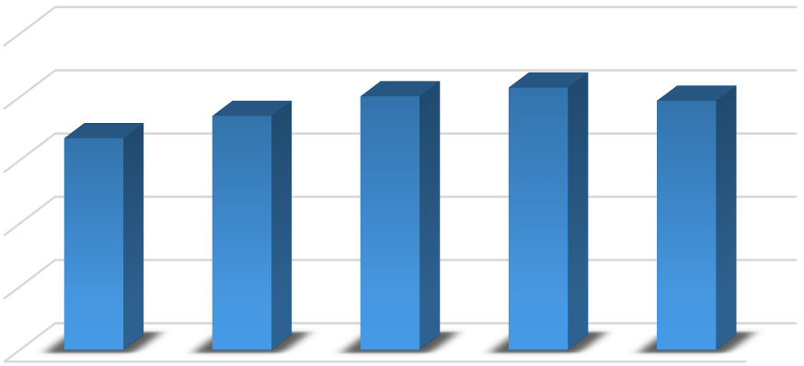
10.00
8.00
8.02
8.30
7.88
6.70
7.40
6.00
4.00
2.00
0.00
T0
T1
T2
Treatments
T3
T4

fig.1 The Bar Graph shows the Score obtained for colour and appearance of Sorghum based Probiotic Ambil
  - Flavour
NINE POINT SCALE
Flavour plays crucial role in consumer’s acceptance and preference it also indicates the freshness and quality of the product by enhancing satisfaction level. The score observed regarding flavour of Sorghum based Probiotic Ambil presented in table 2
The data regarding flavour of Sorghum based Ambil fortified with probiotic curd (L. acidophilus) at different levels indicate that at 40 per cent addition of probiotic curd

(L. acidophilus) to treatment T3 scored highest (8.24) followed by treatment T2, T4 and T1 whereas the control T0 scored least (6.88).
It has been observed that there was continuous increase in score for flavour when probiotic curd (L. acidophilus) was added @ 20 per cent, 30 per cent and 40 per cent. However, at 50 per cent addition of probiotic curd (L. acidophilus) product showed declining trend.
The statistical interpretation of data reveals that the results are statistically significant at 1 per cent level of probability. All the levels of probiotic curd (L. acidophilus) were found to be at par with each other whereas control sample differ significantly from Sorghum based probiotic Ambil fortified with probiotic curd (L. acidophilus).
Using both taste and smell, flavour is created. In the present investigation it has been observed that as proportion of probiotic curd (L. acidophilus) goes on increasing product attains concentrated flavour which is not accepted. However, at 40 per cent (T3) addition of probiotic curd (L. acidophilus) product was well accepted by judges.
Flavour is the important criteria for measuring the quality of product, which in turn determines its acceptability as per Kumar (2006) who studied the sensory scores for flavour of the rabadi-like beverage ranged from 6.45 to 7.31. The maximum score was given to the beverage consisting of 5.50 per cent flour and 75.00 per cent of water on the curd basis, while the minimum was obtained with 7.27 per cent flour and
57.32 per cent of water on the curd basis. this indicates clearly that at higher levels, the effect of flour is prominent on flavour.
Shinde (2011) concluded that Ambil prepared from malted sorghum had better acceptability almost far better than the control sample which had formulations containing 100 per cent and 75 per cent malt flour (A3) and (A4) also suggest that A4 sample had good sour taste without off flavours and without any sediments of the spice mix.
Wakil and Kazeem (2012) suggested that sample AB2 had the highest rating (5.80) by the 48 hr fermentation time, in terms of taste as well as flavour.
Chopade (2013) stated that highest score for flavour was observed for treatments C2S2, C2S3 and C3S2 i.e. 8.55 for each, at 12 hrs. Also, the highest scores were observed for treatment C2S2 i.e. 8.66 and 8.61, after 16 hours and 20 hours, respectively.

Table 2 Score obtained for flavour of Sorghum based Probiotic Ambil

 | R-I | R-II | R-III | R-IV | R-V | R-VI | Mean
T0 | 6.45 | 6.66 | 7.11 | 7.00 | 6.92 | 7.16 | 6.88^{b}
T1 | 7.19 | 8.12 | 8.05 | 7.04 | 7.25 | 7.48 | 7.52^{ab}
T2 | 8.45 | 6.79 | 8.41 | 8.57 | 8.24 | 8.15 | 8.10^{ab}

T3 | 8.59 | 6.66 | 8.52 | 8.65 | 8.78 | 8.26 | 8.24ª
T4 | 7.91 | 8.04 | 8.12 | 7.20 | 7.45 | 8.22 | 7.82^{ab}

Anova Table
SV | DF | SS | MSS | Fcal | Ftab 5% | F tab 1% | Result
Tr | 4 | 7.017 | 1.754 | 5.772 | 2.759 | 4.177 | SIG
Er | 25 | 7.598 | 0.304
Total | 29 | 14.615

S. E. ± | CD at 1% | CD at 5%
0.318 | 1.255 | 0.927


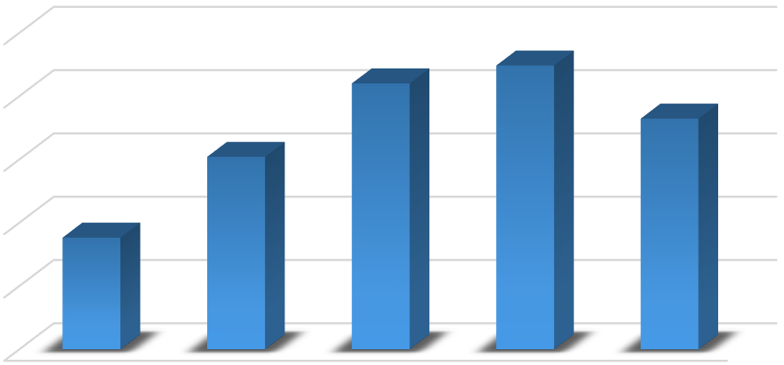
T4
T3
T2
Treatments
T1
T0
7.00
6.50
6.00
6.88
7.50
7.52
8.00
7.82
8.24
8.10
8.50

fig.2 The bar graph presents the Score obtained for flavour of Sorghum based Probiotic Ambil

  - Body and Texture
NINE POINT SCALE
Body and Texture are key physical and sensory characteristics of dairy product which impacts mouthfeel as well as stability of the product. The score observed for Body and Texture of Sorghum based Probiotic Ambil presented in Table 3
The data regarding Body and Texture of Sorghum based Ambil fortified with probiotic curd (L. acidophilus) at different levels indicate that at 40 per cent addition of probiotic

curd (L. acidophilus) to treatment T3 scored highest (8.35) followed by treatment T2, T4 and T1 whereas the control T0 scored least (6.86).
It has been observed that there was continuous increase in score for body and texture when probiotic curd (L. acidophilus) was added @ 20 per cent, 30 per cent and 40 per cent. However, at 50 per cent addition of probiotic curd (L. acidophilus) product showed declining trend.
The statistical interpretation of data reveals that the results are statistically significant at 1 per cent level of probability. While (T2), (T3) and (T4) were found to be at par with each other whereas control sample (T0) and (T1) were found to be at par with each other.
In the present investigation it was observed that as proportion of probiotic curd (L. acidophilus) goes on increasing product showed more homogenize level of body and texture which were accepted by judges. However, at 50 per cent addition of probiotic curd (L. acidophilus) product seems to be less consistent which was not acceptable by judges.
Kumar (2006) explained that maximum body and texture was obtained in formulation of standard order 9, which had 7.27 per cent flour and 57.33 per cent of water on curd basis. The minimum body and texture were obtained with beverage consisting of 3.73 per cent flour and 92.68 per cent of water on curd basis. This is the clear indication that higher levels of water affected the body and texture of product significantly.
Shinde (2011) suggested that the consistency of the formulations A3 and A4 were preferable to that of the others. While sample A4 having good viscosity with inclusion of 75 per cent malt flour.
Chopade (2013) reported that the body and texture for different treatments were significantly differed from each other. It is observed that, the highest score 8.50 was observed for treatment C2S2 at 12 hours and 20 hours, while, highest score 8.55 was observed for treatment C2S2 at 16 hours.

Table 3: Score obtained for Body and Texture of Sorghum based Probiotic Ambil
 | R-I | R-II | R-III | R-IV | R-V | R-VI | Mean
T0 | 7.12 | 6.49 | 6.91 | 6.44 | 6.69 | 7.51 | 6.86^{bc}
T1 | 6.34 | 7.25 | 6.32 | 8.57 | 6.50 | 7.02 | 7.00^{b}
T2 | 7.90 | 7.85 | 8.31 | 8.20 | 8.12 | 8.40 | 8.13^{ab}
T3 | 8.43 | 8.09 | 8.35 | 7.89 | 8.74 | 8.61 | 8.35ª

T4 | 8.16 | 7.87 | 7.24 | 8.22 | 7.56 | 8.34 | 7.90^{ab}

Anova Table
SV | DF | SS | MSS | Fcal | Ftab 5% | F tab 1% | Result
Tr | 4 | 10.986 | 2.746 | 11.123 | 2.759 | 4.177 | SIG
Er | 25 | 6.173 | 0.247
Total | 29 | 17.153

S. E. ± | CD at 1% | CD at 5%
0.287 | 1.131 | 0.835

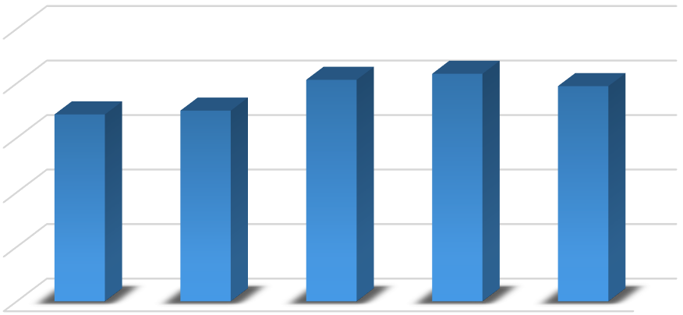
Treatments
T4
T3
T2
T1
T0
4.00
2.00
0.00
7.00
6.86
8.00
6.00
7.90
8.35
8.13
10.00

fig.3 The Bar Graph shows the Score obtained for Body and Texture of Sorghum based Probiotic Ambil

  - Overall Acceptability
NINE POINT SCALE
The overall acceptability of Sorghum based Probiotic Ambil was determined on the basis of average of the score recorded for different sensory attributes viz., colour and appearance, body and texture and flavour was considered. The results are presented in table 4

The data regarding overall acceptability of Sorghum based Ambil fortified with probiotic curd (L. acidophilus) at different levels indicate that at 40 per cent addition of probiotic curd (L. acidophilus) to treatment T3 scored highest (8.30) followed by treatment T2, T4 and T1 whereas the control T0 scored least (6.82).
It was observed that there was continuous increase in score for overall acceptability when probiotic curd (L. acidophilus) was added @ 20 per cent, 30 per cent and 40 per cent. However, at 50 per cent addition of probiotic curd (L. acidophilus) product showed declining trend.
The statistical interpretation of data reveals that the results were statistically significant at 1 per cent level of probability. While (T2), (T3) and (T4) were found to be at par with each other whereas control sample (T0) and (T1) were found to be at par with each other.
In the present investigation it was observed that as proportion of probiotic curd (L. acidophilus) having 40 per cent (T3) were accepted by judges and secured highest score for overall acceptability. Hence treatment T3 was considered as most acceptable level.
Kumar (2006) revealed that overall acceptability is the indicative parameter of sensory quality of product in totality and consists of appearance, flavour, body and textural characteristics according his studies the sensory score for overall acceptability ranged from 6.64 to 7.24. the overall acceptability is affected most by flour, as the minimum scores were obtained in samples with highest amount of flour.
Shinde (2011) interpreted according to statistical analysis that sorghum based Ambil prepared by different sorghum genotypes differed significantly for overall acceptability of product.
Wakil and Kazeem (2012) conclude that overall acceptability indicates that sample AB2 i.e. sample fermented with mixed cultures of Lactobacillus plantarum and Pediococcus acidilactici is significantly different from others and having highest score rating respectively.
Chopade (2013) determined that the overall acceptability for treatment C2S2 shown highest score and it was significantly varied from other treatments. it is observed that, the scores for overall acceptability were 7.83, 8.22 and 8.16 at 12, 16 and 20 hours, respectively. And it is observed that 16 hours was the best time for incubation than that of 12 and 20 hours. Hence, he selected 16 hours incubation time for his research.

Table 4. Score obtained for Overall acceptability of Sorghum based Probiotic Ambil

 | R-I | R-II | R-III | R-IV | R-V | R-VI | Mean
T0 | 6.66 | 6.68 | 7.15 | 6.87 | 6.62 | 6.95 | 6.82^{bc}
T1 | 6.92 | 7.65 | 7.46 | 7.28 | 6.98 | 7.54 | 7.31^{b}

T2 | 8.14 | 7.58 | 8.00 | 8.33 | 8.09 | 8.36 | 8.08^{ab}
T3 | 8.41 | 7.71 | 8.31 | 8.16 | 8.73 | 8.46 | 8.30ª
T4 | 8.07 | 7.94 | 7.77 | 7.86 | 7.44 | 8.11 | 7.87^{ab}

Anova Table
SV | DF | SS | MSS | Fcal | Ftab 5% | F tab 1% | Result
Tr | 4 | 8.726 | 2.182 | 27.899 | 2.759 | 4.177 | SIG
Er | 25 | 1.955 | 0.078
Total | 29 | 10.681

S. E. ± | CD at 1% | CD at 5%
0.161 | 0.636 | 0.470

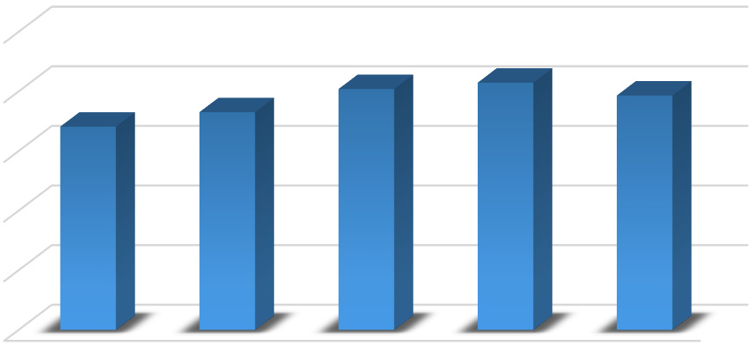
10.00
8.00
8.08
8.30
7.87
6.82
7.31
6.00
4.00
2.00
0.00
T0
T1
T2
Treatments
T3
T4

fig.4 The bar Graph shows the Score obtained for Overall acceptability of Sorghum based Probiotic Ambil

  - Microbial Analysis
NINE POINT SCALE
The most optimal amount discovered throughout study was taken for microbial evaluation on same day. The product was tested for microbial characteristics on the same day. The sensory evaluation of the product was taking place concurrently.
The parameters studied were L. acidophilus count, standard plate count, coliform count, yeast and mould count.

Table 5 displays the results of the Microbial evaluation of the most acceptable level of Sorghum based Probiotic Ambil.

Table 5: Microbial evaluation of most acceptable level of Sorghum based Probiotic Ambil

Most acceptable level treatment (T3) | Probiotic count  (10⁷cfu/g) | Standard plate count  (10⁴cfu/g) | Coliform count  (10¹cfu/g) | Yeast and Mould count  (10¹cfu/g)
Fresh sample | 83 | 0.65 | ND | ND

A critical examination of Table 5 reveals the microbial evaluation of most acceptable level of fresh sorghum based Probiotic Ambil. During same day, the probiotic count was 83 x 10⁷cfu/g, the standard plate count was 0.65 x 10⁴cfu/g, while coliform and yeast and mould count were not detected and thus the viability of probiotics will get decreased due to increase in acidity. As per study it was observed that freshly prepared sorghum based Probiotic Ambil seems to be beneficial for consumption. Thus, Sorghum based Probiotic Ambil could serve as good carrier of probiotics to improve gut health and also suitable for lactose intolerant individuals

SUMMARY

Colour and appearance
The highest score (8.30) was recorded for treatment T3 i.e. Sorghum based Probiotic Ambil with addition of Probiotic curd (L. acidophilus) @ 40 per cent and lowest score (6.70) was observed for treatment T0 i.e. Sorghum based Probiotic Ambil manufactured without addition of Probiotic curd (L. acidophilus).

Flavour
Highest score for flavour was recorded for treatment T3 (8.24) manufactured by addition of Probiotic curd (L. acidophilus) @ 40 per cent and lowest score (6.88) was observed for treatment T0 i.e. Sorghum based Probiotic Ambil manufactured without addition of Probiotic curd (L. acidophilus).

Body and Texture
As far as body and texture is concerned, the highest score was recorded for treatment T3 (8.35) and lowest for T0 (6.86).

Overall acceptability
The highest score for overall acceptability was recorded for treatment T3 (8.30) which contain Probiotic curd (L. acidophilus) @ 40 per cent while lowest score recorded for treatment T0 (6.82).

Microbial Evaluation
The most optimum level found during research was subjected for microbial analysis and sensory evaluation. The parameters studied were probiotic count, standard plate count, coliform count and yeast and mould count for same day. The results of microbial studies indicate that the probiotic count observe for L. acidophilus strain was 83 x 10⁷cfu/g, whereas yeast and mould were absent throughout study, standard plate count observed as 0.65 x 10⁴ cfu/g and Coliform count was absent. Based on sensory evaluation, it is found that product was acceptable only for fresh consumption.

CONCLUSION
Based on results obtained from the present investigation, following conclusions are drawn: The addition of 40 per cent Probiotic curd (L. acidophilus) in Sorghum based Probiotic Ambil was most acceptable. The Sorghum based Probiotic Ambil prepared from 40 per cent Probiotic curd (L. acidophilus) was recorded highest score 8.30 for overall acceptability. Based on microbial and sensory evaluation, it is found that product was acceptable only for fresh consumption.

Disclaimer (Artificial intelligence)
Option 1:
Author(s) hereby declare that NO generative AI technologies such as Large Language Models (ChatGPT, COPILOT, etc.) and text-to-image generators have been used during the writing or editing of this manuscript.
Option 2:
Author(s) hereby declare that generative AI technologies such as Large Language Models, etc. have been used during the writing or editing of manuscripts. This explanation will include the name, version, model, and source of the generative AI technology and as well as all input prompts provided to the generative AI technology
Details of the AI usage are given below:
1.
2.
3.

REFERNECES
A.O.A.C. 1995. Official methods of analysis, 12th Edn. Association of official Analytical Chemists, Washington, D.C., U.S.A.
Bull, M., Plummer, S. and Marchesi, J. 2013. The life history of Lactobacillus acidophilus as a probiotic: a tale of revisionary taxonomy, misidentification and commercial success. FEMS Microbiol. Lett. 349: 77–87.
Burger, J., Kirchner, M., Bramanti, B., Haak, W. and Thomas, M. G. 2007. Absence of the lactase-persistence-associated allele in early Neolithic Europeans. Proceedings of the National Academy of Sciences. 104 (10): 3736–3741.
Chopade, A. A. 2013. Process standardization for preparation of fermented probiotic cereal-based health drink. Ph. D. Agri. thesis, Mahatma Phule Krishi Vidyapeeth, Rahuri, Maharashtra, India.
Curry, A. 2013. Archaeology: The milk revolution. Nature. 500: 20-22.

Dlamini, N. R., Taylor, J. R. and Rooney, L. W. 2007. The effect of sorghum type and processing on the antioxidant activity of African sorghum-based foods. Food Chem. 105:1412-1419.
IS:6273 Part-II 1971. Guide for sensory evaluation of foods. Methods and evaluation cards, Indian standards Institution, Manak Bhavan, New Delhi, India. J. Food Sci. 46: 819–821.
Kumar, R. 2006. Development of rabdi like fermented beverage from sorghum and milk solids. M. Tech. Dairy. thesis, Division of Dairy Technology, National Dairy Research Institute, Karnal, Haryana, India.
Shinde, S. V. 2011. Devolvement and quality characterization of traditional Sorghum (Sorghum bicolor) fermented Ambil beverage. M. tech. (Food tech.) thesis, Vasantarao Naik Marathwada Krishi Vidyapeeth, Parbhani, Maharashtra, India.
Suryawanshi, N. A. 2021. Preparation of synbiotic shrikhand from buffalo milk blended with fresh Papaya (Carica Papaya L.) pulp. M.Sc. Agri. thesis, Dr. Balasaheb Sawant Konkan Krishi Vidyapeeth, Dapoli, Ratnagiri, Maharashtra, India.
Wakil, S. M. and Kazeem, M. O. 2012. Quality assessment of weaning food produced from fermented cereal legume blends using starters. Int. Food Res. J. 19(4): 1679-1685

Taylor, J. R. N., Schober, T. J. and Bean, S. R. 2006. Novel food and non-food uses
for sorghum millets. J. Cereal Sci. 44: 252–271.

Mohammed, N. A. I. A., Mohamed A. and Babiker, E. E. 2011. National evaluation
of sorghum flour (Sorghum bicolor L. Moench) during processing of Injera. World Academy of Sci. Engg. and Tech. 75: 72-76.

