Narrative Literature Review

Amatoxin Poisoning: An Updated Review

Abstract:
Amatoxin-containing mushrooms—principally from the genera Amanita, Lepiota, and Galerina—cause the majority of fatal mushroom poisonings worldwide due to their potent inhibition of RNA polymerase II and the resultant hepatocellular necrosis. Characterized by a delayed onset of symptoms, amatoxin poisoning frequently leads to acute liver and renal failure, with mortality ranging from 10% to 30% without liver transplantation. This review catalogs relevant mushroom species, explores molecular and physiological mechanisms of toxicity, delineates diagnostic tools (e.g., HPLC, urine detection, Meixner test), and outlines management strategies—including activated charcoal, penicillin, N-acetylcysteine (NAC), silymarin/silibinin (Legalon® SIL), and supportive care—with the role of liver transplantation in severe cases. Advances in rapid detection methods, like portable test strips, are also discussed. The aim is to enhance early recognition and improve treatment outcomes.
Keywords: amatoxins • Amanita phalloides • RNA polymerase II • silibinin • mushroom poisoning • hepatotoxicity • Meixner test

Introduction:

Mushrooms that contain amatoxins are responsible for the majority of fatal mushroom poisonings due to their delayed onset of liver cell damage. Reports indicate a rising trend in amatoxin-related poisonings globally, as young adults often confuse toxic mushrooms for hallucinogenic varieties, immigrants misidentify toxic mushrooms as safe ones from their home regions, and accidentally consume poisonous mushrooms while in nature. Amatoxins are mainly generated by three types of mushrooms: Amanita, Lepiota, and Galerina. Epidemiological studies show that the majority of mushroom poisonings result from unidentified mushrooms, with the deadliest cases linked to those containing amatoxins. Among these, species from the Amanita genus are responsible for more fatalities than other amatoxi specifically amanita phalloides accounts for the majority of deaths. Amatoxins are a group of highly toxic peptides a phalloides is responsible for 90–95% of human fatalities and has the highest toxin content. However, the content of these toxins is variable between species and even within a given species. This species is mainly predominant in Europe, especially in Central and Western Europe. The concentration of amatoxins in mushrooms, increases during the first stages of the mushroom’s development and then decreases during the mature stage. This review aims to catalog mushroom species containing amatoxins and provide a diagnostic framework for earlier recognition. Furthermore, it discusses a treatment strategy for amatoxin poisoning. ^{1.2}
The primary mechanism of toxicity associated with amatoxin involves the inhibition of RNA polymerase II, which disrupts transcription and prolongs the presence of mRNA. This decline in mRNA levels subsequently leads to a reduction in protein synthesis, ultimately resulting in cell death and liver failure within 48 hours.³
Additional mechanisms have been proposed, including the formation of reactive oxygen species (ROS), which can induce oxidative stress-related damage. The generation of ROS may be exacerbated by increased activity of superoxide dismutase (SOD) and the inhibition of catalase activity. Furthermore, amatoxins might act synergistically with tumor necrosis factor (TNF) to trigger apoptosis.⁴
Although the exact underlying mechanisms are still not fully understood, amatoxin-induced apoptosis may also involve the translocation of p53 to the mitochondria. This translocation can lead to changes in mitochondrial membrane permeability through the formation of complexes with protective proteins, such as Bcl-xL and Bcl-2. These alterations facilitate the release of cytochrome c into the cytosol, activating the intrinsic pathway of apoptosis. However, several aspects of these mechanisms remain unknown.⁵

Methods:

To achieve the goals of this review article, various Internet search engines such as PubMed, Medline, Google, Google Scholar, and Cochrane were utilized with specific keywords as a science and medical subject headings. The aim was to locate peer-reviewed scientific literature regarding amatoxin-containing mushroom poisonings and their mechanisms, diagnosis, and treatments up to 2025. The keywords used included mushrooms, poisonous, amatoxin-containing, amatoxins, and beta, alpha-amanitin. For the first objective, which was to identify mushroom species that contain amatoxins. The second objective to study the mechanisms of amatoxin in human, and the third objective involved presenting a toxidromic approach for earlier diagnosis and treatment strategies. This included epidemiological and toxicological studies, as well as comparative analyses of different treatments and their results. Articles addressing poisonings from mushrooms that do not contain amatoxins were excluded from the review.

Amatoxin-Containing Mushroom Species:

- Amatoxins are a group of oligopeptides found in three mushroom genera: Amanita, Lepiota, and Galerina. This group includes at least nine distinct toxins, such as α, β, γ, and ε-amanitins, as well as amanullin, amanullinic acid, amaninamide, amanin, and proamanullin. Amatoxins act as selective inhibitors of RNA polymerases, which are essential to produce messenger RNA and micro RNAs. ⁶ Among these toxins, α-amatoxin is recognized as the most harmful to the liver. The estimated median lethal dose for α-amanitin in humans is 0.1 mg per kg, equating to approximately 7 to 8 mg for adults. All amatoxins are heat-stable and are not deactivated by boiling, cooking, drying, steaming, or freezing. The liver is the primary organ affected by ingested amatoxins, as it is the first to encounter these toxins absorbed from the gastrointestinal tract through the portal circulation.⁷ The presence of amatoxins halts protein synthesis in the liver by disrupting messenger RNA production, consequently impairing cellular metabolism. Since α-amanitin predominantly and β-amanitin to a lesser extent inactivate RNA polymerase II and III, respectively, the liver's ability to regenerate is compromised, leading to irreversible damage, including hemorrhagic hepatic necrosis. This results in a swift increase in liver damage biomarkers, particularly serum transaminases, along with coagulopathies due to a lack of liver-produced clotting factors. As liver function deteriorates, it leads to tubulointerstitial nephropathy and can quickly progress to a fatal hepatorenal syndrome without a liver transplant.⁸

Epidemiology of Amatoxin-Containing Mushroom Poisoning:

Amatoxin-containing mushroom species are found globally across Africa, America, Asia, Europe, and Oceania. However, there are few reported instances of amatoxin syndrome from Africa, Asia, and Oceania. According to a report by the National Poison Data System (NPDS) covering 1999 to 2016, many people are unable to identify safe mushroom species, leading to Amanita poisoning. Over the past 18 years, 133,700 cases (average of 7428 per year) of mushroom exposure, primarily through ingestion, have been documented. Most of these cases (83%) were unintentional and caused little to no harm (86%), with 62% occurring in children under six. There were approximately 704 cases (39 per year) resulting in severe harm, alongside 25 reported fatalities (average of 2.9 per year), mainly involving older adults inadvertently consuming cyclopeptide-producing mushrooms (68-89%). Overall, data from the United States and Europe indicate that unknown mushroom species are responsible for most poisonings, and that mushroom fatalities predominantly stem from amatoxin-containing varieties, accounting for 90 to 95% of all mushroom-related deaths. While Amanita mushroom poisonings, including those from A. phalloides, are infrequent, they are linked to delayed symptoms (appearing after 46 hours), longer hospitalization, and a higher risk of acute liver injury and failure. ⁹

- Amatoxin-Containing Mushroom Species:

The amatoxins are a collective group of oligopeptides found in 3 genera of mushrooms: Amanita, Lepiota, and Galerina. The amatoxins include at least 9 different toxins: α, β, γ, and ε-amanitins, amanullin, amanullinic acid, amaninamide, amanin, and proamanullin. ¹⁰

Amanita Species:

The genus Amanita contains about 600 species with 9 known poisonous species containing amatoxins, but contain 2 other classes of toxins (phallotoxins and virotoxins), which are considered nontoxic. Although Lepiota mushrooms have the greatest number of amatoxinproducing species, mushroom species in the genus Amanita especially (A phalloides, the death cap ) are responsible for most fatalities (Figure 1) followed by A virosa and A verna. Amanita mushrooms have a sweet smell and taste and a white spore print. The most common edible species are Agaricus species and Amanita lanei. ^{11,12}

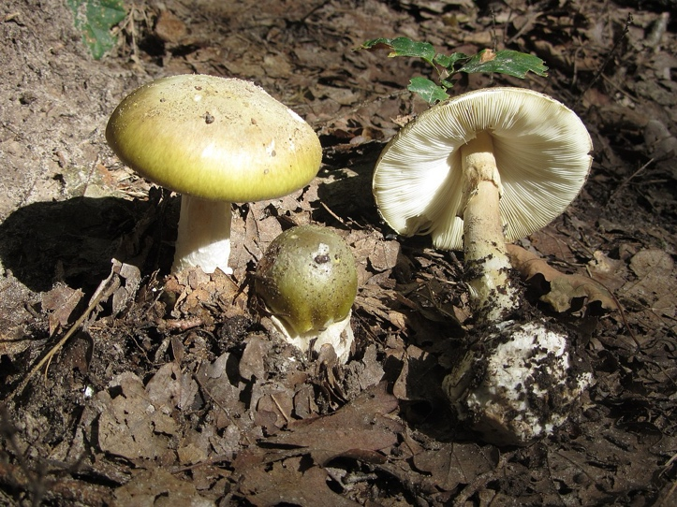
Figure 1. Amanita phalloides. Source: Wikimedia Commons, authorized for reproduction.

Lepiota Species

The genus Lepiota includes approximately 400 species of mushrooms found globally. Some species of Lepiota, particularly Lepiota brunneoincarnata, have been responsible for fatal poisonings. These mushrooms exhibit a white-to-cream spore print and emit a rubbery, unpleasant odor. Lepiota mushrooms that contain amatoxins can be toxic to both the pancreas and the liver. Unlike survivors of Amanita poisoning, who generally regain normal liver function, those who survive Lepiota poisoning may experience long-term issues, such as chronic active hepatitis and mixed polyneuropathy.¹¹

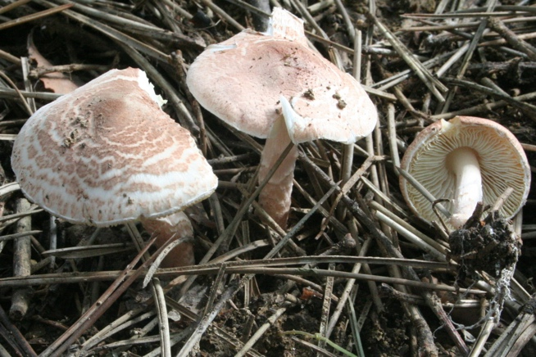

Figure 2. Lepiota brunneoincarnata. Source: Wikimedia Commons, authorized for reproduction.

Galerina Species:

The genus Galerina includes around 300 species found globally, of which 8 are identified as toxic. These mushrooms range in color from light yellow brown to light brown and produce cinnamon-brown spore prints. They are known for their pleasant aroma, which is often described as aromatic and fruity, and their taste resembles that of fresh cucumbers. If supportive therapy is unsuccessful, acute liver insufficiency can lead to acute liver failure and hepatorenal failure, ultimately necessitating a liver transplant.^{13,14}
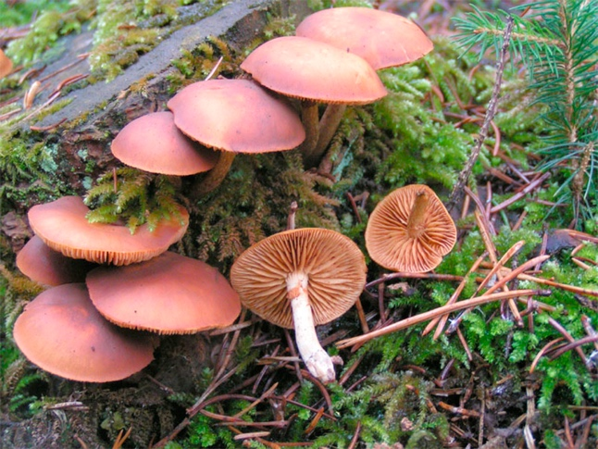
Figure 3. Galerina marginata. Source: Source: Wikimedia Commons, authorized for reproduction.

Structure of Amatoxin:

Amatoxins, structurally, consist of amino acid sequences such as Ile-Trp-Gly-Ile-Gly-Cys-Asn-Pro (α-amanitin) or Ile-Trp-Gly-Ile-Gly-Cys-Asp-Pro (β-amanitin). These sequences are cyclized by head-to-tail peptide bonds and a cross-bridge between the Trp and Cys residues. Additionally, the amatoxins exhibit diversity due to variations in hydroxylations of their side chains, including 4-hydroxyPro, γ,δ-dihydroxyIle, and 6-hydroxyTrp. ⁷

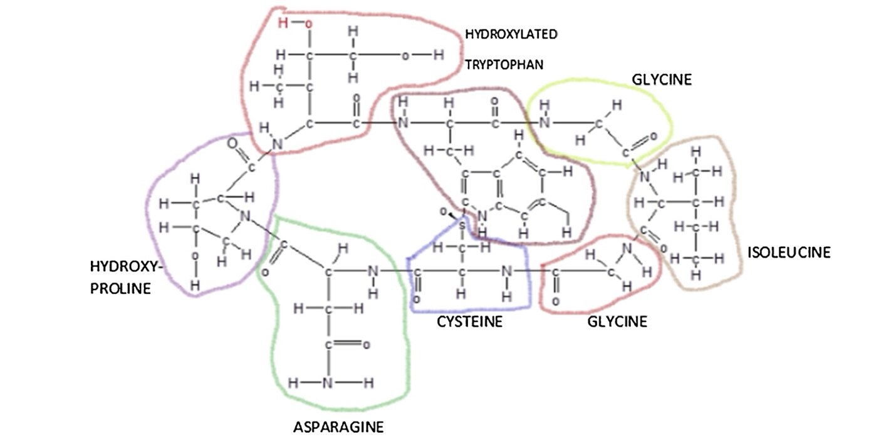
Image 1 Structural arrangement of selected amino acids in a polypeptide chain

Chemical and physical properties:

Amatoxins were first identified by Heinrich Wieland and Rudolf Hallermayer in 1941, with their structure being characterized by Wieland and his team in the 1950s and 1960s. The toxicological research does not provide clarity on the differences between neutral and acidic amatoxins. The distinction arises from the amino acid at position 7: asparagine (Asn) in neutral amatoxins and aspartic acid (Asp) in acidic amatoxins. Therefore, those with Asp, like β-amanitin and ε-amanitin, are classified as acidic, while those with Asn, such as α-amanitin and γ-amanitin, fall under neutral amatoxins. The chemical structures of the most abundant and essential amatoxins, α- and β-amanitin, have been elucidated and confirmed by X-ray crystallography. The molecules differ only in their number of hydroxyl groups and the presence or absence of an amide group at the aspartic acid side, position 7. ^{15,16}

Solubility:

The hydroxyl groups present in the side chains of the molecule confer its high hydrophilicity and, to some extent, its interaction with RNA polymerase. Consequently, amatoxins in their pure form crystallize into white structures containing approximately 10% water molecules. These crystals exhibit solubility in water, methanol, and other polar organic solvents, such as ethanol. Conversely, they are insoluble in ether, chloroform, and other organic solvents. Amatoxins possess remarkable heat stability, and this characteristic, coupled with their solubility in water, renders them exceptionally toxic. Cooking, even at elevated temperatures ranging from 250°C to 280°C, does not effectively destroy these toxins. Furthermore, freezing at -25°C and storing them for a period of 7-8 months does not diminish their ability to cause fatal hepatotoxicity upon ingestion. Notably, these toxins exhibit resistance to enzymes and acid degradation, rendering them resistant to intestinal inactivation and detoxification processes. However, Barceloux et al. reported that amatoxins undergo slow decomposition when stored in open aqueous solutions or after prolonged exposure to sunlight or neon light.¹⁷

Lipophilic characteristics:

The lipophilic properties of amanitins are arranged in a descending order: β-amanitin, amanin, ε-amanitin, α-amanitin, amanin amide, γ-amanitin, amanullinic acid, amanullin, and proamanullin. Proamanullin is more lipophilic than α-amanitin because it lacks two hydroxyl groups at positions 3 and 2, which are dihydroxy-Ile and hydroxy-Pro, respectively. In essence, the number of hydroxyl groups decreases as the lipophilic characteristics of amanitins increase. ¹⁸

Extraction of Amatoxin:

Extracting amatoxins is a complex process that requires a deep understanding of chemistry and mycology, as well as strict adherence to safety protocols due to their high toxicity. Over time, the extraction of amatoxins, especially α-amanitin, has largely targeted the polar cyclopeptides by incubating crushed mushroom tissue for 12–24 hours. Studies of this approach have shown variations in α-amanitin levels across Amanita species. A range of factors can contribute to this variability, including climate, topography, soil properties, the specific tissues of the fruiting body (cap, gills, ring, stipe, bulb, and volva), developmental stage, collection location (notably soil characteristics), and the age of the collected specimens. As a result, when mushrooms are used as samples, it is essential to understand the complete toxin profile and how toxins are distributed within the mushroom tissues. The ring, gills, and cap tend to harbor higher amatoxin levels—primarily α-amanitin, β-amanitin, and γ-amanitin—whereas the volva is richer in phallotoxins. Amatoxin content is relatively high during maturation and varies among species as well as within a single species. Before extraction, all mushroom samples were pre-treated using at least one of the following methods: washing, freeze-drying, grinding, or ultrasonication. This pre-treatment aims to enhance the efficiency of the extraction process. ^{19,20}

Main Steps for Amatoxin Extraction:

1. Sample Collection: Collect fresh samples of mushrooms known to contain amatoxins, such as the death cap mushroom. 2. Homogenization: Grind the mushroom tissue into a fine powder to increase the surface area for extraction. 3. Solvent Extraction: In general, and for mushroom samples, aqueous-methanolic solutions with the added mineral or organic acid (e. g., hydrochloric or formic acid) are the most commonly reported solvent mixture for amatoxin extraction. 4. Filtration: Filter the mixture to remove solid particles, retaining the liquid containing the dissolved amatoxins. 5. Concentration: Evaporate the solvent under reduced pressure or using a rotary evaporator to concentrate the extract. 6. Purification: Further purify the extract using techniques like liquid chromatography to isolate the amatoxins. 7.Analysis: Analyze the purified compounds using methods such as High-Performance Liquid Chromatography (HPLC) or Mass Spectrometry for Identification and Quantification (MSIQ). ²¹

Detecting the Amatoxins in Mushrooms and Poisoned Patients:

The time between mushroom ingestion and the onset of symptoms, alongside the type of systemic involvement (such as neurological or gastrointestinal issues), can aid in identifying the type of mushroom poisoning. The diagnosis can be confirmed by detecting α-amanitin in urine through various methods including radioimmunoassay (RIA), and high-performance liquid chromatography (HPLC). If a sample of the consumed mushroom is available, the Meixner test can be conducted. This test relies on the creation of a blue product from an acid-catalyzed reaction between amatoxins and the biopolymer lignin. Lignin remains in lower-grade cellulose paper like newsprint, which is used in the test: juice from fresh mushroom tissue is expressed onto newspaper, left to dry, and then treated with hydrochloric acid. A positive result is indicated by the appearance of a blue color. Although the Meixner test is effective at detecting high levels of alpha-amanitin, it does not differentiate between alpha-amanitin and other mushroom indoles. ^{22,23}

- Mechanisms of toxicity induced by amatoxins:

The primary mechanism of toxicity associated with amatoxin involves the inhibition of RNA polymerase II, which disrupts transcription and leads to the prolonged presence of mRNA. This decline in mRNA levels ultimately results in reduced protein synthesis, culminating in cell death and potential liver failure within 48 hours. Additionally, other proposed mechanisms include the formation of reactive oxygen species (ROS), which can lead to oxidative stress-related damage. The generation of ROS may be facilitated by an increase in superoxide dismutase (SOD) activity coupled with the inhibition of catalase activity. Furthermore, amatoxins may synergize with tumor necrosis factor (TNF) to induce apoptosis. While the precise underlying mechanisms remain unclear, it has been suggested that amatoxin-induced apoptosis could be driven by the translocation of p53 to the mitochondria. This translocation may alter mitochondrial membrane permeability by forming complexes with protective proteins such as Bcl-xL and Bcl-2. These alterations can lead to the release of cytochrome c into the cytosol and trigger the intrinsic pathway of apoptosis. The presence of question marks indicates that certain mechanisms are still not fully understood.²⁴

Pathophysiology:

After consuming poisonous mushrooms, symptoms usually show up between six to 24 hours later. This delay allows the body to fully absorb the toxins and complicates the diagnosis due to the potential absence of leftover specimens for proper identification. Initial symptoms including; nausea, vomiting, stomach cramps, and diarrhea. Severe cases may involve intense vomiting, severe cramping, and bloody diarrhea. Following a temporary period of seeming recovery lasting about 24 hours, the liver and kidneys may start to fail, often leading to coma, lasting damage to the liver and kidneys, and sometimes death.The onset of symptoms develops over three phases: ²⁵

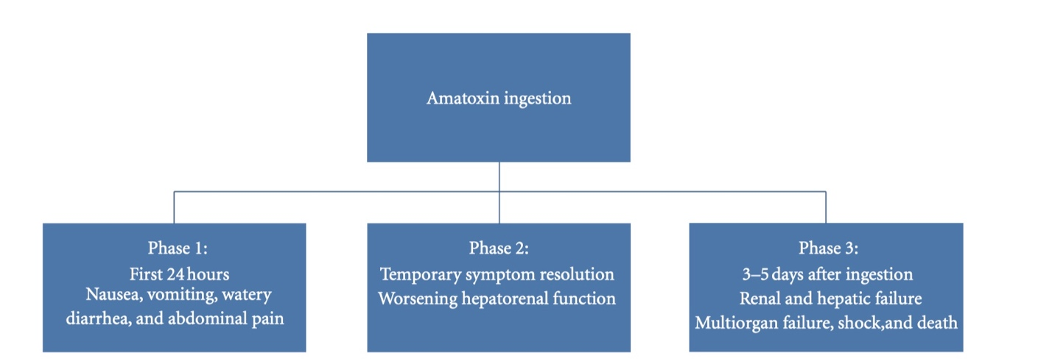
Figure 4: Phases of amatoxin ingestion.

Patients may also bleed out due to the destruction of clotting factors in their blood, and relapses may happen multiple times. The severity of toxicity depends on the concentration of amatoxins in mushrooms that influenced by factors such as growing conditions, seasonal changes, and humidity. As a result, it's challenging to accurately predict toxicity based solely on the number of mushrooms ingested. Estimates suggest that the lethal dose of amatoxins for humans is approximately 0.1 mg/kg of body weight, equating to around 7 to 8 mg of toxin, which may be found in a single mushroom. ^{26,27,28}

10. Treatment Strategies for Amatoxin-Containing Mushroom Poisonings and Outcomes**

Currently, there are no antidotes or specific therapeutic interventions available for amatoxin-containing mushroom poisonings. In the absence of liver transplantation, the case fatality rate associated with amatoxin-induced acute liver failure ranges from 10% to 30%. Management strategies for amatoxin poisoning primarily consist of intravenous rehydration and encompass both gastrointestinal absorptive techniques, such as multidose activated charcoal to interrupt the enterohepatic circulation of amatoxins, and extracorporeal removal techniques, including charcoal hemoperfusion, molecular absorbent recirculating systems, and fractionated plasma absorption and separation systems. The pharmacological treatments employed for amatoxin poisoning are largely nonspecific and anecdotal. ²⁹

Currently, the most frequently administered drug therapies, either used alone or in combination, include intravenous benzylpenicillin, n-acetylcysteine, cimetidine, and silymarin. Benzylpenicillin is hypothesized to impede the hepatic uptake of α-amanitin by inhibiting its transporter protein, although this has not been corroborated in experimental animal models or human subjects. N-acetylcysteine functions as a glutathione precursor and serves as an antioxidant and free radical scavenger. Cimetidine is recognized as an inhibitor of the hepatic microsomal cytochrome P450 system; its enzyme-inhibiting properties are presumed to limit the metabolism of amatoxins to their toxic metabolites, although this mechanism has not been confirmed in the context of hepatotoxic mushroom poisoning. Silymarin exhibits antioxidant and free radical scavenging properties, maintaining hepatic glutathione levels and purportedly providing hepatoprotective effects akin to those of n-acetylcysteine. A meta-analysis involving 452 patients with A. phalloides poisoning treated with silibinin revealed significant mortality differences between patients administered silibinin and those receiving supportive care alone (mortality rates of 9.8% vs. 18.3%, respectively). The authors of this analysis concluded that silymarin possesses a favorable safety profile and may have a beneficial role in the treatment of A. phalloides poisoning. ^{30,31}

Conclusions:
Descriptive epidemiological analyses have confirmed that mushrooms containing amatoxins are responsible for most fatal mushroom poisonings worldwide. While species of Amanita are responsible for the majority of these fatal poisonings, Lepiota species have become increasingly associated with fatal cases in the United States following ingestion. Amatoxin poisoning is responsible for 90% of deaths from mushroom ingestions, with a fatality rate of up to 25%. Amatoxin inhibits mRNA, leading to tissue injury in the intestinal mucosa, liver, and kidneys. Clinical presentation occurs in three phases: initial gastrointestinal symptoms, temporary resolution followed by hepato-renal dysfunction, and finally, multi-organ failure. Diagnosis involves laboratory evaluation, including liver function tests and urine analysis for alpha-amanitin. Treatment is primarily supportive, including GI decontamination, and medical therapies like milk thistle. Liver transplant is often necessary for survival in severe cases. Prognosis is poor in patients with low mean arterial pressure, hepatic encephalopathy, hemorrhage, oliguria, and hypoglycemia. The King's College criteria are used to determine the need for liver transplant. Early predictors of fatal outcome include diarrhea onset less than eight hours after ingestion and a prothrombin index below 10% for four or more days after ingestion.
Disclaimer (Artificial intelligence)
Option 1:
Author(s) hereby declare that NO generative AI technologies such as Large Language Models (ChatGPT, COPILOT, etc.) and text-to-image generators have been used during the writing or editing of this manuscript.
Option 2:
Author(s) hereby declare that generative AI technologies such as Large Language Models, etc. have been used during the writing or editing of manuscripts. This explanation will include the name, version, model, and source of the generative AI technology and as well as all input prompts provided to the generative AI technology
Details of the AI usage are given below:
1.
2.
3.

References:
- Garcia J, Costa VM, Carvalho A, Baptista P, de Pinho PG, de Lourdes Bastos M, et al. Amanita phalloides poisoning: Mechanisms of toxicity and treatment. Food Chem Toxicol. 2015;86:41-55. doi:10.1016/j.fct.2015.09.008
- Poucheret P, Fons F, Doré JC, Michelot D, Rapior S. Amatoxin poisoning treatment decision-making: Pharmaco-therapeutic clinical strategy assessment using multidimensional multivariate statistic analysis. Toxicon. 2010;55(7):1338-45. doi:10.1016/j.toxicon.2009.08.001
- Karlson-Stiber C, Persson H. Cytotoxic fungi – An overview. Toxicon. 2003;42(4):339-49. doi:10.1016/S0041-0101(03)00240-8
- Tuğcan MO, Akpınar AA. Mushroom poisoning: An updated review. Turkish Journal of Emergency Medicine. 2025 Jan 1;25(1):10-6.
- Diaz JH. Amatoxincontaining mushroom poisonings: Species, toxidromes, treatments, and outcomes. Wilderness Environ Med 2018;29:111-8.
- Ward J, Kapadia K, Brush E, Salhanick SD. Amatoxin poisoning: Case reports and review. J Emerg Med. 2013;44(1):116-21. doi:10.1016/j.jemermed.2012.05.016
- Mengs U, Pohl RT, Mitchell T. Legalon® SIL: The antidote of choice in patients with acute hepatotoxicity from amatoxin poisoning. Curr Pharm Biotechnol. 2012;13(10):1964-70. doi:10.2174/138920112802273353
- Jaeger A, Jehl F, Flesch F, Sauder P, Kopferschmitt J. Kinetics of amatoxins in human poisoning: Therapeutic implications. J Toxicol Clin Toxicol. 1993;31(1):63-80. doi:10.3109/15563659309000386
- Ganzert M, Felgenhauer N, Zilker T. Indication of liver transplantation following amatoxin intoxication. J Hepatol. 2005;42(2):202-9. doi:10.1016/j.jhep.2004.10.019
- Enjalbert F, Rapior S, Nouguier-Segueur C, Guillon S, Amouroux N, Cabot C. Treatment of amatoxin poisoning: 20-year retrospective analysis. J Toxicol Clin Toxicol. 2002;40(6):715-57. doi:10.1081/CLT-120014646
- Faulstich H. Mushroom poisoning by Amanita phalloides: From therapy to prevention. Toxicon. 1980;18(4):319-25. doi:10.1016/0041-0101(80)90149-9
- Ganzert M, Felgenhauer N, Schuster T, Eyer F, Gourdin C, Zilker T. Amatoxin poisoning—comparison of silibinin with a combination of silibinin and penicillin. Dtsch Med Wochenschr. 2008;133(44):2261-7. doi:10.1055/s-0028-1091268 Technical University of Munich Medscape Reference
- Hruby K, Csomos G, Fuhrmann M, Thaler H. Chemotherapy of Amanita phalloides poisoning with intravenous silibinin. Arch Toxicol. 1983;53(2):127-33. SAGE Journals
- Sahin A, Arici MA, Yilmaz Y, et al. A comparison of the effectiveness of silibinin and resveratrol in preventing α-amanitin-induced hepatotoxicity. Basic Clin Pharmacol Toxicol. 2018;122(6):633-42. doi:10.1111/bcpt.12954 Wiley Online Library
- Del Rio-Camero M, Sabaté M, Carbonell G, et al. Potential value of urinary amatoxin quantification in patients with hepatotoxic mushroom poisoning. Clin Toxicol (Phila). 2019;57(8):722-729. doi:10.1080/15563650.2018.1514384 PubMed
- Garcia J, Costa VM, Carvalho A, et al. Legalon® SIL: the antidote of choice in patients with acute hepatotoxicity from amatoxin poisoning. Food Chem Toxicol. 2012;50(2):488-92. doi:10.1016/j.fct.2011.11.056 PubMed
- Bantz D, Tuchmann-Durebex C, Schnyder O, et al. Protection by silibinin against Amanita phalloides intoxication in beagles. Vet Hum Toxicol. 1984;26(5):373-7. PubMed
- Rodríguez C, Rivière O, Sánchez-Valle M, et al. Amanita phalloides-associated liver failure: molecular mechanisms and management. Int J Mol Sci. 2024;25(23):13028. doi:10.3390/ijms252313028 MDPI
- Creppy EE, Goumenou M, Lefebvre PA. Silibinin and acute poisoning with Amanita phalloides. J Toxicol Clin Toxicol. 1997;35(5):499-503. PubMed
- Poucheret P, Fons F, Doré JC, et al. Amatoxin poisoning treatment decision-making: pharmaco-therapeutic clinical strategy assessment using multidimensional multivariate statistic analysis. Toxicon. 2010;55(7):1338-45. doi:10.1016/j.toxicon.2009.08.001 PubMed
- Khan A, Müller A, Drechsel A, et al. Assessment of α-amanitin toxicity and effects of silibinin and penicillin in different in vitro models. Toxicol Lett. 2020;323:30-38. doi:10.1016/j.toxlet.2020.05.017 PubMed.
- . H. Diaz, “Syndromic diagnosis and management of con-firmed mushroom poisonings,” Critical Care Medicine, vol. 33,no. 2, pp. 427–436, 2005.[6] A. Meixner, “Amatoxin-Nachweis in Pilzen,” Zeitschrift furMykologie, vol. 45, pp. 137–140, 1979.
- J. A. Beutler and P. P. Vergeer, “Amatoxins in Americanmushrooms: evaluation of the Meixner test,” Mycologia, vol.72, pp. 1142–1144, 1980.
- G. L. Floersheim, “Treatment of human amatoxin mushroompoisoning: myths and advances in therapy,” Medical Toxicologyand Adverse Drug Experience, vol. 2, no. 1, pp. 1–9, 1987.
- R. Gaˇz ́ak, D. Walterov ́a, and V. Kˇren, “Silybin and silymarin—new and emerging applications in medicine,” Current Medici-nal Chemistry, vol. 14, no. 3, pp. 315–338, 2007.
- T. C. Tong, M. Hernandez, W. H. Richardson et al., “Com-parative treatment of alpha-amanitin poisoning with N-acetylcysteine, benzylpenicillin, cimetidine, thioctic acid, andsilybin in a murine model,” Annals of Emergency Medicine, vol.50, no. 3, pp. 282–288, 2007.
- F. Enjalbert, S. Rapior, J. Nouguier-Soul ́e, S. Guillon, N.Amouroux, and C. Cabot, “Treatment of amatoxin poisoning:20-Year retrospective analysis,” Journal of Toxicology, vol. 40,no. 6, pp. 715–757, 2002.
- L. Giannini, A. Vannacci, A. Missanelli et al., “Amatoxinpoisoning: a 15-year retrospective analysis and follow-upevaluation of 105 patients,” Clinical Toxicology, vol. 45, no. 5,pp. 539–542, 2007.
- L. Escudi ́e, C. Francoz, J. P. Vinel et al., “Amanita phalloidespoisoning: reassessment of prognostic factors and indicationsfor emergency liver transplantation,” Journal of Hepatology,vol. 46, no. 3, pp. 466–473, 2007.
- A. A. Demetriou, R. S. Brown, R. W. Busuttil et al., “Prospec-tive, randomized, multicenter, controlled trial of a bioartificialliver in treating acute liver failure,” Annals of Surgery, vol. 239,no. 5, pp. 660–670, 2004.
- D. R. Benjamin, Mushrooms: Poisons and Panaceas—A Hand-book for Naturalists, Mycologists and Physicians, W.H. Free-man, 1995.

