Review Article

Sustainable strategies for freshwater aquaculture in India: steering opportunities and future challenges

Abstract:

With rapidly expanding production, aquaculture is one of the fastest-growing food production sectors globally. In India, the advancement of innovative aquaculture practices has greatly boosted the contribution of aquatic products, generating positive economic impact. This study adopts a three-dimensional perspective covering the economic, environmental and social considerations that govern this growing industry. This study assesses the level of structural upgrading within the fisheries sector in India, identifying alignment with the global sustainability frameworks put forth by FAO, UNEP etc. With climate change emerging as a challenge to both aquatic ecosystems and production systems, associated stressors and changes such as oxygen dynamics, eutrophication, pathogen proliferation etc. need to be judiciously managed as part of mitigation and adaptation measures.

As a major player in the global aquaculture sector, India has witnessed notable progress in the modernization of its fishing industry. This includes technology advancements such as Recirculating Aquaculture Systems (RAS) and Integrated Multi-Trophic Aquaculture (IMTA) which reduce effluent discharge and feed waste, lower disease transmission, allow for nutrient recycling and sustainable intensification through biodiversity conservation. These have tangible links to inclusive growth and sustainable development as they address poverty alleviation (SDG 1), food security (SDG 2), circular economy principles (SDG 12) and biodiversity conservation/ minimizing ecological degradation (SDG 14).

Currently inland fisheries in India show a higher degree of advancement compared to coastal regions, largely due to targeted government initiatives supporting industrial improvements. This study addresses real-world practices, government efforts and environmental concerns and explores broader linkages with policy and sustainability goals. Further, it offers strategic recommendations to further enhance the sector’s sustainable growth by analysing its current status and identifying potential areas for improvement.
Key words: Freshwater Aquaculture in India, RAS, IMTA, Sustainable Aquaculture, Current Perspective, Future Challenges.

1. Introduction:
Aquaculture plays a vital role in India’s economy, ensuring food security and generating employment opportunities. It serves as an important source of high-quality protein for the nation’s growing population (Kumar et al. 2015). India possesses vast potential for both freshwater and marine aquaculture, supported by its extensive natural resources—0.28 million km of rivers and canals, 1.2 million ha of floodplain lakes, 2.45 million ha of ponds and tanks, and 3.15 million ha of reservoirs (Béné et al. 2016). Aquaculture products contribute significantly to seafood production, meeting the protein needs of millions. While India has achieved remarkable progress in crop and fish production through the Green and Blue Revolutions, these advances have also led to environmental challenges due to intensive practices affecting land and water ecosystems (Himaja and Rajagopalasamy 2016). Moreover, increasing demand for aquatic resources has strained inland fisheries, as overfishing, pollution, and habitat degradation continue to reduce fish populations in rivers, lakes.
Fish play a vital role globally as an affordable source of protein, nutrition, and livelihood for billions of people, with over 3.3 billion relying on fish for at least 20% of their animal protein intake (FAO, 2020). In India, aquaculture is a key component of the agricultural and rural economy, providing livelihoods to millions, particularly in coastal and rural areas (Ngasotter et al., 2020). The sector creates employment across various activities, including fish farming, hatcheries, feed production, processing, and marketing. It also supports export earnings and plays a critical role in poverty reduction by improving the socio-economic status of small-scale farmers and fisherfolk (Béné et al., 2007). Small-scale aquaculture empowers marginalized communities by offering sustainable income opportunities. As India faces challenges such as overfishing, declining wild stocks, and environmental degradation, adopting sustainable systems like Integrated Multi-Trophic Aquaculture (IMTA and Recirculating Aquaculture Systems (RAS can enhance food security while conserving aquatic ecosystems (Ghose, 2014).
The key production centres of aquaculture are in the Asia-Pacific region. PR China continues to excel globally in aquaculture production over the past few decades (Wang, Q., et al 2015). India ranks among the world’s largest seafood exporters, with aquaculture products forming a major part of its export portfolio (Geetha et al., 2020).
The country exports diverse products such as shrimp, fish, molluscs, and value-added seafood, significantly contributing to foreign exchange earnings and strengthening India’s position in the global seafood market (Gopalakrishnan et al., 2024). Aquaculture also promotes agricultural diversification, reducing farmers’ dependence on traditional crops (Adhikari, 2013). Integrated systems like rice-fish farming and aquaponics enhance farm productivity, resilience, and income potential (Pingali, 1995). Moreover, aquaculture has spurred extensive research and technological progress in India. Government bodies, research institutions, and private organizations are collaborating to improve breeding programs, disease control, feed efficiency, and farming techniques (Kumar, 2018; Ahmed & Lorica, 2002). Collectively, these developments foster sustainable sectoral growth. This review aims to provide a comprehensive overview of India’s aquaculture sector, emphasizing its challenges, opportunities, and strategies for inclusive, sustainable development.

- Methodology
A systematic search of publications was done using online internet- based search engines between August 2020 and August 2025. The exact procedures are hereby described. Three search engines (electronic databases) were used in this study, namely the National Centre for Biotechnology Information (NCBI) through Pubmed, Google Scholar, and Science Direct. Search terms and phrases used were: “aquaculture” “sustainable aquaculture” “Freshwater farmed fish” “pond management practices”, “fish production regions”, “control strategy”, aquaculture “challenges”, “prospects”, and “India”.
Peer-reviewed journal articles, theses, conference papers, book chapters, projects, and
government reports were downloaded and reviewed. All papers were screened by reading the titles and abstracts. If these criteria were determined to be relevant, the full paper was read. The references from a read paper were also screened to identify relevant papers that might have been missed by the initial search engine search. Information, facts, evidence, or key messages were extracted from these papers and included within the review.
In addition to the comprehensive review of existing literature and industry data, the study is also informed by first-hand experience assisting 1,200 acres of fish farms in the state of Bihar. These farms, located in the Gangetic floodplain region in the Darbhanga district of North Bihar, provide a representative context in which to examine the environmental and economic dimensions of freshwater aquaculture in India. This field-based perspective enabled validation of sustainability strategies and assessment of practical constraints in adopting advanced technologies and water-quality monitoring innovations under real farming conditions.
This study draws on both secondary literature and primary field insights to highlight the interactions between aquaculture, environmental challenges, socio-economic impacts, while outlining pathways for future development in India.

- Historical Development and Growth of Aquaculture in India
Aquaculture in India has a long and rich history, evolving from traditional practices to a structured, technology-driven industry.
2.1 Early Beginnings (Pre-Independence Era):
The roots of aquaculture in India date back to ancient times, when traditional fish farming methods such as carp cultivation in village ponds and brackish water shrimp farming were practice3d mainly for subsistence (Beveridge & Little, 2002). In 1946, the Government of India established the Deep Sea Fishing Station (DSFS), later known as the Fisheries Survey of India, as a pilot project to improve the nation’s fish supply through deep-sea fishing development.
2.2 Initial Growth Phase (1950s–1970s):
Following independence, aquaculture began to expand rapidly with the establishment of key research institutions. The Central Marine Fisheries Research Institute (CMFRI) and the Central Inland Fisheries Research Institute (CIFRI) were founded in 1947 to promote scientific fishery management, biodiversity conservation, and sustainable inland fishery development (Gopalakrishnan et al., 2017). CIFRI became a full-fledged institute in 1959. During this period, freshwater aquaculture flourished, particularly in states like West Bengal, Punjab, Haryana, and Andhra Pradesh. The Central Institute of Coastal Engineering for Fisheries (CICEF) was established in Bengaluru in 1968 to conduct engineering and economic studies for the development of fishery harbours along India’s coastline, marking a key milestone in the modernization of India’s fisheries sector.
In India, aquaculture plays a vital role in the agricultural and rural economy, providing livelihoods to millions, especially in coastal and rural regions. It supports employment in fish farming, hatcheries, feed production, processing, and marketing while contributing significantly to export earnings. By supporting small-scale farmers and fisherfolk, aquaculture helps alleviate poverty and improve socio-economic conditions. Adoption of sustainable practices such as integrated multi-trophic aquaculture (IMTA and recirculating aquaculture systems (RAS are essential to address challenges like overfishing and environmental degradation. As one of the world’s largest seafood exporters, India benefits from aquaculture’s contribution to foreign exchange and agricultural diversification through practices like rice-fish farming and aquaponics. Continued research, innovation, and responsible management will ensure the sector’s sustainable and inclusive growth.es, and reservoirs, threatening long-term sustainability.
2.3 Government Initiatives (1970s–1990s):
During the 1970s to 1990s, the Indian government took significant steps to promote aquaculture, recognizing its potential to enhance food security, employment, and rural development (Das, 2019). In 1971, the Central Inland Fisheries Research Institute (CIFRI) launched four major All India Coordinated Research Projects (AICRPs)—Composite Fish Culture, Riverine Fish Seed Prospecting, Air-Breathing Fish Culture, and Ecology and Fisheries Management of Reservoirs—to improve scientific understanding and production efficiency in aquaculture.
In 1972, the National Institute of Fisheries Post Harvest Technology and Training (NIFPHATT), formerly known as the Integrated Fisheries Project, was established to develop post-harvest technologies and enhance fish processing and value addition. Around the same time, the National Federation of Fishers Cooperatives Ltd. (FISHCOPFED) was formed to improve the socio-economic conditions of fishers across the country.
Further, the Indian Council of Agricultural Research (ICAR) launched the AICRP on Brackish water Fish Farming in 1973, marking the beginning of systematic brackishwater aquaculture in India. The introduction of schemes such as the Integrated Fish Farming Development Agency (IFFDA) and the National Project on Brackishwater Aquaculture (NPBA) provided additional institutional and financial support, significantly accelerating the sector’s modernization and growth during this period.

2.4 Technological Advancements and Diversification (2000s–2010s)
The 2000s marked a period of significant technological progress and diversification within India’s aquaculture sector. This era was characterized by the adoption of intensive and semi-intensive farming systems, improved seed production technologies, and enhanced disease management practices (Katiha et al., 2005). These innovations contributed to higher productivity, better resource utilization, and improved resilience against environmental and biological challenges.
During this decade, species diversification became a major focus beyond traditional carps and shrimp. Farmers increasingly adopted species such as genetically improved tilapia, catfish, pangasius, and ornamental fish, driven by their rapid growth rates, higher survival, and greater market value (Mahapatra, 2018; Manyise et al., 2024).
Institutional support further accelerated this progress. The Coastal Aquaculture Authority (CAA), established in 2005, was mandated to regulate and ensure sustainable aquaculture practices in coastal areas. In 2006, the National Fisheries Development Board (NFDB) was created by the Government of India to promote technological upgradation, species diversification, seaweed cultivation, mariculture, ornamental fisheries, and capacity building among fishers through various development projects (DoF-GOI, 2024).

2.5 Government Support and Sustainable Practices (2010s–Present)
From the 2010s onward, the Indian government has intensified its efforts to promote sustainable and responsible aquaculture through a series of strategic initiatives and policy interventions. The Blue Revolution Scheme, launched in 2015, marked a major milestone in fisheries development, aiming to enhance fish production, improve productivity, and strengthen the livelihoods of fish farmers. The scheme emphasized the adoption of eco-friendly farming practices, certification systems, and the promotion of aquaculture in inland and hilly regions to ensure environmental sustainability and regional equity.
Building on this foundation, the Pradhan Mantri Matsya Sampada Yojana (PMMSY) was launched in 2020 with an investment of ₹20,050 crore to achieve holistic and inclusive growth of the fisheries sector (DoF-GOI, 2025). The program focuses on technological innovation, infrastructure development, value chain enhancement, and the socio-economic upliftment of fishers, farmers, and associated stakeholders.

2.6 Current Scenario
Aquaculture has emerged as a vital pillar of India’s fisheries sector, playing a key role in food security, employment generation, and export earnings. India is now among the largest global producers of fish and shrimp, with major aquaculture hubs located in Andhra Pradesh, West Bengal, Tamil Nadu, Gujarat, Odisha, and Kerala (Kumaran et al., 2021).
The sector contributes substantially to the national economy, both through domestic production and international trade. In 2023–24, India achieved a record seafood export of 1,781,602 metric tonnes, valued at US$ 7.38 billion (₹60,523 crore) - the highest export value to date (MPEDA, 2024).
India’s aquaculture growth trajectory reflects decades of government support, technological innovation, and a gradual transition toward sustainable and eco-friendly practices (Hudson et al., 2016). Continued expansion is driven by rising consumer demand, adoption of modern farming systems, and favourable policy frameworks that strengthen both inland and coastal aquaculture development.

4. Major Aquaculture Production Regions
With its extensive 11,098 km coastline and abundant freshwater resources, India possesses highly favourable conditions for aquaculture development. The country’s diverse aquatic ecosystems- comprising rivers, reservoirs, ponds, and brackishwater zones -support both inland and coastal aquaculture on a large scale.
An estimated 11.91 lakh hectares of brackishwater area in India is suitable for shrimp culture, of which approximately 1.356 lakh hectares are currently under farming. Among cultured species, Litopenaeus vannamei (Pacific white shrimp) has emerged as the dominant species, contributing significantly to India’s aquaculture growth (Chellapandi, 2021). Its cultivation has been approved by the Coastal Aquaculture Authority of India across several states and union territories, including Andhra Pradesh, Tamil Nadu, Maharashtra, Gujarat, Odisha, Goa, Diu, and Puducherry.
Andhra Pradesh remains the leading aquaculture-producing state, with 1,053 km of coastline and 1.75 lakh hectares of brackishwater area (Chellapandi, 2021). The state contributes over half of India’s farmed shrimp production and plays a central role in seafood exports. During 2016–17, shrimp exports increased by 16.21%, reaching 4,34,484 metric tonnes.
Despite challenges posed by the COVID-19 pandemic, which caused disruptions and production constraints (Kumaran et al., 2021), India’s aquaculture sector has demonstrated strong resilience and continues to exhibit a positive growth trend driven by technological innovation, improved seed quality, and expanding market demand.

3.1 Recent Trends in Aquaculture Production
In recent years, India’s aquaculture production has exhibited a strong positive trajectory, driven by technological advancements, improved infrastructure, and progressive government policies. A major trend has been the increasing emphasis on shrimp farming, fuelled by robust export demand and profitability. Concurrently, efforts to promote sustainable aquaculture practices, strengthen disease management, and implement certification programs have further supported the sector’s steady growth.
Although climate change, disease outbreaks, and market fluctuations have occasionally led to production variability, the overall trend remains upward, reflecting the resilience and adaptability of the industry (Handbook of Fisheries Statistics, 2023). Continuous investment in research and development has enhanced productivity through innovations in feed formulations, biosecurity, and water quality management (Mishra et al., 2017).
Key aquaculture-producing states such as Andhra Pradesh, Gujarat, Tamil Nadu, West Bengal, and Kerala continue to dominate national output (Umesh et al., 2010). The widespread adoption of modern farming systems, eco-friendly production models, and technology-driven solutions has been instrumental in advancing India’s position as a global leader in aquaculture. As seafood demand continues to rise domestically and internationally, India’s aquaculture sector is poised to play a pivotal role in ensuring food security and driving socio-economic development.
Compared to neighbouring countries such as Vietnam and Indonesia that have higher overall aquaculture output, India has capacity to grow its exports and expand production through large-scale, technologically intensive and vertically integrated fish farming. However, rapid intensification in neighbouring Bangladesh also demonstrates the associated downsides that India should protect against namely increased disease risk, pressure on local water bodies, input quality issues etc. Smallholder models have overall proven to be more resilient in both India and Bangladesh, highlighting the importance of prudent value-chain integration, incremental intensification, enhanced standards and measures to tackle climate risk etc.

4. Key Government Initiatives Supporting Aquaculture Development

The Government of India has been actively promoting the development of aquaculture through a range of initiatives, policies, and institutional support mechanisms aimed at enhancing productivity, sustainability, and socio-economic benefits. Recognizing the immense potential of the sector, the government has launched several programs to encourage sustainable fish farming practices, provide financial assistance for infrastructure development, and facilitate the adoption of modern technologies.
4.1 National Fisheries Development Board (NFDB): Established in 2006 as an autonomous organization under the Ministry of Agriculture and Farmers Welfare, the National Fisheries Development Board (NFDB) plays a pivotal role in promoting, coordinating, and accelerating the overall development of the fisheries and aquaculture sector in India. The NFDB provides financial assistance, technical support, and training to fish farmers and entrepreneurs. It also undertakes capacity-building programs, facilitates infrastructure development, and supports projects on modern aquaculture technologies, species diversification, and value addition to enhance productivity and profitability.
plays a pivotal role in coordinating national efforts by supporting projects related to pond construction, equipment procurement, seed production, feed management, and capacity building. In addition, a network of research and training institutions—under organizations such as the Indian Council of Agricultural Research (ICAR)—has been established to promote innovation, skill enhancement, and knowledge dissemination in aquaculture management.
4.2 Marine Products Export Development Authority (MPEDA): Established in 1972 under the Ministry of Commerce and Industry, is another key institution responsible for promoting and regulating marine product exports. MPEDA provides technical guidance, quality control, and export facilitation, thereby strengthening India’s position in the global aquaculture and seafood markets.
4.3 Blue Revolution Scheme (2015) is another Government initiative to reinforce the country’s commitment to sustainable aquaculture, infrastructure development, and livelihood enhancement for fish farmers. Together, these measures underscore India’s strategic focus on building a vibrant, competitive, and environmentally responsible aquaculture sector.
4.4 Rashtriya Krishi Vikas Yojana (RKVY): Launched in 2007 as a centrally sponsored scheme, the Rashtriya Krishi Vikas Yojana (RKVY) aims to promote the holistic growth of agriculture and allied sectors, including fisheries and aquaculture (Vijayan & Nain, 2021). Under this scheme, financial assistance is provided to states for the development of aquaculture infrastructure, training and extension services, and the adoption of best management practices (BMPs). The RKVY encourages innovation at the state level, enabling tailored interventions to strengthen aquaculture-based livelihoods and improve resource efficiency.
4.5 National Mission for Protein Supplements (NMPS): The National Mission for Protein Supplements (NMPS) was launched in 2011–12 by the Government of India as a component of the Rashtriya Krishi Vikas Yojana (RKVY). The primary objective of the NMPS is to enhance the production and availability of animal-based protein sources, thereby improving the nation’s overall nutritional security. For the aquaculture sector, the NMPS plays a crucial supportive role by focusing on the availability and affordability of high-quality feed and feed ingredients for fish and shrimp farming. By promoting the production of protein-rich feed and fodder, the initiative contributes to enhanced productivity, better feed conversion efficiency, and reduced production costs in aquaculture.
4.6 Pradhan Mantri Matsya Sampada Yojana (PMMSY): The Pradhan Mantri Matsya Sampada Yojana (PMMSY), launched in 2020, is a flagship initiative of the Government of India designed to promote the sustainable and holistic development of the fisheries and aquaculture sector. The scheme integrates multiple ongoing programs related to aquaculture, fisheries infrastructure, modernization, and value chain enhancement, ensuring a unified approach toward sectoral growth and sustainability. The PMMSY focuses on increasing fish production and productivity, promoting entrepreneurship, and creating employment opportunities across the fisheries value chain. It emphasizes sustainable resource utilization, modern technological adoption, and improved post-harvest management to enhance the sector’s efficiency and global competitiveness. A key component under the PMMSY is the Pradhan Mantri Matsya Kisan Samridhi Sah-Yojana (PM-MKSSY), a Central Sector Sub-scheme aimed at formalizing the fisheries sector and supporting micro and small enterprises (MSEs) engaged in fisheries and aquaculture. The PM-MKSSY involves an investment of over ₹6,000 crores over four years (FY 2023–24 to FY 2026–27) to strengthen the sector’s institutional and financial framework (DoF-GOI, 2025).
4.7 Fisheries and Aquaculture Infrastructure Development Fund (FIDF) was also established in 2018 with a total fund size of ₹7,522.48 crores to develop robust infrastructure in both marine and inland fisheries. The FIDF aims to achieve a sustainable annual growth rate of 8–9% by enhancing production capacity, improving cold chain and processing facilities, and ensuring long-term sectoral resilience (MoF, 2025). Together, these initiatives underline the government’s commitment to fostering a resilient, inclusive, and sustainable aquaculture ecosystem that contributes significantly to food security, livelihoods, and export growth.
It is important to note that government initiatives and support measures for aquaculture in India are dynamic and evolving. As the sector continues to expand, new policies, programs, and financial mechanisms are periodically introduced to address emerging challenges and opportunities. Therefore, it is advisable to refer to the latest notifications, schemes, and guidelines issued by relevant authorities—such as the Department of Fisheries (DoF), National Fisheries Development Board (NFDB), and other government agencies—for the most up-to-date information on aquaculture promotion and development in India.

5.0 Policies, Regulatory and Legal Frameworks
Aquaculture in India is governed by a comprehensive set of legal and regulatory frameworks established at both the national and state levels. These frameworks are designed to promote sustainable aquaculture practices, ensure food safety and quality, protect the environment, and regulate industry operations effectively.
Key legislation and policies include:
- The Coastal Aquaculture Authority Act (2005) – Regulates coastal aquaculture activities and ensures environmental sustainability in coastal regions.
- The Environment (Protection) Act (1986) – Provides guidelines for pollution control, effluent management, and environmental impact assessment in aquaculture operations.
- The National Fisheries Policy (2020) – Serves as a strategic blueprint for sustainable fisheries and aquaculture development, emphasizing innovation, inclusivity, and resource conservation.
- The Fisheries (Regulation) Act (2009) – Addresses licensing, vessel registration, and catch management to prevent overfishing and ensure resource sustainability.
- The Food Safety and Standards Act (2006) – Ensures compliance with national food safety standards for aquaculture products intended for domestic and export markets.
In addition to conservation, India’s policies emphasize modernization and diversification of the fisheries and aquaculture sectors through the promotion of eco-friendly practices, technological innovation, and research and development. The government also prioritizes livelihood security and social welfare of fisherfolk, ensuring equitable participation and income stability across communities.
Furthermore, regular monitoring, surveillance, and stakeholder collaboration—involving government agencies, cooperatives, and private enterprises—have strengthened policy implementation. Collectively, these measures aim to foster a resilient, inclusive, and sustainable fisheries sector that supports long-term ecological balance and economic growth.
Legal provisions are complemented by state-specific regulations and institutional frameworks that guide the implementation of aquaculture projects, promote best management practices, and facilitate stakeholder participation. Collectively, they provide a robust governance structure that balances economic growth with environmental stewardship and social responsibility. Aquaculture in India operates under a robust legal and regulatory structure designed to promote sustainable practices, ensure environmental protection, and safeguard consumer interests. The framework involves both central and state-level legislations addressing various aspects of aquaculture development, operation, and compliance.
5.1 The Coastal Aquaculture Authority Act (CAA), 2005: Enacted on 23 June 2005, this Act regulates coastal aquaculture activities in designated areas. The Coastal Aquaculture Authority (CAA) establishes guidelines for the establishment, operation, and management of aquaculture farms, including registration, licensing, and measures to prevent environmental pollution (https://caa.gov.in).
5.2 The Environment (Protection) Act, 1986: Implemented on 19 November 1986, this Act empowers the Central Government to take measures for environmental protection and conservation. It includes provisions for regulating aquaculture projects that may impact the environment and mandates environmental clearance for certain activities (https://cpcb.nic.in).
5.3 The Biological Diversity Act, 2002: Enacted on 5 February 2003, this Act focuses on the conservation of biodiversity and the regulation of access to biological resources. Aquaculture operators using indigenous genetic resources must obtain necessary permits and comply with benefit-sharing provisions (http://nbaindia.org).
5.4 State Fisheries Acts and Rules: Individual states in India have their own fisheries laws that govern aquaculture within their jurisdictions. These regulations cover aspects such as licensing, registration, stocking, disease control, and water quality management, tailored to local ecological and socio-economic contexts.
5.5 The Food Safety and Standards Act, 2006: This Act established the Food Safety and Standards Authority of India (FSSAI), which sets standards for food safety and quality. It applies to aquaculture by regulating the processing, packaging, labeling, and sale of aquaculture products to ensure consumer safety (https://www.fssai.gov.in).
5.6 The Indian Fisheries Act, 1897: This is one of the earliest fisheries legislations in India, empowering state governments to regulate inland fisheries, including aquaculture activities, within their territories (https://www.fao.org).
It is important to note that India’s legal and regulatory frameworks for aquaculture continue to evolve in response to changing environmental, economic, and technological conditions. Stakeholders are advised to consult relevant government authorities or legal experts for the most up-to-date and region-specific guidance on aquaculture operations.

6. Socio-Economic Issues and Livelihoods
The socio-economic dimensions of aquaculture play a critical role in determining its sustainability and inclusiveness. While the sector contributes significantly to employment generation, food security, and rural development, several issues continue to affect equitable growth and livelihood stability among stakeholders.
One of the major socio-economic concerns in aquaculture is the unequal distribution of benefits (Krause et al., 2015). Large-scale and export-oriented aquaculture operations often dominate the industry, leading to the concentration of wealth, resources, and market access in the hands of a few major producers. This imbalance tends to marginalize small-scale fish farmers and coastal communities, who face limited access to credit, inputs, technology, and market networks. Addressing these disparities is essential to ensure inclusive growth, equitable benefit sharing, and social justice within the sector.
Another pressing challenge is the environmental impact associated with certain aquaculture practices. Unsustainable production methods—such as the overuse of antibiotics and chemicals, poor waste management, and destruction of mangroves and coastal habitats—can degrade water quality, reduce biodiversity, and harm wild fish populations. These environmental consequences, in turn, affect the livelihoods of fishing communities that depend on healthy ecosystems for their survival. Balancing economic growth with environmental stewardship is therefore critical for long-term sustainability.
The vulnerability of small-scale aquaculture producers also raises socio-economic concerns. Many rural farmers depend on aquaculture as their primary source of income, yet they often lack access to technical knowledge, affordable credit, and insurance mechanisms to protect against losses caused by disease outbreaks, natural disasters, or market fluctuations. Strengthening institutional support, capacity building, and financial inclusion can help improve resilience and livelihood security.
Additionally, gender inequality remains an under-addressed issue in the aquaculture sector. Women play vital roles in fish processing, marketing, and value addition, yet they frequently face barriers to land ownership, training, and access to decision-making spaces. Empowering women through targeted policies, training programs, and cooperative participation can enhance both equity and productivity in aquaculture.
Overall, addressing socio-economic challenges in aquaculture requires a multi-dimensional approach that integrates social inclusion, environmental protection, and economic efficiency. Promoting smallholder participation, supporting community-based management, and ensuring fair market access will be key to achieving sustainable and equitable growth in India’s aquaculture sector.
Balancing the benefits of aquaculture with environmental stewardship is crucial for ensuring the long-term viability of the industry and the protection of natural resources. The livelihoods of aquaculture workers and dependent communities are shaped by a range of social, economic, and institutional factors (Manlosa et al., 2021).
In many rural and coastal regions, aquaculture serves as a vital source of employment and income diversification, particularly where alternative livelihood opportunities are scarce. The sector provides not only direct employment in farming, hatcheries, and processing but also indirect opportunities in feed production, input supply, and marketing. However, it is essential to ensure decent working conditions, fair wages, and social protection measures to prevent labor exploitation and to improve the overall well-being of aquaculture workers.
Access to credit, technical knowledge, and markets is equally critical for shaping the livelihoods and productivity of small-scale fish farmers. Many smallholders face barriers in obtaining financing or adopting modern technologies, which limits their capacity to improve yields and expand operations. Addressing these constraints requires the strengthening of institutional support systems, including targeted training programs, cooperative networks, and improved market linkages.
By enhancing capacity building and promoting inclusive participation in the aquaculture value chain, small-scale farmers can benefit more equitably from sectoral growth. Such inclusive and sustainable approaches not only uplift livelihoods but also contribute to the overall resilience and competitiveness of India’s aquaculture industry.

6.1 Sustainable Development Linkages and Inclusive Growth
While aquaculture holds immense potential to meet global food demands and alleviate pressure on wild fisheries, it is essential to address the socio-economic challenges associated with the industry. Promoting inclusive growth, environmental sustainability, and enhanced livelihoods can transform aquaculture into a key driver of rural development, poverty alleviation, and long-term sectoral resilience.
Sustainable aquaculture serves as an economic lifeline in regions with limited alternative income sources, providing employment opportunities and supporting local economies. By generating jobs and ensuring the responsible use of aquatic resources, the sector directly contributes to SDG 1: No Poverty (Troell et al., 2023). Furthermore, aquaculture enhances food and nutritional security by providing a consistent supply of affordable, high-quality protein, aligning with SDG 2: Zero Hunger (Meharoof et al., 2023).
Environmentally responsible aquaculture practices help minimize ecological degradation and biodiversity loss, supporting SDG 14: Life Below Water (Moretti et al., 2024). At the same time, responsible production systems encourage resource efficiency and circular economy principles, contributing to SDG 12: Responsible Consumption and Production.
Moreover, aquaculture plays a pivotal role in advancing gender equality (SDG 5) by creating diverse employment opportunities for women, particularly in rural and coastal communities where they engage in activities such as seed collection, processing, and marketing (Misk et al., 2021).
Investing in innovation, effective governance, and resource-efficient technologies will strengthen the sector’s resilience and ensure the sustainable management of aquatic ecosystems, supporting India’s broader commitment to achieving the United Nations Sustainable Development Goals.

6.2 Technological Innovations and Sustainable Feed Development
Advancements in genetic selection techniques, including selective breeding and genetic engineering, offer significant potential to enhance aquaculture sustainability in India. Through these methods, researchers can develop disease-resistant and fast-growing strains that are better adapted to diverse Indian environmental conditions. Such genetic improvements can reduce mortality rates, enhance productivity, and minimize the need for chemical or antibiotic interventions.
Equally important is the development of sustainable aquafeeds, as current formulations often rely heavily on wild-caught fishmeal and fish oil, contributing to overfishing and ecological imbalance. To address this, research should prioritize alternative and renewable protein sources such as plant-based ingredients, insect meal, algal biomass, and microbial proteins. These substitutes not only reduce environmental pressure but also improve feed efficiency and cost-effectiveness.
Integrating genetic advancements with eco-friendly feed innovations can significantly enhance the resilience, productivity, and environmental sustainability of India’s aquaculture sector, ensuring long-term food security and economic viability.

6.2.1 Harnessing Technology and Collaboration for Sustainable Aquaculture
To reduce dependence on marine resources, feed innovation must focus on developing sustainable alternatives and optimizing feed formulations to enhance digestibility, nutrient utilization, and growth efficiency. Such improvements not only boost production but also help minimize waste discharge and environmental impacts associated with aquaculture operations.
The adoption of emerging technologies, including automation, Artificial Intelligence (AI), and the Internet of Things (IoT) is transforming modern aquaculture systems. These technologies enable real-time monitoring of water quality, feed management, and fish health, allowing for data-driven decisions that enhance production efficiency, reduce operational costs, and promote environmental stewardship (Das et al., 2022). These serve as powerful enablers of sustainable aquaculture management by improving precision, efficiency and risk prediction across the lifecycle. Significant advances in vision technology and deep machine learning now enable automated fish tracking and counting, biomass estimation, early detection of diseases and predictive analytics that allow for a timely and responsive optimisation strategies to be adopted as required (Fernandes, 2024; Yang et al., 2025).
Hybrid systems are increasingly linking AI-based control platforms with RAS and IMTA infrastructures, enabling automated nutrient balancing, biofilter regulation, and adaptive water recirculation (Garlock et al., 2024). Such innovative methods and the use of advanced tools are progressively transforming aquaculture from hitherto experience-based management to predictive, climate-smart future-ready systems that can achieve sustainable scale. However, adoption constrains persist due to issues with data interoperability and limited investment and digital capacity among small-scale producers.
Collaboration among researchers, industry stakeholders, and policymakers is vital to ensure inclusive and sustainable sectoral growth. Partnerships between research institutions, private enterprises, and government agencies can accelerate knowledge transfer, technology adoption, and policy implementation, leading to a robust and resilient aquaculture industry.
By combining technological innovation with coordinated policy and institutional support, India can strengthen its position as a global leader in sustainable aquaculture, driving economic prosperity while safeguarding aquatic ecosystems.

7. Present Status of Freshwater Aquaculture in India
7.1 Scale & Growth: India is one of the world’s largest producers of fish; a substantial fraction is from aquaculture, especially freshwater aquaculture. Sources report that freshwater fish production is in the order of over 5 million tonnes annually from aquaculture. There has been a shift from traditional/semi-intensive towards more intensive culture systems, with higher stocking densities, use of improved feeds, fertilizers, more husbandry inputs.
7.2 Main Species & Culture Systems: Carp (Indian major carps: Catla, Rohu, Mrigal) dominate freshwater aquaculture in many parts of India. Culture includes ponds, cages, raceways, with fingerlings, grow-out stages. More s tates are intensifying production.
7.3 Economic and Livelihood Importance: Many smallholder farmers depend on freshwater aquaculture for income, nutrition, employment. Losses due to disease are a significant economic drain.
7.4 Regulation, Research & Tools: Research institutes such as ICAR-CIFA have developed diagnostic kits (spot agglutination, Dot-ELISA) to detect major bacterial diseases in the field. Some vaccine development and outer membrane protein-based vaccine research is underway for bacterial pathogens.

8. Sustainable Strategies: Freshwater aquaculture faces numerous challenges that influence its growth and sustainability. The key challenges faced by Indian aqua-culturists are discussed as follows:

8.1 Environmental Sustainability

8.1.1 Water Quality Management
- Recirculating Aquaculture Systems (RAS): Reuse and treat water to minimize discharge and water use.
- Integrated Multi-Trophic Aquaculture (IMTA): Combine species (e.g., fish + plants + filter feeders) to recycle nutrients.
- Constructed Wetlands: Use aquatic plants to filter effluents naturally.
- Aeration and Monitoring: Regularly monitor dissolved oxygen, pH, ammonia, and temperature.

8.1.2. Effluent and Waste Control
- Sedimentation Ponds or Biofilters: Capture solid waste before water is released.
- Use of Biofloc Technology: Promote beneficial microbial communities that convert waste into nutrients.
- Feed Optimization: Use high-quality, digestible feed to reduce waste output.

8.1.3 Habitat Conservation
- Avoid converting natural wetlands or critical ecosystems into ponds.
- Implement buffer zones with vegetation to prevent runoff and erosion.

8.2 Economic Sustainability

8.2.1 Efficient Feed Management
- Replace fishmeal and fish oil with plant-based proteins (soy, algae, insect meal).
- Develop on-farm feed production using local ingredients.
- Apply automated or demand feeders to reduce waste.

8.2.2. Diversification of Species
- Use polyculture systems (e.g., fish + prawns or tilapia + catfish).
- Focus on native species that are well adapted to local conditions.

8.2.3. Energy Efficiency
- Incorporate solar-powered aerators and pumps.
- Improve pond design for gravity-based water flow to reduce energy costs.

8.3 Social and Institutional Sustainability

8.3.1 Community Involvement
- Promote cooperative management and shared resource use among farmers.
- Provide capacity-building and training in sustainable practices.

8.3.2 Certifications and Best Practices
- Adopt Aquaculture Stewardship Council (ASC) or Best Aquaculture Practices (BAP) standards.
- Maintain traceability and transparency in production and supply chains.

8.3.3 Policy and Governance
- Enforce zoning regulations to prevent over-concentration of farms.
- Provide incentives for sustainable technologies and resource-efficient production.
8.4 Technological Innovation
- IoT and Sensor Monitoring: Real-time tracking of water quality and fish health.
- Genetic Improvements: Use selective breeding for disease resistance and efficient feed conversion.
- Blockchain and Data Management: Ensure transparent records for sustainability audits.

8.5 Ecosystem-Based Approaches
- Integrate aquaculture with agriculture (Aquaponics) to recycle nutrients.
- Combine with rice-fish culture for dual productivity and pest control.
- Restore and maintain natural water bodies as part of farm management.

9. Main Stages of monitoring Freshwater Aquaculture in India:
Aquaculture can have detrimental environmental implications that include water pollution and habitat degradation. Below are the, with key actions at each stage:
9.1 Site Selection & Preparation: It is essential to assess the climate, soil type, water source (quality, quantity) and topography of the site where the pond has to be made. Further, the legal/regulatory permissions, zoning, water rights should be checked. Then the design of the pond/tank layout including inlet/outlet, drainage, buffer zones should be carefully constructed. The land should be properly prepared i.e., the site should be cleared, levelled and soil treatment (liming, etc.) should be done as per the requirement.
9.2 Seed / Broodstock Procurement: Once the pond has been prepared as per specifications, it is important to identify the species suitable to the region and market (carps, catfish, etc.) and purchased from reputable hatcheries to ensure disease-free, healthy seed/fingerlings. They should be transported with care and acclimatized to farm conditions.
9.3 Nursery / Early Rearing: The fry/fingerlings should be reared under controlled conditions. The survival rates should be regularly monitored. Small amounts of feed should be given and the water conditions have to be maintained.
9.4 Grow-out Phase: Then comes the stocking in ponds/tanks at appropriate densities. The feeding regime and feed type has to be adjusted according to the growth pattern of the stocked fish. It is essential to monitor the water quality and environment i.e., (DO, pH, ammonia, temperature). Regular disease management and biosecurity (quarantine, regular health checks) are necessary. Aeration, filtration (if using higher input systems like RAS or semi-intensive).
9.5 Harvesting: It requires determining the harvesting schedule (partial or full). Use of appropriate nets or draining methods to grade and sort the fish. Post-Harvest Handling is essential once fish are harvested which involves washing, cooling (icing) and transport to market or to a processing facility. Harvesting also includes processing (if applicable) that will include packaging and storage.
9.6 Waste / Effluent Management & Sustainability Measures: Further, handling of pond sludge, uneaten feed, faecal matter should be ensured and treatment of effluents i.e., settling tanks, biofilters, constructed wetlands is
required. The return or reuse of water if possible e.g. in RAS.
9.7 Monitoring, Record-Keeping & Improvement: The most important aspect is to maintain records of inputs (feed, seed), outputs (yield), mortality, water quality by
periodic evaluation of cost vs revenue and adoption of improved practices/technologies (biofloc, IMTA, RAS). Lastly, statutory compliances with regulatory norms, certifications should be done as needed.
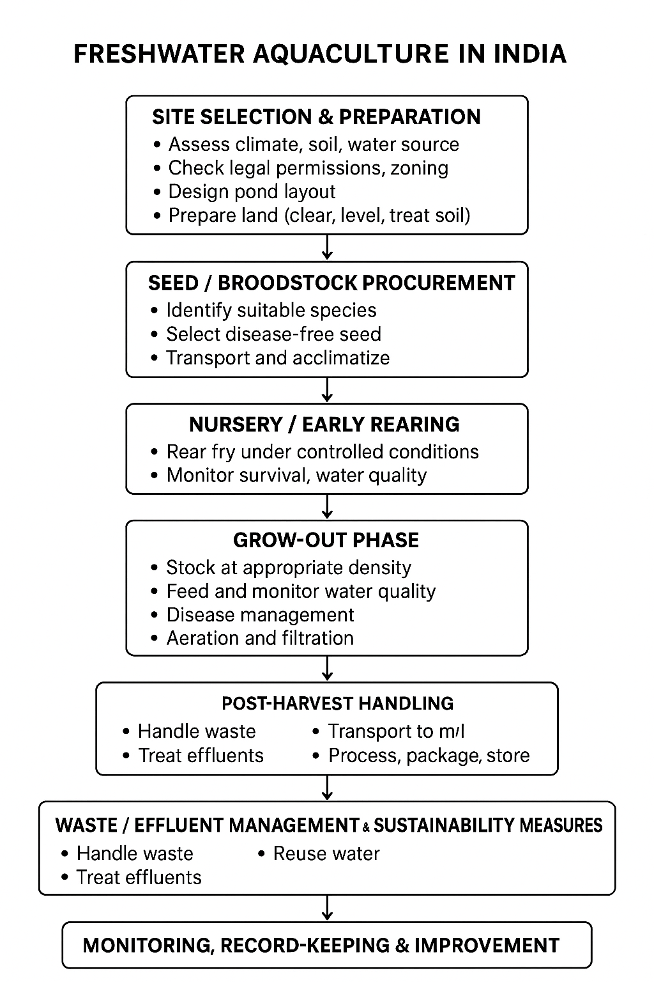
Fig 1: Stages of Monitoring Freshwater Aquaculture in India

10. Freshwater Aquaculture can be categorised based on:
10.1 Culture Systems:

10.1.1 Pond Culture
- Most common system in India.
- Fish are raised in earthen ponds of various sizes.
- Managed through feeding, fertilization, aeration, and water exchange.
- Common species: Indian major carps (Rohu, Catla, Mrigal), Tilapia, Catfish.

10.1.2 Cage Culture
- Fish are reared in floating cages placed in reservoirs, lakes, or rivers.
- Allows high stocking density with minimal land requirement.
- Advantages: easy monitoring, good water exchange, and efficient feeding.
- Example species: Pangasius, Tilapia, Catfish.

10.1.3 Tank Culture
- Uses cement, fiberglass, or plastic tanks for intensive culture.
- Suitable for small-scale or urban aquaculture.
- Often used for seed rearing, ornamental fish, or RAS setups.

10.1.4 Raceway Culture
- Water flows continuously through rectangular channels (raceways).
- Provides high oxygen and waste removal - ideal for fast-growing species.
- Species: Trout, Carp, Catfish.

10.1.5 Recirculating Aquaculture System (RAS)
- Closed-loop system where water is filtered and reused.
- Highly efficient in water use and environmental control.
- Used for intensive production near urban centers.
- Species: Tilapia, Catfish, Ornamental fish, Shrimp (freshwater).

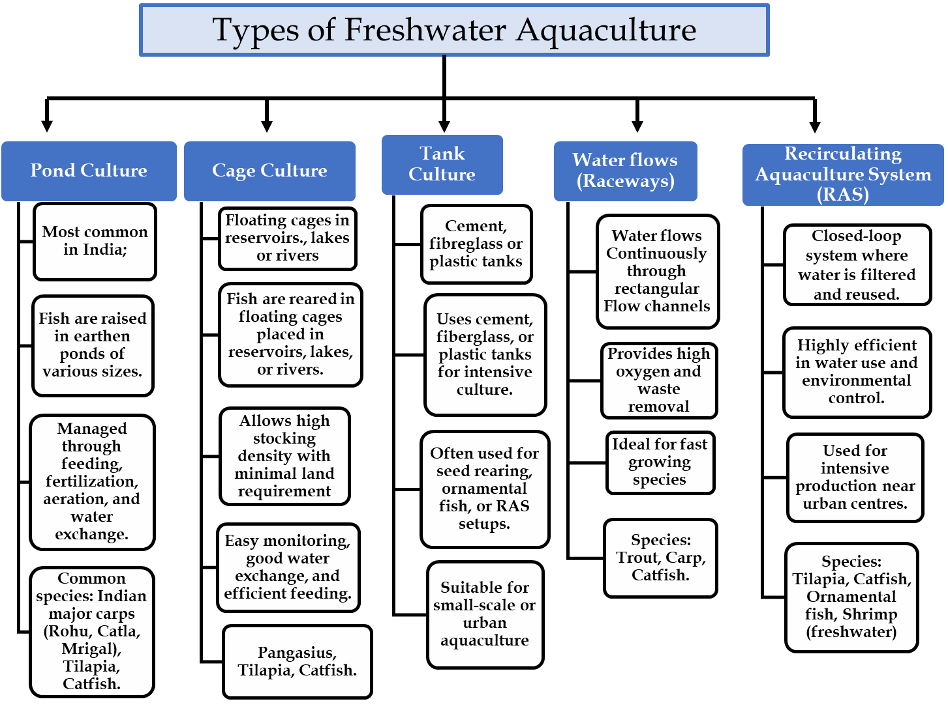
Fig 2: Types of freshwater aquaculture

10.2 Based on Intensity of Culture

Table 1 depicts the type of freshwater aquaculture based on intensity of culture
Type | Characteristics | Example
Extensive | Natural feed only, low stocking density, minimal input | Traditional pond farming
Semi-intensive | Supplementary feeding and fertilization | Most carp ponds in India
Intensive | Complete feed, aeration, water exchange or RAS | Tilapia, Pangasius, Catfish culture

10.3 Based on Species Composition

10.3.1 Monoculture
- Single species cultured for uniform management and harvesting.
- Example: Tilapia-only or Catla-only systems.

10.3.2. Polyculture
- Two or more species with complementary feeding habits are cultured together to maximize resource use.
- Example: Indian major carps — Catla (surface feeder) + Rohu (column feeder) + Mrigal (bottom feeder).

10.3.3 Based on Integration with Other Farming

10.3.3.1 Integrated Fish Farming
- Combines aquaculture with agriculture or livestock to recycle nutrients.
- Examples:
  - Fish-cum-duck farming (duck droppings as pond fertilizer)
  - Fish-cum-poultry farming
  - Fish-cum-pig farming
  - Fish-cum-horticulture

10.3.3.2 Aquaponics
- Combines aquaculture + hydroponics (plants grown using fish waste as nutrients).
- Environmentally friendly, ideal for urban or small-scale systems.
10.3.3.3 Rice-Fish Culture
- Fish are raised in flooded paddy fields.
- Fish control pests and aerate soil; rice provides shade and habitat.
- Common species: Common carp, Tilapia, Catfish.

Table 2: Summary of the basis of classification of aquaculture systems
Basis | Type | Example Systems / Species
Culture System | Pond, Cage, Tank, Raceway, RAS | Carp ponds, Tilapia cages
Intensity | Extensive, Semi-intensive, Intensive | Traditional vs. modern systems
Species Composition | Monoculture, Polyculture | Tilapia-only, Carp polyculture
Integration | Fish-livestock, Aquaponics, Rice-fish

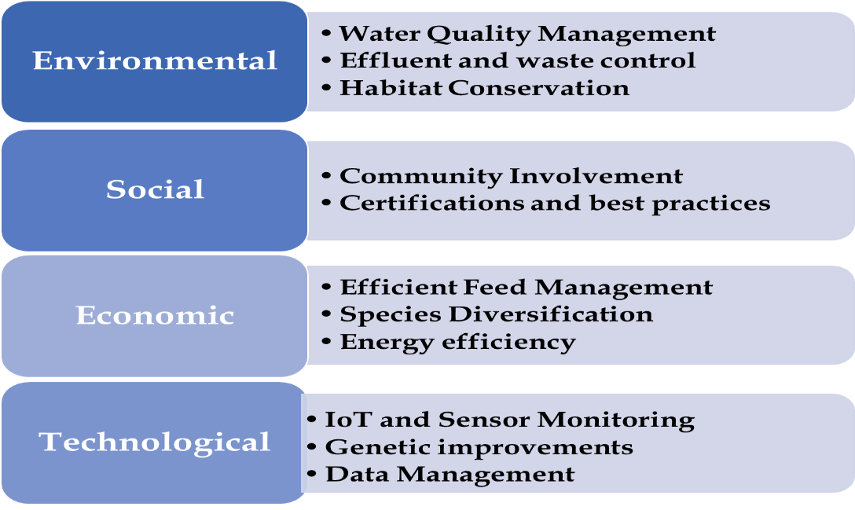
Fig 3: Sustainable Strategies for Freshwater Aquaculture

11. Future Research Directions for Sustainable Aquaculture in India
As India’s aquaculture sector evolves toward greater sustainability and technological sophistication, targeted research and innovation will play a decisive role in enhancing production and securing long-term resilience. Future efforts must focus on refining and integrating systems and technologies that improve efficiency, minimize environmental pressures, and promote responsible use of natural resources. Advanced production models such as Recirculating Aquaculture Systems (RAS) and Integrated Multi-Trophic Aquaculture (IMTA) have been found to offer viable pathways for sustainable intensification by facilitating water conservation, nutrient recovery, and reduced ecological footprints. Despite their potential, these systems face considerable challenges, including high capital and operational costs, lengthy payback periods, and technical issues related to sludge handling and oxygen management (Badiola et al., 2012; Ende et al., 2024). Continued research into bio-based treatment and waste-recovery technologies will be essential to make RAS and related systems economically viable while maintaining environmental integrity.
Integrating renewable energy systems and cost-effective filtration technologies, such as microalgae-based treatment systems, could further enhance the sustainability of RAS and IMTA operations (Méndez et al., 2022; Zhang et al., 2024). In addition, cooperative investment models and public–private partnerships can help overcome financial barriers, making these systems more accessible to small- and medium-scale enterprises.
Climate change poses a multifaceted threat to aquaculture systems through changes in water temperature and quality, oxygen and feed availability, pathogen dynamics etc. affecting fish growth, reproduction and survival. According to the IPCC Sixth Assessment Report of 2022, aquatic ecosystems are among the most climate-sensitive food production systems with inland aquaculture particularly vulnerable to heat stress, salinity intrusion, and variable freshwater availability (IPCC, 2022, WGII, Chapter 5: Food, Fibre and Other Ecosystem Products). Mitigation and adaptation measures are therefore essential with the adoption of climate-smart aquaculture practices, climate-resilient species and early warning systems that can enhance resilience and sustainability.
Another crucial research direction lies in the development of high-quality, disease-resistant aquatic species. Disease outbreaks remain one of the most pressing threats to aquaculture productivity and profitability. UNEP (2021) highlights that climate-induced fluctuations in hydrology and nutrient loading can increase the risk of harmful algal blooms and disease outbreaks, undermining sustainability in aquaculture operations. The emergence of new hosts for viruses, parasites, and bacteria in Indian aquaculture underscores the urgent need for advanced diagnostic tools, surveillance, and biosecurity strategies (Dekari et al., 2024b).
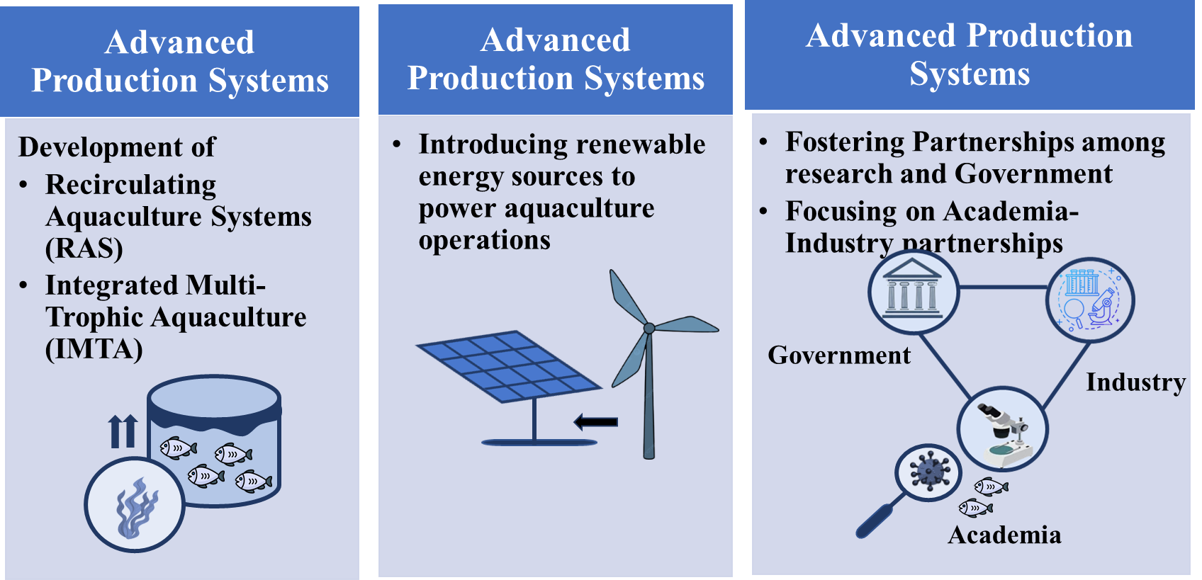
Fig 4: Future Research directions for Sustainable Aquaculture (Selfdrawn figure using images from Creative Commons)

Recent studies have highlighted several alarming cases, including TiPV detection in tilapia and its eggs in Tamil Nadu (Badhusha et al., 2025), the first reports of Aeromonas veronii, Aeromonas sp., and Pseudomonas alcaligenes infections in freshwater fish from the Andaman Islands (Praveenraj et al., 2024), and Micrococcus luteus infections in Nile tilapia from Andhra Pradesh (Suresh et al., 2025). Similarly, the first report of Paracapillaria philippinensis in flowerhorn cichlids from Chennai (Arumugam et al., 2024) emphasizes the need for strengthened biosecurity measures. Viral outbreaks such as Lymphocystis Disease Virus in Asian seabass (Nair et al., 2024) and ISKNV in Etroplus maculatus (Kushala et al., 2024), along with Ichthyophthirius multifiliis infections in ornamental fish causing significant mortalities (Banu et al., 2025), further highlight the necessity of early detection, pathogen characterization, and disease mitigation strategies. To safeguard the future of Indian aquaculture, research must focus on developing rapid diagnostic tools, effective vaccines, and environmentally sustainable disease management practices. Integrating these innovations with responsible aquaculture practices will enhance resilience, maintain productivity, and support the sector’s sustainable expansion.

12. Conclusion
Aquaculture plays a pivotal role in India’s food security, economic growth, poverty alleviation, and sustainable management of aquatic resources. It provides employment, income, and nutritional benefits to millions while supporting agricultural diversification and contributing significantly to the country’s export earnings. The collaborative efforts of the government and private sector—through research institutions, training centers, and technology transfer programs—have strengthened the foundation of the aquaculture industry. Financial incentives, subsidies, and supportive policies have further facilitated the adoption of advanced technologies, benefiting small-scale farmers and entrepreneurs alike.
India’s aquaculture sector has achieved remarkable growth, with inland fisheries production rising from 7.5 lakh tons in 1950–51 to 139.07 lakh tons in 2023–24, and marine fisheries from 5.34 lakh tons to 44.95 lakh tons during the same period. Under the Viksit Bharat@2047 vision, India aims to achieve over 40 million tons of fish production by 2047, positioning itself as a global leader in sustainable aquaculture.
However, ensuring the long-term sustainability of this growth requires addressing key challenges such as environmental degradation, disease management, and productivity enhancement. Improving feed efficiency, strengthening genetic selection programs, and integrating innovative technologies like Recirculating Aquaculture Systems (RAS) and automation can optimize production while minimizing resource use. Investment in infrastructure, hatcheries, processing facilities, and cold chains will also be critical for market expansion and value addition.
Furthermore, capacity building, training, and the incorporation of traditional knowledge are vital for effective and adaptive fisheries management. By prioritizing sustainability, promoting equitable access to markets, and fostering innovation, India can transform its aquaculture sector into a model of inclusive, environmentally responsible, and globally competitive development.
In summary, India’s aquaculture sector has evolved into a dynamic and strategically significant industry, supported by an extensive network of government initiatives, regulatory mechanisms, and institutional frameworks. These measures collectively ensure that the sector progresses along a sustainable and inclusive path, balancing economic development, environmental conservation, and social welfare.
Despite remarkable growth, the industry faces several emerging challenges—ranging from environmental degradation and disease management to market fluctuations and climate change impacts. At the same time, new opportunities are arising through technological innovation, diversification of species, international trade expansion, and eco-certification programs. Understanding these challenges and leveraging opportunities will be key to ensuring the long-term sustainability and competitiveness of India’s aquaculture sector.

Disclaimer (Artificial intelligence)
Author(s) hereby declare that NO generative AI technologies such as Large Language Models (ChatGPT, COPILOT, etc.) and text-to-image generators have been used during the writing or editing of this manuscript.
References:
1. Kumar P, Khar S, Dwivedi S, Sharma SK (2015) An overview of fisheries and aquaculture in India. Agro-Economist 2 (2):1-6 DOI 10.5958/2394-8159.2015.00011.0
2. Béné, C., et al. (2016) Contribution of Fisheries and Aquaculture to Food Security and Poverty Reduction: Assessing the Current Evidence. World Development, 79, 177-196. https://doi.org/10.1016/j.worlddev.2015.11.007
3. Himaja PHS, Rajagopalasamy CBT (2016) Potential and futuristic prospectus of cage aquaculture in Indian. J Aquacult Trop 31(3/4):179; DOI: 10.32381/JAT

4. Hodar AR, Vasava RJ, Mahavadiya DR, Joshi NH (2020) Fish meal and fish oil replacement for aqua feed formulation by using alternative sources: A review. J Exp Zool India 23(1):13-21; https://www.researchgate.net/publication/338392541

5. FAO (2020) The state of world fisheries and aquaculture. Rome: FAO. http://www.fao.org/documents/card/en/c/ca9229en

6. Ngasotter S, Panda SP, Mohanty U, Akter S, Mukherjee S, Waikhom D, Devi LS (2020) Current scenario of fisheries and aquaculture in India with special reference to Odisha: A review on its status, issues and prospects for sustainable development. Int J Bio-resource. Stress Manag 11(4):370-380; doi:10.23910/1.2020.2126a
7. Béné C, Macfadyen G, Allison EH (2007) Increasing the contribution of small-scale fisheries to poverty alleviation and food security. FAO Fisheries Technical Paper. No. 481. Rome, FAO. 125; DOI: https://doi.org/10.1016/j.worlddev.2015.11.007
8. Ghose B (2014) Fisheries and aquaculture in Bangladesh: Challenges and opportunities. Ann Aquacult Res 1(1):1-5; DOI: 10.1080/14634980903578233
9. Wang, Q., Cheng, L., Liu, J., Li, Z., Xie, S., & De Silva, S. S. (2015). Freshwater aquaculture in PR China: trends and prospects. Reviews in Aquaculture, 7(4), 283-302. DOI: 10.1111/raq.12086
10. Geetha R, Ravisankar T, Patil PK, Avunje S, Vinoth S, Sairam CV, Vijayan KK (2020) Trends, causes and indices of import rejections in international shrimp trade with special reference to India: A 15-year longitudinal analysis. Aquacult Int 28:1341-1369; DOI: 10.1007/s10499-020-00529-w
11. Gopalakrishnan A, Shinoj P, Muktha M, Suresh VVR, George G, Kizhakudan SJ, Sukumaran S, Ignatius B (2024) Propelling India’s blue economy: technological and governance perspectives in fisheries and aquaculture. Curr Sci 126(2):169-176; https://www.currentscience.ac.in/show.issue.php?vo...
12. Adhikari B (2013) Poverty reduction through promoting alternative livelihoods: implications for marginal drylands. J Int Dev 25(7):947-967; https://doi.org/10.1002/jid.1820
13. Pingali, P., & Rosegrant, M. W. (1995). Agricultural commercialization and diversification: Processes and policies. Food Policy, 20(3), 171–185. https://doi.org/10.1016/0306-9192(95)00012-4
14. Kumar G, Engle C, Tucker C (2018) Factors driving aquaculture technology adoption. J World Aquacult Soc 49(3):447-476; DOI: 10.1111/jwas.12514
15. Ahmed M, Lorica MH (2002) Improving developing country food security through aquaculture development—lessons from Asia. Food Policy 27(2):125-141; https://doi.org/10.1016/S0306-9192(02)00007-6
16. Beveridge MC, Little DC (2002) The history of aquaculture in traditional societies. In: Ecological Aquaculture: The Evolution of the Blue Revolution pp 3-29; https://doi.org/10.1002/9780470995051.ch1
17. Gopalakrishnan A, Ignatius B, George G (2017) India’s largest fisheries research body turns 70: CMFRI’s legacy and few recent achievements. Fishing Chimes 37(1):38-43; http://eprints.cmfri.org.in/id/eprint/12030
18. Das PC (2019) Development of aquaculture for commercially important finfishes in India. In: Aquaculture of commercially important finfishes in South Asia. SAARC Agriculture Centre, SAARC, Dhaka, Bangladesh pp 15-46; ISBN: 978-984-34-6740-9
19. Katiha PK, Jena JK, Pillai NGK, Chakraborty C, Dey MM (2005) Inland aquaculture in India: past trend, present status and future prospects. Aquacult Econ Manag 9(1-2):237-264; DOI: 10.1080/13657300590961573
20. Manyise T, Lam RD, Lazo DPL, Padiyar A, Shenoy N, Chadag MV, Rossignoli CM (2024) Exploring preferences for improved fish species among farmers: A discrete choice experiment applied in rural Odisha, India. Aquaculture 583:740627; https://doi.org/10.1016/j.aquaculture.2024.740627
21. DoF-GOI, 2024 DoF-GOI (Department of Fisheries) Government of India (2024) Annual Report 2023-24 https://dof.gov.in/sites/default/files/2024-07/Annual_Report_2023-24_English.pdf
22. DoF-GOI (Department of Fisheries) Government of India (2025). https://dof.gov.in/PMMKSSY
23. Kumaran M, Geetha R, Antony J, Vasagam KK, Anand PR, Ravisankar T, Angel JRJ, De D, Muralidhar M, Patil PK, Vijayan KK (2021) Prospective impact of Coronavirus disease (COVID-19) related lockdown on shrimp aquaculture sector in India–a sectoral assessment. Aquaculture 531:735922; DOI: 10.1016/j.aquaculture.2020.735922
24. MPEDA (2024) (Marine Product Export Development Authority) Annual Report 2023-2024,Kochi,Kerala.https://mpeda.gov.in/wp-content/uploads/2024/06/Export-performance_2023-24-approved_V5.pdf
25. Hudson S, Krogman N, Beckie M (2016) Social practices of knowledge mobilization for sustainable food production: nutrition gardening and fish farming in the Kolli hills of India. Food Sec 8: 523-533; DOI 10.1007/s12571-016-0580-z
26. Chellapandi P (2021) Development of top-dressing automation technology for sustainable shrimp aquaculture in India. Discover Sustain 2(1):26; https://doi.org/10.1007/s43621-021-00036-9
27. Handbook of Fisheries Statistics, 2023 Handbook of Fisheries Statistics (2023) Department of fisheries ministry of fisheries, animal husbandry and dairying, government of India, Krishi Bhavan, New Delhi http://fsi.gov.in/sites/default/files/hand-book-fishery-statistics-document/hofs-2008.pdf
28. Mishra SS, Rakesh D, Dhiman M, Choudhary P, Debbarma J, Sahoo SN, Mishra CK (2017) Present status of fish disease management in freshwater aquaculture in India: state-of-the-art-review. J Aquacult Fish 1(003):14; DOI:10.24966/AAF-5523/100003
29. FAO. The State of World Fisheries and Aquaculture (SOFIA) 2022/2024 — global production and country breakdown. https://www.fao.org/newsroom/detail/fao-report-global-fisheries-and-aquaculture-production-reaches-a-new-record-high/en#:
30. Umesh NR, Mohan AC, Ravibabu G, Padiyar PA, Phillips MJ, Mohan CV, Bhat BV (2010) Shrimp farmers in India: Empowering small-scale farmers through a cluster-based approach. In: Success stories in Asian aquaculture, pp 41-66; DOI: 10.1007/978-90-481-3087-0_3
31. Jyotsna C, Sinha B, Bisaria J (2024) Analysis of policies and programmes for tackling coastal climate risks in India. Ocean Coast Manag 253:107141; https://doi.org/10.1016/j.ocecoaman.2024.107141
32. Vijayan B, Nain MS (2021) Rashtriya Krishi Vikas Yojana remunerative approaches for agriculture and allied sector rejuvenation (RKVY-RAFTAAR). Agric Food e-Newsletter 3(6):76-78; http://doi.org/10.48165/IJEE.2022.58323
33. MoF (2025) (Ministry of Fisheries) Animal Husbandry and Dairying https://pib.gov.in/PressReleaseIframePage.aspx?PRID=1777708
34. Krause G, Brugere C, Diedrich A, Ebeling MW, Ferse SC, Mikkelsen E, Agúndez JAP, Stead SM, Stybel N, Troell M (2015) A revolution without people? Closing the people–policy gap in aquaculture development. Aquaculture 447:44-55; DOI: https://doi.org/10.1016/j.aquaculture.2015.02.009
35. Manlosa AO, Hornidge AK, Schlüter A (2021) Aquaculture-capture fisheries nexus under COVID-19: impacts, diversity,and social-ecological resilience. Mar Stud 20:75-85; DOI: 10.1007/s40152-021-00213-6
36. Troell M, Costa‐Pierce B, Stead S, Cottrell RS, Brugere C, Farmery AK, Barg U (2023) Perspectives on aquaculture’s contribution to the Sustainable development goals for improved human and planetary health. J World Aquacult Soc 54(2):251-342; https://doi.org/10.1111/jwas.12946
37. Meharoof M, Albin Albert C, Ratheesh Kumar R (2023) Sustainable development goals and fisheries sector: progressing towards a sustainable future. Aquaculture Spectrum 6(3):12-25;https:// eprints.cmfri.org.in/17088/1/Aquaculture%20Spectrum_2023
38. Moretti V, Corraini NR, Melo EL, Scherer MEG, Colmenero JC (2024) Progress towards the sustainable development goal 14 (Life below water) in the context of Brazil: A multicriteria approach. Sustain Futures 8:100410; DOI: 10.1016/j.sftr.2024.100410
39. Misk R, Penarubia O, Gee J (2021) Gender on the agenda: Towards the achievement of SDG 5 in aquaculture. FAO Aquaculture; Newsletter 63:58-61 MoF (2025) (Ministry of Fisheries) Animal Husbandry and Dairying https://pib.gov.in/PressReleaseIframePage.aspx?PRID=1777708.
40. Das BK, Meena DK, Das A, Sahoo AK (2022) Prospects of smart aquaculture in Indian Scenario: A new horizon in the management of aquaculture production potential. In: Smart and Sustainable Food Technologies. Springer Nature, Singapore pp 59-85; DOI: 10.1007/978-981-19-1746-2_3.
41. Fernandes, S. (2024). Artificial intelligence in the aquaculture industry: A critical review. Aquaculture & Fisheries, Advance online publication. https://doi.org/10.1016/j.aaf.2024.101001
42. Yang, H., et al. (2025). AI-driven aquaculture: A review of technological advancements and applications. Aquaculture Reports, Advance online publication. https://doi.org/10.1016/j.aqrep.2025.1005083
43. Garlock, T. M., et al. (2024). Environmental, economic, and social sustainability in aquaculture: The aquaculture performance indicators. Nature Communications, 15, 5274. https://doi.org/10.1038/s41467-024-49556-8
44. Badiola M, Mendiola D, Bostock J (2012) Recirculating aquaculture systems (RAS) analysis: main issues on management and future challenges. Aquacult Eng 51:26-35; https://doi.org/10.1016/j.aquaeng.2012.07.004
45. Ende S, Henjes J, Spiller M, Elshobary M, Hanelt D, Abomohra A (2024) Recent advances in recirculating aquaculture systems and role of microalgae to close system loop. Bioresour Technol 407(2024):131107; https://doi.org/10.1016/j.biortech.2024.131107
46. Méndez L, Sepúlveda-Muñoz CA, del Rosario Rodero M, de Godos I, Muñoz R (2022) Decarbonization potentials using photobiological systems. In Ren ZJ, Pagilla P (Eds) Pathways to water sector decarbonization, carbon capture and utilization, IWA publishing pp 143-170; DOI: 10.2166/9781789061796_0143
47. Zhang R, Chen T, Wang Y, Short M (2024) An optimisation approach for the design and operation of recirculating aquaculture systems integrated with sustainable hybrid energy systems. J Clean Prod 477:143860; https://doi.org/10.1016/j.jclepro.2024.143860
48. Intergovernmental Panel on Climate Change (IPCC) (2022). Climate Change 2022: Impacts, Adaptation and Vulnerability. Contribution of Working Group II to the Sixth Assessment Report of the Intergovernmental Panel on Climate Change (Chapter 5). Cambridge University Press. https://doi.org/10.1017/9781009325844
49. United Nations Environment Programme (UNEP). (2021). Climate change adaptation in the fisheries and aquaculture sector: Policy brief. UNEP. https://www.unep.org/resources/report/climate-change-adaptation-fisheries-and-aquaculture-sector
50. Dekari D, Saha H, Chouhan N, Irungbam S, Ghosh L, Saikia P, Choudhury TG, Saha RK (2024b) Exploring the genetic and morphological diversity of Argulus ectoparasite infecting the aquaculture and ornamental fish in Tripura. Indian J Anim Res 58(11):1906-1916; DOI 10.18805/IJAR.B-5455
51. Badhusha A, Mithra S, Taju G, Rajkumar V, Abdul Majeed S, Suryakodi S, Sahul Hameed AS (2025) Detection of Tilapia parvovirus in farm-reared tilapia in India and its isolation using fish cell lines. In Vitro Cell Dev Biol Anim 1-13. DOI:10.1007/s11626-024-01012-z
52. Praveenraj J, Saravanan K, Uma A, Kiruba-Sankar R, Ahilan B, Gopalakannan A, Manikandavelu D (2024) First report of two bacterial diseases from the freshwater fishes of the Andaman islands, India. Indian J Anim Res 58(8):1333-9; DOI: 10.18805/IJAR.B-5237
53. Suresh K, Pillai D, Soni M, Rathlavath S, Narshivudu D (2025) Micrococcus luteus, an emerging opportunistic pathogen in farmed Nile tilapia, Oreochromis niloticus in Andhra Pradesh, India. Aquac Int 33(1):51; DOI: 10.1007/s10499-024-01761-4
54. Arumugam U, Pandian RG, Jayasimhan P, Sudarsanan GB, Sornappan G (2024) First report of Paracapillaria philippinensis infection in flowerhorn cichlid in India. Parasitol Res 123(3):150; DOI: 10.1007/s00436-024-08175-4.
55. Nair RR, John KR, Krishnan R, Gopi A, Safeena MP (2024) PCR detection and phylogenetic analysis of the major capsid protein gene of Lymphocystis disease virus from cultured Asian seabass (Lates calcarifer Bloch 1790) along the west coast of Kerala, India. Aquacult Int 32(2):1041-1049; DOI: 10.1007/s10499-023-01203-7
56. Kushala KB, Nithin MS, Girisha SK, Dheeraj SB, Harshitha H, Suresh T, Patil R (2024) Emergence of infectious spleen and kidney necrosis virus (ISKNV) as the etiological agent for mass mortality in Etroplus maculatus in Mangaluru, India. J Exp Zool India 27(1):1305; DOI: 10.51470/JEZ.2024.27.1.1305
57. Banu H, Swain HS, Bharathi Rathinam R, Singh PK, Kamei M (2025) Ciliate parasite Ichthyophthirius multifiliis causing acute mortality in tiger barb (Puntigrus tetrazona, Bleeker 1855) and widow tetra (Gymnocorymbus ternetzi, Boulenger 1895). J Parasit Dis 1-5. DOI:10.1007/s12639-024-01776-x.

