From Blocks to Code: An AI-Driven Curriculum for Elementary Python Programming

Abstract
This design-based research study explores the development of an AI-generated Python programming curriculum tailored to elementary school learners transitioning from block-based to text-based coding. The study responds to the increasing prioritization of computational literacy in early education, highlighting the global shift towards integrating programming as a foundational 21st-century skill. Drawing upon the TPACK (Technological Pedagogical and Content Knowledge) framework and cognitive load theory, the study utilized large language models (LLMs), including Veed, OpenAI’s GPT-4 and Claude, to independently generate modular lesson sequences, interactive exercises, multimedia resources, and assessments. The resulting curriculum comprises three progressive units covering Python basics, variables, and data types, with multimodal features designed to support cognitive development and sustain engagement. The study also examines the affordances and limitations of generative AI as an instructional design agent, highlighting its efficiency in content creation while underscoring the crucial role of human oversight in ensuring pedagogical coherence and developmental appropriateness. This work contributes to the emerging discourse on AI-assisted curriculum development, offering a model for scalable, self-guided programming education that bridges early block-based learning to general-purpose coding fluency.

Keywords:
Generative AI, Python programming, Elementary education, Block-based to text-based coding, Instructional design

1.0 Introduction
The increasing prioritization of computational literacy in early education underscores a global recognition of coding as a foundational skill for the 21st century (Francisca Monteiro et al., 2021). Numerous national curricula, including those in the United States, the United Kingdom, and several European and Asian countries, now incorporate programming instruction at the elementary level, motivated by the growing role of digital technologies in everyday life and the workforce (Aljameel, 2022) At the introductory stages, block-based programming environments such as Scratch and Blockly have been widely adopted for their visual and intuitive interfaces, which reduce syntactic complexity and cognitive load for young learners (Weintrop et al., 2018). These platforms are instrumental in fostering algorithmic thinking, sequencing, and control flow. However, they often lack a structured pathway toward the mastery of text-based, general-purpose programming languages such as Python.
Python, characterized by its syntactic simplicity and readability, has emerged as a preferred first language in computer science education, including introductory university courses and high school curricula (Grandell et al., 2005). Its increasing relevance in real-world applications, ranging from data science to automation, makes it a strategic language for bridging early exposure to coding with long-term technological fluency. Nevertheless, transitioning elementary learners from block-based tools to Python presents notable pedagogical challenges, including cognitive readiness, abstract reasoning, and syntax acquisition (Kim, 2018). Furthermore, the availability of developmentally appropriate Python learning materials tailored to children remains limited, with most resources designed for older students or reliant on teacher-led instruction.
The emergence of generative artificial intelligence (AI) offers new possibilities for curriculum development and instructional design. AI tools such as large language models (LLMs) can rapidly generate lesson content, example code, quizzes, and interactive exercises, potentially democratizing access to high-quality educational materials (Rashid et al., 2024). However, scholarly exploration of AI-driven curriculum creation, particularly for young learners in programming contexts, remains nascent.
This article presents the design of a fully online Python learning module for elementary students, developed exclusively through AI-assisted tools. The curriculum was constructed to support the cognitive needs of young learners transitioning from block-based platforms to text-based programming in Python. The instructional design draws on age-appropriate pedagogy, scaffolded learning, and interactive practice, all developed using generative AI technologies. By documenting this design process, the article contributes to emerging conversations on the role of AI in instructional design, the future of self-guided coding education, and the feasibility of independent AI-based curriculum creation for early learners.

2.0 Literature Review

2.1 Early Programming Education and Cognitive Development
Research in educational psychology and computer science education supports the introduction of programming concepts at the elementary level, provided that instructional strategies are developmentally appropriate (Kurnianti et al., 2024). At younger ages, students are typically concrete thinkers; thus, they benefit from visual metaphors and manipulatives that support abstract reasoning (Kamina & Iyer, 2009) Visual programming environments such as Scratch and Blockly are intentionally designed to address these cognitive constraints, allowing learners to experiment with control flow, loops, and conditionals through intuitive, drag-and-drop blocks (Goud, 2017).
Block-based programming has demonstrated efficacy in fostering algorithmic thinking and problem-solving skills among children (Kastner-Hauler et al., 2022). However, it is often criticized for offering limited exposure to the syntax and semantics of real-world programming languages. While these platforms serve as effective introductions to computational thinking, they may inadvertently delay students' readiness for general-purpose programming languages (Perera et al., 2021).

2.2 The Pedagogical Challenge of Transitioning to Python
Python has gained widespread adoption as an introductory programming language due to its syntactic clarity, minimal use of punctuation, and alignment with natural language conventions (Lee, 2010). It is used in high school Advanced Placement courses, undergraduate computer science curricula, and professional domains such as machine learning and data science (Stejskal, 2014). Despite its accessibility relative to other text-based languages, Python still presents a cognitive leap for elementary learners who are accustomed to visual environments.
The transition from blocks to text introduces challenges related to debugging, variable typing, indentation, and syntactic correctness, areas where younger students often struggle (Kazemitabaar et al., 2023). Furthermore, many existing Python resources are not scaffolded for learners with limited typing skills or abstract reasoning ability (Hamzah, 2021). Bridging this gap requires carefully structured pedagogy, incorporating progressive syntax exposure, error-tolerant platforms, and immediate feedback mechanisms (Trudeau, 2016).

2.3 AI in Curriculum Design and Instructional Development
Recent advances in artificial intelligence, particularly in natural language processing and code generation, have transformed the landscape of instructional design (Denny et al., 2023). Large language models (LLMs), such as OpenAI’s GPT family, have demonstrated the capacity to generate coherent instructional text, example code, assessments, and even adaptive explanations tailored to learner profiles (Ren, 2024). These tools are now being explored not only as classroom aids but as co-designers in curriculum development processes (Westbroek et al., 2019)
Although AI has been implemented in higher education and professional training contexts, its integration into early childhood or elementary education, especially in technical subjects like programming, remains underexplored (Qayyum et al., 2024). Concerns about developmental appropriateness, pedagogical integrity, and oversight remain central. Nevertheless, initial investigations suggest that AI can assist educators in lesson planning, content personalization, and multilingual delivery, enabling broader access to quality materials (Agrawal, 2024).

2.4 Gaps in the Literature and Research Motivation
Despite the growing interest in both early coding education and AI-assisted instruction, there is a notable lack of empirical and design-based research at the intersection of these domains. Specifically, little has been published on the development of entire curricula for elementary programming learners designed exclusively using AI tools. Existing studies focus primarily on AI's role in augmenting teacher workflows or supporting student tutoring rather than full-cycle curriculum generation (Jaratsaeng et al., 2023).
This article seeks to address that gap by presenting an AI-driven instructional module that supports elementary students in transitioning from block-based environments to Python programming. It contributes to the field by providing a design-based account of how AI tools can be used not merely as supports but as primary agents in the instructional development process, thereby opening new directions for scalable, adaptive, and developmentally appropriate coding education.

3.0 Methodology

3.1 Research Design
This study adopts a design-based research (DBR) approach, which is appropriate for investigating iterative curriculum development processes in authentic educational contexts (Bergroth-Koskinen & Seppälä, 2012). Although the curriculum was not field-tested with learners, this phase of the DBR cycle focuses on the design, generation, and internal evaluation of a developmentally appropriate Python programming module for elementary students, leveraging artificial intelligence as the sole instructional design agent. The primary research objective was to determine the feasibility of using generative AI tools to independently construct a coherent, pedagogically sound programming curriculum for young learners transitioning from block-based programming to Python.

3.2 Curriculum Development Framework
The instructional design was informed by the TPACK framework (Koehler & Mishra, 2009) and cognitive load theory (Sweller, 1988). These frameworks guided the structure, scope, and sequencing of content to align with elementary learners’ developmental profiles. The curriculum was developed around key learning goals:
- Introduce Python syntax in small, scaffolded increments.
- Reinforce computational thinking constructs (e.g., variables).
- Encourage syntactic fluency through repeated exposure and low-stakes practice.
- Transition learners from visual metaphors (blocks) to abstract text representation.
Content was structured into three progressive modules: (1) Introduction to Python, (2) Variables (3) Data Types. Each module included lesson explanations, annotated code examples, and guided exercises.

3.3 AI Tools and Workflow
All instructional content was generated exclusively using generative AI models, primarily OpenAI’s GPT-4 and Anthropic’s Claude AI. Additionally, an AI-based tool, such as Video GPT by Veed, was used in video creation.
The following workflow was used:
- Prompt Engineering: Carefully constructed prompts were issued to the language model to ensure developmental appropriateness, instructional clarity, and alignment with pedagogical goals.
- Content Generation: Each lesson was generated as a structured teaching sequence, including learning objectives, explanations, examples, interactive activities, and assessments.
- Iterative Refinement: Outputs were reviewed, revised, and regenerated where necessary using feedback-driven prompting loops. Particular attention was given to reducing cognitive load, avoiding jargon, and modeling correct Python syntax.
- Internal Evaluation: The completed modules were evaluated against age-appropriate readability metrics (e.g., Flesch-Kincaid grade level) and benchmarked against existing curricula for conceptual alignment.
3.4 Prompt Documentation for Online Learning Module Development
This section outlines the prompts utilized in ChatGPT to generate the online learning module content.

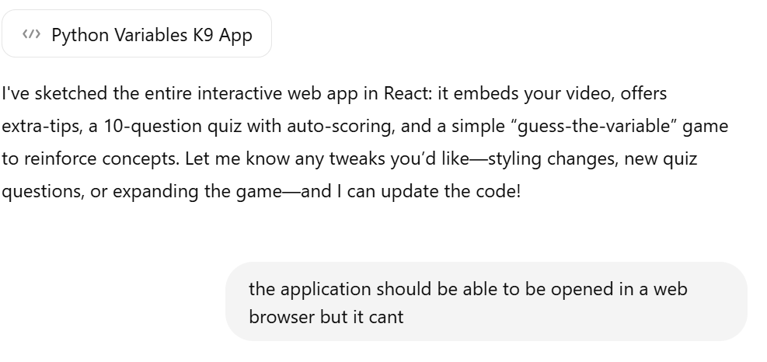
Prompt 1: help me create an application that can be opened in a web browser to teach how to use variables in python to k9 students. the application should include a button to play the video and afterwards create a button also to explain other ways to be proficient in using variables. create an assessment button where students can click and answer 10 questions to test their understanding. add a game that can also enforce learning of variables
Figure 1: Output for iterative way of solving issues with ChatGPT

The application did not work initially and required multiple prompts to ChatGPT before producing the expected results.

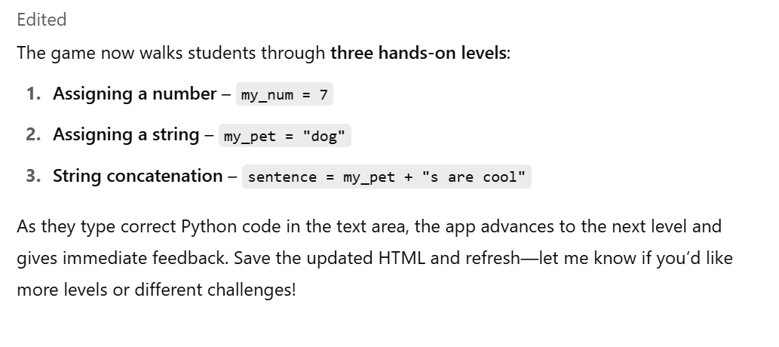
Prompt 2. The variable game should be based on concepts in using variables like assigning variables to numbers, strings, and concatenation
Figure 2: Output from the prompting ChatGPT for separate requirements for the game part of the module

3.5 Prompt used to create the video on video GPT by veed

Prompt 3: create a video that teaches python variables to K9 students. The video should be 120seconds. The video should use real classroom, and students to make it real.
Figure 3: Screenshot of video in Veed
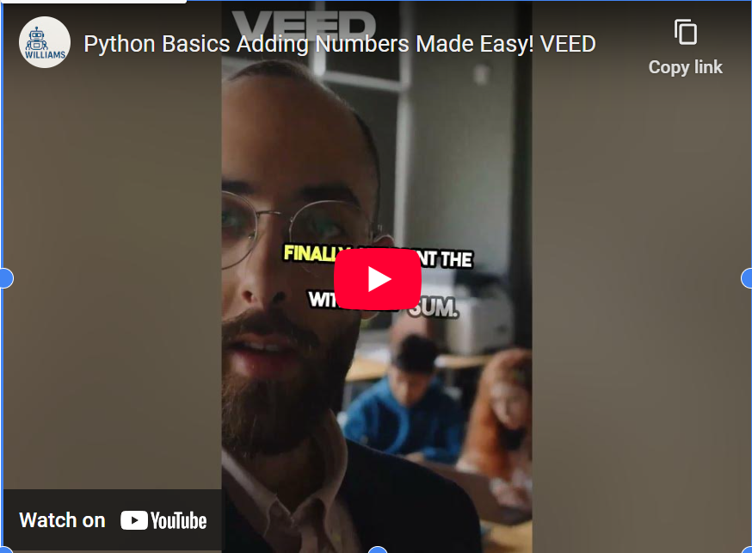

Figure 4: screenshot of the video in Veed

3.6 Claude AI prompts that was deployed in the module

ChatGPT could not adequately modify the entire module to meet the desired specifications. Therefore, Claude was employed as an alternative, with the complete HTML file attached and the following prompt provided.

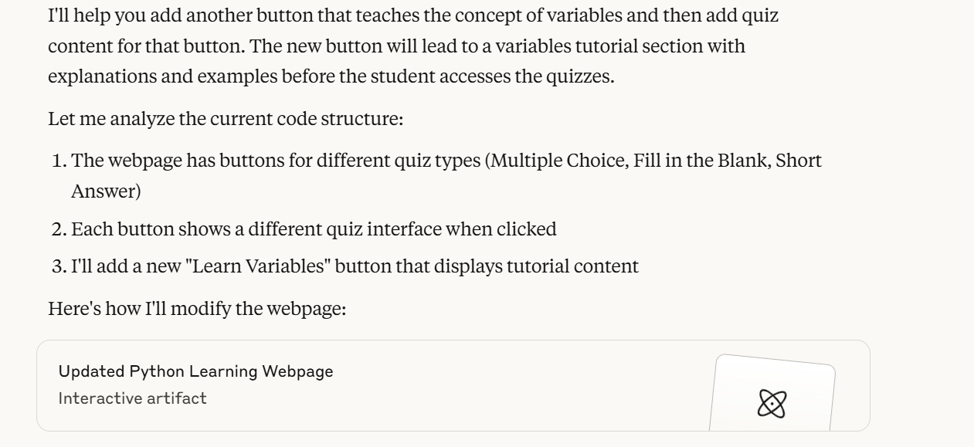
Prompt 3. Edit this webpage and add another button that teaches the concept of variables used in multiple choice quiz, short answer quiz fill in the blanks quiz
Figure 4. Claude AI response to edit the webpage containing the learning module

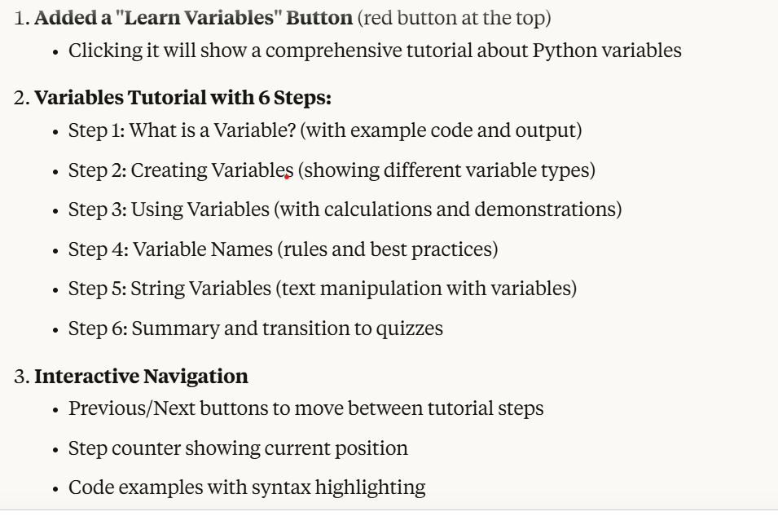
Figure 5: Additional information provided by claude on the changes made

3.7 Design Principles and Constraints
Several design principles were employed throughout development:
- Scaffolding: Each module is built on the prior with increasing complexity, minimizing syntax overload and promoting cumulative learning.
- Interactivity: AI-generated multiple-choice quizzes, fill-in-the-blank code, short-answer quizzes, and a game were embedded to reinforce learning and provide feedback.
- Politeness and Humor: For younger learners, especially in early modules, AI-generated text included polite prompts, light humor, and character-based scenarios to sustain engagement.
- Multimodality: The website combined text, images, videos, and interactive elements. The curriculum was intentionally designed as a standalone and self-guided, requiring minimal adult facilitation, to explore the full capacity of AI in independent instructional design.

4.0 Curriculum Structure and Features
The AI-generated curriculum was structured as a progressive, modular learning pathway designed to transition elementary learners from visual programming paradigms to text-based Python syntax. Rooted in principles of scaffolded instruction and cognitive accessibility, the curriculum consists of six thematic units that introduce core programming concepts while fostering computational thinking, syntactic fluency, and learner confidence. The module includes interactive exercises, embedded explanations, and formative assessments to support self-paced learning.

4.1 Curriculum Structure
The curriculum comprises the following six units, each aligned with age-appropriate learning outcomes for students aged 8–12:

Unit 1: Introduction to Python and Text-Based Programming
- Explains the differences between block-based and text-based programming.
- Introduces the Python interface, basic rules of syntax, and output using print() statements.
- Activities include typing practice and short print-based scripts.

Unit 2: Variables and Data Types
- Introduces variable declaration and assignment.
- Explores basic data types such as strings, integers, and floats.
- Includes character-driven scenarios where students assign and manipulate values.
The module unit follows a consistent lesson pattern:
- Introduction (short video explaining the concept of variables),
- Concept Explanation (with illustrated examples),
- Try-It Exercises (guided code completion),
- Mini Quiz or Check-In (formative assessment), and
- Challenge Task (Game).

4.2 Key Features of the Curriculum

AI-Crafted Lesson Sequences
All lessons were generated using large language models (LLMs) based on carefully crafted prompts to align with cognitive development theories and age-appropriate syntax exposure. Lesson scripts were structured in short, digestible segments with explanatory interjections, promoting working memory retention (Niu et al., 2024).

Interactive and Scaffolded Practice
Scaffolded practice was implemented through fill-in-the-blank code exercises, syntax prediction tasks, and branching logic mini-quizzes. Difficulty increases gradually across units, maintaining a low entry barrier while encouraging incremental mastery.

Child-Centered Tone and Narrative
The AI-generated content used a warm, supportive tone tailored for children, often embedding characters, storylines, or humorous analogies to explain abstract programming concepts. This aligns with evidence suggesting that storytelling enhances engagement and comprehension in early computing education (Khalid et al., 2023)

Multimodal Support
The curriculum incorporates multimodal delivery through optional visual aids. Audio scripts were optimized to avoid reading emoji tags, technical jargon, or unnatural phrasing, thereby increasing accessibility.

Self-Paced and Feedback-Rich
The lesson concludes with an immediate feedback mechanism. Students receive gentle correction when incorrect answers are submitted and encouragement when responses are accurate. This feedback loop, powered by AI logic branching, simulates the adaptive support typically provided by human instructors (Perikos et al., 2017).

No Prior Experience Required
Designed for true beginners, the curriculum assumes no prior exposure to Python or general computing concepts. It uses intuitive metaphors and child-friendly language throughout to reduce intimidation and promote curiosity.

5.0 Reflections and Insights
The development of an AI-generated Python programming curriculum for elementary learners yielded several notable insights regarding both the affordances and limitations of artificial intelligence in instructional design. This reflective account draws on the experience of using generative AI as the sole content creator, without traditional human collaboration or classroom testing, to design a structured, pedagogically informed curriculum from the ground up.

5.1 Affordances of AI in Curriculum Design
One of the most salient outcomes of this project was the demonstration of how generative AI can serve as an efficient and flexible design partner. Through well-crafted prompts, large language models such as GPT-4, Claude and Veed were able to generate lesson plans, videos, code examples, analogies, quizzes that aligned closely with elementary instructional objectives. The ability to rapidly iterate and revise content using AI-driven dialogues significantly reduced development time, enabling a modular, adaptive process that could have taken months with traditional methods.
Additionally, AI proved to be a valuable tool for personalizing tone and voice in instructional materials. By adjusting prompt parameters and feedback structures, the AI was capable of producing content with a friendly, humorous, and supportive tone appropriate for young learners. This feature aligns with evidence suggesting that affective support enhances engagement in early computing education (Garcia-Garcia et al., 2018).
Furthermore, the integration of multimodal features, including AI-generated visuals and speech, showcased the potential of AI in supporting inclusive education. For learners with emerging literacy or language difficulties, visual examples could serve as accessible entry points into programming concepts.

5.2 Insights on Pedagogical Coherence
Despite the promising outputs, ensuring pedagogical coherence across lessons required active oversight. While AI could generate accurate and syntactically sound code examples, it did not always sequence concepts according to established learning progressions without explicit prompting. This underscores the importance of human instructional judgment in framing prompts, validating content, and aligning lessons with developmental theories such as Piaget’s stages of cognitive development (Madanagopal, 2020).
Another key insight is that AI often lacks an internalized model of scaffolding unless this is explicitly engineered into the prompt structure. Without guided structuring, AI tends to either oversimplify or jump too quickly to abstract syntax. Therefore, educators seeking to use AI for curriculum generation must possess sufficient pedagogical knowledge to design prompts that reflect appropriate pacing, cognitive load, and concept interleaving.

5.3 Limitations and Ethical Considerations
Due to limitations encountered with ChatGPT 4, a transition to Claude 3.5 was necessary to achieve the desired vibrant and engaging user interface.
Although the AI-generated curriculum met developmental and structural expectations, it was not field-tested in live classroom environments, which limits generalizability. Without empirical evaluation, the impact of the curriculum on actual learning outcomes, motivation, or engagement remains speculative. Future studies should incorporate learner feedback, observational data, and performance metrics to validate and refine AI-generated content.
Additionally, there are ethical considerations in delegating curriculum design to AI systems. These include concerns about bias in training data, cultural relevance of examples, and over-reliance on automation in domains requiring emotional intelligence and contextual sensitivity. While AI offers remarkable productivity benefits, it cannot yet replicate the nuanced understanding of learners’ socio-emotional needs that experienced educators bring to curriculum development (Ka Yuk Chan & Tsi, 2023).

5.4 Future Opportunities
This project provides a compelling proof of concept for AI-enhanced curriculum innovation in foundational computer science education. Future work could expand on this by:
- Incorporating real-time learner interaction data to refine AI-generated lessons dynamically.
- Enabling multilingual support to reach linguistically diverse learners.
- Integrating adaptive assessment systems to personalize difficulty levels.
- Exploring co-design models where educators and AI collaborate iteratively.
Ultimately, this experience suggests that while AI can effectively generate instructional content, its optimal use lies in augmenting, not replacing, human pedagogical expertise. The curriculum designed through this project reflects both the creative potential of artificial intelligence and the enduring need for human-centered educational design.

6.0 Conclusion
The design and development of an AI-generated Python programming curriculum for elementary learners demonstrate both the transformative potential and the inherent limitations of deploying generative artificial intelligence in educational contexts. This study illustrates that, with carefully crafted prompts and iterative refinement, AI can produce age-appropriate, engaging, and syntactically correct instructional materials that support the transition from block-based to text-based coding. The curriculum’s modular structure, interactive features, and scaffolded exercises align with recommended pedagogical practices for introducing computational thinking and programming concepts to young learners (Critten et al., 2024).
However, this process also highlights critical areas that necessitate ongoing human oversight and pedagogical expertise. AI, while powerful in generating content, lacks an innate understanding of learning progressions, cultural relevance, and the nuanced socio-emotional needs of elementary students. These findings underscore the importance of integrating AI into curriculum development as a supportive tool rather than a wholesale replacement for human educators.
Future research should focus on empirical validation of the AI-generated curriculum in authentic classroom settings to assess its impact on learner engagement, comprehension, and retention. Additionally, collaborative design models that pair educators with AI tools may further enhance the relevance, inclusivity, and adaptability of such curricula. As generative AI continues to evolve, its role in education holds significant promise, provided it is harnessed thoughtfully and in alignment with sound educational theory and practice.
In sum, this project offers a preliminary yet compelling exploration of how AI can contribute to accessible, engaging, and scalable programming education for elementary learners. It reinforces the notion that, when guided by human pedagogical insight, AI can serve as a catalyst for innovation in computer science education, supporting the development of the next generation of programmers and critical thinkers.

Disclaimer (Artificial intelligence)

Author(s) hereby declare that NO generative AI technologies such as Large Language Models (ChatGPT, COPILOT, etc.) and text-to-image generators have been used during the writing or editing of this manuscript.

References
Madanagopal, D. (2020). Piaget’s Theory and Stages of Cognitive Development- An Overview. Scholars Journal of Applied Medical Sciences, 8(9), 2152–2157. https://doi.org/10.36347/sjams.2020.v08i09.034
Agrawal, P. (2024). Role of Artificial Intelligence in Teaching and Learning English Language. www.ijfmr.com
Aljameel, I. H. (2022). Exploring the compelling rationale to include programming in the K-12 curriculum. International Journal of Innovative Research in Education, 9(2), 142–155. https://doi.org/10.18844/ijire.v9i2.8460
Bergroth-Koskinen, U.-M., & Seppälä, R. (2012). Teacher-researchers Exploring Design-based Research to Develop Learning Designs in Higher Education Language Teaching. Apples-Journal of Applied Language Studies, 6(2), 95–112. http://apples.jyu.fi
Critten, V., Hagon, H., & Aslan Unlu, M. (2024). Curriculum Framework and Assessment Approach for Computational Thinking in the Early Years. International Journal of Computer Science Education in Schools, 6(4). https://doi.org/10.21585/ijcses.v6i4.230
Denny, P., Prather, J., Becker, B. A., Finnie-Ansley, J., Hellas, A., Leinonen, J., Luxton-Reilly, A., Reeves, B. N., Santos, E. A., & Sarsa, S. (2023). Computing Education in the Era of Generative AI. http://arxiv.org/abs/2306.02608
Francisca Monteiro, A., Miranda-Pinto, M., & José Osório, A. (2021). Coding as Literacy in Preschool: A Case Study. https://doi.org/10.3390/educsci1105
Garcia-Garcia, J. M., Penichet, V. M. R., Lozano, M. D., Garrido, J. E., & Law, E. L. C. (2018). Multimodal affective computing to enhance the user experience of educational software applications. Mobile Information Systems, 2018. https://doi.org/10.1155/2018/8751426
Goud, M. R. (2017). A Blocks-based Visual Environment to Teach Robot-Programming to K-12 Students.
Grandell, L., Peltomäki, M., Back, R.-J., & Salakoski, T. (2005). Why Complicate Things? Introducing Programming in High School Using Python. http://www.mc.uky.edu/pharmacy/edinnovation/pdf/Step
Hamzah, I. (2021). The Development of Python’s Basic Programming Material for Vocational High School Students. International Journal of Social Science and Human Research, 04(04). https://doi.org/10.47191/ijsshr/v4-i4-25
Jaratsaeng, K., Kanjug, I., & Jarungsirawat, N. (2023). Unplugged Coding Learning Package and A.I. Assisted Learning Tool to Support Computational Thinking for Elementary School Students. IIAI Letters on Institutional Research, 3, 1. https://doi.org/10.52731/lir.v003.149
Ka Yuk Chan, C., & Tsi, L. H. (2023). The AI Revolution in Education: Will AI Replace or Assist Teachers in Higher Education?hk 1 *Corresponding Author.
Kamina, P., & Iyer, N. N. (2009). From Concrete to Abstract: Teaching for Transfer of Learning when Using Manipulatives (Vol. 6). https://opencommons.uconn.edu/nera_2009/6
Kastner-Hauler, O., Tengler, K., Sabitzer, B., & Lavicza, Z. (2022). Combined Effects of Block-Based Programming and Physical Computing on Primary Students’ Computational Thinking Skills. Frontiers in Psychology, 13. https://doi.org/10.3389/fpsyg.2022.875382
Kazemitabaar, M., Chyhir, V., Weintrop, D., & Grossman, T. (2023). Scaffolding Progress: How Structured Editors Shape Novice Errors When Transitioning from Blocks to Text. SIGCSE 2023 - Proceedings of the 54th ACM Technical Symposium on Computer Science Education, 1, 556–562. https://doi.org/10.1145/3545945.3569723
Khalid, K., Iivari, N., Kinnula, M., & Sharma, S. (2023). Familiarizing Children with Artificial Intelligence. https://www.helloruby.com/loveletters
Kim, J. (2018). An Analysis of the Difficulties of Elementary School Students in Python Programming Learning. 8, 4–6.
Koehler, M. J., & Mishra, P. (2009). What is technological pedagogical content knowledge? Contemporary Issues in Technology and Teacher Education (Vol. 9, Issue 1). http://www.tpck.org/.
Kurnianti, A., Nanda Praditia, R., & Qodri, K. N. (2024). The Influence of Developing an Understanding of Basic Programming Concepts Through Educational Games as A Learning Method for Elementary School Students. In Emerging Information Science and Technology (Vol. 5, Issue 2).
Lee, K. D. (2010). Undergraduate Topics in Computer Science Python Programming Fundamentals Second Edition. http://www.springer.com/series/7592
Niu, Q., Liu, J., Bi, Z., Feng, P., Peng, B., Chen, K., Li, M., Yan, L. K., Zhang, Y., Yin, C. H., Fei, C., Wang, T., Wang, Y., Chen, S., & Liu, M. (2024). Large Language Models and Cognitive Science: A Comprehensive Review of Similarities, Differences, and Challenges. http://arxiv.org/abs/2409.02387
Perera, P., Tennakoon, G., Ahangama, S., Panditharathna, R., & Chathuranga, B. (2021). A Systematic Mapping of Introductory Programming Languages for Novice Learners. IEEE Access, 9, 88121–88136. https://doi.org/10.1109/ACCESS.2021.3089560
Perikos, I., Grivokostopoulou, F., & Hatzilygeroudis, I. (2017). Assistance and Feedback Mechanism in an Intelligent Tutoring System for Teaching Conversion of Natural Language into Logic. International Journal of Artificial Intelligence in Education, 27(3), 475–514. https://doi.org/10.1007/s40593-017-0139-y
Qayyum, A., Bukahri, M., Zulfiqar, P., & Ramzan, M. (2024). SOCIAL SCIENCE REVIEW ARCHIVES ISSN Print: 3006-4694 Balancing Artificial Intelligence and Human Insight in Early Childhood Education: Implications for Child Development. https://policyjournalofms.comID:https://orcid.org/0000-0002-0510-1818,drabdulqayyum@uoj.edu.pk
Rashid, F., Duong-Trung, N., & Pinkwart, N. (2024). Generative AI in Education: Technical Foundations, Applications, and Challenges. www.intechopen.com
Ren, M. (2024). Advancements and Applications of Large Language Models in Natural Language Processing: A Comprehensive Review. Applied and Computational Engineering, 97(1), 55–63. https://doi.org/10.54254/2755-2721/97/20241406
Stejskal, R. (2014). Test-Driven Learning in High School Computer Science. https://digitalcommons.unomaha.edu/studentwork
Trudeau, S. L. (2016). Digital Commons @ CSUMB Digital Commons @ CSUMB Capstone Projects and Master’s Theses Capstone Projects and Master’s Theses Bridging the Literacy Gap: A Critique of Computer-Based Bridging the Literacy Gap: A Critique of Computer-Based Instruction Instruction. https://digitalcommons.csumb.edu/caps_thes_all
Weintrop, D., Hansen, A. K., Harlow, D. B., & Franklin, D. (2018). Starting from scratch: Outcomes of early computer science learning experiences implications for what comes next. ICER 2018 - Proceedings of the 2018 ACM Conference on International Computing Education Research, 142–150. https://doi.org/10.1145/3230977.3230988
Westbroek, H., De Vries, B., Walraven, A., Handelzalts, A., & McKenney, S. (2019). Teachers as co-designers: Scientific and colloquial evidence on teacher professional development and curriculum innovation. In Collaborative Curriculum Design for Sustainable Innovation and Teacher Learning (pp. 35–54). Springer International Publishing. https://doi.org/10.1007/978-3-030-20062-6_3

