Climate-Induced Water Resource Variability and Livelihood Adaptation in Kenya’s Tana Delta
Abstract
The Tana Delta, a vital water-dependent and biodiverse region in Kenya, is increasingly affected by hydro-climatic variability, with significant implications for local livelihoods such as farming, fishing, and pastoralism. This study integrates 30 years of climatic (rainfall and temperature) and remote sensing data (1993–2023) with household surveys (n = 382), focus group discussions (3 FGDs), and key informant interviews (10 KIIs) across the Upper, Middle, and Lower Delta zones to assess spatial and seasonal changes in water resources and livelihood adaptations. Quantitative analyses included linear regression and time-series assessment of rainfall and temperature, while NDWI (Normalized Difference Water Index) and NDVI (Normalized Difference Vegetation Index) tracked changes in surface water and vegetation. Qualitative data were analyzed thematically using NVivo to identify household adaptation strategies.
Results indicate declining rainfall (~8–12%) and rising temperatures (~1.2 °C) over three decades, accompanied by reductions in surface water (~20%) and vegetation greenness (~17%). Zone-specific analysis shows the Middle Delta experienced the highest water stress, while the Upper Delta remained relatively stable. These hydro-climatic changes have negatively impacted crop yields, fish stocks, and pasture quality. Households have adapted through livelihood diversification into petty trade, casual labor, charcoal production, and small businesses, but these strategies only partially mitigate food insecurity, with limited institutional support further constraining effective adaptation.
The findings underscore the urgent need for integrated water resource management, climate-resilient infrastructure, and targeted adaptation strategies to enhance livelihood resilience and food security in deltaic regions facing climate stress. This study provides one of the first comprehensive assessments linking long-term hydro-climatic trends with household-level adaptation in the Tana Delta.
Keywords: Climate change; water variability; livelihoods; adaptation strategies; Tana Delta
1 Introduction
Deltaic ecosystems are among the most productive yet ecologically fragile environments, where stable water resources are critical for sustaining human livelihoods. The Tana Delta in Kenya is a prime example, supporting diverse water-dependent livelihoods such as farming, fishing, and pastoralism, while also harboring rich biodiversity and providing essential ecosystem services, including flood regulation, fisheries and pasture resources (Maithya et al., 2020; Duvail et al., 2012; GoK, 2018).
Globally, deltas face increasing pressure from climate-induced variability, land-use change, and population growth, resulting in heightened exposure to hydrological instability, habitat degradation, and socio-economic stress (Adhikari et al., 2015; Awuor et al., 2015). The Tana Delta has experienced pronounced hydro-climatic changes over the past three decades, including declining rainfall, rising temperatures, and altered flooding patterns, which have affected wetland extent, water availability, and vegetation greenness (Duvail et al., 2012; Mati et al., 2010; Hamerlynck & Duvail, 2003).
Despite growing literature on climate impacts in East African deltas (Awuor et al., 2015), limited empirical research explicitly links long-term hydrological variability with household-level livelihood adaptation in the Tana Delta (Mati et al., 2010; Adhikari et al., 2015). Existing studies often address water variability and livelihood outcomes separately, overlooking the integrated socio-ecological dynamics that shape vulnerability and resilience (Hirji & Davis, 2009).
To fill these gaps, this study combines 30 years of climatic (rainfall and temperature) and remote sensing data (1993–2023) with household surveys (n = 382), focus group discussions (3 FGDs, one per delta zone) and key informant interviews (10 KIIs) to examine how water resource variability affects local livelihoods and how households adapt. Specifically, the study pursues three objectives:
- Quantify the spatial and seasonal patterns of water resource variability in the Tana Delta using remote sensing and climatic data.
- Assess the impacts of water variability on major livelihood activities, including farming, fishing, and pastoralism.
- Document household strategies for coping with and adapting to hydro-climatic changes.
By explicitly linking long-term hydro-climatic trends with livelihood adaptation, this study provides evidence-based insights for climate-resilient water management, sustainable livelihoods, and policy planning in deltaic ecosystems vulnerable to climate change. The findings can inform local and national policymakers on designing adaptive strategies that integrate environmental monitoring, community livelihoods, and institutional support to enhance resilience in climate-stressed deltas.
Highlights
• Water resources in the Tana Delta have declined by 21% over three decades, with vegetation greenness reducing by 17%.
• Key livelihoods farming, fishing, and pastoralism are increasingly water-stressed, particularly in the Middle Delta zone.
• Households have adapted through livelihood diversification (petty trade, casual labor, charcoal production, small businesses), but food insecurity remains high.
• Limited institutional support and weak water governance constrain effective adaptation.
• Urgent interventions needed: integrated water resource management, climate-resilient infrastructure, and targeted livelihood support to enhance resilience and food security.
2. Materials and Methods

2.1 Study Area
The Tana Delta, located along Kenya’s coast between latitudes 2°15′–2°45′ S and longitudes 40°05′–40°25′ E, spans approximately 130,000 hectares and comprises riverine forests, floodplains, mangroves, and estuarine wetlands (Kitheka et al., 2016; Duvail et al., 2012). It is among Kenya’s most biodiverse and productive wetland systems, supporting water-dependent livelihoods such as farming, fishing and pastoralism (Maithya et al., 2020; Duvail et al., 2012).
For this study, the delta was divided into three ecological and administrative zones, each represented by a key settlement:
- Upper Tana Delta (Mnazini): Perennial rivers, farmlands and mixed agro-pastoral livelihoods (Mati et al., 2010).
- Middle Tana Delta (Garsen): Transitional floodplain with seasonal flooding, borehole dependence, and mixed farming (Duvail et al., 2012).
- Lower Tana Delta (Kipini): Coastal-mangrove environment with saline intrusion, tidal creeks, and fishing-based livelihoods (Maithya et al., 2020).
This zonal division allowed spatial comparison of hydro-climatic variability, ecological status, and livelihood adaptation strategies across the delta (Adhikari et al., 2015). Figure 1 illustrates the Tana Delta map.

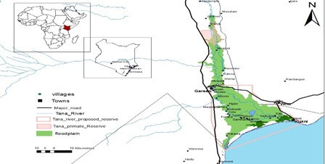
Figure 1: A Map of Tana Delta

2.2 Research Design
A mixed-methods approach was adopted (Bryman, 2016; Creswell & Creswell, 2018) to link hydro-climatic variability with livelihoods and adaptation strategies. Primary data were collected via household surveys, focus group discussions (FGDs) and key informant interviews (KIIs), while secondary data included satellite imagery and climatic records (Gao, 1996; McFeeters, 1996; Rokni et al., 2014).
- Household surveys: 382 households across three zones
- FGDs: Three in total, one per zone (Mnazini, Garsen, Kipini)
- KIIs: 10 interviews with community leaders, water officers, county environment officials, and NGO representatives
This design allowed the integration of quantitative ecological data with qualitative livelihood and adaptation insights.

2.3 Hydro-Climatic and Remote Sensing Analysis
Climatic and remote sensing analyses were integrated with household and institutional data to assess the effects of water resource variability on livelihoods and adaptation strategies. Climatic data (rainfall and temperature) covering 1993–2023 were obtained from the Kenya Meteorological Department and analyzed using linear regression and time-series methods (Adhikari et al., 2015).
Landsat imagery from Landsat 5 TM, Landsat 7 ETM+, and Landsat 8 OLI (1995–2023; 30 m resolution) was processed to derive the Normalized Difference Water Index (NDWI) and Normalized Difference Vegetation Index (NDVI). NDWI quantified surface-water availability, while NDVI assessed vegetation greenness. Both indices were explicitly linked to ecological status and livelihood impacts, including crop yields, fish stocks and pasture quality. ArcGIS and QGIS were used for spatial mapping, and seasonal trends were analyzed for the long-rains (March–May) and short-rains (October–December) period.

2.4 Household Surveys
Structured questionnaires were administered to 382 households using stratified random sampling based on KNBS census data (KNBS, 2009; Cochran, 1977). The sample size ensured a 95% confidence level with a ±5% margin of error. Survey questions covered water access, livelihood activities, perceived impacts of hydro-climatic variability and household adaptation strategies.

2.5 Focus Group Discussions (FGDs) and Key Informant Interviews (KIIs)
FGDs explored community perspectives on water access, climate impacts, livelihood challenges and adaptation strategies. Three FGDs were conducted in Mnazini, Garsen and Kipini. Participants were purposively selected and stratified by gender, age and livelihood type (Krueger & Casey, 2015; Morgan, 1998). Discussions were audio-recorded, transcribed, and thematically analyzed.
KIIs involved community leaders, water officers, county environment officials and NGO representatives to validate FGD findings and provide institutional perspectives. Semi-structured protocols were used and thematic analysis identified adaptation strategies and governance challenges (Patton, 2015).

2.6 Data Analysis
Quantitative survey data were coded and analyzed in SPSS (version 25) to generate descriptive statistics, frequencies, percentages, and cross-tabulations (Bryman, 2016). Correlation and regression analyses were conducted at a 95% confidence level (α = 0.05) to test relationships between key variables.
Qualitative data from FGDs and KIIs were analyzed in NVivo, following Braun and Clarke’s (2006) thematic framework. NDWI and NDVI temporal trends were visualized in ArcGIS to link climatic variability with livelihood dynamics. Regression analyses were used to assess relationships between water availability, vegetation status and livelihood outcomes.

2.8 Data Availability
The datasets generated and analyzed during this study are available from the corresponding author on reasonable request.

3 Results
3.1 Spatial and Seasonal Patterns of Water Resource Variability
This section corresponds to Objective 1: To quantify the spatial and seasonal patterns of water resource variability in the Tana Delta from 1995 to 2023 using remote sensing and climatic data. Climatic trends were analyzed from Kenya Meteorological Department records, while Landsat imagery (30 m resolution) was used to compute NDWI and NDVI indices, providing quantitative measures of surface water availability and vegetation greenness.
3.1.1 Rainfall and Temperature Trends (1995–2023)
Analysis of 30 years of climatic data from the Kenya Meteorological Department and Tana River hydrological stations revealed significant spatial and temporal variability in rainfall and temperature across the delta (Mati et al., 2010). The findings, derived using linear regression and time-series methods (Section 2.3), indicate:
- Mean annual rainfall: 350–900 mm, with a bimodal distribution corresponding to long rains (March–May) and short rains (October–December) (Awuor et al., 2015).
- Declining rainfall reliability: Prolonged dry spells, irregular onset and cessation of rains have been observed over the study period (Adhikari et al., 2015).
- Trend analysis: Rainfall declined by approximately 8–12% between 1993–2002 and 2013–2023.
- Extreme events: Droughts occurred in 2000–2009 and 2017–2023, while El Niño-related floods were recorded in 1997–1998 and 2011–2012 (Nicholls et al., 2020).
- Temperature trends: Warming of ~1.2 °C, with minimum temperatures rising faster than maximum temperatures (FAO, 2021).
These climatic changes have increased evapotranspiration, reduced soil moisture and intensified the drying of shallow water bodies, creating significant hydrological stress across the delta. The results are illustrated in Figure 2.

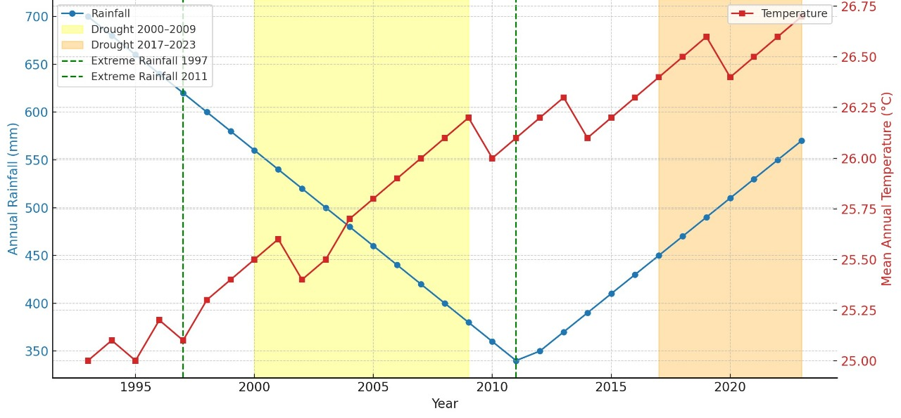
Figure 2: Trends in Annual Rainfall and Temperature in the Tana Delta (1993–2023)

3.1.2 Remote Sensing Analysis of NDWI and NDVI (1995–2023)
Surface water availability and vegetation greenness were quantified using NDWI and NDVI derived from Landsat imagery (30 m resolution, 1995–2023). NDWI trends were used to assess changes in surface water persistence, while NDVI trends reflected vegetation dynamics relevant to crop production, pasture quality and fish habitat.
Key findings include:
- Overall trends: NDWI declined by ~21% and NDVI declined by ~17%, indicating reduced water availability and vegetation greenness across the delta.
- Upper Delta (Mnazini): NDWI ~70%, NDVI ~75%; surface water and vegetation remained relatively stable.
- Middle Delta (Garsen): NDWI declined by 45%, NDVI by 23%; this zone experienced the highest water stress.
- Lower Delta (Kipini): NDWI declined by 40%, NDVI by 28%; inland areas were affected by saline intrusion and reduced recharge.
Regression analysis confirmed a significant correlation between rainfall decline and NDWI reduction (r = 0.68; p < 0.05), linking remote sensing observations directly to climatic variability. Spatial and seasonal trends were visualized using ArcGIS and QGIS, focusing on long rains (March–May) and short rains (October–December)
Table 1 below illustrates the spatial and seasonal patterns of rainfall, temperature, NDWI and NDVI across the Tana Delta, providing a visual link between hydro-climatic variability and ecosystem dynamics.
Table 1: Patterns of Surface Water Variation by Season and Location (1995–2023)
Delta Zone | NDWI Water Persistence (%) | NDVI Vegetation Stability (%) | Dominant Water Sources | Seasonal Characteristics
Upper Delta (Mnazini) | ~70 | ~75 | River channels, piped supply, shallow wells | Stable during long and short rains; minor seasonal variability
Middle Delta (Garsen) | 55 → 30 (−45%) | 65 → 50 (−23%) | Boreholes, river abstraction, seasonal pans | High variability; flooding in long rains, poor recovery in short rains
Lower Delta (Kipini) | 60 → 35 (−40%) | 58 → 42 (−28%) | Tidal creeks, shallow wells, brackish boreholes | Coastal stability; inland decline due to saline intrusion and recharge loss

Integration:

Declining rainfall, rising temperatures and NDWI/NDVI changes collectively indicate progressive hydro-climatic transformation across the delta. Regression analysis confirms a significant correlation between rainfall decline and NDWI reduction (r = 0.68; p < 0.05).
3.2 Impacts of Water Variability on Major Livelihood Activities
This section addresses Objective 2: “To assess the impacts of water variability on farming, fishing, and pastoralism.”
3.2.1 Farming Livelihood Impacts
Farming in the Tana Delta remains predominantly rain-fed and highly sensitive to hydro-climatic fluctuations. Household surveys indicate that 37% of households rely primarily on crop production, concentrated in floodplains traditionally sustained by seasonal inundation. However, erratic rainfall, reduced flood frequency and declining soil moisture have compromised this system (Mati et al., 2010).
Analysis of NDWI and NDVI time series (Landsat 30 m, 1995–2023) shows a progressive reduction in floodplain water coverage and vegetation greenness, corresponding to decreased crop yields. A ~17% NDVI decline aligns with an estimated 15–20% reduction in average maize and rice yields, as reported by household respondents and field observations. Interviews and key informant data confirm that formerly productive floodplain areas now experience delayed floods or complete dry spells, while inland zones suffer prolonged droughts.
Irrigated farming accounts for < 10% of households, limited by deteriorating canal infrastructure and low river discharge during dry seasons (Adhikari et al., 2015). Spatial mapping indicates a gradual shift of agricultural activity toward residual-moisture zones, where communities rely on shallow wells and small water pans.
To sustain livelihoods, farmers increasingly supplement crop production with petty trade, charcoal production, and motorbike transport reflecting early adaptation strategies to hydro-climatic stress (Bryman, 2016). The findings are illustrated in Figure 3.

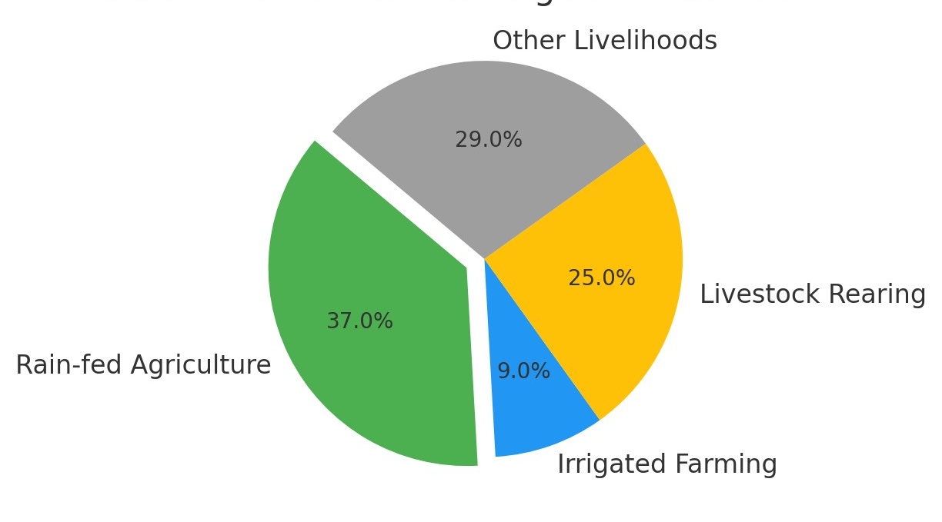

Figure 3: Spatial distribution of farming and supplementary livelihoods under water-stress conditions in the Tana Delta

3.2.2 Fishing Livelihood Impacts
Fishing supports approximately 37% of households, with livelihoods closely tied to surface-water dynamics. Historically, seasonal flooding and freshwater inflows sustained estuarine and floodplain fisheries, particularly during long rains when nutrient mixing enhanced productivity (Duvail et al., 2012).
NDWI analysis (Landsat 30 m, 1995–2023) reveals a marked reduction in inundated floodplain areas (−21% overall), shortening breeding seasons and reducing fish stocks. In the Lower Delta, saline intrusion and sedimentation have further diminished freshwater fish habitats. Estuarine fishing, practiced by 22% of households, now faces declining catches and increased operational costs as fishers travel further offshore (Maithya et al., 2020).
Focus Group Discussions (FGDs) in Kipini and Garsen specifically reported declining tilapia and catfish catches and noted that drying floodplains have altered traditional fishing calendars. As a result, some groups have shifted toward mangrove harvesting, small-scale trading and aquaculture initiatives (Adhikari et al., 2015). Figure 4 illustrates these seasonal patterns.

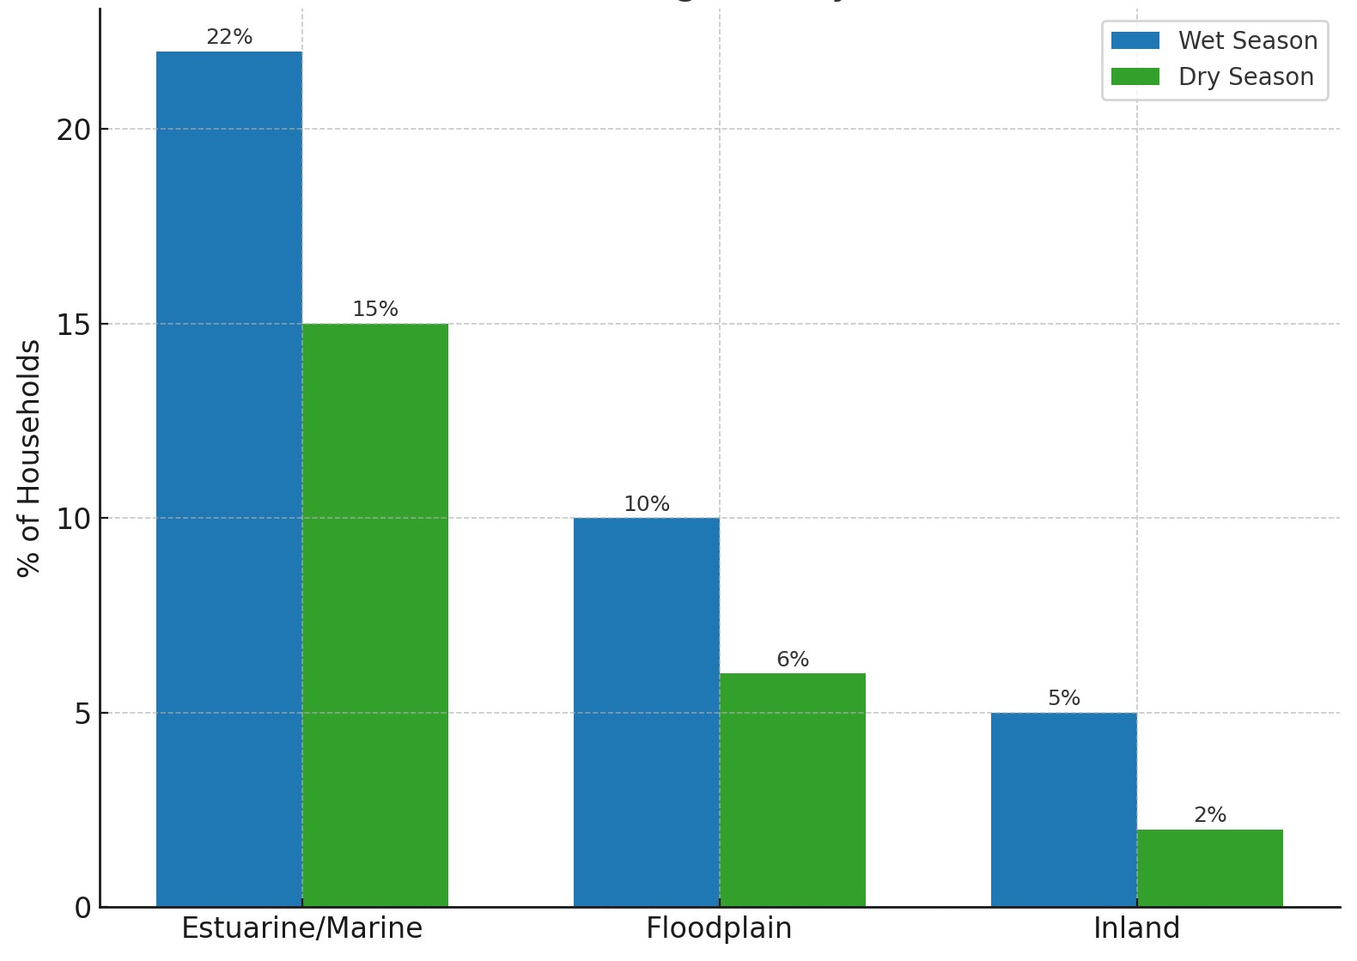

Figure 4: Seasonal distribution of fishing activities in the Tana Delta and their dependence on water availability

3.2.3 Pastoralist Livelihood Impacts
Pastoralism represents 22% of household livelihoods, mainly in inland and upper delta zones. Livestock systems are highly sensitive to water scarcity, with grazing mobility dependent on seasonal water availability.
Household survey data (n = 382) showed significant reductions in pasture quality (p = 0.037) and water-point reliability (p = 0.041) during major drought years. NDVI analysis (1995–2023) confirmed a linear decline in vegetation greenness across pastoral rangelands (R² = 0.63), corresponding to reduced forage biomass and herd productivity.
During prolonged dry spells, herders migrate toward riverine or coastal areas, often causing resource conflicts with farmers and fishers. FGDs from Mnazini highlighted increased cattle mortality during the 2017–2023 drought due to depleted pasture and stagnant water sources.
These patterns illustrate livelihood transformation driven by persistent hydro-climatic stress, accompanied by ecosystem degradation and reduced livelihood security. The findings are summarized in Figure 5.

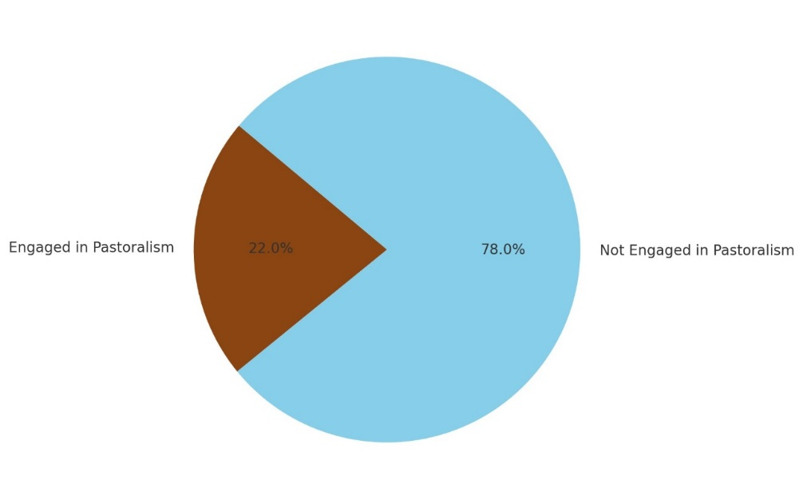
Figure 5: Proportion of households engaged in pastoralism compared with other water-dependent livelihoods
3.2.4 Livelihood Diversification as an Adaptation Strategy
Livelihood diversification has emerged as a critical adaptation mechanism in response to climate-induced water resource variability and the declining reliability of traditional, water-dependent livelihoods in the Tana Delta. Farming (36%), pastoralism (21%), and fishing remain dominant activities; however, their viability is increasingly undermined by erratic rainfall, prolonged droughts, saline water intrusion and reduced river flows associated with hydro-climatic variability.
Household survey data (n = 382), supported by Focus Group Discussions (FGDs) and Key Informant Interviews (KIIs), reveal that households are supplementing these core livelihoods with alternative income-generating activities such as petty trade (17%), casual labor (14%), charcoal production (11%) and small-scale businesses (9%). These percentages are derived from the household survey data. The diversification aims to reduce dependency on unstable water-based systems.
For example:
- In Mnazini and Garsen, recurrent crop failure and livestock mortality have forced households to adopt informal labor and small-scale trading.
- In Kipini, siltation of river channels and rough sea conditions have driven shifts toward mangrove harvesting and residual moisture farming.
This diversification reflects a proactive adaptation pathway, enhancing livelihood resilience to hydrological stress. However, certain measures, such as charcoal production, pose environmental risks, potentially creating negative feedback loops that exacerbate ecosystem degradation and undermine long-term adaptation.
Qualitative evidence from FGDs and KIIs provides further insights into household-level adaptation:
• A female farmer in Garsen stated:
“We can no longer rely solely on the rains. Some years our fields remain dry even when the long rains start. “We have started selling small goods and working for neighbors to survive.”
• A male pastoralist in Mnazini explained:
“The river water is more unpredictable now. We move our cattle to different areas and sometimes rely on boreholes, but these are limited.”
• A community leader in Kipini noted:
“Fish are fewer in the estuary during the dry season. Many rely on mangrove harvestings to supplement income.”
These insights confirm that households adopt flexible, context-specific adaptation strategies, combining traditional water-dependent livelihoods with alternative income sources. The findings are illustrated in Figure 6, which presents the spatiotemporal patterns of water resource variability and associated livelihood effects
.

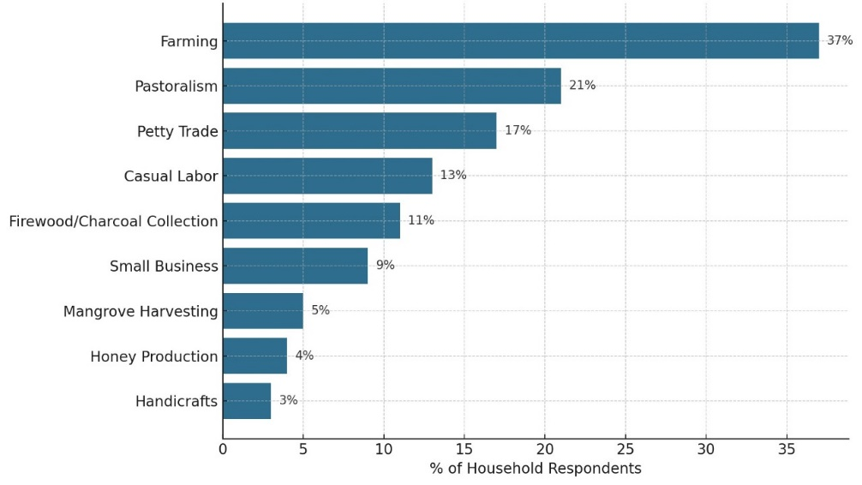

Figure 6: Distribution of primary and supplementary livelihood strategies in the Tana Delta under water stress conditions

3.2.5 Coping Mechanisms During Food Insecurity
Figure 7 illustrates that climate-induced water variability has severe implications for household food security in the Tana Delta. Percentages reported in this section are derived from the household survey (n = 382), supplemented by insights from Focus Group Discussions (FGDs) and Key Informant Interviews (KIIs).
Survey findings indicate that farming-dependent households are the most affected, with 60% reporting food insecurity, followed by pastoralist households (58%). Other water-sensitive activities, including casual labor (54%), charcoal production (52%), and mangrove harvesting (50%), also exhibit high vulnerability. Households engaged in diversified income sources, such as petty trade (48%), honey production (45%) and small businesses (43%) likewise report notable exposure to food insecurity.
Insights from FGDs reinforce these patterns, linking food shortages to declining river flows, saline boreholes, and increasingly erratic rainfall.
- In Mnazini, participants identified crop failures caused by drought and flooding as primary drivers of hunger.
- In Garsen, respondents highlighted borehole salinity and shifting river channels as major challenges.
- In Kipini, fishing households though slightly less food insecure—reported that unpredictable rains and limited irrigation infrastructure remain critical constraints to stable food production.
These findings demonstrate that households dependent on water-based livelihoods bear the greatest burden of food insecurity, prompting coping strategies such as temporary migration, engagement in informal labor and dietary adjustments. However, these measures provide only short-term relief, underscoring the urgent need for climate-resilient water management and adaptive livelihood strategies to secure food systems in the Tana Delta.
Key observations from FGDs:
- In Garsen, borehole salinity and shifting river channels exacerbate food insecurity.
- In Mnazini, crop failures caused by drought and delayed floods were cited as primary drivers of hunger.
- In Kipini, fishing households reported that unpredictable rains
Common coping strategies include temporary migration to areas with better water access, casual labor, petty trade and dietary adjustments relying on stored or wild foods.
Climatic Context: Temperature trends indicate a warming of approximately 1.2°C, with minimum temperatures rising faster than maxima, further intensifying hydrological stress and impacting water-dependent livelihoods.

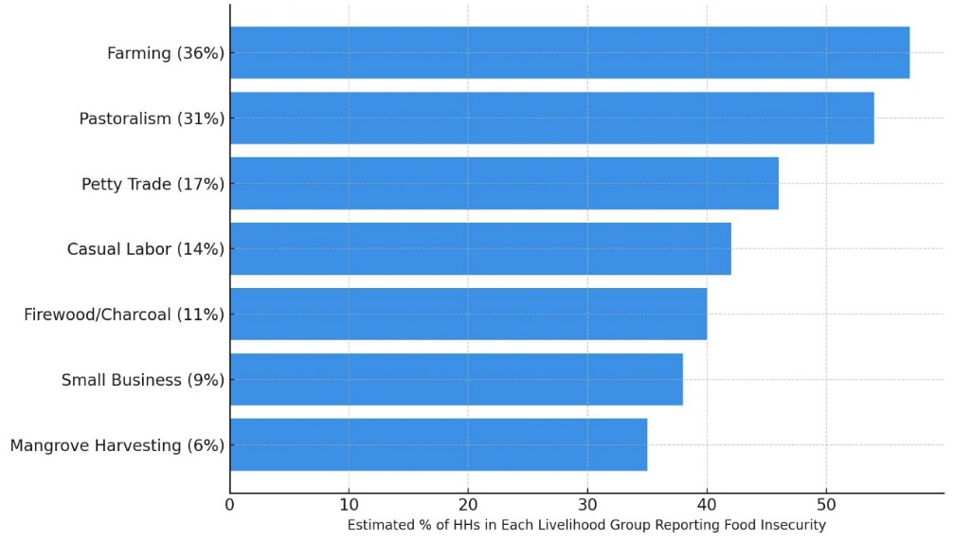

Figure 7: Food insecurity patterns linked to water stress across major livelihood systems in the Tana Delta

3.3 Adaptation Insights and Institutional Perspectives
Key Informant Interviews (KIIs) revealed that government support for small-scale irrigation and borehole maintenance remains limited, while weak enforcement of water allocation rules contributes to conflicts among farmers, pastoralists and fishers. Respondents emphasized the need for climate-smart initiatives such as drought-tolerant crops, mangrove restoration, and community-based water governance to strengthen adaptive capacity.
Integrated findings from surveys, FGDs, and KIIs indicate that households diversify livelihoods to reduce dependency on unstable water sources. Adaptation strategies are largely reactive, driven by necessity rather than planned resilience. Food security remains highly vulnerable to hydro-climatic variability, highlighting the importance of institutional support and effective water governance as critical enablers for sustainable adaptation in the Tana Delta.
4. Discussion
This study examined hydro-climatic variability in the Tana Delta and its implications for water-dependent livelihoods, framed around three key objectives: quantifying spatial and seasonal water variability, assessing impacts on livelihoods and exploring adaptation strategies. The discussion interprets NDWI and NDVI trends in the context of broader regional climate change and livelihood resilience.
  - Spatial and Seasonal Patterns of Water Resource Variability
Analysis of three decades of climatic and remote sensing data revealed clear spatial heterogeneity in water availability and vegetation greenness across the Tana Delta. Overall declines in NDWI and NDVI reflect prolonged dry spells, reduced rainfall reliability, rising temperatures, and increased evapotranspiration. The Middle Delta (Garsen) emerged as the most vulnerable, followed by the Lower Delta (Kipini), while the Upper Delta (Mnazini) remained relatively stable.
These patterns mirror broader trends observed in other East African deltas, such as the Rufiji (Tanzania) and Nyando (Kenya), where low-lying floodplains face intensified droughts, salinity intrusion and altered flood regimes (Niang et al., 2014; Mutie et al., 2021). Mechanistically, declining river flows and estuarine sedimentation reduce both surface water persistence and groundwater recharge, amplifying hydrological stress in downstream zones. Such spatial heterogeneity underscores the importance of targeted water management interventions across deltaic landscapes.
  - Impacts of Water Variability on Major Livelihood Activities
Declining water and vegetation availability have direct and compounding effects on the Tana Delta’s primary livelihoods:
- Farming: Rain-fed agriculture is increasingly constrained by reduced floodplain inundation and soil moisture deficits. Communities have shifted toward residual-moisture zones and rely on shallow wells and small water pans, highlighting the vulnerability of traditional cropping systems.
- Fishing: Reduced freshwater inflows, estuarine siltation, and salinity intrusion shorten breeding seasons and reduce fish stocks, forcing households to supplement income with mangrove harvesting or small-scale aquaculture.
- Pastoralism: Water scarcity and declining pasture quality limit livestock mobility and increase conflict over grazing areas, particularly during prolonged droughts.
The convergence of environmental stressors with socio-economic pressures demonstrates double exposure, where communities are simultaneously challenged by climatic variability and livelihood constraints (Leichenko & O’Brien, 2008). Compared with other East African deltas, Tana Delta communities face similar threats from erratic flooding, saline intrusion, and ecosystem degradation, though specific spatial patterns vary due to local hydrology and land use.
  - Livelihood Diversification and Adaptation
Households have responded to hydro-climatic stress through diversification. While farming, fishing, and pastoralism remain central, alternative income sources petty trade, casual labor, charcoal production, and small businesses partially mitigate vulnerability.
However, adaptation is largely reactive, driven by immediate survival needs rather than strategic resilience. Charcoal production and other environmentally intensive activities, while supporting livelihoods in the short term, risk exacerbating ecosystem degradation, creating negative feedback loops that undermine long-term adaptation. Limited institutional support, weak enforcement of water allocation and low investment in climate-resilient infrastructure further constrain effective adaptation.
These findings align with patterns observed in other East African delta regions, where household-level adaptation strategies are constrained by both environmental variability and governance deficits (Mutie et al., 2021; Adhikari et al., 2015)
  - Synthesis and Implications
The integration of climatic trends, remote sensing data and livelihood assessments highlights that hydro-climatic variability drives both ecological and socio-economic transformations in the Tana Delta. Zone-specific vulnerabilities suggest the need for targeted interventions:
- Middle Delta: urgent water scarcity and flood management measures.
- Lower Delta: salinity control, freshwater augmentation, and estuarine restoration.
- Upper Delta: continued protection of perennial water sources.
Policy and development efforts should prioritize climate-resilient infrastructure, sustainable livelihood diversification and integrated water resource management, supporting households to cope with both current and projected hydro-climatic variability. These measures can enhance adaptive capacity, secure food systems and maintain ecosystem health in the face of climate change.

5 Conclusion
This study demonstrates that climate-induced hydro-climatic variability is a major driver of ecological and livelihood transformations in Kenya’s Tana Delta. Over the past three decades, declining rainfall (8–12%) and rising temperatures (~1.2°C) have contributed to a 21% reduction in surface water (NDWI) and a 17% decline in vegetation greenness (NDVI), with the Middle and Lower Delta zones experiencing the greatest stress. These changes have significantly affected water-dependent livelihoods, undermining crop production, reducing fish stocks and degrading pastures and have forced households to diversify into petty trade, casual labor, charcoal production and small-scale businesses.
While livelihood diversification offers partial resilience, adaptation remains largely reactive, constrained by limited institutional support, inadequate water governance, and environmental pressures such as salinity intrusion and soil degradation. The findings highlight the urgent need for integrated water resource management, climate-resilient infrastructure and targeted livelihood support to enhance food security and resilience in deltaic communities.
The Tana Delta exemplifies how hydro-climatic variability intersects with socio-economic vulnerabilities, emphasizing the importance of evidence-based strategies for sustainable adaptation to climate change in delta regions.

Limitations
This study has several limitations that should be considered when interpreting the results:
- Household surveys relied partly on recall, which may introduce reporting bias.
- NDWI and NDVI analyses are constrained by the spatial and temporal resolution of remote sensing data, potentially overlooking fine-scale hydrological or vegetation changes.
- Key informant interviews (KIIs) were limited in number, which may restrict the representativeness of qualitative insights.
Future research could address these limitations by incorporating higher-resolution remote sensing data, longitudinal household monitoring and broader qualitative engagement.

Recommendations
Based on the findings, the following actions are proposed to address climate-induced water resource variability and enhance livelihood adaptation in the Tana Delta:
- Integrated Water Resource Management: Develop and implement strategies for sustainable management of river flows, wetlands, and groundwater to improve water availability and reduce vulnerability of water-dependent livelihoods.
- Climate-Resilient Infrastructure: Invest in irrigation systems, water storage facilities, and flood-control measures to buffer communities against rainfall variability, droughts, and saline intrusion.
- Sustainable Livelihood Diversification: Promote environmentally friendly alternative income sources, such as aquaculture, agroforestry and eco-tourism, to reduce dependence on high-risk, water-sensitive activities.
- Community-Based Adaptation and Capacity Building: Strengthen local knowledge, participatory water governance and training programs to enable communities to implement context-specific adaptive strategies effectively.
- Policy and Institutional Support: Enhance coordination among government agencies, NGOs, and local communities to provide timely technical and financial support, enforce water allocation rules and reduce conflicts over scarce resources.
- Monitoring and Early Warning Systems: Establish robust climate, hydrological and remote sensing monitoring systems to provide early warnings for floods, droughts and salinity risks, facilitating proactive adaptation measures.

Ethical Approval and Consent:

The study obtained ethical approval from the Kenyatta University Ethics Review Committee (Approval 11/July/2025). Informed consent was obtained from all participants, and confidentiality and anonymity were strictly maintained.

Disclaimer (Artificial intelligence)
Author(s) hereby declare that NO generative AI technologies such as Large Language Models (ChatGPT, COPILOT, etc.) and text-to-image generators have been used during the writing or editing of this manuscript.

References
- Awuor, C. B., Orindi, V. A., & Adwera, A. O. (2015). Climate change and coastal cities: Building adaptive capacity for resilience to climate change in Kenya. Environment and Urbanization, 20(1), 231–242. https://doi.org/10.1177/0956247808089158
- Bryman, A. (2016). Social Research Methods (5th ed.). Oxford University Press.
- Creswell, J. W., & Creswell, J. D. (2018). Research Design: Qualitative, Quantitative, and Mixed Methods Approaches (5th ed.). SAGE Publications.
- Duvail, S., Médard, C., Hamerlynck, O., & Nyingi, D. W. (2012a). Land and water grabbing in an East African coastal wetland: The case of the Tana Delta. Water Alternatives, 5(2), 322–343. https://www.water-alternatives.org/index.php/volume5/v5issue2/172-a5-2-8/file
- Food and Agriculture Organization of the United Nations (FAO). (2021). The State of the World’s Land and Water Resources for Food and Agriculture. https://www.fao.org/3/cb7654en/cb7654en.pdf
- Gao, B.-C. (1996). NDWI: A normalized difference water index for remote sensing of vegetation liquid water from space. Remote Sensing of Environment, 58(3), 257–266. https://doi.org/10.1016/S0034-4257(96)00067-3
- Hirji, R., & Davis, R. (2009). Environmental flows in water resources policies, plans, and projects: Findings and recommendations. Washington, DC: World Bank. https://hdl.handle.net/10986/2635
- Kothari, C. R. (2004). Research Methodology: Methods and Techniques (2nd ed.). New Age International Publishers.
- Maithya, J. K., Ming’ate, F. L., & Letema, S. C. (2022). The impact of wetland utilisation on provisioning ecosystem services in Nyando Wetland, Kenya. Journal of Environmental Assessment Policy and Management, 24(1), 2250023. https://doi.org/10.1142/S1464333222500234
- Maithya, J., Ming’ate, F., & Letema, S. (2020). A review on ecosystem services and their threats in the conservation of Nyando Wetland, Kisumu County, Kenya. Tanzania Journal of Science, 46(3), 711–722.
- Mati, B. M., Mutie, S., Gadain, H., Home, P., & Mtalo, F. (2010). Land use changes in response to climate and water availability: A case study of the Tana River Basin, Kenya. Journal of Hydrology, 393(3–4), 318–326. https://doi.org/10.1016/j.jhydrol.2010.08.020
- McFeeters, S. K. (1996). The use of the normalized difference water index (NDWI) in the delineation of open water features. International Journal of Remote Sensing, 17(7), 1425–1432. https://doi.org/10.1080/01431169608948714
- Ming’ate, F. L. M. (2014). Combining ethnography and case study research designs in studying forestry co-management approaches. Journal of Human and Social Science Research, 3(2), 67–79. http://ir-library.ku.ac.ke/handle/123456789/14504
- Nicholls, R. J., et al. (2010). Sea-level rise and its impact on coastal zones. Science, 328, 1517–1520. https://doi.org/10.1126/science.1185782
- Adhikari, U., Nejadhashemi, A. P., & Herman, M. R. (2015). A review of climate change impacts on water resources in East Africa. Transactions of the ASABE, 58(6), 1493-1507.
- Omondi, P., Nyangena, W., & Wekesa, C. (2021). Water resource variability and adaptation strategies in East African river basins. Water, 13(5), 620. https://doi.org/10.3390/w13050620
- Patton, M. Q. (2015). Qualitative Research & Evaluation Methods (4th ed.). SAGE Publications.
- Rokni, K., Ahmad, A., Selamat, A., & Hazini, S. (2014). Water feature extraction and change detection using multitemporal Landsat imagery. Remote Sensing, 6(5), 4173–4189. https://doi.org/10.3390/rs6054173

