Biodiversity of Bird Species in the Work Area
PT. Sinar Mas Agro Resources and Thecnology Tbk., Papua Region

A B S T R A C T
The research aims to determine the biodiversity of bird species in the work area of PT. Sinar Mas Agro Resources and Technology Tbk., Papua Region. The research was conducted in July – December 2024 in the High Conservation Value Area (HCV) owned by PT. Sinar Kencana Inti Perkasa (SKIP) and PT Sumber Indah Perkasa (SIP) Papua Lereh Region, Kaureh District, Jayapura Regency. The results of the inventory of bird diversity and population density showed that there were 59 species of birds from the Acipitridae family, 7 species from the Psittaculidae family, and 4 species from the Columbidae family. The observation location with the highest number of individuals was found at station A, namely 24 types from 15 families; Station G as many as 18 types from 10 families; and Station B as many as 24 species from 13 families The bird diversity index values for all locations ranged from medium to high with a Shannon-Wienner index value H' = 2.590 – 3.681. The highest score was at station F with H'= 3.6811station I with H'= 3.543; and station B with H'= 3.201. Based on their conservation nature, 42 species of birds are in protected status based on applicable laws and regulations, 58 species are classified as LC and NT categories according to IUCN, 37 species are classified as Appendix I and II categories of CITES, 14 species are classified as endemic birds of Papua and 2 types of migratory birds. The Yellow Paradise Bird (Paradiseae minor) which is an endemic bird was found at 7 observation stations.

Keywords: Biodiversity, Birds, PT. Sinar Mas Agro Resources and Technology Tbk.,
Papua Region

Introduction
Indonesia's biodiversity ranks second in the world after Brazil. A total of 5,131,100 biodiversity is recorded in the world, 15.3% of which is found in Indonesia. The Land of Papua accounts for 50% of Indonesia's total biodiversity wealth. The lowland rain forest and mangrove and mountain forest ecoregions are unique complexes in Papua. Such conditions are certainly a source of support and have an influence on the existence of biodiversity in northern Papua, in addition to the existing culture and social communities. The fauna diversity is a form of adaptation over centuries to ecosystems and vegetation that are used as fauna habitats of various taxa. For example, mammals, birds, fish, reptiles and insects taxa with a high level of diversity in Papua (HCVF, 2010).
Indonesia has a wealth of very awesome bird species. Data from Conservation International-Indonesia (2011) states that Indonesia has 17% of all species of birds in the world. The number of bird species in Indonesia in 2014 increased dramatically to 1,666 species of birds. In fact, in 2013 Indonesia was recorded to have 1,605 species of birds. The addition is mostly the result of the separation of existing species, due to differences in morphology or sound based on the results of the latest research (Burung Indonesia, 2014).
Papua not only has a high species richness, but also has a high level of species endemism. The endemism of Papuan birds is the highest compared to other islands in Indonesia. Of the approximately 426 species of birds endemic to Indonesia, more than 50 species are scattered on the island of Papua.
In 2013, the IUCN International Union for Conservation of Naturestated that some animals have even been endangered and their status is on the verge of extinction.The IUCN hasreleased several endemic animals of Papua that have been included in the redlist, both animals and plants. As is known in Papua there are approximately 38 species of Paradise scattered in Papua, several types of Paradise have been included in the list. This is certainly very reasonable when viewed from the results of many studies conducted by Academics, the Government and Non-Governmental Organizations (NGOs) who care aboutthe biodiversity of KEHATI in Papua.
WWF Papua research in 2000 in Yapen found that in each natural expanse of one square kilometer there were six birds of paradise. If multiplied by the area of 2,050 square kilometers (the area of Yapen), the total bird of paradise is around 12,300 birds. Meanwhile, the results of the last study in March 2012 conducted by the Papua BKSDA in one of the habitat locations of the paradise are known that every one square kilometer only 2-3 paradise birds are found. In fact, in 2000-2005 10-15 were still found (Kompas, 2012).
PT. Sinar Mas Agro Resources and Technology Tbk, is one of the pillars of the Sinarmas group's business in the oil palm plantation sub-sector and processing industry that has been integrated from upstream and downstream. The company has business operations in Indonesia, including in Papua Province. PT. Sinar Kencana Inti Perkasa (SKIP) and PT Sumber Indah Perkasa (SIP) are two member companies operating in Kaureh District, Jayapura Regency. Thus this company has moved as one of the development agents to improve the welfare of the community, especially around Kaureh District, Jayapura Regency. The presence of this company has opened jobs for the community and opened access that has been isolated with road conditions that are difficult for motorized vehicles to pass. However, as a company engaged in oil palm plantations that utilizes natural forests as oil palm plantation land, the existence of this company also has an impact on reducing the biodiversity found in forest areas that have changed their function, including the diversity of bird species. Thus, research on the diversity of bird species in the company's concession area is very important to be carried out as one of the efforts to manage the environment in a sustainable manner while still having a positive impact on the welfare of the surrounding community.

Methods
  - Survey design
Primary data collection used a combination method between the point count method (Point and Stand Count) on the parent tree or IPA (Indices Punctuele d'Abundance – Abundance Index at Points) and the path method (Transect) (Bibby et al., 2000). The determination of plot points is based on information on the habitat of birds such as birds of paradise, old cockroaches and parrot sand several other endemic birds on previous observations both by the local community and PT. Sinar Kencana Inti Perkasa (SKIP) and PT. Sumber Indah Perkasa (SIP) Kaureh previously. Shape a circle plot with a 50-meter plot finger, the distance between plots is 200 meters with a plot of 6 plots. So the area of the entire sample plot ± 4 Ha. Furthermore, observation is made silently at a certain point and then records encounters with birds. The parameters measured are the type, number, activity of birds and vegetation use patterns. Observation uses six Point Counts/observation stations. All observation stations are located in a transect path with a length of + 1,800 meters with an observation radius as far as the eye can see and a distance between points (Point Count) of + 200 meters. The observation time span is + 25 minutes, 15 minutes for observation at each point and + 10 minutes is the time to walk to the next observation point. Every type of bird found at any point in the observation line is recorded with all forms of activity. Observations were carried out in the morning at 06.00 — 09.00 WIT and in the afternoon at 15.00 — 17.30 WIT. Observations were made repeatedly 3 times for each observation location. Identification and scientific naming of bird species using the "Bird of New Guinea 2nd edition" Field Guide (Pratt and Beehler, 2015).
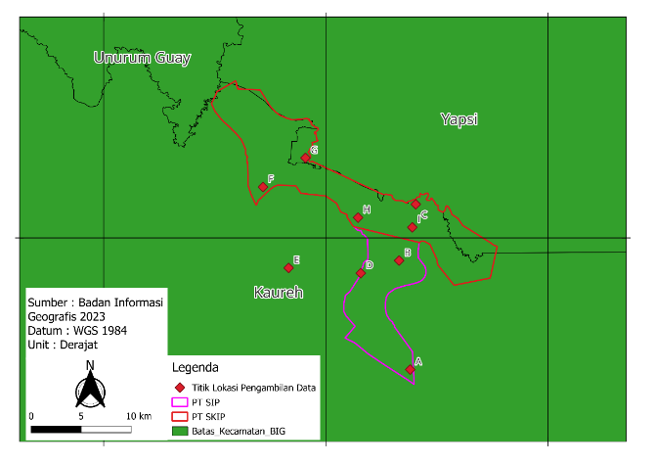
This activity was carried out at the company's location member PT. SMART Tbk. in Kaureh District, Jayapura Regency in the High Conservation Value (HCV) Area owned by PT. Sinar Kencana Inti Perkasa (SKIP) and PT Sumber Indah Perkasa (SIP) Papua Lereh Region, Kaureh District, Jayapura.

Figure 1. Research Location of PT. Sinar Kencana Inti Perkasa (SKIP) and
PT. Sumber Indah Perkasa (SIP)
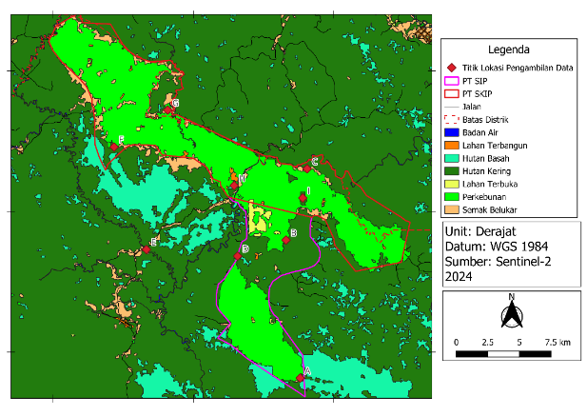

Figure 2. Position of the Research Location with the HCV area PT. Sinar Kencana Inti Perkasa (SKIP) and PT. Sumber Indah Perkasa (SIP), Kaureh

  - Resource availability index
Bird species density can be determined by correlating the plot area with the number of species within and outside the plot. This density is calculated using formula Bibby et al., (1992) as follows:
D = Ln (Ntot/ N2) x (Ntot/(Mxπr 2)

Where :
D : Bird species density per hectare
Ntot : Number of Birds Observed (N1+N2)
N1 : Number of Birds Obderved on Plot
N2 : Number of Birds Observed Outside Plot
M : Amount of Plot
π : Phi (3,14)
r : Jari-jari Plot

The relative abundance of bird species was calculated using the following formula and abundance categories:
$$Relative Abundance \left(KR\right)=\frac{the number of individuals of a species}{number of hours of observation} x 10$$
Table 1. Relative abundance conversion
Number of Individu per 10 hours of observation | Relative Abudance Category
< 0,1 | Seldom
0,1 – 2,0 | Not common
2,1 – 10,0 | Often
10,1 – 40,0 | General
> 40,0 | Abudance

  - Statistical analyses
Data analysis was conducted using quantitative descriptive method to obtain an overview of species richness. Habitat descriptions focused on endemic bird species that are classified as rare and / or have high economic value and aimed to obtanin an overview of the microhabitats of these species.
Data analysis on burrung was carried out qualitatively. Iidentify the conservation status of each species referring to the distribution area, IUCN status, CITES category and protection based on Law No. 5/1990 on the Conservation of Biological Natural Resources and Their Ecosystems, Government Regulation No. 7/1999 on the Preservation of Plant and Animal Species, and Government Regulation No. 8/1999 on the Utilization of Plant and Wildlife Species.
Wildlife conservation status which includes four criteria, namely, roaming area (WJ), globally threatened status based on the 2007 IUCN Redlist category, international trade regulation status according to CITES (Convention on International Trade of Endangered Species of Wild Fauna and Flora) and Protection Status in the state law of the Republic of Indonesia or other laws and regulations that are still in force.
The data was analyzed by overlaying the map and data of the area that had been collected. The process of overlapping data is carried out with the help of software that is commonly used in GIS processes. So that from the analysis, information on sensitive areas was obtained.

Results
The results of the survey at the observation location of bird biodiversity and preferences that are habitats, especially endemic birds, were carried out at 9 observation stations. The location of bird observation and vegetation of bird habitats is focused on conservation areas in the form of High Conservation Value (HCV) areas which are still in the form of natural forests which have been conserved since the beginning of the opening of oil palm plantations and in the forest area outside the HGU to the two companies and still adjacent to the location of the company's HGU.
Table 2. The forest area of the two companies
No | Types of HCV | Area  (Ha) | Area of  PT. SIP (Ha) | Area of  PT. SKIP (Ha)
1 | Sempadan Sungai | 1.534,2 | 529,32 | 1.004,88
2 | Area Berhutan | 5.244,32 | 2.232,1 | 3.012,22
3 | Area Berbukit | 1.202,05 | 360,62 | 841,43
4 | Area Berbatu | 1,6 | 0 | 1,6

Bird observation was carried out at the location of the PT. SIP consists of three observation stations, the HCV area of PT. SKIP was observed at 5 observation stations. Meanwhile, the comparison location was carried out in forests outside the area of the Right to Use (HGU) of the two companies, namely in the forest around Kampung Sisir one observation station. All the monitoring stations in these two companies are HCV (High Conservation Value) areas that have been determined by the company far away must be at the opening of plantation activities, thus all observation areas are forests while at the newly determined HCV location, no observations were made, because the vegetation was still dominated by oil palm plants which were no longer replanted for the replanting of oil palm plants that old (replanting).
Of all the observation stations at the location of HCV PT. SKIP all show the existence of birds that are still quite good, this is when compared to the results of bird observations outside the PT. SKIP this. So overall the results of the field survey for all observation stations are good in the Conservation area of PT SKIP, PT. SIP and Location of Kampung Sisik obtained a total of 59 species of birds from 23 families. The family with the highest number of species that was successfully covered in this survey was the eagle group from the family Acipitridae with a total of 13 types, followed by the parrot group from the family Psittacidae 10 types and group of pigeons from the family Columbidae as many as 5 types.

- Bird Observation Location on Station A
Observation Location A is an observation station with the highest number of bird species and bird pollution found as many as 24 species and 94 individuals. In this location, there is also a population of birds of paradise of the yellow paradise species (Paradiseae minor) which has received the most attention from many people, both in Papua and from outside Papua. This location is dominated by swamp forests with quite tall natural sago plants. With conditions like this, this location is rarely visited by people who hunt animals. In addition to the swamp forest in this location, there are also rivers and dry land in the form of scrub forests that are suitable for bird habitat.
Tabel 3. List of Types, Abundance and Population Density of Birds at the Observation Site of
Station A. HCV Area PT. SIP
No | Local Name | Types of Name | Family | Population |  | Density (ind/Ha) | H’
1 | Yellow-bellied Gerygone | Gerygone chrysogaster | Acanthizidae | 1 |  | 0.33 | 0.05
2 | Elang - Alap Pucat Sosonokan | Accipiter poliocephalus | Acipitridae | 2 |  | 0.67 | 0.09
3 | Elang-laut Dada-putih | Haliaeetus leucogaster | Acipitridae | 2 |  | 0.67 | 0.09
4 | Elang Bondol | Haliastur indus | Acipitridae | 3 |  | 1.00 | 0.12
5 | Elang - Alap Doria | Megatriorchis doriae | Acipitridae | 2 |  | 0.67 | 0.09
6 | Raja Udang | Dacelo gaudichaud | Alcedinidae | 7 |  | 2.33 | 0.21
7 | Rangkong Jantan & Betina | Rhyticeros plicatus | Bucerotidae | 5 |  | 1.67 | 0.17
8 | Kakatua Jambul Kuning | Cacatua galerita | Cacatuidae | 8 |  | 2.67 | 0.23
9 | Kakatua Raja | Probosciger aterrimus | Cacatuidae | 2 |  | 0.67 | 0.09
10 | Kasuari gelambir ganda | Casuarius casuarius | Casuariidae | 1 |  | 0.33 | 0.05
11 | Common Dollarbird | Eurystomus orientalis | cocaciidae | 2 |  | 0.67 | 0.09
12 | Kum-Kum | Ducula pinon | Colombidae | 5 |  | 1.67 | 0.17
13 | Elang | Falco cenchroides | Falconidae | 3 |  | 1.00 | 0.12
14 | Maleo | Megapodius decollatus | Megapodiidae | 2 |  | 0.67 | 0.09
15 | Puff-backed Meliphaga | Meliphaga aruensis | Meliphigidae | 1 |  | 0.33 | 0.05
16 | Pilemon | Philemon meyeri | Meliphigidae | 2 |  | 0.67 | 0.09
17 | Raja Udang | Merops ornatus | Meropidae | 2 |  | 0.67 | 0.09
18 | Cenderawasih kuning | Paradisaea minor | Paradisaeidae | 2 |  | 0.67 | 0.09
19 | Perkici papua | Charmosyna papou | Psittaculidae | 22 |  | 7.33 | 0.35
20 | Nuri Bayan | Eclectus roratus | Psittaculidae | 6 |  | 2.00 | 0.19
21 | Kasturi Kepala-hitam | Lorius lory | Psittaculidae | 5 |  | 1.67 | 0.17
22 | Nuri-kate topi-kuning | Micropsitta keiensis | Psittaculidae | 2 |  | 0.67 | 0.09
23 | Parkisan | Trichoglossus haematodus | Psittaculidae | 6 |  | 2.00 | 0.19
24 | Mata Merah | Aplonis cantoroides | Sturnidae | 6 |  | 2.00 | 0.19
Species Diversity Indeks Shannon-Wienner (H') |  |  |  |  | 2.81

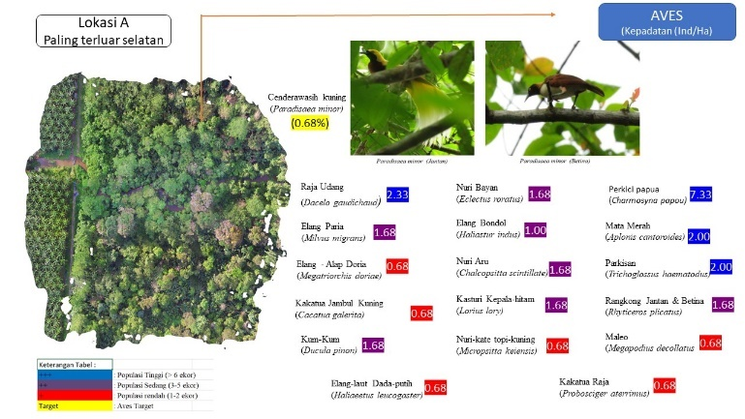
Figure 3. Profile of bird species diversity and density in the habitat at Observation Station A
- Bird Observation Location at Station B
The Observation Station is an observation location with a high number of species diversity. This is because in this location there are many species of top predatory birds that control the population of existing species. Although the bird population is relatively not very dense, in terms of the number of species it is quite rich. This location also gets relatively little disturbance so that the diversity of bird species is relatively high.

Table 4. List of Types, Abundance and Population Density of Birds at the Observation Site of Station B. Conservation Area PT. SIP
No | Local Name | Name of Type | Family | Population | Density (ind/Ha) | H’
1 | Elang alap Kelabu | Accipiter hiogaster | Acipitridae | 2 | 0.67 | 0.12
2 | Elang-alap Tiongkok | Accipiter soloensis | Acipitridae | 3 | 1.00 | 0.16
3 | Elang Bondol | Haliastur indus | Acipitridae | 3 | 1.00 | 0.16
4 | Elang Paria | Milvus migrans | Acipitridae | 3 | 1.00 | 0.16
5 | Raja Udang | Dacelo gaudichaud | Alcedinidae | 2 | 0.67 | 0.12
6 | Rangkong Jantan & Betina | Rhyticeros plicatus | Bucerotidae | 2 | 0.67 | 0.12
7 | Kakatua jambul kuning | Cacatua galerita | Cacatuidae | 2 | 0.67 | 0.12
8 | Kakatua Raja | Probosciger aterrimus | Cacatuidae | 2 | 0.67 | 0.12
9 | Common Dollarbird | Eurystomus orientalis | cocaciidae | 1 | 0.33 | 0.07
10 | Kum-Kum | Ducula pinon | Colombidae | 2 | 0.67 | 0.12
11 | Brown Cuckoo-Dove | Macropygia amboinensis | Colombidae | 2 | 0.67 | 0.12
12 | Orange-bellied Fruit-Dove | Ptilinopus iozonus | Columbidae | 1 | 0.33 | 0.07
13 | Pink-spotted Fruit-Dove | Ptilinopus perlatus | Columbidae | 2 | 0.67 | 0.12
14 | Lowland Peltops | Peltops blainvillii | Cracticidae | 1 | 0.33 | 0.07
15 | Srigunting Lencana | Dicrurus bracteatus | Dicruridae | 2 | 0.67 | 0.12
16 | Elang | Falco cenchroides | Falconidae | 2 | 0.67 | 0.12
17 | Pilemon | Philemon meyeri | Meliphgidae | 2 | 0.67 | 0.12
18 | Raja Udang | Merops ornatus | Meropidae | 2 | 0.67 | 0.12
19 | Cenderawasih kuning | Paradisaea minor | Paradisaeidae | 4 | 1.33 | 0.20
20 | Nuri Aru | Chalcopsitta scintillata | Psittaculidae | 10 | 3.33 | 0.31
21 | Perkici papua | Charmosyna papou | Psittaculidae | 2 | 0.67 | 0.12
22 | Nuri Bayan | Eclectus roratus | Psittaculidae | 2 | 0.67 | 0.12
23 | Kasturi Kepala-hitam | Lorius lory | Psittaculidae | 2 | 0.67 | 0.12
24 | Parkisan | Trichoglossus haematodus | Psittaculidae | 2 | 0.67 | 0.12
Species Diversity Indeks Shannon-Wienner (H') |  |  |  | 3.20

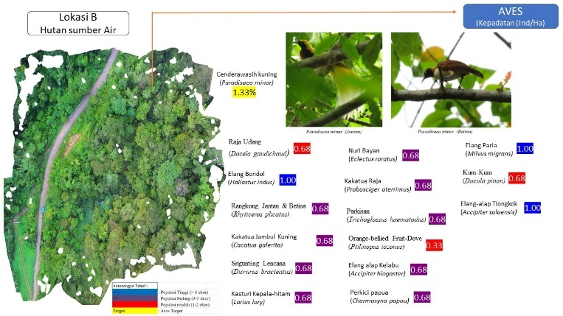
Figure 4. Profile of bird species diversity and density in the habitat at Observation Station B

- Bird Observation Location at Station C
Observation Station C is a natural forest known as the Bat Cave hutn which is located in the conservation area of PT. SKIP. In this location there is a pond with several holes inhabited by thousands of bats of various types and sizes from small to large bats or kalong. From the point of view of vegetation, this location is actually the most ideal location and place of all locations that are suitable for the life of various types of birds, because in this location there are overgrown types of trees that are suitable for the mother bird of paradise and others. The size of the trees in this place is also relatively large with the diameter of the trunk ranging from 50cm to 120 cm. The height of the trees is dominated by trees with a height of 30 – 40 m. However, this location is also often visited by the community with various purposes. The common purpose of people coming to this place is to hunt or catch bats to be consumed as a source of animal protein. However, based on information from the community found at the location when conducting a survey of bury other birds were also carried out such as hunting kum kum type birds for consumption and birds of paradise for sale. Based on observations a few days before the survey was carried out to this place, about 2 days before there was a hunter community that entered. This is one of the causes of the lack of observed birds.
In addition, this place also has mystical value based on the recognition ofthe people who hunt in the location. This can be at leastseenfrom the fact that all documentsin the form of photos were observed both with manual cameras and with drone cameras, all of which were disturbedeven though they had been tried several times.

Table 5. List of Types, Abundance, and Population Density at the Observation Station Location C.
HCV Area PT. SKIP
No | Local Name | Name of Type | Family | Population | Density (ind/Ha) | H’
1 | Elang alap Kelabu | Accipiter hiogaster | Acipitridae | 4 | 1.33 | 0.29
2 | Baza Pasifik | Aviceda subcristata | Acipitidae | 2 | 0.67 | 0.20
3 | Rangkong Jantan & Betina | Rhyticeros plicatus | Bucerotidae | 2 | 0.67 | 0.32
4 | Kaktua Jambul Kuning | Cacatua galerita | Cacatuidae | 5 | 1.67 | 0.32
5 | Kakatua Raja | Probosciger aterrimus | Cacatuidae | 2 | 0.67 | 0.20
6 | Papuan Cicadabird | Edolisoma incertum | Campephagidae | 1 | 0.33 | 0.13
7 | Common Dollarbird | Eurystomus orientalis | cocaciidae | 1 | 0.33 | 0.13
8 | Kum-Kum | Ducula pinon | Colombidae | 5 | 1.67 | 0.13
9 | Maleo | Megapodius decollatus | Megapodiidae | 1 | 0.33 | 0.20
10 | Pilemon | Philemon meyeri | Meliphgidae | 5 | 1.67 | 0.20
11 | Raja Udang | Merops ornatus | Meropidae | 2 | 0.67 | 0.25
12 | Cenderawasih kuning | Paradisaea minor | Paradisaeidae | 3 | 1.00 | 0.32
13 | Nuri Bayan | Eclectus roratus | Psittaculidae | 2 | 0.67 | 0.20
14 | Beo | Mino dumontii | Sturnidae | 2 | 0.67 | 0.20
Species Diversity Indeks Shannon-Wienner (H') |  |  |  |  |  |  | 3.05

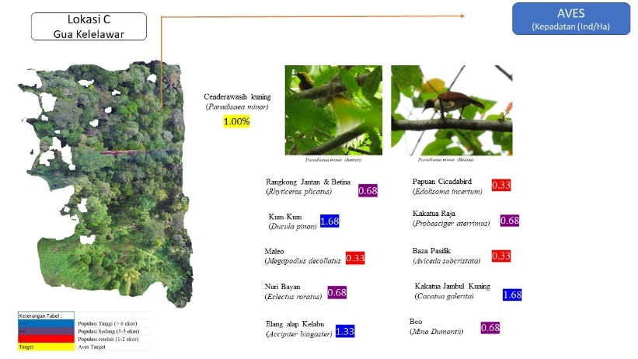
Figure 5 . Profile of bird species diversity and density in the habitat at Observation Station C

- Bird Observation Locaion at Station D
Observation Station D is an HCV located in the source forest of PT. SIP. This forest, although still in the form of a natural forest, is relatively open. Where this area is located, there is a main road to the forest plantation and office. Thus, this location is quite crowded and has a high noise level, but from the observation results of the mother tree which is right on the side of the road, it is still always visited by dozens of species of birds with a large amount of populsion. In this tree, various types of endemic birds and protected birds are also found, such as birds of paradise, yellow-crested cockatoos, king cockatoos, and various types of parrots. With conditions like this, the existing bird species are relatively very susceptible to disturbances.

Tabel 6. List of Species, Abundance, and Population Density at Observation Location Station D,
HCV PT. SIP Conservation Area
No | Local Name | Types of Name | Family | Population | Density (ind/Ha) | H’
1 | Elang-alap Tiongkok | Accipiter soloensis | Acipitridae | 2 | 0.67 | 0.13
2 | Elang Siul | Haliastur sphenurus | Acipitridae | 1 | 0.33 | 0.29
3 | Rajawali Papua | Harpyopsis novaeguineae | Acipitridae | 1 | 0.33 | 0.13
4 | Raja Udang | Dacelo gaudichaud | Alcedinidae | 2 | 0.67 | 0.13
5 | Rangkong Jantan & Betina | Rhyticeros plicatus | Bucerotidae | 2 | 0.67 | 0.20
6 | Common Dollarbird | Eurystomus orientalis | cocaciidae | 2 | 0.67 | 0.13
7 | Kum-Kum | Ducula pinon | Colombidae | 2 | 0.67 | 0.20
8 | Brown Cuckoo-Dove | Macropygia amboinensis | Colombidae | 2 | 0.67 | 0.13
9 | Cabai Papua | Dicaeum pectoral | Dicaidae | 4 | 1.33 | 0.13
10 | Elang | Falco cenchroides | Falconidae | 2 | 0.67 | 0.13
11 | Cenderawasih kuning | Paradisaea minor | Paradisaeidae | 2 | 0.67 | 0.13
12 | Papua Babbler | Garritornis isidorei | Pomatostonidae | 1 | 0.33 | 0.08
13 | Nuri Aru | Chalcopsitta scintillate | Psittaculidae | 2 | 0.67 | 0.08
14 | Perkici papua | Charmosyna papou | Psittaculidae | 2 | 0.67 | 0.08
15 | Nuri-ara Dada-Jingga | Cyclopsitta gulielmitertii | Psittaculidae | 4 | 1.33 | 0.13
16 | Nuri Bayan | Eclectus roratus | Psittaculidae | 2 | 0.67 | 0.23
17 | Nuri-kate topi-kuning | Micropsitta keiensis | Psittaculidae | 5 | 1.67 | 0.13
18 | Nuri Kelam | Pseudeos fuscata | Psittaculidae | 5 | 1.67 | 0.23
19 | Mata Merah | Aplonis cantoroides | Sturnidae | 8 | 2.67 | 0.13
Species Diversity Indeks Shannon-Wienner (H') |  |  |  |  |  |  | 2,77

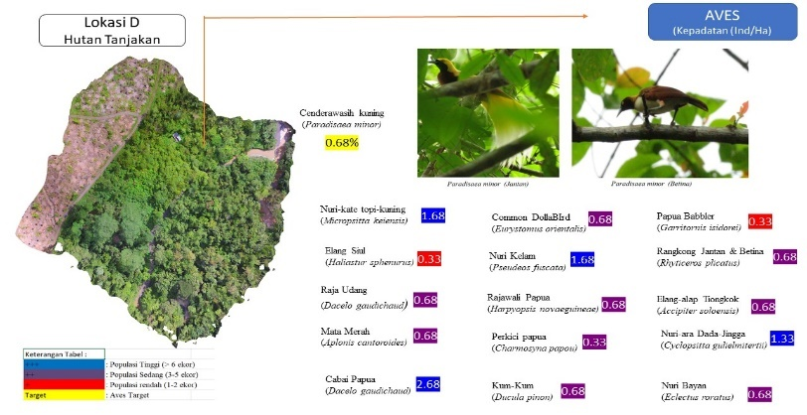
Figure 6. Profile of bird species diversity and density in the habitat at Observation Station D

- Bird Observation Location at Station E.
The location is located in the Kampung Sisik forest which is located outside the HGU of both PT. SKIP and PT. SIP companies. This location was taken to compare the results of bird observations found in the two plantation companies PT. SKIP and PT. SIP above. Observations in the forest area around Kampong Sisik or location E are relatively close to the work area or the Right to Use Business (HGU) of these two companies. Observations are carried out by the same methods and techniques and the area of observation as those carried out in the two companies above. Where observations are made in the natural forests around Kampung Sisik with an observation area of 3 hectares, namely with a point count centerd with an observation circle diameter of 100 meters. So observations are made on 4 Observation Plots.
Based on the results of observations at the Kampung Sisik Forest Station, it shows that the existence of birds is almost no different or still quite good. Even if you look more closely, the number of birds at the HGU location to the two companies is higher than the observation results of the observation station in Kampung Sisik. This is likely to be in the existing observation forest , there are still many community activities in the forest, such as gardening, hunting, and logging activities by the community. Lower bird diversity in this location. However, over all the existence of a relatively diverse variety of bird species is still said to be not much different. The complete bird data can be seen in Table below.
Table 7. List of Types, Abundance, and Population Density in Kampung Sisik Forest Locations
No | Local Name | Types of Name | Family | Population | Density (ind/Ha) | H’
1 | Elang Paria | Milvus migrans | Acipitridae | 2 | 0.67 | 0.16
2 | kakatua Jambul kuning | Cacatua galerita | Cacatuidae | 5 | 1.67 | 0.27
3 | Kakatua Raja | Probosciger aterrimus | Cacatuidae | 4 | 1.33 | 0.24
4 | Black-browed Triller | Lalage atrovirens | Campephagidae | 2 | 0.67 | 0.16
5 | Pink-spotted Fruit-Dove | Ptilinopus perlatus | Columbidae | 5 | 1.67 | 0.27
6 | Maleo Paruh-Hitam | Talegalla fuscirostris | Magapodiidae | 2 | 0.67 | 0.16
7 | Pilemon | Philemon meyeri | Meliphgidae | 4 | 1.33 | 0.24
8 | Glossy Manucode | Manucodia ater | Paradisaeidae | 2 | 0.67 | 0.16
9 | Cenderawasih kuning | Paradisaea minor | Paradisaeidae | 5 | 1.67 | 0.27
10 | Nuri Bayan | Eclectus roratus | Psittaculidae | 2 | 0.67 | 0.16
11 | Kasturi Kepala-hitam | Lorius lory | Psittaculidae | 8 | 2.67 | 0.33
12 | Parkisan | Trichoglossus haematodus | Psittaculidae | 1 | 0.33 | 0.10
13 | Mata Merah | Aplonis cantoroides | Sturnidae | 11 | 3.67 | 0.36
Species Diversity Indeks Shannon-Wienner (H') |  |  |  |  |  |  | 2.71

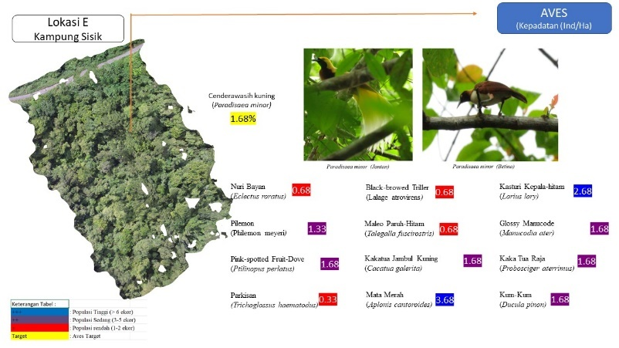
Figure 7. Profile of Bird Species Diversity A Density in the habitat Observation Station E

- Bird Observation Location at Station F
This observation station is a mixed sago swamp forest with a relatively flat topography. With such conditions, this location is relatively more difficult to reach by various hunting activities from the community. Except for some relatively dry land, there are a number of fields that are worked by the community of garden employees in their spare time. The types of birds observed at this observation station can be seen in the following table.

Table 8. List of Types, Abundance, and Population Density at the Observation Site of Station F.
No | Local Name | Types of Name | Family | Population | Kepadatan (ind/Ha) | H
1 | Elang alap Kelabu | Accipiter hiogaster | Acipitridae | 2 | 0.67 | 0.13
2 | Elang-alap Tiongkok | Accipiter soloensis | Acipitridae | 1 | 0.33 | 0.08
3 | Elang-rawa Coklat | Circus approximans | Acipitridae | 2 | 0.67 | 0.13
4 | Elang Paria | Milvus migrans | Acipitridae | 2 | 0.67 | 0.13
5 | Raja Udang | Dacelo gaudichaud | Alcedinidae | 5 | 1.67 | 0.24
6 | Kakatua Jambul Kuning | Cacatua galerita | Cacatuidae | 5 | 1.67 | 0.24
7 | Kakatua Raja | Probosciger aterrimus | Cacatuidae | 2 | 0.67 | 0.13
8 | Papuan Cicadabird | Edolisoma incertum | Campephagidae | 2 | 0.67 | 0.13
9 | Black-browed Triller | Lalage atrovirens | Campephagidae | 4 | 1.33 | 0.21
10 | Common Dollarbird | Eurystomus orientalis | cocaciidae | 2 | 0.67 | 0.13
11 | Pink-spotted Fruit-Dove | Ptilinopus perlatus | Columbidae | 2 | 0.67 | 0.13
12 | Alap – Alap Kawah | Falco peregrinus | Falconidae | 4 | 1.33 | 0.21
13 | Maleo Paruh-Hitam | Talegalla fuscirostris | Magapodiidae | 2 | 0.67 | 0.13
14 | Pilemon | Philemon meyeri | Meliphgidae | 6 | 2.00 | 0.26
15 | Glossy Manucode | Manucodia ater | Paradisaeidae | 2 | 0.67 | 0.13
16 | Cenderawasih kuning | Paradisaea minor | Paradisaeidae | 2 | 0.67 | 0.13
17 | Nuri Aru | Chalcopsitta scintillate | Psittaculidae | 4 | 1.33 | 0.21
18 | Nuri Bayan | Eclectus roratus | Psittaculidae | 2 | 0.67 | 0.13
19 | Kasturi Kepala-hitam | Lorius lory | Psittaculidae | 5 | 1.67 | 0.24
20 | Parkisan | Trichoglossus haematodus | Psittaculidae | 1 | 0.33 | 0.08
21 | Mata Merah | Aplonis cantoroides | Sturnidae | 7 | 2.33 | 0.28
Species Diversity Indeks Shannon-Wienner (H') |  |  |  |  |  | 3.68

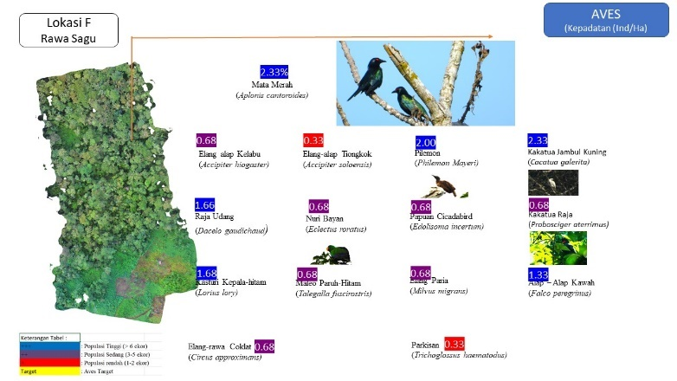
Figure 8. Profil of Bird Species Diversity A Density in the habitat Observation Station F

- Bird Observation Location at Station G
Observation Location G is an observation station with an atmosphere that is pleasing to the research team. Where in this location is closest to the Company's office. At this location G, various types of endemic birds are also always found. In this location, there is also apopulation of birds of paradise of various types, especially the yellow paradise burung (Paradiseae minor) which has received the most attention from many people, both in Papua and from outside Papua. The types of birds observed in the G satellite can be seen in the following table.
.Table 9. List of Spesies Abudance and Population Density Observation Location Sation G
No | Local Name | Types of Name | Family | Population | Density (ind/Ha) | H’
1 | Elang - Alap Pucat Sosonokan | Accipiter poliocephalus | Acipitridae | 2 | 0.67 | 0.11
2 | Elang Rawa Timur | Circus spilonotus | Acipitridae | 2 | 0.67 | 0.11
3 | Elang Bondol | Haliastur indus | Acipitridae | 4 | 1.33 | 0.18
4 | Rangkong Jantan | Rhyticeros plicatus | Bucerotidae | 6 | 2.00 | 0.22
5 | Kakatua Jambul Kuning | Cacatua galerita | Cacatuidae | 7 | 2.33 | 0.24
6 | Kakatua Raja | Probosciger aterrimus | Cacatuidae | 2 | 0.67 | 0.11
7 | Common Dollarbird | Eurystomus orientalis | cocaciidae | 2 | 0.67 | 0.11
8 | Kum-Kum | Ducula pinon | Colombidae | 4 | 1.33 | 0.18
9 | Cabai Papua | Dicaeum pectorale | Dicaidae | 2 | 0.67 | 0.11
10 | Maleo | Megapodius decollatus | Megapodiidae | 1 | 0.33 | 0.07
11 | Pilemon | Philemon meyeri | Meliphgidae | 2 | 0.67 | 0.11
12 | Aniahui | Myiagra alecto | Monarchidae | 2 | 0.67 | 0.11
13 | Cenderawasih kuning | Paradisaea minor | Paradisaeidae | 9 | 3.00 | 0.28
14 | Nuri Bayan | Eclectus roratus | Psittaculidae | 6 | 2.00 | 0.22
15 | Nuri Pipi-merah | Geoffroyus geoffroyi | Psittaculidae | 2 | 0.67 | 0.11
16 | Kasturi Kepala-hitam | Lorius lory | Psittaculidae | 10 | 3.33 | 0.29
17 | Nuri-kate topi-kuning | Micropsitta keiensis | Psittaculidae | 2 | 0.67 | 0.11
18 | Parkisan | Trichoglossus haematodus | Psittaculidae | 7 | 2.33 | 0.24
Species Diversity Indeks Shannon-Wienner (H') |  |  |  |  |  |  | 2.69

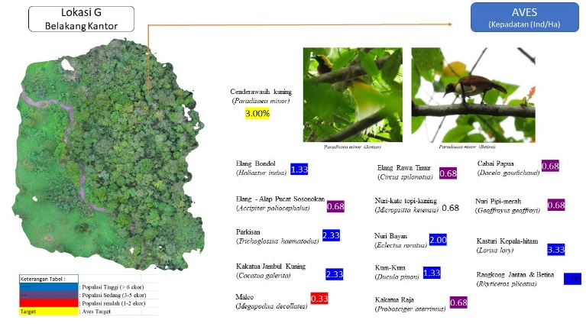
Figure 09. Profile of Bird Species Diversity A Density in the habitat Observation Station G
- Bird Observation Location at Station H
Observation Station H is the observation location with the lowest number of birds. This is because this location is a location that has experienced a lot of delays. This location is behind a palm oil seed processing plant. This location is also in the form of a natural forest, but many human activities have been found such as farming, pig farming and fishing grounds by the community. In addition, this location is also relatively noisy with factory activities, shadow terminals and workshop nearby. It turns out that this has an impact on the bird life in the location. The types of birds determined at this station can be seen in detail in the following table.

Table 10. List of Spesies Abudance and Population Density Observation Location Sation H
No | Local Name | Types of Name | Family | Population | Density (ind/Ha) | H’
1 | Elang Bondol | Haliastur indus | Acipitridae | 2 | 0.67 | 0.18
2 | Kakatua Jambul Kuning | Cacatua galerita | Cacatuidae | 2 | 0.67 | 0.18
3 | Kakatua Raja | Probosciger aterrimus | Cacatuidae | 2 | 0.67 | 0.18
4 | Srigunting Lencana | Dicrurus bracteatus | Dicruridae | 2 | 0.67 | 0.18
5 | Elang | Falco cenchroides | Falconidae | 2 | 0.67 | 0.18
6 | Pilemon | Philemon meyeri | Meliphgidae | 2 | 0.67 | 0.18
7 | Plain Honeyeater | Pycnopygius ixoides | Meliphgidae | 1 | 0.33 | 0.11
8 | Aniahui | Myiagra alecto | Monarchidae | 1 | 0.33 | 0.11
9 | Nuri Aru | Chalcopsitta scintillata | Psittaculidae | 5 | 1.67 | 0.30
10 | Perkici papua | Charmosyna papou | Psittaculidae | 2 | 0.67 | 0.18
11 | Nuri-ara Dada-Jingga | Cyclopsitta gulielmitertii | Psittaculidae | 5 | 1.67 | 0.30
12 | Nuri Bayan | Eclectus roratus | Psittaculidae | 2 | 0.67 | 0.18
13 | Parkisan | Trichoglossus haematodus | Psittaculidae | 2 | 0.67 | 0.18
14 | Willie Wagtail | Rhipidura leucophrys | Rhipiduridae | 2 | 0.67 | 0.18
15 | Mata Merah | Aplonis cantoroides | Sturnidae | 6 | 2.00 | 0.32
Species Diversity Indeks Shannon-Wienner (H') |  |  |  |  |  |  | 2.59

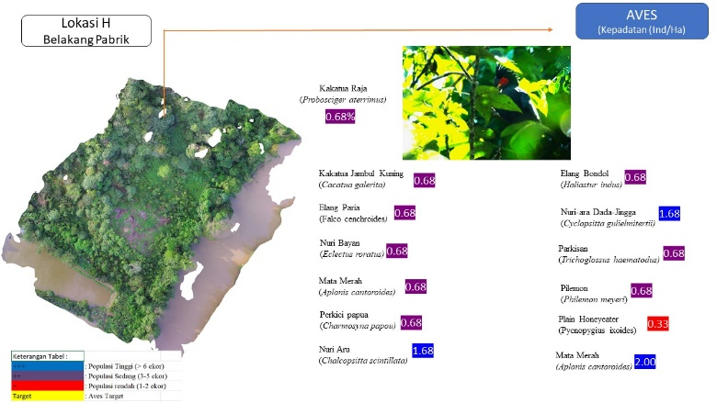
Figure 10. . Profile of Bird Species Diversity A Density in the habitat Observation Station H

- Bird Observation Location at Station I
Observation Station I is an HCV located in the Saltwater Spring Forest. Although still a natural forest, this forest is relatively isolated, like an island in the middle of a sea of oil palm plantations. Due to these conditions, the bird species present are also relatively isolated from the surrounding birds, especially the relatively resident or permanent species. This place is also relatively frequently visited by people, considering this place is a rare natural phenomenon, where salt water, usually found in the sea, appears in the middle of the forest at an altitude and location far from the sea. Therefore, this location has become a special tourist attraction or ecotourism object based on the beauty and uniqueness of the panorama and rare natural phenomenon. The salt water always comes out in small bursts every few minutes.
Tabel 11. List of Species Abundance and Population Density Observation Location Station I
No | Local Name | Types of Name | Family | Population | Density (ind/Ha) | H’
1 | Elang alap Kelabu | Accipiter hiogaster | Acipitridae | 2 | 0.67 | 0.19
2 | Elang | Accipiter poliocephalus | Acipitridae | 2 | 0.67 | 0.19
3 | Raja Udang | Dacelo gaudichaud | Alcedinidae | 2 | 0.67 | 0.19
4 | Black Butcherbird | Cracticus quoyi | Artamidae | 2 | 0.67 | 0.19
5 | Rangkong Jantan & Betina | Rhyticeros plicatus | Bucerotidae | 2 | 0.67 | 0.19
6 | Kaktua Jambul Kuning | Cacatua galerita | Cacatuidae | 5 | 1.67 | 0.31
7 | Kakatua Raja | Probosciger aterrimus | Cacatuidae | 2 | 0.67 | 0.19
8 | Black-browed Triller | Lalage atrovirens | Campephagidae | 1 | 0.33 | 0.12
9 | Kum-Kum | Ducula pinon | Colombidae | 2 | 0.67 | 0.19
10 | Pilemon | Philemon meyeri | Meliphgidae | 2 | 0.67 | 0.19
11 | Raja Udang | Merops ornatus | Meropidae | 2 | 0.67 | 0.19
12 | Glossy Manucode | Manucodia ater | Paradisaeidae | 2 | 0.67 | 0.19
13 | Cendrawasih belah rotan | Cicinnurus magnificus | Paradisaeidea | 2 | 0.67 | 0.19
14 | Nuri Bayan | Eclectus roratus | Psittaculidae | 5 | 1.67 | 0.31
15 | Nuri Pipi-merah | Geoffroyus geoffroyi | Psittaculidae | 2 | 0.67 | 0.19
16 | Kasturi Kepala-hitam | Lorius lory | Psittaculidae | 2 | 0.67 | 0.19
17 | Mata Merah | Aplonis cantoroides | Sturnidae | 8 | 2.67 | 0.36
Species Diversity Indeks Shannon-Wienner (H') |  |  |  |  |  |  | 3.54

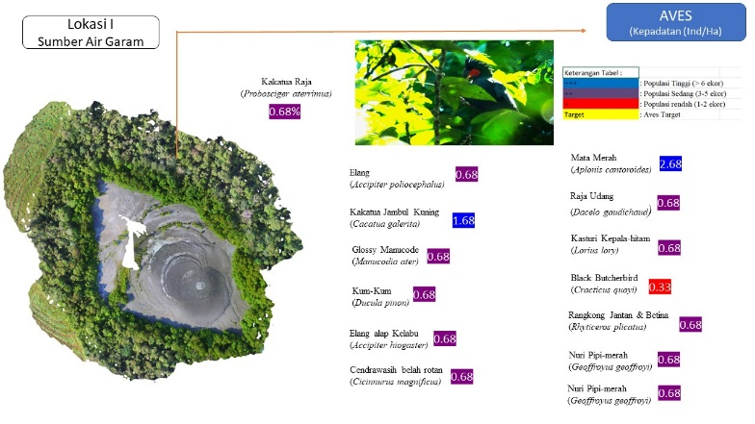
Figure 11. . Profile of Bird Species Diversity A Density in the habitat Observation Station I

  - Discussion
Based on table 3. There are 24 species of bird from various families, consisting of 13 families with a total of 94 birds observed. The Psittaculidae family (parrot group) has the most spesies with 5 species folled by the Aciptridae (eagle group) with 4 species. The Cacatuidae family and The Meliphigidae family each have 2 species. Meanwhile the speices with the largest population members based on observations at this location are the Papuan Lorikeet (Charmosna papua) with 22 individuals the Koki Cockatoo (Cacatua galerita) ith 8 individuals, the Kingsfisher (Merops ornatus) with 7 individuals, the Bayan Parrot (Electus roratus) the Perkisan (Charmosyna papua) and the Red- eyed (Rhyticeros plicatus), the Kum- kum (Daculapinomn) and the Black headed Lory (Lorius lory) with 5 individuals each. Meanwhile, the number of other species directly observed was less than 4 individuals.
From the table mentioned above, it can also be seen that the population density of birds at Observation Station A is 33.00 individuals/Ha. This means that every 10 hectares of forest in the location can be found various types of birds, around 330 birds of various types. From the observation results, 2 birds of paradise were also found with a density of 0.667 individuals/ha. Thus, for every 10 hectares of forest in this area, as many as 7 yellow birds of paradise are found. As is known, the bird of paradise (Paradiseae minor) is the bird that receives the most attention in Papua, because of the beauty of its feathers and its very melodious and shrill voice in the natural forest. This bird is the most vulnerable target of illegal poaching and trading in Papua. Therefore, the presence of this bird at the location of the HGU of this enterprise needs to receive serious attention from all parties, including the management of the enterprise.
Meanwhile, the diversity index of Shannon-Wienner (H') birds at Observation Station A is 2.81. Based on this value of H', it can be said that the condition of the stability of the bird community at the observation location of Station A is categorized as moderate. Thus, the existence of birds in this location is still good because it is supported by a fairly good and stable habitat and the possibility of hunting is relatively less.
Based on table 4, there are 24 species of birds from various families, namely the smallest of 13 families with a total of 53 burng observed. The family Psittaculidae (nuri group) has the most members of the genus yangni 5 species, followed by the family Acipitridea (eagle group) with 4 members and the pigeon-pigeon group (Columbidea) with 3 species. Meanwhile, the species that have the most polluted members based on the results of observations at this location are 10 aru parrots (Chacopsitta scintillate), yellow Cenderawasih (Paradiseae minor) as many as 4 While other types of sevara are less than 3 species.
From the table above, it can also be seen that the population density of birds at Observation Station B is 19.33 individuals/Ha. This means that every 10 hectares of forest in the location can be found various types of birds that exist around 193 birds. From the observation results, 4 birds of paradise minor (Paradiseae minor) were also found. With a density of 1.33 individuals/Ha. Thus, every 10 hectares of forest in this area are found as many as 13 yellow birds of paradise. As is known, the bird of paradise (Paradiseae minor) is the bird that receives the most attention in Papua, because of the beauty of its feathers and its very melodious and shrill voice in the natural forest. This bird is the most vulnerable target of illegal poaching and trading in Papua. Therefore, the presence of this bird in the location of the Conservation Area of this enterprise needs to receive serious attention from all parties, including the management of the enterprise.
Meanwhile, the Shannon-Wienner (H') diversity index of birds at Observation Station H is 3.20. Based on this value of H', it can be said that the condition of the stability of the bird community at the observation location of Station B is categorized as very high. Thus,the existence of birds in this location is a fairly stable habitat and the possibility of hunting is relatively lacking.
Based on table 5, there are 14 species of birds from various families, namely the smallest of 12 families with a total of 29 birds were observed. The Cacatuidea family (cockatoo group) and the Aciptridae family (Eagle group) with 2 members each. Meanwhile, the species that have the most population members based on the results of observations at this location are the Kum-Kum bird (Dakula pinon) and the chef's cockatoo (Cacatua galerita) as many as 5 each then followed by the gray eagle (Acipiter hiogaster) as many as 4 birds. While other types of sevara are less than 4 species.
From the table mentioned above, it can also be seen that the bird population density at Observation Station C is 12.33 individuals/Ha. This means that every 10 hectares of forest in the location can be found various types of birds that existaround 123 heads. From the observation results, 2 birds of paradise minor (Paradiseae minor) were also found with a density of 1 individual/Ha. Thus, for every 10 hectares of forest in this area, 10 souvenir birds are found. As is known, the bird of paradise (Paradiseae minor) is the bird that receives the most attention in Papua, because of the beauty of its feathers and its very melodious and shrill voice in the natural forest. This bird is the most vulnerable target of illegal poaching and trading in Papua.
Meanwhile, the Shannon-Wienner (H') diversity index of birds at Observation Station F is 3.00. Based on this value of H', it can be said that the condition of the stability of the bird community at the observation location of Station C is categorized as high. Thus, the existence of birds in this location is still very good because it is supported by a fairly good and stable habitat.
Table 6 shows that there are 19 species of birds from various families, namely the smallest of 11 families with a total of 51 birds observed. The family Psittaculidae (nuri group) has the most members of 6 species, followed by the family Aciptridae (Eagle group) with 3 species. The Colombidea family is 2 types. Meanwhile, the species that have the most polluted members based on the results of observations at this location are the red-eyed bird (Aplonis cantoroides) as many as 8 people, the dark-hat parrot (Pseudeos fuscata) and the yellow-hat parrot (Electus roratus) as many as 5 each heads, the Papuan Chili (Common dollarbird) and the Aru parrot (Chalcopsitta scintillate) as many as 4 each heads. While other types of sevara are less than 4 species.
From the table above, it can also be seen that the population density of birds (D) at Observation Station D is 15.00 individuals/Ha. This means that every 10 hectares of forest in the location can be found various types of birds around 170 birds. Birds of paradise are found in this place relatively few, but based on the results of observations at this location, no birds of paradise are found with a density of 0.67 individuals. Ha. Thus, every 10 hectares of forest around 7 birds of paradise are found.
Meanwhile, the Shannon-Wienner (H') diversity index of birds at Observation Station F is 2.77. Based on this value of H', it can be said that the stability condition of the bird community at the observation location of Station D is categorized as moderate. Thus,the existence of birds in this location is still good because it is supported by a fairly good and stable habitat and the possibility of extra protection compared to other locations.
Table 7 shows that there are 13 species of birds from 11 families with a total of 51 birds observed. The family Psittaculidae (nuri group) has the most members of 3 types, followed by the families Cacatuidea and Padariaseidea, each with 2 members. Meanwhile, the species that have the most polluted members based on the results of observations at this location are 11 red-eyed birds (Aplonis cantoroides), 8 black-headed parrots (Lorius lory), yellow Paradiseae minor, Cockatoos (Cacatua galerita), and 5 species each of Ptilinopus perlatus. While other types of sevara are less than 4 species.
From the table mentioned above, it can also be seen that the population density of birds (D) at Observation Station E is 14.00 individuals/Ha. This means that every 10 hectares of forest in the location can be found around 140 types of birds. Birds of paradise are found in great abundance in this place with a density of 1.67 individuals/ha. Thus, for every 10 hectares of forest, around 17 birds of paradise are found.
The Shannon-Wienner (H') diversity index of birds at the Kampung Sisik observation station is 2.71. Based on this value of H', it can be said that the condition of the stability of the bird community at the observation location of Station E is categorized as moderate. Thus, the existence of birds in this location is still good because it is supported by a fairly good and stable habitat and the possibility of protection that is more extreme than other locations.
Based on table 8, there are 21 species of birds from various families, namely the smallest of 12 families with a total of 57 burng were observed. The family Psittaculidae (nuri group) has the most members of the 4 species followed by the family Aciptridae (Eagle group) with 3 species. While the species that have the most polluted members based on the results of observations at this location are the Red-Eyed bird (Aplonis cantroides) as many as 7 birds, Pilemon (Philemon mayeri) as many as 6 followed by the black-headed parrot (Lorius lorry) as many as 5 birds, the king shrimp (Dacelo sp.) as many as 5 and the chef's cockatoo (Cacatua galerita) as many as 5 birds, while other types of sevara are less than 4 species.
From the table above, it can also be seen that the population density of birds at Observation Station F is 20.67 individuals/Ha. This means that every 10 hectares of forest in the location can be found various types of birds that exist around 207 of various types. From the observation results, 2 birds of paradise were also found with a density of 0.13 individuals/Ha. Thus, for every 10 hectares of forest in this area, 1 to 2 souvenir birds are found. The bird of paradise (Paradiseae minor) is the bird that gets the most attention in Papua, because of the beauty of its feathers and its very melodious and shrill voice in the natural forest. This bird is the most vulnerable target of illegal poaching and trading in Papua. Therefore, the presence of this bird in the location of the Conservation Area (HCV area) of this enterprise needs to receive serious attention from all parties, including the management of the enterprise.
Meanwhile, the Shannon-Wienner (H') diversity index of birds at Observation Station F is 3.68. Based on this value of H', it can be said that the stability conditionof the bird community at the observation location of Station F is categorized as very high. Thus, the existence of birds in this location is still very good because it is supported by a fairly good and stable habitat and the possibility of huntingis relatively low.
Table 9 shows that there are 18 species of birds from various families, namely the smallest of 10 families with a total of 68 burng observed. The family Psittaculidae (nuri group) has the most members of 5 species, followed by the family Aciptridae (Eagle group) with 3 species. Meanwhile, the species that have the most polluted members based on the results of observations at this location are 10 black-headed parrots (Lorius lorry), 9 yellow Paradiseae minor, 7 Chef's Cockatoos (Cacatua galerita), 7 Perkisan (Trchoglosus haematodou), 6 Bayan parrots (Electus roratus) and 6 hornbills (Rhyticeros plicatus). While other types of species are less than 4 species observed directly.
From the table above, it can also be seen that the population density of birds at Observation Station G is 24.00 individuals/Ha. This means that every 10 hectares of forest in the location can be found various types of birds, which exist around 240 birds of various types. From the observation results, 9 birds of paradise minor (Paradiseae minor) with a density of 3.00 individuals/ha were also found. Thus, every 10 hectares of forest in this area as many as 30 yellow birds of paradise are found. The bird of paradise (Paradiseae minor) is the bird that receives the most attention in Papua, because of the beauty of its feathers and its very melodious and shrill voice in the natural forest. This bird is the most vulnerable target of illegal poaching and trading in Papua. Therefore, the presence of this bird in the location of the Conservation Area of this enterprise needs to receive serious attention from all parties, including the management of the enterprise.
Meanwhile, the Shannon-Wienner (H') diversity index of birds at Observation Station G is 2.69. Based on this value of H', it can be said that the condition of the stability of the bird community at the observation location of Station G is categorized as moderate. Thus, the existence of birds in this location is still good because it is supported by a fairly good and stable habitat and the possibility of huntingis relatively low.
Based on table 10, there are 15 species of birds from various families, namely the smallest of 9 families with a total of 30 burng observed. The family Psittaculidae (nuri group) has the most members of the genus yangni with 5 species followed by the family Meliphigidae with 2 members. Meanwhile, the species that have the most polluted members based on the results of observations at this location are 6 Red-eyed parrots (Aplonis cantroides), 5 aru parrots (Chacopsitta scintillate), and 5 orange-breasted fig parrots (Chalcopsitta gulielmitertii). While other types of types observed are less than 4 heads. Based on direct observation and sound hearing at this location, no yellow bird of paradise (Paradiseae minor) was found, but based on a recording device placed at this location for 3 days. It turned out that a sound from a bird of paradise was found. Thus, the existence of the actual bird of paradise in this place still needs to be re-observed more closelyFrom the table mentioned above, it can also be seen that the population density of birds at Observation Station H is 10.67 individuals/Ha. This means that every 10 hectares of forest in the location can be found various types of birds around 107 birds. Meanwhile, the Shannon-Wienner (H') diversity index of birds at Observation Station H is 2.59.
Based on this H' value, it can be said that the stability condition of the bird community at the observation location of Station H is categorized as moderate. Thus, the existence of birds in this location has begun to experience a lot of disturbances or is less stable and the possibility of hunting is relatively frequent.
Based on table 11, there are 17 species of birds from various families, namely the smallest of 13 families with a total of 37 birds. The family Psittaculidae (nuri group) has the most members of 3 types, followed by the family Aciptridae (Eagle group) with 2 members. 2 types of Cacatuidea family, 2 types of Paradisidea family. Meanwhile, the species that have the most polluted members based on the results of observations at this location are 8 Red-eyed parrots (Aplonis cantroides), parrots (Electusroratus) and Cacatua galerita cockatoos. While other types of species observed sevara directly less than 4 From the table
The above mentioned above can also be seen that the population density of birds (D) at Observation Station I is 15.00 individuals/Ha. This means that every 10 hectares of forest in the location can be found various types of birds around 150 birds. Although in terms of the existence of vegetation that is the habitat of birds of paradise, there are a lot of birds of paradise found in this place, but based on the results of observations at this location, no birds of paradise are found (Paradiseae minor). However, based on the results of the installation of the recording device, at this location there is a sound of birds of paradise.
Meanwhile, the diversity index of the Shannon-Wienner (H') birds at Observation Station F is 3.57. Based on this value of H', it can be said that the condition of the stability of the bird community at the observation location of Station I is categorized as very high. Thus, the existence of birds in this location is still very good because it is supported by a fairly good and stable habitat and the possibility of protection that is more extreme than other locations.

Conclussion
The overall results of the field survey for all observation stations both in the Conservation Area (HCV) at PT. SKIP, PT. SIP and Kampung Sisik (Sisik Village) found a total of 59 species of birds from 23 families. The family with the highest number of species that was successfully covered in this survey was the eagle group from the family Acipitridae with a total of 13 types, followed by the parrot group from the family Psittacidae 10 types and group of pigeons from the family Columbidae as many as 5 types. All observations of bird species during this survey were only limited to areas in the form of natural forests which became conservation areas in the form of High Value Conservation Areas (HCV) which had been specifically designated during the clearing of oil palm plantation land and natural forests in the Village Scales. Data from direct observation as well as based on the tracks and sounds of birds found during the survey.
COMPETING INTERESTS
Authors have declared that they have no known competing financial interests OR non-financial interests OR personal relationships that could have appeared to influence the work reported in this paper.
Disclaimer (Artificial intelligence)
Option 1:
Author(s) hereby declare that NO generative AI technologies such as Large Language Models (ChatGPT, COPILOT, etc.) and text-to-image generators have been used during the writing or editing of this manuscript.
Option 2:
Author(s) hereby declare that generative AI technologies such as Large Language Models, etc. have been used during the writing or editing of manuscripts. This explanation will include the name, version, model, and source of the generative AI technology and as well as all input prompts provided to the generative AI technology
Details of the AI usage are given below:
1.
2.
3.

Acknowledgements
We would like to thank PT. Sinar Mas Agro Resources and Technology, Tbk., Indonesia for funding and supporting the entire research process.

References
Abdulhadi R, Kusuwata K., dan Sukristiojo S. 1981. Effects of Mechanized logging in The Lowland Dipterocarp Forest at Lempake, East Kalimantan. The Malayan Forester Vol. 44(2&3): 407-418.
Adisoemarto, S., 1997. Nilai Kepentingan Pelestarian Keanekaragaman Hayati di Indonesia; Seminar Nasional Biologi XV, PBI, Bandar Lampung.
Allen, G.K and Roger Swainston. New Guinea. A field Guide for Divers, Anglers and Naturalist. Publication No. 8 of the Christensen Research Institute.
Antropologi, Tim. 1991. Analisa Etnografi Suku Bangsa Kaureh.
Badan Pusat Statistik. 2023. Kecamatan Kaureh Dalam Angka.
Beehler. 1984. Birds of New Guinea. Philadelphia Inc. Toronto.
Beehler B.M and Andrew L.M. 1999. Constraints to Characterising spatial heterogeneity in low land forest Avifauna in New Guinea, dalam Adam N.J and Slotow R.H. (eds). Proc. 22 Int. Ornithol. Congr., Durban:2569-2579. Johanesburg.
Beehler B.M, John B.S, Christopher F and Kurt M. 1995. Documenting the Lowland Rainforest Avifauna in Papua New Guinea-Effect of Patchy Distribution, Survey Effort and Methodology. EMU Vol. 95 : 149-161.
Bibby, C.J., Burgess, N.D. and Hill, D.A.1992. Bird Census Techniques. Academic Press, London.
Bibby, Colin. Martin Jones and Stuart Marsden.1998. Expedition Field Techniques: BIRD SURVEYS. Published by the Expedition Advisory.
Centre Royal Geographical Society (with The Institute of British Geographers) 1 Kensington Gore, London.
Bibby, Colin. Martin Jones and Stuart Marsden.2000.Expedition Field Techniques: BIRD SURVEYS. Published by BirdLife International, Wellbrook Court, Girton Road, Cambridge. BirdLife International.2001. Threatened birds of Asia: the BirdLife International Red Data Book.Cambridge, UK: BirdLife International.
Burung Indonesia. 2014. Infographic Burung Indonesia. www.burdlife.org.
Buytaerta, Wouter, Francisco Cuesta-Camachob, Conrado Tobónc. 2010. Potential impacts of climate change on the environmental services of humid tropical alpine regions. Global Ecology and Biogeography.
Conservation International-Indonesia. 2011. Kilas Balik 20 Tahun. Conservation International Indonesia.CII, Jakarta.
Cracraft, J., and Feinstein, J. (2000). What is not a bird of paradise? Molecular and morphological evidence places Macgregoriain the Meliphagidae and the Cnemophilinae near the base of the corvoid tree. Proceedings of the Royal Society of London. Series B: Biological Sciences 267.
Fanani, Zainal dan T. Partomihardjo. 1992. Beberapa Tipe Vegetasi dan Lingkungan di Sekitar Danau Habema, Jayawijaya-Irian Jaya. Pros. Seminar Hasil Litbang SDH.LIPI. Bogor.
Ferianita, M. 2007. Metode Sampling Bioekologi. Bumi Aksara. Jakarta.
Hall, L.S., P.R. Krausman, dan M.L. Morrison. 1997. The Habitat Concept and A Plea for Standard Terminology. Wildlife Society Buletin, Vol 25(1): 173-182.
IUCN. 1994. Guidlines for Protected Areas Management Catagories. IUCN. Gland. Switzerland and Cambridge, UK.
Kartikasari, Sri. Nurani., Andrew J. Marshall., Bruce M. Beehler (ed). 2012. Ekologi Papua:Seri Ekologi Indonesia, jilid IV. Yayasan Pustaka Obor Indonesia dan Conservation Internasional. Jakarta.
Kawatu P. Johan dan Basa T. Rumahorbo. 2003. Penyusunan Data Perkembangan Spesies Eksotik, Endemik dan Invansif di Kabupaten Fak-fak, Nabire, Paniai,Mimika, Puncak Jaya, Yapen Waropen dan Biak Numfor Provinsi Papua. Proyek studi Pengendalian Spesies eksotik, endemic, dan invasive tersebar di 7 (tujuh) Kabupaten Provinsi Papua, Kerjasama antara Bapedalda Provinsi Papua dengan Bidang Ilmu Biologi Uncen. Jayapura.
Krausman, P.R. 2002. Introducing to Wildlife Management: The Basic. Prentice Hall. New Jersey. US.
Lambert F.R. 1987. The consequences of selective logging for Bornean lowland forest Birds. Looging and Bornean Bird. Page: 444-451.
Manly, B.F.J, L.L. MacDonald, dan D.L. Thomas.1993. Resource Selection By Animals Statistical Design and Analisis for Field Studies. Chapman & Hall. London.
Mangen, J.-M., (1993) Ecology and vegetation of Mt. Trikora New Guinea (Irian Jaya/Indonesia).31Ministère des Affaires Culturelles, Luxembourg.
Maturbongs, J.A., Karel W., Alex, S., Tonny S., Herkilaus R. dan Alexander K. 1994. Studi Habitat dan Populasi Burung Cenderawasih di Barawai, Kawasan Penyangga Cagar Alam Yapen Tengah Kabupaten Yapen Waropen Irian Jaya, Laporan Penelitian.
WWF, MAPIA UNCEN dan Sub Seksi KSDA Yapen Waropen.
Nurwatha, Pupung F. 2013. Modul Pelatihan Identifikasi, Inventarisasi Dan Monitoring Avifauna (Burung). Integrated Citarum Water Resources Management Investment Program (Icwrmip) dan Citarum Watershed Management And Biodiversity Conservation (Cwmbc).
Odum, E.P. 1993. Dasar-Dasar Ekologi. Edisi ketiga . Gajah mada University. Press. Jogjakarta.
Peraturan Pemerintah No. 7 Tahun 1999 tentang jenis tumbuhan dan satwa yang dilindungi Pratt, Thane K., Bruce M. Beehler. 2015.
Birds of New Guinea, Second Edition. Princeton University Press. Princeton, NJ, USA.
Pratt TK and Edmund W.S. 1985. The influence of Fruit Size and Structure on Composision of Frugivore Assemblages in New Guinea, Biotropica 17(4) : 314-321.
Primack, J.B.; J. Supriatna; M. Indrawa & P. Kramadibrata. 1998. Biologi Konservasi. Yayasan Obor Indonesia. Jakarta.
Raidin, La. 1997. Sistem Bercocok Tanam dan Pengaruhnya Terhadap Tingkat Pendapatan Petani Taja Di Desa Tabbeyan Kecamatan Kaureh.
Ralph C. J. 1981. An Investigation of The Effect of Seasonal Activity Levels on Avian censusing, Studies in Avian Biology No 6:265-270.
Rand, A.L and Gilliand. 1967. Hand Book of New Geunia Birds, Weidenfeld and Nicalson. London.
Robbins C.S. 1981. Effect of Time of Day on Bird Activity. Studies in Avian Biology. No 6: 275-286.
___________ 1981. Bird activity levels related to weather, Studies in Avian Biology. No 6: 301-310.
Robinson W. D. and Scot K.R. 1998. Effects of Selective Logging on Forest Bird Population in a Fragmented Landscape, Consertvation Biology 13(1) : 58-66.
Sawaki, Habel. 1996. Pengaruh Eksploitasi Hutan Terhadap Sistem Mata Pencaharian Hidup Penduduk Desa Tabbeyan Kecamatan Kaureh Kabupaten Jayapura.
Skirvin A.A. 1981. Effect of Time of Day and Time of Season on The Number of Observations and Desinty estimates of Breeding Birds, Studies in Avian Biology No 6:271-274.
Stocker G.C and A.K. Irvine. 1983. Seed Dispersal by Cassowaries (Casuarius casuarius) in North Queensland’s Rainforests. Biotropica 15(3): 170-176.
Thiollay J.M. 1991. Influence of Selective Logging on Bird Species Diversity in a Guianan Rain Forest, Conservation Biology No 6:47-63.
Wilson W.L. and Johns A.D.1982. Diversity And Abundance of Selective Animal Species in Undisturbed Forest, Selectively Logged Forest abd Palntation in East Kalimantan Indonesai. Biological conservation 24 : 205-218.

