Assessment of Background Radiation Level at Dumpsites in Ogwashi-Uku and its Environs in Delta State, Nigeria

Abstract
This study assesses background radiation levels at six dumpsites in Ogwashi-Uku and its environs in Delta State, Nigeria, using a calibrated Geiger-Muller counter. Obtained readings were used to calculate equivalent dose rate (EDR), absorbed dose rate (ADR), annual effective dose rate (AEDR), and excess life time cancer risk (ELCR). Measurements revealed that while average outdoor background ionizing radiation (BIR) and EDR was below recommended levels, absorbed dose rates (ADR), annual effective dose equivalent (AEDE) and excess lifetime cancer risk (ELCR) estimates exceeded global averages. The maximum outdoor BIR (0.018 mRhr⁻¹) was in Ogwashi-Uku market dump 1 and is above the United Nation Scientific Committee on the Effects of Atomic Radiation (UNSCEAR) mean value of (0.013 mRhr⁻¹). The background ionizing radiation from these dumpsites were exactly same as the value recommended in the (UNSCEAR) report, but EDR, AEDE and ELCR were higher compared to recommended values highlighting urgent needs for improved waste management practices in order to reduce its effects on the local populace working and living around the dumpsites.

Keywords: Dumpsites; Background Ionizing Radiation (BIR); Equivalent Dose Rate (EDR); Absorbed dose rate (ADR); Excess Life time Cancer Risk (ELCR).

1. INTRODUCTION
The world as it is today is been ravaged by various challenge one of which is environmental pollution which happens to be the most significant (Odunaike et al., 2009). Wastes are primarily created by human activities and the forms of disposal and collection poses great threat to human health (Avwiri and Esi, 2014). The health and live of any citizen lies onthe sanitary condition of the. This is so because when an environment is clean, the lives of citizen are not threatened by illnesses and disease (Opara, 2020). Dumpsite is a site used to dispose of solid wastes without environmental control (Akaha and Christopher, 2012).
Dumpsite is a mixture of variety of waste from different sources that may include but are not limited to household waste, agricultural waste, industrial waste, medical waste, metal scraps etc(Avwiri and Esi, 2014; Ijabor et al., 2022). Dumpsites do not only pose threat to our environment by causing environmental degradation but is also a great health hazard to people living and working around these dumpsites. However, radiation emanating from these dumpsites due to background radiation is a major factor from human health challenge. (Odunaike et al., 2008). This ionizing radiation may be as a result of the radionuclide present in different waste type concentrated in our environment with cosmic rays contributing a fraction (Usikalu et al., 2017; Esi et al., 2024). Although people have little control over the kind of radiation to which they are exposed, yet this exposure must be put into perspective (Oladele et al., 2018).
Ionizing radiation in very high level is known to increase the incidence of cancer, birth abnormalities, erythema and other problems. Avwiri and Esi (2014) have reported a correlation between exposure to radiation and human health risks to humansand the environment. This is largely due to various types of waste found in dumpsites.
Human continuous exposure to background radiation from the environment is a vital reason for one to measure its level and concentration.As a result of those various effects caused by ionizing radiation, there’s a need to ascertain the background radiation level of these dumpsites.
Although some researchers have carried out researches from dumpsites but radiological data on exposure are not widely known by people in the environment. Consequently there is a general lack of awareness and knowledge about the level of ionizing radiation humans are exposed to. The objective of this study is to evaluatethe level of background radiation level from selected dumpsite in selected Local Government Area of Delta State. The study will measure and know the level of radiation which the citizens living around the dumpsites are inhaling into their system which might cause long term cancer and also create awareness on the health implication of indiscriminate refuse dump.

2. METHODOLOGY

2.1 The SamplingArea
The sampling area is the following 3 selected Local Government Areas, Aniocha South, Oshimili North and Oshimili South of Delta State. The 3 selected local government areas of Delta state is found within Niger Delta Structural Basin region in which three sedimentary cycles have occurred. The soil type identified within the sampled area is the alluvial soil. For climatic conditions, Delta State is situated in the tropics and therefore experiences a fluctuating climate with average rainfall of about 266.5 mm in the study area.
The 3 selectedlocal government areas is an area of economic importance and has experiences population growth and much human activity like commercialization and other domestic activities all of which generates a lot of waste. As a result, dumpsites have become landmarks in the following areas and market which includes Ogwashi-UkuMarket, Ogwashi-Uku town, Ibusa Market, Immigration, and Oko Market. The details about the dumpsites and sampling locations are shown in Figure 1.
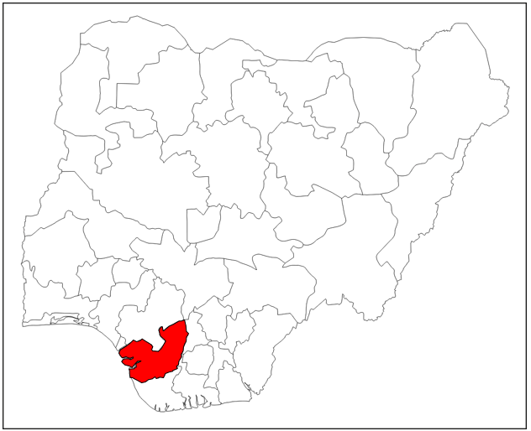
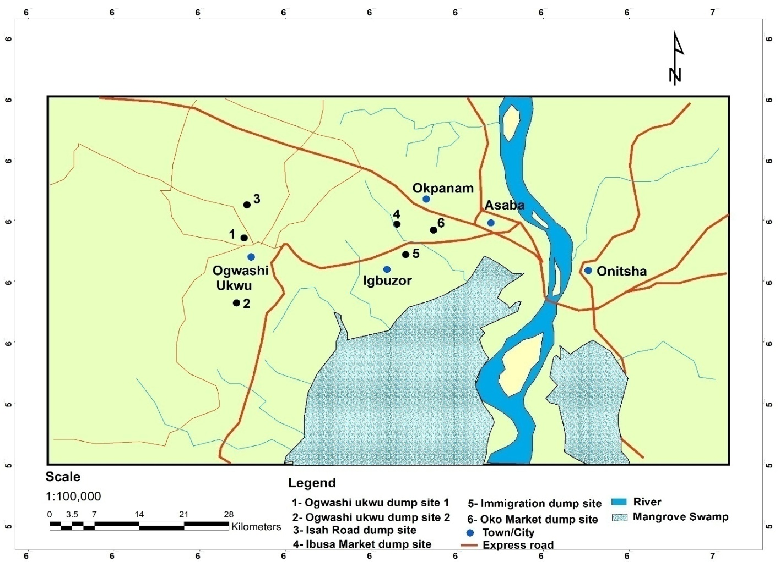
Fig. 1. Map of the sampled area.

2.2 Method of Data Collection
Background radiation measurements were carried out at several dump sites in the following location 2 dumps in Ogwashi-Uku market, 1 dump at Isah road in Ogwashi-Uku, 1 dump at Ibusa market, 1 dump at immigration road, and 1dump at Oko market in Delta state. A global positioning system (GPS) and a well calibrated portable radiation Radalert-100 survey meter (Figure 2) from the National Institute of Radiation Protection and Research (NIRPR), University of Ibadan, Oyo State, Nigeria was used to collect GPS and background radiation levels data respectively.

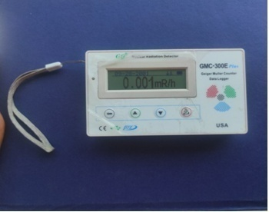
Fig. 2. Digital Radiation Meter

An in-situ method formeasuring background radiation was chosen to ensure that the samples retained their original environmental conditions. Readings was taken in several refuse dump sites, while a geographical Positioning system (GPS) application software downloaded on an android phone and used to obtain coordinates of the precise location (longitudes, latitude and elevation) of data collection points for all the dumpsite location of the studied areasconsidered. The GPS status, on the android phone upon receiving signals, it displays the coordinates and elevation for the particular position of the dumpsite.
The radiation meter’s tubewas placed at a height of 1.0m above the ground (Avwiri and Agbalagba, 2012). The detector was turned on to capture radiation for a few minutes, and the highest stable reading was recorded. This measurement was thenconverted to an annual effective dose equivalent in milli Sievert per year (mSvy⁻¹) (Avwiri and Agbalagba, 2012).
The following equation was used:
(1)
Radiation hazard indices were then calculated using various models. The radiation parameters to be calculated are as follows;
Equivalent Dose Rate(EDR)
Calculation oftotal body equivalent dose rate for a one-year period was done using equation 2, (Avwiri et. al., 2013):
(2)
Absorbed Dose Rate (ADR)
Data obtained for external exposure rate was converted into absorbed dose rates in nGyh⁻¹ using the relations in Rafique (2014).

(3)
The annual effective dose equivalent (AEDE)
The calculated absorbed dose rates was used to determine the annual effective dose equivalent (AEDE) using a conversion factor of 0.7 Sv/Gy, as according to UNSCEAR (1993). Additionally, we used an occupancy factor of 0.2 to account for outdoor exposure (UNSCEAR, 1993). AEDE was determined using equation 4;
(4)

Excess Lifetime Cancer Risk (ELCR)
The obtained AEDE values were used to calculate for ELCR using equation 5, as noted by Mokobia and Oyibo (2017); Mokobia et al., (2020).
(5)
Where DL is lifeduration (70 years) and RF is risk factor (Sv⁻¹). For low levels of background radiation, that isconsidered to cause random health effects, ICRP 60 assigns 0.05 for public exposure as fatal cancer risk (Taskin, 2009).
Equation 6 was used to calculate the effective dose rate to any organ:
(6)
Where:
OFis the occupancy factor (0.8) and Fis the conversion factor for organ dose from ingestion. The calculated effective dose rates delivered to the different organs for lungs, ovaries, bone marrow, testes, kidneys, liver and whole body are 0.64, 0.58, 0.69, 0.82, 0.62, 0.46and 0.68, respectively, as obtained from (ICRP, 1995).
3. RESULT AND DISCUSSION
3.1 Result
Table 1- 6 shows the BIR measurement and the calculated values for EDR, ADR, AEDE and ELCR for all the dumpsites considered in this study. The result presented in Table 1 shows that the BIR and EDR are within acceptable limits, while the ADR, AEDE and ELCR are above the world standard limits. The result presented in Table 2-6 revealed that calculated values for EDR, ADR, AEDE and ELCR for the maximum BIR were observed to be above standard values while the minimum BIR measurement for the calculated values for EDR, ADR, AEDE and ELCR is below the world standard limit.

Fig. 3. GIS Contour Map of the study Area showing sampled dumpsites with BIR Measurements
6
6.05
6.1
6.15
6.2
6.25
6.3
6.35
6.45
6.5
6.55
6.6
6.65
6.7
6.75
6.8
6.85
6.9
6.95
0.0045
0.005
0.0055
0.006
0.0065
0.007
0.0075
0.008
0.0085
0.009
0.0095
0.01
0.0105
0.011
0.0115
0.012
0.0125
0.013
0.0135
0.014
0.0145
0.015
0.0155

•

Isah Road

D
ump site

•

Ibusa Market

Dump

site

•

Ogwashi
–

Ukwu Market Dump

1

0
0.05
0.1
0.15
0.2
Scale

Table 1. BIR, EDR, ADR, AEDE and ELCR Measurement at Ogwashi-Uku Market Dump 1
S/N | Sample Code | BIR (mRhr⁻¹) |  |  | EDR (mSvy⁻¹) | ADR (nGyh⁻¹) | AEDE (mSvy⁻¹) | ELCR X 10⁻³  (µSvy⁻¹)
S/N | Sample Code | BIR 1 | BIR 2 | BIR_{AV}
 | A1 | 0.017 | 0.019 | 0.018 | 1.514 | 156.6 | 0.192 | 0.672
 | A2 | 0.007 | 0.009 | 0.008 | 0.673 | 69.6 | 0.085 | 0.299
 | A3 | 0.009 | 0.011 | 0.010 | 0.841 | 87 | 0.107 | 0.373
 | A4 | 0.013 | 0.017 | 0.015 | 1.261 | 130.5 | 0.160 | 0.560
 | AVERAGE |  |  | 0.013±0.005 | 1.072±0.385 | 110.925±39.789 | 0.136±0.049 | 0.476±0.171
 | WORLD STANDARD |  |  | 0.013 | 1.00 | 59.00 | 0.07 | 0.29
.
Table 2. BIR, EDR, ADR, AEDE and ELCR Measurement at Ogwashi-Uku Market Dump 2
S/N | Sample Code | BIR (mRhr⁻¹) |  |  | EDR (mSvy⁻¹) |  | ADR (nGyh⁻¹) |  | AEDE (mSvy⁻¹) | ELCR X 10⁻³(µSvy⁻¹)
S/N | Sample Code | BIR 1 | BIR 2 | BIR_{AV}
 | B1 | 0.011 | 0.013 | 0.012 |  | 1.009 |  | 104.4 | 0.128 |  | 0.448
 | B2 | 0.012 | 0.011 | 0.012 |  | 0.967 |  | 100.05 | 0.123 |  | 0.429
 | B3 | 0.012 | 0.013 | 0.013 |  | 1.051 |  | 108.75 | 0.133 |  | 0.467
 | B4 | 0.010 | 0.011 | 0.011 |  | 0.883 |  | 91.35 | 0.112 |  | 0.392
 | AVERAGE |  |  | 0.012±0.001 |  | 0.978±0.072 |  | 101.138±7.429 | 0.124±0.009 |  | 0.434±0.032
 | WORLD STANDARD |  |  | 0.013 |  | 1.00 |  | 59.00 | 0.07 |  | 0.29

Table 3. BIR, EDR, ADR, AEDE and ELCR Measurement at Isah Road Dump Site
S/N | Sample Code | BIR(mRhr⁻¹) |  |  | EDR (mSvy⁻¹) | ADR (nGyh⁻¹) | AEDE (mSvy⁻¹) | ELCR X 10⁻³ (µSvy⁻¹)
S/N | Sample Code | BIR 1 | BIR 2 | BIR_{AV}
 | C1 | 0.011 | 0.012 | 0.012 | 0.967 | 100.05 | 0.123 | 0.429
 | C2 | 0.013 | 0.014 | 0.014 | 1.135 | 117.45 | 0.144 | 0.504
 | C3 | 0.013 | 0.011 | 0.012 | 1.009 | 104.4 | 0.128 | 0.448
 | C4 | 0.011 | 0.013 | 0.012 | 1.009 | 104.4 | 0.128 | 0.448
 | AVERAGE |  |  | 0.012±0.001 | 1.030±0.073 | 106.575±7.534 | 0.131±0.009 | 0.457±0.032
 | WORLD STANDARD |  |  | 0.013 | 1.00 | 59.00 | 0.07 | 0.29

Table 4. BIR, EDR, ADR, AEDE and ELCR Measurement at Ibusa Market Dump Site
S/N | Sample Code | BIR(mRhr⁻¹) |  |  | EDR (mSvy⁻¹) | ADR (nGyh⁻¹) | AEDE (mSvy⁻¹) | ELCR X 10⁻³(µSvy⁻¹)
S/N | Sample Code | BIR 1 | BIR 2 | BIR_{AV}
 | D1 | 0.009 | 0.015 | 0.012 | 1.009 | 104.4 | 0.128 | 0.448
 | D2 | 0.013 | 0.013 | 0.013 | 1.093 | 113.1 | 0.139 | 0.485
 | D3 | 0.012 | 0.011 | 0.012 | 0.967 | 100.05 | 0.123 | 0.429
 | D4 | 0.011 | 0.013 | 0.012 | 1.009 | 104.4 | 0.128 | 0.448
 | AVERAGE |  |  | 0.012±0.001 | 1.020±0.053 | 105.488±5.474 | 0.129±0.007 | 0.453±0.023
 | WORLD STANDARD |  |  | 0.013 | 1.00 | 59.00 | 0.07 | 0.29

Table 5. BIR, EDR, ADR, AEDE and ELCR Measurement at Immigration Road Dump Site
S/N | Sample Code | BIR(mRhr⁻¹) |  |  | EDR (mSvy⁻¹) | ADR (nGyh⁻¹) | AEDE (mSvy⁻¹) | ELCR X 10⁻³(µSvy⁻¹)
S/N | Sample Code | BIR 1 | BIR 2 | BIR_{AV}
 | E1 | 0.012 | 0.012 | 0.012 | 1.009 | 104.4 | 0.128 | 0.448
 | E2 | 0.011 | 0.015 | 0.013 | 1.093 | 113.1 | 0.139 | 0.485
 | E3 | 0.011 | 0.015 | 0.013 | 1.093 | 113.1 | 0.139 | 0.485
 | E4 | 0.012 | 0.015 | 0.014 | 1.135 | 117.45 | 0.144 | 0.504
 | AVERAGE |  |  | 0.013±0.001 | 1.083±0.053 | 112.013±5.474 | 0.137±0.007 | 0.481±0.023
 | WORLD STANDARD |  |  | 0.013 | 1.00 | 59.00 | 0.07 | 0.29

Table 6. BIR, EDR, ADR, AEDE and ELCR Measurement at Oko Market Dump Site
S/N | Sample Code | BIR(mRhr⁻¹) |  |  | EDR (mSvy⁻¹) | ADR (nGyh⁻¹) | AEDE (mSvy⁻¹) | ELCR X 10⁻³(µSvy⁻¹)
S/N | Sample Code | BIR 1 | BIR 2 | BIR_{AV}
 | F1 | 0.013 | 0.014 | 0.014 | 1.135 | 117.45 | 0.144 | 0.504
 | F2 | 0.013 | 0.017 | 0.015 | 1.261 | 130.5 | 0.160 | 0.560
 | F3 | 0.016 | 0.014 | 0.015 | 1.261 | 130.5 | 0.160 | 0.560
 | F4 | 0.011 | 0.013 | 0.012 | 1.009 | 104.4 | 0.128 | 0.448
 | AVERAGE |  |  | 0.014±0.001 | 1.167±0.121 | 120.713±12.494 | 0.148±0.015 | 0.518±0.054
 | WORLD STANDARD |  |  | 0.013 | 1.00 | 59.00 | 0.07 | 0.29

For dose to various organ (mSvyr⁻¹) the highest dose received was recorded inthe testes and the dose to the liver was the least. Doses for the lungs, ovaries, bone marrow, testes, kidney, liver and whole body was below the UNSCEAR 2000 recommended limit (Table 7)

Table 7. Estimation of Organ Doses in mSvyr⁻¹
ORGANS | Lung | Ovary | Bone Marrow | Testes | Kidney | Liver | Whole Body
ICRP 1996, UNSCEAR, 2000, | 0.64 | 0.58 | 0.69 | 0.82 | 0.62 | 0.42 | 0.68
D_{organ}(mSvy⁻¹) | 0.068 | 0.062 | 0.074 | 0.090 | 0.066 | 0.050 | 0.073

3.2 DISCUSSION
The study generally shows that background radiation levels in most of the dump sites were within acceptable limits. The maximum outdoor BIR (0.018 mRhr⁻¹) (Table 1) was in Ogwashi – Uku Market Dump 1, which was above the world average value (0.013 mRhr⁻¹). The average outdoor BIR and EDR were below the average recommended value but the ADR, AEDE and ELCR was above the recommended world average value (UNSCEAR, 2000).The testes are the most affected body part, although the received dose values are below the annual recommended organ dose reference (ICRP, 1996).
3.2.1 Annual Equivalent Dose Rate (AEDR):
The AEDR for the six dump sites are presented in (Tables 1-6). A summary of the Annual Equivalent Dose rate (Table 8) shows that the Indoor dose rate ranges from 101.138±7.429 nGyh⁻¹to 120.713±12.494 nGyh⁻¹with a mean of 109.475±13.032 nGyh⁻¹. These values are below the standard background radiation of 59nGyh⁻¹.
3.2.2 Annual Effective Dose Equivalent (AEDE):
The AEDE a comparison with the internationally recommended limit for the six dump sites are shown in (Tables 1 - 6). A summary of the AEDE (Table 8) shows that the Outdoor AEDE ranges from 0.124±0.009 to 0.148±0.015 mSv/y with a mean of 0.134±0.016 mSv/y. The measured values are below the recommended limits set by the ICRP, which are 1.0 mSv/y for the general public and 20 mSv/y for workers exposed to radiation. This suggests that the areas studied are within safe limits and do not pose any immediate health risks from background ionizing radiation (BIR) to either workers or the public. However, its important to regularly check the levels of natural radionuclides and BIR in the area to ensure that radiation exposure remains as low as possible.
3.2.3 Excess Lifetime Cancer Risk (ELCR):
The excess lifetime cancer risk helps assess how likely it is that a person will develop cancer during their lifetime from exposure to low doses of radiation, if such an occurrence is possible at all. The ELCR and a comparison with world average are shown on (Tables 4-6). A summary of the ELCR (Table 8) shows that the Outdoor ELCR ranges from 0.434x 10⁻³at Ogwashi dump site 2 to 0.518x 10⁻³at Oko market with a mean of 0.470 x 10⁻³ which is only 1.62 times higher than the world’s average of 0.29 x 10⁻³ (Qureshi et al., 2014).

The low ELCR values suggest a low likelihoodof workers and residents developing cancer from spending their entire lives in the area. The reports of Agbalagba for ELCR values in Warri and Effurun (Agbalagba. 2017), as well as reports off Avwiri et al, from Okposi, Okwu and Uburu salt lake regions in Ebonyi State, Nigeria (Avwiri et al., 2016).Results from Emene Industrial Layout in Enugu State are well above those reported in this study (Ugbede and Benson, 2018), crowded motor parks in Enugu State (Benson and Ugbede, 2018), Unity park in Uyo, Akwa-Ibom state (Etuk et al., 2017) and river sediments from Northern Pakistan (Qureshi et al, 2014).

3.2.4 Effective dose rate (Dorgan) to different body organs and tissues:
Table 7 shows the effective dose rate for various organs with the values for lungs, ovaries, bone marrow, testes, kidneys, liver and whole body being 0.64, 0.58, 0.69, 0.82, 0.62, 0.46 and 0.68 respectively, as reported by ICRP (1996). The average dose values estimated for these organs due to exposure to radiation and inhalation in the study area are 0.068 for the lungs, 0.062 for the ovaries, 0.074 for bone marrow, 0.090 for the testes, 0.066 for the kidneys, 0.050 for the liver, and 0.073 for the whole body. All these values are lower than international safe limits of 1.0 mSv/y (Agbalagba, 2017;Ugbede and Benson, 2018), indicating that the levels of radiation in the study area pose no immediate health risks toworkers and residents.
The findings suggest that the testes are most sensitive to radiation, while liver shows the least sensitivity, both indoors and outdoors. The higher dose to the testes and lower dose to the liver can be explained by the rate of nutrient absorption from food (Zaid et al., 2010) implying that exposure to BIR in the study area has a minimal impact on radiation doses to these organs in adults. Similar conclusions have been reached by Darwish et al. (2015), Agbalagba (2017), and Ugbede and Benson (2018).
Table 8. Summary (a)
S/N | Area | Code | BIR_{AV} | EDR (mSvy⁻¹) | ADR (nGyh⁻¹) |  | AEDE (mSvy⁻¹) | ELCR X 10⁻³(µSvy⁻¹)
 | Ogwashi – Uku Market Dump 1 | OUM1 | 0.013±0.005 | 1.072±0.385 | 110.925±39.789 |  | 0.136±0.049 | 0.476±0.171
 | Ogwashi – Uku Market Dump 2 | OUM2 | 0.012±0.001 | 0.978±0.072 | 101.138±7.429 |  | 0.124±0.009 | 0.434±0.032
 | Isah Road Dump Site | IRD | 0.012±0.001 | 1.030±0.073 | 106.575±7.534 |  | 0.131±0.009 | 0.457±0.032
 | Ibusa Market Dump Site | IMD | 0.012±0.001 | 1.020±0.053 | 105.488±5.474 |  | 0.129±0.007 | 0.453±0.023
 | Immigration Road Dump Site | IRS | 0.013±0.001 | 1.083±0.053 | 112.013±5.474 |  | 0.137±0.007 | 0.481±0.023
 | Oko Market Dump Site | OMD | 0.014±0.001 | 1.167±0.121 | 120.713±12.494 |  | 0.148±0.015 | 0.518±0.054
MEAN VALUES (This Study) |  |  | 0.013±002 | 1.058±0.126 | 109.475±13.032 |  | 0.134±0.016 | 0.470±0.056
WORLD STANDARD |  |  | 0.013 | 1.00 |  | 59.00 | 0.07 | 0.29

Table 9. Summary (b)
Indicators | This study (average) | World average | Limit
BIR | 0.013mRhr⁻¹ | 0.013mRhr⁻¹ | Same
EDR | 1.058mSvyr⁻¹ | 1.00mSvyr⁻¹ | Above
ADR | 109.475ηGyhr⁻¹ | 59ηGyhr⁻¹ | Above
AEDE | 0.134mSvyr⁻¹ | 0.07mSvyr⁻¹ | Above
ELCR | 0.470µSvyr⁻¹ | 0.29µSvyr⁻¹ | Above

4. CONCLUSION
A study to assess BIR, EDR, ADR, AEDE, ELCR and organ dose have been carried out in selected dump sites in Delta state. Estimated values were comparable to studies in Nigeria. The average BIR from this study was exactly same as the value recommended in the UNSCEAR report but EDR, ADR, AEDE and ELCR were higher when compared to recommended values. The estimated organ dose was within the acceptable range. The organ dose for the testes appears to be highest although it was seen to be below the recommended valuehighlighting urgent needs for improved waste management practices to reduce its effects on the populace living and working around the dumpsites.

DISCLAIMER (ARTIFICIAL INTELLIGENCE)

Author(s) hereby declare that NO generative AI technologies such as Large Language Models (ChatGPT, COPILOT, etc.) and text-to-image generators have been used during the writing or editing of this manuscript.

REFERENCES
Agbalagba, O.E. (2017).Assessment of excess lifetime cancer risk from gamma radiation levels in Effurun and Warri city of Delta state, Nigeria. Journal of Taibah University for Science. 11(3):367-380.
Akaha, C.T. & Christopher, I .A. (2012). Assessment of Anthropogenic Influence on Quality of Groundwater in Hand-Dug Wells in Parts of Makurdi Metropolis, North Central Nigeria. Ife Journal of Science. 14(1):123-135.
Avwiri, G.O. & Agbalagba, E.O. (2012). Studies on the Radiological Impact of Oil and Gas Activities in Oil Mineral Lease 30 (OML3) Oil Fields in Delta State. Nigeria. J. Pet. Environ Biotechnol. 3(2): 1- 8.
Avwir, G.O., Egieya, J.F., & Chinyere, P.O. (2013).Radiometric survey of Aluu Landfill, in rivers state, Nigeria. Advances in Physics Theories and Applications. 22:24–30.
Avwiri, G.O.& Esi, E.O. (2014). Evaluation of Background Ionization Radiation level in some selected dumpsites in Delta State Nigeria. Advances in Physics Theories and Applications. 35: 36-42
Avwiri. G.O., Nwaka, B.U., & Ononugbo, C.P. (2016). Radiological health risk due to gamma dose rates around Okposi Okwu and Uburu salt lakes, Ebonyi State. International J. Emerg. Res. in Manage.Technol. 5(9):36-46.
Benson, I.D & Ugbede, F.O. (2018). Measurement of Background Ionizing Radiation And Evaluation Of Lifetime Cancer Risk In Highly Populated Motor Parks In Enugu City, Nigeria.” IOSRJournal of Applied Physics(IOSR-JAP)10(3), 77- 82.
Darwish, D.A.E., Abul-Nasr, K.T.M., &El-Khayatt, A.M. (2015). The assessment of natural radioactivity and its associated radiological hazards and dose parameters in granite samples from South Sinai, Egypt. Journal of Radiation Research and Applied Sciences. 8(1):17- 25.
Esi, E.O., Nwabuoku, A.O., Oduah, E.C., Ugbede, F.O., & Okpilike, J.C. (2024). Evaluation of Indoor and Outdoor Radiation Levels and its Health Hazard at Dennis Osadebay University, Asaba, Delta State, Nigeria. Dutse Journal of Pure and Applied Sciences (DUJOPAS), Vol. 10(1): 1-9.
Etuk, S.E., Essiett, A.A., Okechukwu, E., & Agbasi, O.E. (2017). Measurement of Outdoor Ambient Radioactive Radiation and Evaluation of Radiation Indices and Excess Lifetime Cancer Risk within Uyo, Unity Park, Uyo, Nigeria. JGEESI. 9(4): 1-9.
ICRP, (1995). Age-dependent Doses to the Members of the Public from Intake of Radionuclides - Part 5 Compilation of Ingestion and Inhalation Coefficients. ICRP Publication 72. Ann. ICRP 26 (1).
Ijabor, B.O., Nwabuoku, A.O., Ozakpor, A.F., Azesi, D., Nwaebise, I., Ikechukwu, O. & Nwankwo, I.P. (2022). Assessment of Indoor and Outdoor Radiation Dose Levels in Delts State Polytechnic, Ogwashi-Uku, Delta State, Nigeria. Open Journal of Physical Science. 3(2): 35-46
Mokobia, C.E., Nwabuoku, A.O., & Igbeka, C. (2020). Indoor Radon ConcentrationMeasurements in Houses of Selected Communities in Delta Central of Delta State. Nigerian Journal of Science and Environment 18: (2).
Odunaike, R.K., Laoye, J.A., Alausa, S.K., Ijeoma, G.C., & Adelaja, A.D. (2008). Radiation emission characteristics of waste dumpsites in the city of Ibadan in Oyo State of Nigeria. Research journal of environmental toxicology. 2(2): 100-103.
Odunaike, R.K., Alausa, S.K., Fasunwon, O.O., Orunsolu, B.A., & Ijeoma, G.C. (2009). Radiation does survey of refuse dumpsites in Abeokuta in Ogun State in the south Western zone of Nigeria. Research journal of environmental toxicology2009; 3(2): 262-266.
Oladele, B.B.& Arogunjo, A. M. (2018).Assessment of Background Radiation Levels in Selected Diagnostic Radiology Department across Ondo State, Nigeria. Journal of Pure & Applied Physics. 8(1): 16 – 19.
Opara, J. (2009). Urban waste management in Port Harcourt metropolis of the Niger Delta region of Nigeria. PhD Thesis submitted to Universidad central de Nicaragua Managua Nicaragua
Qureshi, A.A., Tariq, S., Din, K.U., Manzoor, S., Calligaris, C., & Waheed, A. (2014). Evaluation of excessive lifetime cancer risk due to natural radioactivity in the rivers sediments of Northern Pakistan. Journal of Radiation Research and Applied Sciences. 7(4): 438-447.
Rafique, M., Saeed, R., Muhammad, B., Wajid, A., Iftikhar, A., Khursheed, A.L., & Khalil, A. (2014).Evaluation of excess life time cancer risk from gamma dose rate in Jhelum valley. Journal of Radiation Research and Applied Sciences. 7(1): 29-35.
Taskin, H., Karavus, M., Ay, P., Topuzoglu, A., Hidiroglu, S., & Karaha, G. (2009). Radionuclide concentrations in soil and lifetime cancer risk due to the gamma radioactivity in Kirklareli, Turkey. J. Environ. Radioact,100(1): 49–53.
United Nationals, Sources and Effects of Atomic Radiation (UNSCEAR). (1993). Report to the General Assembly with Scientific Annexes, United Nations, New York.
United Nations Scientific Committee on the Effects of Atomic Radiation (UNSCEAR) (2000). ―Sources and effects of ionizing radiation (Report to the General Assembly) New York: United.
Usikalu, M.R., Ola, O.O., Achuka, J.A., Babarimisa, I.O., &Ayara, W.A. (2017). Background radiation dose of dumpsite in Ota and environs. Journal of physics: 2017series 852:2-7.
Zaid, Q.A., Khled, M.A., Anas, M.A., & Abdalmajeid, M.A. (2010). Measurement of Natural and Artificial radioactivity in Powder Milk corresponding Annual Effective Dose.
UNSCEAR. (2000). United Nation Scientific Committee on the Effects of Atomic Radiation. Sources and effect of Ionizing radiation. Report to the general assembly with scientific annexes. United Nations; New York.

