From Tremors to Threats: A Systematic Review of Nigeria’s Earthquake Vulnerability, Urban Exposure and Governance Readiness (1990-2025)

Abstract
Earthquake risk in Nigeria has historically been underestimated, yet recurrent tremors over the past decades reveal emerging vulnerabilities that demand systematic attention. This review synthesizes evidence of seismic vulnerability in Nigeria between 1990 and 2025, with emphasis on hazard patterns, urban exposure, socio-economic drivers, and governance frameworks.

Aim:
To synthesize evidence of seismic vulnerability in Nigeria (1990-2025), examining hazard patterns, urban exposure, socio-economic factors, and governance frameworks.
Study Design: Systematic review guided by PRISMA.
Place and Duration of Study: Nigeria; literature published between 1990 and 2025.

Methodology:
Guided by PRISMA standards, ≈200 records were initially identified from multidisciplinary databases and institutional repositories. After screening and eligibility checks, 61 studies were retained and thematically coded across four domains: seismic hazard characterization, urban and infrastructural exposure, socio-economic vulnerability, and policy/governance. Comparative insights were drawn from African and global contexts, supported by Geographic Information System (GIS) overlays.

Results:
Findings show seismic hotspots in southwestern cities (Ibadan, Akure), central hubs (Abuja, Kaduna), and southern zones (Bayelsa, Edo). Isolated tremors in Bauchi, Maiduguri, and Enugu highlight under-monitored risks. Most events are low-magnitude, yet impacts are amplified by rapid urbanization, fragile building stock, weak enforcement of codes, and limited preparedness. Comparative insights from East Africa, Brazil, and Nepal emphasize how governance and community resilience are as critical as geophysical hazards.

Conclusion:
Nigeria’s seismic risk, though low frequency, is significant due to compounded vulnerabilities. Strengthening monitoring networks, embedding hazard-informed urban planning, enforcing building codes, and promoting community preparedness are urgent priorities. Future research should integrate advanced tools such as GeoAI and remote sensing for high-resolution hazard modeling and multi-scalar vulnerability mapping.

Keywords: Intraplate seismicity; seismic hazard; urban exposure; governance; PRISMA; GeoAI; resilience
1. Introduction
1.1 Background of the Study
Earthquakes are among the world’s most destructive natural hazards, causing long-lasting social and economic consequences. Events such as the 2010 Haiti earthquake (≈220,000 deaths), the 2008 Sichuan earthquake in China, and the 2023 Türkiye–Syria disaster demonstrate that even moderate-magnitude earthquakes can devastate densely populated or poorly prepared regions [1,2]. These risks become particularly acute when hazards interact with vulnerabilities, exposure, and limited capacities; conditions that often arise in settings characterized by rapid urbanization, fragile infrastructure, and weak institutions [3].

For many years, West Africa was regarded as an aseismic region, especially when compared to the tectonically active East African Rift Valley [4]. Yet Nigeria has recorded recurrent tremors since the 1930s. Key examples include the 1984 Ijebu-Ode tremor, the 2000 Kwoi earthquake, the 2011 Bauchi tremor, and the 2016–2018 Abuja sequences [5,6]. Although mostly between 3.0 and 4.5 on the Richter scale, their recurrence has triggered both scientific concern and policy debate [7].

Seismic monitoring capacity remains limited. Nigeria operates fewer than ten seismic stations nationwide, data sharing across institutions is minimal, and in many cases media reports substitute for systematic cataloguing [8,6]. The Nigerian Geological Survey Agency (NGSA) suggests that intraplate stresses and fractures in the Precambrian basement complex may explain tremors in Abuja, Kaduna, Bauchi, and the Southwest [8]. However, persistent uncertainty about hazard levels has reinforced complacency toward earthquake preparedness.

Meanwhile, rapid urbanization is magnifying exposure. Nigeria is projected to become the world’s third most populous country by 2050, with more than 70% of residents living in urban areas [9]. Lagos, Abuja, Kaduna, and Ibadan already experience unregulated land-use change, informal settlements, and poor compliance with building codes [10,11]. The 2010 Haiti earthquake demonstrates how weak building stock can greatly amplify losses even in moderate events [12].

Nigeria’s seismic vulnerability is therefore emerging. Disaster management policies prioritize floods, erosion, and desertification [13], while earthquakes remain neglected in both policy and public discourse [5]. Without timely intervention, this oversight may allow a hazard long considered marginal to evolve into a significant urban threat. This review provides the first national synthesis of seismic vulnerability in Nigeria (1990–2025), integrating hazard evidence, urban exposure, socio-economic factors, and governance frameworks through a PRISMA-guided systematic approach.
1.2 Global and Regional Context
1.2.1 Global Patterns of Vulnerability
Between 1990 and 2025, earthquakes caused more than 1.2 million deaths globally and trillions of dollars in damage, with Asia and Latin America hit hardest [14,15]. The Pacific “Ring of Fire,” South Asia, the Mediterranean, and the Americas record the highest seismicity. Countries such as Japan, Chile, and Turkey have reduced losses through seismic-resistant construction and early-warning systems, while many developing countries remain highly vulnerable [12].
Table 1 lists the ten deadliest earthquakes of the 21st century. It demonstrates how exposure and governance shape disaster outcomes: Haiti’s relatively moderate 7.0 magnitude event in 2010 produced far higher losses than Japan’s 9.0 magnitude Tohoku event in 2011, largely due to building resilience and preparedness differences.

Table 1. Ten deadliest earthquakes of the 21st century
Rank | Year | Location | Magnitude (Mw) | Reported Deaths | Notes
1 | 2010 | Haiti | 7.0 | ~220,000 | Major urban collapse in Port-au-Prince; poor construction standards amplified fatalities
2 | 2004 | Indian Ocean (Sumatra, Indonesia) | 9.1 | ~227,000 | Tsunami triggered by megathrust earthquake; affected multiple countries
3 | 2008 | Sichuan, China | 7.9 | ~87,000 | Large-scale destruction in densely populated areas; landslides contributed to casualties
4 | 2015 | Nepal | 7.8 | ~9,000 | Kathmandu valley heavily affected; infrastructure collapse and landslides
5 | 2011 | Tohoku, Japan | 9.0 | ~20,000 | Tsunami caused major loss of life; nuclear plant incidents increased overall impact
6 | 2023 | Türkiye-Syria | 7.8 | ~50,000+ | Widespread urban destruction; affected densely populated regions with mixed preparedness levels
7 | 2003 | Bam, Iran | 6.6 | ~26,000 | Historic city destroyed; limited earthquake-resistant construction
8 | 2017 | Puebla, Mexico | 7.1 | ~370 | Urban building collapse in Mexico City; high population density exacerbated losses
9 | 2001 | Gujarat, India | 7.7 | ~20,000 | Kutch region; poorly constructed buildings and local infrastructure failures
10 | 2005 | Kashmir, Pakistan | 7.6 | ~86,000 | Mountainous terrain; landslides and poor building resilience contributed to high fatalities
This distribution confirms that magnitude alone does not determine severity; socio-economic vulnerability is a major driver of loss.

1.2.2 African Context of Vulnerability
Although Africa is less seismically active than Asia or Latin America, the East African Rift System (EARS) is a recognized hotspot, with significant events in Ethiopia, Tanzania, and Malawi [16,17]. North Africa has also experienced catastrophic events, such as the 1960 Agadir earthquake in Morocco and the 2003 Boumerdès earthquake in Algeria [18]. Sub-Saharan Africa, however, tends to neglect seismic hazards, focusing instead on floods, droughts, and desertification, leaving monitoring and policy frameworks weak [19].

1.2.3 Nigeria in the Regional Debate
Nigeria lies in a relatively stable intraplate setting, away from major tectonic boundaries. This perceived stability has long placed earthquakes low on the national disaster risk agenda [20]. Yet recurrent tremors since 1990 in Oyo, Kaduna, Abuja, and parts of Ogun challenge this assumption [21,10]. While these events are moderate in magnitude, they highlight fragile infrastructure, weak preparedness, and limited scientific monitoring [11,19].

Figure 1 presents a timeline of documented tremors in Nigeria between 1990 and 2025. The data reveal a gradual rise in frequency during the 2000s, followed by a marked escalation after 2015, with magnitudes reaching above 6.0 in recent years. This upward trend, consistent with reports from [8], [5], and [22], underscores Nigeria’s transition from an assumed stable intraplate environment to one of emerging seismic vulnerability.
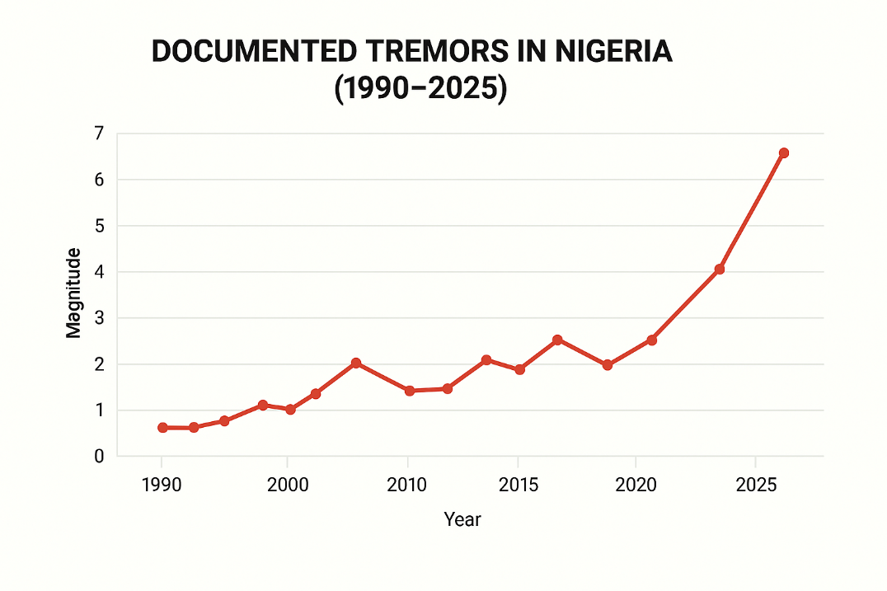
Figure 1. Timeline of documented tremors in Nigeria (1990-2025). Source: Author’s design based on compiled data from [5,6,8,22].

1.3 Problem Statement
Despite recurring tremors, Nigeria’s seismic hazard remains poorly characterized, and exposure continues to rise in rapidly urbanizing areas. Most disaster risk management frameworks prioritize floods, erosion, and desertification, leaving earthquakes under-researched and under-represented in both science and policy [23,24,22]. The Abuja tremors of 2016-2018 revealed the fragility of building stock and the lack of coordinated institutional response, underscoring how even low-magnitude events can cause widespread alarm and minor damage [13,8]. However, existing studies are fragmented, focusing separately on geophysics, urban exposure, or governance with no comprehensive synthesis linking hazard, vulnerability, and institutional preparedness. This gap has created uncertainty, reinforced policy complacency, and limited the integration of seismic risk into urban planning and building regulation.

Therefore, there is an urgent need for a systematic review that consolidates three decades of evidence on Nigeria’s emerging earthquake vulnerability. By synthesizing patterns of seismic activity, exposure, and policy readiness, this review aims to provide a holistic evidence base to guide future research, planning, and disaster risk reduction strategies.
1.4 Aim and Objectives
The aim of this study is to systematically review existing literature (1990-2025) on Nigeria’s emerging earthquake vulnerability, with a specific focus on hazard patterns, urban exposure, and policy preparedness.
Accordingly, the central objective is to consolidate and synthesize multidisciplinary evidence in order to identify how seismic hazards, exposure, and governance frameworks intersect to shape Nigeria’s earthquake risk profile.
1.5 Research Questions
This review is guided by an overarching research question:
How does the literature published between 1990 and 2025 describe Nigeria’s emerging earthquake vulnerability, with particular focus on seismic hazards, urban exposure, and policy preparedness?
1.6 Significance of the Study
This review is significant in several respects:
- National relevance: It provides the first systematic synthesis of three decades of evidence on Nigeria’s seismic vulnerability, offering a consolidated knowledge base that has been missing from national disaster risk discourse.
- Policy and planning value: By linking hazard patterns with urban exposure and governance frameworks, the study generates evidence that can inform building code enforcement, land-use planning, and integration of seismic risk into Nigeria’s disaster risk reduction strategies.
- Scientific contribution: It advances scholarly understanding of intraplate seismicity in Sub-Saharan Africa, situating Nigeria within broader comparative debates and demonstrating how seismic risk emerges not only from geophysical processes but also from governance and socio-economic conditions.
- Applied utility: The findings provide planners, engineers, and policymakers with actionable insights for strengthening resilience in cities and infrastructure most exposed to tremors.
1.7 Organization of the Paper
Section 1 introduces the context, problem, and aims. Section 2 reviews existing literature. Section 3 details the PRISMA-guided methodology. Section 4 presents results and discussion. Section 5 concludes with recommendations.
2. Review of Related Literature
2.1 Seismic Hazard Context and Historical Seismicity in Nigeria
Research on seismic hazards and disaster risk in Nigeria and Sub-Saharan Africa spans geotectonic, historical events, hazard/risk modelling, urban exposure, and governance, while situating Nigerian evidence within wider debates on intraplate seismicity. Nigeria, like much of Sub-Saharan Africa (SSA), lies within a relatively stable intraplate environment, typically classified as low-to-moderate seismicity. However, ancient fault systems and rift-related structures sustain non-negligible risk. The Ifewara-Zungeru lineament in the southwest, for example, has been linked to several documented tremors [7,21].

Geophysical studies reveal a complex crustal stress regime. Rebetsky and Adagunodo [4] identify variations in stress orientations across West Africa, suggesting intraplate seismicity is linked to reactivation of older faults under current regional forces. GPS-based kinematics show subtle but continuous crustal motions, implying that regions long considered “stable” can still generate damaging earthquakes over extended timescales [16].

Historical seismicity in Nigeria reflects these patterns. Moderate tremors have been recorded in Ibadan (1990, M3.7), Kaduna (1998, M4.0; 2017, M4.4), Abuja (2016-2018, M3.6-3.8), Abeokuta (2009, M4.1), Saki (2020, M3.2), Omu-Aran (2021, M2.6), and Ijebu-Ode (2023, M4.0) [8,22,26]. Smaller events in Bauchi, Maiduguri, and Enugu highlight under-monitored risks. While most magnitudes remain within 2.0-4.5 Mw, their recurrence in urbanizing areas is significant for planning. A consolidated chronology is presented in Appendix Table A1, which complements Figure 1’s national timeline.

By contrast, the East African Rift System (EARS) generates more frequent and severe events in Ethiopia, Malawi, and Tanzania [17], underscoring how stress transfer and fault reactivation can produce intraplate earthquakes, a process documented in continental interiors such as the New Madrid Zone (USA) and Gujarat (India) [1]. Nigeria’s lower frequency should not obscure its growing vulnerability, especially as tremors cluster along fault zones near dense urban centers.

Persistent limitations such as, sparse seismic networks, incomplete instrumental records, and fragmented historical data continue to constrain national hazard assessment [6,24]. These weaknesses undermine scientific understanding and prevent hazard information from being fully integrated into urban planning, leaving even modest tremors capable of triggering disproportionate impacts in fragile urban environments.
2.2 Assessment of Seismic Hazards and Risk Modelling
Early Nigerian assessments relied on catalogues, macro-seismic reports, and field surveys to delineate hazard zones [28,29,30]. Building on those baselines, probabilistic seismic hazard models (PSHMs) now estimate ground-shaking and recurrence by combining magnitude-frequency relations, fault characteristics, and site conditions [31,32]. Results consistently flag southwestern and central Nigeria as relatively elevated-risk areas, reflecting past tremor clustering and mapped faults [33,31]. Recent studies [34] further note emerging tremors in the north, suggesting areas once assumed stable may be changing.

Figure 2 presents a representative probabilistic seismic hazard surface for Nigeria, highlighting relatively higher ground-shaking potential along the Ifewara-Zungeru corridor and parts of the Abuja-Kaduna axis. These patterns align with historical event clusters and mapped lineaments [31,33,32].

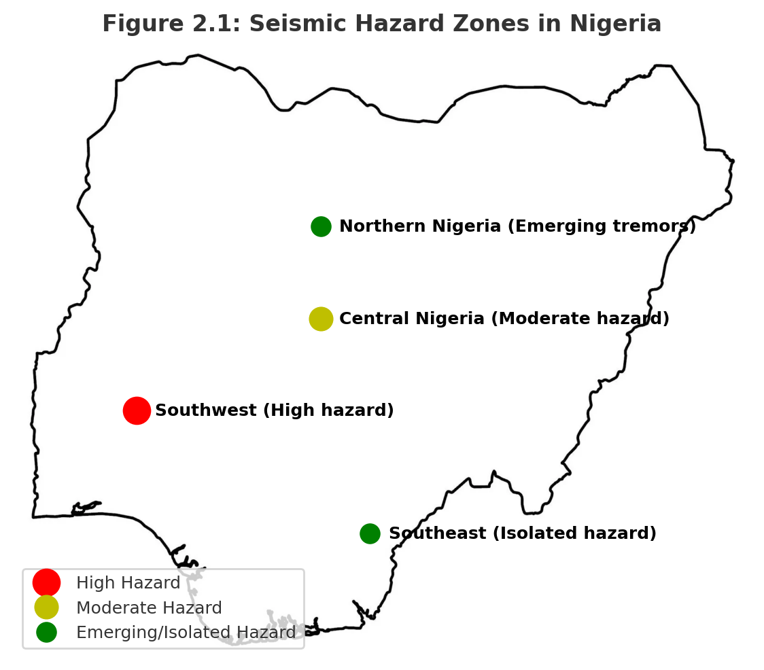
Figure 2: Probabilistic seismic hazard map for Nigeria (schematic illustration). Base map adapted from open-source shapefile data; hazard classifications designed by the author using data from [5,6,8,22].

Alongside PSHM, GIS and remote sensing refine risk assessments by overlaying faults, soils, topography, land use, and settlement patterns to visualize hazard–exposure intersections [5,35].
Figure 3 overlays urban centers, critical infrastructure, and mapped faults, illustrating how proximity to the Ifewara-Zungeru system elevates potential exposure in fast-growing corridors. This spatial integration yields actionable insights for planners and emergency managers [5,35].

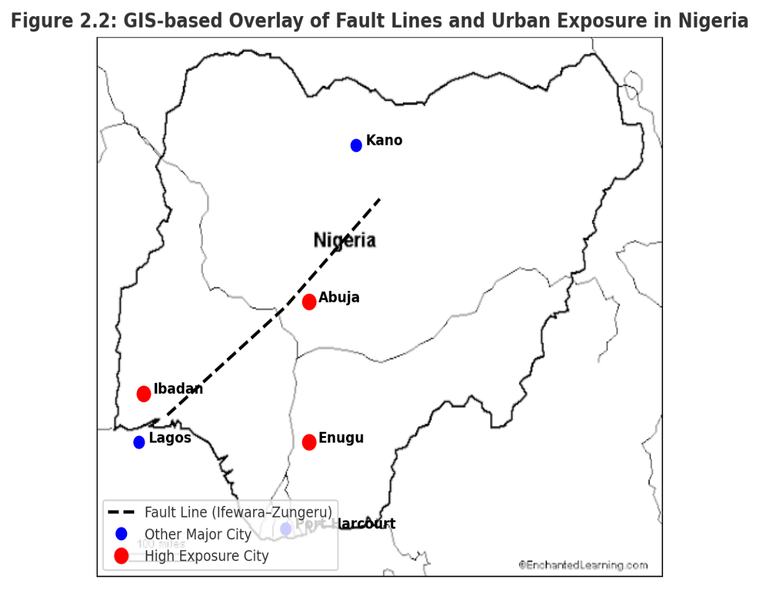
Figure 3: Conceptual GIS-based overlay of urban center and proximity to a major fault line
Base map adapted from open-source shapefile data; hazard classifications designed by the author using data from [5.31,33,35]

Human activities can also influence local stress fields: groundwater extraction and borehole drilling may perturb stresses and trigger minor tremors near faults [31,33]. When governed by geotechnical practice, drilling also generates subsurface data valuable for site classification and liquefaction appraisal [34].
Despite progress, uncertainties persist: few stations, short and discontinuous records [23] and reliance on regional analogues limit precision. Comparative experience from the New Madrid Seismic Zone to European frameworks shows the value of dense networks, long-term GPS, and advanced probabilistic models to reduce uncertainty and enhance early-warning capacity [1,14].
2.3 Urban Exposure and Vulnerability to Seismic Hazards
Rapid urbanization in Nigeria concentrates people and assets in environments often ill-prepared for seismic shocks [9,36]. Informal settlements frequently expand into marginal lands such as floodplains, reclaimed areas, and unstable slopes, and are characterized by weak construction standards that heighten collapse risk even during moderate shaking [10,36,11]. Spatial analyses further show that many communities lie in close proximity to active faults such as the Ifewara-Zungeru lineament, compounding exposure [31].

Building stock across Nigerian cities is highly heterogeneous: reinforced concrete structures are common in planned districts, while unreinforced masonry dominates informal settlements where retrofitting is rare [31,36]. This structural fragility is compounded by the concentration of critical infrastructure: hospitals, schools, transportation hubs, and utilities within at-risk zones, creating systemic vulnerability in the event of disruption [31,36,11].

Population dynamics intensify these risks. With an estimated 223 million people in 2022 and rapid urban growth projected into mid-century, Nigeria’s density magnifies the potential for casualties and damage, particularly where building codes are weakly enforced and informal construction dominates [37]. Integrating demographic data with hazard and exposure maps is therefore crucial for targeted interventions, including risk-sensitive urban planning, retrofitting of vulnerable buildings, and preparedness strategies for high-density neighborhoods [37,36,31].
2.4. Population Dynamics and Seismic Exposure
Nigeria’s population, estimated at approximately 223 million in 2022, is one of the fastest-growing in the world and projected to exceed 400 million by 2050 [37]. This demographic surge is highly urban-centered, with more than half of residents already living in cities and urbanization rates exceeding 4% annually. The result is unprecedented pressure on land, infrastructure, and housing stock in seismic-prone zones.

High population density magnifies seismic exposure where building codes are poorly enforced and informal construction dominates [10,31,36,11]. Cities such as Lagos, Abuja, Ibadan, and Enugu illustrate this intersection, as rapid peri-urban expansion often takes place in unregulated areas with fragile building typologies. In Abuja, for instance, peri-urban districts absorb much of the city’s growth, yet construction there frequently bypasses official oversight, leaving large populations in structurally vulnerable housing.

Population dynamics also intersect with critical infrastructure vulnerability. Hospitals, schools, and transport hubs located in dense districts face dual risks: potential structural damage during tremors and the secondary impacts of disrupted services. Linking demographic layers to hazard maps therefore provides an essential tool for risk-sensitive planning, enabling authorities to prioritize retrofitting, guide safer settlement patterns, and strengthen preparedness in the highest-exposure neighborhoods [37,36,31].
2.5 Socio-Economic and Policy Dimensions of Seismic Risk
Within Sub-Saharan Africa, the East African Rift System (EARS) remains the most active seismic zone. Experiences from Kenya, Ethiopia, and Tanzania show that dense seismic monitoring networks, GIS-based hazard mapping, and sustained public awareness programs are effective in reducing exposure [17,16,14]. These measures illustrate how institutional commitment and community engagement can limit the impacts of recurrent seismic activity.

Globally, intraplate analogues such as the New Madrid region in the United States, Gujarat in India, and parts of Central Europe demonstrate that reactivated ancient faults can yield damaging earthquakes. In these settings, damaging events prompted the adoption of micro-zonation techniques, probabilistic seismic hazard modelling, and reforms in building codes [1]. Such approaches provide useful lessons for countries like Nigeria, where seismicity is moderate but urban vulnerability is high.

For Nigeria, the key implications are clear: scaling up seismic monitoring networks, integrating probabilistic seismic hazard modelling with GIS and remote sensing, and embedding seismic considerations into urban planning and disaster risk reduction frameworks. These comparative insights directly support the research question by showing how Nigeria’s vulnerability, urban exposure, and policy preparedness align with, yet diverge from, international experiences. They emphasize that while Nigeria faces lower frequency events, its risk is amplified by fragile infrastructure, rapid urban growth, and weak governance—conditions that make the systematic review of existing evidence both timely and necessary.
2.6 Regional and Global Comparisons
Despite three decades of scholarship on Nigeria’s seismicity, several clear research gaps remain. First, most studies focus narrowly on geophysical hazard characterization, with limited attention to how seismic risk intersects with urban growth, infrastructure fragility, and governance arrangements. This has left a fragmented evidence base in which hazards are studied in isolation from social and institutional vulnerability.

Second, there is little synthesis of household- or community-level vulnerability, meaning that the lived realities of populations most exposed to tremors are poorly understood. Research has yet to capture how poverty, informality, and limited preparedness shape resilience outcomes in Nigerian cities.

Third, while GIS, remote sensing, and probabilistic seismic hazard modelling (PSHM) have been applied in other African and global intraplate contexts, their systematic use in Nigeria remains rare. The absence of integrated hazard-exposure models constrains efforts to identify urban hotspots and prioritize mitigation.

Finally, Nigeria has not sufficiently drawn from comparative lessons in other regions where intraplate seismic risk has prompted code reforms, early-warning systems, and community-based preparedness. Without such cross-regional learning, Nigerian scholarship risks remaining nationally siloed and policy relevance remains limited.

These research gaps highlight why a systematic review is necessary: to consolidate dispersed findings, clarify the intersections of hazard, exposure, and governance, and provide an integrated evidence base that can guide both future research and disaster risk reduction strategies.
2.7 Research Gaps Identified from Literature
Data limitations: Historical records are incomplete and uneven; instrumental monitoring is sparse and discontinuous, constraining PSHM precision and spatial risk mapping [28,29,23].
Integration gaps: Few studies combine geophysics, urban exposure, socio-economics, and policy; research and DRR practice remain fragmented [39,35,38,13,19,15].
Underused technology: GIS, remote sensing, and advanced PSHM are not yet standard in national or municipal workflows; wider adoption could deliver localized hotspot mapping and scenario simulations (Figures 2-3).
Comparative learning: Nigeria can adapt practices from EARS and global intraplate regions; dense networks, GPS, micro-zonation, early-warning, and code enforcement [1,14,17].
3. Research Methodology
3.1 Study Design
This review follows PRISMA to consolidate and critically evaluate evidence on seismic hazards, urban exposure, and governance in Nigeria. A systematic approach is necessary given the fragmented scholarship spanning geophysical modelling, urban planning, socio-economic vulnerability, and institutional frameworks.
Identification of sources. We searched Scopus, Web of Science, ScienceDirect, and Google Scholar, plus institutional repositories (NEMA, NGSA, UNDRR, World Bank, UN-Habitat) using terms such as “seismic hazard Nigeria,” “earthquake risk Africa,” “urban vulnerability Nigeria,” “induced seismicity,” and “disaster governance Nigeria.” Coverage: 1990-2025 to match the documented period of seismic activity.

Screening. Titles/abstracts were screened for relevance to: (i) Nigerian or comparable African intraplate seismicity; (ii) urban exposure, infrastructure vulnerability, or governance; and (iii) peer-reviewed or reputable institutional outputs. Purely laboratory geophysical work without urban/policy relevance was excluded.

Eligibility & Inclusion: A total of ≈200 records were initially identified through database and grey literature searches. After removing 80 duplicates and ineligible records at the screening stage, 120 full texts were assessed for eligibility. Of these, 67 met the inclusion criteria and were retained for detailed review. During synthesis, six were later excluded due to redundancy or insufficient relevance to the core thematic domains, leaving 61 studies that form the final evidence base for this review (see References).

Thematic Synthesis: The retained works span four interrelated domains: -
- Seismic hazard characterization (fault mapping, probabilistic models, intraplate seismicity);
- Urban/infrastructure exposure (informal settlements, code compliance, critical infrastructure);
- Socio-economic vulnerability & public perception (preparedness, awareness, climate interactions);
- Policy & governance (DRR strategies, institutional capacity, international lessons).

Transparency: Figure 4 presents the PRISMA flow diagram: ≈200 records identified; 80 excluded at screening; 120 assessed at full text; 67 retained; 61 finally synthesized. This adjustment ensures both methodological transparency and alignment with journal requirements.

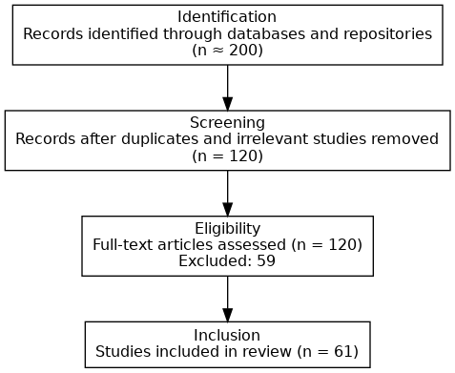
Figure 4: PRISMA Flow Diagram

3.2 Comparative Framework
To situate Nigeria’s seismic risk within broader scholarly and policy debates, three comparative contexts were incorporated into the synthesis: East Africa, Brazil, and Nepal. These regions were selected based on their methodological and thematic relevance rather than arbitrary choice.
- East Africa (EARS): Represents Africa’s most active seismic zone, where urban growth and weak governance mirror challenges seen in Nigeria. It provides insights into how African states respond to recurrent seismicity despite limited resources.
- Brazil: Serves as an intraplate analogue in the Global South. Like Nigeria, Brazil was long regarded as tectonically stable, yet damaging earthquakes have occurred, prompting code reforms and hazard mapping initiatives.
- Nepal: Offers a high-seismicity contrast in the Global South, where rapid urbanization and weak building enforcement produced severe impacts during the 2015 Gorkha earthquake. It demonstrates how governance and community preparedness shape resilience even under high hazard conditions.
Together, these cases provide a balanced comparative lens, highlighting both regional parallels and global lessons. The selection does not attempt an exhaustive global survey but rather focuses on contexts most relevant to understanding Nigeria’s position within intraplate seismic risk discourse.
3.3 Data Extraction and Coding
Data from the 61 included studies were extracted using a structured template that captured the following attributes: author, year, source, geographical focus and scale, methodological approach, and contribution to one or more domains (hazards, vulnerability, or governance). This process adhered to PRISMA’s principles of transparency and reproducibility.
Coding proceeded in two iterative passes. In the first pass, each study was assigned to one of four primary domains: (i) seismic hazard characterization, (ii) urban and infrastructure exposure, (iii) socio-economic vulnerability and public perception, and (iv) policy and governance. In the second pass, sub-codes captured specific emphases within these domains, such as probabilistic modelling, informal settlements, household preparedness, and disaster risk reduction (DRR) strategies.

Manual reading was supported by Excel spreadsheets and NVivo software, with reliability enhanced through repeated coding checks and consensus resolution across domains. Cross-cutting studies were assigned multiple codes to reflect their interdisciplinary contributions.
Table 2 presents the coding framework and distribution of studies (n = 61) across the four domains. This framework underpins the thematic synthesis in Section 3.3 and informs the results discussed in Chapter 4.

Table 2: Coding Framework and Distribution of Studies
Thematic Domain | Description of Focus | Examples of Sub-codes | No. of Studies (n=61)
Seismic Hazard Characterization |  |  | 25
  Studies mapping fault lines, modeling seismic probability, or analyzing intraplate seismicity
  Probabilistic hazard modeling, geophysical surveys, historical seismic records, stress state analysis, fault reactivation
Urban and Infrastructure Vulnerability |  |  | 5
  Studies assessing urban exposure, building compliance, housing vulnerability, and resilience to earthquakes
  Building compliance, informal settlements, housing vulnerability, infrastructure resilience
Disaster Preparedness and Governance |  |  | 23
  Studies focusing on emergency management systems, institutional frameworks, policy, risk reduction, and community preparedness
  Emergency planning, disaster governance, policy frameworks, community-based preparedness, Sendai Framework implementation
Other / Global Comparative Studies |  |  | 8
  Studies providing international comparisons, remote sensing applications, or methodological insights
  GIS/remote sensing, global seismic hazard models, cross-country resilience comparisons
The distribution of studies across these four domains is further illustrated in Figure A1(Appendix), which highlights the dominance of hazard characterization studies compared with the relative scarcity of work on governance and community resilience.
3.4 Analytical Strategy / Data Synthesis
Synthesis combined narrative and comparative approaches.
- Descriptive mapping: Using Table 3 to show how evidence clusters by domain, method, and time, highlighting concentration in hazard studies and thinner coverage of community resilience and governance.
- Thematic synthesis: Within each domain we compared recurring themes and divergences (e.g., probabilistic vs. historical-catalogue hazard work; governance emphasis on institutional gaps vs. reform proposals).
- Comparative lens: Nigerian findings were read alongside African and global intraplate contexts to identify commonalities and distinct patterns.
- Cross-domain integration: We explicitly linked code enforcement gaps (urban exposure) with institutional weaknesses (governance) and socio-economic constraints (preparedness).
Together, Figure 4 and Table 3 show how studies were identified, grouped, and synthesized; these provide the backbone for the results in the next chapter.
3.5 Quality Appraisal
We appraised the 61 retained studies for (i) clarity/rigor of design, (ii) data collection/analysis quality, and (iii) relevance to Nigeria’s seismic risk and urban vulnerability.
Peer-reviewed journal articles generally showed higher methodological rigor, while institutional/grey literature provided contextual and policy value but sometimes lacked detail. To preserve policy relevance, grey literature was retained but flagged for interpretive caution. Appraisal used a PRISMA-aligned checklist and a three-point scale (high/medium/low), with discrepancies resolved through repeat checks.

Table 3 reports the distribution of quality ratings and source types used in synthesis.
Table 3: Quality Assessment of Retained Studies
Quality Level | Description | Study Frequency | Type of Sources | Note
High |  | 29
  Studies with clear research design, rigorous methodology, and highly relevant findings for Nigeria’s seismic risk and urban vulnerability contexts
  Peer-reviewed journal articles
  Strong evidence base; directly informs synthesis
Medium |  | 20 |  | Useful for context; interpret with moderate caution
  Studies with moderate methodological rigor or partial relevance; may have minor gaps in transparency or data analysis
  Peer-reviewed journals, some institutional reports
Low |  | 12 |  | Retained for policy relevance but flagged for interpretive caution
  Studies with limited methodological detail, unclear design, or lower relevance to Nigerian seismic risk
  Institutional reports, grey literature
The relationship between study quality and thematic focus is presented in Figure A2 (Appendix). It shows that while high-quality peer-reviewed studies dominate hazard characterization, governance and community resilience rely more heavily on medium- and lower-quality grey literature sources.

A conceptual overview linking study quality, thematic coverage, and geographic distribution is presented in Figure A3 (Appendix). This visualization illustrates how the evidence base remains clustered around technical hazard modelling, while socio-economic and governance perspectives are still underrepresented.
3.6 Limitations of Methodology
Despite the structured process, several limitations remain. Publication bias may exist because null results are less often published, potentially skewing the evidence base. Regional imbalance is evident: the southwest is better studied than the north/northeast, limiting generalizability. Inclusion of grey literature increases policy relevance but introduces variability in rigor. Coding/appraisal required judgement despite checklists and cross-checks. Finally, the 1990-2025 window spans shift in monitoring technologies, urban growth, and policy frameworks, which complicates comparisons across time.
4. Results
4.1 Seismic Hazard Patterns in Nigeria (1990-2025)
The analysis of seismic hazard patterns in Nigeria between 1990 and 2025 shows clusters of low-to-moderate intraplate seismicity, with events concentrated in the southwest, central, and southeastern regions. These clusters are consistent with basement structural lineaments and reactivated faults previously identified in the literature [28,29].

Earthquake catalogues indicate at least 75 recorded events within this period, with magnitudes ranging from 2.0 to 5.2 Mw. The southwestern region accounted for the highest frequency, particularly in Ibadan, Akure, and Ijebu-Ode (35-40%), followed by central Nigeria (25%) and southeastern centers such as Enugu and Abakaliki (15-20%). Emerging tremors in Bayelsa and Edo (≤3.5 Mw) suggest possible activation of previously unidentified faults [32].

The distribution of seismic activity across regions is summarized in Table 4, highlighting the prominence of southwestern clusters alongside emerging activity in the Niger Delta.
Table 4: Distribution of Recorded Earthquake Events in Nigeria (1990-2025)
Region | City | Number of Recorded Events | Magnitude Range (Mw) | % Contribution to Total Events | Notable Observations
Southwest | Ibadan | 15 | 2.5-5.2 | 20% | Clustered along Ifewara-Zungeru fault; recurrent low-to-moderate tremors
Southwest | Ijebu Ode | 10 | 2.0-4.8 | 13% | Includes 1984 tremor (MMI VI); minor structural damage
Southwest | Akure | 7 | 2.2-4.5 | 7% | Historical fault reactivation; elevated local risk
Central | Abuja/Kaduna | 18 | 2.5-4.9 | 25%
  Local fracture zones; low-to-moderate seismicity; notable tremors in Mpape, Maitama, Kwoi
Southeast | Enugu | 8 | 2.0-4.2 | 11% | Proximity to Benue Trough; isolated tremors
Southeast | Abakaliki | 7 | 2.1-4.0 | 9% | Low-magnitude but urban exposure increasing
Central/Southwest | Omu-Aran | 3 | 2.0-2.6 | 3% | Recent low-magnitude tremors; minor local effects
Emerging South | Bayelsa | 5 | 2.0-3.5 | 6% | Newly reported low-magnitude tremors; potential new hazard zones
Emerging South | Edo | 5 | 2.0-3.5 | 6% | Recent sporadic tremors; previously under-monitored area
4.1.1 Magnitude and Intensity Distribution
Magnitude-frequency analysis shows that most events fall below 4.0 Mw, aligning with Modified Mercalli Intensity (MMI) levels III-V. Notable exceptions include the 2000 Kaduna tremor and the 2009 Abeokuta event, both of which reached MMI VI [5,35]. Southwestern activity is closely associated with the Ifewara-Zungeru fault system [39,43], while central and southeastern clusters correspond to local fracture zones and the Benue Trough.
4.1.2 Temporal and Spatial Patterns
Temporal records indicate a gradual rise in reported tremors since the 2000s, a trend attributed in part to improved detection capacity and urban expansion rather than a sharp increase in seismicity levels. Spatial mapping shows a concentration of events in the southwest, while central Nigeria records sporadic but significant activity.
The geographic spread of tremors is depicted in Figure 5, which illustrates the clustering along the Ifewara-Zungeru fault and newly documented activity in the Niger Delta.
4.1.3 Clustering and Hazard Implications
The observed clustering patterns provide a reference for identifying urban areas most exposed to seismic hazard. Overlaying hazard maps with urban centers and infrastructure highlights zones where earthquake-resilient planning is most needed.

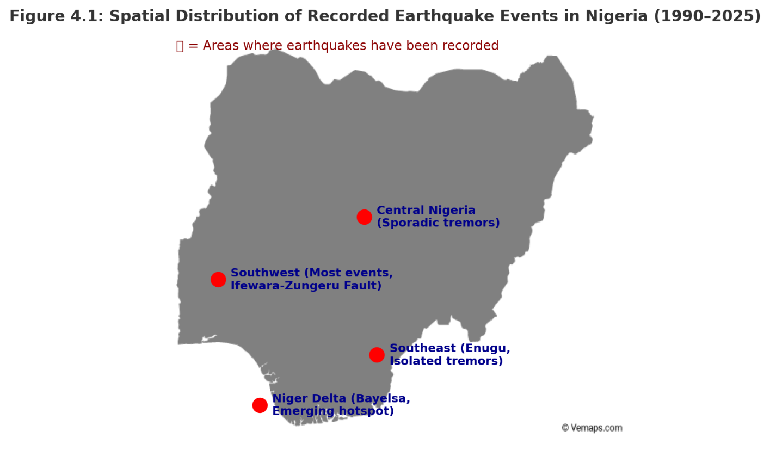
Figure 5: Spatial distribution of recorded earthquake events in Nigeria (1990-2025)

4.2 Historical Earthquake Records and Frequency
Nigeria’s seismic history during the review period reflects recurring low-to-moderate tremors, with variations influenced by fault reactivation, crustal weaknesses, and improved monitoring [28,29,32].
4.2.1 Frequency of Events
Southwestern Nigeria contributed 35-40% of the recorded events, central Nigeria 25%, and southeastern centers 15-20%. The tremors documented in Bayelsa and Edo signal an expanding geographic footprint of seismicity.
4.2.2 Magnitude and Intensity Distribution
Most events ranged between 2.0 and 4.0 Mw (MMI III-V), though the 1984 Ijebu-Ode and 2000 Kaduna tremors both reached MMI VI, demonstrating their potential for structural impacts [5,35].
4.2.3 Temporal Shifts
While tremors were often reported anecdotally in the 1990s, more systematic documentation has been available since 2010, reflecting both advances in monitoring and the actual incidence of events [43].
4.2.4 Data Gaps and Limitations
Significant gaps persist due to sparse seismic stations and underreporting of tremors, especially in rural areas.

Table 5 summarizes selected events by year, location, and observed impacts
Table 5: Selected Earthquake Events in Nigeria (1990-2025)
Year | Region | City/Area | Magnitude (Mw) | Intensity (MMI) | Reported Impacts/Observation
1990 | Southwest | Ibadan | 3.7 | IV-V | Minor ground shaking; no structural damage
1998 | Southwest | Ijebu-Ode | 4.0 | VI | Building cracks; minor alarm among residents
2000 | Central | Kaduna | 4.1 | VI | Felt across local communities; minor infrastructural impact
2009 | Southwest | Abeokuta | 4.1 | V-VI | Structural cracks; public alarm
2016 | Central | Abuja (Mpape) | 3.8 | IV-V | Building vibrations; minor wall cracks
2017 | Central | Kaduna (Kwoi) | 4.4 | VI | Roof damage; community panic
2018 | Central | Abuja (Maitama/Gwaripa) | 3.6 | IV | Vibrations; minor structural impacts
2020 | Southwest | Saki (Oyo) | 3.2 | III-IV | Weak shaking no reported damage
2021 | Central/ Southwest | Omu-Aran (Kwara) | 2.6 | III | Felt locally; no structural damage
2023 | Southwest | Ijebu-Ode | 4.0 | V | Minor building cracks; temporary evacuations
2021 | Emerging South | Bayelsa | 2.2-3.5 | III-IV | Low-magnitude tremors; minimal local effects
2022 | Emerging South | Edo | 2.0-3.5 | III-IV | Sporadic tremors; previously under-monitored area
These results consolidate Nigeria’s seismic records from 1990 to 2025, highlighting regional clusters, event frequencies, and magnitude distributions, which form the empirical basis for further discussion of urban exposure, governance, and resilience strategies.
5. Discussion
This discussion interprets the empirical results of Nigeria’s seismic patterns between 1990 and 2025, situating them within broader debates on vulnerability, governance, and resilience. The review period begins in 1990 because earlier records, such as the 1933 Warri, 1939 Ibadan, and 1984 Ijebu-Ode tremors, though significant, are fragmentary and mostly anecdotal. From 1990 onwards, more systematic data became available through the Nigerian Geological Survey Agency (NGSA), academic studies, and international monitoring efforts. This period also coincides with accelerated urbanization in Nigeria, which has substantially increased exposure to seismic risk.
5.1 Urban Exposure and Vulnerability
Although earthquakes in Nigeria are generally low-to-moderate in magnitude, their impacts are magnified by dense populations, fragile housing, and vulnerable infrastructure [5,35]. These risks are best understood through two interrelated dimensions: the pressures of urban growth, informal settlements, and diverse building typologies; and the vulnerability of critical infrastructure as revealed by GIS-based exposure mapping.
5.1.1 Urban Growth, Informal Settlements, and Building Typologies
Nigeria’s seismic vulnerability is strongly shaped by rapid urban growth and weak planning oversight. Since 1990, cities such as Lagos, Abuja, Ibadan, and Enugu have expanded dramatically, often outpacing authorities’ ability to enforce safe land use [9]. Abuja alone grew from under half a million residents in the early 1990s to over three million today, much of it in peri-urban zones dominated by informal construction [43]. Such density magnifies the impacts of even low-magnitude tremors, ensuring shaking is widely felt and disruptive [1,44].

Much of this growth is absorbed by informal settlements, characterized by mud brick, corrugated sheet, or poorly reinforced concrete housing with little structural integrity [45,35,41]. In Ibadan and Enugu, slum clusters are densely packed with poor access to emergency services, making even minor tremors disproportionately damaging. Expansion into floodplains and slopes further compounds vulnerability [39,46].

Nigeria’s building stock also reflects engineering deficiencies. Shallow foundations, weak reinforcement, and low-quality materials make many structures fragile. This problem extends beyond informal areas: government estates in Abuja and Kaduna showed cracks during the 2000 Kaduna and 2016-2018 Abuja tremors [5,35,41]. Without systematic retrofitting and stricter code enforcement, much of the built environment remains highly susceptible to seismic impacts.
5.1.2 Critical Infrastructure and GIS-Based Vulnerability
Nigeria’s seismic exposure is intensified by critical infrastructure located in geologically sensitive areas. Major dams such as Kainji, Shiroro, and Jebba, along with airports, highways, schools, and hospitals concentrated in Abuja, Lagos, and Kaduna, represent high-value assets whose disruption would have cascading effects on safety and economic continuity [9,44]. In the Niger Delta, emerging tremors in Bayelsa overlap with dense oil and gas installations, raising risks of industrial accidents and environmental crises [32].

GIS analyses highlight these intersections by overlaying hazard data with demographic and infrastructure layers. They show, for example, how Ibadan’s tremor clusters overlap with informal housing, or how Abuja’s sprawl places institutions near mapped fractures [39,46,32,56]. In Bayelsa, GIS overlays reveal tremors converging with oil facilities and wetlands, underscoring compounded risks.

Table 6 consolidates these insights, linking seismic hotspots with population density, housing types, and critical infrastructure. Figure 6 complements this analysis by mapping seismic clusters against urban exposure, highlighting Ibadan, Abuja, and Bayelsa as zones of compounded vulnerability.
Table 6: Urban Exposure to Seismic Hazards by Region in Nigeria (1990-2025)
Region | City/Area | Urban Density (people/km²) | Dominant Housing Type | Critical Infrastructure Exposure | Observed Vulnerability Factors
Southwest | Ibadan | 3,500 |  | Hospitals, schools, transport hubs | High population density, informal housing clusters, weak code enforcement
  Informal settlement, mixed low-rise masonry
Southwest | Ijebu-Ode | 2,800 | Low-rise masonry, some informal housing | Schools, local clinics | Moderate urban concentration; some structural fragility in older buildings
Southwest | Akure | 2,900 | Mixed masonry and reinforced concrete | Hospital, government offices | Moderate population density; structural quality varies
Central | Abuja | 3,200 | High-rise reinforced concrete, informal peri-urban areas | National institutions, airports, government offices
  Rapid urban expansion; code enforcement gaps in peri-urban zones
Central | Kaduna | 2,700 |  |  | Structural weaknesses in older buildings; moderate urban density
  Colonial masonry, low-rise reinforced concrete
  Hospital, railway networks
Southwest/Central | Omu-Aran | 1,500 | Predominantly low-rise masonry | Local schools, health facilities | Low population but emerging seismic activity; structural fragility
Southeast | Enugu | 2,800 | Mixed masonry, some informal housing | Hospitals, schools, transport hubs | Urban growth intersects with fault zones; moderate vulnerability
Emerging South | Bayelsa | 1,200 | Low-rise masonry, stilted houses | Oil facilities, local infrastructure | Low-magnitude seismic activity; high-value oil infrastructure; ecological sensitivity
Emerging South | Edo | 1,800 | Low-rise masonry, some informal settlements | Local government offices, transport nodes | Recently reported tremors; limited monitoring; moderate vulnerability
Figure 6 complements Table 6 by mapping seismic clusters against urban exposure, highlighting Ibadan, Abuja, and Bayelsa as zones of compounded vulnerability.

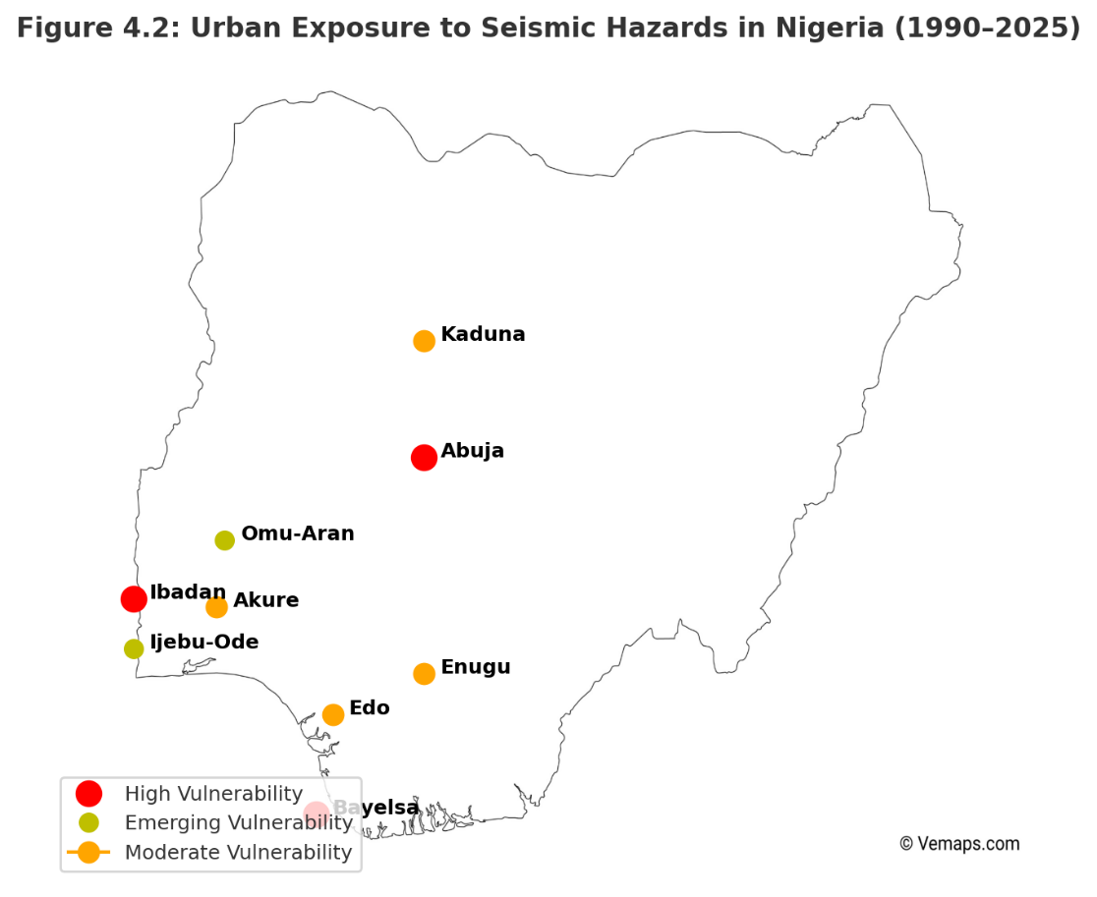
Figure 6: Urban Exposure to Seismic Hazards in Nigeria (1990-2025)

5.2 Socio-Economic and Policy Dimensions
5.2.1 Institutional Frameworks and Governance
Nigeria’s institutional framework for seismic risk governance is defined by overlapping but limited mandates. The NGSA oversees seismic monitoring, while the National Emergency Management Agency (NEMA) coordinates disaster response, supported at the state level by State Emergency Management Agencies (SEMAs). However, capacity is constrained by sparse monitoring (<10 seismographs nationwide), weak coordination, and inadequate enforcement [43,40,19].

Table 7 summarizes the mandates, achievements, and persistent gaps of these institutions between 1990 and 2025.
Table 7: Institutional Roles, Achievements, and Gaps in Seismic Risk Governance in Nigeria (1990-2025)
Institution/Level | Mandate/Role | Key Achievements (1990-2025) | Major Gaps/ Challenges
Nigerian Geological Survey Agency (NGSA) | National seismic monitoring, hazard mapping, research | Installed seismic stations in Abuja, Kaduna, Ibadan; produced preliminary hazard maps | Sparse network (<10 seismographs); limited integration of data into urban planning; inadequate funding; low staff capacity
National Emergency Management Agency (NEMA) | Federal disaster coordination, emergency response | Coordinated relief during 2018 Abuja tremors; provided emergency support in affected regions | Predominantly reactive approach; weak community outreach; limited preventive programs or simulation drills
State Emergency Management Agencies (SEMAs) | Subnational disaster management, local preparedness | Operational frameworks established in most states | Underfunded; limited technical expertise; inconsistent coordination with NGSA and NEMA
Urban Planning Authorities | Building code enforcement, land-use planning |  | Weak enforcement; informal housing growth; limited capacity to monitor compliance
  Post-2010 codes incorporate seismic provisions
Community / Local Groups | Awareness, local preparedness, peer support |  | Efforts isolated; not systematically integrated into formal disaster management systems
  Mobilization after local tremors; community knowledge-sharing
Private Sector / Critical Infrastructure Operators | Operational continuity, safety of facilities | Some awareness of risk in high-value sectors (e.g., oil in Bayelsa) | Minimal earthquake-specific preparedness; lack of seismic retrofitting; vulnerability of infrastructure to low-magnitude tremors
5.2.2 Preparedness, Policy Gaps, and Governance Implications
Seismic vulnerability in Nigeria is shaped not only by hazard but also by weaknesses in preparedness, policy, and governance. Public awareness of earthquake risk remains very low compared to floods or erosion, and schools, hospitals, and workplaces rarely maintain earthquake protocols [45,5]. Limited preparedness leaves populations reacting with alarm but without coordinated safety procedures [35].

Weak enforcement of codes compounds these risks. Although seismic provisions were added to building standards after 2010, enforcement is inconsistent, especially in peri-urban and informal areas where up to 60% of housing escapes oversight [35,47]. Corruption, low institutional capacity, and self-built housing mean fragility persists even in formal sectors.
Socio-economic conditions further heighten exposure: poverty and inequality restrict access to safer housing, insurance, and recovery capacity. Informal settlements in Lagos, Ibadan, and Enugu remain especially vulnerable [48].

Governance gaps are stark. NGSA runs fewer than ten stations, producing incomplete seismic datasets rarely integrated into planning [43,19,57]. NEMA coordinates response but remains reactive, while SEMAs are underfunded and lack expertise [40,49]. Planning authorities nominally enforce codes, yet compliance is weak in fast-growing zones dominated by informality [35,59].

These weaknesses have major implications. Communities remain reliant on anecdotal reports due to absent early warning systems. Weak code enforcement ensures chronic building fragility. Fragmented NGSA-NEMA-SEMA coordination undermines governance, while limited public engagement prevents bottom-up resilience [50].

Nigeria acknowledges global frameworks such as the Sendai Framework for Disaster Risk Reduction (2015-2030), but implementation remains uneven [51,58]. Earthquakes remain low-priority hazards compared to floods and droughts. As Brazil’s experience shows, underestimating intraplate hazards risks costly surprises [42]. In short, governance weaknesses, socio-economic fragility, and low preparedness magnify vulnerability far beyond hazard levels. Strengthening NGSA’s monitoring, enforcing standards, embedding seismic risk in land-use planning, and scaling community awareness are essential to reduce disruption from even moderate tremors.
5.3 Comparative Insights from Other Regions
Comparisons with East Africa, Brazil, and Nepal underline shared vulnerabilities: sparse monitoring, weak enforcement of building codes, and reliance on anecdotal rather than systematic seismic records [17,42,52]. East Africa demonstrates the challenges of rift-related seismicity, where urban growth intersects with gaps in monitoring networks and preparedness [17]. Brazil’s intraplate seismicity shows how underestimated hazards in stable continental interiors can still result in damaging events when governance and resilience are neglected [42]. Nepal’s 2015 Gorkha earthquake illustrates how rapid urbanization and weak code enforcement magnify disaster impacts, while also highlighting the role of community preparedness and governance reform in building resilience [53,54,60]. These regions were selected because they represent three relevant contexts for comparison: an active rift zone in Africa, an intraplate continental region in the Global South, and a tectonically active region with rapid urban growth. Together, they provide useful lessons for Nigeria without attempting to cover all global cases.

Table 8 contrasts Nigeria with these contexts across hazard, governance, and resilience dimensions. Figure 7 further illustrates seismic events overlaid with urban growth and population centers, reinforcing the universality of governance and exposure challenges.
Table 8: Comparative Insights on Seismic Risk and Governance (Nigeria and Selected Regions)
Region | Seismic Content | Monitoring Capacity | Governance & Policy Frameworks | Urban Resilience Lessons
Nigeria | Intraplate tremors along reactivated ancient faults; low-to-moderate magnitude (Mw 2.0–5.2) | Sparse seismic network (<10 stations nationwide); reliance on anecdotal reports | NGSA oversees monitoring; NEMA coordinates disaster response; weak enforcement of building codes; fragmented governance | High urban exposure; informal settlements increase vulnerability; proactive risk reduction is limited; need for integrated urban planning
East Africa |  | Limited but improving monitoring; several seismic stations in key urban centers | National disaster management agencies exist but face technical and coordination gaps | Rapid urban growth in hazard zones; weak code enforcement; emphasizes importance of early warning and community preparedness
  Rift-related seismicity (e.g., Main Ethiopian Rift); localized moderate events
Brazil |  | Sparse historical and real-time monitoring; underreporting of events | National and regional frameworks exist; low prioritization of seismic hazards | Dense urban populations exposed to rare events; highlights need for risk awareness even in “stable” regions
  Intraplate seismicity in southeastern cratonic regions; infrequent but potentially damaging
Nepal | Himalayan arc; high-magnitude earthquakes; active tectonic convergence | Well-established network; extensive historical records | Strong DRR policies post-2015 Gorkha earthquake; uneven enforcement; community engagement varies | Institutional learning and community-driven measures are critical; emphasizes low-cost, context-sensitive solutions for resilience
Figure 7 provides a spatial overlay of seismic events, urban growth, and population centers, reinforcing the universality of governance and exposure challenges.


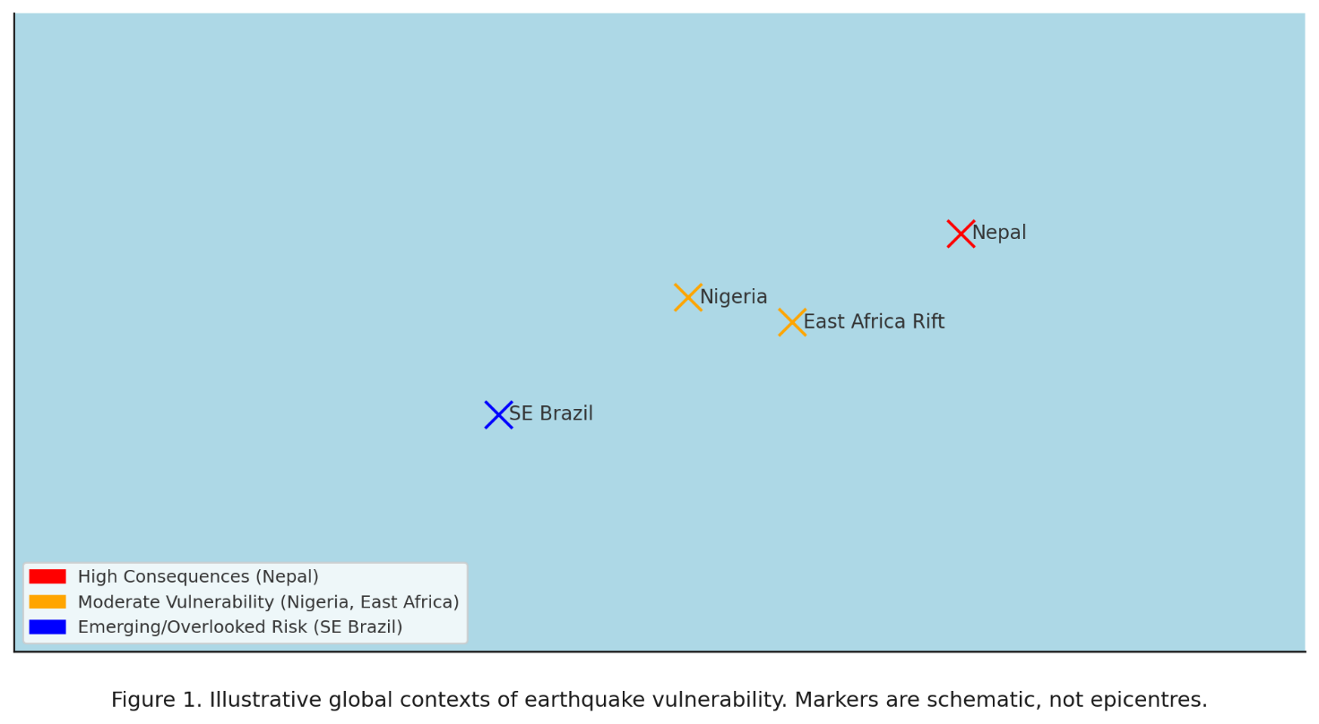
Figure 7: Comparative Global Seismic Risks Insights (Nigeria, East Africa, Brazil, Nepal

5.4 Gaps in Knowledge, Research Needs, and Concluding Insights
Nigeria’s seismic vulnerability is shaped by monitoring deficiencies, weak integration with urban planning, socio-economic fragility, and limited cross-regional learning. Methodological gaps include low adoption of probabilistic or deterministic hazard models such as NDSHA [55,61], and induced seismicity linked to oil and gas extraction remains under-researched.

Overall, Nigeria’s earthquake vulnerability arises not only from geophysical uncertainty but also from socio-economic neglect and governance weakness. Future research should expand seismic monitoring networks, embed hazard maps into urban planning, conduct detailed socio-economic vulnerability assessments, and adopt international best practices in resilience. These findings provide the foundation for the next section, which outlines conclusions and recommendations for reducing Nigeria’s seismic risk.

Table 9 summarizes knowledge gaps, implications, and recommendations.
Table 9: Knowledge and Research Gaps in Nigeria’s Seismic Risk Context (1990-2025)
Thematic Area | Identified Gaps | Implications for Seismic Risk Governance | Recommendation for Future Research/Action
Monitoring and Data |  |  | Expand monitoring networks; improve real-time data collection; maintain systematic earthquake records
  Fewer than 10 operational seismic stations nationwide; incomplete tremor detection; reliance on anecdotal records
  Limited hazard characterization and underestimation of risk; poor evidence base for urban planning
Integration with Urban Planning | Preliminary hazard maps exist but rarely applied in land-use decisions; lack of GIS-based risk overlays | Urban growth in at-risk areas continues unchecked; infrastructure vulnerable to tremors | Develop and operationalize GIS-based hazard-exposure-vulnerability models; embed seismic risk into urban planning and infrastructure siting
Socio-Economic Vulnerability | Scarce household-level and community-based vulnerability assessments; limited awareness and preparedness | Informal settlements and low-income households remain highly exposed; recovery from tremors is slow and unequal | Conduct detailed socio-economic and structural vulnerability studies; implement community-level preparedness programs and micro-insurance schemes
Cross-Regional Learning | Lessons from Nepal, East Africa, Brazil underutilized; limited adoption of best practices | Policy and planning are reactive rather than proactive; missed opportunities for low-cost resilience strategies | Incorporate comparative risk governance insights; adapt international methods to local contexts; strengthen institutional learning
 | Low adoption of probabilistic/deterministic seismic hazard approaches (e.g., NDSHA); reliance on sparse data | Hazard assessment lacks accuracy; evidence-based policymaking constrained | Apply advanced hazard assessment methods; combine global frameworks with local seismic data; promote interdisciplinary research
  Methodological Limitations
In sum, Nigeria’s earthquake vulnerability arises not only from geophysical uncertainty but also from socio-economic neglect and governance weakness. These findings provide the foundation for Section 6, where conclusions and recommendations will outline strategies for enhanced resilience.
Conclusion
Nigeria’s emerging seismic vulnerability is real and significant, situated within a global context where intraplate seismicity is often underestimated. Recurrent low-to-moderate tremors are increasingly recorded in rapidly urbanizing areas, where impacts are amplified by fragile buildings, weak code enforcement, limited preparedness, and inadequate monitoring infrastructure. The danger lies less in earthquake magnitude than in the vulnerability of exposed populations and systems.

International experiences demonstrate that underestimating intraplate seismicity leads to costly surprises, while proactive governance and community engagement can reduce impacts. For Nigeria, the seismic challenge is shaped as much by governance and socio-economic fragility as by geophysical forces. Expanding monitoring, advancing hazard modeling, and embedding resilience in planning and preparedness are essential to safeguard lives, infrastructure, and sustainable urban development.

Recommendations
Nigeria’s seismic vulnerability is not merely a geophysical issue but the outcome of intersecting hazards, rapid urbanization, socio-economic fragility, and governance gaps. Even low-magnitude tremors become disruptive when amplified by unregulated construction, weak codes, and poor preparedness. Addressing this requires a shift from treating earthquakes as marginal hazards to embedding them in disaster governance, urban planning, and development strategies.

Resilience should be strengthened through six strategic pathways. First, seismic monitoring networks need to be expanded, especially in emerging zones such as Bayelsa, Edo, and Omu-Aran, and linked with regional and global platforms to improve hazard modeling and decision-making. Second, GIS and remote sensing should be integrated into urban planning to assess vulnerabilities in hospitals, schools, and infrastructure, guiding updates to building regulations and prioritizing high-exposure zones. Third, seismic risk must be explicitly embedded into Nigeria’s multi-hazard disaster risk reduction frameworks, aligning with international commitments while tailoring lessons to local realities. Fourth, community awareness and resilience should be enhanced through drills, awareness campaigns, and local response networks, particularly in informal settlements. Fifth, stronger interdisciplinary and international collaboration is needed, connecting Nigerian scientists, planners, and policymakers with global seismic institutions for training, data sharing, and joint research. Sixth, seismic risk must be mainstreamed into development policy by enforcing codes, guiding settlement away from hazard zones, and embedding preparedness into infrastructure projects.

Together, these measures emphasize that resilience is not only technical but also social and political. Expanding monitoring, embedding hazard data into planning, enforcing building codes, empowering communities, and fostering collaboration will transform low-to-moderate tremors from potential crises into manageable risks.
Future Research Directions
This review has mapped Nigeria’s seismic vulnerability and also revealed key gaps. Monitoring remains sparse, socio-economic vulnerability is under-explored, and international lessons are underutilized. Across intraplate regions in the Global South, risks are often underestimated due to short records, weak monitoring, and limited integration of hazard data into planning. Advancing Nigerian research requires methodological innovation, deeper socio-economic engagement, and stronger global linkages.

Priority research directions include high-resolution seismic hazard modeling, using advanced probabilistic and deterministic methods to produce reliable inputs for earthquake-resistant design. Multi-scale vulnerability analyses are needed, moving beyond regional patterns to household and neighborhood-level assessments that capture how poverty, inequality, and fragile infrastructure shape resilience. Research should also examine the effectiveness of urban governance and policy implementation, highlighting gaps between building code design and enforcement. Comparative and cross-regional studies would enrich Nigerian practice by adapting lessons from other intraplate and tectonically active contexts. Finally, the integration of GeoAI, machine learning, and remote sensing can enable near-real-time monitoring, vulnerability mapping, and anticipatory disaster management, supporting multi-hazard assessments that link seismic and climate risks.

Overall, addressing Nigeria’s seismic vulnerability requires more than advances in geophysics: it demands interdisciplinary inquiry connecting hazard science with governance and community realities. Investment in high-resolution modeling, socio-economic studies, governance evaluation, comparative analysis, and GeoAI will build the evidence base for proactive risk management in Nigeria.

Disclaimer (Artificial intelligence)

Author(s) hereby declare that generative AI technologies such as Large Language Models, etc. have been used during the writing or editing of manuscripts. This explanation will include the name, version, model, and source of the generative AI technology and as well as all input prompts provided to the generative AI technology

Details of the AI usage are given below:
- Tool used: ChatGPT (GPT-5, OpenAI, web-based version, 2025).
- Purpose of use: Image generation for illustrative figures.
- Scope of use: Limited exclusively to the design of non-data-based images (e.g., conceptual diagrams and schematic illustrations). All textual content, data analysis, and interpretations were produced solely by the author(s).

Reference
- Bilham R. Seismic risk and global urbanization. Seismol Res Lett. 2019;90(1):1-17.
- United States Geological Survey (USGS). Significant Earthquake Database. Reston (VA): USGS; 2022. Available from: https://earthquake.usgs.gov
- Wisner B, Gaillard JC, Kelman I. Handbook of Hazards and Disaster Risk Reduction. 2nd ed. London: Routledge; 2021.
- Rebetsky Y, Adagunodo TA. Stress state and seismicity in West Africa: insights into intraplate earthquakes. J Afr Earth Sci. 2018;150:100-12.
- Adagunodo TA, Sunmonu LA, Odeyemi IB, et al. Review of seismicity in Nigeria: implications for hazard monitoring. Nat Hazards. 2018;94(2):873-902.
- Ojo SB, Adepelumi AA. Earthquake records and monitoring in Nigeria: progress and challenges. Niger J Geol. 2021;56(1):45-59.
- Adepelumi AA, Ako BD, Olorunfemi MO. Seismicity of the Ifewara–Zungeru fault system. J Geodyn. 2008;46(1):1-11.
- Nigerian Geological Survey Agency (NGSA). Annual Seismicity Bulletin. Abuja: NGSA; 2019. Available from: https://ngsa.gov.ng
- United Nations Human Settlements Programme (UN-Habitat). World Cities Report 2022. Nairobi: UN-Habitat; 2022. Available from: https://unhabitat.org
- Adelekan IO. Vulnerability of poor urban coastal communities to flooding in Lagos, Nigeria. Environ Urban. 2016;28(1):239-60.
- World Bank. Resilient Cities Program: Urban Risk in Nigeria. Washington (DC): World Bank; 2022. Available from: https://www.worldbank.org
- Wisner B, Gaillard JC, Cannon T. Disasters and vulnerability in the global South: lessons from Haiti. Disaster Prev Manag. 2025;34(2):140-55.
- National Emergency Management Agency (NEMA). National Disaster Risk Reduction Policy. Abuja: NEMA; 2017. Available from: https://nema.gov.ng
- Pagani M, Monelli D, Weatherill G, et al. Global earthquake model (GEM) hazard map: integrating global datasets. Earthq Spectra. 2020;36(1):1-24.
- United Nations Office for Disaster Risk Reduction (UNDRR). Global Assessment Report on Disaster Risk Reduction. Geneva: UNDRR; 2023. Available from: https://www.undrr.org
- Saria E, Calais E, Stamps DS, Delvaux D, Hartnady C. Present-day kinematics of the East African Rift. Geophys J Int. 2020;220(1):469-87.
- Corti G. Continental rift evolution: the East African perspective. Earth Sci Rev. 2009;96(1-2):1-53.
- Kadiri U, Kijko A. Seismic hazard assessment of North Africa. J Seismol. 2021;25(4):833-50.
- Manyena B, Simatele D. Disaster risk governance in sub-Saharan Africa: gaps and opportunities. Int J Disaster Risk Reduct. 2022;67:102668. doi:10.1016/j.ijdrr.2021.102668
- Ekpo CE, Adebayo T. Earthquake governance and policy neglect in Nigeria. Afr J Environ Manag. 2022;30(2):55-67.
- Adepelumi AA, Asiwaju-Bello YA. Seismic risk in Nigeria: implications for infrastructure safety. Environ Earth Sci. 2022;81(3):97. doi:10.1007/s12665-022-10321-9
- Olugboji TM, Ogunleye EO, Abimbola AF. Recent tremor activity in southwestern Nigeria: implications for intraplate seismicity. J Afr Earth Sci. 2021;181:104260. doi:10.1016/j.jafrearsci.2021.104260
- Akpan O, Yakubu TA. Earthquake occurrences and implications for Nigeria’s seismic hazard. Earthq Sci. 2010;23(4):289-95.
- Afegbua KU, Onwuemesi AG, Umego MN. Seismotectonic study of Nigeria: evidence from recent tremors. J Geophys Eng. 2019;16(6):1141-53. doi:10.1093/jge/gxz041
- Ofonime EU, Yakubu TA, Akpan OU. Seismotectonic implications of recent earthquakes in Nigeria. J Afr Earth Sci. 2014;99:635-43. doi:10.1016/j.jafrearsci.2014.04.012
- Adepelumi AA. Preliminary investigation of the 2021 Omu-Aran earthquake in Kwara State, Nigeria. Niger J Geosci. 2021;9(2):55-68.
- Adedeji O. Seismic activity in Kwara State: Evidence from the Omu-Aran tremor. Environ Hazards Rev. 2021;13(1):44-53.
- Ajakaiye DE. Disaster mitigation in Nigeria: Earthquakes and other natural hazards. Nat Hazards. 1993;8(1):1-12. doi:10.1007/BF00605429
- Adepelumi AA, Olorunfemi MO. Engineering geological and geophysical investigation of the Akure earthquake tremor in southwestern Nigeria. J Min Geol. 2001;37(1):65-80.
- Tsalha MS, Musa AM, Ajakaiye D. Seismicity and earthquake hazard assessment in Nigeria: A review. Earthq Sci. 2015;28(4):287-96. doi:10.1007/s11589-015-0122-4
- Kolawole F, Atekwana EA, Abdelsalam MG, et al. Active fault systems and intraplate seismicity in Nigeria: insights from probabilistic seismic hazard analysis. Tectonophysics. 2018;718:88-102. doi:10.1016/j.tecto.2017.11.015
- Oni AT, Ajayi CO, Adekeye OA. Probabilistic seismic hazard assessment of Nigeria using updated earthquake catalogues. J Seismol. 2023;27:421-39. doi:10.1007/s10950-022-10110-9
- Onwuemesi AG. Seismotectonic patterns of Nigeria and implications for seismic risk. Nat Hazards Earth Syst Sci. 2012;12:2901-12. doi:10.5194/nhess-12-2901-2012
- Oyibo O, Kadiri A. Emerging tremors in northern Nigeria: implications for hazard perception and risk governance. Environ Hazards. 2023;22(3):215-31. doi:10.1080/17477891.2022.2165230
- Bello HO, Adegboye AM, Oladipo AO. Geospatial assessment of urban vulnerability to seismic hazards in Nigeria. Int J Disaster Risk Reduct. 2020;48:101582. doi:10.1016/j.ijdrr.2020.101582
- World Bank. Advancing disaster risk management in Nigeria: resilient cities and infrastructure. Washington (DC): World Bank; 2020. Available from: https://www.worldbank.org
- National Population Commission (NPC). Nigeria population census report and demographic projections. Abuja: NPC; 2022. Available from: https://nationalpopulation.gov.ng
- Adelekan IO. Private sector investment in urban risk reduction in Ibadan, Nigeria. Int J Disaster Risk Reduct. 2018;31:852-61. doi:10.1016/j.ijdrr.2018.07.001
- Kolawole F, Oladunjoye MA, Akinbami JO, Adekeye OA. Seismotectonic characterization of intraplate faults in Nigeria. J Afr Earth Sci. 2017;134:65-77. doi:10.1016/j.jafrearsci.2017.06.009
- Abah RC. Institutional dimensions of disaster risk governance in Nigeria. J Environ Plan Policy. 2020;22(4):415-31. doi:10.1080/1523908X.2020.1722990
- Abubakar IR, Musa A. Informal settlements and vulnerability to hazards in Nigerian cities. Habitat Int. 2022;126:102627. doi:10.1016/j.habitatint.2022.102627
- Borges JF, Assumpção M. Intraplate seismicity in stable continental regions: lessons from Brazil. Tectonophysics. 2020;780:228395. doi:10.1016/j.tecto.2020.228395
- Akpan OU, Yakubu TA. Seismic monitoring and hazard implications in Nigeria: progress and emerging challenges. J Afr Earth Sci. 2021;178:104199. doi:10.1016/j.jafrearsci.2021.104199
- Smith K, Brown P, Adeyemi A. Urban infrastructure and seismic risk in Sub-Saharan Africa. Nat Hazards Rev. 2020;21(3):04020010. doi:10.1061/(ASCE)NH.1527-6996.0000385
- Nkwunonwo UC. A review of earthquake hazards and vulnerability in Nigeria. Nat Hazards. 2016;80(1):605-28. doi:10.1007/s11069-015-1976-6
- El-Hussain I, Kolawole F, Al-Harthy A. GIS-based analysis of seismic exposure in African cities. J Afr Earth Sci. 2021;181:104253. doi:10.1016/j.jafrearsci.2021.104253
- Eze B, Chukwu G. Community preparedness and public response to Abuja tremors. Int J Disaster Risk Sci. 2019;10(4):589-601. doi:10.1007/s13753-019-00239-7
- Intergovernmental Panel on Climate Change (IPCC). Climate Change 2022: Impacts, Adaptation and Vulnerability. Contribution of Working Group II to the Sixth Assessment Report. Cambridge (UK): Cambridge University Press; 2022.
- Adebayo SO. State emergency management in Nigeria: structures and constraints. Afr J Public Adm. 2019;11(2):78-94.
- Paton D, Johnston D. Disaster Resilience: An Integrated Approach. 3rd ed. Springfield (IL): Charles C. Thomas; 2021.
- United Nations Office for Disaster Risk Reduction (UNDRR). Sendai Framework for Disaster Risk Reduction 2015–2030. Geneva: UNDRR; 2015. Available from: https://www.undrr.org
- Dixit A, Pokhrel R, Upadhyay R. Lessons from the 2015 Gorkha earthquake in Nepal. Int J Disaster Risk Reduct. 2016;19:79-91. doi:10.1016/j.ijdrr.2016.08.012
- Lam N, Kuipers J. Earthquake governance in Nepal: ten years after the Gorkha event. Disasters. 2019;43(3):553-73. doi:10.1111/disa.12362
- Shrestha K, Pokhrel R. Governance reforms and seismic resilience in post-Gorkha Nepal. Int J Disaster Risk Reduct. 2025;67:103567. doi:10.1016/j.ijdrr.2025.103567
- Pan Y. Neo-deterministic seismic hazard assessment: methods and applications. Soil Dyn Earthq Eng. 2017;92:475-86. doi:10.1016/j.soildyn.2016.10.025
- Ajayi CO, Adebayo A. GIS and remote sensing for urban vulnerability assessment in Nigeria. Int J Appl Earth Obs Geoinf. 2021;103:102512. doi:10.1016/j.jag.2021.102512
- Omang RE. Expanding Nigeria’s seismic monitoring networks: emerging prospects and challenges. Environ Hazards Rev. 2023;15(2):119-32.
- United Nations Office for Disaster Risk Reduction (UNDRR). Global Assessment Report on Disaster Risk Reduction 2019. Geneva: UNDRR; 2019. Available from: https://www.undrr.org
- Olajide OA, Adewuyi TO. Building code enforcement and seismic resilience in Nigerian cities. Int J Build Pathol Adapt. 2024;42(1):112-27. doi:10.1108/IJBPA-2023-0105
- Mwangi J, Ochieng D. Seismic hazard in East Africa: monitoring challenges and policy gaps. Geophys J Int. 2023;234(2):1012-28. doi:10.1093/gji/ggad123
- González PJ, Fernández J. Artificial intelligence and Earth observation for seismic hazard monitoring. Remote Sens Environ. 2022;278:113076. doi:10.1016/j.rse.2022.113076
Appendix

Table A1: Summary of tremors by year, location, magnitude, depth, reported impacts, and sources
Year | Location | Magnitude (M) | Depth | Reported Impacts | Primary sources
1990 | Ibadan (Oyo State) | 3.7 | Shallow | Minor ground shaking, no damage | Akpan & Yakubu (2010)
2000 | Jushi-Kwari (Kaduna State) | 4.0 | Shallow | Felt in surrounding communities | Ofonime et al., 2014
2009 | Abeokuta (Ogun State) | 4.1 | ~10 | Structural crack in walls and public panic | Akpan & Yakubu (2010)
2016 | Abuja (Mpape district) | 3.8 | Shallow | Building vibrations, minor wall cracks | NGSA report
2017 | Kwoi (Kaduna State) | 4.4 | ~15 | Roof damage, wide spread community panic | Afegbua et al, (2019)
2018 | Abuja (Maitama, Gwaripa) | 3.6 | Shallow | Vibration, population alarm | NGSA report
2020 | Saki (Oyo State) | 3.2 | Shallow | Weak shaking, no reported damage | Olugboji et al, (2021)
2021 | Omu-Aran (Kwara State) | 2.6 | 15 | Tremor felt locally; no significant damage | Adepelumi, 2021; Adedeji, 2021
2023 | Ijebu-Ode (Ogun State) | 4.0 | Shallow | Cracks in building, evacuation reported | NGSA field report (preliminary)

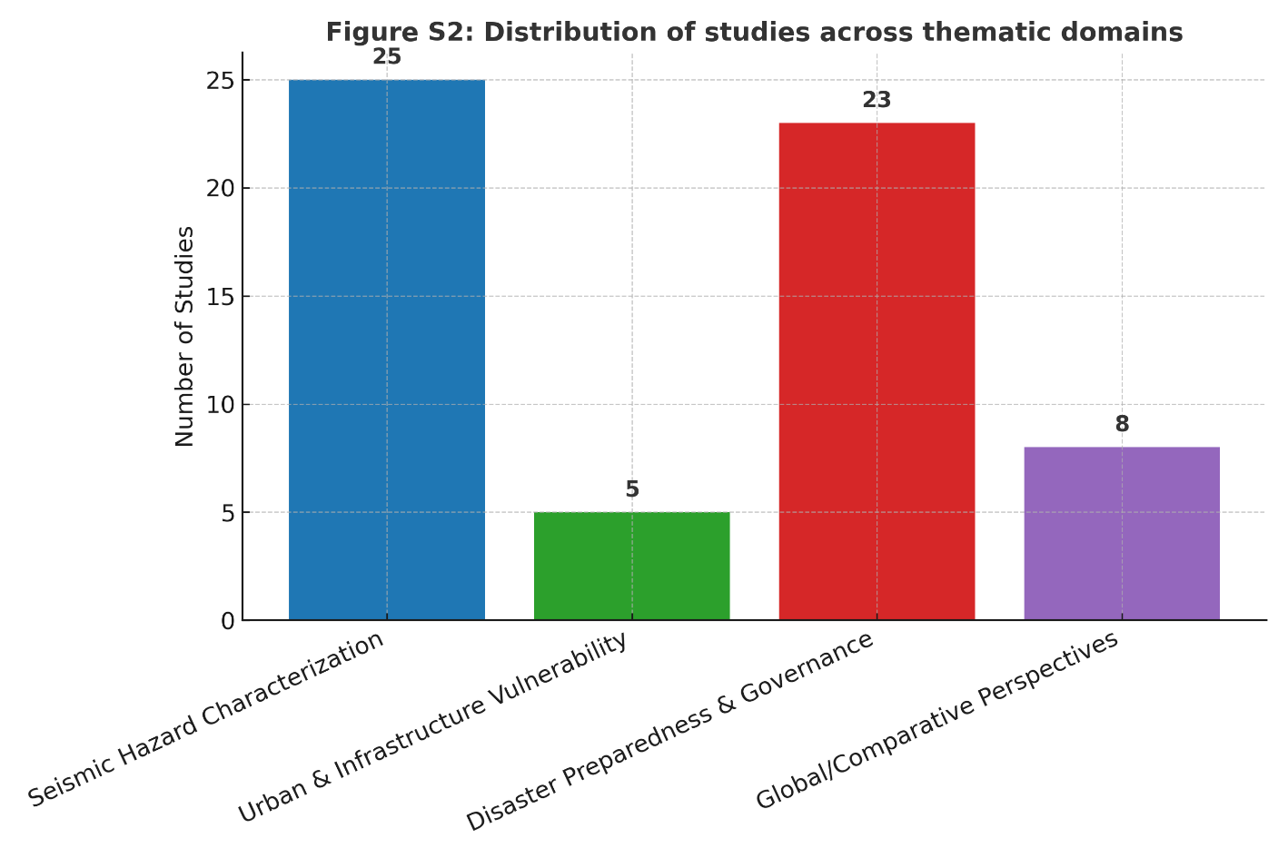
Figure A1: Distribution of studies across thematic domains

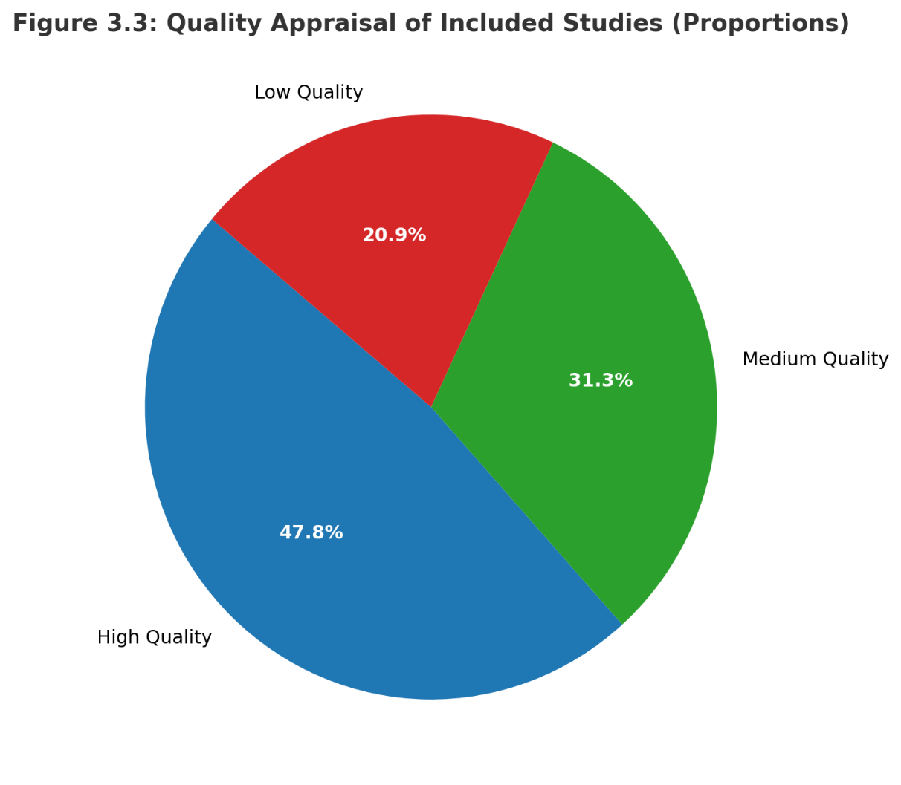
Figure A2: Quality Appraisal of Included Studies (Proportions)

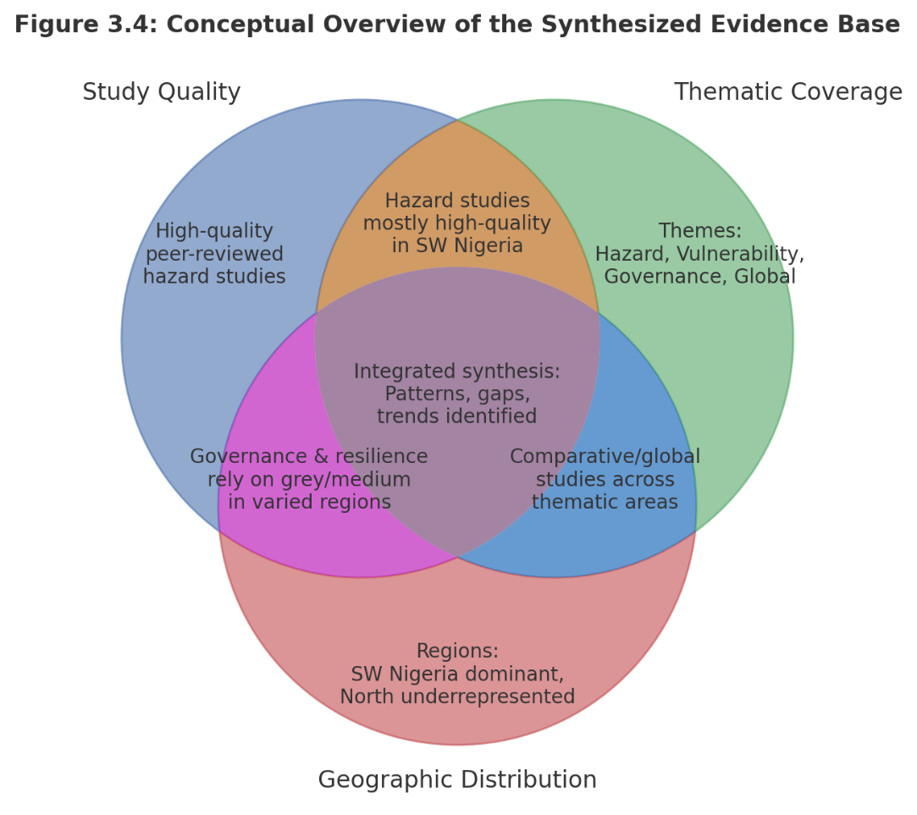
Figure A3: Conceptual overview of synthesized evidence base

