Assessment of Environmental and Anthropogenic Drivers of Heavy Metal and Hydrocarbon Pollution in Oguta Lake, Nigeria: Seasonal Variability and Comparative Analysis

Abstract
This study assessed the environmental and anthropogenic factors influencing heavy metal (HM) and total petroleum hydrocarbon (TPH) pollution in Oguta Lake, Imo State, Nigeria, with Abadaba Lake serving as a control. A mixed-method approach was adopted, combining field sampling of water and sediments over one year (April 2023–February 2024) with a questionnaire survey of 271 residents. Samples were collected in both wet and dry seasons and analysed following APHA (1999) standards. Descriptive statistics, Chi-square tests, and two-sample t-tests were applied to evaluate patterns and seasonal variations. Survey results indicated that oil and gas activities (38%), agricultural runoff (24%), crude oil loading (20%), and domestic waste disposal (18%) were the major contributors to contamination. Laboratory findings showed that TPH concentrations ranged from 0.07–45.20 mg/L, with no significant seasonal difference (p > 0.05). In contrast, heavy metals displayed notable variations: Pb (0.42–1.15 mg/kg), Cr (0.31–0.89 mg/kg), and Cd (0.02–0.11 mg/kg) were significantly higher in sediments during the dry season (p < 0.05), while Ni (0.15–0.44 mg/kg) was elevated in the wet season. Iron (Fe) remained consistently high across both seasons. The results highlight sediments as a more reliable indicator of pollution trends, underscoring the urgent need for stronger regulatory control of oil-related activities and improved waste management practices around Oguta Lake.
Keywords: Oguta Lake, Heavy metals (HM), Total petroleum hydrocarbons (TPH), Seasonal variation, Environmental pollution
Introduction
Land and water contamination from heavy metals and petroleum hydrocarbons has become a critical global environmental challenge over the last few decades. In developing countries like Nigeria, particularly within the Niger Delta region, widespread ecological degradation resulting from crude oil exploration, illegal refining, and inadequate waste management practices continues to expose aquatic ecosystems and human populations to significant risks [1, 2].
Oguta Lake, one of the largest freshwater lakes in Imo State, southeastern Nigeria, plays a vital role as a source of domestic water supply, fishery resources, and transportation for surrounding communities. Yet, its integrity is increasingly threatened by anthropogenic activities. The presence of multinational oil companies, artisanal refining, oil transportation, and domestic practices such as waste discharge and open defecation have resulted in recurrent pollution of the lake [3, 4]. These activities release heavy metals such as lead, cadmium, nickel, chromium, and iron, alongside total petroleum hydrocarbons (TPH), both of which are non-biodegradable, toxic, and capable of bioaccumulating in aquatic organisms and sediments [5]. Such contaminants not only threaten biodiversity, reducing fish populations and endangering unique species, but also compromise human health through water consumption and fish consumption [6, 7].
A critical but often overlooked dimension of aquatic contamination in tropical regions is its seasonal variability. Hydro-meteorological conditions in Nigeria, marked by distinct wet and dry seasons, influence the mobilization, dissolution, and sedimentation of pollutants in freshwater ecosystems. During the wet season, increased runoff can elevate contaminant inflows, whereas the dry season often concentrates pollutants in sediments due to reduced water levels [8, 9]. Understanding how seasonal cycles shape pollutant dynamics is essential for designing effective monitoring and remediation strategies.
Despite mounting evidence of hydrocarbon and heavy metal pollution in Oguta Lake, systematic studies that link environmental activities to the seasonal variation of pollutant concentrations remain scarce. Moreover, the extent of contamination relative to nearby non-oil-impacted freshwater systems, such as Abadaba Lake, has not been well established. Addressing this gap is crucial for informing both local stakeholders and national regulatory frameworks on strategies for pollution mitigation and ecosystem conservation.
This study therefore investigates the environmental drivers of heavy metal and TPH contamination in Oguta Lake, while also evaluating their seasonal variability in both water and sediments. Abadaba Lake, a nearby freshwater body with minimal oil-related activities, serves as a control to strengthen comparisons. Findings are expected to provide evidence-based insights for environmental management, pollution control, and sustainable use of freshwater resources in southeastern Nigeria.
Literature Review
Heavy metal (HM) and total petroleum hydrocarbon (TPH) pollution have been widely documented in aquatic systems across the world, with diverse sources and complex environmental implications. Globally, multiple studies have demonstrated that anthropogenic activities are the dominant drivers of HM and TPH contamination. [10] reported elevated concentrations of lead, mercury, and zinc in sediments of intermittent streams in the U.S. Virgin Islands, linking these pollutants to commercial and industrial activities. A global review of 12 heavy metals across five decades showed that mining, industrial waste, agricultural runoff, and petroleum-related activities remain the leading contributors to contamination, particularly in developing countries [11].
Beyond their occurrence, these pollutants pose significant ecological and health challenges. Heavy metals such as cadmium, lead, and mercury are persistent, bioaccumulative, and toxic, with links to carcinogenic and non-carcinogenic risks in humans [12]. Studies further reveal adverse ecological consequences, including biodiversity loss, fish mortality, and disruption of aquatic food chains. [13] documented that heavy metal and hydrocarbon concentrations in coastal areas of southern Nigeria exceeded WHO limits, raising concerns for both ecological integrity and human health. Similarly, [14] found that fish species in Oguta Lake contained TPH concentrations ranging from 1,111.37 to 6,373.27 µg/L, with associated risks to consumers, especially children.
The interactions between HMs, TPH, and microbial communities have also been highlighted. Research in Poland by [15] revealed that microbial biomass and functional diversity were negatively impacted by HM and TPH contamination. Complementary findings from [16] demonstrated that single and combined contaminations reduce microbial alpha diversity, impair ecological functions such as nitrogen and sulfur cycling, and alter community assembly patterns. These findings underscore how pollution alters both chemical and biological processes in aquatic ecosystems.
Seasonal and spatial variability of contaminants is another key aspect. Studies consistently report that hydro-meteorological conditions influence pollutant levels. [17] found that heavy metal concentrations were higher in the dry season, while wet-season floods enhanced mobilisation of cadmium, copper, and zinc. [18] observed seasonal fluctuations of calcium, magnesium, copper, and cadmium in Bangladesh rivers, attributing them to industrial and agricultural discharges. [19] documented significant temporal variations in TPH and HM levels across the Niger Delta, with climate-driven variables exacerbating pollution dynamics.
Methodology
Research Design
This study adopted a mixed-method research design that combined both survey and laboratory approaches in order to achieve the stated objectives. The survey component involved the use of a structured questionnaire administered to residents and stakeholders within the Oguta Lake catchment area. The questionnaire was designed to elicit information on the environmental factors and human activities contributing to heavy metals (HM) and total petroleum hydrocarbon (TPH) pollution of the lake. This approach enabled the collection of primary data directly from the local population, providing insight into anthropogenic drivers of contamination such as oil exploration, artisanal refining, agricultural practices, and domestic waste disposal.
In addition, a laboratory experimental design was employed to generate quantitative data on the concentrations of selected heavy metals (lead, chromium, cadmium, nickel, and iron), total petroleum hydrocarbons (TPH), and pH in both the water column and bed sediments of Oguta Lake. This involved systematic sampling across wet and dry seasons, with Abadaba Lake serving as a control site for comparative purposes.
Study Area
Oguta Lake is situated in the Oguta Local Government Area of Imo State; it constitutes the largest natural Lake in Imo State, South-eastern Nigeria. It lies between Latitudes 05041' to 05044'N and Longitudes 06041' to 06050'E. It has an elevation of 50m above sea level. It occupies a surface area ranging between 1.8km² and 2.5km², a shoreline length of 10km, and maximum and mean depths of 8.0m and 5.5m, respectively.
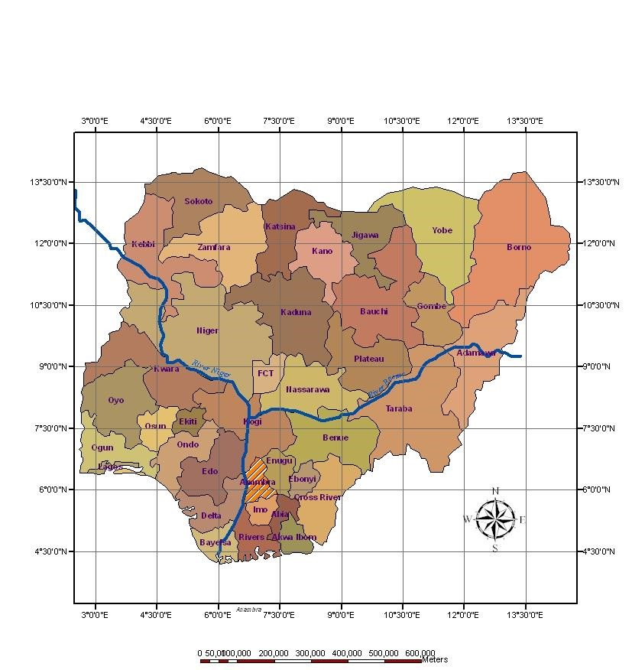
Fig.1. Map of Nigeria showing Imo State
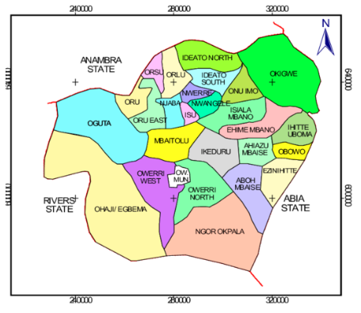
Fig. 2: Map of Imo State showing Oguta L.G.A.

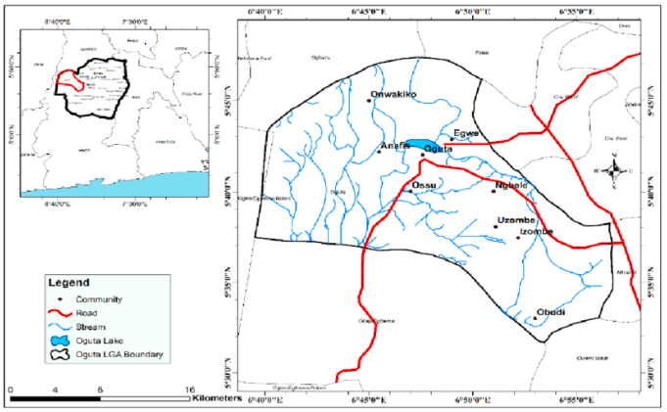
Fig. 3. Map of Oguta Showing Oguta Lake
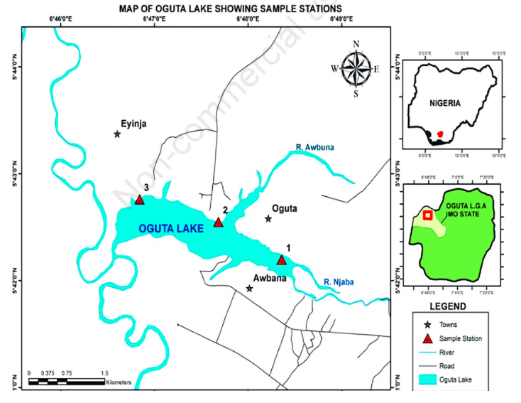
Fig. 4. Map of Oguta Lake Showing the Sampling Points
Sample and Sampling Techniques
The study was carried out in Eziorsu village of Oguta Autonomous Community, which hosts Oguta Lake. The community has a population of 22,684 people spread across 27 villages (NPC, 2006). Using Taro Yamane’s formula, a total of 271 questionnaires were distributed to randomly selected households, while purposive sampling was applied to ensure proper coverage based on location and accessibility. One adult respondent (15 years and above) was chosen per household.
For the laboratory analysis, water and sediment samples were collected from Oguta Lake and Abadaba Lake (control). Sampling was done monthly for both the rainy season (April–September 2023) and dry season (October 2023–February 2024), covering a year. In total, 144 composite samples were obtained. Water samples were collected in 2 L plastic containers from about 30 cm below the water surface, while sediment samples were collected with a grab. All samples were transported to the laboratory for analysis.
Methods of Data Collection and Analysis
Data for this study were obtained through both field sampling and survey methods. For the fieldwork, water and sediment samples were collected during both rainy (April–September 2023) and dry (October 2023–February 2024) seasons to capture seasonal variations. Water samples were taken at about 0.3 m depth using grab sampling techniques, while sediment samples were collected from the top 5 cm with a core sampler. Sampling points were located at the upstream, midstream, and downstream sections of the lake where human activities were most concentrated. Water samples were stored in 500 mL glass bottles, and sediment in aluminium foils. All sampling materials were pre-cleaned with 10% HNO₃ and rinsed with distilled water. Samples were preserved at 4°C and transported to Ebic Integrated Services Ltd, a NOSDRA-approved laboratory, for analysis. Laboratory procedures followed APHA, AWWA, and WEF (1999) standards.
For the survey, a structured questionnaire was administered to 271 respondents selected from households in the study area to obtain information on human activities contributing to heavy metals (HM) and total petroleum hydrocarbon (TPH) pollution, as well as perceived health impacts. Oral interviews were also conducted with uneducated members of the community to complement the questionnaire data.
Data collected from the questionnaires were analysed using descriptive statistics such as frequency, percentage, and mean scores to summarise responses to the research questions. Chi-square test was applied to determine whether the factors contributing to heavy metals (HM) and total petroleum hydrocarbons (TPH) pollution significantly varied with human activities around the lake. Laboratory results on HM and TPH concentrations were analysed using a two-sample t-test to compare seasonal differences between the wet and dry seasons.
Results
Table 1. Demographic Information of the Respondents
Variable | Category | Frequency | Percentage (%)
Gender | Male | 141 | 52.03%
 | Female | 130 | 47.97%
 | Total | 271 | 100%
Age (years) | 15-29 | 81 | 29.89%
 | 30-44 | 122 | 45.02%
 | 45-60 | 38 | 14.02%
 | Above 60 | 30 | 11.07%
 | Total | 271 | 100%
Educational Level | No formal education | 5 | 1.85%
 | Primary | 54 | 19.93%
 | Secondary | 117 | 43.17%
 | Tertiary | 95 | 35.06%
 | Total | 271 | 100%
Occupation | Fisherman | 73 | 26.94%
 | Farmer | 98 | 36.16%
 | Trader | 16 | 5.90%
 | Civil/ Public servant | 49 | 18.08%
 | Others | 35 | 12.92%
 | Total | 271 | 100%

Table 1 presents the demographic information of the respondents. The gender distribution showed that 141 (52.03%) males and 130 (47.97%) females participated in the study, indicating no significant difference in gender representation.
The age distribution revealed that the majority of respondents belonged to the 30-44 years age group (45.02%), while those in the 15-29 years group (29.89%) were the second largest. Participants over 60 years were the least represented in the study (11.07%).
Under the educational qualification distribution, 117 (43.17%) respondents had secondary education, while 95 (35.06%) had tertiary education. The results also showed that only 5 (1.85%) respondents had no formal education, and 54 (19.93%) had a primary school qualification. Indicating that the majority of respondents possess good knowledge of environmental issues in the Oguta area.
The distribution further revealed that 73 (26.94%) fishermen, 98 (36.16%) farmers, 16 (5.90%) traders, 49 (18.08%) civil/public servants, and others participated in the study, with the highest number dependent on land and water resources. Conversely, traders made up the smallest group.

Table 2. Responses on the Activities Responsible for the HM & TPH Pollution of Oguta Lake
S/N | Activities | SD | D | UN | A | SA | Mean Score | Rank
1 | Oil & gas operations & maintenance activities | 10 (3.69%) | 15 (5.54%) | 58 (21.4%) | 100 (36.9%) | 88 (32.47%) | 3.89 | 1
2 | Agricultural activities | 9 (3.32%) | 20 (7.38%) | 97 (35.79%) | 80 (29.52%) | 65 (23.99%) | 3.63 | 3
3 | Dredging | 19 (7.01%) | 27 (9.96%) | 100 (36.9%) | 76 (28.04%) | 49 (18.08%) | 3.40 | 5
4 | Loading of illegal bunkering crude from trunk lines along the bank of the lake | 14 (5.17%) | 43 (15.87%) | 49 (18.08%) | 84 (31.00%) | 81 (29.89%) | 3.65 | 2
5 | Disposal of oil waste and containers by boats | 27 (9.96%) | 68 (25.09%) | 87 (32.10%) | 48 (17.71%) | 41 (15.13%) | 3.03 | 6
6 | Ferrying activities | 24 (8.86%) | 78 (28.78%) | 74 (27.31%) | 62 (22.88%) | 33 (12.18%) | 3.01 | 7
7 | Home/sanitary waste disposal practices | 19 (7.01%) | 38 (14.02%) | 65 (23.99%) | 81 (29.89%) | 68 (25.09%) | 3.52 | 4
Note: SD, D, UN, A, and SA represent Strongly Disagreed, Disagreed, Undecided, Agreed, and Strongly Agreed, respectively.

Table 2 presents respondents’ perceptions of activities responsible for heavy metals (HM) and total petroleum hydrocarbons (TPH) in Oguta Lake. The results indicated that 100 (46.9%) respondents agreed, while 88 (32.4%) strongly agreed that oil and gas operations and maintenance activities are among the major causes of HM and TPH pollution. Conversely, 10 (3.69%) and 15 (5.54%) respondents strongly disagreed and disagreed, respectively, that oil and gas operations and maintenance activities lead to HM and TPH pollution.
The data showed that 80 (29.52%) respondents agreed, and 65 (23.99%) strongly agreed that agricultural activities contribute to HM and TPH levels. Additionally, 9 (3.32%) respondents strongly disagreed, and 20 (7.38%) disagreed that agricultural activities significantly impact HM and TPH on Oguta Lake. The highest number of respondents, 97 (35.79%), remained undecided.
Regarding dredging as a significant factor, 76 (28.04%) respondents agreed, and 49 (18.08%) strongly agreed. In contrast, 27 (9.96%) and 19 (7.01%) respondents disagreed and strongly disagreed that dredging is a key contributor to HM and TPH. Still, nearly half, 100 (36.9%), did not provide a decisive response.
For the loading of illegally bunkered crude oil from trunk lines along the lake bank, 84 (31%) agreed, while 81 (29.89%) strongly agreed. Conversely, 49 (18.08%) respondents were unaware, and 14 (5.17%) were opposed, with 43 (15.87%) outright disagreeing that this activity contributes to HM and TPH pollution.
Concerning the disposal of oil waste and containers by boats, 41 (15.13%) strongly agreed, and 48 (17.71%) agreed that it causes HM and TPH pollution. Conversely, 68 (25.09%) opposed this, and 27 (9.96%) strongly opposed it. Notably, 87 (32.10%) respondents did not express a clear opinion.
As for ferrying activities, 62 (22.88%) agreed, while 33 (12.18%) strongly agreed that they affect HM and TPH levels. On the other hand, 78 (28.78%) disagreed, with 24 (8.86%) strongly opposing this notion.
Regarding home and sanitary waste disposal practices, 81 (29.89%) respondents agreed, and 68 (25.09%) strongly agreed, viewing these as contributing factors. Meanwhile, 19 (7.01%) strongly disagreed, and 38 (14.02%) disagreed that these practices impact HM and TPH levels. A further 65 (23.99%) respondents were uncertain about their influence.
Table 2 also presents the mean scores, which quantifiably measure respondents' overall perceptions. The average mean score stands at 3.45; activities scoring below this are not deemed significant contributors. Results indicate that oil and gas operations and maintenance activities (mean score = 3.89), loading of illegal bunkered crude (mean score = 3.65), agricultural activities (mean score = 3.63), and home/sanitary waste disposal practices (mean score = 3.52) have mean scores exceeding 3.45, signifying their significance as contributors to HM and TPH pollution. In contrast, dredging (mean score = 3.40), disposal of oil waste and containers by boats (mean score = 3.03), and ferrying activities (mean score = 3.01) have lower mean scores, indicating they are less significant factors.
Based on the mean scores, oil and gas operations and maintenance activities rank as the most influential factor affecting HM and TPH pollution in Oguta Lake. Loading of illegal bunkering crude ranks second, with ferrying activities ranking last. The perceived responses regarding contributing factors to HM and TPH pollution are illustrated in Figure 5, with each bar representing a composite response.
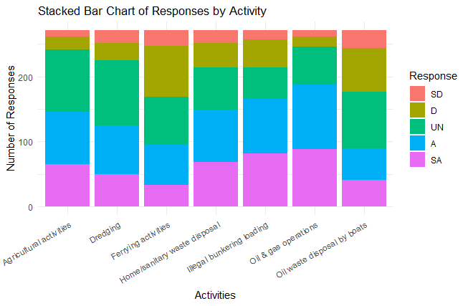
Fig. 5. Responses on the Activities Responsible for the HM & TPH Pollution of Oguta Lake

Table 3. Seasonal Fluctuations of TPM and HM in Bed Sediment in Oguta and Abadaba Lake
 |  | Wet Season |  |  |  |  |  | Dry Season
 |  | Apr | May | Jun | Jul | Aug | Sept | Oct | Nov | Dec | Jan | Feb
pH | Oguta | 6.36 | 6.36 | 6.35 | 6.36 | 6.36 | 6.33 | 6.80 | 6.80 | 6.87 | 6.80 | 6.87
 | Abadaba | 6.51 | 6.52 | 6.51 | 6.51 | 6.51 | 6.55 | 7.10 | 7.10 | 7.00 | 7.03 | 7.07
TPH | Oguta | 49.95 | 49.95 | 49.41 | 49.44 | 49.44 | 36.43 | 42.71 | 48.85 | 48.973 | 48.987 | 48.867
 | Abadaba | 2.43 | 2.433 | 2.40 | 2.67 | 2.67 | 1.40 | 1.433 | 1.40 | 1.427 | 1.4133 | 1.42
Pb | Oguta | 0.010 | 0.0103 | 0.011 | 0.0117 | 0.0117 | 0.0347 | 0.037 | 0.1853 | 0.19233 | 0.19233 | 0.194
 | Abadaba | 0.0013 | 0.0013 | 0.00067 | 0.001 | 0.001 | 0.00033 | 0.00033 | 0.00033 | 0.00133 | 0.00133 | 0.00133
Cr | Oguta | 0.00097 | 0.00097 | 0.00096 | 0.00097 | 0.00097 | 0.05133 | 0.05667 | 0.197 | 0.19836 | 0.19836 | 0.19838
 | Abadaba | 0.00036 | 0.00035 | 0.00039 | 0.00039 | 0.00039 | 0.00077 | 0.00077 | 0.00046 | 0.00046 | 0.00046 | 0.00046
Cd | Oguta | 0.014 | 0.014 | 0.014 | 0.014 | 0.014 | 0.0127 | 0.0127 | 0.11033 | 0.114 | 0.1153 | 0.116
 | Abadaba | 0.0013 | 0.0013 | 0.00067 | 0.001 | 0.001 | 0.00033 | 0.00033 | 0.00037 | 0.00067 | 0.00067 | 0.001
Ni | Oguta | 0.015 | 0.016 | 0.015 | 0.015 | 0.015 | 0.01013 | 0.01033 | 0.00507 | 0.00523 | 0.0054 | 0.0055
 | Abadaba | 0.006 | 0.006 | 0.006 | 0.006 | 0.006 | 0.00033 | 0.00033 | 0.0006 | 0.00057 | 0.00063 | 0.00063
Fe | Oguta | 116.90 | 118.09 | 118.82 | 121.423 | 130.36 | 131.00 | 132.053 | 133.317 | 133.893 | 134.503 | 134.73
 | Abadaba | 34.79 | 35.113 | 35.24 | 35.277 | 35.33 | 35.42 | 35.44 | 35.6 | 35.687 | 35.93 | 36.027

Table 3 presents the results of pH, TPH, and HM in the bed sediment in Oguta Lake and Abadaba Lake across the seasons (wet and dry). The pH value was higher for Oguta Lake in February 2024 (pH = 6.87) and lower in September (pH = 6.33). For Abadaba Lake, the pH was higher in October and November (pH = 7.10, each) and lower in April, June, July, and August (pH = 6.51, each). Thus, the pH values across the months were higher for Abadaba Lake compared to Oguta Lake. The sediment in Oguta Lake was acidic in both wet and dry seasons, while in Abadaba Lake, it was alkaline in the dry season and acidic in the wet season.
The results also revealed that total petroleum hydrocarbon (TPH) pollution in bed sediment was higher in both wet and dry seasons in Oguta Lake compared to Abadaba Lake, with the highest values experienced in April (49.95 mg/kg) and May (49.95 mg/kg), and the lowest in September and November (TPH = 1.40 mg/kg, each).
Furthermore, the results showed that the concentration of lead (Pb) was higher in both wet and dry seasons in Oguta Lake than in Abadaba Lake, where Pb was highest in February 2024 (0.194 mg/kg) and lowest in April 2023 (Pb = 0.010 mg/kg). Furthermore, the results also revealed that the concentration of Pb was higher in the dry season.
Chromium (Cr), on the other hand, was higher in Oguta Lake in all seasons compared to Abadaba Lake, given that the highest concentration of Cr was observed in February 2024 (0.19838 mg/kg), while the lowest was experienced in Abadaba Lake in May 2023 (Cr = 0.00035 mg/kg). However, in Oguta Lake, the concentration of Cr was greater in the dry season than in the wet season.
Moreover, the concentration of Cadmium (Cd) in Oguta Lake was greater than in Abadaba Lake in both wet and dry seasons. In Oguta Lake, the concentration of Cd was highest in February 2024 (Cd = 0.116 mg/kg) and lowest in September and November, with Cd = 0.0127mg/kg each. The results also revealed that the concentration of Cd was higher in the dry season than in the wet season.
The results further showed that the bed sediment in Oguta Lake was polluted with a higher concentration of Ni in all the seasons compared to Abadaba Lake. In Oguta Lake, the highest concentration of Ni was experienced in May (Ni = 0.016 mg/kg) and the lowest in November (Ni = 0.00507 mg/kg). Thus, the results also showed that the concentration of Ni in the bed sediment of Oguta Lake was higher in the wet season.
For the concentration of Fe in the bed sediment, a higher concentration of experienced in Oguta Lake compared to Abadaba Lake in all the seasons. The results indicate that in the Oguta Lake, the highest concentration of Fe was in February (Fe = 134.73 mg/kg), while the lowest was in April (116.90 mg/kg). However, the results also revealed that the concentration of Fe was higher in the dry season.
Fig. 6 shows the concentration of TPH and HM (Pb, Cr, Cd, Ni, and Fe) in the bed sediment in Oguta Lake and Abadaba Lake across the months. From the figure, the values of TPH and HM (Pb, Cr, Cd, Ni, and Fe) are higher in Oguta Lake than in Abadaba Lake across the months.
Table 4. Correlation Matrix of Physicochemical and Heavy Metal Parameters in Oguta Lake Sediment
 | pH | TPH | Pb | Cr | Cd | Ni | Fe
pH | 1.000
TPH | 0.076 | 1.000
Pb | 0.878 | 0.162 | 1.000
Cr | 0.899 | 0.064 | 0.994 | 1.000
Cd | 0.844 | 0.268 | 0.993 | 0.975 | 1.000
Ni | -0.894 | 0.131 | -0.951 | -0.978 | -0.909 | 1.000 | -0.859
Fe | 0.774 | -0.310 | 0.751 | 0.794 | 0.690 | -0.859 | 1.000

Table 4 presents the results of the correlation coefficients of physicochemical and heavy metal parameters in Oguta Lake sediment. The results revealed a strong positive relationship between pH and Lead (r = 0.878), Chromium (r = 0.899), Cadmium (r = 0.844), and Iron (r = 0.774), while a positive but weak association exists between pH and total petroleum hydrocarbon (r = 0.076), and a strong negative correlation with Nickel (r = -0.894). Furthermore, positive but weak relationship exist between TPH and the heavy metals (Pb: r = 0.162, Cr: r = 0.064, Cd: r = 0.268, Ni: r = 0.131), and weak negative association with Fe (r = -0.310).
The results further showed that strong positive relationship exists between Pb and Cr (0.994), Cd (0.993), and Fe (0.751), and a strong negative relationship with Ni (-0.951). The results also indicated that Cr has a strong positive association with Cd (0.975) and Fe (0.794), and a negative with Ni (-0.978). Cd also showed a strong negative association with Ni (-0.909) and positive with Fe (0.690), while Ni had a strong negative relationship with Fe (r = -0.859).

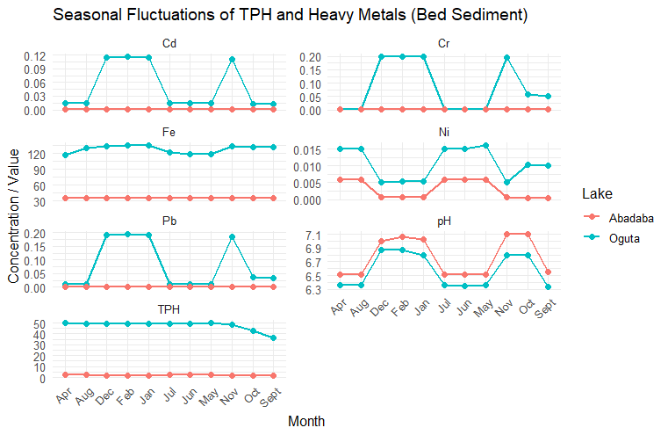
Fig. 6. Seasonal Fluctuations of TPH and Heavy Metals in Bed Sediment

Table 5. Seasonal Fluctuations of TPM and HM in Water in Oguta and Abadaba Lake
 |  | Wet Season |  |  |  |  |  | Dry Season
 |  | Apr | May | Jun | Jul | Aug | Sept | Oct | Nov | Dec | Jan | Feb
pH | Oguta | 7.49 | 7.38 | 7.43 | 7.42 | 7.26 | 7.47 | 7.44 | 7.47 | 7.43 | 7.43 | 7.43
 | Abadaba | 7.15 | 7.17 | 7.13 | 7.12 | 7.12 | 7.11 | 7.11 | 7.11 | 7.29 | 7.30 | 7.50
TPH | Oguta | 0.00073 | 0.0008 | 0.00077 | 0.0008 | 0.00083 | 0.00317 | 0.00083 | 0.0009 | 0.00063 | 0.0008 | 0.00077
 | Abadaba | 0.000 | 0.000 | 0.000 | 0.000 | 0.000 | 0.000 | 0.0003 | 0.00033 | 0.00037 | 0.0003 | 0.0001
Pb | Oguta | 0.00094 | 0.00094 | 0.00093 | 0.00094 | 0.00094 | 0.0009 | 0.00371 | 0.00373 | 0.00093 | 0.00094 | 0.0009
 | Abadaba | 0.00036 | 0.00036 | 0.00027 | 0.00028 | 0.00028 | 0.00135 | 0.00036 | 0.00036 | 0.00035 | 0.00035 | 0.00132
Cr | Oguta | 0.00074 | 0.00075 | 0.00071 | 0.00072 | 0.00072 | 0.00072 | 0.00057 | 0.00057 | 0.00058 | 0.00059 | 0.0006
 | Abadaba | 0.00041 | 0.00042 | 0.00016 | 0.00017 | 0.00017 | 0.00043 | 0.00013 | 0.00013 | 0.00013 | 0.00013 | 0.00071
Cd | Oguta | 0.00057 | 0.00057 | 0.00055 | 0.00056 | 0.00059 | 0.0006 | 0.00052 | 0.00053 | 0.00054 | 0.00056 | 0.00055
 | Abadaba | 0.00028 | 0.00028 | 0.00023 | 0.00024 | 0.00024 | 0.00023 | 0.00021 | 0.0002 | 0.00017 | 0.00017 | 0.00019
Ni | Oguta | 0.00060 | 0.00061 | 0.0006 | 0.00061 | 0.00059 | 0.00058 | 0.00054 | 0.00054 | 0.00059 | 0.00059 | 0.00061
 | Abadaba | 0.00037 | 0.00037 | 0.0003 | 0.0003 | 0.0003 | 0.00028 | 0.00015 | 0.00015 | 0.00019 | 0.00019 | 0.00012
Fe | Oguta | 3.389 | 3.389 | 3.397 | 3.399 | 3.399 | 3.405 | 4.216 | 4.217 | 4.217 | 4.219 | 4.219
 | Abadaba | 0.737 | 0.738 | 0.797 | 0.798 | 0.798 | 0.802 | 0.802 | 0.802 | 0.771 | 0.773 | 0.7683

Table 5 presents seasonal variations in total petroleum hydrocarbon (TPH) and heavy metal (HM) in water in Oguta Lake and Abadaba Lake. The results showed that the pH values in Oguta Lake are greater than in Abadaba Lake from April to January, except in February, where the pH is highest (pH = 7.50). In Oguta Lake, the highest pH was in April (7.49), while the lowest was observed in August (pH = 7.26). However, the results also revealed that the water in Oguta Lake and Abadaba Lake from April to February was alkaline.
Under the TPH, the TPH pollution water in Oguta Lake is higher than in Abadaba Lake, but the results also showed that although TPH is higher in Oguta Lake, the TPH values revealed that there was no actual TPH contamination in the water.
Moreover, the concentration of Pb is lower in the water in Oguta Lake than in Abadaba Lake in September (Oguta: Pb = 0.0009 mg/L; Abadaba: Pb = 0.00135 mg/L) and in February (Oguta: Pb = 0.0009; Abadaba: Pb = 0.00132 mg/L). The results revealed that the concentration of Pb was highest in November (Pb = 0.00373 mg/L) and lowest in September and February (Pb = 0.0009 mg/L each) in Oguta Lake.
Based on the Cr concentration, the results revealed that the concentration of Cr in water in Oguta Lake is higher than in Abadaba Lake across the months. In Oguta Lake, the concentration of Cr was highest in May (0.0075 mg/L) and lowest in October (0.00057 mg/L) and November (0.00057 mg/L). However, the results also indicate that the Cr concentration in water is higher in the wet season compared to the dry season.
Furthermore, the results indicated that the concentration of Cd in water was higher in Oguta Lake across all seasons compared to Abadaba Lake, and that in Oguta Lake, the highest concentration of Cd was seen in September (0.0006 mg/L) and the lowest in October (0.00052 mg/L). Again, the results revealed that the concentration of Cd in water was higher in the wet season compared to the dry season.
The results indicate that the concentration of Ni in water was higher in Oguta Lake than in Abadaba Lake, with the highest concentration of Ni found in May (0.00061 mg/L), July (0.00061 mg/L), and February (0.00061 mg/L). During the wet season, water in both Oguta Lake and Abadaba Lake was polluted with higher concentrations of Ni compared to the dry season.
Based on the results, the Fe concentration was found to be higher in Outa Lake compared to Abadaba Lake across all seasons. In Oguta Lake, the Fe concentration in water was highest in January (4.219 mg/L) and February (4.219 mg/L), while the lowest Fe concentration was experienced in April (3.389 mg/L) and May (3.389 mg/L). Thus, the results showed that the concentration of Fe in water was higher in the dry season than in the wet season.
Fig. 7 shows the seasonal variations of pH, TPH and heavy metals (HM) from April 2023 to February 2024. From the plots, the concentration of Cd, Fe, and Ni was higher in Oguta Lake than in Abadaba Lake, while the Cr and pH plots showed that the concentration was higher in February in Abadaba Lake compared to Oguta Lake.
Table 6. Correlation Matrix of Physicochemical and Heavy Metal Parameters in Oguta Lake Water
 | pH | TPH | Pb | Cr | Cd | Ni | Fe
pH | 1.000
TPH | 0.239 | 1.000
Pb | 0.255 | -0.103 | 1.000
Cr | -0.265 | 0.250 | -0.583 | 1.000
Cd | -0.349 | 0.570 | -0.684 | 0.755 | 1.000
Ni | -0.239 | -0.141 | -0.921 | 0.593 | 0.501 | 1.000
Fe | 0.268 | -0.281 | 0.512 | -0.985 | -0.722 | -0.503 | 1.000

Table 6 presents the results of the correlation matrix of physicochemical and heavy metal parameters in Oguta Lake water. The results showed a strong positive relationship between Cd and Cr (r = 0.755), a partial strong positive between Cd and TPH (0.570), Ni and Cr (0.593), and Ni and Cd (0.501). The results also revealed a strong negative association between Ni and Pb (-0.921), Cd and Pb (-0.684), Fe and Cr (-0.985), and Fe and Cd (-0.722), and a partial strong negative interaction between Fe and Ni (-0.503). Furthermore, the study also revealed that the association between pH and TPH (0.239), Pb (0.255), and Fe (0.268) are weak and positive, while pH had a weak negative association with Cr (-0.265), Cd (-0.349), and Ni (-0.239).
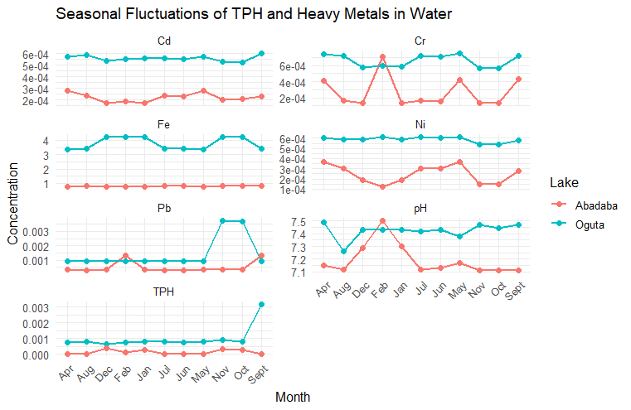
Fig. 7. Seasonal Fluctuations of TPH and Heavy Metals in Water

Table 7. Pearson’s Chi-squared test for Comparing the Contributions of TPH and HM to Human Activities
X-squared | df | p-value
192.86 | 24 | < 2.2e-16

Table 7 presents the results of the Pearson Chi-squared test to determine whether the factors that contribute to TPH and HM contaminations do not differ significantly from human activities within the vicinity of the Lake. The results revealed a Chi-squared statistic of 192.86 and a corresponding p-value of < 2.2e-16, which is less than the 0.05 level of significance (set as the threshold). This implies that the factors that contribute to TPH and HM contaminations differ significantly from human activities within the vicinity of the Lake.
Table 8. Two-Sample t-test Results Comparing Seasonal Variation of TPH and Heavy Metals in Sediments of Oguta Lake
Parameter | Mean in group Dry | Mean in group Wet | t value | df | p-value
TPH | 24.54803 | 24.88550 | -0.032684 | 20 | 0.9743
Pb | 0.080501 | 0.00792 | 2.626 | 20 | 0.01619
Cr | 0.085138 | 0.00491 | 2.7944 | 20 | 0.01119
Cd | 0.047137 | 0.007358 | 2.3845 | 20 | 0.02712
Ni | 0.003429 | 0.009705 | -3.2308 | 20 | 0.004191
Fe | 84.718 | 78.98025 | 0.27584 | 20 | 0.7855

Table 8 presents the two-sample t-test results assessing whether Total Petroleum Hydrocarbons (TPH) and heavy metals (Lead, Chromium, Cadmium, Nickel, and Iron) in sediments of Oguta Lake differ significantly across the wet and dry seasons. The mean concentrations of TPH in the dry season (24.54 mg/kg) were slightly lower than in the wet season (24.88550 mg/kg), given a t-value of -0.032684 with a corresponding p-value of 0.9743. In addition, the concentration of Iron exhibited a t-value of 0.27584 and a p-value of 0.7855, with the concentration of Fe greater in the dry season (mean = 84.718 mg/kg) than in the wet season (mean = 78.98025 mg/kg). The p-values of TPH and Fe concentrations above the 0.05 threshold imply that the Total Petroleum Hydrocarbons (TPH) contamination in Oguta Lake sediment during the dry and wet seasons remains constant, and the concentration of Fe in both seasons was the same.
The results also revealed that the concentrations of Cr and Cd in Oguta Lake sediment in dry season (Cr: mean = 0.085138 mg/kg; Cd: mean = 0.047137 mg/kg) are higher than in wet season (Cr: mean = 0.00491 mg/kg; Cd: mean = 0.007358 mg/kg), with t-values (Cr: 2.7944; Cd: 2.3845) and respective p-values (Cr: 0.01119; Cd: 0.02712) less than the 0.05 threshold, implies that the concentration of Cr and Cd in the Oguta Lake sediments in dry season are significantly greater than in the wet season.
Furthermore, Ni concentration in Oguta Lake sediment in the dry season (0.003429 mg/kg) is lower than in the wet season (0.009705 mg/kg), exhibiting a t-value of -3.2308 with a corresponding p-value of 0.004191. However, this result suggests that Ni concentration in Oguta Lake sediment is significantly lower than that in the wet season.
Table 9. Two-Sample t-test Results Comparing Seasonal Variation of TPH and Heavy Metals in Water of Oguta Lake
Parameter | Mean in group Dry | Mean in group Wet | t value | df | p-value
TPH | 0.000533 | 0.0005917 | -0.19709 | 20 | 0.8458
Pb | 0.001295 | 0.0007075 | 1.4785 | 20 | 0.1549
Cr | 0.000414 | 0.000510 | -0.91039 | 20 | 0.3735
Cd | 0.000364 | 0.0004117 | -0.62714 | 20 | 0.5377
Ni | 0.000367 | 0.0004592 | -1.1699 | 20 | 0.2558
Fe | 2.500430 | 2.087333 | 0.60985 | 20 | 0.5488

Table 9 shows the results of the concentrations of TPH and the heavy metals (Pb, Cr, Cd, Ni, and Fe) in Oguta Lake water in both wet and dry seasons. The mean concentrations of TPH, Pb, Cr, Cd, Ni, and Fe in Oguta Lake water in the dry season (TPH: 0.000533 mg/L; Pb: 0.001295 mg/L; Cr: 0.000414 mg/L; Cd: 0.000364 mg/L; Ni: 0.000367 mg/L; Fe: 2.500430 mg/L) based on their p-values (TPH: 0.8458; Pb: 0.1549; Cr: 0.3735; Cd: 0.5377; Ni: 0.2558; Fe: 0.5488) which are above the 0.05 threshold, implies they are similar to the concentrations in Oguta Lake water in the wet season (TPH: 0.0005917 mg/L; Pb: 0.0007075 mg/L; Cr: 0.00510 mg/L; Cd: 0.0004117 mg/L; Ni: 0.0004592 mg/L; Fe: 2.087333 mg/L).
Discussion
The demographic profile of respondents provides useful context for understanding community perspectives on pollution in Oguta Lake. The relatively balanced gender distribution indicates that both males and females are equally involved in activities around the lake, making their views representative of the population. The predominance of respondents within the 30–44 years age group suggests that economically active individuals, who are most engaged in fishing, farming, and other livelihood activities, are directly aware of the lake’s environmental conditions. The high proportion of respondents with secondary (43.17%) and tertiary education (35.06%) also implies that the community has a reasonable level of environmental awareness, which enhances the credibility of their responses. Occupational distribution further reveals that farmers and fishermen dominate, showing the community’s heavy reliance on land and water resources, which may also increase their exposure to pollutants.
Respondents’ perceptions of pollution sources (Table 2) highlight oil and gas operations and maintenance as the primary contributors to heavy metal (HM) and total petroleum hydrocarbon (TPH) pollution in Oguta Lake [14]. This aligns with the study of [20] in the Niger Delta, where oil exploration and illegal bunkering have been linked to significant hydrocarbon contamination of aquatic ecosystems. Agricultural activities, illegal crude oil loading, and home waste disposal practices also ranked high, reflecting the multiple human-induced pressures on the lake. In contrast, ferrying activities, dredging, and disposal of oil waste by boats were rated less significant, although their cumulative effects should not be overlooked. The Chi-square result further confirms that human activities significantly contribute to the observed HM and TPH contamination.
The seasonal variations observed in sediments underscore the influence of hydrological cycles on pollution dynamics. TPH levels in sediments did not vary significantly across seasons, suggesting a relatively constant hydrocarbon load, possibly due to continuous oil-related activities. However, heavy metals showed clear seasonal differences. Lead (Pb), Chromium (Cr), and Cadmium (Cd) were significantly higher in the dry season, likely due to reduced water volume and concentration effects. In contrast, Nickel (Ni) was higher in the wet season, which may be attributed to leaching from agricultural runoff and enhanced mobility under higher rainfall conditions. These findings are consistent with environmental studies showing that seasonal changes alter pollutant distribution and bioavailability in aquatic sediments [21, 22].
In water samples (Table 4 and Table 7), the results revealed relatively low TPH concentrations, which were not statistically different across wet and dry seasons. Similarly, heavy metals (Pb, Cr, Cd, Ni, and Fe) in water showed no significant seasonal variation, although their concentrations were generally higher in Oguta Lake than in Abadaba Lake. The stability of these parameters in water may be explained by dilution effects and the tendency of heavy metals and hydrocarbons to adsorb more strongly to sediments than remain dissolved in water. This finding corroborates earlier reports that sediments often act as sinks and secondary sources of pollutants in aquatic environments.
Conclusion
This study examined the contributions of human activities and seasonal variations to heavy metal (HM) and total petroleum hydrocarbon (TPH) contamination in Oguta Lake, with Abadaba Lake serving as a control. The findings revealed that oil and gas operations, agricultural practices, crude oil loading, and improper waste disposal are the primary anthropogenic drivers of pollution in Oguta Lake. Laboratory analyses showed that TPH concentrations in sediments and water did not differ significantly across seasons, suggesting relatively stable hydrocarbon levels. However, heavy metals such as Pb, Cr, and Cd were significantly higher in sediments during the dry season, while Ni was more pronounced in the wet season. Iron concentrations remained consistently high in both seasons, further reflecting the lake’s vulnerability to contamination.
The results underscore that sediments act as a sink and long-term indicator of HM and TPH pollution compared to water, which exhibited lower and more stable concentrations. Importantly, the Chi-square analysis confirmed a significant association between human activities and contamination levels. These findings highlight the urgent need for effective environmental monitoring, enforcement of oil and gas regulations, and sustainable agricultural and waste management practices to mitigate pollution risks. Protecting Oguta Lake is critical for safeguarding aquatic biodiversity, fisheries, and the livelihoods of surrounding communities.

Disclaimer (Artificial intelligence)
Author(s) hereby declare that NO generative AI technologies such as Large Language Models (ChatGPT, COPILOT, etc.) and text-to-image generators have been used during the writing or editing of this manuscript.

References
[1] Numbere AO, Gbarakoro TN, Babatunde BB. Environmental degradation in the Niger Delta ecosystem: the role of anthropogenic pollution. In Sustainable utilization and conservation of Africa’s biological resources and environment 2023 Apr 18 (pp. 411-439). Singapore: Springer Nature Singapore.
[2] Abayomi O, Olayemi TE, Ogungbade T. Environmental pollution and its ecological consequences on the Niger Delta: A review of the literature. African Journal of Environment and Natural Science Research. 2021; 4:27-42.
[3] Onuh PA, Omenma TJ, Onyishi CJ, Udeogu CU, Nkalu NC, Iwuoha VO. Artisanal refining of crude oil in the Niger Delta: A challenge to clean-up and remediation in Ogoniland. Local Economy. 2021; 36(6):468-86.
[4] Babatunde AO. Oil pollution and water conflicts in the riverine communities in Nigeria’s Niger Delta region: challenges for and elements of problem-solving strategies. Journal of Contemporary African Studies. 2020 Apr 2; 38(2):274-93.
[5] Isukuru EJ, Opha JO, Isaiah OW, Orovwighose B, Emmanuel SS. Nigeria's water crisis: Abundant water, polluted reality. Cleaner Water. 2024; 2:100026.
[6] Reid AJ, Carlson AK, Creed IF, Eliason EJ, Gell PA, Johnson PT, Kidd KA, MacCormack TJ, Olden JD, Ormerod SJ, Smol JP. Emerging threats and persistent conservation challenges for freshwater biodiversity. Biological reviews. 2019; 94(3):849-73.
[7] Ogidi OI, Akpan UM. Aquatic biodiversity loss: impacts of pollution and anthropogenic activities and strategies for conservation. In Biodiversity in Africa: potentials, threats and conservation 2022 Aug 27 (pp. 421-448). Singapore: Springer Nature Singapore.
[8] Gunes G. The change of metal pollution in the water and sediment of the Bartın River in rainy and dry seasons. Environmental Engineering Research. 2022; 27(2).
[9] Taylor KG, Owens PN. Sediments in urban river basins: a review of sediment–contaminant dynamics in an environmental system conditioned by human activities. Journal of Soils and Sediments. 2009; 9(4):281-303.
[10] Lancellotti BV, Hensley DA, Stryker R. Detection of heavy metals and VOCs in streambed sediment indicates anthropogenic impact on intermittent streams of the US Virgin Islands. Scientific reports. 2023; 13(1):17238.
[11] Falih KT, Mohd Razali SF, Abdul Maulud KN, Abd Rahman N, Abba SI, Yaseen ZM. Assessment of petroleum contamination in soil, water, and atmosphere: a comprehensive review. International Journal of Environmental Science and Technology. 2024; 21(13):8803-32.
[12] Budi HS, Catalan Opulencia MJ, Afra A, Abdelbasset WK, Abdullaev D, Majdi A, Taherian M, Ekrami HA, Mohammadi MJ. Source, toxicity and carcinogenic health risk assessment of heavy metals. Reviews on Environmental Health. 2024; 39(1):77-90.
[13] Onyena AP, Folorunso OM, Nwanganga N, Udom GJ, Ekhator OC, Frazzoli C, Ruggieri F, Bocca B, Orisakwe OE. Engaging one health in heavy metal pollution in some selected Nigerian Niger delta cities. A Systematic review of pervasiveness, bioaccumulation and subduing environmental health challenges. Biological Trace Element Research. 2024; 202(4):1356-89.
[14] Wirnkor VA, Iheanyichukwu OA, Ebere EC, Ngozi VE, Natheniel C O, Kingsley OU, Chizoruo IF, Amaka AP. Petroleum Hydrocarbons and Heavy Metals Risk of Consuming Fish Species from Oguta Lake, Imo State, Nigeria. Journal of Chemical Health Risks. 2021; 11(1).
[15] Klimek B, Sitarz A, Choczyński M, Niklińska M. The effects of heavy metals and total petroleum hydrocarbons on soil bacterial activity and functional diversity in the Upper Silesia industrial region (Poland). Water, Air, & Soil Pollution. 2016; 227(8):265.
[16] Zhang D, Hu Q, Wang B, Wang J, Li C, You P, Zhou R, Zeng W, Liu X, Li Q. Effects of single and combined contamination of total petroleum hydrocarbons and heavy metals on soil microecosystems: Insights into bacterial diversity, assembly, and ecological function. Chemosphere. 2023; 345:140288.
[17] Nwosu EC, Amadi PC, Ogbonda IG. Hydrogeochemical variability between wet and dry seasons in Lagos State, Nigeria. Ayden Journal of Engineering and Applied Sciences. 2025; 13(1):30-42.
[18] Hassan HB, Moniruzzaman M, Majumder RK, Ahmed F, Bhuiyan MA, Ahsan MA, Al-Asad H. Impacts of seasonal variations and wastewater discharge on river quality and associated human health risks: A case of northwest Dhaka, Bangladesh. Heliyon. 2023; 9(7).
[19] Anyanwu IN, Beggel S, Sikoki FD, Okuku EO, Unyimadu JP, Geist J. Pollution of the Niger Delta with total petroleum hydrocarbons, heavy metals and nutrients in relation to seasonal dynamics. Scientific Reports. 2023; 13(1):14079.
[20] Babatunde BB, Zabbey N, Vincent-Akpu IF, Mekuleyi GO. Bunkering activities in Nigerian waters and their Eco-economic consequences. In The political ecology of oil and gas activities in the Nigerian aquatic ecosystem 2018 Jan 1 (pp. 439-446). Academic Press.
[21] Huang CW, Chai ZY, Yen PL, How CM, Yu CW, Chang CH, Liao VH. The bioavailability and potential ecological risk of copper and zinc in river sediment are affected by seasonal variation and spatial distribution. Aquatic Toxicology. 2020; 227:105604.
[22] Eggleton J, Thomas KV. A review of factors affecting the release and bioavailability of contaminants during sediment disturbance events. Environment international. 2004; 30(7):973-80.

