Artificial Intelligence and Its Implications for Banking and Finance in Indonesia

ABSTRACT
The present study examines the impact of Artificial Intelligence (AI) adoption on the performance of Indonesia's banking and financial sectors. By comparing data from the World Bank, CEIC, BIS, and Otoritas Jasa Keuangan (OJK) during the pre-AI (2002–2018) and post-AI (2019–2023) periods, the research identifies key trends. The study shows that, after AI implementation, non-banking financial institutions (NBFIs), mutual funds, and insurance companies experienced growth, while the number of commercial banks declined. The growth rate of banks dropped from 15.17% to 7.24%, despite an increase in total assets. The analysis reveals that the top five banks showed higher asset concentration, lower cost-to-income ratios, reduced administrative expenses, improved lending-deposit spreads, and fewer non-performing loans. AI contributed to slight improvements in financial inclusion and increased operational efficiency, leading to a greater enhancement in Return on Equity (ROE) compared to Return on Assets (ROA). These findings suggest that AI promotes stability and efficiency but also increases market concentration. This outcome underscores the need for strategic AI investments to ensure balanced growth in the sector.
Keywords: Artificial Intelligence; Banking Sector; Operational Efficiency and Financial Inclusion
I. INTRODUCTION
Indonesia has the largest economy in Southeast Asia, with a GDP of over $1.37 trillion. The largest 10 banks (including 4 public sector banks) hold 66 percent of banking assets. Indonesia has made significant progress in financial inclusion, with over 70% of adults having a bank account and digital payments are growing rapidly in Indonesia, with e-wallets and mobile banking apps becoming increasingly popular. The financial sector of the country is further expected to grow after the adoption of AI from 2022 to 2025. The use of Artificial Intelligence (AI) in Indonesia can bring an overall change in the working environment of the banking and financial sector of the country.
The use of AI in banking and financial sectors is not new. It has become the part of this sector with emergence of Information and Communication Technology (ICT). But this was mainly predictive in nature and helping the sector in automating the everyday job; whether it is the processing of transactions or compliance check. Over the years, this predictive nature of AI has been supplemented by the generative AI, and has made the presence of AI in banking and financial sectors in a better and more aggressive way. Now the AI is being used to perform both the decision-making and optimization task based on algorithmic, rule-based interactions as well as content creation on demand based on qualitative reasoning and orchestration of other system. This capability not only saves time and energy but also broadens the use cases from very specific applications with predictive AI to a wider range of applications with GenAI.
The adoption of AI by banking sector is assumed to have great potential for the change in the composition of banking sector. The application of chatbots and virtual assistance, digital onboarding, personalized marketing etc. have power to cater larger number of customers by small number of staffs and institutions. Those banks who will be unable to adopt this emerging technology may exit from the market or can merge in existing larger one. This may lead to a fall in the number of banks operating in the economy. Further AI can potentially boost productivity growth and potential output, leading to an increase in demand for capital and, subsequently, an increase in bank total assets.
As far as the impact of AI on asset concentration is concerned, it is multifaceted. If AI is being adopted and implemented by all existing banks in the same way and with same efficiency, asset concentration will be low. But if AI is implemented by some banks with high degree efficiency and utilization, the concentration of assets with few banks will be more. The economies of scale led by AI can also be one of the reasons for high bank’s assets concentration.
Adoption of AI is one time investment and thereafter only maintenance and improvement are required. AI can perform many tasks automatically without use of any labour force and other resources. While anticipating the impact of AI in reducing the cost, the survey of business leaders in Indonesia observed a 41 percent reduction in the cost. The same is also expected to happen in banking sector of Indonesia. In addition to this, the increased use of AI may improve the operational efficiency of the banking sector and thereby can lower down the bank cost to income ratio in the country.
The above-mentioned survey outlined the 5 purposes for the use of AI by banks to facilitate the customers. Most of the business leaders used AI to provide 24/7 customer support, followed by higher quality customer services, reduced waiting period for customers, lower cost to serve customers and improved rates for debt collection. This improvement in services to customers through AI may result in bank lending-deposit spread and can reduce the size of bank non-performing loans to gross loans in Indonesia.
The financial sector of an economy is composed of banks, Non-Banking Financial Institutions (NBFIs), Insurance, Pension Funds & Mutual Funds. Each of these institutions are specialised in discharging different kind of financial services. The application of AI by these institutions can make them more focussed and precise and creates space for each of them which was otherwise served by banks in traditional form. Under these circumstances, it is quite possible that the some of the space of traditional banks can be taken away by the other participants of the financial sector. Because of very specialised products by NBFIs for a selected group of people, the growth of funds with them is expected to rise faster than the banks. In addition to this AI can empower the other institutions like insurance companies, pensions funds, mutual funds etc. to create confidence and have better access to people to attract more savings as compared to non-institutional sources like saving clubs in Indonesia because they are part of an institutionalized system.
The most significant anticipated benefit of GenAI is the improvement of operational efficiency, such as the automation of basic tasks. The other benefits of AI as marked by report on ‘Harnessing the Power of (Gen)AI in Indonesian Financial Services’ are enhanced customer experience, product innovation, improved employee productivity, cost reduction and advanced risk management. These all added benefits of AI can bring higher return on assets and equity of the financial sector. Similarly, by virtue of having greater access to public through different AI tools, Indonesia is expected to realise the goal of financial inclusion by registering improvement in having account at formal financial institution.
In this paper, an attempt has been made to evaluate all these impacts of AI on the banking and financial sector of Indonesia. For this purpose, data has been collected for above mentioned variables from many sources like the World Bank, CEIC Data (Centre for Economics and Business Research), Bank for International Settlements (BIS), Otoritas Jasa Keuangan (Financial Services Authority of Indonesia), Statistics Bank Indonesia (BI), and the International Monetary Fund (IMF). For understanding the impact of AI on the performance of the banking and financial sector, the available data has been divided into two periods; one the period earlier to the introduction of AI in Indonesia and the other after the introduction of AI. In Indonesia, AI was introduced in 2019 and hence the period before 2019 is considered as pre-AI introduction period and the period since 2019 is considered as post AI period.
II. LITERATURE REVIEW
The adoption of Artificial Intelligence (AI) has transformed the financial sector, reshaping banking operations, risk management, and financial inclusion on a global scale. In Indonesia, the implementation of AI mirrors international trends, with technologies such as machine learning and predictive analytics enhancing decision-making and operational efficiency.
AI has redefined how financial institutions operate, enabling streamlined processes and increased effectiveness. Indonesian banks have embraced AI to improve customer experiences, manage risks more effectively, and optimize operations. For example, AI-driven systems have enhanced credit risk assessment, reduced default probabilities and boosting portfolio performance. In parallel, AI-powered chatbots have provided 24/7 customer service, increasing satisfaction by addressing queries promptly. Beyond operational improvements, AI has enhanced the ability of financial institutions to identify and mitigate risks. AI-powered systems play a critical role in detecting and preventing financial crimes like money laundering and terrorism financing. Additionally, AI supports regulatory compliance by identifying potential risks of noncompliance and ensuring adherence to complex legal frameworks. These advancements not only safeguard institutions but also enhance their financial management capabilities, including accurate forecasting and reporting. Moreover, the impact of AI in Indonesia is not limited to banking and insurance sector but it also improves risk assessment and policy pricing, offering a more precise evaluation of customer needs. Similarly, AI adoption in financial markets increases trading efficiency while reducing operational costs, fostering a more competitive environment.
However, the adoption of AI comes with significant challenges. Concerns over data privacy and security have grown, as financial institutions must handle sensitive information with greater care. Moreover, the automation facilitated by AI raises the risk of job displacement, particularly in roles traditionally reliant on manual tasks. Despite these concerns, the advantages of AI—such as improved efficiency, cost reduction, and enhanced customer satisfaction are clear. Customer engagement has also been revolutionized by AI in Indonesia. Financial institutions now use AI-driven chatbots to deliver round-the-clock customer service, significantly improving client satisfaction. These tools foster stronger relationships by building customer trust and enhancing loyalty. As the demand for digital services continues to rise, AI-driven innovations will likely play an increasingly central role in shaping customer experiences. The future of AI in Indonesia’s financial sector looks bright. Its ability to enhance efficiency, lower costs, and improve client interactions presents substantial opportunities for growth and innovation. Despite existing challenges, Indonesian financial institutions are ready to harness AI, paving the way for long-term progress.
Overall, the literature highlighted the role of AI in improving efficiency, reducing costs, and enhancing customer experiences in finance. However, significant gaps exist in understanding the long-term economic effects of AI on Indonesia's financial and banking sectors and its impact on financial inclusion. Therefore, the present study aims to evaluate the impact and implications of AI on these sectors in Indonesia.
III. DATA AND METHODOLOGY
This study employs a comparative empirical analysis to assess the impact of Artificial Intelligence (AI) on Indonesia's banking and financial sectors. The research is based on secondary data collected from authoritative sources including the World Bank Global Findex database, CEIC Data, Bank for International Settlements (BIS), Otoritas Jasa Keuangan (Financial Services Authority of Indonesia), and the International Monetary Fund (IMF).
The pre-AI period (2002–2018) and the post-AI period (2019–2023) are the two separate time periods into which the data is divided in the analysis. Based on Wadipalapa et al. (2024), who identify 2019 as the start of the formal application of AI policy in Indonesia's financial sector, this year is chosen as the demarcation point. A clear comparison of sectoral performance prior to and following the broad deployment of AI technologies is made possible by this periodization.
The number of commercial banks, total assets and growth rates, 5-bank asset concentration, overhead costs to total assets, cost-to-income ratio, lending-deposit spread, non-performing loans to gross loans, return on equity (ROE), return on assets (ROA), and financial inclusion metrics are just a few of the performance indicators that are examined in this study. Although the analysis finds patterns and correlations between AI use and these metrics, it also admits that other factors, such the COVID-19 epidemic and world economic conditions, might have had an impact on these results at the same time.
IV. HOW ARTIFICIAL INTELLIGENCE IS RESHAPING INDONESIA’S FINANCIAL AND BANKING LANDSCAPE
The findings of this study shed light on Artificial Intelligence's influence on Indonesia's banking and financial sectors during the last two decades. By studying data patterns, we can see how AI has impacted major parts of the industry, such as commercial bank composition, financial inclusion, asset concentration, and operational efficiency.
IV.A. IMPACT OF AI ON THE COMPOSITION OF COMMERCIAL BANKS
The data in Table 1 shows a steady decline in the number of commercial banks in Indonesia from 2001 to 2023, dropping from 145 to 105. This reflects how the banking industry became more consolidated over time. After the Asian financial crisis, more capital requirements ratio pushed smaller banks to either merge or close. Limited competition and high entry barriers in the market also made it harder for smaller banks to survive. The global financial crisis in 2008 and the COVID-19 pandemic sped up mergers and acquisitions, aimed at creating a stronger and more resilient banking sector.
Table 1: Composition of Commercial Banks
Year | No. of Commercial Banks
2001 | 145
2003 | 138
2015 | 118
2020 | 109
2023 | 105

By 2015, advancements in digital banking gave larger banks an advantage, while smaller institutions struggled to keep up. The rise of AI added to this trend, as it helped bigger Indonesian banks to streamline operations, improve risk management, and expand financial inclusion. Smaller banks that couldn’t adopt these technologies were forced to merge or shut down, leading to a banking sector that is now more focused on efficiency and technological innovation.
IV.B. IMPACT OF AI ON BANKS' TOTAL ASSETS
Table 2.a and 2.b highlights the significant growth and challenges faced by Indonesia's banking sector during the pre-AI (2002–2018) and post-AI (2019–2023) periods. In the pre-AI period, assets rose from $72.4 billion in 2002 to $529.69 billion in 2018. The annual growth rates during these years averaged to 15.17%, with the highest growth in 2010 at 18.78% and the lowest in 2015 at 8.64%. This remarkable expansion can be attributed to several factors, including the growth of bank branches, particularly in rural areas, which improved access to financial services. Increased consumer activity, such as the rising demand for loans for housing, education, and business purposes further supported asset growth. This trend is driven by various factors, including economic conditions, interest rates, and the evolving consumer market.
Further, banks also enhanced their customer services and introduced a wider range of financial products, attracting more clients and increasing asset accumulation. Furthermore, Indonesia's stable political environment, a growing middle class, and financial inclusion initiatives played a significant role in supporting this sustained growth.
Table 2.a: Total Assets of Banks: Pre-AI Period
Year | Assets (Billion US$) | Annual Growth Rate (%) | Year | Assets (Billion US$) | Annual Growth Rate (%)
2002 | 72.4 | --- | 2011 | 239.45 | 21.41
2003 | 79.17 | 9.35 | 2012 | 279.56 | 16.75
2004 | 83.21 | 5.1 | 2013 | 324.88 | 16.21
2005 | 96.22 | 15.64 | 2014 | 368.34 | 13.38
2006 | 110.85 | 15.2 | 2015 | 400.15 | 8.64
2007 | 130.05 | 17.32 | 2016 | 441.84 | 10.42
2008 | 151.26 | 16.31 | 2017 | 485.11 | 9.79
2009 | 166.04 | 9.77 | 2018 | 529.69 | 9.19
2010 | 197.22 | 18.78

Table 2.b: Total Assets of Banks: Post-AI Period
Year | Assets (Billion US$) | Annual Growth Rate (%)
2019 | 562.53 | 6.2
2020 | 602.58 | 7.12
2021 | 663.78 | 10.16
2022 | 729.3 | 9.87
2023 | 767 | 5.17

The post-AI period brought significant operational changes. Banks invested heavily in AI technologies for fraud detection, data analysis, and customer service, which increased operational costs and slowed immediate growth. Additionally, market saturation by 2019 limited the scope for acquiring new customers, while global economic challenges like the COVID-19 pandemic and trade uncertainties added to the slower pace of asset growth in Indonesia.

Table 3: Comparison of Total Asset between Pre-AI and Post-AI Periods
Period | Average Total Assets (Billion US$) | Average Annual Growth Rate (%)
Pre-AI (2002-2018) | 529.69 | 15.17%
Post-AI (2019-2023) | 767 | 7.24%

Table 3 compares the average total assets and growth rates between the pre- and post-AI periods. The average total assets in the pre-AI period were $529.69 billion, with a robust annual growth rate of 15.17%. In contrast, the post-AI period recorded an increase in average total assets to $767 billion, but the annual growth rate fell sharply to 7.24%. This shift highlights the transition from rapid expansion driven by traditional banking methods to a more stabilized, technology-enhanced growth and AI based banking system. This fall in the rate of growth of assets is also contributed by fall in the number of banks in Indonesia, after AI adoption due to merger and acquisition.
Figure 1 clearly shows the annual growth rates of total bank assets, with a noticeable distinction between the two periods. During the pre-AI period, the figure 1 illustrates a consistent upward trajectory in asset growth, peaking in 2010. In the post-AI period, the figure 1 depicts a slower but steady growth pattern. The highest growth rate of 10.16% occurred in 2021, partially driven by economic recovery efforts post-pandemic. By contrast, the growth rate dipped to its lowest point of 5.17% in 2023, reflecting the challenges of market saturation, increased competition due to AI adoption, and global economic uncertainties. The graph further emphasizes the stark difference in average annual growth rates, with the pre-AI period averaging 15.17% and the post-AI period declining to 7.24%. It is quite possible that the banking sector may have started depending more on AI for resource mobilization also that can have comparative lower pursuance power than the bank agents in the post-AI period.

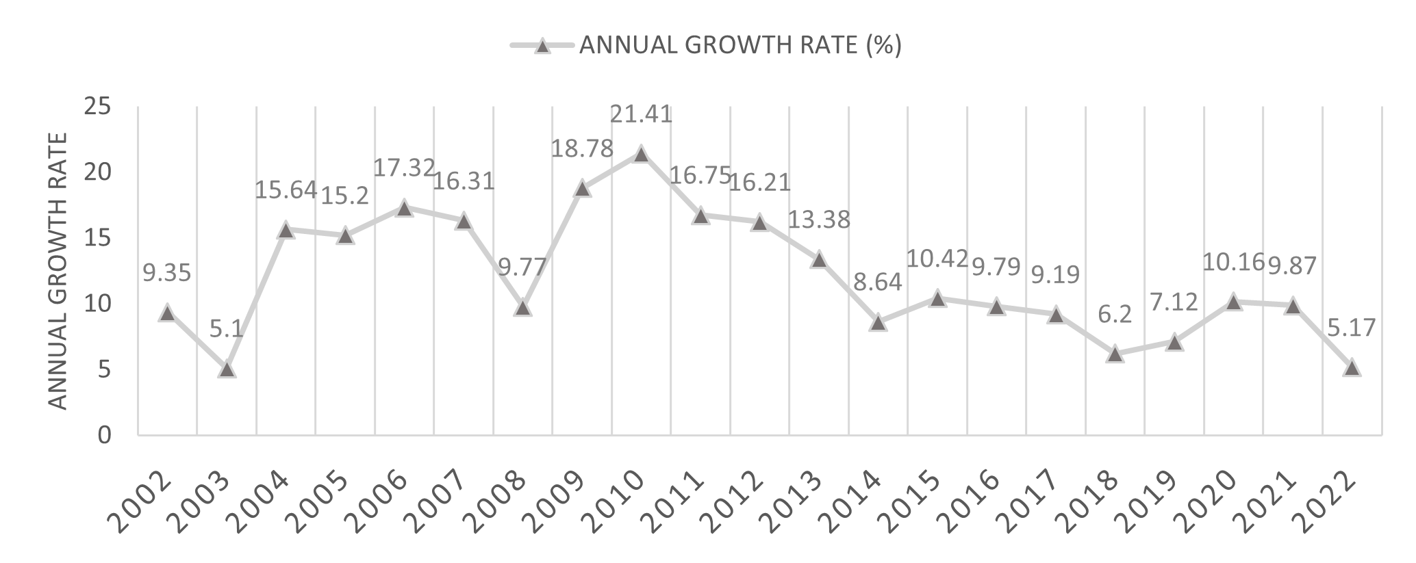
Figure 1: Annual Growth Rate of Bank’s Assets

Overall, the tables and graph together highlight the distinct growth patterns of Indonesia’s banking sector. The pre-AI period was marked by rapid expansion due to traditional banking strategies, while the post-AI period showed slower but transformative growth driven by technological advancements. Although the immediate growth rate declined, AI laid a strong foundation for future innovations and operational efficiency in the banking sector. Also, it is important to note that post ai period was a phase of recovery from the Covid-19 shock and it is too early to conclude on the impact of AI.
IV.C IMPACT OF AI ON 5-BANK ASSET CONCENTRATION IN INDONESIA
The table 4 shows how the concentration of assets among Indonesia's five largest banks has changed over time. In 1999, these banks controlled 73.36% of total assets, which reflects the effects of the 1997 Asian financial crisis. Many smaller banks closed or merged, leaving the larger banks to dominate the market.
By 2005, the concentration fell sharply to 58.46%, a drop of 14.90 percentage points. This suggests a phase where smaller banks gained more prominence due to policies that encouraged competition. The trend continued, and by 2013, the concentration dropped further to 51.23%, indicating a more diversified and competitive banking sector.
However, the situation shifted in 2019 when concentration rose to 55.18%. This increase points to a period of consolidation, likely caused by economic challenges or mergers among larger banks. By 2021, the concentration had risen slightly to 57.05%, which shows that the largest banks were gaining strength, possibly due to technological advancements and increased efficiencies backed by adoption of AI in different fields of bank services.
Table 4: Bank Asset Concentration
Year | Bank Asset Concentration (%) | Change (%)
1999 | 73.36 | -
2005 | 58.46 | -14.90
2013 | 51.23 | -7.23
2019 | 55.18 | 3.95
2021 | 57.05 | 1.87

Figure 2: Bank Asset concentration
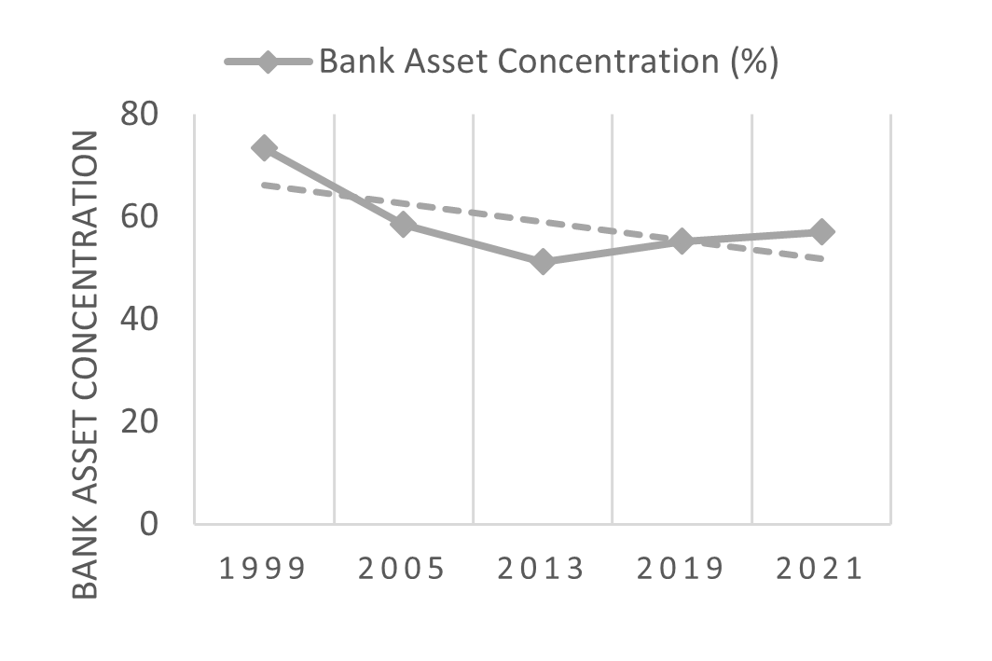
Figure 2 also shows that before AI, market concentration decreased as digital banking allowed smaller banks to expand. After AI adoption, larger banks strengthened their position by leveraging advanced technologies, reducing the competitive space for smaller banks. Overall, the analysis shows a change in Indonesia’s banking sector from a concentrated market to a more competitive environment and then a shift back to dominance by major banks.
IV.D. TREANDS IN BANK OVERHEAD COSTS TO TOTAL ASSETS
Table 5.a shows how bank overhead costs as a percentage of total assets changed over time. In 2000 the costs were 2.66% of the total assets and it reflects the recovery after the Asian financial crisis. However, the costs increased in 2008 to 3.29%, might be the cause of the global financial crisis, which caused banks to spend more on administration and operations. By 2010, costs peaked at 3.72% because banks faced higher compliance and operational demands. Thereafter, the costs dropped to 3.17% by 2015, reflecting efforts to control expenses as economic conditions improved. By 2019, costs had reduced to 2.98%, after the use of digital tools. In 2020 and 2021, costs further decreased to 2.77% and slightly increased to 2.78% as banks increasingly adopted AI and digital systems to improve efficiency, especially in response to the pandemic-driven need for digital transformation.
Moreover, as far as the comparison of overhead costs between the two periods is concerned, the average costs during the post-AI period are lower than those in the pre-AI period. As shown in Panel B of Table 1, this improvement might be due to the adoption of AI in the Indonesian banking sector, which has resulted in better efficiency, less manual work, and more digital banking.
Table 5.a: Bank Overhead Costs to Total Assets

Year | Overhead Costs (%)
2000 | 2.66
2008 | 3.29
2010 | 3.72
2015 | 3.17
2019 | 2.98
2020 | 2.77
2021 | 2.78
Table 5.b: Comparison Pre & Post Periods
Period | Average Overhead Costs (%)
Pre-AI (2000–2019) | 3.25
Post-AI (2020–2021) | 2.78

Figure 3: Bank Overhead Costs to Total Assets (%)
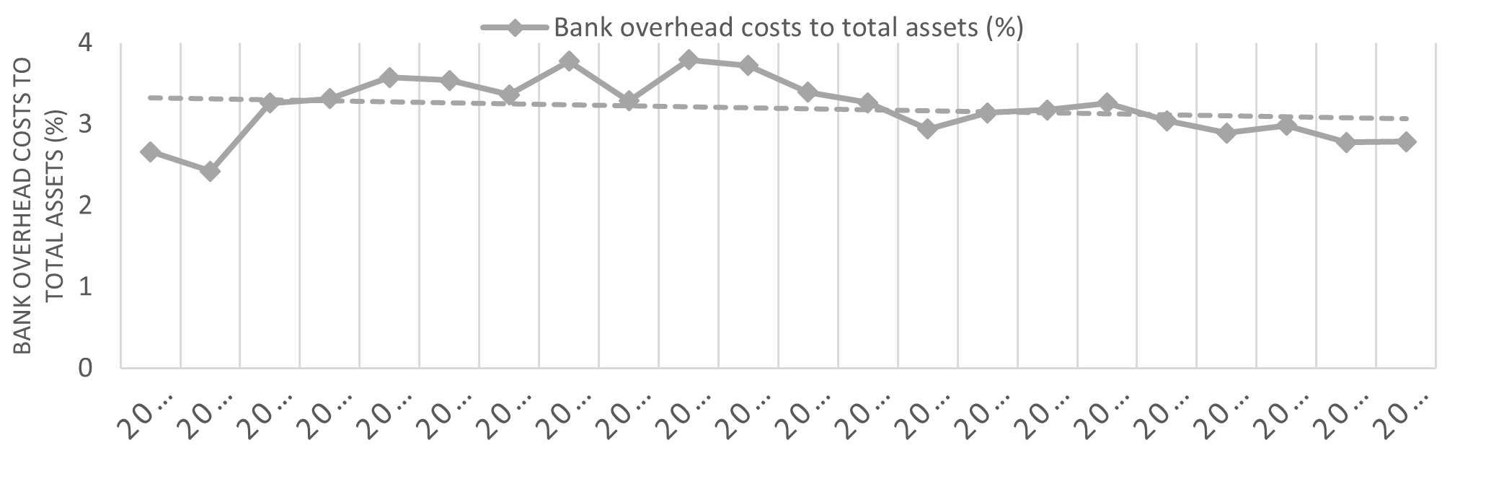
IV.E. IMPACT OF AI ON BANK COST-TO-INCOME RATIO
The cost-to-income ratio is crucial for assessing a bank's operational efficiency, reflecting the proportion of operating costs relative to income. A lower ratio indicates higher efficiency.
Table 6 shows a steady decline in Indonesia's banks' cost-to-income ratios, dropping from 59.76% in 2000 to 46.59% in 2019, driven by basic digitization, automation, and process improvements. However, reliance on manual processes and outdated systems slowed progress, even as banks faced growing competition from Non-Bank Financial Institutions and pressures from the 2008 financial crisis, which forced banks to focus on efficiency. After 2019, the adoption of AI, accelerated by the COVID-19 pandemic, led to a rise in costs. By 2023, the cost-to-income ratio increased to 76.34%, reflecting investments in AI tools, cybersecurity, and regulatory compliance. These short-term expenses highlight the financial strain of transitioning to advanced systems. However, AI has enabled cost-saving measures in areas like loan processing and customer service. As these technologies mature, the cost-to-income ratio is expected to improve, balancing initial investments with long-term benefits in efficiency and profitability.
Figure 4: Bank Cost to Income Ratio (%)
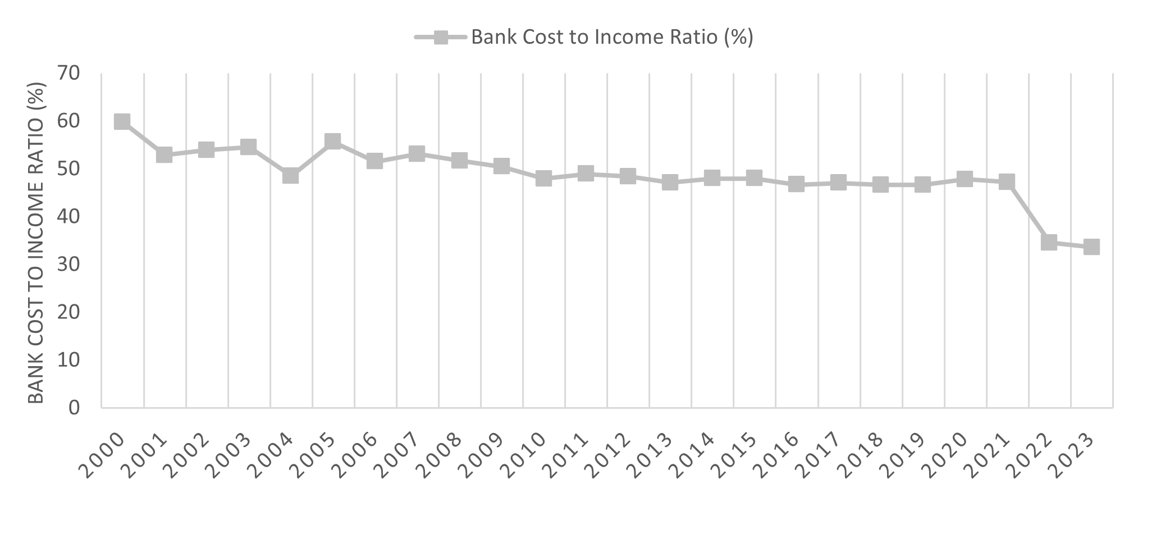
Table 6: Comparative Analysis of Bank Cost to Income Ratio
Year | Bank Cost to Income Ratio (%) | Growth Rate (%)
2000 | 59.76 | ---
2005 | 55.61 | -6.97
2010 | 47.92 | -13.79
2015 | 47.97 | 0.11
2019 | 46.59 | -2.89
2020 | 47.78 | 2.56
2021 | 47.22 | -1.17
2023 | 76.34 | 61.93

IV.F. IMPACT OF AI ON BANK LENDING-DEPOSIT SPREAD
The bank lending-deposit spread refers to the gap between the interest rate applied to loans (lending rate) and the interest rate offered on deposits (deposit rate). This spread is an important indicator of a bank's profitability since it represents how much the bank receives from lending versus how much it pays on deposits. A wider spread usually indicates better profitability for banks, whereas a lesser spread denotes lower profit margins or increasing competition.
During the pre-AI period (1990–2019), the bank lending-deposit spread fluctuated significantly. In the early 1990s, the gap was quite narrow, hovering around 3.29% in 1990 and falling to 2.22% in 1991. However, the margin increased sharply in the mid to late 1990s, peaking at 7.68% in 2004. This was attributed to a combination of high interest rates during the Asian financial crisis and increased inflationary pressures in Indonesia. Throughout the 2000s, the spread was unpredictable, with some years, such as 2008, having a spread of 5.1%, reflecting the global financial crisis' impact on bank lending practices.
Table 7: Bank Lending-Deposit Spread
Year | Bank Lending-Deposit  Spread (%) | Growth Rate (%) | Year | Bank Lending-Deposit  Spread (%) | Growth Rate (%)
1990 | 3.29 | --- | 2007 | 5.89 | 28.9
1991 | 2.22 | -32.5 | 2008 | 5.11 | -13.3
1992 | 4.43 | 99.6 | 2009 | 5.22 | 2.1
1993 | 6.04 | 36.3 | 2010 | 6.24 | 19.5
1994 | 5.23 | -13.4 | 2011 | 5.47 | -12.3
1995 | 2.13 | -59.2 | 2012 | 5.85 | 6.9
1996 | 1.96 | -8.0 | 2013 | 5.39 | -7.9
1997 | 1.80 | -8.1 | 2014 | 3.85 | -28.6
1999 | 1.93 | 7.2 | 2015 | 4.33 | 12.5
2000 | 5.95 | 208 | 2016 | 4.72 | 9.0
2001 | 3.07 | -48.4 | 2017 | 4.56 | -3.4
2002 | 3.44 | 12.1 | 2018 | 4.41 | -3.3
2003 | 6.35 | 84.3 | 2019 | 3.68 | -16.5
2004 | 7.68 | 20.8 | 2020 | 4.04 | 9.8
2005 | 5.97 | -22.2 | 2023 | 4.29 | 6.2
2006 | 4.57 | -23.5

The spread fluctuated during the 2010s, but generally remained in the 4-5% area. The lowering trend witnessed after 2015. The lower spread in the years after 2015 indicated a more cautious economic situation, with banks focusing on credit quality and lowering lending rates to entice customers.
Figure 5: Bank Lending-Deposit Spread (%)
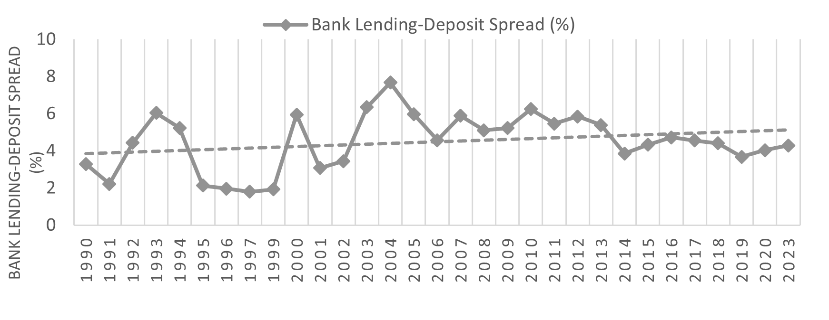
The lending-deposit spread's growth rate suggests that, while the spread fell in 2019, the post-2019 rebound in 2020 and 2023 illustrates the influence of AI-driven efficiency and banking sector digitization, which has stabilized and even increased the spread modestly in recent years. The post-2019 timeframe shows signs of growing deposit volumes, aided by the incorporation of AI into the banking industry.
Table 8: Comparative Analysis of Bank Lending-Deposit Spread
Period | Average Bank Lending-Deposit Spread (%) | Average Growth of Bank Lending-Deposit Spread (%)
Pre-AI (1990-2019) | 4.40 | -2.18
Post-AI (2020-2024) | 4.21 | 6.5

According to the CEIC Data, Indonesia total deposits increased from USD 514.974 billion in August 2024 to USD 528.733 billion in September 2024, demonstrating a consistent increase in deposit volumes during this time period. This is consistent with the larger use of AI technologies in banking, which have improved client targeting, risk assessment, and deposit mobilization techniques.
IV.G. IMPACT OF AI ON BANK NON-PERFORMING LOANS TO GROSS LOANS (%)
The ratio of Non-Performing Loans (NPLs) to Gross Loans is an important indicator of the soundness of the banking industry. It calculates the percentage of loans that are not paid on time (i.e. loans that are past due or unlikely to be collected). A high NPL ratio indicates poor credit quality, which might jeopardize the viability of the banking industry, whereas a low level indicates healthy financial conditions.
Table 9: Bank’s non-performing loans to Gross loans
Year | Bank NPL to  Gross loans (%) | Year | Bank NPL to  Gross loans (%)
1998 | 48.60 | 2010 | 2.53
1999 | 32.90 | 2011 | 2.14
2000 | 34.40 | 2012 | 1.77
2001 | 31.90 | 2013 | 1.69
2002 | 24.00 | 2014 | 2.07
2003 | 6.80 | 2015 | 2.43
2004 | 4.50 | 2016 | 2.90
2005 | 7.60 | 2017 | 2.56
2006 | 6.10 | 2018 | 2.29
2007 | 4.00 | 2019 | 2.43
2008 | 3.20 | 2020 | 2.75
2009 | 3.30 | 2023 | 2.53

During the Pre-AI Period, the NPL ratio was high in the late 1990s, especially after the Asian Financial Crisis of 1997-1998. The crisis caused significant defaults due to economic insecurity. Since the early 2000s, the NPL ratio has been dropping, reflecting economic recovery, tighter regulatory frameworks, and greater risk management in the banking sector. However, there were swings caused by macroeconomic issues, such as the Global Financial Crisis 2008 and subsequent commodity price declines, which impacted borrowers' ability to repay loans. During the Asian and worldwide financial crises, high non-performing loans were caused by widespread economic instability, currency depreciation, and loan defaults by enterprises. The implementation of tougher credit risk management frameworks and increased banking oversight resulted in a decline in NPLs in the post-crisis years.

Figure 6: Bank Non-Performing Loans to Gross Loans (%)
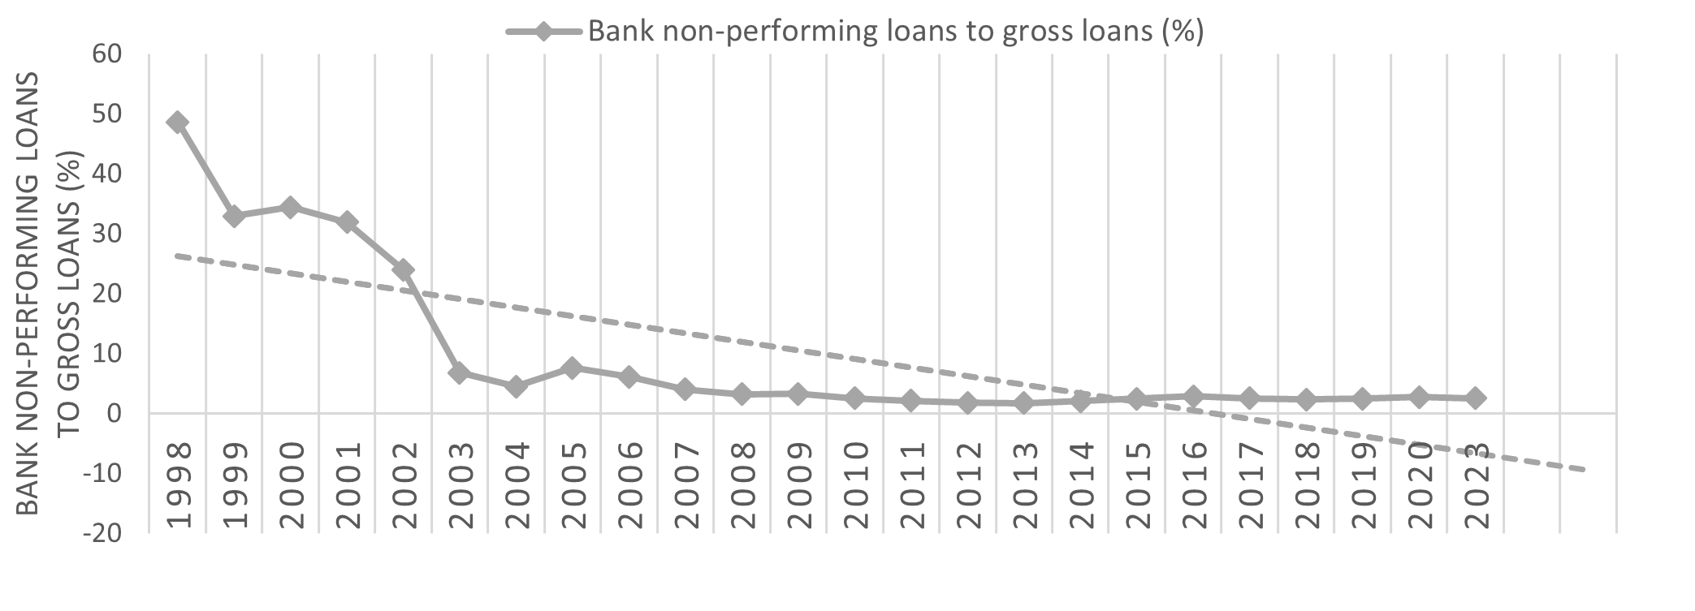
Table 10: Comparison of NPLs to Gross Loans between Pre and Post AI Periods
Period | Average NPL to  Gross Loans (%) | Average Growth of  NPL to Gross Loans (%)
Pre-AI (1998-2019) | 7.18 | -11.3%
Post-AI (2020-2024) | 2.56 | -2.92%

During the post-AI period from 2019 to 2024 with the widespread adoption of AI, the NPL ratio became stable as it rose slightly in 2020 but declined again in 2023. The role of AI in risk prediction, loan monitoring, and collections contributed to the overall improvement in loan quality. Furthermore, the pandemic prompted banks to use digital and AI technology, which most likely resulted in better management of customer relations and loan repayments. AI-driven advancements in loan risk assessment and management have dramatically reduced NPLs. AI also helped banks become more resilient during the pandemic by allowing for improved monitoring of customer financial conditions via digital tools. AI has emerged as a revolutionary force in mitigating risks and improving loan approvals procedures. According to data trends, the introduction of AI helped to stabilize the NPL ratio, which averaged 2.56% compared to 7.18% in the pre-AI period. This progress may be credited to AI-driven credit risk models that use a variety of variables, including customer behaviour, transaction histories, and market circumstances, to provide more accurate creditworthiness assessments. Furthermore, AI-powered monitoring systems enabled early detection of probable loan defaults, greatly decreasing risks.
IV.H. THE EFFECT OF AI ON THE CHANGE IN COMPOSITION OF FINANCIAL SECTOR

From 2005 to 2023, Indonesia's financial sector experienced significant transformations, with distinct changes observed between pre- and post-AI periods. In 2005, the financial sector's total assets accounted for 63.4% of GDP, which increased to 72% by 2023. The banking sector, though dominant initially with 52% of GDP in 2005, saw its contribution stabilize at 54.9% in 2023.
Non-bank financial institutions (NBFIs) gained prominence during this period, with their share of GDP rising from 11.3% in 2005 to 17.6% in 2023. AI-enabled technologies like automated risk assessments and personalized services allowed these institutions to attract more clients and expand their market share. Insurance companies maintained gradual growth, with their GDP share rising from 4.4% in 2005 to 8.9% in 2023.

Table 11: AI and Its Impact on the Composition of the Financial Sector
Year | % of GDP |  |  |  | Number of Institution
Year | 2005 | 2010 | 2015 | 2023 | 2005 | 2010 | 2015 | 2023
Banking Sector | 52 | 45.6 | 55.4 | 54.9 | 2143 | 1828 | 1755 | 1518
Other Non-Bank Financial Institutions | 11.3 | 14.3 | 16.3 | 17.6 | 1115 | 1275 | 1916 | 2546
Insurance Companies | 4.4 | 5.9 | 7.2 | 8.9 | 157 | 142 | 137 | 151
Pension Funds | 2.2 | 1.9 | 1.8 | 1..8 | 321 | 272 | 260 | 199
Mutual Funds | 1 | 2.2 | 2.4 | 2.5 | 293 | 559 | 1091 | 1967

Figure 7 depicts the change in number of institutions from 2005 to 2023 (with 2005, 2015, and 2023 as reference years). The data show that the number of banking institutions has decreased from 2143 in 2005 to 1518 in 2023 due to market concentration and technological advancements, while the number of NBFIs has climbed from 1115 in 2005 to 2546 in 2023. Mutual funds showed the most significant growth, with their institutions increasing from 293 in 2005 to 1,967 in 2023, driven by AI in market analysis and portfolio management. It can also be noted that the number of insurance businesses has declined from 157 to 137 between 2005 and 2015, before significantly increasing from 137 to 151 between 2015 and 2023. Pension fund institutions have likewise fallen, from 321 in 2005 to 199 in 2023.

Overall, AI has reshaped Indonesia's financial sector by increasing operational efficiency, enhancing customer engagement, and driving innovation, especially in the post-2019 period. While larger institutions benefited most, smaller entities faced challenges in adapting, resulting in a more competitive and technology-driven financial environment.

Figure 7: Change in Composition of Financial Institutions 2005,2015,2023
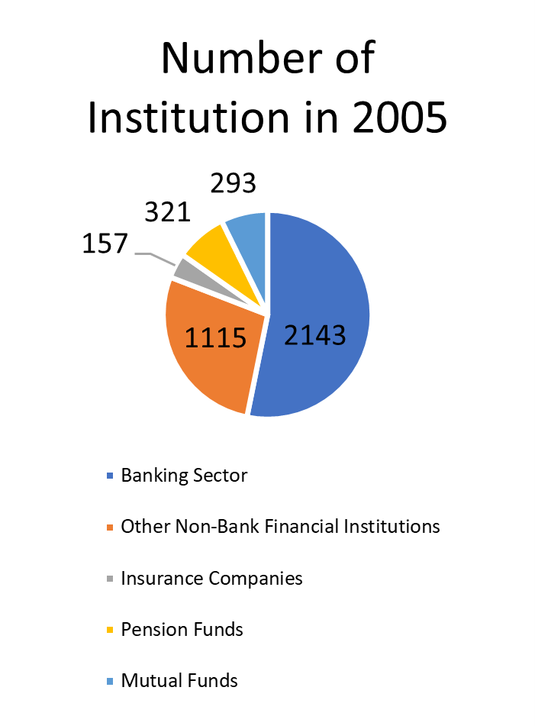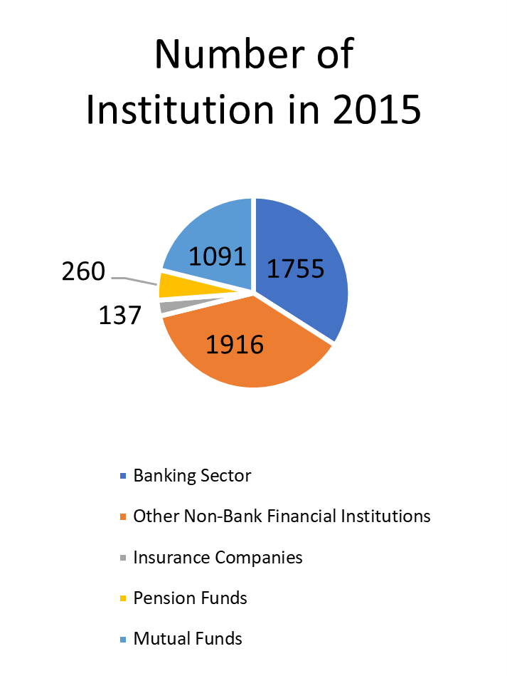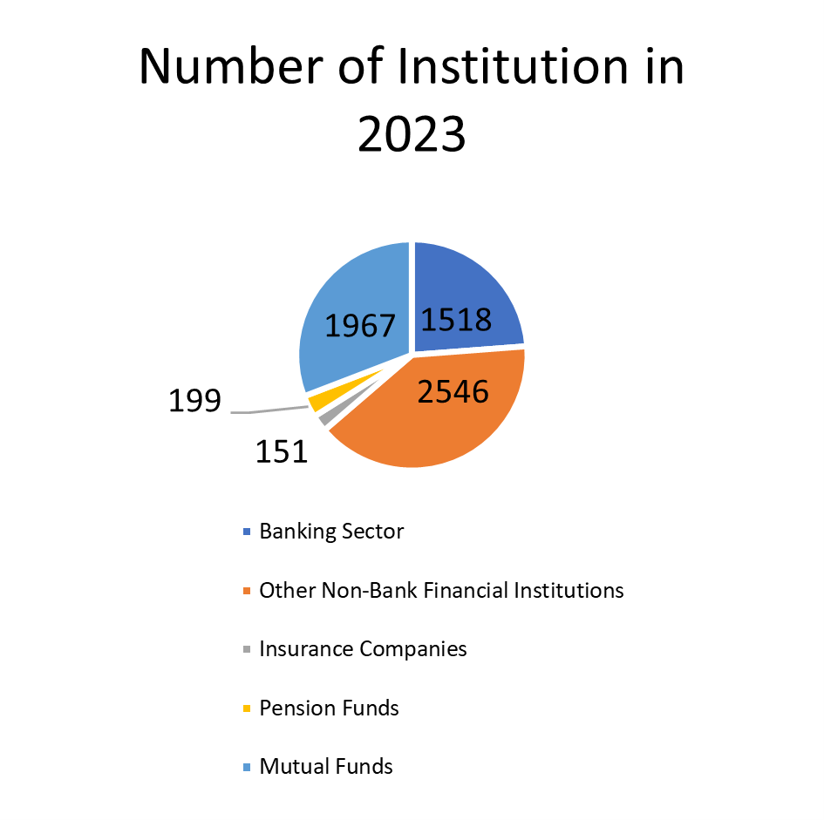
IV.I. IMPACT OF AI ON BANKING SECTOR OPERATIONAL EFFICIENCY BETWEEN ROA AND ROE
Table 12, evaluates the influence of Artificial Intelligence (AI) on operational efficiency in Indonesia's banking sector by analyzing Return on Assets (ROA) and Return on Equity (ROE) during the pre-AI period (2000 to 2018) and the post-AI period (2019 to 2024). ROA reflects how efficiently banks utilize their assets to generate profits, while ROE measures their ability to create earnings from shareholder equity.
In the pre-AI period, ROA showed gradual improvement, peaking at 2.49% in 2019. This growth was driven by economic stability, regulatory reforms, and the expansion of consumer lending, though global events such as the 2008 financial crisis caused temporary decline. Similarly, ROE experienced fluctuations, rising after the Asian financial crisis but dropping sharply during the global financial crisis. The average ROA and ROE during this period were 2.45% and 24.75%, respectively, with growth shaped by market conditions and limited adoption of advanced technologies.
Table 12: Trends in ROA and ROE of Bank
Year | Bank Return on Assets | Growth Rate of ROA | Bank Return on Equity | Growth Rate of ROE
2000 | 0.50 | NA | 10.04 | NA
2001 | 0.86 | 72.45 | 23.25 | 131.66
2002 | 2.02 | 136.04 | 29.86 | 28.42
2003 | 2.63 | 30.04 | 31.74 | 6.31
2004 | 3.45 | 31.19 | 36.18 | 13.99
2005 | 2.27 | -34.35 | 23.23 | -35.81
2006 | 2.31 | 1.70 | 23.17 | -0.25
2007 | 2.67 | 15.76 | 26.15 | 12.86
2008 | 1.84 | -31.12 | 22.70 | -13.20
2009 | 2.62 | 42.76 | 26.84 | 18.27
2010 | 3.01 | 14.79 | 28.64 | 6.67
2011 | 2.92 | -2.89 | 25.90 | -9.57
2012 | 2.99 | 2.33 | 25.32 | -2.23
2013 | 2.77 | -7.50 | 22.87 | -9.67
2014 | 2.77 | -0.05 | 22.27 | -2.63
2015 | 2.35 | -15.17 | 17.94 | -19.44
2016 | 2.22 | -5.45 | 15.82 | -11.85
2017 | 2.44 | 9.79 | 16.58 | 4.83
2018 | 2.46 | 1.04 | 16.52 | -0.36
2019 | 2.49 | 1.30 | 16.30 | -1.35
2020 | 1.55 | -37.95 | 10.23 | -37.20
2021 | 1.84 | 18.92 | 12.25 | 19.67
2022 | 2.43 | 31.87 | 12.40 | 1.26
2023 | 2.76 | 13.57 | 20.01 | 61.37
2024 | 2.77 | 0.40

Table 13: Comparative Analysis of Average ROA and ROE
Period | Average ROA (%) | Average Growth of ROA (%) | Average  ROE (%) | Average Growth of ROE (%)
Pre-AI (2000-18) | 2.45 | 5.84 | 24.75 | 8.43
Post-AI (2019-24) | 2.57 | 4.48 | 18.80 | 10.17

Figure 8: Bank Return on Assets
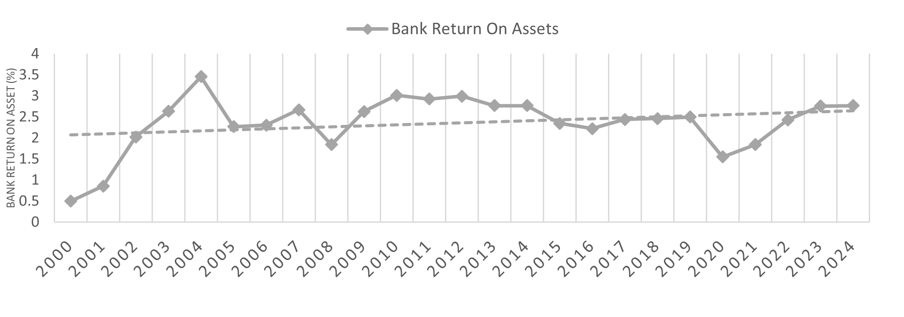
Figure 9: Bank Return on Equity
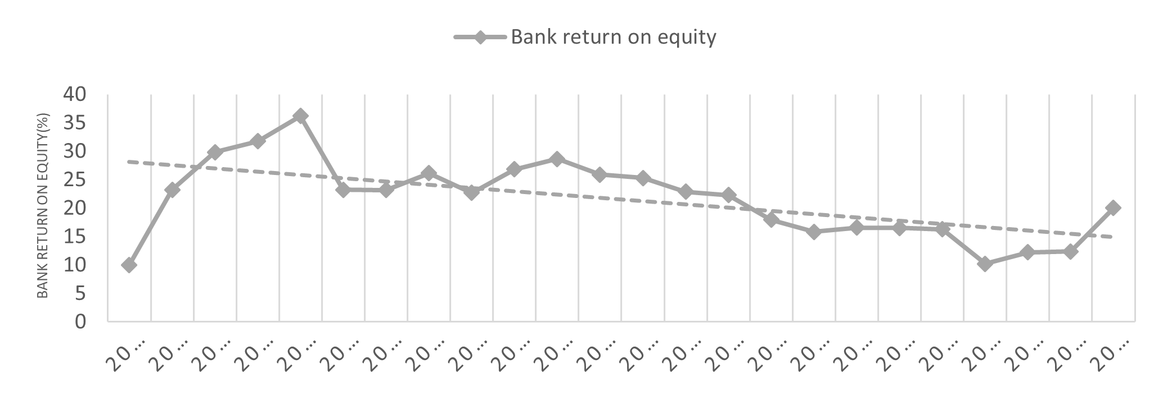
Moreover, the post-AI period saw notable advancements, with ROA rising consistently to 2.76% in 2023, reflecting better profitability and asset utilization. The average ROA increased to 2.57%, driven by AI-enabled technologies such as automated risk assessments and fraud detection, which streamlined operations and reduced costs. However, there is fall in the growth rate of ROA in the post AI period. ROE also improved significantly, increasing from 10.23% in 2020 to 20.01% in 2023, with an average of 18.80%. This improvement was fueled by AI-driven decision-making, enhanced risk management, and digital transformation, particularly during the COVID-19 pandemic. The average growth rate of ROE reached 10.17%, showcasing improved capital efficiency and financial performance. The overall findings emphasize the transformative impact of AI in the post-2019 period, characterized by greater operational efficiency and profitability in Indonesia’s banking sector. AI adoption enhanced asset management, reduced operational costs, and improved decision-making, allowing banks to overcome challenges and achieve sustained growth.

IV.J IMPACT OF AI ON FINANCIAL INCLUSION
The changes in account ownership at formal financial institutions in Indonesia from 2011 to 2021 are presented in Table 14 which highlights the differences between pre- and post-AI periods. In 2011, only 19.58% of individuals aged 15 and above held accounts, reflecting limited financial inclusion and reliance on physical branches. By 2014, this percentage had grown to 35.95%, driven by economic growth and government programs promoting financial literacy and access to banking in underserved areas. The increase was substantial during this period, with a growth rate of 83.38%, indicating early success in expanding financial inclusion without significant technological intervention.
Table 14: Account Ownership Trends at Formal Financial Institutions
Year | Account at a Formal Financial Institution (% age 15+) | Growth Rate (%)
2011 | 19.58% | -
2014 | 35.95% | 83.38%
2017 | 48.39% | 34.81%
2021 | 50.51% | 4.39%

Figure 10: Account Ownership Trends at Formal Financial Institutions
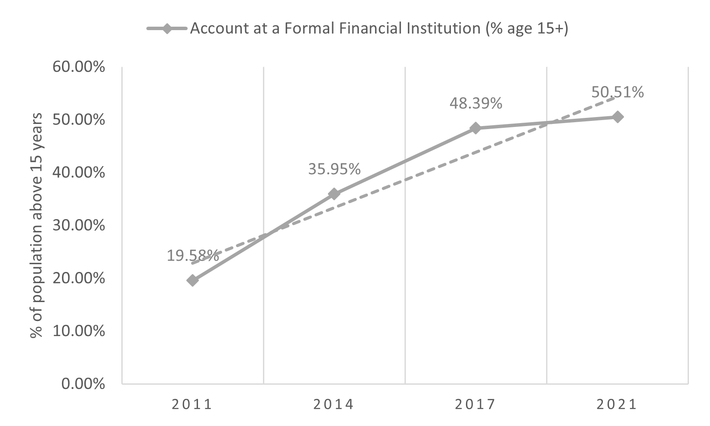
Between 2014 and 2017, account ownership continued to rise, reaching 48.39% and the growth rate slowed to 34.81%. This period saw the early adoption of digital banking technologies, which complemented traditional methods, though AI tools had not yet become a major factor. The increase was supported by greater financial literacy and the gradual expansion of digital banking platforms, which started to attract more users. From 2017 to 2021, during the post-AI period, account ownership grew moderately to 50.51%, with a much lower growth rate of 4.39%. This slowdown can be attributed to market saturation, as many individuals had already opened accounts. However, the role of AI in enhancing financial inclusion became significant in this phase. AI-powered tools like mobile banking apps, chatbots, and digital wallets simplified access to financial services, especially during the COVID-19 pandemic, when remote banking became essential. These innovations allowed users to open accounts and manage finances without visiting physical branches, improving inclusivity for previously underserved populations.
V. CONCLUSION
The study examined the role of Artificial Intelligence and its implications for Indonesia's banking and financial sectors during the pre- and post-AI periods. The findings suggest that, despite initial obstacles such as investment costs and adjustments to technology, AI has increased profitability, enhanced operational efficiency, and expanded access to financial services. The study found that after the adoption of AI there is a fall in the number of commercial banks operating in the Indonesian economy along with the fall in the growth rate of assets of banks. This raises the question on the capacity of AI in perusing the customers for asset mobilization. In this case the central bank of Indonesia may play a role in motivating banks to either return to their banking agents or transforming or improving AI for better pursuance. Further the study found U-Shaped curve for asset concentration with five largest banks. Perhaps, the implementation of AI in banking sector has created the dominance of large banks, that needs to be corrected to avoid the emergence of monopoly market in banking sector. The AI has very positive impact on bank overhead costs to total assets and helped in reducing it. This has improved the operational efficiency of banks and bank cost to income ratio has declined after the adoption of AI in this sector, but in 2023 there is a massive increase in this ratio which is a cause of concern and the central bank of Indonesia needs to monitor the AI and its use in any malpractices.
The bank-lending deposit spread that determines their profitability has been positively contributed by AI and its average growth has improved drastically in post-AI period. The AI has also positively impacted the non-performing loans and its growth rate has declined in the post-AI period. The adoption of AI has also improved the dominance of financial sector by improving its share in the GDP. The AI regime has given better place to specialized non-banking institutions like NBFIs, Mutual Funds, Insurance Companies, etc. and diversified the Indonesian banking and financial sector. The AI has also improved the operational efficiency represented by ROA and ROE of the banks. However, the growth rate of ROA has fallen while the growth rate of ROE has increased that lead us to the conclusion that AI has favored more to the investment in equity as compared to investments in assets. After the adoption of AI, the account ownership with financial institution has improved but the improvement is lower than the pre-AI period. It looks that there is not much scope of increasing the account ownership because already 70% of the adult population has the access to the banking services. The central bank of Indonesia needs to devise the means for further penetration of the banking services with the help of AI-driven strategies.

Disclaimer (Artificial intelligence)

Option 1:

Author(s) hereby declare that NO generative AI technologies such as Large Language Models (ChatGPT, COPILOT, etc.) and text-to-image generators have been used during the writing or editing of this manuscript.

Option 2:

Author(s) hereby declare that generative AI technologies such as Large Language Models, etc. have been used during the writing or editing of manuscripts. This explanation will include the name, version, model, and source of the generative AI technology and as well as all input prompts provided to the generative AI technology

Details of the AI usage are given below:
1.
2.
3.

REFERENCES
Agustiawan, D. A. “Digital Banking Transformation: AI Enhances Efficiency and Customer Experience - Seminar Perspective Industry.” Wacana (Jakarta) 23, no. 1 (2024): 191–200. https://doi.org/10.32509/wacana.v23i1.4130.
Alzaidi, A. A. “Impact of Artificial Intelligence on Performance of Banking Industry in Middle East.” International Journal of Computer Science and Network Security 18, no. 10 (2018): 140–148.
Bakri, A. A., Hasanah, N., and Lasmiatun, K. “Financial Technology Innovation and Banking Industry Transformation.” MFC 1, no. 3 (2024). https://doi.org/10.61397/mfc.v1i3.112.
Bholat, D., and D. Susskind. “The Assessment: Artificial Intelligence and Financial Services.” Oxford Review of Economic Policy 37, no. 3 (2021): 417–434.
Candiwan, C., and R. R. Annikmah. “Exploring the Impact of Artificial Intelligence on User Satisfaction and Acceptance in Digital Banking Services in Indonesia.” In 2024 IEEE 30th International Conference on Telecommunications (ICT), 1–8. IEEE, June 2024.
Dede, Arisko, and Agustiawan. “Digital Banking Transformation: AI Enhances Efficiency and Customer Experience - Seminar Perspective Industry.” Wacana (Jakarta) 23, no. 1 (2024): 191–200. https://doi.org/10.32509/wacana.v23i1.4130.
Effendi, N., Setiawan, M., and Indiastuti, R. “Technical Efficiencies of Indonesian Regional and Non-Regional Banks Pre- and Post-Financial Crisis.” International Journal of Economics and Business Research 16, no. 3 (2018): 355–366. https://doi.org/10.1504/IJEBR.2018.10015243.
Fernandez, Ana. “Artificial Intelligence in Financial Services.” Banco de Espana Article 3/19 (2019). SSRN: https://ssrn.com.
Ginting, A. M. “Pengaruh Makroekonomi Terhadap Non-Performing Loan (NPL) Perbankan.” JEKP 7, no. 2 (2017): 159–170. https://doi.org/10.22212/JEKP.V7I2.669.
Golić, Z. “Finance and Artificial Intelligence: The Fifth Industrial Revolution and Its Impact on the Financial Sector.” Zbornik Radova Ekonomskog Fakulteta u Istočnom Sarajevu 19 (2019): 67–81.
Hamdillah, D. N., Ermawati, W. J., and Suprayitno, G. “Forecasting Tingkat Kesehatan dan Tingkat Ketahanan Perbankan di Indonesia.” Manajemen IKM: Jurnal Manajemen Pengembangan Industri Kecil Menengah 19, no. 2 (2024).
Herlina, Kurniati, Kuryani, Saputra, Fristia, Berdian, and Tamza. “Analisis Pencabutan Izin Usaha dan Likuidasi Bank di Indonesia.” Asas: Jurnal Politik, Hukum, Ekonomi dan Kebudayaan Islam 13, no. 2 (2022): 44–58. https://doi.org/10.24042/asas.v13i2.11278.
Hidayat, M., Defitri, S. Y., and Hilman, H. “The Impact of Artificial Intelligence (AI) on Financial Management.” Management Studies and Business Journal (Productivity) 1, no. 1 (2024): 123–129.
Husain, A. R. A. M., Hamdan, A., and Fadhul, S. M. “The Impact of Artificial Intelligence on the Banking Industry Performance.” In Future of Organizations and Work After the 4th Industrial Revolution: The Role of Artificial Intelligence, Big Data, Automation, and Robotics, 145–156, 2022.
Hussain, S. “The Assessment of Operational Efficiency of Commercial Banks in India Using Cost to Income Ratio Approach.” International Journal of Management and Business Research 4, no. 3 (2014): 225–234. https://ijmbr.srbiau.ac.ir/article_2877.html.
IMF. “Indonesia: Financial Sector Assessment Program - Financial System Stability Assessment.” International Monetary Fund. Monetary and Capital Markets Department (2024). https://www.elibrary.imf.org/view/journals/002/2024/272/article-A001-en.xml (retrieved January 24, 2025).
Indriasari, E., Gaol, F. L., and Matsuo, T. “Digital Banking Transformation: Application of Artificial Intelligence and Big Data Analytics for Leveraging Customer Experience in the Indonesia Banking Sector.” In 2019 8th International Congress on Advanced Applied Informatics (IIAI-AAI), 863–868. IEEE, 2019.
Khoirudin, R. “Determinants of Mortgage Credit Demand in Indonesia.” Ekonimikawan 17, no. 2 (2017): 105–120. https://doi.org/10.30596/EKONOMIKAWAN.V17I2.1794.
Kristofano, Y. Y., and Febriani, R. E. “The Role of Political Stability and Foreign Direct Investment in Indonesia’s Economic Growth.” Asian Journal of Applied Business and Management 3, no. 3 (2024): 261–276.
Kunwar, M. “Artificial Intelligence in Finance: Understanding How Automation and Machine Learning Are Transforming the Financial Industry.” (2019).
Laksmana, K. A. R. I. “Penerapan Permodalan Basel III dan Implikasinya Terhadap Kinerja Perbankan di Indonesia.” 2019. https://doi.org/10.31227/osf.io/mnhcj.
Maghfuriyah, A., Dewi, N. F., and Antono, Z. M. “Coronanomics: Implications of COVID-19 Pandemic in the Economy in Indonesia.” Jurnal Teknologi & Manajemen 22, no. 2 (2024): 11–20. https://doi.org/10.52330/jtm.v22i2.255.
Marina, A. N. “The Effect of Artificial Intelligence Disclosure on Financial Performance (Empirical Study on Banking Industries Listed on The Indonesia Stock Exchange in 2020–2022).” Doctoral dissertation, Universitas Andalas, 2024.
Megawati, I. A. P., and Kertiriasih, N. N. R. “Dampak Layanan Perbankan Digital Terhadap Kinerja Perbankan di Indonesia.” Fonduri de Investiţii 13, no. 3 (2024): 1578–1591. https://doi.org/10.34127/jrlab.v13i3.1205.
Mishra, P., and T. Guru Sant. “Role of Artificial Intelligence and Internet of Things in Promoting Banking and Financial Services During COVID-19: Pre and Post Effect.” 2021 5th International Conference on Information Systems and Computer Networks (ISCON), Mathura, India, 2021, 1–7. https://doi.org/10.1109/ISCON52037.2021.9702445.
Monika, Mucsková. “Transforming Banking with Artificial Intelligence.” Trends Economics and Management (2024). https://doi.org/10.13164/trends.2024.42.21.
Muhammad, Asif, and Khan. “Understanding the Impact of Artificial Intelligence (AI) on Traditional Businesses in Indonesia.” Journal of Management Studies and Development 3, no. 2 (2024): 146–158. https://doi.org/10.56741/jmsd.v3i02.584.
Pandu Sjahrir and Andy Lees. “Harnessing the Power of (Gen)AI in Indonesian Financial Services.” Jointly published by AC Ventures, Boston Consulting Group, Kadin Indonesia, and BCG X, 2024. https://web-assets.bcg.com/1b/42/1554aac447d88aecbe1048285eed/harnessing-the-power-of-genai-in-indonesian-financial-services.pdf (retrieved January 22, 2025).
Primandari, A. H., and W. K. Arum. “Analyzing the Impact of the Pandemic on Indonesia’s Economic Growth Using Dynamic Time Warping.” Enthusiastic 4, no. 1 (2024). https://doi.org/10.20885/enthusiastic.vol4.iss1.art7.
Ridha, M., and K. Haura Maharani. “Implementation of Artificial Intelligence Chatbot in Optimizing Customer Service in Financial Technology Company PT. FinAccel Finance Indonesia.” Proceedings, vol. 83, no. 1 (December 2022): 21. MDPI.
Rizkina, A., and A. W. Diana. “Pengaruh Tingkat Suku Bunga dan Inflasi terhadap Kredit Konsumsi di Indonesia.” Jurnal Ekonomi dan Kebijakan Publik Indonesia. https://doi.org/10.24815/ekapi.v10i1.37461.
Rofi'i, Y. U. “Financial Risk Management in Indonesian Banking: The Integrative Role of Data Analytics and Predictive Algorithms.” International Journal of Software Engineering and Computer Science (IJSECS) 3, no. 3 (2023): 300–309.
Rosadi, S. D., S. Yuniarti, and R. Fauzi. “Protection of Data Privacy in the Era of Artificial Intelligence in the Financial Sector in Indonesia.” Journal of Central Banking Law and Institutions 1, no. 2 (2022): 353–366.
Safrianto, S., and E. Erniati. “Analysis of the Impact of Artificial Intelligence on the Development of Industry 4.0 in Indonesia.” In Proceeding of International Conference on Islamic and Interdisciplinary Studies, vol. 3, 327–332, August 2024.
Said, M. “Digital Innovation in Indonesian Sharia Banks.” In Advances in Human Resources Management and Organizational Development Book Series, 78–96. https://doi.org/10.4018/979-8-3693-3530-7.ch005.
Shafyra, Nuruzzakiyya, Mar'atushsholihah, and Tuti Karyani. “Dampak Financial Technology terhadap Kinerja Bank Umum Konvensional di Indonesia.” Jurnal Ekonomi dan Kebijakan Publik Indonesia 7, no. 1 (2021): 450. https://doi.org/10.25157/MA.V7I1.4707.
Sinha, M., E. Chacko, and P. Makhija. “AI-Based Technologies for Digital and Banking Fraud During COVID-19.” In Integrating Meta-Heuristics and Machine Learning for Real-World Optimization Problems, edited by E. H. Houssein, M. Abd Elaziz, D. Oliva, and L. Abualigah, vol. 1038, 341–358. Cham: Springer, 2022. https://doi.org/10.1007/978-3-030-99079-4_17.
Soeharjoto, Soeharjoto. “Structure of Commercial Banks in Indonesia During the COVID-19 Pandemic.” The European Proceedings of Social and Behavioural Sciences. https://doi.org/10.15405/epsbs.2023.11.02.8.
Thormundsson, B. “Adoption Rate of AI in Global Finance Business, 2022–2025.” Statista (2023). https://www.statista.com/statistics/1346736/ai-function-adoption-rates-business-finance/ (retrieved January 24, 2025).
Umamaheswari, S., and A. Valarmathi. “Role of Artificial Intelligence in the Banking Sector.” Journal of Survey in Fisheries Sciences 10, no. 4S (2023): 2841–2849.
Wadipalapa, R. P., R. Katharina, P. P. Nainggolan, S. Aminah, T. Apriani, D. Ma’rifah, and A. L. Anisah. “An Ambitious Artificial Intelligence Policy in a Decentralised Governance System: Evidence from Indonesia.” Journal of Current Southeast Asian Affairs 43, no. 1 (2024): 65–93. https://doi.org/10.1177/18681034231226393.
Wardoyo, Wisnu. “Indonesia Accounts for 40% Digital Transaction Value in ASEAN.” Indonesia.go.id, January 24, 2025.
World Bank. “World Development Indicator.” https://data.worldbank.org/indicator/NY.GDP.MKTP.CD?locations=ID. Accessed January 24, 2025.
World Economic Forum. “How Indonesia Is Creating Financial Inclusion Through Digital Wallets.” https://www.weforum.org/stories/2024/02/indonesia-financial-inclusion-digital-wallets/. Accessed January 24, 2025.
Xie, M. “Development of Artificial Intelligence and Effects on Financial System.” Journal of Physics: Conference Series 1187, no. 3 (April 2019): 032084. IOP Publishing.
Yoganandham, G. “Transformative Impact: The Role of Modern and Innovative Banking Technologies in Driving Global Economic Growth.” Tuijin Jishu/Journal of Propulsion Technology 45, no. 1 (2024).

Wardoyo, Wisnu. “Indonesia Accounts for 40% Digital Transaction Value in ASEAN.” Indonesia.go.id, January 24, 2025.
IMF. “Indonesia: Financial Sector Assessment Program - Financial System Stability Assessment.” International Monetary Fund. Monetary and Capital Markets Department (2024). https://www.elibrary.imf.org/view/journals/002/2024/272/article-A001-en.xml (retrieved January 24, 2025).
World Economic Forum. “How Indonesia Is Creating Financial Inclusion Through Digital Wallets.” https://www.weforum.org/stories/2024/02/indonesia-financial-inclusion-digital-wallets/. Accessed January 24, 2025.
Thormundsson, B. “Adoption Rate of AI in Global Finance Business, 2022–2025.” Statista (2023). https://www.statista.com/statistics/1346736/ai-function-adoption-rates-business-finance/ (retrieved January 24, 2025).
Pandu Sjahrir and Andy Lees. “Harnessing the Power of (Gen)AI in Indonesian Financial Services.” Jointly published by AC Ventures, Boston Consulting Group, Kadin Indonesia, and BCG X, 2024. https://web-assets.bcg.com/1b/42/1554aac447d88aecbe1048285eed/harnessing-the-power-of-genai-in-indonesian-financial-services.pdf (retrieved January 22, 2025).
Ibid.
Ibid.
Ibid.
Wadipalapa, R. P., R. Katharina, P. P. Nainggolan, S. Aminah, T. Apriani, D. Ma’rifah, and A. L. Anisah. “An Ambitious Artificial Intelligence Policy in a Decentralised Governance System: Evidence from Indonesia.” Journal of Current Southeast Asian Affairs 43, no. 1 (2024): 65–93. https://doi.org/10.1177/18681034231226393.
Yoganandham, G. “Transformative Impact: The Role of Modern and Innovative Banking Technologies in Driving Global Economic Growth.” Tuijin Jishu/Journal of Propulsion Technology 45, no. 1 (2024).
Fernandez, Ana. “Artificial Intelligence in Financial Services.” Banco de Espana Article 3/19 (2019). SSRN: https://ssrn.com.
Indriasari, E., Gaol, F. L., and Matsuo, T. “Digital Banking Transformation: Application of Artificial Intelligence and Big Data Analytics for Leveraging Customer Experience in the Indonesia Banking Sector.” In 2019 8th International Congress on Advanced Applied Informatics (IIAI-AAI), 863–868. IEEE, 2019.
Xie, M. “Development of Artificial Intelligence and Effects on Financial System.” Journal of Physics: Conference Series 1187, no. 3 (April 2019): 032084. IOP Publishing.
Ridha, M., and K. Haura Maharani. “Implementation of Artificial Intelligence Chatbot in Optimizing Customer Service in Financial Technology Company PT. FinAccel Finance Indonesia.” Proceedings, vol. 83, no. 1 (December 2022): 21. MDPI.
Alzaidi, A. A. “Impact of Artificial Intelligence on Performance of Banking Industry in Middle East.” International Journal of Computer Science and Network Security 18, no. 10 (2018): 140–148.
Hidayat, M., Defitri, S. Y., and Hilman, H. “The Impact of Artificial Intelligence (AI) on Financial Management.” Management Studies and Business Journal (Productivity) 1, no. 1 (2024): 123–129.
Husain, A. R. A. M., Hamdan, A., and Fadhul, S. M. “The Impact of Artificial Intelligence on the Banking Industry Performance.” In Future of Organizations and Work After the 4th Industrial Revolution: The Role of Artificial Intelligence, Big Data, Automation, and Robotics, 145–156, 2022.
Umamaheswari, S., and A. Valarmathi. “Role of Artificial Intelligence in the Banking Sector.” Journal of Survey in Fisheries Sciences 10, no. 4S (2023): 2841–2849.
Kunwar, M. “Artificial Intelligence in Finance: Understanding How Automation and Machine Learning Are Transforming the Financial Industry.” (2019).
Rosadi, S. D., S. Yuniarti, and R. Fauzi. “Protection of Data Privacy in the Era of Artificial Intelligence in the Financial Sector in Indonesia.” Journal of Central Banking Law and Institutions 1, no. 2 (2022): 353–366.
Bholat, D., and D. Susskind. “The Assessment: Artificial Intelligence and Financial Services.” Oxford Review of Economic Policy 37, no. 3 (2021): 417–434.
Golić, Z. “Finance and Artificial Intelligence: The Fifth Industrial Revolution and Its Impact on the Financial Sector.” Zbornik Radova Ekonomskog Fakulteta u Istočnom Sarajevu 19 (2019): 67–81.
Rofi'i, Y. U. “Financial Risk Management in Indonesian Banking: The Integrative Role of Data Analytics and Predictive Algorithms.” International Journal of Software Engineering and Computer Science (IJSECS) 3, no. 3 (2023): 300–309.
Safrianto, S., and E. Erniati. “Analysis of the Impact of Artificial Intelligence on the Development of Industry 4.0 in Indonesia.” In Proceeding of International Conference on Islamic and Interdisciplinary Studies, vol. 3, 327–332, August 2024.
Soeharjoto, Soeharjoto. “Structure of Commercial Banks in Indonesia During the COVID-19 Pandemic.” The European Proceedings of Social and Behavioural Sciences. https://doi.org/10.15405/epsbs.2023.11.02.8.
Hamdillah, D. N., Ermawati, W. J., and Suprayitno, G. “Forecasting Tingkat Kesehatan dan Tingkat Ketahanan Perbankan di Indonesia.” Manajemen IKM: Jurnal Manajemen Pengembangan Industri Kecil Menengah 19, no. 2 (2024).
The Data were processed by author from Statista 2025 and IMF Staff Country Reports 2010, 2017, 2024
Monika, Mucsková. “Transforming Banking with Artificial Intelligence.” Trends Economics and Management (2024). https://doi.org/10.13164/trends.2024.42.21. , Muhammad, Asif, and Khan. “Understanding the Impact of Artificial Intelligence (AI) on Traditional Businesses in Indonesia.” Journal of Management Studies and Development 3, no. 2 (2024): 146–158. https://doi.org/10.56741/jmsd.v3i02.584., Dede, Arisko, and Agustiawan. “Digital Banking Transformation: AI Enhances Efficiency and Customer Experience - Seminar Perspective Industry.” Wacana (Jakarta) 23, no. 1 (2024): 191–200. https://doi.org/10.32509/wacana.v23i1.4130., Shafyra, Nuruzzakiyya, Mar'atushsholihah, and Tuti Karyani. “Dampak Financial Technology terhadap Kinerja Bank Umum Konvensional di Indonesia.” Jurnal Ekonomi dan Kebijakan Publik Indonesia 7, no. 1 (2021): 450. https://doi.org/10.25157/MA.V7I1.4707.
Khoirudin, R. “Determinants of Mortgage Credit Demand in Indonesia.” Ekonimikawan 17, no. 2 (2017): 105–120. https://doi.org/10.30596/EKONOMIKAWAN.V17I2.1794.
Rizkina, A., and A. W. Diana. “Pengaruh Tingkat Suku Bunga dan Inflasi terhadap Kredit Konsumsi di Indonesia.” Jurnal Ekonomi dan Kebijakan Publik Indonesia. https://doi.org/10.24815/ekapi.v10i1.37461.
Megawati, I. A. P., and Kertiriasih, N. N. R. “Dampak Layanan Perbankan Digital Terhadap Kinerja Perbankan di Indonesia.” Fonduri de Investiţii 13, no. 3 (2024): 1578–1591. https://doi.org/10.34127/jrlab.v13i3.1205.
Kristofano, Y. Y., & Febriani, R. E. (2024). “The Role of Political Stability and Foreign Direct Investment in Indonesia’s Economic Growth.” Asian Journal of Applied Business and Management, 3(3), 261–276.
Author’s Calculation based on data obtained from CEIC database.
Author’s Calculation based on data obtained from CEIC database.
Primandari, A. H., & Arum, W. K. (2024). “Analyzing the Impact of the Pandemic on Indonesia’s Economic Growth Using Dynamic Time Warping.” Enthusiastic. https://doi.org/10.20885/enthusiastic.vol4.iss1.art7., Maghfuriyah, A., Dewi, N. F., & Antono, Z. M. (2024). “Coronanomics: Implications of COVID-19 Pandemic in The Economy in Indonesia.” Jurnal Teknologi & Manajemen, 22(2), 11–20. https://doi.org/10.52330/jtm.v22i2.255.
Authors Calculation based on data obtained from CEIC database
IMF. “Indonesia: Financial Sector Assessment Program - Financial System Stability Assessment.” International Monetary Fund. Monetary and Capital Markets Department (2024). https://www.elibrary.imf.org/view/journals/002/2024/272/article-A001-en.xml (retrieved January 24, 2025).
Authors Calculation based on data obtained from CEIC database
Author’s Calculation based on data obtained from Global Findex, World Bank Database.
Author’s Calculation based on data obtained from Global Findex, World Bank Database.
Effendi, N., Setiawan, M., & Indiastuti, R. (2018). “Technical efficiencies of Indonesian regional and non-regional banks pre- and post-financial crisis.” International Journal of Economics and Business Research, 16(3), 355–366. https://doi.org/10.1504/IJEBR.2018.10015243., Laksmana, K. A. R. I. (2019). “Penerapan permodalan basel iii dan implikasinya terhadap kinerja perbankan di indonesia.” https://doi.org/10.31227/osf.io/mnhcj.
Agustiawan, D. A. (2024). “Digital Banking Transformation AI Enhances Efficiency And Customer Experience Seminar Perspective Industry.” Wacana (Jakarta), 23(1), 191–200. https://doi.org/10.32509/wacana.v23i1.4130., Bakri, A. A., Hasanah, N., & Lasmiatun, K. (2024). “Financial technology innovation and banking industry transformation.” https://doi.org/10.61397/mfc.v1i3.112., Said, M. (2024). “Digital Innovation in Indonesian Sharia Banks.” Advances in Human Resources Management and Organizational Development Book Series, 78–96. https://doi.org/10.4018/979-8-3693-3530-7.ch005.
Author’s Calculation based on data obtained from Global Findex, World Bank Database.
Author’s Calculation based on data obtained from Global Findex, World Bank Database.
Author’s Calculation based on data obtained from Global Findex, World Bank Database
Husain, A. R. A. M., Hamdan, A., & Fadhul, S. M. (2022). “The impact of artificial intelligence on the banking industry performance.” Future of organizations and work after the 4th industrial revolution: The role of artificial intelligence, big data, automation, and robotics, 145-156.
Processed by author based on data obtained from Global Findex, World Bank Database and Kontan.co.id
Author’s Calculation based on data obtained from Global Findex, World Bank Database and Kontan.co.id
Author’s Calculation based on data from Global Findex, World Bank Database and Trading Economics
Processed by author based on data from Global Findex, World Bank Database and Trading Economics
Author’s Calculation based on data from Global Findex, World Bank Database and Trading Economics
Author’s Calculation based on data from Global Findex, World Bank and CEIC Databases.
Ginting, A. M. “Pengaruh Makroekonomi Terhadap Non-Performing Loan (NPL) Perbankan.” JEKP 7, no. 2 (2017): 159–170. https://doi.org/10.22212/JEKP.V7I2.669.
Prossed by Author based on data from Global Findex, World Bank and CEIC Databases.
Author’s Calculation based on data from Global Findex, World Bank and CEIC Databases.
IMF. “Indonesia: Financial Sector Assessment Program - Financial System Stability Assessment.” International Monetary Fund. Monetary and Capital Markets Department (2010,2017,2024). https://www.elibrary.imf.org/view/journals/002/2024/272/article-A001-en.xml (retrieved January 24, 2025).
Based on data sourced from: OJK; Bloomberg; BIS Debt Securities Statistics; and IMF staff estimates
Processed by author Based on data sourced from: OJK; Bloomberg; BIS Debt Securities Statistics; and IMF staff estimates
Author’s Calculation based on data obtained from Global Findex, World Bank and CEIC Databases.
Author’s Calculation based on data obtained from Global Findex, World Bank Database.
Processed by author based on data obtained from Global Findex, World Bank Database.
Processed by author based on data obtained from Global Findex, World Bank Database.
Author’s Calculation based on data obtained from Global Findex, World Bank Database.
Processed by author based on data obtained from Global Findex, World Bank Database.
Mishra, P., and T. Guru Sant. “Role of Artificial Intelligence and Internet of Things in Promoting Banking and Financial Services During COVID-19: Pre and Post Effect.” 2021 5th International Conference on Information Systems and Computer Networks (ISCON), Mathura, India, 2021, 1–7. https://doi.org/10.1109/ISCON52037.2021.9702445.

