Original Research Article

Gender Gap in Digital Financial Services: In Search of Financial Inclusivity in Indian Sundarban

.
ABSTRACT

India is on the progressive path of development and its rural population is an integral part of the growth trajectory. As India gears up for an era of increased digitalization, the issue of digital banking, specifically in rural areas is the need of the hour for financial inclusion and social empowerment. The present research scrutinises the extent of female population, under the ‘Digital India’ initiative in the banking-based financial sector in the selected study area i.e. Indian Sundarbans and explores the aspects behind the resultant low female clientele; the factors influencing the female customer satisfaction regarding digital banking through Principal Component Analysis and evaluates issues regarding implementation of usage of Digital Financial Services (DFS) by women through SWOC analysis. The study is based on mixed-method approach, involving a stratified sampling, taking a sample of 2400 customers (1030 female respondents) along with 36 bank officials 100 women of Self-Help Group and 36 small entrepreneurs for the study from different pockets of Indian Sundarbans, revealing low digital literacy levels in general and psychological phobia among women in particular put a setback. The banks are to level up their operations in the rural areas exposing the locals more to digital avenues leading to capacity building.

Keywords: Digitalization, Rural Banking, Gender, Financial Inclusion

1. INTRODUCTION

India is on the progressive path of development and its rural population is an integral part of the growth trajectory. As India gears up for an era of increased digitalization, the issue of holistic and inclusive economic growth remains a pivotal concern. India is one of the world’s fastest-developing economy, still equitable growth remains a critical imperative.
Today, digitalization is not just a need of the town and big cities but has because a necessity across all regions and strata of the country including the rural India. So, government is working on two areas: firstly - reforming, strengthening, and making the banking system transparent and secondly - financial inclusion. Financial Inclusion is one of the cornerstones of a developing economy. Launched in 2015, Digital India has been regarded as a significant intervention to bring the unbanked population, who had been kept out of the mainstream economy, into the formal financial net (Draboo, 2020; Sharma et al., 2022).
India’s public digital infrastructure has been on a steady rise and recently in 2021 Unified Payments Interface (UPI) transactions surpassed Rs. 4 trillion in value, Aadhaar (unique identification number) authentications too crossed 55 trillion indicating that the country is at a cusp of digital revolution in financial transactions steered in by the Jan Dan-Aadhaar Mobile (JAM) trinity ensuring seamless Direct Benefit Transfer (DBT). To join the bandwagon of digital revolution smartphone penetration rose from 9% in 2015 to 25% in 2018 in rural India; amongst 761 million mobile internet users on 2022, rural India had a share of 345 million (GoI, 2023) and the affordable rates assure expansion of digital frontiers to many more. According to Global Findex Report, 2017 by Demirguc-Kunt et al. (2018), 80% Indian adults have a bank account; it also estimates that 77% Indian women have bank accounts, against 43% and 26% respectively in 2014 and 2011 (Qazi, 2019). Moreover, rural livelihood can get a new momentum by trade promotion through e-banking. If the rural agro-products and products of Micro, Small and Medium Enterprises, Self Help Groups can be marketed through e-banking or Government e-Marketplace (GeM), involving the grassroot representatives, a whole new world of possibilities will open up (Chinnasamy et al., 2024).
Financial inclusion is crucial because India has a larger population of the disadvantaged, illiterate and "unbanked" than other countries (Rangarajan, 2008). To reach this ‘unreached’ community, the Indian government launched the "Pradhan Mantri Jan-Dhan Yojana" in 2014 with an aim to offer low-cost financial products and services (such as debit cards, credit/borrowing, pension plans, zero balance savings accounts, insurance, etc.) to the "lower strata" of society. India has very low acceptance rates for mobile banking, despite advances in information and communication technology (ICT) and a rise in bank accounts. Nearly 1.2 billion adults (15–64 years old) opened bank accounts between 2011 and 2017, totalling 3.4 billion accounts, out of 4.9 billion adults, or 69% penetration, according to World Bank (2018) research. It's also interesting to note that developing nations account for 80% of mobile penetration, indicating that cellular connections are more common than bank accounts (Porteous, 2006).
Many studies (Fathima, 2020; Pikkarainen et al., 2004; Sha and Mohammed, 2017; Shih and Fang, 2004) have pointed out that digital banking implies the provision of internet –based banking facilities and financial products offered by the physical branches of banks including automated teller machines (ATMs) and desk or counter based customer services, while the digital-only banking operates fully in a virtual mode (Duggal & Kumar, 2024) and therefore, substantially reduce the operating expenses. Singh and Malik (2019) emphasized on the challenges faced by the rural banking sectors and the innovation of techniques adopted by banks to perceive the attitude and inclination of rural customers towards cashless digital services.
Mohapatra et. al. (2020) explored the elements that indicate the degree of usefulness of technology for the purpose of expanding financial inclusion among Indian rural consumers; it was found that primarily four kinds of attributes like performance expectancy, effort expectancy, social influence, and perceived risk have a significant influence on users’ intention of using digital banking services, especially via mobile banking. Demirguc-Kunt et al. (2018) also estimates that 77% Indian women have bank accounts, against 43% and 26% respectively in 2014 and 2011 (Qazi, 2019).

2. STUDY AREA

The Indian part of the Sundarban comprises of 102 islands, of which 54 are inhabited, having 19 community development (CD) blocks, of which 6 are in North and 13 are in South 24-Parganas districts with a total of 190 Gram Panchayats and 1064 villages (GoWB, 2009; Danda et al., 2011) (Fig 1).

Fig 1: Study area map locating the blocks of Indian Sundarban, West Bengal.

At the outset six blocks were selected on the basis of principal component analysis; two each from three zones representing highly developed, moderately developed and less developed regions respectively. Then in the second level, two villages from each selected block were chosen based on a calculated Composite Index Score (CIS) (Table 1). The criteria for selection for both the cased involved - demographic variables (like percentage of households, population density (person/sq km) and percentage of population of scheduled social affiliation (Scheduled Caste and Scheduled Tribe)), population served per bank; social variables (like literacy rate, percentage of total worker, percentage of main worker, percentage of non worker, percentage of household Below Poverty Level) and infrastructure related variables (like number of schools (primary and secondary), distance to state highway, availability of bus/ferry/railway service, availability of health centre, existence of -agricultural credit society, agricultural marketing society, Self Help Group, pucca road and bank branch, frequency of customer service point, existence of ATM, distance from nearest bank branch).

Table 1: Villages selected as study area from Indian Sundarban
Village Selection Criteria | Blocks
Block headquarter with good accessibility and banking facility, better socio-economic status  (Region I with high CIS) | Hingalganj CT (Hingalganj Block); Nyzat (Sandeshkhali II); Baribhanga Abad (Mathurapur II), Rudranagar (Sagar), Gosaba (Gosaba), Deuli (Canning II)
Away from block headquarter with moderate to poor accessibility, socio-economic status and have banking facility  (Region-II with medium CIS) | Jogesganj (Hingalganj Block), Agarhati (Sandeshkhali II), Kautala (Mathurapur II), Chemagari (Sagar), Palpur (Gosaba), Baintala (Canning II)
Inaccessible villages with no banking facility and poor socio-economic status (Region-III with low CIS) | Samsernagar (Hingalganj Block), Bholakhali (Sandeshkhali II), Damkal (Mathurapur II), Sikarpur (Sagar) Chhoto Molla khali (Gosaba), Ramrayer Gheri (Canning II)
Source: Based on Census of India, 2011

Overall, Indian Sundarban suffers from tremendous paucity of transport web. Scarcity of metalled road, lack of connectivity, accessibility, deltaic landscape makes most part of the terrain inaccessible. To boot, there has not been proportional physical expansion of bank branches or other financial infrastructure creating excessive physical load on the under-staffed branches.

3. Objectives

The prime objectives of the study are:
1. To identify the extent of female population, who has come under the ‘Digital India’ initiative in the banking-based financial sector in the selected study area i.e. Indian Sundarban and exploring the aspects behind the resultant low female clientele.
2. To bring out the factors influencing the female customer satisfaction regarding digital banking.
3. To evaluate Issues and challenges regarding implementation of usage of Digital Financial Services (DFS) by women through SWOC analysis.

4. material and methods

The cross-sectional study is based on a mixed-method approach i.e. the QUAN and QUAL approaches, to investigate dynamics of digital banking and financial inclusion, primarily targeting the women population, who in general are less conversant with banking system.
A stratified and target group sampling was adopted taking a sample of 2400 customers 1030 women respondents (400 respondents from each selected block) along with interaction with 36 bank officials, 100 women of Self-help groups and 36 small entrepreneurs from the clusters were done to grasp the grassroot reality. Primary data was collected through semi-structured questionnaires, besides, focus group discussion and in-depth interview were also carried. Apart from percentage-based analysis, principal component analysis, SWOC analysis in-depth personal interviews, focus group discussions and case-studies are involved.

5. results and discussion

In the context of the study area, it was revealed from the primary survey, close to 29 percent of the customers are using digital mode in all sorts of banking transactions. About 16 percent are using transactions through ATM card. If the ATM and the other digital payment transaction modes [like Immediate Payment Service (IMPS), Unified Payments Interface (UPI), Bharat Interface for Money (BHIM), Unstructured Supplementary Service Data (USDD), Rupee and Payment (RuPaY) etc.] taken together, about 43 percent are the digital users of the study area. Close to 56 percent people still remain non digital users. Only 1 percent still do not have any bank account. The primary users of the digital/ online banking services are the students (within 15-30 years of age group) and young adults (below 45 years of age) in all the villages of the surveyed blocks. Digital activities are mostly biased towards tertiary sector activities where velocity of circulation of money is very high. The younger respondents (students, small-scale traders) chose UPI as easy and convenient mode to transfer money to friends and make on-line payments from their android apps. A section of respondents has started to fall back on money withdrawal through AePS (Aadhaar Enabled Payment System) from PoS (Point of Sale / Micro Automated teller machine) very recently after the pandemic avoiding long queues at bank branches or ATMS far off, initiating a change. Few shopkeepers have started using QR codes and UPI payment links for customer handling but is still not very popular. Geographically remote location, climatic vulnerability, limited source of income, financial backwardness are the primary reasons of less involvement of respondents in digital financial services.
The demand-side barriers faced by the women consumers are low-digital and financial literacy; limited access to digital devices (physical ownership of gadgets and internet access), low and irregular income limiting their need for or ability to save in formal accounts. The supply-side barriers on the part of the financial institutions and DFS providers in delivering appropriate services are absence of tailor-made products/schemes for women who look for more secured financial instruments; limited agent networks to gain confidence from the women customers; Lack of Gender-Disaggregated Data (SGDD) failing to fathom the actual ground reality regarding financial product aspirations of women. The infrastructural barriers encompass limited physical infrastructure in remote cyclonic disaster-prone areas as Confidence Building Measures (CBM) for resultant internet banking; poor connectivity leading to unsmooth transactions; absence of policies to encourage female consumer participation. Besides, this is the classic case expressing the overarching social-cultural theory of gender norms where women in traditional, rural setting have restrictive mobility, tied up with family responsibilities have little time to take effort in taking time out for perusing digital literacy of their own, lack control over asset and often suffer ‘technology gatekeeping’ by male family members (father, husband or son) lowering their confidence to handle digital finance.
5.1 Gender-wise Observations
A social scientist always wishes to have a gender-equal society and the situation for digital financial transaction is also no different. But in the remote areas of Indian Sundarban, it is still difficult to have gender-parity as financial independence of women is still a far-cry (Table 2). Gender, age, community, marital status and educational attainment strongly influence the access of digital banking and vary across regions. Regarding gender- distribution of the online customers a gross disproportion (inequity) has been identified as most of the women have not geared up to convert their mode of banking. Women in general showed a lack of intent and interest in using digital banking. Out of 1030 female respondents, 764 (74%) have not availed any DFS till date. Low digital literacy levels in general and psychological phobia among women in particular put a setback; a feeling of fear, lack of money and smart phone in hand, lack of confidence and insecurity, risk factors are the reasons for not using digital banking. Being part of several government cash subsidy programmes the poor and marginal women who get Direct Benefit Transfer (DBT) are compelled to open zero-balance bank accounts but the presence of physical branches is few and far between. The inaccessibility of the branches, overcrowding, lack of infrastructure and manpower together create an aversion of the less educated and less exposed womenfolk about the entire banking system and they become more apprehensive about the unchartered territory of digital banking even if the ‘ease-of-use’ online transactions are spoken about to promote digital public infrastructure (DPI).
The remote study area has a high percentage of backward population (including Scheduled Caste and Scheduled Tribe communities); 53% of the women respondents are from this backward communities. Out of them, 83% of the Scheduled Caste female respondents did not avail any digital financial avenues. When religious composition is taken into account, out of the two main groups – Hindu and Muslim, the Muslim minority women lag more far behind in terms of financial digitalisation; only 12% of them availing the amenities. Education also has an important role to play. In the cohort, taking resort to digital financial services – 54% have exposure to secondary education, 20% are from higher secondary background and 15% completing graduation and above levels. The situation was entirely different for the ones having no acquaintance with financial digitalisation – 8% were illiterate, 28% were stuck in primary level. So, there is a clear correlation between educational level and interest in handling digital financial avenues.
Table 2: Overview of female digital banking users across the selected blocks of Indian Sundarban, West Bengal.

Canning II
Total Number of Respondents | 400
Number of Female Respondents | 197
Number of Female DFS Users | 22
Percentage of Female DFS Users | 11.16
Percentage of Female DFS Users among Total Digital Users | 21.36
Gosaba
Total Number of Respondents | 400
Number of Female Respondents | 172
Number of Female DFS Users | 31
Percentage of Female DFS Users | 18.02
Percentage of Female DFS Users among Total Digital Users | 23.13
Hingalganj
Total Number of Respondents | 400
Number of Female Respondents | 227
Number of Female DFS Users | 40
Percentage of Female DFS Users | 17.62
Percentage of Female DFS Users among Total Digital Users | 30.77
Sandeshkhali I
Total Number of Respondents | 400
Number of Female Respondents | 204
Number of Female DFS Users | 48
Percentage of Female DFS Users | 23.53
Percentage of Female DFS Users among Total Digital Users | 26.92
Sagar
Total Number of Respondents | 400
Number of Female Respondents | 144
Number of Female DFS Users | 45
Percentage of Female DFS Users | 31.25
Percentage of Female DFS Users among Total Digital Users | 21.63
Mathurapur II
Total Number of Respondents | 400
Number of Female Respondents | 143
Number of Female DFS Users | 40
Percentage of Female DFS Users | 27.97
Percentage of Female DFS Users among Total Digital Users | 28.88
Source: Primary Survey, 2023-24

The interactions (Fig 2) unfolded that the use of digital medium for banking purposes among married women is less than that of unmarried or separated or widowed women in the region. Married women have more tendency of not using digital banking probably due to inadequate educational qualification and excessive dependence on husbands. Overall, field survey and researchers’ observations showed that rural married women are completely dependent on their husbands or other family members for any decision, no exception was observed in the case of banking. It was found that most of them have only bank account where they withdraw money from Self Help Groups or any other government welfare schemes, even though it is decided by their husband or other family members. A smartphone is the minimum requirement to avail digital services and it is mostly exclusively unavailable to rural married housewives. Moreover, since the responsibility of managing their banking activities was entrusted to their husbands, they never felt the need to enjoy the benefits of using digital medium in the field of financial transactions. Interestingly, bulk of the digital non-user female respondents who are housewives see visiting bank branch once in a month as a social, recreational activity and looks forward to that rather than avoiding the long queue.
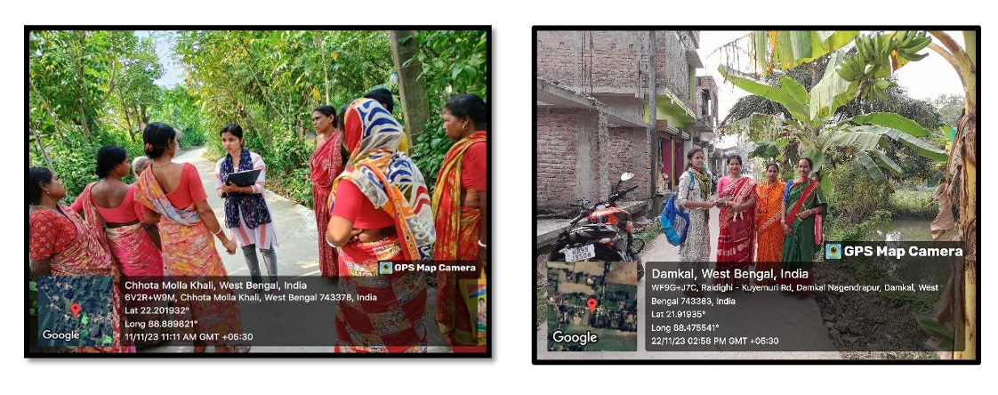
Fig 2: Interaction with the womenfolk regarding Digital Financial Service (DFS) usages in the selected blocks of Indian Sundarban, West Bengal.

The women engaged in tertiary sector activities though numerically insignificant with respect to the total sample, are more comfortable in using the digital medium – 63% of the business-women, 64% of the service-holders are digital financial service users. Besides, girls and women from student community are also coming forward in using digital transactions (44%). Since they have to handle their own banking activities, involvement in banking and use of digital banking facilities has been observed relatively high among them. Besides, from the field study, it was found that most of the female non-digital users, especially students and working ones realised that digital banking will play a positive role in their professional development and were aware that these services will reduce workloads by saving time and increasing work speed; in turn improving their standard of living by increasing self-confidence. All these indicate that the usage of DFS by women will increase in near future.
5.2 Nuances of Female Customer Satisfaction Regarding Digital Banking
The study identifies that the dominant barriers of not using digital banking services are lack of knowledge about the services, digital security issues and inertia about taking up something new. As psychology played an important role in adoption of digital banking services, to include womenfolk in its fold the understandability regarding the perceived usability. The close correlation between behavioural intention and performance expectancy suggests that people of three regions will adopt mobile banking once they see its benefits. In this regard, governments, banks, financial institutions, and corporate entities ought to collaborate in order to highlight the benefits of digital banking and pique the curiosity of the low-income and low-literate demographic.
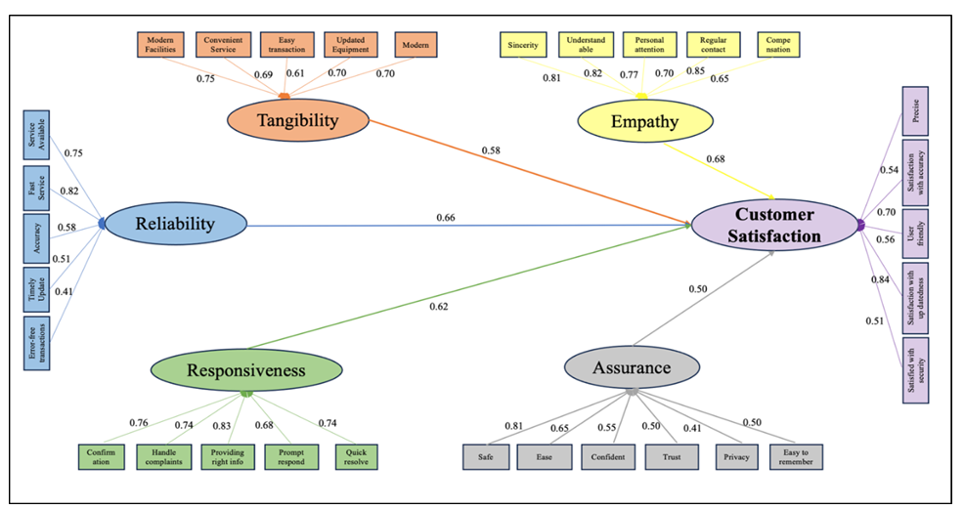
Fig 3: Structural Equation Modelling with path coefficients and coefficients of determinations from AMOS output indicating women customer satisfaction regarding digital banking in the selected blocks of Indian Sundarban, West Bengal. Source: Primary Survey, 2023-24

Principal Component Analysis has been used to derive the level of satisfaction of the women customers about digital banking. The structural equation model suggests that in rural base, most of the customers are newly-experienced in digital banking, and therefore, banking sectors usually extend their sincere interest to the customers whenever they face any banking related problem. So, the key points of concern are – empathy, responsiveness, reliability and customer satisfaction; if these can be ensured then the policy will be a success. On the other hand, the main factors behind the barriers of using digital banking services are lack of knowledge about the servicers, inertia, perceived risk and inaccessibility.
The model (Fig 3) suggests that ‘Empathy’ carries the strongest effect (0.68) on ‘Customer satisfaction’. All other path relations are significant statistically. The fact is that in rural base, most of the customers are newly-experienced in digital banking, and therefore, banking sectors usually extend their sincere interest to the customers whenever they face any banking related problem. Banks must demonstrate their legitimacy and win clients' trust by providing expert services, having superior technical expertise, acting politely, and having effective communication skills. They must also have compassion for their customers (Kaur et al., 2021). The loadings of the factor ‘Empathy’ also depict the same. Other factors of ‘Reliability’ (0.66) and ‘Responsiveness’ (0.62) also exert stronger effect on ‘Customer Satisfaction’. In the modern digital era, digitally friendly services are valued highly, but not as highly as "Reliability." However, the importance of "Responsiveness" demonstrates that customers value prompt problem-solving, efficient handling of customer complaints, and a readiness to assist and satisfy customers.
5.3 SWOC Analysis
The rationale behind a SWOC (Strength-Weakness Opportunities-Challenge) analysis is to maximise opportunities and strengths while minimising challenges and weaknesses in implementing digitalization in banking sector and especially involving women in this drive with reference to Indian Sundarban of West Bengal (Fig 4).
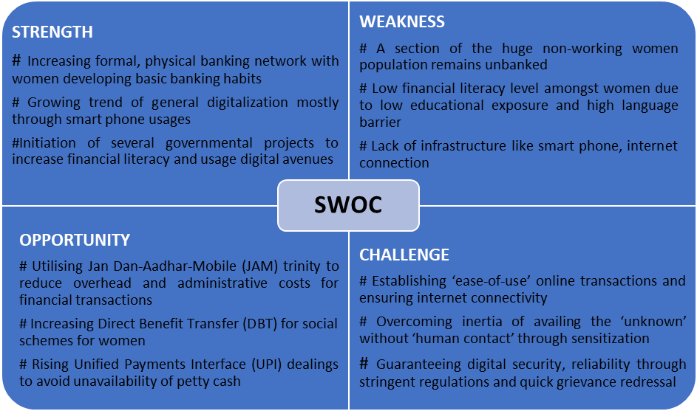
Fig 4: SWOC Analysis regarding Digital Financial Services (DFS) usages by women in the selected blocks of Indian Sundarban, West Bengal. Source: Primary Survey, 2023-24

6. Conclusion
The flagship program of Digital India has the potential to empower the Indian society to become a knowledge economy. Pandemics have forced many to take digital avenue and in rural areas where physical banking was a unanimous choice there was a gradual transition to ‘phygital’ (physical and digital blended). In the context of present study, it can be said that effective use digital payment system has helped in smoothening financial transactions but has long way to go to achieve the relevance targeted by the Government of India, especially taking the womenfolk within its ambit.
From the grassroot level scenario, relevance of availing the digital payments avenue is not clear to the majority of the population as their economic activity is limited, business aspirations are restricted and educational exposure too is constrained. As most of the women in this backward area are not economically active the factors like professional benefit, livelihood development, income enhancement are not considerable factors; the section of women involved in Self Help Groups treat digital transactions as a tool to encourage micro-finance and empowerment. Both the private and public sector banks are to level-up their operations in the rural areas exposing the locals more to digital avenues and the rural banks should break their moulds of only traditional, physical mode leading to capacity building.
Policy and strategy implementation are the need of the hour for reducing gap between the idea and the experienced reality that is between the digital banking facility and the people’s involvement in digital banking.

7. RECOMMENDATIONS
To address the barriers and promote financial inclusivity for women in the Indian Sundarban the paths that can be treaded are – deploying ‘Digital Sakhi’ model where local women through Self-Help Groups (SHGs) will act as trainers for addressing the digital trust issues among the women consumers, educating them about Aadhaar Enabled Payment System (AePS) and other UPI gateways. Incentivizing Financial Service Providers (FSPs) to set up AePS points recruiting women as ‘Bank Mitras’ for overcoming the challenge of physical access to banks.
The government in partnership with banks and/or mobile companies may roll out schemes to provide subsidized smartphones/low-cost tablets to enrolled women who are need of such assistance. As connectivity is the base for DFS Department of Telecom can treat Sundarban as a special priority zone for 4G/5G tower installation and push for fibre-optic too. Installing solar-powered community charging and Wi-Fi kiosks in cyclone shelters or common village areas will ensure network access even during power outages. Besides, natural resource-based livelihood training may be imparted to the womenfolk from Sundarban as it will help them to generate dispensable income and in turn more interest in banking sector and digital banking.

Consent

Not required.

Ethical approval (where ever applicable)

Not applicable.

Disclaimer (Artificial intelligence)

We, the author(s) do hereby declare that NO generative AI technologies such as Large Language Models (ChatGPT, COPILOT, etc.) and text-to-image generators have been used during the writing or editing of this manuscript.

References

Draboo, S. (2020). A commentary on affirmative action policies for women in India in the Backdrop of International Commitments. MIER Journal of Educational Studies Trends and Practices, 15-29.
Sharma, S., Sharma, R., Kayal, G., & Kaur, J. (2022). Digital banking: A meta-analysis approach. Indian Journal of Marketing, 52(5), 41-68.
GoI – Government of India (2023). Digital payments se pragati ko gati – A compendium on india’s digital payments journey. Ministry of Electronics and Information Technology.
Mohapatra, M. R., Moirangthem, N. S., & Vishwakarma, P. (2020). Mobile banking adoption among rural consumers: Evidence from India. American Business Review, 23(2), 6.
Demirguc-Kunt, A., Klapper, L., Singer, D., & Ansar, S. (2018). The Global Findex Database 2017: Measuring financial inclusion and the fintech revolution. World Bank Publications.
Qazi, M. (2019). The truth about India’s financial inclusion, The Banking and Finance. Retrieved from https://bfsi.eletsonline.com/the-truth-about-indias-financial-inclusion/ on 7.11.2023
Chinnasamy, G., Vinoth, S., & Jain, A. (2024). Revolutionizing finance: a comprehensive analysis of digital banking adoption and impact. International Journal of System Assurance Engineering and Management, 1-12.
GoWB (Government of West Bengal) (2019). District Human Development Report South 24 Parganas. Development and Planning Department, Government of West Bengal.
Danda, A. A., Sriskanthan, G., Ghosh, A., Bandyopadhyay, J., & Hazra, S. (2011). Indian Sundarban delta: a vision. World Wide Fund for Nature-India, New Delhi, 40.
Rangarajan, C. (2008). Report of the committee on financial inclusion. Ministry of Finance, Government of India.
Porteous, D. (2006). The enabling environment for mobile banking in Africa. DFID, Boston.
Census of India (2011). Rural urban distribution of population, provisional population total. Office of the Registrar General and Census Commissioner, India, New Delhi.
Fathima, J. S. (2020). Challenge management of banking services-with special reference to virtual banking service challenges. Shanlax International Journal of Management, 7(3), 57–66.
Pikkarainen, T., Pikkarainen, K., Karjaluoto, H., & Pahnila, S. (2004). Consumer acceptance of online banking: an extension of the technology acceptance model. Internet research, 14(3), 224-235.
Sha, N., & Mohammed, S. (2017). Virtual banking and online business. Banks and Bank Systems, 12(1), 75−81.
Shih, Y. Y., & Fang, K. (2004). The use of a decomposed theory of planned behavior to study Internet banking in Taiwan. Internet research, 14(3), 213-223.
Duggal, H., & Kumar, S. (2024). E-Banking In India: Growth, Challenges and Future Prospects. Digital Economy of India, 49.
Singh, R., Malik, G., (2019). Impact of Digitalization on Indian Rural Banking Customer: With Reference to Payment Systems. Emerging Economy Studies, 5(1), 31–41.

