WELFARE POLICIES AND EMPLOYEE PERFORMANCE: EVIDENCE FROM KENYA UNIVERSITIES AND COLLEGES CENTRAL PLACEMENT SERVICE

ABSTRACT
This study examined the influence of welfare policies on employee performance within the Kenya Universities and Colleges Central Placement Service. Guided by Maslow’s hierarchy of needs, the research explored how health insurance coverage, retirement planning support, and educational assistance programs affect employee engagement, customer satisfaction, timeliness, efficiency, and quality of work. A descriptive design was employed, targeting all 69 Kenya Universities and Colleges Central Placement Service employees through a census approach, with a high response rate of 88.7%. Data were collected using semi-structured questionnaires and analyzed using descriptive and inferential statistics in SPSS version 25. Findings revealed that welfare policies significantly enhance employee performance by improving professional growth, motivation, recognition, and stress management. This was supported by a mean of 3.833 and standard deviation of 0.491. Respondents particularly emphasized the value of training opportunities, career development, recognition programs, and financial incentives in motivating performance. The study concludes that welfare policies are not mere administrative functions but strategic tools that drive productivity, job satisfaction, and organizational efficiency. For the scientific community, this study makes an important contribution by empirically demonstrating the strategic role of welfare policies in enhancing employee performance within a public institution. Further, the study provides a theoretical and practical lens for understanding how welfare provisions such as health insurance, training, recognition and financial incentives directly influence employee motivation, engagement and efficiency.
Key Words: Welfare; Policies; Employee; Performance; Productivity; Satisfaction

INTRODUCTION
Background
Employee welfare policies represent structured initiatives aimed at improving workers’ well-being, safety, and quality of life within organizations. They extend beyond basic pay to include health and safety provisions, medical benefits, housing schemes, work–life balance initiatives, recreational facilities, and retirement plans. Historically, such policies emerged as responses to industrial disputes and poor working conditions, evolving into formalized structures entrenched in organizational practice and labor legislation (Allen et al., 2018; Armstrong & Taylor, 2020; Maimunah, 2018). Their implementation demonstrates an employer’s commitment to employee well-being while also fostering satisfaction, retention, and productivity.
The influence of welfare policies on employee performance has increasingly become a focal point of organizational research. Evidence shows that comprehensive welfare programs reduce absenteeism, accidents, and turnover, while boosting motivation and efficiency (Sarma, 2011). Provisions such as flexible work arrangements and medical insurance enhance employees’ sense of security and loyalty, leading to greater focus and productivity. On the contrary, inadequate or poorly executed welfare measures may trigger dissatisfaction, low morale, and poor performance, ultimately jeopardizing organizational objectives (Ahmad et.al 2019; Sarma, 2011).
In contemporary workplaces, welfare policies are no longer perceived as cost centers but as strategic investments in human capital. Well-designed programs strengthen employer–employee relations, build trust, and nurture a positive workplace culture that fosters high performance (Dessler, 2020). Studies emphasize that employee confidence in organizational care and recognition directly influences their organizational commitment, responsibility, and innovative contributions (Serena, Muhammad, & Emran, 2019). Thus, aligning welfare policies with employee needs enhances not only performance but also organizational sustainability and competitiveness.
Employee performance, in turn, remains vital to achieving organizational goals. Effective performance requires systematic processes such as feedback mechanisms, performance evaluations, and skill development to maintain competitiveness and productivity (Obiageli, Uzochukwu, & Ngozi, 2018). Moreover, modern scholarship highlights that performance should not be measured solely through output and productivity but also through multi-dimensional indicators like creativity, adaptability, organizational citizenship behavior, and job satisfaction (Robbins & Judge, 2018; Brown & Johnson, 2024). Hence, conceptualizing employee performance requires both quantitative and qualitative assessments, including customer satisfaction, innovation, and teamwork (Armstrong, 2020).
In Kenya, the Kenya Universities and Colleges Central Placement Service (KUCCPS) is mandated with placing government-sponsored students in universities and colleges (KUCCPS, 2022). Although the institution has instituted some welfare programs, gaps remain in their full operationalization, raising concerns about staff motivation and efficiency. Limited evidence of effective welfare frameworks threatens employee satisfaction and overall institutional performance, especially during peak placement cycles. This gap underscores the necessity of examining the relationship between welfare policies and employee performance at KUCCPS, as doing so can provide empirical insights to guide policy enhancement and ensure organizational success.
LITERATURE REVIEW
Research on employee welfare and work-life balance has increasingly focused on their influence on employee performance. Wanja (2024) examined the relationship between employee Welfare programmes and performance of deposit taking savings and credit cooperative societies in Embu County, Kenya. Using a self-developed questionnaire with both open and closed-ended items, the study found a strong relationship between pay and job productivity. However, the study lacked a sufficient theoretical foundation to fully interpret the findings. This gap highlights the need for further research that grounds the analysis of welfare programs in established theoretical frameworks, such as Maslow’s hierarchy of needs, which posits that employees’ performance improves as their basic and higher-order needs are progressively satisfied (Maslow, 1943). According to Guest (2017), human resource management (HRM) practices should more explicitly consider employee well-being as a distinct goal alongside performance. He highlighted that there has been a historical overemphasis on performance and called for a broader understanding of HRM practices that incorporate aspects like extensive two-way communication, trust, and support to enhance both employee welfare and overall performance.
Similarly, Keitany (2014) analyzed employee welfare policies at Kenya Pipeline Company (KPC) and reported that the organization provided a wide range of welfare benefits, including pensions, maternity and sick leave, cafeteria services, commuter subsidies, car loans, safety gear, health collaborations, fitness facilities, and sports opportunities. These provisions align with multiple levels of Maslow’s needs framework, ranging from physiological (cafeteria, commuter subsidies) and safety (safety gear, medical insurance) to social and esteem needs (sports teams, fitness programs). Although Keitany’s findings demonstrate the breadth of welfare measures organizations can adopt, the study did not explore the extent to which these policies translated into measurable improvements in employee performance. The present study seeks to build on this by specifically examining the link between employee welfare provisions and performance outcomes at KUCCPS.
Agusioma, Nyakwara, and Mwiti (2019) employed a descriptive survey design to investigate the effect of employee well-being on productivity. Their analysis, using correlation and regression methods, revealed a significant positive relationship between welfare policies and job performance. By showing how welfare practices enhance employee outcomes in public institutions, this study provides empirical evidence supporting Maslow’s proposition that meeting employees’ needs increases motivation and efficiency (Maslow, 1943). However, its general focus on public service means that the findings may not directly capture the unique challenges of specialized government agencies such as KUCCPS, which operate under strict deadlines and workload cycles tied to university placements.
Muruu (2016) conducted a study to established the effects of compensation programmes and safety and health programmes on employee’s satisfaction in public sector. The study found that workers compensation programmes and safety and health programmes affected employee satisfaction in public sector. While the study yielded insights into the application of welfare programs, it lacked a strong theoretical grounding and did not fully address how welfare translates into improved employee performance. Likewise, Brown and Johnson (2023), in a quantitative survey of 623 employees, found that welfare policies such as training and development, organizational culture, and leadership styles positively influenced satisfaction and retention. Despite these contributions, both studies faced methodological weaknesses, particularly in data design and analysis, which limits the generalizability of their conclusions.
Taken together, these studies underscore the importance of linking welfare policies to performance outcomes using a solid theoretical lens. Maslow’s hierarchy of needs provides a useful framework, as it explains how organizations can systematically address employees’ physiological, safety, social, esteem, and self-actualization needs to enhance motivation, satisfaction, and performance (Maslow, 1943). By applying this framework, the current study seeks to fill both the empirical and theoretical gaps evident in prior research by investigating how welfare policies and work-life balance practices influence employee performance within KUCCPS. This approach not only contextualizes welfare in the public sector but also ensures that findings contribute to organizational behavior and human resource management theory. For the scientific community, this paper makes an important contribution by empirically demonstrating the strategic role of welfare policies in enhancing employee performance within a public institution. By integrating Maslow’s hierarchy of needs with organizational practice, the study provides a theoretical and practical lens for understanding how welfare provisions such as health insurance, training, recognition and financial incentives directly influence employee motivation, engagement and efficiency. In their research dealing with the relationship between HRM, employee well-being, and individual/organizational performance (HRM-WB-IOP research), Peccei and Van De Voorde (2019) found that mutual gains conceptualizations play a dominant role in extant HRM-WB-IOP research, at the expense of alternative conflicting outcomes and mutual losses models, which are also shown to receive very limited empirical support across 46 studies. Sharma et.al (2024) carried out a survey study on Human Resources Practices in Higher Education Institutes (HEIs) in India. The survey findings underscored importance of balancing employees' professional and personal lives for optimal productivity and well-being. Leading HEIs in India prioritize programs that promote this balance resulting in high employee satisfaction and retention rates.
Based on the relevant literature reviewed, the resultant conceptual framework illustrates the relationship between welfare policies and employee performance. Welfare policies, represented as the independent variable (IV), include health insurance coverage, retirement planning support, and educational assistance programs. These policies are expected to positively influence employee performance, the dependent variable (DV), which is measured through employee engagement, customer satisfaction, timeliness and efficiency, and quality of work. The framework assumes that by addressing employees’ welfare needs, organizations enhance motivation, satisfaction, and commitment, ultimately leading to improved organizational performance outcomes.
Welfare Policies (IV)
- Health Insurance Coverage
- Retirement Planning support
- Educational Assistance programs
Employee performance (DV)
- Employee engagement
- Customer satisfaction
- Timeliness and Efficiency
- Quality of Work

Chart 1- The framework assumes an independent variable (IV) and a dependent variable (DV) to improve organisational performance outcomes
MATERIALS AND METHODS

Research Design
This study used a descriptive design. This approach defines the data and characteristics relevant to the population under study, making it ideal for the study. Additionally, this design tackles important research inquiries regarding who, what, where, when, and how (Mugenda & Mugenda, 2024).

Target population
The study targeted all employees at KUCCPS. According to institution’s HR (2023), there are 69 employees in the organization. All employees were part of the study as it aims to examine how WLB on the entire workforce. By targeting the entire population, it ensures that the research findings are representative of the entire workforce.
Sample Size and Sampling Technique
Because the population was small, census sampling approach was employees. According to Ngechu (2018), an appropriate sampling technique for a small sample size is census because it allows representation of the population.
Data Collection and Analysis
In this study, a semi-structured questionnaire was used as the main data collection tool. A questionnaire, according to Chandra (2024), is a measurement instrument that facilitates communication between the researcher and respondents in order to collect empirical data aligned with research objectives. Structured questionnaires are particularly recommended for descriptive research due to their simplicity and ease of administration (Kothari, 2024). The instrument combined both open-ended and closed-ended questions to balance quantitative rigor with qualitative depth.
Each participant in the sample received a questionnaire. The closed-ended questions provided specific data points, reducing repetitive responses and enabling clear analysis, while the open-ended questions allowed respondents to share additional insights. This dual approach captured both measurable and nuanced perspectives. Prior to data collection, approvals and permits were obtained, starting with an introductory letter from the university, followed by authorization from the National Commission for Science, Technology and Innovation (NACOSTI). This ensured compliance with ethical and legal research standards. Approval was also sought from the KUCCPS administration to access its staff for the study.
To improve the return rate of questionnaires, trained research assistants were engaged. They received orientation on ethical considerations, data handling, and the study tool, and carried official introduction letters for legitimacy. The collected quantitative data were analyzed using SPSS version 25, employing descriptive statistics such as mean, standard deviation, frequencies, and percentages, presented in tables and figures. Inferential analysis included correlation and regression, based on the following model:
Y=α₀+β₁X₁+β₂X₂+β₃X₃+e
Where employee performance (Y) was modeled against health insurance coverage (X₁), retirement planning support (X₂), and educational assistance (X₃).
RESULTS AND DISCUSSIONS

Response Rate
All 69 employees of KUCCPS were targeted. The sample used was a census method of sampling since the population is small and all employees were sampled. Prior to the actual study, 10 percent of the population (7 employees) had a pilot test done in order to verify the questionnaire. The pilot group was not involved in the number of 62 employees of the target population.

Figure.1: Questionnaire Response Rate
There was an 88.7% response rate with the total of 55 out of 62 questionnaires returned duly filled. Metsamuuronen (2024) further notes that 70 percent or above response is excellent and therefore valid for analysis and interpretation. The respondents participate actively in the study given the high response rate that implies the relevance.

Demographic Information Analysis
The respondent’s demographic characteristics were analyzed to gain insights into their profiles. The characteristics sought were presented and discussed in sub-sections below.

4.3.1 Gender of the Respondents
Gender can influence the perceptions of working and the performance of employees.

Figure 2: Gender Distribution of the Respondents
From Figure 2, 60% are male to 40% female implying that males had a little bigger representation in the organization. This gender distribution indicates representative of both the male and female workers. The balanced representation helps prove the validity of the study since gender variations in balanced work-life perceptions like the preference towards leave policies or the flexible working arrangement are properly represented. The balance is important because past research, like the one by Eagly and Carli (2007) reveals how gender can affect how workers perceive and gain access to WLB programs.

Respondents’ Age Distribution
Figure 3 shows the age composition of study respondents
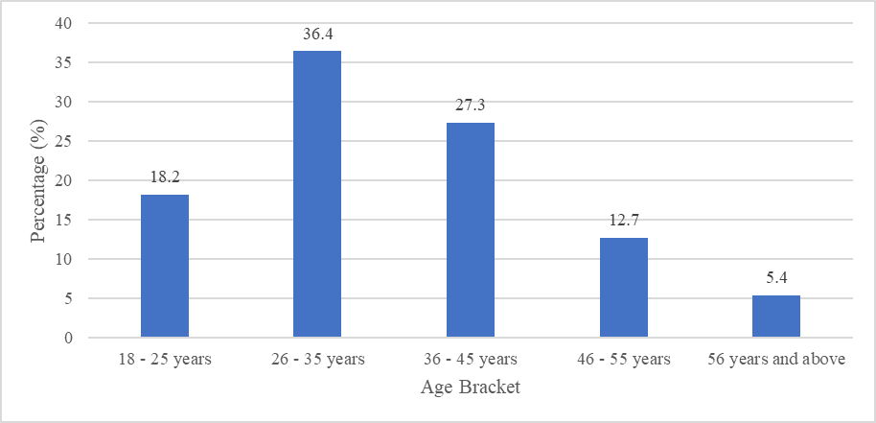
Figure 3: Age Distribution of Respondents
Figure 3 depicts that the ages ranged from 18 years to over 56 years. From the participants, 36.4% were aged between 26 and 35 years, while 27.3% fell within the 36 to 45-year age bracket. This age mix shows majority are young and middle aged implying that the work life policies should be designed to fit individuals, probably with the early to middle career requirements and other personal needs like family and education. Younger workforce can also pose increased preference to flexibility in work and wellness programs as younger workers tend to seek organizations with healthy work life balance as Twenge et al. (2010) affirm.

4.3.3 Respondents’ Educational Background
How educated the respondents were was sought and findings presented in Figure 4.

Figure 4:Educational Background of Respondents
As illustrated in Figure 4, 45.5 percent have a bachelor degree, 25.5 percent having a diploma, and 23.6 percent having a master’s degree. This education profile shows a highly education populations. The high education supports the research's conclusions that welfare policies, such as providing access to professional development and training were much valued and had a considerable effect upon the performance. Equally, based on the evidence presented by Armstrong (2024), employees holding superior educational backgrounds have increased tendencies of indulging in continuous learning opportunities initiated by employers, augmenting their job performance.

4.3.4 Respondents’ Years of Service
As shown in figure 5, tenure of respondents was presented.
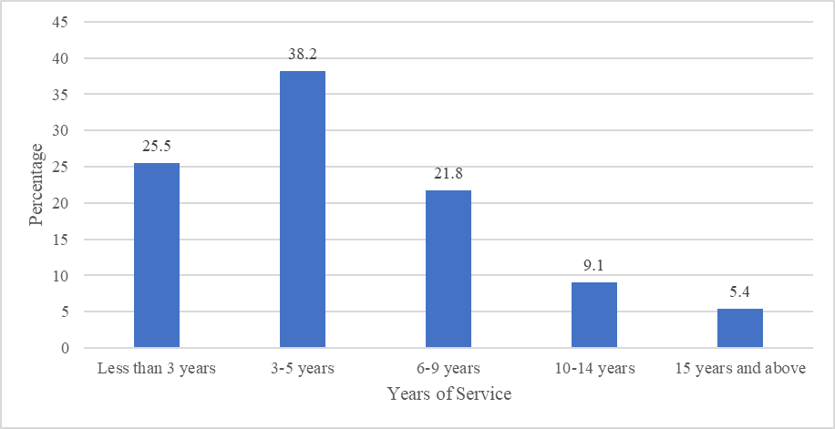
Figure 5: Respondents’ Years of Service
Figure 5 indicates that most of the respondents which were 38.2 percent years of service were 3 and 5 years, and 25.5 percent had less than 3 years of service. This means that the workforce is markedly new at the organization and therefore it is important that there are proper inductions, training and supporting systems to stimulate the job performance. The distribution of staff of different tenure also indicates that balanced occupational–personal life management measures in the company should accommodate the staff in the early and mature tenure. According to Chênevert et al. (2013) newer employees might need more formal assistance in adaptation to organizational culture, whereas the long-term employees may need to be provided an opportunity to work continuously and maintained via the engagement and wellness programming.
Descriptive Statistics Analysis for the Study Variables

Welfare Policies
The respondents indicated the degree to which they aligned themselves with various statements as far as welfare policies were concerned to address the third objective.
Table 1: Welfare Policies
Statements | Mean | Std. Dev.
The welfare measures accessed through the institution including opportunities to grow into professionals creates a positive change to the performance of employees. | 3.85 | 0.49
Welfare policies place training and development programs at the disposal of employees, which qualifies them to be skilled and more qualified to perform better in their jobs. | 3.83 | 0.50
There is a greater knowledge base and skills competency among employees that have showed the desire of pursuing higher learning or improving skills acquired through welfare policies. | 3.82 | 0.48
The welfare policies which provide financial rewards such as grants on research and innovation increased the more motivated and productive workforce. | 3.80 | 0.51
The existence of welfare policies to advance a career (mentorship programs or coaching policies) has a positive effect on the professional development and performance among the employees. | 3.82 | 0.49
Welfare policies give recognition and reward to the employees and improve involvement and commitment of the employee to his/her job, which leads to better jobs performance. | 3.85 | 0.48
Wellness programs or flexible work arrangements, are welfare policies that help to lessen stress and enhance performance. | 3.86 | 0.49
Aggregate Score | 3.833 | 0.491
Respondents generally perceive welfare policies as having a positive effect on employee performance (M=3.833, SD = 0.491). Respondents agreed that welfare policies, including opportunities for professional development, positively affect worker’s performance (M = 3.85, SD = 0.49). Access to training and development initiatives through welfare policies was viewed as a key factor in boosting employees' skills and capabilities, which subsequently improves job performance (M = 3.83, SD = 0.50). Moreover, workers who pursued further education or skill enhancement through these policies demonstrated a higher level of expertise and competence in their roles (M = 3.82, SD = 0.48).
Respondents also acknowledged that welfare policies offering financial incentives or grants for research and innovation results in inspired and industrious staff (M = 3.80, SD = 0.51). The availability of policies supporting career development, such as mentorship programs or coaching, was viewed as positively effecting employees' professional growth and performance (M = 3.82, SD = 0.49). Recognition and rewards through welfare policies were identified as key drivers of employee engagement and commitment, resulting in better job performance (M = 3.85, SD = 0.48). Additionally, welfare policies were acknowledged for their role in reducing stress and boosting performance (M = 3.86, SD = 0.49).
The aggregate score for welfare policies was 3.833, suggesting that respondents generally perceive welfare policies as beneficial to employee performance, particularly through professional development opportunities and recognition programs. This concurs with Agusioma et al. (2019), who emphasized the positive effect of welfare initiatives, like training, financial incentives, and recognition, staff engagement and competence. Similarly, Wanja (2024) highlighted a strong connection between compensation through employee performance and welfare initiatives, highlighting the significance of supportive welfare policies in enhancing job satisfaction and commitment. Collectively, these results reinforce the essential role that well-structured welfare programs play in promoting a motivated and high-performing workforce.
Participants were also invited to suggest additional ways in which welfare policies influence employee performance. Responses revealed that access to training, professional development, and financial incentives are key motivators for employees. A respondent mentioned: “The training programs offered through welfare policies help me improve my skills, which directly effects my job performance.” This view is in line with Armstrong (2014), who found that welfare policies that provide continuous learning opportunities enhance employee capabilities and job performance. Other respondents highlighted the importance of recognition and rewards through welfare programs, noting that: “Recognition makes us feel valued and motivates us to work harder.” Such feedback resonates with findings by Deci and Ryan (2022), who emphasize that recognition and reward systems significantly boost employee morale, leading to higher performance levels.

SUMMARY OF FINDINGS, CONCLUSIONS AND RECOMMENDATIONS
Summary of Findings
The study found that KUCCPS employees generally perceive welfare policies as beneficial to their performance. Welfare provisions such as training and development programs, career mentorship, wellness initiatives, and recognition schemes received high approval (aggregate mean = 3.833, SD = 0.491). Respondents confirmed that these policies enhanced skills, improved motivation, reduced stress, and increased engagement, which in turn boosted efficiency and job quality. Educational assistance programs and financial incentives were highlighted as strong motivators for productivity, while recognition and reward systems significantly improved commitment and engagement. The demographic analysis showed that KUCCPS has a relatively young and highly educated workforce, which values continuous learning and professional development. The regression analysis demonstrated a significant positive relationship between welfare policies and employee performance, confirming that well-designed welfare programs directly contribute to better organizational outcomes.
Conclusions
The study concludes that welfare policies are essential strategic investments that directly influence employee performance at KUCCPS. Health insurance coverage, retirement planning support, and educational assistance programs were found to enhance employee engagement, reduce stress, and improve efficiency. Recognition and reward mechanisms further encouraged commitment and job satisfaction, while professional development opportunities helped employees build competence and confidence in their roles. Without adequate welfare measures, the organization risks lower morale, higher turnover, and inefficiency, especially during peak placement cycles. Therefore, welfare policies should be considered as integral to organizational sustainability and competitiveness.

Recommendations
Based on the findings, the study recommends that KUCCPS strengthen its welfare policies by expanding professional development and training opportunities to match the needs of its highly educated workforce. The organization should enhance recognition and reward programs to sustain motivation and engagement, while also institutionalizing financial incentives and grants that support innovation and productivity. Wellness programs and flexible work arrangements should be prioritized to reduce stress and improve work-life balance, especially for the younger workforce that values flexibility. Furthermore, retirement planning support should be structured to ensure long-term security for employees, thereby fostering loyalty. Lastly, KUCCPS should continuously evaluate and align welfare policies with employee needs and organizational goals to maintain efficiency, improve customer satisfaction, and sustain high-quality service delivery.

Disclaimer (Artificial intelligence)
Option 1:
Author(s) hereby declare that NO generative AI technologies such as Large Language Models (ChatGPT, COPILOT, etc.) and text-to-image generators have been used during the writing or editing of this manuscript.
Option 2:
Author(s) hereby declare that generative AI technologies such as Large Language Models, etc. have been used during the writing or editing of manuscripts. This explanation will include the name, version, model, and source of the generative AI technology and as well as all input prompts provided to the generative AI technology
Details of the AI usage are given below:
1.
2.
3.

References
Agusioma, N., Nyakwara, S., & Mwiti, F. (2019). Employee well-being and productivity in public institutions. Journal of Human Resource Management, 7(2), 45–57.
Ahmad,A.,Pervaiz,K.,Fatima,S.&Ahmad,M.(2019).Employee welfare programs and organizational performance in Kenya. International Journal of Human Resource Studies, 9(2), 112–125. https://doi.org/10.5296/ijhrs.v9i2.14890
Armstrong, M., & Taylor, S. (2020). Armstrong's handbook of human resource management practice (15th ed.). Kogan Page.
Brown, T., & Johnson, R. (2023). The impact of welfare programs on employee satisfaction and retention: Evidence from the service sector. International Journal of Human Resource Studies, 9(3), 21–35. https://doi.org/10.5296/ijhrs.v9i3.15321
Dessler, G. (2020). Human resource management (16th ed.). Pearson.
Guest, D.E (2017). Human resource management and employee well-being: towards a new analytic framework.
Keitany, P. (2014). Perceived Relationship between Employee Welfare Programmes and Employee Performance at Kenya Pipeline Company.
Kenya Universities and Colleges Central Placement Service. (2017). HR policies and procedures manual; Code of conduct. KUCCPS. https://www.kuccps.net
Maimunah, A. M. (2018). Human resource management: Principles and practices. Oxford University Press.
Maslow, A. H. (1943). A theory of human motivation. Psychological Review, 50(4), 370–396. https://doi.org/10.1037/h0054346
Munywoki, G. M. (2019). The influence of perceived employee welfare programs on employee job satisfaction at Kenya Railways Corporation (Unpublished master’s thesis). University of Nairobi Repository.
Muruu,R.W. (2016). Effects of Welfare Programmes on Employee Satisfaction in the Public Sector: A Case of the Public Service Commission
Nielsen, K., Nielsen, M. B., Ogbonnaya, C., Känsälä, M., Saari, E., & Isaksson, K. (2017). Workplace resources to improve both employee well‐being and performance: A systematic review and meta‐analysis. Work & Stress, 31(2), 101–120. https://doi.org/10.1080/02678373.2017.1304463
Peccei, R, & Van De Voorde, K. (2019). Human resource management–well-being–performance research revisited: Past, present, and future.
Sarma, A. M. (2011). Aspects of labour welfare and social security. Himalaya Publishing House.
Sharma. A, Sabale. N, Gill. K, Jaiswal. V, &Thakur. A (2024). Human Resources Practices in Higher Education Institutes in India.
Wanja, W. (2024). Employee Welfare Programmes and Performance of Deposittaking Savings and Credit Cooperative Societies in Embu County, Kenya. Kenyatta University Repository.

