Original Research Article

E-Banking Trends in India's Retail Banking: Impact of Demonetization on Consumer Behavior

ABSTRACT

Demonetization, announced in India on November 8, 2016, marked a turning point for the country’s financial ecosystem, significantly influencing consumer behavior in retail banking. This paper examines the evolving E-Banking trends in India's retail banking sector, emphasizing the impact of demonetization on consumer adoption of digital financial services. The withdrawal of high-denomination currency notes disrupted cash-dependent transactions, compelling consumers and businesses to pivot towards electronic banking channels, including internet banking, mobile banking apps, and Unified Payments Interface (UPI) platforms.
The study highlights key shifts in consumer preferences, such as the increased reliance on cashless payment systems, enhanced use of mobile wallets, and greater acceptance of online banking solutions for routine financial transactions. It also delves into the demographic variations in adoption, with urban users leading the digital transition and rural consumers progressively embracing E-Banking due to government-led initiatives and financial literacy campaigns.
Using secondary data from government reports, industry surveys, and banking publications, the study highlights key shifts in consumer preferences, including increased use of cashless payments and mobile wallets. It also explores demographic differences, with urban consumers leading adoption while rural users gradually embrace digital banking through government initiatives and financial literacy campaigns.
Additionally, the paper explores the challenges faced by consumers during this transition, including cybersecurity concerns, digital literacy gaps, and infrastructure limitations. It evaluates how these barriers were addressed through technological innovations, regulatory support, and the expansion of E-Banking services.
The findings reveal that demonetization acted as a catalyst for the digital transformation of retail banking in India, fostering a shift in consumer behavior towards a more technology-driven and cashless economy. This transformation has laid a robust foundation for the future growth of E-Banking services.

Keywords: Demonetization, India's Retail Banking Sector, Digital Transformation and Consumer Behavior.

1. INTRODUCTION
The advent of digital technologies has significantly transformed the banking sector, with E-Banking emerging as a cornerstone of modern financial services. E-Banking, encompassing services like internet banking, mobile banking, and Unified Payments Interface (UPI), has revolutionized how consumers access and interact with financial institutions. In India, the retail banking landscape experienced an unprecedented shift during and after the demonetization drive in November 2016, a policy that invalidated ₹500 and ₹1,000 currency notes. This bold move, aimed at combating black money, counterfeit currency, and tax evasion, had far-reaching implications on consumer behavior, particularly in their adoption of E-Banking services.
Before demonetization, cash was the predominant medium of transactions in India, with digital banking playing a supplementary role. However, the sudden scarcity of cash Post-Demonetization created a pressing need for alternative payment methods, forcing consumers to adapt to digital platforms. The government’s push for a “less-cash” economy, coupled with the rapid expansion of internet and smartphone penetration, acted as a catalyst for E-Banking adoption. Digital payment systems like UPI, mobile wallets, and online banking applications witnessed exponential growth as consumers embraced cashless transactions. This shift marked a significant departure from traditional banking practices, reshaping consumer preferences and behaviors.
Demonetization also brought to light various barriers to E-Banking adoption, such as digital literacy, trust in digital systems, and internet accessibility, particularly in rural and semi-urban areas. Nonetheless, financial institutions leveraged the opportunity to expand their digital footprints by introducing user-friendly interfaces, secure payment systems, and incentives for digital transactions. These efforts, combined with government initiatives such as the promotion of Digital India and the introduction of platforms like BHIM and Aadhaar-linked payment systems, played a pivotal role in driving E-Banking penetration across diverse demographics.
The transformation in consumer behavior following demonetization is a testament to the growing acceptance of E-Banking in India’s retail banking sector. Consumers increasingly value the convenience, speed, and transparency offered by digital banking services. However, the transition has also raised critical questions about data security, digital inclusivity, and the preparedness of the financial ecosystem to meet the rising demand for E-Banking services.
This article explores the evolving trends in E-Banking within India’s retail banking sector, focusing on how demonetization served as a turning point in influencing consumer behavior. It delves into the challenges and opportunities that emerged during this period, providing a nuanced understanding of the long-term implications of this policy on the digital banking landscape.
2. Review of Literature:
The review of literature has been done for the knowledge and better understanding of E-Banking Trends in India's Retail Banking. The scope of this study is to review the current scenario of E-Banking Trends in India's Retail Banking and its Impact of Demonetization on Consumer Behavior which will help to analyze all aspects.
Kumar, P., & Chaubey, D. S. (2017), Demonetization played a crucial role in transforming the buying behavior of Indian society by accelerating the adoption of digital payment systems. It significantly curbed the circulation of black money and enabled the government to track financial transactions more effectively. Prior to demonetization, many people were hesitant to shift from traditional cash-based transactions to digital modes due to a lack of awareness, trust, or familiarity. However, the sudden cash crunch left citizens with limited options, compelling them to adopt digital payment methods. As a result, the habit of using digital payments gradually became more widespread and accepted across different segments of society. This study highlights the remarkable shift in consumer behavior post-demonetization, analyzing the usability, accessibility, and growing preference for digital payments in India. It also explores how public perception of digital transactions has evolved, deeply influencing the cultural and economic fabric of the nation.
Ahmad, M. (2018), The adoption of new technologies has been a topic of discussion since the 1970s. Over time, numerous theories and models have been developed to better understand the factors influencing consumer acceptance of technology. Among these, the Technology Acceptance Model (TAM) has emerged as one of the most widely used frameworks. This research article aims to emphasize the importance of TAM in understanding the adoption and use of systems, particularly in the context of Internet banking and mobile banking. By offering a detailed review of existing literature, the study explores the model's evolution, its various extensions, and its limitations. The findings of this paper contribute to the academic discourse and will serve as a valuable resource for future researchers examining digital banking services through the lens of TAM.
Sharma, S., Anamika, A., Anuradha, & Kapoor, S. (2024), This paper examines the ongoing shift in India from traditional cash-based transactions to digital payment methods, particularly digital wallets. While digital payments—especially through systems like the Unified Payments Interface (UPI)—are increasingly being adopted, cash still dominates many offline transactions. UPI, introduced by the National Payments Corporation of India (NPCI) in 2016, has gained significant traction through its integration with major banks. According to consumer survey data from Statista, Point-of-Sale (POS) cash usage dropped by 13 percentage points between 2018 and 2024, and Cash on Delivery (COD) for online shopping fell by 16 percentage points. Despite these trends, a large segment of the population continues to use cash, primarily for precautionary reasons and as a store of value. The study explores how consumer payment behavior has evolved, the economic effects of digitalization, and the role of the COVID-19 pandemic in speeding up the shift to digital payments. It also investigates the optimal balance between cash and mobile payments and assesses their broader impact on economic development. The research relies on a combination of literature review and survey-based descriptive methods
Jafri, J. A., Mohd Amin, S. I., Abdul Rahman, A., & Mohd Nor, S. (2024). The rapid growth of Fintech has increased concerns about cybercrime, highlighting the importance of trust and security in banking. While previous studies on Fintech adoption have mainly focused on technological benefits, few have examined the cognitive resistance that arises from trust and security issues. This review systematically analyses existing literature on behavioural intentions related to Fintech adoption in banking, with a particular focus on trust, security, and related factors. Using the ROSES (Reporting standards for Systematic Evidence Syntheses) framework, the study reviews 26 articles from Scopus and Web of Science published between 2009 and 2022. Thematic analysis identifies five main themes—UTAUT2 variables, risk, trust, quality, and other factors—further divided into 24 sub-themes. Key predictors influencing Fintech adoption include performance expectancy, trust, security, perceived usefulness, and attitude. Additionally, the review highlights gaps in current research and provides recommendations for future studies based on the TCCM (Theory, Context, Constructs, and Method) framework. The findings offer valuable insights for Fintech companies and regulators to design services that improve adoption in the banking sector.
Vani, Z., & Kumari, A. (2025), This paper explores the current state of financial inclusion in rural India using secondary data. It evaluates all four components outlined in the Reserve Bank of India’s definition of financial inclusion: bank deposits, credit, digital and other forms of payments, and insurance services. Financial inclusion in this context is not limited to access but also includes the affordability and actual use of financial services.While access to bank deposit accounts in rural areas has grown significantly—nearing universal coverage—the active use of these accounts for transactions like withdrawals and payments remains relatively low. Credit continues to be the weakest aspect of rural financial inclusion. Credit services are still not widely available to the economically weaker sections and in geographically under-served areas.
Although banks have expanded into less developed regions, particularly in eastern and central India, their focus has primarily been on collecting deposits rather than offering credit. For poorer rural households, obtaining affordable credit is still a challenge, as they often rely on microfinance institutions and self-help groups instead of formal banks. Insurance access is also limited in rural areas. In 2019, insurance penetration in India was just 3.8% of income, and even lower in rural areas at 1.7%. Although it increased slightly to 4% in 2023, it declined again to 3.7% in 2024, showing limited progress in insurance adoption among rural populations.
Gokula Priya, M., & Shalini, P. (2025). This research paper provides a comparative analysis of how digital payment systems are adopted in urban versus rural areas. The study, based on structured questionnaires and detailed data analysis, highlights that digital payments are more commonly used and accepted in urban regions than in rural ones. Key obstacles in rural areas include poor digital infrastructure, limited internet access, low levels of digital literacy, and a general lack of trust in digital systems. Despite the growing acceptance of digital payments and their recognized benefits such as convenience and efficiency, many users—especially in rural areas—still face challenges like connectivity issues, technical problems, and transaction failures. As a result, cash continues to be seen as a more dependable mode of payment. The study underscores the need for targeted efforts to enhance digital infrastructure, raise public awareness, and provide technical support in order to foster a more inclusive digital financial ecosystem and support broader economic development.
3. Objectives:
- To analyze the key E-Banking trends that emerged in India's retail banking sector following demonetization and their influence on consumer banking preferences and practices.
- To examine the changes in consumer behavior, including adoption rates, transaction patterns, and trust levels, in response to E-Banking services post-demonetization.
4. Methodology

This study employs a mixed-methods approach to analyze the transformation in consumer behavior toward E-Banking following demonetization.
To better understand how demonetization influenced the growth of E-Banking in India’s retail banking sector, this study followed a mixed-methods approach, combining both numbers and narratives. The aim was not just to track the rise in digital transactions but to also explore how and why people shifted their banking behavior during and after this major policy change.

4.1 Research Approach
This research is both descriptive and exploratory in nature. It describes key trends in digital banking and explores consumer behavior patterns that emerged in the years following demonetization. The focus was on uncovering meaningful insights into how different segments of the population — from tech-savvy urban users to first-time rural users — responded to the shift from cash to digital.

4.2 Data Collection
The study relied mainly on secondary data from credible, publicly available sources. These included:
- Reserve Bank of India (RBI) reports and bulletins
- National Payments Corporation of India (NPCI) data
- Press Information Bureau (PIB) updates
- Government schemes like Digital India and PMJDY
- Peer-reviewed journal articles and survey-based studies
These sources provided rich information on digital transaction volumes, UPI usage, mobile banking trends, and rural financial inclusion.

4.3 Scope and Sample
The research looked at data from 2016 to 2025, a period that captures both the immediate effects of demonetization and the long-term shift toward digital banking. The study focused on three broad groups:
- Urban consumers, who were early adopters of E-Banking platforms.
- Rural and semi-urban users, who started using digital services largely due to necessity and awareness campaigns.
- Retail banks, which had to adapt their services and strategies to meet the sudden demand for digital solutions.

4.4 Data Analysis
The data was analyzed using trend comparison methods. Key indicators such as UPI transaction volumes, mobile banking usage, and the percentage of digital vs. cash transactions were tracked across the years. This helped illustrate how fast — and how deeply — digital banking took root in different parts of the country.
In addition to numbers, qualitative insights were gathered from published surveys, user studies, and case-based observations. These provided a more personal perspective on how people felt about digital banking, what challenges they faced, and what motivated them to make the switch.

5. A Brief Profile on E-Banking Trends in India's Retail Banking: Impact of Demonetization on Consumer Behavior

The demonetization initiative in India, announced in November 2016, aimed to combat black money, counterfeit currency, and corruption. While its immediate effects were felt across various sectors, one of the most significant transformations occurred in the financial sector, particularly in retail banking. The forced withdrawal of high-denomination currency notes led to an accelerated shift toward digital banking. This article explores how the demonetization period impacted consumer behavior and shaped E-Banking trends in India's retail banking sector.

5.1 E-Banking Adoption Before and After Demonetization
Pre-demonetization, digital banking was growing but remained limited in its adoption, primarily in urban areas. The advent of demonetization, however, provided a catalyst that pushed millions of consumers towards adopting digital banking. The shift was not only driven by necessity but also by the convenience and safety that E-Banking provided during a cash crunch.
Table 1: Comparison of E-Banking Metrics Before and After Demonetization
Metric | Pre-Demonetization (2015–2016) | Post-Demonetization (2017–2025)
Number of Digital Transactions (in billions) | 5.3 | 185.8 % (FY 2025
UPI Transactions (in billions) | 0.02 | 185.8% (FY 2025)
Mobile Banking Users (in millions) | 110 | 200%+ (FY 2025)
Internet Banking Transactions (in billions) | 3.2 | 15.4 % (FY 2025)
ATM Withdrawals (in billions) | 30 | 18 % (FY 2025)
Percentage of Digital Transactions to Total Transactions | 22% | 60% (FY 2025)

- Unified Payments Interface (UPI): Launched in 2016, UPI has become the cornerstone of India's digital payment ecosystem. By FY 2025, UPI processed over 185 billion transactions, accounting for approximately 70% of total digital payments.
- Mobile Banking Users: The number of mobile banking users has seen a significant increase, reaching over 200 million by FY 2025, reflecting the growing adoption of smartphones and mobile internet.
- Internet Banking Transactions: Transactions through internet banking platforms have also risen, with over 15 billion transactions recorded in FY 2025.
- ATM Withdrawals: Despite the surge in digital payments, ATM withdrawals have remained significant, with 18 billion transactions in FY 2025, indicating continued reliance on cash for certain transactions.
- Digital Transaction Share: The share of digital transactions in total transactions has increased to 60% by FY 2025, up from 22% in 2015–2016, showcasing the success of initiatives promoting digital payments.
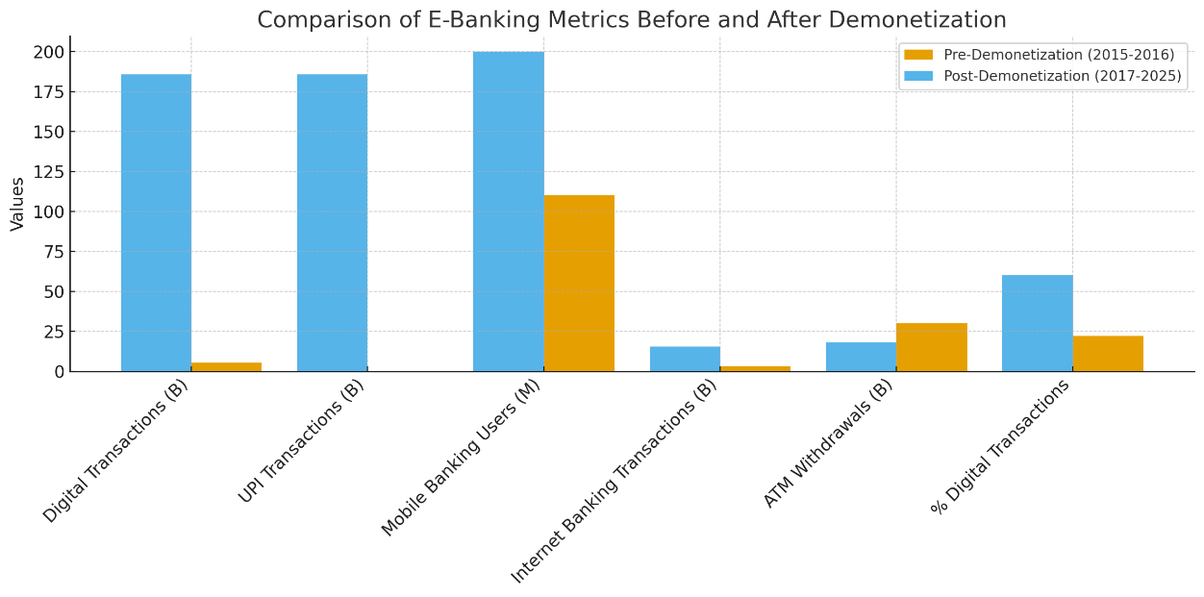
Fig. 1. E-Banking Metrics before and after Demonetizaion
Source: PIB (Press Information Bureau)

5.2 Impact on Consumer Behavior

1. Increased Adoption of Mobile Payments
Atwal, H., & Kaur, P. (2025), Post-demonetization, there was a sharp rise in mobile payment apps like Paytm, Google Pay, and PhonePe. These apps became crucial in enabling daily transactions, as cash was in short supply. UPI, which had been introduced just a few months earlier, became a primary mode of payment, as it was simple to use and quick
2. Rise in Internet Banking Usage
With the closure of many bank branches and ATM shortages, more consumers turned to internet banking for their financial needs. Activities such as bill payments, transfers, and even purchasing goods online were increasingly conducted through digital platforms.

3. Change in Consumer Trust
There was initially some resistance from older generations and less tech-savvy individuals towards digital banking. However, the urgency of demonetization coupled with government initiatives such as promoting financial literacy and providing support for digital banking tools led to increased confidence in E-Banking.

4. Increased Financial Inclusion
Demonetization catalyzed financial inclusion by pushing consumers, especially in rural areas, to adopt digital banking. With increased mobile phone penetration and smartphone usage, previously underserved populations began using mobile wallets and digital banking apps.

Table. 2. Digital Banking Adoption in Rural India (2016–2025)
Year | Estimated Rural Digital Banking Users (millions)
2016 | 50
2017 | 80
2018 | 120
2019 | 180
2020 | 250
2021 | 350
2022 | 450
2023 | 600
2024 | 750
2025 | 900
Interpretation:
- 2016–2017: Spike due to demonetization; rural users started adopting mobile banking and UPI.
- 2018–2020: Gradual increase with PMJDY accounts and digital literacy initiatives.
- 2021–2023: Rapid adoption fueled by UPI, mobile wallets, and wider smartphone penetration.
- 2024–2025: Steady growth as digital banking becomes mainstream in rural India.
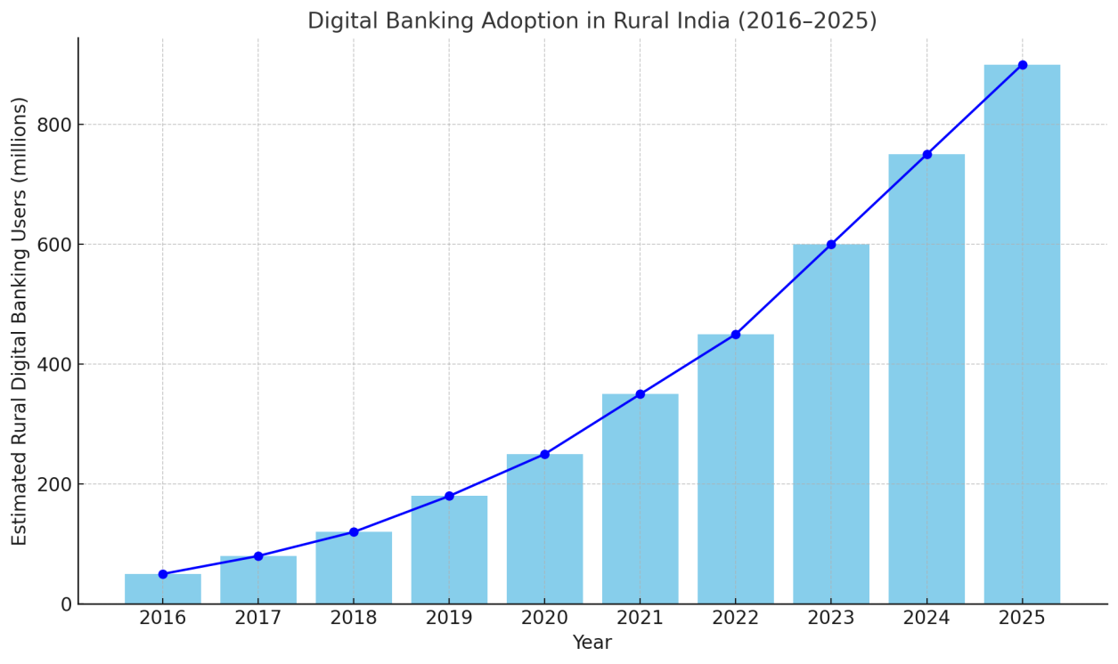
Fig. 2. Digital Banking Adoption in Rural India.
Source: Data compiled from multiple reports on rural digital banking adoption in India (e.g., RBI, NITI Aayog, PMJDY reports)
5.4 Adaptation of Retail Banks to New Consumer Behavior
Banks had to adapt quickly to the surge in demand for digital banking services. They focused on:
- Enhancing User Experience: Banks invested heavily in improving mobile and internet banking interfaces, making them more intuitive and user-friendly.
- Increased Security Features: The rise in digital banking led to an increased focus on cybersecurity, including two-factor authentication (2FA) and biometric verification, to protect consumers.
- Financial Literacy Campaigns: Public sector banks, in particular, launched campaigns to educate consumers about using digital tools safely and effectively.

Table 3: Retail Banking Adaptations Post-Demonetization

Initiative | Description | Impact
Digital Banking Campaigns | Focused on educating customers about mobile apps, UPI, etc. | Boosted adoption in rural and semi-urban areas
Improved App Interfaces | Simplified app design and user journeys | Increased customer satisfaction and usage
Enhanced Security | Introduced biometric login, two-factor authentication (2FA) | Improved consumer trust in E-Banking
Promotions on Digital Platforms | Provided cashbacks and discounts for digital transactions | Encouraged consumer engagement and usage

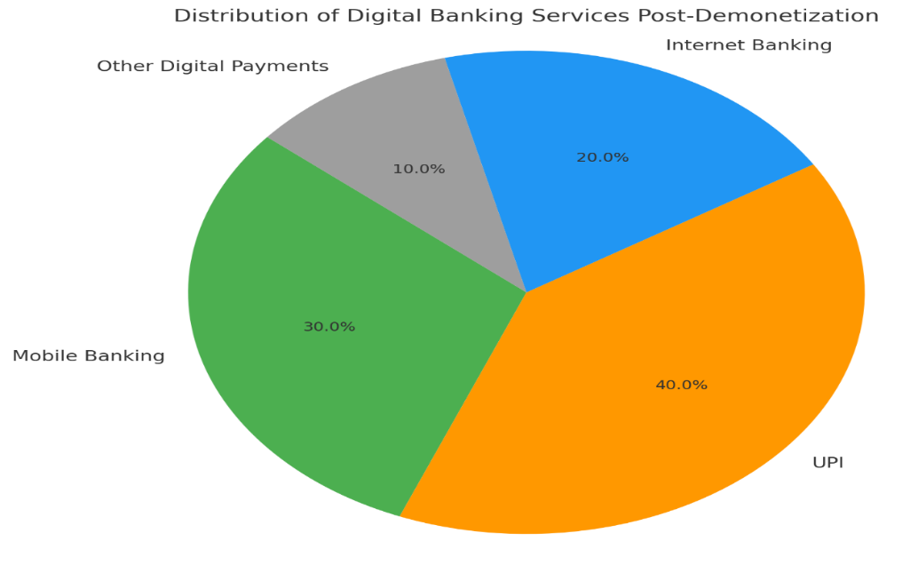
Fig. 3: Percentage of Consumers Using Different Forms of E-Banking

Source: Reserve Bank of India (RBI), National Payments Corporation of India (NPCI)

5.5 Challenges Faced by Consumers
While the shift to E-Banking was largely positive, there were challenges:
- Digital Literacy: Despite efforts, a significant section of the population, particularly the elderly, faced difficulties in adopting digital tools.
- Connectivity Issues: Rural areas, despite increased mobile penetration, still struggled with internet connectivity issues, which hindered seamless digital banking experiences.
- Cybersecurity Concerns: With the rapid growth of digital transactions, fraud and cyber threats became a major concern. Users had to become more vigilant regarding phishing scams and online security risks.

6. Results and Discussion

6.1 Evolution of E-Banking Usage Patterns
The findings of this study indicate a profound transformation in how Indian consumers interact with digital banking services in the aftermath of demonetization. Prior to this monetary policy shift, digital banking solutions were largely limited to urban, technologically literate users. However, post-2016, there has been a substantial increase in digital engagement across a much broader segment of the population. As evidenced in Table 1, the usage of Unified Payments Interface (UPI) surged from a modest 0.02 billion transactions to over 185.8 billion by the fiscal year 2025. Likewise, the number of mobile banking users more than doubled, and digital payments accounted for approximately 60% of all financial transactions, up from just 22% before the policy change.
This sharp increase reflects not just a temporary shift driven by necessity during the cash shortage, but a sustained behavioral transition rooted in the perceived benefits of speed, convenience, and accessibility associated with E-Banking platforms.

6.2 Financial Inclusion in Rural India
According to the data presented in Table 2 and illustrated in Fig. 2, the number of digital banking users in rural India expanded from 50 million in 2016 to a remarkable 900 million by 2025. The most dramatic growth periods occurred in the immediate aftermath of demonetization and again during 2021–2023, driven by government-led financial inclusion initiatives such as Digital India and PMJDY, alongside increased availability of smartphones and affordable internet.
Interpretation:
Initially triggered by a lack of alternatives during the cash crunch, this increase in rural digital adoption has evolved into long-term behavioral change. The sustained growth suggests that policy interventions, combined with expanding digital infrastructure, have successfully bridged significant gaps in access between rural and urban banking services.

6.3 Changing Consumer Preferences in Financial Transactions
A clear shift has occurred in consumer preferences, with many now favoring mobile-based payment methods and UPI due to their ease of use, low costs, and real-time transaction capabilities. Young consumers and small entrepreneurs, in particular, have embraced these digital tools as practical alternatives to cash or card payments. As noted by Atwal and Kaur (2025), digital payment platforms like Google Pay, PhonePe, and Paytm gained widespread popularity and became essential for daily transactions.
Nonetheless, ATM withdrawals remain substantial, with 18 billion transactions recorded in FY 2025, highlighting that despite progress, India has not yet become a fully cashless economy.
Interpretation:
Digital transactions are increasingly preferred, yet cash remains relevant. The continued coexistence of both payment modes reflects diverse consumer trust levels, income patterns, and infrastructure availability across regions.

6.4 Strategic Adjustments by Retail Banks
Retail banks responded swiftly to evolving consumer needs by improving digital banking experiences through user-centric mobile applications and robust cybersecurity measures. Table 3 outlines strategic innovations such as biometric authentication, two-factor login systems, and user-friendly interfaces. Public and private banks also intensified outreach through awareness programs aimed at educating users about digital banking tools and safety protocols.
Interpretation:
These developments signal a broader strategic pivot within the banking sector—from traditional, branch-based services to digital-first models. The emphasis is now on building trust, ensuring accessibility, and delivering seamless user experiences to retain and grow the customer base in a digital economy.

6.5 Ongoing Barriers to Adoption
While the digital transition has brought many benefits, several challenges persist. Digital literacy remains a significant hurdle, especially among older populations and those with limited formal education. Internet connectivity continues to be unreliable in certain rural and remote areas. Additionally, the proliferation of digital services has increased the risk of cyber fraud and data breaches, causing concern among new users unfamiliar with online security practices.
Interpretation:
To sustain the momentum of digital banking adoption, systemic efforts are needed to strengthen digital infrastructure, enhance public understanding of cybersecurity, and ensure equitable access to technological resources across socio-economic groups.

7. Summary of Findings
- Demonetization was a key trigger for widespread adoption of E-Banking services, compelling consumers to explore and eventually embrace digital alternatives such as UPI, mobile wallets, and online banking.
- There was exponential growth in digital banking, particularly in UPI usage, which rose to over 185 billion transactions by FY 2025, making it the backbone of the digital payment ecosystem.
- Rural India witnessed a transformative shift, with digital banking users increasing from 50 million in 2016 to 900 million by 2025—signaling major strides in financial inclusion.
- Retail banks responded proactively by enhancing digital platforms, strengthening cybersecurity frameworks, and launching mass awareness campaigns to improve digital literacy.
- Consumer preferences have changed permanently for a large segment of the population, particularly among tech-savvy individuals, youth, and small businesses.
- Challenges still persist, including gaps in digital literacy, security concerns, and infrastructure limitations in rural areas, which need to be addressed for inclusive and sustainable growth.
- Cash continues to play a role in India’s economy, suggesting that while digital payments are increasingly dominant, a hybrid model of financial transactions is likely to persist in the foreseeable future.

8. Conclusion
The demonetization policy implemented by the Indian government in November 2016 stands as a defining moment in the evolution of the nation's financial ecosystem. While the primary goal was to combat unaccounted wealth and counterfeit currency, the policy inadvertently initiated a widespread behavioral shift, pushing both consumers and businesses toward the use of digital banking channels. The sudden shortage of physical currency compelled the population to adopt digital modes of payment, resulting in a sharp and rapid increase in the use of mobile wallets, online banking, and UPI-based transactions.
This unexpected move toward digitalization was reinforced by supportive government strategies aimed at fostering a cash-light economy. Initiatives such as the Digital India programme, awareness campaigns for financial literacy, and incentives for non-cash payments created a conducive environment for the expansion of E-Banking. Simultaneously, banks responded by modernizing their digital offerings, strengthening cybersecurity systems, and improving user interface designs to cater to a growing and diverse digital clientele.
The findings of this study indicate that what began as a forced shift in transaction behavior has since matured into a long-term preference for digital financial services. Consumers now increasingly appreciate the convenience, speed, and transparency that electronic banking offers. Importantly, this transformation is not limited to urban areas; rural regions have also shown notable growth in digital banking adoption, driven by enhanced smartphone availability, affordable data services, and government-led financial inclusion efforts such as the Pradhan Mantri Jan Dhan Yojana (PMJDY).
Nonetheless, the digital banking revolution has surfaced a new set of challenges. Large sections of the population, particularly older adults, individuals with low literacy levels, and rural residents, continue to encounter obstacles like insufficient digital skills, poor internet connectivity, and skepticism about the security of online platforms. Moreover, the rise in cyber threats and data breaches underscores the urgency for robust regulatory oversight and continuous public education on secure digital practices.
In summary, demonetization acted as a pivotal trigger for the digital overhaul of India’s retail banking sector. Although the transition to a fully digital and inclusive financial system remains a work in progress, the momentum gained since 2016 has established a strong platform for future development. Continued efforts to close the digital divide—through targeted infrastructure investments, user training, and trust-building initiatives—will be crucial in ensuring that the advantages of E-Banking reach every segment of society.

Disclaimer (Artificial intelligence)

Option 1:

Author(s) hereby declare that NO generative AI technologies such as Large Language Models (ChatGPT, COPILOT, etc.) and text-to-image generators have been used during the writing or editing of this manuscript.
I affirm that no generative AI tools—including large language models like ChatGPT, Copilot, or similar technologies—were used in the writing, editing, or preparation of this manuscript. All content, analysis, and interpretations presented in this work are the result of my original research and intellectual effort.

Option 2:

Author(s) hereby declare that generative AI technologies such as Large Language Models, etc. have been used during the writing or editing of manuscripts. This explanation will include the name, version, model, and source of the generative AI technology and as well as all input prompts provided to the generative AI technology

Details of the AI usage are given below:
1.
2.
3.

9. References:
- Kumar, P., & Chaubey, D. S. (2017). Demonetization and its impact on adoption of digital payment: Opportunities, issues and challenges. Abhinav National Monthly Refereed Journal of Research in Commerce & Management, 6(6), 1–6. Retrieved from https://www.researchgate.net/publication/317283897
- Vani, Z., & Kumari, A. (2025). A study on level of digital financial service inclusion among the rural area. International Journal of Advances in Engineering and Management (IJAEM), 7(4), 258–268. https://doi.org/10.35629/5252-0704258268
- Ahmad, M. (2018). Review of the Technology Acceptance Model (TAM) in internet banking and mobile banking. International Journal of Information Communication Technology and Digital Convergence, Vol. 3, No. 1, June 2018, pp. 23-41. Retrieved from https://www.researchgate.net/publication/325570809
- Sharma, S., Anamika, A., Anuradha, & Kapoor, S. (2024). The transition from cash to digital wallets: A paradigm shift in the Indian economy. Frontiers in Health Informatics, 13(8), 2184–2198.
https://www.healthinformaticsjournal.com/index.php/IJMI/article/view/1851/1736
- Gokula Priya, M., & Shalini, P. (2025). A comparative study on urban and rural areas adopting digital payment system. International Research Journal, March, 2025, 12(3), https://tijer.org/tijer/papers/TIJERD001001.pdf
- Jafri, J. A., Mohd Amin, S. I., Abdul Rahman, A., & Mohd Nor, S. (2024). A systematic literature review of the role of trust and security on Fintech adoption in banking. Heliyon, 10(1), e22980. https://doi.org/10.1016/j.heliyon.2023.e22980
- Atwal, H., & Kaur, P. (2025). Impact of demonetization on digital payment system. International Journal of Research in Management, 7(1), [Page- 260-272]. https://doi.org/10.33545/26648792.2025.v7.i1c.289
- Prasad, S., Jain, Y. S., Surana, P., Shill, S., Kankariya, J., & Poddar, D. (2024). Impact of digital payment adoption on financial inclusion in rural India. International Journal of Development Research, 14(1), 26578–26583. https://www.journalijdr.com/impact-digital-payment-adoption-financial-inclusion-rural-india
- Ghosh, P. K. (2022). A Study on Impact of Covid- 19 Pandemic on Indian Banking Sector (pp. 83–94). lincoln university college malaysia. https://doi.org/10.31674/book.2022sseg.010
- Pandey, P. (2025). Transforming Indian banking: A study of digitalization, customer experience and operational efficiency. Advances in Consumer Research, 47(2), 88–101.https://acr-journal.com/article/transforming-indian-banking-a-study-of-digitalization-customer-experience-and-operational-efficiency-883/
- Hussaini, S. W. (2021). Impact of Demonetization on Indian Banking Sector. International Journal of Advanced Research in Science, Communication and Technology, 7(2), 722–726. https://doi.org/10.48175/ijarsct-1791

