Determinants of Working Hours of Child Labor: An Evidence from Selected Districts of Bangladesh

Abstract
Background: Bangladesh has achieved remarkable socioeconomic progress, yet child labor continues to be a major social concern. Understanding the determinants of children’s working hours is essential for designing effective interventions.
Aim: The present study aimed to investigate the causes of child labor and family characteristics as determinants of child labor in different districts of Bangladesh.
Methods: A cross-sectional study was conducted between October 2024 and July 2025 among 186 child labors aged 5–17 years. Participants were randomly selected from three districts of Bangladesh (Gopalganj, Bagerhat, and Jhenaidah). Data were collected through a structured questionnaire. Multiple linear regression analysis was employed to identify the socioeconomic and household factors influencing children’s working hours across different sectors.
Results: The analysis revealed that the age of child labor (p = 0.004), their educational status (p = 0.032), their household head’s education level (p = 0.041), their household size of (p = 0.027), and their working area (p = 0.008) area significantly affect working hours of child labor. Conversely, the gender of child labor (p = 0.457), their household income (p = 0.0.218) and their family’s loan status (p = 0.341) are not statistically significant predictors.
Conclusion: Working hours of child labors in Bangladesh are shaped by both individual and family characteristics rather than solely by economic status. Policy measures such as strengthened social protection, school retention initiatives, family planning support, and stricter child labor legislation are recommended to address excessive working hours and safeguard child well-being.

Keywords: Child Labor, Socioeconomic status, Working Hours, Multiple Linear Regression, Bangladesh.

- Introduction
In the last two decades, Bangladesh has been making remarkable progress in various socio-economic development indicators and has already been declared as a middle-income country by the World Bank. According to the survey of Bangladesh Bureau of Statistics (BBS) released a preliminary estimate on 27 May 2025, stating that the economy of Bangladesh has increased at a growth rate of 3.97 percent in the fiscal year 2024-25. Over the past decade, the economic and social performance of Bangladesh has increased remarkably. The latest figures reveal that the GDP growth has been on a downward spiral to 5.8 percent in 2023, 4.2 percent in 2024 and 3.8 percent in 2025, whereas previously the average GDP growth was 6.5 percent and poverty decreased down to 24.3 percent (2016) as compared to 40 percent (2005). Levels of poverty have been decreasing despite this dip with 2024 levels at 18.7 percent with 5.6 percent of the population in acute poverty. Meanwhile, unemployment averaged 5.1 percent in 2023 and the working population rose to a high of over 71.4 million in 2024. However, at a three-decade high of 16%, child unemployment is still a concern wich was reported by Global Estimates published in 2024. In this study, the causes of child labor and family characteristics as determinants of child labor in different districts of Bangladesh has been investigated.

1.1 Concepts of Child Labor
Musa & Magaji (2023) defined child labor as any kind of employment, which endangers the health of children or denies them access to education. In 2023, 1 in 5 children in the poorest countries in the world were children workers, according to a study. Almost a quarter of such children works as child labors in Sub-Saharan Africa, which ranks first among such countries. Child labor is an acute social problem in Bangladesh and the rest of the world. Child labor has been in its various forms, e.g. in the home in terms of domestic work, on farms, in shops as staff or assembly work at home, factories, in the mines, services. To supplement revenue at a low-income family, children were often used as labors. The definition of child labor provided by the International Labor Organization (ILO) is exploitation of a child by any means by employing him or her as long as it deprives him or her of his or her child, deprives him or her of regular schooling, or interferes with his or her moral, social, mental or physical development. Such exploitation is prohibited through regulations all over the world. The SDGs of the UN seek to address the world economic and social challenges. Implementing the 8th Sustainable Development Goal, called Decent Work and Economic Growth, will eliminate all child labor activities. With an end date of 2025, it aims to eliminate child work in all its forms, including the most abhorrent types of child labor and the use, recruitment and enrolment of child labor.
1.2 Characterization of Child Labor
Child labor has found many definitions with many international bodies. ILO (International Labor Organization) has defined a child as a person below 18 years of age and the general minimum admissible employment entry aged 15 (13 years under light work), and hazardous work 18 (16 years under specified strict terms). It allows the possibility that the general minimum age can be initially established at 14 (In case of light work 12 years may be accepted) where the economy is not adequately developed and where educational facilities are inadequate, under the Worst Forms of Child Labor Convention, 1999 (No. 182) and Minimum Age Convention, 1973 (No. 138). According to The Bangladesh Bureau of Statistics, children working one or more hour/weeks (both paid and in an unpaid capacity) aged 5-14 are not considered child labors. Any economic activity especially those involving children who are beyond the age of 10 are considered as child labor. This entails both domestic and outside work. (Hossain et al., 2025)

1.3 A Snapshot of Child Labor in Bangladesh
Child labor in Bangladesh is a significant issue especially since it is an emerging economy where child labor is decreasing gradually over the years. Bangladesh is known as one of the countries of child-labor abundance (Rahman et al., 1999). Child labor has primarily a connection with the poverty in Bangladesh, but there are other social and cultural factors underlying it. A case was demonstrated by Delap (2001) that purely economic causes do not suffice to explain the phenomenon of child labor. Among the cultural reasons why families send their children to work is the fear that in the absence of working the children will be idle. The most recent estimate indicates that there were more than 160 million children involving in child labor in the world in 2020 among which 97 million boys and 63 million girls. Of those boys and girls, it is estimated that 79 million do not work in hazardous child labor thus exposing their welfare to danger, morals and health. Though children in the age range between 12 and 17 are progressing, there is one more age group that has taken a hit. Since she is new to the state, students can form an opinion on how to treat her based on the information presented in this case (Hoque, M. M. 2023)
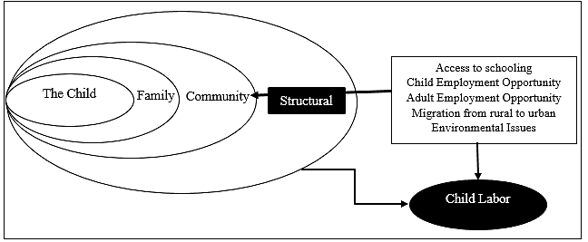
Figure 1: Conceptual framework of child labor

As it is estimated by The National Child Labor Survey 2013, we have only 3.45 million of the working children in our country, between the ages of 5 and 17 years and that is roughly 8.7 percent of the total children (39.65 million) within this age group. Higher concentration of child labor exists in the rural regions (71 %) than in the urban (29%). The child labor among boys surpasses girls in child labor with 2.10 (61%) and 1.35 million (39%) respectively. They are working and involved in various sectors whereby the maximum division is child labors employed in the agriculture sector 36.9%, 27.3 in the manufacturing industry, 17.89 at elementary occupational, and 17.39 in the sales and service workers. In majority of the cases, informal employment constitutes 94.85 percent total child labor. Only 30.9 of the working children are now in school where 30 percent never joined school and 28.9 percent could not join the school at all since they could not afford school fees by their parents. Child labor averagely puts in 39 working hours per week. (Vergara-Romero et al., 2024)

1.4 Objectives of the Study
The specific research objectives are:
- To identify the factors that influence the working hours of child labor
- To analyze the socio-economic condition of child labor’s family
- To recommend policy to eliminate child labor in Bangladesh.

- Literature Review
Child labor has been extensively addressed on the national and international scale through numerous authors in the literary contexts in numerous aspects. This is also what has been done before by (Pollack et al.,1990). In the article, they concentrated on the historical perspective of child labor with positive effects, health risks, and laws that regulate child labor in the American society. They discovered that there has been a significant rise in child labor and most of the pronounced rise has been registered in the restaurant and the garments industry in the United States of America. Manning (2000) has reviewed the socio economic effects of the financial and economic crisis on child workers in Indonesia. Salient results of the study included child labor in farming and the informal sector and they were largely exploited in the small and medium scale sector as opposed large scale factories.
In another study, Hadi (1995) employed multivariate analysis to demonstrate determinants of child labor in the countryside of Bangladesh. He discovered that given an illiterate and land-poor father, whose work is that of a labor, the chance that the child will be a labor too is even higher than before in case that child is a labor. Amin et al. (2004) discussed the relationship between poverty and other factors determine child labor in Bangladesh. They estimate the possibility of a child working based on individual logistic regression models of child boys and girls in the urban and rural locations. Among the few studies carried out using the 2000 data, Salmon (2005) carried out a study to examine the magnitude, nature and determinants of child labor in Bangladesh. The article supports that poverty makes children work and relations between adult labor and child labor also confirm the premise that kids are the ultimate economic asset of the family. Alam et al., (2008) have taken 1000 samples and used logistic regression to determine the various factors that influence the occurrence of child labor in Dinajpur district of Bangladesh.
September, J. (2014) proposed to view child work through the prism of human rights that considers Brazilian and South African laws and practices as well as those of India. This report brings to focus the risk experienced by children and families that rely on child labor to earn a living and progress on minimized exploitation and criminalization of child labor. The negative influence of living in a rural environment on working hours found in the given study aligns with Rad et al., (2015) observation about the significant influence of the socioeconomic environment of the country, specifically the family situation and place of residence, on the child labour rates in Iran. Rad et al., (2015) established that household demographics and type of residence (rural or urban) were important determinants of prevalence of child labour in less developed provinces of Iran. This result is consistent with our recent observation that place of residence has negative influence on working hours.
Abdallah & et al., (2020) utilized logistic regression to show that the household size and gender had a considerable impact on the likelihood that children would participate in labour in Red Sea State. This is consistent with the existing model that recognized gender and household size as relevant forecasts of the count of hours worked by children. Ahad et al., (2021) established factors that influence child labor and the nature of the working conditions they go through in Bangladesh urban child labor. The demographic report indicates that majority of the child labors (61.19) are child children (12-14 years), and 32.5 percent of child labor has never been to school. The ranking of the determinants depicts that poverty aside, the expenditure of schooling and the inability to get access to opportunities in primary schools are also the first-ranked push factors to initiate children into labor. Close to 72.5 percent of children labor more than 8 hours a day.
According to Hoque, M. M. (2023), the main causes of child labor in the urban slums of Bangladesh were the local factors including: lack of education opportunities, a large number of works in the field of the unorganized sector, and irregular adult income. Child labor is computed as the result of natural disasters, family problems and climate change. The researchers found out that children are often worked overtime at hours more than what they can easily be controlled with their low wage rates. Policies and programs addressing the needs of families and children along with root causes of child labor are needed in order to minimize child labor.
Ahmed et al., (2025) respectively revealed a study in Rajshahi, Bangladesh in which 62.5 percent of child workers are employed by family conditions. Forty-five percent of them are victimized by physical abuse at their place of work and 60 percent work 8-14 hours per day. It is the findings that in order to have a solution to end this inhumane practice and to improve the lives of children in this country policymakers, the government, and non-governmental organizations (NGOs) must work in association. Hossain et al., (2025) substantiated the hypothesis that family size, parental education, and income affect the wellbeing of children, including their engagement in labour, by emphasizing the impact of the socioeconomic and cultural factors on the outcomes of child development. Rahman et al., (2019) carried out a research on child labor in Dhaka, Bangladesh and its socioeconomic factors, causes, and consequences. Most of the children in the labor work force are between 12 and 14 years due to poverty and the inability to get a proper education. They are also regularly mistreated by their managers, and spend long time in toxic environments. The report notes that widespread mental and behavioral problems are caused mostly by poverty. Child labor jeopardizes the education of children, denies their rights, undermines their future opportunities and contributes to the poverty and child exploitation cycle that perhaps can last generations.

- Methodology
The study is mainly based on primary data that was obtained through a sample of 186 child labors considering time, resource, and feasibility factors so that a meaningful statistical analysis can be conducted. Where 50 respondents are from Gopalganj, 50 are from Bagerhat and 86 respondents who are child labor from Jhenaidah Upzilla in Bangladesh, developed in a setting between October 2024 and July 2025. The basis of sampling was to make sure that the selected respondents represent the diversified characteristics of child laborers in the perspective of Bangladesh. The sampling units consisted of individual child workers in the various homes and workplaces, and the population was categorized as working children aged 6 to 17. The districts were purposively selected according to accessibility and prevalence of child labor and the respondents were selected stratified by age, gender, and employment in each district. The approach provides a just, representative and a practical model of analyzing the variables that drive the working hours of child laborers. The information was gathered by employing a random sample method with questionnaire in order to get precise information in first hand rather than a secondary source of information. The collected raw information was coded, categorized, and transferred to Microsoft Excel and SPSS where they were analyzed.

  - Model Specification
Since the dependent variable is continuous (Numerical) and independent variables are dummy in nature, the model suggests multiple linear regression. The multiple linear regression was used to estimate the working hours of the child labors based on information about child labor and their family. A total of 186 child labors aged from 5 to 17 were chosen for the survey that was randomly selected from three different districts (Gopalganj, Bagerhat, and Jhenaidah) in Bangladesh. The formula of multiple linear regression as follows:

$$Y= β_{0}+{β_{1}Χ_{1}+β}_{2}Χ_{2}+ β_{3}Χ_{3}+ ⋅⋅⋅⋅⋅⋅⋅⋅⋅+ β_{n}Χ_{n}+ ϵ$$

$Y (Working Hours)=$ $β_{0}+{{β_{1}\left(Age of child labor\right)+β}_{2}\left(Gender of child labor\right)+β}_{3}\left(Working area of child labor\right)+ β_{4}\left(Education of child labor\right)+ ⋅⋅⋅⋅⋅⋅⋅⋅⋅+ β_{8}\left(Loan Status child labor’s family\right)+ Error Term$

Details classification of dependent variable and independent variables and conversion of them in to dummy variables:

Table 1: Classification of Variables
Variables |  | Name of the Variables | Coding | References
Dependent Variable (Y) | Y | Working Hours of child labor | Continuous | Khanam, R. (2008)
Independent Variable (X) | X₁ | Age of child labor | Continuous | Basu, K., & Van, P. H. (1998)
Independent Variable (X) | X₂ | Gender of child labor | Female = 0  Male =1 | Basu, K., & Van, P. H. (1998)
Independent Variable (X) | X₃ | Working Area of Child labor | Urban = 0  Rural = 1 | Ray, R. (2000)
Independent Variable (X) | X₄ | Education of child labor | Not educated = 0  Educated = 1 | Heady, C. (2003)
Independent Variable (X) | X₅ | Household Size child labor | Continuous | Grootaert, C., & Kanbur, R. (1995)
Independent Variable (X) | X₆ | Education of child labor’s household | No = 0  Yes = 1 | Heady, C. (2003)
Independent Variable (X) | X₇ | Income of child labor’s family | Continuous | Heady, C. (2003)
Independent Variable (X) | X₈ | Loan Status child labor’s family | No = 0  Yes = 1 | Islam, A., & Choe, C. (2013)

3.2 Validity of the Model
To ensure the validity of the model, few diagnostic tests such as multicollinearity and homoscedasticity were conducted prior to regression analysis. Multicollinearity was examined through Variance Inflation Factor (VIF) and the value of VIF for all variables are less than 10 which indicates that there is no multicollinearity problem in the model. The homoscedasticity assumption was tested by using Breusch-Pagan Test or (White Test) which indicates that the variance of the residuals was constant across fitted values. It was also identified that the residuals are roughly normally distributed because the residuals histogram seems to closely resemble the overlay normal curve and the residuals of the model of a regression are normally distributed.

- Result and Discussion
This section presents and discusses the socio-economic and demographic characteristics and the key findings on the factors affecting working hours of child labors in the study areas. In terms of gender, 168 were male child labors and only 18 were female child labors, representing percentages of 90% and 10%, respectively. In this survey, nearly half of the respondents are from urban areas, and half of them live in rural areas. The average family size of the respondents is 5.4, where 72 percent of child labors live in a big family that contains 4 to 6 members, and 20 percent live in a huge family that contains 7 to 11 members. The average age of child labor is 13 years and 64.5 percent of the children start their working as early as before 14 years, which is very early stage of their childhood and the percentage of the child labor aged 15-17 years old is 35.5%. A significant 61 percent of respondents have completed their primary education, and 23 percent have attained secondary educati
Table 2: Demographic Characteristics of respondents and their family
Category | Total  (sample Size=186) | Percentage (%)
Gender
Boy | 168 | 90
Girl | 18 | 10
Area
Urban | 88 | 47
Rural | 98 | 53
Age Distribution
5-8 | 6 | 3.2
9-11 | 21 | 11.3
12-14 | 93 | 50.0
15-17 | 66 | 35.5
Education Status
No Education | 30 | 16
Primary | 114 | 61
Secondary | 42 | 23
Household Size
1-3 | 15 | 8
4-6 | 133 | 72
7-9 | 36 | 19
10-12 | 2 | 1
Parents Alive
Yes | 162 | 87
No | 24 | 13
Separation
Yes | 21 | 11
No | 165 | 89
Source: Authors’ calculation based on field survey, 2024

4.1 Occupation of the child labor
Child labor engages in diverse work. In this survey, it is found that large numbers of children work in shops, as day labors, in workshops, and at restaurants, representing 40, 37, 32, and 27 out of 186, respectively.

Figure 2: Occupation of the child labor
In terms of risky jobs for children, 51 out of 186, which is about 27 percent of the total, are involved in various workshops, auto drivers, and industry. Traditionally, children are involved with agricultural work and domestic work, and the hawker report observed that 31(17%) out of 186 child labors are engaged in these types of traditional work.

4.2 Working Hours and Experiences of Child Labor
In this survey, children work an average of 8.6 hours daily, whereas the 2006 Labor Act of Bangladesh states that each adult employee can work for 8 hours per day. In this survey, a maximum of 48 percent, as well as 90 out of 186 child labors, work 6 to 8 hours daily, and 23 percent of child labors work 9 to 11 hours daily. Since all of them are engaged in informal jobs or activities with no skill, the working hours are no limit or bar for child labor.
Figure 3: Working Hours and Experiences of Child Labor
The figure shows that working experiences of child labor means when child labor newly enters the job market. The study reveals that the highest 79 number of children (42%) entered the job market in the last 01 year or 12 months. About 42 percent of children work for more than 12 months to 36 months.

4.3 Occupation of Household Head
Family socioeconomic status mostly depends on occupation, education, and income. In the study area, 35 percent of the family heads work in day labor, 32 percent engage in agricultural work, 19 percent are rickshaw pullers, and 11 percent are industrial workers.
Table 3: Occupation and Education status of household head
Occupation | Frequency | Percentage
Day labor | 65 | 35
Rickshaw puller | 35 | 19
Agricultural Work | 59 | 32
Industrial Worker | 20 | 11
Work in a shop | 5 | 3
Domestic Worker | 2 | 1
Total | 186 | 100
Source: Authors’ calculation based on field survey, 2024.
- Multiple Linear Regression model
A multiple linear regression model was employed to analyze the factors influencing the working hours of child labors. The dependent variable was the children’s working hours, while the independent variables included their age, gender, working area, education status, household size, and education level of their household head, household income, loan status of their family. The results of the model are presented in terms of regression coefficients, ANOVA statistics, and a model summary, as outlined below:
Table 4: Model Summary^{b}
Model | R | R Square | Adjusted R Square | Std. Error of the Estimate | Durbin-Watson
1 | .371ª | .137 | .098 | 2.501 | 1.523
- Predictors: (Constant), Age of child labor, Gender of child labor, Working Area of Child labor, Education of child labor, Household Size of child labor, Education of child labor’s household, Income of child labor’s family, Loan Status child labor’s family
b. Dependent Variable: Working Hours of child labor
Sources: The result of primary data processing with SPSS
The regression model was evaluated in order to determine the influence of certain household and child characteristics on working hours of child workers. As the summary of the model presents, the relationships between the predictors and the dependent variable are moderate (R = 0.371).
The independent variables in the model (R² = 0.137) explain about 13.7 percent of change in working hours. On adjusting the number of covariates, the Adjusted R² goes down to 0.098 which reflects inadequate explanatory power of predictors. Based on the Standard Error of the Estimate (2.501), the actual and expected working hours vary by an average of 2.5-hours. Moreover, the statistic of Durbin-Watson (1.523) falls within the normal range of 1.5 to 2.5 which means that there is no significant problem of autocorrelation between residuals.

Table 5: ANOVAª
Model |  | Sum of Squares | df | Mean Square | F | Sig.
1 | Regression | 176.349 | 8 | 22.044 | 3.524 | .001^{b}
1 | Residual | 1107.054 | 177 | 6.255
1 | Total | 1283.403 | 185
a. Dependent Variable: Working Hours child labor
b. Predictors: Age of child labor, Gender of child labor, Working Area of Child labor, Education of child labor, Household Size, Education of child labor’s household, Income of child labor’s family, Loan Status child labor’s family
Sources: The result of primary data processing with SPSS

The overall significance of the model is supported by the results of ANOVA. The result of the analysis provided a p-value of 0.001 and F-statistic of 3.524, which makes the results statistically significant at the 5% level. This result supports the argument that the independent covariates collectively account a significant percentage of the variation in the working hours of child labors. However, the explanatory power of the model is modest as seen by the low F-value, as well as by the small R² value, thus suggesting that a significant portion of the variance is not explained.

Table 6: Coefficientsª
Model |  | Unstandardized Coefficients |  | Standardized Coefficients | t | Sig. | Collinearity Statistics
 |  | B | Std. Error | Beta | t | Sig. | Tolerance | VIF
1 | (Constant) | 6.105 | 1.475 |  | 4.137 | .000
1 | Age of the Child Labor | .188 | .094 | .148 | 1.991 | .048 | .877 | 1.140
1 | Gender of Child Labor | 1.002 | .627 | .113 | 1.599 | .112 | .980 | 1.021
1 | Area of Working Child Labor | -1.288 | .374 | -.245 | -3.442 | .001 | .963 | 1.038
1 | Education of Child Labor | -1.505 | .541 | -.211 | -2.781 | .006 | .849 | 1.179
1 | Household Size | .287 | .122 | .173 | 2.341 | .020 | .895 | 1.118
1 | Education of Child Labor’s Family | -.659 | .391 | -.122 | -1.687 | .093 | .938 | 1.066
1 | Income of Household of Child Labor | -.082 | .534 | -.011 | -.153 | .878 | .950 | 1.052
1 | Loan Status of Child Labor’s Family | -.295 | .402 | -.054 | -.735 | .464 | .887 | 1.127
a. Dependent Variable: Working Hours child labor

Sources: The result of primary data processing with SPSS
The table of coefficients provides extra information regarding the effects of each predictor on working hours of child labor. With other factors held constant, the intercept of 6.105 suggests that on average, child labor works for about 6 hours in a day. The strongest negative coefficients are the level of education of the child (B = -1.505, p = 0.006) and the residential area (B = -1.288, p = 0.001). Children in rural areas have around 1.3 less hours of labour, and higher-educated children have around 1.5 less hours of labour than children in urban areas, respectively. The statistically significant and positive correlation with the number of people in the household demonstrates that each extra family member leads to an increase in the working time of a child by roughly 0.3 hours (B = 0.287, p = 0.020).
Furthermore, the age of the child labor have a positive and statistically significant impact on the duration of work (B = -0.188, p = 0.048), which means that the older children spend a little more hours at work. Other covariates failed to achieve statistical significance. An example of this is that gender is found to be related to an extra hour of work among boys as compared to girls (B = 1.002, p = 0.112), although the estimate lacks significance.
Both income of the household head (B = -0.082, p = 0.878) and his/her educational attainment (B = -0.659, p = 0.093) relate to the negative coefficients, meaning that parents with high incomes or educational attainment are less likely to send their children to work; however, these effects are small and insignificant. In the same way, the impact of loan status does not have a statistically significant effect on working hours (B = -0.295, p = -0.464) even though the coefficient is negative.
The negative coefficients that were detected in the model are especially interesting, as they always imply an inversely proportional relationship with the number of hours children work. In particular, the lower the number of hours of labour, the more likely it is to reside in rural settings, attain higher educational levels of the child, attain higher educational levels of the parents, earn higher household income, and have outstanding loans.
Though few among these associations are statistically significant, the general directionality of their relationships indicates that structural and educational reform can be an effective solution to the severity of child labour. An analysis of the regression shows that age of the child, family size, place of residence, and the level of education are the most salient determinants of working hours among children. As a result, age and family size are independent variables that show a tendency to raise the probability of long labour, and formal education is a protective factor, defusing work hours. Although they have a negative relationship, the income, parental education and loan status variables are not statistically significant in this model, suggesting that education and demographic variables have a stronger effect on child labour time as compared to economic variables alone.

  - Summary of the Findings
The regression analysis yields insights into the determinants of child labors' working hours. The model explains about 13.7 percent of the variation in working hours ( R² = 0.137) and has overall statistically significant (F = 3.524, p = 0.001) joint effect on the working hour of child labor, but with a weak explanatory power. The value of Durbin-Watson of 1.523 shows that this does not indicate any serious autocorrelation and the residuals meet the normality assumption. Among the predictors, residence area, child education, household size, and age emerge as the most influential variables. The number of hours that children who live in rural areas can work is on average 1.29 shorter than those living in urban areas (p = 0.001), which highlights structural differences between the two places. The negative impact of child education is high (B = -1.505, p = 0.006), which shows that schooling lowers working hours and underlines its protective role. There is a positive influence of household size (B =.287, p =.020), which means that larger families exert more demands on children in terms of labor. There is also a positive correlation with age (B = 0.188, p= 0.048), as children who worked more hours are older. Other variables, including gender, education and income of the household head, and loan status have the directional effect anticipated but are not statistically significant. Boys are working more hours than girls, parental education has a slightly negative impact, parental income has a slightly negative impact and loan status has a slightly negative impact. On the whole, the results suggest that demographic and education variables including child education, household size, age, and residence have a more decisive influence on working hours in comparison to the purely economic variables. These findings indicate the need to improve education access and minimize family-level stress in order to decrease child labor.
Furthermore, this model illustrates a clear picture that the dispersion of the points is quite random and has no rather structured pattern and this way, homoscedasticity assumption is probably fulfilled in relation to the dependent variable of Working Hour. It also suggests that the residuals are roughly normally distributed because the residuals histogram seems to closely resemble the overlay normal curve and the residuals of the model of a regression are normally distributed. This is a precondition of the soundness of numerous statistical conclusions made after a regression analysis. The closer shown points are to the diagonal line, the more the residuals tend to appear in normal distribution.

- Conclusion
In Bangladesh, the most significant causes of child labor are poverty related family characteristics including dropping out of school, age of child labor, their gender, working area, large family size, low parental education level, household debt etc. according to this study. The results of the multiple linear regression model indicates that the child level of education, age, family size and residence are the most conclusive determinants of employment engagement. In rural areas and school-going children work fewer hours than in larger families and older children, and are more likely to face longer hours of work. Such economic factors related to child labor like the income of a household head, education level and loan status, which were theoretically important, did not have a statistically significant effect on working time on this analysis, showing that the causes of child labour go beyond financial limitations and into broader social and family processes.
These findings highlight the urgent need of specific policy actions prioritizing access to education, decreasing the use of child labour by families, and alleviating the susceptibility of bigger families. By enabling unbiased access to education, especially in urban areas, and creating awareness about the long-term expenses of child labour, there will be a significant reduction of the labour burden carried by children. Consequently, child labour requires both short-term and long-term social support, which involves equipping families with economic support as well as ensuring the rights of children to education, growth, and dignity.

- Policy Recommendation
Policy makers should focus on the implementation of child work laws, establishment of income earning options to parents, enhancement of social protection schemes and reduction of cases of school dropout. Government, non-governmental organizations, and communities need to work together to cut the poverty cycle and child labor to protect the rights of children in order to get access to education, health, and decent future. (Vergara-Romero et al., 2024)
Different types of policies are made based on a thorough understanding of the causes of child labor. Most of the cases, child labor comes from family. Based on the results schooling of children, age, household education, major earning person, household size and loan status of a family all these variables are related to households and substantial impact on causes of child labor. So, family members or household head should be given income generating work, motivation, encouragement and advice that their children do not go to work. For improving schooling status of children that means reducing dropout rate government should focus simultaneously on reasons of dropout and raising parents’ awareness. The conditional loan system must be applied for example; families whose children drop out of school or have child labor will not get a loan. Families, communities and government should work together to contest child labor where strict policies and smooth assistance from them should be certain.

References
Abdallah, A., Saied, A., & Abdallah, R. (2020). Using logistic regression to identify the factors affecting child labor in Red Sea State. International Journal of Advanced and Applied Sciences, 7(10), 12-19.
Ahad, M. A., Chowdhury, M., Parry, Y. K., & Willis, E. (2021). Urban child labor in Bangladesh: Determinants and its possible impacts on health and education. Social Sciences, 10(3), 107.
Ahmed, M. S., Tajwar, T., & Ajmir, R. (2025). Child labor in Rajshahi City, Bangladesh: A survey based analysis. Global Studies of Childhood, 20436106241309022.
Alam, S., Mondal, N. I., & Rahman, M. (2008). Child labor due to poverty: A study on Dinajpur district, Bangladesh. The Social Sciences, 3(5), 388-391.
Amin, S., Quayes, M. S., & Rives, J. M. (2004). Poverty and other determinants of child labor in Bangladesh. Southern Economic Journal, 70(4), 876-892.
Basu, K., & Van, P. H. (1998). The economics of child labor. American Economic Review, 88(3), 412–427.
BEGUM, R. A. (2025). Child Labor in Dhaka City: A Study on Nature and Consequences (Doctoral dissertation, © University of Dhaka).
Delap, E. (2001). Economic and cultural forces in the child labor debate: Evidence from urban Bangladesh. Journal of Development Studies, 37(4), 1-22.
Heady, C. (2003). The effect of child labor on learning achievement. World Development, 31(2), 385–398.
Hoque, M. M. (2023). Understanding the role of structural factors and realities in normalizing child labor in urban slums of Bangladesh. Cogent Social Sciences, 9(2). https://doi.org/10.1080/23311886.2023.2272319
Hossain, R., Faruk, M. O., & Begum, N. (2025). Determinants of child physical health development in Bangladesh: a study of key socioeconomic and cultural influences. BMC Public Health, 25(1), 2447.
https://www.google.com/url?sa=t&source=web&rct=j&opi=89978449&url=https://www.ilo.org
https://www.google.com/url?sa=t&source=web&rct=j&opi=89978449&url=https://www.uniceforg/bangladesh/en/press-releases/bangladesh-faces-mixed-progress-child-labor-persists-138
ILO, & UNICEF. (2021). Child labor: Global estimates 2020, trends and the road forward. International Labor Office and United Nations Children’s Fund.
Islam, A., & Choe, C. (2013). Child labor and schooling responses to access to microcredit in rural Bangladesh. Economic Inquiry, 51(1), 46–61.
Khan, M. K. J., & Suchana, S. S. (2025). Regional Delineation of Violence Exposure Among Women and Children in Bangladesh. International Social Research Nexus (ISRN), 1(2), 1-15.
Khanam, R. (2008). Child labour and school attendance: Evidence from Bangladesh. International Journal of Social Economics, 35(1/2), 77–98.
Manning, C. (2000). The economic crisis and child labor in Indonesia. ILO/IPEC Working Paper, 80.
Musa, I., & Magaji, S. (2023). Nexus between household income and child labor in Northeastern Nigeria. African Journal of Social Sciences and Humanities Research, 6(3), 57-70.
Rad, E. H., Gholampoor, H., & Jaafaripooyan, E. (2015). Child labor and the influencing factors: evidence from less developed provinces of Iran. Iranian journal of public health, 44(9), 1244.
Rahman, M. A., Rahman, M. S., Alam, M. A., Hasan, M., & Rahul, M. I. H. (2019). Child labor in the Era of Sustainable Development: insights from Jhenaidah City of Bangladesh.
Rahman, M. M., Khanam, R., & Absar, N. U. (1999). Child labor in Bangladesh: A critical appraisal of Harkin’s Bill and the MOU-Type schooling program. Journal of Economic issues, 33(4), 985-1003.
Ray, R. (2000). Child labor, child schooling, and their interaction with adult labor: Empirical evidence for Peru and Pakistan. The World Bank Economic Review, 14(2), 347–367.
Salmon, C. (2005). Child labor in Bangladesh: Are children the last economic resource of the household?. Journal of Developing Societies, 21(1-2), 33-54.
September, J. (2014). Children's rights and child labor: a comparative study of children's rights and child labor legislation in South Africa, Brazil and India.
Vergara-Romero, A., Macas-Acosta, G., Márquez-Sánchez, F., & Arencibia-Montero, O. (2024). Child Labor, Informality, and Poverty: Leveraging Logistic Regression, Indeterminate Likert Scales, and Similarity Measures for Insightful Analysis in Ecuador. Neutrosophic Sets and Systems, 66, 136-145.
2024 Global Estimates of Child Labor Figures (Retrieved from Google)
Abdullah el , H. (1995, December). Child labor in Bangladesh villages: incidence, correlates and implications. Research Reports (1995): Social Studies, Vol – XI, 67–75.
Bangladesh Bureau of Statistics (2015, October), Child Labor Survey (CLS) Bangladesh 2013. http://203.112.218.65:8008/WebTestApplication/userfiles/Image/LatestReports/ChildLaborSurvey2013.pdf

Appendix: Pre-test for Linear Regression

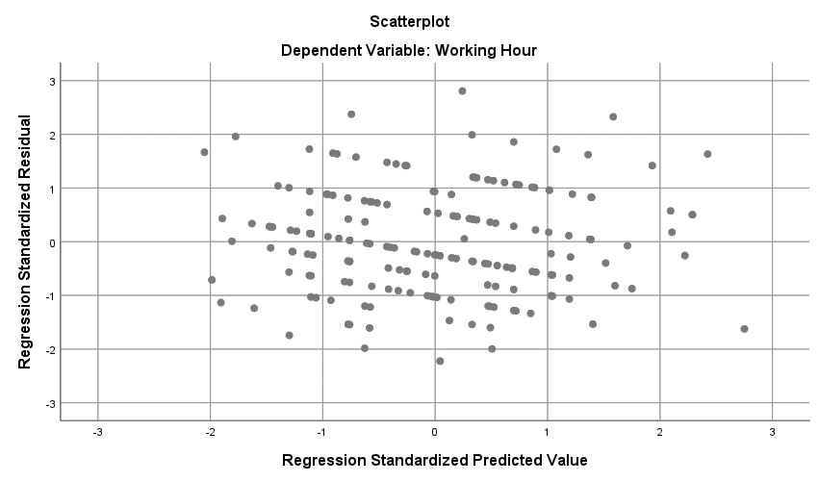
Figure: Scatterplot for Homoscedasticity Detection

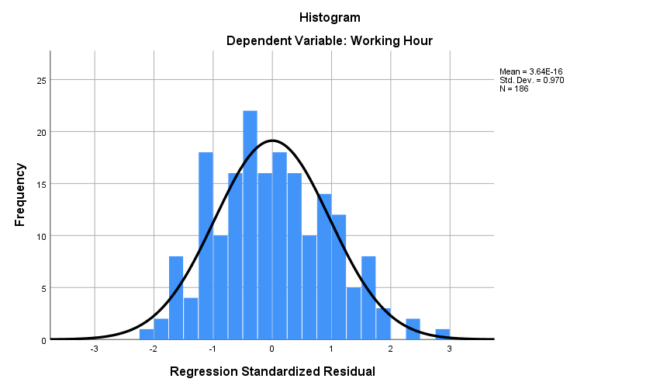
Figure: Histogram of Regression Residuals
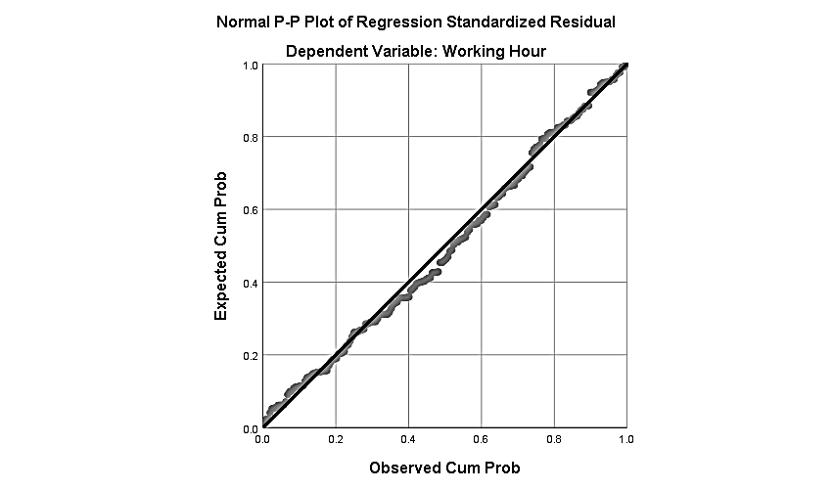
Figure: Normal P-P Plot of Regression Standardized Residual

