Case report
Apexification with Biodentine for Management of an Immature Necrotic Permanent Tooth: A Clinical Case Report

Abstract
Background:
Immature permanent teeth with necrotic pulps and open apices present a challenge for endodontic treatment due to wide canals, thin dentinal walls, and lack of an apical stop. Apexification aims to create an apical barrier and allow proper obturation. Biodentine, a bioactive calcium silicate material, offers advantages such as rapid setting, biocompatibility, and dentin-like mechanical properties.
Case Report:
A 27-year-old male with a history of trauma presented with discoloration and pain in tooth #21. Clinical and radiographic examination revealed an Ellis Class III fracture, an open apex, and periapical radiolucency. After cleaning and shaping, calcium hydroxide was used as an intracanal medicament for two weeks. Biodentine was then placed to form a 3–4 mm apical plug, followed by sectional obturation and composite restoration. A lithium disilicate crown was later cemented.
Outcome:
At the 3-month follow-up, the tooth was asymptomatic and radiographic evaluation showed periapical healing and apical barrier formation.
Conclusion:
Biodentine is a reliable material for single-visit apexification due to its excellent sealing ability, rapid setting time, bioactivity, and reinforcement of thin dentinal walls. This case demonstrates successful clinical and radiographic outcomes using Biodentine in the management of an immature necrotic permanent tooth.
KEYWORDS: OPEN APEX ,APEXIFICATION ,BIODENTINE

INTRODUCTION
Dental traumatic injuries are a major etiological factor leading to pulp necrosis and subsequent root canal infection in immature permanent teeth . Post-eruption, root development and apical closure are typically completed within three years. During this developmental period, the tooth remains particularly susceptible to trauma and other external insults. When such immature teeth sustain injuries, the cessation of root formation can occur, resulting in incomplete root development and open apices. These conditions pose significant challenges during endodontic therapy due to the wide canal diameter and the absence of a natural apical constriction. (1)
Trauma is one of the primary causes of the development of teeth with open apices. Significant alterations in pulpal microcirculation resulting from irritation or disruption of the pulp tissue can lead to pulpal necrosis and arrest of root formation (2)In addition to trauma, other factors such as thermal or chemical injuries during restorative or operative procedures may also compromise the vitality of the pulp, thereby interrupting normal root development and apical closure.
According to Andreasen et al., approximately 30% of pulp necrosis cases in immature permanent teeth are a direct consequence of dental trauma (3). Endodontic management of these teeth is complex for several reasons. First, the anatomical characteristics of the developing tooth make mechanical instrumentation difficult and increase the risk of weakening already thin dentinal walls. Second, the absence of an apical stop complicates adequate obturation and sealing of the root canal using conventional techniques. Finally, the fragile canal walls of immature teeth are highly susceptible to fracture, necessitating careful selection of treatment protocols that promote apical closure and reinforce the remaining root structure. (4)
Apexification is a biologically based procedure aimed at inducing apical closure in an immature, nonvital permanent tooth through the removal of necrotic pulp tissue followed by the placement of a biocompatible material within the canal space. Traditionally, calcium hydroxide has been the material of choice for apexification due to its antimicrobial properties and ability to promote hard tissue formation. However, this method often requires multiple visits and extended treatment duration.
Recent advances in endodontic materials have introduced alternatives such as mineral trioxide aggregate (MTA) and biodentin , which allow for faster apical barrier formation and, in some cases, single-visit apexification. (5)

CASE DESCRIPTION:
A 27 year old male patient reported to the department of conservative dentistry and endodontics with the chief complaint of broken tooth in upper front tooth region .The patient had history of intermittent pain with respect to tooth # 21 . Patient had a history of trauma in his childhood,because there was no discomfort at the time of trauma neither the patient nor his parent sought dental treatment. On clinical examination tooth 21 had Ellis class III fracture ,with discolouration and was tender on percussion . No other significant dental or medical history was found. Radiographic examination revealed an immature apex and periapical radiolucency in relation to tooth #21.(Fig 1) Electric pulp test and cold test results were negative and the final diagnosis of the case was made as asymptomatic apical periodontitis.
The patient was explained about the treatment and informed consent was obtained.
Under local anesthesia with 2% lidocaine containing 1:80000 epinephrine and rubber dam was placed in the involved tooth.(Fig 2) Access opening was done using an Endo access bur (Dentsply Maillefer, Ballaigues, Switzerland), and apical patency was obtained with # 15 K-file and working length was determined .(Fig 3)
The canal was cleaned and shaped with hand K-files (Mani, India) to an appropriate size to disrupt bacterial biofilm on the canal walls. Root canal irrigation was done with 3% sodium hypochlorite (NaOCl)(Hyposol; Prevest DenPro, India) between each instrument, followed by 17% EDTA (NEOEDTA; Orikam, India) and saline.The root canal was then carefully dried with sterile paper points (Diadent ,India ). The root canal was disinfected with calcium hydroxide (RC Cal; Prime Dental) for 2 weeks and the access cavity was sealed with sterile cotton pellet and temporary restorative material (Neotemp; Orikam, India).
At the next appointment, the patient was found asymptomatic. Following tooth isolation, calcium hydroxide medicament was removed with copious amount of 3% NaOCl irrigation
After that, sterile paper points were used to dry the root canal. Biodentine (Septodont, Saint-Maur-des-Fossés, France) was then prepared according to the manufacturer’s instructions, carried into the canal with a MTA carrier and condensed with hand pluggers to form an apical Biodentine plug of 3–4 mm in thickness.(Fig 4) The excess material from the walls was removed with paper points. After 12–15 min, the remaining root canal space was filled using sectional obturation technique and composite resin was used to seal the access cavity.(fig 5)
After two weeks, the tooth was prepared for full-coverage restoration. A final impression was made, and a lithium disilicate crown was fabricated and cemented.(fig 6) The patient was recalled after three months for follow-up. Clinically, the tooth was asymptomatic, and the periapical radiograph demonstrated satisfactory healing with resolution of the periapical lesion.(fig 7)

Discussion

Apexification is defined as ‘a method to induce a calcified barrier in a root with an open apex or the continued apical development of an incomplete root in teeth with necrotic pulp’ (American Association of Endodontists 2003). The goal of this treatment is to obtain an apical barrier to prevent the passage of toxins and bacteria into periapical tissues from the root canal. (6)
Apexification procedures have historically been performed using calcium hydroxide, which induces the formation of a calcified barrier at the root apex. However, this technique presents several drawbacks, including unpredictable apical closure, the requirement for multiple long-term appointments, the need for patient compliance, and the potential for coronal seal loss between visits. Moreover, prolonged exposure of calcium hydroxide to root dentin has been associated with an increased risk of cervical root fractures due to its effect on dentinal strength .(7)
To overcome these limitations, single-step apexification procedures using MTA have gained widespread acceptance and demonstrated highly favorable clinical and radiographic outcomes . (8)MTA exhibits superior sealing ability, biocompatibility, and the capacity to induce cementogenesis and hard tissue formation, making it the material of choice for apical barrier formation in nonvital immature teeth (9)
In recent years, Biodentine, a calcium silicate–based bioactive material, has emerged as an effective alternative to MTA for apexification procedures. It is composed of tricalcium silicate, dicalcium silicate, calcium carbonate, zirconium oxide, and calcium hydroxide. Biodentine offers several advantages, including ease of handling, shorter setting time, and improved mechanical properties. While MTA requires approximately 2 hours and 45 minutes to set, Biodentine achieves complete setting within 12 minutes, enabling more efficient single-visit procedures (7)
The material is supplied in pre-dosed capsules designed for mechanical mixing, ensuring uniform consistency and clinical convenience . Additionally, Biodentine exhibits high compressive strength, elasticity, and micro-stiffness values comparable to those of natural dentin, thereby reinforcing thin canal walls . It also forms tag-like crystalline structures within dentinal tubules, establishing micromechanical bonding between dentin and the calcium silicate matrix. This occurs due to its high specific particle surface area and the inclusion of calcium chloride, which accelerates hydration reactions and improves material density.(10)
Biodentine demonstrates superior biocompatibility and sealing ability and is less cytotoxic than many other materials currently used in vital pulp therapy . About et al. reported that Biodentine promotes dentin regeneration by stimulating odontoblastic differentiation of pulp progenitor cells, confirming its bioactive potential in human tooth culture models .(11) Similarly, Laurent et al. observed that Biodentine significantly enhances the secretion of transforming growth factor-β1 (TGF-β1) from pulp cells, a cytokine known to play a key role in initiating early mineralization and pulp healing (12). Furthermore, Han and Okiji compared the uptake of calcium and silicon ions by adjacent dentin in contact with Biodentine and ProRoot MTA. Their findings revealed that Biodentine produced thicker calcium- and silicon-rich interfacial layers over time, with greater ion exchange and biomineralization than MTA after 30 and 90 days (13)
Collectively, these studies highlight Biodentine’s excellent bioactivity, its capacity for tissue regeneration, and its strong chemical integration with dentin. In the present case, Biodentine was selected as the apical barrier material due to its favorable handling characteristics, rapid setting time, and superior biological performance. Radiographic follow-up after three months demonstrated successful apical closure and periapical healing, confirming Biodentine’s efficacy as a reliable material for apexification in immature permanent teeth..

Conclusion
Apexification remains a valuable treatment modality for managing immature nonvital permanent teeth with open apices. The introduction of bioactive calcium silicate materials such as Biodentine has significantly improved treatment predictability and clinical outcomes. Owing to its excellent sealing ability, superior biocompatibility, rapid setting time, and dentin-like mechanical properties, Biodentine serves as a reliable material for single-visit apexification.

Disclaimer (Artificial intelligence)

Option 1:

Author(s) hereby declare that NO generative AI technologies such as Large Language Models (ChatGPT, COPILOT, etc.) and text-to-image generators have been used during the writing or editing of this manuscript.

Option 2:

Author(s) hereby declare that generative AI technologies such as Large Language Models, etc. have been used during the writing or editing of manuscripts. This explanation will include the name, version, model, and source of the generative AI technology and as well as all input prompts provided to the generative AI technology

Details of the AI usage are given below:
1.
2.
3.

REFRERENCES:
- Gill I, Mittal S, Kumar T, Keshav V. Open Apex and its Management: Review Article. J Pharm Bioallied Sci. 2024 Feb;16(Suppl 1):S31-S34. doi: 10.4103/jpbs.jpbs_615_23. Epub 2024 Feb 29. PMID: 38595371; PMCID: PMC11000961.
- . Chen X, Bao ZF, Liu Y, Liu M, Jin XQ, Xu XB. Regenerative endodontic treatment of an immature permanent tooth at an early stage of root development: A case report. J Endod. 2013;39:719–22. doi: 10.1016/j.joen.2012.12.023
- Andreasen FM, Kahler B. Pulpal response after acute dental injury in the permanent dentition: Clinical implications-A review. J Endod. 2015;41:299–308. doi: 10.1016/j.joen.2014.11.015.
- Gill I, Mittal S, Kumar T, Keshav V. Open Apex and its Management: Review Article. J Pharm Bioallied Sci. 2024 Feb;16(Suppl 1):S31-S34. doi: 10.4103/jpbs.jpbs_615_23. Epub 2024 Feb 29. PMID: 38595371; PMCID: PMC11000961.
- Tolibah YA, Kouchaji C, Lazkani T, Ahmad IA, Baghdadi ZD. Comparison of MTA versus Biodentine in Apexification Procedure for Nonvital Immature First Permanent Molars: A Randomized Clinical Trial. Children (Basel). 2022 Mar 14;9(3):410. doi: 10.3390/children9030410. PMID: 35327782; PMCID: PMC8946907.
- Khetarpal, Ambica; Chaudhary, Sarika; Talwar, Sangeeta; Verma, Mahesh¹. Endodontic management of open apex using Biodentine as a novel apical matrix. Indian Journal of Dental Research 25(4):p 513-516, Jul–Aug 2014. | DOI: 10.4103/0970-9290.142555
- Thakur, Vivek. Modified single-step apexification and strengthening of thin dentinal walls with Biodentine. Journal of Conservative Dentistry and Endodontics 27(2):p 214-218, February 2024. | DOI: 10.4103/JCDE.JCDE_239_23
- Kahler B, Rossi-Fedele G, Chugal N, Lin LM. An evidence-based review of the efficacy of treatment approaches for immature permanent teeth with pulp necrosis. J Endod 2017;43:1052–7.
- Torabinejad M, Parirokh M. Mineral trioxide aggregate:A comprehensive literature review –Part II:Leakage and biocompatibility investigations. J Endod 2010;36:190–202.
- .Nayak G, Hasan MF. Biodentine-a novel dentinal substitute for single visit apexification. Restor Dent Endod. 2014 May;39(2):120-5. doi: 10.5395/rde.2014.39.2.120. Epub 2014 Mar 21. PMID: 24790925; PMCID: PMC3978102.
- About I, Laurent P, Tecles O. Bioactivity of Biodentine™ a CA3SiO5-based Dentine Substitute. Oral session IADR Congress July 2010. Barcelona, Spain
- Laurent P, Camps J, About I. Biodentine (TM) induces TGF-ß1 release from human pulp
- Han L, Okiji T. Uptake of calcium and silicon released from calcium silicate-based endodontic materials into root canal dentine Int Endod J. 2011;44:1081–7
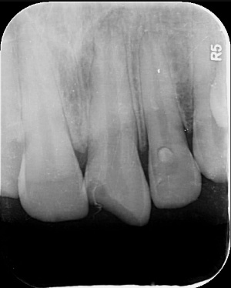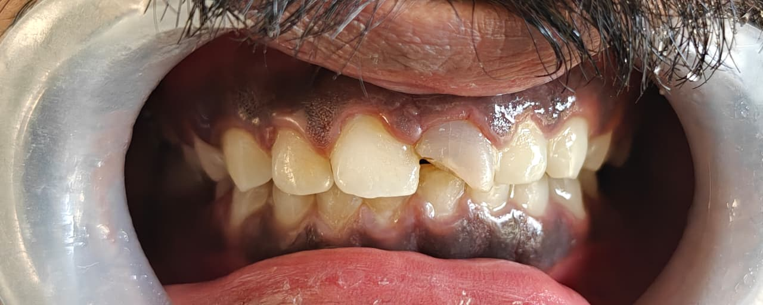
Fig 1: Pre operative photograph and radiograph

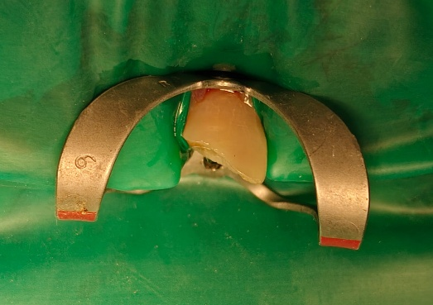
Fig 2 : Rubber dam isolation
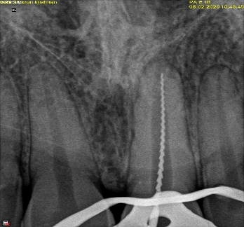
Fig 3: Working length deteremination
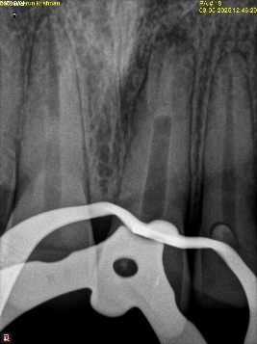
Fig 4 : Placement of Biodentin
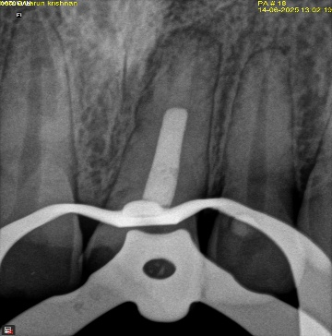
Fig 5 : Obturation
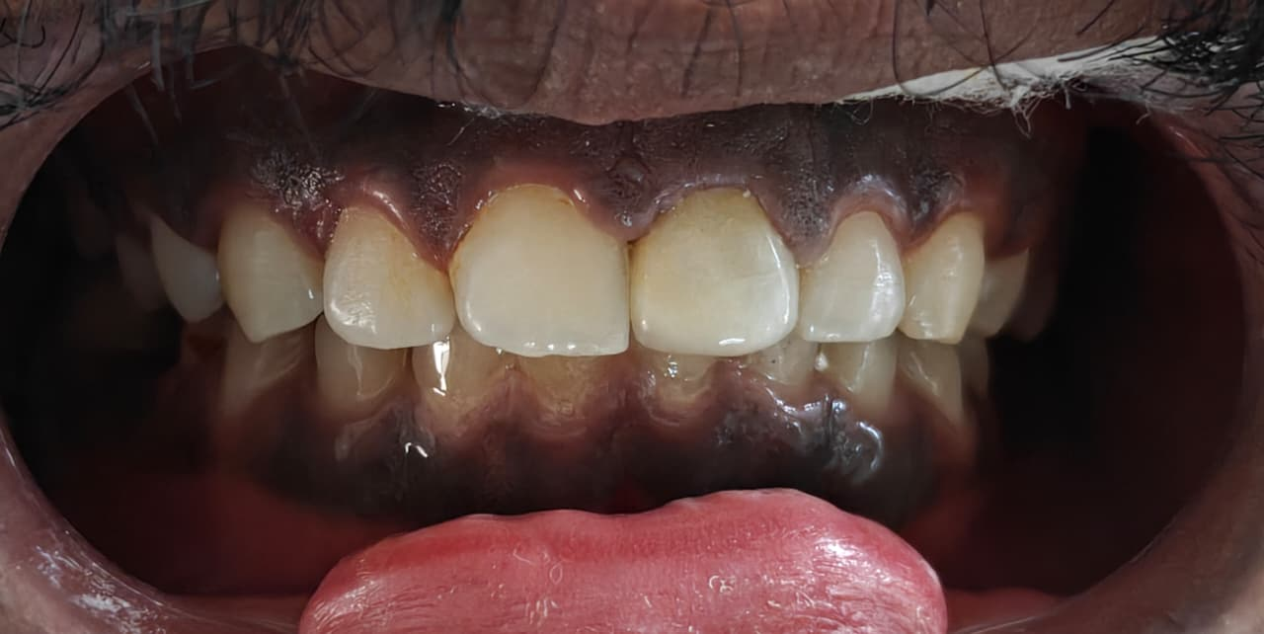
Fig 6: Post operative clinical picture after crown cementation

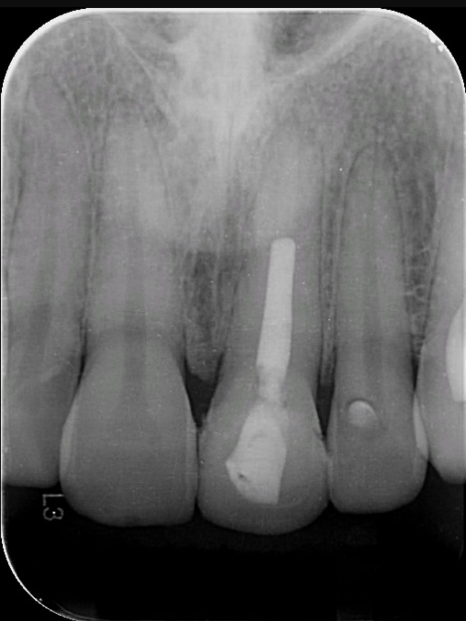
Fig 7 : 3 month follow up radiograph

