Original Research Article

Comparative Evaluation of Flexural Strength, Compressive Strength and Fracture Resistance of Glass-Ceramic and Zirconia-Filled Core Build-Up Materials

Abstract
Background:
Dual-cure resin composites are widely used for core build-ups, yet limited comparative data exist between glass ceramic and zirconia filled core build up materials.
Aim:
To compare the flexural strength, compressive strength and fracture resistance of the two core build up materials.
Materials and Methods:
Sixty specimens were prepared and divided into two groups (n=30). Subgroups (n=10) were tested for flexural strength, compressive strength and fracture resistance using standardized protocols and a universal testing machine. Data were analyzed with t-test and ANOVA (p < 0.05).
Results:
Fusion Core DC Flo showed significantly higher flexural strength (p < 0.05), while compressive strength and fracture resistance were comparable between groups.
Conclusion:
Both materials exhibited satisfactory performance, with Fusion Core DC Flo offering an advantage in flexural strength.
Keywords: Core build-up, Dual-cure composite, Flexural strength, Compressive strength, Fracture resistance

Introduction
Restoration of endodontically treated teeth frequently requires the use of core build-up materials to replace lost coronal structure, enhance retention of definitive restorations, and withstand functional occlusal stresses. An ideal core material should demonstrate sufficient flexural strength, compressive strength and fracture resistance to resist intraoral forces and ensure the longevity of the restoration [1,2]. Failure of the core material can result in microleakage, debonding or catastrophic tooth fracture, ultimately compromising treatment prognosis [3]. Among these mechanical properties, flexural strength is of prime importance, as it reflects the ability of the material to resist bending and tensile stresses under masticatory load [4]. Compressive strength is equally critical since posterior teeth endure high vertical forces along the tooth’s long axis [5], while fracture resistance determines the material’s ability to prevent crack propagation and maintain structural stability under cyclic loading [6]. Dual-cure resin composites have become popular for core build-ups due to their convenient handling, polymerization in areas of limited light transmission, and enhanced mechanical properties compared to amalgam and glass ionomer cements [7,8]. The reinforcement strategy in these composites often involves different filler technologies, such as glass ceramic fillers or zirconia fillers, which significantly influence the final properties of the material [9,10]. Glass ceramic–based composites, such as Fusion Core DC Flo (PrevestDenPro, India), are designed with nano-hybrid glass ceramics that enhance translucency, esthetics, and bonding compatibility with resin cements [11]. Their microstructural configuration improves stress distribution and contributes to favorable flexural behavior [12]. In contrast, zirconia-filled composites, such as LuxaCore Z (DMG America, USA), incorporate high-density zirconia fillers to improve strength, radiopacity, and resistance to crack propagation [13,14]. Zirconia reinforcement has been shown to significantly enhance compressive and tensile properties due to its high modulus of elasticity and crack-deflection mechanism [15]. Although both materials are clinically popular, direct comparative evidence on their flexural strength, compressive strength, and fracture resistance under standardized conditions remains limited. Therefore, the present in vitro study aimed to evaluate and compare the mechanical performance of aglass ceramic–based core build-upmaterial (Fusion Core DC Flo)andazirconia-filled core build-up material (LuxaCore Z).
Materials and Methodology
This in-vitro study was designed to evaluate and compare the flexural strength, compressive strength and fracture resistance of two dual-cure core build-up materials: Fusion Core DC Flo (PrevestDenPro, India) and LuxaCore(DMG America, USA). The methodology was adapted from previously published in-vitro studies on core build-up materials to maintain standardization and reproducibility [1–4]. The required sample size was calculated using power analysis at 80% power and 5% level of significance based on effect sizes reported in earlier studies [2,3]. A total of sixty specimens were prepared, with thirty specimens assigned to each material. These were further divided into three subgroups of ten specimens each for testing flexural strength, compressive strength and fracture resistance respectively. Group 1: Fusion Core DC (PrevestDenPro, India)Subgroup 1A (n=10): Flexural strength testingSubgroup 1B (n=10): Compressive strength testingSubgroup 1C (n=10): Fracture resistance testing. Group 2: LuxaCore Z (DMG America, USA)Subgroup 2A (n=10): Flexural strength testingSubgroup 2B (n=10C):Compressive strength testingSubgroup 2C (n=10): Fracture resistance testing. For the flexural strength test, specimens were fabricated in a stainless steel split mold with dimensions of 25 mm × 2 mm × 2 mm, following ISO 4049:2019 specifications for polymer-based restorative materials [5]. The core material was dispensed into the mold in a single increment, covered with a Mylar strip and a glass slide, and light cured with an LED unit (1000 mW/cm²) for 40 seconds per surface. Chemical curing was allowed to proceed for an additional five minutes to ensure complete polymerization. The specimens were then finished with 600-grit silicon carbide paper to obtain uniform surfaces and stored in distilled water at 37 °C for 24 hours prior to testing. Flexural strength was determined using a three-point bending test on a universal testing machine (Instron, USA) with a span length of 20 mm and a crosshead speed of 1 mm/min. The flexural strength (σ) in megapascals (MPa) was calculated using the formula: σ=3FL/2bd² where F was the maximum load at fracture (N), L was the span length (mm), b was the specimen width (mm), and d was the specimen thickness (mm).For compressive strength evaluation, cylindrical specimens were fabricated using a stainless steel mold with dimensions of 6 mm height × 4 mm diameter, according to ANSI/ADA Specification No. 27 [6]. The materials were dispensed into the mold, covered with a Mylar strip, and cured in the same manner as described above. After curing, the specimens were stored in distilled water at 37 °C for 24 hours before testing. Compressive strength was determined using the universal testing machine under axial loading at a crosshead speed of 1 mm/min until failure. The compressive strength (σ) was calculated in MPa using the following formula:σ=4F/πd²where F was the maximum load at fracture (N), and d was the diameter of the specimen (mm). This formula correctly expresses compressive strength as load divided by cross-sectional area.For the fracture resistance test, twenty freshly extracted, caries-free human mandibular premolars of similar dimensions were selected. Teeth with cracks, restorations, or previous endodontic treatment were excluded. The teeth were cleaned and stored in 0.1% thymol solution at room temperature until use. Standardized endodontic access cavities were prepared, and root canals were instrumented using rotary nickel–titanium files up to size F3, followed by obturation with gutta-percha and resin sealer using cold lateral condensation. The teeth were decoronated at the cementoenamel junction to standardize the root length at 15 mm. Post spaces of 10 mm depth were prepared with Peeso reamers, leaving 4–5 mm of gutta-percha intact apically. No fiber posts were placed; instead, the post spaces were directly filled with the core material being tested to a height of 5 mm above the coronal tooth surface. Each specimen was embedded vertically in an acrylic resin block, leaving 2 mm of the root exposed to simulate the level of the alveolar crest.Fracture resistance was tested using the universal testing machine by applying a compressive load with a 3 mm diameter stainless steel ball placed at the center of the core at an angle of 30° to the long axis of the tooth to simulate occlusal contact. The load was applied at a crosshead speed of 1 mm/min until catastrophic failure occurred, and the maximum load at fracture was recorded in Newtons (N).All data were tabulated and subjected to statistical analysis using SPSS version 25.0 (IBM Corp., USA). Mean and standard deviation were calculated for each group. Intergroup comparisons between the two core materials were performed using the independent samples t-test. Intragroup comparisons, when required, were analyzed using one-way ANOVA followed by Tukey’s post hoc test. The level of statistical significance was set at p< 0.05. Typically, the modes of fracture for such studies are classified as: Type I – Cohesive failure within core material, Type II – Adhesive failure at the tooth–core interface (debonding), Type III – Mixed failure (both cohesive and adhesive)

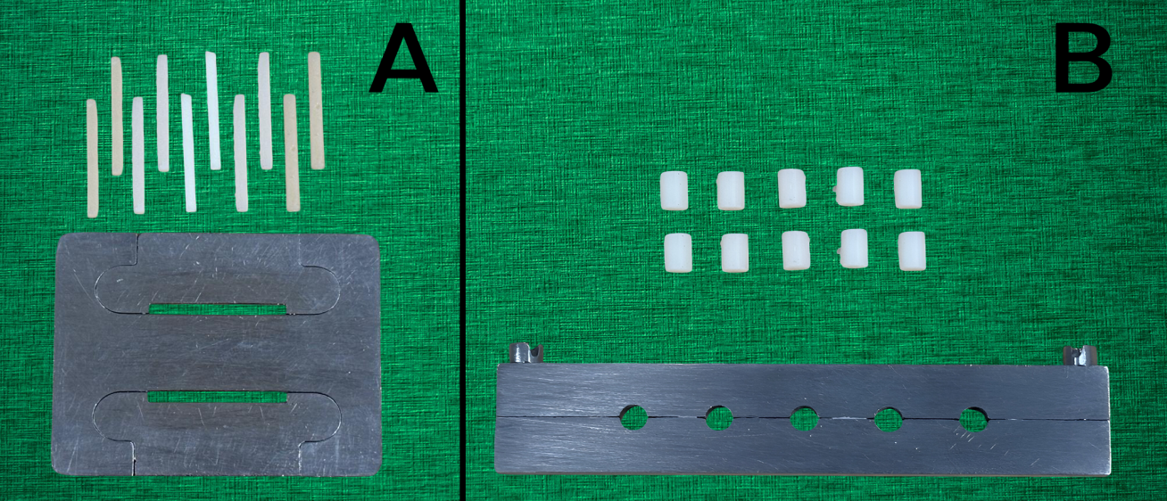
Figure 1: (A) Flexural strength specimens and mold (B) Compressive strength specimens and mold
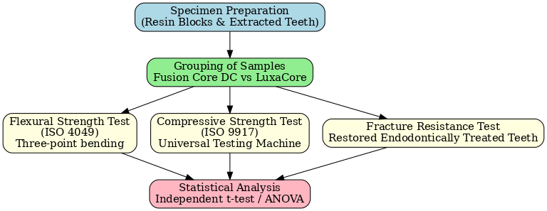

Results
A total of sixty specimens were tested across three parameters: flexural strength, compressive strength and fracture resistance. The mean values (±SD) are presented in Table 1.
Flexural Strength:
Fusion Core DC Flo demonstrated significantly higher flexural strength (132.5 ± 5.6 MPa) compared to LuxaCore Z(118.2 ± 4.9 MPa). Independent t-test revealed a highly significant difference (t = 11.92, p< 0.001).
Compressive Strength:
The compressive strength of Fusion Core DC Flo (290.3 ± 7.2 MPa) and LuxaCore Z (295.6 ± 6.8 MPa) was comparable. Statistical analysis showed no significant difference (t = 1.43, p = 0.170).
Fracture Resistance:
Fracture resistance values for Fusion Core DC Flo (447.7 ± 35.4 N) and LuxaCore Z (451.1 ± 32.8 N) were close. Although the independent t-test indicated a numerical difference (t = 2.43, p = 0.026), the clinical relevance of this finding may be limited, as both materials demonstrated comparable fracture resistance within functional ranges.

Table 1. Descriptive statistics of core build-up materials
Property | Material | Minimum | Maximum | Mean ± SD
Flexural Strength (MPa) | Fusion Core DC Flo | 124.2 | 140.8 | 132.5 ± 5.6
 | LuxaCore Z | 110.7 | 125.3 | 118.2 ± 4.9
Compressive Strength (MPa) | Fusion Core DC Flo | 280.5 | 301.6 | 290.3 ± 7.2
 | LuxaCore Z | 286.1 | 304.2 | 295.6 ± 6.8
Fracture Resistance (N) | Fusion Core DC Flo | 398.2 | 495.4 | 447.7 ± 35.4
 | LuxaCore Z | 406.8 | 495.2 | 451.1 ± 32.8
Values are expressed as Mean ± Standard Deviation (n = 10 per group).

Table 2. Distribution of fracture modes among the tested core build-up materials
Fracture Mode | Description | Fusion Core DC Flo (n = 10) | LuxaCore Z (n = 10)
Type I – Cohesive failure | Fracture within the core material | 3 (30%) | 4 (40%)
Type II – Adhesive failure | Debonding at tooth–core interface | 2 (20%) | 4 (40%)
Type III – Mixed failure | Combination of cohesive and adhesive failure | 5 (50%) | 2 (20%)
Total |  | 10 (100%) | 10 (100%)

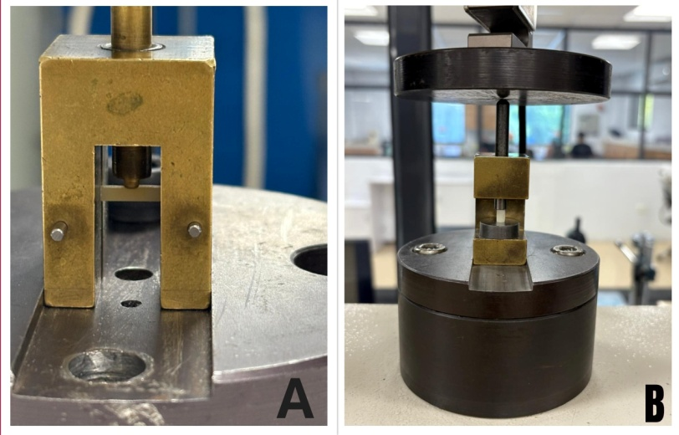
Figure 2:Flexural (A) and compressive strength (B) specimens loaded on Universal testing machine for testing
Discussion
This in-vitro study compared the flexural strength, compressive strength, and fractureresistance of a glass ceramic–based core build-up material (Fusion Core DC Flo) and a zirconia-filled composite (LuxaCore Z). The findings revealed that Fusion Core DC Flo demonstrated significantly higher flexural strength, while both materials exhibited comparable compressive strength and fracture resistance. The superior flexural strength of Fusion Core DC Flo (132.5 ± 5.6 MPa) compared to LuxaCore Z (118.2 ± 4.9 MPa) may be attributed to its glass ceramic nano-hybrid filler technology, which promotes better stress distribution and resistance to bending stresses. Glass ceramic fillers have been shown to enhance interfacial adhesion within the resin matrix and improve flexural properties due to their ability to reduce polymerization shrinkage stress and improve filler–resin bonding [16,17]. Additionally, smaller filler particle size and homogeneous distribution within glass ceramic composites facilitate superior crack deflection, thereby enhancing their ability to resist tensile stresses under functional loading [18]. This finding is clinically relevant, as flexural strength is directly related to a material’s resistance against lateral and shear stresses during mastication, especially in posterior restorations [19]. In contrast, LuxaCore Z contains high-density zirconia fillers, which are known for their high modulus of elasticity and crack propagation resistance [20]. The current study found no significant difference in compressive strength between the two materials (p = 0.170). Previous investigations have suggested that zirconia-filled composites tend to perform well under compressive loading, as zirconia particles improve bulk stability and resistance to axial forces [21]. However, our results indicate that glass ceramic reinforcement in Fusion Core DC Flo provides comparable compressive strength, demonstrating that both filler systems produce values within clinically acceptable ranges. The fracture resistance of endodontically treated teeth restored with the two core build-up materials showed no clinically meaningful differences, although statistical analysis indicated a minor variation (p = 0.026). Both materials demonstrated mean values (~448–451 N) within the range of average premolar occlusal forces (400–800 N), suggesting their suitability for clinical function [22]. It is possible that the absence of fiber posts in this study minimized differences, as the reinforcement provided by posts often magnifies material-dependent variations in fracture resistance [23]. Moreover, fracture resistance depends not only on the intrinsic material strength but also on its adhesive integration with dentin, restoration design, and residual tooth structure [24]. The present results align with earlier reports showing that dual-cure resin composites outperform amalgam and glass ionomer cements in terms of strength and durability [25]. While zirconia fillers enhance radiopacity and resistance to crack propagation, glass ceramic fillers contribute to better flexural properties and esthetics. Clinically, this suggests that Fusion Core DC Flo may be more advantageous in teeth subjected to multidirectional stresses, while LuxaCore Z remains a reliable option for cases requiring high compressive strength and radiopacity.

Clinical Implications
Both materials tested in this study—Fusion Core DC Flo (glass ceramic based) and LuxaCore Z (zirconia filled)—are dual-cure composites that provide effective polymerization even in areas of limited light penetration. Fusion Core DC Flo’s higher flexural strength suggests it may perform better in scenarios involving significant lateral or shear forces, such as premolars and anterior teeth under oblique loading. LuxaCore Z, with its zirconia reinforcement, offers enhanced radiopacity and mechanical durability, making it advantageous in posterior regions. Since both materials provided fracture resistance exceeding normal occlusal loads, they can be recommended as dependable choices for core build-up procedures.
Limitations
This study was conducted in vitro without consideration of fatigue loading, thermal cycling or long-term degradation. Only two materials were tested and the influence of different post systems or adhesive interfaces was not evaluated. Future studies incorporating artificial aging and clinical trials are needed to validate these findings.

Conclusion
Both Fusion Core DC Flo and LuxaCore being dual-cure resin composite core build-up materials, demonstrated adequate compressive strength and fracture resistance, confirming their suitability for clinical use. Fusion Core DC Flo however exhibited significantly higher flexural strength, indicating enhanced resistance to bending stresses. Fusion Core DC Flo may provide a practical and durable alternative to LuxaCore in core build-up procedures.
Disclaimer (Artificial intelligence)
Author(s) hereby declare that NO generative AI technologies such as Large Language Models (ChatGPT, COPILOT, etc.) and text-to-image generators have been used during the writing or editing of this manuscript.

References
- Ahmed J, Naidu E, Thakur B, Karobari MI, Marya A, et al. Fracture resistance of endodontically treated teeth restored with different core build-up materials: A systematic review and meta-analysis of in vitro studies. Polymers (Basel). 2021;13(14):2251. doi:10.3390/polym13142251
- Sreedevi A, Koneru S, Nujella BPS, Kumar M, Chaitanya KK, et al. Comparative evaluation of flexural strength and fracture toughness of different core build-up materials: An in-vitro study. J Conserv Dent. 2023;26(2):132-136. doi:10.4103/jcd.jcd_421_22
- Kaur J, Verma KG, Mahal H, Natt AS, Kaur A, et al. Comparative evaluation of compressive strength, diametral tensile strength and flexural strength of three different core materials: An in vitro study. J Conserv Dent. 2018;21(6):602-606. doi:10.4103/JCD.JCD_147_18
- Al-Sharif A, Al-Wahadni A, Abbadi MS, Al-Omari M. Evaluation of flexural strength and bond strength of core build-up materials to root dentin. Polymers (Basel). 2020;12(12):2947. doi:10.3390/polym12122947
- Joshi S, Gupta P, Jaiswal S, Mitali, Kaur M. Comparative evaluation of fracture resistance of endodontically treated teeth restored with different post and core systems: An in vitro study. J Appl Oral Sci. 2017;25(3):367-373. doi:10.1590/1678-7757-2016-0289
- Kale S, Hegde V, Rekha S. Evaluation of fracture resistance of endodontically treated maxillary premolars with different core build-up materials: An in vitro study. J Conserv Dent. 2021;24(4):375-380. doi:10.4103/JCD.JCD_140_21
- Sharma A, Arora A, Aggarwal A, Tewari S, Kumar S, et al. Comparative evaluation of fracture resistance of endodontically treated teeth restored with bulk-fill, dual-cure, and short fiber reinforced composite resins. J Conserv Dent. 2021;24(3):249-253. doi:10.4103/JCD.JCD_300_20
- Iqbal A, Shetty HK, Yadav NS, Ahmed S. Comparative evaluation of compressive and flexural strength of different core build-up materials: An in vitro study. J Int Oral Health. 2014;6(3):20-24. PMID: 25121062
- Tiwari S, Nandlal B. Evaluation of physical and mechanical properties of nano-filled composites. J Indian SocPedodPrev Dent. 2016;34(3):234-240. doi:10.4103/0970-4388.186747
- Garoushi S, Lassila L, Vallittu PK. Short fiber reinforced resin composite: A new alternative for direct onlay restorations. Open Dent J. 2009;3:181-185. doi:10.2174/1874210600903010181
- Ilie N, Hickel R. Investigations on mechanical behavior of dental composites. Clin Oral Investig. 2009;13(4):427-438. doi:10.1007/s00784-009-0258-4
- Mazzitelli C, Monticelli F, Toledano M, Ferrari M. Flexural behavior of fiber-reinforced resin composites for dental restorations. Dent Mater. 2012;28(9):910-918. doi:10.1016/j.dental.2012.05.009
- Al-Harbi FA, Ayad NM, ArRejaie AS, et al. In vitro evaluation of mechanical properties of zirconia-reinforced composites. Materials (Basel). 2019;12(20):3280. doi:10.3390/ma12203280
- Elsaka SE. Influence of zirconia filler content on the mechanical properties of resin composites. J Mech Behav Biomed Mater. 2013;21:124-132. doi:10.1016/j.jmbbm.2013.01.018
- Silva NRFA, Witek L, Coelho PG, Thompson VP, Rekow ED. The effect of zirconia-based systems on crack propagation in resin composites. Dent Mater. 2008;24(1):28-34. doi:10.1016/j.dental.2007.02.010
- Ilie N, Bucuta S, Draenert M. Bulk-fill resin-based composites: An in vitro assessment of their mechanical performance. Oper Dent. 2013;38(6):618–625. doi:10.2341/12-395-L
- Mitra SB, Wu D, Holmes BN. An application of nanotechnology in advanced dental materials. J Am Dent Assoc. 2003;134(10):1382–1390. doi:10.14219/jada.archive.2003.0054
- Ferracane JL. Resin composite—State of the art. Dent Mater. 2011;27(1):29–38. doi:10.1016/j.dental.2010.10.020
- Ruse ND, Sadoun MJ. Resin-composite blocks for dental CAD/CAM applications. J Dent Res. 2014;93(12):1232–1234. doi:10.1177/0022034514553976
- Elsaka SE. Influence of zirconia filler content on the mechanical properties of resin composites. J Mech Behav Biomed Mater. 2013;21:124–132. doi:10.1016/j.jmbbm.2013.01.018
- Al-Harbi FA, Ayad NM, ArRejaie AS, et al. Mechanical behavior of zirconia-reinforced resin composites for core build-up. Materials (Basel). 2019;12(20):3280. doi:10.3390/ma12203280
- Soares CJ, Pizi EC, Fonseca RB, Martins LR. Influence of root embedment material and periodontal ligament simulation on fracture resistance tests. Braz Oral Res. 2005;19(1):11–16. doi:10.1590/S1806-83242005000100003
- Lassila LV, Tanner J, Le Bell AM, Narva K, Vallittu PK. Flexural properties of fiber reinforced root canal posts. Dent Mater. 2004;20(1):29–36. doi:10.1016/S0109-5641(03)00067-0
- Schwartz RS, Robbins JW. Post placement and restoration of endodontically treated teeth: A literature review. J Endod. 2004;30(5):289–301. doi:10.1097/00004770-200405000-00001
- Dyer SR, Lassila LV, Alander P, Vallittu PK. Comparison of the flexural properties and fracture behavior of fiber-reinforced composite post and core systems. Dent Mater. 2005;21(5):457–464. doi:10.1016/j.dental.2004.07.014

