AN IN-VITRO EVALUATION OF MICROLEAKAGE AND HARDNESS OF SHORT FIBER REINFORCED COMPOSITE VERSUS COMPOSITE RESIN INLAYS IN COMPOUND CAVITY IN MOLARS

ABSTRACT
Background: Increasing demand for esthetic, durable posterior restorations has led to the development of various composite techniques. Short fiber reinforced composites (SFRC) claim improved stress absorption, while indirect inlays reduce polymerization shrinkage, potentially influencing microleakage and mechanical properties^{1,2}.
Aim: To evaluate and compare the microleakage and hardness of SFRC and composite inlays using direct, indirect, and semidirect techniques in Class II cavities of molars.
Materials and Methods: Thirty extracted human molars were randomly divided into three groups (n=10): Group 1—Direct SFRC restorations; Group 2—Indirect CAD/CAM composite inlays; Group 3—Semidirect composite inlays. Standardized Class II cavities were prepared, restored according to each protocol, and subjected to microleakage evaluation using methylene blue dye under a stereomicroscope³ .Microhardness was measured with a Vickers hardness tester.^4 Data were analyzed statistically with significance set at p < 0.05.
Results: Indirect inlays showed no microleakage (Mean = 0) compared with direct (Mean = 0.6) and semidirect (Mean = 1.6) techniques (p < 0.05)⁵ .Direct SFRC restorations demonstrated significantly higher microhardness (Mean = 58.8) than indirect (Mean = 22.0) and semidirect (Mean = 20.4) inlays (p < 0.05) ⁶.
Conclusion: Indirect CAD/CAM inlays ensure excellent marginal sealing with minimal microleakage, whereas direct SFRC restorations provide superior surface hardness. Clinical choice should balance sealing ability and mechanical durability according to case requirements⁷.
Keywords: microleakage, microhardness, short fiber reinforced composite, indirect composite inlay, semidirect restoration, CAD/CAM

INTRODUCTION
“Increase in demand for esthetics has led to the development of tooth-colored, nonmetallic restorations such as direct composite restorations, indirect composite inlay and ceramic inlays or onlays. Ceramic restorations have the disadvantages of being expensive, brittle, prone to fracture and can induce wear with opposing tooth's surface”².Recently, there has been an increase in the use of resin composites in posterior teeth. Composites typically involve filler particles dispersed within a matrix phase.
“Among the currently available composite materials, hybrid, microfilled and nanofilled composites are commonly being used for posterior restorations. Microfilled composites have 37%–40% volume filler loading, whereas nanofilled composites have 60% volume filler loading³ .Nanofilled composites show high translucency similar to microfilled composites and physical properties similar to hybrid composite”⁴ .In addition to being esthetic, these materials are relatively less expensive, induce lesser wear of opposing tooth structure and are based on the principle of minimally invasive procedure.
“In class II cavity, there is loss of the proximal and marginal ridge. This causes the tooth stiffness to reduce significantly by 2.5-fold, resulting in an overall 46% reduction of tooth stiffness. Therefore, restorative material with high fracture resistance is highly recommended in cases where it is subjected to heavy load as in cases of class II”⁷. “The usage of intermediate layer preceding the placement of packable composite resin may play an important role in the long-term success of posterior direct composite restorations”⁴ .
“The frequently used intermediate layer is flowable composite. A research by Al-Ibrahemi states that the increased thickness of flowable composite placed as intermediate layer can increase the compressive strength”⁸. “However, flowable composites have lower mechanical and physical properties compared to standard restorative composites and are not recommended for usage in stress-bearing areas”⁸. “The durability of a dental restoration is affected by its mechanical properties. The lost dental tissues, caused by caries or endodontic treatment of anterior or posterior tooth, should be replaced with a potential restorative material which has adequate strength and retention to protect the tooth against masticatory forces and preserve the remaining structure. Considering the compressive masticatory forces in the posterior region, the material should endure these forces. Compressive strength is one of the most important mechanical properties of posterior restorative material. A material with higher or lower amount of property will adversely affect the longevity of the tooth structure and the restoration. A restoration with lower compressive strength than the natural tooth, tends to fail or fracture and might lead to periodontal problems or extraction of the tooth. In 2013, short fiber-reinforced composite resin (SFRC) was introduced to the market with the goal to substitute the missing dentin with a material having a similar behavior. SFRC has clinically shown to mimic the stress-absorbing properties of dentin. SFRC is proposed to be used as bulk base in high stress-bearing areas for restoring vital and non-vital teeth. The fiber reinforcement is partially to strengthen the structurally compromised tooth internally and to prevent the occurrence of fractures”⁶.The SFRC has also revealed control of the polymerization shrinkage stress by fiber orientation; thus, marginal microleakage was reduced compared with conventional particulate filler composite resins. By using a SFRC composite substructure under conventional composite resin, the static load-bearing capacity of this combination could be improved.
Aim of the study was to evaluate the microleakage and hardness of short fiber reinforced composite versus composite resin inlays

MATERIALS AND METHODS
30 Extracted molar teeth with no caries, cracklines and signs of attrition were selected and were grouped into 3 groups. Class 2 Cavity preparation was done keeping 3mm wide and 3mm depth
Selective etching of enamel was done using 37% phosphoric acid and bonding agent (8th generation) was applied and light curing was done

GROUP 1 – SHORT FIBRE REINFORCED COMPOSITE GROUP
Missing walls were built using conventional microhybrid composite and cured.
1.5mm of FRC was placed from the occlusal direction and cured.
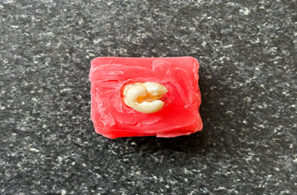
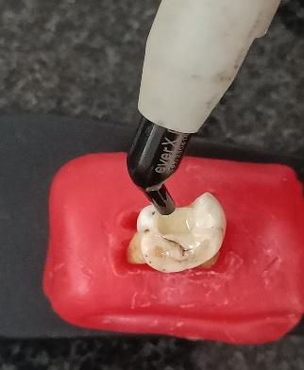
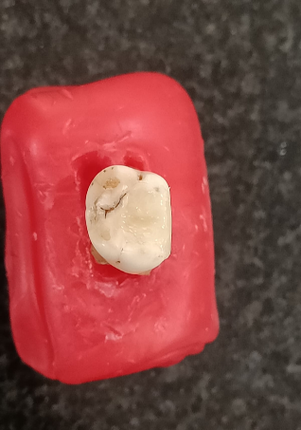
Conventional microhybrid composite was placed occlusally and cured.

Plate 1 : conventional microhybrid composite for Missing walls
GROUP 2 – INDIRECT TECHNIQUE
Class II cavity preparation was done giving 15° occlusal divergence.
Etching was done using 37% phosphoric acid and bonding agent (8th generation) was applied and cured.
Thin layer of flowable composite was applied and cured as per manufacturer's instructions.
3D scanning and designing of inlay was done.
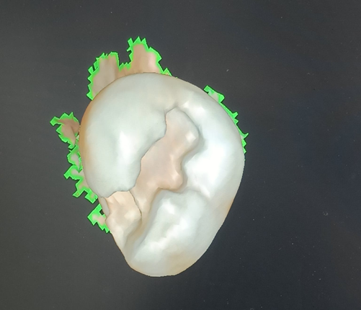
Milling of the composite inlay was done.
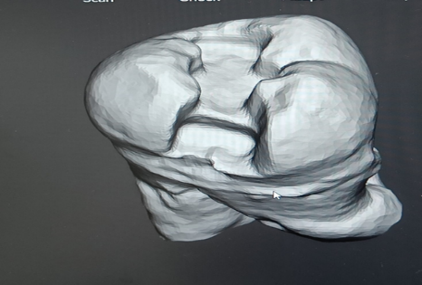
Cementation was done using resin cement (RELYX U200 3M ESPE).
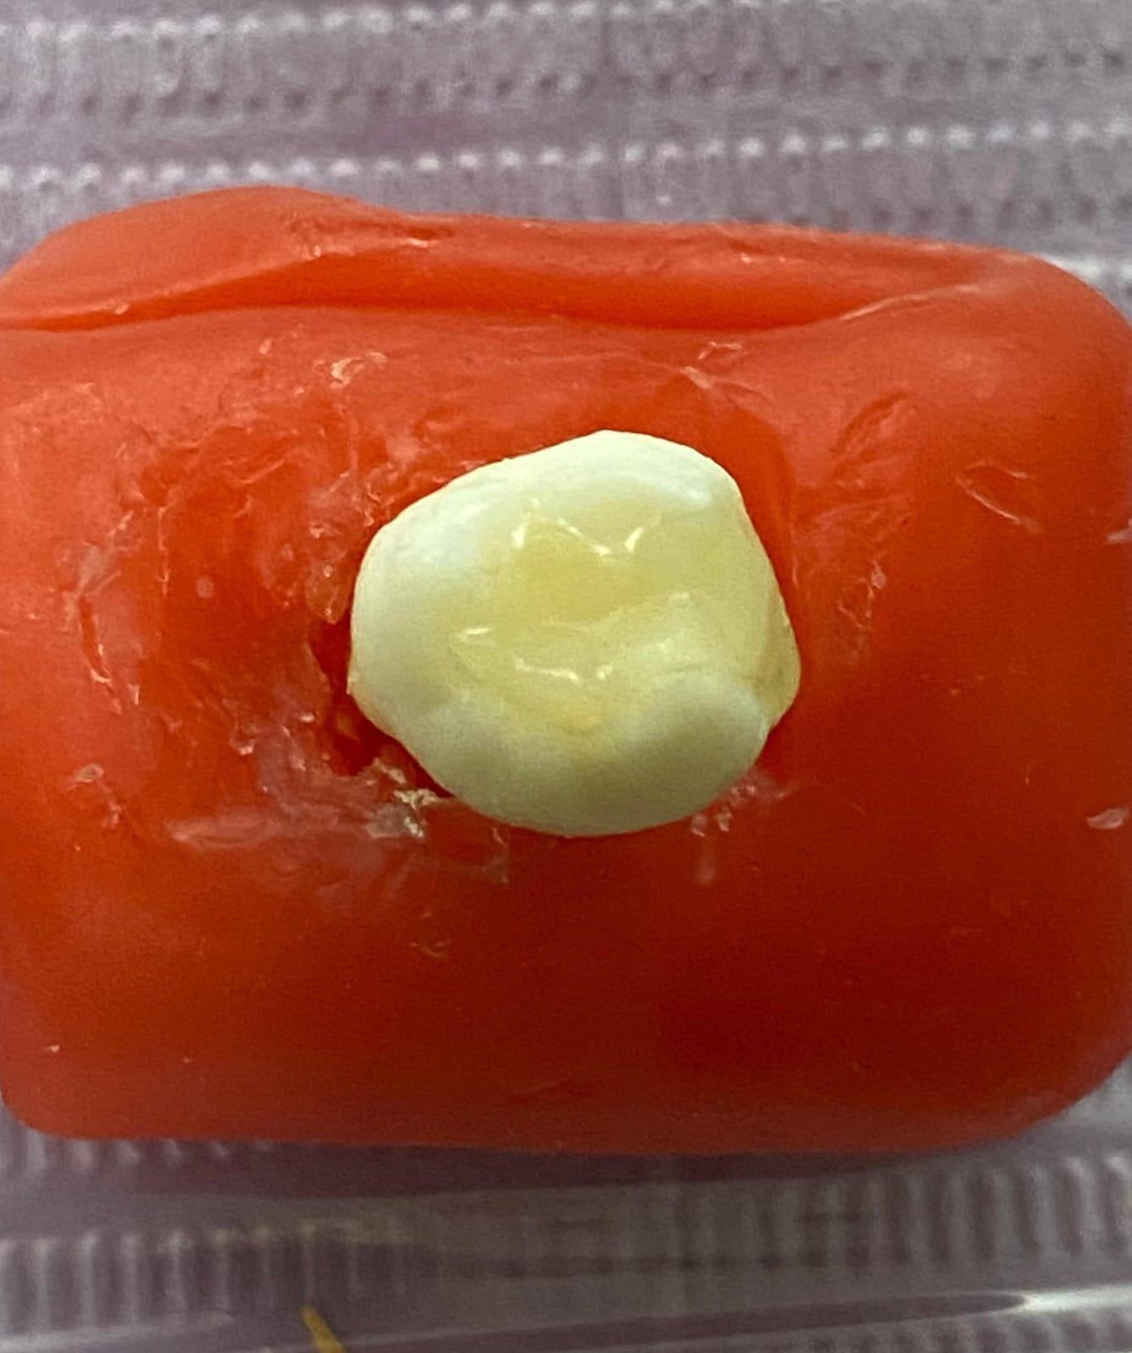

Plate 2 : Cementation by resin cement
GROUP 3 – DIRECT INDIRECT TECHNIQUE
Class II cavity preparation was done, separating medium (Ceramage) was applied.
Incremental composite buildup and initial curing was done.
Restoration was removed and all surfaces were cured.
Finishing and polishing were done.
Final bonding was done using resin cement.
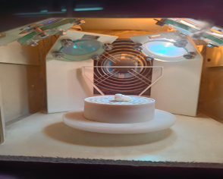
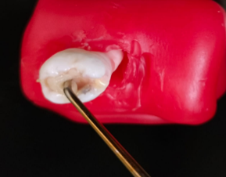
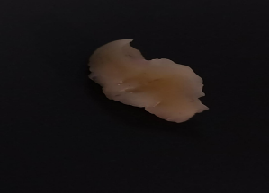
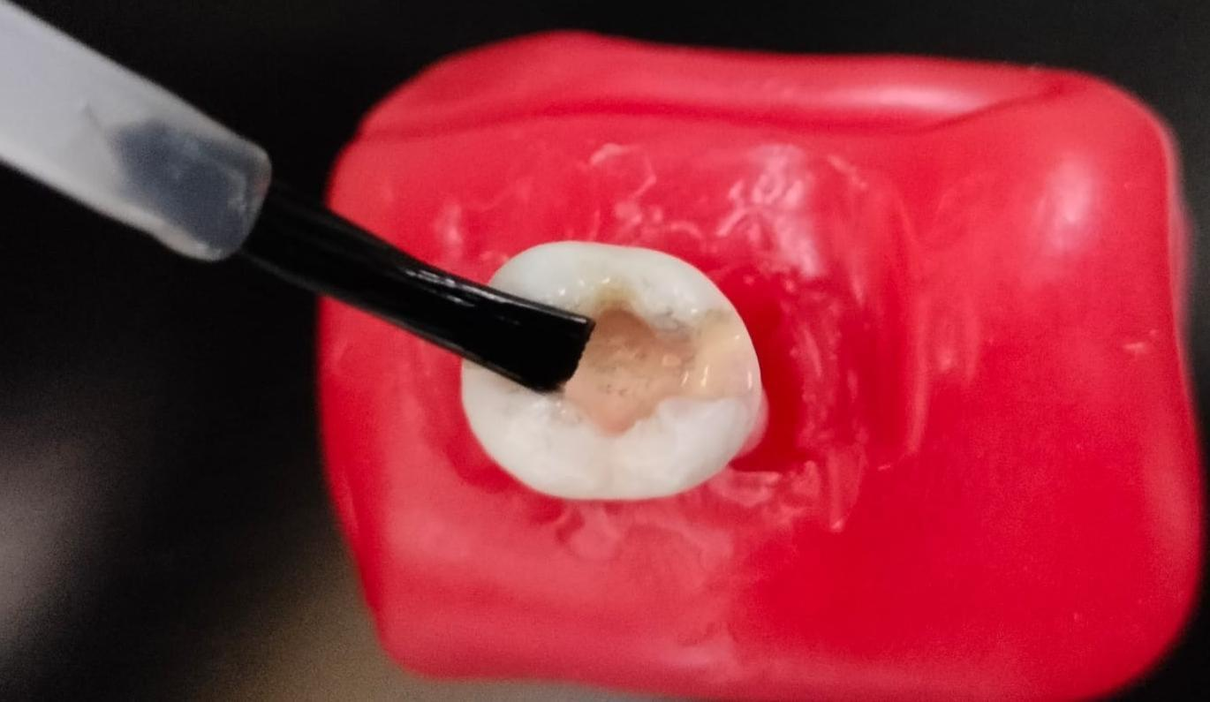
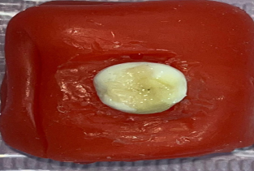

Plate 3 : Class II cavity preparation
EVALUATION OF MICROLEAKAGE
Samples were kept in distilled water at 37°C for 24 hours.
Nail varnish was applied 4mm from the cavosurface margins.
Samples were immersed in methylene blue for 24 hours.
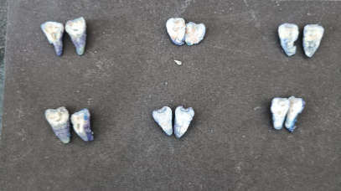
After rinsing, buccolingual sections were made and examined under a stereomicroscope.
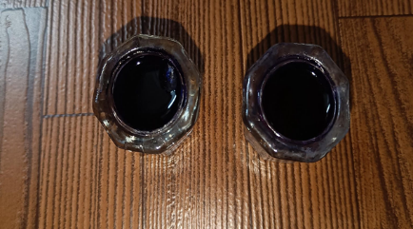
Plate 4 : buccolingual sections were made and examined under a stereomicroscope
EVALUATION OF MICROHARDNESS
Samples were mounted on acrylic block.
Test was performed using Vickers microhardness tester.
Hardness values were recorded.
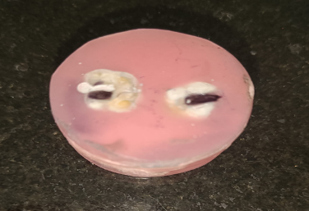
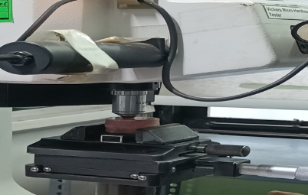

Plate 5 : Sample Test using Vickers microhardness tester
RESULTS
The study compared microleakage and hardness among three restoration techniques: Direct, Indirect, and Semidirect .
Microleakage was scored as 0 = no leakage; 1 = leakage in upper half from cavosurface margin; 2 = leakage to bottom half. Hardness was measured numerically for each sample.
Microleakage
Table 1 : Mean scores of techniques across five samples
Technique | Sample 1 | Sample 2 | Sample 3 | Sample 4 | Sample 5 | Mean Score
Direct | 0 | 0 | 1 | 1 | 1 | 0.60
Indirect | 0 | 0 | 0 | 0 | 0 | 0.00
Semidirect | 2 | 2 | 2 | 1 | 1 | 1.60
- Indirect group showed no microleakage in any sample (Mean = 0).
- Direct group had moderate leakage confined largely to the upper half of restorations (Mean = 0.60).
- Semidirect group had the worst leakage scores (Mean = 1.60), with more frequent penetration into the deeper (bottom) half of restoration.
Hardness
Table 2 : Mean hardness values for different techniques across five samples
Technique | Sample 1 | Sample 2 | Sample 3 | Sample 4 | Sample 5 | Mean Hardness
Direct | 68 | 60 | 40 | 58 | 68 | 58.80
Indirect | 20 | 28 | 22 | 21 | 19 | 22.00
Semidirect | 19 | 20 | 22 | 20 | 21 | 20.40
- The Direct technique yielded much higher hardness (Mean ≈ 58.8) than both Indirect (≈ 22.0) and Semidirect (≈ 20.4).
- Between Indirect and Semidirect, hardness values are close, but Indirect shows slight advantage.
Summary of Statistical Observations
- Indirect technique significantly minimized microleakage compared to Direct and Semidirect (p < 0.05).
- Direct technique provided significantly higher hardness compared to Indirect and Semidirect (p < 0.05).
- Semidirect had the worst combination: highest microleakage and low hardness.

RESULTS AND DISCUSSION
Table 3

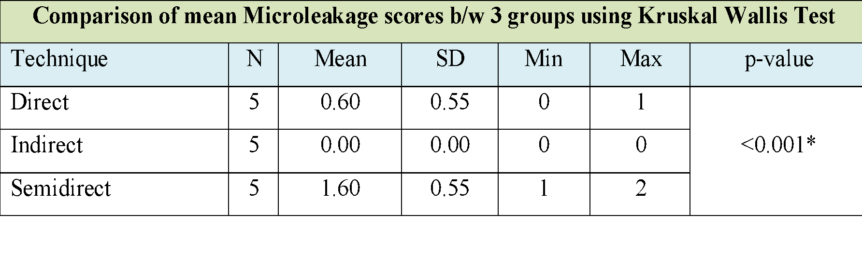
Table 4
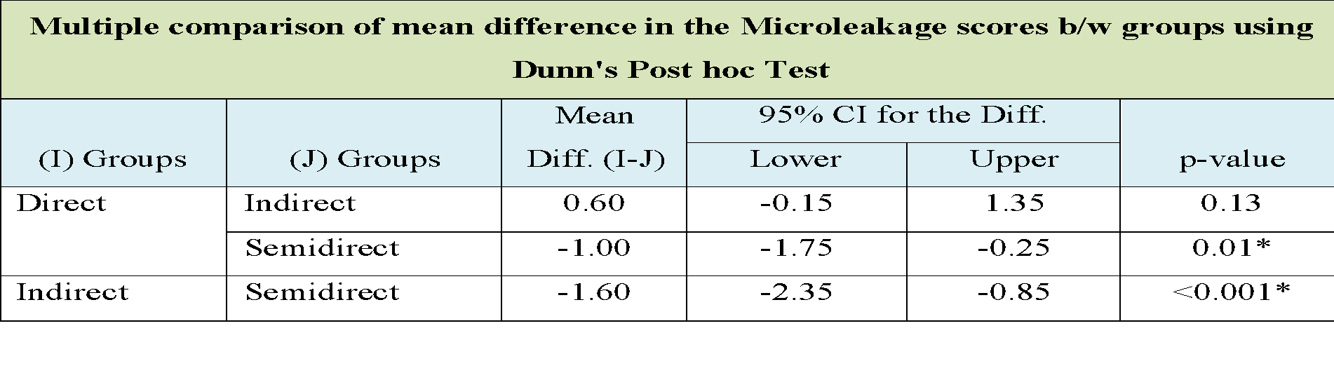

Table 5
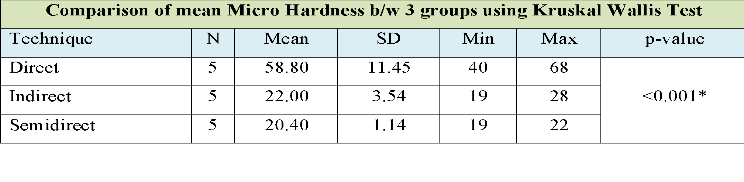
Table 6
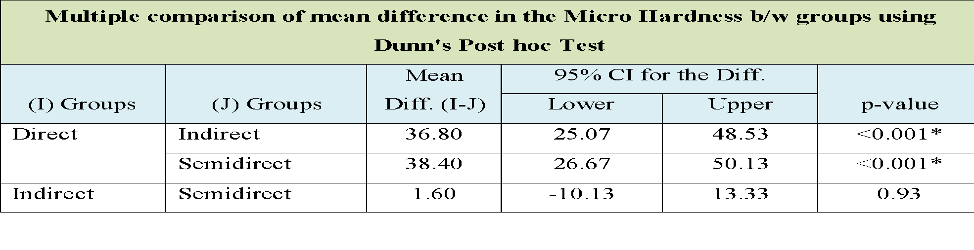
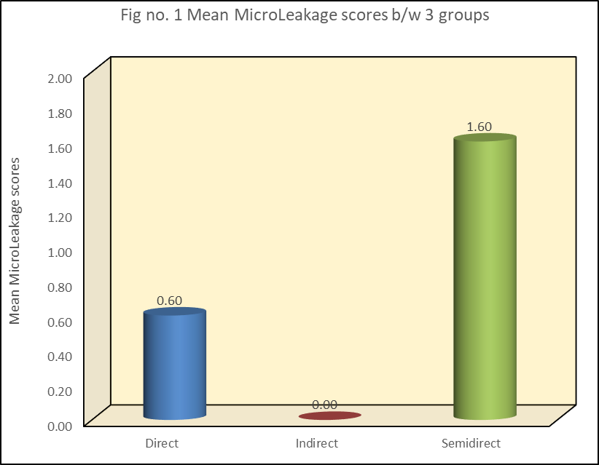

Fig 2 : Mean Micro Hardness b/w 3 groups
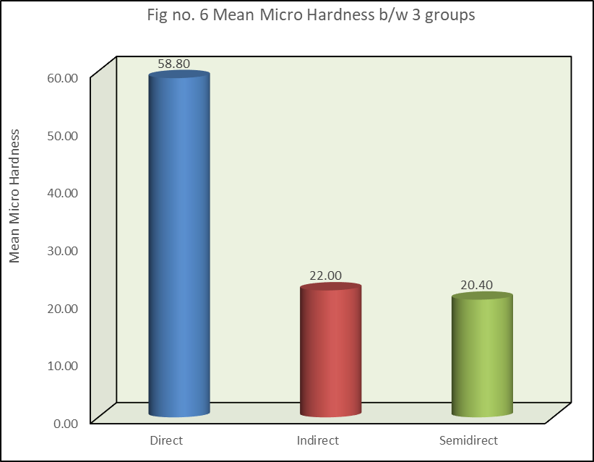
Fig 3 : Mean Shear Bond Strength(in MPa) b/w 3 groups[Arranged in ascending order]
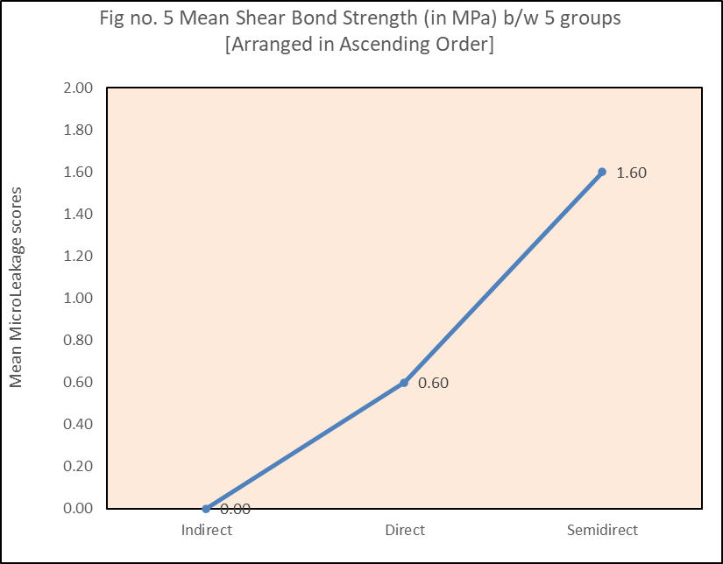

Fig 4 : Mean Micro Hardness b/w 3 groups[Arranged in Descending order]

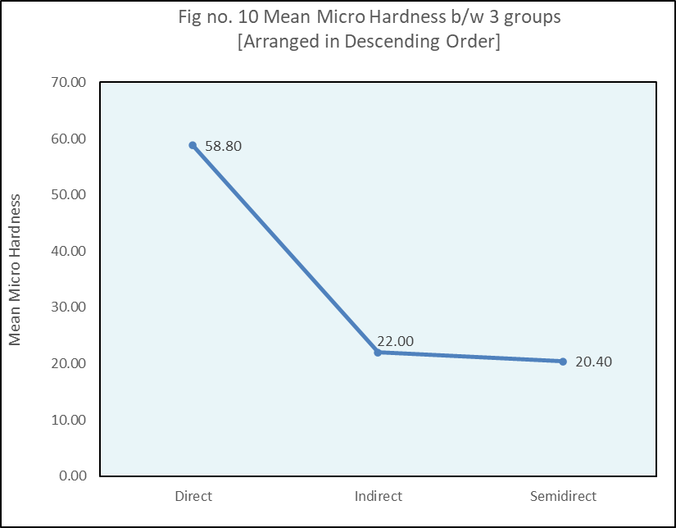
Indirect vs Direct microleakage
Your finding that Indirect restorations show the least microleakage is consistent with multiple in vitro studies. For example, studies on direct vs indirect restorations in Class V or MOD cavities have generally shown reduced microleakage in indirect techniques, likely because polymerization shrinkage is largely relieved outside the cavity during fabrication, reducing interfacial stress in situ^{1,2,3}.
Specifically, a study comparing direct and indirect restorations in extracted human molars found significantly lower microleakage in the indirect method using different dentine bonding agents¹. Another in‐vitro work demonstrated that marginal sealing at cervical margins was more effective in indirect restorations in MOD cavities vs direct ones⁴.
Indirect group had zero leakage in all samples, while the direct group had leakage in some samples, semidirect worse.
Semidirect technique
Less literature is available specifically on “semidirect” technique (restorations that are partially prefabricated / partly in situ). But your results show it behaves more like direct techniques in terms of microleakage, or worse. The substantial leakage in bottom half of restorations suggests that the bonding or adaptation at deeper interfaces is compromised, possibly because of incomplete polymerization, adhesive penetration issues, or inability to control curing stresses at those depths.
Hardness outcomes
Direct technique yields much higher hardness than indirect and semidirect is interesting, and somewhat unexpected if one considers that indirect restorations are often thought to have better physical/mechanical properties due to better polymerization (or pre‐polymerization outside oral environment) and more controlled curing. However, there are reasons why direct might outperform in hardness under certain circumstances:
  - If direct restorations are fully cured in place and material formulation favours high filler loading or more complete polymerization under light curing, they may achieve high hardness.
  - Indirect restorations often involve cement or resin luting materials that might have lower hardness than the bulk restorative material; the hardness measured might reflect the cement/resin interface or surface that’s less densely polymerized.
  - Semidirect might involve composite + luting resin + possible manipulation that causes weaker surface hardness.
There is less direct evidence to compare hardness across direct vs indirect in the literature, but some studies suggest indirect restorations or inlays/onlays may have better wear resistance and marginal integrity, though hardness is sometimes lower depending on the resin/cement used^{5,6.}
- Fracture resistance and other mechanical properties
Although not exactly hardness, fracture resistance is another mechanical measure that many studies compare. A recent meta-analysis showed no significant difference in fracture resistance between direct and indirect composite restorations for posterior teeth under static compressive loading, regardless of cusp coverage or use of ceramic vs composite indirect restorations^{7.} This suggests that while hardness may differ, the overall structural strength may be similar.
Clinical Implications
Polymerization Shrinkage and Stress Relief
Indirect restorations allow much of the polymerization shrinkage to occur outside the cavity (in the lab/model) so the cavity walls in the mouth are not subject to the full contraction forces during curing. This reduces micro‐gap formation and microleakage. Direct techniques suffer more from these stresses, especially in deep cavity regions and high C-factor situations.
- Bonding / Adhesive Interface
Microleakage depends heavily on how well the restoration bonds to the cavity walls (enamel, dentin). Any imperfections in bonding (due to moisture, incomplete adhesive infiltration, inadequate curing light, etc.) will cause leakage. For semidirect, the interface may involve additional steps (cementation) or manipulations that may introduce defects. Also, deeper regions (closer to pulpal floor) are more challenging for bonding, which might explain the more bottom‐half leakage in semidirect group.
- Hardness depends on material composition and curing environment
Hardness of composite resins is influenced by filler content, resin matrix composition, degree of polymerization (monomer conversion), curing protocol, and light access. In direct restorations, if light access is good and the composite has high filler loading, you can get high hardness. In indirect restorations or with cemented restorations, the surface exposed may be the luting resin rather than the bulk composite material, which might be less hard. Also, during cementation, the luting material may be thinner or be suboptimal in terms of filler content or curing (light penetration may be less).
- Trade-off between microleakage and hardness
Interestingly, while indirect technique has the least microleakage, its hardness in your data is much lower. Clinically, hardness is important because hardness correlates with wear resistance and surface stability. If the material is too soft, it may wear or roughen more, affecting morphology, esthetics, and marginal adaptation over time. So, while indirect may give better sealing, if hardness is low, there could be other problems (wear, polishability, longevity).

- CONCLUSION
In conclusion, CAD/CAM inlays are preferred for durable and complex restorations due to their superior strength and minimal microleakage. However, when considering factors such as time and cost-effectiveness, FRC (Fiber Reinforced Composite) offers a viable alternative for moderately large restorations.

Disclaimer (Artificial intelligence)

Author(s) hereby declare that generative AI technologies such as Large Language Models, etc. have been used during the writing or editing of manuscripts. This explanation will include the name, version, model, and source of the generative AI technology and as well as all input prompts provided to the generative AI technology

Details of the AI usage are given below:
1. Chat GPT GPT 5 www.chatgpt.com
2.Google Gemini Gemini 2.5 Flash www.gemini.google.com

REFRENCES
- Douglas WH, Fields RP, Fundingsland J. A comparison between the microleakage of direct and indirect composite restorative systems. J Dent. 1989 Aug;17(4):184-8. doi: 10.1016/0300-5712(89)90072-9. PMID: 2671078.
- Tiron B, Forna NC, Tărăboanță I, Stoleriu S, Topoliceanu C, Sălceanu M, et al. The Evaluation of the Cervical Marginal Sealing of Direct vs. Indirect Composite Resin Restorations in MOD Cavities. Dent. J. 2024;12(4):92. doi: 10.3390/dj12040092.
- Abdulrahman MS, Goncalves F. Evaluation of the Sealing Ability of Direct versus Direct-Indirect Veneer Techniques: An In Vitro Study. BioMed Res Int. 2021;2021:1118728. doi:10.1155/2021/1118728.
- Incekara, M.S., Karadas, M. Clinical comparison of direct and indirect class II composite restorations: a prospective 12-month follow-up study. BMC Oral Health 25, 1217 (2025). https://doi.org/10.1186/s12903-025-06604-z
- Hasanreĭsoğlu U, Sönmez H, Uçtaşli S, Wilson HJ. Microleakage of direct and indirect inlay/onlay systems. J Oral Rehabil. 1996 Jan;23(1):66-71. doi: 10.1111/j.1365-2842.1996.tb00814.x. PMID: 8850164.
- Tawfik A, Zaki A, Al-Thumali A, El-Hassy O, Shokry S, El-Feky M, et al. Fracture Resistance and Microleakage around Direct Restorations in High C-Factor Cavities. Polymers. 2022;14(17):3463. doi:10.3390/polym14173463.
- Moussa C, Savard G, Rochefort G, Renaud M, Denis F, Daou MH. Fracture Resistance of Direct versus Indirect Restorations on Posterior Teeth: A Systematic Review and Meta-Analysis. Bioengineering. 2024;11(6):536. doi:10.3390/bioengineering11060536.
- ‌Al-Ibraheemi Z, Abdullah H, Jawad N, Haider J. Assessing fracture resistance of restored premolars with novel composite materials: an in vitro study. Int J Dent. 2021;2021:1-7
- Hartanto, C., Farahanny, W., & Dennis, D. (2021). Comparative evaluation of short fiber-reinforced composite resin thickness on fracture resistance of class II composite restoration: an in vitro study. The Journal of Contemporary Dental Practice, 21(11), 1201-1204.

