Prosthetic mitral valve obstruction: pannus, thrombus, or both?

Abstract:

Background: Prosthetic mitral valve obstruction is an uncommon but serious complication after mechanical valve replacement. It is usually caused by pannus, thrombus, or both together. Distinguishing between these causes is essential because the treatment and prognosis differ, yet diagnosis can be difficult since imaging findings often overlap and surgical confirmation is sometimes needed.
Case Presentation: A 42-year-old woman with a previous mechanical mitral valve replacement presented with increasing shortness of breath and orthopnea. On examination, the prosthetic click was faint, and signs of pulmonary congestion were present. Echocardiography showed high transvalvular gradients and limited leaflet motion. Cinefluoroscopy confirmed restricted movement of one leaflet, while cardiac CT identified a dense structure around the sewing ring suggesting pannus with a superimposed low-density thrombus. Laboratory results were normal, including coagulation tests. Despite optimized anticoagulation, the patient’s condition worsened, and urgent reoperation was performed. Surgery confirmed mixed pannus and thrombus formation obstructing the prosthesis. The valve was replaced, and recovery was uneventful.
Discussion: This case highlights the difficulty of distinguishing pannus from thrombus in prosthetic mitral valve obstruction and shows the importance of combining different imaging techniques. Recognizing this dual mechanism early can help guide appropriate management and improve patient outcomes.

- Keywords: Prosthetic valve obstruction, Mechanical valve dysfunction, Thrombus, Pannus, cardiac surgery

Introduction:

Valvular heart disease affects more than 100 million persons worldwide and is associated with significant morbidity and mortality (1). Surgical valve replacement is one of the main treatments of severe valvular heart disease in patients at low and intermediate risk for surgery (1). Mechanical prosthetic valve (MPV) replacement exposes to various complications such as thromboembolism, prosthetic mismatch, endocarditis, microangiopathic hemolytic anemia, valve dehiscence, and valve dysfunction (pannus, dehiscence, valvular, or paravalvular regurgitation) (2) , resulting in a reduction of the leaflet motion or impaired leaflet coaptation, leaflet thickening , and a reduce or increased effective orifice area, this in turn, leads to an increased transvalvular gradient or transvalvular regurgitation, with or without valve-related symptoms.

Displaying both issues, valve dysfunction may be the result of thrombus formation which is the most common complication or fibrous tissue ingrowth (3). Both entities might occur simultaneously rendering the diagnosis and the management challenging.
Determining the main etiology of MPV dysfunction is a challenging yet crucial task requiring multimodal imaging including fluoroscopy, transthoracic, transesophageal echocardiogram, CT scan.

Case Presentation

Mrs. A.H., a 43-year-old woman with no cardiovascular risk factors, had a history of mechanical mitral valve replacement (St. Jude Medical, 27 mm) performed ten years earlier for severe rheumatic mitral stenosis. She was admitted to our department for progressive exertional dyspnea.
At presentation, she was in good general condition, afebrile, with a heart rate of 68 bpm, respiratory rate 16/min, and blood pressure 97/72 mmHg. There were no clinical signs of heart failure. Cardiac auscultation revealed a slightly muffled prosthetic valve sound, while pulmonary and peripheral examinations were unremarkable. Examination of the other systems, including neurological, pleuropulmonary, and digestive, was normal. She had been taking acenocoumarol, with an INR of 1.98 on admission.
Transthoracic echocardiography (TTE) showed preserved left ventricular systolic function and a fixed closed mitral valve leaflet. The mean transvalvular gradient was 10 mmHg, and the mitral valve area calculated by the continuity equation was 1.1 cm². The maximum E-wave velocity was 2.13 m/s (Fig 1).
Cine-fluoroscopy demonstrated a bileaflet mechanical valve with normal mobility of one leaflet and restricted motion of the other (Fig 2).
Transesophageal echocardiography (TEE), including three-dimensional imaging, confirmed restricted leaflet motion. It also showed a circular fibrotic tissue ingrowth from the atrial side and a small mass attached to the leaflet, consistent with thrombus (Fig 3). Doppler analysis revealed a mean gradient of 12 mmHg.
Serial postoperative echocardiograms had shown a gradual rise in the trans-mitral gradient from 6 mmHg to 8 mmHg, and later to 10 mmHg.
Given the gradual hemodynamic progression and the subtherapeutic INR, the coexistence of pannus and thrombus was suspected. A short trial of unfractionated heparin and aspirin was attempted without improvement. The patient subsequently underwent redo mitral valve replacement.
At surgery, circumferential pannus tissue was seen encasing both the atrial and ventricular aspects of the prosthesis, with overlying thrombus formation (Figure 4). The prosthesis was replaced, and the postoperative course was uneventful.

Discussion:

Prosthetic valve obstruction (PVO) occurs in about 0.5 % to 6 % of valve replacements per year, depending on the valve type and position (4). The main causes are prosthetic valve thrombosis (PVT) and pannus formation.
Thrombotic obstruction results from activation of the coagulation cascade on the metallic surface of the prosthesis, leading to fibrin and clot formation. It is often associated with inadequate anticoagulation and tends to appear within the first few years after surgery. Prompt diagnosis is critical because severe obstruction can lead to acute heart failure or embolic complications.
Pannus formation, in contrast, is a slow, fibrotic process caused by a chronic inflammatory reaction to the prosthetic material. Fibroelastic and collagen tissue progressively invade the prosthetic ring, leading to mechanical restriction of leaflet motion. This process generally appears many years after implantation (5).
Both mechanisms may coexist, with pannus serving as a site for thrombus formation. The combination of pannus and thrombus has been reported in 12 % to 75 % of all PVO cases (6). In our patient, the suboptimal anticoagulation level suggested a thrombotic component, whereas the slow increase in the transvalvular gradient over several years pointed toward pannus development.
The diagnosis of PVO relies on multimodality imaging:
- Transthoracic echocardiography (TTE) is the first-line test for assessing gradients and leaflet motion but is often limited by acoustic shadowing.
- Cine-fluoroscopy is the reference method for evaluating leaflet motion in mechanical prostheses, yet it cannot define the underlying cause (6,7).
- Transesophageal echocardiography (TEE), especially three-dimensional imaging, provides better visualization of the prosthetic ring and leaflets and helps distinguish pannus from thrombus. It correlates closely with surgical findings (8,9).
- Cardiac CT and, less commonly, CMR can be used when echocardiographic findings are inconclusive or technically limited (10).
Management depends on the cause and clinical status. Medical therapy, consisting of optimized anticoagulation or fibrinolysis, is reserved for thrombotic obstruction when symptoms are mild, and surgery carries high risk. Surgical replacement remains the treatment of choice for pannus-related obstruction or for cases where both mechanisms coexist.
Our case emphasizes the diagnostic value of combining TTE, TEE, fluoroscopy, and clinical data to identify mixed obstruction. It also emphasizes the importance of maintaining therapeutic anticoagulation in patients with mechanical valves and of early surgical intervention when medical therapy fails.

Conclusion:
PVO is a feared complication of mechanical valve replacement. Careful clinical and multiple non-invasive imaging modalities are necessary in the evaluation of these patient, since the diagnosis can be challenging specially especially when both thrombotic and pannus mechanisms coexist.

Disclaimer (Artificial intelligence)
Option 1:
Author(s) hereby declare that NO generative AI technologies such as Large Language Models (ChatGPT, COPILOT, etc.) and text-to-image generators have been used during the writing or editing of this manuscript.
Option 2:
Author(s) hereby declare that generative AI technologies such as Large Language Models, etc. have been used during the writing or editing of manuscripts. This explanation will include the name, version, model, and source of the generative AI technology and as well as all input prompts provided to the generative AI technology
Details of the AI usage are given below:
1.
2.
3.

References:

- Bernard Iung et Alec Vahanian, « Epidemiology of Valvular Heart Disease in the Adult », Nature Reviews Cardiology 8, no 3 (mars 2011): 162-72, https://doi.org/10.1038/nrcardio.2010.202.
- Rick A. Nishimura et al., « 2014 AHA/ACC Guideline for the Management of Patients With Valvular Heart Disease », Journal of the American College of Cardiology 63, no 22 (juin 2014): e57-185, https://doi.org/10.1016/j.jacc.2014.02.536.
- Jeanne M. Vesey et Catherine M. Otto, « Complications of Prosthetic Heart Valves », Current Cardiology Reports 6, no 2 (mars 2004): 106-11, https://doi.org/10.1007/s11886-004-0007-x.
- George D. Dangas et al., « Prosthetic Heart Valve Thrombosis », Journal of the American College of Cardiology 68, no 24 (décembre 2016): 2670-89, https://doi.org/10.1016/j.jacc.2016.09.958.
- Jason Salamon et al., « Mechanical valve obstruction: Review of diagnostic and treatment strategies », World Journal of Cardiology 7, no 12 (26 décembre 2015): 875-81, https://doi.org/10.4330/wjc.v7.i12.875.
- Patrizio Lancellotti et al., « Recommendations for the Imaging Assessment of Prosthetic Heart Valves: A Report from the European Association of Cardiovascular Imaging Endorsed by the Chinese Society of Echocardiography, the Inter-American Society of Echocardiography, and the Brazilian Department of Cardiovascular Imaging », European Heart Journal – Cardiovascular Imaging 17, no 6 (juin 2016): 589-90, https://doi.org/10.1093/ehjci/jew025.
- Macit Kalçık et al., « Identification of Mechanical Prosthetic Heart Valves Based on Distinctive Cinefluoroscopic and Echocardiographic Markers », The International Journal of Artificial Organs 42, no 11 (novembre 2019): 603-10, https://doi.org/10.1177/0391398819860845.
- Paul A. Grayburn, « Multimodality Imaging of Suspected Mechanical Prosthetic Valve Obstruction », JACC: Cardiovascular Imaging 12, no 11 (novembre 2019): 2193-95, https://doi.org/10.1016/j.jcmg.2018.12.025.
- Lissa Sugeng et al., « Real-Time Three-Dimensional Transesophageal Echocardiography in Valve Disease: Comparison With Surgical Findings and Evaluation of Prosthetic Valves », Journal of the American Society of Echocardiography 21, no 12 (décembre 2008): 1347-54, https://doi.org/10.1016/j.echo.2008.09.006.
- Jesse Habets et al., « Imaging of Prosthetic Heart Valve Dysfunction », JACC: Cardiovascular Imaging 5, no 9 (septembre 2012): 956-61, https://doi.org/10.1016/j.jcmg.2012.03.018.

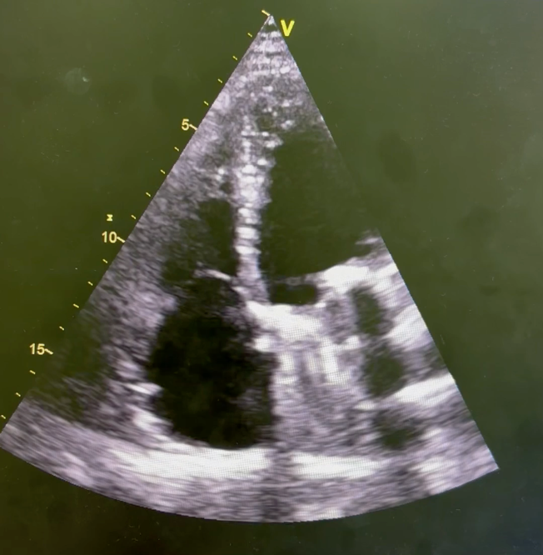
Fig 1: Transthoracic echocardiography (TTE) showing an unchanged ejection fraction and a fixed closed mitral valve leaflet
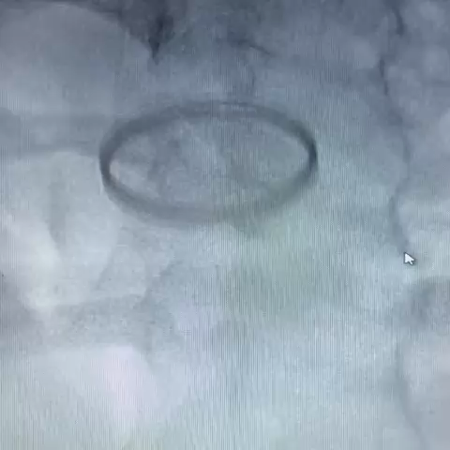
Fig 2: cine-Fluoroscopy showing a bi-leaflet mechanical mitral valve with absence of mobility of one mitral leaflet, and normal motion of the other one.

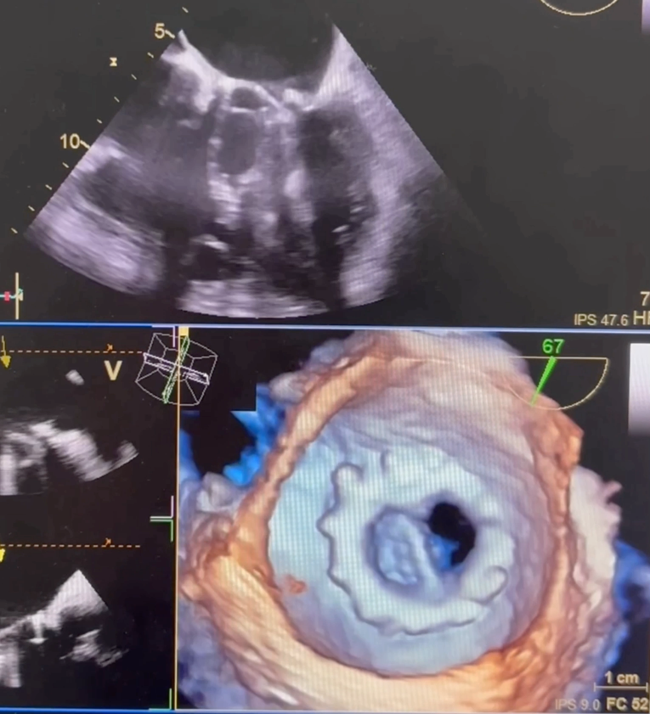

Fig 3: TEE: Two- and three-dimensional showing a reduced mobility of the leaflet, a circular fibrotic tissue ingrowth from the atrial view and a small element appending to the leaflet suggestive of a thrombus.

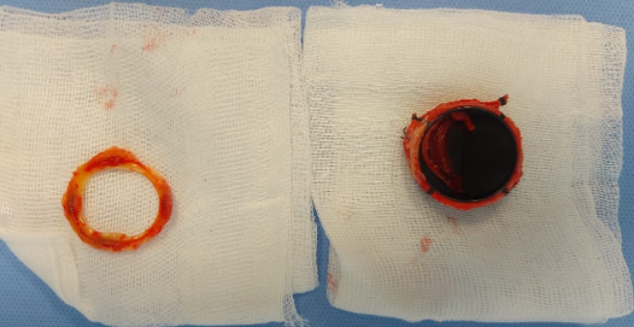

Figure 4: Surgical view showing the excised pannus (left) and the explanted mechanical mitral valve prosthesis with adherent thrombus (right).

Author (Year) | Study Type / Case | Valve Type & Location | Etiology of Obstruction | Key Findings | Management / Outcome
Roudaut et al., 2003 (J Am Coll Cardiol) | Retrospective study (263 PVO cases) | Mechanical, aortic & mitral | Thrombus (57%), pannus (10%), mixed (33%) | Pannus presented later and progressed slowly; thrombus related to subtherapeutic INR | Surgery indicated for pannus or mixed obstruction; thrombolysis reserved for pure thrombus
Barbetseas et al., 1998 (J Am Coll Cardiol) | Prospective TEE study | Mechanical mitral | Pannus vs. thrombus differentiation by TEE | Thrombus: soft, mobile, low echo density; Pannus: dense, fixed, ring-like | TEE highly sensitive for etiology distinction
Tsai et al., 2005 (Circulation) | Case series | Mechanical mitral | Mixed pannus–thrombus | Gradual gradient rise with acute obstruction | Successful redo valve surgery
Deviri et al., 1991 (J Thorac Cardiovasc Surg) | Surgical series | Mechanical (mostly mitral) | 65% thrombus, 23% pannus, 12% both | Early (<1 year): thrombus; Late (>5 years): pannus | Surgical removal or valve replacement recommended
Ozkan et al., 2013 (J Am Coll Cardiol Cardiovasc Imaging) | Imaging study | Mechanical mitral | Thrombus vs. pannus differentiation | 3D TEE provides accurate mass localization and morphology | Imaging guides therapy choice
García-Bustamante et al., 2021 (Eur Heart J Case Rep) | Case report | Mechanical mitral | Mixed pannus and thrombus | CT and TEE showed both fibrotic tissue and thrombus | Redo valve surgery with good outcome
Present case (2025) | Case report | Mechanical mitral (St. Jude 27 mm) | Mixed pannus and thrombus | Progressive gradient rise + subtherapeutic INR | Redo mitral valve replacement; uneventful recovery

Table 1. Summary of published literature on prosthetic mitral valve obstruction.

