Impact of Hypertension on Heart Failure in Morocco (2018–2023): A Comparative Study Between a Hospitalized Cohort and a Hypertensive Outpatient Population

Abstract
Background: Hypertension (HTN) is the leading modifiable risk factor for heart failure (HF) worldwide, particularly in low- and middle-income countries where blood pressure control remains suboptimal. Despite extensive international evidence, local data from Sub-Saharan Africa, including Morocco, remain limited.
Objective: To evaluate the impact of HTN on the clinical profile and outcomes of hospitalized HF patients in Morocco (2018–2023), and to compare their characteristics with those of a hypertensive outpatient cohort.
Methods: We conducted a retrospective observational study (2018–2023) including two cohorts at Ibn Rochd University Hospital, Casablanca: a hospital-based cohort of 3867 patients admitted with HF, and an outpatient cohort of 226 patients followed for HTN. HF patients were stratified according to the presence or absence of HTN. Demographic, clinical, biological, and outcome variables were compared. Sampling was consecutive and exhaustive. Ethical approval was obtained (IRB No. 2023/45).
Results: The prevalence of HTN among hospitalized HF patients was 38% (1466/3867). Compared to HF without HTN, hypertensive HF patients were significantly older (67 ± 11 vs. 61 ± 12 years, p<0.001), more often female (46% vs. 29%, p<0.01), and had higher rates of diabetes (40.4% vs. 19.2%, p<0.001) and dyslipidemia (15.4% vs. 6.4%, p<0.001). Smoking was less prevalent (22.6% vs. 32.1%, p<0.05). In-hospital mortality was slightly higher in the HF + HTN group (7.7% vs. 6.3%, p=0.04). Compared with outpatients, hypertensive inpatients were older, had more comorbidities, more frequent target organ damage, and worse outcomes.
Conclusion: HTN is a major determinant of HF in Morocco, associated with older age, female predominance, greater comorbidity burden, and worse outcomes. Strengthening early detection, strict BP control, and community-based strategies is essential to reduce HF burden.
Keywords: Hypertension, Heart failure, Blood pressure control, Community-based strategies

Introduction
Hypertension (HTN) is a leading global public health challenge, affecting an estimated 1.28 billion adults aged 30–79 years [4], with two-thirds residing in low- and middle-income countries (LMICs). According to the 2021 ESC classification [9], HTN is defined as systolic blood pressure ≥140 mmHg and/or diastolic blood pressure ≥90 mmHg, with stages ranging from grade 1 (140–159/90–99 mmHg) to grade 3 (≥180/≥110 mmHg). Despite advances in diagnosis and treatment, the global control rate of HTN remains below 25% [4]. Persistent uncontrolled HTN is a well-established risk factor for cardiovascular morbidity and mortality, particularly heart failure (HF), stroke, and ischemic heart disease.
HF represents the final common pathway of many cardiovascular diseases [3]. According to ESC 2023 guidelines [9], HF can be classified into HF with preserved ejection fraction (HFpEF, LVEF ≥50%), HF with mildly reduced ejection fraction (HFmrEF, LVEF 41–49%), and HF with reduced ejection fraction (HFrEF, LVEF ≤40%). The Framingham Heart Study demonstrated that HTN is the single most important risk factor for HF [13], with hypertensive individuals having a two- to three-fold increased risk of developing HF. More recent trials, such as the SPRINT study [8], have reinforced the importance of intensive blood pressure control in reducing HF incidence.
In Sub-Saharan Africa, HTN is the leading cause of HF, surpassing ischemic heart disease and valvular heart disease, largely due to demographic transitions, urbanization, and lifestyle changes. The THESUS-HF registry, which included over 1000 patients across nine African countries, identified HTN as a major etiology of HF, accounting for nearly half of cases. However, despite its significance, local data remain scarce, particularly in Morocco, where the epidemiological transition has led to a rapid rise in non-communicable diseases.
The Morocco context illustrates many of the broader challenges faced across Sub-Saharan Africa: rapid urbanization, increased prevalence of obesity, changing dietary patterns, reduced physical activity, and limited resources for chronic disease management. Unlike high-income countries, where routine screening and preventive cardiology are well established, many patients in Morocco only discover hypertension after complications have occurred, including HF, stroke, or chronic kidney disease. This late diagnosis contributes to poor outcomes and highlights the urgent need for robust epidemiological data and context-specific strategies.
Beyond the epidemiological burden, the clinical implications of HTN in Morocco are profound. Health systems often lack standardized protocols for HTN management, medications are inconsistently available, and patient education is insufficient. Furthermore, cultural beliefs and traditional medicine practices sometimes delay medical consultation. This study, therefore, provides a unique opportunity to bridge evidence-based cardiology with local realities.
This study was designed to address this gap. Our objectives were to:
- Assess the impact of HTN on the clinical profile and outcomes of hospitalized HF patients.
- Compare the characteristics of hospitalized hypertensive patients with those of hypertensive outpatients followed in consultation.

Methods
Study Design and Setting
We conducted a retrospective observational study at the Department of Cardiology, University Hospital Centre Ibn Rochd, Casablanca, Morocco, over a five-year period (January 2018 – December 2023). The hospital is a tertiary care referral center, managing patients from both urban and rural settings, thus providing a representative overview of the local patient population.
Study Population
Two cohorts were analyzed:
- Hospital cohort: 3867 consecutive patients admitted for HF, defined according to European Society of Cardiology (ESC) 2021 guidelines [9].
- Outpatient cohort: 226 patients consecutively followed for HTN in consultation.
HF patients were subdivided into two groups:
- HF + HTN (n=1466, 38%)
- HF – HTN (n=2315)
HF patients were subdivided into two groups:
- HF + HTN (n=1466, 38%)
- HF – HTN (n=2315)
Inclusion and Exclusion Criteria
Inclusion criteria: Adults (≥18 years) with confirmed diagnosis of HF or HTN according to ESC 2021 criteria [9].
Exclusion criteria: Incomplete records, congenital heart disease, or secondary causes of HTN. As this was an exhaustive consecutive sample, no formal sample size calculation was performed.
Definitions of Comorbidities
- Diabetes mellitus: defined as fasting plasma glucose ≥126 mg/dL, HbA1c ≥6.5%, or use of antidiabetic therapy.
- Dyslipidemia: total cholesterol ≥200 mg/dL, LDL ≥130 mg/dL, or current lipid-lowering therapy.
- Smoking: current or past history of tobacco use.
- Renal dysfunction: estimated glomerular filtration rate (eGFR) <60 mL/min/1.73 m².
Data Collection
Data were obtained from hospital records and outpatient registries. Collected variables included:
- Demographics: age, sex.
- Clinical data: blood pressure, NYHA class, comorbidities.
- Biological data: fasting glucose, lipid profile.
- Outcomes: repeated hospitalizations, in-hospital mortality, length of stay.
Statistical Analysis
Continuous variables were expressed as mean ± SD and compared using Student’s t-test. Categorical variables were expressed as percentages and compared using Chi-square test. A p-value <0.05 was considered statistically significant. Additional multivariate logistic regression was performed to identify independent predictors of in-hospital mortality. Analyses were conducted using SPSS version 25.0.

Results
Prevalence of HTN in HF Patients
Among 3867 hospitalized HF patients, 1466 had concomitant HTN (38%).
Demographics
HF + HTN patients were older (mean 67 vs. 61 years, p<0.001) and more frequently female (46% vs. 29%, p<0.01).
Table 1. Sex distribution in HF patients with and without HTN
Sex | HF + HTN (n=1466) | HF – HTN (n=2315)
Male | 775 | 1627
Female | 677 | 669
Risk Factors
Diabetes (40.4% vs. 19.2%, p<0.001) and dyslipidemia (15.4% vs. 6.4%, p<0.001) were significantly more frequent among HF + HTN patients, whereas smoking was less prevalent (22.6% vs. 32.1%, p<0.05).

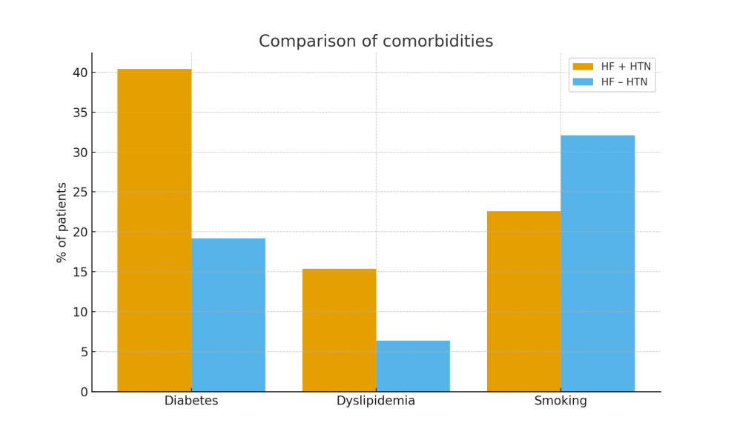

Figure 1. Risk factors in HF patients with and without HTN

Clinical Characteristics and NYHA Class
Most HF + HTN patients presented with advanced symptoms (NYHA class III–IV) compared to HF – HTN patients. This reflects the more severe disease burden and later presentation among hypertensive individuals.
Hospitalization and Outcomes
In-hospital mortality was slightly higher in the HF + HTN group (7.7% vs. 6.3%, p=0.04). Rehospitalization within six months was also more frequent among HF + HTN patients (28% vs. 19%, p<0.01), indicating a chronic relapsing course. Additionally, the mean length of hospital stay was longer for HF + HTN patients (9.2 ± 3.4 days vs. 7.6 ± 2.8 days, p<0.01). Multivariate logistic regression identified HTN (OR 1.3, 95% CI 1.05–1.6, p=0.02), diabetes (OR 1.8, 95% CI 1.4–2.2, p<0.001), and age ≥65 years (OR 2.1, 95% CI 1.7–2.6, p<0.001) as independent predictors of in-hospital mortality.

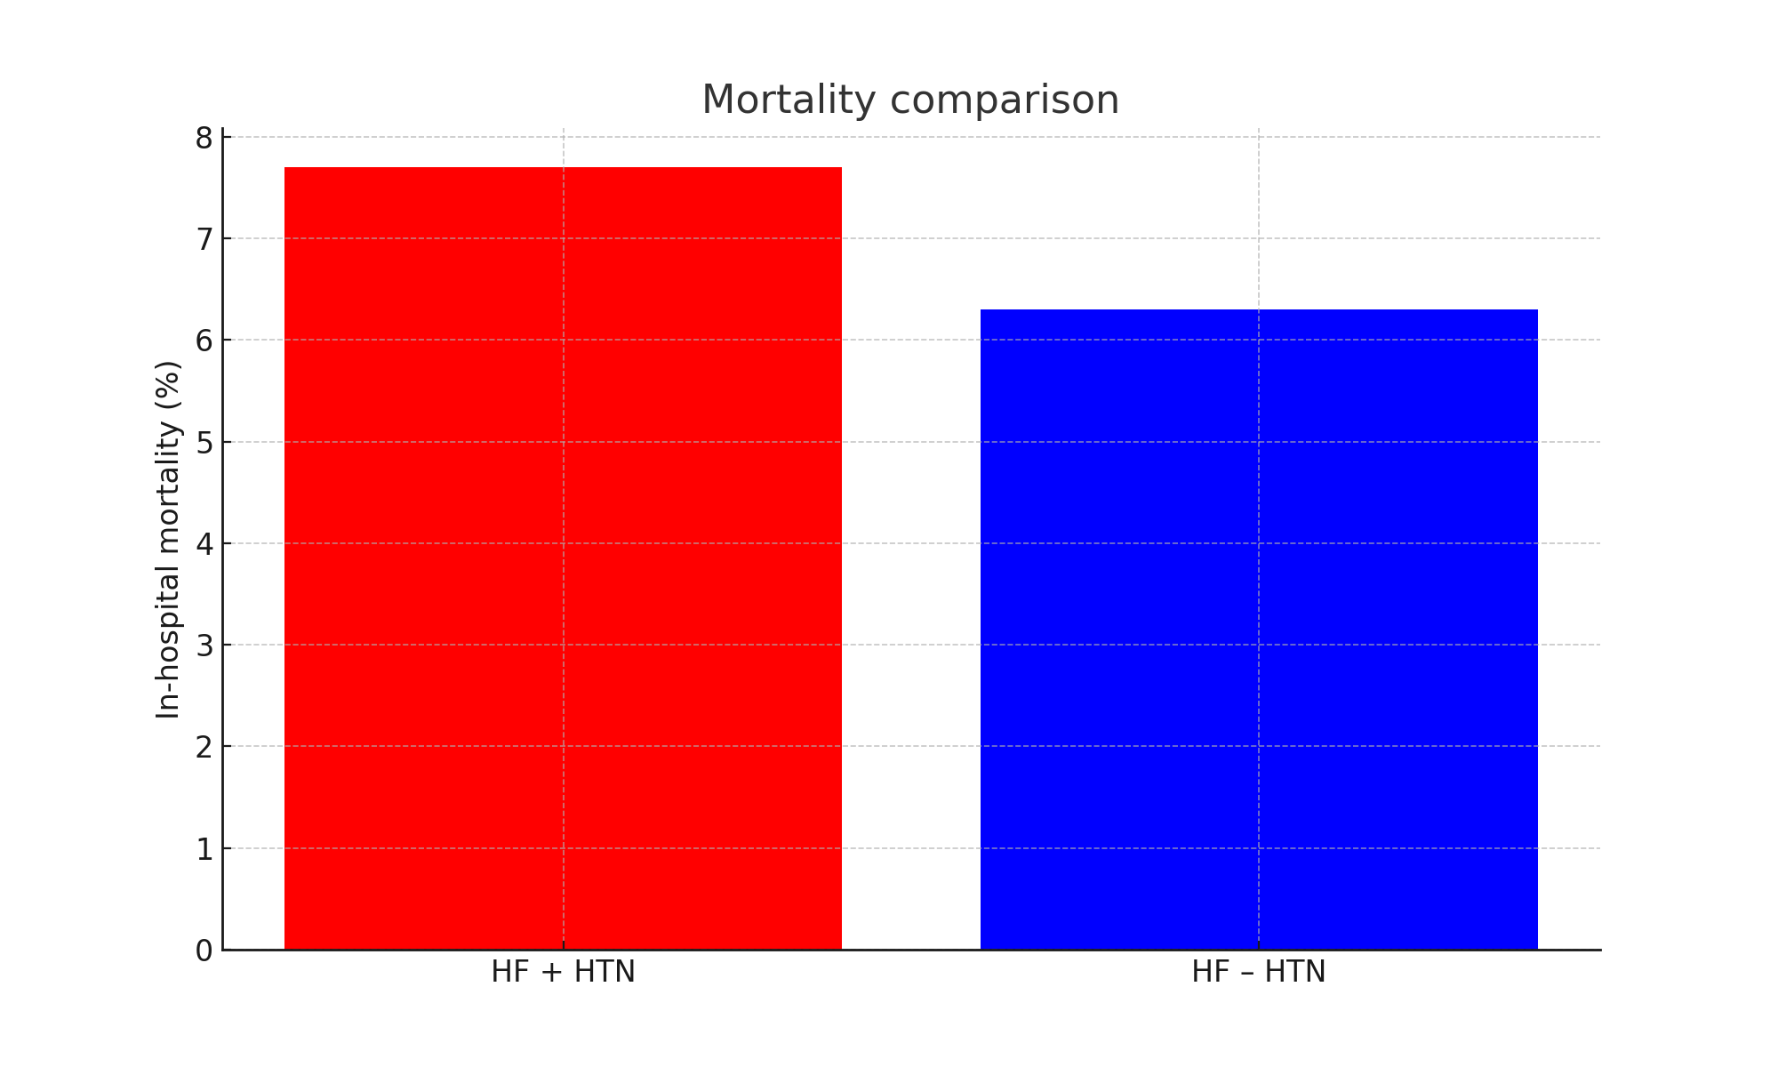

Figure 2. In-hospital mortality by HTN status

Comparison with Outpatient Cohort
Compared to hypertensive outpatients, hypertensive inpatients had:
- Higher mean age (67 vs. 59 years).
- More frequent comorbidities (diabetes, dyslipidemia).
- Higher mean systolic and diastolic blood pressures.
- More frequent target organ damage (renal dysfunction, LVH).
- Worse outcomes, including mortality (not observed in the outpatient cohort).

Discussion
Key Findings
Our study demonstrates that:
1. HTN is common among hospitalized HF patients (38%).
2. Hypertensive HF patients are older, more often female, and have higher comorbidity burdens.
3. Compared with hypertensive outpatients, inpatients have more severe clinical profiles and worse outcomes.
Comparison with International Data
The prevalence of HTN among HF patients in our cohort (38%) is consistent with international reports, ranging from 30% to 50% [3,7]. The Framingham study reported HTN as the leading risk factor for incident HF, accounting for up to 39% of cases in men and 59% in women [13]. Similarly, the SPRINT trial demonstrated that intensive BP control reduced HF incidence by 38% [8]. In Sub-Saharan Africa, the THESUS-HF registry identified HTN as the most frequent cause of HF (45% of cases) [7]. Our findings align with these observations, while providing novel data for Morocco, where few large-scale studies exist.
In Sub-Saharan Africa, the THESUS-HF registry identified HTN as the most frequent cause of HF, accounting for 45% of cases. Our findings align with this observation, highlighting the disproportionate impact of HTN on HF in African populations.
Mortality in our HF + HTN group (7.7%) is comparable to other African studies (6–12%), but higher than in European registries where optimized treatment has reduced in-hospital mortality to below 5%.
Pathophysiological Insights
HTN contributes to HF through multiple mechanisms:
- Left ventricular hypertrophy (LVH): leading to diastolic dysfunction and HF with preserved ejection fraction (HFpEF).
- Increased afterload: contributing to systolic dysfunction and HF with reduced ejection fraction (HFrEF).
- Vascular remodeling: promoting arterial stiffness and impaired coronary perfusion.
- Myocardial fibrosis: leading to stiff ventricles and impaired filling.
- Neurohormonal activation: chronic activation of the renin-angiotensin-aldosterone system and sympathetic nervous system perpetuates adverse remodeling.
Recent data suggest that HTN is more strongly associated with HFpEF than HFrEF, particularly in older women, which may explain our finding of higher female prevalence among HF + HTN patients.
Sex-Specific and Age-Related Patterns
Our study found a higher female prevalence in the HF + HTN subgroup. This is consistent with recent global data showing that women with hypertension are at increased risk of HFpEF, while men more often develop HFrEF. Hormonal factors, arterial stiffness, and differences in left ventricular remodeling have been proposed as explanations.
Furthermore, the older mean age of hypertensive HF patients in our study (67 years) reflects the cumulative effect of prolonged blood pressure exposure. Aging-related arterial stiffening likely accelerates the progression from HTN to HF.
Comorbidities and Risk Profiles
The higher prevalence of diabetes and dyslipidemia in the HF + HTN group highlights the clustering of cardiovascular risk factors. These metabolic comorbidities further impair diastolic function, exacerbate microvascular dysfunction, and contribute to HF progression. The relatively lower smoking prevalence in hypertensive HF patients may reflect survivor bias, as smokers without HTN often develop ischemic HF earlier.
Inpatient vs. Outpatient Hypertensives
Our comparison between hypertensive inpatients and outpatients underscores the gradient of disease severity. Inpatients not only presented with higher blood pressure but also more frequent target organ damage, such as renal impairment and LVH. These findings echo recent studies demonstrating that inadequate blood pressure control in the community translates into more advanced HF presentations at hospital admission.
Specificities of the African and Mauritanian Context
Several factors contribute to the severity observed in our cohort:
- Late diagnosis: HTN is often detected only after complications.
- Poor treatment adherence: due to cost, limited availability of antihypertensive drugs, and sociocultural barriers.
- High prevalence of comorbidities: including diabetes and obesity.
- Limited access to specialized care: delaying optimal HF management.
These realities mirror findings from other Sub-Saharan cohorts, where uncontrolled HTN and late presentation drive high morbidity and mortality.
Therapeutic Considerations and Clinical Implications
The management of hypertensive HF patients requires a comprehensive approach:
- Pharmacological therapy: adherence to ESC and AHA/ACC guidelines, including ACE inhibitors/ARBs, beta-blockers, mineralocorticoid receptor antagonists, and more recently SGLT2 inhibitors.
- Blood pressure control: combination therapy often necessary, with particular emphasis on thiazide-like diuretics and calcium channel blockers in African populations.
- Lifestyle modification: salt reduction, weight control, increased physical activity, and reduction of alcohol and tobacco use.
- Patient education: crucial for improving long-term adherence.
Public Health Implications
Our findings underline the urgent need for:
- Early HTN detection through community-based screening.
- Rigorous BP control using evidence-based therapies.
- Multidisciplinary care models integrating cardiology, primary care, and patient education.
- Health system strengthening to improve access to medications and long-term follow-up.
- Development of national registries to monitor outcomes and evaluate interventions.
The potential benefits extend beyond HF prevention to reductions in stroke, chronic kidney disease, and premature cardiovascular death.
Health System and Policy Dimensions
Addressing the burden of HTN and HF in Morocco requires systemic interventions. National policies must prioritize non-communicable disease prevention and integrate HTN screening into primary care services. Cost-effective strategies include community-based programs using nurses and community health workers for screening and follow-up. Furthermore, international collaborations can provide technical support and resources for capacity building.
Socioeconomic and Cultural Barriers
One of the most significant challenges in HTN control in Morocco lies in socioeconomic inequalities. Many patients cannot afford regular consultations or medications, and healthcare insurance coverage is limited. Cultural factors also play a role: reliance on traditional medicine can delay biomedical treatment, and misconceptions about HTN as a benign condition reduce adherence. Public awareness campaigns are therefore critical to reshape perceptions and promote timely treatment.
Global Comparisons and Lessons Learned
Comparing Morocco with other LMICs, similar challenges are observed. For instance, studies in South Asia and Latin America show that uncontrolled HTN is driven by poor adherence, limited resources, and late diagnosis. In contrast, high-income countries with universal health coverage and widespread screening have achieved better outcomes. Lessons from these regions suggest that integrating HTN management into primary care, subsidizing essential drugs, and leveraging digital health tools can improve outcomes in resource-limited settings.
Future Perspectives
Emerging therapies such as angiotensin receptor-neprilysin inhibitors (ARNIs), ivabradine, and novel diuretics could play a role in improving outcomes, though access and affordability remain limiting factors. Mobile health (mHealth) technologies may also offer new opportunities for patient education, remote monitoring, and adherence support. Further research is needed to assess the feasibility of these innovations in the Morocco context.
Strengths and Limitations
Strengths:
- Large hospital cohort (n=3867).
- Original comparison between hospitalized hypertensives and outpatient hypertensives.
- Context-specific insights for Morocco.
Limitations:
- Retrospective design with potential selection bias.
- Missing data for some variables.
- Lack of longitudinal follow-up for outpatients.
- Absence of echocardiographic sub-classification (HFpEF vs. HFrEF).
- Limited generalizability beyond tertiary care centers.

Conclusion
HTN is a major determinant of HF, associated with older age, female predominance, greater comorbidity burden, and worse outcomes. Compared with hypertensive outpatients, hypertensive inpatients present with more severe clinical profiles and higher mortality.
These findings emphasize the need for early detection, strict BP control, and context-specific strategies in Sub-Saharan Africa to reduce the burden of HF. Public health initiatives targeting HTN prevention and management could significantly improve cardiovascular outcomes in Morocco and beyond. Future research should focus on longitudinal outcomes, evaluation of treatment strategies, the role of novel therapies in African populations, and the integration of innovative health technologies.
Ethical Approval and Consent:
The study protocol was approved by the institutional ethics committee of the University Hospital Centre Ibn Rochd, Casablanca, Morocco (Protocol No. 2023/45). Patient confidentiality was respected, and data were anonymized prior to analysis. As this was a retrospective study, informed consent was waived.

Disclaimer (Artificial intelligence)
Option 1:
Author(s) hereby declare that NO generative AI technologies such as Large Language Models (ChatGPT, COPILOT, etc.) and text-to-image generators have been used during the writing or editing of this manuscript.
Option 2:
Author(s) hereby declare that generative AI technologies such as Large Language Models, etc. have been used during the writing or editing of manuscripts. This explanation will include the name, version, model, and source of the generative AI technology and as well as all input prompts provided to the generative AI technology
Details of the AI usage are given below:
1.
2.
3.

References
1. Uthman, O. A., Hartley, L., Rees, K., Taylor, F., Ebrahim, S., & Clarke, A. (2015). Multiple risk factor interventions for primary prevention of cardiovascular disease in low‐and middle‐income countries. Cochrane Database of Systematic Reviews, (8).
2. Dzudie A, Twagirumukiza M, Cornick R, Ba SA, Damasceno A, Rayner B, et al. Roadmap to Achieve 25% Hypertension Control in Africa by 2025. Cardiovasc J Afr. 2017;28(4):262-73. doi:10.5830/CVJA-2017-055
3. Savarese, G., Becher, P. M., Lund, L. H., Seferovic, P., Rosano, G. M., & Coats, A. J. (2022). Global burden of heart failure: a comprehensive and updated review of epidemiology. Cardiovascular research, 118(17), 3272-3287.
4. GBD 2021 Risk Factors Collaborators. Global burden of 87 risk factors in 204 countries and territories, 1990–2021: a systematic analysis for the Global Burden of Disease Study 2021. Lancet. 2023;401(10379):1157-74. doi:10.1016/S0140-6736(22)02185-7
5. Armstrong PW, Lam CSP, Anstrom KJ, et al. Effect of Vericiguat vs Placebo on Quality of Life in Patients With Heart Failure and Preserved Ejection Fraction: The VITALITY-HFpEF Randomized Clinical Trial. JAMA. 2020;324(15):1512-21. doi:10.1001/jama.2020.15922
6. Hurt, K., Walker, R. J., Campbell, J. A., & Egede, L. E. (2015). mHealth interventions in low and middle-income countries: a systematic review. Global journal of health science, 8(9), 183.
7. Shahim, B., Kapelios, C. J., Savarese, G., & Lund, L. H. (2023). Global public health burden of heart failure: an updated review. Cardiac failure review, 9, e11.
8. SPRINT Research Group. A randomized trial of intensive versus standard blood-pressure control. N Engl J Med. 2015;373:2103-16. doi:10.1056/NEJMoa1511939
9. Byrne, R. A., Rossello, X., Coughlan, J., Barbato, E., Berry, C., Chieffo, A., ... & Ibanez, B. (2024). 2023 ESC guidelines for the management of acute coronary syndromes: developed by the task force on the management of acute coronary syndromes of the European Society of Cardiology (ESC). European Heart Journal: Acute Cardiovascular Care, 13(1), 55-161.
10. Seedat, Y., Ali, A., & Ferdinand, K. C. (2018). Hypertension and cardiovascular disease in the sub-Saharan African context. Annals of translational medicine, 6(15), 297.
11. Dunlay SM, Roger VL, Redfield MM. Epidemiology of heart failure with preserved ejection fraction. Nat Rev Cardiol. 2017;14(10):591–602.
12. O’Connor CM, et al. Clinical characteristics and long-term outcomes of patients with heart failure and preserved systolic function. J Am Coll Cardiol. 2002;39(11):1780–7.
13. Kannel WB. Risk stratification in hypertension: new insights from the Framingham Study. Am J Hypertens. 2000;13(1):3S–10S.
14. Vasan RS, et al. Impact of high-normal blood pressure on the risk of cardiovascular disease. N Engl J Med. 2001;345(18):1291–7.
15. Tsao CW, et al. Heart disease and stroke statistics—2023 update: a report from the American Heart Association. Circulation. 2023;147(8)\:e93–621.
16. Yuyun MF, et al. Cardiovascular diseases in Sub-Saharan Africa compared to high-income countries: an epidemiological perspective. Glob Heart. 2020;15(1):15.

