Global Heart Failure Decompensation Revealing Fabry Disease: A Case Report

Abstract
Background: Fabry disease is a rare X-linked lysosomal storage disorder caused by mutations in the GLA gene, resulting in deficient activity of α-galactosidase A and subsequent accumulation of globotriaosylceramide (Gb3) in multiple organs. Cardiac involvement may mimic hypertrophic cardiomyopathy (HCM) or amyloidosis, leading to delayed recognition.
Case Presentation: We report a 67-year-old man with a history of complete atrioventricular block requiring pacemaker implantation, who was admitted with global heart failure decompensation. Echocardiography revealed concentric left ventricular hypertrophy and reduced ejection fraction. Coronary angiography was normal, and an extensive workup for amyloidosis was negative. Enzymatic assay confirmed markedly reduced α-galactosidase A activity, establishing Fabry disease diagnosis. Genetic testing and cardiac magnetic resonance imaging (CMR) were scheduled. The patient was referred for enzyme replacement therapy (ERT).
Conclusion: This case emphasizes the importance of considering Fabry disease in elderly patients with unexplained LVH, especially after amyloidosis exclusion. Early diagnosis, timely initiation of ERT or chaperone therapy, and systematic family screening are essential to improve outcomes.
Keywords: Fabry disease, GLA gene, Hypertrophic cardiomyopathy, Enzyme replacement therapy

Introduction
Fabry disease is a rare X-linked lysosomal storage disorder first described in 1898. It results from deficient activity of α-galactosidase A, leading to progressive accumulation of glycosphingolipids such as globotriaosylceramide (Gb3) and its derivative lysoGb3 in lysosomes of multiple cell types. The systemic accumulation affects vascular endothelium, cardiomyocytes, renal podocytes, neurons, and skin cells, producing a multisystemic disorder.
The clinical spectrum is broad. In its classic early-onset phenotype, affected males present in childhood or adolescence with acroparesthesias, angiokeratomas, corneal verticillata, hypohidrosis, renal impairment, and cerebrovascular events. Without treatment, progressive renal failure and cardiac disease lead to premature death. The late-onset or variant phenotype, often presenting in adulthood, is dominated by cardiac or renal manifestations and is easily misdiagnosed as other more common disorders.
From a cardiology perspective, Fabry disease is increasingly recognized as an important cause of unexplained left ventricular hypertrophy (LVH). Cardiac manifestations include concentric LVH, conduction abnormalities, arrhythmias, valvular thickening, and progressive systolic dysfunction. Importantly, Fabry cardiomyopathy can closely mimic sarcomeric HCM and infiltrative cardiomyopathies such as amyloidosis. The differentiation requires high suspicion, biochemical testing, and genetic confirmation.
Molecularly, α-galactosidase A deficiency disrupts glycosphingolipid metabolism, leading not only to substrate accumulation but also to secondary processes such as oxidative stress, inflammation, and myocardial fibrosis. These mechanisms explain the transition from hypertrophy to systolic dysfunction and heart failure.
Although disease-specific therapies such as enzyme replacement therapy (ERT) and pharmacological chaperones are now available, diagnosis remains frequently delayed. Raising awareness among cardiologists is therefore essential to avoid missed opportunities for early treatment.

Case Presentation
A 67-year-old man was admitted in March 2025 for global decompensated heart failure. His medical history was notable for complete atrioventricular block diagnosed in 2013, treated with dual-chamber pacemaker implantation. He had been diagnosed with type 2 diabetes mellitus one month prior to admission. Surgical history included appendectomy and cholecystectomy. No family history of cardiomyopathy, sudden cardiac death, or renal disease was reported.
He reported progressive exertional dyspnea evolving from NYHA class II to IV over two years, worsening peripheral edema, and occasional presyncopal episodes. He denied chest pain or palpitations. His baseline functional capacity had been declining despite regular follow-up with cardiology for pacemaker checks.
On admission: blood pressure 118/63 mmHg, heart rate 50 bpm (paced), respiratory rate 18/min, and oxygen saturation 99% on room air. Examination revealed bilateral lower limb edema, mild jugular venous distension, and clear lungs on auscultation.
Electrocardiogram (ECG) demonstrated a paced ventricular rhythm at 60 bpm. Echocardiography revealed concentric LVH with interventricular septal thickness 18 mm, posterior wall thickness 17 mm, global hypokinesia, and a moderately reduced LVEF (39–45%). There was biatrial enlargement, preserved RV function, and no significant valvular disease.
Laboratory findings showed NT-proBNP 908 pg/mL (ref <125), hs-troponin 54 ng/L (ref <14), HbA1c 7.2%, normal creatinine (0.9 mg/dL), and normal liver enzymes. Coronary angiography was normal. Extensive amyloidosis workup—including serum and urine electrophoresis, immunofixation, free light chain assay, and bone scintigraphy—was negative.
Enzymatic testing revealed markedly decreased α-galactosidase A activity (0.5 nmol/h/mg; ref 3.0–20). Diagnosis of Fabry disease was established. Genetic analysis of the GLA gene and cardiac magnetic resonance imaging (CMR) were scheduled for further characterization.
During hospitalization, he was treated with IV diuretics and started on eplerenone, dapagliflozin, metformin, and rosuvastatin. He responded well to diuresis and was discharged in stable condition. He was referred to a specialized metabolic center for evaluation and initiation of ERT. At one-month follow-up, the patient remained clinically stable (NYHA class II–III), with persistent LVH on echocardiography but improved symptoms.

Table 1. Key Laboratory and Diagnostic Findings
Test | Result | Reference Range
NT-proBNP | 908 pg/mL | <125 pg/mL
hs-Troponin | 54 ng/L | <14 ng/L
HbA1c | 7.2% | <6.5%
Creatinine | 0.9 mg/dL | 0.6–1.2 mg/dL
Liver enzymes | Normal | Normal
α-galactosidase A activity | 0.5 nmol/h/mg | 3.0–20 nmol/h/mg
Coronary angiography | Normal | No stenosis
Amyloidosis workup | Negative | Negative

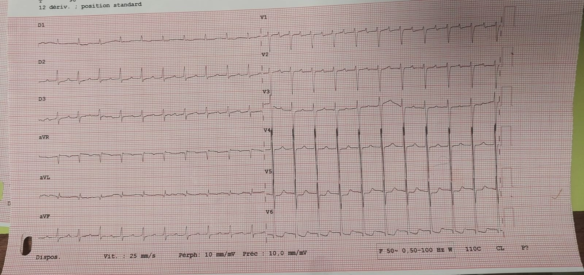

Figure 1. Electrocardiogram (ECG): Paced ventricular rhythm at 60 bpm with underlying complete atrioventricular block.

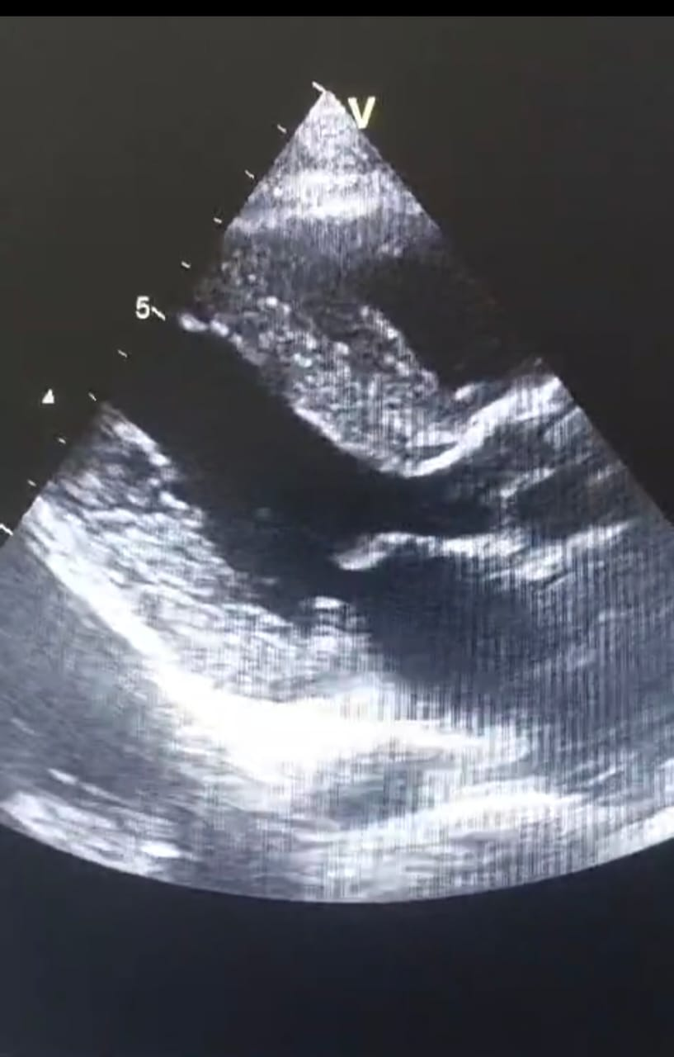 Figure 2. Transthoracic Echocardiography (TTE): Parasternal long-axis view showing concentric left ventricular hypertrophy (interventricular septum thickness 18 mm) and reduced ejection fraction (39–45%).

Discussion
This case highlights the diagnostic challenge of Fabry disease presenting as heart failure in an elderly patient. The overlap between Fabry cardiomyopathy and more common causes of LVH, particularly HCM and amyloidosis, is well recognized. Our patient had conduction disease, LVH, and systolic dysfunction, initially raising suspicion for amyloidosis. However, negative amyloidosis testing and reduced α-galactosidase A activity confirmed Fabry disease.
Differential diagnosis of LVH is crucial. Sarcomeric HCM typically shows asymmetric septal hypertrophy, while Fabry disease produces concentric LVH. Amyloidosis may show concentric hypertrophy as well, but often with low-voltage ECG and abnormal strain patterns. A summary comparison is shown in Table 2.

Table 2. Differential Diagnosis of LVH: Fabry Disease vs HCM vs Amyloidosis
Feature | Fabry Disease | HCM | Amyloidosis
Pattern of LVH | Concentric | Asymmetric (septal) | Concentric
ECG voltage | Normal/High | Normal/High | Low
Conduction abnormalities | Frequent (AV block) | Rare | Possible
Biomarkers | Low α-galactosidase A | Normal | Abnormal light chains/ATTR
CMR hallmark | Basal inferolateral LGE, low T1 | Asymmetric hypertrophy | Global subendocardial LGE, high T1
Pathophysiologically, Fabry cardiomyopathy reflects glycosphingolipid accumulation in cardiomyocytes, endothelial cells, and conduction tissue, leading to hypertrophy, fibrosis, arrhythmias, and eventual heart failure. Inflammatory pathways and oxidative stress contribute to disease progression. Late gadolinium enhancement (LGE) on CMR, particularly in the inferolateral wall, is a hallmark and indicates fibrosis.
The prevalence of late-onset cardiac Fabry disease is increasingly recognized, with estimates of 1–2% among patients with unexplained LVH. This highlights the importance of testing in elderly men with unexplained cardiomyopathy. Our case supports this recommendation.
Management of Fabry disease has evolved. ERT remains the cornerstone, reducing Gb3 accumulation and stabilizing LVH, especially if started early. Migalastat provides an oral option for amenable mutations. Supportive therapies (SGLT2 inhibitors, mineralocorticoid antagonists) should be used as in other cardiomyopathies. Even when initiated late, ERT can provide symptomatic and prognostic benefit.
Family screening is critical. Given its X-linked inheritance, male relatives are at high risk, and female carriers may present variably due to lyonization. Genetic counseling ensures timely identification and treatment.
Emerging therapies, including substrate reduction therapy and gene therapy, hold promise for altering disease trajectory. Device-based monitoring may also detect early decompensation (Hawkins et al., Eur J Heart Fail 2016).
This case reinforces three lessons: (1) Fabry disease must be considered in unexplained LVH; (2) late diagnosis still allows meaningful intervention; (3) genetic screening of relatives is essential for comprehensive management.

Conclusion
We report the case of a 67-year-old man presenting with global heart failure decompensation, ultimately diagnosed with Fabry disease. This case underscores the diagnostic complexity of Fabry cardiomyopathy and the need for systematic testing when amyloidosis and HCM are excluded. Early recognition remains key, but even late diagnosis enables initiation of disease-specific therapy and improved outcomes. Family screening and multidisciplinary management—integrating cardiology, genetics, and internal medicine—are critical to reducing disease burden. Increased awareness among clinicians will facilitate timely recognition of this rare yet treatable disorder.
Consent
As per international standards or university standards, patient(s) written consent has been collected and preserved by the author(s).
Disclaimer (Artificial intelligence)
Option 1:
Author(s) hereby declare that NO generative AI technologies such as Large Language Models (ChatGPT, COPILOT, etc.) and text-to-image generators have been used during the writing or editing of this manuscript.
Option 2:
Author(s) hereby declare that generative AI technologies such as Large Language Models, etc. have been used during the writing or editing of manuscripts. This explanation will include the name, version, model, and source of the generative AI technology and as well as all input prompts provided to the generative AI technology
Details of the AI usage are given below:
1.
2.
3.

References
1. Pande S, et al. Fabry disease cardiomyopathy: a state‑of‑the‑art review. Prog Cardiovasc Dis. 2025.
2. Hung CL, et al. 2024 Update of the TSOC Expert Consensus of Fabry disease. Acta Cardiol Sin. 2024.
3. Pieroni M, et al. Cardiac involvement in Fabry disease: recent advances. Eur Heart J Suppl. 2025.
4. Duro G, et al. Early diagnosis of cardiac involvement in Anderson‑Fabry disease. Expert Rev Cardiovasc Ther. 2025.
5. Jovanovic A, et al. Clinical efficacy and real‑world effectiveness of Fabry disease treatments: a systematic review. J Clin Med. 2025.
6. Dougherty S, et al. Cardiac manifestations of Fabry disease. Nat Rev Cardiol. 2025.
7. Oudit GY, et al. Cardiac and cerebrovascular outcomes of agalsidase beta treatment: systematic review. Front Cardiovasc Med. 2025.
8. Senlis J, et al. Cardiac magnetic resonance imaging in Fabry disease follow‑up. Int J Cardiol Imaging. 2025.
9. Figliozzi S, et al. Enzyme replacement therapy and cardiac MRI in Fabry disease. Orphanet J Rare Dis. 2024.
10. Lenders M, et al. Progress and challenges in the treatment of Fabry disease. Drugs. 2025.
11. Kallish S, et al. Long‑term efficacy of migalastat in females with Fabry disease. J Med Genet. 2025.
12. Tognola C, et al. Anderson–Fabry disease: current approaches and arrhythmic risk. Diagnostics (Basel). 2025.
13. Giliberti M, et al. Current and future therapeutic strategies for Fabry disease. J Transl Genet Genom. 2024.
14. Ricci F, et al. Prognostic significance of late gadolinium enhancement in Fabry disease. Am J Cardiol. 2023.
15. Averbuch T, et al. Anderson‑Fabry cardiomyopathy: recognition, diagnostics, management. Front Cardiovasc Med. 2023.
16. Giugliani R, et al. Diagnosis, therapy and follow‑up of Fabry disease: expert review. Mol Genet Metab. 2025.
17. Hawkins NM, et al. Predicting heart failure decompensation using cardiac implantable electronic devices: practices and challenges. Eur J Heart Fail. 2016;18(8):977‑986.

