Unraveling the Silent Crisis: A Rare Case of Acute Intestinal Obstruction Caused by Superior Mesenteric Artery Syndrome

ABSTRACT

Superior Mesenteric Artery (SMA) Syndrome, also known as Wilkie's Syndrome, is a rare and potentially life-threatening gastrovascular disorder characterised by the compression of the third portion of the duodenum between the abdominal aorta and the superior mesenteric artery. This case report presents a 22-year-old male with acute intestinal obstruction secondary to SMA syndrome. The patient, who had kyphoscoliosis and syndromic features, presented with sudden-onset epigastric pain, abdominal distension, and constipation. Imaging studies, including ultrasonography and contrast-enhanced CT, confirmed SMA syndrome with associated Nutcracker syndrome. Given the severity of obstruction, the patient underwent emergency exploratory laparotomy with surgical bypass procedure . Postoperatively, patient recovered well with no complications and was discharged This case highlights the importance of early recognition and prompt surgical intervention in SMA syndrome, particularly in patients with anatomical predispositions. Delayed diagnosis can lead to severe complications such as malnutrition, electrolyte imbalance, and gastrointestinal perforation. A multidisciplinary approach is crucial for optimal patient management and long-term outcomes. The case presents the diagnostic challenge and requirement of early diagnosis and emergency surgical intervention to avoid severe complications such as malnutrition, electrolyte imbalance, or gastrointestinal perforation. With this uncommon clinical presentation and successful surgery, the study offers valuable pointers that will assist clinicians to handle such complex cases. Furthermore, it contributes to the limited literature on SMA syndrome, particularly its correlation with other congenital deformities, thereby providing more clinical knowledge and choice.
Keywords: Superior Mesenteric Artery Syndrome, abdominal distension, Nutcracker syndrome, malnutrition, electrolyte imbalance

Introduction
“Superior Mesenteric Artery (SMA) syndrome, also known as Wilkie’s syndrome, is a rare cause of proximal small bowel obstruction resulting from compression of the third portion of the duodenum between the superior mesenteric artery and the aorta. The condition arises due to a reduction in the aortomesenteric angle and distance, leading to duodenal entrapment and subsequent obstruction” [1,2]. The reported incidence ranges from 0.013% to 0.3% in the general population, with a higher prevalence among young, thin individuals, particularly females [3].

Multiple etiological factors contribute to SMA syndrome, including rapid weight loss due to trauma, burns, anorexia nervosa, malignancy, or postoperative catabolic states. These conditions result in the loss of the mesenteric fat pad that normally cushions the duodenum from vascular compression [4,5]. Clinically, “patients often present with nonspecific symptoms such as postprandial epigastric pain, nausea, vomiting, early satiety, and significant weight loss, making diagnosis challenging” [6].
Radiological evaluation—especially computed tomography (CT) angiography—plays a crucial role in confirming the diagnosis by demonstrating a decreased aortomesenteric angle (<25°) and aortomesenteric distance (<8 mm) [7]. Initial management typically involves conservative measures aimed at nutritional rehabilitation and weight gain; however, surgical intervention such as duodenojejunostomy may be required in refractory cases [8].
Given its rarity and diagnostic complexity, early recognition of SMA syndrome is essential to prevent complications such as severe malnutrition and gastric perforation. This case report highlights the clinical presentation, diagnostic challenges, and management of a patient with superior mesenteric artery syndrome, emphasizing the importance of maintaining a high index of suspicion in at-risk individuals.

Presentation of case
A 22 year old male patient presented with complaints of Abdominal pain from 1 day of sudden onset in the epigastric region which gradually progressed in intensity with no aggravating and relieving factors, patient also complaints of abdominal distension, constipation, obstipation from 1 day.
No history of vomiting, trauma to abdomen, weight loss
Patient had no known Co-morbidities and denies substance abuse
Patient has Kyphoscoliosis from birth with high arched palate having syndromic features.
On examination patient was vitally stable , per abdominal examination revealed distended abdomen with umbilicus displaced inferiorly ,guarding present in the epigastrium, left hypochondrium and umbilical region,Tenderness present in the epigastric region , left hypochondriac and umbilical region with no rigidity , Bowel sounds sluggish .Abdominal X-ray and chest rays were done and showed air fluid level

Fig 1: Abdominal X-ray and chest rays indicating air-fluid level
Fig 2: Contrast CT scan of the abdomen and pelvis showing gross dilatation of stomach

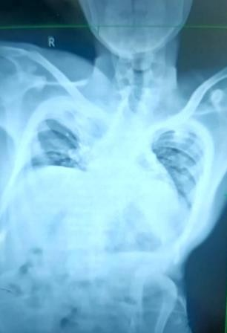
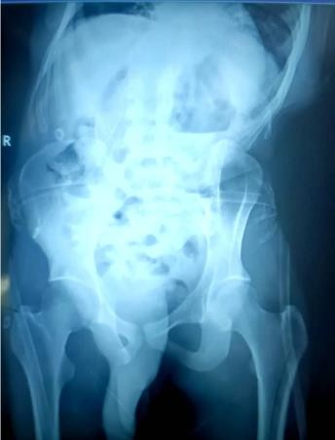
Air fluid level

All Routine investigation was sent and was within normal limits
Nasogastric tube of 16 Fr was inserted and was continued to decompress the bowel Foleys urinary catheter was inserted so as to monitor the intake and output
Patient was kept nil by mouth and was started on IV antibiotics, analgesics and Intravenous fluids
- Ultrasonography showed dilated bowel loops with to and fro peristalsis- likely suggestive of acute intestinal obstruction
Contrast enhanced CT scan of Abdomen and Pelvis was done which showed Gross dilatation of stomach , 1st and 2nd part of duodenum with abrupt cut off between 2nd and 3rd part of duodenum due to compression of 3rd part of duodenum with aorta and superior mesenteric artery at the level of vertebra L3
- Severe narrowing of aorta-mesenteric angle and aorto-mesenteric distance-Wilkie’s syndrome
- Common origin of celiac and superior mesenteric artery
- Compression of left renal vein with abdominal aorta and superior mesenteric artery suggestive of
Nutcracker syndrome
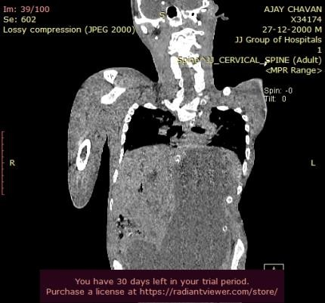
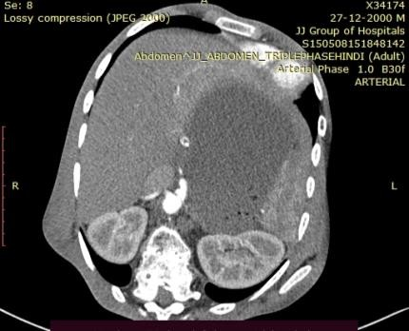

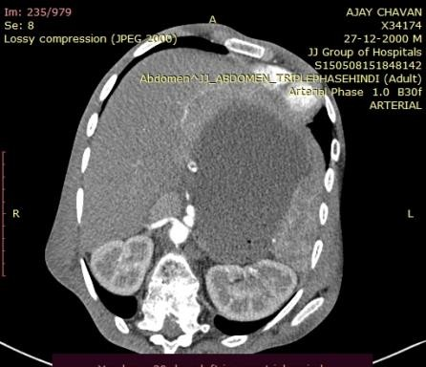
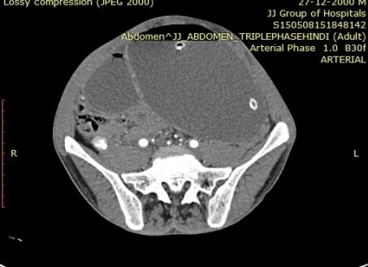
Short SMA

- Oesophagoduodenoscopy was done which showed dilated stomach and 1st and 2nd part of duodenum
Fig 3: CT scan of the abdomen indicating superior mesenteric artery
Patient and his relatives were explained about the complexities and the risk associated with the Disease and the urgent requirement of surgery with its risk and complications associated with it following their consent.Patient was taken up for Emergency Exploratory Laparotomy where in the stomach along with 1st and 2nd part of duodenum was grossly distended with collapsed 3rd part showing no gangrenous changes, 50 cm from the Duodeno-Jejunal flexure the jejunum was cut using blue linear cutting stapler and the second part of Duodenum Kocherised and side to side Roux-en Y duodeno-jejunostomy with side to side jejuno-jejunostomy and Abdominal drains were placed, near the site of anastomosis and the other at the pelvis

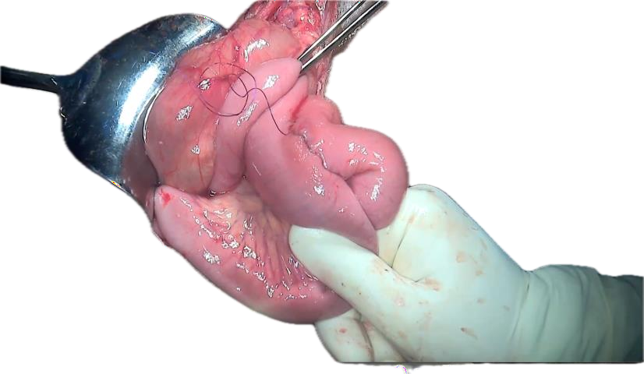

Duodenojejunostomy Jejunojejunostomy
Fig 4:
Fig 5:

Patient was then shifted to Critical care unit and was extubated gradually .Patient was started on oral sips on Post operative day(POD) 2 and was started on liquid diet on Post operative day-2 and was mobilised. Ryles tube and foley’s were removed and started on liquid diet on Post Operative Day 3 and was gradually started on full diet.

Drain outputs were monitored and anastomotic site drain was removed on POD 5 and pelvis drain was removed on POD 7.Patient also underwent 2D-echo and was found to be normal and chest medicine reference was done to rule out any lung pathology and was normal. Orthopaedic reference was done in view of Kyphoscoliosis and was advised to follow up in OPD after 3 months post surgery.Patient was tolerating feeds orally and was well mobilised and was discharged on POD 10
Fig 6: Post-operative stage of the patient who underwent the emergencyexploratory laparotomy

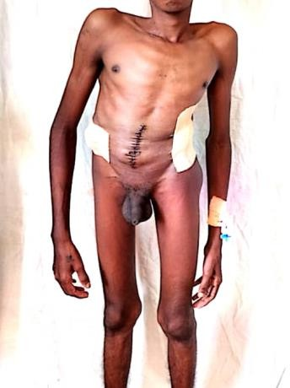





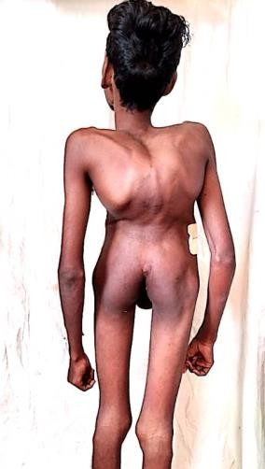

Discussion
The disease was first reported in 1842 by Carl Von Rokitansky, and in 1927, “Wilkie further detailed the pathophysiology and diagnostic findings of the disease, the morbidity and mortality associated with its complications make it a crucial differential to consider when concerned for bowel obstruction, especially in the setting of recent weight loss”
Incidence 0.1-0.3 % Male:Female-2:3 Age-10-39
Pathophysiology-
“Duodenal compression is usually due to the loss of the intervening mesenteric fat pad between the aorta and SMA, which in turn, results in a narrower angle between the vessels. The fat pad cushion functions to hold the SMA off the spine and protect it from duodenal compression. A normal aortomesenteric angle is 38 to 65 degrees; however, decreasing the angle less than 25 degrees will decrease the distance to less than 10 mm and cause compression to the third part of the duodenum. Decreases in the aortomesenteric angle can be either congenital or acquired. SMA syndrome is associated with significant weight loss including situations of hypermetabolism (trauma and burns) dietary conditions (anorexia nervosa and malabsorptive diseases) and cachexia causing conditions (AIDS, cancer, paraplegia). Other risk factors include surgical correction of scoliosis, congenitally short or hypertrophic ligament of Treitz, peritoneal adhesions, duodenal malrotation, Ladd's bands, abdominal aortic aneurysm, lumbar hyperlordosis, and mesenteric root neoplasm” ^{[17].}
The management of this condition can vary, and it's essential to approach it in a multi-faceted manner, considering both conservative and surgical options.

Conservative Management

- Nutritional Support: Initially, patients may benefit from nutritional support via parenteral nutrition or a modified diet (e.g., small frequent meals that are low in fat) to alleviate symptoms.9
- Weight Gain: In cases where malnutrition is a factor, an increase in body weight can help widen the angle between the aorta and the SMA, potentially relieving compression.10
- Physical Therapy: Some patients may benefit from physical therapy to strengthen the abdominal muscles and improve posture, which can sometimes relieve symptoms

Pharmacological Management

    - Pain Management: Analgesics may be prescribed to help control abdominal pain as needed.
    - Prokinetics: Medications that increase gastrointestinal motility can help alleviate symptoms of nausea and vomiting.11
    - Other Medications: Depending on the patient's symptoms, antiemetics may also be considered.

Surgical Intervention

      - Decompression Surgery: If conservative management fails, surgical options may be considered. Techniques include:

Duodenojejunostomy: Creation of an anastomosis between the duodenum and jejunum to bypass the obstructed region.12
SMA Release(Strong procedure): Surgical division of the ligament of Trietz (the suspensory ligament of the duodenum) may be performed to relieve the pressure on the duodenum.13
Angioplasty or SMA reconstruction: In some cases, vascular intervention may be indicated to relieve the compression.14
      - Laparoscopic Approaches: Minimally invasive techniques may be employed where
appropriate, offering quicker recovery and less postoperative pain.

Long-term Follow-up and Management

      - Ongoing Monitoring: Regular follow-up is necessary to monitor for symptoms of recurrence and nutritional status.
      - Patient Education: Educating patients about the condition, possible dietary
modifications, and the importance of seeking medical help for recurring symptoms.

In our case the patient presented with features of acute obstruction clinically without any history of acute weight loss or any recent surgical procedure and X-ray and CT showed features of acute obstruction which was a rare presentation in a patient with kyphoscoliosis preoperatively and hence the patient was taken up for emergency exploratory laparotomy and a Roux-en Y duodeno- jejunostomy with side to side jejunojejunostomy was done

“SMA syndrome is important to consider because the delay in diagnosis can result in significant morbidity and mortality from malnutrition, dehydration, electrolyte abnormalities, gastric pneumatosis and portal venous gas, gastrointestinal haemorrhage and gastric perforation” ^{[17].}

Conclusion
The management of superior mesenteric artery syndrome requires a comprehensive approach tailored to the patient's specific needs. While conservative management may suffice in some cases, surgical intervention may be necessary for patients who do not respond to dietary changes and pharmacotherapy. A multidisciplinary team, including surgeons, dietians, and primary care providers, is essential for effective management and improved patient outcomes.
Consent
As per international standards or university standards, patient(s) written consent has been collected and preserved by the author(s).

References

- Welsch T, Büchler MW, Kienle P. Recalling superior mesenteric artery syndrome. Digestive Surgery. 2007;24(3):149–156.
- Ahmed AR, Taylor I. Superior mesenteric artery syndrome. Postgraduate Medical Journal.
1997;73(866):776–778.
- Shiu JR, Chao HC, Luo CC, et al. Clinical and nutritional outcomes in children with idiopathic superior mesenteric artery syndrome. Journal of Pediatric Gastroenterology and Nutrition. 2010;51(2):177–182.
- Lippl F, Hannig C, Weiss W, et al. Superior mesenteric artery syndrome: diagnosis and treatment from the gastroenterologist’s view. Journal of Gastroenterology. 2002;37(8):640– 643.
- Unal B, Aktaş A, Kemal G, et al. Superior mesenteric artery syndrome: CT and ultrasonography findings. Diagnostic and Interventional Radiology. 2005;11(2):90–95.
- Biank V, Werlin S. Superior mesenteric artery syndrome in children: a 20-year experience.
Journal of Pediatric Gastroenterology and Nutrition. 2006;42(5):522–525.
- Neri S, Signorelli SS, Mondati E, et al. Ultrasound imaging in diagnosis of superior mesenteric artery syndrome. Journal of Internal Medicine. 2005;257(4):346–351.
- Merrett ND, Wilson RB, Cosman P, Biankin AV. Superior mesenteric artery syndrome: diagnosis and treatment strategies. Journal of Gastrointestinal Surgery. 2009;13(2):287– 292.
- Van Horne N, Jackson JP. Superior Mesenteric Artery Syndrome. [Updated 2022 Jul 18]. In: StatPearls [Internet]. Treasure Island (FL): StatPearls Publishing; 2022 Jan-. Available from: https://www.ncbi.nlm.nih.gov/books/NBK482209/

- Ruiz Padilla FJ, Mostazo Torres J, Vílchez Jaimez M. Significant gastric distension caused by superior mesenteric artery syndrome or Wilkie's syndrome. Gastroenterol Hepatol. 2017

Oct;40(8):581-583. English, Spanish. doi: 10.1016/j.gastrohep.2017.02.010. Epub 2017 Apr
20. PMID: 28434785.

- Buchman, A. L., et al. (1996). "Surgical management of superior mesenteric artery
syndrome." American Journal of Surgery, 172(6): 683-688.

- Carton, E. J., et al. (2020). "Surgical treatment of superior mesenteric artery syndrome: a review." Hernia, 24(3): 477-482.

- Novitsky, Y. W., et al. (2014). "Surgical Treatment of Superior Mesenteric Artery
Syndrome: A Review of the Literature." American Surgeon, 80(7): 745-748.

- Schmidt, C., et al. (2018). "A review of superior mesenteric artery syndrome." Journal of Surgical Case Reports, 2018(8): rjy226.

- Zachariah, T. S., & Melton, G. B. (2018). "A Novel Approach to the Anterior Division of the Superior Mesenteric Artery for Patients with Superior Mesenteric Artery Syndrome: A Case Report." International Journal of Surgery Case Reports, 50: 25-28.

- Wright, H. H., et al. (2020). "Superior Mesenteric Artery Syndrome: A Case Report and Review of the Literature." The American Journal of Medicine and Medical Sciences, 10(1): 1-6.

- Van Horne N, Jackson JP. Superior Mesenteric Artery Syndrome. [Updated 2023 Jul 17]. In: StatPearls [Internet]. Treasure Island (FL): StatPearls Publishing; 2025 Jan-. Available from: https://www.ncbi.nlm.nih.gov/books/NBK482209/?utm_medium=email&utm_source=transaction

