Case report
Role of Robotic-Assisted Thoracic Surgery to Reduce Morbidity in Challenging Mediastinal Tumors

Abstract

Background: Robotic-assisted thoracic surgery provides magnified three-dimensional vision, tremor filtration, and wristed instrumentation, enabling least-morbidity resections. It is usually preferred for small, well-encapsulated tumors. The authors have used robotic assistance for challenging tumors which would otherwise necessitate sternotomy, thereby reducing the morbidity of sternotomy. Median sternotomy remains the classical exposure for challenging anterior mediastinal tumors, but it is associated with higher morbidity, prolonged length of stay (LOS), and long-term functional limitations.

Methods: We describe three challenging anterior mediastinal tumors managed robotically: (1) thymectomy for a large thymoma in a 60-year-old man with myasthenia gravis, (2) excision of a large teratoma in a 22-year-old man with raised serum alpha-fetoprotein (AFP), and (3) resection of a pretreated thymoma in a 70-year-old man with poor performance status and post-chemotherapy fibrosis.

Results: All three operations were completed robotically without conversion or sternotomy. Mean operative time was 210 minutes; mean blood loss <50 mL. Pain (VAS ≤2 by 24 hours), early ambulation (Day 1), mean drain removal on Day 2.3, and mean hospital stay of 3.6 days reflected low morbidity. No patient required intensive care stay beyond 24 hours.

Conclusion: Robotic-assisted thoracic surgery reduces morbidity and broadens operability in difficult anterior mediastinal tumors, including those otherwise unfit for sternotomy. Tumor biology still dictates surgical complexity, but robotics transforms many borderline cases into safe, feasible operations.

Keywords: Robotic thoracic surgery; Mediastinal tumors; Thymoma; Teratoma; Minimally invasive surgery

Introduction

Thymic epithelial tumors (TETs) and germ cell tumors are the most frequent anterior mediastinal masses. Traditionally, their surgical management has relied on median sternotomy, which offers wide exposure but carries substantial perioperative morbidity, pain, increased LOS, and long-term musculoskeletal limitation, especially problematic in young patients or those with systemic illness such as myasthenia gravis (MG).¹

Minimally invasive approaches evolved with video-assisted thoracoscopic surgery (VATS) in the 1990s, showing reduced pain and LOS but limited by straight instruments and two-dimensional vision.² RATS provides three-dimensional magnification, articulating wrists, and ergonomic control.³ Systematic reviews demonstrate equivalent oncological completeness to sternotomy and VATS, but with lower blood loss, shorter LOS, and fewer complications.⁴⁻⁶ However, its use is generally preferred for small, well-defined masses. This series highlights three contrasting cases, illustrating how RATS reduces morbidity and expands candidacy in mediastinal tumors while acknowledging the continuing role of biology in influencing operative complexity.

Technical Note: Anesthetic and Port Placement Strategy

Unlike most open thoracic procedures, one-lung anesthesia is not required for robotic mediastinal tumor resections. Patients undergo routine general anesthesia with bilateral ventilation. A capnothorax of 8 mmHg is established through a blind port insertion in the anterior axillary line at the 3rd–4th intercostal space.
Once the camera is introduced, the other two robotic ports are sited as far away from the tumor and as anterior as possible to maintain safe geometry and provide adequate working space. Typically:

- Right-hand port: axillary position.
- Left-hand port: parasternal position.
- Camera port: between the two working arms.
- 12-mm assistant port: triangulated between camera and a working arm, either between left hand and camera or between right hand and camera, depending on tumor location.

The patient’s ipsilateral arm is allowed to hang below the table edge, preventing collision with robotic arms. The operating table is tilted 15° contralaterally to create a sub-sternal “rooftop” space. All three tumors in this series were left-sided and were successfully managed via a purely left-sided approach, without contralateral docking. In our center, however, we are always prepared for contralateral docking if the tumor spills significantly to the opposite side.

Table 1: Case Presentations

Parameter | Case 1 â€“ MG (Thymoma, 60 y) | Case 2 â€“ Teratoma (22 y) | Case 3 â€“ Pretreated Thymoma (70 y)
Operative time | 190 min | 210 min | 230 min
Blood loss | Less 10 mL | Less 10 mL | Less 30 mL
Pain (VAS at 24 hr) | 2 | 1 | 2
Drain removal | Day 2 | Day 3 | Day 2
Hospital stay (LOS) | 3 days | 4 days | 4 days
Conversion | Nil | Nil | Nil
ICU stay | <24 hr

Case 1. 60-year-old man with Myasthenia Gravis
A 60-year-old gentleman with generalized MG was considered high risk for sternotomy. RATS thymectomy was performed using bipolar capsule-hugging dissection. Both phrenic nerves were preserved, blood loss was <10 mL, and the patient was extubated on table and discharged on day 3. Robotic thymectomy is well established as safe and effective in MG, with shorter LOS and reduced morbidity compared to sternotomy.⁷

Case 2. 22-year-old man with Mature Teratoma
A 22-year-old male presented with a large anterior mediastinal mass and elevated AFP. Biopsy suggested mature teratoma. RATS excision revealed a well-encapsulated tumor, resected completely with <5 mL blood loss. Final pathology confirmed mature teratoma. Avoidance of sternotomy spared the patient life-long morbidity.⁸

Case 3. 70-year-old man with Pretreated Thymoma and Poor Performance Status
A 70-year-old gentleman with poor performance status was diagnosed outside as invasive thymoma and treated with neoadjuvant chemotherapy. Imaging suggested partial response. Intraoperatively, dense fibrosis was encountered, consistent with treatment-related desmoplasia. Despite technical hostility, a robotic dissection achieved R0 resection. Final histopathology: thymoma without invasion, clear margins. Without RATS, this patient would not have been considered fit for sternotomy and thus for surgery at all. Thymomas are chemo-sensitive, and induction regimens achieve partial responses in up to 70% of cases, though often at the cost of fibrosis and necrosis.⁹,¹⁰

Discussion

Sternotomy morbidity and need for alternatives: Sternotomy provides excellent exposure but is associated with higher blood loss, longer LOS, and sternal complications, leading to its relative contraindication in frail or young patients.¹,⁵
Evolution from VATS to RATS: VATS reduced morbidity compared to sternotomy but is limited in complex resections.² RATS improves dexterity and visualization, enabling complex anterior mediastinal surgery while preserving the benefits of minimally invasive access.³,⁶
Myasthenia gravis (Case 1): MG patients are particularly vulnerable to the morbidity of sternotomy. Several series demonstrate that RATS thymectomy achieves outcomes equivalent to sternotomy with reduced perioperative stress, making it preferable in this cohort.⁷
Teratoma (Case 2): Young patients face decades of functional and cosmetic burden from sternotomy. RATS offers complete excision with minimal morbidity. Elevated AFP may raise suspicion for immature or malignant components, but our case reinforced that mature teratomas can still present with biochemical elevations.⁸
Pretreated thymoma (Case 3): Thymomas are chemo-sensitive, with induction regimens achieving partial responses in up to 70% of cases but frequently producing fibrosis and necrosis, which complicates surgery.⁹,¹⁰ Although technically difficult, RATS enabled safe resection in a 70-year-old with poor performance status who otherwise would have been excluded from surgery.
Reduced morbidity:
Across all three cases, measurable morbidity parameters—pain, drain duration, and LOS—were uniformly low. The mean LOS ( avg 3.6 days) and early drain removal (Day Avg 2.3) are consistent with contemporary robotic series.⁷ The avoidance of sternotomy eliminates sternal pain and infection risk, and the absence of one-lung ventilation reduces postoperative atelectasis and fatigue. Early ambulation and minimal analgesic requirement supported enhanced recovery.

Comparison with literature:
Several meta-analyses show that robotic thymectomy reduces LOS by 2–4 days compared with sternotomy, with lower postoperative pain scores and faster functional recovery.⁴⁻⁶ Rückert et al.³ emphasized improved precision near phrenic nerves and vessels, decreasing intraoperative trauma. Jurado et al.² observed fewer pulmonary complications and shorter drain duration with minimally invasive techniques.

Patient selection:
This series demonstrates the versatility of robotic surgery across three biological spectrums—an MG-related thymoma, a benign teratoma, and a chemo-altered thymoma. The last case particularly highlights robotics’ utility in patients unfit for sternotomy due to poor cardiopulmonary reserve and frailty, expanding eligibility without compromising safety.

Tumor biology and technical interplay:
Surgical complexity correlates closely with tissue reaction. The smooth capsule in teratoma and thymoma allowed almost bloodless resection, whereas the post-chemotherapy desmoplastic field in Case 3 posed high difficulty. Despite this, RATS magnification and articulation ensured safety, affirming that technology and biology must harmonize rather than compete.

Conclusion

Robotic-assisted thoracic surgery provides safe, least-morbidity access to challenging mediastinal tumors. Pain scores, drain removal, and length of stay indicate significantly reduced morbidity. The technique extends operability to patients otherwise excluded due to frailty or poor cardiopulmonary reserve, transforming “inoperable by sternotomy” into “safely operable by robotics.”

Disclaimer (Artificial intelligence)
This manuscript was prepared with the assistance of ChatGPT (OpenAI, 2024) to support the author in structuring, editing, and refining the scientific narrative. All clinical content, surgical details, and final interpretations are original, based on the author’s direct experience and expertise. The AI tool was used strictly as an editorial aid and did not contribute to the generation of medical data, analysis, or clinical decision-making.

Ethics approval: As per international standards or university standards written ethical approval has been collected and preserved by the author(s).

Consent: As per international standards or university standards, patient(s) written consent has been collected and preserved by the author(s).

References

- Wright CD. Management of thymomas. Crit Rev Oncol Hematol. 2008;65(2):109–120. doi:10.1016/j.critrevonc.2007.11.001
- Jurado, J., Javidfar, J., Newmark, A., Lavelle, M., Bacchetta, M., Gorenstein, L., ... & Sonett, J. R. (2012). Minimally invasive thymectomy and open thymectomy: outcome analysis of 263 patients. The Annals of thoracic surgery, 94(3), 974-982.
- Na, K. J., & Kang, C. H. (2020). Robotic thymectomy for advanced thymic epithelial tumor: indications and technical aspects. Journal of thoracic disease, 12(2), 63.
- O’Sullivan, K. E., Kreaden, U. S., Hebert, A. E., Eaton, D., & Redmond, K. C. (2019). A systematic review of robotic versus open and video assisted thoracoscopic surgery (VATS) approaches for thymectomy. Annals of cardiothoracic surgery, 8(2), 174.
- Burt, B. M., Yao, X., Shrager, J., Antonicelli, A., Padda, S., Reiss, J., ... & Scott, W. (2017). Determinants of complete resection of thymoma by minimally invasive and open thymectomy: analysis of an international registry. Journal of Thoracic Oncology, 12(1), 129-136.
- Chen, K., Zhang, X., Jin, R., Xiang, J., Han, D., Zhang, Y., & Li, H. (2020). Robot-assisted thoracoscopic surgery for mediastinal masses: a single-institution experience. Journal of thoracic disease, 12(2), 105.
- Romano, G., Zirafa, C. C., Ceccarelli, I., Guida, M., Davini, F., Maestri, M., ... & Melfi, F. (2021). Robotic thymectomy for thymoma in patients with myasthenia gravis: neurological and oncological outcomes. European Journal of Cardio-Thoracic Surgery, 60(4), 890-895.
- Hwang, S. K., Park, S. I., Kim, Y. H., Kim, H. R., Choi, S. H., & Kim, D. K. (2016). Clinical results of surgical resection of mediastinal teratoma: efficacy of video-assisted thoracic surgery. Surgical Endoscopy, 30(9), 4065-4068.
- Okuma, Y., Saito, M., Hosomi, Y., Sakuyama, T., & Okamura, T. (2015). Key components of chemotherapy for thymic malignancies: a systematic review and pooled analysis for anthracycline-, carboplatin-or cisplatin-based chemotherapy. Journal of cancer research and clinical oncology, 141(2), 323-331.
- Yue, J., Gu, Z., Yu, Z., Zhang, H., Ma, Z., Liu, Y., ... & Chinese Alliance for Research in Thymomas. (2016). Pretreatment biopsy for histological diagnosis and induction therapy in thymic tumors. Journal of Thoracic Disease, 8(4), 656.

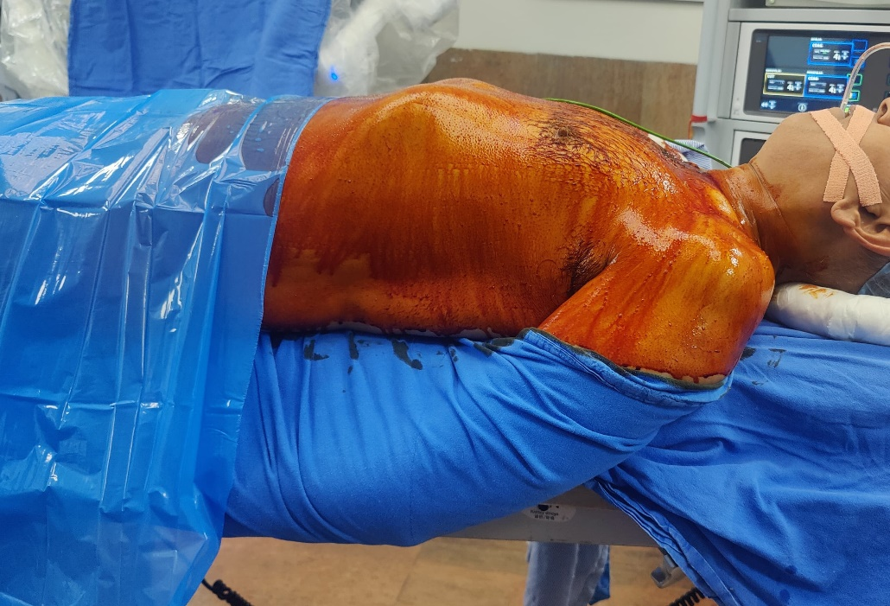
Fig 1 : Patient positioning with ipsilateral arm suspended on a sling below the level of the operating table.

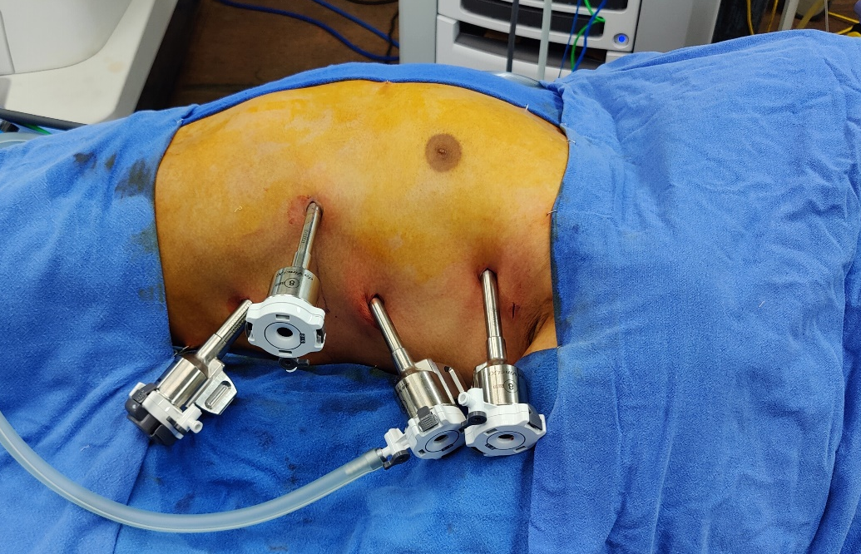

Fig 2 : Port placement on the chest wall demonstrating ideal triangulation.

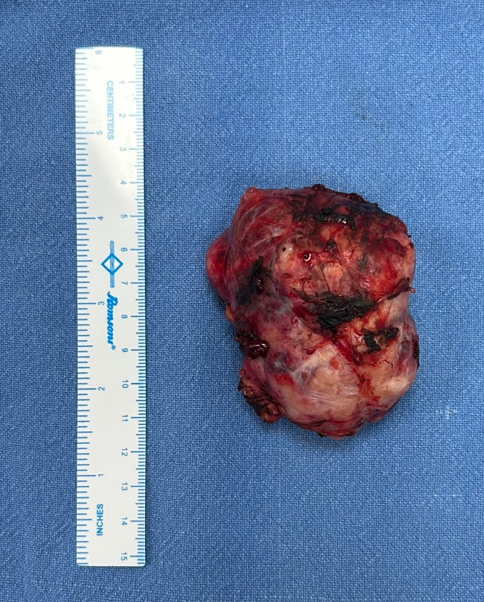
Fig 3 : Excised thymus specimen case 1

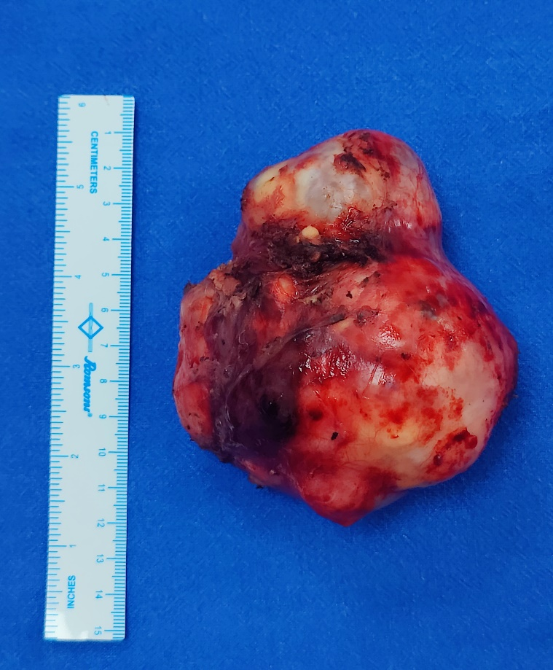

Fig 4 : Excised Mature Teratoma specimen case 2

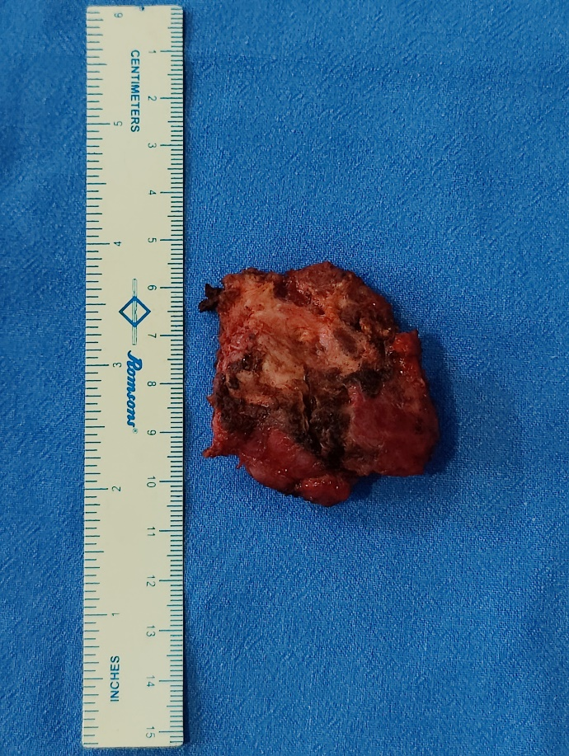

Fig 5 : Excised Thymus specimen case 3

