Case report

When Peritoneal Tuberculosis Mimics Carcinosis in a Patient Followed for Prostate Adenocarcinoma

Abstract

Peritoneal tuberculosis is a rare extrapulmonary manifestation of tuberculosis that often mimics peritoneal carcinomatosis clinically and radiologically, especially in patients with known malignancies. We present a case of a patient with prostate adenocarcinoma initially suspected to have peritoneal carcinomatosis due to radiological findings of peritoneal nodules and ascites. Exploratory laparoscopy revealed multiple small whitish nodules, and intraoperative frozen section examination showed necrotizing tuberculoid granulomatous inflammation consistent with tuberculosis. The patient was started on antituberculous therapy with careful adjustments to avoid interactions with his hormonal treatment. This case highlights the critical need for considering peritoneal tuberculosis in the differential diagnosis of peritoneal nodules to ensure timely and appropriate treatment and to avoid misdiagnosis and unnecessary interventions. Laparoscopic biopsy remains the gold standard for diagnosis in such challenging cases.

Keywords
Prostate adenocarcinoma, Peritoneal carcinomatosis, Pseudotumoral tuberculosis

Introduction

Peritoneal tuberculosis is a rare form of extrapulmonary tuberculosis that accounts for a small proportion of abdominal tuberculosis cases [1]. Its pseudotumoral presentation may closely mimic peritoneal carcinomatosis, especially in patients with a known history of malignancy, thus posing a significant diagnostic challenge [2].
Prostate adenocarcinoma commonly metastasizes to the bones, lymph nodes, liver, and lungs [3]. However, peritoneal metastases are exceptionally rare, with only a few cases reported in the literature [4,5].
We report the case of a patient followed for prostate adenocarcinoma in whom peritoneal carcinomatosis was initially suspected, but histopathological examination ultimately revealed peritoneal tuberculosis

Case Report
A 62-year-old patient had been followed for 5 months for bilateral acinar-type prostate adenocarcinoma with a Gleason score of 3+4 and a prostate-specific antigen (PSA) level of 20 ng/ml, under androgen deprivation therapy. For 2 months, he had developed abdominal distension with diffuse abdominal pain, without fever or night sweats, in a context of general health deterioration.
On clinical examination, the abdomen was distended and tender, with shifting dullness.
Abdominopelvic CT scan (Figure 1) revealed abundant peritoneal effusion in all recesses, associated with peritoneal thickening.

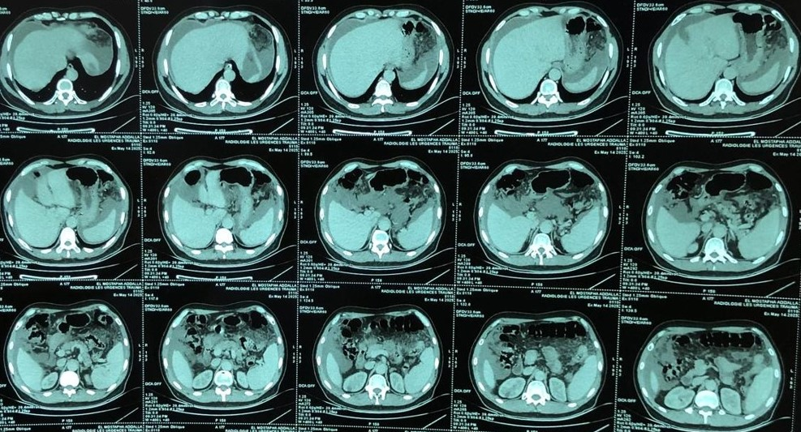
Figure 1. Abdominal CT scan showing peritoneal effusion and peritoneal thickening.
Ascitic fluid aspiration showed: no malignant cells on cytology; protein level <25 g/l (transudative fluid). Tumor markers were negative, including CEA at 2.4 ng/ml and CA19-9 at 3.6 U/ml.
Upper gastrointestinal endoscopy revealed minimal antral-fundic gastritis without histological evidence of malignancy.
Exploratory laparoscopy (Figure 2) showed abundant ascites and multiple whitish "pinhead" nodules scattered throughout the peritoneal cavity, which were biopsied.
Frozen section examination revealed necrotizing tuberculoid granulomatous inflammation (Figure 3).
The patient was started on antituberculosis** therapy with appropriate adjustments to prevent drug interactions with his ongoing hormonal treatment.
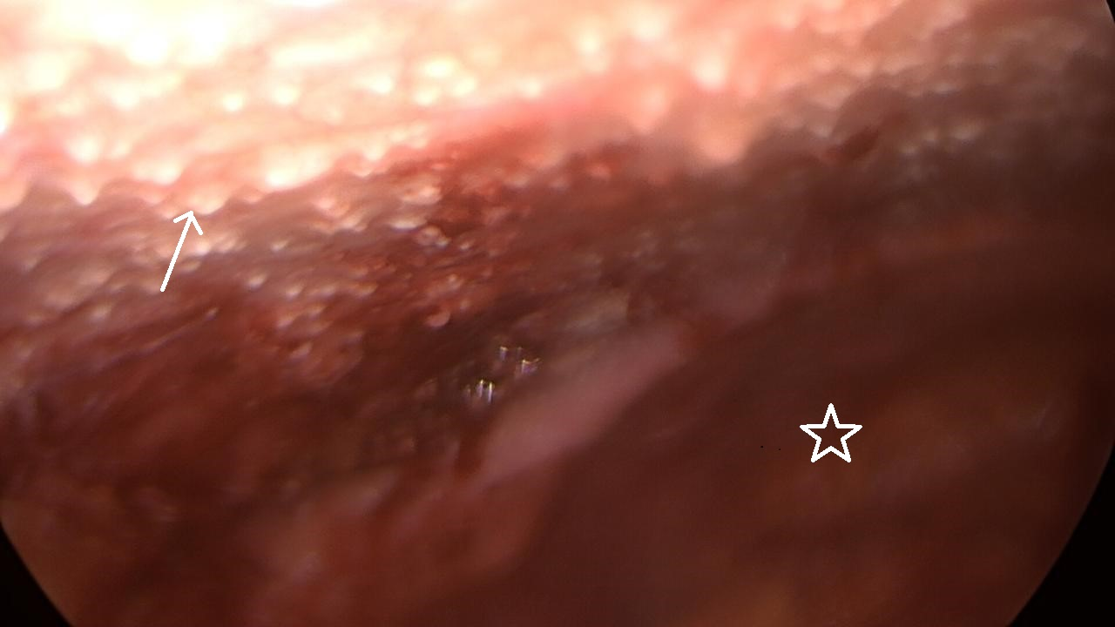
Figure 2. Whitish nodules suggestive of peritoneal tuberculosis marked by an arrow and ascites indicated with a star.
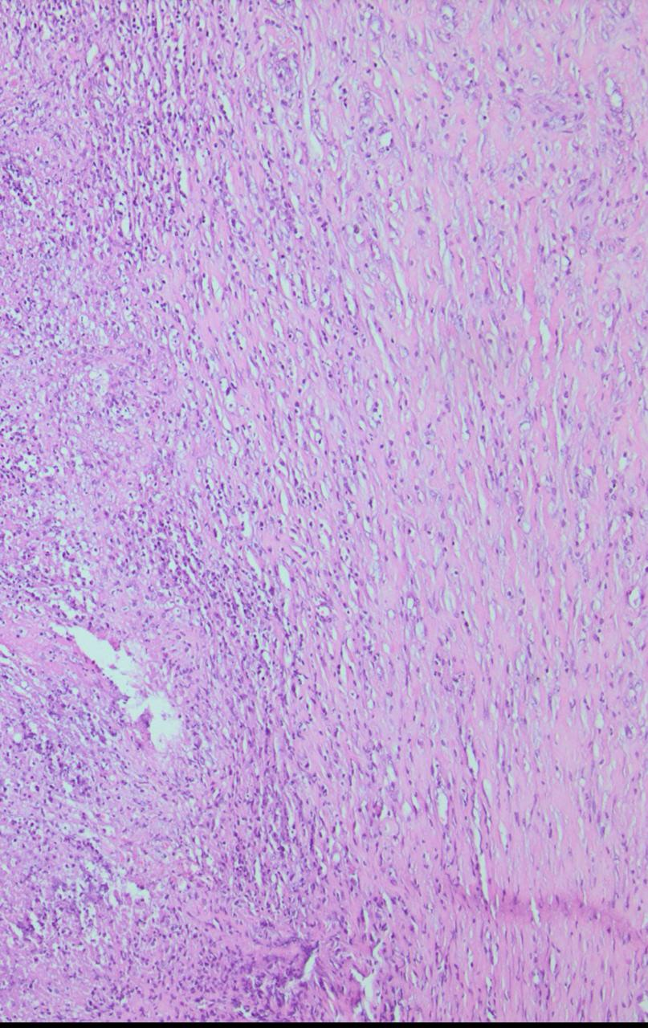
Figure 3. Necrotizing tuberculoid granulomatous inflammation (H&E stain, ×300).

Discussion

Morocco remains an endemic area for tuberculosis [5]. This infection often affects patients with predisposing conditions such as malnutrition, immunosuppression, or underlying malignancy.
From a pathophysiological standpoint, peritoneal tuberculosis usually results from hematogenous or lymphatic dissemination from a primary focus — most frequently pulmonary, lymphatic, or intestinal — or by direct contiguous extension [6]. Once Mycobacterium tuberculosis reaches the peritoneum, it triggers a granulomatous inflammatory response characterized by caseating granulomas and persistent macrophage activation, accounting for most of the clinical manifestations such as ascites, abdominal pain, and constitutional symptoms.
Prostate adenocarcinoma remains one of the most prevalent malignancies in men worldwide and accounts for approximately 80,000 deaths annually [7,8]. Diagnosis is generally suspected based on digital rectal examination revealing a hard, irregular prostate and confirmed by elevated prostate-specific antigen (PSA) levels. Histopathological examination of prostate biopsy specimens remains the diagnostic gold standard.
Metastatic spread of prostate cancer typically involves bones, regional lymph nodes, liver, and lungs [9]. Peritoneal metastases are exceedingly rare, with only a few cases described in the literature [10]. Therefore, when peritoneal thickening and ascites occur in a patient with a known history of prostate adenocarcinoma, peritoneal carcinomatosis is often the first suspected diagnosis.
However, peritoneal carcinomatosis and peritoneal tuberculosis share many clinical and radiological features. Both can present with ascites of moderate to large volume, abdominal distension, weight loss, and peritoneal nodularity [11]. On CT imaging, our findings are consistent with those reported by Chen et al. [12], who showed that smooth peritoneal thickening, high-density ascites, and necrotic lymph nodes are more typical of peritoneal tuberculosis, whereas irregular nodular implants and diffuse omental infiltration are more suggestive of peritoneal carcinomatosis.
Exploratory laparoscopy is therefore essential to establish a definitive diagnosis. In carcinomatosis, nodules are typically firm, irregular, and clustered, corresponding histologically to malignant implants. In contrast, tuberculous nodules are whitish, with regular margins, and histology reveals epithelioid granulomas with caseous necrosis [13].
This case underlines the diagnostic challenge of differentiating peritoneal tuberculosis from carcinomatosis in patients with a history of cancer. In endemic regions, tuberculosis should always be considered in the differential diagnosis before attributing peritoneal lesions to metastatic disease. Early histopathological confirmation is crucial to avoid misdiagnosis and inappropriate oncologic management.

Conclusion

In the context of endemic regions, peritoneal tuberculosis is a condition that may affect at-risk populations. It can present with various clinical forms, and in its pseudotumoral presentation, it may mimic peritoneal carcinomatosis, such as clinical presentation, and radiological images. However, the exploratory laparoscopy remains a crucial tool for establishing the final diagnosis before the start of tuberculosis treatment.

Artificial Intelligence Statement
The authors acknowledge the use of artificial intelligence tools during the preparation of this manuscript. AI assistance was used to design the literature search algorithm and to generate preliminary summaries of selected articles. All outputs were critically reviewed and edited by the authors to ensure accuracy and scientific integrity.
Details of the AI usage are given below:
- ChatGPT version gratuit 1.2025.287

References
- Koff A, Azar MM. Diagnosing peritoneal tuberculosis. BMJ Case Rep. 2020 Feb.
- Bouchaib AE, Drissi J, Babahabib A, Elhassani MEM, Kouach J. Tuberculose péritonéale pseudo tumorale: à propos d’une série de 14 cas [Pseudotumoral peritoneal tuberculosis: about 14 cases]. Pan Afr Med J. 2022 Nov
- Gandaglia G, Abdollah F, Schiffmann J, Trudeau V, Shariat SF, Kim SP, Perrotte P, Montorsi F, Briganti A, Trinh QD, Karakiewicz PI, Sun M. Distribution of metastatic sites in patients with prostate cancer: A population-based analysis. Prostate. 2014 Feb.
- Okouo, M., Service, G., Atipo Ibara, B.I. et al. Carcinose péritonéale secondaire à un adénocarcinome de la prostate: une entité rare. J Afr Hepato Gastroenterol 3, 224–225 (2009).
- Mahad Abdillahi, Gaspard Nizigiyimana, Kamal Khadija, Majdabdessamad, Ettaoussi Abdelhak, Bouali Mounir, Abdelilah Elbakouri, El Hattabi Khalid, Ridha Allali. Tuberculous Peritonitis. SAS J Surg, 2025 Mar 11.
- Al Jazzar RI, et al. Pleura Peritoneum. 2023.
- Nguyen-Nielsen M, Borre M. Diagnostic and Therapeutic Strategies for Prostate Cancer. Semin Nucl Med. 2016 Nov.
- Rawla, P. Épidémiologie du cancer de la prostate. World J. Oncol. 2019.
- Tareen SA, Rodriguez J, Wu P. Prostate Cancer Metastatic to the Peritoneum: A Road Less Traveled by a Common Malignancy. Cureus. 2019 Mar 11.
- Khan Q, Myers B, Bowar B, Khan M, Mullaney H, Gainey J, Schneider R, Dahmoush L, Nepple KG, Byrne JD. Case report: Robotically visualized and biopsy-confirmed peritoneal carcinomatosis as initial identification of metastatic prostate adenocarcinoma in a patient with a history of prostatic urethral lift. Front Oncol. 2024 Jan 19.
- Al Jazzar RI, Sulaihim Z, Alkhiary A, Alzahrani N. Abdominal tuberculosis mimicking peritoneal metastasis. Pleura Peritoneum. 2023 Jun 15;8(3):139-140. doi: 10.1515/pp-2023-0012. PMID: 37662603; PMCID: PMC10469162.
- Chen, J., Liu, S., Tang, Y., Zhang, X., Cao, M., Xiao, Z., ... & Chen, T. (2020). Diagnostic performance of CT for differentiating peritoneal tuberculosis from peritoneal carcinomatosis: a systematic review and meta-analysis. Clinical Radiology, 75(5), 396-e7.
- El Khoury MB, Van Eycken M, Roumeguère T, Albisinni S. Isolated non-ascitic peritoneal carcinomatosis after robotic radical prostatectomy for prostate cancer: A case report. Urol Case Rep. 2020 Sep 15.

