[Case report
Isolated Solitary Hydatid Cyst of the Left Hemidiaphragm: Case Report and Management Challenge

Abstract
Hydatid disease of the diaphragm caused by Echinococcus granulosus is a rare entity. Its localization poses a diagnostic challenge, especially if the diaphragmatic hydatid cyst is isolated and on the left side.
Case presentation:
We present a case of a 56-year-old male farmer with a hydatid cyst located in the left copula of the diaphragm. However, the radiological investigations could not accurately determine the location of the cyst. While the ultrasound suggested that it was present within the chest cavity, the computed tomography indicated that it was in the abdominal cavity. Consequently, the patient had to undergo a laparoscopic exploration, which had to be converted to a laparotomy. During the operative intervention, the diaphragmatic seat of the cyst was confirmed, and it was completely excised. The diaphragmatic defect was also repaired successfully, and the postoperative course was unremarkable. The patient was prescribed albendazole after the operation to prevent recurrence.
Conclusion:
Uncertainty regarding the location of a diaphragmatic hydatid cyst can affect the surgical strategy, and the final diagnosis is often made during surgery.
Key Words: Diaphragm, Hydatid, Cyst

Introduction:
Hydatid disease caused by Echinococcus granulosus is an ancient disease that was known to Hippocrates. It remains a significant health problem in Asian and Mediterranean countries, which are considered endemic areas ⁽¹⁾. It can affect almost all human body organs, with the liver and lungs being the most frequently involved ⁽²⁾. Hydatid disease of the diaphragm is a rare condition, accounting for about 1% of hydatid cases reported in the literature ⁽³⁾. A diaphragmatic hydatid cyst (DHC) develops within the thickness of the diaphragmatic muscle, covered with pleural and peritoneal serous membranes ⁽⁴⁾. This rare localization poses a diagnostic challenge that requires combining different efficient imaging techniques. However, the diaphragmatic seat of the cyst can be confirmed only during operation ⁽⁵⁾.

Case presentation:
A 56-year-old male farmer presented with stitching left hypochondriac pain for one year. He is known to be hypertensive and he had a travel history to Iraq 30 years ago. The patient's current physical examination and laboratory tests were unremarkable. A plain chest X-ray film demonstrated an elevated left copula of the diaphragm with an obscured left lung lower zone field and mediastinal shift to the right.
Abdominal and pelvic ultrasound (US) revealed a large multilocular cyst 13X10 cm mostly originating from the left lower lobe of the lung. It was suggested to be a hydatid cyst (HC). Subsequently, computed tomography (CT) of the chest and abdomen with contrast was done and it showed a large sub-diaphragmatic intra-abdominal cyst 14X11 cm with thick septae, solid internal components, and no calcification (Fig. 1). This cyst was seen between greater curvature of the stomach and splenic hilum with elevated left copula of the diaphragm. Serology for hydatid disease was negative while tumor markers (CEA, CA19-9) were within normal levels.
During a discussion between the gastrointestinal tract general surgery and thoracic surgery teams, it was decided to proceed with laparoscopic exploration of the abdomen as a first step based on CT findings. Upon visualizing the cystic lesion during laparoscopy (Fig. 2a), which was pushing the left lobe of the liver and displacing the spleen, it was found to be covered with a peritoneal layer. Despite an attempt to dissect the lesion, the whole extent of it could not be reached, and thus, it was decided to convert to an open left subcostal laparotomy (Fig. 2b). During the operation, it was discovered that the cystic lesion had invaded the diaphragm. The surgical field was isolated with multiple packs soaked in 20% sodium chloride solution, and a radical excision was conducted. The first step of the excision was to evacuate the cyst contents after injection of hypertonic saline and cetrimide within the cavity using a special cannula. This process was repeated several times until the tense cystic lesion became partially collapsed
During the surgery, the lateral side of the left copula of the diaphragm was opened to gain access to the extended cystic lesion in the thoracic cavity. It was found to be smooth and covered with pleura, with no diaphragmatic musculature and no adhesion to any intrathoracic organ. The cyst, along with the adherent ring of the diaphragmatic muscle, was completely excised (Fig. 3). The redundant remnant of the diaphragmatic muscle was then repaired in two layers using prolene sutures and reinforced with a polypropylene mesh (Fig. 2c). An intercostal tube was inserted to aid in recovery. The patient was prescribed albendazole tablets to be taken twice daily for a month after the surgery. The patient had a smooth post-operative recovery, and five months later a chest X-ray showed an almost normal contour of the left diaphragmatic copula (Fig.4). The histopathological examination confirmed the diagnosis of a hydatid cyst of the diaphragm and established the presence of striated muscle fibers in the peri-cyst ring between the pleura and peritoneum (Fig.5).
Discussion:
We present a rare case of a hydatid cyst that was primarily located within the left copula of the diaphragm. This type of cyst is sporadically reported in the medical literature. Our patient had a history of traveling to Iraq, which is known to have a high incidence of hydatid disease. The disease is considered to be the cancer of Iraq ⁽⁶⁾. Typically, the right side of the diaphragm is more commonly affected and is often associated with liver hydatidosis ⁽⁷⁾. The location of a hydatid cyst within the diaphragm is a puzzle, especially if it is isolated. It is believed that Echinococcus granulosus embryos reach the diaphragm through arterial or lymphatic channels. Systemic vascular pathways, such as the portocaval, pulmonary-bronchial anastomoses, and arterial channels from the phrenic artery and branches from the intercostal arteries, were proposed as possible pathways ^{(8,9)}. However, the diaphragmatic location is still not well understood, as other factors are believed to prevent this type of localization. Diaphragmatic muscle contractility and the production of lactic acid within the muscles prevent the fixation and development of the embryo in the muscle ⁽¹⁰⁾. The diagnosis of this reported case presented a challenge, as our radiological investigations could not determine the precise location of the cyst. There was a discrepancy between the US and CT scan results. Typically, chest radiographs and US are used to diagnose hydatid cysts of the lung and liver. However, a CT scan is the most effective imaging modality to determine the abdominal topography, the exact location, the details of the cysts, and the condition of neighboring organs ⁽³⁾. Previous studies have shown that cases of isolated DHC were often misdiagnosed as liver or lung hydatid cysts before surgery, and were only found to be diaphragmatic during the operation ^{(3,11)}. A study involving 27 cases found that abdominal US and thoracic CT only diagnosed DHC in 82% of cases ⁽⁴⁾. The current case exemplifies this diagnostic challenge, as it was an isolated left-sided DHC.
In our case, the serological tests for hydatid disease came out negative. This is not surprising as it is rare for hydatid serology to be positive when the HC is isolated, and it may remain negative even after the intervention ⁽¹²⁾. Some studies have shown that hydatid serology has a diagnostic yield of only 50%, making its role supplementary ⁽¹³⁾. When it comes to treating DHC, surgery is currently the only option available. However, there are no uniform surgical guidelines, and the approach must be flexible. The choice among thoracic, abdominal, or combined approaches depends on the radiological information and the extent of organ involvement in the thoracic and abdominal cavities. The main aim of the surgical strategy is to completely remove the cyst, repair the diaphragm thoroughly, prevent recurrence, and treat any associated lesions ⁽¹⁴⁻¹⁶⁾. We initially opted for exploratory laparoscopy under the assumption that our cystic lesion was sub-diaphragmatic, as suggested by the CT scan. However, we had to resort to laparotomy to assess the extent of the cyst and remove it entirely. The cyst was found to be diaphragmatic and covered by both pleura and peritoneum, with a clear loss of diaphragmatic musculature in the area occupied by the cyst. In a previous study, three types of DHCs were identified, including subpleural, subperitoneal, and intramuscular ⁽⁹⁾. However, this classification appears to be theoretical. Diagnosing DHCs can be challenging because the cyst causes local ischemia, muscle erosion, and tissue distortion during its growth, which can make it difficult to pinpoint the exact location of the cyst. A diaphragmatic hydatid cyst may be incorrectly diagnosed as a diaphragmatic mesothelial cyst, bronchogenic cyst, teratoma, or a simple hepatic cyst, particularly if it is located on the right side ⁽¹⁷⁾. This might explain why CT scans can sometimes fail to differentiate between DHCs and cysts adjacent to the diaphragm. Although CT scans can detect the spread of DHCs, visualizing the diaphragmatic gap can be challenging ⁽¹⁸⁾.
Upon retrospective review of the preoperative CT scan, we observed a split in the diaphragm around the hydatid cyst in the sagittal views (Fig 1d).
After taking necessary surgical precautions, we performed a partial cyst evacuation to prevent its rupture and create space for lateral dissection. This allowed us to reach the dome of the cyst, followed by total cystectomy. Other surgeons have also adopted this technique of evacuation followed by total cystectomy, especially in cases of large HCs ⁽¹⁹⁾. To ensure a competent diaphragmatic repair and prevent possible herniation and respiratory dysfunction ⁽¹⁾, we repaired the diaphragmatic defect using a two-layer technique reinforced by a prosthetic mesh. After the surgery, the patient received medical treatment based on albendazole, which aimed to reduce the risk of secondary hydatidosis and recurrence ⁽²⁰⁾.
Conclusion:
A diaphragmatic hydatid cyst should be considered as a possible diagnosis when a cystic space-occupying lesion is present in close relation to the diaphragm. However, diagnosing this condition can be challenging, and a high level of suspicion is necessary. Uncertainty about the location of the cyst can impact the surgical approach, and the final diagnosis may only be made during surgery.
Abbreviations list:
CT Computed Tomography
DHC Diaphragmatic hydatid cyst
HC Hydatid Cyst
US Ultrasound
Declaration of competing interest:
We have no conflict of interest to disclose.

Patient consent:
Written informed consent was obtained from the patient for publication of this case report and accompanying images. A copy of the written consent is available for review on request.
Ethical approval:
Not applicable.

Disclaimer (Artificial intelligence)
Details of the AI usage are given below:
Grammerly which is an AI assistant was used for some grammar and language correction.
References:
- Kjossev K, Losanoff J, Velitchkov N, Belokonski E. (2002). Hydatid cyst of the diaphragm: A case report and review of the literature. The Internet Journal of Thoracic and Cardiovascular Surgery, 6:1. DOI:10.5580/200f
- Vagianos CE, Karavias DD, Kakkos SK, Vagenas CA, Androulakis JA. (1995). Conservative surgery in the treatment of hepatic hydatidosis. European Journal of Surgery,161(6):415-20 PMID: 7548377.
- Eren S, Ulku R, Tanrıkulu AC, Eren MN. (2004). Primary giant hydatid cyst of the diaphragm, Annals of Thoracic and Cardiovascular Surgery,10 (2):118-9 PMID: 15209555
- Kabiri H, Al Aziz S, El Maslout A, Benosman AC. (2000). L’hydatidose diaphragmatique. Revue de Pneumologie Clinique, 57:13-9
- Hanane B, Meryem A, Nahid Z, Najiba Y. (2021). Diaphragmatic hydatid cyst, a rare entity simulating a thoracic localization (About 4 observations). Scholars Journal of Medical Case Reports, Feb 9(2): 167-71 doi: 10.36347/sjmcr.2021.v09i02.013
- Babero B.B., AL-Dabagh M.A., AL-Saffar A.S., Ali F.M. (1963). The zoonosis of animal parasitic in Iraq. VIII. Hydatid disease. Annals of Tropical Medicine and Parasitology, 57: 499-510. doi:10.1080/00034983.1963.11686204. PMID: 14101940
- Gurbanaliev IG, Gadzhiev SI, Dzhavadov E. (1989). Echinococcosis of the diaphragm. Khirurgiia (Mosk), (3):73-76. PMID: 2724853
- De Vega DS, Vazquez E, Tamames S. (1991). Hydatid cyst of the diaphragm. Apropos of a case, Journal de Chirurgie (Paris), 128: 76–78. PMID: 2026677
- Kapitanov G, Nikiforov G, Markov T, Bunev G. (1965). Echinococcosis of the diaphragm. Khirurgiia (Sofia), 18:505-11
- Daali M, Hssaida R. (2000). Kyste hydatique du diaphragme rompu dans la plèvre : à propos d’un cas, Annales de Chirurgie,125:493-5. doi:10.1016/S0003-3944(00)00230-3
- Carlo ID, Toro A, Sparatore F, Malfa P. (2006). Isolated hydatid cyst of the diaphragm without liver or lung involvement: a case report, Acta Chirurgica Belgica, 106 (5): 599–601, doi.org/10.1080/00015458.2006.11679960
- Abu-Eshy SA. (1998). Some rare presentations of hydatid cyst (Echinococcus granulosus). Journal of the Royal College of Surgeons of Edinburgh, 43 (5):347-52 PMID: 9803111.
- Atanasov A, Stoianov K, Dimitrov A. (1989). Two case reports of echinococcosis of the diaphragm. Khirurgiia (Sofia), 42:76-77
- Yoruk Y, Yalcinkaya S, Coskun I, Ekim T, Kose S, Mehmet R. (1998). Simultaneous operation for coexisting lung and liver hydatid cyst: A treatment modality. Hepatogastroenterology, 45 (23):1831-32 PMID: 9840157.
- Oguzkaya F, Akcali Y, Kahraman C, Emirogullari N, Bilgin M, Sahin A. (1997). Unusually located hydatid cysts: intrathoracic but extra pulmonary. Annals of Thoracic Surgery, 64 (2):334-37
doi: 10.1016/S0003-4975(97)00521-3.
- Lewall DB, McCorkell SJ. (1986). Rupture of echinococcal cysts: diagnosis, classification and clinical implications. American Journal of Roentgenology,146 (2):391-94 doi: 10.2214/ajr.146.2.391.
- Akinci D., Akhan O., Ozmen M., Ozkan O., and Karcaaltincaba M. (2005). Diaphragmatic Mesothelial Cysts in Children: Radiologic Findings and Percutaneous Ethanol Sclerotherapy, American Journal of Roentgenology,185
( 4):873-877 doi.org/10.2214/AJR.04.1590.
- Kilani T, El Hammami S, Horchani H, Ben Miled-Mrad K, Hantous S, Mestiri I, et al. (2001). Hydatid disease of the liver with thoracic involvement. World Journal of Surgery, 25 (1):40-45 doi:10.1007/s002680020006.
- Makni A., Jouini M., Kacem M., Ben Safta Z. (2013). Extra-hepatic intra-abdominal hydatid cyst: which characteristic, compared to the hepatic location? Updates in Surgery, 65:25–33.
doi: 10.1007/s13304-012-0188-6.
- Stamatakos M, Sargedi C, Stefanaki C, Safioleas C, Matthaiopoulou I, Safioleas M. (2009). Anthelminthic treatment: an adjuvant therapeutic strategy against Echinococcus granulosus. Parasitology International, 58(2):115-20. doi: 10.1016/j.parint.2009.01.002.

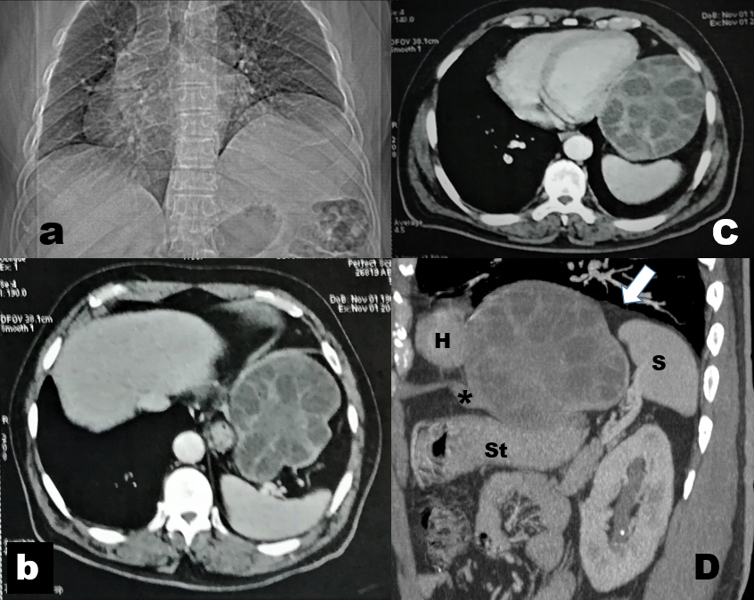

Fig. 1: (a) A scanogram of chest and abdominal CT shows apparently elevated left copula of the diaphragm, obscured left lung lower zone, and mediastinal shift to the right, (b,c) Cross-section computed tomography shows multilocular cyst (11X14 cm) with thick internal septation and solid central component in relation to the spleen( b) and the heart (c).
(d) Sagittal CT reformed image demonstrates the bifurcation of the anterior aspect of the diaphragm at the site of the multilocular cystic lesion and the relation of this lesion to the heart, spleen and stomach.

H heart, S spleen, St stomach, * anterior aspect of the diaphragm, arrow head, posterior aspect of the diaphragm.

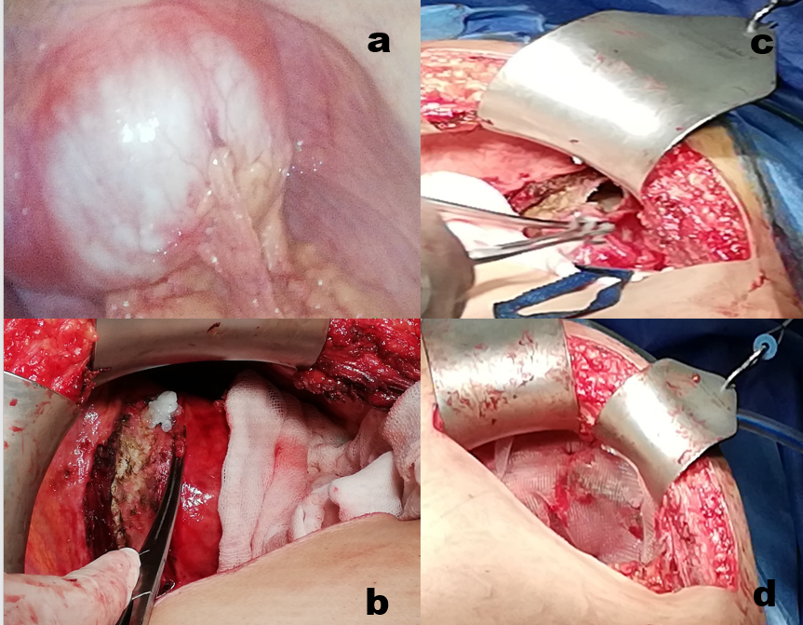

Fig. 2: Photographs taken during hydatid cyst resection (a) laparoscopic view of the cyst bulging through the diaphragm (b) after open laparotomy with a small rent and whitish membrane seen through this rent. (c) after complete resection of the cyst with a gap in the diaphragm. (d) after
repair of the diaphragmatic gap with reinforcement by a prolene mesh
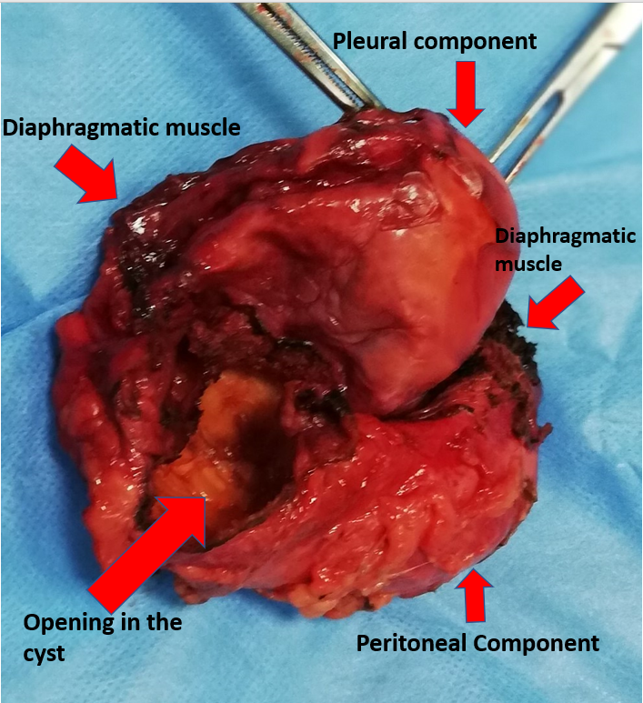

Fig. 3: Photograph of the resected hydatid cyst. It shows its pleural and peritoneal components with a rim of the resected diaphragmatic muscle.

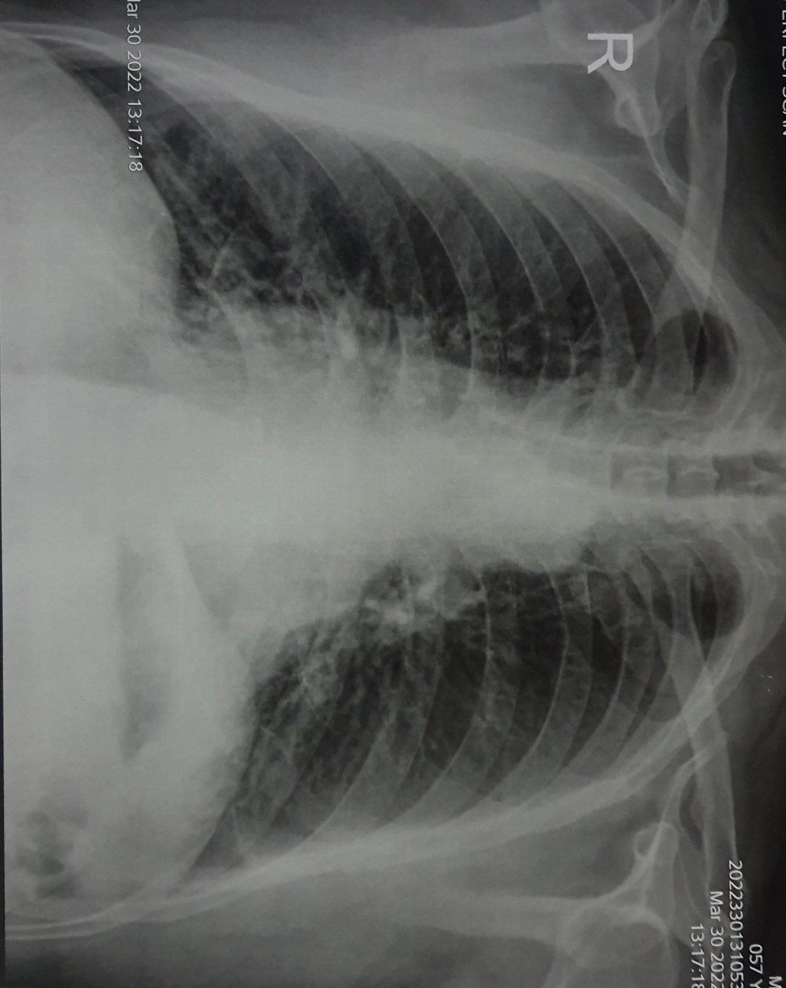

Fig. 4: Postoperative chest x-ray (5 months) revealing almost normal left diaphragmatic contour.

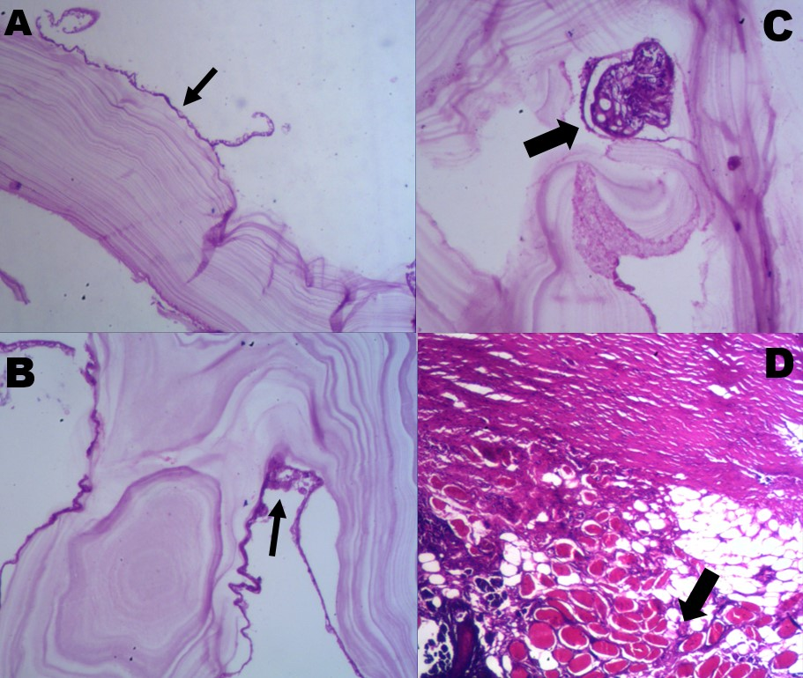
Fig. 5: A) Histopathology image of the True Hydatid Cyst wall showing chitinous lamellated material with germinal layer (Black arrow) (H&E X100). B) Histopathology image of the True Hydatid Cyst wall showing germinal layer with appearing scolices (Black arrow) (H&E X 100) C) Histopathology of the True Hydatid Cyst wall showing a scolex (Thick Black Arrow) (H&E X 200) D) Histopathology image of the Hydatid pseudocyst showing thick hypocellular collagenous hyalinized cyst wall with adipose tissue covering with an area of striated muscle fibers of the diaphragm (Thick Black arrow) (H&E 100).

