Case report
The Surgical implications of a left-sided Gallbladder: A case report
Abstract
A left-sided gallbladder is a rare anomaly that is often discovered when performing a laparoscopic cholecystectomy. Its position has implications when performing the cholecystectomy, as retraction of the gallbladder will require proper placement of the ports. The dissection will have to be done carefully, looking for the atypical presentation of the cystic duct and cystic artery. An on-table cholangiogram should be performed to show the biliary anatomy and confirm the insertion of the cystic duct and the presence of any atypical anatomy of the biliary system. In this case, we present a 38-year-old female patient with symptoms of cholecystitis, and upon performing a laparoscopic cholecystectomy, a left-sided gallbladder was discovered. The laparoscopic cholecystectomy was completed after performing an on-table cholangiogram.

Keywords- “left-sided gallbladder”,” cholecystectomy”,” cholangiogram”,” cholecystitis”, and “Sinistroposition”

Introduction
“The left-sided gallbladder is often defined as the gallbladder that is situated to the left of the falciform ligament. It may or may not be associated with other congenital anomalies of the intrahepatic or extrahepatic biliary system”(Hsu et al., 2007).The prevalence of left-sided gallbladder ranges from 0.2% to 1.1% and is classified into a left-sided gallbladder with associated situs viscerum inversus, a true left-sided gallbladder, and a left-sided gallbladder with an abnormally located right-sided ligamentum teres. There have been several case reports on this clinical entity, and there are clinical implications when performing a laparoscopic cholecystectomy when an incidental left-sided gallbladder is detected intra-operatively(Szymoniuk et al., 2023).
Left-sided gallbladder is seldom diagnosed preoperatively and is often encountered when a laparoscopic cholecystectomy is performed. The implications that can occur during surgery include the placement of the ports, which may be placed to the left or upward retraction of the falciform ligament. “The cystic artery usually crosses from the right to the left in front of the common bile duct, and the cystic duct may cross in front of the common hepatic artery to join the common bile duct on the right. The use of an on-table cholangiogram is often advised to delineate the biliary anatomy before clipping the cystic duct”(Jung et al., 2022).
We will discuss this female patient who presented with symptoms of biliary colic, and she underwent a laparoscopic cholecystectomy when a left-sided gallbladder was encountered with no situs inversus, and the laparoscopic cholecystectomy was performed safely.
Case presentation
A 38-year-old lady who had presented with symptoms of upper abdominal pain for the past few days, associated with symptoms of dyspepsia and intolerance to spicy and fatty food. She was initially treated by a general practitioner for peptic ulcer disease. Still, her symptoms did not improve over the next two days, and she presented to the emergency department with upper abdominal pain, and she was treated with analgesics and anti-secretory medication. An abdominal ultrasound was done, which revealed an inflamed gallbladder with gallstones, and there were no abnormalities in the intra-hepatic or extra-hepatic biliary system.
She was then treated with antibiotics and analgesics, and she was scheduled for a laparoscopic cholecystectomy, and which a left-sided gallbladder was discovered. The standard 4-port laparoscopic cholecystectomy was performed, with the epigastric port placed to the left to allow access to the gallbladder. The cystic duct and artery were dissected, and an on-table cholangiogram was performed, which did not reveal any atypical biliary anatomy. The cystic duct and artery were clipped and cut. The gallbladder was dissected from the fossa, and the patient did not develop any complications. and she was discharged after 2 days. She was followed up and has been symptom-free.

Image 1: Intra-operative image showing the left-sided gallbladder with the falciform ligament to the right.

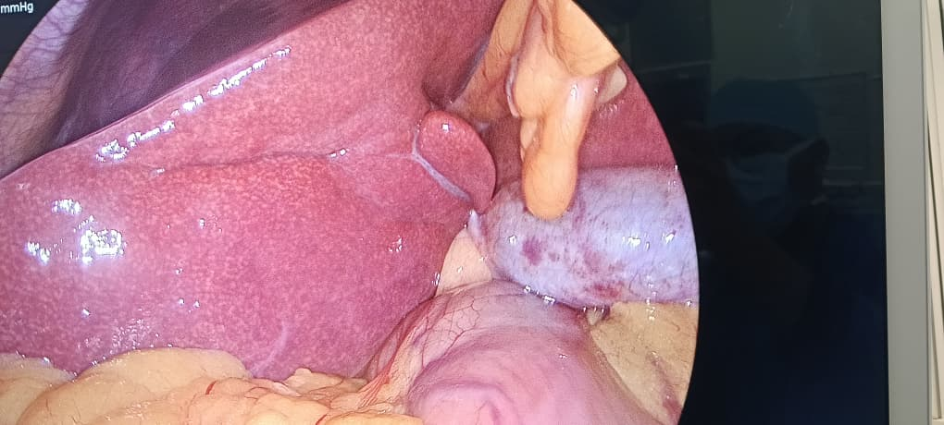
gallbladder
Falciform ligament

Image 2: Intraoperative image showing the dissected cystic duct and its insertion into the gallbladder. (The blue arrow indicates the cystic duct).

Falciform ligament
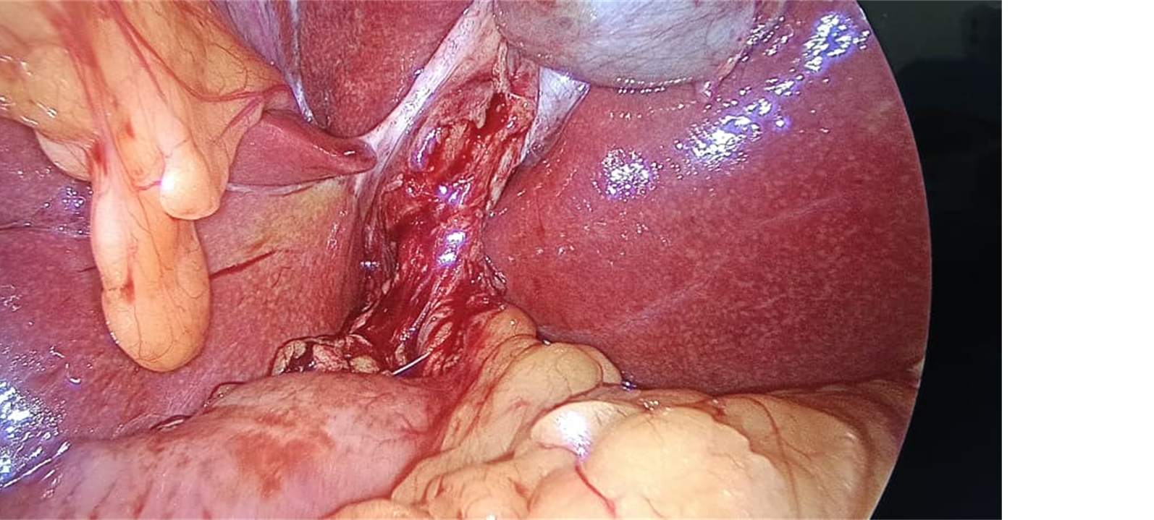
Cystic duct

Image 3: On table cholangiogram demonstrating the normal biliary anatomy and passage of contrast to the duodenum.

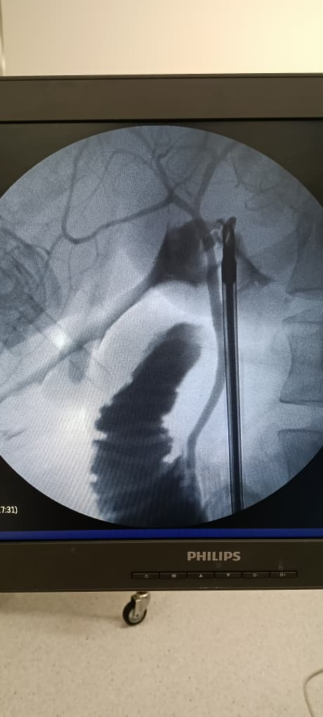

Discussion
The left-sided gallbladder is defined as the presence of the gallbladder located to the left of the round ligament and lying on segment 3 of the liver, without situs inversus. It has an incidence of 0.5% to 1.1% and is almost always identified during surgery. Despite its low incidence, the risk of bile duct injury is higher due to the variation in the attachment of the cystic duct to the common bile duct. “Some of the variations include the cystic duct passing anterior to the common hepatic duct and joining on the right side of the common hepatic duct; the cystic duct may open on the left side of the common hepatic duct, the cystic duct unites with the left hepatic duct, or the cystic duct may join the right hepatic duct. This is referred to as the sinistroposition of the gallbladder”(Pereira, Singh, et al., 2019). “The clinical implications of the left-sided gallbladder are the risk of bile duct injury, especially when performing a laparoscopic cholecystectomy. The position of the ports may need to be altered when performing a laparoscopic cholecystectomy, with the epigastric port being shifted to the left. The falciform ligament may be retracted upwards to improve the view” (Lee et al., 2019). “The Gallbladder dissection may follow an antegrade approach, with the dissection being as close to the gallbladder as possible, and an on-table cholangiogram should be performed to delineate the cystic duct and its attachment to the common bile duct before applying clips. The presence of any aberrant anatomy in the biliary system can also be demonstrated here” (Hawkins & Ben David, 2024; Iskandar et al., 2013; Pereira, Perera, et al., 2019).
“The position of the patient can be altered from the standard supine position to the lithotomy position, with the legs being placed on a stir-up. This position will allow the surgeon better access and mobility. There should also be limited diathermy usage, and the use of energy devices like LigaSure is encouraged to limit injury to the surrounding structures” (Hirohata et al., 2019; Naffa’ et al., 2024; Nagendram et al., 2017; Saafan et al., 2018).A retrospective review by Abongwa et al on the implications of the left-sided gallbladder in the emergency setting has stated the extreme care that has to be taken when dissecting the cystic duct and cystic artery, and to be aware of the crossing over of the cystic artery in front of the common bile duct. In some cases, a hepatopancreatobiliary surgeon may have to be called in if there is difficulty in identifying the structures or if there is difficulty in the dissection of the gallbladder(Abongwa et al., 2017).
Conclusion
The left-sided gallbladder is a rare clinical entity, but it is always discovered during surgery, which makes it difficult to perform a cholecystectomy. The position of the ports when performing a laparoscopic cholecystectomy and the knowledge of the anatomy of the gallbladder and surrounding structures are important. The use of an on-table cholangiogram is important to delineate the biliary anatomy and insertion of the cystic duct before clipping and cutting it.

Disclaimer (Artificial intelligence)
Option 1:
Author(s) hereby declare that NO generative AI technologies such as Large Language Models (ChatGPT, COPILOT, etc.) and text-to-image generators have been used during the writing or editing of this manuscript.

Consent
As per international standards or university standards, patient(s) written consent has been collected and preserved by the author(s).

References
Abongwa, H. K., De Simone, B., Alberici, L., Iaria, M., Perrone, G., Tarasconi, A., Baiocchi, G., Portolani, N., Saverio, S. Di, Sartelli, M., Coccolini, F., Manegold, J. E., Ansaloni, L., & Catena, F. (2017). Implications of Left-sided Gallbladder in the Emergency Setting: Retrospective Review and Top Tips for Safe Laparoscopic Cholecystectomy. www.surgical-laparoscopy.com
Hawkins, N., & Ben David, M. (2024). Left-Sided Gallbladder: Tips and Tricks to Safe Cholecystectomy. Cureus. https://doi.org/10.7759/cureus.76503
Hirohata, R., Abe, T., Amano, H., Kobayashi, T., Nakahara, M., Ohdan, H., & Noriyuki, T. (2019). Laparoscopic cholecystectomy for acute cholecystitis in a patient with left-sided gallbladder: a case report. Surgical Case Reports, 5(1). https://doi.org/10.1186/s40792-019-0614-9
Hsu, S.-L., Chen, T.-Y., Huang, T.-L., Sun, C.-K., Concejero, A. M., Leung-Chit Tsang, L., Cheng wwwwjgnetcom, Y.-F., & Cheng, Y.-F. (2007). Left-sided gallbladder: Its clinical significance and imaging presentations. World J Gastroenterol, 13(47), 6404–6409. www.wjgnet.com
Iskandar, M. E., Radzio, A., Krikhely, M., & Michael Leitman, I. (2013). Laparoscopic cholecystectomy for a left-sided gallbladder. World Journal of Gastroenterology, 19(35), 5925–5928. https://doi.org/10.3748/wjg.v19.i35.5925
Jung, Y. K., Choi, D., & Lee, K. G. (2022). Laparoscopic cholecystectomy for left-sided gallbladder. Langenbeck’s Archives of Surgery, 407(1), 207–212. https://doi.org/10.1007/s00423-021-02263-0
Lee, D. H., Kim, D., Park, Y. H., & Kim, J. S. (2019). Clinical significance and characteristics of left-sided gallbladder: Case series study of 10 patients. Annals of Surgical Treatment and Research, 97(6), 302–308. https://doi.org/10.4174/astr.2019.97.6.302
Naffa’, M. F., Al-Hurani, M. A., Al-Khawaled, Y. O., Albaddawi, Y. Y., & Alfalahat, A. M. (2024). True Left-Sided Gallbladder: A Case Report of Rare Incidental Findings During Cholecystectomy in a Jordanian Patient. Cureus. https://doi.org/10.7759/cureus.75301
Nagendram, S., Lynes, K., & Hamade, A. (2017). A case report on a left sided gallbladder: A rare finding during cholecystectomy. International Journal of Surgery Case Reports, 41, 398–400. https://doi.org/10.1016/j.ijscr.2017.11.004
Pereira, R., Perera, M., Roberts, M., & Avramovic, J. (2019). Surgical approach to a left-sided gallbladder. BMJ Case Reports, 12(8). https://doi.org/10.1136/bcr-2019-230681
Pereira, R., Singh, T., Avramovic, J., Baker, S., Eslick, G. D., & Cox, M. R. (2019). Left-sided gallbladder: a systematic review of a rare biliary anomaly. In ANZ Journal of Surgery (Vol. 89, Issue 11, pp. 1392–1397). Blackwell Publishing. https://doi.org/10.1111/ans.15041
Saafan, T., Hu, J. Y., Mahfouz, A. E., & Abdelaal, A. (2018). True left-sided gallbladder: A case report and comparison with the literature for the different techniques of laparoscopic cholecystectomy for such anomalies. International Journal of Surgery Case Reports, 42, 280–286. https://doi.org/10.1016/j.ijscr.2017.12.029
Szymoniuk, M., Brachet, A., Ciejka, K., Zielkowska, A., Błaszczyk, J., Burdan, O., & Baj, J. (2023). Clinical significance of Left-Sided Gallbladder for laparoscopic cholecystectomy and hepatectomy. Polish Journal of Surgery, 96(1), 65–74. https://doi.org/10.5604/01.3001.0016.2124

