Case report
OCCULT CERVICAL CARCINOMA PRESENTING AS PSOAS ABSCESS- DIAGNOSTIC INSIGHTS
ABSTRACT

Psoas abscess as an initial presentation of cervical squamous cell carcinoma is exceedingly rare, particularly in HIV-negative women, with only a few cases reported. This rarity often leads to diagnostic delays, as initial imaging findings may mimic infectious psoas abscesses, resulting in misdirected therapeutic interventions. Our case underscores the importance of maintaining a high index of suspicion, as malignancies may masquerade as benign inflammatory conditions. Accurate diagnosis requires multidisciplinary evaluation with imaging, biopsy, and histopathology. Surgeons should consider cervical carcinoma in the differential diagnosis of atypical psoas abscesses to avoid delays and improve outcomes.

Keywords: Cervical carcinoma, psoas abscess, occult, flank pain

1. INTRODUCTION

A Psoas abscess is a localized collection of pus in the iliopsoas muscle and is uncommon now a days and can be either primary or secondary. Primary psoas abscess is believed to arise from hematogenous spread from hidden infectious sources within the body. In contrast, secondary Psoas abscess typically results from the direct spread of infections, such as spinal osteomyelitis, Crohn’s disease, diverticulitis, peri-appendicular abscess and cecal carcinoma ⁽¹⁾. Carcinoma of the cervix with skeletal muscle metastasis masquerading as a psoas abscess is an uncommon presentation ^{(2,3)}. Cervical carcinoma tends to spread locally and metastasizes later to lymph nodes and adjacent areas ⁽¹⁾. Subcutaneous and intramuscular metastasis are exceedingly rare ^{(3,4)}. In HIV-positive females, cervical carcinoma tends to exhibit more aggressive behavior, sometimes leading to the unusual clinical presentation as psoas abscess formation ⁽⁵⁾. In some instances, psoas muscle metastasis may be diagnosed before the primary tumor is discovered ⁽⁶⁾. Psoas muscle involvement result from either direct intramuscular metastasis or extra-nodal extension from regional lymph nodes ⁽⁷⁾. Surgical drainage of a presumed abscess may provide symptomatic relief, but tissue biopsy during such procedures is critical for identifying malignant causes and guiding definitive oncological treatment. As emphasized in our case, psoas muscle metastasis in HIV-negative women with cervical carcinoma is uncommon. Without a high index of suspicion, such cases may be misdiagnosed, resulting in a delay in appropriate treatment.

2. presentation of case

History and presenting complaints: A woman in her 60s presented to the emergency department following the accidental removal of her pigtail catheter, which had been placed at another hospital two months earlier to treat a left psoas abscess. She currently complained of abdominal pain localized to the left lower quadrant, which had a gradual onset, was throbbing in nature, worsened after catheter removal, and was relieved by medication. Additionally, she reported a ten-day history of intermittent fever that responded to medication, along with one day of copious, purulent, foul-smelling discharge from the catheter site associated with back pain. There was no history of bowel or bladder disturbances, weight loss, or other swellings. She had a six-year history of type 2 diabetes mellitus managed with oral hypoglycemic agents.

General examination: The patient appeared moderately built and was oriented to time, place, and person, with normal vital signs. Abdominal examination revealed a purulent discharging sinus in the left lower quadrant, emitting a copious foul-smelling discharge. No visible masses, engorged veins, pulsations, or flank fullness were noted, and the external genitalia appeared normal.

Laboratory investigations: showed anemia (Hb – 7.3 g/dL) with normal total WBC and platelet counts. Liver and kidney function tests were within normal limits. Pus samples were negative for acid fast bacilli, while Gram staining revealed gram-negative bacilli and pus cells.

Imaging study: Ultrasound examination of the abdomen and pelvis revealed a well-defined, heterogeneously hypoechoic collection in the subcutaneous plane of the left iliac region, suggestive of an organized abscess. Following this, the patient was started on broad-spectrum antibiotics. Subsequent contrast-enhanced CT (CECT) and MRI scans demonstrated a relatively well-defined soft tissue collection with necrotic areas in the left iliac region, along with erosions of the iliac bone and lumbar vertebrae (Fig. 1), indicating a potentially infective collection. The differential diagnoses included osteomyelitis with abscess formation, lymphoma, and retroperitoneal soft tissue sarcoma with bone erosion.

Following the imaging studies, ultrasound-guided fine-needle aspiration cytology (FNAC) was performed, yielding 2.5 mL of pus-like material. Microscopic examination revealed suppurative inflammation (Fig. 2), while a cell block preparation showed a few atypical squamous cells.

The patient subsequently underwent incision and drainage of the left psoas abscess along with a tissue biopsy (Fig. 3).

Histopathological examination revealed multilayered epithelium showing loss of polarity, pleomorphic cells with squamous differentiation, and areas of necrosis and brisk mitosis (Figs. 4 and 5). The differential diagnoses included squamous cell carcinoma of unknown primary and transitional cell carcinoma with squamous differentiation. Tissue blocks were sent for an immunohistochemistry panel to evaluate for carcinoma of unknown primary (CUP).

After comprehensive evaluation to identify the primary cause, the patient was referred to the Obstetrics and Gynecology (OBG) department for a Pap smear and cervical biopsy. Per speculum examination revealed minimal cervical erosion, a pulled-up cervix, absence of vaginal rugae, minimal cystocele, and an anteverted uterus with free bilateral fornices.

The Pap smear revealed a high-grade squamous intraepithelial lesion (HSIL), while the cervical biopsy confirmed squamous cell carcinoma – not otherwise specified (Fig. 6). Subsequently, immunohistochemistry results showed that the tumor cells exhibited diffuse immunopositivity for p40 (Fig. 7), CK5, and CK6, supporting the diagnosis of invasive keratinizing, squamous cell carcinoma.

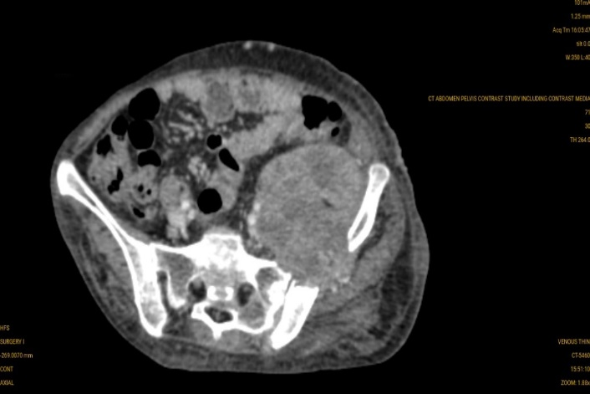

Fig 1, – CT showing a well-defined hypodense collection with air foci in the upper part of the left psoas muscle extending from L1 – L3 vertebral body level along with erosion of iliac bone and lumbar vertebrae.
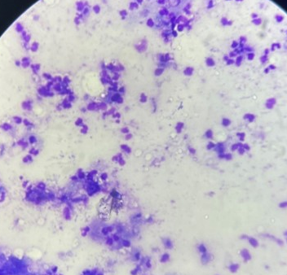
Fig 2 – Photomicrograph (20X, Giemsa) showing mature and degenerated neutrophils, few lymphocytes and histiocytes suggestive of suppurative inflammation.

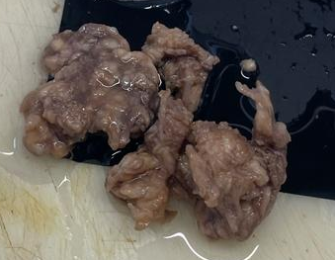
Fig 3 – Excised tissue from left iliac fossa sent for histopathology.
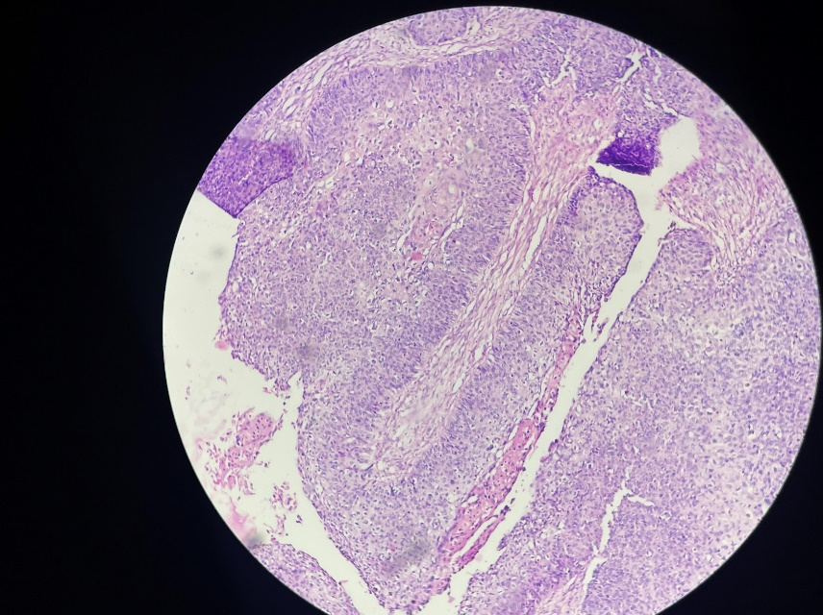
Fig 4 – Photomicrograph (20X, H&E) section showing multilayered epithelium, arranged in papillae with fibrovascular core and nests.

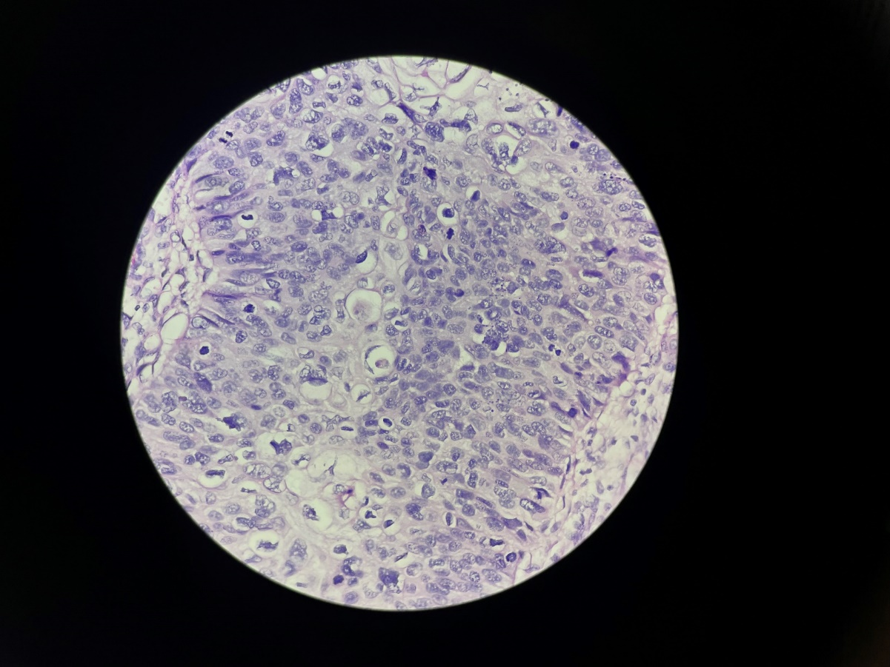
Fig 5 - Photomicrograph (40X, H&E) section showing pleomorphic cells, along with squamous differentiation and brisk mitosis.
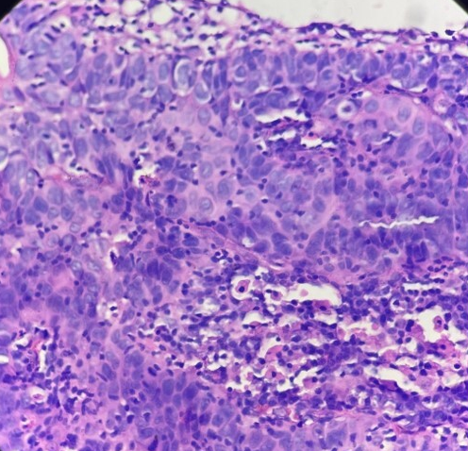
Fig 6- Photomicrograph (40X, H&E) of cervical biopsy showing dysplastic tumor cells with invasion and stromal reaction.

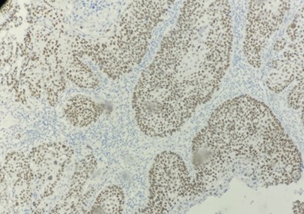

Fig 7 – Photomicrograph (20X) immunohistochemical study of p40 showing positive nuclear staining in tumor cells.

3. discussion
Cervical carcinoma is the second most common cancer in women worldwide and encompasses a range of mild to severe epithelial neoplastic changes^{(1,2)}. Cervical cancer primarily spreads through the lymphatic system and by direct extension, while hematogenous spread is relatively rare^{(1,3)}. HIV-induced immunosuppression increases the likelihood of atypical presentations in cases of invasive cervical carcinoma. Therefore, cervical cancer in HIV-positive women typically progresses aggressively and peculiarly^{(5).} The occurrence of skeletal metastasis in the context of cervical carcinoma suggests an advanced stage of the disease where the tumor has breached adjacent structures. However, there are only a limited number of documented cases of psoas abscess-like bony metastases from cervical cancer in HIV-negative women, rendering it an uncommon condition.
Primary psoas abscess most likely arises from the hematogenous spread of infection, most commonly caused by Staphylococcus aureus, from an unidentified source within the body⁽⁹⁾. Usually, the direct transmission of infection from adjacent structures results in a secondary psoas abscess. Secondary psoas abscess has been linked to several conditions, including septic arthritis, gastrointestinal tract disorders (such as diverticulitis, Crohn’s disease, and infections), genitourinary tract disorders (such as cancers, infections, and treatments), and tuberculous spondylitis. The leading cause of secondary psoas abscess with dorsolumbar spine involvement in India is tuberculosis^{(9,10).}
Patients with a psoas abscess may exhibit nonspecific symptoms like fever, flank pain, lower back pain, and difficulty with hip movement⁽¹⁰⁾. When associated with cervical carcinoma, these symptoms might be initially misleading, especially if the primary tumor is asymptomatic or minimally symptomatic^{(11,12)}.
Devendra and Tay et al.⁽¹¹⁾ reported a case of cervical carcinoma presenting as a psoas abscess without any bone involvement. In contrast, Chatzis and Daniilidis et al.⁽⁸⁾ described a case of metastatic cervical carcinoma manifesting as a psoas abscess following a radical total hysterectomy. Kalra et al.⁽⁵⁾ highlighted a case where metastatic cervical carcinoma mimicked a psoas abscess on imaging, with lytic lesions in the L2 and L3 vertebrae and cortical destruction. Similarly, Sharma et al.⁽¹⁾ discussed a case of well-differentiated keratinizing squamous cell carcinoma of the cervix with skeletal metastasis.
Compared with previous reports, our case is distinctive because the metastasis occurred at an unusual, solitary site with no prior history or clinical suspicion of a primary cervical lesion. The diagnosis of cervical carcinoma was established retrospectively during the search for the primary malignancy, with the tumor confined to the cervix and showing no regional spread. Diagnosing skeletal muscle metastasis is particularly challenging in the absence of prior malignancy or symptoms of a primary tumor, as seen in our case.
The initial presentation as a psoas abscess, coupled with the absence of an evident primary lesion and the high prevalence of tuberculosis in India, led to an early assumption of an infective etiology ^{(13).} Therefore, this case underscores the importance of maintaining a broad differential diagnosis when evaluating atypical abscess-like masses. Clinicians should consider the possibility of underlying malignancy in non-resolving or atypical abscesses, as timely diagnosis and multidisciplinary management are crucial for improving patient outcomes.
4. Conclusion

Cervical carcinoma presenting as a psoas abscess is exceedingly rare, especially in HIV-negative individuals. Clinicians should maintain a broad differential diagnosis when evaluating atypical abscess-like lesions to avoid delayed recognition of underlying malignancy. A comprehensive diagnostic approach—including imaging, FNAC with cell block, histopathology, and immunohistochemistry—is vital for identifying the primary tumor. Early diagnosis and multidisciplinary management combining abscess control with oncologic therapy are essential for improved outcomes. In tuberculosis-endemic regions, malignancy should always be considered in non-resolving or atypical abscess presentations.

Consent

All authors declare that ‘written informed consent was obtained from the patient (or other approved parties) for publication of this case report and accompanying images.

Ethical approval (where ever applicable)

As per international standards or university standards written ethical approval has been collected and preserved by the authors.

Disclaimer (Artificial intelligence)

Authors hereby declare that NO generative AI technologies such as Large Language Models (ChatGPT, COPILOT, etc.) and text-to-image generators have been used during the writing or editing of this manuscript.

References

Sharma A, Dey A, Gupta M. Metastatic cervical carcinoma masquerading as iliopsoas abscess in an HIV negative woman-diagnosed on fine-needle aspiration cytology: A case report. Journal of Cytology. 2015 Oct 1;32(4):275-7.
Jain HA, Bagri PK, Tripathy A, Chaudhary KG, Joshi H. Psoas muscle metastasis in cervical cancer: A case study and literature review. Indian Journal of Case Reports. 2024 Nov 27;10(12):428-31.
Bachheti Y, Nair SR, Durgapal P, Gupta S. Intramuscular metastasis in carcinoma of the cervix: Atypical site of clinical presentation. Journal of Cancer Research and Practice. 2022 Apr–Jun;9(2):82-85.
Zhao X, Chen R, Zhou Q. Skin metastasis in squamous cell cancer of cervix: A case report. Precision Radiation Oncology. 2023 Jun;7(2):142-6.
Kalra N, Aiyappan S, Nijhawan R, Sharma SC, Khandelwal N. Metastatic carcinoma of cervix mimicking psoas abscess on imaging: a case report. Journal of Gynecologic Oncology. 2009 Jun 1;20(2):129-31.
Gunn C, Fani M. Psoas muscle metastatic disease mimicking a psoas abscess on imaging. BMJ Case Reports. 2022 Aug 19;15(8):e250654.
Takamatsu S, Murakami K, Takaya H, Tobiume T, Nakai H, Suzuki A, et al. Malignant psoas syndrome associated with gynecological malignancy: Three case reports and a review of the literature. Molecular and Clinical Oncology. 2018;9:82-86.
Chatzis P, Daniilidis A, Papathanasiou N, Lathouras K, Loufopoulos PD, Vrachnis N. Metastatic cervical carcinoma presenting as psoas abscess, after a radical total hysterectomy. Journal of Obstetrics and Gynaecology. 2014 Jan 1;34(1):101-2.
Van den Berge M, de Marie S, Kuipers T, Jansz AR, Bravenboer B. Psoas abscess: report of a series and review of the literature. The Netherlands journal of medicine. 2005 Jan 1;63(10):413-6.
Mehdorn M, Petersen TO, Bartels M, Jansen-Winkeln B, Kassahun WT. Psoas abscess secondary to retroperitoneal distant metastases from squamous cell carcinoma of the cervix with thrombosis of the inferior vena cava and duodenal infiltration treated by Whipple procedure: a case report and review of the literature. BMC surgery. 2016 Dec;16:1-6.
Devendra K, Tay SK. Metastatic carcinoma of the cervix presenting as a psoas abscess in an HIV-negative woman. Singapore Medical Journal. 2003 Jun 1;44(6):302-5.
Afrose R, Akram M, Khalid S, Ahmad SS, Siddiqui SA. Psoas abscess: a rare metastatic presentation of asymptomatic carcinoma of the cervix. Southern African Journal of Gynaecological Oncology. 2015 Jan 2;7(1):37-9.
Askin A, Bayram KB, Demirdal US, Korkmaz MB, Gurgan AD, Inci MF. An easily overlooked presentation of malignant psoas abscess: hip pain. Case Reports in Orthopedics; 2015(1)

