Case report
A Rare Bite: Oesophageal Obstruction by a Mango Seed in the Elderly

Abstract
Aims: To report a rare case of oesophageal obstruction in an elderly male due to ingestion of a mango seed.
Presentation of Case: A 75-year-old male presented five days after swallowing a mango seed, with progressive dysphagia and regurgitation of food. Imaging revealed a mid-sized filling defect with proximal oesophageal dilatation. Endoscopic removal failed, necessitating surgical extraction via left thoracotomy.
Discussion: While foreign body ingestion is more common in children and mentally challenged individuals, it can occur in elderly patients due to impaired sensation or swallowing difficulties. Large and irregular foreign bodies such as mango seeds are rare and may require surgical removal if endoscopy fails. Early diagnosis and timely management are crucial to prevent complications such as perforation and mediastinitis.
Conclusion: Foreign body ingestion should be considered in elderly patients presenting with sudden dysphagia. Prompt imaging and appropriate intervention, including surgery, when necessary, can ensure good outcomes.

Keywords
Foreign body ingestion, Oesophageal obstruction, Elderly, Mango seed, Thoracotomy

Introduction
Foreign body ingestion is an uncommon but potentially serious clinical problem that can lead to severe complications. It is defined as the ingestion of any object—intentionally or accidentally—or materials consumed during eating or medication intake, which may cause complications such as impaction under specific circumstances (1).
High-risk populations include prisoners, individuals with intellectual disabilities, drug users, alcoholics, and the elderly with reduced oral tactile sensation. A wide variety of Oesophageal foreign bodies are encountered in clinical practice. Coins are the most ingested objects overall and represent the most frequent type in children, whereas bones account for most cases in adults. In a large retrospective study from Central India, coins were the most common ingested objects in children, whereas bones and dentures predominated in adults, with rare instances of plant-based materials such as mango seeds also reported (7). Other commonly ingested objects include meat, cartilage, dentures, bezoars, fruit stones, toys, batteries, and buttons.
Some foreign bodies may be aspirated, but when lodged in the oesophagus, they typically become impacted at the level of the cricopharyngeus muscle in children, and at the lower Oesophageal sphincter or at sites of pre-existing Oesophageal pathology in adults (2).
Large or irregularly shaped foreign bodies can cause edema, ischemia, and erosion due to pressure effects. Oesophageal perforation, though rare, is a serious complication most commonly associated with bone ingestion or the presence of sharp foreign bodies (3).
While most reported complications include obstruction and perforation, rare but severe sequelae such as tracheoesophageal fistula have also been described following mango endocarp ingestion (10).
We report a rare case of Oesophageal foreign body (mango seed) ingestion in an elderly male who presented five days after the incident.

Case Presentation
A 75-year-old male arrived at the emergency department at a tertiary care center in Central India complaining of difficulty swallowing solid foods for the past five days. He was able to consume oral liquids. The patient mentioned experiencing pain while swallowing and noticed food coming back up after eating. He had a documented history of high blood pressure and was consistently taking medication to manage it. The patient had no prior history of mental health conditions, neurological disorders, or gastrointestinal problems. The patient shared a detailed account of accidentally swallowing a mango seed five days before experiencing symptoms.
On overall assessment, the patient's state was typical. His vital signs remained steady: pulse rate of 88 per minute, blood pressure of 138/88 mmHg, and oxygen saturation (SPO₂) of 95% in the presence of room air. He showed no signs of breathing difficulties when he arrived at the hospital.
The initial x-rays of the chest and abdomen (CXR and AXR) did not reveal any signs of obstruction or perforation. The barium swallow study showed a mid-sized (56 × 38 mm) filling defect in the middle and lower third of the oesophagus, leading to substantial luminal obstruction with proximal dilation. The barium contrast stayed in the dilated oesophagus for up to 10 minutes after the imaging, indicating the possibility of a retained foreign object or a space-occupying lesion.

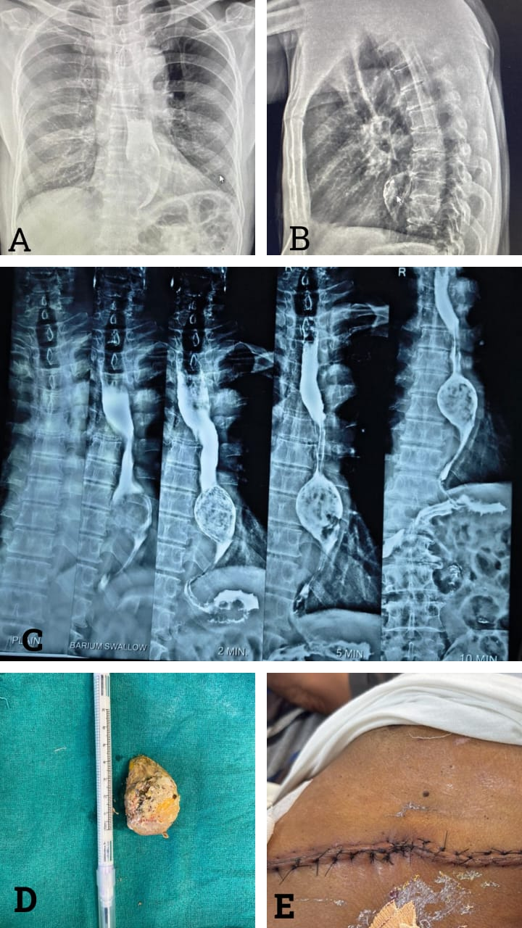

Figure 1
A,B,C: Preoperative contrast study
D: Excised specimen of foreign body (Mango Seed)
E: Post operative wound

An attempt was made to retrieve the object through endoscopy at an external facility, but it was unsuccessful. Considering the size and location of the foreign object, the patient was scheduled for surgical extraction.
A surgical procedure was carried out on the left side of the chest (Left Anterolateral Thoracotomy). The lung was pulled up above to reveal the oesophagus. A noticeable bulge was observed in the lower-middle third of the oesophagus, leading to the decision to perform an oesophagostomy at that specific location. The mango seed—a foreign object—was successfully extracted. The incision in the oesophagus was stitched together in a single layer, and a drainage tube was inserted on the left side of the chest.
After the surgery, the patient was placed on positive pressure ventilation until postoperative day 1. Ryle's tube feeding started on POD 3. Oral sips were initiated on POD 5, with careful observation for any indications of leakage or respiratory issues. On POD 7, a gentle diet was implemented, and the chest tube was taken out on POD 9. The patient was discharged on POD 10 and on the follow up POD 14 stich removal done.

Discussion
Foreign body ingestion is most frequently observed in children and individuals with psychiatric illness, but it may also occur in older adults due to diminished sensation, dental issues, or dysphagia. In adults, bones are the commonest ingested foreign objects, while large plant-based materials such as mango seeds are extremely rare and scarcely documented (4). A neglected pickled mango seed in the cervical oesophagus managed with rigid endoscopy has been described previously (8).
In the present case, a 75-year-old male presented five days after ingesting a mango seed with progressive dysphagia, odynophagia, and regurgitation. Delayed presentation led to significant oesophageal obstruction, visible on radiograph as a filling defect with proximal dilatation. Although most foreign bodies pass spontaneously or are endoscopically retrievable, large irregular objects impacted for a prolonged period often necessitate surgery. In this case, endoscopic removal was unsuccessful, and a thoracotomy was required to extract the 56 × 38 mm seed.
Foreign body impaction in adults usually occurs at the upper or lower oesophageal sphincters or at sites of narrowing such as strictures or tumours. The large size and irregular shape of the mango seed, together with mucosal compression, increase the risk of pressure necrosis, perforation, and mediastinitis if not treated promptly (5). Interestingly, Sapkota et al. recently reported the first case of acquired tracheoesophageal fistula in an adult following ingestion of a mango endocarp, underscoring the spectrum of life-threatening complications possible with such foreign bodies (10). Vegetative foreign bodies are particularly hazardous, as they imbibe water and swell, aggravating inflammation and obstruction. In elderly patients, associated regurgitation further predisposes to aspiration pneumonitis, adversely affecting perioperative outcomes. Hence, early diagnosis and intervention are crucial.
Imaging is vital for diagnosis and management planning; in this case, a barium swallow clearly outlined the obstruction. While Biswas et al. successfully managed a similar case with rigid esophagoscopy, our patient required thoracotomy due to delayed presentation and the unusually large seed (6).

Conclusion
This case emphasizes the significance of being vigilant for foreign body ingestion in elderly patients who experience sudden difficulty swallowing. While endoscopy is typically the initial method for diagnosis and removal, surgical intervention becomes necessary when non-operative approaches are ineffective. Rarely, non-endoscopic swallowing techniques have also been reported to resolve obstruction without the need for invasive procedures (9). Timely diagnosis, accurate imaging, and collaborative management among healthcare professionals can prevent severe complications and achieve positive outcomes, even in cases where treatment is delayed.

Consent
Written informed consent was obtained from the patient for publication of this case and accompanying images.

Ethical Approval
All procedures were conducted in accordance with institutional ethical standards and the Declaration of Helsinki.

Disclaimer (Artificial intelligence)
Option 1:
Author(s) hereby declare that NO generative AI technologies such as Large Language Models (ChatGPT, COPILOT, etc.) and text-to-image generators have been used during the writing or editing of this manuscript.

References
1. Alturkmani OG, Al-Badawi MM, Alturkmani SG, Al-Midani MH, Attar SA. A Case Report of Non-intentional Foreign Body Ingestion in an Elderly Patient. Cureus. 2023;15(4):e37684. doi:10.7759/cureus.37684.
2. Ashraf O. Foreign body in the oesophagus: a review. Sao Paulo Med J. 2006;124(6):346-9. doi:10.1590/s1516-31802006000600010.
3. Al-Faham FS, Al-Hakkak SM. The largest oesophageal foreign body in adults: A case report. Ann Med Surg. 2020;54:82-84. doi:10.1016/j.amsu.2020.04.039.
4. Ambe P, Weber SA, Schauer M, Knoefel WT. Swallowed foreign bodies in adults. Dtsch Arztebl Int. 2012;109(50):869-75. doi:10.3238/arztebl.2012.0869.
5. Webb WA. Management of foreign bodies of the upper gastrointestinal tract: update. Gastrointest Endosc. 1995;41(1):39-51.
6. Biswas D, Majumdar AB, Paul SS, Ray S. A rare case presentation of foreign body in esophagus (large mango seed). J Indian Med Assoc. 2019;117(12):26–7, 29.
7. Gupta Y, Gourh G, Mundra RK. Retrospective study of upper digestive tract foreign bodies in central India. Int Surg J. 2015;2(4):539-43. doi:10.18203/2349-2902.isj20151076.
8. Singh SP, Chopra L, Sandhu KS, Singh J. Neglected and impacted foreign body (pickled mango seed) in the upper cervical oesophagus: a case report. Glob J Otolaryngol. 2019;20(2):556031. doi:10.19080/GJO.2019.20.556031.
9. Barden M, Schwartz ME. Oesophageal obstruction from food bolus impaction successfully managed with the “upright posture, chin tuck, double swallow” maneuver: a case report. Clin Pract Cases Emerg Med. 2024;8(4):343–345. doi:10.5811/cpcem.19397.
10. Sapkota R, Luitel P, Rayamajhi S, Pandey A, Thapa A. Acquired tracheoesophageal fistula in an adult due to mango endocarp: a case report. Ann Med Surg (Lond). 2025;87:2440-2443. doi:10.1097/MS9.0000000000003111.

