Video-Assisted Thoracoscopic Surgery In A Case of Blunt Chest Trauma: A Case report

Abstract

Video-Assisted Thoracoscopic Surgery (VATS), like other minimally invasive procedures, offers clear benefits such as reduced surgical trauma, faster recovery, shorter hospital stays, lower healthcare costs, and quicker return to work. This last advantage—an earlier return to employment—is particularly significant in developing countries. However, despite these benefits, minimally invasive techniques like VATS are still not widely adopted in trauma surgery within many developing regions, largely due to various challenges . In this report, we present a case where VATS was effectively utilized to manage a pleural effusion resulting from a chest injury caused by an assault.

Keywords: Pleural effusion ,Video Assisted Thoracoscopy, assaulted chest injury .

INTRODUCTION
Over the past three decades, minimally invasive surgery has become essential in various fields of elective general surgery, even becoming the gold standard for procedures like laparoscopic cholecystectomy. Its ability to minimise surgical trauma has resulted in quicker patient recovery and several associated benefits. Despite these advantages, the adoption of minimally invasive techniques in trauma surgery has been limited globally. This is especially true in developing countries, which face approximately 80% of the world’s trauma cases, yet have been slower to embrace these modern surgical methods.

CASE Presentation
A 56 year old male patient had sustained chest injury by assaulted chest injury . He presented with right side chest pain . He was hemodynamically stable and had no respiratory symptoms or signs and abdomen was normal. X-ray chest revealed the presence pleural effusion in the right side , diagnostic tapping of pleural fluid done which suggest yellow fluid ( 4-5 rbc /hpf , 150-200 wbc /uL 80% polymorphs , no clot ) and fluid CBNAAT negative . CT scan confirmed our suspicion that there was moderate to gross loculated pleural effusion with multiple septa with thickened pleura over right side suspicious empyema with associated atelectasis of right lower lobe . We decided to try minimal access surgery but with full preparations for open thoracotomy in case of failure. He needed one lung ventilation as a prerequisite for thoracoscopy. Hence the procedure was done under general anesthesia and intubated with a double lumen tube. He was placed on the anterolateral right thoracotomy position. Single lung ventilation was instituted. A 10mm camera port was placed in the (R) 6th intercostal space in the anterior axillary line.Another 10 mm working port introduced in 6th ICS in mid axillary line . A 5 mm working port was placed in the 5th intercostal space In posterior axillary line and another 5 mm working port introduced in 2nd ICS mid axillary line . The pleural cavity suggestive of thick adherent membrane with adhesion was found in lateral and posterior surface of lung with multiple thin walled lobulated collection .Adhesiolysis with removal of thick membrane was done with decortication of lung .The rest of the thoracic cavity and diaphragm were found to be normal.Two intercostal chest drainage tube was kept one in mid axillary line towards Base of lung and another one anterior axillary line towards apex of lung .He had no adverse event intraoperatively and promptly recovered from anesthesia and extubated, with a well expanded lung that was confirmed clinically and with a bedside X ray and shifted to SICU Upper ICD removed on POD 3rd day and in lower icd continuous low grade suction applied and removed on POD 12th.. He was discharged and came for followed up regularly and is doing well.

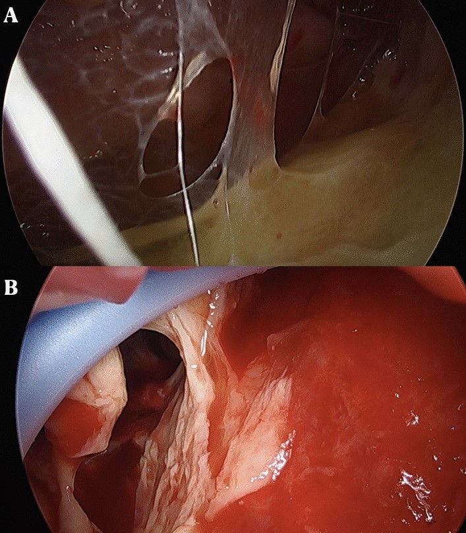
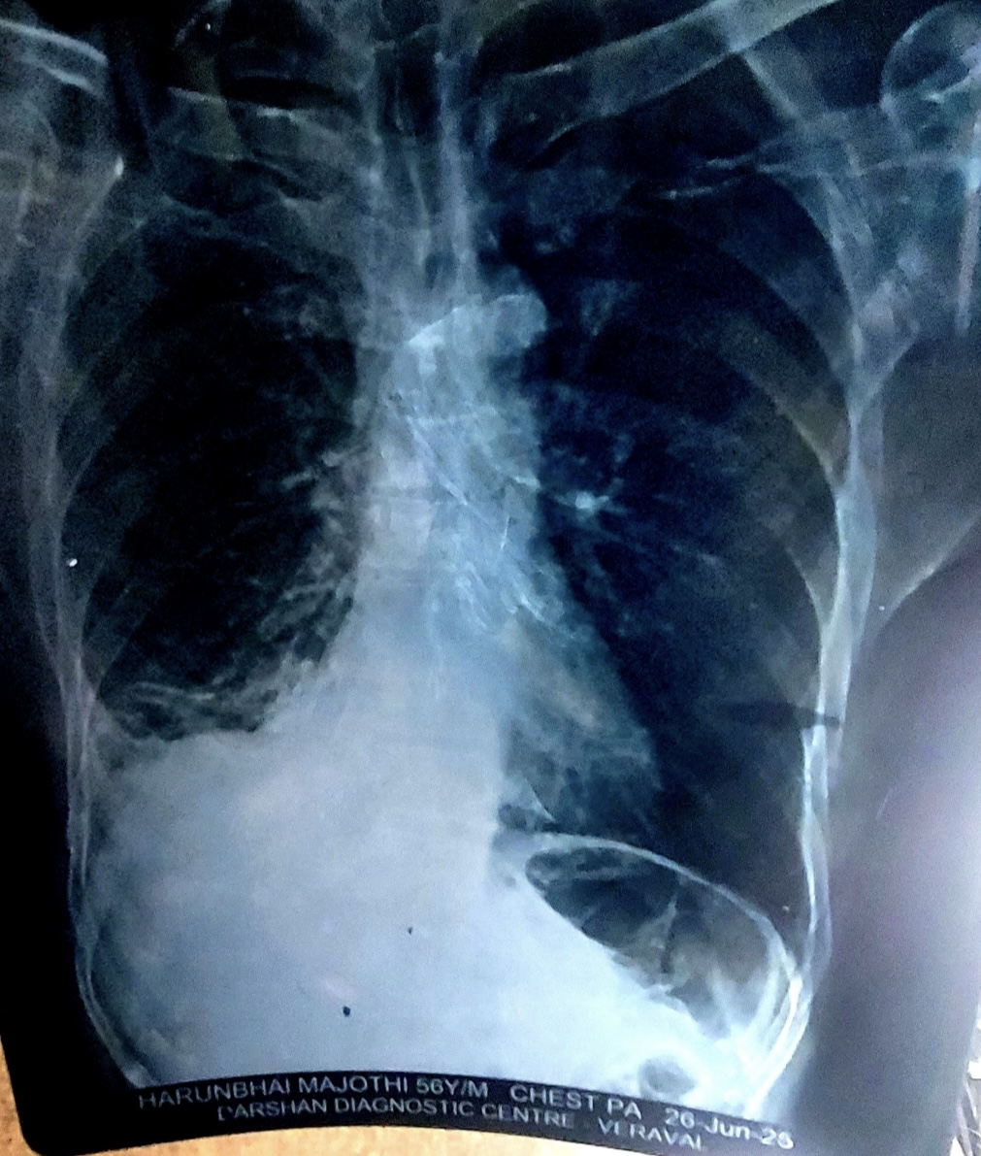
Figure 1 : Preoperative CHEST X-RAY

Figure 2:Intraoperative images show thick pleural membrane

DISCUSSION
Thoracoscopy in trauma patients was first introduced in 1976 by Jackson and Ferreira for diagnosing diaphragmatic injuries.[1] In the early 1980s, Jones and colleagues performed emergency thoracoscopy under local anesthesia to manage persistent hemothorax, thereby avoiding the need for thoracotomy.[2]

Although the terms thoracoscopy and video-assisted thoracoscopic surgery (VATS) are often used interchangeably, they have distinct differences. Thoracoscopy involves direct three-dimensional visualization of the pleural cavity through a single incision. In contrast, VATS provides a two-dimensional image using a video monitor and multiple ports, allowing for more complex surgical interventions.

While both techniques are commonly employed in elective thoracic surgery, their use in trauma cases remains limited.[3] Compared to open thoracotomy, VATS offers significant benefits, such as better postoperative pain control, improved lung expansion, quicker return to daily activities, and reduced duration of chest tube drainage.[4,5]

In thoracic trauma, VATS has several specific indications, including:

- Management of retained hemothorax and persistent pneumothorax
- Evaluation of diaphragmatic injuries in penetrating thoracoabdominal trauma
- Evacuation of post-traumatic empyema
- Hemorrhage control in hemodynamically stable patients
- Less commonly, it is used for foreign body retrieval, management of traumatic chylothorax, and rib resections.

The timing of VATS in trauma can be categorized as:

- Emergency VATS (Day 0–2): Used for diagnostic purposes, evacuation of hemothorax, control of intercostal artery bleeding, and removal of intrathoracic foreign bodies.
- Early VATS (Day 2–7): Suitable for bronchial injury repair and thoracic duct ligation.
- Late VATS (After Day 7): Typically performed for complications like retained hemothorax, empyema, pleural effusion, or pericardial effusion.

Conversion rates from VATS to thoracotomy are low—around 4%—in high-volume trauma centers. Current evidence suggests VATS is both safe and more effective when used in early and late trauma settings.[3,6] However, the primary contraindication remains hemodynamic instability, where open surgery is more appropriate.[8] Recognizing the need for prompt conversion to thoracotomy is critical.

Despite being introduced in trauma care over two decades ago, thoracoscopy has yet to see widespread adoption among trauma surgeons. Several factors hinder its broader implementation:

- Lack of training in minimally invasive techniques
- Overwhelming patient loads in trauma centers
- Limited availability of thoracoscopic equipment due to financial or institutional constraints

Developing countries bear the brunt of global trauma, accounting for 80% of trauma-related morbidity and mortality. In countries like ours, the burden of acute trauma care largely falls on government hospitals, which often lack the resources to cope up with high patient volumes. These systems are frequently under-equipped and underfunded.

With advancing technology and more clearly defined indications for VATS, there is a growing need for trauma surgeons to integrate it into thoracic trauma protocols.[9]

Conclusion: minimally invasive surgery has, so far, played only a marginal role in acute trauma care. The core challenge is the emergent nature of trauma, often accompanied by hemodynamic instability—especially in the early stages—making open surgery the safer option. This challenge is magnified in developing nations due to high trauma incidence, underdeveloped prehospital care, absence of dedicated trauma systems, and lack of training in minimally invasive techniques among trauma surgeons.

As a result, many trauma patients who are potentially stable and suitable candidates for VATS are denied this option due to skill gaps. There is a pressing need to incorporate minimally invasive surgical training into trauma education—starting with elective general surgery and gradually extending into trauma care.

Consent
As per international standards or university standards, patient(s) written consent has been collected and preserved by the author(s).
Ethical Approval:
As per international standards or university standards written ethical approval has been collected and preserved by the author(s).

Disclaimer (Artificial intelligence)
Option 1:
Author(s) hereby declare that NO generative AI technologies such as Large Language Models (ChatGPT, COPILOT, etc.) and text-to-image generators have been used during the writing or editing of this manuscript.
Option 2:
Author(s) hereby declare that generative AI technologies such as Large Language Models, etc. have been used during the writing or editing of manuscripts. This explanation will include the name, version, model, and source of the generative AI technology and as well as all input prompts provided to the generative AI technology
Details of the AI usage are given below:
1.
2.
3.

REFERENCES
- 1.Jackson AM, Ferreira AA. Thoracoscopy as an aid to the diagnosis of diaphragmatic injury in penetrating wounds of the left lower chest: A preliminary report. Injury. 1976;7:213–7. doi: 10.1016/0020-1383(76)90216-3. [DOI] [PubMed] [Google Scholar]
- 2.Jones JW, Kitahama A, Webb WR, McSwain N. Emergency thoracoscopy: A logical approach to chest trauma management. J Trauma. 1981;21:280–4.[PubMed] [Google Scholar]
- 3.Milanchi S, Makey I, McKenna R, Margulies DR. Video-assisted thoracoscopic surgery in the management of penetrating and blunt thoracic trauma. J Minim Access Surg. 2009;5:63–6. doi: 10.4103/0972-9941.58499. [DOI] [PMC free article] [PubMed] [Google Scholar]
- 4.Whitson BA, Andrade RS, Boettcher A, Bardales R, Kratzke RA, Dahlberg PS, et al. Video-assisted thoracoscopic surgery is more favorable than thoracotomy for resection of clinical stage I non-small cell lung cancer. Ann Thorac Surg. 2007;83:1965–70. doi: 10.1016/j.athoracsur.2007.01.049. [DOI] [PubMed] [Google Scholar]
- 5.Ben-Nun A, Orlovsky M, Best LA. Video-assisted thoracoscopic surgery in the treatment of chest trauma: Long-term benefit. Ann Thorac Surg. 2007;83:383–7. doi: 10.1016/j.athoracsur.2006.09.082. [DOI] [PubMed] [Google Scholar]
- 6.Hanvesakul R, Momin A, Gee MJ, Marrinan MT. A role for video assisted thoracoscopy in stable penetrating chest trauma. Emerg Med J. 2005;22:386–7. doi: 10.1136/emj.2003.014076.[DOI] [PMC free article] [PubMed] [Google Scholar]
- 7.Lang-Lazdunski L, Mouroux J, Pons F, Grosdidier G, Martinod E, Elkaïm D, et al. Role of videothoracoscopy in chest trauma. Ann Thorac Surg. 1997;63:327–33. doi: 10.1016/s0003-4975(96)00960-5. [DOI] [PubMed] [Google Scholar]
- 8.Cetindag IB, Neideen T, Hazelrigg SR. Video-Assisted Thoracic Surgical Applications in Thoracic Trauma. Thorac Surg Clin. 2007;17:73–9. doi: 10.1016/j.thorsurg.2007.02.007. [DOI] [PubMed] [Google Scholar]
- 9.Degiannis E, Bowley DM, Smith MD. Minimally invasive surgery in trauma: technology looking for an application. Injury. 2004;35:474–8. doi: 10.1016/j.injury.2003.07.002. [DOI] [PubMed] [Google Scholar]

