Case report

Rare Primary Osseous Kaposiform Hemangioendothelioma Treated with Maternal Fibular Allograft: A Case Report and Review

Abstract

Kaposiform hemangioendothelioma (KHE) is a rare vascular tumour of intermediate malignancy, with primary osseous involvement being exceptionally uncommon. The first case from India of femoral diaphyseal KHE in a 3-year-old boy who presented with recurrent fractures and thigh swelling was reported. The MRI was suggestive of a T2 hyperintense soft tissue mass in the mid-diaphysis of the right femur with multiple hypointense foci within. Diagnosis was confirmed by histopathology and immunohistochemistry. The patient underwent wide excision of the femoral diaphysis with maternal fibular allograft reconstruction. At 11 months, graft displacement and non-union required revision surgery with a second maternal fibular strut, after which stable function was achieved. Femoral diaphysis was removed, preserving 3 cm proximal and 2 cm distal femur, and a maternal non-vascularized fibular allograft was used for bony reconstruction with two plates and screw fixation. The post-op period was uneventful. Since KHE may regress over time, conservative management is an option if symptoms are controlled and limb salvage is not possible. Further studies are necessary to validate these approaches and establish standardised treatment protocols. This case demonstrates the feasibility of maternal fibular allograft in pediatric bone KHE and emphasises the need for close follow-up due to graft-related complications.

Keywords: Kaposiform hemangioendothelioma, maternal fibular allograft, femoral diaphysis, right femur, fracture

Introduction

Kaposiform hemangioendothelioma (KHE) is a neoplasm originating mainly from blood vessels and has a low propensity for malignancy. This neoplasm mainly arises in soft tissue and the retroperitoneum. It is traditionally considered to be a tumour of infants and children, but many adult cases have also been reported in the literature. Distal extremities are the classic sites, but many unusual sites, including the head and neck region and viscera, have also been reported (Chundriger et al., 2021; Ji et al., 2022). Histological findings include a nodular arrangement of oval-to-spindle cells containing pale cytoplasm (Hu et al., 2023). Vascular spaces are in the form of slit-like channels in which red blood cells are trapped [3]. Treatment options include surgical excision with wide margins and adjuvant chemotherapy in various combinations. Very few case reports have been published on KHE of long bones worldwide (Li et al., 2024). The presentation of this condition is variable, with an incidence of approximately 0.07/100000.2. Kasabach Merritt phenomenon (KMP) occurs in 40% to 71% of KHE patients and is characterised by severe thrombocythemia combined with consumptive coagulopathy (Zhou et al., 2025). Here we present the very first published case report on KHE of the diaphysis of the femur from India.

Case Report

A 3-year-old boy presented to us with a history of recurrent fracture of the right femur with trivial trauma managed by a cast in outside facilities and a recent onset of gradually progressive swelling of the right thigh. He was evaluated with X-ray and MRI of the right thigh.

MRI: Suggestive of a T2 hyperintense soft tissue mass in mid-diaphysis of the right femur with multiple hypointense foci within. There’s associated periosteal elevation in the proximal part of the lesion. The plane with the Superficial Femoral Artery (SFA) and Superficial Femoral Vein (SFV) is maintained.

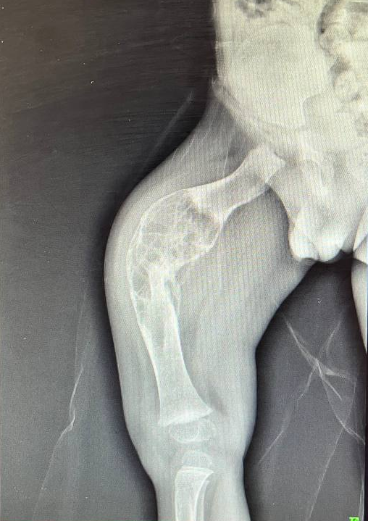
Fig 1. Pre-op XRay

Histopathological Examination (HPE) with Immunohistochemistry (IHC): Showed low to intermediate grade spindle cell tumour, CD31-, CD34+, SATB2-, ERG+. The tumour cells were negative for Human Herpesvirus 8 (HHV8) and Latency-Associated Nuclear Antigen 1 (LNA-1). Friend leukaemia integration 1 transcription factor (Fli1) was unavailable in our institute. Overall features suggestive of kaposiform hemangioendothelioma.

Surgery: Femoral diaphysis was removed, preserving 3 cm proximal and 2 cm distal femur, and a maternal non-vascularized fibular allograft was used for bony reconstruction with two plates and screw fixation. The post-op period was uneventful.
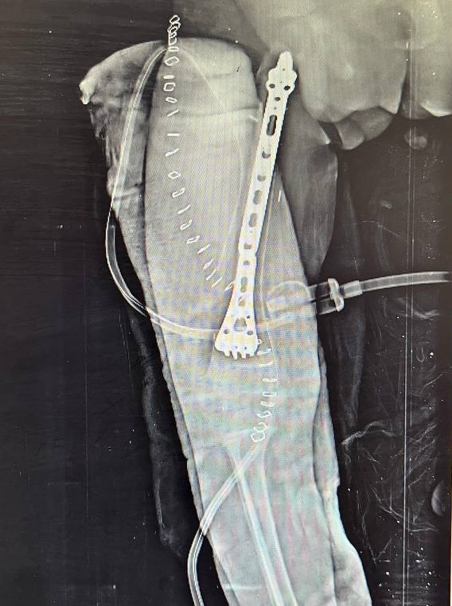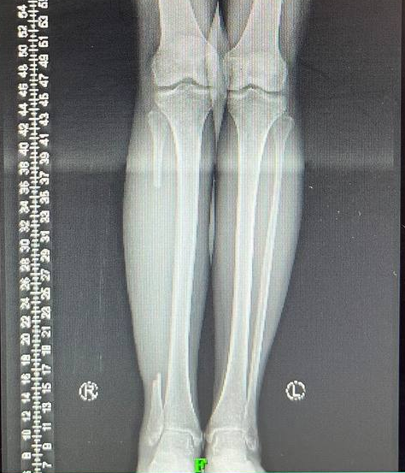
Fig 2. Post op Fibula Allograft Fig 3. Maternal right fibula harvested

Follow-up: Patient was on regular follow-up, and at the 11th month, the follow-up X-Ray showed the distal end of the bony graft was displaced with frank non-union and limb shortening. Re-operation was planned, and the mother agreed to donate the opposite fibula for an allograft fibula strut.
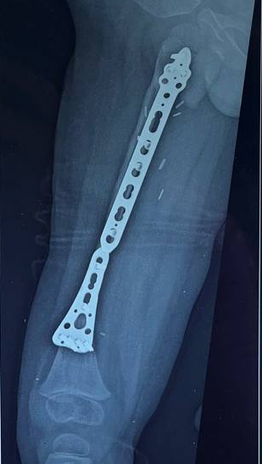
Fig 4. 9th month follow-up X-Ray
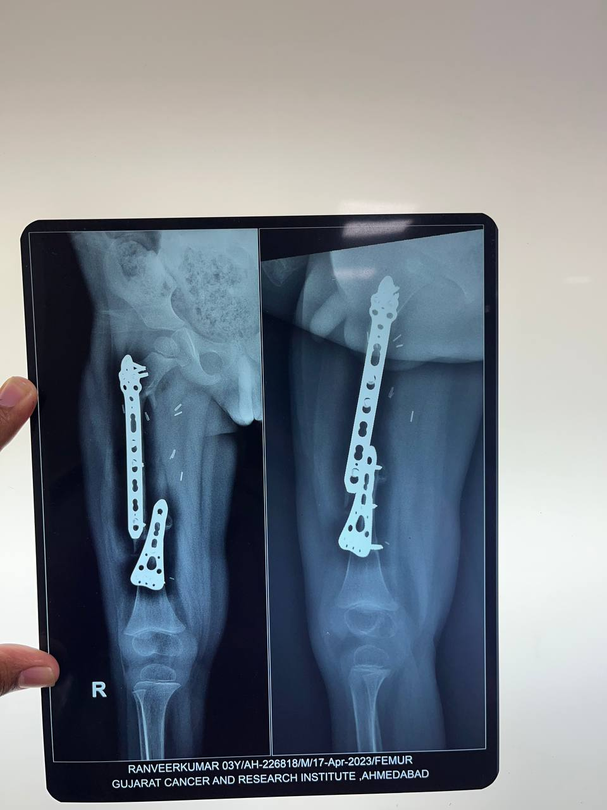
Fig 5. 11th-month follow-up X-ray showing a displaced fracture at the distal end

Repeat Surgery: Previous plate removal, open reduction of displaced bony ends with plate fixation and fibular strut allograft was done using the maternal femur. Steel wire was used to stabilise the new fibular strut.
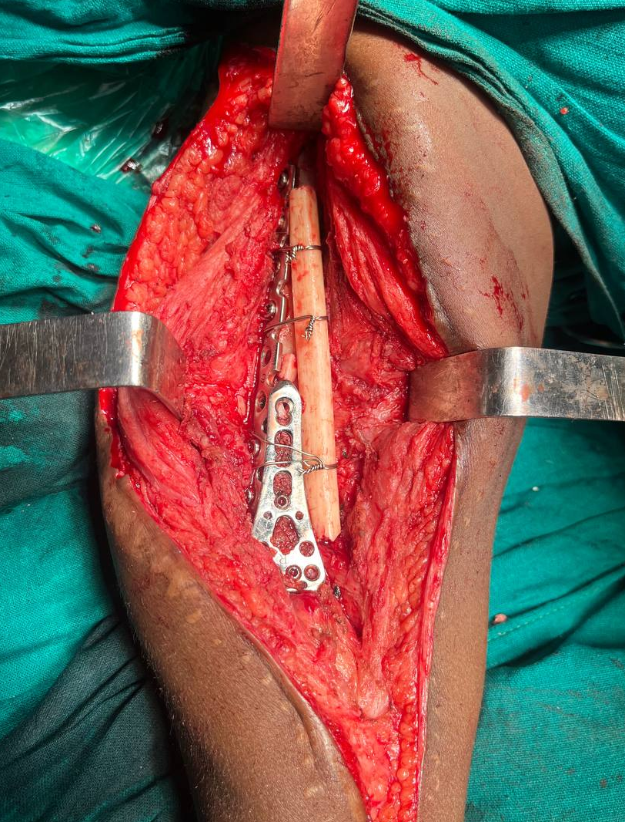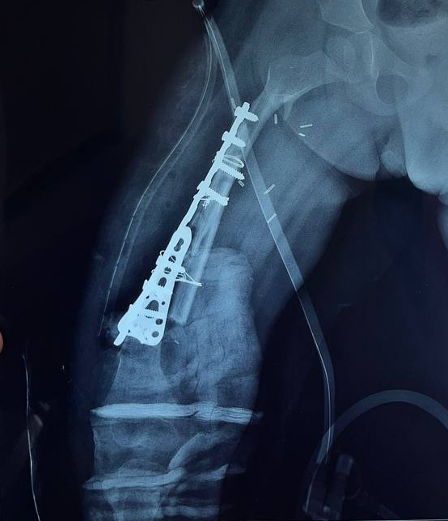
Fig 6. Intra-op image Fig 7. Post-op X-Ray

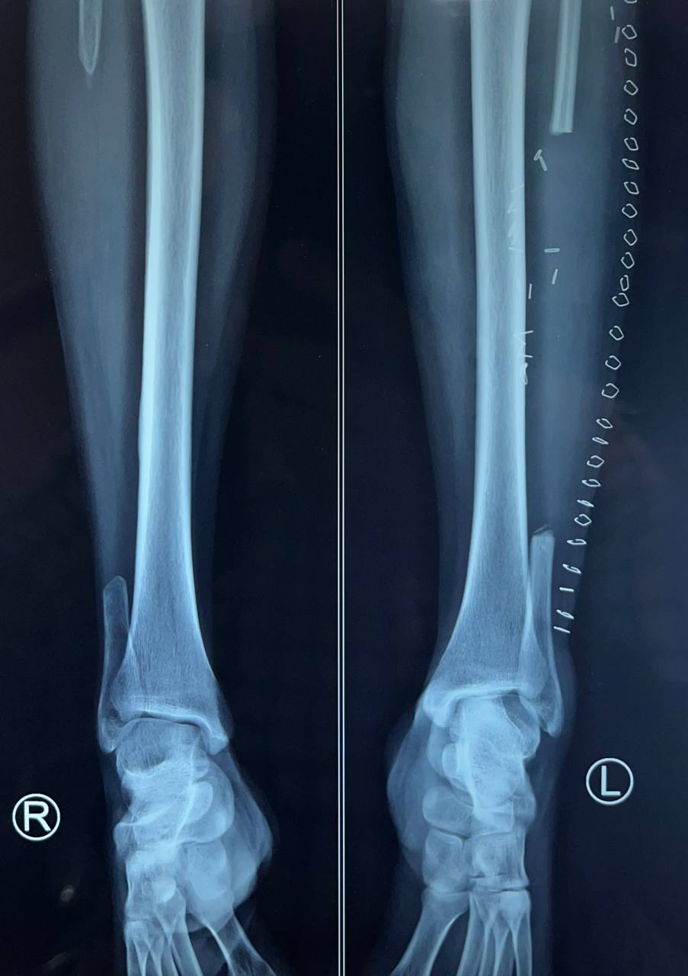
Fig 8. The left fibula of the mother has been harvested

Review of Literature

Kaposiform hemangioendothelioma (KHE), a name coined by Zukerberg et al. in 1993, is a rare and locally aggressive endothelial neoplasm that often involves the entire dermis and extends into the subcutaneous tissue that mainly occurring in children and early adolescents. The tumour is characterised by lobular infiltrates of capillaries and spindled endothelial cells. KHE commonly affects the skin, deep soft tissues of extremities, head and neck, trunk, and retroperitoneum; less commonly, the mediastinum, spleen, bone and testis. It is an entity distinct from infantile hemangioma (IH) because of its locally invasive growth, aggressive course and ‘focal Kaposi-like appearance’. KHE can occur with or without Kasabach-Merritt phenomenon (KMP), which is marked by severe thrombocytopenia and a variable degree of anaemia. Most of the KHEs present with KMP, namely coagulopathic KHE, cause significant mortality by fatal bleeding; whereas at least 90% of KMP are secondary to KHE. KHE has an incidence of 0.7/100.000/year.

Macroscopically, KHE is characterised by the presence of abundant vascular structures that infiltrate the surrounding soft tissues, and it is structured as a tender mass that causes pain when platelets congest within the vessels, and the coagulation cascade is activated. Tumour nodules have irregular borders and are composed of fascicles of spindle endothelial cells, which are positive for vascular markers like Fli1, CD31 and CD34, and negative for HHV8, LNA-1 or Glut1, with a low Ki67 proliferative index, rare mitosis, no nuclear atypia, and no necrosis. KHE doesn’t metastasise. The neoplastic cells form poorly canalised or slit-like blood vessels alternating with solid spindle areas. D2-40 and PROX1 stain the neoplastic spindle cells and lymphatic channels near the vascular lobules.

Zhou and coworkers provided evidence of a somatic translocation between chromosomes 13 and 16 at the bands of 13q14 and 16p13.3 in 10% of metaphase cells in KHE lesions, with the presence of normal cells in the karyotype. Somatic activating GNA14 c.614A > T (p.Gln205Leu) mutation was found in 30% of KHE specimens, although these studies were weakened by a small sample size. Somatic mutations in GNAQ and its paralogues (e.g., GNA11 and GNA14) have also been identified in many other vascular tumours, vascular malformations and solid tumours. GNAQ mutations, whether they are causative or develop secondarily in KHE, are yet to be discovered [5].

Serial No | Age | Sex | Site | KMP | Biopsy | Management | Literature
1 | 8y | M | Prox tibia & fibula | No | KHE  CD34 +  CD31 +  HHF35 + | WLE with bone allograft and plating | DOI: 10.1007/s11805-007-0289-z
2 | 2y | M | Prox humerus | No | KHE  CD34+  D2-40 +  ERG + | Vincristine chemotherapy | DOI: 10.7759/cureus.21262
3 | 9y | F | Distal femur | No | KHE | WLE | DOI:10.1111/j.1440-1827.2011.02681.x
4 | 5y | M | Prox humerus | No | KHE  CD31 +  CD34 +  Fli1 +  D2-40 + | WLE | DOI:10.1111/j.1440-1827.2011.02681.x
5 | 15y | F | Left Meta-  tarsals | No | KHE  CD31 +  CD34 +  D2-40 + | Embolization f/b Syme amputation | DOI: 0.1002/pbc.  29392
6 | 5y | M | Left distal femur | No | KHE  CD31 +  CD34 +  D2-40 + | 1) WLE with bone graft  2) Sirolimus after recurrence at 9 month follow-up | DOI: 0.1002/pbc.  29392
7 | 3y | M | Right femur diaphysis | No | KHE  CD34+  ERG+ | 1) WLE with fibula allograft and plating  2) Open reduction and plating with allograft fibula strut for fracture at 11-month follow-up | Our case study

Table 1. Comparison among reported cases of long bone KHE

Discussion
Most documented KHE cases originate outside the bone, with osseous involvement mainly secondary. Due to limited published data, a standardised treatment protocol for primary bone KHE does not exist. This case documents a primary KHE of a long bone without cutaneous involvement or KMP association. For young patients without KMP, complete surgical excision is the preferred treatment. However, because of the tumour’s infiltrative pattern, surgery is not always feasible. For unresectable or residual tumours, therapies such as corticosteroids, vincristine, interferon-alpha, aspirin, ticlopidine, cyclophosphamide, and mTOR inhibitors have been used. Sirolimus is now considered first-line therapy, with vincristine and corticosteroids reserved for cases with KMP [4], [5]. Since KHE may regress over time, conservative management is an option if symptoms are controlled and limb salvage is not possible [4]. Further studies are necessary to validate these approaches and establish standardised treatment protocols.

Conclusion
This case demonstrates the feasibility of maternal fibular allograft in pediatric bone KHE and emphasises the need for close follow-up due to graft-related complications.

Disclosures
- Consent: Obtained or waived from the participant in this case report.
- Financial Support: None declared by any author for this work.
- Financial Relationships: None declared by any author at present or within the past three years with relevant organisations.
- Other Relationships: None declared that could influence the submitted work.

Disclaimer (Artificial intelligence)
Option 1:
Author(s) hereby declare that NO generative AI technologies such as Large Language Models (ChatGPT, COPILOT, etc.) and text-to-image generators have been used during the writing or editing of this manuscript.
Option 2:
Author(s) hereby declare that generative AI technologies such as Large Language Models, etc. have been used during the writing or editing of manuscripts. This explanation will include the name, version, model, and source of the generative AI technology and as well as all input prompts provided to the generative AI technology
Details of the AI usage are given below:
1.
2.
3.

References
- Zhou G, Zheng JW, Mai HM, Wang YA, Yang XJ, Fan XD, et al. Kaposiform hemangioendothelioma: clinical analysis of 13 cases from a single hospital. Chin J Clin Oncol. 2007;4(4):288-92. doi:10.1007/s11805-007-0289-z.
- Ali Z, Qasim SM, Faisal F, Faizan M, Shahid A, Hamid M, et al. Primary kaposiform hemangioendothelioma of the humerus: a case report. Cureus. 2022 Jan 15;14(1):e21262. doi:10.7759/cureus.21262.
- Matsumoto Y, Nakatani Y, Seki K, Yao T, Hara K, Miyake K, et al. Kaposiform hemangioendothelioma: a case report with immunohistochemical and ultrastructural studies. Pathol Int. 2011;61(7):382-6. doi:10.1111/j.1440-1827.2011.02681.x.
- Chinello M, Di Carlo D, Olivieri F, Balter R, De Bortoli M, Vitale V, et al. Successful management of kaposiform hemangioendothelioma with long-term sirolimus treatment: a case report and review of the literature. Mediterr J Hematol Infect Dis. 2018;10(1):e2018043. doi:10.4084/MJHID.2018.043.
- Ji Y, Chen S, Peng S, Xia C, Li L, Yang K, et al. Kaposiform hemangioendothelioma: current knowledge and future perspectives. Orphanet J Rare Dis. 2020;15:39. doi:10.1186/s13023-020-1320-1.
- Cheah JSC, Ooi GC, Loong CK, Lee ACW, Li CH, Leung CW, et al. Kaposiform hemangioendothelioma: clinical features and treatment outcomes from a single center. Pediatr Blood Cancer. 2022;69(1):e29392. doi:10.1002/pbc.29392.
- Zhou, J., Qiu, T., Zhang, Z., Lan, Y., Huo, R., Xiang, B., ... & Ji, Y. (2025). Consensus statement for the diagnosis, treatment, and prognosis of kaposiform hemangioendothelioma. International Journal of Cancer, 156(10), 1986-1994.
- Chundriger, Q., Tariq, M. U., Abdul-Ghafar, J., Ahmed, A., & Din, N. U. (2021). Kaposiform Hemangioendothelioma: clinicopathological characteristics of 8 cases of a rare vascular tumor and review of literature. Diagnostic Pathology, 16(1), 23.
- Ji, Y., Chen, S., Zhou, J., Yang, K., Zhang, X., Xiang, B., ... & Zhang, Y. (2022). Sirolimus plus prednisolone vs sirolimus monotherapy for kaposiform hemangioendothelioma: a randomized clinical trial. Blood, The Journal of the American Society of Hematology, 139(11), 1619-1630.
- Li, M., Wang, X., Kieran, R., Sun, Z. W., Gong, Y., Lei, H., ... & Huo, R. (2024). Treatment experience for different risk groups of Kaposiform hemangioendothelioma. Frontiers in Oncology, 14, 1336763.
- Hu, Y., Song, D., Wu, C., Wang, L., Li, J., & Guo, L. (2023). Clinical and imaging features of Kaposiform hemangioendothelioma in infants. Heliyon, 9(5).

