Case report
Negative Pressure Pulmonary Oedema Following Laryngospasm: A Potentially Fatal yet Reversible Complication of General Anaesthesia

Abstract
Negative pressure pulmonary oedema (NPPE) is a rare but potentially fatal complication following tracheal intubation and general anaesthesia. We report the case of a 57-year-old male who underwent arthroscopy under general anaesthesia at another hospital. Shortly after extubation, the patient developed acute respiratory distress accompanied by pink frothy secretions and oxygen desaturation. Immediate reintubation was performed, and he was subsequently transferred to our facility, where he was successfully managed with positive pressure mechanical ventilation. NPPE often results from laryngospasm, which induces forceful inspiration against a closed glottis, generating markedly negative intrathoracic pressure and leading to rapid transudation of fluid into the pulmonary interstitium and alveoli. This condition typically manifests within minutes after extubation, and prompt diagnosis with early intervention is essential to prevent morbidity and mortality. In our case, symptoms resolved completely within 24 hours of appropriate ventilatory support. This report highlights the importance of recognising NPPE in the immediate postoperative period and instituting rapid, targeted management to ensure favourable outcomes. In this case, rapid recognition and ventilatory support led to full recovery within 24 hours.
Key words: Negative pressure pulmonary oedema, laryngospasm, airway obstruction, respiratory distress, mechanical ventilation
Introduction
“Negative pressure pulmonary oedema (NPPE) is a form of noncardiogenic pulmonary oedema which occurs after an upper airway obstruction. It is a potentially life-threatening complication that develops rapidly after upper airway obstruction in otherwise healthy young persons who are capable of producing markedly large intrathoracic pressures. The incidence of NPPE, has been estimated to be up to 12 % post obstruction” ^{[1]}. “NPPE is a rare, but potentially life-threatening complication of general anaesthesia with tracheal intubation that occurs in 0.05%–0.1% of the cases”.^{[2] “}Most patients with NPPE are treated with mechanical ventilation, with few reported cases requiring extracorporeal membrane oxygenation (ECMO)” ^{[3]}. Here we present a severe case of negative pressure pulmonary oedema which was diagnosed in a timely manner and successfully managed by intubation and mechanical ventilation.
Case Presentation
57-year-old male with known case of Hypertension, Type 2 Diabetes Mellitus and Lymphoma was admitted to a previous hospital for arthroscopic ligament reconstruction under General Anaesthesia. He had no allergies or cardiac diseases. Perioperative physical examination was unremarkable, and vital signs stable.
Premedication’s were given and General anaesthesia was induced with intravenous administration of Propofol, Fentanyl and Rocuronium. Patient was intubated using 8mm The endotracheal tube was placed and maintained using Sevoflurane, Remifentanil, and Rocuronium. The surgery went smoothly with very little blood loss. After surgery, extubation was carried out following the confirmation of full consciousness and spontaneous respiration. A few minutes post-extubation, the patient began to exhibit signs of respiratory distress and severe coughing, producing frothy red sputum along with a rapid decline in oxygen saturation. The patient was promptly re-intubated using an 8mm endotracheal tube and transferred to our hospital for additional treatment.
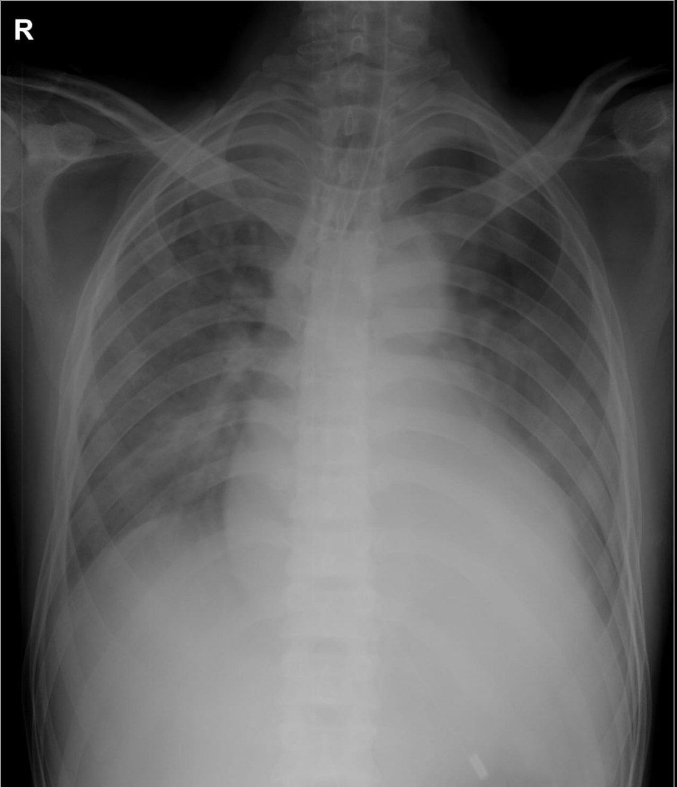
On arrival to our ER, patient was under sedation and ventilated via Bain circuit, a pink frothy fluid was seen coming out of endotracheal tube. Endotracheal tube suction was given and patient was mechanically ventilated in ACMV VC mode with tidal volume 6ml/kg, positive end expiratory pressure (PEEP) 10 cm H2O and FiO2 90%. Xray chest showed bilateral infiltrates (Fig 1) suggestive of pulmonary oedema. Echocardiography showed good LV function with Ejection Fraction (EF) 55%. Patient was maintaining an oxygen saturation of 96%. Patient was slowly weaned off from ventilator and extubated within 24 hours. Patient was maintaining good oxygen saturation and symptom free since then, hence discharged 3 days later.

Fig 1: X-ray Chest of patient showing features of pulmonary oedema

Discussion
“Negative pressure pulmonary oedema, also known as post obstructive pulmonary oedema, is a pure form of hydrostatic oedema ^{[15]}, characterised by the formation of negative intrathoracic pressure in cases with upper airway obstruction, leading to severe hypoxemia and pulmonary oedema”.^{[4] “}Most NPPE cases in children have been caused by glottis or subglottic obstruction”.^{[5]} But in adults most common reported reason for a NPPE is post-extubation laryngospasm,^{[6]} there have been reports of NPPE in patients with hanging due to external airway obstruction^{[7]}.
Dr. Deepika et al. reported “one of the largest scale case series studies in patients developed NPPE in the operating rooms, post-anesthesia care units (PACU), and ICU after surgery. The overall incidence of post-extubation NPPE was 0.094% (30 cases in 31,826 surgical patients) in their clinical case review” (Deepika et al. 1997).^{[8]} “A similar incidence of 0.084% (14 cases in 16,653 surgical patients) was reported during orthopaedic surgery that eventually developed post-extubation NPPE” (Patton and Baker Jr 2000).^{[9] “}Several perioperative risk factors of post-extubation NPPE have been proposed, including patients of younger age, male, generally healthy (ASA I–II), difficult intubation, use of irritant volatile agents, operation on the head and neck region, obese, and recent upper airway infection”.^{[8,10-14]} Similarly, Our patient was a middle aged healthy male, post arthroscopic surgery who developed severe laryngospasm and pink frothy secretion with saturation fall minutes after extubation, radiological evidence of pulmonary oedema and normal cardiac status , which rules out cardiogenic cause of oedema. Further the onset and time course of clinical and radiological recovery was in agreement with aetiology of negative pressure pulmonary oedema.
The main differential diagnosis of NPPE is cardiogenic pulomonary edema but will show evidence of LV dysfunction or valvular insufficiency. Other differential diagnoses include pulmonary embolism, Anaphylaxis, aspiration pneumonitis, Acute respiratory distress syndrome(ARDS), high altitude pulmonary edema and re-expansion pulmonary oedema.
“Swift diagnosis and intervention are necessary in Negative Pressure Pulmonary Oedema. Failure to diagnose NPPE correctly may lead to unnecessary administration of antibiotics and anticoagulants, and other therapeutic modalities. Treatment of NPPE with or without alveolar haemorrhage consists mainly of supportive measures. Supplement of oxygen may be sufficient in most cases and modest diuresis may be beneficial even though patients do not have peripheral oedema” ^{[16]}. “Mechanical ventilation and positive pressure ventilation is not routinely needed and should be reserved for patients who fail to maintain adequate oxygenation despite supplemental oxygenation and airway control” ^{[17]} “The use of steroids is controversial; however, they have been shown to lessen the pulmonary oedema lesion resulting from trauma” ^{[18]}. “High negative pressures may cause damage to pulmonary alveoli and capillaries, steroid administration may be useful in such conditions. Other measures could be adopted during surgery to minimise development of NPPE, including pharyngeal suctioning or intravenous injection of lidocaine”.^{[19] “}Early identification and prompt treatment has been shown critical and time to clinical and radiological recovery is 24-48 hours, whether treated aggressively or with supportive care”.^{[20]}
Conclusion
Negative pressure pulmonary edema is an uncommon yet potentially lethal complication after extubation. While it is a self-resolving condition that can be controlled through reintubation and mechanical positive pressure ventilation, it can complicate the results of straightforward surgical procedures, extend ICU stays, and necessitate mechanical ventilation in otherwise healthy patients. This could raise the expense of surgery and postpone their return to regular daily routines. A significant drop in oxygen saturation soon after extubation should raise a strong suspicion for NPPE. Timely identification and awareness are likely to result in effective handling of this possibly severe complication. In summary, a strong level of suspicion, prompt identification, and airway management can be crucial for survival in this potentially deadly complication

Declaration of Conflicting Interests
The authors declared no potential conflicts of interest with respect to the research, authorship, and/or publication of this article.

Ethical Approval
Our institution exempts individual case reports and case series from the requirement of ethical approval.

Consent
Informed written consent was secured from the patient regarding their involvement and the dissemination of their data.
Disclaimer (Artificial Intelligence)
Author(s) hereby declare that NO generative AI technologies such as Large Language Models (ChatGPT, COPILOT, etc.) and text-to-image generators have been used during the writing or editing of this manuscript.
References
- Tami, T. A., Chu, F., Wildes, T. O., & Kaplan, M. (1986). Pulmonary edema and acute upper airway obstruction. The Laryngoscope, 96(5), 506-509.
- Liu, R., Wang, J., Zhao, G., & Su, Z. (2019). Negative pressure pulmonary edema after general anesthesia: A case report and literature review. Medicine, 98(17), e15389.
- Marino, D., Baggi, M., Casso, G., & Pagnamenta, A. (2010). Near-fatal acute postobstructive pulmonary oedema requiring extracorporal membrane oxygenation. Intensive care medicine, 36(2), 365-366.
- Bhattacharya, M., Kallet, R. H., Ware, L. B., & Matthay, M. A. (2016). Negative-pressure pulmonary edema. Chest, 150(4), 927-933.
- Berdai, A. M., Labib, S., & Harandou, M. (2013). Postobstructive pulmonary edema following accidental near-hanging. The American Journal of Case Reports, 14, 350.
- Chen, Y., & Zhang, X. (2019). Acute postobstructive pulmonary edema following laryngospasm in elderly patients: a case report. Journal of PeriAnesthesia Nursing, 34(2), 250-258.
- Parepalli, A., Reddy, H., Sontakke, T., Acharya, S., & Rahul, N. (2024). Surviving the Unthinkable: A Case of Post-obstructive Pulmonary Edema and Cerebral Edema in a Suicidal Hanging Survivor. Cureus, 16(9).
- Deepika, K., Kenaan, C. A., Barrocas, A. M., Fonseca, J. J., & Bikazi, G. B. (1997). Negative pressure pulmonary edema after acute upper airway obstruction. Journal of clinical anesthesia, 9(5), 403-408.
- Patton, W. C., & Baker Jr, C. L. (2000). Prevalence of negative-pressure pulmonary edema at an orthopaedic hospital. Journal of the Southern Orthopaedic Association, 9(4), 248-253.
- Lang, S. A., Duncan, P. G., Shephard, D. A., & Ha, H. C. (1990). Pulmonary oedema associated with airway obstruction. Canadian journal of anaesthesia, 37(2), 210-218.
- Lorch, D. G., & Sahn, S. A. (1986). Post-extubation pulmonary edema following anesthesia induced by upper airway obstruction: are certain patients at increased risk?. Chest, 90(6), 802-805.
- Al Ghofaily, L., Simmons, C., Chen, L., & Liu, R. (2013). Negative pressure pulmonary edema after laryngospasm: a revisit with a case report. Journal of anesthesia & clinical research, 3(10), 252.
- Krodel, D. J., Bittner, E. A., Abdulnour, R., Brown, R., & Eikermann, M. (2010). Case scenario: acute postoperative negative pressure pulmonary edema. Anesthesiology, 113(1), 200-7.
- McConkey, P. P. (2000). Postobstructive pulmonary oedema—a case series and review. Anaesthesia and intensive care, 28(1), 72-76.
- Kapoor, M. C. (2011). Negative pressure pulmonary oedema. Indian journal of anaesthesia, 55(1), 10-11.
- Mulkey, Z., Yarbrough, S., Guerra, D., Roongsritong, C., Nugent, K., & Phy, M. P. (2008). Postextubation pulmonary edema: a case series and review. Respiratory medicine, 102(11), 1659-1662.
- Lang, S. A., Duncan, P. G., Shephard, D. A., & Ha, H. C. (1990). Pulmonary oedema associated with airway obstruction. Canadian journal of anaesthesia, 37(2), 210-218.
- Oswalt, C. E., Gates, G. A., & Holmstrom, F. M. (1977). Pulmonary edema as a complication of acute airway obstruction. Jama, 238(17), 1833-1835.
- Gefke, K., Andersen, L. W., & Friesel, E. (1983). Lidocaine given intravenously as a suppressant of cough and laryngospasm in connection with extubation after tonsillectomy. Acta anaesthesiologica scandinavica, 27(2), 111-112.
- Koh, M. S., Hsu, A. A. L., & Eng, P. (2003). Negative pressure pulmonary oedema in the medical intensive care unit. Intensive care medicine, 29(9), 1601-1604.

