Unexpected Anaphylaxis from Amoxicillin–Clavulanate in a Hospitalized Patient: A Case Report

.

ABSTRACT

Background: Amoxicillin–clavulanate is a widely prescribed broad-spectrum antibiotic. Although generally well-tolerated, it can rarely cause life-threatening anaphylaxis. Prompt recognition and timely management are essential to prevent serious outcomes.
Case Presentation: A 60-year-old female presented with a left breast lump and was admitted for evaluation. She had no known history of allergies or adverse drug reactions. During hospitalization, she received prophylactic intravenous amoxicillin–clavulanate, and within five minutes, she developed generalized pruritus, dyspnea, hypotension (BP: 80/50 mmHg), and tachycardia (HR: 120 bpm), consistent with anaphylaxis. Immediate management included oxygen therapy, intravenous fluids, adrenaline, hydrocortisone, antihistamines, and bronchodilators, leading to rapid clinical stabilization. The Naranjo Adverse Drug Reaction Probability Scale indicated a probable causal relationship for amoxicillin–clavulanate.The patient recovered completely with no recurrence during a 48-hour observation period. She was counseled on avoidance of β-lactam antibiotics, advised to undergo allergy testing, and educated on emergency preparedness, including the use of an epinephrine auto-injector.
Discussion: Anaphylaxis due to β-lactam antibiotics is primarily IgE-mediated, with both amoxicillin and clavulanic acid acting as potential allergens. Structured causality assessment using validated tools like the Naranjo scale, adherence to international anaphylaxis management guidelines, and comprehensive patient counseling are critical for preventing recurrence. Recognition of clavulanic acid as an independent allergen is also essential to guide future therapy and avoid mislabeling of penicillin allergy.
Conclusion:This case underscores the importance of early recognition, structured causality evaluation, guideline-based management, and patient education in amoxicillin–clavulanate–induced anaphylaxis, even in patients without prior allergy history.
Keywords: Amoxicillin–clavulanate, Anaphylaxis, β-lactam allergy, Naranjo scale, Drug-induced hypersensitivity

1. INTRODUCTION
Anaphylaxis is a severe, rapid-onset allergic reaction that can be life-threatening if not promptly recognized and treated. It is characterized by symptoms such as urticaria, angioedema, respiratory distress, and cardiovascular collapse. Drug-induced anaphylaxis is a significant concern in clinical practice, with β-lactam antibiotics, including amoxicillin-clavulanate, being among the most common culprits. (1)
Amoxicillin-clavulanate is a widely prescribed antibiotic combination, known for its broad-spectrum activity against various bacterial pathogens. Despite its efficacy, it has been implicated in a substantial proportion of immediate allergic reactions to β-lactams. Beta-lactam antibiotics are the second leading cause of drug-induced anaphylaxis, responsible for about 14.3% of reported cases, with amoxicillin being the most frequent agent. More recently, clavulanic acid—commonly co-administered with amoxicillin—has also been recognized as a potential trigger.(2)
The pathophysiology of amoxicillin-clavulanate-induced anaphylaxis involves an IgE-mediated hypersensitivity reaction, leading to the release of mediators from mast cells and basophils. This cascade results in the clinical manifestations of anaphylaxis, which can occur within minutes of drug administration. Notably, patients may experience severe reactions even if they have previously tolerated the medication without issues.(3)

This case report aims to highlight the occurrence of anaphylaxis following the administration of amoxicillin-clavulanate in a 60-year-old female patient, emphasizing the importance of early recognition and management of drug-induced anaphylaxis.

2. CASE PRESENTATION
A 60-year-old female presented to the hospital with a palpable lump in the left breast, without any history of systemic illness, known allergies, or prior adverse drug reactions. On admission, she was hemodynamically stable, afebrile, and had normal oxygen saturation. Baseline investigations, including complete blood count and vital parameters, were within normal limits.

During hospitalization, she received supportive therapy with paracetamol, ranitidine, and vitamin C. Subsequently, she was prescribed amoxicillin–clavulanate for prophylactic antibiotic coverage. Within five minutes of administration, the patient developed sudden onset of generalized pruritus, dyspnea, hypotension (BP: 80/50 mmHg), and tachycardia (HR: 120 bpm), consistent with anaphylaxis. Laboratory investigations (Table 1) were all within normal limits.”
Table 1 Laboratory Investigations
Investigation | Result | Reference Range | Remarks
Hemoglobin (g/dL) | 13.5 | 12–16 | Normal
Total Leukocyte Count (×10³/µL) | 7.8 | 4–11 | Normal
Differential Count (%)
- Neutrophils | 60 | 40–70 | Normal
- Lymphocytes | 30 | 20–45 | Normal
- Monocytes | 6 | 2–8 | Normal
- Eosinophils | 4 | 1–6 | Normal
Platelet Count (×10³/µL) | 250 | 150–400 | Normal
Random Blood Sugar (mg/dL) | 98 | 70–140 | Normal
Renal Function Test |  |  | Normal
- Serum Creatinine (mg/dL) | 0.9 | 0.6–1.2 | Normal
- Blood Urea (mg/dL) | 28 | 15–40 | Normal
Liver Function Test |  |  | Normal
- AST (U/L) | 22 | 10–40 | Normal
- ALT (U/L) | 25 | 7–56 | Normal
- Total Bilirubin (mg/dL) | 0.8 | 0.3–1.2 | Normal
Electrolytes |  |  | Normal
- Sodium (mEq/L) | 138 | 135–145 | Normal
- Potassium (mEq/L) | 4.2 | 3.5–5.0 | Normal

Immediate emergency interventions were initiated as per standard guidelines:
• Oxygen therapy via face mask to maintain adequate oxygenation
• Intravenous Ringer’s lactate for fluid resuscitation
• Intravenous adrenaline (0.5 mg) for cardiovascular support
• Intravenous hydrocortisone (100 mg) to prevent biphasic reactions
• Intravenous pheniramine (Avil, 45 mg) for antihistaminic effect
• Intravenous deriphylline for bronchodilation

The patient responded promptly to the interventions, with normalization of blood pressure, heart rate, and resolution of respiratory distress within one hour. Amoxicillin–clavulanate was immediately discontinued, and the reaction was documented in the patient’s medical records. She was counseled regarding avoidance of beta-lactam antibiotics and advised on emergency preparedness, including the potential use of an epinephrine auto-injector. No further adverse events occurred during her hospital stay.

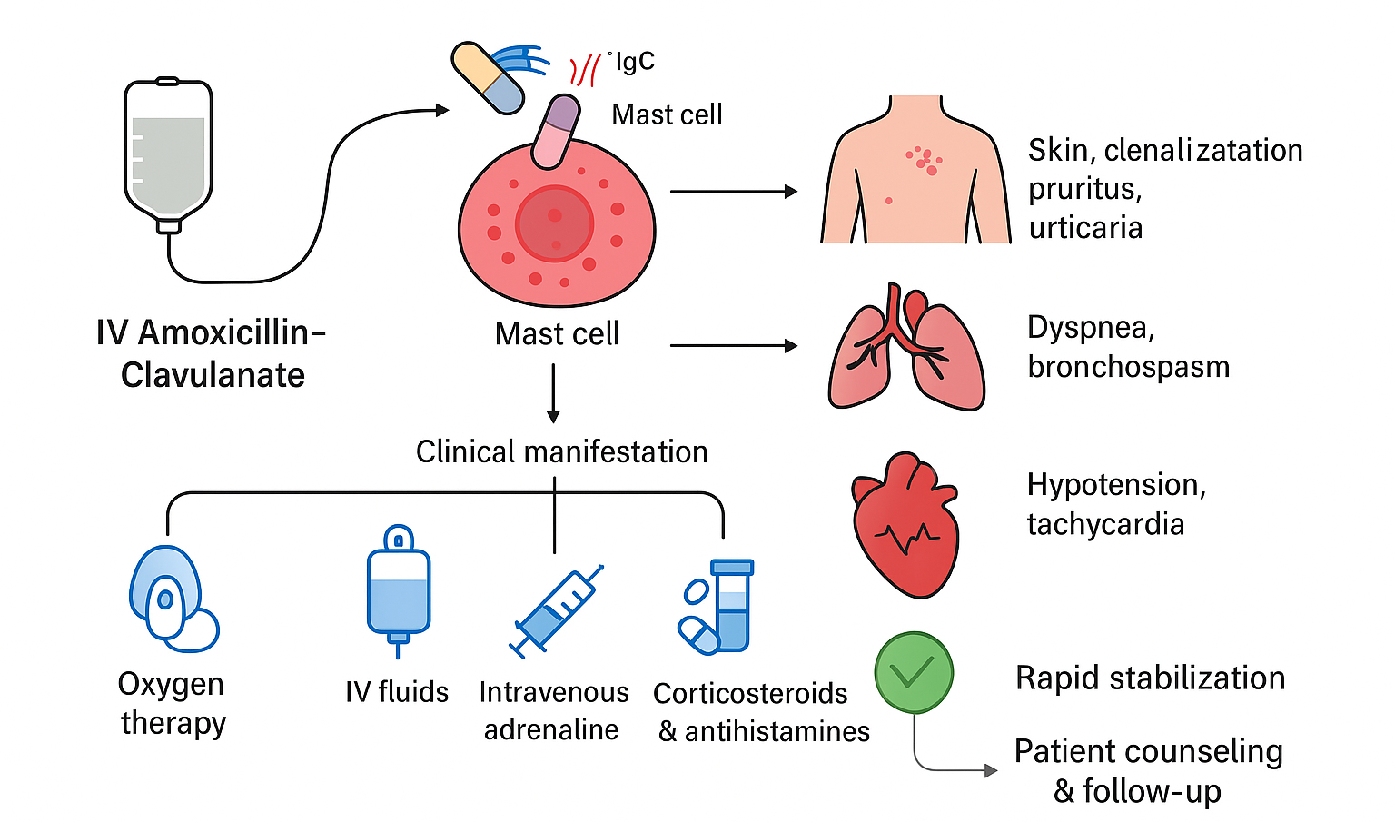
Figure 1 Mechanism of Amoxcillin Induced Anaphylaxis

3. discussion
Anaphylaxis due to β-lactam antibiotics remains a major concern in clinical practice. Worldwide data show that β-lactams account for a substantial proportion of drug-induced immediate hypersensitivity, ranking as the second most common cause after non-steroidal anti-inflammatory drugs (NSAIDs) . Among β-lactams, amoxicillin is the most frequently implicated agent, but increasing evidence indicates that clavulanic acid, when combined with amoxicillin, is itself a significant allergenic determinant . This distinction is clinically important, since some patients may tolerate amoxicillin alone while reacting severely to the clavulanic component.(2)

The mechanism underlying amoxicillin–clavulanate–induced anaphylaxis is primarily IgE-mediated. During sensitization, the drug induces the production of specific IgE antibodies, which bind to mast cells and basophils. Upon re-exposure, cross-linking of these antibodies triggers the rapid release of histamine and other mediators such as leukotrienes and prostaglandins, resulting in urticaria, bronchospasm, hypotension, and cardiovascular collapse. Evidence suggests that mediator release can occur either as a rapid discharge of small vesicles or as a complete release of stored granules, both of which contribute to the severity of the reaction.(2)

To establish causality, the Naranjo Adverse Drug Reaction Probability Scale was applied (Table 2). The total score was 7, indicating a probable adverse drug reaction due to amoxicillin–clavulanate(4).

Table 2 Naranjo Adverse Drug Reaction Probability Scale
Question | Response | Score
1. Are there previous conclusive reports on this reaction? | Yes | +1
2. Did the adverse event appear after the suspected drug was administered? | Yes | +2
3. Did the adverse reaction improve when the drug was discontinued or a specific antagonist was administered? | Yes | +1
4. Did the adverse reaction reappear when the drug was re-administered? | Not applicable | 0
5. Are there alternative causes that could have caused the reaction? | No | +2
6. Did the reaction reappear when a placebo was given? | Not applicable | 0
7. Was the drug detected in any body fluid in toxic concentrations? | Not applicable | 0
8. Was the reaction more severe when the dose was increased, or less severe when the dose was decreased? | Not applicable | 0
9. Did the patient have a similar reaction to the same or similar drugs in any previous exposure? | No | 0
10. Was the adverse event confirmed by any objective evidence? | Yes (clinical signs and rapid response to treatment) | +1

Recent pharmacogenomic evidence has expanded our understanding of susceptibility to β-lactam hypersensitivity. A genome-wide association study identified HLA-DRB1*10:01 and related alleles as potential genetic risk factors for immediate hypersensitivity to penicillins (5). Such findings suggest that host factors may partially explain why only a subset of patients develop life-threatening reactions despite widespread antibiotic use.

The management in this case—prompt administration of adrenaline, intravenous fluids, antihistamines, corticosteroids, and bronchodilators—was consistent with international guideline recommendations (6). Epinephrine remains the first-line therapy and should be administered without delay, as early treatment is associated with reduced morbidity and mortality.

A key aspect of care involves documentation and counselling. Mislabelled “penicillin allergy” is a well-documented problem, leading to the unnecessary use of broad-spectrum alternatives, longer hospital stays, and higher antimicrobial resistance rates. Where feasible, patients with severe reactions should be referred for allergy evaluation—including skin testing and, if appropriate, graded provocation tests—to clarify whether the culprit is amoxicillin, clavulanic acid, or the combination (7). This approach not only improves patient safety but also supports antimicrobial stewardship efforts by enabling the safe use of narrower β-lactam antibiotics when appropriate.

Several case reports, including fatal events, have been published on amoxicillin–clavulanate-induced anaphylaxis, underlining its clinical significance (8,9). The present case reinforces the need for heightened awareness among clinicians prescribing this commonly used antibiotic. Three key lessons emerge: (i) anaphylaxis can occur even in patients without prior allergy history, (ii) immediate guideline-based management is lifesaving, and (iii) structured documentation and follow-up allergy assessment are essential to prevent recurrence and guide future therapy

4. Conclusion

This case highlights the occurrence of probable anaphylaxis following administration of amoxicillin–clavulanate in a 60-year-old female. Prompt recognition and immediate management with adrenaline, intravenous fluids, antihistamines, corticosteroids, and oxygen led to rapid stabilization. The Naranjo Adverse Drug Reaction Probability Scale indicated a probable causality, underscoring the importance of systematic assessment of suspected adverse drug reactions. Clinicians should be aware of clavulanic acid as a potential allergen, counsel patients regarding avoidance of β-lactam antibiotics, and ensure proper documentation to prevent recurrence.

Consent

All authors declare that written informed consent was obtained from the patient for publication of this case report. The patient has given permission for the use of clinical details and any accompanying images. A copy of the written consent is available for review by the Editorial Office or Chief Editor upon request.

Ethical approval

As this is a single case report, formal ethical committee approval was not required. Written informed consent was obtained from the patient for publication of clinical details, and all measures were taken to ensure patient confidentiality and anonymity.

DISCLAIMER

The authors hereby declare that generative AI technology was used to assist in the writing or editing of this manuscript. The details are as follows:

Name and version of the AI tool: ChatGPT (GPT-5) by OpenAI

Purpose of use: Language refinement, grammar correction, and formatting suggestions

Author verification: All scientific content, interpretations, and conclusions were reviewed and validated by the authors before submission

References
- Torres-Rojas I, Pérez-Alzate D, Somoza ML, Pfeifer AP, Diaz EH, Jimenez-Rodriguez TW, Sánchez JF, Ruano FJ, Blanca M, Blanca-López N. Clavulanic Acid Is a Leading Culprit Beta-Lactam in Immediate Allergic Reactions to Penicillins. Allergy Asthma Immunol Res. 2023 Mar;15(2):201-213. doi: 10.4168/aair.2023.15.2.201. PMID: 37021506; PMCID: PMC10079519.
- Montañez MI, Mayorga C, Bogas G, Barrionuevo E, Fernandez-Santamaria R, Martin-Serrano A, Laguna JJ, Torres MJ, Fernandez TD, Doña I. Epidemiology, Mechanisms, and Diagnosis of Drug-Induced Anaphylaxis. Front Immunol. 2017 May 29;8:614. doi: 10.3389/fimmu.2017.00614. PMID: 28611774; PMCID: PMC5446992.
- Weisser C, Ben-Shoshan M. Immediate and non-immediate allergic reactions to amoxicillin present a diagnostic dilemma: a case series. J Med Case Rep. 2016 Jan 18;10:10. doi: 10.1186/s13256-016-0801-2. PMID: 26781593; PMCID: PMC4717649.
- Naranjo CA, Busto U, Sellers EM, Sandor P, Ruiz I, Roberts EA, Janecek E, Domecq C, Greenblatt DJ. A method for estimating the probability of adverse drug reactions. Clin Pharmacol Ther. 1981 Aug;30(2):239–45. doi:10.1038/clpt.1981.154.
- Nicoletti P, Carr DF, Barrett S, et al. Beta-lactam-induced immediate hypersensitivity reactions: A genome-wide association study. J Allergy Clin Immunol. 2021;147(5):1830-1837.e15. doi:10.1016/j.jaci.2020.10.004
- Cardona V, Ansotegui IJ, Ebisawa M, et al. World Allergy Organization anaphylaxis guidance 2020. World Allergy Organ J. 2020;13(10):100472. doi:10.1016/j.waojou.2020.100472.
- Sunagawa SW, Hirota K, Saito M, et al. Implementation of a beta-lactam graded challenge process in inpatients: Supporting antimicrobial stewardship. Front Allergy. 2023;4:1161683. doi:10.3389/falgy.2023.1161683.
- Ralapanawa, Udaya&Kularatne, Senanayake. (2015). Kounis syndrome secondary to amoxicillin/clavulanic acid administration: A case report and review of literature Case Reports. BMC Research Notes. 8. 10.1186/s13104-015-1072-5.
- Conlon NP, Edgar JDM. Fatal anaphylaxis to intravenous co-amoxiclav: a case series. Int J Case Rep Images. 2013;4(4):190-193.
- Quoc QL, et al. Recent update on the management of anaphylaxis. J Allergy Clin Immunol Pract. 2021;9(9):txxxx.
- Chatterjee S, et al. Kounis Syndrome after Oral Amoxicillin Clavulanate. Case Rep. 2025; (open access).
- Aminou S, et al. IgE-mediated hypersensitivity to clavulanic acid, a rare case. Int J Allergy. 2025; (open access).
- Guyénard L, Tauber M, et al. Mast cell anergy: absence of symptoms after accidental re-exposure to amoxicillin/clavulanic acid 3 days after anaphylaxis. Front Allergy. 2024;5:1366922.

