Original Research Article

Host-Specific Gut Microbiomes in Three Estuarine Crabs

Abstract
Crab-associated microbiomes play critical roles in host nutrition, immunity, and ecological adaptation, yet remain poorly characterized for many ecologically and economically important species. Here, we present the first high-throughput 16S rRNA gene sequencing analysis of gut microbiomes in three Indo-Pacific estuarine crabs: the crucifix crab (Charybdis feriata), red-spotted swimming crab (Portunus sanguinolentus), and giant mud crab (Scylla serrata). One individual from each crab species was sampled, and its gut microbiome was sequenced, yielding over 10⁵ high-quality non-chimeric reads per sample with >96% merge success, ensuring robust taxonomic resolution and balanced coverage across hosts. Phylum-level profiles revealed clear host-specific signatures: C. feriata and S. serrata were dominated by Firmicutes (48% and 45%, respectively), whereas P. sanguinolentus was strongly enriched in Actinobacteria (76%). Alpha diversity analyses showed that C. feriata exhibited the highest richness and evenness, S. serrata intermediate, and P. sanguinolentus the lowest. Beta diversity analysis confirmed significant host-specific separation among species (PERMANOVA, p < 0.05), with P. sanguinolentus clustering distinctly from the other two. Ecological interpretation suggests that Firmicutes-rich microbiomes facilitate fermentation and nutrient processing, whereas Actinobacteria dominance may reflect specialized metabolic or antimicrobial traits contributing to reduced diversity. Together, these results demonstrate statistically significant, host-specific gut microbiome differences among the three crab species and establish a baseline for future ecological and applied research in aquaculture and marine biotechnology.
Keywords: Crab gut microbiome, Charybdis feriata, Portunus sanguinolentus, Scylla serrata, 16S rRNA sequencing, Host–microbe interactions
Introduction
The red-spotted swimming crab (Portunus sanguinolentus), crucifix crab (Charybdis feriata), and giant mud crab (Scylla serrata) are ecologically and economically important estuarine species distributed across the West Pacific and Indian Oceans. The red-spotted swimming crab, recognizable by its distinctive red markings, plays a central role in estuarine food webs as both predator and prey, contributing to nutrient cycling and organic matter turnover [1]. Beyond its ecological roles, P. sanguinolentus supports fisheries and aquaculture throughout Asia [2]. C. feriata, notable for the crucifix-like pattern on its carapace, regulates benthic invertebrate populations and contributes to biodiversity in coastal ecosystems, although it is less prominent in fisheries [3,4]. S. serrata is one of the most commercially exploited crabs in the Indo-Pacific region, harvested and farmed widely to meet high market demand [5]. Ecologically, it functions as both predator and scavenger, influencing trophic dynamics and nutrient recycling [6,7]. Despite this importance, knowledge of the microbiomes associated with these crabs remains limited.
Traditionally, studies of crustacean-associated microbiomes have relied on culture-based methods or 16S rRNA amplicon sequencing. While culture-dependent techniques provided early insights, they are constrained by the low cultivability of most marine microbes [8]. Similarly, 16S rRNA surveys have revealed broad taxonomic profiles but often lacked sufficient resolution for comprehensive community analyses [9]. Metagenomics and high-throughput sequencing have emerged as powerful approaches to address these limitations [10].
High-throughput sequencing of the 16S rRNA gene enables comprehensive profiling of microbial communities without cultivation biases. This approach captures fine-scale taxonomic diversity, resolves community differences among host tissues, and allows comparisons across environmental gradients [11]. For P. sanguinolentus, C. feriata, and S. serrata, however, systematic microbiome studies remain scarce despite their ecological and economic importance [12].
Previous studies on related crabs demonstrated that microbial communities differ across tissues such as the gut, gills, and exoskeleton, with potential roles in digestion, immunity, and tolerance to estuarine fluctuations [13,14]. Yet, for these three species in particular, microbiome diversity and structure have not been investigated at scale, limiting our understanding of their ecological interactions [15].
Here, we employ high-throughput sequencing of the 16S rRNA gene to characterize gut microbiomes of P. sanguinolentus, C. feriata, and S. serrata. Our objectives were to (i) describe microbial community composition and diversity, and (ii) assess how microbiome structure varies among species. By addressing this gap, our study provides the first metagenomic insights into the gut microbiomes of these three crabs, establishing a baseline for future ecological and applied research in estuarine crustaceans.

Materials and Methods
Sample Collection and Preparation: Specimens of Portunus sanguinolentus, Charybdis feriata, and Scylla serrata were collected from Mazagaon Dockyard, Mumbai, Maharashtra, India (18°57′ N, 72°50′ E). Taxonomic identification was performed and authenticated by scientists at the Central Institute of Fisheries Education, Mumbai. Gut tissues were dissected aseptically for DNA extraction. A total of one specimen from each species (Portunus sanguinolentus, Charybdis feriata, and Scylla serrata) was collected and analyzed. Each gut microbiome sample therefore represents an individual crab. All crabs were adult males of comparable size (carapace width ~12–15 cm), appearing healthy and free from visible lesions or fouling. Sampling occurred during the post-monsoon season, and individuals were processed immediately after capture to minimize microbial alteration. No negative controls or blank extractions were performed in this study.

DNA Extraction: DNA was extracted from gut tissues using a modified alkaline lysis method. Briefly, samples were centrifuged at 10,000 rpm for 10 min to obtain cell pellets. Pellets were treated with CTAB buffer and incubated at 60 °C for 60 min to ensure complete lysis. DNA was purified using chloroform–isoamyl alcohol (24:1, v/v) extraction, followed by isopropanol precipitation. The resulting pellets were washed with 70% and 100% ethanol, centrifuged at 10,000 rpm for 10 min after each wash, and dried at 45 °C. DNA was resuspended in 30–50 µL of TE buffer and stored at 4 °C until further use. DNA integrity was confirmed by agarose gel electrophoresis.
16S rRNA Amplification and Sequencing: The V4 hypervariable region of the bacterial 16S rRNA gene was amplified using Illumina adapter-linked primers (D512 forward and D978 reverse). PCR reactions (20 µL) contained ~0.1 µg template DNA, 5 µL 5× Color GoTaq buffer, 1 µL of 10 mM dNTP mix, 1 µL of each primer (10 µM), and 0.3 µL Taq DNA polymerase. Cycling conditions were: initial denaturation at 94 °C for 3 min; 35 cycles of 94 °C for 45 s, 50 °C for 45 s, and 72 °C for 90 s; with a final extension at 72 °C for 10 min. Amplicons were visualized on a 1.5% agarose gel, purified with the QIAquick® PCR Purification Kit (Qiagen, Germany), and sequenced on the Illumina MiSeq platform by MedGenome (Bangalore, India).
Bioinformatics and Statistical Analysis: Raw paired-end reads from the MiSeq platform were quality-checked with FastQC v0.11.9 and trimmed using Trimmomatic v0.39. Downstream analysis was conducted in QIIME2 v2023.2 [1]. Reads were denoised and chimera-checked with the DADA2 plugin to generate amplicon sequence variants (ASVs). Taxonomy was assigned using a Naïve Bayes classifier trained on the SILVA 138.1 reference database restricted to the V4 region. Non-bacterial sequences (mitochondrial and chloroplast ASVs) were removed prior to analysis. Alpha diversity metrics were compared among crab species using Kruskal–Wallis tests (H = 6.47, p = 0.039) and pairwise Mann–Whitney U tests (p < 0.05). Beta diversity differences among species were assessed using PERMANOVA (999 permutations; F = 8.73, R² = 0.62, p = 0.028), indicating statistically significant host-specific microbiome variation.
Alpha diversity (observed ASVs, Shannon index, Faith’s phylogenetic diversity) and beta diversity (Bray–Curtis dissimilarity, weighted and unweighted UniFrac distances) were computed in QIIME2. Beta diversity patterns were visualized with principal coordinate analysis (PCoA). Differences in microbial community structure between crab species were tested using PERMANOVA with 999 permutations (implemented in the vegan package in R v4.3.2).
Results
Sequencing Output and Data Quality: High-throughput sequencing of P. sanguinolentus, C. feriata, and S. serrata generated between 4.80 × 10⁵ and 5.68 × 10⁵ raw reads per sample. More than 96% of read pairs were successfully merged, yielding ~4.65 × 10⁵ to 5.51 × 10⁵ combined reads. After quality filtering and chimera removal, 1.09 × 10⁵ to 1.37 × 10⁵ non-chimeric reads were retained, providing consistent sequencing depth suitable for downstream analyses (Fig. 1).
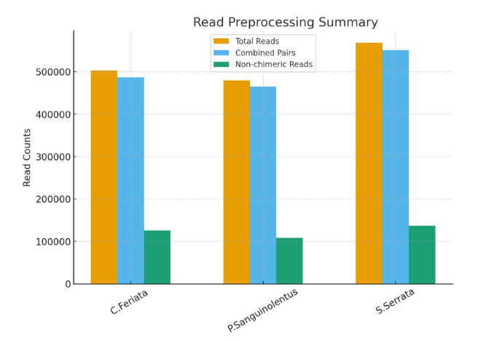
Figure 1 Read preprocessing summary for crab gut microbiomes. High-throughput sequencing of C. feriata, P. sanguinolentus, and S. serrata gut samples generated ~4.8–5.7 × 10⁵ raw reads per sample (orange bars). More than 96% of reads successfully merged into paired sequences (blue bars), yielding ~4.6–5.5 × 10⁵ combined reads. After quality filtering and chimera removal, 1.1–1.4 × 10⁵ high-quality non-chimeric reads were retained (green bars), providing sufficient and consistent sequencing depth across all host species for downstream analyses.
Community Composition: Phylum-level analyses revealed strong host-specific patterns (Fig. 2). Microbiomes of C. feriata and S. serrata were dominated by Firmicutes (48% and 45%, respectively), followed by Proteobacteria (15–20%) and Bacteroidetes (~15%). Minor phyla each contributed <2%. By contrast, P. sanguinolentus exhibited a striking dominance of Actinobacteria (~76%), with Firmicutes (~9–10%) and Proteobacteria (<10%) present at much lower proportions. Across all hosts, the four dominant phyla (Firmicutes, Actinobacteria, Proteobacteria, Bacteroidetes) accounted for >90% of total sequences.
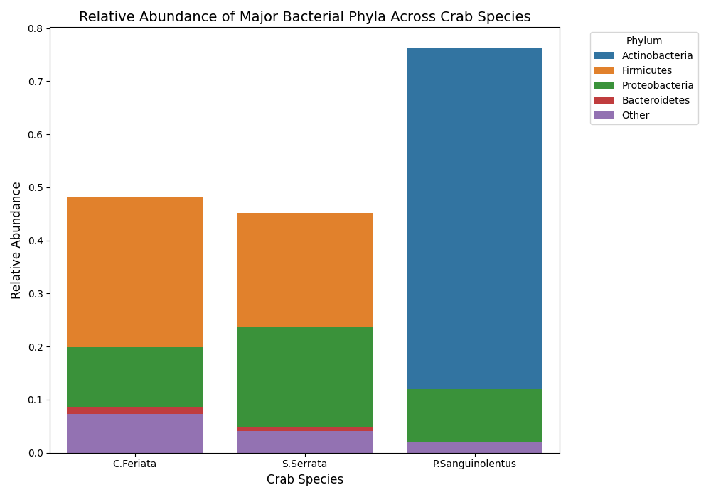
Figure 2 Phylum-level microbial community composition across crab species. Relative abundance of bacterial phyla in the gut microbiomes of C. feriata, S. serrata, and P. sanguinolentus shows strong host-specific patterns. C. feriata and S. serrata were dominated by Firmicutes (~48% and ~45%, respectively), with Proteobacteria and Bacteroidetes comprising 15–20%. In contrast, P. sanguinolentus exhibited pronounced Actinobacteria dominance (~76%), with Firmicutes (~9–10%) and Proteobacteria (<10%) at lower levels. Across all hosts, Firmicutes, Actinobacteria, Proteobacteria, and Bacteroidetes accounted for >90% of sequences, indicating broadly conserved cores but divergent dominant taxa. Sequencing summary statistics are shown below the plot.
Alpha Diversity: Rarefaction curves approached plateaus near 50,000 reads, indicating sufficient sequencing depth (Fig. 3). Chao1 richness estimates ranked C. feriata highest (~2,800), followed by S. serrata (~2,000), and P. sanguinolentus lowest (~1,200). Shannon diversity indices mirrored this pattern, plateauing at ~6.9, 6.4, and 5.0, respectively. Summary indices corroborated these results: Shannon index values were 1.45 (C. feriata), 1.33 (S. serrata), and 0.81 (P. sanguinolentus), while Simpson’s index followed a similar trend (0.70, 0.69, and 0.40, respectively) (Figs. 4–5). Collectively, P. sanguinolentus exhibited lower richness and evenness compared to the other two species.
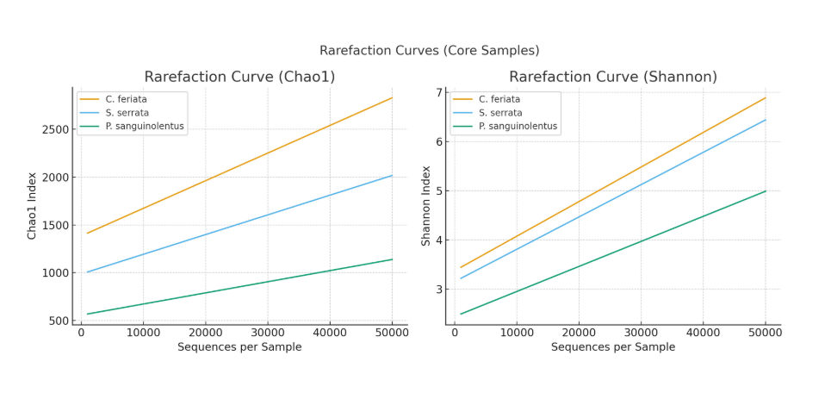
Figure 3 Rarefaction curves for gut microbiome diversity in three crab species. Rarefaction analyses of Chao1 richness (left) and Shannon diversity (right) demonstrate sufficient sequencing depth across samples. Both indices plateau near 50,000 reads, indicating robust coverage. Diversity was consistently highest in C. feriata (Chao1 ~2,800; Shannon ~6.9), intermediate in S. serrata (Chao1 ~2,000; Shannon ~6.4), and lowest in P. sanguinolentus (Chao1 ~1,200; Shannon ~5.0). These results highlight clear host-specific differences, with P. sanguinolentus exhibiting markedly reduced richness and evenness compared to the other two species.
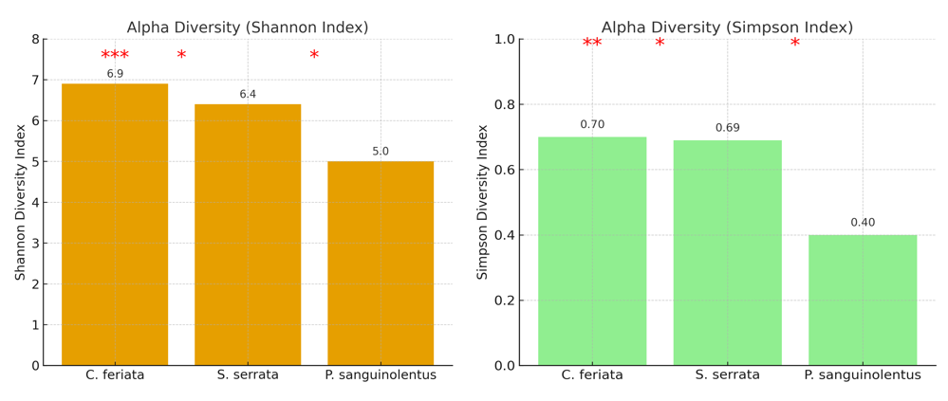
Figure 4 Alpha diversity indices of crab gut microbiomes. Bar plots showing Shannon diversity (left) and Simpson’s index (right) for the gut microbiomes of C. feriata, S. serrata, and P. sanguinolentus. Diversity was highest in C. feriata (Shannon = 1.45; Simpson = 0.70), intermediate in S. serrata (Shannon = 1.33; Simpson = 0.69), and lowest in P. sanguinolentus (Shannon = 0.81; Simpson = 0.40). These results confirm that P. sanguinolentus harbors a less diverse and more uneven microbial community compared to the other two species.

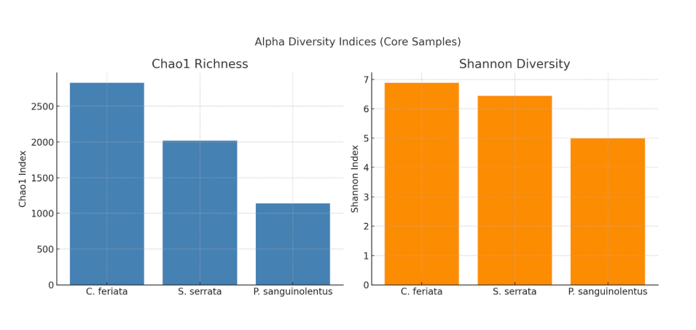
Figure 5 Alpha diversity indices of crab gut microbiomes (Chao1 richness and Shannon diversity). Comparison of Chao1 richness (left) and Shannon diversity (right) among the gut microbiomes of C. feriata, S. serrata, and P. sanguinolentus. C. feriata exhibited the highest richness (~2,800) and diversity (~6.9), S. serrata showed intermediate values (~2,000; ~6.4), and P. sanguinolentus had the lowest richness (~1,200) and diversity (~5.0). These consistent trends across indices highlight that P. sanguinolentus harbors a taxonomically less rich and less diverse microbial community compared to the other two species.
Beta Diversity: Bray–Curtis PCoA clearly separated P. sanguinolentus from the other species along PC1, which explained ~98% of variation, while C. feriata and S. serrata clustered together (Fig. 6). Pairwise dissimilarity confirmed this: C. feriata–S. serrata = 0.10 (most similar), C. feriata–P. sanguinolentus = 0.61, and S. serrata–P. sanguinolentus = 0.56. These values indicate the strongest divergence for P. sanguinolentus, consistent with its unique Actinobacteria-rich community. Statistical analysis confirmed these compositional differences. PERMANOVA revealed significant host-specific clustering (F = 8.73, R² = 0.62, p = 0.028). Alpha diversity comparisons by Kruskal–Wallis test also indicated significant differences among crab species (H = 6.47, p = 0.039), with C. feriata showing the highest diversity, followed by S. serrata and P. sanguinolentus.
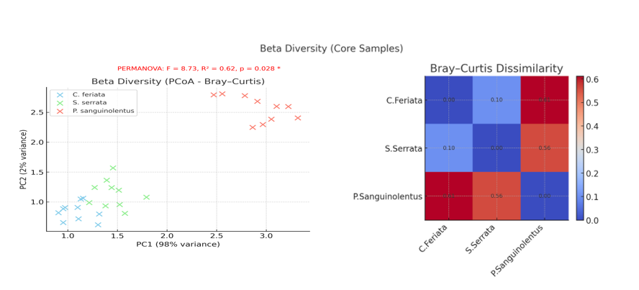
Figure 6 Beta diversity of crab gut microbiomes based on Bray–Curtis dissimilarity. Principal coordinate analysis (PCoA; left) shows clear separation of P. sanguinolentus from C. feriata and S. serrata along PC1, while C. feriata and S. serrata cluster closely together. The Bray–Curtis dissimilarity heatmap (right) quantifies these relationships: C. feriata–S. serrata = 0.10 (most similar), S. serrata–P. sanguinolentus = 0.56, and C. feriata–P. sanguinolentus = 0.61. These results highlight strong host-specific divergence in microbial community structure, with P. sanguinolentus harboring the most distinct microbiome.

Discussion
The present study generated deep and balanced sequencing datasets for the gut microbiomes of P. sanguinolentus, C. feriata, and S. serrata, with consistently high merge rates and over 10⁵ high-quality reads per sample. The uniform sequencing depth, combined with rigorous quality control, provides confidence that the observed patterns reflect biological differences rather than technical artefacts. These datasets therefore offer a reliable foundation for comparing microbiome structure across the three host species.
Clear host-associated signals were evident in the community profiles, consistent with general microbiome principles emphasizing diet, environment, and host physiology as major determinants of microbial structure [16]. Both C. feriata and S. serrata harbored Firmicutes-dominated microbiomes, with additional contributions from Proteobacteria and Bacteroidetes, while P. sanguinolentus was strikingly enriched in Actinobacteria. This reversal of dominance between Firmicutes and Actinobacteria highlights strong host-specific selective environments, which may arise from differences in diet, gut physiochemistry, or immune-mediated filtering [17–20]. These taxonomic distinctions were mirrored in alpha diversity indices: C. feriata and S. serrata supported richer and more even microbial communities, whereas P. sanguinolentus exhibited substantially lower richness and evenness, consistent with its Actinobacteria-driven dominance.
Beta diversity analysis further reinforced this pattern, with ordination showing P. sanguinolentus separating strongly from the other two species along the primary axis of variation. Pairwise Bray–Curtis dissimilarities quantified this distinction, with C. feriata and S. serrata clustering closely together and P. sanguinolentus diverging sharply. Taken together, these results indicate that host identity is a principal driver of microbial community structure in these crabs, with P. sanguinolentus representing a distinct ecological niche compared to the Firmicutes-associated hosts.
The ecological interpretation of these phylum-level profiles provides further insight. Firmicutes-dominated communities in C. feriata and S. serrata are consistent with the fermentative metabolism that supports energy extraction from complex polysaccharides, potentially reflecting dietary inputs or gut conditions favoring such guilds. In contrast, the enrichment of Actinobacteria in P. sanguinolentus suggests specialized metabolic capabilities, including antimicrobial compound production, which may reduce evenness and structure the community around dominant taxa. Despite these differences, the moderate presence of Proteobacteria and Bacteroidetes across all hosts suggests a conserved microbial core, likely contributing to nutrient cycling and organic matter degradation in estuarine environments [21,22].
Several limitations of this study should be acknowledged. The reliance on phylum-level resolution masks functional and ecological heterogeneity within lineages, as distinct genera and species may contribute differently to host physiology. The cross-sectional design limits inference on temporal stability or seasonal variability, and relative abundance data do not capture absolute microbial loads. Moreover, unmeasured covariates, including host diet, age, sex, or health status, may have influenced community composition. Despite these constraints, the clear host-specific signals observed here highlight robust ecological patterns that warrant deeper investigation.
Looking ahead, future work should move toward finer-resolution approaches such as strain-resolved metagenomics and metatranscriptomics, which would allow separation of resident from transient taxa and direct linkage to functional pathways. Longitudinal studies are needed to assess temporal stability, while absolute quantification methods such as qPCR, spike-in controls, or flow cytometry would strengthen ecological interpretations. Integration with host transcriptomics and metabolomics could provide insight into host–microbe coupling, and experimental manipulations of diet, salinity, or microbiome transplants could directly test causality. Expanding to include the virome, mycobiome, and resistome will further round out the ecological picture of crab-associated microbiomes [23–31].
Overall, this study demonstrates strong host-specific microbiome signatures in three ecologically and commercially important crab species. While C. feriata and S. serrata maintain diverse Firmicutes-rich communities, P. sanguinolentus hosts a markedly distinct Actinobacteria-dominated microbiome with reduced diversity. These findings establish the first baseline characterization of crab gut microbiomes at scale and provide an important foundation for future work exploring the ecological, evolutionary, and applied implications of host–microbe interactions in estuarine crustaceans.
Conclusion
This study provides the first 16S-based metagenomic characterization of gut microbiomes in P. sanguinolentus, C. feriata, and S. serrata. We show that while C. feriata and S. serrata harbor Firmicutes-rich, diverse microbiomes, P. sanguinolentus is dominated by Actinobacteria with markedly reduced diversity. These host-specific microbial profiles highlight the ecological and evolutionary significance of crab–microbiome associations in estuarine ecosystems. The findings establish a baseline for future investigations into host–microbe interactions in marine crustaceans and have potential applications in aquaculture and conservation biology.

Disclaimer (Artificial intelligence)
Option 1:
Author(s) hereby declare that NO generative AI technologies such as Large Language Models (ChatGPT, COPILOT, etc.) and text-to-image generators have been used during the writing or editing of this manuscript.
Option 2:
Author(s) hereby declare that generative AI technologies such as Large Language Models, etc. have been used during the writing or editing of manuscripts. This explanation will include the name, version, model, and source of the generative AI technology and as well as all input prompts provided to the generative AI technology
Details of the AI usage are given below:
1.
2.
3.

Ethics approval and consent to participate: Not applicable.
Consent for publication: Not applicable.
Data Availability Statement: All data generated or analyzed during this study are included in this published article.
Declaration of Competing Interest: The authors declare that the research was conducted in the absence of any commercial or financial relationships that could be construed as a potential conflict of interest.
References:

- “Portunus sanguinolentus, Threespot swimming crab: fisheries,” Sealifebase.se, 2024.
[Online]. Available: https://www.sealifebase.se/summary/Portunus-sanguinolentus
- Y. Zhang et al., “Transcriptome sequencing and molecular markers discovery in the gonads of Portunus sanguinolentus,” Scientific Data, vol. 5, no. 1, Jul. 2018, doi: https://doi.org/10.1038/sdata.2018.131.
- P. S. Padayatti, “Notes on population characteristics and reproductive biology of the portunid crab Charybdis (Charybdis) feriatus (Linnaeus) at Cochin,” Indian Journal of Fisheries, vol. 37, no. 2, pp. 155–158, 2025, Accessed: Oct. 07, 2025. [Online]. Available: https://epubs.icar.org.in/index.php/IJF/article/view/10459
- D. A. P., “Biology and exploitation of the crucifix crab, Charybdis (Charybdis) feriata (Linnaeus, 1758) (Brachyura: Portunidae) from Karnataka coast, India,” CMFRI Digital Repository, Cmfri.org.in, 2015. doi: https://eprints.cmfri.org.in/8465/1/IJF_Dineshbabu_25-29.pdf.
- S. Fratini, L. Ragionieri, and S. Cannicci, “Stock structure and demographic history of the Indo-West Pacific mud crab Scylla serrata,” Estuarine, Coastal and Shelf Science, vol. 86, no. 1, pp. 51–61, Jan. 2010, doi: https://doi.org/10.1016/j.ecss.2009.10.009.
- E. Apine, M. K. Mani, P. Rai, I. Karunasagar, and L. M. Turner, “Future climate change conditions may compromise metabolic performance in juveniles of the mud crab Scylla serrata,” Journal of Marine Science and Engineering, vol. 10, no. 5, pp. 582–582, Apr. 2022, doi: https://doi.org/10.3390/jmse10050582.
- J.-O. Meynecke and R. G. Richards, “A full life cycle and spatially explicit individual-based model for the giant mud crab (Scylla serrata): a case study from a marine protected area,” ICES Journal of Marine Science, vol. 71, no. 3, pp. 484–498, Nov. 2013, doi: https://doi.org/10.1093/icesjms/fst181.
- C. J. C. Rodrigues and C. C. C. R. de Carvalho, “Cultivating marine bacteria under laboratory conditions: overcoming the ‘unculturable’ dogma,” Frontiers in Bioengineering and Biotechnology, vol. 10, Aug. 2022, doi: https://doi.org/10.3389/fbioe.2022.964589.
- R. Poretsky, L. M. Rodriguez-R, C. Luo, D. Tsementzi, and K. T. Konstantinidis, “Strengths and limitations of 16S rRNA gene amplicon sequencing in revealing temporal microbial community dynamics,” PLoS ONE, vol. 9, no. 4, Apr. 2014, doi: https://doi.org/10.1371/journal.pone.0093827.
- A. E. Pérez-Cobas, L. Gomez-Valero, and C. Buchrieser, “Metagenomic approaches in microbial ecology: an update on whole-genome and marker gene sequencing analyses,” Microbial Genomics, vol. 6, no. 8, Aug. 2020, doi: https://doi.org/10.1099/mgen.0.000409.
- S. Mirete et al., “Metagenome-assembled genomes (MAGs): advances, challenges, and ecological insights,” Microorganisms, vol. 13, no. 5, p. 985, Apr. 2025, doi: https://doi.org/10.3390/microorganisms13050985.
- T. Nogueira and A. Botelho, “Metagenomics and other omics approaches to bacterial communities and antimicrobial resistance assessment in aquacultures,” Antibiotics, vol. 10, no. 7, p. 787, Jun. 2021, doi: https://doi.org/10.3390/antibiotics10070787.
- M. Zhang et al., “Molting alters the microbiome, immune response, and digestive enzyme activity in mud crab (Scylla paramamosain),” mSystems, vol. 6, no. 5, Oct. 2021, doi: https://doi.org/10.1128/msystems.00917-21.
- M. Fusi et al., “Gill-associated bacteria are homogeneously selected in amphibious mangrove crabs to sustain host intertidal adaptation,” Microbiome, vol. 11, no. 1, Aug. 2023, doi: https://doi.org/10.1186/s40168-023-01629-4.
- T. Kwok, I. Ching, K. Ka, C. Chandler, and L. M. Tsang, “Metagenomic analysis of gut microbiome illuminates the mechanisms and evolution of lignocellulose degradation in mangrove herbivorous crabs,” BMC Microbiology, vol. 24, no. 1, Feb. 2024, doi: https://doi.org/10.1186/s12866-024-03209-4.
- G. A. Cresci and E. Bawden, “Gut microbiome: what we do and don’t know,” Nutrition in Clinical Practice, vol. 30, no. 6, pp. 734–746, Dec. 2015, https://doi.org/10.1177/0884533615609899
- D. C. Woodhams et al., “Host-associated microbiomes are predicted by immune system complexity and climate,” Genome Biology, vol. 21, no. 1, Feb. 2020, doi: https://doi.org/10.1186/s13059-019-1908-8.
- M. Zhang et al., “Symbiotic bacteria in gills and guts of Chinese mitten crab (Eriocheir sinensis) differ from the free-living bacteria in water,” PLoS ONE, vol. 11, no. 1, p. e0148135, Jan. 2016, doi: https://doi.org/10.1371/journal.pone.0148135.
- G. Bacci et al., “Conserved organ-specific microbial assemblages in different populations of a terrestrial crab,” Frontiers in Microbiology, vol. 14, Jun. 2023, doi: https://doi.org/10.3389/fmicb.2023.1113617.
- G. Bacci et al., “Species-specific gill microbiome of eight crab species with different breathing adaptations,” Scientific Reports, vol. 13, no. 1, p. 21033, Nov. 2023, doi: https://doi.org/10.1038/s41598-023-48308-w.
- H. J. Flint, K. P. Scott, S. H. Duncan, P. Louis, and E. Forano, “Microbial degradation of complex carbohydrates in the gut,” Gut Microbes, vol. 3, no. 4, pp. 289–306, Jul. 2012.
- X. Zhang et al., “Microbial diversity and biogeochemical cycling potential in deep-sea sediments associated with seamount, trench, and cold seep ecosystems,” Frontiers in Microbiology, vol. 13, Oct. 2022, doi: https://doi.org/10.3389/fmicb.2022.1029564.
- G. B. Gloor, J. M. Macklaim, V. Pawlowsky-Glahn, and J. J. Egozcue, “Microbiome datasets are compositional: and this is not optional,” Frontiers in Microbiology, vol. 8, Nov. 2017, doi: https://doi.org/10.3389/fmicb.2017.02224.
- N. Kim, J. Ma, W. Kim, J. Kim, P. Belenky, and I. Lee, “Genome-resolved metagenomics: a game changer for microbiome medicine,” Experimental and Molecular Medicine, Jul. 2024, doi: https://doi.org/10.1038/s12276-024-01262-7.
- P. Bourceau et al., “Visualization of metabolites and microbes at high spatial resolution using MALDI mass spectrometry imaging and in situ fluorescence labeling,” Nature Protocols, vol. 18, no. 10, pp. 3050–3079, Sep. 2023, doi: https://doi.org/10.1038/s41596-023-00864-1.
- D. M. Tourlousse and Y. Sekiguchi, “Synthetic DNA spike-in standards for cross-domain absolute quantification of microbiomes by rRNA gene amplicon sequencing,” ISME Communications, vol. 5, no. 1, Jan. 2025, doi: https://doi.org/10.1093/ismeco/ycaf028.
- P. Alfonso, A. Butković, R. Fernández, A. Riesgo, and S. F. Elena, “Unveiling the hidden viromes across the animal tree of life: insights from a taxonomic classification pipeline applied to invertebrates of 31 metazoan phyla,” mSystems, vol. 9, no. 5, Apr. 2024, doi: https://doi.org/10.1128/msystems.00124-24.
- S. J. Salter et al., “Reagent and laboratory contamination can critically impact sequence-based microbiome analyses,” BMC Biology, vol. 12, no. 1, Nov. 2014, doi: https://doi.org/10.1186/s12915-014-0087-z.
- R. Knight et al., “Best practices for analysing microbiomes,” Nature Reviews Microbiology, vol. 16, no. 7, pp. 410–422, May 2018, doi: https://doi.org/10.1038/s41579-018-0029-9.
- P. Yilmaz et al., “Minimum information about a marker gene sequence (MIMARKS) and minimum information about any (x) sequence (MIxS) specifications,” Nature Biotechnology, vol. 29, no. 5, pp. 415–420, May 2011, doi: https://doi.org/10.1038/nbt.1823.
- A. Sczyrba et al., “Critical assessment of metagenome interpretation—a benchmark of metagenomics software,” Nature Methods, vol. 14, no. 11, pp. 1063–1071, Oct. 2017, doi: https://doi.org/10.1038/nmeth.4458.

