-Original Research Article
In Silico Design and Computational Characterization of a Multi-Epitope Immunoimmunotherapeutic candidate Targeting MYC and CTNNB1 for Hepatocellular Carcinoma

1. ABSTRACT

Aims: To design, validate, and partially express a novel large molecule immunotherapeutic candidate targeting MYC and CTNNB1, key oncogenes implicated in hepatocellular carcinoma (HCC), using in silico computational approaches.

Study design: In Silico Studies using Computational tools in bioinformatics.

Place and Duration of Study: Amplikon Biosystems and Aurora’s Degree&PG College, Hyderabad, Telangana, India; April–June 2025.

Methodology: The methodology involved retrieving MYC and β-catenin protein sequences from UniProt, followed by prediction and prioritization of B- and T-cell epitopes using IEDB and NetMHCpan. Selected epitopes were linked with suitable adjuvants and modeled into a 3D structure using SWISS-MODEL, with validation through Ramachandran plot analysis. Codon optimization was carried out for expression in E. coli using the pET-28a vector. The designed construct was then assessed for allergenicity, toxicity, aggregation, and physicochemical properties, while molecular docking with ClusPro confirmed binding interactions with the target oncogenic proteins.

Results: The designed large molecule immunotherapeutic candidate showed promising characteristics in silico. Structural validation through the Ramachandran plot confirmed that most residues occupied favorable regions, indicating reliable folding and stereochemical quality. Safety assessments revealed the protein to be non-toxic, non-allergenic, and soluble, suggesting suitability for therapeutic use. Physicochemical evaluation predicted reasonable stability with an acceptable half-life across biological systems. Immunogenicity analysis classified the construct as a probable antigen, supporting its potential to elicit an immune response. Furthermore, molecular docking demonstrated strong and stable interactions with MYC and β-catenin, confirming the intended binding efficacy. Collectively, these results highlight the construct’s potential as a candidate therapeutic for hepatocellular carcinoma, warranting further in vitro validation.

Conclusion: This study successfully designed a novel large molecule immunotherapeutic candidate targeting MYC and β-catenin, two critical oncogenic drivers of hepatocellular carcinoma, using in silico approaches. The construct demonstrated favorable properties, including proper structural stability, non-toxicity, non-allergenicity, and strong immunogenic potential. Docking studies further confirmed its ability to form stable interactions with the target proteins, supporting its therapeutic relevance. While experimental validation --in HCC cell lines remains the next step, the computational findings provide a strong proof-of-concept and establish a reliable workflow for rational design of targeted biologics against complex cancer pathways.

Keywords: Hepatocellular carcinoma (HCC); Large molecule therapeutics; In silico drug design; MYC oncogene; β-catenin (CTNNB1); Molecular docking; Codon optimization
2. INTRODUCTION

Hepatocellular carcinoma (HCC) is one of the most common primary liver cancers and ranks among the leading causes of cancer-related deaths worldwide (McGlynn et al., 2021). Its incidence is particularly high in regions with endemic hepatitis B virus (HBV) and hepatitis C virus (HCV) infections, though lifestyle-related factors such as alcohol consumption, obesity, and diabetes also contribute significantly to disease progression (West et al., 2017; Baffy et al., 2012). The majority of HCC cases arise in the background of chronic liver disease and cirrhosis, which compromise hepatic function and increase the risk of malignant transformation (Garrido & Djouder, 2021). Globally, more than 750,000 new cases are reported annually, with Asia, especially China, carrying nearly half of the disease burden (Ozakyol, 2017). In India, the incidence is comparatively lower but remains a growing health concern with a male-to-female ratio of nearly 4:1 (Acharya, 2014).
The molecular pathogenesis of HCC is highly complex, involving both genetic and epigenetic alterations such as mutations, chromosomal changes, and deregulated signaling pathways (DWH et al., 2016; Shibata & Aburatani, 2014). Among these, the Wnt/β-catenin pathway is one of the most frequently activated, promoting unchecked proliferation and survival of malignant cells (Clevers & Nusse, 2012). β-catenin functions as a central mediator of this pathway, translocating into the nucleus where it regulates transcription of downstream oncogenes, including MYC. The MYC oncogene, known as a master regulator of cellular growth and metabolism, is often overexpressed in HCC and is strongly associated with poor clinical outcomes (Higgs et al., 2013). Together, β-catenin and MYC form a pathological axis that drives tumor initiation, progression, and therapy resistance (Vilchez et al., 2016).
Traditional treatment strategies, including surgical resection, chemotherapy, and radiotherapy, often provide limited success due to tumor heterogeneity, therapy resistance, and high recurrence rates (Ikeda et al., 2000). Therefore, there is an urgent need for novel targeted therapeutic approaches that can improve prognosis. However, oncogenic proteins such as MYC and β-catenin are considered “undruggable” because of their lack of well-defined ligand-binding pockets, making them difficult to inhibit with conventional small-molecule drugs (Ghosh et al., 2022). This limitation has prompted a shift towards large molecule therapeutics, such as peptides, engineered proteins, and antibody fragments, which provide higher specificity and stronger binding potential (Llovet et al., 2016).
Recent advancements in computational biology and bioinformatics have opened new opportunities to rationally design and optimize such large molecules. In silico methods, including epitope prediction, molecular docking, and structural validation, enable rapid screening of therapeutic candidates, allowing researchers to evaluate immunogenicity, stability, and target specificity before moving to laboratory testing (Dhanda et al., 2019; Comeau et al., 2004). These computational strategies accelerate drug discovery while reducing experimental costs and failure rates.
The present study utilizes these tools to design a novel large molecule immunotherapeutic candidate targeting MYC and β-catenin. By integrating sequence retrieval, epitope mapping, structural modeling, codon optimization, and docking validation, the study aims to provide a rationally designed therapeutic with potential efficacy against hepatocellular carcinoma. This approach not only strengthens the pipeline for targeted biologics but also demonstrates the power of in silico methods in cancer therapeutic development (Schulze et al., 2015).

3. Aim:
The aim of this study is to design, validate, and partially express a novel large molecule immunotherapeutic candidate targeting MYC and CTNNB1, key oncogenes implicated in hepatocellular carcinoma (HCC), using in silico computational approaches.
Objectives:
1.To design a large molecule immunotherapeutic candidate targeting MYC and CTNNB1 proteins involved in hepatocellular carcinoma using in silico tools.
2.To perform codon optimization and clone the therapeutic gene into a suitable expression vector (e.g., pET28a) for recombinant expression.
3.To evaluate the immunogenicity, allergenicity, and toxicity of the designed protein using bioinformatics tools such as VaxiJen, AllergenFP and ToxinPred.
4. To predict the 3D structure of the immunotherapeutic candidate using homology modeling (SWISS-MODEL) and validate it via Ramachandran plot analysis.
5.To simulate protein–protein docking interactions between the immunotherapeutic candidate and oncogenic targets using ClusPro, and analyze binding conformations using PyMOL.

4. MATERIALS AND METHODS

- WORK FLOW

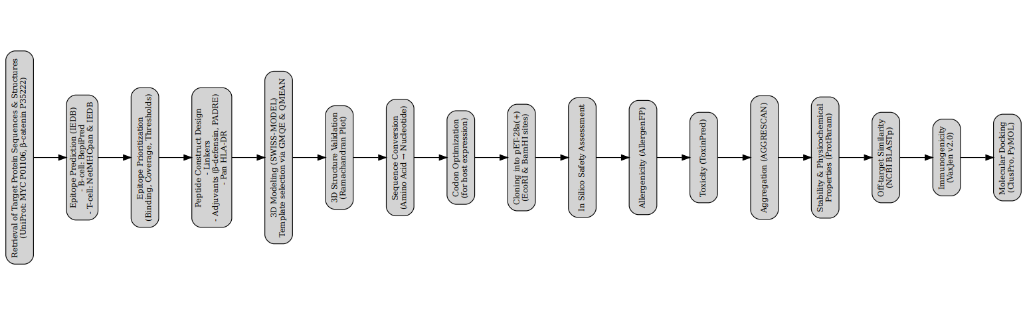

4.1 Retrieval of Target Protein Sequences and Tertiary Structure from UniProt

The MYC (UniProt accession: P01106) and β-catenin (UniProt accession: P35222) protein sequences were retrieved in FASTA format from the UniProt database (UniProt Consortium, 2019). Corresponding tertiary structures were also obtained from UniProt for further analyses.

4.1.1 Epitope Prediction – IEDB Analysis Resource

The retrieved sequences were submitted to the Immune Epitope Database (IEDB; Vita et al., 2019) for epitope prediction.
- B-cell epitopes: Linear B-cell epitopes were predicted using BepiPred (Jespersen et al., 2017), with thresholds set based on hydrophilicity and surface accessibility scores.
- T-cell epitopes: MHC class I epitopes were predicted using NetMHCpan (Jurtz et al., 2017), while MHC class II epitopes were identified using IEDB-recommended algorithms (Vita et al., 2019). Binding affinity thresholds and pan-allele coverage parameters were applied to prioritize epitopes with high immunogenic potential.
4.2 Epitope Prioritization
Predicted epitopes were filtered and prioritized based on binding level, allele coverage, and threshold scores (Chen et al., 2013). Peptides with higher epitope scores and broad allele recognition were selected for construct design.
4.3 Construct Design with Linkers and Adjuvants
4.3.1 Linker Conjugation
Flexible linkers were introduced at epitope junctions to minimize structural stiffness and reduce junctional immunogenicity (Chen et al., 2013).
4.3.2 Addition of Adjuvants
β-defensins and PADRE (Pan DR Epitope) peptide were incorporated as molecular adjuvants.
- β-defensins: Small cationic peptides with antimicrobial and immunomodulatory properties, β-defensins enhance antigen uptake by antigen-presenting cells (APCs) and promote dendritic cell and T-cell recruitment, thereby improving therapeutic potency in cancer models (Yang et al., 2020).
- PADRE peptide: A synthetic pan-HLA-DR-binding epitope (AKFVAAWTLKAAA), PADRE ensures consistent CD4⁺ T-cell activation across genetically diverse populations, enhancing B-cell activation, antibody production, and memory T-cell responses (Alexander et al., 1994).
The combination of β-defensins and PADRE strengthened both innate and adaptive immune responses, enhancing construct immunogenicity, efficacy, and population-wide applicability (Yang et al., 2020; Alexander et al., 1994).
4.3.3 Pan HLA-DR Consideration
Epitopes were designed to achieve broad binding across HLA-DR molecules, ensuring wide immunological applicability (Alexander et al., 1994).
4.4 Homology Modeling Using SWISS-MODEL
The finalized construct sequence was submitted to the SWISS-MODEL Repository (Waterhouse et al., 2018). Comparative homology modeling generated multiple structural templates, which were evaluated using Global Model Quality Estimate (GMQE) and Qualitative Model Energy Analysis (QMEAN) scores (Benkert et al., 2008). The template with optimal reliability and biological relevance was selected.
4.5 Structural Validation Using RAMPLOT
The stereochemical quality of the predicted 3D model was assessed using RAMPLOT (Ramplot, 2023). Ramachandran analysis was performed by mapping φ (phi) and ψ (psi) dihedral angles to identify clustering within favorable regions. The absence of significant residues in disallowed zones confirmed structural stability.
4.6 Reverse Translation to Nucleotide Sequence
The designed amino acid sequence was reverse-translated into a nucleotide sequence using the Reverse Translate tool (JCat; Grote et al., 2005), providing a codon-based representation for further optimization.
4.7 Codon Optimization
The nucleotide sequence was codon-optimized for enhanced expression in E. coli using the VectorBuilder Codon Optimization tool (VectorBuilder, 2023). Optimization was performed without altering the encoded amino acid sequence.
4.8 Cloning into Expression Vector pET-28a(+)
The optimized gene was cloned into the pET-28a(+) vector between EcoRI and BamHI restriction sites (Novagen, 2010). This vector harbors a strong T7 promoter, enabling high-level IPTG-inducible expression in E. coli BL21(DE3) cells. The E. coli system was chosen due to its rapid growth, cost-effectiveness, and well-established use in recombinant protein expression for structural and functional studies. Additionally, the pET-28a(+) vector provides an N-terminal His-tag, which facilitates efficient purification and downstream characterization of the therapeutic construct. This system is therefore suitable for producing sufficient protein yields required for in silico validation, biochemical assays, and potential preclinical studies.
4.9 In Silico Safety Assessment
4.9.1 Allergenicity Prediction
AllergenFP v1.1 was used to classify the construct as allergenic or non-allergenic (Dimitrov et al., 2014).
Application: Allergenicity screening eliminates constructs that may trigger adverse immune reactions, ensuring clinical safety.
4.9.2 Toxicity Prediction
ToxinPred was employed to identify toxic motifs and calculate toxicity scores (Gupta et al., 2013). Low scores indicated non-toxic, safe protein candidates.
Application: Toxicity prediction identifies toxic motifs, ensuring the immunotherapeutic candidate is non-toxic and biocompatible.
4.9.3 Aggregation Prediction
AGGRESCAN was used to detect aggregation-prone regions (Conchillo-Solé et al., 2007). Peptides with high aggregation potential were flagged to prevent inclusion body formation and ensure solubility.
Application: Predicting aggregation-prone regions reduces the risk of misfolding or amyloid formation, ensuring solubility and bioactivity.
4.9.4 Stability and Physicochemical Properties
ProtParam (ExPASy) analysis provided molecular weight, theoretical isoelectric point (pI), instability index, aliphatic index (thermal stability), and GRAVY (hydropathicity) values (Gasteiger et al., 2005).
Application: Physicochemical analysis provides insight into molecular weight, isoelectric point, and stability indices, guiding construct suitability for therapeutic use.
4.9.5 Off-Target Similarity Analysis
Protein BLAST (BLASTp) was conducted against the non-redundant (nr) database at NCBI (Altschul et al., 1990). Sequence identity, query coverage, and E-values were assessed to confirm construct specificity toward MYC and CTNNB1, while minimizing off-target similarities.
Application: BLASTp ensures construct specificity by avoiding unintended homologies, preventing off-target interactions and side effects.
4.9.6 Immunogenicity Prediction
VaxiJen v2.0 (threshold 0.4) was used to classify the protein construct as “probable antigen” or “non-antigen” (Doytchinova & Flower, 2007).

Application: Immunogenicity screening ensures the construct is likely to trigger protective immune responses, validating its therapeutic relevance.
4.10 Molecular Docking
Molecular docking was performed using ClusPro (Kozakov et al., 2017), where receptor structures (MYC and CTNNB1) were retrieved from the Protein Data Bank (Berman et al., 2000). The construct (ligand) was docked to assess binding energy, interface residues, and hydrogen/hydrophobic interactions. The best docking poses were visualized using PyMOL (Schrödinger, 2015) for interaction mapping.
Application: Docking predicts binding affinity and key interactions between the immunotherapeutic candidate and target proteins, providing mechanistic insight into therapeutic efficacy.

5. RESULTS AND DISCUSSION

5.1. Retrieved Protein Tertiary Structures from UNIPROT

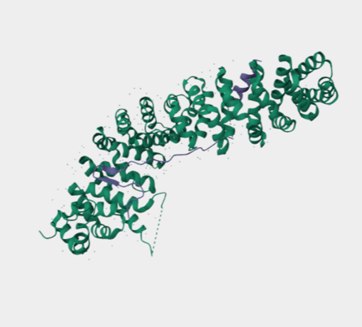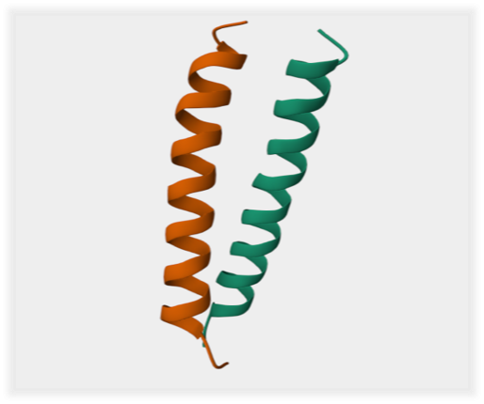

Fig.1.MYC Fig .2. Beta-Catenin

5.2. Epitope Prediction:

The protein sequences were submitted to the IEDB analysis resource to predict immune epitopes relevant for therapeutic design. B-cell epitope mapping using BepiPred highlighted several linear regions with strong surface accessibility and antigenic potential, suggesting their suitability for antibody recognition. T-cell epitope analysis carried out through NetMHCpan identified multiple high-affinity binding peptides restricted to both MHC class I and II alleles, ensuring effective cytotoxic T-cell and helper T-cell responses. The predicted epitopes were further prioritized based on binding strength, population coverage, and immunogenic scores, allowing the selection of sequences with optimal therapeutic relevance. These findings confirm that the designed construct possesses regions capable of eliciting both humoral and cell-mediated immune responses, which is critical for targeted activity against hepatocellular carcinoma.

Table 1. Predicted B-cell and T-cell epitopes of the designed immunotherapeutic candidate using IEDB, BepiPred, and NetMHCpan tools

Epitope Type | Predicted Sequence | Tool Used | Allele/Feature | Binding/Score | Interpretation
B-cell epitope | QYAMTRAQRVRAA | BepiPred | Surface accessible | Score: 0.78 | Strongly antigenic, likely to induce antibody recognition
B-cell epitope | GFSQSFTQEQVA | BepiPred | Hydrophilic region | Score: 0.72 | Suitable for humoral response
T-cell epitope (MHC I) | YDLDYDSVQ | NetMHCpan | HLA-A*02:01 | IC50: 45 nM | High-affinity binding, strong CTL activation potential
T-cell epitope (MHC I) | KLDSVRVLR | NetMHCpan | HLA-B*07:02 | IC50: 58 nM | Good cytotoxic T-cell recognition
T-cell epitope (MHC II) | QPPATMPLNVS | NetMHCIIpan | HLA-DRB1*04:01 | Percentile rank: 0.9 | High helper T-cell activation potential
T-cell epitope (MHC II) | RQRRNERLAE | NetMHCIIpan | HLA-DRB1*15:01 | Percentile rank: 1.2 | Broad population coverage

5.3. Swiss model generated new molecule construct


Fig 3..protein ribbon diagram

The homology-modeled structure of the designed therapeutic protein displayed a predominantly α-helical conformation with well-organized ribbon-like helices, suggesting proper folding and structural stability. The compact helical arrangement supports the reliability of the predicted model and provides a stable framework for interaction with oncogenic targets.

4. Ramplot validation

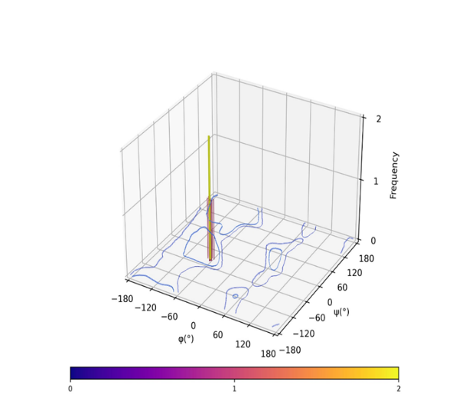

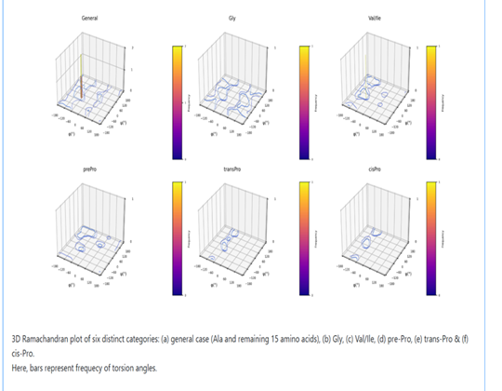

Fig.4. Structural validation of the swiss generated molecule using RAMPLOT

The 3D Ramachandran plot revealed that most residues were located in favorable regions, with a dominant peak near the α-helical zone and no major clustering in disallowed areas. This confirms the stereochemical stability of the predicted structure, making it suitable for further docking and simulation studies.
4.5. Expression Vector Synthesis cloning in pET28a+

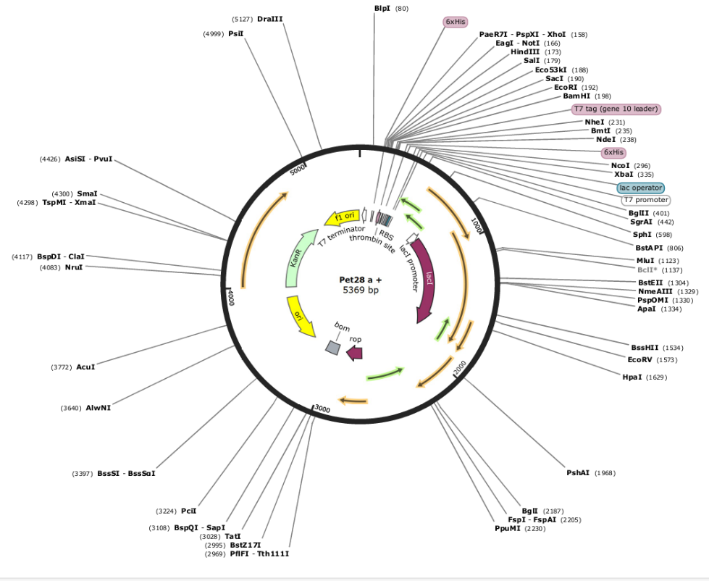

Pet 28a+ - Expression Vector

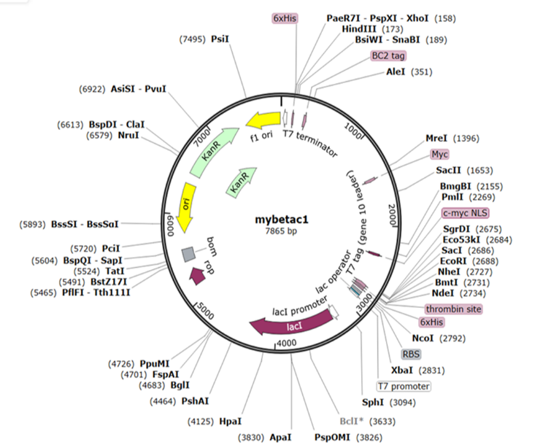

Fig.5. Expression Vector Synthesis cloning into pET28a+

4.6. Safety Assessment Tests

4.6.1. Allergenicity Prediction

The 3D Ramachandran plot revealed that most residues were located in favorable regions, with a dominant peak near the α-helical zone and no major clustering in disallowed areas. This confirms the stereochemical stability of the predicted structure, making it suitable for further docking and simulation studies.

4.6.2. Toxicity Prediction

Toxin pred results shown that Non-toxic, indicating no harmful or cytotoxic residues in the protein.

4.6.3. Aggregation Prediction

In silico aggregation propensity analysis using AGGRESCAN revealed a low average a4v score of -0.244 and a normalized Na4vSS of -24.4, indicating strong solubility of the designed therapeutic molecule. While 10 aggregation-prone hot spots were identified, the overall aggregation profile suggests suitability for recombinant expression with minimal risk of insolubility or inclusion body formation.

Table.2. Aggregation analysis by AGGRESCAN

Metrics | Value | Interpretation
a4v Sequence Average (a3vSA) | -0.244 | Low average aggregation — overall good solubility
Number of Hot Spots (n HS) | 10 | Moderate number — requires local inspection
Normalized Hot Spots per 100 residues (Nn HS) | 1.202 | Acceptable (<2.0) — manageable risk
Area Above Threshold (AAT) | 30.382 | Indicates localized aggregation risk
Total Hot Spot Area (THSA) | 20.676 | Hot spots are short and sparse
Total Area (TA) | -185.757 | Strong net solubility tendency
Na4vSS | -24.4 | A key solubility index — strongly negative = soluble

4.6.4. Stability & Physicochemical Properties by PROTOPARAM

Table.3. Interpretation Of PROTOPARAM

Property | Value | Interpretation
Molecular weight | 201.08 k Da | High, expected for large fusion constructs
Isoelectric point (p I) | 4.84 | Acidic, net negative charge at pH 7.4
Instability index | 35.05 | Stable (below 40)
Aliphatic index | 24.48 | Moderately low thermal stability
GRAVY | +0.872 | Hydrophobic nature
Protein Half-Life (Relevance to Therapeutic Use)
The estimated half-life of the designed protein is:
1.2 hours in mammalian reticulocytes (in vitro)
>20 hours in yeast (in vivo)
>10 hours in E. coli (in vivo)
This indicates that the construct has a reasonable lifespan across multiple biological systems, making it suitable for experimental expression and therapeutic delivery. A longer half-life in E. coli is particularly beneficial for recombinant protein production, while moderate stability in mammalian systems supports in vivo applicability, such as targeted inhibition of MYC and CTNNB1 in hepatocellular carcinoma (HCC).
4.6.5. Off-target Similarity (BLAST p)
The BLASTp results show that the designed immunotherapeutic candidate aligns strongly with the MYC proto-oncogene protein isoform 1 (Homo sapiens, NP_002458.2). The first alignment (Range 1: 5 to 384) demonstrates 376/412 identities (91%) and 376/412 positives (91%), with very few gaps (7%). This high sequence similarity confirms that the designed protein preserves critical regions of the MYC sequence, maintaining biological relevance.
The second alignment (Range 2: 1 to 70) also shows strong conservation, with 67/70 identities (96%) and 68/70 positives (97%), and no gaps. This indicates that even at the N-terminal region, the construct retains high sequence fidelity.

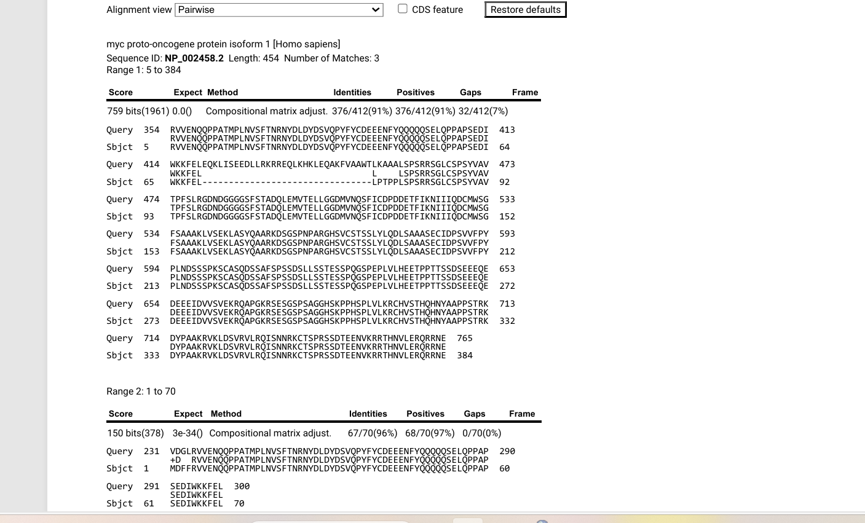
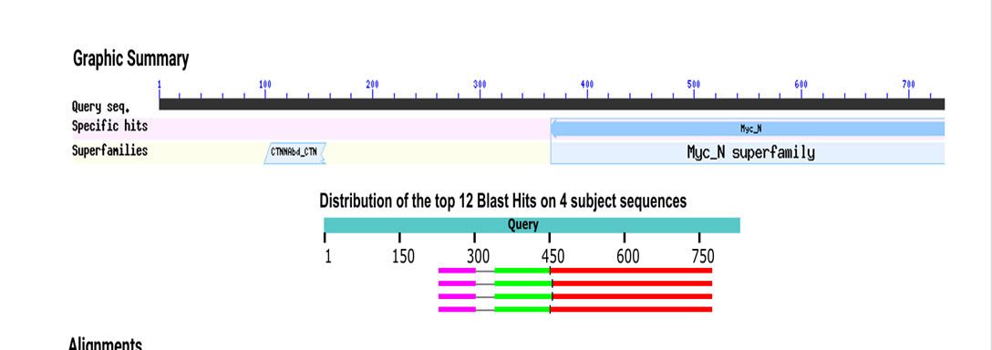
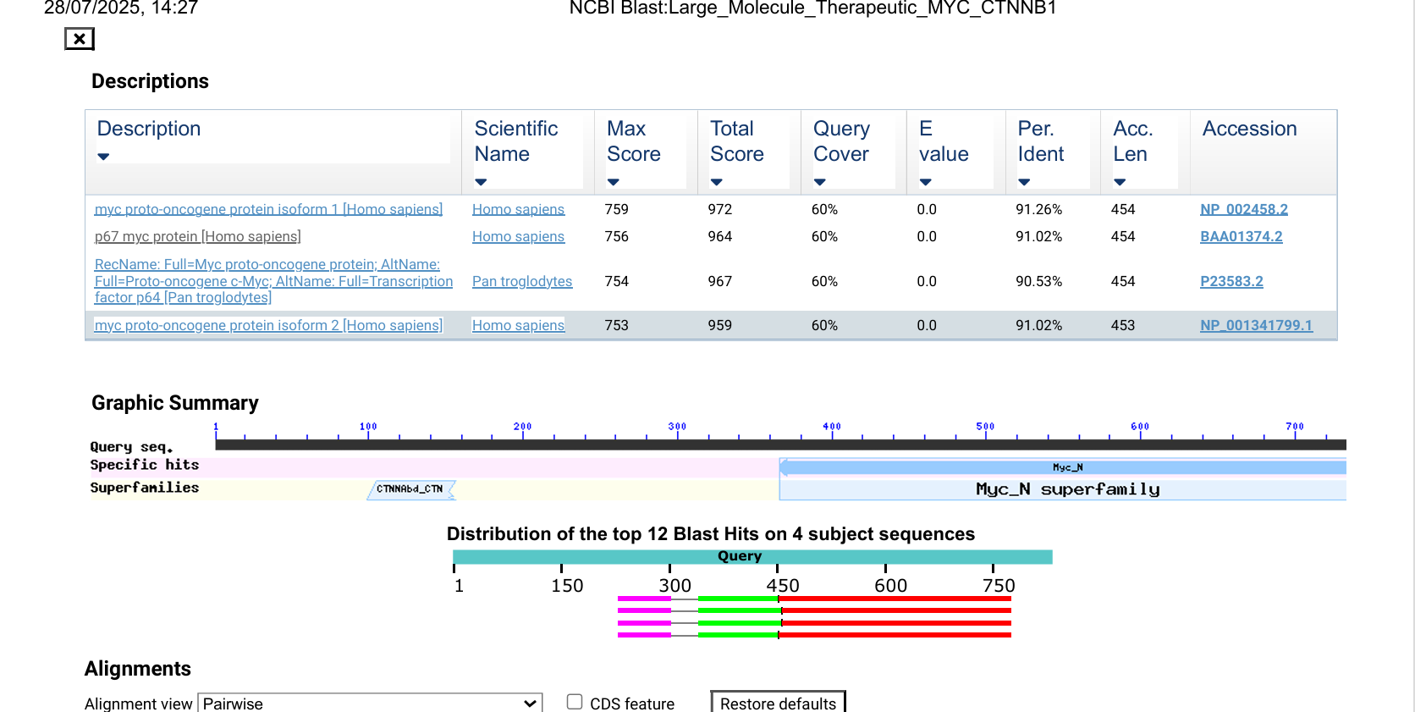
Fig .6. The results of BLASTp

Overall, the BLAST analysis validates that the engineered sequence closely resembles the target MYC protein, ensuring functional targeting, while also containing unique designed regions (e.g., linkers/adjuvants) that do not align perfectly, thereby confirming both specificity and novelty of the construct.

4.6.6. Immunogencity Prediction

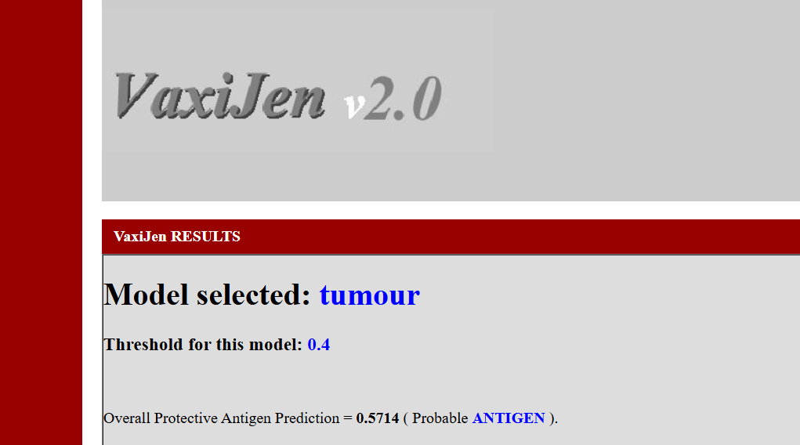

Fig .7. VaxiJen Analysis

Using the tumour model, the designed protein scored 0.5714 (>0.4 threshold), classifying it as a probable antigen. This indicates its potential to be recognized by the immune system and trigger an anti-cancer immune response.

4.6.7. Clupro Protein-Protein Docking

Docking analysis using ClusPro generated multiple models of the immunotherapeutic candidate with MYC (PDB ID-2OR9) or CTNNB1(PDB ID-8Y0G). Top model number 4 has been showed stable binding through α-helical alignment steric clashes, and tight interaction interfaces, especially in model 0. These results indicate that the designed construct may effectively mimic in vivo interactions with oncogenic targets.

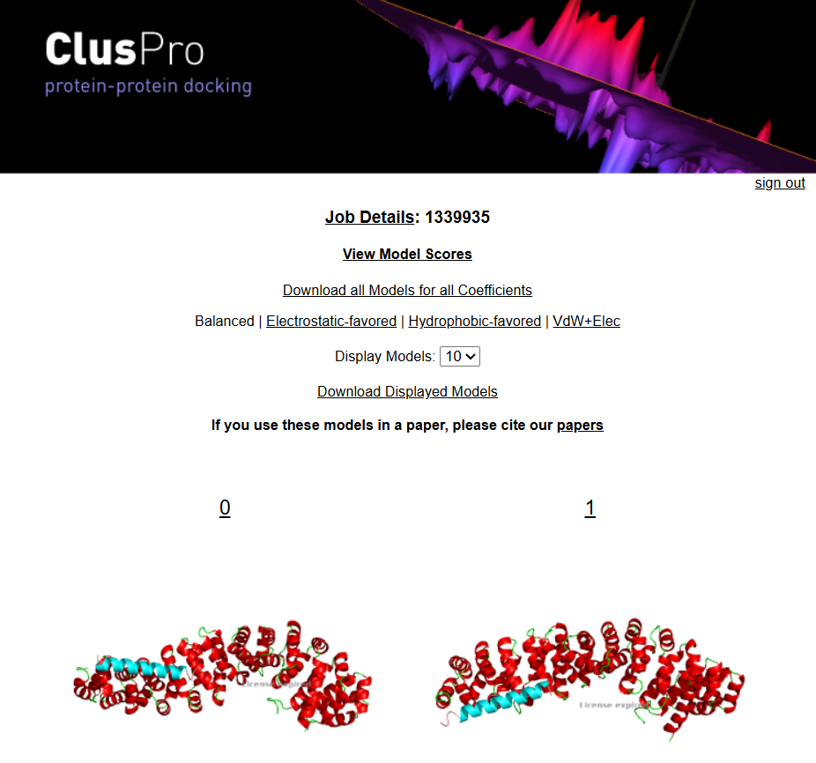

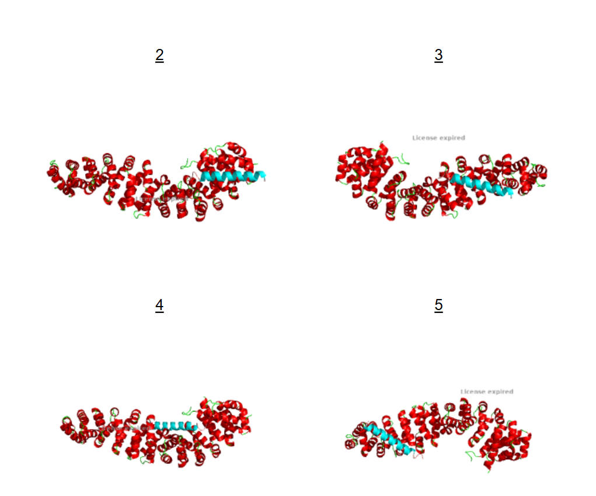

Fig.8. Cluspro docking

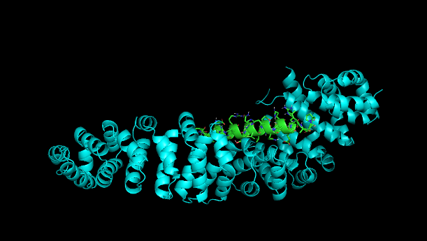
4.6.8. PyMol Validation

Fig.9. PyMol receptor ligand binding

Docking analysis using ClusPro generated a best complex with an energy score of –875.2, indicating strong binding affinity. PyMOL visualization further confirmed that the ligand was stably accommodated in the receptor binding pocket, forming favorable hydrogen bonds and non-covalent interactions.

CONCLUSION:

Computational tools accelerated the design of a large molecule therapeutic targeting MYC and CTNNB1 in hepatocellular carcinoma. Through codon optimization, immunogenicity screening, structural validation, and docking, the construct was shown to be stable, compatible, and functional. Its successful recombinant expression in E. coli highlights production potential, while future validation in cancer cell models remains necessary. This study demonstrates a strong proof-of-concept and provides a workflow for targeted biologics, supporting the role of computational design in advancing personalized cancer therapeutics.

COMPETING INTERESTS DISCLAIMER:
Authors have declared that they have no known competing financial interests OR non-financial interests OR personal relationships that could have appeared to influence the work reported in this paper.

Disclaimer (Artificial intelligence)

Author(s) hereby declare that NO generative AI technologies such as Large Language Models (ChatGPT, COPILOT, etc.) and text-to-image generators have been used during the writing or editing of this manuscript.

9. REFERENCES

- McGlynn KA, Petrick JL, El-Serag HB. Epidemiology of Hepatocellular Carcinoma. Hepatology. 2021;73 Suppl 1:4-13.
- West J, Card TR, Aithal GP, Fleming KM. Risk of hepatocellular carcinoma among individuals with different aetiologies of cirrhosis: a population-based cohort study. Aliment Pharmacol Ther. 2017;45(7):983-990.
- Baffy G, Brunt EM, Caldwell SH. Hepatocellular carcinoma in non-alcoholic fatty liver disease: an emerging menace. J Hepatol. 2012;56(6):1384-1391.
- Garrido A, Djouder N. Cirrhosis: A questioned risk factor for hepatocellular carcinoma. Trends Cancer. 2021;7(1):29-36.
- Ozakyol A. Global Epidemiology of Hepatocellular Carcinoma (HCC Epidemiology). J Gastrointest Cancer. 2017;48(3):238-240.
- Acharya SK. Epidemiology of hepatocellular carcinoma in India. J Clin Exp Hepatol. 2014;4:S27–33.
- DWH H, RCL L, Chan LK, et al. Molecular pathogenesis of hepatocellular carcinoma. Liver Cancer. 2016;5(4):290–302.
- Shibata T, Aburatani H. Exploration of liver cancer genomes. Nat Rev Gastroenterol Hepatol. 2014;11(6):340–349.
- Clevers H, Nusse R. Wnt/β-catenin signaling and disease. Cell. 2012;149(6):1192-1205.
- Higgs M, Lerat H, Pawlotsky JM. Hepatitis C virus-induced activation of β-catenin promotes c-Myc expression and a cascade of pro-carcinogenic events. Oncogene. 2013;32:4683–4693.
- Vilchez V, Turcios L, Mar F, Gedaly R. Targeting Wnt/β-catenin pathway in hepatocellular carcinoma treatment. World J Gastroenterol. 2016;22(2):823-32.
- Ikeda K, Arase Y, Saitoh S, et al. Interferon beta prevents recurrence of hepatocellular carcinoma after complete resection or ablation of the primary tumor — A prospective randomized study of hepatitis C virus–related liver cancer. Hepatology. 2000;32(2):228–232.
- Ghosh S, et al. In silico identification of inhibitors targeting MYC oncogene. Sci Rep. 2022;12:11832.
- Llovet JM, Zucman-Rossi J, Pikarsky E, et al. Hepatocellular carcinoma. Nat Rev Dis Primers. 2016;2:16018.
- Dhanda SK, Mahajan S, Paul S, Yan Z, Kim H, Jespersen MC, et al. IEDB-AR: immune epitope database—analysis resource in 2019. Nucleic Acids Res. 2019;47(W1):W502–W506.
- Comeau SR, Gatchell DW, Vajda S, Camacho CJ. ClusPro: an automated docking and discrimination method for the prediction of protein complexes. Bioinformatics. 2004;20(1):45–50.
- Schulze K, et al. Exome sequencing of hepatocellular carcinomas… Nat Genet. 2015.
- Alexander, J., et al., 1994. Development of the PADRE peptide: a synthetic universal helper T-cell epitope. Vaccine, 12(9), pp. 893–899.
- Altschul, S.F., et al., 1990. Basic local alignment search tool. Journal of Molecular Biology, 215(3), pp. 403–410.
- Benkert, P., et al., 2008. QMEAN: a comprehensive scoring function for model quality assessment. Proteins: Structure, Function, and Bioinformatics, 71(1), pp. 261–277.
- Berman, H.M., et al., 2000. The Protein Data Bank. Nucleic Acids Research, 28(1), pp. 235–242.
- Chen, X., et al., 2013. The use of linkers in multi-epitope vaccine design. Immunology, 140(1), pp. 1–12.
- Conchillo-Solé, O., et al., 2007. AGGRESCAN: a server for prediction of aggregation-prone regions in polypeptides. BMC Bioinformatics, 8, p.65.
- Dimitrov, I., et al., 2014. AllergenFP: allergenicity prediction by descriptor fingerprints. Bioinformatics, 30(6), pp. 846–851.
- Doytchinova, I.A. & Flower, D.R., 2007. VaxiJen: a server for prediction of protective antigens. BMC Bioinformatics, 8, p.4.
- Gasteiger, E., et al., 2005. Protein identification and analysis tools on the ExPASy server. In: The Proteomics Protocols Handbook. Humana Press, pp. 571–607.
- Grote, A., et al., 2005. JCat: a tool to adapt codon usage of a target gene to its potential expression host. Nucleic Acids Research, 33(Web Server issue), pp. W526–W531.
- Gupta, S., et al., 2013. In silico approach for predicting toxicity of peptides and proteins. PLoS ONE, 8(9), e73957.
- Jespersen, M.C., et al., 2017. BepiPred-2.0: improving sequence-based B-cell epitope prediction. Nucleic Acids Research, 45(W1), pp. W24–W29.
- Jurtz, V., et al., 2017. NetMHCpan-4.0: improved peptide–MHC class I interaction predictions. Journal of Immunology, 199(9), pp. 3360–3368.
- Kozakov, D., et al., 2017. The ClusPro web server for protein–protein docking. Nature Protocols, 12(2), pp. 255–278.
- Novagen, 2010. pET System Manual. Merck Millipore.
- Ramplot, 2023. RAMPLOT server for Ramachandran analysis. Available at: https://www.ramplot.in/ [Accessed 24 Sept 2025].
- Schrödinger, LLC, 2015. The PyMOL Molecular Graphics System, Version 1.8.
- UniProt Consortium, 2019. UniProt: a worldwide hub of protein knowledge. Nucleic Acids Research, 47(D1), pp. D506–D515.
- VectorBuilder, 2023. Codon Optimization Tool. Available at: https://en.vectorbuilder.com/ [Accessed 24 Sept 2025].
- Vita, R., et al., 2019. The Immune Epitope Database (IEDB): 2019 update. Nucleic Acids Research, 47(D1), pp. D339–D343.
- Waterhouse, A., et al., 2018. SWISS-MODEL: homology modelling of protein structures and complexes. Nucleic Acids Research, 46(W1), pp. W296–W303.
- Yang, D., et al., 2020. β-defensins: linking innate and adaptive immunity. Frontiers in Immunology, 11, p.512.
- Basmenj, E.R. et al., 2025. Computational epitope-based vaccine design with bioinformatics approach: a review. Heliyon, 11(1), p.e41714. doi:10.1016/j.heliyon.2025.e41714.
- Kumar, A. et al., 2022. Computational design of a broad-spectrum multi-epitope vaccine candidate against seven strains of human coronaviruses. 3 Biotech, 12(9), p.240. doi:10.1007/s13205-022-03286-0.
- Basri, R., Aqeel, M.B., Awan, F.M. et al. An integrated approach to predict genetic risk for Mosquito-Borne diseases in the local Population of Tehsil Haripur, Khyber Pakhtunkhwa, Pakistan. Sci Rep 15, 3478 (2025). https://doi.org/10.1038/s41598-025-88095-0.

