ADVANCES IN CRISPR-CAS9 GENOME EDITING: MECHANISMS, VARIANTS, DELIVERY SYSTEMS, AND BIOMEDICAL APPLICATIONS

ABSTRACT
The CRISPR-Cas9 technology and related programmable nucleases have transformed genome editing by enabling precise and targeted DNA modifications in eukaryotic cells. Compared with earlier tools such as zinc-finger nucleases and TALENs, Cas9 provides higher efficiency and programmability. In practice, optimized systems achieve on-target editing rates exceeding 70–80% in representative mammalian models, while off-target frequencies are often below 1% when using high-fidelity Cas9 variants. A major clinical milestone was reached in 2023 when the U.S. Food and Drug Administration approved the first CRISPR-Cas9–based therapy (exagamglogene autotemcel, for sickle cell disease and β-thalassemia), demonstrating the translational potential of this platform. Mechanistically, Cas9 functions as an RNA-guided nuclease that requires a protospacer adjacent motif (PAM) for target recognition and cleavage, generating double-strand breaks that are repaired through cellular pathways such as non-homologous end joining or homology-directed repair. Despite its advantages, challenges such as off-target effects, delivery barriers, and immune responses remain. Recent innovations—including base editors, which enable precise single-nucleotide substitutions without double-strand breaks (Komor et al., 2016), and prime editors, which allow versatile sequence alterations with high accuracy (Anzalone et al., 2019)—have further expanded the scope of genome engineering. Collectively, these advances continue to redefine possibilities for biological research and therapeutic applications, providing powerful tools for understanding gene function and developing novel treatments.
Key Words: CRISPR-Cas9, Genome editing, Guide RNA, Protospacer Adjacent Motif (PAM), Off-target effects
1. INTRODUCTION
The discovery of programmable nucleases has changed the face of genome editing by making it possible to insert specific sequences of DNA into eukaryotic cells. Three generations of designed nucleases have made it possible for researchers to induce targeted double-strand breaks (DSBs) in DNA (Bhuvana, T. G., & Ranjitha, N. 2022). These include zinc-finger nucleases (ZFNs), transcription activator-like effector nucleases (TALENs), and the CRISPR-Cas systems. When cells undergo DNA damage repair, their own repair machinery may insert or remove short segments from the target DNA (indels) (Cong et al., 2013; Hsu et al., 2014; Nishimasu et al., 2014). For the study of biological pathways and disease causes, this technique has become crucial since it offers a potent tool to disrupt, change, or analyse gene function (Hsu et al., 2014; Wei et al., 2020).
Mutations introduced by Cas9 were at first believed to be the result of random DNA repair mistakes. New computational and molecular methods have shown that mutations caused by Cas9 do not occur at random, but rather follow predictable patterns (Jasieniecka & Domingues, 2025; Cetin et al., 2025). Base editors and prime editors are examples of recent advancements in CRISPR-based tools that have increased the genome-editing toolkit's variety and accuracy (Chen et al., 2024; Seijas et al., 2025). Because of these advancements, the study of gene regulation and disease pathology has taken a new turn in the biological sciences. The significance of comprehending the fundamental DNA repair pathways that govern the results of genome editing technologies is highlighted by the outstanding advancements in this field. There is hope that CRISPR-Cas systems will continue to transform biomedical research and therapeutic applications as they evolve (Wei et al., 2020; Patil & Varma, 2025).

2. DISCOVERY AND EMERGENCE OF CRISPR-CAS9
CRISPR-Cas technology has revolutionized the field of molecular biology, offering scientists an unprecedented ability to target and modify specific genetic sequences within the DNA and RNA of living organisms. The CRISPR-Cas system originates from a natural bacterial defense mechanism, where bacteria capture and store fragments of viral DNA as a form of immune memory. When the same virus attacks again, the bacteria deploy the CRISPR-Cas machinery to precisely recognize and cleave the invader’s genetic material, effectively neutralizing the threat (Makarova et al., 2020; Hille et al., 2018). Since its discovery, CRISPR-Cas9 has rapidly evolved from a fascinating bacterial immune strategy into a versatile and powerful tool for genome editing. Its precision and adaptability have opened new frontiers in genetic research and biomedicine, particularly in the fight against diseases like cancer (Cong et al., 2013; Doudna & Charpentier, 2014; Hsu et al., 2014) (figure 1). Delivery hurdles, and immune responses remain significant barriers to broader therapeutic application (Fu et al., 2013; Lino et al., 2018). Nevertheless, ongoing improvements in CRISPR technology continue to drive hope for safer and more effective treatments for a range of genetic and acquired diseases (Anzalone et al., 2020; Chen et al., 2024) (Figure 1).

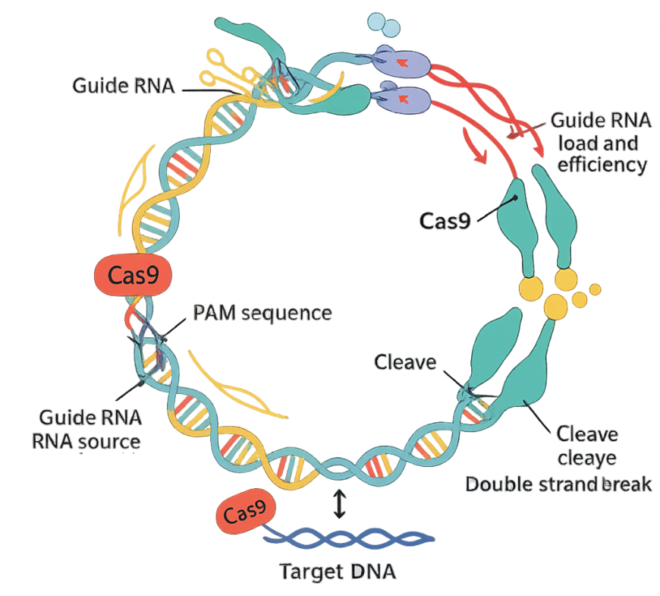
Figure 1. Bacterial Immune Defense Mechanism: A schematic illustrating how bacteria capture viral DNA, integrate it into their genome (CRISPR array), and use Cas proteins to defend against future attacks.

Importance of Cas9 in Modern Biology and Medicine
The Cas9 protein, central to the CRISPR-Cas9 system, has become a transformative tool in both biological research and medicine. Its ability to introduce precise, targeted changes in the genome has revolutionized how scientists study gene function, model diseases, and develop new therapies (Jinek et al., 2012; Komor et al., 2016).
In modern biology, Cas9 is used for a variety of genome engineering tasks, including gene knockout, gene activation, base editing, and prime editing. These techniques enable researchers to systematically investigate the roles of specific genes, unravel complex biological pathways, and conduct large-scale functional genomics studies (Shalem et al., 2014; Anzalone et al., 2020; Seijas et al., 2025). The development of advanced CRISPR-based methods, such as single-cell genomic techniques, has further expanded the possibilities for dissecting cellular diversity and gene regulation at unprecedented resolution (Chen et al., 2024). In medicine, Cas9 holds enormous promise for the treatment of genetic disorders, cancer, and infectious diseases. By correcting disease-causing mutations or disabling harmful genes, Cas9-based therapies have the potential to address the root causes of many conditions. Its potential for treating sickle cell anaemia, beta-thalassemia, and even certain forms of blindness is now being investigated in ongoing clinical studies (Frangoul et al., 2021; Gillmore et al., 2021). An overview of Cas9 and related nucleases is summarized in Table 1.

Table 1. Cas9 and Related Nucleases
Nuclease | PAM Sequence | Size (kb) | Delivery Suitability | Notes | Ref
SpCas9 | NGG | ~4.2 kb | Limited by AAV size | Gold standard, widely studied | Cebrian-Serrano, A., & Davies, B. (2017)
SaCas9 | NNGRRT | ~3.2 kb | AAV-compatible | Smaller, good for in vivo use | Allemailem, K. S., Almatroodi (2023)
CjCas9 | NNNNACAC | ~2.9 kb | AAV-compatible | Compact, less studied | Gao, S., (2023)
SpCas9-NG | NG | ~4.2 kb | LNP/RNP | Broader PAM recognition | Mishra, R., Joshi, R. K. (2019)
SpRY | NRN/NYYN | ~4.2 kb | LNP/RNP | Nearly PAM-free | Walton, R. (2020)
Cas12a | 5'-TTTV-3' (V = A, C, or G) | ~3.9kb | Can be packaged into AAV vectors | T-rich PAM | University of Copenhagen, Copenhagen, Denmark. (2020)

3. AN OVERVIEW OF CRISPR-CAS SYSTEMS AND THEIR DEVELOPMENT
Originating in bacteria and archaea as a defence mechanism against viral invasion, the CRISPR-Cas system is an incredibly clever answer for microbial defence found in nature. Imagine bacteria as microscopic warriors, constantly under threat from viral attackers. Their secret weapon is the CRISPR-Cas system—a sophisticated memory bank and precision strike tool rolled into one.
How the System Works
When a virus infects a bacterium, the CRISPR machinery captures a snippet of the invader’s DNA and stores it within the bacterial genome, much like posting a “wanted” sign for future reference. If the same virus attacks again, the bacterium uses this genetic memory to recognize the invader and deploys the Cas proteins to precisely cut and destroy the viral DNA, effectively neutralizing the threat (figure 2).
Components
The CRISPR-Cas system consists of two main modules:
- Adaptation Module (Memory Keepers): This part collects and stores pieces of viral DNA, creating a historical record of past infections.
- Effector Module (Attack Squad): This component recognizes and eliminates invading genetic material. While the exact evolutionary origins of this module are still being unravelled, it represents a powerful defense mechanism.
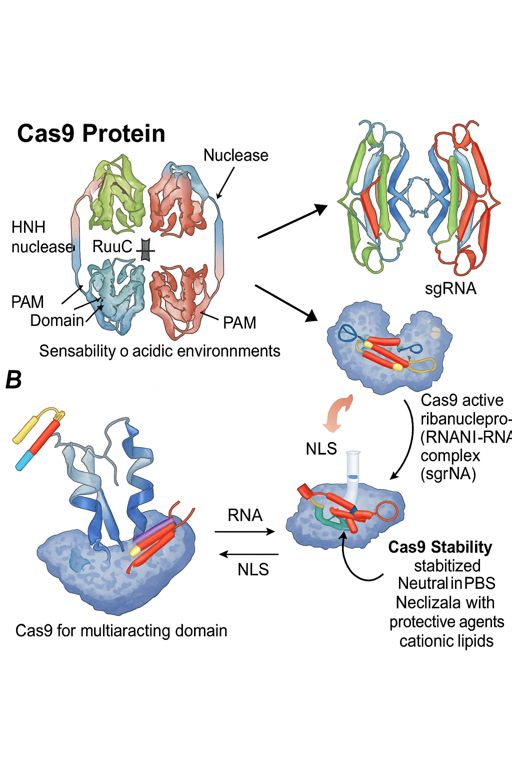
Figure 2. Working of CAS9: A schematic illustrating how CAS-9 works and
key components molecules.

Diversity and Evolution
CRISPR-Cas systems are classified into two broad classes:
Class 1: Utilizes multi-protein complexes to carry out defense functions, working as a coordinated team.
Class 2: Relies on a single, multifunctional protein (such as Cas9) to execute its tasks, making it simpler and more adaptable for genome engineering.
Recent research suggests that some bacteria may have acquired parts of the CRISPR system from ancient stress-response mechanisms, acting as an emergency shutdown to protect the colony. Intriguingly, the same mobile genetic elements that bacteria defend against have, in some cases, hijacked streamlined versions of CRISPR-Cas for their own benefit—a testament to the dynamic evolutionary arms race in the microbial world.
Scientific Significance
The evolutionary journey of CRISPR-Cas systems highlights the remarkable adaptability of microbial life. What began as a microbial immune strategy has now been harnessed by scientists as a revolutionary tool for genome editing, with profound implications for biology, medicine, and biotechnology.
4. STRUCTURE OF CAS9
Composition of Cas9 Protein
Cas9 is a large, multi-domain protein that acts as the molecular “scissors” in the CRISPR-Cas9 genome editing system. Its function depends on maintaining a precise three-dimensional structure, which is sensitive to environmental conditions. When exposed to acidic solutions, Cas9 can lose its native conformation, causing its size in solution to increase dramatically and leading to a loss of activity. This structural sensitivity presents challenges for laboratory handling and for packaging Cas9 into delivery systems like nanoparticles.
Formation of Ribonucleoprotein Complexes
Cas9 does not operate alone; it forms an active ribonucleoprotein (RNP) complex by binding to a guide RNA—typically a single-guide RNA (sgRNA) engineered for genome editing (figure 3). The sgRNA provides the sequence specificity, directing Cas9 to the exact DNA target site. This partnership is essential: without the guide RNA, Cas9 cannot identify or bind to its intended DNA sequence. The formation of the RNP complex is a crucial preparatory step for efficient and accurate gene editing.
Nuclear Localization
For Cas9 to access and edit genomic DNA, it must enter the nucleus of the cell. Cas9 is equipped with nuclear localization signals (NLS), which function as molecular “address tags.” These signals guide the protein from the cytoplasm into the nucleus, ensuring that Cas9 reaches its site of action. Efficient nuclear localization is vital for successful genome editing, as it allows Cas9 to interact with chromosomal DNA.
Stability and Formulation Considerations
Maintaining the stability of Cas9 is a significant concern, especially during formulation for delivery into cells. Many standard nanoparticle preparation methods use acidic conditions, which can destabilize Cas9 and disrupt its function. To overcome this, researchers have developed gentler formulation protocols, such as using neutral buffers like phosphate-buffered saline (PBS) and incorporating protective agents like cationic lipids. These strategies help preserve the protein’s structure and activity, ensuring that Cas9 remains functional during delivery and gene editing processes.

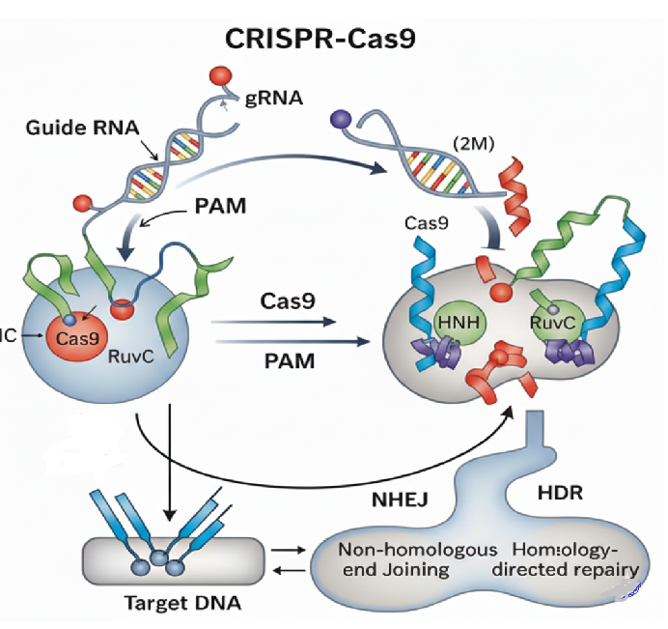
Figure 3. Structure of CAS9: A schematic illustrating how CAS-9, Composition and formation of ribonucleoprotein complexes.

5. MECHANISM OF ACTION
Target Recognition and PAM Sequence
The CRISPR-Cas9 system’s precision begins with its ability to recognize the correct DNA target. This is achieved by a partnership between the Cas9 protein and a guide RNA (usually a single-guide RNA, or sgRNA). The sgRNA contains a sequence that is complementary to the DNA region to be edited, guiding Cas9 to its destination by base pairing with the target DNA. However, Cas9 does not bind indiscriminately; it requires the presence of a short DNA motif adjacent to the target site, known as the protospacer adjacent motif (PAM). For the commonly used Streptococcus pyogenes Cas9 (SpCas9), the PAM sequence is typically “NGG.” The presence of the PAM is essential—it acts as a “landing pad” that allows Cas9 to engage and inspect the DNA for a matching sequence. Without the correct PAM, Cas9 will not bind or cut, even if the guide RNA matches the DNA perfectly.
DNA Cleavage and Activation
Once Cas9, guided by the sgRNA, locates a DNA sequence adjacent to a PAM, it binds tightly to the DNA. This binding triggers a conformational change in the Cas9 protein, activating its nuclease domains. Cas9 possesses two nuclease domains: the HNH domain, which cleaves the DNA strand complementary to the guide RNA, and the RuvC domain, which cuts the non-complementary strand. The coordinated action of these domains results in a precise double-stranded break (DSB) at the target site. This break is the critical event that initiates genome editing, as it signals the cell’s DNA repair machinery to act.
DNA Repair Following Editing
After Cas9 induces a double-stranded break, the cell’s natural DNA repair systems are recruited to fix the damage. The two primary repair pathways are:
Non-Homologous End Joining (NHEJ): This is the most common repair mechanism. It quickly rejoins the broken DNA ends but is prone to errors, often resulting in small insertions or deletions (indels) at the break site. These indels can disrupt gene function, making NHEJ useful for gene knockout experiments.
Homology-Directed Repair (HDR): If a DNA template with homology to the break site is provided, the cell can use this template to accurately repair the break. This allows for precise insertion, deletion, or correction of specific DNA sequences, enabling targeted gene modifications.
The outcome of genome editing depends on which repair pathway the cell uses. NHEJ is efficient but error-prone, while HDR is precise but less frequent in most cell types.
6. ROLE OF GUIDE RNA
Guide RNA (gRNA) is the essential navigator in the CRISPR-Cas9 genome editing system, providing the specificity that allows Cas9 to target and modify precise DNA sequences. In bacteria, the system originally used two separate RNA molecules: the CRISPR RNA (crRNA), which contains the sequence complementary to the target DNA, and the trans-activating crRNA (tracrRNA), which helps assemble the active complex. For genome engineering, scientists have combined these two molecules into a single-guide RNA (sgRNA), streamlining the process and improving efficiency.
The sgRNA acts as a molecular address label, guiding the Cas9 protein to the exact location in the genome that needs editing. It does this through complementary base pairing—matching its own sequence to a specific sequence in the target DNA. Once the sgRNA binds to Cas9, they form a ribonucleoprotein (RNP) complex that can search the genome for the matching DNA sequence.
However, perfect sequence matching is not enough for Cas9 to cut the DNA. The target site must also be adjacent to a short DNA sequence called the protospacer adjacent motif (PAM). The presence of the PAM is critical: it acts as a landing pad that enables Cas9 to bind and activate its cutting function. Without the correct PAM, even a perfectly matched guide RNA will not trigger DNA cleavage.
In summary, the guide RNA serves as both the map and the key for CRISPR-Cas9 genome editing. It determines where Cas9 will act, ensuring that DNA modifications occur only at the intended site. This remarkable specificity underlies the power and versatility of CRISPR technology in research and medicine. “Key methods for off-target detection, along with their principles, sensitivity, advantages, and limitations, are summarized in Table 2.

Table 2. Off-Target Detection Methods
Method | Principle | Sensitivity | Advantages | Limitations | Ref
GUIDE-seq | dsODN integration at DSB | High | Detects genome-wide DSBs | Requires cell transfection | Wu, X., Scott (2014)
CIRCLE-seq | In-vitro digested | Very high | No cell transfection | May not reflect | Tsai, S. Q., Nguyen  (2017)
Digenome-seq | Whole-genome sequencing after Cas9 cleavage | Moderate | Straightforward, unbiased | High sequencing depth required | Kim, D., Bae, S., (2015).
SITE-seq | Biotinylated adapters at cut sites | High | Enrichment improves signal | More complex workflow | Yan, W. X., Mirzazadeh (2017)
BLISS | Labelling of free DNA ends in fixed. | Very High | In vivo on tissues; independent of endogenous DNA repair pathways. | Technically challenging; may not capture transient off-target events. | Yan, W. X., Mirzazadeh  (2017)
GOTI | Isolation of genomic DNA from individual cells and whole-genome sequencing to identify edited loci. | High | Detects all types of genetic edits (not just DSBs); provides single-cell resolution. | Extremely expensive and labour-intensive due to single-cell sequencing. | Zuo, E., Sun, Y., Wei, W., Yuan (2020)

7. ENGINEERING OF CAS9 AND VARIANTS
Wild-Type SpCas9
The original Cas9 protein, derived from Streptococcus pyogenes (SpCas9), is the foundational tool for CRISPR-based genome editing. In its natural form, SpCas9 is guided by a specific RNA sequence to introduce precise double-stranded breaks (DSBs) in DNA at locations adjacent to an NGG protospacer adjacent motif (PAM). SpCas9’s two-lobed structure—one for DNA recognition and one for DNA cleavage—enables it to efficiently locate and cut its target. The wild-type SpCas9 is highly effective for gene knockout and modification, but its broad DNA-cutting activity can sometimes result in unintended, off-target effects.
Enhanced Cas9 Variants (eSpCas9, HypaCas9, SaCas9)
To improve the precision and versatility of genome editing, scientists have engineered several advanced Cas9 variants:
eSpCas9 and HypaCas9:
These are modified versions of SpCas9 with specific amino acid changes that reduce off-target DNA cleavage. By tweaking the protein’s interaction with the DNA backbone, these variants maintain high on-target activity while greatly minimizing unwanted cuts elsewhere in the genome. This makes them ideal for applications requiring high specificity.
SaCas9:
Sourced from Staphylococcus aureus, SaCas9 is smaller than SpCas9, making it easier to deliver into cells using viral vectors. SaCas9 also recognizes a different PAM sequence (NNGRRT), expanding the range of possible target sites for genome editing. Its compact size and distinct targeting preferences provide researchers with more flexibility in experimental design.
Nickase and Dead Cas9 (dCas9)
By introducing a single amino acid mutation (such as D10A in the RuvC domain), SpCas9 can be converted into a “nickase,” which cuts only one strand of DNA instead of both. This gentler approach reduces the risk of large-scale genomic rearrangements and can be used to promote precise gene correction via homology-directed repair. When two nickases are targeted to nearby sites on opposite DNA strands, they create staggered nicks that enhance editing accuracy while minimizing off-target effects.
Dead Cas9 (dCas9):
Further mutating both nuclease domains produces a catalytically inactive Cas9, known as “dead” Cas9 (dCas9). While dCas9 cannot cut DNA, it retains its ability to bind specific DNA sequences guided by RNA. This property makes dCas9 a versatile platform for applications beyond genome editing, such as gene regulation (CRISPR interference and activation), epigenetic modification, and live-cell imaging of genomic loci.
These engineered Cas9 variants have significantly expanded the CRISPR toolkit, enabling more precise, efficient, and versatile genome manipulation for research, biotechnology, and therapeutic development.
8. DELIVERY SYSTEMS:
The success of CRISPR/Cas9 gene editing mainly depends on the delivery systems. The delivery Systems influence the transfection efficiency, target Specificity, therapeutic potential (Lee, J. H., & Han, J. P., 2024.
Types of Delivery Systems:
Viral Systems:
Viral vectors remain among the most widely used vehicles for delivering CRISPR/Cas9 components into mammalian cells. Commonly applied systems include adeno-associated viruses (AAVs), lentiviruses, and adenoviruses, each with distinct properties. Lentiviral vectors integrate into the host genome, enabling stable and long-term expression of the editing machinery, which is advantageous in applications requiring persistent activity. By contrast, AAV vectors typically remain episomal within the nucleus, providing sustained yet largely non-integrating expression with relatively low immunogenicity. Adenoviral vectors also do not integrate but can mediate high-level, transient expression, making them useful for short-term interventions. While viral vectors offer high transduction efficiency and, in the case of lentiviruses, stable gene expression, limitations exist: AAVs have a restricted cargo capacity, and adenoviral vectors may elicit stronger immune responses. To address these challenges, advanced platforms such as self-inactivating lentiviruses and engineered next-generation AAV variants are being developed, offering improved safety, efficiency, and broader applicability in therapeutic genome editing.
Non-Viral Delivery Systems
Non-viral delivery systems provide a valuable alternative to viral vectors, offering safer and more versatile means of introducing CRISPR/Cas9 components. These carriers reduce the risks of immunogenicity and adverse genomic integration associated with viral methods (Brokowski & Adli, 2019). Among them, lipid nanoparticles (LNPs) have gained particular attention. LNPs can encapsulate and protect nucleic acids or ribonucleoproteins, enhancing cellular uptake and providing stability against enzymatic degradation. Their lipid composition facilitates fusion with cell membranes, enabling efficient intracellular delivery. Formulations often include cholesterol, 1,2-dioleoyl-sn-glycero-3-phosphoethanolamine (DOPE), polyethylene glycol–derived lipids, and other bio-reducible or anionic polymers to optimize performance. While reported efficiencies vary across studies and depend on both formulation and experimental context, optimized LNPs have demonstrated high transfection potential in-vitro and in preclinical in vivo models. Continued refinements in lipid chemistry and particle engineering are expected to further improve delivery efficiency and expand therapeutic applicability.
Physical Delivery Methods:
Microinjection
The delivery formats are DNA, mRNA, and protein. Applicable in case of both in-vivo and in-vitro. The benefits are dosage controllable and direct delivery. Main limitation is that microinjection is time consuming process.
Electroporation
Electroporation is a widely used physical method for delivering DNA, mRNA, or protein-based CRISPR/Cas9 components directly into cells. The technique relies on applying short electrical pulses that transiently permeabilize the cell membrane, allowing nucleic acids or ribonucleoprotein complexes to enter. Its advantages include relative simplicity, broad applicability, and the absence of cargo size limitations. While electroporation is frequently applied in-vitro for cultured cells, it is also extensively used ex vivo in therapeutic contexts, such as the modification of T cells or hematopoietic stem cells for clinical applications. A key limitation, however, is the potential reduction in cell viability due to membrane damage, which necessitates careful optimization of electrical parameters for each cell type.
9. NEXT-GENERATION EDITORS:
Recent developments in genome editing have produced tools with greater precision and control than classical CRISPR-Cas9, which relies on double-strand break (DSB) formation and is prone to indels. Among these innovations are base editors and prime editors, which enable targeted sequence modifications without introducing full DSBs.
Base Editors (CBEs and ABEs)
Base editors consist of a Cas9 nickase (nCas9) fused to a deaminase enzyme. Upon binding to a target site, the nCas9 unwinds DNA to form an R-loop, exposing a single strand for base modification.
- Cytosine base editors (CBEs): Convert C•G to T•A by using a cytidine deaminase to deaminate cytosine to uracil, which is then read as thymine during repair (Komor et al., 2016).
- Adenine base editors (ABEs): Convert A•T to G•C by using an engineered adenosine deaminase to deaminate adenine to inosine, which is interpreted as guanine during replication (Gaudelli et al., 2017).
Early base editors carried a risk of off-target RNA editing, since APOBEC1 (in CBEs) and other deaminases can act promiscuously on RNA. To address this, refined systems such as SECURE-BE3 and SECURE-ABE incorporate mutations that minimize unintended RNA deamination while retaining high on-target efficiency.
Glycosylase Editors:
lycosylase editors (GBEs) represent a newer class of base editors that do not rely on deamination. Instead, they couple nCas9 to a DNA glycosylase, which excises a specific base and generates an abasic site (AP site). This lesion is processed by the base excision repair pathway, allowing researchers to program the installation of a desired base. Glycosylase-based editors expand the scope of base conversions to include transversions, such as G-to-T or G-to-C edits, that are not possible with conventional deamination-based systems.
Prime Editors
Prime editing extends the genome editing toolkit even further by enabling all 12 possible base substitutions, as well as small insertions and deletions, without DSBs or donor templates. The system uses a Cas9 nickase fused to a reverse transcriptase and a prime editing guide RNA (pegRNA), which contains both a spacer to target Cas9 and a 3′ extension encoding the desired edit. After Cas9 nicks one DNA strand, the primer-binding site of the pegRNA anneals, and the reverse transcriptase synthesizes the new DNA segment guided by the reverse transcriptase template. Cellular repair machinery then incorporates this edited DNA into the genome (Anzalone et al., 2019).
Prime editors exhibit a lower indel rate compared with conventional DSB-based approaches, although indels may still occur, particularly with PE3 systems that introduce an additional nick to improve efficiency.
The representative applications of Cas9-based genome editing in preclinical and clinical pipelines are outlined in Table 3 (Akter, F., & Kumar, S. 2024).

Table 3. Cas9 Applications in Biomedicine
Application | Target | Outcome | Status | Ref
Sickle Cell Disease | BCL11A enhancer | Reactivate fetal Hb | Clinical trials (Vertex/CRISPR Tx) | Singh, A., Irfan, H., Fatima, E., Nazir, Z., Verma, A (2024)
Cancer Immunotherapy | PD-1 knockout in T cells | Enhanced antitumor activity | Early-phase trials | Ou, X., Ma, Q., Yin, W., Ma, X., & He, Z. (2021)
HIV Therapy | CCR5 | Knockout receptor | Proof-of-concept | Xiao, Q., Guo, D., &
Hemophilia | FVIII or FIX gene | Correct gene to restore clotting factor production | Preclinical and early-phase clinical trials | Lee, J. H., & Han, J. P. (2024).
Duchenne Muscular Dystrophy (DMD) | Dystrophin gene | Restore the gene's reading frame | Preclinical models showing promise, early-stage trials | Lee, J. H., & Han, J. P. (2024).
Cardiovascular Disease | PCSK9 gene | Inactivate gene to reduce cholesterol | Clinical trials for certain genetic forms of high cholesterol | Ou, X., Ma, Q., Yin, W., Ma, X., & He, Z. (2021)

10. Safety, Ethics, and Regulation
Technical Risks
Although CRISPR-Cas9 and its derivatives represent transformative tools for genome engineering, several safety concerns remain. Mosaicism, in which only a fraction of cells within an organism carry the intended edit while others remain unmodified, has been reported in both animal models and early embryo studies, complicating therapeutic predictability (Zuccaro et al., 2020). Another documented risk is the occurrence of large on-target genomic rearrangements, where the nuclease introduces the correct cut site but the cell’s repair processes lead to extensive deletions, insertions, or chromosomal rearrangements (Kosicki et al., 2018). These events are challenging to detect with standard genotyping approaches and raise concerns about long-term genomic stability. Addressing such risks requires comprehensive genomic characterization, optimized nuclease variants, and continued refinement of editing strategies before clinical application.
Ethical and Policy Considerations
A critical distinction must be made between somatic and germline editing. Somatic editing targets non-reproductive cells, with changes confined to the treated individual. This form of intervention is increasingly considered ethically acceptable when applied to treat severe genetic diseases, provided that safety and efficacy standards are met. In contrast, germline editing involves modifications to embryos, gametes, or early developmental stages, thereby generating heritable changes. This raises profound ethical and societal concerns, as alterations could affect future generations without their consent. International organizations, including the National Academies of Sciences (2017) and the World Health Organization (WHO, 2021), have emphasized that germline interventions should not proceed to clinical practice until robust ethical, societal, and regulatory frameworks are established.
Transparent communication with the public and research participants, stringent oversight, and globally harmonized regulatory standards are essential to ensure that genome editing technologies are applied responsibly. Such measures will help balance the promise of therapeutic innovation with the obligation to minimize risks and uphold societal trust.
11. CONCLUSION
The CRISPR-Cas9 method has revolutionised genetic engineering by providing a new level of accuracy and flexibility in DNA editing. Although it first appeared as an immunological defence mechanism in bacteria, Cas9 has since developed into a very useful tool for studying gene function, disease modelling, and the discovery of novel treatment approaches. Its structure and mechanism—relying on a guide RNA for sequence specificity and the presence of a PAM sequence for target recognition—ensure that genome editing can be both targeted and efficient.
Ongoing advancements in Cas9 engineering, such as the development of enhanced variants, nickases, and catalytically inactive forms, have further expanded the system’s applications and minimized off-target effects. These innovations, coupled with improved delivery methods and computational tools, are addressing many of the challenges that initially limited the technology’s clinical potential. Despite some remaining hurdles, including delivery efficiency and immune responses, the CRISPR-Cas9 platform continues to drive breakthroughs in both basic research and medicine.
As the technology matures, it holds immense promise for treating genetic disorders, advancing personalized medicine, and deepening our understanding of biology at the molecular level. The journey of Cas9 from a microbial defense protein to a cornerstone of modern biotechnology exemplifies the power of scientific discovery and innovation.

12. LIST OF ABBREVIATIONS
ABE (Adenine Base Editor), AAV (Adeno-Associated Virus), BER (Base Excision Repair), CBE (Cytosine Base Editor), CRISPR (Clustered Regularly Interspaced Short Palindromic Repeats), CRISPRi (CRISPR Interference), CRISPRa (CRISPR Activation), Cas (CRISPR-Associated Protein), dCas9 (Dead Cas9), DSB (Double-Strand Break), gRNA (Guide RNA), HDR (Homology-Directed Repair), Indel (Insertion/Deletion Mutation), LNP (Lipid Nanoparticle), NHEJ (Non-Homologous End Joining), NLS (Nuclear Localization Signal), PAM (Protospacer Adjacent Motif), PBS (Phosphate-Buffered Saline), pegRNA (Prime Editing Guide RNA), RNP (Ribonucleoprotein), RT (Reverse Transcriptase), SaCas9 (Staphylococcus aureus Cas9), sgRNA (Single Guide RNA), SpCas9 (Streptococcus pyogenes Cas9), TALENs (Transcription Activator-Like Effector Nucleases), and ZFNs (Zinc Finger Nucleases).

Disclaimer (Artificial Intelligence)
The authors hereby declare that generative artificial intelligence (AI) technologies were used during the preparation and editing of this manuscript. Specifically, ChatGPT (GPT-5, OpenAI), Perplexity AI, and Google Gemini were employed to assist in language refinement, grammatical editing, rephrasing of sections for clarity, and generation of schematic images. All input prompts provided to these AI tools were limited to tasks such as rewriting text for improved readability, summarizing reviewer comments, suggesting scientific structuring, and creating scientific-style diagrams. The intellectual content, interpretation of data, and final conclusions presented in this manuscript remain entirely the responsibility of the authors.

REFERENCES
- Khan, M. S., Qureshi, N., Khan, R., Son, Y., & Maqbool, T. (2025). CRISPR/Cas9-Based therapeutics as a promising strategy for management of Alzheimer’s disease: progress and prospects. Frontiers in Cellular Neuroscience, 19. https://doi.org/10.3389/fncel.2025.1578138
- Navarro, C., Díaz, M. P., Duran, P., Castro, A., Díaz, A., Cano, C., Carbonell-Zabaleta, A., Solano-Jimenez, D., Rivera-Porras, D., Contreras-Velásquez, J. C., & Bermúdez, V. (2025). CRISPR-CAS Systems: a functional perspective and innovations. International Journal of Molecular Sciences, 26(8), 3645. https://doi.org/10.3390/ijms26083645
- Hassan, Y. M., Mohamed, A. S., Hassan, Y. M., & El-Sayed, W. M. (2025b). Recent developments and future directions in point-of-care next-generation CRISPR-based rapid diagnosis. Clinical and Experimental Medicine, 25(1). https://doi.org/10.1007/s10238-024-01540-8
- Seijas, A., Cora, D., Novo, M., Al-Soufi, W., Sánchez, L., & Arana, Á. J. (2025). CRISPR/CAS9 delivery systems to enhance gene editing efficiency. International Journal of Molecular Sciences, 26(9), 4420. https://doi.org/10.3390/ijms26094420
- Gonzalez-Avila, L. U., Vega-López, J. M., Pelcastre-Rodríguez, L. I., Cabrero-Martínez, O. A., Hernández-Cortez, C., & Castro-Escarpulli, G. (2021). The challenge of CRISPR-Cas toward bioethics. Frontiers in Microbiology, 12. https://doi.org/10.3389/fmicb.2021.657981
- Cetin, B., Erendor, F., Eksi, Y. E., Sanlioglu, A. D., & Sanlioglu, S. (2025). Advancing CRISPR Genome Editing into Gene Therapy Clinical Trials: Progress and Future Prospects. Expert Reviews in Molecular Medicine, 1–96. https://doi.org/10.1017/erm.2025.10
- Jasieniecka, A., & Domingues, I. (2025). CRISPR-CAS9 and its Bioinformatics Tools: A systematic review. Current Issues in Molecular Biology, 47(5), 307. https://doi.org/10.3390/cimb47050307
- Chen, F., Chen, L., Yan, Z., Xu, J., Feng, L., He, N., Guo, M., Zhao, J., Chen, Z., Chen, H., Yao, G., & Liu, C. (2024). Recent advances of CRISPR-based genome editing for enhancing staple crops. Frontiers in Plant Science, 15. https://doi.org/10.3389/fpls.2024.1478398
- Brokowski, C., & Adli, M. (2018). CRISPR Ethics: moral considerations for applications of a powerful tool. Journal of Molecular Biology, 431(1), 88–101. https://doi.org/10.1016/j.jmb.2018.05.044
- Nishimasu, H., Ran, F. A., Hsu, P. D., Konermann, S., Shehata, S. I., Dohmae, N., Ishitani, R., Zhang, F., & Nureki, O. (2014). Crystal Structure of Cas9 in Complex with Guide RNA and Target DNA. Cell, 156(5), 935–949. https://doi.org/10.1016/j.cell.2014.02.001
- Hsu, P. D., Lander, E. S., & Zhang, F. (2014). Development and applications of CRISPR-CAS9 for genome engineering. Cell, 157(6), 1262–1278. https://doi.org/10.1016/j.cell.2014.05.010
- R, P. G., & K, V. S. (2025). CRISPR/CAS9 and gene editing in Drug delivery: Emerging delivery systems for gene therapy and genome. International Journal of Drug Delivery Technology, 15(01). https://doi.org/10.25258/ijddt.15.1.46
- Razzaq A, Masood A (2018) CRISPR/Cas9 System: A Breakthrough in Genome Editing. Mol Biol 7: 210. doi: 10.4172/2168-9547.1000210.
- Rees, H. A., & Liu, D. R. (2018). Base editing: precision chemistry on the genome and transcriptome of living cells. Nature Reviews Genetics, 19(12), 770–788. https://doi.org/10.1038/s41576-018-0059-1
- Zhang, Y., & Showalter, A. M. (2020). CRISPR/CAS9 genome editing technology: a valuable tool for understanding plant cell wall biosynthesis and function. Frontiers in Plant Science, 11. https://doi.org/10.3389/fpls.2020.589517
- https://ieeexplore.ieee.org/author/614775320328834
- RodrGuez-RodrGuez, D., RamRez-SolS, R., Garza-Elizondo, M., Garza-RodrGuez, M., & Barrera-SaldaA, H. (2019). Genome editing: A perspective on the application of CRISPR/Cas9 to study human diseases (Review). International Journal of Molecular Medicine. https://doi.org/10.3892/ijmm.2019.4112Kang, K., Song, Y., Kim, I., & Kim, T.-J. (2022). Therapeutic applications of the CRISPR-CAS system. In Bonghee Lee (Ed.), Bioengineering (Vol. 9, p. 477). https://doi.org/10.3390/bioengineering9090477.
- Alsmani, Saeed. (2023). Ethical Issues Concerned with CRISPR- CAS9 SYSTEM.
- Allemailem, K. S., Almatroodi, S. A., Almatroudi, A., Alrumaihi, F., Abdulmonem, W. A., Al-Megrin, W. a. I., Aljamaan, A. N., Rahmani, A. H., & Khan, A. A. (2023). Recent Advances in Genome-Editing Technology with CRISPR/Cas9 Variants and Stimuli-Responsive Targeting Approaches within Tumor Cells: A Future Perspective of Cancer Management. International Journal of Molecular Sciences, 24(8), 7052. https://doi.org/10.3390/ijms24087052
- Karp, H., Zoltek, M., Wasko, K., Vazquez, A. L., Brim, J., Ngo, W., Schepartz, A., & Doudna, J. A. (2025). Packaged delivery of CRISPR–Cas9 ribonucleoproteins accelerates genome editing. Nucleic Acids Research, 53(5). https://doi.org/10.1093/nar/gkaf105
- Ngo, W., Peukes, J., Baldwin, A., Xue, Z. W., Hwang, S., Stickels, R. R., Lin, Z., Satpathy, A. T., Wells, J. A., Schekman, R., Nogales, E., & Doudna, J. A. (2024). Mechanism-guided engineering of a minimal biological particle for genome editing. Proceedings of the National Academy of Sciences, 122(1). https://doi.org/10.1073/pnas.2413519121
- Gao, S., Wang, Y., Qi, T., Wei, J., Hu, Z., Liu, J., Sun, S., Liu, H., & Wang, Y. (2023). Genome editing with natural and engineered CjCas9 orthologs. Molecular Therapy, 31(4), 1177–1187. https://doi.org/10.1016/j.ymthe.2023.01.029
- Mishra, R., Joshi, R. K., & Zhao, K. (2019). Base editing in crops: current advances, limitations and future implications. Plant Biotechnology Journal, 18(1), 20–31. https://doi.org/10.1111/pbi.13225
- Walton, R. T., Christie, K. A., Whittaker, M. N., & Kleinstiver, B. P. (2020). Unconstrained genome targeting with near-PAMless engineered CRISPR-Cas9 variants. Science, 368(6488), 290–296. https://doi.org/10.1126/science.aba8853
- Paul, B., & Montoya, G. (2020). CRISPR-Cas12a: Functional overview and applications. Biomedical Journal, 43(1), 8–17. https://doi.org/10.1016/j.bj.2019.10.005
- Tsai, S. Q., Nguyen, N. T., Malagon-Lopez, J., Topkar, V. V., Aryee, M. J., & Joung, J. K. (2017). CIRCLE-seq: a highly sensitive in vitro screen for genome-wide CRISPR–Cas9 nuclease off-targets. Nature Methods, 14(6), 607–614. https://doi.org/10.1038/nmeth.4278
- Kim, D., Bae, S., Park, J., Kim, E., Kim, S., Yu, H. R., Hwang, J., Kim, J., & Kim, J. (2015). Digenome-seq: genome-wide profiling of CRISPR-Cas9 off-target effects in human cells. Nature Methods, 12(3), 237–243. https://doi.org/10.1038/nmeth.3284
- Yan, W. X., Mirzazadeh, R., Garnerone, S., Scott, D., Schneider, M. W., Kallas, T., Custodio, J., Wernersson, E., Li, Y., Gao, L., Federova, Y., Zetsche, B., Zhang, F., Bienko, M., & Crosetto, N. (2017). BLISS is a versatile and quantitative method for genome-wide profiling of DNA double-strand breaks. Nature Communications, 8(1). https://doi.org/10.1038/ncomms15058
- Zuo, E., Sun, Y., Wei, W., Yuan, T., Ying, W., Sun, H., Yuan, L., Steinmetz, L. M., Li, Y., & Yang, H. (2020). GOTI, a method to identify genome-wide off-target effects of genome editing in mouse embryos. Nature Protocols, 15(9), 3009–3029. https://doi.org/10.1038/s41596-020-0361-1
- Wu, X., Scott, D. A., Kriz, A. J., Chiu, A. C., Hsu, P. D., Dadon, D. B., Cheng, A. W., Trevino, A. E., Konermann, S., Chen, S., Jaenisch, R., Zhang, F., & Sharp, P. A. (2014). Genome-wide binding of the CRISPR endonuclease Cas9 in mammalian cells. Nature Biotechnology, 32(7), 670–676. https://doi.org/10.1038/nbt.2889
- Singh, A., Irfan, H., Fatima, E., Nazir, Z., Verma, A., & Akilimali, A. (2024). Revolutionary breakthrough: FDA approves CASGEVYTM, the first CRISPR/Cas9 gene therapy for sickle cell disease. Annals of Medicine and Surgery, 86(8), 4555–4559. https://doi.org/10.1097/ms9.0000000000002146
- Prasadula, N. P. D. N. (2024c). A Study on Profitable of Futures with the Reference to SBI Bank. International Journal of Information Technology and Management, 17(1), 1–6. https://doi.org/10.29070/mqdy3790
- Xiao, Q., Guo, D., & Chen, S. (2019). Application of CRISPR/CAS9-Based gene editing in HIV-1/AIDS therapy. Frontiers in Cellular and Infection Microbiology, 9. https://doi.org/10.3389/fcimb.2019.00069
- Lee, J. H., & Han, J. P. (2024). In vivo LNP-CRISPR Approaches for the Treatment of Hemophilia. Molecular Diagnosis & Therapy, 28(3), 239–248. https://doi.org/10.1007/s40291-024-00705-1
- https://orcid.org/my-orcid?orcid=0000-0002-9764-6048
- https://scholar.google.com/citations?user=99wmG2IAAAAJ&hl=en
- Du, Y., Liu, Y., Hu, J., Peng, X., & Liu, Z. (2023). CRISPR/Cas9 systems: Delivery technologies and biomedical applications. Asian Journal of Pharmaceutical Sciences, 18(6), 100854. https://doi.org/10.1016/j.ajps.2023.100854
- Li, M., Lin, Y., Cheng, Q., & Wei, T. (2025). Prime Editing: a revolutionary technology for precise treatment of genetic disorders. Cell Proliferation. https://doi.org/10.1111/cpr.13808
- Tong, H., Li, T., & Yang, H. (2024). Programmable G-to-Y base editing using engineered DNA glycosylase. Life Medicine, 3(1). https://doi.org/10.1093/lifemedi/lnae005
- Jeong, Y. K., Song, B., & Bae, S. (2020). Current status and challenges of DNA base editing tools. Molecular Therapy, 28(9), 1938–1952. https://doi.org/10.1016/j.ymthe.2020.07.021
- Akter, F., & Kumar, S. (2024). CRISPR-Cas9: A Cutting-edge Genome-editing Technology with Many Potential Applications. Journal of Advances in Biology & Biotechnology, 27(11), 59–73. https://doi.org/10.9734/jabb/2024/v27i111591
- Bhuvana, T. G., & Ranjitha, N. (2022). Overview of CRISPR-CAS Mediated Genome Engineering. Journal of Applied Life Sciences International, 37–46. https://doi.org/10.9734/jalsi/2022/v25i6583.

***

