Letter to the Editor
Cerebral Tuberculoma in a Kidney Transplant Patient : A Case Letter

To the Editor,
We report a case of a 47-year-old woman with SE, who had been monitored for end-stage renal failure due to undetermined nephropathy since 1998 and who underwent a kidney transplant from a cadaveric donor six years ago. Induction therapy consisted of thymoglobulin and solumedrol boluses, and maintenance therapy with mycophenolate mofetil and tacrolimus combined with a low dose of corticosteroids. Her progress was marked by a delayed recovery of renal function, with a nadir creatinine level of 176 µmol/L.
In her second year post-transplant, the patient developed TPM+ pulmonary tuberculosis (TB), which was discovered following weight loss and a deterioration in her general condition. She was treated with anti-bacillary medication for 12 months with good results. Six months after stopping the anti-bacillary treatment, the patient presented with a generalized tonic-clonic seizure, for which she was hospitalized. In addition, the patient reported auditory hallucinations, tinnitus associated with helmet headaches, vomiting, and diarrhea.
On clinical examination, the patient was apyretic, showed no sensory-motor deficits, with unquantified weight loss.
Admission tests: WBC: 4600/mm3, with lymphopenia : 800/mm3, hemoglobin: 11.8 g/dl, platelets: 207,000/mm3, CRP: 3.4 mg/L, LDH: 360 IU/L, CPK: 306 IU/L, creatinine: 229 µmol/L, urea: 0.59 g/L, Na+: 131 mEq/L, K+: 3.4 mEq/L, ASAT: 29 IU/L, ALAT: 12 IU/L, urine analysis found positive proteinuria, negative hematuria and leukocyturia.

Given the neurological signs, a non-contrast brain CT scan was performed, which revealed the presence of two bilateral parietal areas of hypodensity in a glove-like pattern consistent with edema, suggesting a lesion that could not be identified on the scan. This was supplemented by a brain magnetic resonance imaging (MRI), which revealed two well-defined oval nodular lesions with T2 Flair hypersignal enhancement in a ring pattern after gadolinium injection, surrounded by a perilesional edema with T2 Flair hypersignal, located and measuring: Right temporal: 6x6 mm, left parietal: 8x11 mm; strongly suggesting cerebral tuberculomas (Figure1).
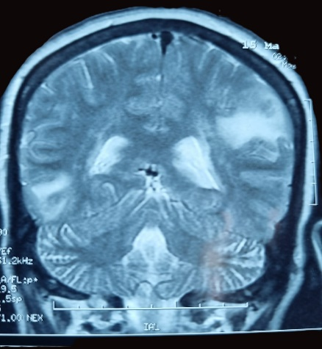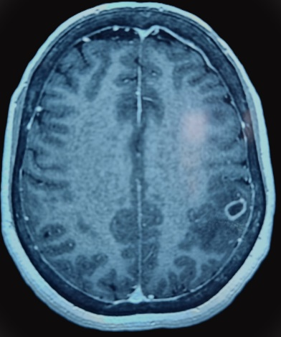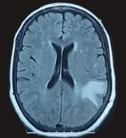
Figure 1 : Magnetic resonance imaging (MRI) showing well-defined oval nodular lesions surrounded by perilesional edema in hypersinal T2, and enhanced in an annular fashion after injection of gadolinium

The absence of papilledema was noted on fundus examination. Positron emission tomography (PET) provided guidance for the diagnosis by revealing two heterogeneous uptake foci corresponding to tuberculomas.
We also investigated other tuberculous sites, particularly in the lungs, for which direct examination and PCR (Genexpert) on sputum, as well as a culture on a specific medium, were negative.
Given the diarrhea, a colonoscopy was performed, revealing hyperemic cecal mucosa, with a negative PCR (Genexpert) search on a cecal biopsy.
The diagnosis of tuberculoma was made in the light of the clinical context: the patient lives in an endemic region (Morocco) and has a history of pulmonary tuberculosis in a kidney transplant recipient on long-term immunosuppressive treatment, presenting neurological signs correlated with the locations of the cerebral lesions found on MRI and PET scans, the appearance of which is strongly suggestive of tuberculoma.

Medical treatment was indicated based on quadruple therapy; rifampicin 10 mg/kg/day, and the doses of Isoniazid, Ethambutol, Pyrazinamide were adapted to the creatinine clearance, for a total duration of antibacillary treatment of 12 months, paying attention to the interaction with anti-calcineurin by carrying out a closer monitoring of To tacrolimus and watching for side effects by adapting the doses of izoniazid and rifampicin to their serum levels. To prevent possible convulsions the patient was put on antiepileptics. The evolution was marked by an improvement in neurological signs.
Despite therapeutic advances, tuberculosis (TB) remains one of the leading causes of infectious morbidity and mortality worldwide [1]. It represents a major concern in solid organ transplantation, particularly among kidney transplant patients, due to chronic immunosuppression and the increased risk of reactivation of latent infection.

Kidney transplant patients have a 20- to 70-fold higher risk of developing active TB compared to the general population. TB in kidney transplant recipients is often extrapulmonary (30-50% of cases) and multifocal [2].
In Morocco, TB remains endemic, with an estimated national incidence of 90-100 cases per 100,000 population [9] and a prevalence of 3-8% of post-kidney transplant tuberculosis [3]. The average time between transplantation and the onset of TB is 6 to 24 months, with 80% of cases occurring within the first 2 years, when the dose of immunosuppressants is highest [4]. The most common locations are pulmonary, lymph node, osteoarticular, and neurological. [5]
Central nervous system (CNS) tuberculosis, particularly cerebral tuberculoma, accounts for 2 to 5% of cases in kidney transplant patients [6,7]. It manifests with focal neurological signs, headaches, or seizures. MRI shows ring-shaped nodular lesions with perilesional edema, often simulating a brain tumor. The diagnosis is confirmed by stereotaxic biopsy with the detection of M. tuberculosis by culture or PCR [6].
Mortality from post-transplant TB varies between 10 and 25%, depending on diagnostic delay and vital organ involvement[4].
Coexistence with graft rejection is common, due to the interaction between rifampicin and immunosuppressants (reduction of plasma levels of ciclosporin and tacrolimus)[8]. Careful therapeutic adaptation is therefore necessary.
Tuberculosis remains a major opportunistic infection in kidney transplant patients, particularly in highly endemic countries such as Morocco. Prevention relies on systematic screening for latent TB before transplantation, prophylactic isoniazid treatment for those with latent infection, and close clinical and radiological monitoring after transplantation.
Cerebral tuberculoma, although rare, is a serious complication whose early diagnosis significantly improves the prognosis. A multidisciplinary approach—nephrological, infectious disease, and neurosurgical—is essential to reduce mortality and preserve graft function.
Disclaimer (Artificial intelligence)
Author(s) hereby declare that NO generative AI technologies such as Large Language Models (ChatGPT, COPILOT, etc.) and text-to-image generators have been used during the writing or editing of this manuscript.

References :
1. World Health Organization. Global tuberculosis report 2024. Geneva: WHO; 2024. Available from: https://www.who.int/publications/b/74877
2. Sorohan BM, Ismail G, Tacu D, Obrișcă B, Ciolan G, Gîngu C, Sinescu I, Baston C. Mycobacterium tuberculosis infection after kidney transplantation: a comprehensive review. Pathogens. 2022;11(9):1041. doi:10.3390/pathogens11091041
3. Mabrouk K, Izem A, Imangue G, et al. Prevalence and aspects of tuberculosis after kidney transplantation. Nephrology & Therapeutics. 2015;11:407–427. doi:10.1016/j.nephro.2015.07.439
4. Bull Acad Natl Med. 2006;190(8):1711–1721. Session of 21 November 2006. doi:10.1016/S0001-4079(19)33170-X
5. Anand M, Nayyar E, Concepcion B, Salani M, Schaefer H. Tuberculosis in kidney transplant recipients: a case series. World J Transplant. 2017;7(3):213–221. doi:10.5500/wjt.v7.i3.213
6. Costa de Oliveira CM, Neto EB, da Conceição Araújo Filho S, Emanuele de Oliveira Souza L, Costa O Santos L, et al. Cerebral tuberculoma in renal transplant recipient treated in a tertiary care hospital of Brazil: case report and literature review. J Clin Case Stu. 2016;1(2). doi:10.16966/2471-4925.110
7. Belhaj I, et al. Intracranial tuberculomas: about 125 cases. Pan Afr Med J. 2012;12:56. PMCID: PMC3428176. PMID: 22937196.
8. Am J Transplant. 2004;4(Suppl 10):164–166. doi:10.1111/j.1600-6135.2004.00738.x
9. World Health Organization Morocco. National Tuberculosis Report 2024. Rabat: Ministry of Health; 2024.

